**Development and Rheological Characterization of Jam and Jelly from *Annona squamosa* L. (Custard apple) and its sensory Studies**

**Abstract:**

*Annona Squamosa* L. (Custard apple) is a tropical fruit known for its sweet taste, distinct flavour, and pleasant, aromatic creamy pulp. The fruit has high nutritional value as it is rich in protein, carbohydrate, sugars, vitamins, phosphorus, potassium and high dietary fibre. In this study, an attempt has been taken to formulate custard apple based products like jam and jelly from custard apple pulp and studies of their rheological properties. Custard apple jam and jelly developed with 50% (w/w) sucrose, 0.75% (w/w) commercial high methoxyl content-HCM pectin and 0.5% (w/w) citric acid have overall good acceptability with respect to other composition of jam. The shear rate for all custard apple products (pulp, jam and jelly) ranged between 61.15 S-1 to 183.5 S-1. The Bingham model resulted yield stress for custard apple pulp, jam and jelly as 25.1 dyn/cm2, 38.8 dyn/cm2 and 10.2 dyn/cm2 respectively. The Power law model resulted in consistency index *(k)* for pulp, jam and jelly as 1442 cP, 1221 cP and 775 cP respectively with a flow index *(n)* of 0.154, 0.333 and 0.194 respectively. The processed products were found stable for a period of nine months without off-flavour and discolouration.

**Key words:** Fruits, pectins, quality assessment, rheology and viscosity.

**Introduction:**

*Annona Squamosa* L. (Custard apple) is a native of West-India-island, but is well cultivated all around tropical area today (Iwasa, 2001). In India, custard apple is grown in Maharashtra, Gujarat, Rajasthan, Orissa, Tamil Nadu Uttar Pradesh, Andhra Pradesh, Madhya Pradesh, Bihar, Jharkhand and Assam (APEDA). In India, it has been cultivated in 30,000 hectare area with an annual production of 228 thousand MT (2014-15), while for the year 2015-2016, it was cultivated in 35,000hectare area with total production of 271 thousand MT (NHB report, 2015-16).

Custard apple fruit is known for its sweet taste, rich flavour and pleasant aroma. The fruit is nutritionally superior which constitutes protein, fibres, minerals, vitamins and very little fat. It gives about 40% (w/w) pulp with TSS 26.40Brix, pH 5.5 and tannins 0.5 % (w/v), and may play an important role as nutraceuticals (Bhardwaj et al., 2014). The fruit ripening is fast due to high respiration rate and ethylene production and spoiled quickly (Benassi et al., 2003). Storage of custard apple fruits also has limitations due to its very short shelf life and chilling injury at low temperature (Prasanna, 2000). In these circumstances, there is need to develop standard techniques to reduce post-harvest losses (Chikhalikar et al., 2000). Therefore, incorporation of custard apple pulp into different processed product like jam and jelly becomes necessary to obviate the post harvest losses and to increase nutritional security.

Jam and jelly is a product of fruit pulp used for preservation and to secure the nutritional value of different fruits. These are prepared by adding a number constituent like sugar, pectin, citric acid etc which affects the gel structure (Fugel et al., 2005). The processing of fruits for different products must meet the fundamental characteristics like TSS, pH, total sugar and viscosity to ensure the quality of processed products. According to Bureau of Indian Standards (BIS) and Prevention of Food Adulteration (PFA) specifications, jam should contain more than 68.5 % total soluble solids and atleast 45% fruit pulp (Santanu, 2010), whereas according to Codex Alimentarius the jam should contain more than 65% TSS.

Rheological performance of pulp, jelly and jam have been widely studied for different fruits to observe their consistency, flow behaviour and yield stress etc. (Falguera et al. 2010; Basu et al. 2013. Rheological categorization of food systems is useful in optimization of formulation, quality control and observation of ingredient functionality (Kokini and Plutchok 1987, Nourmohammadi et al. 2021). Rheological properties are extremely affected by amount and type of gelling agent, concentration of sugar, fruit pulp content and process temperature (Basu and Shivhare 2010). Rheological properties can be determined by different types of test, namely steady shear and dynamic shear measurements etc. Different types of rheological models are being studied by various researcher for studies of rheological behaviour of various fruit products. Power law model, Bingham model, Herschel-Bulkley models are some frequently employed models for study of flow characteristics (Shinwari and Rao, 2020).

The power law model is the simplest model representing the shear-thinning (pseudoplastic) behaviour where viscosity decreases with increase in shear rate. It is expressed as: τ = Kγⁿ, where τ is the shear stress, γ is the shear rate, K is the consistency coefficient and n is the flow behaviour index(0 < n < 1 for shear thinning). The power low model can be reasonable approximation for some fruit jams and jellies, particularly at higher shear rates where the yield stress is overcome. The Another rheological model, Bingham model incorporate yield stress (τ₀) into the equation τ = τ₀ + μγ, where μ is the plastic viscosity. It describes material that behave like a rigid body below the yield stress and the as a viscous fluid above it.

The custard apple based products have not been attempted so far and hence, the present study deals with formulation of custard apple based jam and jelly and characterization of their rheological behaviour. The study also provides various formulation methods of custard apple based products with their biochemical and sensory characteristics.

**Materials and Methods:**

Fresh, fully ripened fruits were selected which were free from blemishes and mechanical injury. The fruits were washed with running tap water, treated with 200 ppm of sodium hypochlorite for 15 min and rinsed thoroughly. The fruits were cut into two halves and scooped with stainless steel spoon. Subsequently, the seeded pulp was passed to electronic pulper machine for separation of seeds from pulp (Bala et al., 2017). Extracted pulp was immediately used for TSS measurement with hand refractometer (BM, India) in the range of 0 to 50 0B.

**Preparation of Custard Apple Jam**

The jam of custard apple was prepared by cooking fruit pulp at 100 ºC with sucrose and pectin until reached to 65 ºB (Awan and Rehman, 1999). About 40 to100 % (w/w) of custard apple pulp was mixed with water, followed by addition of sucrose of different strength (25, 50, 75 and 100%, w/v) and the mixture was heated for about 3-5 minute (Bala et al., 2017). Commercial food grade pectin (2.5 g/kg of pulp - 10g/kg of pulp) was dissolved in hot water separately, added to the kettle for cooking to about 65 0B with manual stirring.TSS (0B) of the reaction contents was determined at 250 C. About 5-10g of citric acid (per kg of pulp) was added at the end of cooking to adjust pH around 3.2-3.4. When the jam reached the standard TSS (68 to 700B), the heat was turned off and the surface scum/foam was removed. The jam thus prepared were poured into sterile glass jars, packed, cooled to room temperature and stored for further analysis.

**Preparation of Jelly:**

The jelly was prepared from the combination of sucrose, pectin, citric acid and juice of custard apple fruit. For extraction of juice deseeded pulp was treated with pectinase enzyme (0.10 % w/v) and incubated at 35-40 ºC for 180 min (Yosuf and Ibrahim, 1994) followed by centrifugation at 1600g for 15 min. Thus obtained juice was used for formulation of jelly. As the recovery of juice was very less therefore only 60 % (v/v) of juice was used for preparation of jelly. The custard apple juice was mixed with 40% (v/v) water and 50- 100% (w/v) of sucrose and heated for about 3-5 min. To this mixture, varying amount of high methoxyl content of pectin was added with continuous stirring to avoid lump formation. The pH of sample was adjusted with citric acid. Preservative like potassium meta bisulphite (KMS) 40 ppm was added when TSS reaches 62 ºB. The mixture was boiled to reduce the amount of water content in the sample for lowering water activity (aw) resulting final TSS of jelly to 65 ºB.

**Chemical Analysis of Custard Apple Pulp, Jam and Jelly**

The chemical constituents of prosessed product of custard apple pulp, jam and jelly were analysed to assure the quality of Jam and jelly. **Total Soluble Solids** of all samples were determined by using ERMA hand refractometer and expressed in 0B (Ranganna, 2003*.)* The **pH** of all samples was recorded by Zenieth digital pH meter.

**Titrable acidity** was determined by titration with 0.1 N NaOH (AOAC, 2006). **Ascorbic acid** content was estimated by titration with 2, 6-dichloroindophenol dye (Ranganna, 2003). **Moisture** content was determined by drying known amount of sample in oven at 105 0C for 4 hrs to constant weight (AOAC, 2006).Total sugars were measured by Lane Eynon method (AOAC, 1997).

**Measurement of Rheological Properties:**

Rheological properties of custard apple pulp, jam and jelly were measured at a constant temperature 30±0.5 ºC by using Brookfield Rheometer Model DV3T (Brookfield, Middleboro, USA). About 250 g of pulp jam and jelly was put into stationary rheometer cup. The spindle RV05 was used for evaluation of viscosity and shear rate of pulp, jam and jelly of custard apple. All the experimental data were calculated using Rheotalc software for analysis of rheological properties.

**Storage of Custard Apple Based Products:**

Storage stability of Custard apple jam and jelly has been studied by storing them at three different temperatures (4 0C, 25±5 0C and 37 0C respectively) for 12 months and their physico chemical properties were analysed. The presence of contamination by bacteria was determined by agar plate counting method as given by Chacko et al. (2010).

**Results and Discussion:**

**Formulation of Jam and Jelly**

Four different formulations were attempted namely Group A to Group D for preparation of jam. The table1 showed the different treatment for custard apple jam preparation. The observations of Group A revealed that when custard apple pulp was used at 80 % (w/w) the prepared jam was less gritty as compared to jam which contains 100% (w/w) pulp. Jam which contains 60 % (w/w) of pulp had less aroma and flavour of custard apple. According to food product order (FPO) specification, a jam must contain 45 % of fruit pulp. The treatment used in Group B revealed that 7.5 g of pectin per kg of pulp was required to achieve the proper gel setting. Colin, (1992) reported that pure commercial food grade pectin is requisite in a range of 0.5-1.5% (w/v) for gel setting. The observations of Group C showed that 50 % (w/w) of sugar was sufficient to prepare jam from custard apple which gives perfect gel structure and texture. Group D treatments were carried out for variable amount of citric acid which established that 5 g of citric acid for 1 kg of pulp was adequate to maintain the pH (3.2-3.4) of the prepared jam

**Table 1:** Different formulation for Custard Apple Jam

|  |  |  |  |  |  |  |
| --- | --- | --- | --- | --- | --- | --- |
| S. No. | Pulp (g) | Sugar  (g) | Citric acid (w/w) | Water (ml) | Pectin  (w/v) | Remark |
| **Group A** | | | | | | |
|  | 100 | 50 | 0.5 | Nil | 0.75 | Gel formed, setting was good enough with more gritty pulp of CA |
|  | 80 | 50 | 0.5 | 20 | 0.75 | **Gel formed with good setting without gritty pulp** |
|  | 60 | 50 | 0.5 | 40 | 0.75 | Gel formed with less aroma and flavour of Custard apple |
|  | 40 | 50 | 0.5 | 60 | 0.75 | Poor gel formation |
| **Group B** | | | | | | |
| 1. | 80 | 50 | 0.5 | 20 | Nil | No setting of jam |
| 2. | 80 | 50 | 0.5 | 20 | 0.25 | No jam setting, only thickening was present |
| 3. | 80 | 50 | 0.5 | 20 | 0.5 | Gel formed, setting was good |
| 4. | 80 | 50 | 0.5 | 20 | 0.75 | **Gel formed with firm setting** |
| 5 | 80 | 50 | 0.5 | 20 | 1.0 | Gel formed, setting was slightly tough |
| **Group C** | | | | | | |
| 1. | 80 | 25 | 0.5 | 20 | 0.75 | Gel formed, setting was tough |
| 2. | 80 | 50 | 0.5 | 20 | 0.75 | **Gel formed, setting was very good** |
| 3. | 80 | 75 | 0.5 | 20 | 0.75 | Gel formed but setting was poor |
| 4. | 80 | 100 | 0.5 | 20 | 0.75 | No jam setting, only thickening was present |
| **Group D** | | | | | | |
| 1. | 80 | 50 | 0.25 | 20 | 0.75 | Gel formed with poor setting |
| 2. | 80 | 50 | 0.50 | 20 | 0.75 | **Gel formed, setting was very good** |
| 3. | 80 | 50 | 0.75 | 20 | 0.75 | Gel formed, more acidity |
| 4. | 80 | 50 | 1.0 | 20 | 0.75 | Gel formed with highest acidity |

After all these different treatments, we noticed that the jam prepared from 80% (w/w) fruit pulp in presence 50% (w/w) sugar, followed by addition of 0.75 % (w/v) of high grade commercial pectin and 0.5% (w/w) of citric acid resulted the optimised condition for jam preparation. Desrosier, (1977) also reported that jam must have more than 45 % (w/w) pulp and 55% (w/w) sugar with less than 1% (w/w) of pectin for satisfactory gel structure.

**Formulation of Custard Apple Jelly**

Similar approach was also adapted for formulation of jelly with various combinations to get the optimized conditions. Two different Group A and B were attempted for jelly preparation (table 2). The custard apple jelly was prepared from the juice extracted from pulp in presence of enzyme pectinase (Yosuf and Ibrahim, 1964). The table 2 showed the results of different treatments for custard apple jelly preparation.

**Table 2:** Different formulation of jelly from custard apple juice

|  |  |  |  |  |  |  |
| --- | --- | --- | --- | --- | --- | --- |
| S. No. | Fruit Extract  (ml) | Sugar (g) | Citric acid (w/v) | Water (ml) | Pectin (w/v) | Remarks |
| **Group A** | | | | | | |
| 1. | 60 | 50 | 0.5 | 40.0 | Nil | No gel formation |
| 2. | 60 | 75 | 0.75 | 40.0 | Nil | No gel formation |
| 3. | 60 | 100 | 1.0 | 40.0 | Nil | No Gel formed |
| **Group B** | | | | | | |
| 1. | 60 | 50 | 0.5 | 40.0 | 0.25 | Gel formed, setting was slightly tough |
| 2. | 60 | 50 | 0.5 | 40.0 | 0.50 | Gel formed, setting was good enough |
| 3. | **60** | **50** | **0.5** | **40.0** | **0.75** | **Gel formed, setting was very good**  **Good** |

The observation of group A of table 2 showed that when custard apple juice was mixed with varying amount of sugar without addition of pectin, there was no gel formation. In case of group B treatments when 0.75 % (w/v) of pectin was added in mixture, the gel setting was achieved. This result was in accordance with Arauzo et al. (2006) who studied a detailed description on various processes required for manufacturing of jam and jelly including sugar and acid ratio. From various treatments for jelly preparations, it was noticed that jelly containing 60% (v/v) juice with 50 % (w/v) sugar, 0.75% (w/v) pectin and 0.5% (w/v) citric acid was most accepted due to proper setting of gel. The present study also depicts that pectin is essential for the gel to set in proper consistency. According to Colin (1992), the gel structure is determined by concentration of pectin which should be in a range from 0.5 to1.5 %. Figure 1 showed the formulated jam and jelly of custard apple.

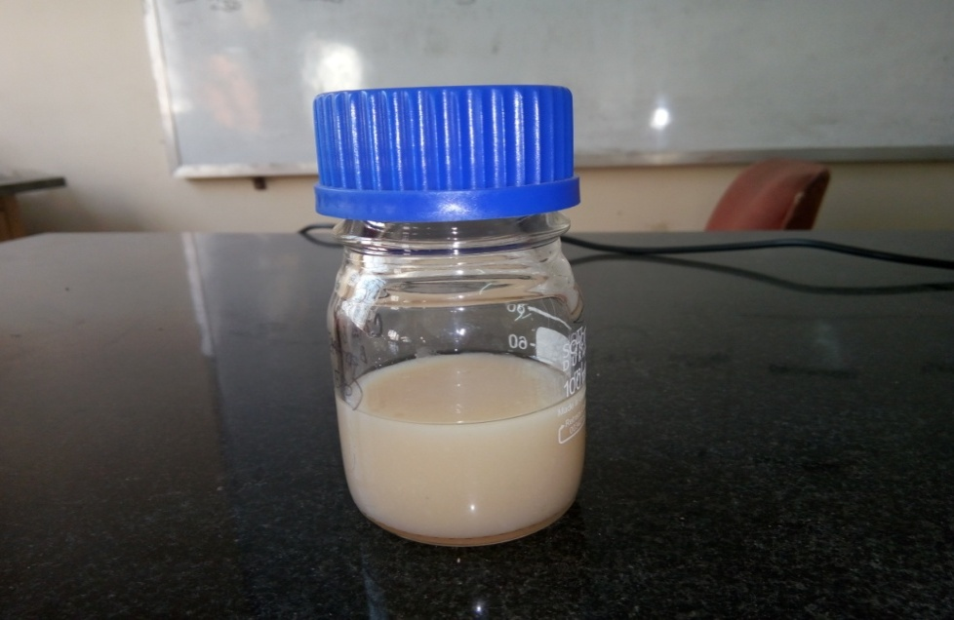 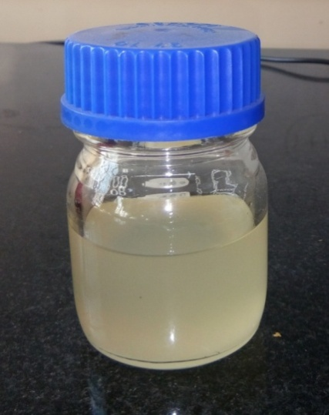

**Figure 1:** Jam and Jelly of Custard Apple

**Chemical analysis of Custard Apple Pulp, Jam and Jelly**

The chemical analysis of custard apple pulp, jam and jelly were shown in table 3. The final Brix of custard apple pulp, jam and jelly was observed to be 28, 68 and 65 ºB respectively whereas total sugar was found 20.96, 51.26 and 49.8 g.100g-1 respectively. The pH was recorded 5.48, 3.43 and 3.52 respectively for pulp, jam and jelly, with a titrable acidity of 0.29, 0.43 and 0.46 g.100g-1 (Bala et al., 2017). The final moisture content was observed as 74.6, 27.52 and 31.42 g.100g-1 in custard apple pulp, jam and jelly respectively.

The 68-70 oB of jam provides good taste and also prevents jam from deterioration by preventing growth of microorganism at such a higher sugar concentration (Taufic and Karim, 1992). Lago et al., (2006) reported that low acidity (0.3-0.8 %) and low pH in a range of 3.4- 3.5 contribute to pectin gelation and increases the stability of formulated jam and jelly. It has been also reported by Farkas (1991) that texture of jam is a result of various parameters like pH, sugar concentration, viscosity and elasticity.

**Table 3:** Analysis of custard apple pulp, jam and jelly

|  |  |  |  |  |
| --- | --- | --- | --- | --- |
| S. No. | Constituents | Pulp | Jam | Jelly |
| 1. | Moisture (g.100g-1) | 74.6 | 27.52 | 31.42 |
| 2. | TSS (ºBrix) | 28 | 68 | 65 |
| 3. | pH | 5.48 | 3.43 | 3.52 |
| 4. | Titrable acidity (g.100g-1) | 0.29 | 0.43 | 0.46 |
| 5. | Total sugar (g.100g-1) | 20.96 | 51.26 | 49.83 |
| 6. | Vitamin C (mg.100g-1) | 32.5 | 16.4 | 15.8 |

**Rheological properties:**

Different rheological properties like viscosity, shear force, torque were determined for all the processed samples using spindle RV05 of Brookfield rheometer. A multipoint viscosity data were recorded at a fixed rotation per minute (RPM) of 100 for a time interval of 10 seconds. Shear stress forces were determined by single point data taken at different RPM of 50, 75, 100, 125 and 150 for a time interval of 2 minutes. The Power law and Bingham mathematical models were used for describing various rheological characteristics of processed products of custard apple.

**Rheological Properties of custard apple based products**

The table 4 described the multipoint rheological parameters for custard apple based products observed at 100 rpm with spindle RV05. The table indicates that custard apple pulp, jam and jelly have a range of viscosity as 31.23 - 28.86 cP, 53.57 - 49.22 cP and 8.58 cP -11.78 cP respectively which was in accordance with the data presented by Maceiras et al., (2006) for strawberry, pear puree and jam. This multipoint viscosity analysis also revealed that viscosity decreases with increase in shear time. The shear stress and torque also decreased with decrease in viscosity. The viscosity of jamun jam was reported in the range of 47841 to 46093 (Poise) by Shahnawaj M Sheikh, (2011). According to Toledo, (1993) when the material exhibits a decrease of viscosity as shear rate increases, it is called shear thinning or pseudoplastic with the yield stress. In case of jelly prepared from Custrad apple, increase of viscosity with rise in shear time could be attributed to reorganisation of materials at high shear rate (Royer et al., 2006).

**Table 4:** Multi point rheological parameters at fixed rpm (100) of custard apple based products

|  |  |  |  |  |  |  |
| --- | --- | --- | --- | --- | --- | --- |
| **Pulp** | | | | | | |
| Viscosity (cP) | Speed (RPM) | Torque (%) | Shear Stress (dyn/cm²) | Shear Rate (1/s) | Temp (°C) | Time  (hh:mm:ss) |
| 31.23 | 100 | 48.8 | 38.20 | 122.3 | 29.6 | 00:00:10. |
| 30.91 | 100 | 48.3 | 37.81 | 122.3 | 29.6 | 00:00:20. |
| 30.59 | 100 | 47.8 | 37.41 | 122.3 | 29.6 | 00:00:30. |
| 30.40 | 100 | 47.5 | 37.18 | 122.3 | 29.6 | 00:00:40. |
| 30.08 | 100 | 47.0 | 36.79 | 122.3 | 29.6 | 00:00:50. |
| 30.08 | 100 | 47.0 | 36.79 | 122.3 | 29.7 | 00:01:00. |
| 29.82 | 100 | 46.6 | 36.47 | 122.3 | 29.7 | 00:01:10. |
| 29.57 | 100 | 46.2 | 36.16 | 122.3 | 29.7 | 00:01:20. |
| 29.44 | 100 | 46.0 | 36.01 | 122.3 | 29.7 | 00:01:30. |
| 29.25 | 100 | 45.7 | 35.77 | 122.3 | 29.7 | 00:01:40. |
| 29.18 | 100 | 45.6 | 35.69 | 122.3 | 29.7 | 00:01:50. |
| 28.86 | 100 | 45.1 | 35.30 | 122.3 | 29.6 | 00:02:00. |
| **Jam** | | | | | | |
| 53.57 | 100 | 83.7 | 65.51 | 122.3 | 30.3 | 00:00:10.1 |
| 53.44 | 100 | 83.5 | 65.36 | 122.3 | 30.3 | 00:00:20.1 |
| 51.78 | 100 | 80.9 | 63.32 | 122.3 | 30.3 | 00:00:30.1 |
| 51.46 | 100 | 80.4 | 62.93 | 122.3 | 30.3 | 00:00:40.1 |
| 51.14 | 100 | 79.9 | 62.54 | 122.3 | 30.3 | 00:00:50.1 |
| 51.01 | 100 | 79.7 | 6 2.38 | 122.3 | 30.3 | 00:01:00.1 |
| 50.50 | 100 | 78.9 | 61.76 | 122.3 | 30.3 | 00:01:10.1 |
| 50.30 | 100 | 78.6 | 61.52 | 122.3 | 30.3 | 00:01:20.1 |
| 49.86 | 100 | 77.9 | 60.97 | 122.3 | 30.3 | 00:01:30.1 |
| 49.79 | 100 | 77.8 | 60.90 | 122.3 | 30.3 | 00:01:40.1 |
| 49.73 | 100 | 77.7 | 60.82 | 122.3 | 30.3 | 00:01:50.1 |
| 49.22 | 100 | 76.9 | 60.19 | 122.3 | 30.3 | 00:02:00.1 |
| **Jelly** | | | | | | |
| 8.58 | 100 | 13.4 | 10.49 | 122.3 | 30.3 | 00:00:10.1 |
| 9.28 | 100 | 14.5 | 11.35 | 122.3 | 30.3 | 00:00:20.1 |
| 10.43 | 100 | 16.3 | 12.76 | 122.3 | 30.3 | 00:00:30.1 |
| 10.75 | 100 | 16.8 | 13.15 | 122.3 | 30.3 | 00:00:40.1 |
| 11.01 | 100 | 17.2 | 13.46 | 122.3 | 30.4 | 00:00:50.1 |
| 11.58 | 100 | 18.1 | 14.17 | 122.3 | 30.4 | 00:01:00.1 |
| 11.78 | 100 | 18.4 | 14.40 | 122.3 | 30.3 | 00:01:10.1 |
| 11.90 | 100 | 18.6 | 14.56 | 122.3 | 30.3 | 00:01:20.1 |
| 11.97 | 100 | 18.7 | 14.64 | 122.3 | 30.3 | 00:01:30.1 |
| 12.10 | 100 | 18.9 | 14.79 | 122.3 | 30.3 | 00:01:40.1 |
| 12.16 | 100 | 19.0 | 14.87 | 122.3 | 30.3 | 00:01:50.1 |
| 12.22 | 100 | 19.1 | 14.95 | 122.3 | 30.3 | 00:02:00.1 |

The table 5 showed the single point rheological parameters at different rpm of 50, 75, 100, 125 and 150 for all the processed products of custard apple. The apparent viscosity was found to be vaying in range of 44.42 cP - 17.28 cP, 78.08 - 37.72 cP and 21.89 - 11.39 cP for pulp, jam and jelly respectively which decreased with increase of shear rate. The shear stress was found in the range of 27.16 - 31.70 dyn/cm2 for pulp, 47.75 - 69.19 dyn/cm2 for jam1338 - 20.90 dyn/cm2 for jelly with increase in shear rate from 61.15- 183 1/s. Tiwari et al., (2016) reported that shear rate for jackfruit jam and jelly ranged between 600 s-1 to 2700 s-1.. Rao and Steffe, (1992); Saravacos; MarouliS, (2001) also reported that the majority of food fluids presents pseudoplastic behaviour as the apparent viscosity decreases with an increase in shear rate. They also verified that the pseudoplastic behaviour of fruit juices and pulps deviates from Newtonian behaviour. Figure 2 presents the comparative viscosity of different processed products of custard apple with respect to shear time that showed decrease in the viscosity.

**Table 5:** Single point rheological parameters at different rpm for Custard apple based products

|  |  |  |  |  |  |  |
| --- | --- | --- | --- | --- | --- | --- |
| **Pulp** | | | | | | |
| Viscosity  (cP) | Speed  (RPM) | Torque  (%) | Shear Stress  (dyn/cm²) | Shear Rate  (1/s) | Temp  (°C) | Time  (hh:mm:ss) |
| 44.42 | 50 | 34.7 | 27.16 | 61.15 | 29.7 | 00:02:00 |
| 31.23 | 75 | 36.6 | 28.65 | 91.73 | 29.7 | 00:04:00 |
| 25.15 | 100 | 39.3 | 30.76 | 122.3 | 29.6 | 00:06:00 |
| 20.74 | 125 | 40.5 | 31.70 | 152.9 | 29.6 | 00:08:00 |
| 17.28 | 150 | 40.5 | 31.70 | 183.5 | 29.5 | 00:10:00 |
| **Jam** | | | | | | |
| 78.08 | 50 | 61.0 | 47.75 | 61.15 | 28.6 | 00:02:00 |
| 61.18 | 75 | 71.7 | 56.12 | 91.73 | 28.5 | 00:04:00 |
| 49.02 | 100 | 76.6 | 59.96 | 122.3 | 28.6 | 00:06:00 |
| 42.96 | 125 | 83.9 | 65.67 | 152.9 | 28.6 | 00:08:00 |
| 37.72 | 150 | 88.4 | 69.19 | 183.5 | 28.6 | 00:10:00 |
| **Jelly** | | | | | | |
| 21.89 | 50 | 17.1 | 13.38 | 61.15 | 28.9 | 00:02:00 |
| 17.32 | 75 | 20.3 | 15.89 | 91.73 | 28.8 | 00:04:00 |
| 16.38 | 100 | 25.6 | 20.04 | 122.3 | 28.8 | 00:06:00 |
| 13.82 | 125 | 27.0 | 21.13 | 152.9 | 28.9 | 00:08:00 |
| 11.39 | 150 | 26.7 | 20.90 | 183.5 | 29.0 | 00:10:00 |

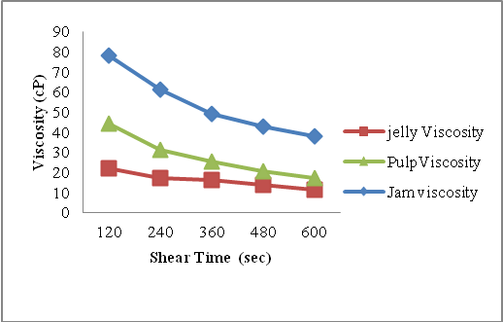

**Figure 2:** Comparison between apparent viscosity of custard apple pulp, jam and jelly

The Bingham model resulted in a plastic viscosity of 3.97 cP and yield stress of 25.1 dyn/cm² with a confidence of fit value of 98.3% for custard apple pulp. Power law model showed a yield consistency index *(n)* of 1442 cP and with flow index of 0.154. Chin et al., (2009) reported that white guava puree and pummelo juice concentrate showed a behaviour index (*n*) value below unity (*n* <1) which indicates pseudoplastic behaviour which is found in accordance with present finding. Figure 3 and 4 showed the Bingham and power law model for custard apple pulp.

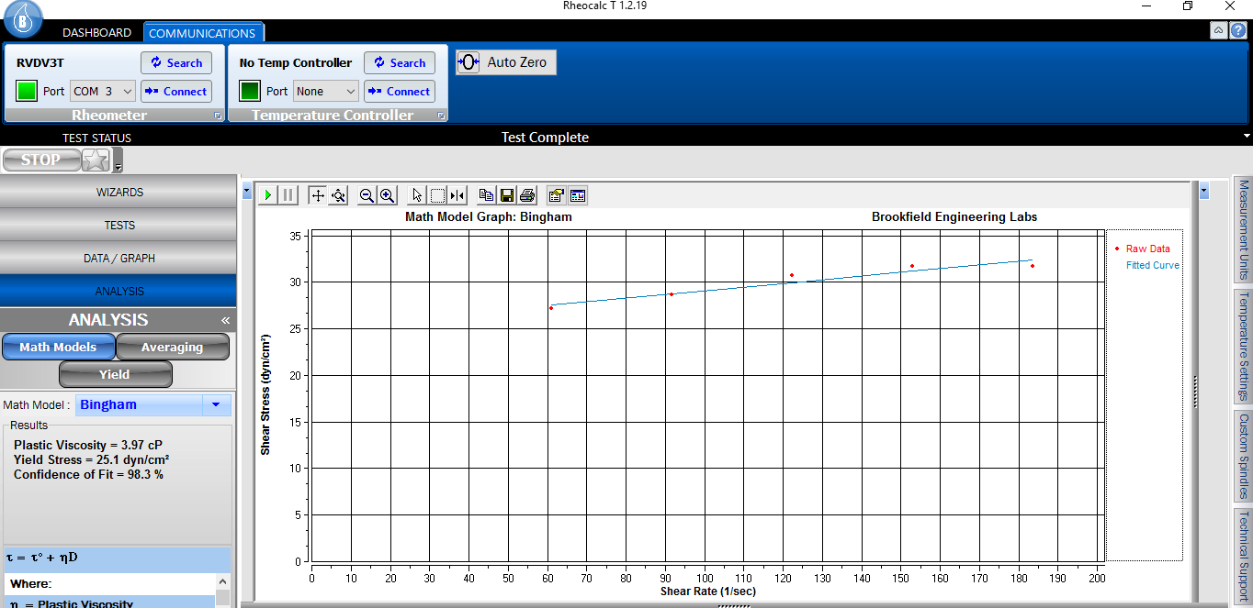

**Figure 3:** Bingham model for custard apple pulp (shear stress v/s shear rate)

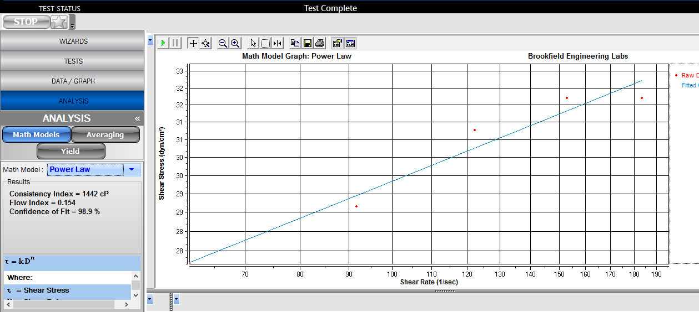

**Figure 4:** Relationship between shear stress and shear rate of custard apple pulp (Power law model)

The curve fitting of the data into Bingham model for custard apple jam resulted in a yield stress of 38.8 dyn/cm2 and plastic viscosity equal to 17.1 cP with a confidence of fit value of 98.2% for custard apple pulp. While Power law model resulted in 99.1% of confidence fit value which is more realistic and results a consistency index (*k)* equal to 1221 cP and a shear thinning Power Law index of 0.333 indicating the thick consistency of custard apple jam with shear thinning behaviour. Mohammadi et al., (2009) reported marmalade of pistachio hull's behaved as pseudo-plastic fluid with consistency index in the range of 1.9 - 121 Pa sn. Pseudoplastic behaviour of jam was also reported by Alvarez, (2006). Yu et al., (2011) reported rheological properties of four kinds of jams (kewpie strawberry, blueberry, marmalade and ST. Dalfour) belonged to non- Newtonian fluid model, with thixotropy nature. Figure 5 and 6 showed the Bingham and Power law model for custard apple jam. However other researcher has also reported the shear thinning behaviour of food products which means the become easier to spread at higher shear rate (Arrieta-Durango et al., 2022; Mieles-Gomez et al., 2023).

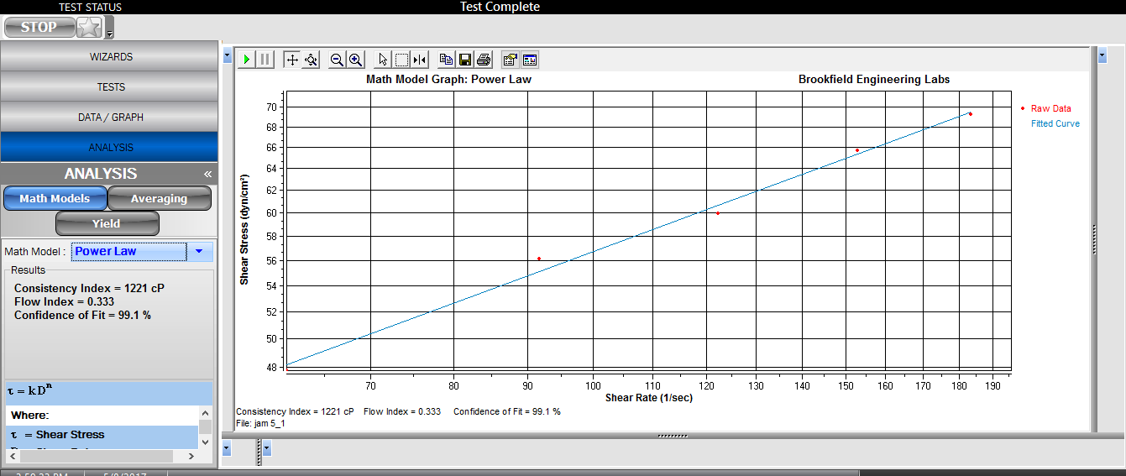

**Figure 5 :** Power law model for custard apple jam (Shear stress v/s shear time)

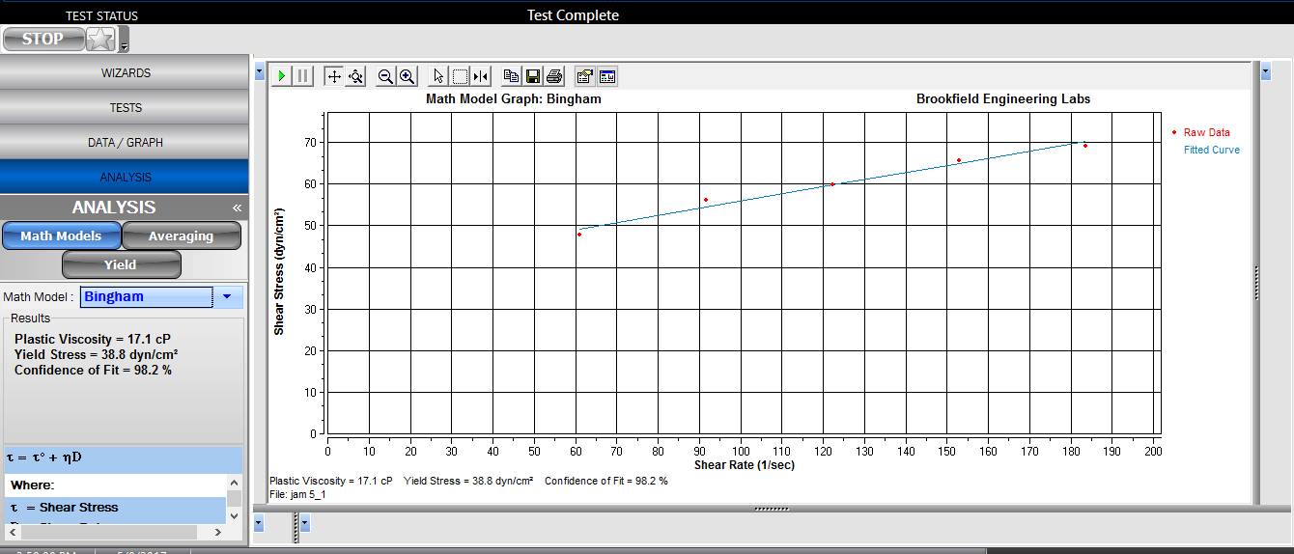

**Figure 6:** Bingham model for custard apple jam (Shear stress v/s shear time)

Bingham model for custard apple jelly had a yield stress of 10.2 Dyn/Cm2 with a plastic viscosity of 6.63 cP. The Bingham model gives a yield stress of 198.1 Pa with apparent viscosity of 286.7 Pa for jackfruit jelly (Tiwari et al., 2016). The Power law model resulted a consistency index *(k)* of 215 cP and flow index *(n)* 0.448 with a confidence of fit value of 95.8%. Figure 7 and 8 showed flow curve Bingham and Power law model.

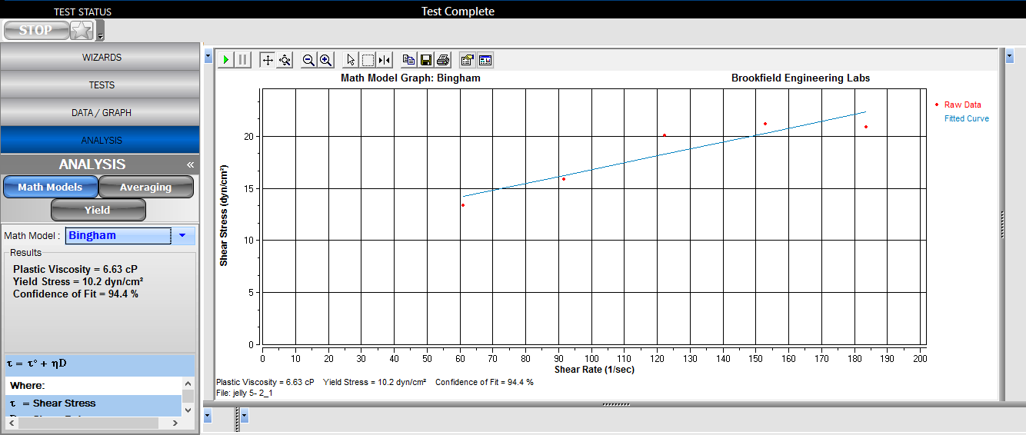

**Figure 7:** Bingham model of custard apple jelly

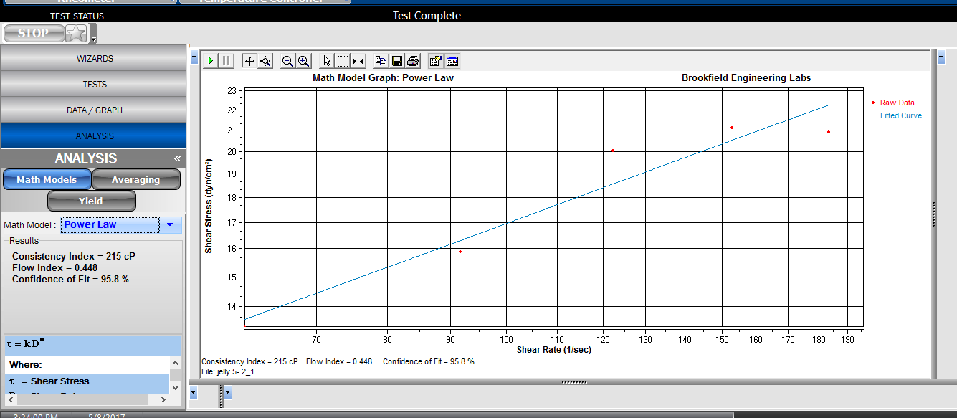

**Figure 8:** Power law model of custard apple jelly

Table 6 showed a comparative analysis of Bingham and Power Law model for custard apple pulp, jam and jelly. Figure 9 showed Changes of shear stress with the shear rate increase for different products of custard apple. From present study it was noticed that custard apple pulp, jam and jelly showed non-Newtonian flow behaviour with pseudoplastic and shear thinning nature. Maceiras *et al*. (2007) also reported similar pseudoplastic behavior for peach, plum, strawberry and raspberry purees and also described that fruit jam have higher apparent viscosity than the fruit purees due to addition of sugar.

**Table 6:** Bingham and Power law parameters of custard apple based products

|  |  |  |  |  |
| --- | --- | --- | --- | --- |
| Samples | Plastic viscosity (*μB*) (cP) | Yield stress *(σo*) dyn/cm2 | Consistency *(k)* (cP) | Flow index *(n)* |
| Pulp | 3.97 | 25.1 | 1442 | 0.154 |
| Jam | 17.1 | 38.8 | 1221 | 0.333 |
| Jelly | 6.63 | 10.2 | 775 | 0.194 |

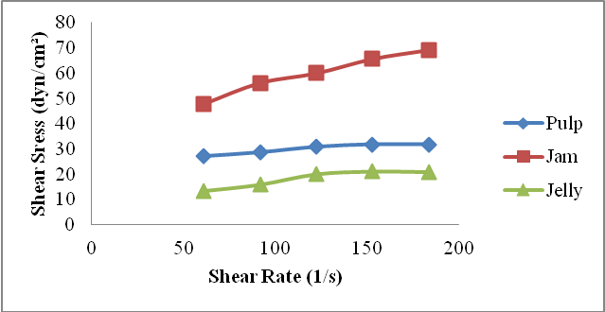

**Figure 9:** Changes of shear stress with the shear rate increase for different products of custard apple

The impact of total soluble solids on the rheological parameters of different products has been studied in a number of literatures. According to Krokida et al. (2001), concentration of soluble solids with insoluble solid contents has a strong non-linear effect on the viscosity of Newtonian fluid foods, the consistency coefficient (*k*), and the apparent viscosity of non-Newtonian foods. The increase in the consistency coefficient (*k*) was observed in all data fitted with the power law or Herschel–Bulkey model.

**Storage stability of custard apple jam and jelly**

Table 7 showed the changes in colour of custard apple jam and jelly during storage period of 12 months. All the products of custard apple were stable at cold temperature for a period of 12 months as the quality parameters like colour, flavour and texture remain unchanged. However, products stored at ambient temperature were stable for 9 months only after that the colour changes slight brownish. There was no off flavour during 9 months of storage of jam and jelly at all temperature of storage. Selvamuthukumaran et al., (2007) reported browning colour in sea buckthorn-grape jelly during storage at 37 0C temperature.

**Table 7:** Change in colour of custard apple jam and jelly during storage

|  |  |  |  |
| --- | --- | --- | --- |
| Jam | | | |
| Duration of study  (Months) | Cold temp.  (4ºC) | Room temp. (25±5ºC) | Incubator  (37ºC) |
|
| 0 | No Changes | No Changes | No Changes |
| 3 | No Changes | No Changes | No Changes |
| 6 | No Changes | No Changes | No Changes |
| 9 | No Changes | Slight brownish | Slight brownish |
| 12 | No Changes | Brownish yellow | Blackish on Top |
| Jelly | | | |
| 0 | No Changes | No Changes | No Changes |
| 3 | No Changes | No Changes | No Changes |
| 6 | No Changes | No Changes | No Changes |
| 9 | No Changes | Light brownish | Light brownish |
| 12 | No Changes | Brownish yellow | Blackish on Top |

Microbial evaluation of prepared custard apple jam and jelly was conducted by serial dilution and presented in table 8. The microbial load in stored jam and jelly was found acceptable at the end of storage period (12 months).

**Table 8:** Microbial count (Cfu/ml ) of custard apple jam and jelly.

|  |  |  |  |
| --- | --- | --- | --- |
| **Jam** | | | |
| Duration of study  (Months) | Cold temp.  (4ºC) | Room temp. (25±5ºC) | Incubator  (37ºC) |
|
| 0 | ND | ND | ND |
| 3 | ND | ND | ND |
| 6 | ND | ND | ND |
| 9 | ND | 1 | 2 |
| 12 | ND | 5 | 7 |
| **Jelly** | | | |
| 0 | ND | ND | ND |
| 3 | ND | ND | ND |
| 6 | ND | ND | ND |
| 9 | ND | 2 | 3 |
| 12 | ND | 6 | 7 |

**ND-Not detected**

**Conclusion:**

Processing of custard apple based products like jam and jelly is a way to exploit exotic flavour, aroma and valuable nutrients. Formulated products of custard apple showed a good processing technology which could be an alternative for conservation of these underutilized fruits and can also add value and expand their prospect through the consumer market. The study concluded the requirement of pectin (0.75 %) for gelation of jam and jelly. The rheological measurement of custard apple based products provides very useful behavioural and predictive information as guidelines for processing, formulation and product development. The custard apple pulp, jam and jelly showed non-newtonian fluid behavior with thick consistency and shear thinning behaviour. The custard apple jam has a high apparent viscosity as compared to pulp and jelly. It was also observed that all measurement was fitted to Bingham and Power law model proving the structural and textural characteristics of products. Custard apple jam and jelly was found to be excellent processed products due to nice gel formation with apparent viscosity ranged from 21.89 cP - 78.08 cP. Flow index of jam and jelly was found to be 0.154 and 0.333 respectively withlow plastic viscosity. The processing of custard apple fruits holds a good promising consumer market in future.

**References:**

1. AOAC (1997) Fruits and fruit products. Official Methods of Analysis. (16th ed., 3rd revision). Washington, DC: Association of official Analytical Chemists
2. AOAC (2006) Official methods of analysis. 18rd ed. Gaithersburg
3. APEDA: http://apeda.gov.in/apedawebsite/trade_promotion/study_and_report.hm
4. Araujo BMN, Hoffmann FL, Goncalves TMV, Ribeiro VFA, Papa AL, Ferrari LG (2006) A study on the hygiene and sanitation of samples of industrial and handmade fruit jam available in the town of Saõ José do Rio Preto, Saõ Pauloa. Higiene Alimentar 20(142):96-104
5. Arrieta-Durango, C, Henao-Rivas, L, Andrade-Pizarro, R (2022) Rheological Behavior of Passion Fruit (Passiflora edulis) Peel Extract. Gels, 8(9):566
6. Awan JA and Rehman SU (1999) Food Preservation Manual, Uni Technology Publishers. Faisalabad. Pakistan
7. Bala S, Nigam VK, Tiwari AK, Vidyarthi AS (2017) Studies on Nutraceutical Properties of Annaona squamosa. In Applications of Biotechnology for Sustainable Development, Springer, Singapore pp 81-87
8. Basu S, Shivhare US (2010) Rheological, textural, micro-structural and sensory properties of mango jam. J Food Eng100(2): 357-365
9. Basu S, Shivhare US, Singh TV (2013) Effect of substitution of stevioside and sucralose on rheological, spectral, color and microstructural characteristics of mango jam. J Food Eng 114(4):465-476
10. Benassi G, Correa GASF, Kluge RA, Jacomino AP (2003) Shelf life of custard apple treated with 1-methylciclopropene: an antagonist to the ethylene action. Braz Arch Biol Technol46(1):115-120
11. Bhardwaj A, Satpathy G, Gupta RK (2014) Preliminary screening of nutraceutical potential of *Annona squamosa*, an underutilized exotic fruit of India and its use as a valuable source in functional foods. J Pharmacogn Phytochem 3(2):172-180
12. Chacko A, Muraleedharan H, Sastry PS (2010) Effect of storage coditions on the microbial quality of fermented foods. World Appl Sci J9(12):1365-1369
13. Chikhalikar NV, Sahoo AK, Singhal RS, Kulkarni PR (2000) Studies on frozen pourable custard apple (Annona squamosa L) pulp using cryoprotectants.  J Sci Food Agric 80(9):1339-1342
14. Chin NL et al (2009) Modelling of rheological behaviour of pummelo juice concentrates using master-curve. J Food Eng 93(2):134-140
15. Colin D (1992) Recent trends in fruit and vegetable processing. In Food Science and Technology Today 7(2), pp 111-116
16. Desrosier NW (1977) Elements of food technology. AVI Publishing Co. Inc. Westport, Connecticut
17. Falguera V, Vélez‐Ruiz JF, Alins V, Ibarz A (2010) Rheological behaviour of concentrated mandarin juice at low temperatures.  Food Sci Technol Int 45(10):2194-2200
18. Farkas DF (1991) How to describe a process for quality control. PA'91 - Session B-2, Oregon State University, Corvallis, 4: 112-121
19. Fugel R, Carle R, Schieber A (2005) Quality and authenticity control of fruit purees, fruit preparations and jams- a review. Trends Food Sci Technol 16:433-441
20. Iwasa S. (2001). Tropical fruit trees, illustrated, JIRCAS International Agriculture Series No.11, JIRCAS, Tsukuba, Japan. p. 56-82
21. Kokini JL, Plutchok GJ (1987) Viscoelastic properties of semisolid foods and their biopolymers components. Food Technol 41(3):89-95
22. Krokida MK, Maroulis ZB, Saravacos GD (2001) Rheological properties of fluid fruit and vegetable puree products: compilation of literature data. *International* J Food Prop  4(2):179-200
23. Lago ES, Gomes E, Silva RD (2006) Produção de geléia de jambolão (Syzygium cumini Lamarck): processamento, parâmetros físico-químicos e avaliação sensorial.   
    Ciênc Tecnol Aliment Campinas 26(4):47-852
24. Maceiras R, Alvarez E, Cancela MA (2006) Rheological properties of fruit purees: Effect of cooking. J Food Eng 80(3): 763-769
25. Mieles-Gómez, L, Martinez, SEQ, Zapateiro, LG (2023) Physicochemical properties, Steady and Dynamic Rheological Measurements of Sour Guava (Psidium Araca) Pulp. Curr Res Nutr Food Science J. 11(2):560-568
26. Mohammadi MT, Seyed MA, Razavi, MF, Shaker AA (2009) Chemical composition and rheological characterization of pistachio green Hull’s marmalade. J Texture Stud (40):390–405
27. Nourmohammadi A, Ahmadi E, Heshmati A (2021) Optimization of physicochemical, textural, and rheological properties of sour cherry jam containing stevioside by using response surface methodology. Food Sci & Nutr. 9:2483–2496.
28. Prasanna KNV, Rao DVS, Krishnamurthy S (2000) Effect of storage temperature on ripening and quality of custard apple (*Annona squamosa* L.) fruits. J Hortic Sci Biotechnol 75(5):546-550
29. Ranganna S (2003) Analysis of Fruit and Vegetable Products. 2nd edition, pp 12-16
30. Rao MA, Steffe JF (1992) Viscoelastic Properties of Foods. London: Elsevier Applied Science*,* pp 535-539
31. Royer G, Madieta E, Symoneaux R, Jourjon F (2006) Preliminary study of the production of apple pomace and quince jelly. LWT-Food Sci Technol 39(9):1022-1025
32. Santanu B, Shivhare US (2010) Rheological, textural, micro-structural and sensory properties of mango jam. J Food Eng 100:357-365
33. Saravacos GD, Maroulis ZB (2001) Transport properties of foods. CRC Press.
34. Selvamuthukumaran M, Khanum F, Bawa AS (2007) Development of sea buckthorn mixed fruit jelly. Int J Food Sci Technol 42:403–410
35. Shahnawaz M, Shiekh SA (2011) Analysis of viscosity of jamun fruit juice, squash and jam at different compositions to ensure the suitability of processing applications. Int J Plant Physiol Biochem *3*(5):89-94
36. Shinwari KJ, Rao PS (2020) Development of a reduced-calorie high pressure processed sapodilla (Manilkara zapota L.) jam based on rheological, textural, and sensory properties. J Food Sci. 85(9):2699-2710
37. Taufik YCM, Karim MNA (1992). Storage stability of ciku leather. ASEAN Food J 1(7): 53-55
38. Tiwari AK, Vidyarthi AS, Nigam VK and Hassan MA. (2016). Study of Rheological Properties and Storage Life of Ripe Jackfruit Products: Jam and Jelly. Asian Jr of Microbiol Biotech Env Sc 18(2):475-482
39. Toledo RT (1993) Flow of Fluids. In: Fundamentals of Food Process Engineering. Springer, Boston, MA, 160-231
40. Yusof S, Ibrahim N (1994) Quality of sour sop juice after pectinase enzyme treatment. Food Chem 51(1): 83-88