Review Article

Sentience of Plants towards Bioacoustics
Abstract
Plant bioacoustics is a multidisciplinary study that studies how plants detect, produce, and react to acoustic cues in their surroundings. As a result, the traditional view of plants as static, unresponsive animals is fast changing. A rising amount of research suggests that sound waves, especially those in the low-frequency (20 Hz-2 kHz) and ultrasonic (>20 kHz) ranges, can function as powerful environmental signals that can affect a variety of physiological processes in plants. Enhanced germination rates, faster vegetative growth, better biomass accumulation, delayed fruit ripening, increased tolerance to drought stress, and increased resistance to biotic stressors like pathogens and pests are just a few of the positive effects of acoustic stimulation on plant behaviour, as shown by experimental studies. These reactions are not just anecdotal; they are backed by quantifiable alterations in hormone signalling pathways, gene expression, and oxidative stress indicators such reactive oxygen species (ROS). Plants producing ultrasonic noises is a particularly fascinating occurrence, especially when they are experiencing abiotic stressors like drought. These remotely detectable emissions, which are frequently linked to xylem cavitation events, may be early markers of plant stress and present new possibilities for remote crop monitoring. Additionally, it has been shown that plants react to mechanical vibrations in the environment, such as those brought on by water flow, insect feeding, or pollinator movement, indicating that sound contributes to biotic interaction awareness. Plants respond to sound by mechanosensory perception, which is regulated at the molecular level by transcriptional regulatory mechanisms and mechanosensitive ion channels. Growth, development, and defence are all impacted by the downstream consequences that these channels cause when they transform physical vibrations into electrical or biochemical signals. Applications of sound waves in agricultural biotechnology are becoming more popular, going beyond natural processes. Technologies such as ultrasound-enhanced tissue culture procedures and sonication-assisted Agrobacterium-mediated transformation (SAAT) have demonstrated promise in enhancing the regeneration capacity and genetic transformation efficiency in resistant agricultural species. These methods use sound as a non-invasive physical agent to help create high-yielding, stress-resilient cultivars. Through the application of sound as a tool for precision farming, early stress diagnosis, and non-chemical crop promotion, the discipline of plant bioacoustics creates revolutionary opportunities for sustainable agriculture. Current research solidifies sound as a useful and ecologically significant signal in plant adaptation and development, even though the entire range of the molecular mechanisms underlying these acoustic responses is still being explored.
Keywords: Plant acoustics, Ultrasonic plant signals, Sound-induced plant responses, Cavitation stress, Mechano-transduction, Abiotic stress resilience.
1.1 Introduction
Bioacoustics is an interdisciplinary field that investigates how living things make, transmit, and experience sound. Initially concentrating on animal communication, particularly in insects, birds, and marine mammals, the study has recently broadened its scope to encompass plants, which were previously thought to be passive and silent. The main cause of this change is new research that indicates plants can perceive, emit, and react to sound stimuli, exposing a previously unnoticed aspect of plant-environment interaction. To understand how sonic cues affect plant development, behaviour, and adaptability, plant bioacoustics now combines elements of environmental science, physics, plant physiology, molecular biology, and electrophysiology.
Biological systems use a variety of mediums, such as air, water, or solid tissues, to transmit sound, which is defined by its frequency, amplitude, waveform, and duration. These sound waves have the ability to activate signal transduction pathways and carry information that is biologically significant. The issue of how plants sense sound has sparked new debates over their sensory and signalling abilities, given that they do not have the same neural systems or sensory organs as animals (Gagliano et al., 2012; Mishra et al., 2016). According to experimental research, exposure to particular sound frequencies, especially those in the low-frequency (20-1000 Hz) and ultrasonic (>20 kHz) ranges, can have a major impact on plant physiology. These effects can range from enhancing photosynthetic efficiency and stress tolerance to encouraging seed germination and root elongation (Jeong et al., 2008; Hassanien et al., 2014).
The groundbreaking research of Sir Jagadish Chandra Bose established the fundamental idea that plants are sentient or sensitive beings. Bose created the crescograph, a device that can identify minute changes in plant development, around the beginning of the 20th century. With the aid of this apparatus, he proved that plants have quantifiable physiological responses to environmental stimuli such as light, temperature, touch, and most importantly sound (Bose, 1926). Since contemporary electrophysiological research have demonstrated action potentials and variation potentials in plant tissues, his notion that electrical signalling in plants operates similarly to brain transmission in mammals has received more and more traction (Fromm & Lautner, 2007). Early investigations by Bose indicated that while harsh or unpredictable noises can inhibit plant growth, calm, repetitive sounds might promote it. Although these findings were regarded as conjectural for many years, more recent studies have recently confirmed them. Research has demonstrated, for instance, that plants of rice, mung beans, and tomatoes subjected to particular sound treatments had higher biomass and faster flowering (Hassanien et al., 2014; Chivukula & Ramaswamy, 2014). Similar to classical conditioning in mammals, Gagliano et al. (2014) showed that pea plants can learn to correlate a sound cue with the orientation of a light source by using associative learning. The ability of plants to produce sound is a particularly fascinating feature of plant bioacoustics. Khait et al. (2019) found that tobacco and tomato plants under drought stress produce ultrasonic "clicks" that are audible from a distance of several meters and are probably the result of cavitation events in the xylem. These emissions could be indicators of environmental stress to nearby plants or even animals. Other research has looked at how plants react to vibrations from herbivores or pollinators. A function for vibrational sensing in reproductive ecology is suggested by Thelwall et al. (2022), who found that flowering plants can increase nectar production when exposed to the frequency of bee wingbeats.
Mechanosensitive ion channels, reactive oxygen species (ROS) signalling, calcium fluxes, and alterations in gene expression are thought to be involved in the mechanisms of sound perception at the cellular and molecular levels (Monshausen & Haswell, 2013). Sound waves can change the cytoskeleton or membrane fluidity, triggering intracellular reactions that control stress response pathways and hormone signalling. Additionally, ultrasound has been demonstrated to improve tissue culture regeneration and organogenesis and is being employed in plant biotechnology for procedures like sonication-assisted Agrobacterium-mediated transformation (SAAT) (Zhang et al., 2012). The idea that plants have sophisticated sensory systems and flexible behaviour is contentious but is becoming more widely accepted as a result of these studies. Although plants lack animal-style brains and consciousness, they do display a type of "non-neural intelligence" that is based on memory, electrochemical signalling, and environmental reactivity (Trewavas, 2005; Baluška & Mancuso, 2009). Therefore, a crucial area of research in plant sensory biology and ecological communication is the study of plant bioacoustics. As the world's agriculture industry looks for non-invasive, sustainable crop management technology, plant bioacoustics could be used as a diagnostic and improvement tool. Precision agriculture has new opportunities in this industry, from identifying plant stress before symptoms show up to affecting growth and output with effective treatments. In order to better understand plant behaviour and ecological interactions, this review will summarize current developments in plant bioacoustics, investigate the physiological processes behind sound perception and emission, and go over the consequences of these findings.

1.2 Acoustic Frequencies Relevant to Plants
Fundamentally, sound is a type of mechanical energy that travels through solid surfaces, water, or air as longitudinal pressure waves. Physical characteristics of these waves include wavelength, duration, amplitude (intensity), frequency (measured in Hertz), and shape. The idea that plants can sense and react to auditory stimuli has only just received empirical confirmation, despite the fact that the biological significance of sound in animals particularly in communication, navigation, and predator-prey interactions has been well documented. Plants have shown distinct, quantifiable reactions to particular sound frequencies despite having neither neural systems nor auditory organs, indicating the existence of other sensing systems.
MSL (Mechanosensitive-Like) proteins and MCA (Mid1-Complementing Activity) channels, which are embedded in cellular membranes and have the ability to sense mechanical disturbances brought on by sound vibrations, are thought to be the mechanosensitive proteins and ion channels involved in these processes. By converting vibrational energy into biochemical signals, these channels are thought to trigger physiological reactions downstream (Fig 1).
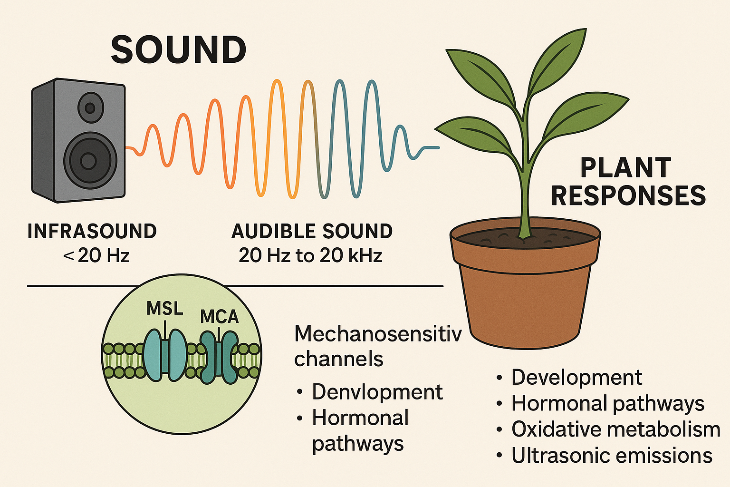
Fig 1: Mechanisms of Sound Perception in Plants and Their Physiological Responses Across Frequency Ranges
Generally, there are three types of sound frequencies: infrasound (less than 20 Hz), audible sound (20 Hz to 20 kHz), and ultrasound (more than 20 kHz). Even though the human ear can only detect noises in the 20 Hz to 20 kHz range, plants appear to be highly sensitive to low-frequency sounds, particularly those in the 100 Hz to 1.5 kHz range. A rising amount of research suggests that frequencies in the 500–1000 Hz range can have a positive impact on a number of plant development processes, such as photosynthetic efficiency, enzyme activity, cell division, root and shoot elongation, and seed germination.
By modulating oxidative metabolism and cell wall loosening enzymes, Jeong et al. (2014) showed that sound wave treatment at 500 Hz significantly increased root length and biomass accumulation in rice seedlings (Fig 2). Comparably, Sharan et al. (2023) found that subjecting tomato and mung bean plants to 1 kHz sound waves increased the rate of germination and the Vigor of the seedlings. This was likely due to the activation of reactive oxygen species (ROS) and calcium influx, two important secondary messengers in plant signalling pathways. A systemic effect of sonic stimulation at the molecular level is suggested by the fact that these physiological reactions frequently occur in tandem with alterations in gene expression, especially in genes linked to hormone pathways like as auxin, gibberellin, salicylic acid, and jasmonic acid.
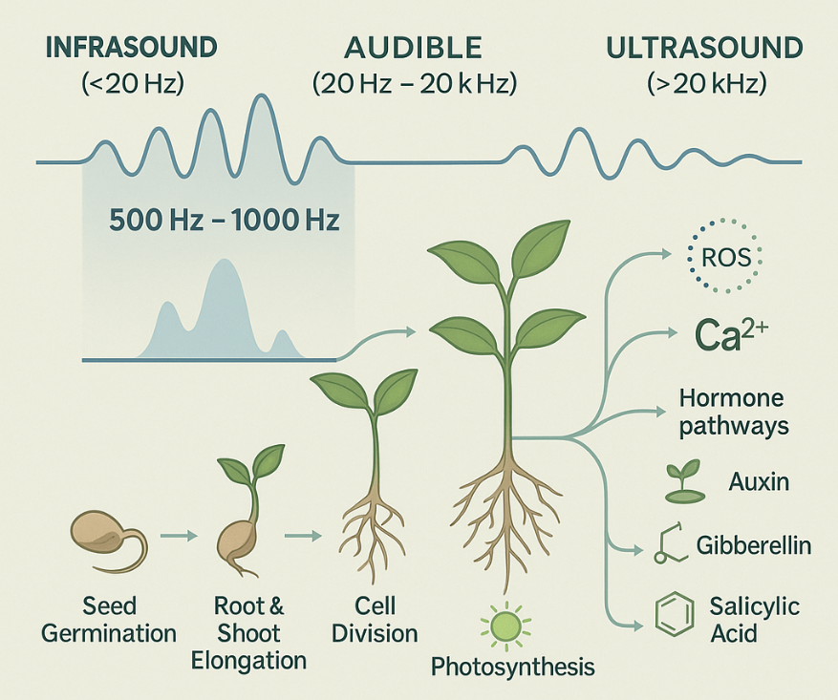
Fig 2: Acoustic Sensitivity and Developmental Responses of Plants: Exploring the Bioacoustics Frequency Window of 500–1000 Hz and its Impact on Growth and Hormonal Signaling"
Ultrasonic frequencies (>20 kHz) have also been detected in plant systems, however in a different setting than low-frequency sound. According to research by Khait et al. (2019), plants that are exposed to abiotic stressors including physical damage or dehydration produce high-frequency airborne sounds. These sounds are probably related to xylem cavitation events, which are the sudden collapse of water columns under tension. Although these ultrasonic emissions are not perceptible to the human ear, they could be intra- or interspecific signals and could be used as early stress markers. These emissions may be perceived by animals that can sense ultrasonic vibrations, such as insects, rodents, and bats, which may affect their behaviour in terms of pollination, herbivory, or seed dissemination.
Additionally, it is becoming more and more likely that nearby plants may also be able to detect these ultrasonic signals, which could lead to stress adaptations or pre-emptive defence reactions. All things considered, sound frequencies both internally produced and externally applied seem to affect plant physiology on a variety of scales, ranging from molecular signaling cascades to whole-plant behaviour and intersystem communication. Sound is positioned as a mechanical, non-chemical signal with significant ramifications for plant biology as a result of these discoveries. Knowing the frequency specificity of plant responses helps us better understand how plants interact with their surroundings and paves the way for cutting-edge agricultural applications including precision farming instruments, early stress detection, and acoustic-based crop stimulation.

1.3 Ultrasonic Emissions as Indicators of Plant Stress
Stressed plants can send out airborne ultrasonic signals, according to recent developments in the field of plant bioacoustics. Researchers from Tel Aviv University showed in a noteworthy study that when tobacco (Nicotiana tabacum) and tomato (Solanum lycopersicum) plants are stressed by mechanical damage or dehydration, they both create unique ultrasonic pulses (Fig 3). These emissions were observed in greenhouse settings and controlled acoustic chambers. They were in the inaudible 20-100 kHz frequency range. Under the direction of Itzhak Khait and Lilach Hadany, the group analysed the recorded noises using machine learning techniques. Their algorithms demonstrated over 70% accuracy in differentiating between various stress states, including cutting and dehydration. According to Khait et al. (2019), this suggests that the sounds that are released are not arbitrary and may really contain particular information about the physiological condition of the plant. It is possible that animals or even nearby plants may be able to perceive and react to these signals, as they were remarkably noticeable from a distance of 3 to 5 meters. These ultrasonic noises are most likely caused by xylem cavitation, a phenomenon in which air bubbles form and burst inside the plant's water-transport system when it is stressed by dryness (Fig 4). Although cavitation-induced noises have been previously detected in trees using internal sensors, the airborne transmission reported in herbaceous species represents a major advancement in our knowledge of plant communication. Wide-ranging ecological and agricultural ramifications result from this discovery. These auditory signals may indicate a hitherto unknown ecological communication mechanism if other creatures are able to detect and decipher them. Remote acoustic monitoring of plant stress in agricultural contexts may result in novel, non-invasive crop management techniques.
Fig.3:  Ultrasonic sound emissions recorded from tomato and tobacco plants under different stress treatments.  The bar chart illustrates the number of ultrasonic pulses emitted per plant within 60 minutes across four categories: pot control (no plant), neighbour control (unstressed plants adjacent to stressed ones), self-control (unstressed plants in isolation), and treated (plants subjected to stress). The treated group shows a significant increase in sound emissions, especially in drought-stressed tomato plants (red) and tobacco (black), followed by cut tomato (orange) and cut tobacco (grey), confirming stress-induced acoustic activity. (Khait et al., 2019)  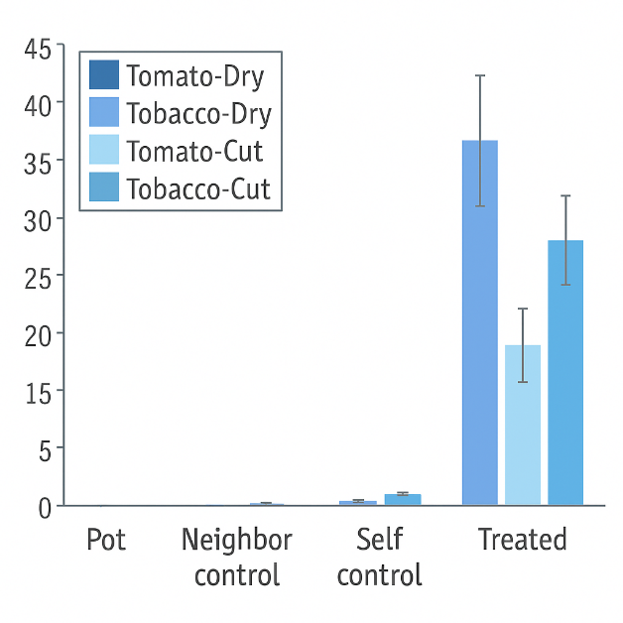 | Fig.4:  Frequency distribution of ultrasonic emissions from stressed tomato and tobacco plants.  The line graphs display power spectra (dB/Hz) of ultrasonic signals emitted under drought and cutting treatments. Each graph represents a distinct plant-treatment combination. Emissions from both species show peak intensities between 40 and 80 kHz, with tomato plants exhibiting higher peak power values. The distinct acoustic profiles suggest that different stress types may generate unique frequency signatures. (Khait et at 2019)  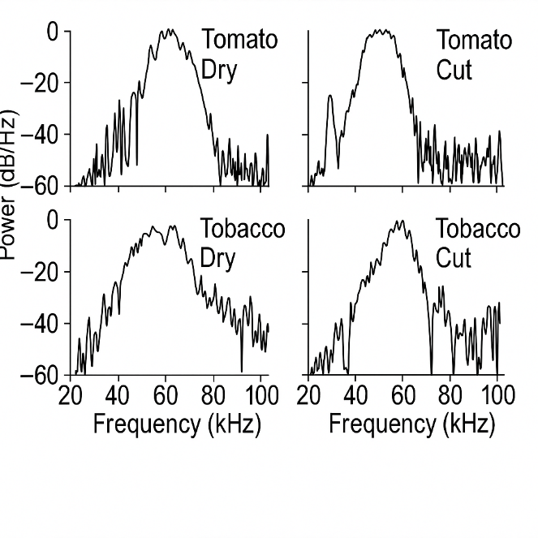

1.4 Perception of Sound in Plants
According to new research, plants can perceive and respond to sound through vibrational sensing, despite lacking ears or other auditory organs like animals. In a seminal study, Gagliano and associates (2017) investigated how the roots of Pisum sativum (pea plants) reacted to the sound of water flowing through subterranean pipes. Surprisingly, roots showed directed development toward the sound source even when there was no moisture. The plants gave the moisture signal precedence over the aural signals when both were present. Nevertheless, when there was no water present, the roots followed the sound gradient, proving that plants are able to sense and respond to low-frequency vibrations of about 200 Hz. Interestingly, root growth's precision toward the sound decreased when background noise was added. This implies that root navigation may be hampered by acoustic interference, such as that caused by ambient noise pollution. These findings support the notion that plants are not inert entities but rather actively engage with their healthy surroundings.
The response of Arabidopsis thaliana to vibrations from herbivore grazing provides further information on plant sound perception (Appel and Cocroft, 2014). Prior to actual insect eating, plants exposed to chewing vibration simulations had increased levels of anthocyanins and glucosinolates, two protective substances crucial for plant tolerance. However, the plants were able to distinguish between vibrations from herbivory and vibrations from innocuous sources, such as insects buzzing or wind. Mechanosensitive ion channels or signal transduction pathways most likely mediate this selectivity, which suggests that plants have an advanced vibrational sensing system.
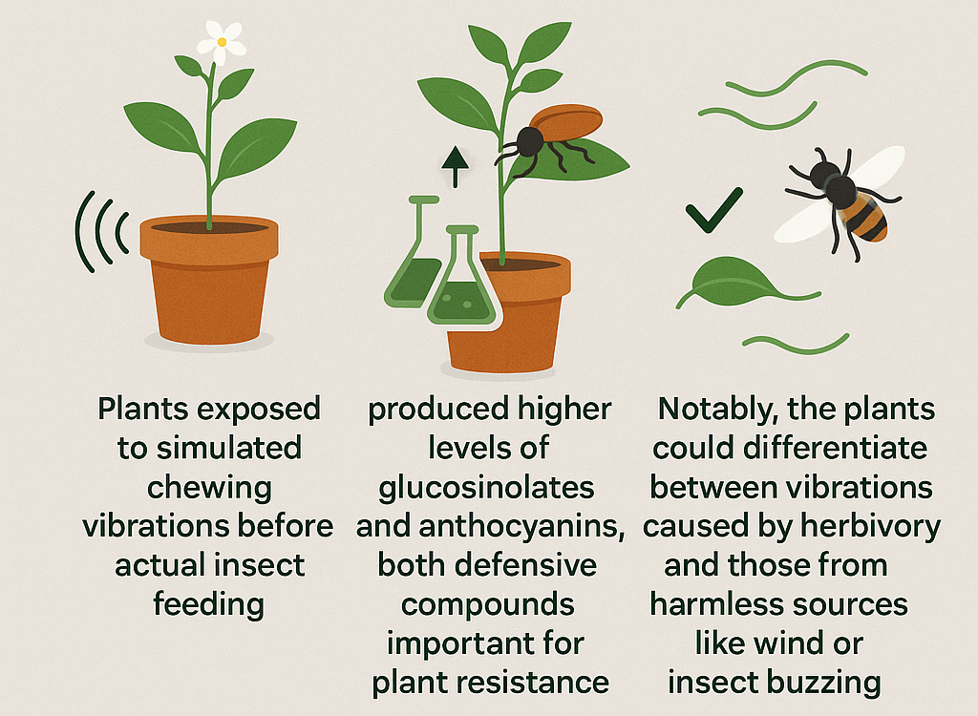
Fig 5: Vibrational Sensing in Plants: Arabidopsis Response to Herbivore Feeding

Veits et al. (2019) found in similar research that the nectar sugar concentration of Oenothera drummondii (evening primrose) flowers increased immediately after they were exposed to bee buzzing. The only frequencies that elicited this response were those that matched the wingbeats of real pollinators (~0.2 to 0.5 kHz), not irrelevant high-frequency disturbances. The petals themselves were found to tremble in reaction to sound using laser vibrometer, indicating that floral components might serve as biological sound sensors. These findings collectively imply that plants possess a type of bioacoustics sensibility. Plants seem to be able to decipher vibrational signals and start the proper reactions, whether they are used to locate water sources, detect herbivores, or react to pollinators. Mechanosensitive channels (like MSLs and MCAs) and downstream hormonal signaling systems like the salicylic acid and jasmonic acid pathways are probably involved in the underlying mechanisms.

1.5 Acoustic Emissions in Plants: Structural Adaptations and Stress Responses
Research on plant bioacoustics has historically focused on how plants hear sound, but new findings show that plants can also actively send out acoustic signals. These emissions are caused by either unique structural adaptations or physiological stress byproducts, especially in the ultrasonic frequency range (usually above 20 kHz). High-sensitivity acoustic sensors and directional microphones can detect these sounds, despite the fact that people cannot hear them. The carnivorous pitcher plant Nepenthes hemsleyana is a remarkable illustration of how plants have adapted for acoustic operation. In order to reflect the ultrasonic frequencies that bats generate, this species has developed a parabolic reflector at the rim of its pitcher. For mutualistic bat species like Kerivoula hardwickii, which use echolocation to find roosting locations in dense tropical woods, this modification improves the plant's visibility. The bats provide nitrogen-rich excrement by defecating inside the plant in exchange for protection. According to Schoner et al. (2015), this mutualism is an example of how acoustic structures can mediate interactions between plants and animals, allowing plants to control sound for their own ecological benefit.
In comparison to almost silent, unstressed controls, quantitative measurements showed that stressed plants produced noticeably more ultrasonic clicks up to 30–40 per hour. It's interesting to note that the frequency and pattern of these sounds changed according to the stress type. With over 70% accuracy, the researchers were able to differentiate between emissions caused by wounding and drought using machine learning techniques. This implies that rather than being random noise, these noises might be carrying particular physiological data about the interior condition of the plant. In terms of the environment, these emissions could be substantial. High-frequency sound is perceptible to some animals, such as insects, rodents, and bats. These species may use these cues to determine the health of plants, either selecting healthier hosts or avoiding stressed ones. Moreover, neighbouring plants might also perceive these sounds and prime their own stress responses, though direct experimental evidence remains limited. If validated, such findings would support the concept of plant–plant communication via airborne acoustic signals. (Khait et al., 2019)

1.6 Applications of Ultrasound in Gene Transfer and Plant Morphogenesis
The ability of ultrasound, a tool more frequently linked to industrial imaging and medical diagnostics, to promote both in vitro morphogenesis and genetic change has attracted a lot of interest in plant biotechnology. This non-invasive physical instrument has become a useful supplement to conventional tissue culture methods, providing new opportunities to enhance plant transformation and regeneration, particularly in species that are thought to be resistant. Agrobacterium tumefaciens inoculation and low-intensity ultrasonic exposure are combined in Sonication-Assisted Agrobacterium-mediated Transformation (SAAT), one of the most promising applications. T-DNA complexes enter host cells more easily during this process because short ultrasonic pulses, known as sonoporation, momentarily damage plant cell walls and membranes.
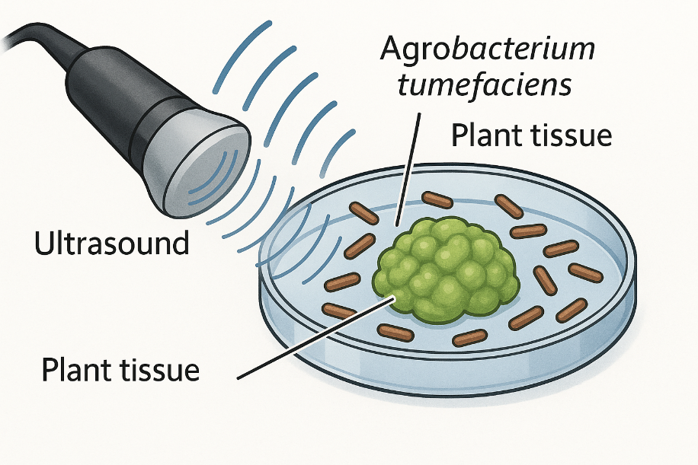

Fig 6: "Sonication-Assisted Agrobacterium-Mediated Transformation (SAAT) in Plant Tissue Culture"

By showing increased transient and stable gene expression in a number of plant species, including gymnosperms (Picea glauca), monocots (Zea mays, Triticum aestivum), and dicots (Glycine max, Vigna unguiculata), Liu et al. (2006) invented this technique. In their tests, they found that in certain tissues, SAAT enhanced the expression of the β-glucuronidase (GUS) reporter gene by more than 100 times. This method has been particularly helpful in converting meristematic tissues, cotyledons, zygotic embryos, and embryogenic calli all of which are frequently inaccessible to conventional Agrobacterium-based procedures. In addition to genetic transformation, ultrasonography has demonstrated the ability to promote organogenesis and somatic embryogenesis, two important processes in plant regeneration. A number of factors, including frequency (usually 20–40 kHz), intensity, exposure time, and explant growth stage, greatly influence how ultrasound affects tissue differentiation. Low-frequency ultrasound can function as a mild abiotic stressor, causing membrane depolarization, cytosolic calcium influx, and oxidative bursts all of which are known to promote embryonic reprogramming and cellular dedifferentiation.
In crops such as rice (Oryza sativa), cotton (Gossypium hirsutum), tobacco (Nicotiana tabacum), and tomatoes (Solanum lycopersicum), ultrasound exposure has been shown in numerous studies to enhance callus induction and shoot/root regeneration. For example, Shekhawat et al. (2015) showed that pretreatment with ultrasound increased shoot proliferation in cotton explants, particularly when paired with the right amounts of auxins and cytokinins. At the molecular level, these regenerative effects are believed to be mediated by the upregulation of important developmental genes involved in organ patterning, somatic embryogenesis, and meristem maintenance, including WUSCHEL (WUS), SHOOT MERISTEMLESS (STM), and LEAFY COTYLEDON (LEC1/LEC2).
Although the precise signalling pathways are still under exploration, there is growing evidence that ultrasound may activate ROS-mediated and MAPK-dependent transcriptional responses that mimic natural wounding or stress cues, thereby enhancing tissue responsiveness. Moreover, ultrasound has also been tested for improving secondary metabolite production in plant cell cultures, as seen in Panax ginseng, Withania somnifera, and Catharanthus roseus, where short ultrasound treatments increased the yield of valuable compounds like ginsenosides and with anolides.

Table 1: Effects of Sound/Ultrasound on Plant Tissue Cultures.

Plant (Genus, Species, Cultivar) | Target Tissue(s) | Equipment & Frequency Used | Growth/Regeneration Medium | Positive Effects
Carrot (Daucus carota L.) | Suspension culture from callus | NS 100-2U (Nihon Seiki Co.); 28 kHz for 2, 5, 10, 20, 40 s; 27°C | MS + 30 mg/L sucrose, 0.5 mg/L 2,4-D; shaker at 27°C | 5% increase in suspension culture at 28 kHz for 2 s
Chrysanthemum (species/cultivar not defined) | Callus | 800, 8,000 Hz, 100 dB, twice daily for 0.5 h over 5 days | MS + 1 mg/L NAA, 1.5 mg/L 2,4-D; 26°C | Sound increased elasticity and viscosity coefficients of plasmamembrane
Rice (Oryza sativa L. 'Nipponbare') | Callus cell culture | NS-2U (Nihon Seiki Co.); 28 kHz for 2–120 s; 25°C | Modified MS + 3% sucrose, 1.2,4-D; shaker at 120 rpm, 25°C | Cell cultures enhanced at 2 and 5 s; cell number ↑ by 14–34.2%, fresh weight ↑ by 28–55.5%
Aloe (Aloe arborescens Mill.) | Suspension culture (leaf-derived callus) | NS-2U (Nihon Seiki Co.); 28 kHz for 2, 5, 10, 30, 60 s | MS + 2% sucrose, 1% mannitol, 2 mg/L 2,4-D, 0.5 mg/L lactalbumin hydrolysate; shaker at 100 rpm, 25°C | 9% more fresh weight after 3 s exposure at 28 kHz
Callus cells (solid medium) | Callus | Digital sonifier S-250D (Branson Ultrasonics); 20 kHz for 2–10 s or 1–10 W (cycle of 10% at 2 W) | MS + 1 mg/L BA, 2 mg/L NAA, 0.9% agar, 3% sucrose; 25°C, 16-h photoperiod | 2 W for 2 s gave 80.7% callus growth (vs. 63.45% control)
Chrysanthemum or Gerbera (?) | Seedling stems | Sound generator; 1,000 Hz, 100 dB for 9 days, 60 min/day | MS + 0.001 mg/L IAA; 26°C | Accelerated callus growth and affected cell cycle: ↑ S-phase cells, ↓ G₀–G₁ cells

According to new research, sound stimuli especially those with regular rhythms and frequencies may have a beneficial effect on plant physiology. Recently, Sharan et al. (2023) investigated how devotional music affected the growth and yield of mung beans (Vigna radiata L.) in order to determine whether acoustics could improve plant development. Under carefully monitored field circumstances, the study was carried out during the kharif agricultural season. For daily periods ranging from one to three hours, mung bean plants were exposed to devotional music with decibel levels between 70 and 100. To guarantee constant exposure, the sound treatments were delivered via speakers placed uniformly throughout the test plots. Light, water, soil, and temperature were all given to the control group in the same way, but they were not given any audio stimuli. Comparing plants exposed to music to untreated controls, the former showed notable improvements in a number of important physiological measures. Significant increases were seen in the following parameters: fresh and dry biomass accumulation, shoot and root lengths, leaf count, seed germination rate, and seedling vigor. The length of the roots increased by over 36%, and the length of the shoots improved by roughly 19%. There was also a more than 30% rise in dry biomass.
More notably, factors linked to yield were improved. Under the ideal exposure condition of 85 ± 5 dB for three hours a day, the number of seeds per plant and the total seed weight rose by more than 130% and 150%, respectively. These results imply that structured sound waves may affect internal plant signaling processes, possibly through the regulation of hormones that promote growth, such as auxin and cytokinin, as well as the production of reactive oxygen species (ROS) and the upregulation of nitrate reductase, both of which are linked to increased metabolic and developmental activity. The study supports the idea that acoustic stimuli, particularly devotional or rhythmic music, can be used as a non-invasive, non-chemical method to increase plant productivity, even though the precise molecular pathways are still being studied. Particularly for low-input agricultural systems looking for environmentally friendly growth boosters, this has encouraging ramifications for sustainable agriculture.
Recent developments in plant acoustics have shown that ultrasonic sound frequencies (>20 kHz), which are above the human hearing threshold, can function as a strong abiotic stimulator, inducing defensive physiological reactions in plants. A noteworthy study by Kim et al. (2015) investigated how sound waves, especially those in the low-kHz and ultrasonic range, can improve disease resistance and drought tolerance in important crop species like spinach (Brassica oleracea), rice (Oryza sativa), and tomatoes (Solanum lycopersicum). In the drought tolerance experiment, rice plants were exposed to sound waves in the 0.8–1.2 kHz range for one hour per day. This was followed by a five-day controlled water restriction period. In comparison to untreated controls, plants subjected to ultrasonic treatments showed noticeably greater RWC and stomatal conductance during drought. Additionally, they showed reduced amounts of hydrogen peroxide (H2O₂), a reactive oxygen species that builds up under oxidative stress, and increased photosynthetic efficiency, as demonstrated by improved Fv/Fm ratios. Better water retention and transpiration management during times of moisture stress are made possible by ultrasound-mediated manipulation of the stomatal aperture, which is probably the cause of the observed benefits. The decreased buildup of H2O₂ in treated plants implies that ultrasound may also activate antioxidant enzyme systems, including catalase (CAT) and superoxide dismutase (SOD), improving the plant's ability to detoxify its cells. The results of other stress-reduction techniques, such as mechanical stimuli that trigger systemic acquired resistance (SAR) or acquired systemic tolerance (AST) through hormonal signaling pathways including abscisic acid (ABA) and jasmonic acid (JA), are echoed by this sonic priming effect.
Additionally, parallel experiments with rice, cabbage, and tomatoes showed that plants treated with ultrasound were more resistant to harmful infections, especially those caused by the prevalent and destructive fungal pathogen Fusarium spp. Before being exposed to pathogens, plants treated with acoustic irradiation showed delayed onset of symptoms, decreased illness incidence, and decreased pathogen colonization. The overexpression of pathogenesis-related (PR) genes, particularly PR1a, a recognized marker gene of the salicylic acid (SA) signaling pathway, which is essential for defense against biotrophic infections, was linked to these effects at the molecular level. The results of Kim et al. (2015) highlight ultrasound's biostimulatory potential as a non-invasive, cost-effective, and environmentally beneficial method of enhancing crop resilience. Through the enhancement of biotic (pathogen) and abiotic (drought) stress responses, ultrasound exposure could be a new tool in sustainable agriculture. It has promising uses since it can create systemic tolerance without the use of chemical treatments, especially in farming areas with limited resources or minimal inputs. These findings also pave the way for precision agriculture, where acoustic treatments and remote sensing technology might be used to enhance stress management and plant health monitoring.
The plant hormone ethylene is the primary regulator of climacteric fruit ripening, including color change, softening, respiration rate, and flavour development in tomatoes (Solanum lycopersicum). A new field of study has investigated how sound waves affect perception and ethylene production, providing a creative postharvest method to increase fruit shelf life without the use of chemical preservatives. Harvested tomatoes were subjected to low-frequency sound waves at 1 kHz for 6 hours in a comprehensive study by Kawakami et al. (2019). The fruits were then kept for 14 days in standard postharvest circumstances. Finding the underlying chemical pathways and determining whether sound waves may slow the ripening process were the goals. The outcome was remarkable. In contrast to less than 50% of the control group, almost 85% of the sound-treated tomatoes were still in the green (unripe) state by the seventh day after treatment. Untreated tomatoes had gone red and softened considerably by day 14, whereas fruits that had been sound-treated showed slower colour shift and delayed softening, which suggested delayed ripening.
Physiological tests showed that the treated fruits had lower respiration rates, less ethylene was produced, and the climacteric ripening phase started later. The potential of sonic energy as a regulatory signal that modifies metabolic activity in postharvest fruit is highlighted by these alterations. Quantitative real-time PCR investigation demonstrated downregulated expression of important genes involved in ethylene production at the molecular level, such as ACO1 (1-aminocyclopropane-1-carboxylic acid oxidase) and ACS2 and ACS4 (which encode 1-aminocyclopropane-1-carboxylic acid synthase). Furthermore, ripening-related transcription factors were inhibited, including E8, NOR (Non-Ripening), and RIN (Ripening Inhibitor). These transcription factors are essential for coordinating the networks of ethylene-mediated genes that produce cell wall degradation proteins, softening enzymes like polygalacturonase, and colour change. According to the study, some frequencies of acoustic energy may influence hormone signaling cascades by altering membrane potential or acting through mechanosensitive channels. Although the exact physiological destinations of sonic energy are still unknown, mechanoperception in plants has been connected to secondary messenger systems, calcium influx, and reactive oxygen species (ROS) signaling all of which can affect transcriptional activity and hormone biosynthesis.
Crucially, this approach has a number of benefits over traditional ripening control techniques like refrigeration or ethylene inhibitors (such 1-MCP), which can be expensive or have an adverse effect on flavour. Sound treatment is a promising method for sustainable postharvest management since it is non-invasive, non-chemical, and eco-friendly. Additionally, it has the potential to be used into cold-chain logistics, particularly for perishable and organic agricultural products. However, more adjustment is required for the response's frequency specificity, exposure length, and crop reliance. Standardizing acoustic methods and examining their impacts on different tomato cultivars as well as other climacteric fruits like papaya, bananas, and mangos should be the goals of future research.

Conclusions and Future Perspectives
Plant bioacoustics, which emphasizes that plants have an extraordinary sensitivity to sound-based environmental cues, has developed from a theoretical idea to a new scientific field. According to recent studies, plants can both create and hear acoustic signals, especially in the ultrasonic and low-frequency ranges, and use them to mediate physiological responses such growth modulation, stress recognition, and defence activation. Although the underlying molecular processes are still unclear, mechanosensitive ion channels like MSLs and MCAs are believed to be essential in translating these vibrational cues into intracellular reactions. Plants have highly tuned, frequency-dependent sensory processes, as evidenced by their capacity to distinguish between vibrational patterns linked to various biotic and abiotic inputs despite lacking specialized auditory organs. Known mechano-transduction pathways, including calcium signaling, reactive oxygen species (ROS), and hormone cascades like ethylene, salicylic acid, and jasmonic acid, seem to be impacted by these reactions. Integrative methods that map gene and protein networks activated by certain auditory stimuli utilizing omics tools, especially transcriptomics and proteomics, would be very helpful in expanding our knowledge in this field.
From a practical aspect, the detection of plant-emitted sounds, such as those associated with xylem cavitation under dry circumstances, provides interesting applications in precision agriculture. Early stress detection may be made possible by acoustic monitoring systems, facilitating prompt management choices and more economical resource use. From an ecological perspective, the possibility that plants could interact acoustically with nearby plants or animals points to a wider range of interspecies communication than was previously recognized. There are still a number of obstacles to overcome, such as figuring out the ecological significance of sound perception in natural settings and differentiating genuine acoustic reactions from general mechanical perturbations. Research that crosses the boundaries of plant physiology, molecular biology, physics, and agricultural engineering is necessary to fill these gaps. In conclusion, plant bioacoustics adds a new perspective to our knowledge of interactions between plants and their surroundings. Deciphering the "acoustic language" of plants has enormous potential for developing sustainable agricultural and ecosystem management advances in addition to enhancing basic plant research.

References:
Appel HM, Cocroft RB. Plants respond to leaf vibrations caused by insect herbivore chewing. Oecologia. 2014;175(4):1257–66.
Baluška F, Mancuso S. Deep evolutionary origins of neurobiology in plants. Commun Integr Biol. 2009;2(1):60–5.
Bhatia P, Joshi H, Sood A, Sharma M. Sonication: A versatile technique in plant tissue culture and genetic engineering. J Plant Biochem Biotechnol. 2019;28(3):361–73.
Bose JC. The nervous mechanism of plants. London: Longmans, Green and Co.; 1926.
Chivukula V, Ramaswamy N. Effect of different sound waves on the germination, growth and development of Phaseolus vulgaris. Int J Environ Sci Dev. 2014;5(5):431–4.
Gagliano M, Grimonprez M, Depczynski M, Renton M. Tuned in: Plant roots use sound to locate water. Oecologia. 2017;184(1):151–60.
Gagliano M, Mancuso S, Robert D. Towards understanding plant bioacoustics. Trends Plant Sci. 2012;17(6):323–5.
Hassanien RHE, Hou TZ, Li YF, Li BM. Advances in effects of sound waves on plants. Plant Signal Behav. 2014;9(2):e27940.
Jeong MJ, Shim CK, Lee JO, Kwon TR, Kim YH, Lee SK, et al. Sound frequencies induce drought tolerance in rice plant. Mol Breed. 2008;21(2):217–26.
Jeong MJ, Cho JI, Park SH, Kim KH, Lee SK, Kwon TR, et al. Sound frequencies induce drought tolerance in rice plant. Pak J Bot. 2014;46:2015–20.
Kawakami D, Yoshida T, Kanemaru Y, Zaquinaula MHH, Mizukami T, Arimoto M, et al. Induction of resistance to diseases in plant by aerial ultrasound irradiation. J Pestic Sci. 2019;44(1):41–7.
Khait I, Sharon R, Perelman R, Boonman A, Yovel Y, Hadany L. Plants emit remotely detectable ultrasounds that can reveal plant stress. bioRxiv. 2019. https://doi.org/10.1101/507590
Khait I, Sharon R, Perelman R, Boonman A, Yovel Y, Hadany L. Plants emit remotely detectable ultrasounds that reveal stress. Cell. 2019;179(6):1295–1303.e7.
Kim JY, Lee JS, Kwon TR, Lee SI, Kim JA, Lee GM, et al. Sound waves delay tomato fruit ripening by negatively regulating ethylene biosynthesis and signaling genes. Postharvest Biol Technol. 2015;110:43–50.
Liu CM, Xie WY, Li XL. Sonication-assisted Agrobacterium-mediated transformation: An efficient method for genetic transformation of recalcitrant plants. Plant Cell Rep. 2006;25(2):109–14.
Liu Y, Luo D, Wu W, Zhang H, Li G. Ultrasound: Mechanical gene transfer into plant cells by sonoporation. Biotechnol Adv. 2006;24(1):1.
Mishra RC, Ghosh R, Bae H. Plant acoustics: Involvement of sound in stress tolerance and growth regulation. Trends Plant Sci. 2022;27(1):60–75.
Monshausen GB, Haswell ES. A force of nature: Molecular mechanisms of mechanoperception in plants. J Exp Bot. 2013;64(15):4663–80.
Schöner MG, Schöner CR, Kerth G, Simon R, Grafe TU. Ultrasound-reflecting surfaces in a pitcher plant: Echolocation-based mutualism with bats. Curr Biol. 2015;25(7):851–5.
Schöner MG, Schöner CR, Simon R, Grafe TU, Puechmaille SJ, Ji LL, et al. Bats are acoustically attracted to mutualistic carnivorous plants. Curr Biol. 2015;25(14):1911–6.
Sharan SY, Goswami S, Ghosh PK, Barik LK, Saw RK. A novel approach to supplement plant growth with devotional music: An experimental research on mung bean (Vigna radiata L.). J Sound Vib Stud Agric. 2023. Advance online publication.
Shekhawat MS, Manokari M, Ravindran CP. Ultrasound-assisted in vitro regeneration and genetic transformation in cotton (Gossypium hirsutum). Biol Plant. 2015;59(2):301–8.
Singh S, Saran PL, Singh AK, Yadav V, Kumar A. Ultrasound as an emerging tool in plant biotechnology: Mechanistic insights and future directions. Plant Cell Biotechnol Mol Biol. 2022;23(1–2):75–89.
Subramanian S, Yadav SK. Sonication enhances callus induction and shoot regeneration in rice. Plant Biotechnol Rep. 2014;8(1):41–9.
Thelwall PE, Fraser G, McKenzie J, Flowers TJ. Plant–pollinator interaction through acoustic signals. Plant Ecol. 2022;223(3):399–408.
Trewavas A. Plant intelligence. Naturwissenschaften. 2005;92(9):401–13.
Tyree MT, Sperry JS. Vulnerability of xylem to cavitation and embolism. Annu Rev Plant Physiol Plant Mol Biol. 1989;40(1):19–36.
Veits M, Khait I, Obolski U, Zinger E, Boonman A, Goldshtein A, et al. Flowers respond to pollinator sound within minutes by increasing nectar sugar concentration. Ecol Lett. 2019;22(9):1483–92.
Zhang M, Wang Y, Chen X, Xu J, Li L, Liu B. Sonication-assisted Agrobacterium-mediated transformation. Biotechnol Adv. 2012;30(4):586–93.

