Priming Technologies as a Strategy to Improve Productive Efficiency in Carrots

Abstract: This study evaluated priming techniques - including hydropriming, biopriming, and halopriming - to enhance germination and uniform seedling emergence in seeds of the carrot cultivar Altiplano. In laboratory experiments conducted under a completely randomized design, the most effective treatments were identified as hydropriming (24-48 hours of soaking) and halopriming with KNO₃ (3-15% for 24-48 hours) and NaCl (3-10% for 24-36 hours). These treatments were subsequently tested under field conditions using a randomized complete block design with four replications. Halopriming with 3% KNO₃ for 36 hours proved to be the most effective, resulting in significantly higher values for seedling growth rate (58.33 mm at 30 days), emergence percentage (95.33%), and seedling vigor index (213.07). These findings indicate that halopriming with KNO₃ is a highly effective technique and represents a promising strategy for improving carrot crop establishment.

Keywords: biopriming, halopriming, hydropriming, seed priming, Trichoderma, Daucus carota.

Introduction
Carrot (Daucus carota L.) is one of the most widely cultivated root vegetables worldwide. However, its production is significantly affected by abiotic stress, which reduces yields and primarily impairs seed germination and seedling establishment (Pawar et al., 2018; Que et al., 2019; Paparella et al., 2024).
To mitigate these effects, seed priming - a straightforward technique involving controlled hydration that activates physiological and biochemical processes prior to germination, without triggering radicle protrusion - has been shown to enhance germination rates and promote uniform seedling emergence (Khan et al., 2005; Paparella et al., 2015; Singh et al., 2015; Muhie et al., 2021). Moreover, priming induces tolerance to abiotic stresses through the stimulation of pre-germinative metabolic pathways (Ibrahim, 2016). For instance, primed carrot seeds can reach up to 98% germination within nine days at temperatures ranging from 20 °C to 35 °C (Nascimento et al., 2013).
Several seed priming methods have been developed, including, hydropriming [which activates metabolic processes via controlled water imbibition (Pedrini et al., 2020; Ermis et al., 2021)]; halopriming [which involves soaking seeds in inorganic salt solutions to induce stress resistance (El-Sanatawy et al., 2015; Biswas et al., 2023)] and biopriming [which employs beneficial microorganisms such as plant growth-promoting bacteria and fungi to enhance stress tolerance (Prasad et al., 2016; Forti et al., 2020; Deshmukh et al., 2020)]. These approaches are considered key strategies for optimizing crop performance under stress-prone conditions (Ashraf and Foolad, 2005; Lutts et al., 2016).
Thus, the objective of this study was to evaluate and compare the effectiveness of three seed‑priming techniques - hydropriming, halopriming (using NaCl and KNO₃), and biopriming (with Trichoderma sp.) - on germination performance and early seedling establishment of carrot under both laboratory and field conditions.

Materials and Methods

Study area, variety and evaluated variables

The study was conducted at the facilities of the Centro Nacional de Producción de Semillas de Hortalizas (CNPSH), located in Villa Montenegro, Cochabamba, Bolivia. The plant genetic material used consisted of carrot seeds of the Altiplano variety (Valle de Oro brand), Chantenay type. This variety has an average root length of 12 to 15 cm, a crop cycle of 120 days in valleys and 180 days in high plateaus, and an average yield of 35 to 45 t ha⁻¹. The study was developed in in the laboratory and field.
In the laboratory phase, the following response variables were evaluated: root protrusion (50 and 100% of seeds had protruded), germination (50 and 100% of viable seeds had germinated), germination rate index, total germination percentage, seedling length, and seedling vigor index. In the field phase, the variables assessed were: emergence rate index, total emergence percentage, seedling length, and seedling vigor index (AOSA, 1990; Maguire, 1968).
The laboratory experiment was conducted using a completely randomized design (CRD), while the field experiment (17°26’26.58”S, 66°20’37.97”W; 2550 m a.s.l.) followed a randomized complete block design (CRBD) with four replications. Three seed priming methods - hydropriming, halopriming, and biopriming - were evaluated using certified carrot seeds. Prior to the experiments, seed moisture content and initial germination percentage were determined.

Experimental procedure laboratory and field phases

Hydropriming
For each replicate, 0.6 g of carrot seeds were weighed using a digital analytical balance (ME 104, precision 0.10 mg) and placed in 50 mL beakers containing 20 mL of distilled water. The treatments consisted of five immersion durations (24, 36, 48, 60, and 72 hours), along with a control (no treatment). After immersion, the seeds were shade-dried for 48 hours. Fifty seeds per treatment were randomly selected and sown in Petri dishes lined with moistened absorbent paper. Response variables were evaluated daily under controlled laboratory conditions. Each experimental unit consisted of one Petri dish containing 50 carrot seeds, including those subjected to hydropriming and the control.
Simultaneously, for the field phase, 100 seeds were randomly selected for each hydropriming treatment and sown according to the experimental design in a CNPSH field plot. Each experimental unit comprised four 1.00-meter-long furrows, spaced 0.1 meters apart, with 25 seeds sown at 5 cm intervals in each furrow. This resulted in a seeding density of 200 seeds/m², covering a total area of 0.50 m² per treatment. The response variables were evaluated under field conditions.

Biopriming
Hydropriming experimental protocol was applied until the seed dried. Subsequently, 50 seeds per treatment were randomly selected and inoculated with Trichoderma sp. and sown in Petri dishes with moistened absorbent paper. Response variables were evaluated daily under laboratory conditions. The experimental unit consisted of a Petri dish containing 50 treated carrot seeds, including both the biopriming and control treatments.
In parallel, for the field phase, 100 seeds were randomly selected for each biopriming treatment and sown according to the experimental design in a CNPSH plot. Each experimental unit consisted of four 1 m long furrows, spaced 0.10 m apart, with 25 seeds sown at 5 cm intervals in each furrow. This represented a sowing density of 200 seeds m⁻², occupying a total area of 0.5 m² per treatment. Response variables were evaluated under field conditions.

Halopriming
For each replicate, 0.60 ± 0.01 g of carrot seeds were weighed using a digital analytical balance (ME104, precision: 0.10 mg) and placed in 50 mL beakers. To each beaker, 20 mL of a sodium chloride (NaCl) solution was added at one of four concentrations (3, 5, 10, and 15% w/v), with immersion periods of 24, 36, 48, and 72 hours, along with a control treatment (no solution). After immersion, the seeds were rinsed with distilled water and shade-dried for 48 hours.
Next, 50 seeds from each treatment were randomly selected and sown in Petri dishes containing moistened absorbent paper. Response variables were evaluated daily under laboratory conditions. The experimental unit consisted of one Petri dish containing 50 treated carrot seeds, including both the halopriming treatments with sodium chloride and the untreated control.In the field phase, 100 seeds from each sodium chloride halopriming treatment were randomly selected and sown according to the experimental design in a CNPSH plot.
Each experimental unit consisted of four furrows, each 1 m long and spaced 0.10 m apart, with 25 seeds sown at 5 cm intervals per furrow - resulting in a sowing density of 200 seeds m⁻² and a total area of 0.5 m² per treatment. Response variables were evaluated under field conditions.
The same experimental protocol described above was applied, maintaining the concentrations (3, 5, 10 and 15% w/v) and immersion times (24, 36, 48 and 72 hours), but replacing NaCl with potassium nitrate (KNO₃) as a halopriming agent.

Statistical analysis

Statistical analyses were performed using R software (version 4.4.3) and included the following: (1) validation of statistical assumptions (using the car package), (2) analysis of variance (ANOVA) followed by Tukey’s post-hoc test (p ≤ 0.05; Agricolae package), (3) permutation tests with 10,000 replicates (coin package), along with calculations of the coefficient of variation (CV) and coefficient of determination (R²) to evaluate experimental precision and model fit.

Results and Discussion

Laboratory phase

ANOVA for hydropriming revealed significant differences (p ≤ 0.05) in the response variables: 50 and 100% root protrusion, total germination percentage, and plant vigor index. No significant differences (p > 0.05) were observed for the other variables evaluated during the laboratory phase (Table 1).

Table 1. Analysis of statistical significance (ANOVA) for the effects of priming techniques on response variables under laboratory conditions.
Priming Technique | Source of Variation | 50%  protrusion | 100%  protrusion | 50%  germin. | 100%  germin. | Germin. speed | Germin.  (%) | Seedling  length | Seedling  vigor
Hydropriming | Immersion time (IT) | ** | * | NS | NS | NS | ** | NS | **
Biopriming | IT | NS | NS | ** | ** | ** | NS | NS | NS
Halopriming (NaCl) | Concentration | ** | ** | ** | ** | ** | NS | * | **
Halopriming (NaCl) | IT | NS | ** | ** | NS | ** | * | NS | NS
Halopriming (NaCl) | Concentration × IT | ** | ** | ** | NS | ** | NS | NS | NS
Halopriming (KNO₃) | Concentration | ** | ** | NS | ** | ** | ** | NS | **
Halopriming (KNO₃) | IT | ** | ** | ** | ** | ** | NS | NS | NS
Halopriming (KNO₃) | Concentration × IT | ** | ** | ** | NS | ** | ** | NS | **
50% protrusion: carrot root protrusion on 50% of the seeds. 100% protrusion: carrot root protrusion on 100% of the seeds. 50% germin.: germination of 50% of viable seeds had germinated. 100% germin.: germination of 50% of viable seeds had germinated. Germin. speed: daily average germination counted over a period. Germin. (%): percentage of seed germination. Seedling length: measured from the root tip to the shoot apex. Seedling vigor: mean seedling length × germination.
Significance levels: at 0.01 = ‘**’, and at 0.05 = ‘*’. NS: not significant.

Hydropriming (24 hours) significantly reduced (p ≤ 0.05) the time for carrot seeds to reach 50% root protrusion (3-4 days vs. 6 days for the control), being the most efficient. Likewise, it recorded the shortest time for seeds to reach 100% root protrusion (7 days), significantly lower (p ≤ 0.05) than 72-hour immersion, but without statistical differences (p > 0.05) with 36- and 48-hour immersions or with the control. The reduction in time to root protrusion with hydropriming (24 hours) agrees with Ortiz et al. (2018), although the response varies between species. Optimization is key, since prolonged seed immersion inhibits germination (Pérez et al., 2016; Ermis et al., 2021).
At 20 days after sowing, the germination (%) for the hydropriming treatments (24, 36, and 48 hours) and the control was significantly higher than that of the 72-hour hydropriming treatment. The 24-hour hydropriming treatment showed the highest germination rate, with 66% of seeds germinated. These results contrast with those reported for Momordica charantia by Adhikari et al. (2021), in which hydropriming consistently enhanced germination by increasing water uptake and enzyme activation, indicating a species-specific response.
Regarding the seedling vigor index, the 24- and 48-hour hydropriming treatments were significantly superior to the 72-hour treatment (94.50) and the control (285), with the 24-hour treatment achieving the highest vigor index of 407 (Figure 1). These findings suggest that hydropriming carrot seeds for shorter durations (24-48 hours) enhances seedling vigor, while extended soaking (72 hours) may reduce vigor.

Figure 1. Comparison of means (Tukey test α = 0.05) of hydropriming treatments for the seedling vigor index response variable in the laboratory.
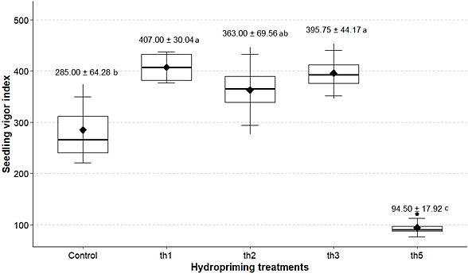
th1: 24-hour immersion in water, th2: 36-hour immersion in water, th3: 48-hour immersion in water, th4: 60-hour immersion in water, th5: 72-hour immersion in water.

The ANOVA for biopriming revealed significant differences (p ≤ 0.05) for the response variables: 50 and 100% germination, and the germination rate index. No significant differences (p > 0.05) were found for the other variables evaluated during the laboratory phase (Table 1).
Biopriming treatments with Trichoderma sp. inoculation (24 and 48 hours of water immersion) and the control significantly reduced (p ≤ 0.05) the time required to reach 50% germination in seeds of the carrot variety Altiplano (9 days), suggesting that fungal inoculation promotes germination, possibly through the production of growth-promoting metabolites. These findings are consistent with those reported by Santana et al. (2016) in tomato, where Trichoderma sp. enhanced germination by stimulating enzymatic activity and mobilizing seed reserves.
The biopriming treatment with 24 hours of water immersion recorded the shortest time to reach 100% germination (10 days), significantly (p ≤ 0.05) lower than all other treatments and the control. The biopriming treatment with 48 hours of immersion and the control showed the highest seedling emergence speed indices (5.62 and 5.68), significantly higher (p ≤ 0.05) than the 24-hour biopriming treatment, but statistically similar to the 36-hour and 72-hour biopriming treatments (Figure 2). These results are in agreement with those reported by Faria et al. (2003) in cotton seeds, where T. harzianum also improved the ESI.

Figure 2. Comparison of means (Tukey test α = 0.05) of biopriming treatments for the response variable germination speed index in the laboratory.
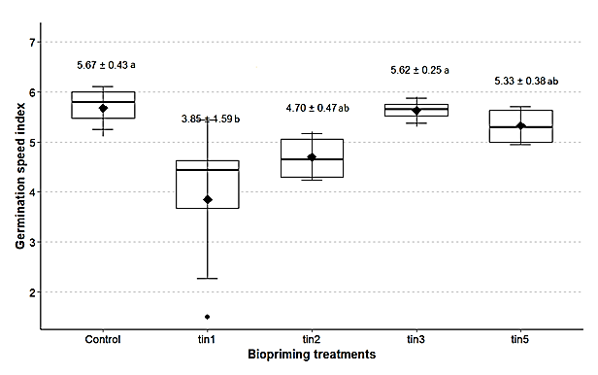
tin1: immersion for 24 hours in water and inoculated with Trichoderma sp., tin2: immersion for 36 hours in water and inoculated with Trichoderma sp., tin3: immersion for 48 hours in water and inoculated with Trichoderma sp., tin5: immersion for 72 hours in water and inoculated with Trichoderma sp.

The ANOVA for halopriming (NaCl) showed significant differences (p ≤ 0.05) for the interaction (concentration NaCl × immersion time) for the response variables 50 and 100% root protrusion, 50% germination and germination speed index. No significant differences (p > 0.05) were observed for the other variables evaluated in the laboratory phase (Table 1).
Halopriming treatments with 24 and 36 hours of immersion in 10% NaCl, 24 hours in 5% NaCl and 48 hours in 15% NaCl recorded the shortest times until 50% seed protrusion under laboratory conditions, with averages of 2.75, 3.00, 3.25 and 3.50 days, respectively, being lower compared to the other treatments evaluated (Figure 3a). In contrast, Killian et al. (2005) reported an adverse effect when pre-soaking carrot seeds in KCl (540 mM) and NaCl (340 mM) solutions, observing a lower percentage of emergence under saline conditions. For their part, Manjavachi et al. (2020) noted that, in parsley seeds, priming treatments with NaCl at 1 and 1.50 MPa for 6 days reduced the number of days to 50% root protrusion.

Figure 3. Interaction of NaCl concentration × immersion time for the response variables (a) 50% root protrusion (days), (b) 100% root protrusion (days), (c) 50% germination (days), and (d) laboratory emergence speed index.
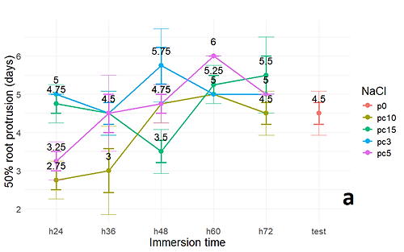
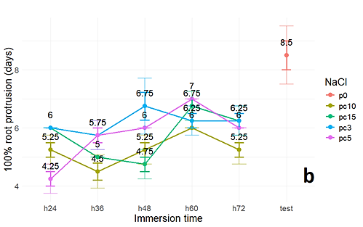
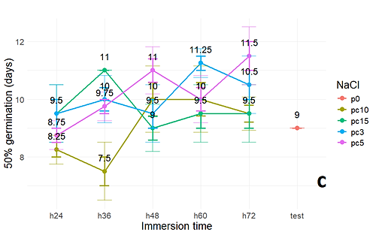
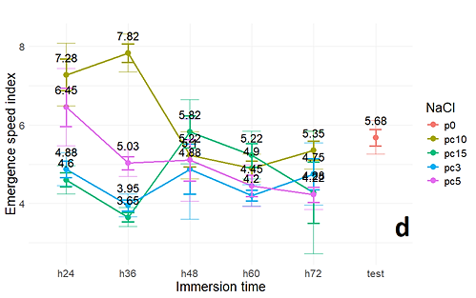
h24: 24-hour immersion, h36: 36-hour immersion, h48: 48-hour immersion, h60: 60-hour immersion, h72: 72-hour immersion. Pc10: 10% NaCl concentration, Pc15: 15% NaCl concentration, Pc3: 3% NaCl concentration, Pc5: 5% NaCl concentration. test: control.

Halopriming treatments involving 36 hours of immersion in 10 and 15% NaCl, 24 hours in 5% NaCl, and 48 hours in 15% NaCl resulted in the shortest times to reach 100% seed protrusion under laboratory conditions, with averages of 4.50, 5.00, 4.25, and 4.70 days, respectively. These values were lower compared to the other treatments evaluated (Figure 3b). In this context, Cayuela et al. (1996), in a pre-germination study using NaCl on tomato seeds, reported a reduction in emergence time with sodium chloride treatments, without significantly affecting the final emergence percentage.
Halopriming treatments with 36 and 24 hours of immersion in 10% NaCl also resulted in shorter times to reach 50% germination under laboratory conditions, with averages of 7.50 and 8.25 days, respectively - both lower than those observed in the other treatments (Figure 3c). However, Sánchez et al. (1997) reported that sodium chloride treatment did not promote germination in cucumber, attributing this outcome to the osmotic properties of the solution rather than its chemical composition.
Halopriming treatments with 36 and 24 hours of immersion in 10% NaCl showed the highest seed germination speed indices under laboratory conditions, with averages of 7.82 and 7.28, respectively - higher than those recorded for the other treatments (Figure 3d). The reduction in germination speed index observed in other NaCl treatments may be attributed to the decreased osmotic potential of the solution, which limits water availability to the seed and hinders key physiological processes such as cell division, elongation, and the mobilization of reserves essential for germination (Mortele et al., 2008).
The ANOVA for halopriming with KNO₃ revealed significant differences (p ≤ 0.05) for the interaction between KNO₃ concentration and immersion time in relation to the response variables: 50 and 100% root protrusion, 50% germination, germination speed index, total emergence percentage, and seedling vigor index. No significant differences (p > 0.05) were observed for the other variables evaluated during the laboratory phase (Table 1).
Halopriming treatments consisting of 24 hours of immersion in 10% KNO₃, 36 hours in 3% KNO₃, and 48 hours in 15% KNO₃ resulted in the shortest times to reach 50% root protrusion under laboratory conditions, with averages of 2.00, 2.00, and 2.25 days, respectively - values lower than those observed in the other treatments (Figure 4a). These results suggest that moderate KNO₃ concentrations (< 15%) combined with immersion times of up to 48 hours optimize root protrusion. These findings are consistent with those reported by Méndez Flores (2014) for Beaucarnea gracilis, where KNO₃ concentrations of 5-10 atm improved both germination speed and percentage.

Figure 4. Interaction of concentration KNO₃ × immersion time for the response variables: a) 50% root protrusion (days), b) 100% root protrusion (days), c) 50% germination (days), d) germination speed index, e) total germination percentage and f) seedling vigor index in the laboratory.
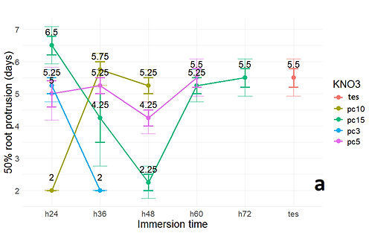
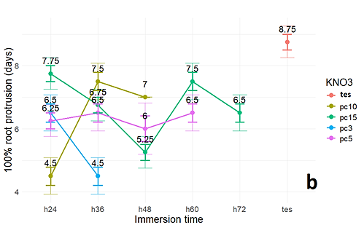
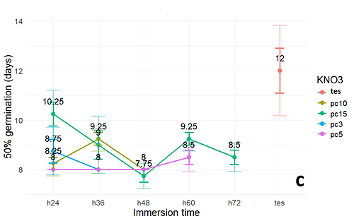
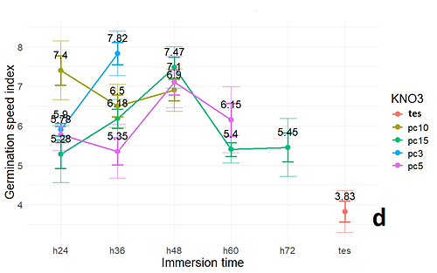
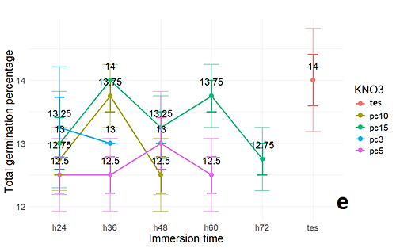
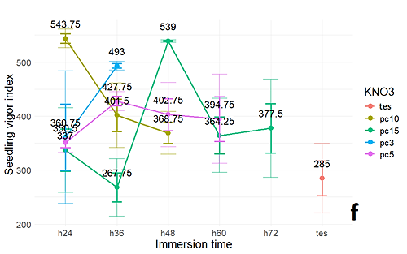
h24: 24-hour immersion, h36: 36-hour immersion, h48: 48-hour immersion, h60: 60-hour immersion, h72: 72-hour immersion. Pc10: 10% KNO₃ concentration, Pc15: 15% KNO₃ concentration, Pc3: 3% KNO₃ concentration , Pc5: 5% NaCl concentration. tes: control.

Halopriming treatments involving 24 hours of immersion in 10% KNO₃, 36 hours in 3% KNO₃, and 48 hours in 15% KNO₃ resulted in the shortest times to reach 100% seed protrusion under laboratory conditions, with averages of 4.50, 4.50, and 5.25 days, respectively - shorter than those observed in the other treatments evaluated (Figure 4b). This suggests that moderate KNO₃ concentrations (< 15%) and immersion durations ≤ 48 hours optimize radicle protrusion. However, these findings contrast with those of Garruña et al. (2014) in Capsicum chinense, where KNO₃ negatively affected germination, possibly due to suboptimal water availability. Such discrepancies may be attributed to differences in methodology, concentration, KNO₃ purity, or species-specific sensitivity.
Halopriming treatments with 48 hours of immersion in 15% KNO₃ and 24, 36, and 48 hours in 5% KNO₃ resulted in the shortest times to reach 50% seed germination under laboratory conditions, with averages of 7.75, 8.00, 8.00, 8.00, and 8.00 days, respectively - lower than those of the other treatments evaluated (Figure 4c). These results confirm that KNO₃ accelerates germination, consistent with the findings of Muhammad et al. (2020) in tomato, where 0.75% concentrations enhanced emergence rates. However, the variation in effective concentrations (5-15% vs. 0.75%) suggests that optimal responses may be species-dependent.
Halopriming treatments consisting of 36 hours of immersion in 3% KNO₃, 48 hours in 5 and 15% KNO₃, and 24 hours in 10% KNO₃ resulted in the highest seed germination speed indices under laboratory conditions, with averages of 7.82, 7.10, 7.47, and 7.40, respectively - surpassing those of the other treatments evaluated (Figure 4d). These findings indicate that immersion durations ≤ 48 hours with KNO₃ enhance germination speed. This is in agreement with Reolon et al. (2013), who reported increased emergence speed in rice using 0.2 M KNO₃ for 24-48 hours, suggesting that longer durations may be detrimental.
Halopriming treatments with 24 hours of immersion in 10% KNO₃, 48 hours in 15% KNO₃, and 36 hours in 3% KNO₃ yielded the highest germination percentages under laboratory conditions, with averages of 80.75%, 79.25%, and 75.00%, respectively - higher than those observed in the other treatments evaluated (Figure 4e). Similarly, halopriming treatments with 24 hours of immersion in 10% KNO₃, 48 hours in 15% KNO₃, and 36 hours in 3% KNO₃ resulted in the highest seedling vigor indices under laboratory conditions, with averages of 543.75, 539.00, and 493.00, respectively - again outperforming the other treatments evaluated (Figure 4f). These findings confirm that KNO₃ enhances seedling vigor, consistent with reports by Batool et al. (2015) in Brassica oleracea var. capitata and Steiner et al. (2018) in wheat, where halopriming with potassium nitrate also improved this parameter.

Field phase

For the field evaluation, the treatments that showed the best laboratory performance compared to the control were selected: hydropriming (immersion for 24-48 hours), halopriming with KNO₃ (3% for 36 hours, 10% for 24 hours, and 15% for 48 hours), halopriming with NaCl (10% for 36 hours, 3% for 24 hours, and 5% for 24 hours), and a control (no treatment). ANOVA revealed significant differences (p ≤ 0.05) among the treatments for the response variables: growth rate index, total emergence percentage, seedling height, and seedling vigor index (Table 2).

Table 2. Analysis of variance for response variables evaluated in the field.
Source of variation | Growth  velocity index | Total emergency  (%) | Seedling  height | Seedling  vigor index
Treatment | < 2e⁻¹⁶** | < 2.22e⁻¹⁶** | < 2e⁻¹⁶** | < 2e⁻¹⁶**
Block | 0.0699^{NS} | 0.3200^{NS} | 0.0460* | 0.2970^{NS}
Significance levels: at 0.01 = ‘**’, and at 0.05 = ‘*’. NS: not significant.

Treatments T2 (2.55 cm), T3 (2.44 cm), and T1 (2.42 cm) recorded the greatest seedling heights at 20 days, showing significant differences (p ≤ 0.05) compared to the other treatments. However, these same treatments exhibited emergence percentages below 60% (Table 3), suggesting that the increased height may be attributed to the lower density of emerged seedlings, likely due to reduced competition for light and nutrients.

Table 3. Means (± SD) of growth speed index, emergence percentage, seedling height and vigor in seedlings of different carrot priming treatments under field conditions.
Treatments | Growth Speed Index | Total Emergency  (%) | Seedling height  (cm) | Seedling vigor index
Hydropriming (24 hours) | 35.24 ± 0.23^{g} | 59.33 ± 0.20^{f} | 2.42 ± 0.01^{b} | 143.29 ± 0.77e
Hydropriming (48 hours) | 27.17 ± 0.31^{h} | 40.83 ± 0.64^{h} | 2.55 ± 0.64ª | 104.02 ± 1.70^{g}
Control | 25.15 ± 0.75^{h} | 39.65 ± 1.01^{h} | 2.17 ± 0.01^{f} | 102.55 ± 1.71^{g}
Halopriming KNO₃ (10%, 24h) | 35.88 ± 0.03^{f} | 56.67 ± 0.50^{g} | 2.44 ± 0.01^{b} | 137.98 ± 0.33^{f}
Halopriming KNO₃ (15%, 48h) | 41.54 ± 0.22^{d} | 69.33 ± 0.31^{d} | 2.33 ± 0.02^{d} | 161.55 ± 1.50^{d}
Halopriming KNO₃ (3%, 36h) | 58.33 ± 0.18ª | 95.33 ± 0.15ª | 2.24 ± 0.01e | 213.07 ± 1.23ª
Halopriming NaCl (10%, 36h) | 51.37 ± 0.25^{b} | 84.50 ± 0.64^{b} | 2.08 ± 0.03^{g} | 175.76 ± 3.08^{b}
Halopriming NaCl (3%, 24h) | 40.26 ± 0.31e | 67.67 ± 0.86e | 2.36 ± 0.01^{c} | 159.35 ± 2.04^{d}
Halopriming NaCl (5%, 24h) | 44.63 ± 0.10^{c} | 76.00 ± 0.54^{c} | 2.16 ± 0.01^{f} | 164.73 ± 1.84^{c}
Means in the same column followed by the same letters do not show significant differences according to the Tukey test (p ≤ 0.05).

Treatment T5, with an growth speed index of 58.33, total emergency of 95.33%, and seed vigor index of 213.07, showed significant differences (p ≤ 0.05) compared to the other treatments (Table 3), standing out as the most effective under field conditions. These results align with previous studies indicating that seed priming - particularly with KNO₃ - enhances germination, growth, and seedling vigor when compared to NaCl, possibly due to its role in the early activation of metabolic processes (Mamun et al., 2018; Nawaz et al., 2018).
Halopriming with KNO₃ (3% for 36 hours) proves to be an effective technique for improving germination, emergence, and seedling vigor in the Altiplano carrot variety, contributing to better crop establishment under field conditions. These findings are consistent with those reported by Tania et al. (2020), confirming that this approach represents a promising strategy for horticultural production.

Conclusions

The treatments that showed the best performance in the laboratory compared to the control were hydropriming (immersion for 24-48 hours), halopriming with KNO₃ (3% for 36 hours, 10% for 24 hours, and 15% for 48 hours), and halopriming with NaCl (10% for 36 hours, 3% for 24 hours, and 5% for 24 hours).
Treatments: hydropriming for 48 hours, halopriming with 10% KNO₃ for 24 hours, and hydropriming for 24 hours resulted in the greatest seedling heights (2.55 cm, 2.44 cm, and 2.42 cm, respectively), despite exhibiting low emergence rates (< 60%). This suggests that the increased growth may be attributed to reduced competition for resources.
In contrast, the halopriming with 3% KNO₃ for 36 hours emerged as the most effective overall treatment, achieving the highest values for seedling vigor index (58.33 mm in 30 days), total emergence percentage (95.33%), and plant vigor index (213.07), thus proving to be the most suitable option for the establishment of Altiplano carrot seedlings under field conditions.

Disclaimer (artificial intelligence)

Author(s) hereby declare that generative AI technologies such as Large Language Models, etc. have been used during the writing or editing of manuscripts. This explanation will include the name, version, model, and source of the generative AI technology and as well as all input prompts provided to the generative AI technology.
Details of the AI usage: The linguistic improvement of the manuscript was carried out with the assistance of the ChatGPT tool (GPT-4, OpenAI), used solely for style and language corrections, without any alteration to the technical or scientific content of the present study.

References

Adhikari B, Dhital PR, Ranabhat S, & Poudel H (2021) Effect of seed hydropriming durations on germination and seedling growth of bitter gourd (Momordica charantia). PLoS ONE 16(8): E0255258. https://doi.org/10.1371/journal.pone.0255258
Ashraf, M. & Foolad, M. (2005). Pre ‐ Sowing Seed Treatment A Shotgun Approach to Improve Germination, Plant Growth, and Crop Yield Under Saline and Non ‐ Saline Conditions. Advances in Agronomy, Academic Press. (88) 223-271. https://doi.org/10.1016/S0065-2113(05)88006-X
Association of Official Seed Analysts (AOSA). (1990). Rules for testing seeds. J. Seed Technol. 12: 1-112. https://www.seedtest.org/en/publications/international-rules-seed-testing.html
Batool, A., Ziaf, K., & Amjad, M. (2015). Effect of halo-priming on germination and vigor index of cabbage (Brassica oleracea var. capitata). Journal of environmental and Agricultural Sciences, 2(7), 1-8. http://jeas.agropublishers.com/wp-content/uploads/2017/09/Article-7.pdf
Biswas, S., Seal, P., Majumder, B., & Biswas, A.K. (2023). Efficacy of seed priming strategies for enhancing salinity tolerance in plants: An overview of the progress and achievements. Plant Stress, 9, 100186. https://doi.org/10.1016/j.stress.2023.100186
Cayuela E., Perez, F., Caro, M. & Bolarín, M. (1996). Priming of seeds with NaCl induces physiological changes in tomato plants grown under salt stress. Physiologia Plantarum, 96 (2), 231-236. https://doi.org/10.1111/j.1399- 3054.1996.tb 00207.x
Deshmukh, AJ, Jaiman, RS, Bambharolia, RP, & Patil, VA (2020). Seed biopriming-a review. International Journal of Economic Plants, 7(1), 038-043. http://dx.doi.org/10.23910/2/2020.0359
El-Sanatawy, AM; Ash- Shormillesy, SM; Qabil, N.; Awad, MF, & Mansour, E. (2021). Seed halo-priming improves seedling vigor, grain yield, and water use efficiency of maize under varying irrigation regimes. Water, 13(15), 2115. https://doi.org/10.3390/w13152115
Ermiş, S., Öktem, G., Gökdaş, Z., & Demir, İ. (2021). Effect of hydro-priming on seed germination and early seedling growth in three cucurbit rootstock cultivars under salt and osmotic stresses. Journal of Agricultural Biotechnology, 2(1), 1-5. https://dergipark.org.tr/en/download/article-file/2039851
Faria, A., Albuquerque, M. & Cassetari, D. (2003). Physiological quality of cotton seeds subjected to chemical and biological treatments. Revista Brasileira de Sementes, (25) 121-127. https://doi.org/10.1590/S0101-31222003000100019
Forti, C., Shankar, A., Singh, A., Balestrazzi, A., Prasad, V. & Macovei, A. (2020). Hydropriming and biopriming improve Medicago truncatula seed germination and upregulate DNA repair and antioxidant genes. Genes (Basel) 11, 242. https://doi.org/10.3390/genes11030242
Garruña, R.; Latournerie, L.; Ayala, O.; Santamaría, J. & Pinzón, L. (2014). Pre-sowing conditioning: an option to increase germination of habanero pepper seeds (Capsicum chinese Jacq.). Agroscience 48(4) 413-423 Texcoco. https://www.scielo.org.mx/scielo.php?pid=S1405-31952014000400006&script=sci_arttext
Ibrahim, E. A. (2016). Seed priming to alleviate salinity stress in germinating seeds. J.Plant Phys., 192, 38-46. https://doi.org/10.1016/j.jplph.2015.12.011
Khan, A., Khalil, S.K., Khan, S., & Afzal, A. (2005). Priming affect crop stand of mung bean. Sarhad J. of Agric., 21: 534-538.
Killian, S.; Leiva, M.; Villagra, A. (2005). Preacondicionamiento osmótico en semillas de zanahoria (Daucus carota L.) en soluciones de K y Na. Revista del CIZAS. 4. Dic. 29-35.
Lutts, S., Benincasa, P., Wojtyla, L., Kubala, S., Pace, R., Lechowska, K., Quinet, M. & Garnczarska, M. (2016). Seed priming: new comprehensive approaches for an old empirical technique. New challenges in seed biology-basic and translational research driving seed technology, 46(10.5772), 64420. https://doi.org/10.5772/64420
Maguire, J.D. (1962). Speed of germination - aid in selection and evaluation for seedling emergence and vigor. Crop. Sci. 2: 176-177. https://doi.org/10.2135/cropsci1962.0011183X000200020033x
Mamun, A.A., Naher, U.A., & Ali, M.Y. (2018). Effect of seed priming on seed germination and seeding growth of modern rice (Oryza sativa L.) varieties. The Agriculturists 16(1): 34-43. https://doi.org/10.3329/AGRIC.V16I1.37532
Manjavachi, M., Silva, T., Guimarães, C., Sartori, M., & Silva, E. (2022). Physiological and biochemical responses of osmo-primed parsley seeds subjected to saline stress. Acta Scientiarum. Agronomy, 44, e54364. https://doi.org/10.4025/actasciagron.v44i1.54364
Méndez Flores, J. E. (2014). Osmoacondicionamiento de semillas de Beaucarnea gracilis Lem. como tratamiento pregerminativo. Master thesis. Universidad Autónoma Metropolitana. 67 p. https://scholar.archive.org/work/ewuplaxderhppfyoubhcqiziau/access/wayback/http://bindani.izt.uam.mx/downloads/3f4625602
Mortele, L., Scapim, C., Braccini, A., Rodovalho, M. & Barreto, R. (2008). Influence of water stress on the physiological performance of milho-pipoca simple hybrid seeds. Ciência e Agrotecnologia, (32), 1810-1817. https://doi.org/10.1590/S1413-70542008000600020
Muhammad, A., Javed, T., Paolo R., Shabbir, R., Afzal, I. & Ahmed, Y. (2020). Effect of Seed Priming with Potassium Nitrate on the Performance of Tomato. Agriculture 10, (498), 1-10. https://doi.org/10.3390/agriculture10110498
Muhie, S., Memiş, N., Özdamar, C., Gökdaş, Z., & Demir, I. (2021). Biostimulant priming for germination and seeding quality of carrot seeds under drought, salt and high temperature stress conditions. Int. J. Agric. Envir. Food Sc., 5(3), 352-359. https://doi.org/10.31015/jaefs.2021.3.13
Nascimento, W., Huber, D., & Cantliffe, D. (2013). Carrot seed germination and respiration at high temperature in response to seed maturity and priming. Science and Technology, 41(1), 164-169. https://doi.org/10.15258/sst.2013.41.1.19
Nawaz, A., Amjad, M., Pervez, M.A., & Afzal, I. (2011). Effect of halopriming on germination and seeding vigor of tomato. African Journal of Agricultural Research, 6(15), 3551-3559. https://doi.org/10.5897/AJAR11.064
Ortiz, T., Ordaz, V., Aldrete, A., Escamilla, E., Sánchez, G., & López, R. (2018). Pre-germination treatments in seeds of two species of the Coffea genus. Agroproductividad., 11(4): 68-73. https://www.cabidigitallibrary.org/doi/full/10.5555/20193283349
Paparella, A., Kongala, P.R., Serio, A., Rossi, C., Shaltiel-Harpaza, L., Husaini, AM, & Ibdah, M. (2024). Challenges and opportunities in the sustainable improvement of carrot production. Plants, 13(15), 2092. https://doi.org/10.3390/plants13152092
Paparella, S., Araújo, SS, Rossi, G., Wijayasinghe, M., Carbonera, D., & Balestrazzi, A. (2015). Seed priming: state of the art and new perspectives. Plant cell reports, 34, 1281-1293. https://doi.org/10.1007/s00299-015-1784-y
Pawar, VA, & Laware, SL (2018). Seed priming a critical review. Int. J. Sci. Res. Biol. Sci, 5(5), 94-101. https://ijsrbs.isroset.org/index.php/j/article/view/110
Pedrini, S., Balestrazzi, A., Madsen, MD, Bhalsing, K., Hardegree, SP, Dixon, KW, & Kildisheva, OA (2020). Seed enhancement: getting seeds restoration ‐ ready. Restoration Ecology, 28, S266-S275. https://doi.org/10.1111/rec.13184
Pérez, C., Carillo, G., Vidal, E., & Ortiz, E. (2016). Imbibition effect in the physiological quality of tomato seeds. Mexican Journal of Agricultural Sciences. https://www.scielo.org.mx/scielo.php?pid=S2007-09342016000701765&script=sci_arttext
Prasad, S., Kamble, U., Sripathy, K., Bhaskar, K. & Singh, D. (2016). Seed bio-priming for biotic and abiotic stress management. In: Singh, DP, Singh, HB, Prabha, R. (Eds.), Microbial Inoculants in Sustainable Agricultural Productivity, 211-228. http://refhub.elsevier.com/S2667-064X(23)00053-2/sbref0085
Que, F., Hou, XL, Wang, GL, Xu, ZS, Tan, GF, Li, T. & Xiong, AS (2019). Advances in research on the carrot, an important root vegetable in the Apiaceae family. Horticulture Research, 6. https://doi.org/10.1038/s41438-019-0150-6
Reolon, F., Marini, P., De Magalhães, J., Silveira, A., Sampaio, N. & Amaral, F. (2013). Osmotic priming of rice seeds subjected to low temperatures. Journal of Seed Science, 35, 231-235. https://www.scielo.br/j/jss/a/BtLgfnhcbjR7M8TrpFYQZZN
Sánchez, J.A., Calvo, E., Orta, R., & Muñoz, B. (1997). Pre-germination hydration-dehydration treatments for cucumber seeds (Cucumis vulgaris). Acta Botánica Mexicana, (38): 13- 20. https://www.redalyc.org/articulo.oa?id=57403803
Santana Baños, Y., del Busto Concepción, A., González Fuentes, Y., Aguiar González, I., Carrodeguas Díaz, S., Páez Fernández, PL, & Díaz Lugo, G. (2016). Efect of Trichoderma harzianum and FitoMas-E® as bioestimulants of the germination y growth of seedlings of tomato. Agricultural Center, 43(3), 5-12. http://scielo.sld.cu/scielo.php?pid=S0253-57852016000300001&script=sci_arttext
Singh, PK, Pandita, VK, Tomar, B.S., & Seth, R. (2015). Standardization of priming treatments for enhancement of seed germination and field emergence in carrot. Indian Journal of Horticulture, 72(2), 306-309. http://dx.doi.org/10.5958/0974-0112.2015.00059.6
Steiner, F., Zuffo, AM, da Silva Oliveira, CE, Honda, GB, & Machado, JS (2018). Potassium nitrate priming mitigates salt stress on wheat seedlings. Revista de Ciências Agrárias, 41(4), 989-1000. https://doi.org/10.19084/RCA16135
Tania, S.S., Rhaman, M.S., & Hossain, M.M. (2020). Hydro-priming and halo-priming improve seed germination, yield and yield contributing characteristics of okra (Abelmoschus esculentus L.). Tropical Plant Research, 7(1), 86-93. https://doi.org/10.22271/tpr.2020.v7.i1.012

