Original Research Article
Application of carboxymethyl cellulose and lemongrass oil edible coating to improve quality of minimally processed pomegranate arils

Abstract
The present study was carried out to investigate the effect of carboxymethyl cellulose (CMC) edible coating incorporated with Lemongrass oil for extending the shelf life of pomegranate arils. CMC was used at concentrations of 0.25%, 0.50%, and 0.75% and incorporated with LGEO at 400 ppm and 800 ppm. The coated arils were packed in polypropylene trays and store at 4°C & 95% RH. During the storage period of 20 days, observations were recorded for the physico-chemical and sensory quality attributes of stored arils on four days intervals. The results revealed that during the storage period, physiological loss in weight of arils steadily increased; however, the coating resulted in retention in some amount of moisture and thus, lower weight loss occurred in the coated arils. Compared to uncoated arils, all the coating treatments resulted in extending shelf life while maintaining optimum quality. Among all the edible coatings of CMC+LGEO, CMC (0.75%) + LGEO (800 ppm) coated arils of pomegranate show best results for PLW, bulk density, arils diameter, TSS, Titrable acidity, Total sugars, Ascorbic acid, Total anthocyanin content throughout the storage period. CMC+LGEO, CMC (0.25%) + LGEO (400 ppm) and CMC+LGEO, CMC (0.50%) + LGEO (400 ppm) show superiority in terms of organoleptic score for aril aroma, taste, texture, juiciness, and overall acceptance.

Key words: Carboxymethyl Cellulose, Lemongrass, Pomegranate arils, Edible coating, Minimal processing

Introduction:
Pomegranate (Punica granatum L.) is one of the important fruit crops in India. Pomegranate is mainly consumed fresh or processed into beverage, wine, jam, jelly, anardana (processed pomegranate seeds), and other value added products. The fruit exhibits high antioxidant activity owing to its bioactive components primarily ellagic acid, gallic acid, punicalagin, anthocyanins, flavonoids, and tannins (Sreekumar et al., 2014; Abid et al., 2017). Membranous walls and white spongy tissue separates the interior of the fruit into various compartments packed with the arils. Pomegranate arils are transparent sacs filled with fleshy, juicy, red pulp. The arils are the edible portion of the pomegranate fruit, which constitutes about 55–60% of the total fruit weight (Allahdad et al., 2019). The arils are valued for their mild aromatic flavor and sweet, acidic, refreshing taste.
The demand for minimally processed pomegranate arils is rising because of their high economic significance, convenience, healthfullness, and appealing qualities. Changing food consumption patterns, especially among urban consumers due to their evolving lifestyles, further contribute to the growing demand for minimally processed arils. However, consumption of arils as a minimally processed product is still limited due to the difficulties of their extraction from the fruit and challenges for its preservation. The arils extracted from fruits have a limited storage life due to their exposure to the environment and tissues damages resulting from processing operations of separation, packaging, and storage. Aril damage may lead to an increase in the rate of respiration and ethylene production rates, which is higher than the whole fruit stored at the same temperature. Processing also alters metabolic activity in the arils and increases the rate of deterioration of nutritional components and adversely affects sensory attributes of the arils, and it ultimately shortens shelf life of the arils.
Many strategies have been devised to satisfy consumer demand for convenient, high-quality, ready-to-eat pomegranate arils with natural, fresh flavors. Active-modified atmospheric packaging (Rokalla et al., 2022), passive-modified atmosphere packaging (Caleb et al., 2013), low and super atmospheric oxygen packaging (Belay et al., 2017), edible coatings (Ozdemir and Gokmen, 2017), and irradiation (Ashtari et al., 2019) are some of the approaches to extend shelf life of pomegranate arils. An edible coating of minimally processed pomegranate arils found to be a novel method to improve the commercial feasibility of the pomegranate products. Edible coatings are thin layers of edible material applied on the surface of the commodity to provide a barrier to moisture and gaseous movements (McHugh and Senesi, 2000). These edible coatings act as barrier during processing, handling, and storage of fruits and vegetables. Several active ingredients, such as antimicrobial agents can be incorporated into the polymer matrix of edible coating to enhance quality and extend shelf life of minimally processed pomegranate arils. The present investigation was carried out for the application CMC coating incorporated with lemongrass oil for minimally processed pomegranate arils.
Currently, there is an increasing interest in the use of CMC in the food industry as a component of functional foods, particularly in drinks, beverages, and ice creams. Carboxymethyl cellulose (CMC) is a water soluble polysaccharide derivative of cellulose obtained by the etherification process. It is widely used in pharmaceutical, textile and food industries due to its suitable barrier and mechanical properties. In foods, CMC is commonly used as thickeners, stabilizer, moisture binders, and emulsifiers in processed food products. As an edible coating material, CMC is suitable material for preservation and extending shelf life of fresh as well as minimally processed fruits and vegetables. The CMC solution is clear, tasteless, odorless, physiologically inert, and also prevent gravitational separation of suspended particles (Ali et al., 2022). CMC as a coating material could help to increase the shelf life and maintain the quality of the coomodity by forming a barrier to gases, reducing water loss, preventing microbiological growth, and decreasing weight loss (Rahman et al., 2021). CMC based edible coating has been applied in case of strawberries (Gol et al., 2013), mangoes (Ali et al., 2022), apples (Saba and Sogvar, 2016), avocado (Tesfay et al., 2017), peach (Hussain et al., 2016). In addition, incorporation of essential oils such as lemongrass oil into edible coatings shows great potential to prolong shelf life of arils and improve the quality of the arils due to their antimicrobial and antioxidant properties as well as its ability to enhance the aroma of the product. The edible coating can reduce the influence of essential oils on the flavor of the product and also can prolong the action time of essential oils through the slow-release effect, which effectively promotes the application of essential oils in edible coating. Thus, a combination of CMC and lemongrass oil could be effective in extending storage life and quality of arils. In the present study, various combinations of CMC and lemongrass oil was employed for coating of arils and different quality attributes of the arils were evaluated at fixed time intervals during the storage.
2. Materials and Methods
2.1 Processing of pomegranate arils
Pomegranate of optimum stage of maturity, free from pests and disease was purchased from the local market. Fruits were selected for uniformity in shape, color, and free from any defects (sunburn, cracking, and bruising).The arils from fruits were extracted manually after splitting the fruit at the equatorial zone with the help of a sterilized knife under a sterile conditions in a disinfected chamber. Arils were washed in sterile distilled water. After rinsing, arils were held in a sieve tray for about 30 min to remove excess water. Arils are then kept under UV treatment for 10 minutes. The material used for minimally processed coatings was CMC (0.25, 0.50, and 0.75% w/v) and lemongrass essential oil (LGEO) (400 and 800 ppm). Arils were dipped in a solution of coatings (CMC+LGEO) for 5 minutes and kept on a sieve tray for about 30 minutes to remove excess solution. All arils were air-dried at room temperature for 30 min. Then, arils of each group were randomly distributed into polystyrene boxes, each box containing about 150 g, and stored at 4⁰C with 95% relative humidity.
2.2 Physico-chemical properties of arils
2.2.1 Physiological Loss in Weight (PLW)
For determining the PLW, arils were weighed before imposing the treatment and noted as the initial weight. The loss in weight of arils after the removal of coting solution was recorded at four-day intervals until the end of shelf life. The PLW of arils was determined by using the following formula and expressed as a percentage.
$$PLW=\frac{(Initial wt of arils-Final wt of arils)×100}{Initial wt of arils}$$
2.2.2 Bulk density
Bulk density which is defined as the ratio of the mass of the sample to its container volume, was calculated as per the procedure suggested by Barych (2000).
$$Bulk Density (g/cm3)=\frac{M}{V}$$
Where, P_{b}=g/cm³M= mass of Pomegranate arils in gm. V= volume
2.2.3 Soluble solids Content (SSC)
SSC was determined with the help of hand refractometer of range 0-45°Brix. The SSC was recorded by placing 1-2 drops of the aril extract on the prism of a hand refractometer. The result was expressed as (°Brix).
2.2.4 Titrable Acidity
Titrable acidity was calculated by titrating a known volume of the diluted sample against 0.1N NaOH using phenolphthalein as an indicator up to faint pink end point (Ranganna, 1986). The titrable acidity was calculated by using formula and expressed in terms of percent citric acid.
$$Titrable Acidity=\frac{Titre×Normality of alkali×Volume made×Eq. wt. of acid×100}{Volume of sample×Wt. of sample×1000}$$
2.2.5 Total Sugar
A known volume of aliquot was taken and the volume was made up to 1 mL with distilled water. One mL of phenol solution (5%) was added to each test tube followed by addition of 5 mL H₂SO₄ (96%) after 10 minutes. The OD of the sample was recorded at 490 nm with the help of a UV-Vis spectrophotometer (UV-1800, Shimadzu, Japan). The standard curve of glucose was used for estimating sugar content in the sample.
2.3 Bioactive components of arils
2.3.1 Ascorbic acid
Ascorbic acid was determined by using the 2, 6-dichlorophenol-indophenols visual titration method. For standardization of dye, 5 mL of the standard ascorbic acid (0.1mg/ml) and 5 mL of 3% Meta-phosphoric acid were mixed and titrated with the dye solution to the Pink colour. Samples were individually prepared in 3% Meta-phosphoric acid solution. Out of this prepared sample, a known aliquot was taken and titrated against the 2,6-dichlorophenol-indophenol dye solution till the pink end point obtained which persisted for at least 15sec. The ascorbic acid was calculated as the formula given below and expressed in mg/100g.
$$Ascorbic acid (mg/100g)=\frac{Titre×Dye Factor×Volume made up×100}{Volume oa aliquot×Volume of sample×Wt. of sample}$$

2.3.2 Anthocyanin
Anthocyanin content was determined by method given by Barnes (2005) which is based on the anthocyanin structural transformation that occurs with a change in pH (colored at pH 1.0 and colorless at pH 4.5). The anthocyanin content was expressed as cyanidin-3-glucoside equivalents, as follows:
$$Anthocyanin content=\frac{A×MW×DF×{10}^{3}}{E×1}$$
Where A = (A520 nm – A700 nm), pH 1.0 – (A520 nm – A700 nm), pH 4.5; MW (molecular weight) = 449.2 g/mol for cyanidin-3-glucoside (cyd-3-glu); DF = dilution factor established in D; l = path length in cm; ( = 26 900 molar extinction coefficient, in L & mol –1 & cm–1 , for cyd-3-glu; and 103 = factor for conversion from g to mg.
2.4 Sensory evaluation
The sensory attributes of minimally processed pomegranate arils were evaluated for characteristics like taste, aroma, texture, juiciness and overall acceptability by a panel of 10 semi-trained persons from the Department of Postharvest Technology. The evaluation employed a 9-point hedonic scale, with scores as follows: 9=like extremely, 8=like very much, 7=like moderately, 6=like slightly, 5=neither like nor dislike, 4=dislike slightly, 3=dislike moderately, 2= dislike very much, 1= dislike extremely.
2.5 Statistical analysis
The data collected were analyzed statistically using two way factorial completely randomized design as per the procedure outlined by Panse and Sukhatme (1985) and valid conclusions were drawn only on significant difference between treatments.
3. Results and Discussions
3.1 Effect of coating on physico-chemical properties of arils
3.1.1 Physiological loss in weight
The loss in weight of the arils during the storage was due to migration of the moisture to the surrounding environment. This weight loss is expressed as physiological loss in weight (PLW) as the metabolic processes such as respiration and transpiration had a major role in the moisture migration from the arils. The PLW directly influences the quality of arils and determines its shelf life. The changes in PLW of minimally processed arils coated with CMC and LGEO are depicted in Fig. 1. The results indicated that there was a gradual increase in PLW during the storage of both coated and uncoated arils; however, the coating treatment significantly influenced the PLW. After 28 days of storage at 4⁰C, lowest PLW (%) of arils was recorded in CMC (0.75%) + LGEO (400 PPM) and CMC (0.75%) + LGEO (800 PPM) among the coated arils. An increasing tendency in PLW was recorded for the control throughout the storage period, with weight loss up to 4.64% (Uncoated arils). The positive effect of CMC on PLW of arils might be due to the hygroscopic nature of the CMC and the ability of the coating material with lemongrass oil to form a barrier to water between the arils and the outer environment. These results are in accordance with similar studies by Salma et al., (2012), Caleb et al., (2013), Yousuf and Srivastava (2017). LGEO with CMC coating may also have played important role in preventing moisture loss from arils. Ayub et al., (2020) observed that essential oils showed significant lower weight loss on peach fruit. Similar findings for essential oil coating on apple were recorded by Shirzadeh & Kameni (2012). Ibrahim et al. (2017) also found that application of lemongrass oil with the coating material could be an effective strategy in reducing the weight loss of fruits. It is noteworthy to report that the PLW of arils during the storage period was well within the limit for the marketability. In the earlier study, Nunes (2015) reported that the loss in weight of the fruit up to 4 to 5% during the storage may not significantly affect its freshness.
3.1.2 Bulk density
Bulk density of arils is one of the important physical parameters. Any changes in bulk density of arils during the storage period provide valuable insight into weight loss-related changes and the quality of the arils. The bulk density of arils was significantly affected by the application of edible coatings, as illustrated in Fig. 2. The bulk density of pomegranate arils during the early stage of the storage period was significantly higher, whereas the density was found to be rapidly declined at the end of the storage period under all the treatment conditions; however, control recorded significantly lowest bulk density values than the coated arils. On 28th day of storage, arils treated with CMC (0.75%) + LGEO (800 PPM) had shown highest Bulk density value (0.63 g/cm³). Among the coated arils, CMC (0.25%) + LGEO (400 PPM) treatment showed lowest bulk density throughout the storage period. It was also observed that at 0.50% and 0.75% concentration of CMC, increase in incorporation of LGEO non-significantly affected bulk density of arils. However at low concentration of 0.25% CMC, incorporation of 800ppm LGEO had significant effect on bulk density of arils. It was also observed that incorporation of lemongrass oil in the coating material resulted in no significant changes in the bulk density of the stored arils.
3.1.3 pH
The changes in pH activity of pomegranate arils coated with different concentrations of CMC and LGEO and stored at a temperature of 4⁰C were graphically presented in Fig. 3. The results revealed that, as compared to uncoated arils, least changes were noticed in the pH of the treated arils. It was also observed that pH of arils steadily increases up to the 8th day of storage and thereafter it decreases gradually at the end of the storage period. A pH decline during the later stage of storage of arils indicates generation of organic acids due to breakdown of sugar. Significantly higher pH activity of pomegranate arils was recorded in arils coated with CMC (0.75%) + LGEO (400 PPM) (3.51, 3.49, 3.48, 3.31, 3.21, 3.15, 3.09 and 2.922 on day 0, 4, 8, 12, 16, 20, 24 and 28 respectively) and CMC (0.75%) + LGEO (800 PPM) (3.51, 3.49, 3.48, 3.32, 3.21, 3.15 and 3.08 on day 0, 4, 8, 12, 16, 20 and 24 respectively). Control recorded pH values of 3.45, 3.46, 3.46, 3.39, 3.28 3.12 and 2.99 on day 0, 4, 8, 12, 16 and 20 respectively. The control recorded significantly lowest pH values than coated arils throughout the storage period, indicating the efficacy of coating materials in preventing decay of the arils during the storage period. Our findings also revealed that the concentration of lemongrass oil had a non-significant effect on pH values of stored arils. Thus, it could be deduced that in comparison to lemongrass oil, the CMC coating had more protective effect for controlling decay and pH of arils during the storage.
3.1.4 Soluble solids content (SSC)
The result pertaining to soluble solid content (SSC) of minimally processed pomegranate arils during the storage period is illustrated in Fig. 4. At the end of the storage period, the SSC of coated arils ranged from 12.84 to 12.95 while uncoated arils had recorded 12.85 of SSC at the end of storage. As revealed from the data, slight variations in the SSC were recorded in the coated arils during the storage as compared to that of uncoated arils. The SSC of coated arils was observed to be slightly increased on the 8th day of storage and thereafter declined gradually for the remaining period of storage. Arils coated with CMC (0.55%) + LGEO (800 PPM) showed the highest SSC on 8th day of storage. The increase in SSC during the initial stage may be attributed to the rapid conversion of starches and other polysaccharides in to sugar or increased respiration and transpiration as reported by Bhuller and Farmahan (1980) in kinnow mandarin. Low respiration rate at cold storage resulted in highest retention of soluble solids during the storage period. Treatment of CMC (0.75 %) + LGEO (400 PPM) and CMC (0.75 %) + LGEO (800 PPM) coating observed to be the most effective in reducing TSS content when compared to the other treatments. Similar results for chitosan coating on pomegranate arils with respect to reduction in TSS were recorded by Zahran et al. (2015). It was also recorded during the study that with increased incorporation of LGEO with CMC as coating material resulted in a decline in SSC throughout the storage period.
3.1.5 Titrable acidity
CMC + LGEO coating treatments significantly affected titratable acidity of minimally processed pomegranate (Fig. 5). The titratable acidity of pomegranate arils decreased gradually at each successive interval of the storage period under all the treatment conditions Arils treated with CMC (0.75%) + LGEO (400 PPM) and CMC (0.75%) + LGEO (800 PPM) recorded significantly highest value of titrable acidity throughout the storage period. However, as compared to the coating treatments, control recorded lowest titrable acidity during the storage. A gradual decrease in titratable acidity may be due to delayed metabolic changes and slow conversion of organic acids to sugars and their further utilization in other metabolic processes (Abbasi et al., 2009). Increased incorporation of lemongrass oil with CMC coating was found to have a significant effect on titratable acidity of the arils. During the initial phase of storage, titratable acidity increases, whereas at a later stage of storage, the acidity was observed to be declined rapidly. Based on the results obtained it may be concluded that pomegranate arils coated with CMC(0.75%) + LGEO (400 PPM) and CMC(0.75%) + LGEO (800 PPM) was found the best coating in maintain the titrable acidity with minimal changes during the entire storage period compared to all other coatings.
3.1.6 Total sugar
Total sugar content of minimally processed pomegranate arils was significantly affected by coating material treatments and storage duration (Fig. 6). Arils treated with CMC (0.75%) + LGEO (800 PPM) recorded significantly higher values of total sugars throughout the storage duration. Lowest values of total sugars recorded in CMC (0.25%) + LGEO (400 PPM) at the end of storage period. During the initial period of storage, total sugar in the stored ails was found to be increased, whereas in the later part of the storage, a rapid decline was observed in the total sugars content. A decline in sugar content was due to the utilization of sugars as a substrate in metabolic processes. A similar trend in sugar content during storage of apple was reported by Rocha et al. (2003).
3.2 Effect of coating on bioactive components of arils
Many health benefits are owing to its bioactive compounds, mainly ascorbic acid and anthocyanin. The bioactive compounds impart anti-inflammatory, antibacterial, and antioxidant properties to the arils. It thus becomes imperative to monitor any change in concentration of bioactive compounds during the storage of minimally processed pomegranate arils.
3.2.1 Ascorbic acid
Ascorbic acid content of the arils was influenced by edible coating with CMC and lemongrass oil at different concentrations (Table 1). It is evident from the data that ascorbic acid content of pomegranate arils treated with different concentrations of CMC coating gradually steadily increased with passage of time up to 12th day and then onwards decreased at each successive interval of the storage. The significantly highest ascorbic acid content of pomegranate arils was recorded in arils coated with CMC (0.75 %) + LGEO 800 ppm throughout the storage period. As compared to coated arils, a significantly lowest ascorbic acid was recorded in case of uncoated arils during the storage period. It is noteworthy to reveal that as compared to uncoated arils, the coating treatments resulted in greater retention of ascorbic acid during the storage period. Thus, coating with CMC and lemongrass oil could be an effective strategy to improve the bioactive potential of the arils during the storage period. Similar observations for ascorbic acid content were recorded by Tulin et al., (2011) in pomegranate arils treated with glycerol plus oleum nigella.
3.2.2 Total anthocyanin
The total anthocyanin content of pomegranate arils was influenced by the edible coating with CMC and LGEO at different concentrations (Table 2). Arils treated with CMC (0.75%) +LGEO (800 PPM) recorded significantly higher anthocyanin content throughout the storage period. Among the coated arils, CMC (0.25%) +LGEO (800 PPM) recorded the significantly lowest total anthocyanin content during the storage period. Our findings also revealed that with an increase in the concentration of lemongrass oil in the coating, a lower amount of anthocyanin was retained in the arils. Thus, CMC coating had a more prominent role to play for better retention of anthocyanin in the arils.
3.3 Effect of coating on sensory properties of arils
The coating treatments with CMC and lemongrass oil had shown major influence on sensory attributes of the arils. The sensory attributes were evaluated for aroma, taste, texture, and juiciness of the arils, and the results were represented in Table 3. All the treatment conditions resulted in acceptable sensory scores of arils up to 28th day of storage. The highest sensory score was recorded in CMC (0.25 %) + LGEO (400 ppm) (8.6) followed by CMC (0.50 %) + LGEO (400 ppm) (8.4) while the lowest score was recorded in CMC (0.75 %) + LGEO (800 ppm) (7.6). It was also observed that the coating treatment resulted in improved aroma and taste of the arils. The synergistic effect of lemongrass oil along with CMC as coating material may have contributed to the greater sensory score given by the panelists for the coated arils. The juiciness of arils was also retained throughout the storage period.
Conclusion
Based on the results obtained from the study, it is concluded that CMC along with lemongrass oil could be an effective strategy to prevent qualitatiative loss of minimally processed pomegranate arils under the cold storage conditions. The coating resulted in better retention moisture, total sugars and acids in the arils along with bioactive components such as ascorbic acid and anthocyanin. The arils coated with CMC and lemongrass oil are thus having enhanced bioactive potential and better sensory attributes at the end of storage period.
References
- Sreekumar S, Sithul H, Muraleedharan P, Juberiya MA, & Sreeharshan S. (2014). Pomegranate Fruit as a Rich Source of Biologically Active Compounds. International Journal on Biomedical Research, 2(7), 12-14.
- Abid, M., Yaich, H., Cheikhrouhou, S., Khemakhem, I., Bouaziz, M., Attia, H., & Ayadi, M.A. (2017). Antioxidant properties and phenolic profile characterization by LC–MS/ MS of selected Tunisian pomegranate peels. Journal of Food Science Technology, 54(9), 2890–2901.
- Allahdad, Z., Nasiri, M., Varidi, M., & Varidi, M.J. (2019). Effect of sonication on osmotic dehydration and subsequent air-drying of pomegranate arils. Journal of Food Engineering, 244, 202-211. https://doi.org/10.1016/j.jfoodeng.2018.09.017
- Rokalla, P., Inbaraj, B.S., Dikkala, P.K., Sridhar, K., Dasi, D.S., Koka, L., et al .(2022). Active-Modified Atmosphere Packaging of Ready-to-Eat Pomegranate (Punica granatum L.) Arils at Ambient Temperature for Extending Shelf-Life. Agriculture, 12,155. https://doi.org/ 10.3390/agriculture12020155.
- Caleb, O.J., Opara, U.L., Mahajan, P.V., Manley, M., Mokwena, L., & Tredoux, A.G. (2013). Effect of modified atmosphere packaging and storage temperature on volatile composition and postharvest life of minimally-processed pomegranate arils (cvs.‘Acco’ and ‘Herskawitz’). Postharvest Biology and Technology, 79, 54–61.
- Belay, Z.A., Caleb, O.J., & Opara, U.L. (2017). Impacts of low and super-atmospheric oxygen concentrations on quality attributes, phytonutrient content and volatile compounds of minimally processed pomegranate arils (cv. Wonderful). Postharvest Biology and Technology, 124, 119-127. https://doi.org/10.1016/j.postharvbio.2016.10.007.
- Ozdemir, K.S., & Gokmen, V. (2017). Extending the shelf-life of pomegranate arils with chitosan-ascorbic acid coating. LWT-Food Science and Technology, 76,172-180. https://doi.org/10.1016/j.lwt.2016.10.057
- Ashtari, M., Khademi, O., Soufbaf, M., Afsharmanesh, H., & Sarcheshmeh, M.A.A. (2019). Effect of gamma irradiation on antioxidants, microbiological properties and shelf life of pomegranate arils cv. ‘MalasSavehʼ. Scientia Horticulturae, 244, 365-371. https://doi.org/10.1016/j.scienta.2018.09.067.
- McHugh, A., & Senesi, S. (2000). A novel method was developed to extend the shelf life and improve the quality of fresh-cut produce. Journal of food science, 65(3), 480-485.
- Ali, S., Anjum, M. A., Khan, A. S., Nawaz, A., Ejaz, S., Khaliq, G., Iqbal, S., Ullah, S., Rehman, R. N., Ali, M. M., Saleem, M. S. (2022) Carboxymethyl cellulose coating delays ripening of harvested mango fruits by regulating softening enzymes activities. Food Chemistry, 380, 131804, https://doi.org/10.1016/j.foodchem.2021.131804.
- Rahman, M. S., Hasan, M.S., Nitai, A.S., Nam, S., Karmakar, A.K., Ahsan, M.S., Shiddiky, M.J.A., Ahmed, M.B. (2021) Recent Developments of Carboxymethyl Cellulose. Polymers, 13, 1345. https://doi.org/ 10.3390/polym13081345.
- Gol, B, Patel, P, & Ramana Rao, T. V. (2013). Improvement of quality and shelf-life of strawberries with edible coatings enriched with chitosan. Postharvest Biology and Technology, 85, 185-195. 10.1016/j.postharvbio.2013.06.008.
- Saba, M K., & Sogvar, O. B. (2016) Combination of carboxymethyl cellulose-based coatings with calcium and ascorbic acid impacts in browning and quality of fresh-cut apples. LWT - Food Science and Technology, 66, 165-171, https://doi.org/10.1016/j.lwt.2015.10.022.
- Tesfay, S.Z., Magwaza, L.S., Mbili, N., Mditshwa, A. (2017) Carboxyl methylcellulose (CMC) containing moringa plant extracts as new postharvest organic edible coating for Avocado (Persea americana Mill.) fruit. Scientia Horticulturae, 226, 201-2017 https://doi.org/10.1016/j.scienta.2017.08.047.
- Hussain, P. R., Suradkar, P. P., Wani, A. M., & Dar, M. A. (2016) Potential of carboxymethyl cellulose and γ-irradiation to maintain quality and control disease of peach fruit. International Journal of Biological Macromolecules, 82, 114-126. https://doi.org/10.1016/j.ijbiomac.2015.09.047.
- Barych, E.A. (2000). Physical properties of Bambara groundnuts. Journal of Food Engineering, 47, 321–326.
- Ranganna, S. (1979). Manual of analysis of fruit and vegetable products. New Delhi India Tanta McGraw Hill Publishing Company Limited, 4, 77-83.
- Salama, M.I., Ayyad, H. M., Aboul-Anean, H. E., Fahmy, H. M. (2012) Effect of edible coating as a carrier of essential oils and ultraviolet light (UV-C) onimproving quality of minimally processed Manfalouty pomegranate. Research Journal of Agriculture and Biological Sciences, 8(2), 315-324.
- Caleb, O. J., Opara, U. L., Mahajan, P. V., Manley, M., Mokwena, L., Tredoux, A. G. (2013) Effect of modified atmosphere packaging and storage temperature on volatile composition and postharvest life of minimally-processed pomegranate arils (cvs. ‘Acco’ and ‘Herskawitz’). Postharvest Biology and Technology, 79, 54–61.
- Yousuf, B. & Srivastava, A. K. (2017) Flaxseed gum in combination with lemongrass essential oil as an effective edible coating for ready-to-eat pomegranate arils. International Journal of Biological Macromolecules, 104, 1030-1038.
- Ibrahim, M.A., Sharoba, A.M., El Waseif, K,H, El Mansy, H.A., & El Tanahy, H.H. (2017). Effect of edible coating by chitosan with lemongrass and thyme oils on strawberry quality and shelf life during storage. Journal of Food Technology and Nutritional Science, 3(1), 1–11.
- Nunes, M.C.N. (2015). Correlations between subjective quality and physicochemical attributes of fresh fruits and vegetables. Postharvest Biology and Technology, 107, 43e54.
- Ayub, H, Ahmad, A., Amir, R.A., & Irshad G. (2020) Multivariate analysis of peach quality treated with essential oil coatings. Journal of Food Processing and Preservation, 45(5), DOI:10.1111/jfpp.15083
- Shirzadeh, E., & Kazemi, M. (2012) Effect of Essential Oils Treatments on Quality Characteristics of Apple (Malus domestica var. Gala) During Storage. Trends in Applied Sciences Research, 7(&), 584-589. DOI:10.3923/tasr.2012.584.589
- Zahran, A., & Hassanein, A. (2015). Effect of chitosan on biochemical composition and antioxidant activity of minimally processed ‘Wonderful’ pomegranate arils during cold storage. Journal of applied Botany and Food quality, 88, 241-248.
- Abbasi, N., & Iqbal, Z. (2009). Postharvest quality of mango (mangifera indica l.) fruit as affected by chitosan coating. Pakistan Journal of Botany, 41(1), 343-35.
- Rocha, A.M., & Morais, M.B. (2003). Shelf life of minimally processed apple (cv. Jonagold) determined by colour changes. Food control, 14, 13-20.

Table 1: Effect of CMC and LGEO on Ascorbic acid (mg/100gm) of arils
Treatments | Days of storage
 | T | 0 | 4 | 8 | 12 | 16 | 20 | 24 | 28 | Mean
Control |  | 58.01 | 57.23 | 56.54 | 54.76 | 52.82 | 49.68 | 46.12 | 43.59 | 52.34
CMC (0.25 %) + LGEO (400 ppm) | T1 | 58.32 | 57.98 | 56.10 | 54.89 | 52.50 | 49.88 | 47.06 | 45.82 | 52.82
CMC (0.50 %) + LGEO (400 ppm) | T2 | 58.60 | 57.86 | 56.93 | 54.50 | 52.68 | 49.81 | 47.11 | 45.92 | 52.92
CMC (0.75 %) + LGEO (400 ppm) | T3 | 58.92 | 57.84 | 56.32 | 54.93 | 52.54 | 49.31 | 47.23 | 45.87 | 52.87
CMC (0.25 %) + LGEO (800 ppm) | T4 | 58.35 | 57.55 | 56.04 | 54.84 | 52.56 | 49.63 | 47.13 | 45.73 | 52.73
CMC (0.50 %) + LGEO (800 ppm) | T5 | 58.62 | 57.91 | 56.31 | 54.20 | 52.56 | 49.59 | 47.24 | 45.77 | 52.77
CMC (0.75 %) + LGEO (800 ppm) | T6 | 58.95 | 57.48 | 56.89 | 54.67 | 52.01 | 49.32 | 47.40 | 47.82 | 53.07
Mean |  | 58.54 | 57.69 | 56.44 | 54.68 | 52.52 | 49.60 | 47.04 | 45.79
CD _{(0.05)} Treatment (T) = 0.051 Storage interval (I) = 0.026 T x I = 0.137
Table 2: Effect of CMC and LGEO on Total Anthocyanin content (mg/100 ml) of arils
Treatments | Days of storage
 | T | 0 | 4 | 8 | 12 | 16 | 20 | 24 | 28 | Mean
Control |  | 77.93 | 76.31 | 74.76 | 74.91 | 71.07 | 72.34 | 69.15 | 66.18 | 72.90
CMC (0.25 %) + LGEO (400 ppm) | T1 | 77.54 | 76.23 | 75.34 | 74.67 | 72.56 | 71.32 | 69.15 | 66.53 | 72.95
CMC (0.50 %) + LGEO (400 ppm) | T2 | 77.76 | 76.65 | 75.43 | 74.28 | 72.98 | 71.02 | 69.77 | 66.88 | 73.10
CMC (0.75 %) + LGEO (400 ppm) | T3 | 77.98 | 76.98 | 74.98 | 73.02 | 72.34 | 70.71 | 69.91 | 66.9 | 72.82
CMC (0.25 %) + LGEO (800 ppm) | T4 | 77.51 | 76.17 | 74.85 | 73.15 | 72.19 | 70.5 | 69.22 | 66.37 | 72.53
CMC (0.50 %) + LGEO (800 ppm) | T5 | 77.73 | 76.43 | 75.62 | 74.53 | 73.06 | 71.73 | 69.79 | 66.92 | 73.12
CMC (0.75 %) + LGEO (800 ppm) | T6 | 77.93 | 76.87 | 75.66 | 74.21 | 73.04 | 71.41 | 69.99 | 66.85 | 73.15
Mean |  | 77.76 | 76.52 | 75.23 | 74.11 | 72.46 | 71.29 | 69.56 | 66.18
CD _{(0.05)} Treatment (T) = 0.072 Storage interval (I) = 0.046 T x I = 0.196
Table 3: Effect of CMC and LGEO on sensory attributes of arils
Treatments |  | Days of storage
 |  | T | 0 | 12 | 20
Aroma | Control |  | 8.01 | 6.1 | 4
 | Aloe Vera (25%) + LGEO (400 ppm) | T1 | 8.50 | 7.3 | 5.2
 | Aloe Vera (50%) + LGEO (400 ppm) | T2 | 8.50 | 7.4 | 5.2
 | Aloe Vera (75%) + LGEO (400 ppm) | T3 | 8.40 | 7.2 | 5.1
 | Aloe Vera (25%) + LGEO (800 ppm) | T4 | 8.40 | 7.2 | 5
 | Aloe Vera (50%) + LGEO (800 ppm) | T5 | 8.3 | 7.2 | 5
 | Aloe Vera (75%) + LGEO (800 ppm) | T6 | 8.2 | 7.15 | 5.9
Taste | Control |  | 8.01 | 6.1 | 4
 | Aloe Vera (25%) + LGEO (400 ppm) | T1 | 8.3 | 7.15 | 5.1
 | Aloe Vera (50%) + LGEO (400 ppm) | T2 | 8.3 | 7.1 | 5.1
 | Aloe Vera (75%) + LGEO (400 ppm) | T3 | 8.2 | 7.05 | 5.1
 | Aloe Vera (25%) + LGEO (800 ppm) | T4 | 8.1 | 7 | 5.05
 | Aloe Vera (50%) + LGEO (800 ppm) | T5 | 8.1 | 7 | 5.05
 | Aloe Vera (75%) + LGEO (800 ppm) | T6 | 8.05 | 6.95 | 5.05
Texture | Control |  | 8.01 | 6.1 | 4
 | Aloe Vera (25%) + LGEO (400 ppm) | T1 | 8.4 | 7.1 | 5.05
 | Aloe Vera (50%) + LGEO (400 ppm) | T2 | 8.35 | 7.05 | 5.05
 | Aloe Vera (75%) + LGEO (400 ppm) | T3 | 8.35 | 7.05 | 5
 | Aloe Vera (25%) + LGEO (800 ppm) | T4 | 8.3 | 7 | 4.95
 | Aloe Vera (50%) + LGEO (800 ppm) | T5 | 8.3 | 7 | 4.95
 | Aloe Vera (75%) + LGEO (800 ppm) | T6 | 8.25 | 6.95 | 4.9
Juiciness | Control |  | 8.01 | 6.1 | 4
 | Aloe Vera (25%) + LGEO (400 ppm) | T1 | 8.45 | 7.25 | 5.15
 | Aloe Vera (50%) + LGEO (400 ppm) | T2 | 8.4 | 7.2 | 5.1
 | Aloe Vera (75%) + LGEO (400 ppm) | T3 | 8.35 | 7.15 | 5.05
 | Aloe Vera (25%) + LGEO (800 ppm) | T4 | 8.3 | 7.2 | 5.1
 | Aloe Vera (50%) + LGEO (800 ppm) | T5 | 8.25 | 7.15 | 5.15
 | Aloe Vera (75%) + LGEO (800 ppm) | T6 | 8.2 | 7.1 | 5.05
Overall acceptability | Control |  | 8.01 | 6.1 | 4
 | Aloe Vera (25%) + LGEO (400 ppm) | T1 | 8.51 | 7.68 | 5.32
 | Aloe Vera (50%) + LGEO (400 ppm) | T2 | 8.38 | 7.41 | 5.12
 | Aloe Vera (75%) + LGEO (400 ppm) | T3 | 8.22 | 7.3 | 5.06
 | Aloe Vera (25%) + LGEO (800 ppm) | T4 | 8.17 | 7.2 | 5.03
 | Aloe Vera (50%) + LGEO (800 ppm) | T5 | 8.03 | 7.18 | 5.03
 | Aloe Vera (75%) + LGEO (800 ppm) | T6 | 8.08 | 7.13 | 5.02

Figure 1: Effect of CMC and LGEO on PLW (%) of arils

Figure 2: Effect of CMC and LGEO on Bulk density of arils (gm/cm³)

Figure 3: Effect of CMC and LGEO on pH of arils

Figure 4: Effect of CMC and LGEO on SSC of arils (⁰Brix)

Figure 5: Effect of CMC and LGEO on Titrable acidity (%) of arils

Figure 6: Effect of CMC and LGEO on Total sugar (%) of arils

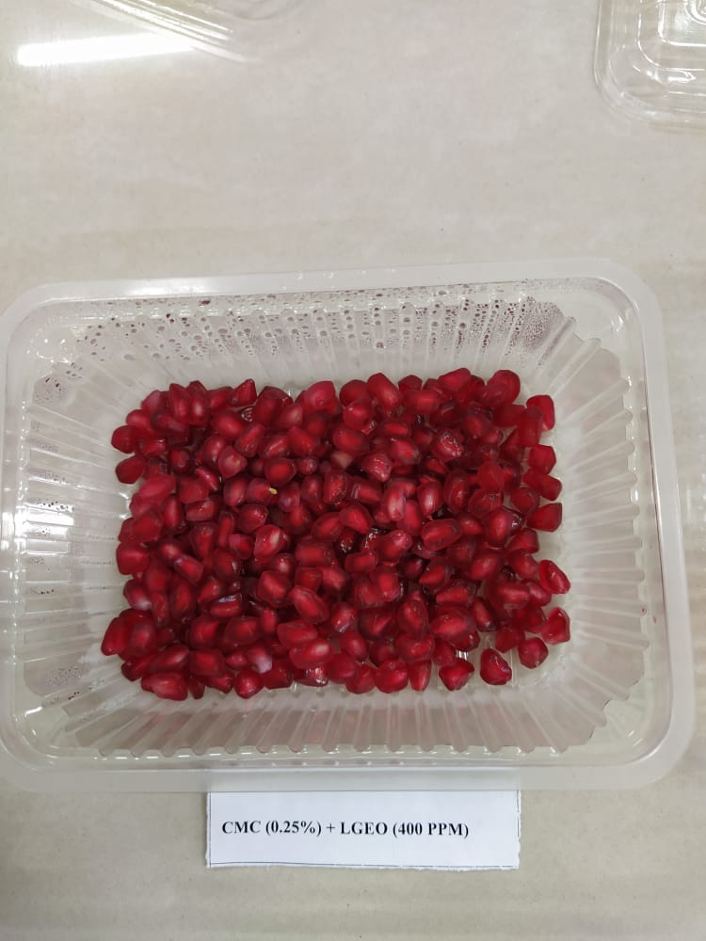 | 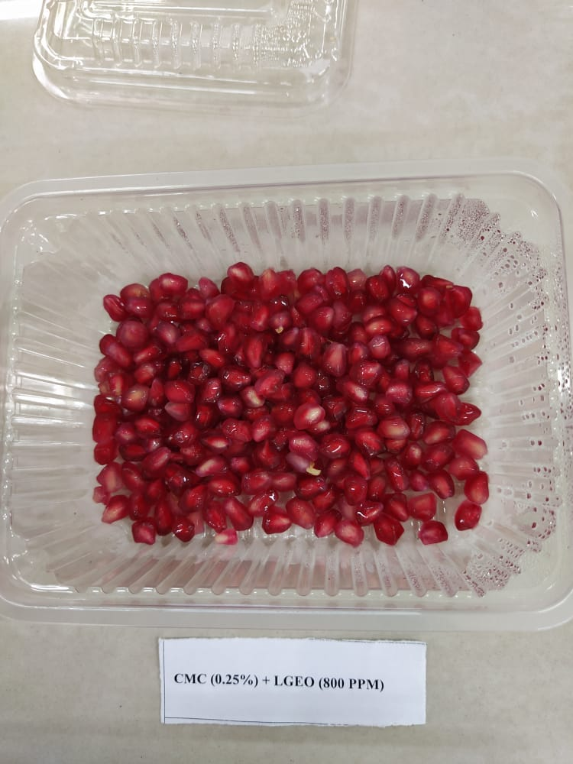
CMC 0.25% + LGEO 400 PPM (LGEO) | CMC 0.25% + LGEO 800 PPM (LGEO)
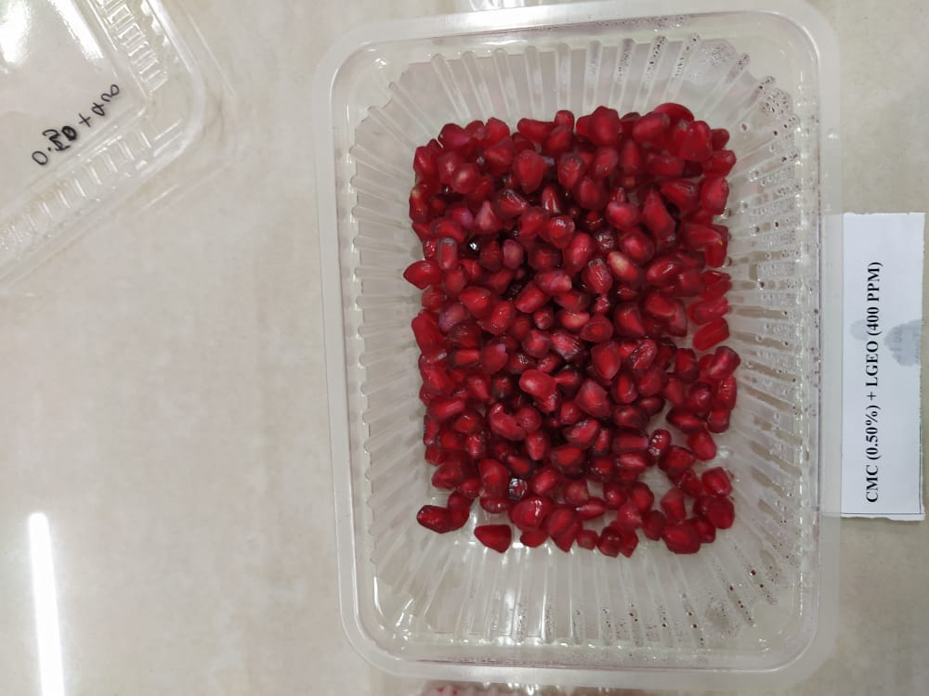 | 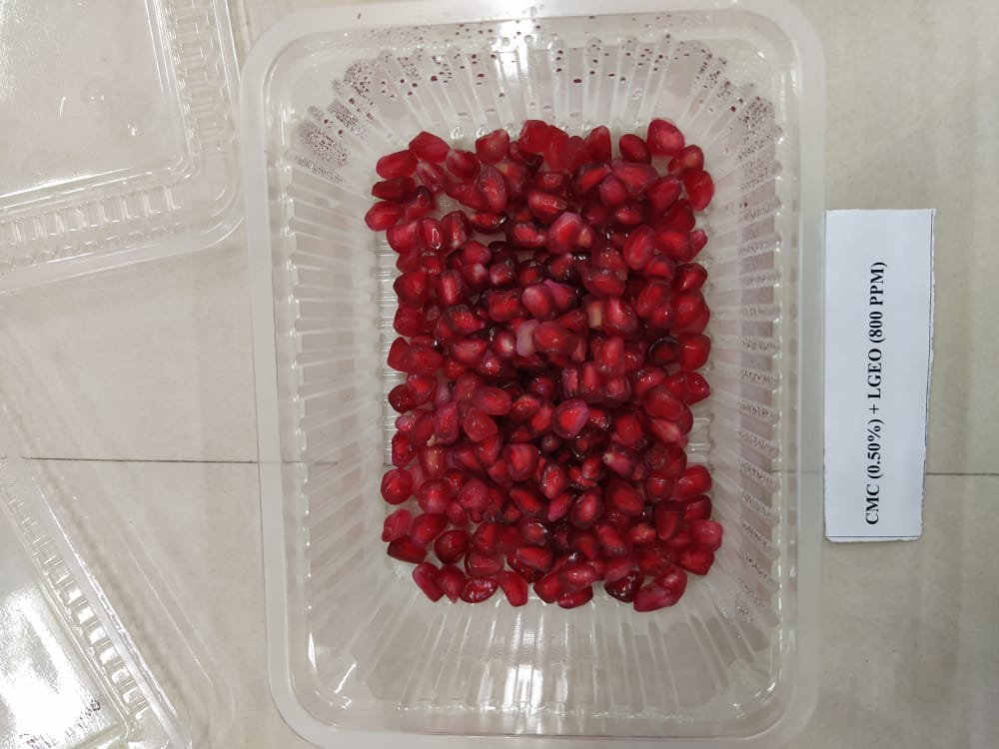
CMC 0.50% + 400 PPM (LGEO) | CMC 0.50 % + 800 PPM (LGEO)
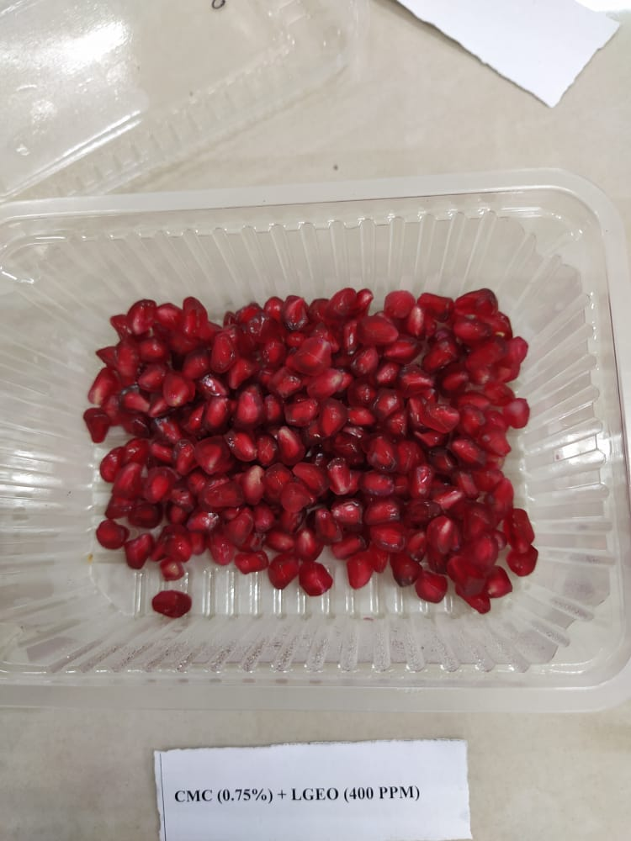 | 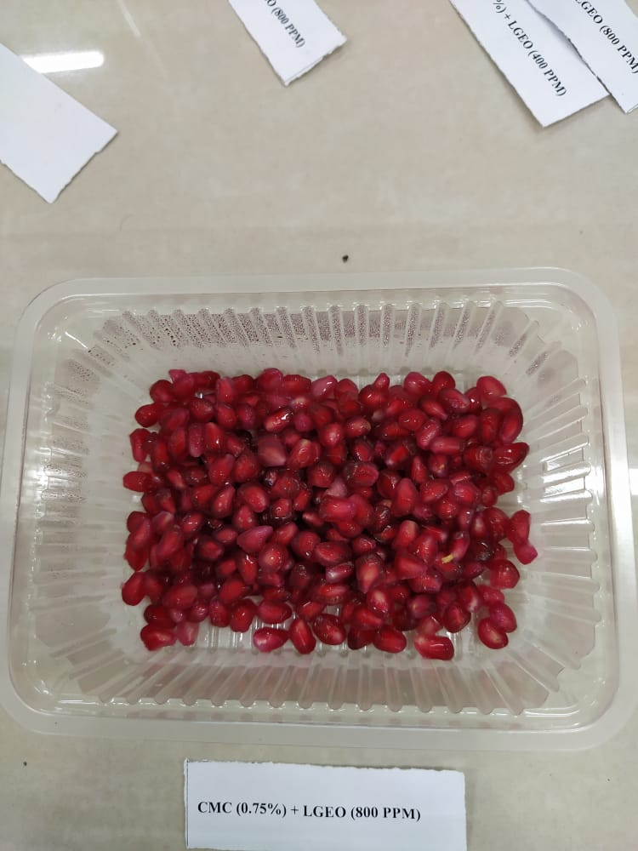
CMC 0.75% + 400 PPM (LGEO) | CMC 0.75% + 800 PPM (LGEO)
Fig 7: CMC and LGEO coated pomegranate arils

