***Review Article***

**PREVALENCE AND THERAPEUTIC MANAGEMENT OF HYPOTHYROIDISM-ASSOCIATED CANINE DEMODICOSIS IN AND AROUND INDORE, MP**

**Abstract** The present study was carried out to assess the prevalence of hypothyroidism-associated canine demodicosis in and around Indore, Madhya Pradesh. A total of 1,177 canine cases were examined between May 2024 and October 2024. The overall prevalence of hypothyroidism-associated demodicosis was found to be 1.19% (14 out of 1,177 cases). The condition was most commonly observed in dogs over 5 years of age, with a higher incidence in males compared to females. Among the breeds, Labrador Retrievers showed a greater susceptibility. Haemato-biochemical analysis revealed reduced hemoglobin (Hb), packed cell volume (PCV), total erythrocyte count (TEC), lymphocyte count, and serum T4 levels, along with marked leukocytosis, neutrophilia, and eosinophilia. A slight elevation in alanine aminotransferase (ALT) levels was also noted. For treatment, oral administration of levothyroxine sodium at a dose of 0.02 mg/kg body weight once daily for 60 days, along with supportive therapy, proved effective in managing hypothyroidism-associated canine demodicosis.

**INTRODUCTION**

Hypothyroidism is recognized as the most common endocrine disorder diagnosed in dogs. Dysfunction within any component of the hypothalamic-pituitary-thyroid axis can lead to hypothyroidism. Most cases of acquired hypothyroidism in dogs are due to either lymphocytic thyroiditis or idiopathic thyroid gland atrophy (Ettinger and Feldman, 2010). Thyroid hormones were extremely important in maintaining cutaneous functions. They play a regulatory role in epidermal differentiation because of their effects on keratinocytes (Doshi *et al*., 2008).

The skin is the largest part of the body, functioning as a vital protective layer that shields the animal from the external environment. The skin of a dog accounts for approximately 12-24% of its total body weight (Moriello, 2016). Skin disorders represent a prevalent category of health concerns in adult animals, characterized by lesions that can spread across the entire body. These disorders encompass a spectrum of conditions, ranging from acute and self-limiting issues to those with a more chronic nature, necessitating lifelong management. Research indicates that chronic skin problems may require ongoing treatment involving haematological and biochemical interventions, as well as adjustments to thyroxin levels (Munjal, 2012).

Mange is the result of microscopic mites invading the skin of healthy animals. Mites induce skin irritation, leading to itchiness, hair shedding and inflammation. The most important canine mange-mite infestations in the tropics are *Demodex canis*, *Sarcoptes scabei* var. canis and *Otodectes cynotis* (Nayak *et* *al*., 1997). Demodicosis is a prevalent skin condition frequently observed in dogs. *Demodex canis* (Plate 01) is an ectoparasite that normally resides in the hair follicles and sebaceous glands of canine skin (Sharma and Pokharel, 2019). Apart from the proliferation of mites, compromised host immunity is considered to be the foremost reason for the development of generalized demodicosis (Singh *et al*., 2019). Demodicosis development is also associated with immunosuppressive treatments, neoplasia and medical conditions characterized by metabolic changes, such as hyperadrenocorticism, hypothyroidism and diabetes mellitus (Duclos *et al*., 1994). Measuring serum T4 levels is a reliable diagnostic method for detecting hypothyroidism in dogs.

**MATERIAL AND METHODS**

**Selection of animals:**

Dogs were screened and clinically examined with special attention to signs related to dermatological disorders at Veterinary Clinical Complex, College of Veterinary Science and A.H. MHOW and in Indore. Based on history and clinical symptoms, dogs were selected irrespective of age, breed, sex and gender. Cases presented with skin lesions like alopecia, itching, erythema, thick yellow crusts, pruritus, spectacle eye, seborrhoea and hyperkeratinisation on many parts of the body. The disease was confirmed by a positive result for *Demodex canis* on skin scrapings.

**Diagnosis of hypothyroidism-associated canine demodicosis**

**Skin scraping examination**

The deep skin sample was taken from the dog to detect mites in cases of suspected dermatological conditions. It remains the most commonly practiced and effective technique for identifying *Demodex* mites in affected dogs. The collected scrapings are examined under a microscope (10x) to confirm the presence of mites.

Estimation of serum T4 µg/dl level was done (BIO NOTE VCHECK V200), using a commercially available standard ELISA kit. Serum T4 µg/dl levels were estimated on day 0 (pre-treatment) and day 28 (post-treatment).

A total of twelve dogs positive for hypothyroidism-associated canine demodicosis were selected for therapeutic trial. The dogs were treated as follows.

* Tab. Levothyroxine sodium @ 0.02 mg/kg of b.wt. orally OD for 60 days
* Inj. Ivermectin @ 200 μg / kg b.wt. S/C weekly for 4 weeks
* Tab. Cephalexin @ 22 mg/kg b.wt. orally BID for 5 days
* Tab. Cetirizine HCl @ 1 mg/kg orally OD for 7 days

Efficacy evaluations were done based on improvement of clinical signs, haemato-biochemical parameters absence of mites in skin scraping examination and level of serum thyroxine (T4) µg/dL.

**RESULT AND DISCUSSION**

The prevalence ofhypothyroidism-associated canine demodicosis was estimated in and around Indore. Overall prevalence was found to be 1.19%. A total number of 1177 dogs were screened during the study period, out of these 40 dogs were suspected based on clinical signs of skin lesions like alopecia, itching, erythema, thick yellow crusts, pruritus, spectacle eye, seborrhoea and hyperkeratinisation on many parts of the body. The disease was confirmed by a positive result for *Demodex canis* on skin scrapings.

**Table 01: Prevalence of hypothyroidism-associated canine demodicosis in and around Indore**

|  |  |  |  |
| --- | --- | --- | --- |
| **Total No. of dogs observed during the study period** | **Suspected for hypothyroidism-associated canine demodicosis** | **Dogs positive for hypothyroidism-associated canine demodicosis** | **Prevalence (%)**  **n=1177** |
| 1177 | 40 | 14 | 1.19 |

**Age-wise prevalence**

Age-wise highest prevalence was found in dogs aged above 5 years, followed by dogs aged 1 to 5 years. Out of the total number of dogs screened, 0.68% (2/295) dogs belonged to the age group of up to 1 year, 0.98% (5/510) belonged to the age group of 1 to 5 years, 1.88% (7/372) of dogs belonged to the age group of more than 5 years. These findings align with the observations of Raja *et al*. (2021), who found that 85% of dogs with hypothyroidism were adults over 5 years old.

**Table 02: Age wise prevalence of hypothyroidism-associated canine demodicosis in and around Indore**

|  |  |  |  |
| --- | --- | --- | --- |
| **Age** | **No. of dogs** | | **Prevalence (%)** |
| **Total** | **Positive** |
| Up to 1 year | 295 | 2 | 0.68 |
| 1 to 5 year | 510 | 5 | 0.98 |
| Above 5 year | 372 | 7 | 1.88 |

**Sex-wise prevalence**

Out of 1177 dogs, 689 were males and 488 were females. Among them, 9 males and 5 females tested positive for hypothyroidism-associated canine demodicosis. The sex wise prevalence was recorded as 1.31% in males and 1.02% in females. The overall prevalence was slightly greater in males as compared to females. Findings are in agreement with the previous researchers, Kour *et al.* (2020) and Ghallab *et al.* (2021), who noted a higher incidence of hypothyroidism in male dogs. Similarly, Thakur *et al.* (2020) reported that the male dogs exhibited a slightly greater susceptibility to demodicosis compared to females.

The differences in the sex wise prevalence of hypothyroidism-associated canine demodicosis can be attributed to regional variations, preferences for specific sexes and the acceptance of neutering as a management practice in the area.

**Table 03: Sex wise prevalence of hypothyroidism-associated canine demodicosis in and around Indore**

|  |  |  |  |
| --- | --- | --- | --- |
| **Sex** | **No. of dogs** | | **Prevalence (%)** |
| **Total** | **Positive** |
| Male | 689 | 9 | 1.31 |
| Female | 488 | 5 | 1.02 |

**Breed-wise prevalence**

During the present study, dogs of various breeds were examined for hypothyroidism-associated canine demodicosis. In the current research the breed wise prevalence was recorded as 1.82% (4/220) in Labrador Retrievers, 1.57% (4/255) in German Shepherds, 1.14% (3/263) in Non-descript breeds, 1.12% (1/89) in Pomeranian, 1.07% (1/94) in Husky and 1.01% (1/99) in Shih Tzu.

Among different breeds, hypothyroidism-associated canine demodicosis was found to be most prevalent in Labrador Retriever, followed by German Shepherd, with the least prevalence observed in Shih Tzu. The findings are consistent with the results reported by Kour *et al*. (2020) and Raja *et al.* (2021), as well as Bhatia (2024), all of which identified Labrador Retrievers as having the highest prevalence of hypothyroidism. However, O’Neill *et al.* (2022) documented the highest prevalence of hypothyroidism in Boxers.

**Table 04: Breed wise prevalence of hypothyroidism-associated canine demodicosis in and around Indore**

|  |  |  |  |
| --- | --- | --- | --- |
| **Breed** | **Total No. of dogs** | **No. of dogs positive** | **Prevalence (%)** |
| Non-descript | 263 | 3 | 1.14 |
| German Shepherd | 255 | 4 | 1.57 |
| Labrador Retriever | 220 | 4 | 1.82 |
| Shih Tzu | 99 | 1 | 1.01 |
| Husky | 94 | 1 | 1.07 |
| Pomeranian | 89 | 1 | 1.12 |
| Beagle | 68 | 0 | 0.00 |
| Rottweiler | 28 | 0 | 0.00 |
| Pug | 21 | 0 | 0.00 |
| Dobermann | 15 | 0 | 0.00 |
| Pitbull | 13 | 0 | 0.00 |
| Lhasa Apso | 12 | 0 | 0.00 |

**Therapeutic efficacy**

In the present study, the therapeutic efficacy was evaluated based on the improvement of clinical signs, haemato-biochemical parameters, absence of mites in skin scraping examination and level of serum thyroxine (T4) µg/dL.

Out of 12 dogs, 10 dogs showed complete recovery by the 28th day. The efficacy of levothyroxine was found 83.33% (Table 05).

**Table 05: Therapeutic efficacy of levothyroxine in hypothyroidism-associated canine demodicosis**

|  |  |  |
| --- | --- | --- |
| **No. of dogs** | | **Efficacy (%)** |
| **Treated** | **Recovered** |
| 12 | 10 | 83.33 |

Dogs diagnosed with low levels of serum thyroxine (T4) were treated with oral levothyroxine sodium at a dosage of 0.02 mg/kg body weight once daily. This initial dose was effective in managing both the clinical symptoms and hormonal imbalances associated with the condition (Le Traon *et al.*, 2009 and Bhatia 2024).

Therapeutic effectiveness was evaluated primarily based on clinical improvement, supported by thyroxine hormone levels, absence of mites in skin scraping examination and hematobiochemical assessments (Table 06). The findings of the present study indicate that the serum T4 levels highly significantly increased to normal (p≤0.01), 02.12±0.21 µg/dL on day 28 post-therapy, as compared to 01.01±0.13 µg/dL on day 0.

All the hypothyroid-associated canine demodicosis dogs showed marked clinical improvement with alleviation of clinical signs from two weeks after initiation of thyroid supplementation and inj. Ivermectin. Resolution of dermatological signs started after 2 weeks of initiation of therapy and it took 3-4 weeks for all the dogs to become normal (Plate 02 and 03).

Post therapy on day 28, a highly significant (p≤0.01) decrease was observed in values of total leucocyte count (11.93±0.42 thousand/μL), neutrophils (64.33±1.61), eosinophils (01.58±0.23), ALT (56.32±3.96) and highly significant increase (p≤0.01) was observed in values of serum T4 (02.12±0.21 µg/dL), lymphocytes (32.83±1.48), TEC (06.01±0.11 million/μL), Hb (11.95±0.23 g/dL), PCV (35.83±0.68%) towards normal level. The significant variation of laboratory values towards normally reflects an overall response to Levothyroxine supplementation.

**Table 06: Assessment of the treatment response in dogs (n=12)**

|  |  |  |
| --- | --- | --- |
| **Clinical observation** | **Days** | |
| **0** | **28** |
| Alopecia | 10 | 04 |
| Itching | 09 | 01 |
| Scab formation | 08 | 01 |
| Crust Formation | 06 | 00 |
| Erythema | 12 | 02 |
| Spectacle eyes | 05 | 00 |
| Low serum T4 level | 12 | 00 |
| Presence of mite | 12 | 02 |

**Clinical observation**

The mean values of clinical parameters such as temperature, pulse rate and respiration rate on day 0 and 28 day were observed and pulse rate and respiration rate were found within the normal physiological range and there was no significant difference observed during the treatment while rectal temperature was elevated before treatment but returned to normal by day 28.

**Table 07: Mean values of rectal temperature (°F), pulse rate (per minute) and respiration rate (per minute) pre and post-treatment in dogs (n=12)**

|  |  |  |
| --- | --- | --- |
| **Clinical parameters** | **Days** | |
| **0** | **28** |
| Rectal temperature (°F) | 102.10±0.16 | 101.72*±0.09 |
| Pulse rate (per minute) | 95.16±1.16 | 92.91±1.05 |
| Respiration rate (per minute) | 19.58±1.17 | 20.25±0.76 |

(*= p≤0.05)

**Serum thyroxine (T4) level**

The mean values of serum T4 (µg/dL) recorded on day 0 and day 28 for the group were 01.01±0.13 and 02.12±0.21 µg/dL, respectively (Table 08).

**Table 08: Mean values of serum T4 (µg/dL) pre and post-treatment in dogs (n=12)**

|  |  |  |
| --- | --- | --- |
| **Parameter** | **Days** | |
| **0** | **28** |
| Serum T4 (µg/dL) | 01.01±0.13 | 02.12**±0.21 |

(**= p ≤0.01)

There was a highly significant (p≤0.01) difference observed in the mean values of serum T4 between day 0 and day 28 of treatment. Similar findings for the serum T4 were recorded by Kwatra *et al.* (2007), Haleem *et al.* (2015), Maharana *et al.* (2016), Das *et al.* (2021) and Bhatia (2024).

The study observed a statistically significant difference in T4 levels in dogs with hypothyroidism-associated demodicosis. These findings correspond with the research reported by Mederle *et al*. (2010) and Wright *et al*. (2013) who identified a potential link between hypothyroidism and demodicosis, likely due to immune system suppression, which facilitates the proliferation of mites. The increase in mites and/or microbes resulting from immunosuppression can lead to skin disorders. However, these results contrast with those of Reddy *et al.* (2015), who reported no significant difference in T4 levels in dogs with demodicosis compared to healthy dogs.

**Table 09: Mean values of haemato-biochemical observations pre and post-treatment in dogs (n=12)**

|  |  |  |
| --- | --- | --- |
| **Parameter** | **Days** | |
| **0** | **28** |
| Hb (g/dL) | 10.45±0.20 | 11.95**±0.23 |
| PCV (%) | 31.35±0.59 | 35.83**±0.68 |
| TEC (million/μL) | 05.26±0.10 | 06.01**±0.11 |
| TLC (thousand/μL) | 15.56±0.63 | 11.93**±0.42 |
| Neutrophils (%) | 72.58±2.05 | 64.33**±1.61 |
| Lymphocytes (%) | 21.42±1.76 | 32.83**±1.48 |
| Monocytes (%) | 02.00±0.21 | 01.58±0.29 |
| Eosinophils (%) | 03.92±0.47 | 01.58**±0.23 |
| Basophils (%) | 00.00±0.00 | 00.00±0.00 |
| ALT (IU/L) | 71.00±5.37 | 56.32*±3.96 |
| AST (IU/L) | 21.77±2.60 | 17.92±1.00 |

(*= p≤0.05, **= p≤0.01)

C**onclusion:**

The study concluded that the hypothyroidism-associated canine demodicosis was more prevalent in dogs aged above 5 years and less prevalent in up to 1 year of age. Among different breeds, prevalence was highest in Labrador Retriever. Male dogs were found to be more susceptible than female dogs. The mean values of clinical parameters such as temperature, pulse rate and respiration rate on day 0 and 28 day were observed and pulse rate and respiration rate were found within the normal physiological range and there was no significant difference observed during the treatment while rectal temperature was elevated before treatment but returned to normal by day 28. The most observed skin lesions were erythema, alopecia, scabs, itching and crust formation.

The haemato-biochemical parameters value of Hb, PCV, TEC, lymphocyte and serum thyroxine (T4) significantly increased towards normal while values of TLC, neutrophils, eosinophils and ALT significantly decreased towards normal level from day 0 pre-treatment to day 28th post-treatment.

In this study, the efficacy assessment was done on the basis of the improvement in clinical signs, haemato-biochemical findings and negative results of skin scraping examination and serum thyroxine level. Treatment with levothyroxine along with supportive therapy was found to be 83.33% effective in the clinical management of hypothyroidism-associated canine demodicosis.

**REFERANCES**

Bhatia, R. N. (2024). 1 Pawing for answers: The tail of canine hypothyroidism. *International Journal of Veterinary Sciences and Animal Husbandry* 2024, **9**(2): 896-904.

Das, G., Deka, P. and Dutta, K. J. (2021). Clinical management of hypothyroidism associated dermatological signs in a Labrador: A case report. *Indian Journal of Veterinary Sciences and Biotechnology*, **17**(1): 91-92.

Doshi, D. N., Blyumin, M. L. and Kimball, A. B. (2008). Cutaneous manifestations of thyroid disease. *Clinics in Dermatology*, **26**(3): 283–287.

Duclos, D. D., Jeffers, J. G. and Shanley, K. J. (1994). Prognosis for treatment of adult-onset demodicosis in dogs: 34 cases (1979-1990). *Journal of American Veterinary Medical Association*, **204**(4): 616-619.

Ettinger, S. J. and Feldman, E. C. (2010). Textbook of Veterinary Internal Medicine, 7th Edn., Saunders Elsevier, Missouri, pp 1752-1754.

Ghallab, E. H., Abdel-Saeed, H., Farghali, H. and Baraka, T. (2021). Epidemiological study on hypothyroidism in dogs in Egypt. *Veterinary Medical Journal* (Giza),**67**(1): 113-121.

Haleem, M. A., Salib, F. A. and Farag, H. S. (2015). Evaluation of haematological parameters, biochemical parameters and thyroxin level in dogs with generalized demodicosis. *Global Veterinaria*, **15**(1): 133-136.

Kour, H., Chhabra, S., and Randhawa, C. S. (2020). Prevalence of hypothyroidism in dogs. *Pharma Innovation Journal*, **9**: 70-72.

Kwatra, J., Randhawa, S. S., Saini, N. and Dhaliwal, P. S. (2007). Thyroid function in dogs suffering from mange infestation. *Indian Journal of Veterinary Medicine*, **27**(1):68-69.

Le Traon, G., Brennan, S. F., Burgaud, S., Daminet, S., Gommeren, K., Horspool, L. J. I., Rosenberg, D. and Mooney, C. T. (2009). Clinical evaluation of a novel liquid formulation of L‐thyroxine for once daily treatment of dogs with hypothyroidism. *Journal of Veterinary Internal Medicine*, **23**(1): 43-49.

Maharana, B. R., Joseph, J. P., Thakre, B. J. and Patel, J. S. (2016). Generalized demodicosis in a hypothyroid dog and its successful therapeutic management. *The Indian Journal of Veterinary Sciences and Biotechnology*, **11**(4): 62-64.

Mederle, N., Darabu, G., Oprescu, I., Morariu, S., Ilie, M., Indre, D. and Mederle, O. (2010). Diagnosis of canine demodicosis. *Scientia Parasitologica*, **11**(1): 20-23.

Moriello, K. A. (2016). Pyoderma in Dogs. In: Aiello, S.E. and Moses, M.A. (ed.), The Merck Veterinary Manual. 11th edn., Merck and Co, Inc, Kenilworth, NJ, USA, pp 25-28.

Munjal, R. S. (2012). Common dermatological diseases by bacteria and fungi in pet dogs. *Indian Journal of Fundamental and Applied Life Science*, **2**: 207-209.

Nayak, D. C., Tripathy, S. B., Dey, P. C., Ray, S. K., Mohanty, D. N., Parida, G. S., Biswal, S. and Das, M. (1997). Prevalence of canine demodicosis in Orissa (India). *Veterinary Parasitology*, **73**(3-4): 347-352.

O’Neill, D. G., Khoo, J. S. P., Brodbelt, D. C., Church, D. B., Pegram, C. and Geddes, R. F. (2022). Frequency, breed predispositions and other demographic risk factors for diagnosis of hypothyroidism in dogs under primary veterinary care in the UK. *Canine Medicine and Genetics*, **9**(1):11.

Raja, R., Mondal, D., Velayudhan, J.M., Mandal, R.S.K., Bhatt, S., Joshi, V. and Dimri, U. (2021). Studies on role of thyroperoxidase (TPO) enzyme in primary hypothyroidism affected dogs. *Journal of Animal Research* **11**(5): 909-914.

Reddy, B. S., Kumari, K. N. and Sivajothi, S. (2015). Haemato-biochemical findings and thyroxin levels in canine demodicosis. *Comparative Clinical Pathology*, **24**: 287-290.

Sharma, S. and Pokharel, S. (2019). Diagnosis and therapeutic management of mixed *Demodex* and *Sarcoptes* mite infestation in dogs. *Acta Scientific Agriculture*, **3**(6): 163-166.

Singh, A., Kumari, P., Singh, S. K., Soman, S. P., Choudhary, S., Srivastava, A., Nigam, R. and Garg, S. K. (2019). Pre and post-therapy circulation immunostimulatory and immuno-suppressive cytokines in dogs with juvenile-onset generalized demodicosis. *Veterinary Parasitology*, **275**: 108954.

Thakur, M., Prasad, H., Samanta, A.K. and Kumar, S. (2020). Study on the incidence of demodectic mange in dogs in and around Mizoram. *Journal of Entomology and Zoology Studies*, **8**(3): 97-103.

Wright, I., Bate, S., Mctaggart, D. and Cox, A. (2013). Clinical forum: canine localised adult-onset demodicosis. *Companion* *Animal*, **18**(6): 252-255.

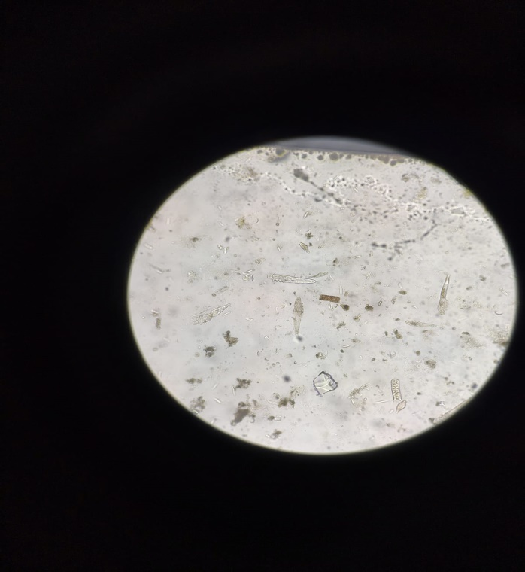

**Plate 01: Skin scraping showing *Demodex canis* (10X)**

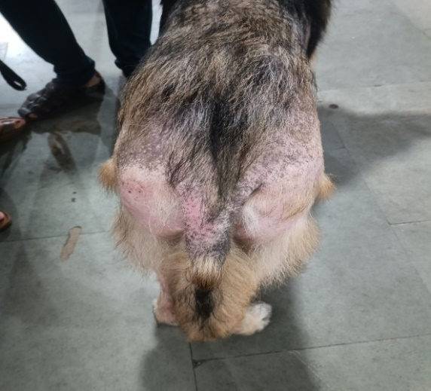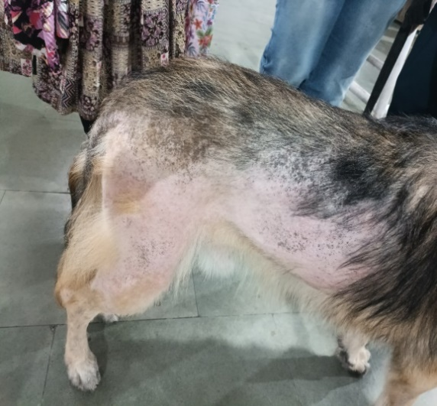

**Plate 02: Bilateral generalized alopecia in hypothyroidism-associated canine demodicosis (pre-treatment)**

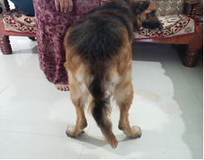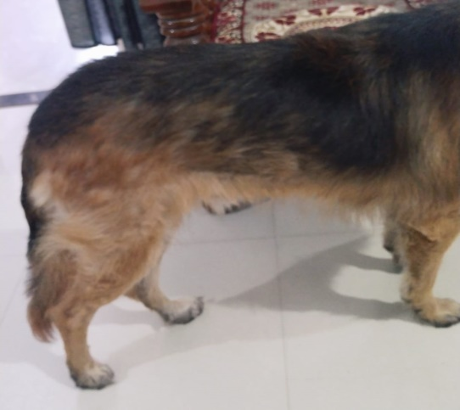

**Plate 03: Dog treated with levothyroxine showing complete recovery on day 28 (post-treatment)**