Original Research Article

Gross Anatomical Study on the Small Intestine of Zoar, the Indigenous Fowl of Mizoram

ABSTRACT

The experiment was conducted from February to November, 2024 in Department of Veterinary Anatomy & Histology, College of Veterinary Science & Animal Husbandry, Central Agricultural University, Aizawl, Mizoram - 796015, India to study the gross anatomical morphology of the small intestine of the Zoar fowl. Parameters like length and weight of each intestinal segment were recorded along with external diameter and wall thickness. The small intestine of Zoar fowl was composed of three parts: the duodenum, jejunum, and ileum, with the duodenum being the first section. The jejunum of Zoar fowl was arranged in the form of numerous loosely arranged loops, while the third section, the ileum ran closely between the paired caeca, terminating at the ileocaecal junction.

Keywords: Zoar, small intestine, duodenum, jejunum, ileum

- INTRODUCTION

In India, poultry farming has been an integral part of the agricultural enterprise for centuries, complementing crop cultivation and livestock rearing. This practice has sustained communities with vital protein sources of animal origin. Beyond sustenance, poultry held cultural significance in rituals, showcasing the interplay between farming and cultural heritage in ancient India's landscape. Many popular breeds/strains of chicken that are being used at present in the organized poultry industry, originated from the red jungle fowl, the wild native chicken from the Indian sub-continent.

The popularity of poultry meat has surged over the past two decades, with consumption increasing from 2.873 million metric tonnes in 2013 to 4.407 million metric tonnes in 2023 (Organisation for Economic Co-operation and Development), representing a remarkable growth rate of 53.4% over the last decade. However, the industry is concentrated in specific regions of the country, with the top five states being Andhra Pradesh, Tamil Nadu, Telangana, West Bengal and Karnataka where intensive poultry farming is practiced using high-yielding breeds like BV 380, Babcock Bovans, Hy-line, for egg production and Cobb, Ross, Hubbard, Hy-bro for meat production. Native chicken breeds like Aseel, Kadaknath, Miri, Nicobari, Chittagong, Kashmir Favorolla, Harringhata Black, Daothigir etc., though neglected by the industry, retain popularity in their home tracts for their resilience as well as meat quality and taste.

Zoar is one such non-descript type of native chicken that inhabits the northeastern state of Mizoram. “Zoar” (Zo means "hill" and ar means "chicken" in the Mizo language) is a medium-sized bird with a moderately developed single comb and wattle, a long beak and shank, and a well-developed wing span (Lalhlimpuia et al., 2021a). The average weight of an adult Zoar cock ranges from 1.984 kg to 2.064 kg, while the average weight of an adult Zoar hen ranges from 1.348 kg to 1.387 kg (Lalhlimpuia et al., 2021b). Despite its low yield, Zoar bird's lean meat boasts a distinctive taste and flavour compared to commercial broilers, translating to a higher market price and value.

There is a paucity of literature on the anatomical organization of the small intestine as well as the complete digestive tract of the Zoar fowl. Therefore, the current study is directed towards the comprehensive examination of the gross morphometry of the Zoar fowl’s small intestine.

- MATERIALS AND METHODS
For the present study, 3 (three) numbers of apparently healthy Zoar fowl were procured from the Aizawl and Mamit districts of Mizoram, and approval of the ‘Institutional Animal Ethics Committee’ was obtained (CPCSEA Registration No.:1476/GO/Re/SL/2011/CCSEA, 29/07/2024).
The gross morphology and morphometric characterstics of the various segments were examined using fresh specimens immediately after exsanguination. The weight of the different sections of the small intestine was measured using the digital balance, AND HR-200. Gross morphometric measurements included the length and weight of each section (Table 2, 3), external diameter (Table 4), and intestinal wall thickness (Table 5). The length of each segment was measured according to the method outlined by Leopold (1953). The whole intestine was extracted from the carcass, and the mesenteric tissue was trimmed. The duodenum, jejunum, and ileum were then resected and straightened without stretching, and their lengths were measured using a Vernier Caliper (0-150 mm) as shown in Table 1.
Table 1: Site of gross measurement

Sl No. | Parts of small intestine | Site of gross measurement
1. | Duodenum | Ascending and descending loop of duodenum
2. | Jejunum | From the end of ascending loop upto the level of blind end of caeca
3. | Ileum | From the level of ileo-caecal junction upto the level of blind end of caeca

- RESULTS AND DISCUSSION

The small intestine of the Zoar fowl from Mizoram had a long, coiled, tubular structure that formed a series of loops within the thoraco-abdominal cavity, connecting the muscular stomach proximally and the colon distally (Fig. 1). It was composed of three parts: the duodenum, jejunum, and ileum, with the duodenum being the first section. Similar observations we noted in other avian species such as McLelland (1975) in fowl; Nickel et al. (1977) in avian; Taylor (2000), Dibner and Richard (2004), Ghosh (2006) in fowl; Vukicevic et al. (2004) as well as Wang and Peng (2008) in Ostrich; Kalita (2009) in Kadaknath Fowl; Yamauchi et al. (2010) in chicken; Nasrin et al. (2012) in Broilers; Zaher et al. (2012) in Common Quail; Mahmud et al. (2015) in Nigerian Indigenous genotypes of Chicken and Saran et al. (2019) in Guinea Fowl. In discrepancy, Klasing (1998) demonstrated that only the duodenum and ileum are present in the small intestine of avian species.
The small intestine occupied the caudal part of the body cavity and made contact with various organs such as the liver, spleen, right testis, and in laying females, the ovary and the loops of the oviduct.

3.1 Duodenum
Positioned on the right side of the abdominal cavity, the duodenum of the Zoar fowl emerged from the right antero-dorsal surface of the muscular stomach as an elongated U-shaped loop that extended cauda-ventrally along the right abdominal wall towards the pelvic inlet, forming a proximal descending limb and a distal ascending limb. The ascending and descending limbs were connected by a thin fold of mesentery, which also nestled the pancreas between them. These findings were in agreement with the descriptions of McLelland (1975), Nickel et al. (1977) in avian; Dyce et al. (2002) in fowl; Kalita (2009) in Kadaknath Fowl; Nasrin et al. (2012) in Broilers; Hamdi et al. (2013) in Black-winged kite; Hristov et al. (2017) in Canaries; Khaleel and Atiea (2017) in Iraqi ducks; Zghair and Khaleel, (2019) in Guinea fowl and Naser and Khaleel, (2020) in adult Bronze male turkeys.
The duodenum of the Zoar fowl weighed 4.03 ± 0.13 grams (Table 4), with a length of 22.21 ± 0.38 cm and a mean external diameter of 11.65 ± 0.08 mm (Table 5, Fig. 2). There was no significant difference in the length of both ascending and descending limbs of the duodenum. Analogous observations were mentioned by Hussein and Rezk (2016) in Sparrow and Heron, where the two limbs of the duodenum were of the same length.
However, this result was in contrast to the findings observed by Hussein and Rezk (2016) in Turkey where the descending duodenum was slightly longer than the ascending one, while in duck and geese, hoopoe, kestrel, cattle egret, owl and darter the ascending limb was longer than the descending limb. The mean wall thickness was measured at 0.56 ± 0.01 mm (Table 6). It was noted that the duodenal lumen of the Zoar fowl was wider than that of the jejunum and ileum, which aligns with the findings reported by Getty (1975) in chickens. In contrast, Verma et al. (1998) reported that the duodenal lumen had a smaller diameter relative to that of the jejunum in fowl.
The pancreatic and bile ducts opened into the ascending duodenum opposite the cranial part of the muscular stomach in the Zoar fowl. Similar observations were noted in Kadaknath fowl (Kalita, 2009); Broilers (Nasrin et al., 2012), Chicken (Mahmud et al., 2015), Common quail (Zaher et al., 2012), and Turkey (Naser and Khaleel, 2020).
The two bile ducts (a hepato-enteric duct and a cystico-enteric duct) from the liver and two pancreatic ducts open close to each other in the ascending limb of the duodenum. A similar observation was documented by Getty (1975) in Fowl; Igwebuike and Eze (2010) in African pied crows; Ahmad et al. (2012) in Japanese quails and Naser and Khaleel (2020) in Turkeys. Khaleel and Atiea (2017) however, reported three pancreatic ducts in indigenous Duck.

3.2 Jejunum
The jejunum of Zoar fowl was arranged in the form of numerous loosely arranged loops which remained suspended in the dorsal aspect of the thoraco-abdominal cavity by mesentery, through which branches of mesenteric arteries passed. Nickel et al. (1977) in Avain; Verma et al. (1998) in Fowl and Kalita (2009) in Kadaknath Fowl noted akin observations.
The jejunum of the Zoar fowl weighed 20.42 ± 0.83 grams (Table 4), with a wall thickness of 0.58 ± 0.02 mm (Table 5) and an external diameter of 9.92 ± 0.29 mm (Fig. 3). With a length of 101.35 ± 1.80 cm (Table 5), the jejunum was the longest section of the small intestine that continued from the termination of the ascending loop of duodenum up to the level of the blind end of the caeca. However, according to Hussein and Rezk (2016) in cattle egrets, the ileum was the longest segment of the small intestine, extending from the Meckel’s diverticulum to the ileocecal junction, while the jejunum began as a continuation of the duodenum and ended at Meckel’s diverticulum.
In the present study, the jejunum connected the duodenum to the ileum and was related to the stomach, the spleen, the right lobe of the liver and, in laying females, the ovary and loops of the oviduct. Comparable observations were reported by Nickel et al. (1977) in Avain.
Meckel's/Vitelline diverticulum (a short, blind remnant of the yolk sac and yolk stalk) was consistently found just caudal to the midpoint of the jejunum in the small intestine of the Zoar fowl (Fig. 4). This is coherent with the observations noted in Kadaknath fowl (Kalita, 2009), Common Quail (Zaher et al., 2012) and Chicken (Nasrin et al., 2012). King and McLelland (1975), however, noted the presence of the vitelline diverticulum between the jejunum and ileum in domestic fowl while no such diverticulum was reported in the jejunum of Peahens (Khaleel, 2022) and Japanese quail (Sinha, 2023).

3.3 Ileum
The short and straight ileum was continuous with the jejunum without any clear distinction and ran closely between the paired caeca, terminating at the ileocaecal junction (Fig. 5).
The ileum of the Zoar fowl weighed 6.77 ± 0.34 grams (Fig. 6), measured 16.07 ± 0.33 cm in length (Table 5), and had an external diameter of 5.30 ± 0.09 mm (Fig. 7), which slightly decreased towards the terminal end. Analogous findings were also reflected in Kadaknath fowl (Sinha, 2023). While the diameter of the ileum was nearly constant throughout its length in Japanese quail, it increased in the middle but reduced towards its terminal end in domestic turkey (Sinha, 2023).
The mean wall thickness of the ileum was measured at 0.45 ± 0.02 mm (Table 6).

Table 2: Showing the weight (gm) of duodenum, jejunum and ileum in Zoar fowl

Bird No. | Duodenum | Jejunum | Ileum
1. | 3.78 | 18.93 | 6.11
2. | 4.07 | 20.55 | 6.98
3. | 4.24 | 21.80 | 7.24
Mean±S.E. | 4.03 ± 0.13 | 20.42 ± 0.83 | 6.77 ± 0.34

Table 3 : Showing the length (cm) of duodenum, jejunum and ileum in Zoar fowl

Bird No. | Duodenum | Jejunum | Ileum
1. | 21.46 | 98.46 | 15.60
2. | 22.75 | 100.93 | 16.73
3. | 22.43 | 104.67 | 15.90
Mean±S.E. | 22.21± 0.38 | 101.35 ± 1.80 | 16.07± 0.33

Table 4 : Showing the external diameter (mm) of duodenum, jejunum and ileum in Zoar fowl
Bird No. | Duodenum | Jejunum | Ileum
1. | 11.76 | 10.53 | 5.37
2. | 11.34 | 8.93 | 4.94
3. | 11.61 | 9.68 | 5.26
4. | 11.84 | 10.42 | 5.5
5. | 11.71 | 10.08 | 5.43
Mean±S.E. | 11.65 ± 0.08 | 9.92 ± 0.29 | 5.30 ± 0.09

Table 5 : Showing the wall thickness (mm) of duodenum, jejunum and ileum in Zoar fowl
Bird No. | Duodenum | Jejunum | Ileum
1. | 0.54 | 0.64 | 0.41
2. | 0.58 | 0.59 | 0.45
3. | 0.61 | 0.48 | 0.49
4. | 0.50 | 0.61 | 0.39
5. | 0.59 | 0.60 | 0.53
Mean±S.E. | 0.56 ± 0.01 | 0.58 ± 0.02 | 0.45 ± 0.02

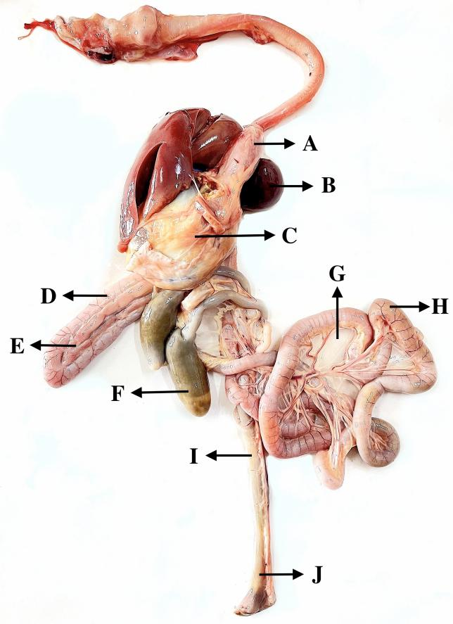
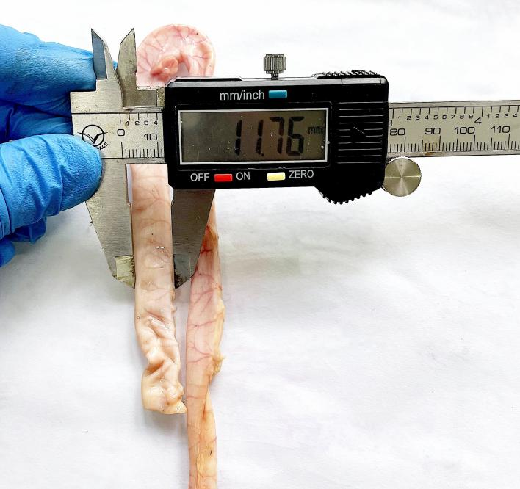
FIG. 1: PHOTOGRAPH SHOWING THE ALIMENTARY TRACT OF THE ZOAR FOWL A) PROVENTRICULUS B) SPLEEN
C) GIZZARD D) DUODENUM E) PANCREAS F) CAECUM G) MESENTERY H) JEJUNUM I) ILEUM J) COLORECTUM

FIG. 2: PHOTOGRAPH SHOWING THE DIAMETER OF THE DUODENUM OF THE ZOAR FOWL

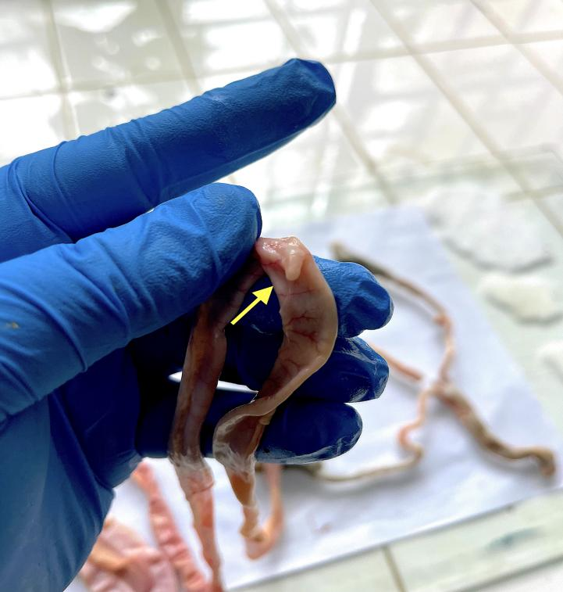
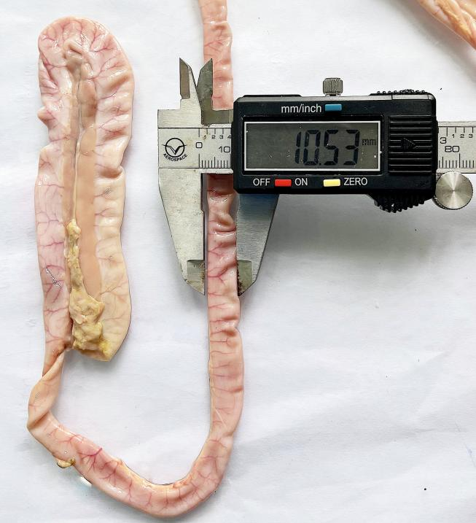
FIG. 3: PHOTOGRAPH SHOWING THE DIAMETER OF THE JEJUNUM OF
THE ZOAR FOWL

FIG. 4: PHOTOGRAPH SHOWING THE MECKEL’S DIVERTICULUM IN THE JEJUNUM OF THE ZOAR FOWL

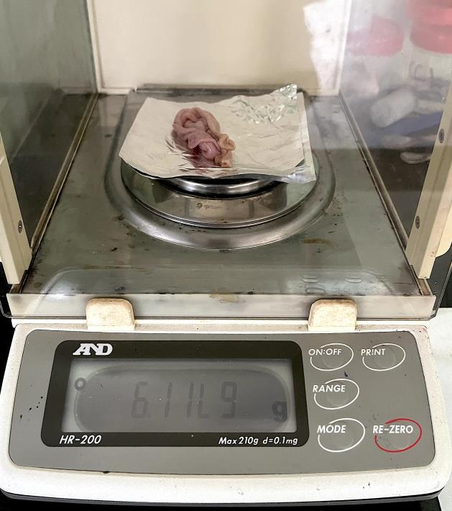
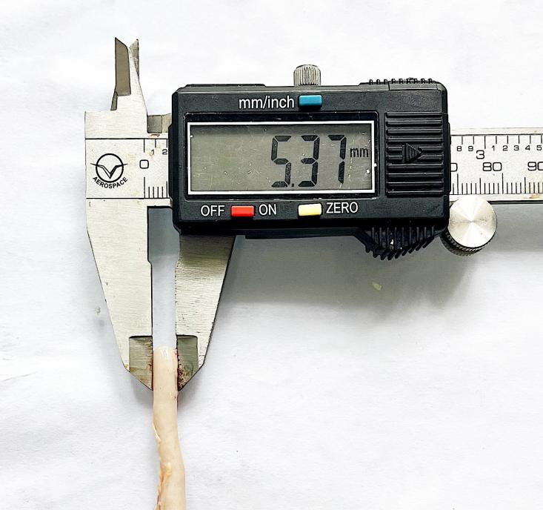
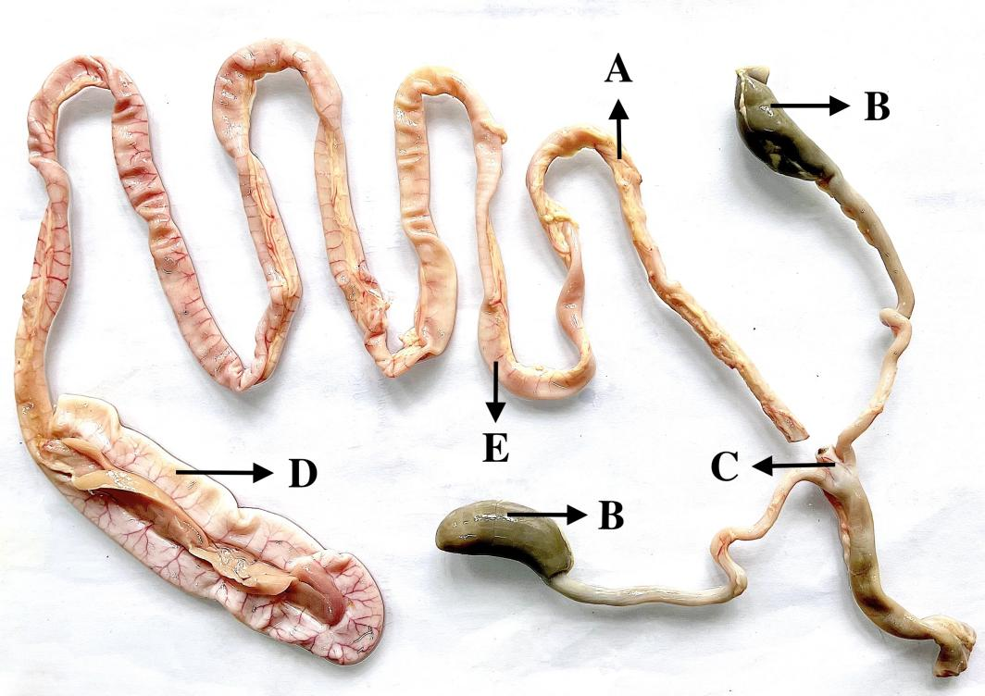
FIG. 6: PHOTOGRAPH SHOWING THE WEIGHT OF THE ILEUM OF
THE ZOAR FOWL

FIG. 7: PHOTOGRAPH SHOWING THE EXTERNAL DIAMETER OF THE ILEUM OF THE ZOAR FOWL

FIG. 5: PHOTOGRAPH SHOWING THE SMALL INTESTINE OF THE ZOAR FOWL A) ILEUM B) PAIRED CAECA C) ILEOCAECAL JUNCTION D) DUODENUM E) JEJUNUM

- CONCLUSION

It could be concluded that the Zoar fowl inhabiting the hilly terrain of Mizoram exhibited typical gross anatomical morphology of the small intestine.

ETHICAL APPROVAL
Approval of the ‘Institutional Animal Ethics Committee’ was obtained (CPCSEA Registration No.:1476/GO/Re/SL/2011/CCSEA, 29/07/2024).

REFERENCES
Ahmad, J.M., Mamde, C.S., Patil, V.S. and Khandare, S.M. (2012). Gross Anatomical Study of Small Intestine in Japanese Quail (Coturnix coturnix japonica), Indian J. Vet. Anat., 24(2): 82-83.
Dibner, J.J. and Richards, J.D. (2004). The Digestive System: Challenges and Opportunities. J. Appl. Poult. Res., 13: 86-93.
Dyce, K. M., Sack, W. O. and Wensing, C.G.J. (2002). Avian Anatomy. In: Textbook of Veterinary Anatomy. 3rd edn. W.B. Saunders Company, Philadelphia. Pp. 819 – 824.
Getty, R. (1975). Sisson and Grossman’s. The Anatomy of the Domestic Animals. 5th edn. W.B. Saunders Company, Philadelphia. USA. pp: 104-1882.
Ghosh, R.K. (2006). Primary Veterinary Anatomy. 4th edn. Publ., Current Books International, Kolkata. Pp. 159- 213.
Hamdi, H.A., El-Ghareeb, A.W., Zaher, M. and AbuAmod, F. (2013). Anatomical, Histological and Histochemical Adaptations of the Avian Alimentary Canal to Their Food Habits: II- Elanus caeruleus, Int. J. of Scientific and Engi. Res., 4(10): 1355-1363.
Hristov, H., Vladova, D., Kostov, D. and Dimitrov, R. (2017). Gross anatomy of some digestive organs of the domestic canary (Serinus canaria). Trakia J. Sci., 2: 106-112.
Hussein, S. and Rezk, H. (2016). Macro and microscopic characteristics of the gastrointestinal tract of the cattle egret (Bubulcus ibis) Int. J. Anat. Res., 4(2): 2162-2174
Igwebuike, U.M. and Eze, U.U. (2010). Morphological characteristics of the small intestine of the African Pied crow (Corvus albus). Anim. Res. Int., 7(1): 1116-1120.
Kalita, P.C. (2009). Gross morphometric, light-and electron microscopic studies on the small intestine of the kadaknath fowl. Ph.D. Thesis. Submitted to G.B.P.U.A.T. Pantnagar, Uttarakhand, India.
Khaleel, I.M. and Atiea, G.D. (2017). Morphological and Histochemical Study of Small Intestine in Indigenous Ducks (Anas platyrhynchos). J. of Agri. and Vety. Sci., doi: 10.9790/2380-1007021927
Khaleel, S.J. (2022). Anatomical, Histological, and Histochemical studies on Stomach and Intestine of Peahens-Pavo-cristatus, Ph.D.Thesis. Submitted to College of Veterinary Medicine, University of Baghdad. p81.
Klasing, K.C. (1998). Comparative Avian Nutrition. CAB International, Davis, CA.
Lalhlimpuia, C., Singh, N.S., Prva, M., Chaudhary, J.K. and Tolenkhomba, T.C. (2021). Phenotypic characterization of native chicken ‘Zoar’ of Mizoram, India in its home tract. J. Entomol. Zool. Stud., 9(1): 1756-1759.
Lalhlimpuia, C., Singh, N.S., Prva, M. and Tolenkhomba, T.C. (2021). Physical characterstics of Zoar: The indigenous chicken of Mizoram, India. J. Entomol. Zool. Stud., 9(1): 1982-1984.
Leopold, A.S. (1953). Intestinal Morphology of Gallinaceous Birds in Relation to Food Habits. J. Wildl. Manage., doi: https://doi.org/10.2307/3796715
Mahmud, M.A., Shaba, P., Shehu, S.A., Danmaigoro, A., Gana, J. and Abdussalam, W. (2015). Gross morphological and morphometric studies on digestive tracts of three nigerian indigenous genotypes of chicken with special reference to sexual dimorphism. J. World's Poult. Res., 5(2): 32-41.
McLelland. J. (1975). Aves Digestive System. In: Getty, R. Sisson and Grossman’s The Anatomy of the Domestic Animals. 5th Edn. Publ. W. B. Saunders Company, Philadelphia. Pp. 1857 – 1882.
Naser, R.A.A. and Khaleel, I.M. (2020). Morphometrical Study Of Small And Large Intestine In Adult Bronze Male Turkeys (Meleagris Gallopavo), Biochem. Cell. Arch., 20(2): 6335-6339.
Nasrin, M., Siddiqi, M.N.H., Masum, M.A. and Wares, M.A. (2012). Gross and histological studies of digestive tract of broilers during postnatal growth and development. J. Bangladesh Agril. Univ., 10(1): 69-77.
Nickel, R., Schummer, A. and Seiferle, E. (1977). Anatomy of the Domestic Birds. Vol V, Verlag Paul Parey. Berlin, Hamburg. p: 40-61.
OECD. (2023). https://www.oecd.org/en/countries/india.html
Saran, D., Meshram, B., Joshi, H., Singh, G. and Kumar, S. (2019). Gross Morphological Studies on the Digestive System of Guinea Fowl (Numida meleagris). Int. J. Livest. Res., doi: 10.5455/ijlr.20180907051353.
Sinha, R. (2023). Gross anatomical, histological and histochemical studies on gastrointestinal tract of japanese quail, kadaknath fowl and domestic turkey. Ph.D Thesis, Submitted to Sardar VallabhBhai Patel University of Agriculture & Technology, Uttar Pradesh, India.
Taylor, M. (2000). Anatomy and physiology of the gastrointestinal tract for the avian practitioner. In Birds. Post Grad Found in Vet. Sci., University of Sydney, Aust. Proc., 334: 107-113.
Verma, D., Malik, M.R., Parmar, M.L. and Taluja, J.S. (1998). Morphometry of intestine in pre and post hatch fowl (Gallus domesticus). Indian J. Vet. Anat., 10(1/2): 61-69.
Vukicevic, T.T., Babic, K., Mihelic, D. and Kantura, V.G. (2004). The anatomy of the digestive system of the ostrich (Struthiocamelus). Proceedings of the 11th Ostrich World Congress. pp: 66-69, 15-17 October-2004, Island Great Brijun, Croatia.
Wang, J.X. and Peng, K.M. (2008). Developmental Morphology of the Small Intestine of African Ostrich Chicks. Poult. Sci., 87: 2629 – 2635.
Yamauchi, K.E., Incharoen, T. and Yamauchi, K. (2010). The relationship between intestinal histology and function as shown by compensatory enlargement of remnant villi after midgut resection in chickens. Anatom. Rec., 293: 2071 – 2079.
Zaher, M., El-Ghareeb, A.W., Hamdi, H. and AbuAmod, F. (2012). Anatomical, histological and histochemical adaptations of the avian alimentary canal to their food habits: I-Coturnix coturnix. Life Sci. J., 9(3): 253-275.
Zghair, F.S. and Khaleel, I.M. (2019). Morphometrical Study of Small Intestine in the Adult Guinea Fowl (Numidia meleagris). Indian J. Nat. Sci., 9(53): 16965-16974.

