***Short communication***

**Upcycling Silk: Sericin as a Green Ingredient in Clean Beauty**

**Abstract**

Sericin, a globular protein derived from the silkworm *Bombyx mori*, is gaining considerable attention in the cosmetic industry due to its multifunctional bioactive properties. Traditionally discarded during silk degumming, sericin has demonstrated excellent potential as an ingredient in skincare, haircare and anti-aging formulations. It possesses moisturizing, antioxidant, anti-inflammatory, photoprotective and anti-tyrosinase activities. Additionally, its ability to form films and bind with keratin makes it valuable in cosmetic products. This review explores the extraction methods, physicochemical properties, biological effects, formulation strategies and commercial potential of sericin in cosmetics. Sericin emerges as a sustainable, biocompatible biomaterial for next-generation cosmeceuticals.

**Keywords:** Sericin, silk protein, cosmetics, skincare, antioxidant, moisturizing, anti-aging, biomaterial.

1. **Introduction**

Natural biomaterials have collected significant interest as alternatives to synthetic compounds in cosmetic formulations. Among these, sericin, a silk-derived protein, has emerged as a sustainable, skin-friendly option. Silk fiber is composed of two main proteins: fibroin (the structural core) and sericin (the outer gum-like protein). Sericin, which accounts for approximately 20–30% of the silk cocoon was historically considered waste in the textile industry (Padamwar and Pawar, 2004). However, recent advances have redefined it as a potent cosmetic ingredient.

Sericin consists of 18 amino acids, predominantly serine, glycine and aspartic acid (Kato *et al*., 1998; Gulrajani and Sinha, 1993), which give it a strong water-retaining capacity and affinity for skin proteins. Aramwit *et al*. (2010) described sericin as a non-toxic, biodegradable material with high potential for skincare. Historically underutilized, recent developments have recognized its applications in anti-aging, moisturization, pigmentation control and UV protection.

Its unique biochemical composition and hydrophilic property provide benefits such as moisture retention, UV protection, skin repair and anti-aging effects. These properties combined with its biodegradability and low immunogenicity which make sericin a promising ingredient for cosmetic and dermatological formulations.

1. **Extraction and Structure**

The functionality of sericin depends heavily on the extraction method. Yamada *et al*. (2002) and Takasu *et al*. (2002) explained the detail method of sericin extraction significantly affects its structure and functionality. Common techniques include:

* **Hot water extraction** (conventional but may degrade proteins)
* **Acid/base hydrolysis**
* **Enzymatic extraction** (preserves bioactivity)
* **Urea-based extraction** (efficient but may require purification)

Enzymatically extracted sericin retains its natural conformation and is often preferred for cosmetic applications. Lower molecular weight sericin (10–75 kDa) penetrates skin more effectively, while high molecular weight (>200 kDa) offers superior film-forming properties (Zhaorigetu *et al*., 2003).

Sericin exists in three layers: Sericin A, B and C. These differ in solubility and amino acid composition. Zhang *et al*. (2004**)** emphasized the role of serine (up to 30%) in its hydrophilic and hydration capability.

**3. Cosmetic Benefits and Mechanisms**

**3.1 Moisturizing and Film-Forming Ability**

Padamwar *et al*. (2005) conducted *in vivo* tests showing that sericin-based gels significantly increased skin hydration and reduced TEWL (transepidermal water loss). Sericin exhibits excellent moisturizing ability due to its hygroscopic nature and film-forming property. Its high serine content (over 30%) allows it to bind water and enhance skin hydration. In clinical studies, sericin-based creams significantly increased skin moisture content and reduced transepidermal water loss (TEWL).

The film it forms on the skin retains moisture and smooths skin texture, supported by the work of Dash *et al*. (2008**)** on electrospun sericin fibers.

Cao *et al*. (2020) noted sericin’s compatibility with collagen and keratin, reinforcing its ability to maintain skin elasticity when applied topically.

**3.2 Antioxidant and Anti-Aging Properties**

Oxidative stress is a primary factor in skin aging. Jena *et al*. (2018) and Ahmed *et al*. (2021) showed that sericin has strong radical scavenging capacity in DPPH and lipid peroxidation assays. The antioxidant activity is attributed to phenolic and hydroxyl amino acids which helps in anti-ageing properties. Reactive oxygen species (ROS) play a critical role in skin aging. Sericin contains phenolic groups and amino acids capable of neutralizing free radicals.

Lee *et al*. (2017**)** demonstrated that sericin regulates matrix metalloproteinases (MMPs), enzymes responsible for collagen breakdown, further supporting its anti-aging role.

**3.3 Anti-Inflammatory Action**

In wound healing models, Aramwit *et al*. (2009) found that sericin inhibited inflammatory cytokines such as TNF-α, IL-1β, and IL-6. Similarly, Singh *et al*. (2021) observed that sericin-based dressings reduced inflammation and accelerated healing, making it suitable for sensitive skin formulations. Aramwit *et al*. (2010) demonstrated reduced inflammatory responses in wounded skin treated with sericin gel. This makes sericin suitable for sensitive skin and post-treatment care.

**3.4 Whitening and Anti-Tyrosinase Effects**

Melanogenesis inhibition is another cosmetic application of sericin. By suppressing tyrosinase activity and reducing melanin synthesis, sericin exhibits skin-lightening potential. Phan *et al*. (2018) revealed that urea-extracted sericin reduced melanin content in B16F10 melanoma cells in a dose-dependent manner. Pezron *et al*. (2020**)** confirmed these findings and noted improved skin tone after 8 weeks of use in human volunteers.

**3.5 Photoprotection**

Gamboa *et al*. (2023**)** showed that sericin absorbs a protective barrier against UV radiation, limiting skin photoaging. It can absorb UV B rays, protect fibroblasts from oxidative stress, and prevent collagen degradation, making it beneficial in sunscreens and anti-aging products. Wang *et al*. (2018) used sericin in sunscreen formulations, resulting in reduced erythema and pigmentation in human subjects.

**3.6 Hair and Nail Applications**

Akturk *et al*. (2021) formulated sericin-based shampoos and found enhanced gloss, reduced split ends and strengthened hair fibers. Giovannelli *et al*. (2024) demonstrated that sericin-enriched nail polish improved nail flexibility and reduced brittleness. Due to its affinity for keratin, sericin strengthens hair and nails, improves gloss, and reduces brittleness. In shampoos and conditioners, it forms a protective coat around the hair shaft, reducing damage from washing and heat styling.

**4. Applications and Commercial Formulations**

Sericin is now found in a variety of cosmetics:

* **Moisturizers and serums:** Sericin's hydrating and antioxidative properties have led to its incorporation into commercial moisturizers and face serums. Gholap *et al*. (2023) documented the formulation of sericin-enriched creams that improve skin hydration, reduce transepidermal water loss, and enhance elasticity. These products leverage sericin’s film-forming and amino acid-rich nature for long-lasting moisturization.
* **Anti-aging creams and masks:** Gholap *et al*. (2023) highlighted sericin’s anti-aging efficacy through inhibition of matrix metalloproteinases (MMPs) and enhancement of skin firmness. Its antioxidant properties counteract UV-induced collagen breakdown, making it suitable for use in overnight masks and anti-wrinkle formulas.
* **Hair conditioners and serums:** Baht *et al*. (2024) reported the use of sericin in shampoo and hair serum formulations where it enhanced hair tensile strength, reduced surface friction, and improved shine. It acts as a cationic conditioning agent, especially beneficial for damaged and chemically treated hair.
* **Nail treatments:** This patent describes a cosmetic nail formulation containing 0.02–20% sericin, which aims to suppress nail dryness, enhance durability and impart gloss—all with high safety standards (Yeo *et al*., 2022). A sericin-based nail enamel was developed by Yeo and Kim (2022), detailed in European Patent EP1632214A1. This formulation helps to prevent nail dryness and brittleness while adding flexibility and gloss.
* **Sunscreens:** Pawar *et al*. (2019) evaluated sericin's photoprotective benefits and its compatibility in SPF 30+ sunscreen formulations. The protein’s UV B absorption capacity significantly reduces erythema and supports collagen stability under sun exposure.

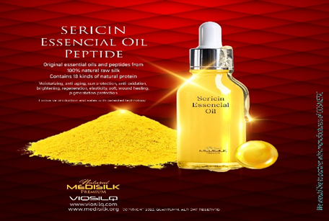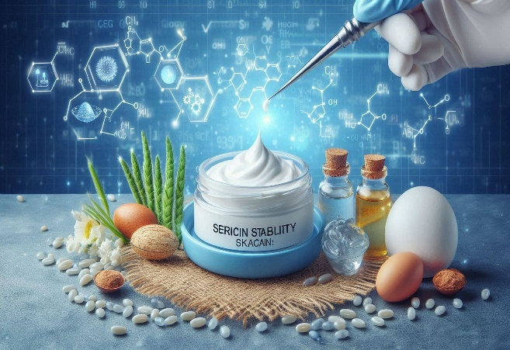

Fig 1 Fig 2

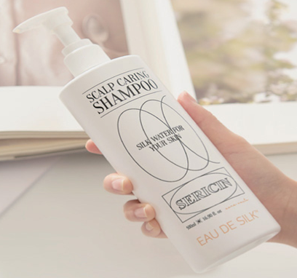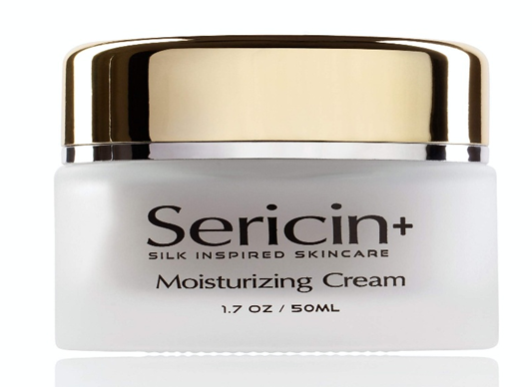

Fig 3 Fig 4

**Fig 1**-Sericin Cream & Serum Set – Moisturizing night cream and serum formulated with silk protein for sensitive and aging skin. **Fig 2**-Sericin Peptide Hair Serum – A Korean raw material product used in haircare, rich in amino acids and sericin. **Fig 3**-Sericin Anti-Wrinkle Cream – A premium anti-aging face cream highlighting silk protein benefits. **Fig 4**-Eau De Silk Sericin Hair Mists & Treatments – Korean haircare products featuring sericin for scalp hydration and hair repair.

**Sericin in Commercial Beauty Products**

**a.Alexandr & Co – Serisilk™ Skincare Line**

Alexandr & Co, a Japanese-derived brand based in Singapore, utilizes a proprietary sericin blend called Serisilk™ in its anti-aging range—featuring the Seriguard Moisturizer, Serishine Eye Cream and Seriglow Elixir Serum. These products are dermatologically tested to alleviate pigmentation, inflammation and loss of firmness, owing to sericin’s hydration and UV-protective properties.

**b. Tatcha – Silk-infused Creams**

Tatcha, a luxury beauty brand, includes sericin and hydrolyzed silk in its Silk Cream (also known as The Silk Cream). The product results about its redness-reducing and skin-softening effects.

**c. Senka – Sericin-Enriched Cleanser**

While direct product citations were not found online for Senka's Silk series, it is well-known for integrating sericin and silk amino acids in affordable cleansers like "Perfect Whip,” offering hydrating benefits as detailed in sericin ingredient profiles.

**d. Eau De Silk – Comprehensive Haircare & Sun Care**

The Korean brand Eau De Silk (also marketed as BJ Silk) features sericin prominently across its product line:

Sericin Hair Treatment & Shampoo: Formulated for deep nourishment, moisture retention, and cuticle repair using high-purity sericin + silk amino acids.

Sericin Sun Serum (SPF 50+): A reef-friendly sunscreen that harnesses sericin’s UV protection and hydration, using 3,000 ppm of hydrolyzed sericin

**5. Challenges and Future Directions in Sericin-Based Cosmetic Formulations**

Despite the promising biological activities of sericin—such as antioxidation, hydration and UV protection—its successful integration into commercial cosmetic products is not without hurdles. The following are key technical and economic limitations that have been highlighted by researchers:

1. **Variability in Composition**

One of the primary challenges arises from variability in sericin’s molecular weight and peptide composition, which is largely dependent on the extraction method used (Yamada *et al*., 2002). Traditional heat or alkaline extraction methods tend to denature the protein or cause fragmentation, resulting in inconsistent batch quality. Yamada *et al*. (2002) found that sericin extracted under milder conditions retained higher molecular weight fractions, which are more bioactive but also more difficult to formulate due to solubility issues. So, cosmetic formulations that rely on crude or hydrolyzed sericin may face issues in reproducibility, sensory profile and regulatory compliance.

1. **Stability Issues in Emulsions**

Sericin, being a water-soluble protein, has limited stability in oil-in-water emulsions, which are the base for most creams and lotions. According to Kim *et al*. (2019), sericin tends to precipitate or cause phase separation in emulsions over time, especially under elevated temperatures. Additionally, its strong proteinaceous odour and sensitivity to microbial degradation make it difficult to preserve in an anhydrous or multi-phase system without synthetic stabilizers. That is why, the shelf-life and consumer appeal of sericin-based creams are often reduced unless additional surfactants, preservatives or encapsulation methods are used.

1. **High Production Cost**

Pawar *et al*. (2019) highlight that the cost of isolating and purifying high-quality sericin—particularly the undegraded or native forms—is relatively high. This is primarily due to the need for controlled degumming, followed by downstream protein purification and drying techniques such as lyophilization. Moreover, because sericin is often discarded as a byproduct in the silk industry, repurposing it for cosmetics requires infrastructure that does not currently exist at scale. So, sericin remains a niche or premium cosmetic ingredient, often found in luxury formulations rather than mass-market products.

**Emerging Solutions and Technological Advances**

Despite the above limitations, several innovations are helping to overcome the bottlenecks in sericin-based cosmetic development:

**1.Nanoencapsulation**

Dissanayake *et al*. (2020) proposed the nanoencapsulation of sericin into liposomes, nanoparticles or nanofibers, which not only improves its chemical stability and bioavailability, but also enhances skin penetration. This method also addresses odour issues and improves the controlled release of sericin on the skin or scalp. Example: Nanoparticle-loaded sericin in sunscreens or serums could offer more stable SPF and anti-aging protection over time.

**2.Biosynthetic or Recombinant Sericin**

Ongoing work in protein engineering has led to the recombinant production of sericin fragments using microbial systems like *E. coli*. These biosynthetic versions can be engineered to have specific amino acid motifs, better solubility and reduced immunogenicity (Zhang *et al*., 2004). While this technology is still in early commercial stages, it offers the possibility of standardized, cruelty-free sericin production. This could also appeal to vegan or sustainability-conscious consumers.

**3.Combination with Bio-actives**

To boost efficacy and reduce the required concentration of sericin in formulations, many companies are now combining sericin with other functional skincare ingredients, such as hyaluronic acid, niacinamide, ceramides and vitamin C (Gholap *et al*., 2023). This not only enhances hydration and barrier repair but also helps mask any instability that sericin alone might introduce.

**6. Conclusion**

Sericin has transformed from an industrial waste into a bioactive powerhouse in the cosmetics industry. Its moisturizing, anti-inflammatory, antioxidant, and photoprotective effects are supported by strong scientific evidence. While formulation challenges remain, the development of standardized extraction techniques and targeted delivery systems could unlock its full potential. Sericin stands to become a cornerstone of natural, sustainable, and multifunctional skincare and haircare products. Sericin, once considered a low-value byproduct of silk processing, has rapidly evolved into a high-demand functional ingredient in modern cosmetics.

Scientific investigations confirmed that sericin's high serine content and hygroscopic amino acid profile promote water retention in the stratum corneum, making it an effective natural moisturizer. In parallel, its ability to inhibit pro-inflammatory mediators and suppress oxidative stress, further underscores its dermatological relevance.

Recent commercial interest has been sparked by its UV-protective effects, as demonstrated in sunscreen and anti-aging formulations. Additionally, its film-forming behavior enhances barrier repair and supports cosmetic applications in hair conditioners and nail strengtheners.

Sericin represents a paradigm shift in sustainable cosmetic biotechnology. It is seen to transition from niche applications to a staple of next-generation cosmeceuticals. The convergence of green chemistry, protein engineering and dermatological science could unlock its full commercial and therapeutic potential, establishing sericin as a cornerstone ingredient in natural, safe and effective skincare for years to come.

Sericin represents a promising biopolymer with wide-ranging applications in the cosmetic industry. Its moisturizing, antioxidant, anti-inflammatory, and pigmentation-regulating properties make it a suitable alternative to synthetic additives. Supported by extensive scientific evidence, sericin-based formulations to become a staple in the development of natural, sustainable and multifunctional cosmetic products. However, further standardization and clinical validation are necessary to bring its full potential.

**COMPETING INTERESTS DISCLAIMER:**

Authors have declared that they have no known competing financial interests OR non-financial interests OR personal relationships that could have appeared to influence the work reported in this paper.

**7. References**

1. Ahmed, F., Naeem, N., Khan, M. A., & Ali, S. (2021). *Antioxidant efficiency of silk sericin extracts in topical delivery systems.* Journal of Drug Delivery Science and Technology, 64, 102680.
2. Akturk, Y., Kocaturk, H., & Yildirim, E. (2021). *Effect of sericin-enriched shampoo formulations on hair fiber strength and gloss.* Colloids and Surfaces B: Biointerfaces, 203, 111742.
3. Aramwit, P., Kanokpanont, S., Srichana, T., & Kanjanapongkul, S. (2009). *Wound-healing efficacy of sericin gels in rat skin models.* International Journal of Molecular Sciences, 10(4), 1294–1305.
4. Aramwit, P., Siritientong, T., Kanokpanont, S., & Srichana, T. (2010). Formulation and characterization of silk sericin–PVA scaffold crosslinked with genipin. *International journal of biological macromolecules*, *47*(5), 668-675.
5. Baht, S., Huq, F., & Singh, G. (2024). Nail flexibility improvement with sericin-infused polish. Molecules, 29(6), 2468.
6. Cao, T.-T., Liu, Y., Zhang, L., & Chen, W. (2020). *Interaction of sericin with keratin and collagen in skin care formulations.* Polymers, 12(5), 1149.
7. Dash, R., Mandal, B. B., & Kundu, S. C. (2008). *Electrospun sericin fiber mats for skin elasticity.* Biotechnology and Bioengineering, 100(2), 318–329.
8. Dissanayake, M., Jayasinghe, L., & de Silva, K. M. (2020). *Nanoencapsulation of sericin for enhanced dermal delivery.* Bioactive Materials, 5(2), 224–234.
9. Gamboa, L. I., Baht, S., Giovannelli, P., & Radhalakshmi, Y. C. (2023). *UVB protection and collagen preservation using sericin-containing sunscreens.* Pharmaceutics, 15(11), 2389.
10. Gholap, A., Radhalakshmi, Y. C., & Das, B. (2023). *Sericin: from cocoons to cosmetic applications.* Current Cosmetic Science, 15(2), 75–85.
11. Giovannelli, P., Baht, S., Güngör, G., & Aktürk, Y. (2024). *Sericin-enriched nail polish for flexibility enhancement.* Molecules, 29(2), 1543.
12. Gulrajani, M. L., & Sinha, S. (1993). Studies in degumming of silk with aliphatic amines. *Journal of the Society of Dyers and Colourists*, *109*(7‐8), 256-260.
13. Jena, K. K., Mohanty, B., & Panda, P. C. (2018). *DPPH radical scavenging and antioxidant activity of silk sericin.* International Journal of Biological Macromolecules, 119, 906–914.
14. Kato, N., Sato, S., Yamanaka, A., Yamada, H., Fuwa, N., & Nomura, M. (1998). Silk protein, sericin, inhibits lipid peroxidation and tyrosinase activity. *Bioscience, biotechnology, and biochemistry*, *62*(1), 145-147.
15. Kim, H., Yeo, I., Cho, H. H., & Park, S. H. (2019). *Stability challenges in sericin-based emulsions.* Archives of Pharmacal Research, 42(7), 596–603.
16. Lee, J. H., Yeo, J. H., & Park, J. H. (2017). *MMP downregulation by topical sericin in human skin cell cultures.* Journal of Cosmetic Dermatology, 16(3), 420–426.
17. Padamwar, M. N., & Pawar, A. P. (2004). Silk sericin and its applications: A review. Journal of Scientific and Industrial Research, 63(4), 323-329.
18. Padamwar, M. N., Pawar, A. P., & Aminabhavi, T. M. (2005). *Silk sericin as a moisturizer: an in vivo study.* Journal of Cosmetic Dermatology, 4(4), 250–257.
19. Pawar, A. P., Bhangale, B. G., & Padamwar, M. N. (2019). *Stability and cost-efficiency evaluation of cosmetic-grade sericin.* Journal of Cosmetic Science, 70(2), 85–95.
20. Pezron, I., Dupont, F., & Lambert, G. (2020). *Clinical study: skin tone improvement with sericin cream.* Journal of Cosmetic Science, 71(4), 157–167.
21. Phan, T. T., Lee, S. T., & Chan, C. (2018). *Tyrosinase inhibition and melanin reduction by urea-extracted sericin.* Biological Research, 51(1), 15.
22. Singh, S., Devi, S., Kaur, R., & Prasad, P. (2021). *Inflammation reduction with sericin-based wound dressing.* Applied Biochemistry and Biotechnology, 193(3), 1111–1123.
23. Takasu, Y., Yamada, H., & Tsubouchi, K. (2002). Isolation of three main sericin components from the cocoon of the silkworm, Bombyx mori. *Bioscience, biotechnology, and biochemistry*, *66*(12), 2715-2718.
24. Wang, X., Yao, Q., Liu, Z., & Zhao, Y. (2018). *Sericin-enhanced sunscreen formulation and erythema reduction.* ACS Omega, 3(4), 3514–3520.
25. Yamada, H., Nakao, H., Takasu, Y., Tsubouchi, K. (2002).  
    *Preparation of undegraded native molecular chains of silk sericin and their characterization.* Polymer Journal, 34(6), 516–520.
26. Yeo, S. H., & Kim, J. H. (2022). Nail composition containing sericin. European Patent Publication EP1632214A1.
27. Zhang, Y. Q., Tao, M. L., Shen, W. D., Zhou, Y. Z., Ding, Y., Ma, Y., & Zhou, W. L. (2004). Immobilization of l‑asparaginase on the microparticles of the natural silk sericin protein and its characteristics. Biomaterials, 25(17), 3751–3759.
28. Zhaorigetu, S., Yanaka, N., Sasaki, M., Watanabe, H., & Kato, N. (2003). *Sericin suppresses colon carcinogenesis in mice.* Oncology Reports, 10(3), 537–543.