Original Research Article
Impact of IIPR-Pulse Demonstrations on Popularisation of Kharif Pulses in Darrang District of Assam

Abstract:
Krishi Vigyan Kendra, Darrang conducted IIPR Pulse demonstration programme on blackgram variety SBC 40 and Green gram variety SGC 16 during Kharif 2024-25 on an area of 30.0 ha for blackgram and 10.0 ha for Green gram under rainfed conditions. There was a wide yield gap between the potential and demonstration grain yields in both the crops blackgram and green gram crop mainly due to technology and extension gaps. Improved crop management practices recorded the highest mean seed yield of 7.7 q ha-1 and 7.5 q ha⁻¹ which was 29.87 and 33.33 per cent higher than the yield obtained with farmers practice (5.9 q ha⁻¹) & (5.6 q ha-¹) in the year 2024-25 respectively. The average technology gap was recorded 2.3 q/ha and 2.5 q/ha in case of blackgram var. SBC40 in 2024-25 respectively while average extension gap was recorded 1.8 q/ha and 1.9 q/ha. Due to adoption of improved package of practices, demonstration plots recorded higher average seed yield over local check. It was further observed that in terms of economics, black gram crop recorded higher net returns/ha compared to farmer’s practice. The benefit cost ratio was 2.2 and 2.65, respectively, during kharif 2024 in demonstration plots of black gram and green gram respectively. The percent technology index varied between 23 and 25 per cent indicating urgent need to motivate the farmers to adopt economical viable technologies for increasing production, productivity and profitability of pulse crops.
Keywords: IIPR, NEH Region, Pulses
Introduction:
Pulses are considered as an indispensable constituent of Indian diet. The major pulses grown in Assam are black gram, green gram, linseed, lentil, peas, beans etc. Assam’s share India’s pulses production is very negligible. The area coverage is only 2.97 per cent of the gross cropped area in the year 2008-09. Area of pulses in Assam rose to 128 thousand hectares in 2001-02 from 113 thousand hectares in 1990-91, but after that it was declined to 107 thousand hectares on 2004-05 to 105 thousand hectares in 2007-08. Similarly, production also rose to 71 thousand M.T. in 2001-02 from 49 thousand M.T in 1990-91. It was increased to 57 thousand M.T. in 2004-05 and further slightly increased to 58 thousand M.T.in 2007-08. The cropping pattern of the state reveals that the farmers usually pay top priority in growing food crops and pulses and other crops are grown in small patches where food crops are not grown. In Assam pulses are generally grown in rabi season. However, some varieties are grown in kharif season in certain districts. But the area under such varieties is very small. Nearly 94 per cent of total pulses cropped area comes under rabi pulses. National Pulse Development Programmes In order to increase the production of pulses in the country the government of India introduced National Pulses Development Programme and Special Food Production Programme during the Seven Five Year Plan period. It was envisages to develop three basic foundations: Productive development package, effective delivery services along with remunerative prices and suitable market. From 1994-95 all these programmes have been merged in to a single scheme known as National Pulse Development Programme (NPDP).The scheme lays emphasis on increase in area through multiple/double cropping and inter cropping to increase the production level of pulses. Attention has been paid to improvement of technology, distribution of HYV seeds, fertilizers, plant protection chemicals and other modern inputs. The agriculture in Assam has tremendous scope of growth and it is witnessing a number of positive developments. The department of agriculture has been implementing various development programmes for augmenting the agriculture productivity under different agro-climatic conditions of the state. For achieving this, it is important to adopt agricultural technologies with emphasis on efficient utilization and management of essential inputs for obtaining maximum economic returns.
Indian Institute of Pulses Research (IIPR) was established as national Institute by the Indian Council of Agricultural Research (ICAR) for basic, strategic and applied research on major pulse crops. The Institute is involved in the generation of basic information, development of high yielding varieties and appropriate production and protection technologies, production of breeder seeds, demonstration and transfer of technologies, and strategic coordination of pulses research through a wide network of testing centres across the country.
Materials and Method:
The study was conducted by Krishi Vigyan Kendra, Darrang, Assam Agricultural University to assess the effect of IIPR Pulse demonstration programme on kharif pulses (Blackgram & Greengram) crop in mostly Char areas of Darrang district during kharif season 2024-25. The demonstrations were being conducted in farmers’ field at five different villages (Barthekerabari, 2 no. Bargarakhuti, Chereng chapori, lengerimari, Gadhowa Chapori) of Darrang district during 2024-25. District Darrang comes under North Bank Plain Agro climatic zone of Assam. The soil of the district ranges from old alluvial to new alluvial type. The soil is sandy to sandy loam in texture and acidic in reaction and is characterized by medium to high organic carbon, low to medium phosphorus and potash content. During the study, total area of 30.0 ha was covered under blackgram and 10.0 ha was covered under greengram crop and the varieties used by the farmers in the nearby field was kept as farmer’s practices. Before conducting IIPR pulse demonstrations, a list of farmers was prepared from group meeting and specific skill training and awareness programmes were arranged by KVK officials at different locations to make the farmers aware about the scientific cultivation practices of the crop. High yielding blackgram variety SBC 40 and greengram variety SGC-16 was used for the study. SBC 40 is short duration blackgram variety (70 – 75days) which has high yield potential (11.89 q/ha) and protein content (25.20 %) with resistance to Cercospora Leaf Spot (CLS)& Yellow Mosaic Virus (YMV), moderate resistance to Web Blight etc. Similarly, Greengram variety SGC-16 is also a short duration greengram variety (65-70 days), with high yield potential (12-13 q/ha) suitable for both kharif and summer season and resistant to CLS and YMV.The need-based inputs were supplied to the selected farmers and stage wise monitoring of the demonstration plots by KVK Scientists ensured proper guidance to the farmers. The sowing of the crop was done during kharif season (mid-August to -mid-September) under rain fed condition in both the years. Crop yield as well other morphological data were recorded from the demonstration and check plots at the time of harvest. The economic-parameters (gross return, net return and B:C ratio) were worked out on the basis of prevailing market prices of inputs and minimum support prices of outputs. The yield increase in demonstrations over farmers’ practice was calculated by using the following formula as suggested by Yadav et al. (2004).
Percent increase in yield over farmers’ practice = Demonstration yield – farmers’ plot yield / Farmers’ plot yield x 100.
Estimation of extension gap, technological gap and technological index along with the benefit cost ratio by following (Samui et al., 2000) as given below:
Technology gap = Potential yield-Demonstration yield
Extension gap = Demonstration yield-Farmer’s yield
Technology index = (Technology gap/potential yield) x 100
Results and discussions:
From the above study, it was observed that the high yielding blackgram variety SBC 40 as well as greengram variety SGC 16 out yield the farmers practice in the same farming situation. The seed yield of blackgram for the season 2024-25 under demonstration was recorded to be as 7.7 q ha⁻¹ against the farmers practice 5.9 q ha⁻¹ and 7.50 q/ha for greengram against farmers practice 5.6 q/ha. The percent increase in yield of demonstration plots over farmers’ plots ranged from 29.87 percent in Blackgram and 33.33 percent in greengram during 2024-25.
Same results for the crop blackgram under IIPR Pulse demonstration was recorded earlier by Mary et.al (2024). The poor productivity in farmers practice might be mainly due to factors like use of nondescript local variety and low level of agronomic management in addition to non-availability of resources in time. The result clearly depicts the positive effects of demonstrations over the existing practices towards enhancing the yield of blackgram and greengram in Darrang district.
Table 1: Influence of IIPR Pulse demonstration yield, technology gap, extension gap, technology index in blackgram variety SBC40 and green gram variety SGC 16
Crop | Year | Potential yield  (q/ha) | IIPR demo (q/ha) | FP (q/ha) | Percent increase in yield over check | Tech gap (qha⁻¹ ) | Extension gap (qha-1) | Technology index (%)
Blackgram | 2024-25 | 10.0 | 7.7 | 5.9 | 29.87 | 2.3 | 1.8 | 23
Greengram | 2024-25 | 10.0 | 7.5 | 5.6 | 33.33 | 2.5 | 1.9 | 25

Chart1: Influence of IIPR Pulse demonstration yield, technology gap, extension gap, technology index in blackgram variety SBC40 and green gram variety SGC 16

Analysis of Technology Gap:
In the present study, technology gap is recorded to be 2.3 qha⁻¹ and 2.5 qha⁻¹ in Blackgram and greengram respectively. The observed technological gap may be attributed to the dissimilarity in the soil fertility status, insect pest attack and erratic weather conditions that prevailed during crop season at different locations.(Table 1 and Chart 1)
Analysis of Extension Gap:
Extension gap is gap between yield of demonstrated plot and farmers’ practice. Extension gap is recorded to be 1.8 qha⁻¹& 1.9 q ha⁻¹ in Blackgram & Greengram respectively which is solely due to non-adoption of high yielding varieties and delayed sowing (1st week of October). Maximum use of the latest production technologies with high yielding recommended varieties of pulse crops will subsequently help in reducing this alarming trend of galloping extension gap.(Table 1 and Chart 1)
Analysis of Technology Index:
Technology index indicates the feasibility of the evolved technology in the farmers’ field. The lower value of technology index, higher is the feasibility of the improved technology. It was observed that the mean technology index of 23 percent & 25 percent was recorded in IIPR Pulse demonstration programmes under the clusters, which showed the efficacy of good performance of technical interventions. The existence of strong gap in technology generated by the research institutes and technology dissemination to the farmers can only be overcome by IIPR Pulse demonstration programme which can accelerate the level of adoption of improved technologies and help in attaining self-sufficiency in pulse production and getting more income of farmers.(Table 1 and Chart 1)
Economic analysis of the data:
The present study showed thatdue to adoption of improved package of practices, demonstration plots of both the crop recorded higher average seed yield over local check. (Table 2 and 3; Chart 2 and 3) It was further observed that in terms of economics, black gram crop recorded higher net returns/ha compared to farmer’s practice i.e. Rs. 23,138.00. Similar case was seen in the economics of green gram. The benefit cost ratio of black gram and green gram was recorded as 2.2 and 2.65, respectively.

Table 2: Economic analysis of the data of crop Black gram
Crop | Demonstrated Plot (variety name) | Yield(q/ha) | Gross Cost (Rs/ha) | Gross Return  (Rs./ha.) | Net Return (Rs./ha.) | B:C Ratio
Blackgram (Technology) | SBC-40 | 7.66 | 18750.00 | 41,888.00 | 23,138.00 | 2.2
Blackgram  (Farmers’ Practise) | Local | 5.90 | 18750.00 | 32,263.56 | 13513.56 | 1.72
Table 3: Economic analysis of the data of crop Green gram
Crop | Demonstrated Plot (variety name) | Yield(q/ha) | Gross Cost (Rs/ha) | Gross Return  (Rs./ha.) | Net Return (Rs./ha.) | B:C Ratio
Greengram (Technology) | SGC-16 | 7.5 | 19800.00 | 52,500.00 | 32,700.00 | 2.65
Greengram (Farmers’ Practise) | Local | 5.60 | 19800.00 | 39200.00 | 19400.00 | 1.97

The economic analysis of the data for the year 2024-25 showed better performance of the demonstration over the check plot. The gross return, net return and B.C ratio of the crop blackgram for the year is recorded to be Rs. 41,888.00,Rs. 23,138.00, 2.2(2024-25) & for Greengram Rs. 52,500.00, Rs. 32,700.00& 2.65 (2024-25) respectively. While in farmers plot the results obtained are Gross return (Rs. 32,263.56), Net return (Rs. 13513.56), B: C ratio 1.72 for the crop Blackgram and Gross return (Rs. 39200.00), Net return (Rs. 19400.00), B: C ratio 1.97 for the crop Greengram.
Chart 2: Economic analysis of the data of crop Black gram

Chart 3: Economic analysis of the data of crop Green gram

Other morpho physiological traits
Table 4: Morpho physiological characters of Blackgram variety SBC 40 and SGC 16 under IIPR Pulse Demonstration programme for the year 2024-25

Year | Date of sowing | Date of harvesting | Duration(days) | Plant Heights  (cm) | No. of pods per plants | No. of seeds per pod
2024-25 | 10.10.2024 | 07.01.2025 | 87 | 50.5 | 26.5 | 6.8
2024-25 | 04.10.2024 | 01.01.2025 | 87 | 47.5 | 24.5 | 6.6

Image 1: Extension activities conducted by KVK, Darrang under IIPR-Pulse Demonstration programme
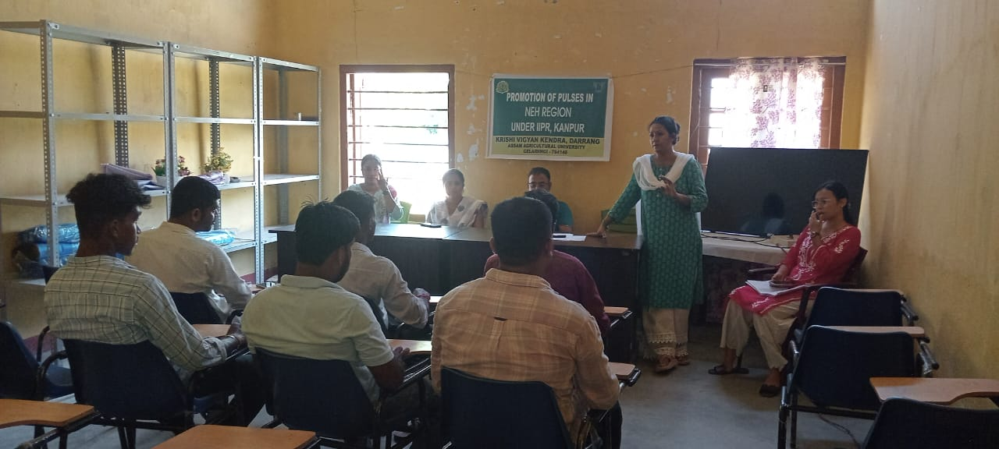 | 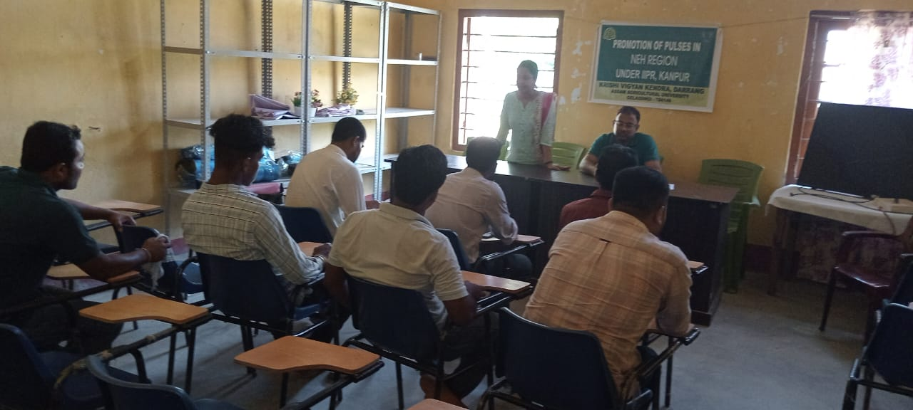
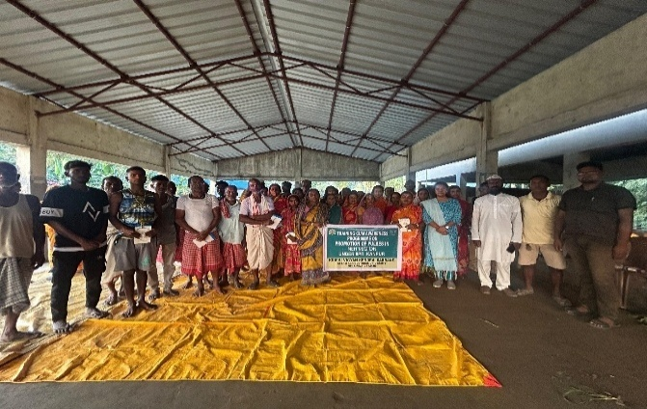 | 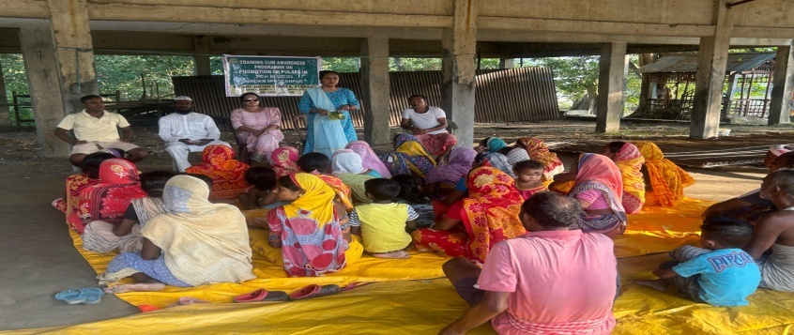
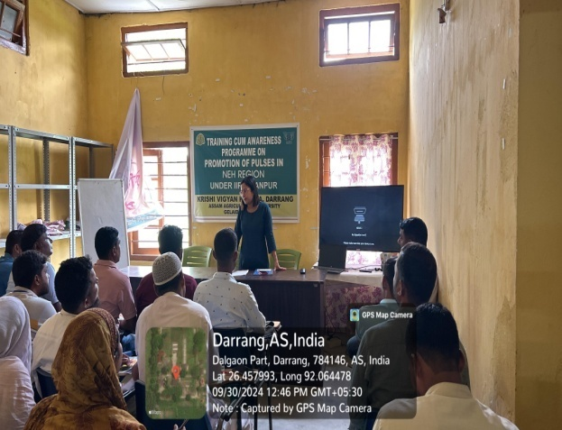 | 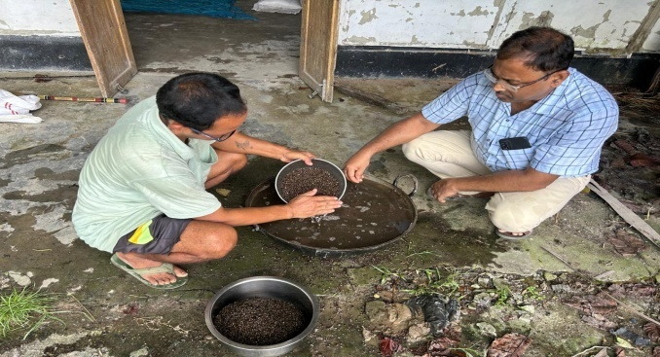
Image 2 : Demonstration programme conducted by KVK, Darrang under IIPR-Pulse Demonstration programme
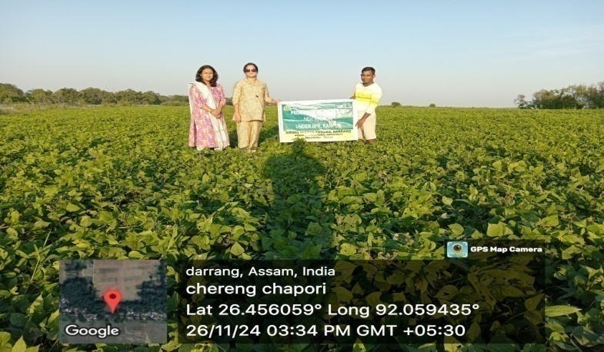 | 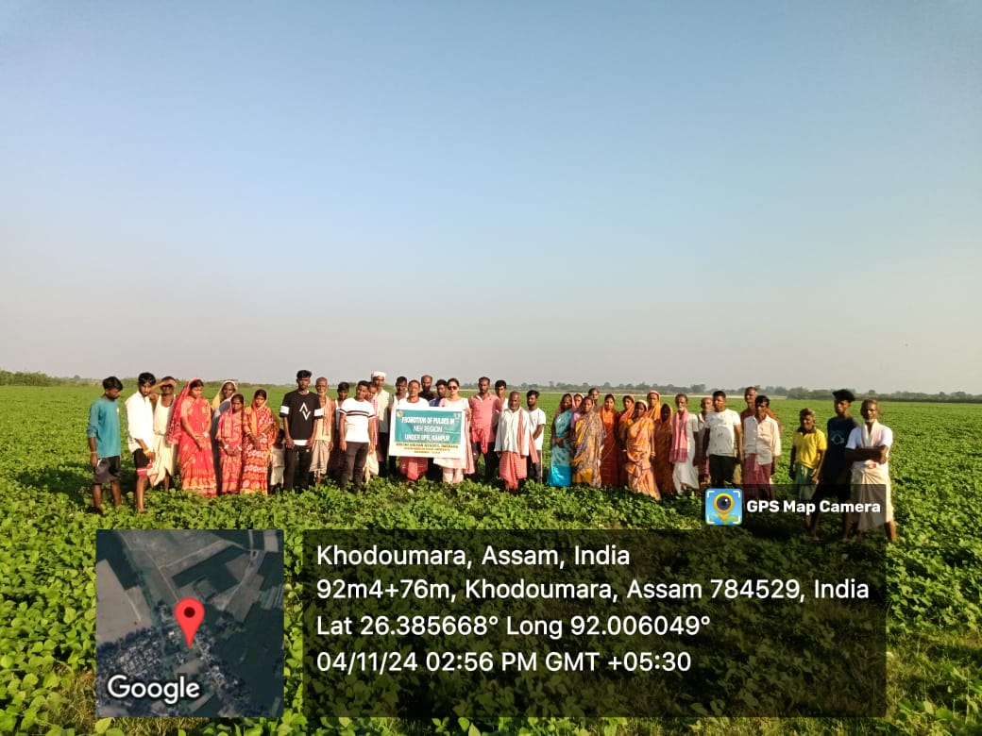
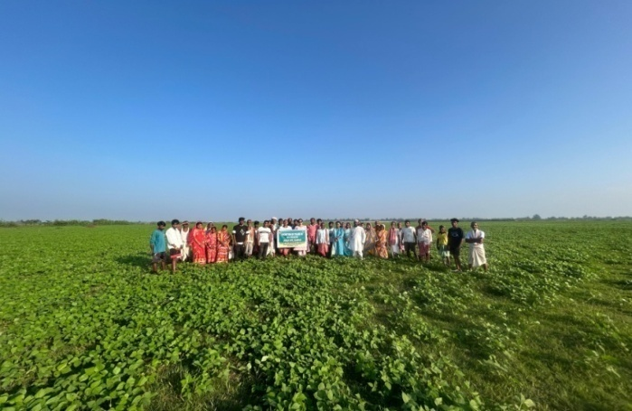 | 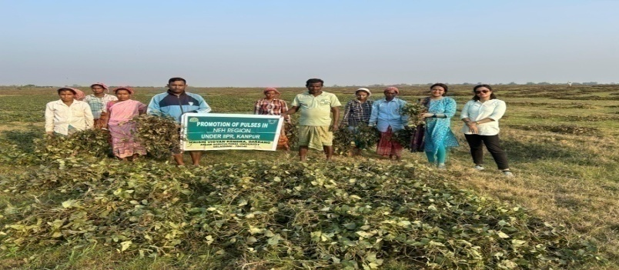
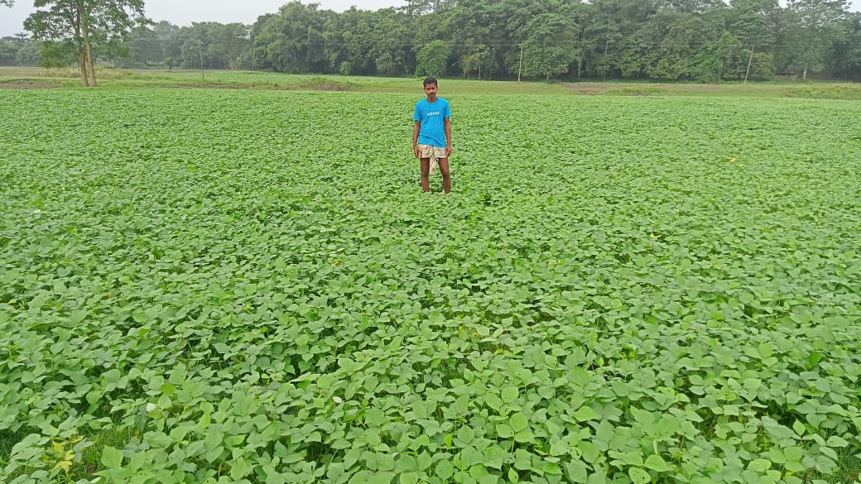 | 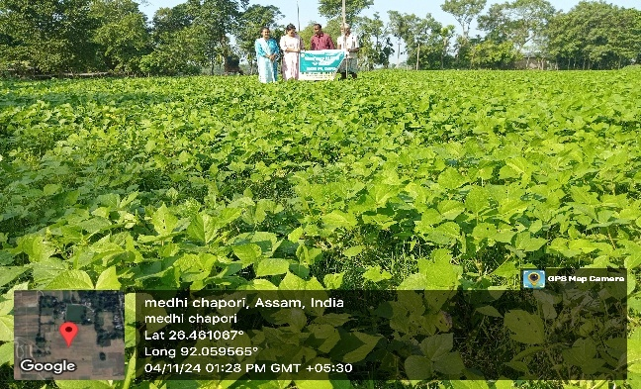
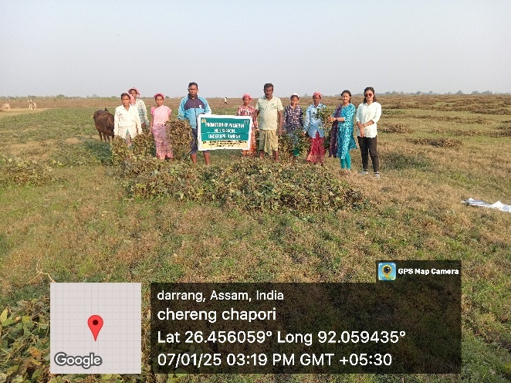 | 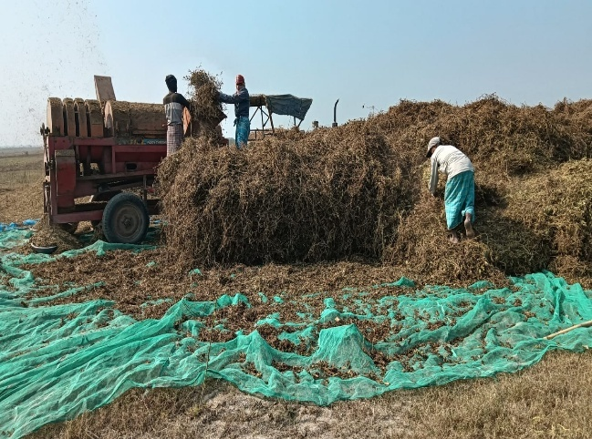
Conclusion
In a nutshell we can conclude from the study that the yield and returns in blackgram & Greengram crop increased substantially with the improved agro-techniques and use of high yielding varieties. However, the grain yield level under IIPR Pulse Demonstration was better than the farmer’s practice and performance of the variety could be further improved by adopting recommended agro-techniques. So, there is need to disseminate the improved agro-techniques among the farmers with effective extension methods like training and field demonstrations. The farmers should be encouraged to adopt the recommended agro-techniques for getting maximum returns in specific locations Conflicts of interest: The authors have no conflicts of interest
References:
1. Anuratha A, Ravi R, Selvi J. Productivity enhancement in black gram by cluster front line demonstrations. J Krishi Vigyan. 2018;7(1):242-4.
2. Kumar S, Singh R, Singh A. Assessment of gaps in pulse production in Hamirpur district of Himachal Pradesh. Indian Res J Ext Edu. 2014;14(2):20-4.
3. Sarma SM, Ojah I, Khaund A, Das KB, Hafiz A. Yield enhancement of toria through cluster frontline demonstration in Darrang district of Assam. The Pharma Innovation Journal. 2024;13(4):41-4.
4. Samui SK, Maitra S, Roy DK, Mandal AK, Saha D. Evaluation on front line demonstration on groundnut. J Indian Soc Coastal Agr Res. 2000;18(2):180-3.
5. Yadav DB, Kamboj BK, Garg RB. Increasing the productivity and profitability of sunflower through crop demonstrations in irrigated agro ecosystem of eastern Haryana. Haryana J Agron. 2004;20(1&2):33-5.

