Original Research Article
NIOBIUM CONCENTRATION TEST FROM
COLUMBO-TANTALITE ORE: GRAVIMETRIC
AND MAGNETIC METHODS

ABSTRACT

The mining of niobium, a strategic metal utilized in the production of high-performance alloys, remains underdeveloped in certain geological contexts despite its potential. In this study, columbite-tantalite ore was utilized as a raw material to investigate methodologies for the physical concentration of niobium. To this end, two fractions of columbite-tantalite ore were prepared: one crushed to 2 mm and the other ground to 250 µm. Following a comprehensive characterization of the ore, the various concentration steps were applied sequentially. Each concentrate was analyzed to evaluate mass yields, metallurgical yields, and enrichment rates. The findings suggest that the integration of methodologies results in a substantial enhancement in niobium concentration, with metallurgical yields attaining 56.94% for the 2 mm fraction and 50.48% for the 250 µm fraction, and enrichment rates exceeding 2. This outcome validates the complementarity of the implemented processes, notwithstanding the occurrence of losses, particularly in the fines. In conclusion, the study demonstrates the effectiveness of physical concentration methods for initial niobium enrichment. These results pave the way for further valorization of the concentrate obtained by hydrometallurgical methods, enabling the selective extraction and purification of niobium for industrial use.

Keywords: tantalum; niobium; panage; dense liquor; magnetic separation.

1. INTRODUCTION
Strategic metals have been identified as playing a crucial role in the development of industry and technology, particularly in the aerospace, electronics, energy, nuclear, and metallurgy sectors (Christmann et al., 2011). Among the metals under consideration, niobium is distinguished by its remarkable properties, namely its corrosion resistance, light weight, high melting point, and its capacity to enhance the mechanical characteristics of steel. Consequently, it is a vital component in the manufacture of high-performance alloys (U.S. Department of the Interior Survey, 2023).
Global demand for niobium is constantly growing. This trend can be explained by the rapid industrialization of certain regions, particularly Asia, and by the expansion of industries that consume specialized alloys. After the global economic crisis of 2008-2009, niobium production rebounded significantly, driven in particular by the Chinese government's industrial stimulus policies (Moisés et al., 2024). According to a study by the Fraunhofer Institute, global production could reach nearly 600,000 tons per year by 2030, implying an average annual growth rate of around 9.5% (Link et al., 2025).
Currently, global niobium production is dominated by Brazil, which accounts for nearly 88% of supply thanks to its pyrochlore deposits, particularly in Araxá and Boa Vista. Other countries such as Canada and Australia also have exploitable reserves (Ren et al., 2023). However, several African countries such as the DRC, Mozambique, and Ethiopia have significant resources that are still under-exploited, particularly in the form of columbite-tantalite or coltan (Melcher et al., 2015; Fuente et al., 2010).
Coltan is one of the few minerals in the Earth's crust whose abundance, expressed in terms of its main metals, is very low, at 2 ppm for tantalum and 24 ppm for niobium (Shikika et al., 2021; Kabangu et al., 2012), despite ever-increasing demand in the new technology sector. In this context of high demand and the search for new sources of supply, it is becoming crucial to optimize niobium extraction and concentration techniques.
In the study conducted by Nzeh et al. (2022), a two-stage separation process was employed for the recovery of heavy minerals, with a particular focus on columbite-tantalite. The initial stage involved the application of gravity-based techniques, including jigging, tabling, and hydrocycloning. These techniques were followed by magnetic separation or flotation, with the objective of enhancing the recovery of tantalum. The conclusion drawn from this study was that advanced gravimetric concentration significantly improves the efficiency of fine particle separation.
The primary objective of this study is to evaluate and optimize the efficiency of three physical separation methods applied to a complex ore containing niobium: gravimetric separation by panning, concentration by dense liquor (bromoform), and high-intensity magnetic separation. The study's specific objectives are as follows: The ore must be subjected to granulometric and chemical characterization. The performance of the different concentration methods must be compared, and the metallurgical yields obtained and the niobium enrichment rate must be calculated. Finally, an optimized treatment scheme for industrial recovery must be proposed.

2. material and methods

2.1 Reagents and chemicals
The reagents used in the various stages of processing are mainly:
Distilled water for preparing suspensions and washing solutions;
Bromoform for producing dense liquor (density = 2.89 g/cm³).
2.2 Ore sample
The ore sample used in this study is colombo-tantalite ore, also known as coltan. It is named BGA. It is a mineral commonly used as a source of tantalum and niobium. This sample is a sedimentary rock from eastern DRC, specifically North Kivu (Figure 1). Macroscopically, the ore grains are mostly sub-rounded to rounded, reflecting mechanical abrasion during river transport. The fragments measure between 2 and 20 mm, corresponding to a deposit ranging from fine gravel to coarse sand. Also, the brown to ochre color indicates the presence of iron oxides (goethite, hematite) formed after deposition in the oxidation zone of the sedimentary profile.
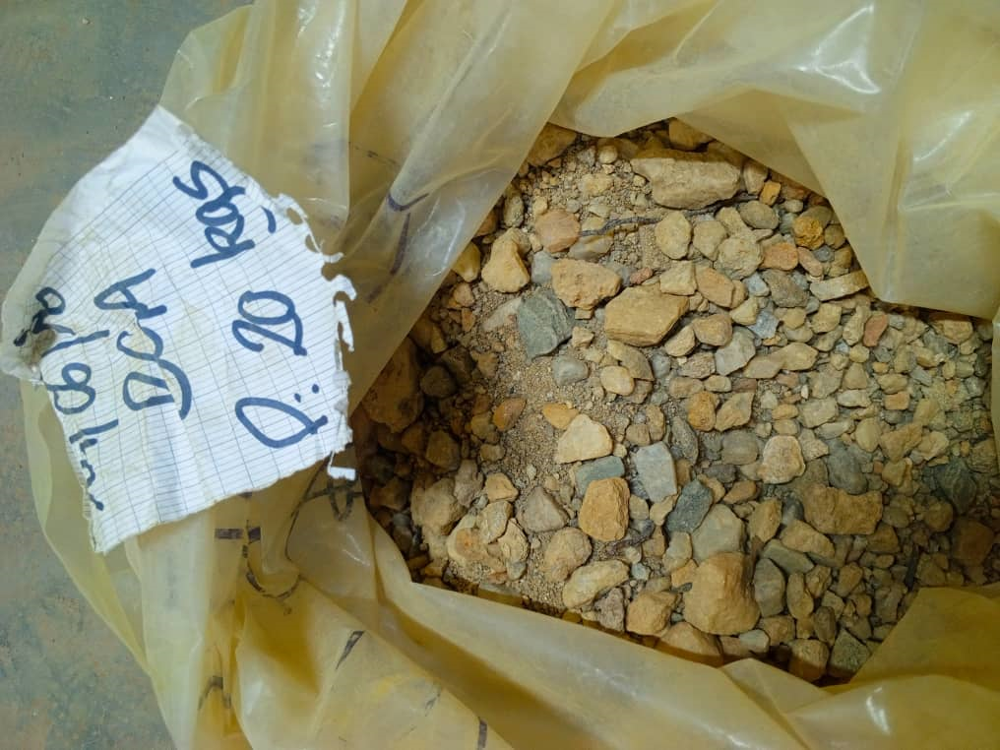
Figure 1. Colombo-tantalite ore

2.3. Laboratory equipment
The equipment used for mineral analysis and separation is listed below:
Precision balance: used for weighing samples and separation products;
Rotary divider (SEPOR brand): used to take a representative sample from the parent sample;
Drying oven: used to dry our sample before any operation;
Jaw crusher; pulverizer: used for grinding and reducing particle size;
Sieve column: used to perform particle size analysis of our sample;
XRF 6000: used to determine the chemical composition of our sample by bombarding it with X-rays;
Chinese pan: used for gravimetric separation based on the difference in mineral density;
Glassware: test tubes, beakers, watch glasses, filters, spatulas, etc., used for sample preparation and testing;
High-intensity magnetic separator (HIMS): used for the magnetic separation of ferromagnetic and paramagnetic minerals from columbite-tantalite concentrate.

2.4 Sample characterization
2.4.1 Mechanical preparation
The sample first underwent mechanical preparation, including key steps such as drying, crushing, and subsampling.
2.4.2 Drying
This is the first stage of mechanical preparation. Our ore is dried using a programmable electric oven. The ore is poured into metal pans before being placed in the oven for 8 hours at a temperature of 110°C. The purpose of drying is to remove the water contained in the rock in order to prevent clogging in the crushing equipment and poor chemical analysis.
2.4.3 Crushing
After drying, we crushed the ore to 2 mm using a jaw crusher. The purpose of this operation is to reduce the size of the rocks to a millimeter scale.
2.4.4 Subsampling
Subsampling is a process that involves sampling a material by dividing it into several representative parts of the parent sample using a divider or sampler. The subsampling of our ore was carried out using a SEPOR rotary divider to prepare the test sample.
2.5 Particle size analysis
Particle size analysis is the measurement of the dimensions, shapes, and proportions of particles in a solid dispersion. Its purpose is to classify fragmented products for mechanical processing operations that require homogeneous dimensions (search for the release mesh of niobium oxides for physical treatment by gravimetry).
The terminology used in particle size classification is presented in Table 1.

Table 1. Terminology used in particle size classification (Prasadini 2020)
Grain size | Grain size class
> 500 µm | Coarse
< 500µm | Grainy
< 100µm | Fine
< 20µm | Very fine
< 5µm | Ultrafine
< 1µm | Colloids
< 0.2µm | Super-Colloids

The sample, weighing 1 kg, which has undergone mechanical preparation, now consists of several granular states ranging from 2 mm to infinitely small.
The aggregate is then poured onto the top of the assembled sieve column (Figure 2). The following mesh sizes were used: 2 mm; 1 mm; 500 µm; 250 µm; 100 µm; 75 µm.

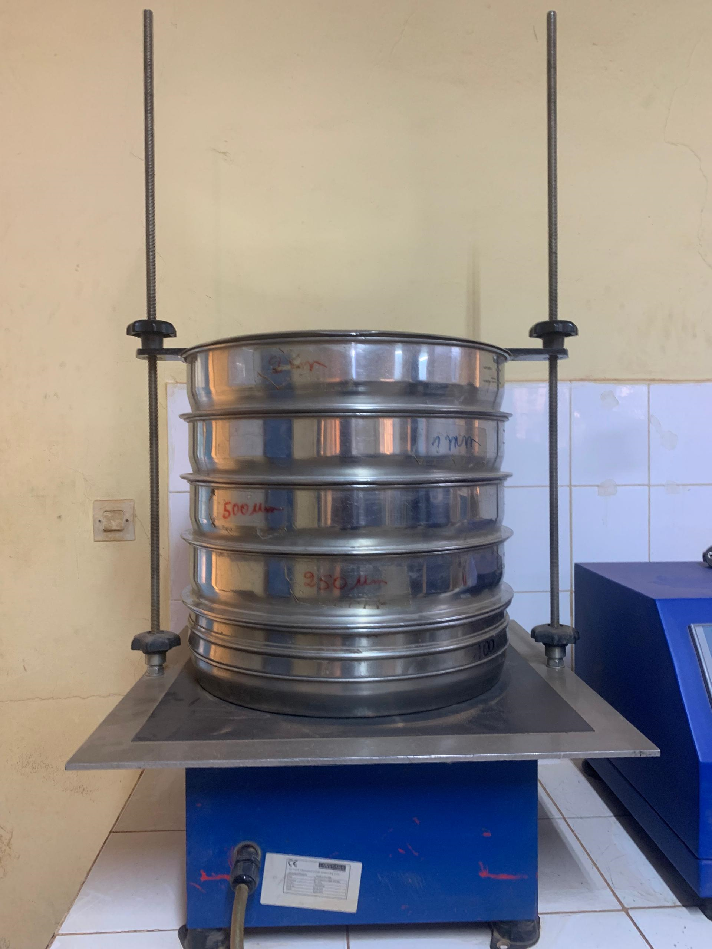
Figure 2. Sieve column mounted on an automatic sieving machine

The sieve column assembly is mounted on an automatic sieving machine and agitated for 5 minutes (Figure 2). The grains retained by each sieve are called “rejects.” The masses of the different rejects are reported in relation to the initial mass of the material. The percentages obtained are presented in graph form.
Theoretically, the sum of the rejects plus the particles at the bottom of the sieve should be equal to the initial mass (mi) of the sample (mi = 1 kg).
Each reject was X-rayed to determine the release mesh size.

2.6 Chemical composition
To characterize the ore, we collected the rejects obtained at each sieve level after particle size analysis. We first weighed them, then pulverized them in agate bowls to avoid any ferrous contamination that could occur with steel bowls.
A second 250 g sample was taken and mechanically prepared before being characterized by X-ray fluorescence. This second sample was taken to get an idea of the distribution of niobium in the raw sample. Each sample pulverized in this way was placed in plastic capsules and then filmed using transparent film paper. It should be noted that we took care to number each capsule with the name of the sample and the corresponding mesh to avoid any confusion. From this point on, each sample is scanned in turn using the OLYMPUS portable XRF 6000 in geochemical analysis mode.

2.7 Physical treatment by gravimetric concentration (panning)
For this experiment, we worked with two types of columbite-tantalite ore:
1 kg of ore crushed to 2 mm and 500 g of the same ore ground to 250 µm;
Before starting the panning, we prepared the necessary equipment:
a Chinese pan (a large conical container facilitating gravimetric separation);
a source of clean water to rinse and fluidize the sediments;
a collection tray to collect the residues and avoid material loss.
We then placed each sample in a separate pan in order to carry out the tests independently.
We poured enough water into each pan to completely submerge the ore particles. Water plays a fundamental role in reducing the adhesive forces between particles, which facilitates their separation according to their density.
We then agitated the pan using circular and vertical movements. This action allowed the particles to gradually rearrange themselves:
The heavy minerals (mainly columbite-tantalite containing niobium) began to sink to the bottom under the effect of gravity.
The lighter materials (quartz, feldspars, and other gangue minerals) remained suspended in the water.
For the ore crushed to 2 mm, the separation took place fairly quickly, with the heavy particles quickly concentrating in the center of the pan.
However, for the sample crushed to 250 µm, the process took longer because the fine, light particles remained suspended for longer.
Once the stratification was well established, we tilted the pan slightly and began to gradually drain off the water and the lightest particles:
For ore crushed to 2 mm, this step was relatively simple because the heavier particles were well concentrated at the bottom.
For ore ground to 250 µm, we had to be more careful because the fine particles tended to remain in suspension longer, which increased the risk of niobium loss with the drainage water.
We repeated this operation several times until almost only the heaviest minerals remained at the bottom of the pan.

2.7.1 Final concentration and recovery of niobium
At this stage, we observed a clear difference between the two samples:
The ore crushed to 2 mm produced a clearly visible concentration of columbite-tantalite, forming a dense black residue at the bottom of the pan.
The ore ground to 250 µm, although showing a similar concentration, had finer particles, which made extraction more difficult.
We performed a final light rinse, then each concentrate obtained was dried in the open air so that we could continue with the next steps of our study.
Figure 3 illustrates the panning operation.

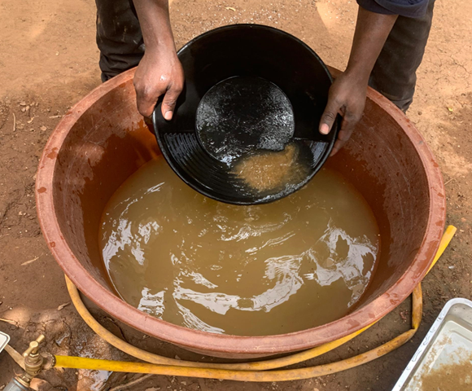
Figure 3. Gravimetric separation by panage

2.8 Dense medium treatment (dense liquor)
For this step, we used bromoform (CHBr₃), an organic liquid with a density of 2.89 g/cm³, which is colorless and soluble in water, making it particularly effective for separating dense minerals from light ones (Figure 4).
We worked with the two concentrates obtained from gravimetric separation:
the concentrate obtained after panning 1 kg of ore crushed to 2 mm;
the concentrate obtained from the treatment of 500 g of ore ground to 250 µm.
Before subjecting them to dense liquid separation, we made sure to dry the concentrates completely, as any moisture could affect the efficiency of the separation by altering the density of the bromoform.
In a beaker, we gradually added each concentrate to the bromoform, stirring gently to allow the particles to disperse properly. The separation took place quickly due to the differences in density:
The heavy minerals (density ˃ 2.89 g/cm3), mainly niobium, sank to the bottom of the beaker.
The light minerals (density ˂ 2.89 g/cm³), such as quartz and feldspars, remained suspended at the surface.
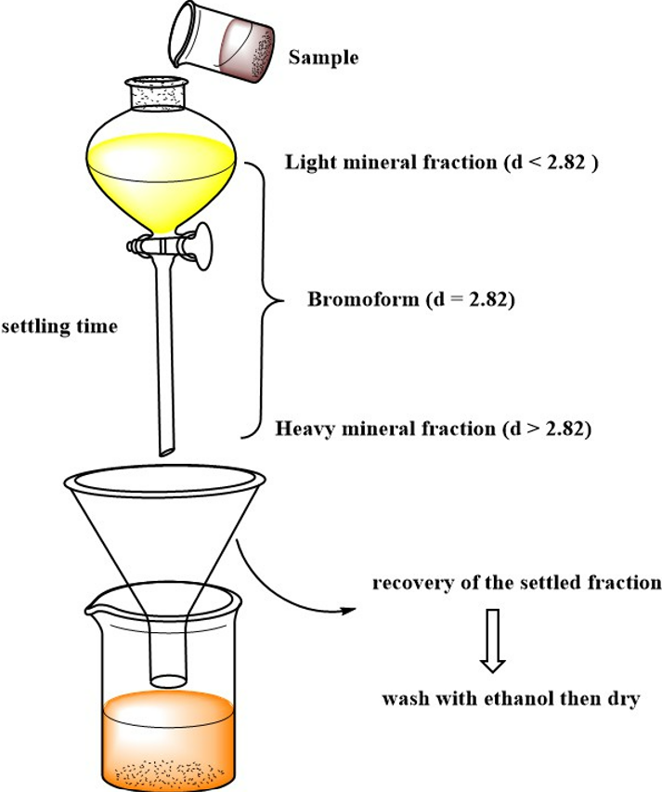
Figure 4. Density sorting processes for minerals using dense liquor

To improve separation, we let the mixture rest for a few minutes to allow the particles to settle in the dense liquid.
Once the separation was clear, we proceeded to recover two fractions:
Removal of light minerals: using a decanter, we carefully removed the upper part containing the floating minerals.
Recovery of heavy minerals: the heavy particles deposited at the bottom were filtered using a funnel equipped with a filter paper resistant to organic solvents. We then rinsed the residue with acetone to remove any residual traces of bromoform.
The concentrates obtained were placed in the open air to dry for further analysis.

2.9 Magnetic separation treatment
Before introducing the concentrates into the magnetic separator (Figure 5), we followed several steps to ensure effective separation:
Drying of samples: although the concentrates had already been dried after density separation, a check was carried out to ensure that they were completely free of moisture, which could affect their behavior during separation.
Particle size control: the fractions obtained were kept as they were, without additional grinding, to ensure continuity in the treatment process.
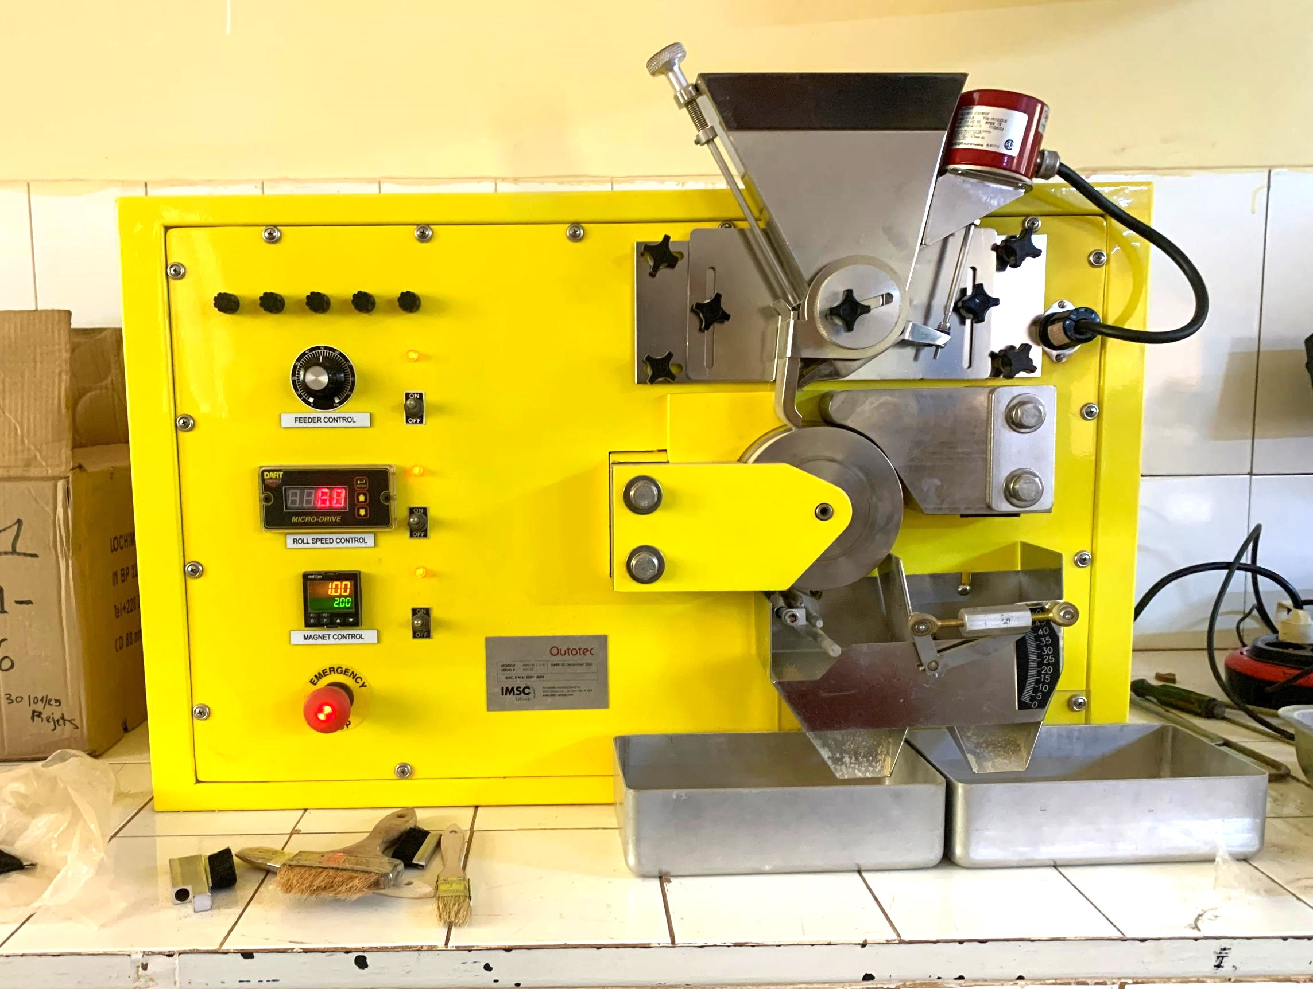
Figure 5. Outotec high-intensity magnetic separator

Outotec separator separation parameters: separation efficiency depends on several adjustable parameters (Table 2), including magnetic field strength, feed rate, particle size (grain size), angle, and speed of the magnetic roller. For our separation, we used the following parameters:

Table 2. Magnetic separation parameters
Parameters | Values
Feeder control (lbs/hr/in) | 60
Roll speed control (rpm) | 60
Magnet control (amps) | 2.00
Angle | 45

Effective separation of magnetic and non-magnetic fractions: Once the samples had been subjected to the magnetic field, we obtained two distinct fractions:
Magnetic fraction: consisting mainly of paramagnetic minerals, including columbite-tantalite, which have a certain affinity with the magnetic field and were retained on the separator rollers. This fraction was carefully recovered after the magnetic field was turned off.
Non-magnetic fraction: This includes diamagnetic minerals, such as quartz and certain sterile gangue minerals, which did not react to the magnetic field and were collected separately.
These fractions were then recovered for characterization and analysis.

3. results and discussion

3.1 Particle size analysis
Particle size analysis allows us to determine the granular behavior of the ore. This behavior does not directly influence the extraction of niobium, but the results help to determine the release mesh size of niobium oxides. The latter influences the results of physical processing by panning. The mesh sizes and number of sieves were chosen based on the nature of the sample and the expected accuracy. The results obtained are classified in Table 3.

Table 3. Granular distribution of columbite
Sieve diameter (mm) | Rejects (g) | Cumulative rejects (g) | Cumulative rejects (%) | Cumulative sieve (%)
2 | 543.61 | 543.61 | 54.85 | 45.15
1 | 145.82 | 689.43 | 69.56 | 30.44
0.5 | 145.9 | 835.33 | 84.28 | 15.72
0.25 | 105.65 | 940.98 | 94.95 | 5.05
0.1 | 44.38 | 985.36 | 99.42 | 0.58
0.075 | 2.25 | 987.61 | 99.65 | 0.35
FT | 3.45 | 991.06 | 100 | 0
Total | 991.06

Figure 6. illustrates the graphical representation on a semi-logarithmic scale
Figure 6. Grain size analysis of the columbite sample

The particle size analysis curve (Figure 6) shows the size distribution of the ore particles after screening. On the x-axis, we have the mesh size of the screens (in mm) on a logarithmic scale, and on the y-axis, the cumulative mass percentage of particles passing through these screens.
In the fines region (to the left of the curve ˂ 0.1 mm), we observe a low cumulative percentage, indicating that few particles are smaller than this size. This suggests that grinding did not produce a large amount of fines, which is favorable for certain extraction methods that favor medium-sized particles.
For the intermediate fractions (0.1 mm to 2 mm), there is a gradual increase in the cumulative percentage, indicating that the majority of particles are in this size range.
Above 2 mm, the curve reaches a higher cumulative percentage, meaning that coarse particles still constitute a significant portion of the ore.
This distribution can have an impact on the separation and extraction of the ore. Indeed, the largest fractions may require additional grinding. Intermediate fractions are favorable for gravimetric enrichment processes, as they provide a good balance between contact surface area and ease of handling. As for fines, they can pose problems because they tend to remain in suspension and are difficult to recover efficiently. Similar results were reported by Alabi OO, Gbadamosi YE, and Akinpelumi T., (2021) in Desliming process of kuru columbite (Plateau state) using scrubbing method towards niobium pentoxide recovery.

3.2 Chemical composition
X-ray fluorescence analysis was used to determine the concentration of niobium (Nb) in the different particle size fractions of columbite-tantalite ore. These results are essential for understanding the distribution of niobium according to particle size and evaluating the effectiveness of the different separation methods used.
The analysis confirmed that the mineral is indeed columbite. The results obtained are shown in Table 4 for the element niobium (Nb).

Table 4. Results of physical-chemical analysis by XRF
Sample (BGA) | Weight (g) | Nb (%) | Nb (ppm) | Absolute error  (+ or -)
Raw ore | 250.01 | 21.43 | 214200 | 0.13
BGA ˃ 2mm | 543.61 | 29.95 | 205900 | 0.10
BGA ˃ 1mm | 145.82 | 20.59 | 299500 | 0.14
BGA ˃ 500µm | 145.9 | 27.80 | 339000 | 0.16
BGA ˃ 250µm | 105.65 | 33.90 | 278000 | 0.16
BGA ˃ 100µm | 44.38 | 22.24 | 222400 | 0.14
BGA ˃ 75µm | 2.25 | ND | ND | -
FT | 3.45 | ND | ND | -
Total | 991,06

ND: Not determined within the detection limit.

These results can also be illustrated graphically (Figure 7) for better visualization of trends. To this end, a histogram was plotted to show the distribution of Nb content as a function of particle size.

Figure 7. Histogram illustrating the chemical composition of the ore

The results obtained show the niobium content in the different grain size fractions of the ore, ranging from raw ore to the finest particles. The absolute error associated with each measurement is also indicated, allowing the accuracy of the analyses to be assessed.
The average overall niobium content of the raw ore is 21.43%, confirming that it is a relatively Nb-rich ore.
The BGA ˃ 2 mm fraction (543.61 g) is fairly concentrated with 29.95% Nb, indicating a possible association of niobium with coarse to medium-sized minerals.
The BGA ˃ 1 mm fraction (145.82 g) contains 20.59% Nb, a value slightly lower than the average content of the raw ore.
With regard to the intermediate fractions, the BGA fraction ˃ 500 µm (145.9 g) contains 27.80% Nb, confirming a significant concentration.
The BGA ˃ 250 µm fraction (105.65 g) has the highest concentration (33.90% Nb), which could indicate that niobium is mainly present in this particle size range.
The BGA ˃ 100 µm fraction contains 22.24% Nb, a value close to the average content of the raw ore.
For the 75 µm and FT fractions, the Nb content was not determined (ND). This is due to the detection limit of the device, but also to the very small quantities of these fractions.
The evolution of the niobium concentration (Figure 7) according to particle size shows significant trends for the optimization of the treatment scheme.
Niobium is mainly concentrated in the 2 mm and 250 µm fractions, indicating that these particle sizes are the most favorable for metal recovery. The coarse fraction (˃ 2 mm) contains less niobium than the 250 µm fraction, confirming that grinding is an essential step in liberating the mineral-bearing particles. These observations are essential for guiding the choice of separation methods and optimizing the processing scheme. Indeed, given that niobium is concentrated in fine but not ultrafine fractions, gravimetric separation can be considered to enrich the ore before applying other methods. Similar studies have been reported by (Somarin et al., 2019) on Geochemical Fingerprinting of Conflict Minerals Using Handheld XRF: An Example for Coltan, Cassiterite, and Wolframite Ores from the Democratic Republic of the Congo, Africa.
For the rest of the work, extraction tests were carried out with:
ore crushed to 2 mm;
ore ground to 250 µm.
After characterizing the ore using the granulo-chemical method, dense liquid separation and magnetic separation were applied.

3.3 Niobium enrichment
The masses of concentrates and rejects obtained after dense liquor separation are detailed in Table 5.

Table 5. Results of dense liquor separation
Sample |  | Mass (g)
Concentrate ˃ 2 mm | Dense liquor ˃ 2.89 | 4.02
Concentrate ˃ 2 mm | Dense liquor ˂ 2.89 | 46.92
Concentrate ˃ 250 µm | Dense liquor ˃ 2.89 | 4.75
Concentrate ˃ 250 µm | Dense liquor ˂ 2.89 | 43.52

The results obtained after flashing the concentrate and mixed sample from each magnetic separation using RFX are shown in Table 6.

Table 6. Magnetic separation results
Sample |  | Nb (%) | Absolute error  (+ or -)
Final concentrate  ˃ 2 mm | Concentrate 1 | 49.52 | 0.30
Final concentrate  ˃ 2 mm | Mixed 1 | 5.575 | 0.045
Final concentrate  ˃ 250 µm | Concentrate 2 | 49.82 | 0.24
Final concentrate  ˃ 250 µm | Mixed 2 | 9.44 | 0.15

Based on the results presented in Tables 5 and 6, we have created a new table (Table 7) that takes into account the masses of the different concentrates, their percentages and ppm content, and the mass of Nb recovered.

Table 7. Recovered concentrate mass
Fraction | Concentrate mass (g) | Nb content  (ppm) | Nb (%) | Mass of Nb recovered (g)
Concentrate 1 | 0.6298 | 495200 | 49.52 | 0.4904
Concentrate 2 | 0.771 | 498200 | 49.82 | 0.5138
Total | 1.4008 | - | - | 1.0042

The results obtained after magnetic separation show a significant concentration of niobium in the final concentrates, with values reaching 49.52% for concentrate 1 and 49.82% for concentrate 2. These relatively high concentration levels indicate the effectiveness of the niobium recovery processes. On the other hand, the so-called mixed fractions, which correspond to the residual materials after separation, show much lower niobium contents (5.57% and 9.44% for mixed fractions 1 and 2, respectively).
This means that most of the niobium has been effectively separated, although some losses remain in the mixed fractions. The relatively low absolute error (0.30 and 0.24 for the final concentrates and 0.045 to 0.15 for the mixed fractions) indicates good analytical measurement accuracy. In fact, in order to reduce the loss of small-sized niobium in the fine fractions, it is advisable to favor magnetic separation and concentration over gravity washing techniques (Kabende E., 2020).
3.4 Calculation of applied process performance
Table 8 illustrates the results of the calculation of the performance of the processes applied to niobium concentration. It is essential to evaluate several indicators to measure the efficiency of the different separation and enrichment stages. Among these, three fundamental parameters are used: mass yield, metallurgical yield, and enrichment rate.
Mass yield (Y_{m}): Also known as weight yield, it represents the fraction of material recovered after a separation process relative to the initial mass of the processed material. It is expressed as a percentage and is used to evaluate the quantity of final product obtained after a concentration or separation stage. Mass yield (Y_{m}) is illustrated by equation 1:
Y_{m} = $\frac{Mass of concentrate obtained}{Initial mass of ore}×100$ (1)

Metallurgical yield (Y_{met}): Metallurgical yield, also known as recovery rate, measures the efficiency of the process in terms of the quantity of metal recovered in the final concentrate compared to the initial quantity present in the processed sample. It indicates what proportion of the initial niobium has been effectively concentrated. Metallurgical yield (Y_{met}) is illustrated by equation (2):
Y_{met} =$\frac{ Mass of Nb recovered}{Initial mass of Nb in the ore}×100$ (2)

Enrichment ratio (E_{R}): The enrichment ratio is used to evaluate the improvement in niobium concentration after the separation process. It expresses how many times the niobium content has been increased compared to the initial content. The enrichment ratio (E_{R}) is illustrated by equation (3):
E_{R} =$\frac{ Nb content of concentrate}{initial niobium content}$ (3)

Or the initial mass of Nb in the ore (M_{i} Nb) and is given by equation (4):

M_{i Nb} = Initial treated mass $×\frac{ Initial Nb content}{100}$ (4)

Table 8. Summary table of performance
Concentrate | Mass yield (Y_{m}) | Metallurgical yield (Y_{met}) | Enrichment ratio (E_{R})
1 | 15.66% | 56.94% | 2.31
2 | 16.23% | 50.48% | 2.33

Concentrate 1 represents 15.66% of the total mass of the ore processed. Despite this relatively low mass yield, it retains 56.94% of the total niobium contained in the feed. This reflects the good selectivity of the separation process, as more than half of the initial niobium has been recovered in a relatively small fraction by mass. In addition, the enrichment rate of 2.31 indicates that the niobium concentration has been multiplied by a factor greater than 2, demonstrating a significant improvement in the quality of the processed ore.
Concentrate 2 has a mass yield of 16.23%, slightly higher than that of concentrate 1. However, its metallurgical yield is slightly lower (50.48%), which means that a significant proportion of the niobium ended up in other fractions (particularly the rejects). The enrichment rate of 2.33 is close to that of concentrate 1, indicating that the separation resulted in similar enrichment in both fractions, although the metallurgical recovery is slightly less efficient in this case.
Thus, the various results obtained show that the separation process significantly concentrated the niobium, with enrichment rates greater than 2, which is an encouraging performance indicator.
However, certain observations can be made regarding the efficiency of the process:
The cumulative metallurgical yield of the two concentrates is 107.42%, which can be explained by minor experimental errors or errors related to the Nb content in certain fractions.
A metallurgical recovery of over 50% in each concentrate shows that the process is generally effective but could be optimized to recover more niobium in a single, higher-quality concentrate.
Concentrate 1 has a better metallurgical yield, meaning that it captures a greater proportion of niobium. However, its lower mass yield suggests that it is more selective and produces a fraction richer in Nb.
Concentrate 2, on the other hand, captures less niobium proportionally, but its higher mass yield indicates that it includes more material, potentially with a higher proportion of gangue.
The similarity of the enrichment rates (2.31 and 2.33) suggests to us that the two concentrates are of relatively similar quality.
An improvement to the process could aim to further increase the Enrichment ratio (E_{R}) by reducing the dilution of niobium with gangue minerals.
Tanvar et al., (2023) reported analogous outcomes in their research on the recovery of niobium and tantalum from columbite-tantalite concentrates.
The obtained Nb₂O₅ contents ranged from 47% to 50%, with metallurgical yields varying from 53% to 58% and enrichment rates ranging from 2.1 to 2.4.
These similarities serve to confirm the effectiveness of simple physical methods (panning, dense liquor separation, high-intensity magnetic separation) for the pre-concentration of niobium from complex ores.
Another study, conducted by Cao, Bu, and Gao., (2021), focused on the preconcentration of low-grade niobium and tantalum ores in China. The researchers' approach primarily incorporated high-intensity magnetic separation with gravimetric concentration, eschewing the immediate resort to chemical treatments.
The results obtained in this study demonstrate that the niobium content varies between 46% and 50%, with metallurgical yields ranging from 52% to 60% and enrichment rates between 2.0 and 2.5. The performances of the two systems are found to be comparable in terms of enrichment rate and yield. The study also confirms that combining gravimetry and magnetic separation achieves satisfactory results without the need for costly chemical treatment.

4. Conclusion

The aim of the study was to extract niobium from columbite-tantalite ore using physical separation methods, namely: gravimetry (panning), densimetric separation using bromoform, and high-intensity magnetic separation. It was part of a broader effort to find simple and accessible processes for concentrating strategic metals from primary deposits.
Particle size and chemical analyses of the ore revealed an average niobium content ranging from 29.95% to 33.90% depending on the particle size fractions, with a notable enrichment for fractions between 2 mm and 250 μm, confirming an interesting potential for gravimetric concentration. Gravimetric separation using a pan yielded an initial concentrate with a mass yield of 15.66% and a metallurgical yield of 56.94%, representing an enrichment rate of 2.31. A second concentrate obtained by densimetric separation yielded a mass yield of 16.23%, a metallurgical yield of 50.48% and an enrichment rate of 2.33.
These results confirm the effectiveness of the treatment chain used, while highlighting residual losses at certain stages of the process. More optimal recovery could have been achieved with more controlled grinding stages, finer classification, or systematic recycling of intermediate waste.
In summary, this study demonstrated the feasibility of concentrating niobium from columbite-tantalite ore using simple physical methods. It also paves the way for more advanced recovery methods, particularly through hydrometallurgical techniques, which would enable more precise selective extraction and more complete recovery of niobium and other elements of interest contained in the ore.
Finally, it should be noted that the four-month internship at BUMIGEB was an extremely enriching experience. It allowed us to deepen our practical knowledge of ore processing, familiarize ourselves with laboratory equipment, and strengthen our ability to carry out a complete scientific approach, from characterization to the recovery of a strategic ore.

References

Alabi, O.O., Gbadamosi, Y.E., and Akinpelumi, T. (2021). “Desliming Process of Kuru Columbite (Plateau State) Using Scrubbing Method towards Niobium Pentoxide Recovery.” International Journal of Engineering Research Updates,1(1), 043–049. https://doi.org/10.53430/ijeru.2021.1.1.0044.
Cao, M., Hao B., and Yude, G. (2021). “Preconcentration of Low-Grade Ta–Nb Deposit Using Physical Separation Methods.” Jom, 73(5), 1310–1320. https://doi.org/10.1007/s11837-021-04625-x.
Carlos, D.F., Eva, M., and Ignacio, Q. (2010). “Niobium-Tantalum Content of Ilmenite-Rich Black Sands from Walikale ( North Kivu , Democratic Republic of Congo ).” Revista De La Sociedad Espanola De Mineralogia, 85–86.
Christmann, P., Angel, J.M., Bailly, L., Barthélémy, F., Benhamou, G., Billa, M., Gentilhomme, (2011). “Panorama (2010) Du Marché Du Niobium.” Brgm/Rp-60579-Fr, 51.
Frank, M., Torsten, G., Hans, E.G., Maria, S., Friedhelm, H.K., Thomas, O., Axel, G., and Stijn, D. (2015). “Tantalum-(Niobium-Tin) Mineralisation in African Pegmatites and Rare Metal Granites: Constraints from Ta-Nb Oxide Mineralogy, Geochemistry and U-Pb Geochronology.” Ore Geology Reviews, 64, 667–719.
https://doi.org/10.1016/j.oregeorev.2013.09.003.
Himanshu, T., Manish, K. S., Jean Baptiste, H., and Brajendra, M. (2023). “Extraction of Niobium and Tantalum Oxides From Columbite Concentrate Using Microwave Processing and Solvent Extraction.” Metallurgical and Materials Transactions B: Process Metallurgy and Materials Processing Science, 54(2), 621–634. https://doi.org/10.1007/s11663-022-02713-0.

Kabangu, M. J., and Crouse, P. L.(2012). “Separation of Niobium and Tantalum from Mozambican Tantalite by Ammonium Bifluoride Digestion and Octanol Solvent Extraction.” Hydrometallurgy, 129–130, 151–55.
https://doi.org/10.1016/j.hydromet.2012.06.008.
Kabende, E. (2020). Pre-treatment of tantalum and niobium ores from Democratic Republic of Congo (DRC) to remove uranium and thorium [Thesis, Murdoch University]. https://researchportal.murdoch.edu.au/esploro/outputs/graduate/Pre-treatment-of-tantalum-and-niobium-ores/991005541631907891#file-0.
Moisés, G., Jinhui, L., and Xianlai, Z. (2024). “Niobium: The Unseen Element - A Comprehensive Examination of Its Evolution, Global Dynamics, and Outlook.” Resources, Conservation and Recycling, 209,107744. https://doi.org/10.1016/J.RESCONREC.2024.107744.
Nzeh, N. S., Samson, A., Abimbola, P.P., Abraham, A., and Daniel, O. (2022). “Process Applications and Challenges in Mineral Beneficiation and Recovery of Niobium from Ore Deposits–A Review.” Mineral Processing and Extractive Metallurgy Review. Taylor & Francis, 43,833-864. https://doi.org/10.1080/08827508.2021.1964965.
Prasadini, P., Madhan, M.M. (2020). Manual on Practical Soil Physics. Regional Agricultural Research Station, Tirupati-517 502, Andhra Pradesh, India, 72.
Shikika, A., Mac C, M., Francois, Z., Fabrice, M., Julien L, C., Mohamed, A., and Stoyan, G. (2021). “Extraction of Ta and Nb from a Coltan Bearing Ore by Means of Ammonium Bifluoride Fluorination and Sulfuric Acid Leaching.” Minerals, 11(12), 1392.
https://www.mdpi.com/2075-163X/11/12/1392%0Ahttps://www.academia.edu/download/77416356/pdf.pdf.
Somarin, A. K. (2019). “Geochemical Fingerprinting of Conflict Minerals Using Handheld XRF: An Example for Coltan, Cassiterite, and Wolframite Ores from Democratic Republic of the Congo, Africa.” Minerals, 9(9), 564. https://doi.org/10.3390/min9090564.
Steffen, L., Lara, S., Annegret, S., Lukas, W., and Patrick, P. (2025). “Feasibility of Meeting Future Battery Demand via Domestic Cell Production in Europe.” Nature Energy 10(4), 526-534. https://doi.org/10.1038/s41560-025-01722-y.
U.S. Department of the InteriorSurvey, U.S. Geological. (2023). Mineral Commodities Summary 2024. Mineral Commodity Summaries 2023. http://pubs.er.usgs.gov/publication/mcs2023.
Yisu, R., Xiaoyong, Y., Xueming, Y., Mingxing, L., and Yulong, L. (2023). “Mineralogical Study on the Distribution Regularity of Niobium in Various Types of Ores in the Giant Bayan Obo Fe-REE-Nb Deposit.” Ore Geology Reviews, 161, (96), 105602.
https://doi.org/10.1016/j.oregeorev.2023.105602.

