Ameliorative Effects of Ethanol Leaf Extract of Annona Muricata on The Renal Function of N-nitroso-N-Methylurea (NMU)- Induced prostate cancer in Albino Rats.

Abstract
Background
This present study was designed to evaluate the effect of A. muricata leave extract
on renal function parameters of NMU-induced prostate cancer in albino rats.
Materials and methods
Fresh leaves were collected from Annona muricata tree in Orji, Owerri, Imo State, and prepared for extract administration. Acute oral toxicity was assessed. Twenty-five (25) male albino rats (average weight 96g) were used and acclimatized for 2 weeks. Induction of prostate cancer with NMU lasted for 21 days. Treatment with A. muricata leave extract commenced immediately via oral route for 28 days. The animals were divided into five (5) groups: Group 1 (normal control), group 2 (negative control), group 3 (NMU-induced, treated with finasteride, groups 4 and 5 (NMU-induced, treated with 250 mg/kg and 500 mg/kg of A. muricata leave extract, respectively). At the end of the study, the animals were sacrificed and serum obtained for assessment of renal function parameters.
Results
The result of this study showed a significant increase in urea level, creatinine concentration, sodium ion and chloride ion levels and a significant decrease in bicarbonate ion and potassium ion concentration in the prostate cancer control group (group 2) when compared to the normal control group (p<0.05). The result further showed that administration of A. muricata ethanol leave extract to prostate cancer induced rats in group 4 and 5 significantly reduced urea, creatinine, sodium ion, chloride ion concentration and increased bicarbonate and potassium ion concentration when compared to group 2.
Conclusion
Annona muricata leave extract is a naturally beneficial medicinal product that can alleviate the renal toxicity resulting from prostate cancer.
Keywords: A. Muricata, Prostate cancer, renal toxicity

INTRODUTION
Kidney disease is a growing health concern worldwide, with millions of people affected every year. Nephrotoxicity, a leading cause of kidney damage can result from exposure to various toxins, including the potent carcinogen N- nitroso methyl urea (NMU). N-methyl-N-nitrosourea is a member of the class of N-nitrosoureas that is urea in which one of the nitrogen’s is substituted by methyl and nitroso groups (Langenberger et al., 2019). It has a role as a carcinogen, a mutagen, a teratogenic agent and an alkylating agent. NMU-Induced nephrotoxicity is characterized by oxidative stress, inflammation and renal dysfunction, ultimately leading to kidney failure. Recent studies have increasingly focused on therapeutic potential of natural compounds in managing renal dysfunction, particularly those induced by chemical agents such as N-MethylN-Nitrosourea (NMU). Among these natural remedies the leaves of Annona muricata, have gained attention due to their beneficial phytochemical constituents. Annona muricata, a tropical plant commonly known as soursop, has been traditionally used in folk medicine for its various health benefits (Gavamukulya et al., 2017). The leaves of Annona muricata are rich in bioactive compounds, including alkaloids, flavonoids and phenolic acids, which have been reported to possess antioxidant, anti-inflammatory and anti-cancer properties (Padma et al., 2011). Preliminary research suggests that ethanol extract of Annona muricata leaves may possess nephroprotective properties that could counteract the detrimental effects of NMU on renal function in albino rats. This essay seeks to investigate the ameliorative effects of this extracts on renal parameters in a controlled experimental settings contributing valuable insights into alternative therapeutic strategies for renal impairments and broadening the understanding of naturally derived treatments.
Renal functions play a critical role in maintaining homeostasis and overall health by regulating the body fluid and electrolytes balance, removing waste products and controlling blood pressure. The kidney filters waste products, such as urea, creatinine and other toxins from the blood (Langenberger et al., 2019). Impaired renal function leads to severe health complications, including hypertension and metabolic disorders, underscoring its significance in disease prevention and management. In experimental studies utilizing models such as NMU induced albino rats, the exploration of therapeutic agents like Annona muricata ethanol leaf extracts has shown promising results in ameliorating renal functions, suggesting its potential role as a natural intervention for kidney health. Understanding renal function not only highlights its physiological importance but also emphasizes the therapeutic implications of natural compounds in mitigating renal dysfunction (Magan˜a et al., 2010).

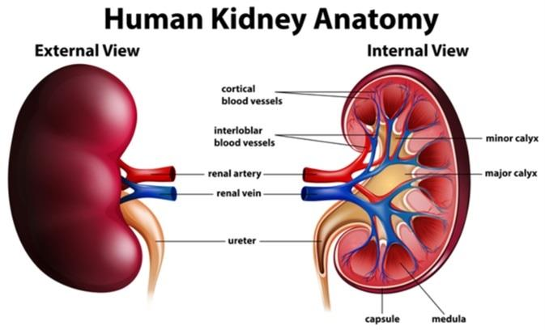

Figure 1. An image of kidney

Medicinal plants are considered as the basis for health preservation and care worldwide. Chronic degenerative disease-s (diabetes, cardiovascular and cancer) have reached epidemic proportions and are considered as a serious health problem; therefore, the treatments of these diseases are of clinical importance (WHO, 2015). Annona muricata is a specie of the Annonaceae family that has been widely studied in the last decades due to its therapeutic potential. The medicinal uses of the Annonaceae family were reported long time ago (Billon 2019), and since then, this species has attracted the attention due to its bioactivity and toxicity. Ethnobotanical studies have indicated that Annona muricata has been used as insecticide (Leatemia and Isman, 2004) and parasiticide (Langenberger et al., 2019). Fruit juice and infusions of leaves or branches have been used to treat fever (Magan˜a et al., 2010), sedative (Defilippis et al., 2014), respiratory illness (Vandebroek et al., 2010), malaria (Boyom et al., 2011), gastrointestinal problems (Atawodi, 2011), liver, heart and kidney affections (Badrie and Schauss 2019). In recent years it has become widely used for hypoglycemic (De Souza, et al., 2011), hypotensive (De Souza et al., 2011; Hajdu and Hohmann, 2012) and cancer treatments (Tisott et al., 2013). Some publications and reviews about Annona muricata have been conducted to integrate the available scientific studies on this plant with special interest on acetogenins as principal bioactive compounds (Badrie and Schauss, 2009; Moghadamtousi et al., 2015) Other bioactive compounds have been identified, more bioactivities have been evaluated, and medicinal uses have been extended. The bioactivity tested can be the base for therapeutic utilization, but the toxicological research results are important to consider the therapeutical uses of this plant versus its toxicity, and the potential harmful effects of products prepared from this plant.

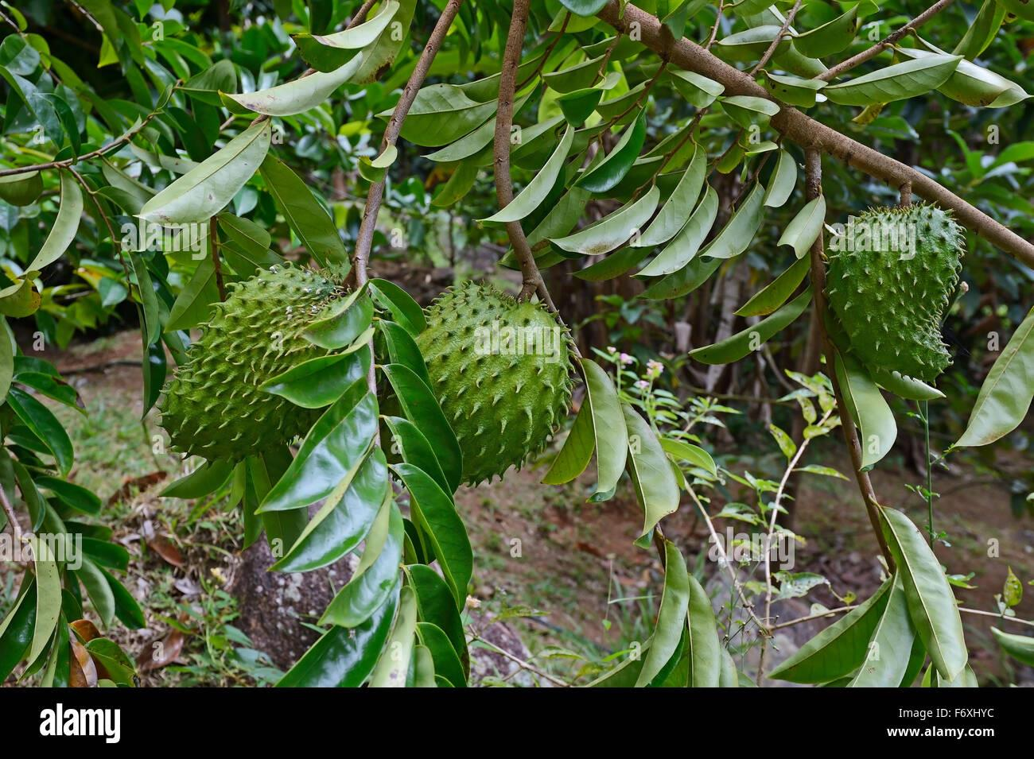

Plate 1: Image of Annona muricata plant showing the leaves and the fruit

MATERIALS AND METHODS
Instruments
The Instruments/apparatus used were of analytical grade and were gotten from the Department of Biochemistry and other scientific shops in Imo State. Equipment/apparatus used for this study are listed below; Weighing balance/Melter HAS, Spatula/Pyrex, Syringe/Lifescan, Beakers/Pyrex, Refrigerator/Haier Thermocool, Conical flask/Pyrex, Dissecting set/Gold rose, Filter paper/Whatman, Filter paper/Kimax, Measuring cylinder/Pyrex, Test tube/Pyrex, Water bath/GallenKamp, Centrifuge/Medifriend, UV spectrophotometer/Genesis.
Chemicals / Reagents
The chemicals and reagents used were of analytical grade. The chemicals used in this study include:
Chemicals reagents Manufacturers, Country
Ethanol
BDH, England
Olive Oil
Goya, Spain
Finasteride
N-nitroso-N-methyl urea (NMU)
Distilled water.
Plant Material
Annona muricata leaves used for this research work was gotten from Orji, Owerri, Imo state and was air-dried and weighed every 2 days till a constant weight is gotten indicating that the leaves have completely dried. The dried Annona muricata leaves was ground to fine powder and then stored in an air tight container for further use.

Plant Extraction Preparation
The extraction method used in the study was the maceration extraction method, which involves simple soaking, filtering and then evaporation. 800g of the ground plant material was weighed into a conical flask, and 2000 mL of 70% ethanol was added, ensuring that the solvent properly covers the plant material. The mixture was allowed to stand for 48 hours with constant stirring. After 48 hours, the mixture was filtered using filter paper, and the filtrate was evaporated in a water bath to obtain an extract.
The extract was weighed using an electronic weighing balance then the percentage yield was calculated as follows:
The percentage yield = $\frac{weight of extract}{weight of ground plant leave}$ X 100

Animal Environment, Handling and Ethics
The male albino rats of body weights (b.w.) mean of d 96g were purchased from the Animal Breeding Unit, Zoology Department, University of Nigeria Nsukka, Enugu state, Nigeria. The animals were kept in stainless–steel cages in a well–ventilated room of temperature 28 ± 2°C and relative humidity of 55–65% with a diurnal 12 h light cycle. The rats had access to water and pelletized standard finishers mesh (Vital finisher) (United Africa Company Nigeria Plc., Jos, Nigeria) ad libitum. A period of 2 weeks was allowed for acclimatization of the rats to environmental conditions. They were all handled according to NIH regulation

Table 1: Experimental Design
Groups. Description. Treatments. No. Of rat
One Normal Control Feed and water only. 5
Two Negative control 50 mg/kg of cyprosterone 5
Acetate (CA) + 100 mg/kg
testosterone propionate (TP) +
50 mg/kg of NMU.
Three Standard control 50 mg/kg of CA+ 100 mg/kg TP. 5
+ 50 mg/kg of NMU+ 50 mg/kg
of Finasteride.
Four Low dose stem 50 mg/kg of CA + 100 mg/kg TP 5
+50 mg/kg of NMU + 250 mg/kg
of stem extract.
Five High dose stem 50 mg/kg of CA + 100 mg/kg TP 5
+ 50 mg/kg of NMU + 500 mg/kg
of stem extract.

2.5.1 Induction of NMU-induced nephrotoxicity
Induction of prostate cancer was carried out according to Bosland and Prinsen 1990. After 2 weeks of acclimatization, the rats were given 50 mg/kg of cyproterone acetate in normal saline via intraperitonial route for 18 days, after which the rats received subcutaneous injection of testosterone propionate (100 mg/kg) in olive oil for another 3 days, this was followed by a single shot of NMU (50 mg/kg) in normal saline via intraperitonial injection. The different doses of extracts and finasteride were administered orally following induction of prostate cancer for 28 days.
2.6 Collection of Samples
At the end of 28 days, the animals were anaesthetized with chloroform and then sacrificed. Whole blood was collected in plain sample bottles through cardiac puncture using sterile needles and syringes. The clotted blood was centrifuged at 3000 rpm for 10 mins to obtain serum. Liver, kidney and prostate were also harvested for histopathological examination.

2.7 Renal function assessment
Blood sample were collected from the rats at the end of the treatment period. The serum, creatinine, urea and electrolytes (sodium, potassium and chloride) were measured using commercial biochemical assay kits. Kidney tissues were harvested and processed for histopathological examination.

2.8 Histopathological Analysis
The kidney was harvested from the animals after they were sacrificed, and these organs were cleaned using saline solution. The organ was preserved in 10% buffered formalin. The organs were then processed, sectioned into 4 microns in thickness using a microtome (Leica, Wetzlar, Germany), and stained with hematoxylin and eosin. A detailed description of the staining process was that the slide was submerged in Xylene, 100% alcohol, and 70% alcohol separately with a duration of 5min for each solution. The slides were first rinsed 3 to 5 times. The slide was then dipped in 1% acid alcohol for 3sec and run under tap water for 5min. Next, the slides were submerged in eosin for 1 min, sprayed with 95% alcohol, and the slide was rinsed again in under running tap water for 5 to 10sec. Then, the slide was mounted with dibutyl phthalate polystyrene xylene (DPX) and ready for viewing. The slide was observed under a light microscope.

2.9 Statistical analysis
The statistical analysis was carried out using SPSS program version 20 (SPSS, Richmond, VA, United States), with the data presented as means ± SE. Data were analyzed using one-way ANOVA, and the significant differences between treatments were assessed by a post hoc review of the Duncan test at p < 0.05.

Result

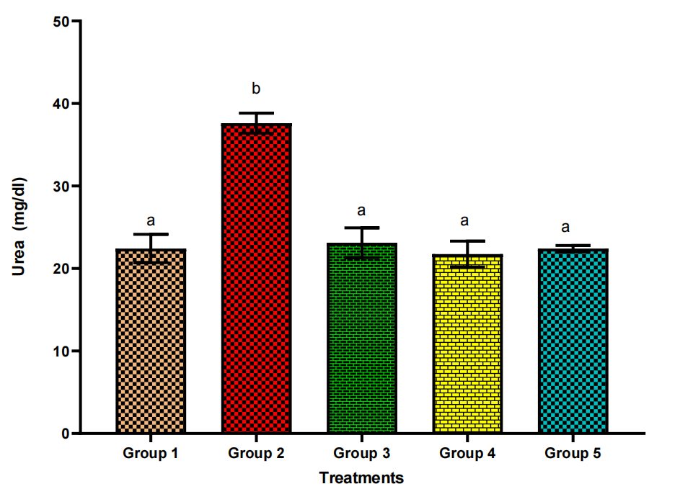

Figure 2: Urea levels in NMU-induced prostate cancer in rats treated with A. muricata ethanol leave extract. Bars represent mean ± standard deviation of triplicate determinations and bars with different alphabets indicate significant difference at p < 0.05. Group 1 = normal control, group 2 = prostate cancer control, group 3 = standard control, group 4 = prostate cancer treated with low dose of leave extract, group 5 = prostate cancer treated with high dose of leave extract.

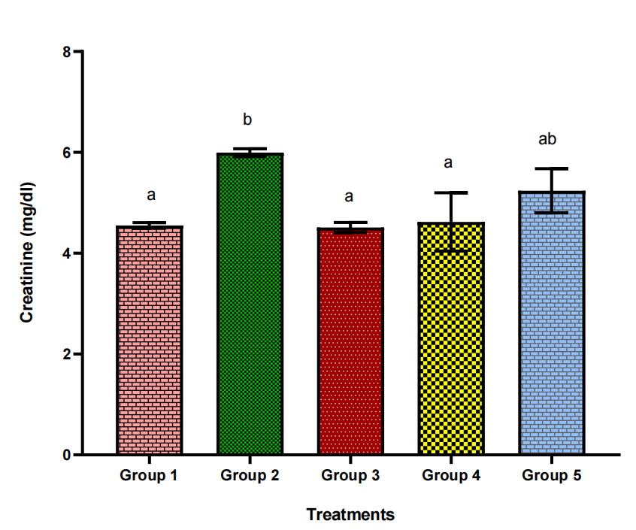

Figure 3: Creatinine levels in NMU-induced prostate cancer in rats treated with A. muricata ethanol leave extract. Bars represent mean ± standard deviation of triplicate determinations and bars with different alphabets indicate significant difference at p < 0.05. Group 1 = normal control, group 2 = prostate cancer control, group 3 = standard control, group 4 = prostate cancer treated with low dose of leave extract, group 5 = prostate cancer treated with high dose of leave extract.

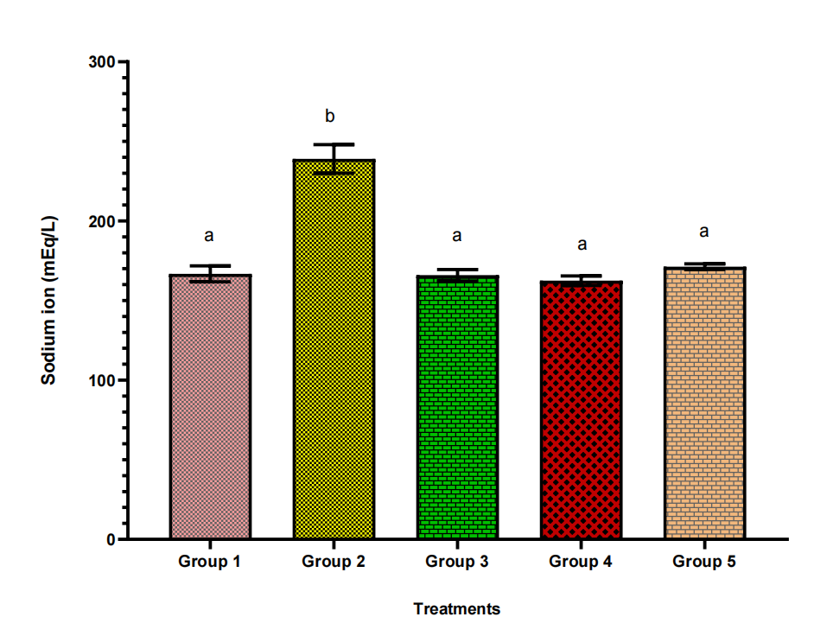

Figure 4: Sodium ion levels in NMU-induced prostate cancer in rats treated with A. muricata ethanol leave extract. Bars represent mean ± standard deviation of triplicate determinations and bars with different alphabets indicate significant difference at p < 0.05. Group 1 = normal control, group 2 = prostate cancer control, group 3 = standard control, group 4 = prostate cancer treated with low dose of leave extract, group 5 = prostate cancer treated with high dose of leave extract.

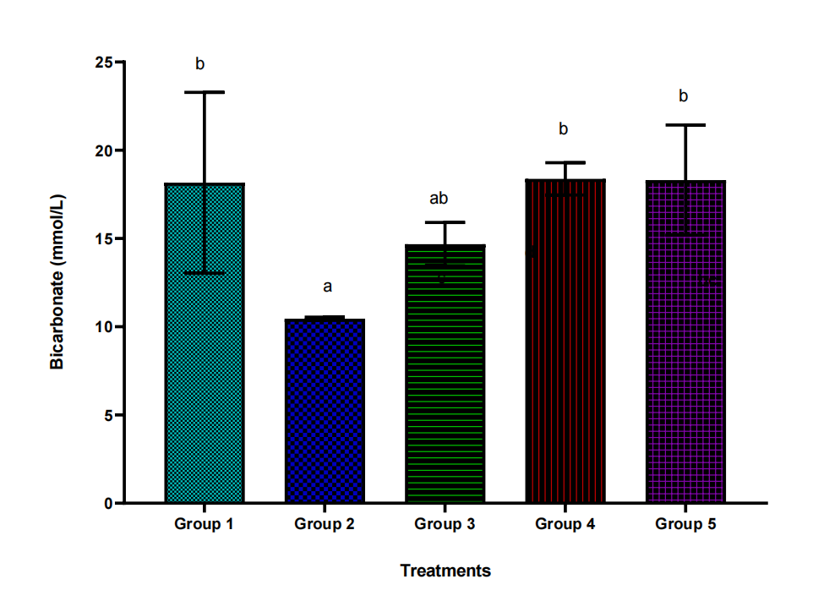

Figure 5: Bicarbonate ion levels in NMU-induced prostate cancer in rats treated with A. muricata ethanol leave extract. Bars represent mean ± standard deviation of triplicate determinations and bars with different alphabets indicate significant difference at p < 0.05. Group 1 = normal control, group 2 = prostate cancer control, group 3 = standard control, group 4 = prostate cancer treated with low dose of leave extract, group 5 = prostate cancer treated with high dose of leave extract.

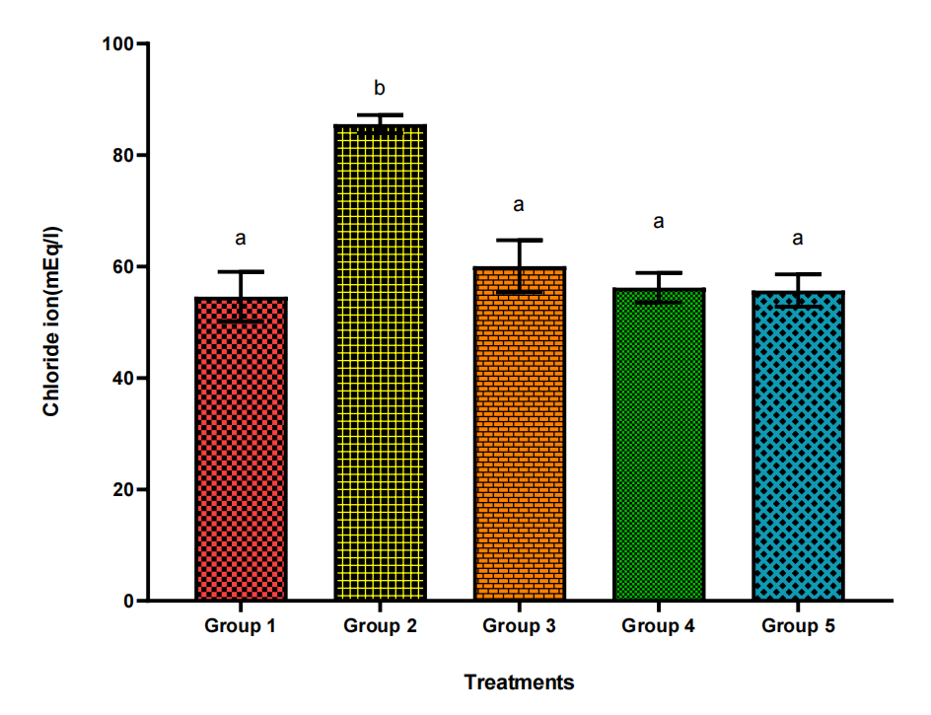

Figure 6: Chloride ion levels in NMU-induced prostate cancer in rats treated with A. muricata ethanol leave extract. Bars represent mean ± standard deviation of triplicate determinations and bars with different alphabets indicate significant difference at p < 0.05. Group 1 = normal control, group 2 = prostate cancer control, group 3 = standard control, group 4 = prostate cancer treated with low dose of leave extract, group 5 = prostate cancer treated with high dose of leave extract.

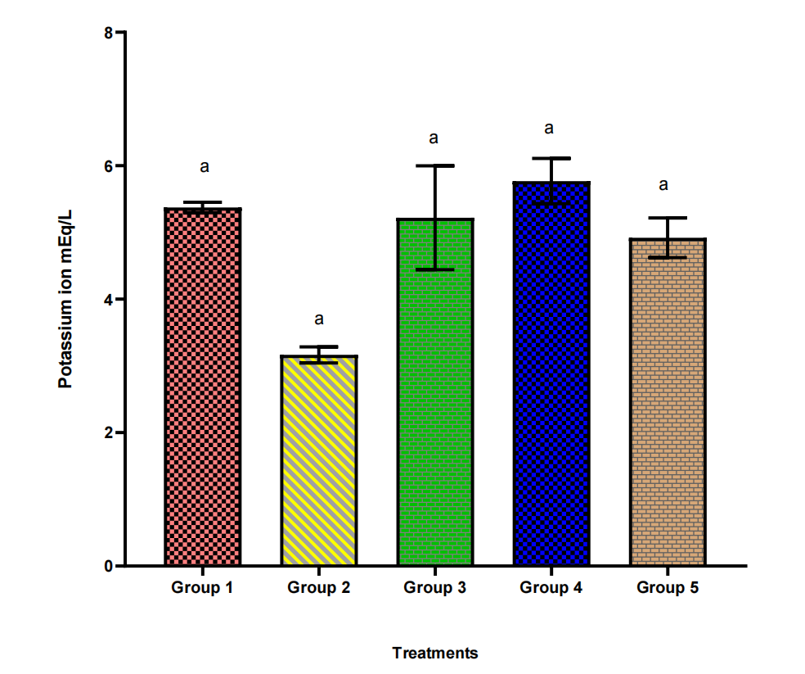

Figure 7: Potassium ion levels in NMU-induced prostate cancer in rats treated with A. muricata ethanol leave extract. Bars represent mean ± standard deviation of triplicate determinations and bars with different alphabets indicate significant difference at p < 0.05. Group 1 = normal control, group 2 = prostate cancer control, group 3 = standard control, group 4 = prostate cancer treated with low dose of leave extract, group 5 = prostate cancer treated with high dose of leave extract

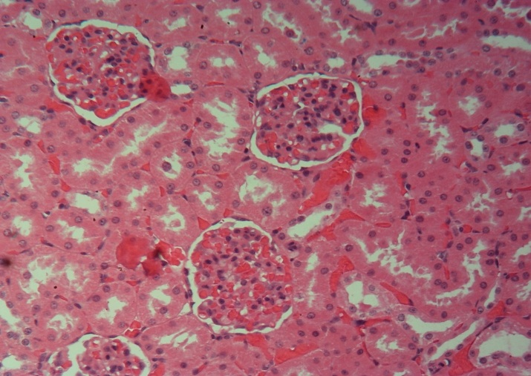
G
G
G
Plate 2: The sections of the kidney presented in this group 1 showed the normal renal histomorphology. Glomeruli (G). Renal tubules (arrow)

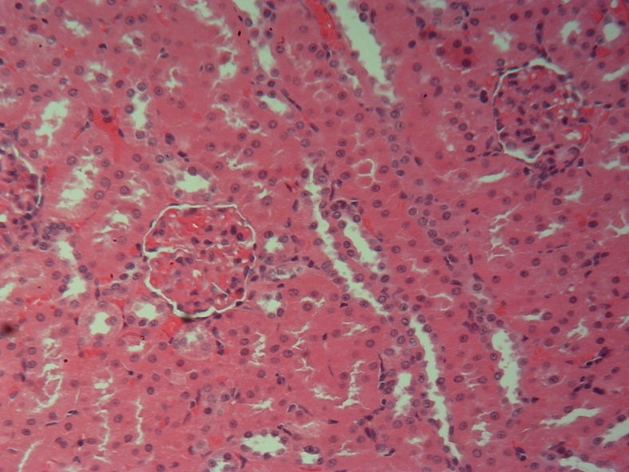
G
Plate 3. The sections of the kidney presented in this group 2 showed the normal renal histomorphology.
Glomeruli (G)
Renal tubules (arrow)
HE x400.

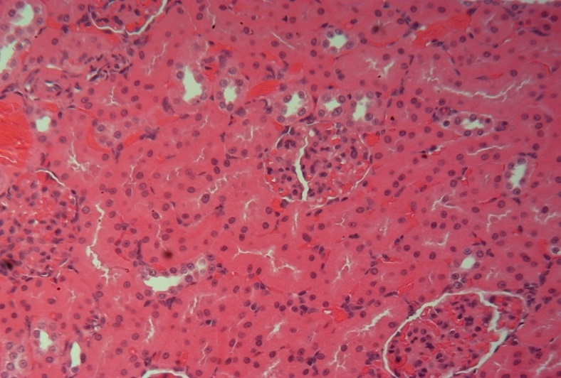
G
Plate 4. The sections of the kidney presented in this group 3 showed the normal renal histomorphology.
Glomeruli (G)
Renal tubules (arrow)
HE x400.

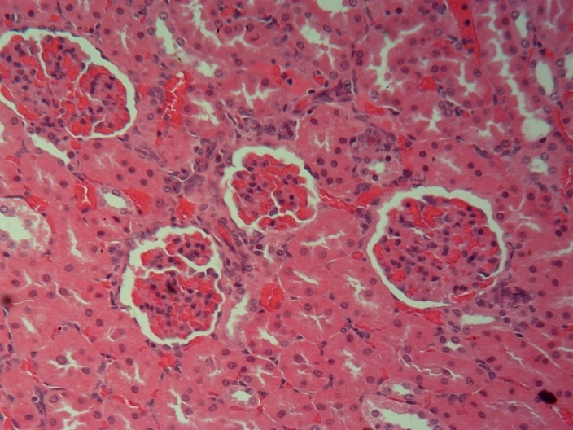
G
G
Plate 5. The sections of the kidney presented in this group 4 showed the normal renal histomorphology.
Glomeruli (G)
Renal tubules (arrow)
HE x400.

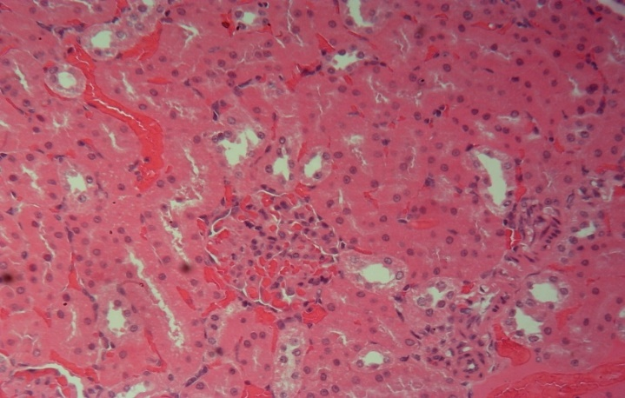
G
G
Plate 6. The sections of the kidney presented in this group 5 showed the normal renal histomorphology.
Glomeruli (G)
Renal tubules (arrow)
HE x400.

Discussion
Annona muricata (soursop or graviola) is a widely known tropical plant consumed by the community. It is also traditionally used to treat diverse ailments such as fever, pain, respiratory illness, infection, diabetes, cancer, and hypertension (Mutakin et al., 2022). The family Annonaceae has a long history of being recognized and used as a natural herbal treatment all throughout the world (Moghadamtousi et al., 2015a). Consuming soursop significantly improves human health (Saleem et al., 2017). It is therapeutically used for anticancer, antibacterial, antiviral, anti-fungal, antimalarial, anti-tumor, anxiolytic, anti-stress, analgesic, hypoglycemic, hypotensive, hepatoprotective, gastroprotective, anti-inflammatory, and immunomodulatory properties (Chaparro et al., 2014; Gavamukulya et al., 2017). However, few reports are available concerning their beneficial impacts against renal injury. This present study was designed to evaluate the effect of A. muricata leave extract on renal function parameters of NMU-induced prostate cancer in albino rats. NMU, one type of atmospheric pollutant, are widely dispersed in the environment and enter human bodies through food, drink, and the air. NMU, an environmental pollutant, has several harmful and carcinogenic consequences (Kleiner et al., 2012). Previously, NMU exposure increased urea and creatinine serum concentrations of group 2 due to an upregulation of protein catabolism (Burchiel et al., 2010). Meanwhile, urea represents the nitrogenous waste produced by protein degradation (Akhouri et al., 2020). As a result, elevated urea and creatinine levels in the serum indicate renal disease (Krishnamoorthy and Sankaran, 2016). While the increased serum sodium ion and chloride ion levels indicate nephrotoxicity (Burchiel et al., 2010), which can indicate kidney impairment (Akhouri et al., 2020). The current study reported a significant increase in the concentration of urea, creatinine, sodium ion and chloride ion and a reduced potassium ion and bicarbonate ion levels in the serum of the NMU-treated group. Oxidative stress is the main cause of nephrotoxicity (Kasprzak, 2023), where the reactive oxygen metabolites are formed by the mitochondria of the renal cortex (Padmini and Kumar, 2012). However, the toxicity of the glomerular and tubular epithelial cells may be induced by mechanisms compromising the mitochondria’s regular cellular functions and/or the integrity of their membranes (Dakrory et al., 2015b), which induces renal injury (Du and Yang, 2014). On the other side, the A. muricata leave extract treated groups showed enhanced renal functions. Histological findings however showed that there was no evident damage to the kidney architecture. The potential efficacy of A. muricata leave extract is due to extensive phytochemical evaluations on different parts of the A. muricata plant, which have shown the presence of various phytoconstituents and compounds, including alkaloids (Yang et al., 2015), flavonol, triglycerides (Nawwar et al., 2012), phenolics (Jimenez et al., 2014), cyclopeptides, and essential oils (Kossouoh et al., 2017). The result of this study is in line with the work of Yang et al. (2015), Nawwar et al. (2012) and Rupprecht et al., (2010) who recorded improved renal function indices following administration of A. muricata stem and leave extract to CCl4 exposed rats.

Conclusion
Based on the findings mentioned above, it could be concluded that A. muricata leave extract is a naturally beneficial medicinal product that can alleviate the renal toxicity resulting from environmental exposure to NMU and in prostate cancer patient. The reno-protective effects offered by the A. muricata stem and leave extract may involve its antioxidant, and/or oxidative free radical scavenging properties. The antioxidant activities of A. muricata leave extract are based on the presence of phytochemical compounds such as kaempferol, quercetin-glucoside, quercetin, and rutin, which were proved to be strong antioxidants due to their abilities to scavenge ROS, reduce hydrogen or donate electrons, and produce stable antioxidant-derived radicals.

Declarations
Ethics approval and consent to participate
The study was approved by the Ethical Committee on Human Research of the Department of Biochemistry, Federal University of Technology, Owerri, Nigeria. With approval NO. FUT/SOBS/BCH/COM.2/013/2022 and done in accordance with the NIH.

Availability of data and materials
The data that support the findings of this study are available from the authors upon reasonable request.

REFERENCES
Akhouri, V., Kumari, M., and Kumar, A. J. S. R. (2020). Therapeutic effect of Aegle marmelos fruit extract against DMBA induced breast cancer in rats. Sci. Rep., 10: 18016–18112.
Atawodi, S.E., (2011). Nigerian foodstuffs with prostate cancer. Infect. Agents Cancer, 6:1–4.
Badrie, N. and Schauss, A.G., (2009). Soursop (Annona muricata L.): composition, nutritional value, medicinal uses, and toxicology. In: Bioactive Foods in Promoting Health. Oxford, pp. 621–643.
Billon, H., (2019). Histoire des plantes. Librairie de L. Hachette, Paris, Pp: 275–276.
Bosland, M.C., and Prinsen M.K. Cancer Research (1990). Induction of dorsolateral prostate adenocarcinomas and other accessory sex gland lesions in male Wistar rats by a single administration of N-methyl-N-nitrosourea, 7,12-dimethylbenz(a)anthracene, and 3,2'-dimethyl-4-aminobiphenyl after sequential treatment with cyproterone acetate and testosterone propionate. Feb 1;50(3):691-9.PMID: 2137026
Boyom, F.F., Fokou, V.T., Yamthe, L.R.T., Mfopa, A.N., Kemgne, E.M., Mbacham, W.F., Tsamo, E., Zollo, P.H., Gut, J. and Rosenthal, P.J. (2011). Potent antiplasmodial extracts from Cameroonian Annonaceae. Journal of ethnopharmacology, 134(3):717-724.
Burchiel, S. W., De Ann, P. D., Gomez, M. P., Montano, R. M., Barton, S. L., and Seamer, L. C. (2010). Inhibition of lymphocyte activation in splenic and gutassociated lymphoid tissues following oral exposure of mice to 7, 12- dimethylbenz [a] anthracene. Toxicol. Appl. Pharmacol., 105 (3): 434–442.
Chaparro, S. P., Tavera, M. L., Martínez, J. J., and Gil, J. H. (2014). Propiedades funcionales de la harina y de los aislados proteicos de la semilla de guanábana (Annona muricata). Revista UDCA Actual. Divulgación Científica., 17 (1): 151–159.
Dakrory, A. I., Al Harbi, M. S., and Mohamed, A. S. (2015b). Antioxidant role of Holothuria atra extract against nephrotoxicity induced by 7, 12-dimethylbenz (a) anthracene in male albino rats. Int. J. Adv. Res., 3 (2): 275–287.
De Sousa, O.V., Vieira, G.D., De Pinho, J.R., Yamamoto, C.H., and Alves, M.S. (2010). Antinociceptive and anti-inflammatory activities of the ethanol extract of Annona muricata L. leaves in animal models. Int. J. Mol. Sci., 11(5):2067- 2078
Gavamukulya, Y., Wamunyokoli, F., and El-Shemy, H. A. (2017). Annona muricata: is the natural therapy to most disease conditions including cancer growing in our backyard? A systematic review of its research history and future prospects. Asian Pac. J. Trop. Med., 10 (9): 835–848.
Jimenez, V. M., Gruschwitz, M., Schweiggert, R. M., Carle, R., and Esquivel, P. (2014). Identification of phenolic compounds in soursop (Annona muricata) pulp by high performance liquid chromatography with diode array and electrospray ionization mass spectrometric detection. Food Res. Int., 65: 42– 46.
Kasprzak, K. S. (2023). Oxidative DNA damage in metal-induced carcinogenesis. Toxicol. Metals, I: 299–320.
Kossouoh, C., Moudachirou, M., Adjakidje, V., Chalchat, J.C., Figue´re´do, G., (2007). Essential oil chemical composition of Annona muricata L. leaves from Benin. J. Essent. Oil Res., 19:307–309.
Langenberger, G., Prigge, V., Martin, K., Belonias, B., Sauerborn, J. (2019) Ethnobotanical knowledge of Philippine lowland farmers and its application in agroforestry. Agrofor Syst., 76(1): 173-194.
Leatemia, J.A. and Isman, M.B. (2014). Insecticidal activity of crude seed extracts of Annona spp., Lansium domesticum and Sandoricum koetjape against lepidopteran larvae. Phytoparasitica 2004; 32(1):30-37.
Magan˜a, M.A., Gama, L.M. and Mariaca, R. (2010). El uso de las plant as medicinales en las comunidades mayachonales de nacajuca, Tabasco, Me´xico. Polibo´ tanica., 29: 213–262.
Moghadamtousi, S.Z., Fadaeinasab, M., Nikzad, S., Mohan, G., Ali, H.M. and Kadir, H.A. (2015). Annona muricata (Annonaceae): a review of its traditional uses, isolated acetogenins and biological activities. Int. J. Mol. Sci., 16(7):15625- 15658.
Morton, J. F. (2017). Soursop. In Fruits of Warm Climates. Greensboro, NC: Media Incorporated. Pp. 75–80.
Mutakin, M., Fauziati, R., Fadhilah, F. N., Zuhrotun, A., Amalia, R., and Hadisaputri, Y. E. (2022). Pharmacological activities of soursop (Annona muricata Lin.). Molecules, 27: 1201.
Nawwar, M., Ayoub, N., Hussein, S., Hashim, A., El-Sharawy, R., Wende, K., Harms, M., Lindequist, U. (2012). A flavonol Triglycoside and investigation of the antioxidants and cell stimulating activities of Annona muricata Linn. Arch. Pharmacal Res., 35:761– 767.
Padmini, M. P., and Kumar, J. V. (2012). A histopathological study on gentamycin induced nephrotoxicity in experimental albino rats. IOSR J. Dent. Med. Sci., 1 (1): 14–17.
Saleem, U., Ejaz-ul-Haq, M., Chudary, Z., and Ahmad, B. (2017). Pharmacological screening of Annona muricata: a review. Asian J Agri Biol., 5 (1): 38–46.
Tisott, G., Molin, D., Colet, C.D.F. (2013). The use of medicinal plants and herbal medicines for patients in chemotherapy in an oncology center of Ijuı´/RS. O Mundo da Sau´ de, 39(3): 287–298.
Vandebroek, I., Balick, M.J., Ososki, A., Kronenberga, F., Yukes, J. and Wade, C. (2010). Peguero BC. The importance of botellas and other plant mixtures in Dominican traditional medicine. J. Ethnopharmacol., 128: 20–41.
World Health Organization (2015). Preventing chronic diseases a vital investment. <http://www.who.int/chp/chronic_disease_report/ full_report.pdf> (accessed on 25.08.15).
Yang, C., Gundala, S. R., Mukkavilli, R., Vangala, S., Reid, M. D., and Aneja, R. (2015). Synergistic interactions among flavonoids and acetogenins in Graviola (Annona muricata) leaves confer protection against prostate cancer. Carcinogenesis, 36: 656–665.

