**Review Article**

**Epidemiology and Geographical distribution; Transmission; Global burden and Control Strategies of Leishmaniasis**

**Abstract**

Leishmaniasis is a globally significant vector-borne zoonotic disease caused by protozoan parasites of the genus *Leishmania*, affecting humans and various mammalian hosts, transmitted through the bite of infected sand flies. It manifests primarily in three clinical forms: visceral, cutaneous, and mucocutaneous leishmaniasis, each varying in severity and geographic prevalence. This disease is endemic in tropical and subtropical regions, with over one billion people at risk, especially among marginalised populations in developing countries.

Transmission occurs via infected female phlebotomine sand flies, with both zoonotic and anthroponotic cycles contributing to disease persistence. Dogs and other domestic animals serve as important reservoirs, particularly in zoonotic transmission cycles. Despite ongoing control efforts, the global burden remains substantial, with estimated annual cases ranging from 600,000 to 1 million for CL and 50,000 to 90,000 for VL, accompanied by significant morbidity and mortality. Environmental changes, urbanisation, and human mobility are expanding leishmaniasis into previously non-endemic areas. Comprehensive control strategies require integrated approaches encompassing vector control, reservoir management, early diagnosis, treatment, and surveillance to mitigate this neglected tropical disease’s impact worldwide.

**Introduction**

Leishmaniasis is a vector-borne zoonotic disease caused by intracellular protozoan parasites of the genus *Leishmania*, affecting both humans and a wide range of mammalian hosts (*Leishmania Parasites - Epidemiology, Immunopathology and Hosts*, n.d.)(Kyari, S., 2024; Alemayehu & Alemayehu, 2017). More than 30 species of *Leishmania* are classified under the subgenera *Leishmania*, *Viannia*, and *Mundinia* (Cantanhêde & Cupolillo, 2023; Steverding, 2017). Out of these, 20 species are found to affect humans, and 10 of them are known to be pathogenic, each associated with distinct clinical syndromes and geographic distributions in both humans and animals (WHO, 2023; McGwire & Satoskar, 2013). Despite presenting various Clinical Signs, leishmaniasis is primarily classified into three forms: visceral leishmaniasis (VL), cutaneous leishmaniasis (CL), and mucocutaneous leishmaniasis (MCL), with disease severity varying from self-limiting skin ulcers to fatal systemic infections if left untreated. (Alvar et al. 2012, WHO,2023, Hide et al. 2007)

**TABLE 1. Geographic distribution and infectious effect of Leishmania Species**

|  |  |  |  |
| --- | --- | --- | --- |
| **Leishmania Species** | **Geographic Distribution** | **Infective to Humans** | **Animal Hosts Affected** |
| *L. donovani* | South Asia, East Africa | Yes | Humans, dogs |
| *L. infantum* (*L. chagasi*) | Southern Europe, Latin America, the Middle East | Yes | Dogs, wild canids, humans |
| *L. tropica* | Middle East, South Asia | Yes | Humans |
| *L. major* | North and Sub-Saharan Africa, the Middle East | Yes | Rodents, humans |
| *L. mexicana* | Mexico, Central America | Yes | Rodents, humans |
| *L. amazonensis* | South America | Yes | Rodents, humans |
| *L. braziliensis* | South America (esp. Brazil, Peru, Bolivia) | Yes | Humans, dogs |
| *L. panamensis* | Central and South America | Yes | Humans |
| *L. guyanensis* | Northern South America | Yes | Humans |
| *L. peruviana* | Peru | Yes | Humans |
| *L. aethiopica* | Ethiopia, Kenya | Yes | Hyraxes, humans |
| *L. enriettii* | South America | No | Guinea pigs |
| *L. tarentolae* | Mediterranean (lizards) | No | Lizards |

Visceral leishmaniasis (kala-azar) causes systemic infection with fever, weight loss, hepatosplenomegaly and anaemia; it is nearly always fatal without treatment. It is primarily caused by the *Leishmania donovani* complex, which includes *L. donovani* in East Africa and the Indian subcontinent, and *L. infantum* (previously known as *L. chagasi*) in the Mediterranean and Latin America. (Cunze et al., 2019; Mann et al., 2021; Thakur et al., 2018) Cutaneous leishmaniasis is the most common form of leishmaniasis, which produces skin ulcers and scarring, often with a raised border and a central crater. In the Old World, CL is caused by species such as L. tropica, L. major, and L. aethiopica. (WHO,2023; McGwire & Satoskar, 2013). In contrast, in the New World, it is caused by *L. mexicana* complex (e.g. *L. mexicana, L. amazonensis), L. braziliensis, L. panamensis, L. guyanensis, and L. peruviana.* (Kevric, Cappel, & Keeling, 2015; Scott & Novais, 2016). Mucocutaneous leishmaniasis refers to metastasis of infection to mucous membranes in the nose, mouth, and throat that can cause severe tissue destruction. MCL is predominantly caused by New World Vannia species (especially *L. braziliensis* complex), though a few Old-World species (e.g. *L. tropica*) have been implicated (Reveiz et al., 2013; Ahluwalia et al., 2004). Over 90% of MCL cases occur in Bolivia, Brazil, Ethiopia and Peru (WHO,2023; Shaw J.J, 2022). The different forms correlate with Leishmania species tropisms: for example, L. donovani and L. infantum cause VL, while *L. tropica, L. major and L. aethiopica* cause Old World CL, and L. braziliensis causes most New World CL and MCL (Kevric, Cappel, & Keeling, 2015; Scott & Novais, 2016; WHO,2023; Steverding, 2017).

Fig 1: Lesion in a Human during Leishmania

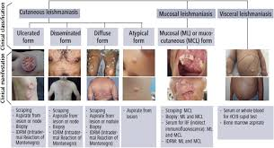

**Epidemiology in Human**

Leishmaniasis is a neglected tropical disease (NTD), endemic to nearly 100 countries (WHO,2023; Mann et al., 2021). The disease outbreaks mainly affect poor rural populations, associated with malnutrition, population displacement, poor housing, weak immune system and lack of resources (Zilberstein & Shapira, 1994; WHO, 2023; Grifferty et al., 2021). VL is mainly reported in South Asia, East Africa, and Latin America, while CL is more geographically widespread, affecting parts of the Americas, the Middle East, Central Asia, and the Mediterranean (WHO,2023; Cunze et al., 2019; Mann et al., 2021; Thakur et al., 2018). Today, more than 1 billion people live in areas endemic for leishmaniasis and are at risk of infection (Alvar et al., 2012; Burza et al., 2018). Despite official figures estimating 50,000 to 100,000 VL cases and up to 1.2 million CL cases annually, actual numbers are likely much higher due to underreporting (WHO,2023; Hide et al., 2007). The global burden is reflected in high disability-adjusted life years (DALYs), particularly from VL due to its mortality (AbouZahr & Vaughan, 2000; King & Bertino, 2008). In 2023, the majority of global VL and CL cases were concentrated in a few countries, including Brazil, Ethiopia, India, Afghanistan, and Syria (WHO,2023). Presently, Leishmaniasis has also been reported in non-endemic regions such as southern Europe, attributed to climate and environmental change, global warming, immigration and travelling and vector migration (Cunze et al., 2019; Abdullah et al., 2017; Ahluwalia et al., 2004).

According to Desjeux (2004), human leishmaniasis can be categorised into two main epidemiological forms:

* **Zoonotic leishmaniasis**, in which the transmission cycle involves domestic or wild animal reservoirs, with humans acting as incidental hosts.
* **Anthroponotic leishmaniasis**, in which humans serve as the primary or sole reservoir and are the main source of infection for the sandfly vector.

**Geographical distribution and Endemicity**

Leishmaniasis is a significant public health concern with a wide geographical distribution. According to the data of the World Health Organisation (WHO) in 2022 A.D, 99 countries are considered endemic for the disease. Among these, 71 countries are endemic for both visceral leishmaniasis and cutaneous leishmaniasis, while 9 are endemic for VL only and 19 for CL only. Since 2013, WHO's Global Leishmaniasis Programme has distinguished between new local (autochthonous) cases and imported cases to better understand incidence trends. In 2023, data were submitted by 53 VL-endemic countries (66%) and 56 CL-endemic countries (62%), Approximately 83% of global VL cases in 2023 are concentrated in seven countries: Brazil, Ethiopia, India, Kenya, Somalia, South Sudan, and Sudan. Similarly, six countries: Afghanistan, Algeria, Brazil, Pakistan, Peru, and the Syrian Arab Republic accounted for 83% of the global CL burden, each reporting over 5,000 cases that year (WHO,2023). However, these numbers likely underestimate the true scale, as only an estimated 25–45% of VL cases are officially reported. According to Global Burden of Disease (GBD) 2021 data, VL and CL caused around 389,000 and 393,000 disability-adjusted life years, respectively.

South Asia, especially the Indian subcontinent, has long borne a heavy VL burden. India, Nepal and Bangladesh together accounted for ~70% of global VL cases in the mid-2000s (Karunaweera & Ferreira, 2018; Mondal et al., 2009). Within this region, elimination programs since 2005 have brought case counts to historic lows (World Health Organization – SEARO, 2005a; WHO - SEARO, 2006). Nepal was the first country to meet WHO’s kala-azar elimination threshold (≤1 case per 10,000) at the implementation unit level in 2013(Cloots et al., 2020; Pandey et al., 2023; Pandey et al., 2021). By 2018, Nepal’s annual VL cases had fallen to just 218 nationwide (versus ~2,200 a decade earlier) to 168 by 2023(Pandey et al., 2023). Similar declines occurred in India and Bangladesh: India’s VL caseload dropped by ~98% from 77,102 cases in 1992 to 39,000 in 2006 to about 6,200 in 2013 and 1,275 in 2021, and Bangladesh was validated by WHO in 2023 as having eliminated VL as a public health problem (fewer than 1/10,000 in all districts), with only 47 VL cases reported in 2022(WHO,2023; Chapman et al., 2018; Karunaweera & Ferreira, 2018). Despite overall success, sporadic transmission has expanded into geographic areas in Nepal (including hill and mountain regions) and nearby regions, indicating that vigilant surveillance is still needed (Pandey et al., 2021; Bastola et al., 2020). Afghanistan, Iran, Pakistan and Sri Lanka are notable South Asian foci: CL is endemic in Afghanistan and Pakistan, while Sri Lanka reports rising CL (due largely to L. tropica), and parts of India/ Bangladesh/Nepal still report residual VL (Rahimi et al., 2025; Amarasinghe & Wickramasinghe, 2020).

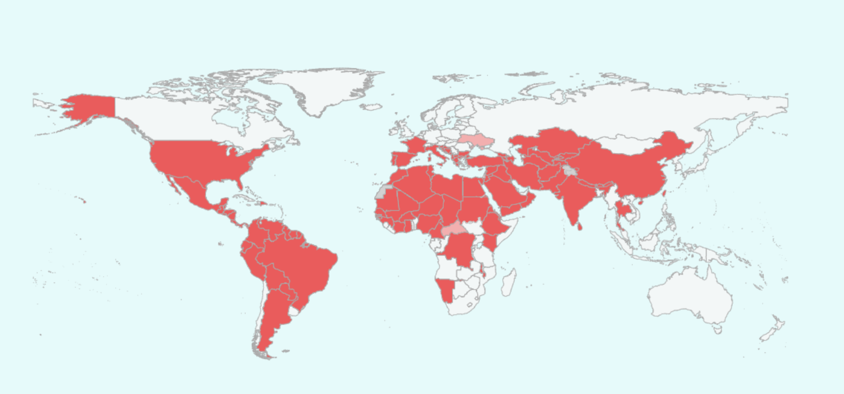

Fig 2: Map of the World Showing Endemic Area for Leishmaniasis in Humans(Global Health Observatory as of 06/12/2025)

**Evolving Trend, Mortality and Public Health Impact**

While South Asia has seen substantial declines due to elimination initiatives, some regions, particularly in East Africa, have experienced a resurgence. For example, Somalia’s VL cases increased from fewer than 100 in 2006 to over 780 in 2016. In contrast, Brazil’s VL incidence has remained relatively steady, averaging around 2,700 cases per year. CL maintains a more stable global incidence, estimated between 600,000 and 1 million cases annually, although its geographic hotspots have shifted, with the highest per capita burdens seen in Afghanistan, Syria, Algeria, and parts of South America (WHO,2023; Cunze et al., 2019; Wamai et al., 2020; Blaizot et al., 2024; Cargnelutti et al., 2016). Mortality is more severe in VL, which is nearly always fatal if untreated, making it a leading parasitic cause of death globally (McGwire & Satoskar, 2013). WHO has classified leishmaniasis among the most neglected tropical diseases, with an estimated yearly burden of up to 1.5 million CL cases and 500,000 VL cases (King & Bertino, 2008; Wamai et al., 2020; WHO,2023). The apparent rise in global incidence might also be due to improvements in diagnostics, reporting, and healthcare access rather than a true surge in transmission (Maroli et al., 2013; Wamai et al., 2020). Nonetheless, both human and animal leishmaniasis are now observed in regions previously considered non-endemic (Symeonidou et al., 2023; King & Bertino, 2008; Kyari, 2024; Dantas-Torres, 2009). Local transmission of leishmaniasis has recently been documented in parts of North America, including U.S. states and Canadian provinces (Boggiatto et al., 2011), as well as in Europe, such as Northern Italy and Germany (Maroli et al., 2008; Maroli et al., 2013; Cunze et al., 2019; Pennisi, 2015; Symeonidou et al., 2023).

**Epidemiology in Animal**

Although Leishmania species affect several animals, it is most prevalent in Dogs, Cats and rodents (Symeonidou et al., 2023; Ratzlaff et al., 2023). Because of the common practice of keeping them as Companion animals, they are of significant zoonotic concern(Pennisi, 2015) Dogs are the primary reservoirs for leishmaniasis, specifically caused by *L. infantum* in various regions of the Old and New Worlds, i.e Mediterranean, where both symptomatic and asymptomatic carriers contribute to the maintenance and transmission of the parasite via female phlebotomine sand flies(Dantas-Torres, 2007; Antoniou et al., 2013; Baneth et al., 2021). They develop a complex syndrome called Canine Leishmaniasis (CanL), whereas Cats develop feline leishmaniasis syndrome (FenL), which is less severe compared to CanL(Baneth et al., 2021; Pennisi & Persichetti, 2018). Infected dogs may exhibit clinical signs such as weight loss, skin lesions, lymphadenopathy, and ocular abnormalities, but many remain subclinical, complicating detection and control efforts (Baneth et al., 2021; Pennisi & Persichetti, 2018; Miró & López-Vélez, 2018). Infections have been reported in other animals such as cats, rodents, foxes, and even horses as occasional hosts, although their epidemiological role remains less clear. They are common in areas with a high prevalence of Canine Leishmaniasis. (Dantas-Torres, 2007; Pennisi & Persichetti, 2018; Morales-Yuste et al., 2022) Many wild animals also play the role of hosts. Small rodents are reservoirs for *L. major* in the Old World and *L. braziliensis* in the New World, while other indigenous animals, such as marsupials, sloths, and monkeys, are the main hosts for other *Leishmania* spp(Ratzlaff et al., 2023).

The disease is endemic in parts of Southern Europe, Latin America, the Middle East, North Africa, and Asia, similar to that of humans. Factors influencing animal leishmaniasis include climate change, increasing urbanisation, pet travel, and importation, which have led to the expansion of sand fly vectors into non-endemic regions such as Northern Europe and North America and higher altitudes (Cunze et al., 2019; Abdullah et al., 2017; Ahluwalia et al., 2004; Pandey et al., 2021; Bastola et al., 2020).

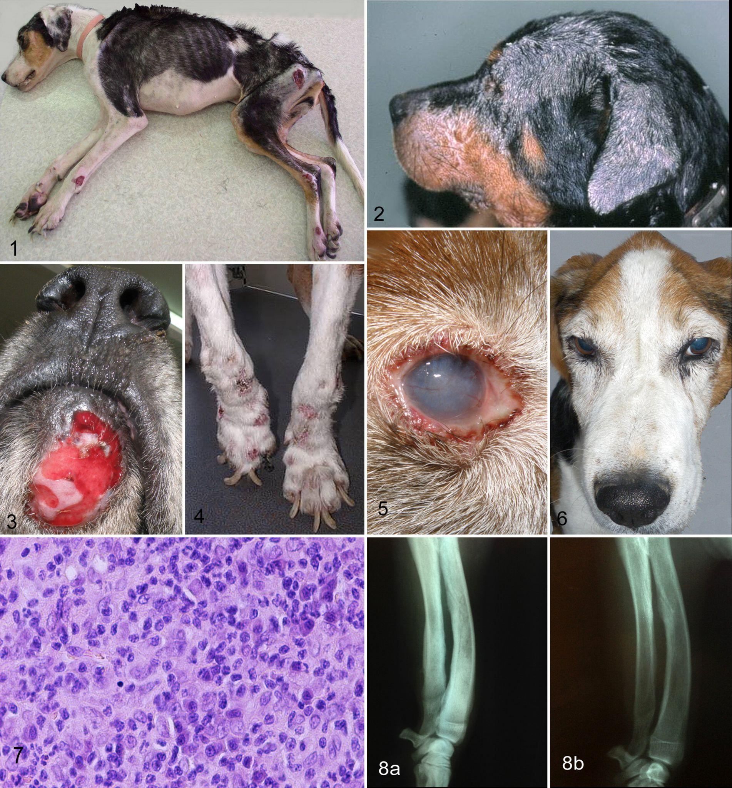

Fig 3: Clinical lesions in Canine leishmaniasis

**Transmission and Life Cycle**

Leishmaniasis is transmitted through the bite of infected female phlebotomine sand flies, which act as biological vectors. These tiny, nocturnal insects (typically 2–3 mm in size) become infected by ingesting blood from an infected host, either an animal reservoir or a human, depending on the species and form of the disease. Once inside the sand fly, Leishmania parasites undergo development from amastigotes to motile promastigotes in the insect’s midgut. Eventually, the infective stage, known as the metacyclic promastigote, migrates to the proboscis of the sand fly, ready to be transmitted to a new host during the next blood meal (Maroli et al., 2013; Antoniou et al., 2013; Lazar & Abass, 2020).

The life cycle of *Leishmania* is digenetic, involving two primary hosts: the phlebotomine sand fly vector and a vertebrate host, which can be either human or animal. It alternates between two morphological forms: promastigotes, the flagellated extracellular form in the sand fly, and amastigotes, the non-flagellated intracellular form in vertebrate host macrophages. When an infected sand fly bites a mammalian host, it injects metacyclic promastigotes into the skin. These parasites are phagocytosed by macrophages and other phagocytic cells, where they differentiate into amastigotes and replicate within the phagolysosome. The multiplying amastigotes eventually rupture the host cell, infecting neighbouring macrophages and causing the clinical symptoms of leishmaniasis (McGwire & Satoskar, 2013; Miró & López-Vélez, 2018).

During a blood meal from an infected host, sand flies ingest macrophages containing amastigotes. Inside the sand fly midgut, these amastigotes are released and transform back into promastigotes, multiplying and migrating to the proboscis as infective metacyclic promastigotes. This cyclical transformation between forms within both vector and host ensures the parasite’s survival and transmission. Factors such as vector density, environmental conditions, and host immune status critically influence transmission dynamics (Maroli et al., 2013; Antoniou et al., 2013; Alemayehu et al.,2017)

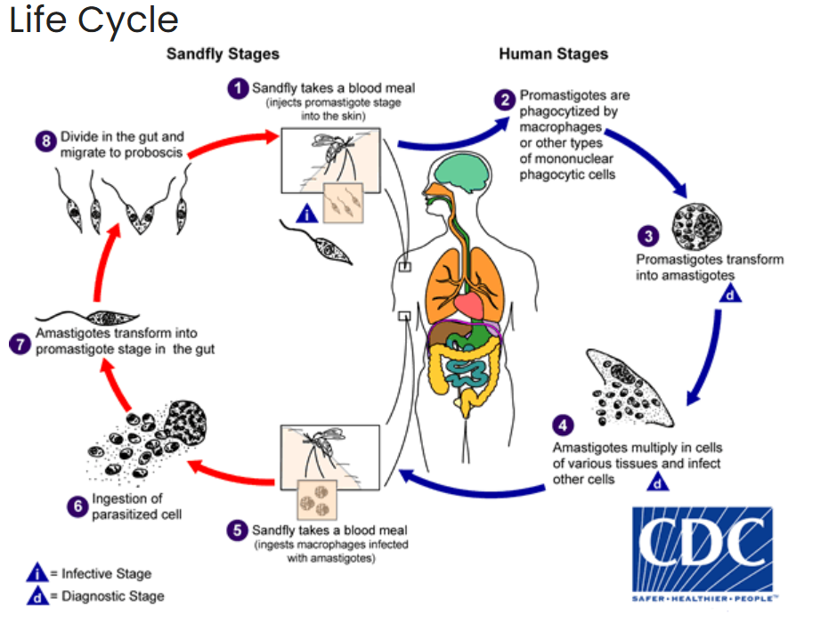

Fig 4: Life Cycle of Leishmania (Centres for Disease Control and Prevention, n.d.)

The transmission cycle can be either **zoonotic** or **anthroponotic**, depending on the Leishmania species involved. In zoonotic transmission, animals (particularly dogs) act as reservoirs of the parasite, and humans are incidental hosts. This is typical for *Leishmania infantum* and *Leishmania braziliensis*, which cause visceral and mucocutaneous forms, respectively. In contrast, *Leishmania donovani*, a major cause of visceral leishmaniasis in South Asia, spreads via anthroponotic transmission, where humans are the main reservoir (Dantas-Torres, 2007; Pennisi, 2015).

The dynamic nature of leishmaniasis transmission is influenced by shifting environmental, demographic, and behavioural factors, including changes in vector and host habitats, immunosuppressive diseases, urban expansion, conflict, and migration, all of which contribute to its evolving global footprint. Environmental and behavioural factors heavily influence transmission. Conditions that increase human-sand fly contact, such as deforestation, urbanisation, war, or poor housing, can amplify the spread. Moreover, climate change and ecological shifts are expanding the range of sand fly vectors into previously non-endemic regions. (Cunze et al., 2019; Maroli et al., 2013).

Beyond classical vector-borne transmission, alternative routes have been documented, especially in animal hosts. In dogs, vertical (transplacental), venereal (sexual), and direct transmission through bites or wounds have been observed, complicating disease control in endemic regions (Dantas-Torres, 2007; Pennisi & Persichetti, 2018). Notably, transplacental transmission of *Leishmania infantum* has been reported in North America, highlighting sustained disease incidence even where vector control is implemented (Boggiatto et al., 2011).

This complexity in transmission routes underscores the challenges faced in controlling leishmaniasis, emphasising the need for integrated “One Health” approaches that address both vector control and animal reservoirs to effectively reduce disease burden (Miró & López-Vélez, 2018).

**Global Burden and Epidemiology of Different Leishmania Forms**

Leishmaniasis continues to pose a significant yet often under-reported public health burden globally. The World Health Organisation and the Global Burden of Disease Study, led by the Institute for Health Metrics and Evaluation (IHME), offer complementary insights into the scale of this disease.

According to WHO estimates, the annual incidence of cutaneous leishmaniasis lies between 600,000 and 1,000,000 cases, though only around 200,000 are typically reported. For visceral leishmaniasis, an estimated number is 50,000 to 90,000 new cases each year, with reported cases representing only 25–45% of the actual burden.

The most recent GBD 2021 data estimate that VL was responsible for approximately 5,500 deaths and 389,000 disability-adjusted life years globally in 2021. Although CL, including its more severe mucocutaneous forms, rarely causes direct mortality, it results in an estimated 393,000 DALYs due to its chronic nature and disfiguring consequences.

Regionally, the burden varies significantly. GBD findings show that around 21.8% of VL-related DALYs occurred in South and Southeast Asia. Afghanistan alone contributed to approximately 15.8% of all DALYs attributed to CL globally. WHO case data also highlight several countries bearing the highest VL burden, namely Brazil, Ethiopia, India, Kenya, Somalia, South Sudan, and Sudan, which together account for roughly 83% of all reported VL cases.

In the Americas, Brazil stands out as the most significant hotspot for both CL and VL. In South Asia and the Eastern Mediterranean, countries such as Afghanistan, Pakistan, India, and Bangladesh are heavily affected by both forms of the disease (Cunze et al., 2019; Wamai et al., 2020; Blaizot et al., 2024; Rahimi et al., 2025; Amarasinghe & Wickramasinghe, 2020).

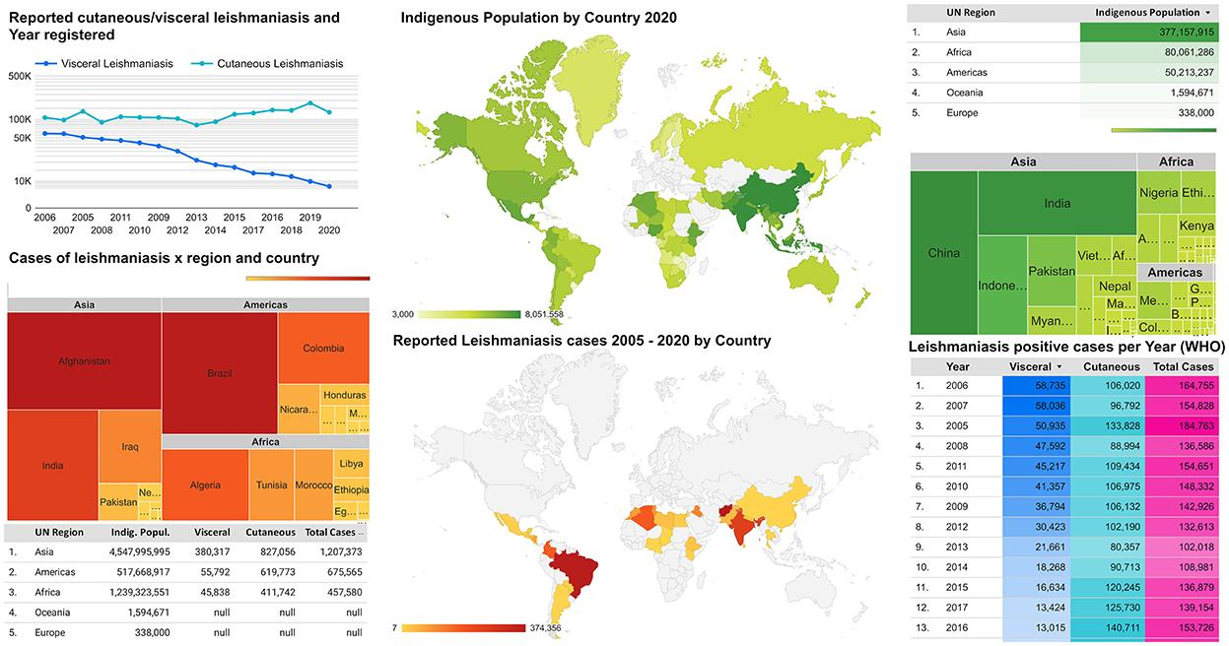

Fig 5: Global distribution of leishmaniasis endemic areas and the average of indigenous populations. (Oryan, Ahmadi, & Hatam, 2022)

To summarise the major global burdens:

* **Visceral leishmaniasis** sees an estimated 50,000–90,000 new cases each year, with 5,000–7,000 associated deaths, primarily occurring in India, Sudan, Brazil, and Ethiopia.
* **Cutaneous leishmaniasis** affects between 700,000 and 1,200,000 individuals annually. Although it rarely causes death, its impact on quality of life is substantial. It is predominantly found in the Americas, the Middle East, and Central Asia.
* **Mucocutaneous leishmaniasis**, a more severe subset of CL, affects about 3–5% of CL cases in Latin America and can lead to severe disability.

Globally, the total disease burden, measured in DALYs, is roughly split between VL and CL. While VL is associated with higher mortality, CL contributes significantly to chronic morbidity. Due to the focal and often hidden nature of the disease, accurate assessment of the global burden requires integrating both WHO surveillance data and GBD estimates to provide a more comprehensive picture.

**Control**

The complex interaction between host, parasite, and vector, influenced by environmental and social factors, makes leishmaniasis a complex disease to control (Cunze et al., 2019; Maroli et al., 2013). Both human and canine leishmaniasis are evolving with changing environmental and socio-political landscapes, highlighting the urgent need for enhanced surveillance, diagnostic tools, and integrated control strategies (Gramiccia & Gradoni, 2005).

* **Control in Reservoir:** Since most *Leishmania* species infect via a zoonotic cycle, studies on domestic and wild animals susceptible to *Leishmania* infection and the identification of reservoir animals are important for the development of control strategies against leishmaniasis (Ratzlaff et al., 2023; Antoniou et al., 2013). In many endemic regions, especially across the Mediterranean, Latin America, and parts of Asia, domestic dogs act as the main reservoir for infection, perpetuating the transmission cycle to humans (Miró & López-Vélez, 2018; Morales-Yuste et al., 2022). Historically, efforts to control canine leishmaniasis often involved mass culling of infected dogs, a strategy that has proven ethically controversial and largely ineffective in the long term (Baneth et al., 2021). Modern control programmes have shifted towards more sustainable and humane approaches, such as the widespread use of insecticide-impregnated collars, which reduce sandfly bites; vaccination of dogs where available (three canine vaccines exist), such as the Leishmune® vaccine employed in Brazil and prompt treatment of infected animals to lower parasite loads (Ayala et al., 2024; Morales-Yuste et al., 2022). However, these interventions face practical obstacles, including financial costs, difficulties in reaching stray or feral dog populations, and the risk of reinfection in endemic environments (Ratzlaff et al., 2023; Pennisi & Persichetti, 2018). In sylvatic foci, reducing rodent populations or modifying their habitat can help. This can be done by keeping poisonous bait for rodents, removing plants they feed on, destroying burrows or setting up traps can be done ((González et al., 2015). But control of wildlife reservoirs (rodents, hyraxes, etc.) is typically impractical on a large scale, so focus remains on domestic animals.
* **Vector Control:** Vector control remains a fundamental pillar in reducing leishmaniasis transmission. It is suggested that elimination of VL is possible if the sand fly density can be reduced by 67% through killing sand flies, or if the number of breeding sites can be reduced by more than 79% (Stauch et al., 2014). Techniques such as indoor residual spraying (IRS) with pyrethroid insecticides and the use of insecticide-treated bed nets have shown considerable success in limiting sandfly populations and their contact with humans (e.g. past DDT campaigns helped eliminate VL in South Asia) (WHO, 2022; Alvar et al., 2012). According to Stauch et al. (2014), Nepal and Bangladesh had a reduction of 79% of the density of Sand flies by using IRS. Environmental management is equally important to reduce indoor resting sites for sandflies. Proper waste management to eliminate breeding grounds, and treating animal shelters to minimise vector habitats. Personal protection (repellents, fine mesh screens) also helps.
* **Diagnosis and Treatment:**  Early diagnosis and treatment are crucial in managing disease spread and improving patient outcomes (World Health Organization – SEARO, 2005a; Pandey et al., 2023; Chapman et al., 2018). Diagnostic tools like the rK39 rapid diagnostic test offer practical, field-friendly options for detecting visceral leishmaniasis, while treatments including liposomal amphotericin B, miltefosine, and pentavalent antimonial, though effective, are often hampered by high costs, limited availability, and emerging drug resistance (Duthie, M.S. et al. 2018; Ghorbani & Farhoudi, 2017). Despite considerable research efforts, a licensed vaccine for human leishmaniasis remains elusive, although several promising candidates, such as viral-vectored DNA vaccines, are undergoing clinical trials (Younis et al., 2021). In contrast, canine vaccines have made notable strides in reducing infection reservoirs, indirectly benefiting human health by lowering zoonotic transmission risk (Morales-Yuste et al., 2022).
* **Vaccination:** Vaccination is an aspiration. Currently, no human vaccine is licensed (Abdellahi et al., 2022; Younis et al., 2021). However, vaccine research is active. Experimental strategies include whole-killed or live-attenuated parasite vaccines, recombinant protein vaccines and viral-vectored DNA vaccines. For example, a recent candidate (ChAd63-KH, a simian adenovirus-vectored vaccine encoding L. donovani antigens) has shown immunogenicity in early trials (Younis et al., 2021). The goal is to elicit a strong Th1 immune response. Progress has been slow, in part due to parasite diversity and complex host immunity, but promising leads continue to emerge. By contrast, canine vaccines do exist: commercial dog vaccines like Leish-Tec™ and CaniLeish™ are used in endemic countries to reduce parasite load and transmission from dogs (Ayala et al., 2024; Morales-Yuste et al., 2022).
* **Surveillance and Case Reporting:** Other control measures include surveillance and case reporting, and health education to rapidly identify outbreaks. WHO advises active surveillance in elimination settings, community mobilisation, and integration with other disease programs. In Nepal and India, specialised VL elimination programs have combined case mapping, insecticide spraying and monitoring (World Health Organization – SEARO, 2005a; Pandey et al., 202;3 Chapman et al., 2018; Karunaweera & Ferreira, 2018). Public health policies can be developed by emphasising integrated surveillance of the reservoir host and animal to control the disease outbreak (screening dogs, treating infected dogs, vaccinating, and vector control around dogs).
* **Other Measures:** Health education, improved housing, and social mobilisation (informing communities about sandflies and protective behaviours) support all interventions. HIV co-infection significantly increases VL risk; integrated screening and treatment of HIV-VL co-infected patients is important (Fontoura et al., 2018).

**Key Issues:**

The key issues that came across during the article review were:

* **Underreporting and diagnostic gaps** are highlighted by WHO data showing only 25–45% of visceral leishmaniasis cases are officially reported, indicating significant gaps in surveillance and diagnostics (WHO,2023; Wamai et al., 2020).
* **Sandfly vector control issues** appear in studies calling for integrated approaches combining insecticide use with environmental management and community participation (Stauch et al., 2014; González et al., 2015).
* **Reservoir hosts, especially dogs,** are recognised as key in sustaining transmission cycles, with control measures complicated by cultural and logistical challenges (Gramiccia & Gradoni, 2005; Karunaweera & Ferreira, 2018).
* **Treatment access and drug resistance** concerns are noted in discussions about uneven healthcare infrastructure and emerging resistance, affecting effective disease management (Ghorbani & Farhoudi, 2017; Younis et al., 2021).
* **Community awareness and engagement gaps** are implicit in mentions of insufficient education and outreach programs in endemic regions, impacting prevention and early treatment (Blaizot et al., 2024; Fontoura et al., 2018).

**Recommendations:**

Based on a thorough review of the literature, the following key recommendations are essential to advance efforts in reducing transmission and improving patient outcomes:

1. **Enhance Surveillance and Diagnostics:** Improving the detection and reporting of leishmaniasis cases is critical for timely intervention and effective control. Investment in laboratory infrastructure, including molecular diagnostic tools, and ongoing training for healthcare personnel will improve case confirmation accuracy. Strengthening national and regional disease surveillance systems enables better mapping of endemic areas and monitoring of disease trends, allowing targeted resource allocation (Pandey et al., 2023; World Health Organization, 2023). Integration of modern diagnostic techniques, such as PCR-based assays, can increase sensitivity in identifying infections, including asymptomatic cases (Younis et al., 2021).
2. **Expand Integrated Vector Management (IVM):** Vector control remains a cornerstone of reducing transmission. Indoor residual spraying (IRS) with effective insecticides, particularly pyrethroids, should be scaled up in endemic communities as it has proven successful in lowering sandfly populations (World Health Organization – SEARO, 2005; Gramiccia & Gradoni, 2005). Distribution and promotion of insecticide-treated bed nets (ITNs) provide personal protection and reduce human-vector contact (Abdullah et al., 2017). Environmental management must complement these efforts by eliminating sandfly breeding and resting sites—proper waste disposal, management of organic matter, and treatment of animal shelters reduce vector habitats (Pandey et al., 2021; Maroli et al., 2013).
3. **Implement Reservoir Control Measures**: Reservoir hosts, especially domestic dogs, play a significant role in sustaining zoonotic leishmaniasis transmission cycles (Dantas-Torres, 2007; Miró & López-Vélez, 2018). Canine vaccination programs should be initiated and scaled up where feasible to reduce infectious reservoirs. Additionally, humane population management of stray and feral dogs through sterilisation and community engagement is essential to limit disease spread (Baneth et al., 2021; Ratzlaff et al., 2023).
4. **Ensure Treatment Accessibility and Drug Efficacy:** Strengtheninghealthcare infrastructure in endemic regions to ensure availability and affordability of effective antileishmanial therapies is paramount (McGwire & Satoskar, 2013). Health systems should implement standardised treatment protocols and monitor for drug resistance or treatment failure (Reveiz et al., 2013). Supporting decentralised care and training frontline health workers will facilitate early diagnosis and management, improving patient outcomes (World Health Organization, 2023).
5. **Promote Community Education and Behaviour Change:** Culturally appropriate health education campaigns tailored to local contexts are vital to increase awareness about leishmaniasis transmission, symptoms, prevention, and the importance of early healthcare seeking (Hide et al., 2007; Pandey et al., 2023). Engaging community leaders and utilising diverse communication channels can foster behavioural changes that reduce risk factors, such as encouraging the use of bed nets and improving housing conditions (King & Bertino, 2008).
6. **Adopt the One Health Approach:** Given the complex interplay between human, animal, and environmental factors in leishmaniasis epidemiology, multisectoral collaboration is critical (). Coordination among veterinary, medical, and environmental agencies can facilitate integrated surveillance, joint vector control efforts, and reservoir management. This holistic approach improves resource efficiency and enhances overall control success (Gramiccia & Gradoni, 2005).
7. **Sustain Political and Financial Commitment:** Long-term success in leishmaniasis elimination depends on sustained political will and consistent funding (World Health Organization – SEARO, 2006; Pandey et al., 2023). Governments and stakeholders should allocate adequate resources, foster public-private partnerships, and support research to innovate diagnostics, treatments, and vector control strategies. Regional and global cooperation through organisations such as the WHO strengthens coordinated responses and knowledge sharing (Alvar et al., 2012).

## **Conclusion**

Leishmaniasis remains a globally significant zoonotic disease with complex epidemiology involving humans, animals, and vectors. Its distribution is expanding due to environmental and Climate changes, globalisation, and socio-political factors, despite the remarkable progress made over the past decades in reducing visceral leishmaniasis cases. The emergence and re-emergence of cases in new regions signal that the disease still poses a threat, especially to vulnerable populations who may lack access to timely diagnosis and treatment. Controlling leishmaniasis requires more than just medical interventions; it calls for a comprehensive approach that includes improving surveillance systems, strengthening vector control efforts, and managing animal reservoirs that perpetuate transmission. Engaging local communities through culturally sensitive education and involving them in prevention efforts is crucial for lasting impact. Furthermore, adopting a One Health perspective that unites human health, veterinary care, and environmental management will be essential to addressing the complex factors that allow leishmaniasis to persist. The world has the potential to eliminate this disease, but it requires sustained political will, coordinated global efforts, collaboration across sectors, and adequate funding to ensure that no one is left behind in this fight to reduce the global burden of this neglected tropical disease.

**Abbreviations**

|  |  |
| --- | --- |
| **Abbreviation** | **Full Form** |
| CL | Cutaneous Leishmaniasis |
| DALY | high disability-adjusted life years |
| VL | Visceral Leishmaniasis |
| MCL | Mucocutaneous Leishmaniasis |
| GBD | Global Burden of Disease |
| CanL | Canine Leishmaniasis |
| FenL | Feline Leishmaniasis |
| NTD | Neglected Tropical Disease |
| IHME | Institute for Health Metrics and Evaluation |

COMPETING INTERESTS DISCLAIMER:

Authors have declared that they have no known competing financial interests OR non-financial interests OR personal relationships that could have appeared to influence the work reported in this paper.

**References**

*Leishmania Parasites—Epidemiology, Immunopathology and Hosts*. (n.d.). Retrieved July 25, 2025, from https://www.researchgate.net/publication/380313029_Leishmania_Parasites_-_Epidemiology_Immunopathology_and_Hosts

1. Abdullah, A. Y. M., Dewan, A., Shogib, M. R. I., Rahman, M. M., & Hossain, M. F. (2017). Environmental factors associated with the distribution of visceral leishmaniasis in endemic areas of Bangladesh: Modelling the ecological niche. *Tropical Medicine and Health, 45*, 1–15.
2. AbouZahr, C., & Vaughan, J. P. (2000). Assessing the burden of sexual and reproductive ill-health: Questions regarding the use of disability-adjusted life years. *Bulletin of the World Health Organization, 78*, 655–666.
3. Abdellahi, L., Iraji, F., Mahmoudabadi, A., & Hejazi, S. H. (2022). Vaccination in Leishmaniasis: A Review Article. *Iranian Biomedical Journal, 26*(1), 1–35.<https://doi.org/10.52547/ibj.26.1.35>
4. Amarasinghe, A., & Wickramasinghe, S. (2020). A comprehensive review of cutaneous leishmaniasis in Sri Lanka and identification of existing knowledge gaps. *Acta Parasitologica, 65*, 300–309.<https://doi.org/10.2478/s11686-020-00176-z>
5. Ahluwalia, S., Lawn, S. D., Kanagalingam, J., Grant, H., & Lockwood, D. N. (2004). Mucocutaneous leishmaniasis: An imported infection among travellers to Central and South America. *BMJ, 329*, 842–844.
6. Alemayehu, B., & Alemayehu, M. (2017). Leishmaniasis: A review on parasite, vector and reservoir host. *Health Science Journal, 11*(4), 1.
7. Alvar, J., Vélez, I. D., Bern, C., Herrero, M., Desjeux, P., Cano, J., ... & WHO Leishmaniasis Control Team. (2012). Leishmaniasis worldwide and global estimates of its incidence. *PLoS ONE, 7*(5), e35671.<https://doi.org/10.1371/journal.pone.0035671>
8. Antoniou, M., Gramiccia, M., Molina, R., Dvorak, V., & Volf, P. (2013). The role of indigenous phlebotomine sandflies and mammals in the spreading of leishmaniasis agents in the Mediterranean region. *Eurosurveillance, 18*(30), 20540.
9. Ayala, A., Llanes, A., Lleonart, R., & Restrepo, C. M. (2024). Advances in Leishmania vaccines: Current development and future prospects. *Pathogens, 13*(9), 812.
10. Baneth, G., Petersen, C., Solano-Gallego, L., & Sykes, J. E. (2021). Leishmaniosis. In *Greene's Infectious Diseases of the Dog and Cat* (pp. 1179–1202).
11. Bastola, A., Shrestha, M., Lamsal, M., Shrestha, S., Prajapati, S., Adhikari, A., Gupta, B. P., et al. (2020). A case of high-altitude cutaneous leishmaniasis in a non-endemic region in Nepal. *Parasitology International, 74*, 101991.
12. Blaizot, R., Pasquier, G., Kone, A. K., Duvignaud, A., & Demar, M. (2024). Cutaneous leishmaniasis in sub-Saharan Africa: a systematic review of Leishmania species, vectors and reservoirs. *Parasites & Vectors*, *17*(1), 318.
13. Boggiatto, P. M., Gibson-Corley, K. N., Metz, K., Gallup, J. M., Hostetter, J. M., Mullin, K., & Petersen, C. A. (2011). Transplacental transmission of *Leishmania infantum* as a means for continued disease incidence in North America. *PLoS Neglected Tropical Diseases, 5*(4), e1019.
14. Burza, S., et al. (2018). Leishmaniasis. *The Lancet, 392*(10151), 951–970. https://doi.org/10.1016/S0140-6736(18)31204-2
15. Cantanhêde, L. M., & Cupolillo, E. (2023). *Leishmania (Viannia) naiffi* Lainson & Shaw 1989. *Parasites & Vectors, 16*(1), 194.<https://doi.org/10.1186/s13071-023-05814-0>
16. Cargnelutti, D. E., Borremans, C. G., Tonelli, R. L., Carrizo, L. C., & Salomón, M. C. (2016). Diagnosis of Leishmania infection in a nonendemic area of South America. *Journal of Microbiology, Immunology and Infection*, *49*(5), 809-812.
17. Chapman, L. A., Morgan, A. L., Adams, E. R., Bern, C., Medley, G. F., & Hollingsworth, T. D. (2018). Age trends in asymptomatic and symptomatic *Leishmania donovani* infection in the Indian subcontinent: A review and analysis of data from diagnostic and epidemiological studies. *PLoS Neglected Tropical Diseases, 12*(12), e0006803.<https://doi.org/10.1371/journal.pntd.0006803>
18. Cloots, K., Uranw, S., Ostyn, B., Bhattarai, N. R., Le Rutte, E., Khanal, B., ... & Boelaert, M. (2020). Impact of the visceral leishmaniasis elimination initiative on *Leishmania donovani* transmission in Nepal: A 10-year repeat survey. *The Lancet Global Health, 8*(2), e237–e243.<https://doi.org/10.1016/S2214-109X(19)30536-4>
19. Centers for Disease Control and Prevention. (n.d.). *Leishmaniasis* [Image]. CDC.<https://www.cdc.gov/dpdx/leishmaniasis/index.html>
20. Cunze, S., Kochmann, J., Koch, L. K., Hasselmann, K. J., & Klimpel, S. (2019). Leishmaniasis in Eurasia and Africa: Geographical distribution of vector species and pathogens. *Royal Society Open Science, 6*(5), 190334.
21. Dantas-Torres, F. (2007). The role of dogs as reservoirs of *Leishmania* parasites, with emphasis on *Leishmania (Leishmania) infantum* and *Leishmania (Viannia) braziliensis*. *Veterinary Parasitology, 149*(3–4), 139–146.
22. Dantas-Torres, F. (2009). Canine leishmaniosis in South America. *Parasites & Vectors, 2*(Suppl 1), S1.
23. Desjeux, P. (2004). Focus: Leishmaniasis. *Nature Reviews Microbiology, 2*(9), 692–692.
24. Duthie, M. S., Raman, V. S., Piazza, F. M., & Reed, S. G. (2012). The development and clinical evaluation of second-generation leishmaniasis vaccines. *Vaccine*, *30*(2), 134-141.
25. Fontoura, I. G., Barbosa, D. S., de Andrade Paes, A. M., Santos, F. S., Neto, M. S., Fontoura, V. M., ... & Silva, A. L. A. (2018). Epidemiological, clinical and laboratory aspects of human visceral leishmaniasis (HVL) associated with human immunodeficiency virus (HIV) coinfection: a systematic review. *Parasitology*, *145*(14), 1801-1818.
26. Ghorbani, M., & Farhoudi, R. (2017). Leishmaniasis in humans: Drug or vaccine therapy? *Drug Design, Development and Therapy*, 25–40.
27. González, U., Pinart, M., Sinclair, D., Firooz, A., Enk, C., Vélez, I. D., ... & Alvar, J. (2015). Vector and reservoir control for preventing leishmaniasis. *Cochrane Database of Systematic Reviews*, (8).
28. Grifferty, G., Shirley, H., McGloin, J., Kahn, J., Orriols, A., & Wamai, R. (2021). Vulnerabilities to and the Socioeconomic and Psychosocial Impacts of the Leishmaniases: A Review. *Research and reports in tropical medicine*, 135-151.
29. Gramiccia, M., & Gradoni, L. (2005). The current status of zoonotic leishmaniases and approaches to disease control. *International Journal for Parasitology, 35*(11–12), 1169–1180.
30. Hide, M., Bucheton, B., Kamhawi, S., Bras-Gonçalves, R., Sundar, S., & others. (2007). Understanding human leishmaniasis: The need for an integrated approach. In M. Tibayrenc (Ed.), *Encyclopedia of Infectious Diseases: Modern Methodologies* (pp. 87–107). John Wiley & Sons.
31. Karunaweera, N. D., & Ferreira, M. U. (2018). Leishmaniasis: current challenges and prospects for elimination with special focus on the South Asian region. *Parasitology*, *145*(4), 425-429.
32. King, C. H., & Bertino, A. M. (2008). Asymmetries of poverty: Why global burden of disease valuations underestimate the burden of neglected tropical diseases. *PLoS Neglected Tropical Diseases, 2*(3), e209.
33. Kevric, I., Cappel, M. A., & Keeling, J. H. (2015). New world and old world Leishmania infections: a practical review. *Dermatologic clinics*, *33*(3), 579-593.
34. Kyari, S. (2024). Epidemiology of leishmaniasis. *IntechOpen*.<https://doi.org/10.5772/intechopen.110490>
35. Lazar, L. T. Y., & Abass, K. S. (2020). Morphology, life cycle, pathogenesis and virulence factors of genus Leishmania: a review.
36. Maroli, M., Feliciangeli, M. D., Bichaud, L., Charrel, R. N., & Gradoni, L. (2013). Phlebotomine sandflies and the spreading of leishmaniases and other diseases of public health concern. *Medical and Veterinary Entomology, 27*(2), 123–147.
37. McGwire, B. S., & Satoskar, A. R. (2013). Leishmaniasis: Clinical syndromes and treatment. *QJM: An International Journal of Medicine, 107*(1), 7–14.<https://doi.org/10.1093/qjmed/hct116>
38. Miró, G., & López-Vélez, R. (2018). Clinical management of canine leishmaniosis versus human leishmaniasis due to *Leishmania infantum*: Putting “One Health” principles into practice. *Veterinary Parasitology, 254*, 151–159.
39. Mondal, D., Singh, S. P., Kumar, N., Joshi, A., Sundar, S., Das, P., ... & Boelaert, M. (2009). Visceral leishmaniasis elimination programme in India, Bangladesh, and Nepal: reshaping the case finding/case management strategy. *PLoS neglected tropical diseases*, *3*(1), e355.
40. Morales-Yuste, M., Martín-Sánchez, J., & Corpas-Lopez, V. (2022). Canine leishmaniasis: Update on epidemiology, diagnosis, treatment, and prevention. *Veterinary Sciences*, *9*(8), 387.
41. Mann, S., Frasca, K., Scherrer, S., Henao-Martínez, A. F., Newman, S., Ramanan, P., & Suarez, J. A. (2021). A review of leishmaniasis: Current knowledge and future directions. *Current Tropical Medicine Reports, 8*(2), 121–132.<https://doi.org/10.1007/s40475-021-00232-7>
42. Oryan, A., Ahmadi, N., & Hatam, G. R. (2022). Leishmaniasis in the Middle East: Incidence, endemicity and epidemiological trends across the last two decades. *Frontiers in Public Health, 10*, 1033803.<https://doi.org/10.3389/fpubh.2022.1033803>
43. Pandey, K., Bastola, A., Haiyan, G., Pyakurel, U. R., Pandey, B. D., & Dumre, S. P. (2021). Emergence of cutaneous leishmaniasis in Nepal. *Tropical Medicine and Health, 49*(1), 1–9.<https://doi.org/10.1186/s41182-021-00331-2>
44. Pandey, K., Dumre, S. P., Shah, Y., Acharya, B. K., Khanal, L., Pyakurel, U. R., ... & Pandey, B. D. (2023). Forty years (1980–2019) of visceral leishmaniasis in Nepal: Trends and elimination challenges. *Transactions of The Royal Society of Tropical Medicine and Hygiene, 117*(6), 460–469.
45. Pennisi, M. G. (2015). Leishmaniosis of companion animals in Europe: An update. *Veterinary Parasitology, 208*(1–2), 35–47.
46. Pennisi, M. G., & Persichetti, M. F. (2018). Feline leishmaniosis: Is the cat a small dog? *Veterinary Parasitology, 251*, 131–137.
47. Reveiz, L., Maia-Elkhoury, A. N. S., Nicholls, R. S., Sierra Romero, G. A., & Yadon, Z. E. (2013). Interventions for American cutaneous and mucocutaneous leishmaniasis: a systematic review update. *PloS one*, *8*(4), e61843.
48. Ratzlaff, F. R., Osmari, V., da Silva, D., de Paula Vasconcellos, J. S., Pötter, L., Fernandes, F. D. A., ... & Sangioni, L. A. (2023). Identification of infection by *Leishmania* spp. in wild and domestic animals in Brazil: A systematic review with meta-analysis (2001–2021). *Parasitology Research, 122*(7), 1605–1619.
49. Rahimi, B. A., Ghatee, M. A., Habib, M. N., Farooqi, K., Ritmeijer, K., Hussain, H. S., ... & Taylor, W. R. (2025). Cutaneous leishmaniasis in Afghanistan. *Transactions of the Royal Society of Tropical Medicine and Hygiene.*<https://doi.org/10.1093/trstmh/traf028>
50. Scott, P., & Novais, F. O. (2016). Cutaneous leishmaniasis: Immune responses in protection and pathogenesis. *Nature Reviews Immunology, 16*(9), 581–592.
51. Steverding, D. (2017). The history of leishmaniasis. *Parasites & Vectors, 10*, 1–10.
52. Stauch, A., Duerr, H. P., Picado, A., Ostyn, B., Sundar, S., Rijal, S., … Eichner, M. (2014). Model-based investigations of different vector-related intervention strategies to eliminate visceral leishmaniasis on the Indian subcontinent. *PLoS Neglected Tropical Diseases, 8*(4), e2810. https://doi.org/10.1371/journal.pntd.0002810
53. Shaw, J. J. (2002). New World leishmaniasis: the ecology of leishmaniasis and the diversity of leishmanial species in Central and South America. In *Leishmania* (pp. 11-31). Boston, MA: Springer US.
54. Symeonidou, I., Sioutas, G., Gelasakis, A. I., Tsokana, C. N., & Papadopoulos, E. (2023). Leishmaniosis in Greece: The veterinary perspective. *Pathogens, 12*(6), 769.<https://doi.org/10.3390/pathogens12060769>
55. Thakur, L., Singh, K. K., Shanker, V., Negi, A., Jain, A., Matlashewski, G., & Jain, M. (2018). Atypical leishmaniasis: A global perspective with emphasis on the Indian subcontinent. *PLoS Neglected Tropical Diseases, 12*(9), e0006659.<https://doi.org/10.1371/journal.pntd.0006659>
56. World Health Organization – SEARO. (2005a). *Regional strategic framework for elimination of visceral leishmaniasis from the South-East Asia Region (2005–2015)* (SEA-VBC-85 Rev.1, p. 22). New Delhi, India: WHO Regional Office for South-East Asia.
57. World Health Organization – SEARO. (2006). *Report of the second meeting of the Regional Technical Advisory Group on Kala-azar Elimination, Kathmandu, Nepal* (SEA-VBC-93). New Delhi, India: WHO Regional Office for South-East Asia.
58. World Health Organization. (2023, February). *Leishmaniasis*. Retrieved June 11, 2025, from<https://www.who.int/news-room/fact-sheets/detail/leishmaniasis>
59. Younis, B. M., Osman, M., Khalil, E. A., Santoro, F., Furini, S., Wiggins, R., ... & Musa, A. M. (2021). Safety and immunogenicity of ChAd63-KH vaccine in post-kala-azar dermal leishmaniasis patients in Sudan. *Molecular Therapy, 29*(7), 2366–2377.
60. Zilberstein, D., & Shapira, M. (1994). The role of pH and temperature in the development of *Leishmania* parasites. *Annual Review of Microbiology, 48*, 449–470.