Radiographic Features of Ameloblastoma: Insights from Histopathologically Diagnosed Cases

Abstract
Ameloblastoma is a benign but locally aggressive odontogenic tumor most commonly affecting the mandible. This retrospective study evaluated the radiographic features of twelve histopathologically confirmed ameloblastoma cases treated over five years. Radiographic assessments included cone-beam computed tomography and conventional radiographs. The majority of cases (66.7%) were observed in females, with ages ranging from 20 to 59 years. All lesions were located in the mandible, predominantly in the posterior angle-ramus region. Radiographically, multilocular radiolucencies (58.3%) were more common than unilocular patterns (41.7%), with most lesions showing well-defined and corticated margins. Cortical expansion, especially buccal (83.3%) and inferior mandibular border involvement (75%), was frequently noted. Internal features varied, including radiolucency, septae, soap-bubble appearance, and calcifications. Root resorption was seen in 91.7% of cases, and 16.7% were associated with impacted mandibular third molars. These radiographic characteristics—particularly multilocular radiolucency, scalloped corticated borders, cortical expansion, and root resorption—are instrumental in diagnosis and treatment planning for ameloblastoma.

Introduction:
Ameloblastoma is one of the most frequently encountered benign tumors of odontogenic origin. It arises from the epithelial components of developing teeth during various stages of odontogenesis. The mandible is affected far more commonly than the maxilla, with a reported mandibular-to-maxillary ratio of approximately 5:1. Although it represents only about 1% of all oral neoplasms, it accounts for 9–11% of all odontogenic tumors.¹ Despite its benign nature, ameloblastoma is known for being slow-growing yet locally aggressive. It most commonly affects individuals in their third to fourth decades of life, with an equal distribution between males and females. The reported incidence is approximately 0.6 cases per million population.²
Ameloblastomas are generally classified into unicystic, multicystic (or solid), and peripheral types, with multicystic forms comprising around 86% of cases. When occurring in the mandible, these tumors may grow extensively, leading to facial asymmetry, tooth displacement, malocclusion, and even pathological fractures. In many cases, the clinical presentation is subtle, with patients often reporting only painless swelling, making radiographic evaluation a cornerstone in early detection and diagnosis ³
Radiographically, ameloblastomas exhibit a wide range of appearances depending on the lesion’s size, location, subtype, and progression. Classic features include unilocular or multilocular radiolucencies, often with well-defined, scalloped, or corticated borders. The internal architecture may reveal septations or a “soap-bubble” or “honeycomb” appearance, especially in multilocular variants. Advanced cases may show root resorption, displacement of adjacent teeth, expansion or perforation of cortical plates, and thinning of the inferior mandibular border. These radiologic characteristics not only help in differentiating ameloblastoma from other odontogenic and non-odontogenic cysts and tumors but also assist in pre-surgical planning by outlining the extent of bony involvement.⁴
Accurate radiographic interpretation is thus crucial for clinicians and oral surgeons to determine the lesion’s behavior, growth pattern, and anatomical spread. With the advent of cone-beam computed tomography (CBCT), more precise three-dimensional visualization of lesions has become possible, enhancing diagnostic accuracy and aiding in surgical decision-making. ⁵
This study aimed to evaluate and analyze the radiographic features of twelve ameloblastoma cases diagnosed in our department over the past five years. By correlating radiologic findings with histopathological confirmation, this study seeks to highlight characteristic imaging patterns that can facilitate earlier diagnosis, differential considerations, and more effective treatment strategies.
Patients and Methods:
This retrospective study included a total of twelve histopathologically confirmed cases of ameloblastoma that were diagnosed and managed at our institution over a period of five years. All patients were evaluated thoroughly through detailed clinical examinations, supplemented by comprehensive radiographic investigations. The diagnostic protocol for each patient involved initial clinical assessment of symptoms such as swelling, facial asymmetry, or other intraoral changes, followed by targeted imaging to determine the extent and nature of the lesion.
Cone-beam computed tomography (CBCT) was performed using Carestream (CS) 9300. CBCT offers high-resolution three-dimensional imaging, allowing for precise evaluation of lesion dimensions, internal architecture, cortical plate involvement, and proximity to vital anatomical structures such as the mandibular canal and adjacent roots.
For diagnostic confirmation, all patients underwent preoperative incisional biopsies under local or general anesthesia. These biopsy samples were subjected to histopathological analysis to establish a definitive diagnosis prior to surgical intervention. Based on the confirmed diagnosis and the size, location, and radiographic characteristics of the lesion, individualized treatment plans were formulated for each case.
Treatment approaches varied depending on the tumor’s aggressiveness and anatomical spread. Conservative management strategies included enucleation and curettage, particularly for smaller or well-contained lesions. In contrast, more extensive or recurrent lesions required radical surgical interventions, such as marginal resection, segmental resection, or total mandibular resection, to ensure complete removal and minimize the risk of recurrence. Intraoperative decisions were guided by the radiographic extent of the lesion as visualized on CBCT.
Post-surgical specimens from all cases were sent for histopathological examination to reconfirm the initial biopsy diagnosis and to evaluate the completeness of tumor excision. The patients were followed up at regular intervals to monitor healing and check for any signs of recurrence.
Results:
Age and gender:
Among the twelve ameloblastoma cases reviewed, eight were female and four were male, resulting in a female-to-male ratio of 2:1. Patient ages ranged from 20 to 59 years.
Location
All twelve cases were located in the mandible. Ten of these involved the posterior angle-ramus region, one was confined to the premolar–molar area, and one extended across both anterior and posterior mandibular regions.

Clinical presentation
In eight patients, the primary complaint was a painless, gradually enlarging swelling accompanied by facial asymmetry. Only one patient reported experiencing pain, while three presented with intraoral swelling. None of the patients reported tooth mobility or any sensory disturbances such as paresthesia.
Radiographic features:
All twelve cases demonstrated significant radiographic evidence of bone involvement. Seven lesions presented as multilocular radiolucencies—five with well-defined margins and two with poorly defined borders. The remaining five cases appeared as large unilocular radiolucencies with clearly defined edges. Thick corticated margins were noted in ten cases. Among the ten lesions assessed for internal architecture, eight exhibited a predominantly radiolucent appearance; five of these displayed internal septations. Two lesions showed a classic "soap bubble" configuration, while two others revealed a mixed radiolucent-radiopaque pattern with specks of calcification.
Buccal cortical plate expansion was observed in ten out of twelve cases, with two of these also showing lingual cortical expansion. Root resorption of adjacent teeth was present in eleven cases, and three also demonstrated displacement of nearby teeth. Nine cases exhibited thinning and outward bulging of the inferior mandibular border. In all patients, the bone immediately adjacent to the lesion maintained a normal radiographic appearance. Additionally, two cases were associated with impacted mandibular third molars (Fig 1 to Fig 5)( Table 1)

Treatment and follow-up
Large lesions, including those that involved the ramus of mandible, were treated by radical surgery which included marginal resection, segmental or total resection of the mandible with wide margins. Four cases were treated with conservative surgical therapy including enucleation. Follow-up ranged from 12 to 34 months until date. Healing

Discussion
Conventional ameloblastomas are usually seen between 20 and 50 years of age, while the unicystic variant may occur in younger patients (20-30 years of age).² In the present case series, six of the 12 cases were seen in the 2-3rd decade of life, which is in agreement with previous studies by White and Pharoah ² Reichart et al.⁶ and Cosola et al.⁷ We found a male-to-female ratio of 1:2 , which is similar to that reported by Al-Khateeb and Ababneh.⁸
The present study aimed to evaluate the radiographic characteristics of histopathologically confirmed ameloblastoma cases. Radiographically, ameloblastomas display a range of features that may assist in their diagnosis and differentiation from other jaw lesions.
The most common radiographic appearance of ameloblastoma is a multilocular radiolucency with a corticated border, and margins, which usually show irregular scalloping. A notable observation in our study was that multilocular radiolucencies were more frequently seen (58.33%) compared to unilocular appearances (41.67%). This supports existing literature where multilocular patterns, especially the "soap bubble" or "honeycomb" appearances, are typically associated with more aggressive lesions and often seen in the posterior mandible. This is in contrast to Reichart, et al. who found a multilocular appearance in 51% cases and a unilocular appearance in 49% cases. ⁶ This difference can be attributed to the relatively small number of cases in our study.
Scalloped margins were the predominant shape (72.73%), reflecting the slow-growing yet infiltrative nature of the lesion. Smooth and irregular margins were comparatively less common.
In terms of internal structure, the majority were purely radiolucent (33.33%), but a range of patterns including soap bubble and mixed radiolucent-radiopaque were also documented. This variability could reflect differences in tumor subtype or maturation stages.
Cortical expansion was most commonly observed buccolingually (41.67%), with many cases also involving the inferior mandibular border. This reinforces the tendency of ameloblastomas to cause significant bony expansion, often without perforation unless advanced.
Ameloblastomas are thought to have a pronounced tendency to cause extensive root resorption and tooth migration, tipping, and displacement is common.⁹ Root resorption was seen in a substantial number of cases, affecting both anterior and posterior teeth, highlighting the invasive potential of the lesion. In contrast, tooth or root displacement was absent in 75% of cases, though some exhibited specific directional movement, often involving molars or premolars. The presence of an impacted tooth, especially third molars, was recorded in 16.67% of the cases, which aligns with the known association between ameloblastomas and impacted teeth. According to White and Pharoah² and Kim and Jang¹⁰ around 10-15% may be associated with a non erupted tooth, often a mandibular third molar.
Interestingly, the adjacent bone appeared radiographically normal in all cases, but the inferior border of the mandible was involved in 70% of cases, showing thinning and expansion—suggesting lesion progression toward the basal bone. ¹¹
These findings emphasize the diverse yet characteristic radiographic features of ameloblastoma, which, when assessed collectively, can significantly aid in clinical diagnosis and surgical planning. Multilocular radiolucency, well-defined scalloped margins, corticated borders, and evidence of cortical expansion and root resorption are particularly indicative.¹²
Conclusion
This study highlights the characteristic radiographic features of ameloblastoma based on a series of histopathologically confirmed cases. The majority of lesions occurred in the posterior mandible and displayed multilocular or large unilocular radiolucencies with well-defined corticated margins. Common findings included buccal cortical expansion, root resorption, and thinning of the inferior mandibular border. Internal features such as septations, soap-bubble appearance, and occasional calcifications further aided in diagnosis. These consistent imaging patterns underscore the importance of thorough radiographic assessment in the early identification, differential diagnosis, and appropriate surgical planning for ameloblastoma

REFERENCES:

1.Wood NK, Goaz PW, editors. 5th ed. Missouri: Mosby-Elsevier; 2011. Differential Diagnosis of Oral and Maxillofacial Lesions; pp. 337–40
2.White SC, Pharoah MJ, editors. 5th ed. New Delhi: Mosby-Elsevier; 2005. Oral Radiology: Principles and Interpretation; pp. 419–22.
3. Li J, Wu T, Yu SF, Yu GY. Unicystic ameloblastoma a clinicopathologic study of 33 Chinese patients. Am J Surg Pathol 2000; 24: 1385–92
4. More, Chandramani et al. Radiographic analysis of ameloblastoma: A retrospective study. Indian Journal of Dental Research 2012;23(5):p 698, DOI: 10.4103/0970-9290.107436
5. Uke WAW, Yunus B. Ameloblastoma radiographic imaging on 3D CBCT: a literature review. Jurnal Radiologi Dentomaksilofasial Indonesia 2024;8(2)89-96.

6.Reichart PA, Philipsen HP, Sonner S. Ameloblastoma: Biological profile of 3677 cases. Eur J Cancer B Oral Oncol. 1995;31B:86–99. doi: 10.1016/0964-1955(94)00037-5
7. Di Cosola M, Turco M, Bizzoca G, Tavoulari K, Capodiferro S, Escudero-Castano N, et al. Ameloblastoma of the jaw and maxillary bone: Clinical study and report of our experience. Av Odontoestomatol. 2007;23:367–73
8. Al-Khateeb T, Ababneh KT. Ameloblastoma in young Jordanians: A review of the clinicopathologic features and treatment of 10 cases. J Oral Maxillofac Surg. 2003;61:13–8. doi: 10.1053/joms.2003.50002
9.Philipsen HP, Reichart PA, Nikai H, Takata T, Kudo Y. Peripheral ameloblastoma: Biological profile based on 160 cases from the literature. Oral Oncol. 2001;37:17–27. doi: 10.1016/s1368-8375(00)00064-6.
10. Kim SG, Jang HS. Ameloblastoma: A clinical, radiographic, and histopathologic analysis of 71 cases. Oral Surg Oral Med Oral Pathol Oral Radiol Endod 2001;91:649-53.
11. Figueiredo NR, Dinkar AD, Meena M, Satoskar S, Khorate M. Ameloblastoma: A clinicoradiographic and histopathologic correlation of 11 cases seen in Goa during 2008-2012. Contemp Clin Dent. 2014 Apr;5(2):160-5.
12. Meng Y, Zhao YN, Zhang YQ, Liu DG, Gao Y. Three-dimensional radiographic features of ameloblastoma and cystic lesions in the maxilla. Dentomaxillofac Radiol. 2019 Sep;48(6):20190066.

Fig 1: Multilocular lesion in molar ramus region of mandible with well-demarcated corticated borders

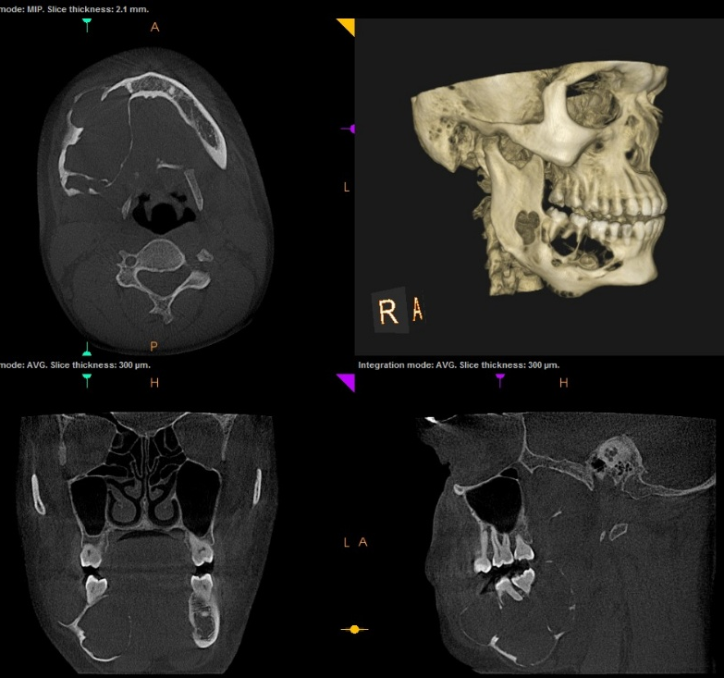

Fig 2: Multilocular lesion in right posterior mandible showing soap bubble appearance

Fig 3: Desmoplastic ameloblastoma with mixed radiolucent and radiopaque appearance in left premolar-molar region of mandible mimicking a fibro-osseous lesion.

Fig 4: Multilocular lesion in left posterior mandible showing soap bubble appearance, severe expansion and perforation of buccal cortical plate expansion

Fig 5: Desmoplastic ameloblastoma with mixed radiolucent and radiopaque appearance in mandibular left ramus region.

