Case report
“Ameloblastic Fibro-Odontoma: A Rare Case Report”

ABSTRACT
Ameloblastic fibro-odontoma (AFO) is a rare benign mixed odontogenic tumor composed of both epithelial and mesenchymal components, along with enamel and dentin formation. It commonly affects children and adolescents, often presenting as a slow-growing asymptomatic lesion associated with an unerupted tooth. Due to its radiographic resemblance to other calcifying odontogenic lesions, an accurate diagnosis requires a combination of clinical, radiographic, and histopathological evaluation. We report a case of a 10 year old female patient with a painless swelling in the right posterior region of the mandible. Radiographic examination revealed a mixed radiolucent-radiopaque lesion, leading to a provisional diagnosis of odontoma. However, histopathological analysis confirmed the presence of both ameloblastic epithelium and odontogenic mesenchyme, along with enamel and dentin-like matrix, consistent with AFO.
This case highlights the diagnostic challenges associated with AFO & emphasizes the importance of histopathological examination in differentiating it from other mixed odontogenic and calcifying tumors. Early diagnosis and appropriate surgical intervention are essential to prevent complications and ensure optimal patient outcomes.
Keywords: Ameloblastic fibro-odontoma, complex odontoma, mixed odontogenic lesions.
INTRODUCTION:
Ameloblastic fibro-odontoma (AFO) is a rare, benign mixed odontogenic tumor that typically arises during the first and second decades of life, with peak incidence between 8 and 12 years of age [1,4]. It is most commonly located in the posterior region of the jaws, particularly the mandible, and generally presents as a painless, slow-growing swelling, often associated with delayed or failed tooth eruption [1,2,4]. Radiographically, AFO typically appears as a well-defined unilocular radiolucent lesion containing variable amounts of radiopaque material, representing disorganized enamel and dentin formation [1,3,5]. Histologically, the lesion consists of proliferating odontogenic epithelium embedded in a cell-rich mesenchymal stroma resembling the dental papilla, along with hard tissue mimicking developing enamel and dentin [3,4,6]. Previously considered as a transitional lesion between ameloblastic fibroma and complex odontoma, the 2017 World Health Organization (WHO) classification now categorize AFO as a developing odontoma rather than a distinct neoplasm [6,7]. However, many researchers contend that its unique histopathological features and potential for significant growth support its classification as a true neoplasm [5,7]. Surgical enucleation and curettage are generally curative, with recurrence being exceptionally rare. Long-term follow-up is still recommended to monitor for unusual behavior or recurrence [3,4,8].
This report presents a rare case of ameloblastic fibro-odontoma in a 10 year old female patient located in lower right posterior region of jaw, discussing the clinical, radiographic, and histopathological findings in the context of current literature.

CASE PRESENTATION:
A 10-year-old female patient presented with the chief complaint of a swelling on the right lower side of her face persisting for the past 5–6 months. The patient was apparently healthy until six months prior, when she first noticed the swelling. It gradually increased in size and was painless in nature throughout its progression. Extraoral examination revealed facial asymmetry with a diffuse, bony hard swelling on the right side of the face, extending anteroposteriorly from the right corner of the mouth to the preauricular region, and superoinferiorly from the ala-tragus line to the lower border of the mandible(Fig 1). Intraoral examination showed a diffuse bony hard swelling in the lower right vestibular region, with noticeable elevation of the buccal cortex, extending from teeth 44 to 47. The overlying mucosa appeared normal.
Orthopantomogram (OPG) revealed a well-defined mixed radiopaque-radiolucent lesion on the right posterior mandible, extending from the tooth 46 to the ascending ramus. An impacted tooth 47 was noted near the lower border of the mandible, along with resorption of the distal root of 46(Fig 2). Cone beam computed tomography (CBCT) showed a well-defined mixed radiopaque-radiolucent lesion associated with an impacted tooth, extending from the lower border of the mandible to the ascending ramus(Fig 3).
Gross examination of the excised specimen revealed multiple hard and soft tissue components. The hard tissue specimens measured 3.5×2 cm and 1×1 cm, while the soft tissue specimens measured 5×2.5 cm and 2.5×2.5 cm. The specimen exhibited a brownish-white color with a rough, nodular surface texture. The crown of the impacted tooth (47) was attached to soft tissue at its neck(Fig 4). Clinically, a provisional diagnosis of odontome or dentigerous cyst was considered. Histopathological examination revealed dentin-like hard tissue surrounded by loosely arranged connective tissue resembling dental papilla, with peripheral odontoblastic cells. Abundant eosinophilic areas suggested dentinoid and basophilic calcified structures resembling cementum-like tissue. Foci of odontogenic epithelial islands lined by peripheral low cuboidal to tall columnar cells displaying nuclear palisading and reversal of polarity were seen along with stellate reticulum-like cells. Deeper sections exhibited osseous trabeculae with prominent resting and reversal lines. Based on the clinical, radiological, and histopathological features, a final diagnosis of Ameloblastic Fibro-Odontoma was made. The differential diagnoses considered included Complex Odontoma and Calcifying Epithelial Odontogenic Tumor (CEOT).

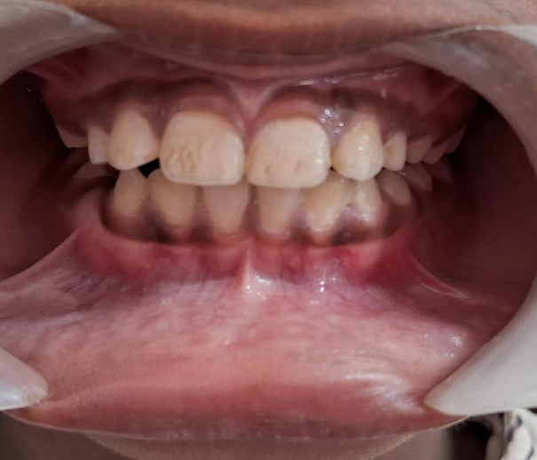
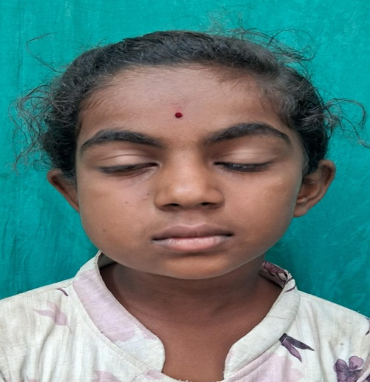
Lower right buccal vestibule obliteration
Fig 1- Facial asymmetry with swelling on right side of face
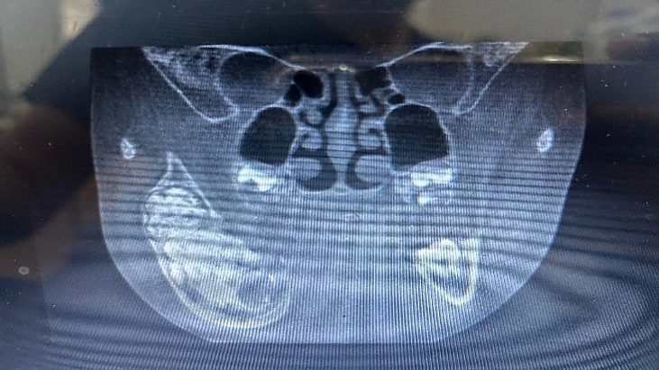
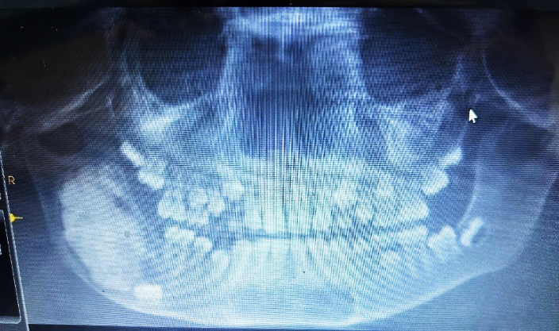
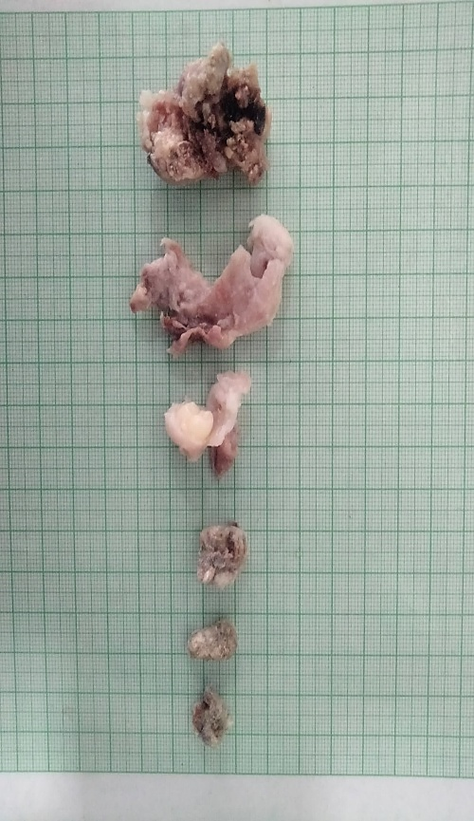
Fig 2-Impacted 47 with well defined mixed lesion in posterior mandible
Fig 3-lesion extending from lower border to the ramus of mandible

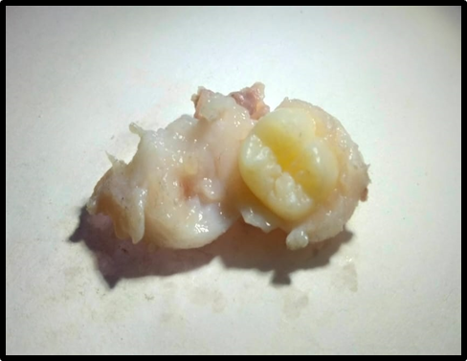
Fig 4- crown of impacted 47 with soft tissue attachment at its neck

Histopathological Examination

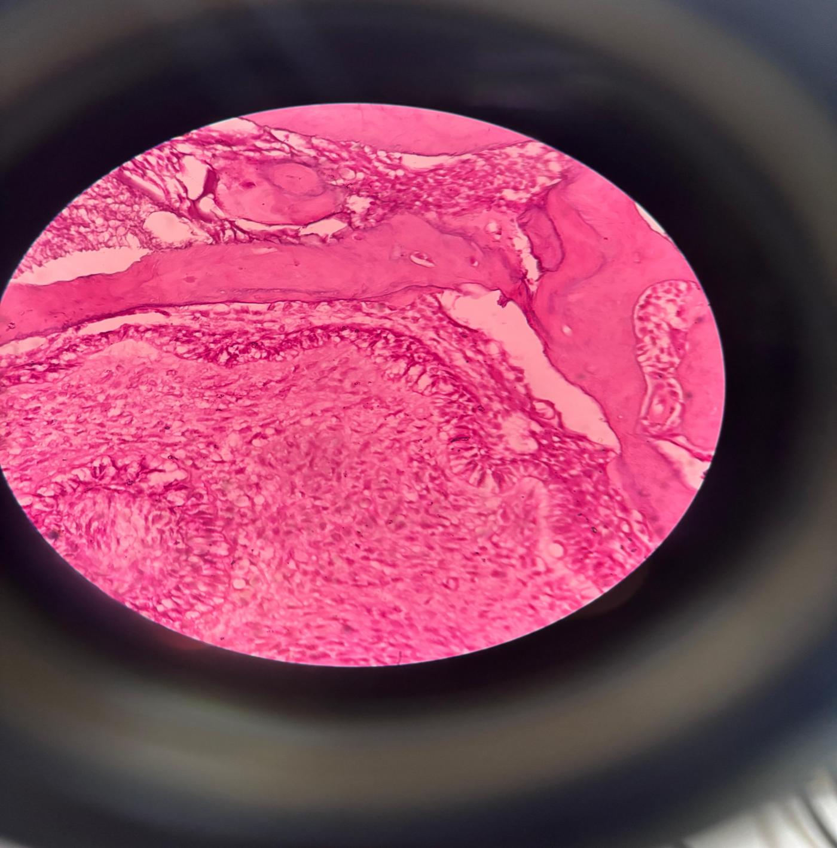
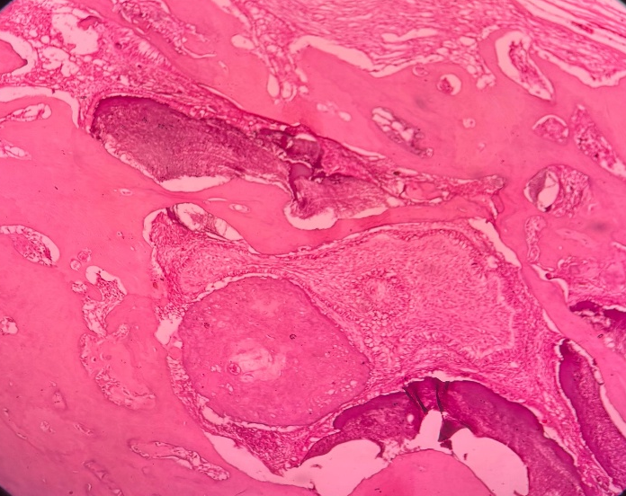
40x
2
1
3
2
1
10X
1.Dentin like hard tissue
2.Stellate reticulum-like cells
3.Enamel like material

1.Odontogenic epithelial islands lined by peripheral low cuboidal to tall columnar cells displaying nuclear palisading and reversal of polarity
2.Stellate reticulum like cells

Plate 1. Histological section denoting hard tissue resembling dentin, cells resembling stellate and enamel material

Plate 2. Histological section denoting Odontogenic epithelial islands and cells resembling stellate reticulum

DISCUSSION:

Ameloblastic Fibro-Odontoma (AFO) is a rare benign mixed odontogenic tumor composed of both epithelial and mesenchymal components. It involves formation of dental hard tissues such as enamel, dentin, and cementum [1,3]. AFO is generally considered a true neoplasm rather than a hamartomatous lesion, primarily due to its potential for continued growth and its distinct histopathologic architecture [5,7]. This tumor primarily affects children and adolescents, with most cases diagnosed within the first two decades of life. The average age at diagnosis is approximately 10 years. In the present case the female affected is of age 10 years. A slight male predilection has been noted (M > F) however, the present case is of a female. The most commonly affected area is the posterior mandible [1,2,4,5], and the present case is consistent with this observation.
Clinically, AFO typically presents as a painless, slow-growing swelling of the jaw, often associated with delayed or failed eruption of permanent teeth. Radiographically, it appears as a well-circumscribed unilocular or multilocular radiolucent lesion containing varying amount of radiopaque material. These radiopaque components often associated with an unerupted tooth represent disorganized enamel and dentin, a hallmark of AFO [1,4,5]. Similarly, the present case shows an impacted tooth along with a well defined mixed radiopaque-radiolucent lesion.
The etiopathogenesis of AFO is believed to be related to aberrant tooth development, involving continued epithelial-mesenchymal interactions. A widely discussed concept in the literature is the "maturation continuum theory", which suggests that AFO represents an intermediate developmental stage in the progression from ameloblastic fibroma (AF) to complex or compound odontoma [6,7].
According to this theory:
Ameloblastic Fibroma exhibits only proliferating odontogenic epithelium and mesenchymal tissue without hard tissue formation. AFO develops as a continued process of interaction and induction leading to the deposition of enamel and dentin. With further maturation, mineralization, and organization of these tissues eventually lead to the formation of odontomas, either complex or compound [6,7].
Histologically, AFO is characterized by islands of odontogenic epithelium showing peripheral palisading and reversal of nuclear polarity, set within a primitive ectomesenchymal stroma resembling dental papilla. Hard tissues such as enamel, dentin, and occasionally cementum-like material are typically present within the lesion [3,4,6]. In the present case, odontogenic epithelial islands are lined by peripheral low cuboidal to tall columnar cells exhibiting nuclear palisading and reversal of polarity, along with stellate reticulum-like cells. Additionally, enamel- and dentin-like material is observed.
Treatment of AFO involves conservative surgical enucleation and curettage, which is generally curative. Recurrence is rare, though long-term follow-up is recommended to monitor for recurrence and to ensure normal eruption and development of adjacent teeth [3,4,11].
AFO must be carefully differentiated from other odontogenic lesions with overlapping clinical and radiologic features such as Complex Odontoma and Calcifying Epithelial Odontogenic Tumor (CEOT).
Complex Odontoma: Radiographically, presents as a well-defined radiopaque mass with a thin radiolucent rim, often lacking the mixed radiolucent-radiopaque pattern of AFO. Histologically, it is composed of a more mature disorganized mass of enamel and dentin, without the epithelial and mesenchymal proliferation that characterizes AFO [5,6].
Calcifying Epithelial Odontogenic Tumor (CEOT): This is a benign but locally aggressive neoplasm. Radiographically, CEOT can present as a mixed radiolucent-radiopaque lesion, often associated with impacted teeth and “driven snow” calcifications. Histologically, it is characterized by sheets of polygonal epithelial cells, amyloid-like material, and calcifications (Liesegang rings) lacking the primitive mesenchymal component and dental hard tissue formation as seen in AFO [4,11].
In this case, the diagnosis of AFO was supported by the patient’s age, clinical presentation, association with an impacted tooth, radiographic findings, and definitive histopathological features showing odontogenic epithelium, dental papilla-like stroma, and hard tissue resembling enamel, dentin, and cementum.

CONCLUSION:
This case of ameloblastic fibro-odontoma (AFO) supports the maturation continuum theory, which proposes that AFO is an intermediate stage between ameloblastic fibroma and odontoma. Its mixed composition of proliferative epithelial and mesenchymal elements with dental hard tissues reflects this transition. Diagnosing AFO can be challenging due to its radiographic similarity to other mixed odontogenic lesions like complex odontoma and CEOT. Thus, histopathology remains essential for accurate diagnosis.Unlike fully calcified odontomas, AFO contains active soft tissue, which may persist or recur if not fully excised - highlighting the need for complete surgical removal and recognizing AFO as a true neoplasm. Early & accurate diagnosis through a multidisciplinary approach is key to effective management and reducing the risk of recurrence.

REFERENCES
1.Qureshi P, Molinari A, Weerakkody Y, et al. Ameloblastic fibro-odontoma. Radiopaedia Reference Article (Accessed March 18, 2025).
2.Dia Tine S, Tamba B, Niang PA, et al. Report of a rare case of ameloblastic fibro-odontoma of the mandible with >400 odontomas and a related literature review. Med Buccale Chir Buccale. 2017;23(2):99–102.
3.Nelson BL, Thompson LDR. Ameloblastic Fibro–Odontoma. PMC Article.
4.Gantala R, Gotoor SG, Kumar RV, Munisekhar MS. Ameloblastic fibro-odontoma. BMJ Case Rep. 2015;2015:bcr2015209739.
5.Buchner A, Kaffe I, Vered M. Clinical and Radiological Profile of Ameloblastic Fibro-Odontoma: an Update on an Uncommon Odontogenic Tumor Based on a Critical Analysis of 114 Cases. Head Neck Pathol. 2013;7(1):54–63.
6.Head & Neck Pathology / American Journal of Neuroradiology. Ameloblastic fibro-odontoma (AFO). AJNR Case Collection, 2018.
7.Bologna-Molina R, et al. Mixed odontogenic tumors: A review of clinicopathological and molecular features and changes in the WHO classification. World J Gastrointest Oncol. Dec 24, 2021.
8. Ash H, Singh RK, Anwar E, Banerjee A, Chatterjee A, Ramalingam K. A Case Report on the Diagnosis and Management of a Rare Ameloblastic Fibro-Odontoma in the Anterior Maxilla of a Pediatric Patient. Cureus. 2025 May 18;17(5):e84343.
9. de Moraes Rocha J,et al. The complex diagnosis of ameloblastic fibro-odontoma: a clinical case report. Oral Surgery, Oral Medicine, Oral Pathology and Oral Radiology. 2025 May 1;139(5):e40-1.
10. Karna P, Rastogi V, Dhungel D, Chaurasia S. Ameloblastic Fibroma of the Mandible Presenting as a Dentinoid Formation in an 8‐Year‐Old Child: A Case Report. Clinical Case Reports. 2025 Feb;13(2):e70169.
11. Dhanuthai K, Kongin K. Ameloblastic fibro-odontoma: a case report. J Clin Pediatr Dent. Jan 2005;29(1):75–78.

