# **Prevalence of oral squamous cell carcinoma among young patients: A retrospective study**

### **Abstract**

**Background:** Oral squamous cell carcinoma (OSCC) ranks as the 12th most common cancer globally, with an increasing prevalence among young adults. Traditionally associated with older populations, recent evidence suggests a worrying rise in early-onset cases, particularly in economically developing regions like India.

**Objective:** To evaluate the clinical and epidemiological characteristics of OSCC in young adults and assess associated risk factors, histopathological grading, and anatomical distribution.

**Materials and Methods:** This retrospective study analyzed 726 histopathologically confirmed OSCC cases from January 2010 to December 2024 in Chhatrapati Sambhaji Nagar, Maharashtra, India. Demographic data, risk habits (tobacco, betel nut, gutkha), tumor sites, and histological grades were evaluated. Tumors were staged using the UICC TNM system (7th edition). Data analysis was conducted using SPSS software.

**Results:** The mean age was 44.42 years, with 25.79% of patients below 40 years. A male predominance was observed (male-to-female ratio 1.8:1). Buccal mucosa (31.79%) was the most affected site, followed by the tongue and alveolus. Tobacco chewing was the most prevalent habit (49.74%). Histologically, 49.74% were well-differentiated carcinomas, while 38.97% were moderately differentiated. Notably, a significant proportion of younger patients lacked traditional risk factors such as tobacco or alcohol use, indicating possible roles for HPV, genetic predisposition, and nutritional deficiencies.

**Conclusion:** The increasing incidence of OSCC among younger adults highlights the need for enhanced public awareness, early diagnostic protocols, and broader consideration of non-traditional risk factors. A multidisciplinary approach is essential for prevention, timely intervention, and improved prognosis in this emerging demographic.

**Keywords:** Oral squamous cell carcinoma, young adults, tobacco, HPV, histopathology, India, buccal mucosa

**Introduction:**

Oral squamous cell carcinoma (OSCC) is the most common type of carcinoma affecting the oral cavity and ranks as the 12th most common cancer in the world [1]. It poses a major health problems in India and Indian subcontinent countries. Tobacco is the main etiological factor for oral squamous cell carcinoma. Tobacco is consumed in various forms such as betel quid, tobacco with lime, bidi, and hookah [2].Additional risk factor includes , Human papillomavirus (HPV) [3,4], nutritional deficiencies [5], and poor oral hygiene [6] though these are minor etiological contributors of oral carcinoma. People of lower socio-economic strata of society are more commonly affected by oral cancer due to a higher prevalence of lifestyle risk factors [7].

The global incidence of oral squamous cell carcinoma (OSCC) continues to rise due to the increased adoption of habits that contribute to cancer, particularly in economically developing countries [1]. Despite advances in standard treatment strategies, the 5-year survival rate of OSCC patients remains relatively low. This is primarily because most cases are diagnosed at advanced stages [7].Oral carcinogenesis is a complex and multi-step process that results from various deleterious habits, multiple environmental factors, and genetic susceptibility. OSCC accounts for approximately 24% of all head and neck cancers [2]. It may arise de novo or be preceded by potentially malignant disorders, such as Oral Submucous Fibrosis (OSMF), Oral Leukoplakia (OLK), and Oral Lichen Planus (OLP) [4].

During malignant transformation, affected tissue undergoes multiple structural, molecular, and functional changes.These include impaired DNA replication, uncontrolled cell proliferation, epithelial–mesenchymal transition, loss of cell adhesion, and increased cell motility [8]. In the early stages of OSCC, molecular changes can be observed at the cellular level even in the absence of noticeable phenotypic changes in the tissue. Biomarkers can serve as useful tools for detecting these molecular alterations, offering diagnostic, prognostic, and therapeutic significance [9].Hence, this study aimed to identify the clinical and epidemiological characteristics of OSCC.

**Material and methods:**

A retrospective study was conducted on 726 OSCC patients from January 2010 to December 2024 in Department of Oral Pathology and Microbiology, Department of Oncology, chh.sambhaji nagar Maharashtra, India. Cases included buccal mucosa, alveolus, anterior two-third of tongue, gingivobuccal sulcus, hard and soft palate, floor of mouth and retromolar trigone . Patient’s details such as sex, age, tobacco habit and oral cancer subsites were recored and analyzed. Cases were classified according to the TNM staging system accordingUnion for International Cancer Control (7th edition) staging of carcinoma of oral cavity.

Continuous data were summarized as mean ± SD while discrete (categorical) in numbers (n) and percentage (%). Continuous groups were compared by independent Student's t test. Categorical groups were compared by chi-square (χ2) test. A two-tailed (α = 2) p value less than 0.05 (p < 0.05) was considered statistically significant. Analyses were performed on SPSS software.

**Results**

A total of 726 OSCC patients were included in this study. The age of patients ranged from 30 to 90 years with mean ±SD years approximately([Table 1](https://www.ncbi.nlm.nih.gov/pmc/articles/PMC4756063/table/tbl0005/)). 44.42 years. Surprisingly more patients of OSCC were in younger age groups i.e. 4th and 5th decade. Among patients, 537(66.93%) were males and 189 (33.06%)

s and 69 females. Male to female ratio was 1.8:1.The disease occurred with greater frequency on buccal mucosa(31.79%),followed by tongue,alveolus,floor of mouth ,palate and least common the lips(1.53%)(Table No.: 2) Habit most commonly observed was tobacco chewing (49.74%)followed by gutkha chewing,betel nut smoking . (Table No.: 3).Histopathological grading in our study showed that the majority of cases were well differentiated (49.74%) followed by moderately differentiated(76%)(Table No.: 4).

|  |  |  |  |  |  |  |
| --- | --- | --- | --- | --- | --- | --- |
| Group 1  3rd decade | **Group 2**  **4th decade** | **Group 3**  **5th decade** | **Group 4**  **6th decade** | **Group 5**  **7th decade** | **Group 6**  **8th decade** | **Group 7**  **9th decade** |
| 35 | 160 | 215 | 182 | 134 | 28 | 2 |
| 4.62% | 21.2% | 28.43% | 24.07% | 17.72% | 3.7% | 0.26% |

**Table No. 1: Age wise distribution of OSCC**

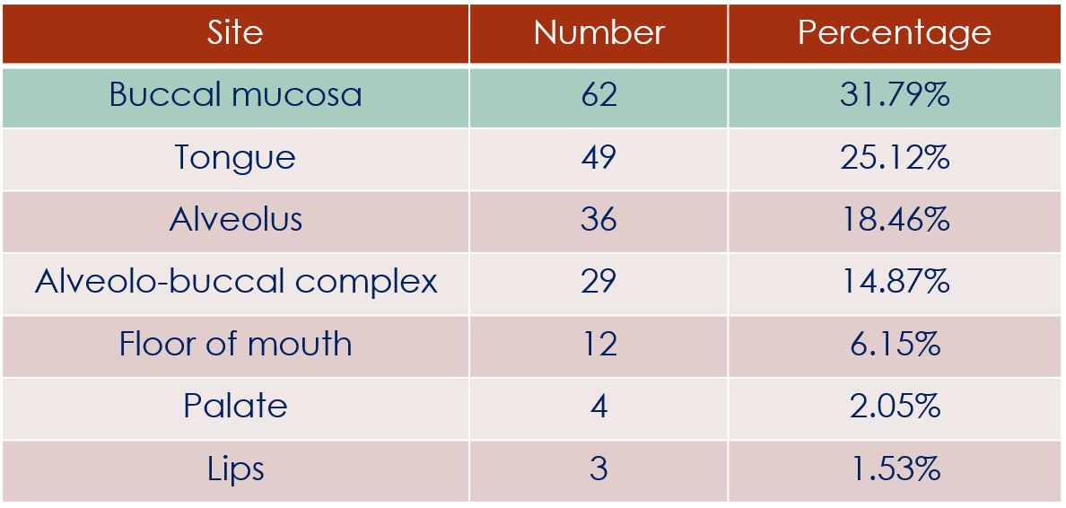

Table No. 2: Site wise distribution of OSCC

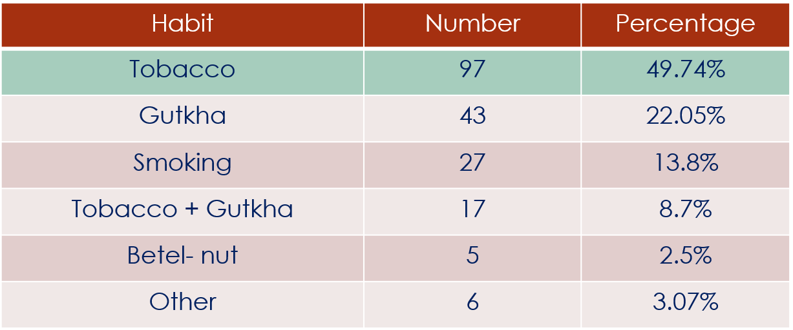

Table No. 3: Habit wise distribution of OSCC

|  |  |  |
| --- | --- | --- |
| **Histological type** | **Number** | **Percentage** |
| Early invasive squamous cell carcinoma | 22 | 11.28% |
| Well-differentiated squamous cell carcinoma | 97 | 49.74% |
| Moderately differentiated squamous cell carcinoma | 76 | 38.97% |

Table No. 4: Histopathological grading distribution of OSCC

**Discussion**

Oral squamous cell carcinoma (OSCC) is the most common type of carcinoma affecting the oral cavity and ranks as the 12th most common cancer in the world.  
Previous studies confirmed that smoking, alcohol consumption and HPV are the most important risk factors of HNSCC . However, these carcinogens are known for their delayed effect. As the time of exposure is limited in young patients, additional factors are suspected in the background. This fact suggested that, compared with the general population with HNSCC, the young group might show a different pattern. The importance of our examination is that the majority of HNSCC studies did not handle young patients separately (31).Oral cancer is predominantly a disease of middle-aged men. With its risk increases with age. Mean age of diagnosis of oral cancer varies from 57.1 years in males and 52.5 years in females with highest number of cases occurring in 6th decade of life[9,10]. The findings of this retrospective study highlight a concerning trend in the increasing prevalence of oral squamous cell carcinoma (OSCC) among young indivisual. Traditionally, OSCC has been considered a disease predominantly affecting older adults due to long-term exposure to established risk factors such as tobacco, alcohol, and poor oral hygiene [11,12]. However, emerging evidence, including our study, suggests a growing number of cases in younger individuals, necessitating further investigation into potential causative factors and preventive strategies [13,14].

In the present study, a total of 726 OSCC patients were included with ages of ranging from 30 to 90 years with mean ±SD approximately years. The mean age was 44.42 years. Surprisingly more patients of OSCC were found in younger age groups particularly in 4th and 5th decade. Among the patients, 537(66.93%) were males and 189 (33.06%) were females. Indicating male predilection. Early occurrence may be attributable to heavier indulgence in risk habits and exposure to sunlight (as a part of outdoor occupations in case of lip cancer) There is an overall male predominance seen in younger age group & No difference was found in a habitual distribution. Across age groups.Our study found a higher prevalence of oscc in younger individual (25.79%) compared to previous reports by Sharma et al 2018 and Tomo S et al 2020 .Also, Patients below 40 years of age were 195(25.79%) which includes 126 males and 69 females. Male to female ratio was 1.8:1.

The disease occurred with greater frequency on buccal mucosa(31.79%),followed by tongue,alveolus,floor of mouth ,palate and with lips the least affected (1.53%).The reason could be prolonged exposure of carcinogens from consumed tobacco products such as smokeless tobacco, betel nut and gutka. early onset of tobacco habit and betel quid habit. In present studies , second most commonly affected site was tongue A recent report by Pickering et al. suggested, that oral tongue SCCs from younger and older patients are genomically similar . This might indicate, that the younger and older patients might rather differ in their susceptibility to carcinogenesis than the characteristics of the tumors. Intrinsic (mainly genetic) and approach involving clinicians, researchers, and public health policymakers is necessary In our study , the most commonly observed habit was tobacco chewing (49.74%)followed by gutkha chewing,betel nut smoking etc.Shenoi R, et al (2012) reported that 25% oral cancers are attributable to tobacco usage ( both smoking and/or chewing), 7–19% to alcohol consumption 10–15% to micronutrient deficiency, and more than 50% to betel quid chewing in areas of high chewing prevalence[18]. In the present study, 70% of patients had smokeless tobacco habits, 22.5% had smoking habits and 7.5% had both smokeless tobacco use and alcohol drinking habit. These findings may suggest that, in developing countries like India, where there are high incidences of alcoholism and tobacco misuse from an early age, the incidence of OSCC may follow that trend and also affect younger individuals. Histopathological grading in our study showed that the majority of cases were well differentiated (49.74%) followed by moderately differentiated(76%).

One of the key observations from our study is the significant proportion of young OSCC Patients who lack history of conventional risk factors such as tobacco or alcohol use. This aligns with previous research suggesting that other etiological factors, such as genetic predisposition, viral infections e.g. human papillomavirus (HPV), dietary habits, and occupational exposures, may contribute to early-onset OSCC. Several studies have showen an association between high-risk HPV strains and oral cancer, particularly in non-smoking and non-drinking young individuals[19-21]. HPV-associated OSCC has distinct molecular and clinical characteristics which may require different management approaches compared to traditional tobacco-related OSCC.  Previous studies also found that chronic immunodeficiency (such as immunosuppression following organ transplantation or HIV) is associated with a higher incidence of oral squamous cancer in young patients; however, the available results are contradictory

Additionally, dietary deficiencies, particularly low intake of antioxidants, vitamins A, C, and E, and iron, have been implicated in the pathogenesis of OSCC[22,23]. Nutritional imbalances may contribute to impaired immune responses and increased susceptibility to malignant transformation. Furthermore, poor oral hygiene and chronic irritation from dental factors, such as ill-fitting dentures or sharp tooth edges, may also serve as potential contributing factors in young patients[24,25].Our study noted a predominance of OSCC cases affecting the tongue and buccal mucosa, consistent with global trends. The tongue, being highly vascular and constantly to exposed mechanical and chemical insults, is particularly susceptible to malignant transformation. Younger patients often present with aggressive tumor behavior, deeper invasion, and a higher rates of lymph node metastasis,as noted in previous literature[26,27]. This could be attributed to inherent biological differences in tumor pathophysiology among younger individuals, including higher rates of genetic mutations and epigenetic alterations[28].

Despite advances in diagnostic and treatment modalities, the prognosis of OSCC in young patients remains controversial.. Some studies suggest that younger individuals may have a more favorable prognosis due to better immune responses and fewer comorbidities, while others indicate an aggressive disease course with poorer outcomes[29,30]. The delay in diagnosis remains a significant challenge, as OSCC in younger patients is often misdiagnosed as benign ulcers, leading to late-stage presentation and reduced treatment success[13].Our finding underscore the need for increased awareness among healthcare professionals regarding the rising incidence of OSCC in younger populations. Early detection through routine oral screenings, identification of high-risk individuals, and the use of biomarker-based diagnostic approaches could significantly improve outcomes. Public health initiatives focused on lifestyle modifications, HPV vaccination, and nutritional education may also play a crucial role in OSCC prevention among young individuals.

**Conclusion**

The increasing prevalence of OSCC cases among young individuals is an alarming trend that calls for further research and proactive public health measures. Understanding the causes and behaviour of OSCC in this young individual is essential for early detection, effective treatment, and improved survival rates. A multidisciplinary approach involving clinicians, researchers, and public health policymakers is necessary) and approach involving clinicians, researchers, and public health policymakers is necessary to address this emerging challenge and reduce the global burden of OSCC.

**References**

1. Bray, F., Ferlay, J., Soerjomataram, I., Siegel, R. L., Torre, L. A., & Jemal, A. (2018). Global cancer statistics 2018: GLOBOCAN estimates of incidence and mortality worldwide for 36 cancers in 185 countries. *CA: A Cancer Journal for Clinicians, 68*(6), 394-424.
2. Johnson, D. E., Burtness, B., Leemans, C. R., Lui, V. W., Bauman, J. E., & Grandis, J. R. (2020). Head and neck squamous cell carcinoma. *Nature Reviews Disease Primers, 6*(1), 92.
3. Gupta, B., Johnson, N. W., & Kumar, N. (2021). Global epidemiology of head and neck cancers: A continuing challenge. *Oncology, 99*(6), 385-403.
4. Mehrotra, R., Yadav, S., & Singh, M. (2009). The role of human papillomavirus in oral squamous cell carcinoma and oral potentially malignant disorders: A review of the literature. *Indian Journal of Cancer, 46*(2), 91-99.
5. Califano, J., van der Riet, P., Westra, W., Nawroz, H., Clayman, G., Piantadosi, S., ... & Sidransky, D. (1996). Genetic progression model for head and neck cancer: Implications for field cancerization. *Cancer Research, 56*(11), 2488-2492.
6. Kaur, J., Matta, A., Kak, I., Srivastava, G., Assi, J., Leong, I., & Siu, K. W. (2020). Biomarkers in oral cancer: Old and new findings. *Oral Oncology, 110*, 104905.
7. Chiang, C. P., Chang, J. Y. F., Wang, Y. P., Wu, Y. H., & Wu, Y. C. (2010). Sunflower seed consumption and the risk of oral cancer: A systematic review. *Oral Oncology, 46*(11), 801-806.
8. Sankaranarayanan, R., Ramadas, K., & Amarasinghe, H. K. (2015). Oral cancer: Prevention, early detection, and treatment. *World Health Organization, WHO Report on Cancer, 16*, 20-28.
9. Llewellyn CD, Johnson NW, Warnakulasuriya KA. Risk factors for squamous cell carcinoma of the oral cavity in young people – a comprehensive literature review. Oral Oncol. 2001;37(5):401–418.
10. Myers JN, Elkins T, Roberts D, Byers RM. Squamous cell carcinoma of the tongue in young adults: increasing incidence and factors contributing to survival. Arch Otolaryngol Head Neck Surg. 2000;126(5):611–615.
11. Gupta B, Johnson NW, Kumar N. Global epidemiology of head and neck cancers: a continuing challenge. Oncology. 2016;91(1):13–23.
12. Warnakulasuriya S. Global epidemiology of oral and oropharyngeal cancer. Oral Oncol. 2009;45(4-5):309–316.
13. Llewellyn CD, Linklater K, Bell J, Johnson NW, Warnakulasuriya KA. An analysis of risk factors for oral cancer in young people: a case–control study. Oral Oncol. 2004;40(3):304–313.
14. Saka-Herrán C, Guevara N, Lassalle S, et al. Oral squamous cell carcinoma in young patients: a matched analysis. Eur Arch Otorhinolaryngol. 2017;274(2):1025–1032.
15. Sharma P, Saxena S, Aggarwal P. Trends in the epidemiology of oral squamous cell carcinoma in Western UP: An institutional study. Indian J Dent Res. 2018;29(2):190–195.
16. Tomo S, Banerjee A, Sinha N, Paul S. Changing trends in oral squamous cell carcinoma: An institutional perspective. J Cancer Res Ther. 2020;16(3):476–480.
17. Kiran G, Sridhar R, Saikrishna D, Reddy BR. Site predilection of oral squamous cell carcinoma in the coastal Andhra population of South India. J Clin Diagn Res. 2012;6(10):1732–1735.
18. Shenoi R, Devrukhkar V, Chaudhuri A, Sharma BK, Sapre SB, Chikhale A. Demographic and clinical profile of oral squamous cell carcinoma patients: A retrospective study. *Indian J Cancer*. 2012;49(1):21–26.
19. Gillison ML, Koch WM, Capone RB, Spafford M, Westra WH, Wu L, et al. Evidence for a causal association between human papillomavirus and a subset of head and neck cancers. *J Natl Cancer Inst*. 2000;92(9):709–720.
20. Syrjänen S. Human papillomavirus (HPV) in head and neck cancer. *J Clin Virol*. 2005;32 Suppl 1:S59–S66.
21. Herrero R, Castellsagué X, Pawlita M, Lissowska J, Kee F, Balaram P, et al. Human papillomavirus and oral cancer: the International Agency for Research on Cancer multicenter study. *J Natl Cancer Inst*. 2003;95(23):1772–1783.
22. Sankaranarayanan R, Ramadas K, Thomas G, Muwonge R, Thara S, Mathew B, et al. Effect of screening on oral cancer mortality in Kerala, India: a cluster-randomised controlled trial. *Lancet*. 2005;365(9475):1927–1933.
23. Gupta B, Johnson NW. Systematic review and meta-analysis of association of smokeless tobacco and of betel quid without tobacco with incidence of oral cancer in South Asia and the Pacific. *PLoS One*. 2014;9(11):e113385.
24. Pavia M, Pileggi C, Nobile CG, Angelillo IF. Association between fruit and vegetable consumption and oral cancer: a meta-analysis of observational studies. *Am J Clin Nutr*. 2006;83(5):1126–1134.
25. Petti S. Lifestyle risk factors for oral cancer. *Oral Oncol*. 2009;45(4–5):340–350.
26. and neck in young adults. *Otolaryngol Head Neck Surg*. 2000;122(6):837–841.
27. Sisk EA, Bradford CR, Wolf GT, Nguyen L, D'Silva NJ. Oral cavity squamous cell carcinoma in young patients: a matched analysis. *Head Neck*. 2009;31(3):269–273.
28. Pitman KT, Johnson JT. Cancer of the oral cavity in young patients: a review of the literature. *Head Neck*. 1999;21(3):204–210.
29. Iype EM, Pandey M, Mathew A, Thomas G, Sebastian P, Nair MK. Oral cancer among patients under the age of 35 years. *J Postgrad Med*. 2001;47(3):171–176.
30. Kuriakose MA, Sankaranarayanan R, Nair MK, Sebastian P, Padmanabhan TK. Comparison of oral squamous cell carcinoma in younger and older patients in India. *Eur J Cancer B Oral Oncol*. 1992;28B(2):113–12
31. **Révész M, Oberna F, Slezák A, Ferenczi Ö, Kenessey I, Nagy ZT.** The characteristics of head and neck squamous cell cancer in young adults: A retrospective single-center study. Pathol Oncol Res. 2023;29:1–9.