*Case report*

Digital smile design for conservative midline diastema closure with indirect ceramic veneers: a case report

abstract

|  |
| --- |
| Aim: this case report demonstrates a fully digital, single-visit workflow to close a 2.5 mm maxillary midline diastema and correct a tilted lateral incisor using 0.5 mm lithium disilicate veneers.  Presentation of case: a 27-year-old female sought aesthetic correction for a midline gap and distally tilted lateral incisor. Intraoral scans (medit i700), virtual smile design, and exocad-based cad/cam planning guided minimal enamel preparation. Veneers were milled chairside from IPS E.MAX CAD blocks and bonded the same day without temporaries. At 6-month follow-up, veneers showed excellent integration, marginal seal, shade stability, and gingival health.  Discussion: digital veneer workflows using lithium disilicate allow conservative treatment with reliable, aesthetic outcomes. Literature reports 10-year survival rates over 96% for cad/cam veneers. In this case, efficient restoration was achieved without compromising biological or aesthetic principles.  Conclusion: Single-appointment, digitally fabricated lithium disilicate veneers are an effective and enamel-preserving option for diastema closure and minor anterior corrections. |

*Keywords: [digital workflow, midline diastema, CAD/CAM, lithium disilicate veneer*

1. INTRODUCTION

A confident smile plays a vital role in self-esteem, and the appearance of one’s teeth has become increasingly important in today’s aesthetic-driven society. Maxillary midline diastema, defined as a 0.5 mm or wider gap between the central incisors, is a common aesthetic concern that can negatively affect facial harmony and personal confidence.[1] traditional treatments such as orthodontics and direct composite restorations—often involve multiple appointments and can lead to enamel loss, staining, and material shrinkage over time.

Porcelain laminate veneers (PLVS) offer a minimally invasive, durable, and highly aesthetic alternative for diastema closure. These thin ceramic shells preserve tooth structure better than full crowns and demonstrate strong long-term outcomes when bonded to enamel.[2] the introduction of digital workflows involving intraoral scanners, virtual smile design, and cad/cam fabrication has further enhanced the precision, efficiency, and enamel preservation of veneer treatments.[3]

Though numerous studies have validated cad/cam veneer use in full-arch and multi-unit restorations, there is limited documentation of single-appointment chairside digital veneer workflows specifically applied to midline diastema cases. Existing case reports predominantly focus on feldspathic veneers, often fabricated in multiple stages.[4]

**AIM:**

This case report aims to showcase a single-visit, chairside digital workflow employing intraoral scanning and cad/cam lithium disilicate veneers to conservatively close a 2.5 mm midline diastema and correct a tilted lateral incisor demonstrating an enamel-preserving, efficient, and esthetic approach to smile enhancement.

**2.CASE REPORT**

**Dental history/Examination:**

A healthy 27‑year‑old female presented to the Department of Conservative Dentistry and Endodontics at SJM Dental College and Hospital,Chitradurga with the chief complaint of a noticeable gap between her front teeth(#11 & 21) and an distally tilted left lateral incisor (#22), affecting her smile aesthetics. She had no systemic conditions, was a non-smoker, and denied previous orthodontic or restorative dental treatment.

The patient avoided smiling due to self-consciousness about her teeth. Although she had been referred for orthodontic treatment, she declined it, preferring a more immediate solution.

Clinical examination revealed a 2.5 mm diastema between the maxillary central incisors (#11 and 21) and a mildly distally-inclined right lateral incisor (#22). The dentition exhibited pristine, unblemished enamel, entirely free of carious defects, while the gingival tissues were well-defined, robust, and completely devoid of inflammation. The patient exhibits a Class I molar and canine occlusion, accompanied by a 2 mm horizontal (overjet) and vertical (overbite) overlap between the upper and lower incisors.

The patient avoided smiling due to self-consciousness about her teeth. Although she had been referred for orthodontic treatment, she declined it, preferring a more immediate solution.

Clinical examination revealed a 2.5 mm diastema between the maxillary central incisors (#11 and 21) and a mildly distally-inclined right lateral incisor (#22). The dentition exhibited pristine, unblemished enamel, entirely free of carious defects, while the gingival tissues were well-defined, robust, and completely devoid of inflammation. The patient exhibits a class i molar and canine occlusion, accompanied by a 2 mm horizontal (overjet) and vertical (overbite) overlap between the upper and lower incisors.

**3.METHODOLOGY:**

High resolution intraoral photographs (frontal, occlusal, 45°) captured the preoperative presentation (Fig. 1a,b,c). Prior to any tooth preparation, profound anesthesia was achieved via buccal and palatal infiltration of 2% lidocaine with 1:100,000 epinephrine to ensure patient comfort during the procedure. Using a fine grit torpedo shaped diamond bur, depth‑cuts of 0.3–0.5 mm were placed on the labial surface; these were completed with controlled chamfering to remove approximately 0.6–0.8 mm of facial enamel and 1.0–1.5 mm of incisal structure parameters aligned with conservative yet effective prep protocols for all‑ceramic veneers. A medium grit round ended diamond bur then joined the depth‑cuts, establishing uniform reduction and ensuring at least 1.0 mm of ceramic thickness.

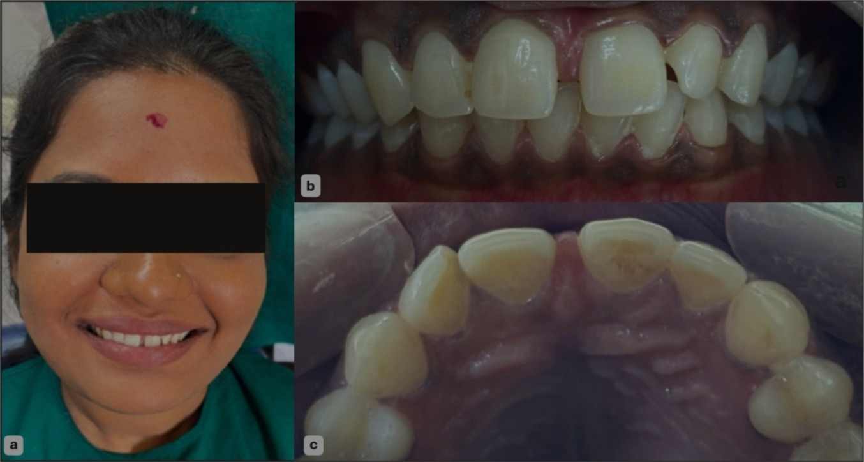 FIGURE 1: a) Pre-operative frontal view of the patient. b) Intraoral photograph of the patient. c) Occlusal photograph of the patient

# Margin design featured a smooth chamfer finish line approximately 0.3 mm deep, located equi to slightly subgingivally (0–0.5 mm), extending seamlessly into the interproximal areas and following polished gingival contours to optimize emergence profile, marginal seal, and aesthetic integration. Subgingival extension was judiciously employed to conceal potential discoloration and improve esthetic blending. After preparing, margins were inspected, smoothed, and verified with a probe to exclude any undercuts or sharp line angles, and the entire preparation was polished. (Fig. 2a)

Following meticulous cleaning and isolation, digital impressions of both arches were captured using the Medit i700 intraoral scanner (Medit Corp., Seoul, South Korea), generating STL files. These files were then imported into Digital Smile Design software (DSD GmbH, Germany) to virtually plan ideal tooth proportions, midline alignment, and the desired inclination of tooth #22 (Fig. 2b)

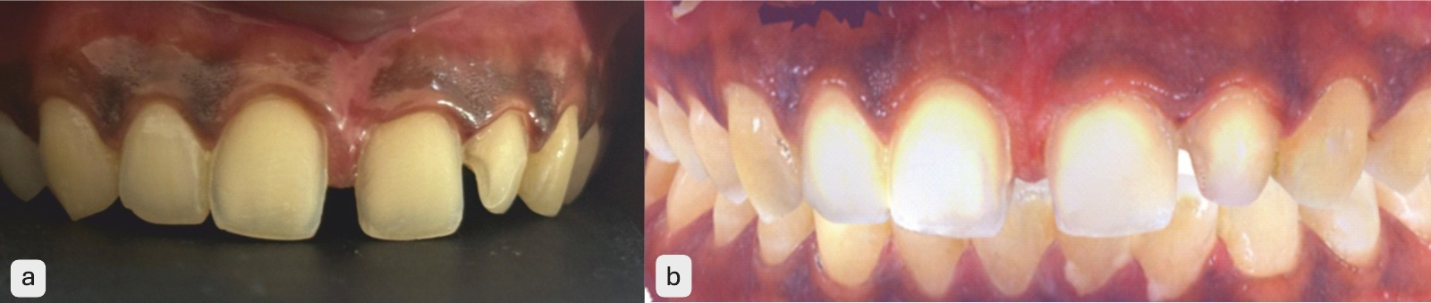

FIGURE 2: a) Teeth preparation irt11,21,22. b) Recorded digital impressions of both arches using the Medit i700 intraoral scanner

The digital design outcome was transferred to exocad DentalCAD software (exocad GmbH, Germany), where two lithium disilicate veneer restorations with a thickness of 0.5 mm were crafted to correct both the diastema and the tilt of tooth 22, while preserving maximum enamel. Following tooth preparation, a second intraoral scan captured the prepared teeth and surrounding structures to ensure fit accuracy and complete capture of margin details. Chairside milling of the veneers was then executed using a CAD/CAM milling unit and IPS E‑max CAD blocks (Ivoclar Vivadent, Schaan, Liechtenstein), followed by crystallization according to the manufacturer’s protocol.

For cementation, the enamel surfaces were etched with 37% phosphoric acid for 15 seconds, rinsed, and air-dried. A universal adhesive primer was applied and the veneer interiors were etched with 5% hydrofluoric acid for 20 seconds, rinsed, and silanized for 60 seconds followed by a sialane primer for 90 seconds and air-dried. The veneers were seated with RelyX™ Ultimate dual-cure resin cement (3M, USA), excess cement was removed, and light-curing was performed for 40 seconds each on buccal, palatal, and incisal surfaces.(Fig. 3) Marginal areas were refined using interproximal finishing strips, and surfaces polished using fine-grit diamond paste.

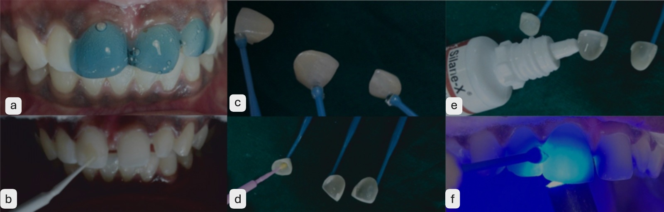

FIGURE 3: a)enamel etching with 37% phosphoric acid. B) adhesive application. c) photograph of porcelain veneer displayed on a neutral background) Hydrofluoric acid etching of the veneer’s intaglio surface e) Silanization of etched veneer. f) Cementation using dual‑cure resin cement, seated and light-cured

Occlusion, contact integrity, shade match, and esthetics were evaluated immediately post-placement. The patient was monitored at 1, 3, and 6 months for color stability, marginal integrity, gingival health, function, and overall satisfaction. At the 6-month recall, restorations showed no loss of retention, fracture, discoloration, or soft tissue complications. The patient was satisfied and had no complaints with the veneer prosthesis.(Fig. 4)

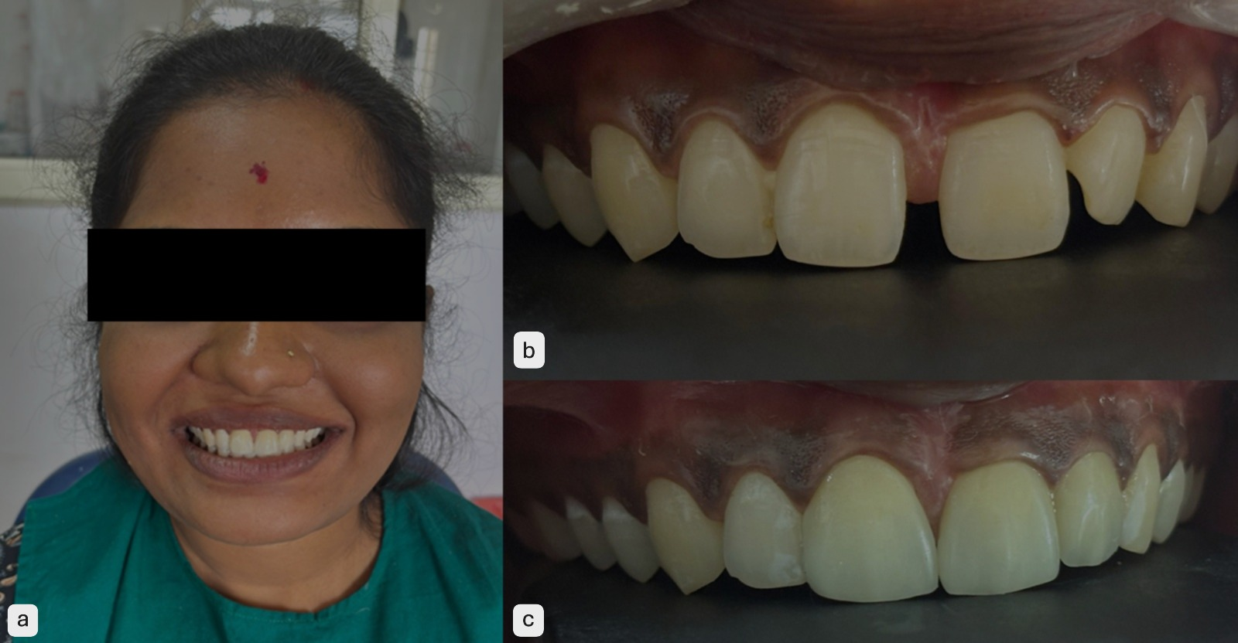

FIGURE 4: a) Pre-operative frontal view of the patient. b )Smile view before the cementation of the veneer prosthesis. c) Smile view after the cementation of the veneer prosthesis.

**4.DISCUSSION:**

The closure of a maxillary anterior diastema represents a significant aesthetic demand in modern dentistry. Alongside creating an appealing smile, treatment must address functional and psychological impacts; comprehensive planning and clear communication between dentist and patient are essential. Diastemas can stem from hereditary causes such as missing teeth, size discrepancies, supernumerary teeth, or aberrant frenal attachments and developmental factors including parafunctional habits, periodontal disease, tooth loss, or bite collapse [5]. Treatment modalities typically involve prosthodontic, orthodontic, and restorative solutions [6].

For conservative diastema closure, porcelain laminate veneers (PLVs) and direct composite restorations are the materials of choice. In many adult cases, patients prioritize immediate esthetic results over prolonged orthodontic treatment a preference reflected in this case, where evenly distributed diastema and patient inclination led to a single-visit restorative approach.[7]

Lithium di‑silicate PLVs offer multiple advantages: strong chemical stability, biocompatibility, smooth glazed surfaces that discourage plaque, and durable adhesion to etched enamel via silane coupling and resin-luting systems [8]. They combine superior esthetics with physiological resilience and ease of maintenance. That said, these restorations are prone to failure in parafunctional patients or where unsupported enamel rods are present; bonding over pre-existing composite restorations can also compromise long-term success.[9]

A single-appointment, chairside digital workflow using intraoral scanning and CAD/CAM technology provides a modern, efficient approach. A clinical report on minimally invasive lithium di-silicate veneers fabricated chairside demonstrated successful same day delivery of a thin 0.4 mm restoration in a single visit mirroring the efficiency achieved in our case. Another case report described maxillary anterior PLVs produced in a single session via a digital workflow, showing favorable one-year outcomes.

Long-term data affirm the reliability of lithium di-silicate veneers. A meta-analysis reported a pooled 10-year survival of ~96.8%, outperforming feldspathic and leucite-reinforced ceramics. One retrospective study found a 92.7% survival for CAD/CAM E‑max veneer systems over ten years. Additionally, randomized clinical trials show equivalent marginal adaptation and satisfaction for CAD/CAM and heat-pressed lithium di-silicate veneers at one year.[10]

Our case aligns with these findings: same-day chairside delivery enabled by the Medit i700 scanner, DSD planning, exocad/CAD-CAM milling of IPS E‑max ensured efficient, enamel-preserving, and esthetic closure of a 2.5 mm diastema and correction of tooth 22's tilt. No temporization was required, reducing chair time and potential patient discomfort. At 6-month follow-up, restorations exhibited excellent marginal integrity, shade stability, and tissue response, with no fractures, discoloration, debonding, or sensitivity.[11]

These outcomes support the effectiveness of fully digital, single-visit workflows in minimally invasive restorative dentistry. They also align with clinical evidence that speaks to the high long-term performance of chairside CAD/CAM lithium di-silicate veneers. Accordingly, such digitally driven, enamel conserving workflows are appropriate for midline diastema cases, combining patient satisfaction with clinical efficiency and longevity.

The implementation of a fully digital, chairside workflow anchored by intraoral scanning (Medit i700), Digital Smile Design (DSD), and CAD/CAM fabrication yielded precise, minimally invasive correction of a 2.5 mm midline diastema with concomitant inclination of tooth 22. The Medit i700 provided accurate, distortion-free digital impressions, enhancing patient comfort and ensuring meticulous margin capture, consistent with literature demonstrating intraoral scanners’ capability to deliver clinically acceptable precision in veneer restorations  Virtual planning in DSD and exocad facilitated conservative enamel reduction (0.3–0.5 mm) and the design of 0.5 mm lithium disilicate veneers, aligning with evidence that CAD/CAM workflows preserve enamel and enhance bonding substrate quality . Chairside milling and crystallization of IPS E‑max CAD blocks enabled single-appointment delivery without temporization, reducing chair time and streamlining treatment—benefits well documented in CAD/CAM veneer protocols.[12] Post-cementation assessment revealed ideal marginal adaptation, shade match, occlusion, and soft-tissue integration, with no debonding, discoloration, fracture, or gingival issues observed at 6‑month follow-up. These outcomes mirror high survival rates (96–99%) for CAD/CAM lithium disilicate veneers reported in long-term clinical studies . Collectively, this case underscores how an intraoral scanner guided, fully digital veneer workflow can offer superior marginal fit, enamel preservation, expedited treatment, and excellent patient centered results, supporting its growing adoption in minimally invasive restorative dentistry.[13]

**5.CONCLUSION**  
A single-visit, chairside CAD/CAM workflow using intraoral scanning and lithium disilicate veneers effectively and immediately closed a 2.5 mm midline diastema with excellent esthetic and functional results. Long -term studies report 5‑year survival rates of 92–99% for such veneers This digital, enamel preserving approach offers a predictable and patient friendly alternative to traditional multi-appointment methods.

**REFERENCES**

1. Omo A, Van Wyk L, Zyl I, Phillips V. Transcultural perception of maxillary midline diastema in Nigeria. Odontostomatol Trop. 2016;39(154):11–17.
2. Morimoto S, Albanesi RB, Sesma N, Agra CM, Braga MM. Main clinical outcomes of feldspathic porcelain and glass‑ceramic laminate veneers: a systematic review and meta‑analysis of survival and complication rates. Int J Prosthodont. 2016;29(1):38–49.
3. Lin WS, Harris BT, Phasuk K, Llop DR, Morton D. Integrating a facial scan, virtual smile design, and 3D virtual patient for treatment with CAD‑CAM ceramic veneers: a clinical report. J Prosthet Dent. 2018;119(2):200–205.
4. Wilson T, Nair VV, Harshakumar K, Prasanth V. CAD/CAM veneers for diastema closure using digital workflow: a case report. J Prosthodontol India. 2024;7(2):XX‑XX.
5. Miranda MI, Rodrigues JC, Valadares Neto JP; et al. Anterior aesthetic rehabilitation for midline diastema closure with veneers: a case report. J Clin Pediatr Dent. 2002;26(2):165–9.
6. Chu CH, Zhang CF, Jin LJ. Treating a maxillary midline diastema in adult patients: a general dentist’s perspective. J Am Dent Assoc. 2011;142(11):1258–64.
7. Aboushelib MN, Kleverlaan CJ. Minimally invasive diastema closure with porcelain laminate veneers: a case series. Clin Oral Investig. 2016;20(3):579–87.
8. Albuquerque RC, Moura SK, Amaral FLB, et al. Lithium disilicate veneers: mechanical behavior, biocompatibility, and clinical performance—a narrative review. J Mech Behav Biomed Mater. 2019;98:237–45.
9. Tylman SD, Calamia JR. Parafunctional habits and their relationship to failure of porcelain laminate veneers: analysis of long-term outcomes. J Prosthet Dent. 2010;104(3):168–74.
10. Klein P, Spitznagel FA, Zembic A, Prott LS, Pieralli S, Bongaerts B, et al. Survival and complication rates of feldspathic, leucite‑reinforced, lithium disilicate and zirconia ceramic laminate veneers: a systematic review and meta‑analysis. J Esthet Restor Dent. 2025;37(3):601–19.
11. Soares-Rusu IB, Villavicencio-Espinoza CA, de Oliveira NA, Wang L, Honório HM, Rubo JH, et al. Clinical evaluation of lithium disilicate veneers manufactured by CAD/CAM compared with heat‑pressed methods: randomized controlled clinical trial. Oper Dent. 2021;46(1):4–14.
12. Park JM, Kim HY, Kang SJ, Kim JH. Trueness and precision of an intraoral scanner (Medit i700) on tooth preparations for fixed restorations. J Prosthet Dent. 2023;129(2):158–165.
13. Layton D, Walton TR. Ten-year survival and complications of pressable and CAD/CAM lithium disilicate laminate veneers: a retrospective clinical study. Joral Rehabil. 2019;46(3):306–14.