Original Research Article
Genetic Analysis of Hulless Barley Genotypes for Various Quantitative Traits

ABSTRACT
The subject of the present study was to assess hulless barley genotypes for various quantitative traits evaluated under timely sown irrigated conditions. The experimental material included thirty six genotypes, planted in lattice design with two replications during 2024-25 at Barley Experimental Area of Department of Genetics and Plant Breeding, CCS Haryana Agricultural University, Hisar (Haryana). The results revealed high estimates of GCV and PCV for number of grains per spike while, grain yield per plot, number of effective tillers per meter row, spike length and peduncle length exhibited moderate estimates of GCV and PCV. High heritability coupled with genetic advance was observed for number of grains per spike, number of effective tillers per meter row, grain yield per plot and spike length. Correlation among traits indicated significant positive association of grain yield per plot with number of effective tillers per meter row, number of grains per spike, biological yield per plot and harvest index, exhibiting the significance of these traits for deciding the selection criterion for yield enhancement in hulless barley. Path coefficient analysis exhibited highest positive direct effect of harvest index on grain yield, followed by biological yield per plot. PCA identified four components with eigen value more than one that explained about 80.02 % of the total variation. PC 1 elucidated 31.29 % of the total variance and showed strong correlation with days to heading and maturity, number of grains per spike, harvest index and grain yield per plot. Cluster analysis based on 11 quantitative traits categorized the genotypes into six distinct clusters of which cluster IV contained high yielding genotypes i.e. RD 3121, DWRB 2427, DWRB 2428, DWRB 2436, PL 976 and DWRB 2442. The genotypes of this group could be utilized as promising breeding material intended to develop new hulless barley varieties.
Keywords: Hulless barley, correlation, path analysis, cluster, PCA

1. INTRODUCTION
Barley (Hordeum vulgare L.) is an ancient crop that is being fourth most important cereal crop in the world after maize, rice and wheat (Yirgu et al., 2022). It serves as a versatile crop, used for various purposes viz., animal feed, malting, brewing, and even for food in many parts of the world (Leisova-Svobodova et al., 2024). Globally, this crop is being cultivated approximately on 47.50 million hectares, producing around 142.29 million tonnes. Nationally, barley occupied nearly 0.55 million hectares of land, with 1.65 million metric tonnes of production and a productivity of 2998 kg/ha (ICAR-IIWBR, 2024). Barley is usually classified as hulless (Naked) or hulled types, depending on the presence or absence of an adhering hull. In India, hulless barley is cultivated in the Himalayan region, where it is consumed as food by tribal people (Yadav et al., 2018). Hulless barley enriched with nutrients also has medicinal properties. The grain of hulless barley consists of an ample quantity of ß-glucan, which plays a critical role in lowering the sugar levels of diabetic patients and maintaining an optimal and stable blood sugar level (Wong and Jimmy, 2016). Owing to its low input requirements, it called as a poor man’s crop and being enriched in health promoting constituents, it is also called as a nutri-cereal. In addition, consumption of barley products enriched with ß-glucan may decrease the risk of coronary heart disease (Bozbulut and Samlier, 2019). Due to health reasons, consumption of hulless barley is now being given more emphasis by modern consumers, which may help to restore the status of barley as a significant component in human diets. Despite its nutritional advantages, hulless barley faces agronomic challenges, including lower yield, reduced seed weight, poor seedling emergence, low tillering capacity and increased lodging compared to hulled varieties. It has been reported that the yield of hulless barley is about 10% to 30% less than that of hulled barley (Dyulgerov and Dyulgerova, 2024). These factors significantly limit its widespread adoption as an alternative to hulled barley. Therefore, increasing attention has been paid to the genetic improvement and breeding of hulless barley to enhance their agronomic traits and promote their commercial viability.
The knowledge of genetic variation available in populations is very important for outlining an efficient breeding programme for genetic enhancement of crops. Hence, analysis of genetic parameters such as coefficient of variation, heritability and genetic advance became crucial in exploiting future research projection of improvement by detecting the magnitude of genetic variability (Verma et al., 2022). Grain yield is a complex trait influenced by genetic and environmental factors. Consequently, the knowledge of the interrelationship between yield and its components is important to develop an effective selection strategy (Vats and Gupta, 2025). Though, association studies alone do not provide exact information about the relative magnitude of direct and indirect influence of each component on yield. Therefore, path coefficient analysis is utilized to partition the correlation into direct and indirect effects and to helps in trait identification to achieve the targeted goal. The genetic divergence studies are also essential for successful hybridization and breeding program through identification and isolation of elite lines for getting heterotic progeny. The technique of PCA facilitates to reduce the dimensionality of large data sets into a smaller one that still contains most of the information of the large set (Jaadi, 2019). Further, biplot approach graphically displays the 2-way data and allows visualization of the interrelations among genotypes and variables.
Therefore, the current study was designed and conducted with a set of 36 hulless barley genotypes aimed to identify component traits and to estimate the magnitude of genetic divergence for their utilization in future breeding programs.
2. MATERIAL AND METHODS

The research encompassed a set of 36 hulless barley genotypes, including three checks (PL 891, K1149 and DWRB 223). These genotypes were procured from Indian Institute of Wheat and Barley Research, Karnal (Listed in Table 2) and were evaluated in lattice design (6 x 6) with two replications. The experimental material represented 6-row (25) and 2-row (11) background. Each genotype was grown in 6 rows of 5.0 m length each with 23 cm spacing between rows, following recommended agronomic practices. The study was carried out during the crop season 2024-25 at Barley Experimental Area of Department of Genetics and Plant Breeding, CCS Haryana Agricultural University, Hisar (Haryana). The experimental location is situated in subtropical region of North Western Plains Zone of India at latitude of 29°10′N, longitude of 75°46′E and altitude of 215.2 m above sea level. The experiment was planted on 12th November, 2024 under timely sown irrigated conditions. A total of 11 quantitative traits were studied comprising PH- Plant height (cm), PL- Peduncle length (cm), TM- Number of effective tillers per meter row, DH- Days to heading, DM- Days to maturity, SL- Spike length (cm), GS- Number of grains per spike, TGW- Thousand grain weight (g), BYP- Biological yield per plot (kg), HI- Harvest index (%) and GYP- Grain yield per plot (kg).
Genotypic and phenotypic coefficients of variation were calculated by the formula given by Burton (1952). Heritability in broad sense was calculated as per formula suggested by Hanson et al. (1956). Estimates of appropriate variance components were substituted for the parameters to predict expected genetic gain suggested by Lush (1949) and Johanson et al. (1955). The genotypic and phenotypic coefficients of variation as well as genetic advance were classified as low (<10%), moderate (10-20%) and high (>20%) while, heritability was categorized as low (<40%), moderate (40-60%) and high (>60%). The estimates of correlation coefficients were calculated as suggested by Al-Jibouri et al. (1958). These estimates were used to work out path coefficient analysis as elaborated by Dewey and Lu, 1959). The recorded observations were subjected to statistical analysis using R STUDIO software (2025.05.01+513).

3. RESULTS AND DISCUSSION
The mean sum of squares and genetic variability parameters were estimated to determine the extent of variability pertaining to 11 quantitative traits presented in Table 1. The mean sum of squares due to genotypes indicated significant differences among the barley genotypes for all the studied traits, unveiling their further investigation for genetic analysis. The estimates of genetic parameters also showed wide range for the traits that offered score for selection of desirable plant types. An appropriate breeding program can be framed to improve the trait depending on its genetic make-up and the degree of environmental effect on its expression. The linear combination of genotypic and environmental coefficient of variation constituted the phenotypic coefficient of variation (PCV). Hence, for the determination of the usable variation present in the genotypes can’t be judged alone by means of PCV whether it is high or low. Consequently, PCV is studied and compared with GCV to determine the actual nature of the traits under study. The result showed higher phenotypic coefficient of variation (PCV) compared to the corresponding genotypic coefficient of variation (GCV) for all the characters, reflecting the impact of environment on the expression of these traits. The estimates of GCV and PCV ranged from 1.44 to 34.84 % and 2.18 to 35.76 %, respectively. The perusal of data revealed high estimates of GCV and PCV for number of grains per spike whereas, grain yield per plot, number of effective tillers per meter row, spike length and peduncle length exhibited moderate estimates of GCV and PCV. Days to heading and maturity were recorded with lower estimates of GCV and PCV. These findings are in congruence with earlier reports by Kumar and Arya (2024) for spike length; Matin et al. (2019) for number of grains per spike; Kumar et al. (2018) for days to heading and maturity; Verma et al. (2022) for peduncle length, 1000-grain weight and harvest index; Dyulgerov and Dyulgerova (2020) for plant height; Ashok et al. (2024b) for grain yield and number of effective tillers. Ashok et al. (2024b), Devi et al. (2020) and Kumar et al. (2013) reported moderate and low estimates of PCV and GCV, respectively for plant height, 1000-grain weight, biological yield and harvest index; and was also observed in the current study.
The information on heritability is quite essential for plant breeder for prediction of response to selection and to review the usefulness and precision of results from cultivar evaluation and screening trials. Heritability in broad sense varied from 24.76 to 94.88 % and was found moderate for plant height, peduncle length, days to maturity and biological yield per plot; however other traits viz., number of effective tillers per meter row, days to heading, spike length, number of grains per spike and grain yield per plot possessed high heritability. Similar results have also been delineated by Shiferaw et al. (2020) and Kumar and Arya (2024) for days to heading, number of effective tillers per meter, number of grains per spike, grain yield and spike length; Eshghi and Akhundova (2010) for biological yield; Ashok et al. (2024b) for plant height; and Tahar et al. (2015) for days to maturity. Two characters i.e. 1000-grain weight and harvest index showed low estimates of heritability, also cited by Ashok et al. (2024b) in barley.
The lowest and highest estimates of genetic advance as percent of mean were 1.95 and 69.90 %, respectively. These estimates were found low for days to maturity, 1000-grain weight and harvest index, also reported in barley by Yadav et al. (2014), Yadav et al. (2015) and Verma et al. (2022). Similarly, it was observed moderate for plant height, peduncle length, days to heading and biological yield per plot; and recorded high for number of grains per spike, number of effective tillers per meter row, grain yield per plot and spike length. High heritability coupled with genetic advance was observed for grain yield per plot, number of effective tillers per meter row, number of grains per spike and spike length. These findings were further validated by the results of Kumar and Arya (2024).
The mean performance of the genotypes for characters studied is depicted in Table 2. The genotypes RD 3121, DWRB 2439 and DWRB 2425 were recorded with minimum number of days to heading, while DWRB 2410, DWRB 2426 and DWRB 2443 exhibited early maturity compared to other studied genotypes. The genotype DWRB 2433 followed by DWRB 2436 and DWRB 2424 were found with maximum number of effective tillers per meter row. Further, the check variety PL 891 showed superiority over others for 1000-grain weight and was also found promising for peduncle length. The genotype namely DWRB 2429 was characterized by longest spike, however maximum number of grains per spike were counted in DWRB 2407. The genotypes i.e. DWRB 2443 followed by DWRB 2438 and RD 3122 were found promising for plant height; could be incorporated in breeding barley for lodging resistance. The peduncle length was observed longest for RD 3125 and this genotype was also found elite for spike length and 1000-grain weight. The genotypes viz., RD 3121, DWRB 2428, DWRB 2436, PL 976 and DWRB 2442 were identified promising over the other genotypes for grain yield and harvest index; however DWRB 2427 also exhibited superiority for grain as well as for biological yield. Yadav et al. (2018), Karkee et al. (2020) and Singh et al. (2024) also evaluated hulless barley genotypes and identified promising genotypes based on various morpho-physiological traits.
The estimates of the correlation coefficients were calculated in order to determine the degree of association among 11 quantitative traits and are given in Table 3 & Fig. 1. Grain yield per plot exhibited significant positive association with number of effective tillers per meter row, number of grains per spike, biological yield per plot and harvest index, exhibiting the relevance of these traits for deciding the selection criterion for yield enhancement in hulless barley. Similar observations were also substantiated for grain yield with number of tillers per meter row (Patial et al., 2023); biological yield and harvest index (Aklilu et al., 2020); number of grains per spike (Dyulgerov and Dyulgerova, 2020; Manhas and Kashyap, 2023). The significant negative association of grain yield with spike length and days to heading was also observed, which can be compared and interpreted in context to the study of Kumar and Arya (2024), Manhas and Kashyap (2023) for spike length; and Kumar et al. (2018) for days to heading. The positive and significant correlation were also found for plant height with peduncle length and spike length; peduncle length with 1000-grain weight; number of tillers per meter row with biological yield per plot; days to heading with days to maturity; number of grains per spike with harvest index. Some findings were in consonance with these results i.e. significant positive association of days to heading with days to maturity (Kumar and Arya, 2024); number of effective tillers per meter row with biological yield (Hailu et al., 2016), plant height with peduncle length and spike length (Kumar and Sehrawat, 2021); number of grains per spike with harvest index (Manhas and Kashyap, 2023); peduncle length with 1000-grain weight (Ashok et al., 2024a).
Similarly, significant negative association was found for number of tillers per meter row with spike length and number of grains per spike; days to heading and maturity with harvest index and number of grains per spike; spike length with biological yield per plot; and number of grains per spike with 1000-grain weight. These results were also corroborated for spike length with biological yield, and number of grains per spike with 1000-grain weight (Kumar and Arya, 2024); days to maturity with harvest index (Shiferaw et al., 2020); spike length with number of tillers per meter row (Kumar and Sehrawat, 2021); days to heading with harvest index (Kumar et al., 2018); days to heading and maturity with harvest index and number of grains per spike (Naresh et al., 2023).
Path coefficient analysis depicts the true path through which the independent variable affects the dependent one. In the current study, phenotypic correlation coefficients were used for path coefficient analysis for all quantitative traits. The results have been illustrated in Table 4. The estimates of direct effects ranged from -0.065 to 0.754 and the magnitude of residual effect recorded was 0.140. The findings of path coefficient analysis exhibited highest positive direct effect of harvest index on grain yield, followed by biological yield per plot and peduncle length, while the traits viz., plant height, number of effective tillers per meter row, days to heading, spike length, number of grains per spike and 1000-grain weight exerted negative direct effect on grain yield per plot.
Plant height, number of effective tillers per meter row and 1000-grain weight showed negative direct effect on grain yield but these traits also contributed to grain yield via biological yield per plot. Peduncle length though illustrated positive direct effect as well as also contributed to grain yield through biological yield per plot. Similarly, number of grains per spike contributed towards grain yield via harvest index; however, it had negative direct effect on grain yield. Days to heading and spike length exhibited significant negative association with grain yield, still added to grain yield as a consequence of indirect effect through number of grains per spike and number of effective tillers per meter row, respectively. Days to maturity still showed negative correlation with grain yield, contributed via number of grains per spike. The positive direct effect of biological yield and harvest index (Ashok et al., 2024a); and peduncle length (Kumar and Sehrawat, 2021) on grain yield; was also validated in barley. Similarly, the negative direct effect of plant height, days to heading, number of grains per spike, and tillers per plant (Hailu et al., 2016; Kumar and Sehrawat, 2021; Kumar and Arya, 2024); spike length and 1000-grain weight (Dyulgerov and Dyulgerova, 2020) towards grain yield were also confirmed in previous studies.
The association between all variables at once can be studied by means of Principal Component Analysis (PCA), which is better criterion over correlation coefficient for assorting promising genotypes with reduced number of variables that accounted for maximum variability of the original data set. PCA based on quantitative traits under study (Table 5) identified first four components with eigen value more than one, explained about 80.022 % of the total variation. The remaining PCs were ignored as a consequence of their lesser contribution towards total variability. The first PC accounted for 31.286 % of the total variance. The second, third and fourth PCs explained 21.666, 15.769 and 11.302 % of the total variability, respectively. Days to heading and maturity, number of grains per spike, harvest index and grain yield per plot showed strong association with PC 1, hence could be considered as yield component. Plant height, peduncle length, number of effective tillers per meter row and spike length exhibited high loading and showed strong correlation with PC 2. Likewise, biological yield per plot and 1000-grain weight were highly associated with PC 3 & PC 4, respectively. In agreement with this study, Kumar and Arya (2024) reported 86.24% of the total variations cumulatively accounted by first four principal components while studying 14 barley genotypes using 11 quantitative traits. The relative contribution of various traits to the total variability has also been validated by Saroei et al. (2017), Amezrou et al. (2018), Kaur et al. (2018), Yadav et al. (2018) and Angassa and Mohammed (2021) in barley.
The biplot analysis is an appropriate method to analyze interaction between genotypes and traits and narrowing down the number of traits to the ones contributing a major portion to the variability. In biplot analysis, vectors of variables displaying acute angles are positively correlated while, those showing obtuse or straight angles are negatively correlated and the vectors with right angles represents no correlation. The biplot was constructed in order to compare the relationship between genotypes and variables employing first two principal components that explained 52.95 % of the total variation (Fig. 2). The biplot demonstrated positive association of grain yield with biological yield per plot, harvest index, number of effective tillers per meter row and number of grains per spike as indicated by the acute angles between their vectors. Likewise, obtuse angles of grain yield with days to heading and maturity, spike length, 1000-grain weight, plant height and peduncle length showed negative correlation of these variables with grain yield. The distribution of the genotypes over the quadrants delineated the presence of significant genetic diversity among the barley genotypes. The distinctiveness of a genotype from other genotypes is measured by the vector length from their origin to the position of genotypes. The genotypes with long vector length may possess higher or extreme values for one or more variable and consequently their utilization in breeding program may respond heterotically. The genotypes of first quadrant namely, DWRB 2436, DWRB 2428, DWRB 2442 and DWRB 2427; and RD 3121 of second quadrant were positively correlated with PC 1. These genotypes possessed superiority for traits associated positively with this component. Four genotypes viz., DWRB 2439, RD 3119, RD 3125 and DWRB 2410 belongings to second and third quadrant were found promising for PC 2, while the genotypes, DWRB 2438, DWRB 2435 and DWRB 2433 placed in fourth quadrant do not performed well with respect to PC 1 & 2. Abdullah et al. (2018) and Kumar et al. (2024b) also applied similar kind of biplot approach in barley for visualizing the association between variables. Further, the variability explained by a particular variable can also be seen by the length of vector pertaining to that variable. Short vectors denote the low magnitude of variability and vice-versa. In addition, the genotypes occupying their position nearer to the origin of biplot performed stable performance compared to other genotypes for the studied traits.
The cluster analysis based on 11 quantitative traits classified all the genotypes into six distinct clusters and the observations are illustrated in Table 6 with genetic distances between clusters. The clustering profile recognized cluster I as biggest one with 13 genotypes, followed by cluster III, IV and V with six genotypes each, while the cluster II and VI being smallest contained four and one genotype, respectively. Angassa and Mohammed (2021) also categorized 138 barley accessions into four clusters and reported wide range of diversity among barley accessions. Kumar et al. (2020) classified 87 barley genotypes into eight clusters and selected trait specific promising genotypes from different clusters.
The genetic distances (intra and inter-cluster) were also calculated (Table 6), indicating the extent of genetic diversity among the barley genotypes. The results revealed maximum intra-cluster distance for cluster III followed by cluster I and cluster IV, implies the genotypes with relatively more diversity compared to genotypes belonging to other clusters. In addition, results also revealed that cluster II placed most distantly from cluster III as exhibited by maximum inter-cluster distance among all cluster combinations, followed by clusters I and II. However, cluster III is most closely placed to cluster VI as observed based on minimum distance among inter cluster distances. The relationship among the genotypes studied is depicted in Fig. 3 in the form of circular dendrogram displayed the serial number (code) of genotypes that may be deciphered by conferring Table 2.
The performance of genotypes in relation to studied traits is portrayed in Table 7. Cluster II exhibited superiority for plant height as well as number of effective tillers per meter row. The genotypes of cluster III were found promising for peduncle length, days to maturity and 1000-grain weight. Similarly, clusters I, V and VI were positively associated with the traits, number of grains per spike, early heading and spike length, respectively. The cluster IV contained high yielding genotypes and were also found elite for biological yield and harvest index. Accordingly, the promising genotypes may be sorted from different clusters for their utilization in barley breeding program. Several studies have also been conducted for assessment of genetic diversity in barley based on different characters for selecting genetically diverse genotypes for hybridization (Kaur et al., 2018; Yadav et al., 2018; and Kumar et al., 2024a). So, this study is also helpful in segregating the genotypes for their economic use for cementing hulless barley breeding programmes.

4. CONCLUSION
It could be concluded from the current study that the genotypes, RD 3121, DWRB 2427, DWRB 2428, DWRB 2436, PL 976 and DWRB 2442 were found promising based on grain yield and other traits. The variability parameters illustrated high estimates of GCV and PCV for number of grains per spike and moderate for grain yield per plot, number of effective tillers per meter row, spike length and peduncle length. High heritability coupled with high genetic advance was also observed for grain yield per plot, number of effective tillers per meter row, number of grains per spike and spike length. Further, association study signifies the importance of number of effective tillers per plant, number of grains per spike, biological yield per plot and harvest index towards grain yield. Principal Component Analysis (PCA) identified first four components with more than one eigen value that explained 80.02 % of the total variation. The PC 1 showed strong association with days to heading and maturity, number of grains per spike, harvest index and grain yield per plot by elucidating 31.286 % of the total variance, hence could be considered as yield component. The genotypes of cluster IV viz., RD 3121, DWRB 2427, DWRB 2428, DWRB 2436, PL 976 and DWRB 2442 portrayed better performance for grain yield, biological yield and harvest index, consequently could be utilized as elite barley cultivars intended to develop high yielding hulless varieties.

DISCLAIMER (ARTIFICIAL INTELLIGENCE)
Author(s) hereby declare that NO generative AI technologies such as Large Language Models (ChatGPT, COPILOT, etc.) and text-to-image generators have been used during writing or editing of this manuscript.
COMPETING INTERESTS
Authors have declared that no competing interests exist.
REFERENCES
Abdullah, M. A., Subhani, M.G., Ahmad, J., & Anwar, J. (2018). Multivariate analysis of some yield and yield related traits of barley (Hordeum vulgare L.) genotypes. Journal of Agricultural Research, 6(7), 189-197.
Aklilu, E., Dejene, T., & Worede, F. (2020). Genotypic and phenotypic correlation and path coefficient analysis for yield and yield related traits in barley (Hordeum vulgare L.) landraces in North Gondar, Ethiopia. Indian Journal of Pure and Applied Biosciences, 8 (3), 24-36.
Al-Jibouri, H. A., Miller, P. A., & Robinson, A. F. (1958). Genotypic and environmental variances in an upland cotton cross of interspecific origin. Journal of Agronomy, 51, 515-518.
Amezrou, R., Gyawali, S., Belqadi, L., Chao, S., Arbaoui, M., Mamidi, S., Rehman, S., Sreedasyam A., & Verma, R.P.S. (2018). Molecular and phenotypic diversity of ICARDA spring barley (Hordeum vulgare L.) collection. Genetic Resources and Crop Evolution, 65, 255-269.
Angassa, D., & Mohammed, J. (2021). Genetic diversity assessment of Ethiopian landrace barley (Hordeum vulgare (L.) genotypes through multivariate analysis. American Journal of Biological and Environmental Statistics, 7 (3), 67-73.
Ashok, Kumar, Y., Sachin, & Kaushik, D. (2024b). Elucidation of barley genotypes for selection approaches based on morpho-physiological traits. Journal of Agricultural Research and Technology, 49 (3), 508-516.
Ashok, Kumar, Y., & Sachin (2024a). Assessment of morpho-physiological traits and their causal relationships in barley genotypes under different sowing conditions. Forage Research, 49(4), 394-403.
Bozbulut, R., & Sanlier, N. (2019). Promising effect of ß-glucans on glycemic control in diabetes. Trends, 83, 151-66.
Burton, G. W. (1952). Qualitative inheritance in grasses. In: Proceedings of the 6th International Grassland Congress, Pennsylvania State College, 1(1), 17-23.
Devi, S., Kumar, Y., Bhuker, A., & Niwas, R. (2020). Assessment of genetic variability for metric traits in barley under different sowing conditions. Forage Research, 45 (4), 277-280.
Dewey, D. R., & K. Lu, (1959). A correlation and path coefficient analysis of components of crested wheatgrass seed production 1. Agronomy Journal, 51(9), 515-518.
Dyulgerov, N., & Dyulgerova, B. (2020). Variability, heritability, and correlations among grain yield and related traits in hulless barley accessions. Trakia Journal of Sciences, 4, 285-293.
Dyulgerov, N., & Dyulgerova, B. (2024). Grain yield and yield-related traits of hulled and hull-less spring barley accessions. Bulgarian Journal of Agricultural Science, 30 (1), 88-95.
Eshghi, R., & Akhundova, E. (2010). Genetic diversity in hulless barley based on agromorphological traits and RAPD markers and comparison with storage protein analysis. African Journal of Agricultural Research, 5 (1), 097-107.
Hailu, A., Alamerew, S., Nigussie, M., & Assefa, E. (2016). Correlation and path coefficient analysis of yield and yield associated traits in barley (Hordeum vulgare L.) germplasm. Advances in Crop Science and Technology, 4(2), 100216.
Hanson, G. H., Robinson, H. F., & Comstock, R. E. (1956). Biometrical studies of yield in segregating population of Korean Lespodzoa. Agronomy Journal, 48, 267-282.
ICAR-IIWBR (2024). Director’s Report of AICRP on Wheat and Barley 2023-24, Eds.: Ratan Tiwari, B.S. Tyagi, Sindhu Sareen, Anuj Kumar and H.M. Mamrutha. ICAR-Indian Institute of Wheat and Barley Research, Karnal, Haryana, India. pp. 72.
Jaadi, Z. (2019). A step by step explanation of Principal Component Analysis. Towards Data Science.
Johanson, H. W., Robinson, H. F., & Comstock, R. E. (1955). Estimates of genetic and environmental variability in Soyabean. Agronomy Journal, 47(7), 314-315.
Karkee, A., Ghimire, K. H., & Joshi, B. K. (2020). Evaluation on naked barley landraces for agro-morphological traits. Journal of Nepal Agricultural Research Council, 6, 34-43.
Kaur, V., Kumari, J., Manju, Jacob, S.R., & Panwar, B.S. (2018). Genetic diversity of indigenous and exotic germplasm of barley (Hordeum vulgare L.) and identification of trait specific superior accessions. Wheat and Barley Research, 10(3), 190-197.
Kumar, Y., & Arya, S. (2024). Relative performance and genetic analysis of dual purpose barley genotypes for green fodder and grain yield. Forage Research, 50(2), 126-133.
Kumar, Y., & Sehrawat, K. D. (2021). Per se performance and selection strategies in barley under organic field condition. Forage Research, 46 (4), 325-331.
Kumar, Y., Bishnoi, O.P., Chaurasia, H., Sachin, & Ashok (2024a). Selection strategies for yield enhancement in barley (Hordeum vulgare L.). International Journal of Environment, Agriculture and Biotechnology, 9 (2), 18-23.
Kumar, Y., Kaushik, D., Chaurasia, H., & Sachin (2024b). Multivariate biplot analysis of exotic barley genotypes based on agro-morphological variables. Plant Archives, 24 (2), 2096-2102.
Kumar, Y., Kumar, N., Bishnoi, O. P., & Devi, S. (2018). Estimation of genetic parameters and character association in barley (Hordeum vulgare L.) under irrigated condition. Forage Research, 44 (1), 56-59.
Kumar, Y., Lamba, R.A.S., Verma, S.R., & Niwas, R. (2013). Genetic variability for yield and its components in barley (Hordeum vulgare L.). Forage Research, 39 (2), 67-70 .
Kumar, Y., Niwas, R., Nimbal, S., & Dalal, M.S. (2020). Hierarchical cluster analysis in barley genotypes to delineate genetic diversity. Electronic Journal of Plant Breeding, 11(3), 742-748.
Leisova-Svobodova, L., Psota, V., Zavrelova, M., Kriz, M., Marik, P., & Nesvadba, Z. (2024). Malting quality molecular markers for barley breeding. Czech Journal of Genetics and Plant Breeding, 60 (2), 70-78.
Lush, J.L. (1949). Heritability of quantitative characters in farm animals. Heriditas, 35 (2), 256-261.
Manhas, N., & Kashyap, S.C. (2023). Correlation and path analysis in barley (Hordeum vulgare L.) for yield and contributing traits under varied conditions. Journal of Cereal Research, 15 (3), 357-364.
Matin, M. Q. I., Amiruzzaman, M., Billah, M. M., Banu, M. B., Naher, N. & Choudhury, D. A. (2019). Genetic variability and path analysis studies in barley (Hordeum vulgare L.). International Journal of Applied Science and Biotechnology, 7(2), 243-247.
Naresh, Sehrawat, K. D., & Kumar, Y. (2023). Assessment of genetic variability for agronomic and biochemical characters in barley (Hordeum vulgare L.). Forage Research, 48(4), 445-452.
Patial, M., Kumar, M., Bishnoi, S.K., Pal, D., Pramanick, K.K., Shukla, A.K., & Gandhi, S. (2023). Genetic variability and trait association for grain yield in barley (Hordeum vulgare L.). Journal of Cereal Research, 15 (2), 284-293.
R Core Team, (2025). R: A Language and Environment for Statistical Computing. R Foundation for Statistical Computing, Vienna, Austria.
Saroei, E., Cheghamirza, K., & Zarei, L. (2017). Genetic diversity of characteristics in barley cultivars. Genetika, 49 (2), 495-510.
Shiferaw, T., Abate, B., & Lakew, B. (2020). Genetic variability and association of traits in Ethiopian barley (Hordeum vulgare L.) genotypes at Holetta, Central Ethiopia. Journal of Agricultural and Crop Research, 8(1), 11-19.
Singh, J., Kumar, S., Gangwar, O. P., Kumar, D., Kumar, L., Lal, C., Verma, A. , Malik, R., Kharub, A. S., Verma, R. P. S., & Singh, G. P. (2024). Genetic evaluation of hulless barley (Hordeum vulgare) genotypes for morpho-physiological traits and stripe rust resistance. The Indian Journal of Agricultural Sciences, 94(2), 129-134.
Tahar, Z., Assefa, A., Alamerew, S., & Gebreselassie, W. (2015). Genetic variability and character association in some Ethiopian food barley (Hordeum vulgare L.) genotypes. Middle East Journal of Scientific Research, 23(12), 2817-2827.
Vats, V., & Gupta, R. K. (2025). Genetic variability and path analysis studies in barley (Hordeum vulgare L.). ldealistic Journal of Advanced Research in Progressive Spectrums, 4(01), 39-46.
Verma, P. K., Rana, V., & Choudhary, R. (2022). Genetic variability for yield and yield related traits in barley (Hordeum vulgare L.). Himachal Journal of Agricultural Research, 48(2), 272-275.
Wong, T.W., & Jimmy, L. (2016). The relationship between resistant starch and glycemic control: A review on current evidence and possible mechanisms. Starch, 68, 1-9.
Yadav, R. K., Gautam, S., Palikhey, E., Joshi, B. K., Ghimire, K. H., Gurung, R., Adhikari, A. R., Pudasaini, N., & Dhakal, R. (2018). Agro-morphological diversity of Nepalese naked barley landraces. Agriculture and Food Security, 7, 86.
Yadav, S. K., Pawar, K. K., Baghel, S. S., Jarman, M., & Singh, A. K. (2014). Genetic analysis for grain yield and its components in barley (Hordeum vulgare L.). Journal of Wheat Research, 6(2), 163-166.
Yadav, S.K., Singh, A.K., & Malik, R. (2015). Genetic diversity analysis based on morphological traits and microsatellite markers in barley (Hordeum vulgar). Indian Journal of Agricultural Sciences, 85 (10), 1285-1292.
Yirgu, M., Kebede, M., Feyissa, T., Lakew, B., & Woldeyohannes, A. B. (2022). Morphological variations of qualitative traits of barley (Hordeum vulgare L.) accessions in Ethiopia. Heliyon, 8, e10949.

Table 1. Analysis of variance and genetic parameters of different quantitative traits in barley
Traits | Treatment  MSS | Significance level | Mean ± SE (m) | Range |  | GCV | PCV | h² (bs)  (%) | GA (% mean)
 |  |  |  | Min. | Max.
PH | 258.91 | ** | 100±6.28 | 80 | 121 | 9.53 | 13.00 | 53.78 | 14.40
PL | 43.51 | * | 30.4±3.30 | 18.7 | 40.0 | 10.49 | 19.01 | 30.47 | 11.93
TM | 648.40 | ** | 101±5.29 | 70 | 146 | 17.29 | 18.29 | 89.29 | 33.65
DH | 52.35 | ** | 91±1.40 | 83 | 107 | 5.40 | 5.81 | 86.25 | 10.33
DM | 13.46 | ** | 140±1.66 | 135 | 146 | 1.44 | 2.18 | 43.48 | 1.95
SL | 2.27 | ** | 7.9±0.37 | 5.5 | 10.0 | 12.39 | 14.46 | 73.46 | 21.88
GS | 572.66 | ** | 47.8±2.45 | 21 | 75 | 34.84 | 35.76 | 94.88 | 69.90
TGW | 42.75 | * | 39.7±3.02 | 32.8 | 51.9 | 7.39 | 14.74 | 25.10 | 7.62
BYP | 1.01 | * | 6.48±0.45 | 5.0 | 8.3 | 8.33 | 13.05 | 40.78 | 10.96
HI | 35.88 | * | 32.44±2.66 | 22.8 | 41.7 | 8.23 | 16.53 | 24.76 | 8.43
GYP | 0.32 | ** | 2.10±0.14 | 1.13 | 3.01 | 17.98 | 20.15 | 79.58 | 33.04
PH: Plant height; PL: Peduncle length; TM: Number of effective tillers/ meter row; DH: Days to heading; DM: Days to maturity; SL: Spike length; GS: Number of grains per spike; TGW: 1000- grain weight: BYP: Biological yield per plot; HI: Harvest index; GYP: Grain yield per plot; *, ** Significant at 0.05 & 0.01 level, respectively

Table 2. Relative performance of hulless barley genotypes for different quantitative traits
Genotypes | Code | Row Type | PH | PL | TM | DH | DM | SL | GS | TGW | BYP | HI | GYP
DWRB 2426 | G 1 | 6 | 117 | 32.3 | 102 | 88 | 136 | 8.3 | 66 | 35.7 | 6.80 | 31.74 | 2.15
PL 891 (c) | G 2 | 2 | 119 | 38.7 | 100 | 94 | 141 | 8.3 | 26 | 51.9 | 7.50 | 28.48 | 2.13
DWRB 2442 | G 3 | 6 | 86 | 30.7 | 106 | 89 | 140 | 5.5 | 50 | 39.7 | 7.05 | 36.96 | 2.60
DWRB 2437 | G 4 | 6 | 110 | 29.7 | 84 | 88 | 139 | 8.3 | 60 | 35.8 | 6.50 | 30.25 | 1.97
DWRB 223 (c) | G 5 | 6 | 100 | 28.0 | 94 | 88 | 138 | 7.0 | 52 | 37.1 | 6.50 | 32.89 | 2.14
RD 3124 | G 6 | 2 | 95 | 30.0 | 114 | 91 | 140 | 8.2 | 23 | 46.9 | 7.00 | 26.82 | 1.88
DWRB 2429 | G 7 | 2 | 121 | 32.3 | 82 | 105 | 145 | 10.0 | 27 | 36.8 | 5.00 | 22.82 | 1.13
DWRB 2431 | G 8 | 6 | 101 | 34.0 | 72 | 92 | 142 | 8.0 | 59 | 40.6 | 6.75 | 29.42 | 1.97
RD 3119 | G 9 | 6 | 106 | 38.3 | 70 | 87 | 139 | 9.6 | 66 | 43.2 | 6.75 | 28.84 | 1.95
DWRB 2434 | G 10 | 6 | 113 | 31.7 | 116 | 96 | 144 | 7.3 | 54 | 38.0 | 6.75 | 27.93 | 1.89
DWRB 2440 | G 11 | 2 | 86 | 27.3 | 110 | 97 | 144 | 7.5 | 21 | 40.5 | 5.75 | 28.50 | 1.64
DWRB 2430 | G 12 | 6 | 95 | 32.3 | 78 | 93 | 141 | 7.5 | 52 | 37.5 | 5.75 | 34.70 | 1.96
DWRB 2408 | G 13 | 6 | 98 | 34.7 | 104 | 89 | 139 | 8.2 | 62 | 34.5 | 6.75 | 34.87 | 2.35
UPB 1129 | G 14 | 6 | 105 | 27.3 | 128 | 97 | 139 | 6.8 | 48 | 37.3 | 6.75 | 31.39 | 2.12
DWRB 2441 | G 15 | 6 | 98 | 35.0 | 102 | 87 | 141 | 7.7 | 63 | 34.9 | 6.25 | 32.62 | 2.05
RD 3125 | G 16 | 2 | 119 | 40.0 | 90 | 95 | 140 | 9.5 | 29 | 48.3 | 6.00 | 29.39 | 1.75
DWRB 2424 | G 17 | 6 | 108 | 30.3 | 130 | 89 | 141 | 8.0 | 59 | 36.8 | 6.50 | 31.91 | 2.05
DWRB 2436 | G 18 | 6 | 94 | 32.3 | 134 | 89 | 139 | 5.8 | 48 | 37.4 | 7.25 | 37.90 | 2.75
DWRB 2439 | G 19 | 6 | 109 | 36.3 | 86 | 84 | 137 | 9.5 | 65 | 45.1 | 6.25 | 31.35 | 1.96
DWRB 2425 | G 20 | 6 | 93 | 24.7 | 90 | 84 | 139 | 6.9 | 48 | 41.1 | 6.00 | 35.38 | 2.11
DWRB 2410 | G 21 | 6 | 120 | 32.0 | 94 | 89 | 135 | 9.2 | 62 | 36.9 | 7.00 | 35.57 | 2.49
RD 3120 | G 22 | 6 | 94 | 29.7 | 100 | 94 | 144 | 8.3 | 64 | 36.9 | 6.75 | 29.72 | 1.99
DWRB 2428 | G 23 | 6 | 87 | 31.7 | 124 | 89 | 140 | 7.8 | 44 | 39.2 | 7.00 | 39.89 | 2.79
RD 3121 | G 24 | 2 | 106 | 30.3 | 118 | 83 | 141 | 9.3 | 27 | 47.8 | 7.25 | 41.72 | 3.01
DWRB 2438 | G 25 | 2 | 82 | 25.7 | 98 | 97 | 144 | 7.7 | 24 | 40.2 | 5.50 | 23.00 | 1.27
DWRB 2409 | G 26 | 6 | 92 | 20.3 | 82 | 90 | 142 | 8.5 | 59 | 41.8 | 5.75 | 34.74 | 1.99
DWRB 2435 | G 27 | 2 | 91 | 29.4 | 110 | 107 | 146 | 7.8 | 23 | 42.8 | 6.00 | 29.25 | 1.76
DWRB 2433 | G 28 | 2 | 92 | 18.7 | 146 | 96 | 142 | 7.7 | 25 | 32.8 | 7.00 | 29.44 | 2.04
K 1149 (c) | G 29 | 6 | 98 | 32.0 | 102 | 88 | 139 | 7.0 | 54 | 34.1 | 5.75 | 35.64 | 2.05
DWRB 2427 | G 30 | 6 | 101 | 28.0 | 108 | 93 | 142 | 6.2 | 48 | 39.2 | 8.25 | 34.44 | 2.85
RD 3122 | G 31 | 2 | 84 | 24.0 | 92 | 93 | 143 | 9.2 | 27 | 39.7 | 6.00 | 34.67 | 2.08
DWRB 2407 | G 32 | 6 | 103 | 27.0 | 106 | 89 | 140 | 8.8 | 75 | 35.9 | 6.50 | 36.69 | 2.39
RD 3123 | G 33 | 2 | 96 | 30.7 | 94 | 91 | 139 | 8.4 | 22 | 48.9 | 5.50 | 34.07 | 1.87
PL 976 | G 34 | 6 | 91 | 29.0 | 90 | 92 | 142 | 6.8 | 66 | 40.7 | 7.00 | 37.39 | 2.60
DWRB 2432 | G 35 | 6 | 110 | 34.7 | 116 | 90 | 139 | 7.3 | 62 | 35.6 | 7.25 | 32.54 | 2.36
DWRB 2443 | G 36 | 6 | 80 | 25.0 | 74 | 87 | 136 | 7.4 | 62 | 35.9 | 5.00 | 34.87 | 1.74

Table 3. Estimates of correlation coefficients among different quantitative traits in hulless barley
Traits | PH | PL | TM | DH | DM | SL | GS | TGW | BYP | HI
PH | 1
PL | 0.445** | 1
TM | -0.005 | -0.097 | 1
DH | -0.005 | -0.076 | 0.108 | 1
DM | -0.112 | -0.182 | 0.084 | 0.593** | 1
SL | 0.435** | 0.151 | -0.346* | 0.004 | 0.029 | 1
GS | 0.147 | 0.122 | -0.248* | -0.505** | -0.365** | -0.091 | 1
TGW | 0.000 | 0.248* | -0.177 | 0.014 | 0.094 | 0.209 | -0.411** | 1
BYP | 0.192 | 0.046 | 0.318** | -0.158 | -0.067 | -0.251* | 0.153 | 0.091 | 1
HI | -0.135 | -0.028 | 0.176 | -0.520** | -0.246* | -0.182 | 0.254* | 0.006 | 0.023 | 1
GYP | 0.013 | -0.002 | 0.343** | -0.480** | -0.224 | -0.311** | 0.277* | 0.026 | 0.654** | 0.756**
*, ** Significant at 0.05 and 0.01 level, respectively

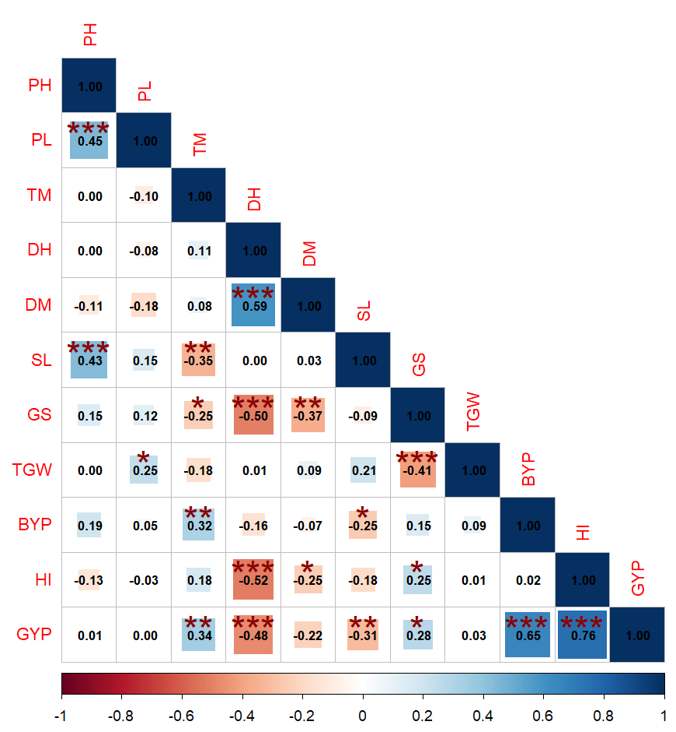
*, **, *** Significant at 0.05, 0.01 and 0.001 level, respectively
Fig. 1. Correlation among different quantitative traits in hulless barley

Table 4. Direct (diagonal) and indirect effects of different quantitative traits on grain yield in hulless barley
Traits | PH | PL | TM | DH | DM | SL | GS | TGW | BYP | HI | rp with GYP
PH | -0.006 | 0.005 | 0.000 | 0.000 | 0.000 | -0.003 | -0.008 | 0.000 | 0.126 | -0.102 | 0.013
PL | -0.003 | 0.012 | 0.002 | 0.000 | 0.000 | -0.001 | -0.006 | -0.016 | 0.030 | -0.021 | -0.002
TM | 0.000 | -0.001 | -0.024 | -0.001 | 0.000 | 0.003 | 0.013 | 0.012 | 0.209 | 0.133 | 0.343**
DH | 0.000 | -0.001 | -0.003 | -0.005 | 0.000 | 0.000 | 0.026 | -0.001 | -0.104 | -0.392 | -0.480**
DM | 0.001 | -0.002 | -0.002 | -0.003 | 0.000 | 0.000 | 0.019 | -0.006 | -0.044 | -0.186 | -0.224
SL | -0.003 | 0.002 | 0.008 | 0.000 | 0.000 | -0.008 | 0.005 | -0.014 | -0.165 | -0.137 | -0.311**
GS | -0.001 | 0.002 | 0.006 | 0.003 | 0.000 | 0.001 | -0.051 | 0.027 | 0.100 | 0.191 | 0.277*
TGW | 0.000 | 0.003 | 0.004 | 0.000 | 0.000 | -0.002 | 0.021 | -0.065 | 0.060 | 0.004 | 0.026
BYP | -0.001 | 0.001 | -0.008 | 0.001 | 0.000 | 0.002 | -0.008 | -0.006 | 0.656 | 0.017 | 0.654**
HI | 0.001 | 0.000 | -0.004 | 0.003 | 0.000 | 0.001 | -0.013 | 0.000 | 0.015 | 0.754 | 0.756**
Residual effect =0.140

Table 5. Principal component analysis in barley genotypes
Components | PC 1 | PC 2 | PC 3 | PC 4
Eigen values | 3.441 | 2.383 | 1.735 | 1.243
Proportion of total variation (%) | 31.286 | 21.666 | 15.769 | 11.302
Cumulative percentage of variance | 31.286 | 52.952 | 68.720 | 80.022
Plant height | 0.006 | 0.713 | 0.407 | 0.417
Peduncle length | 0.070 | 0.725 | 0.382 | 0.118
Number of effective tillers per meter row | 0.244 | -0.581 | 0.528 | 0.232
Days to heading | -0.766 | -0.315 | 0.272 | 0.285
Days to maturity | -0.629 | -0.467 | 0.270 | 0.059
Spike length | -0.393 | 0.661 | 0.016 | -0.146
Number of grains per spike | 0.592 | 0.314 | -0.452 | 0.447
1000-grain weight | -0.238 | 0.331 | 0.489 | -0.711
Biological yield per plot | 0.613 | -0.069 | 0.661 | 0.192
Harvest index | 0.818 | -0.148 | -0.103 | -0.369
Grain yield per plot | 0.888 | -0.149 | 0.326 | -0.134

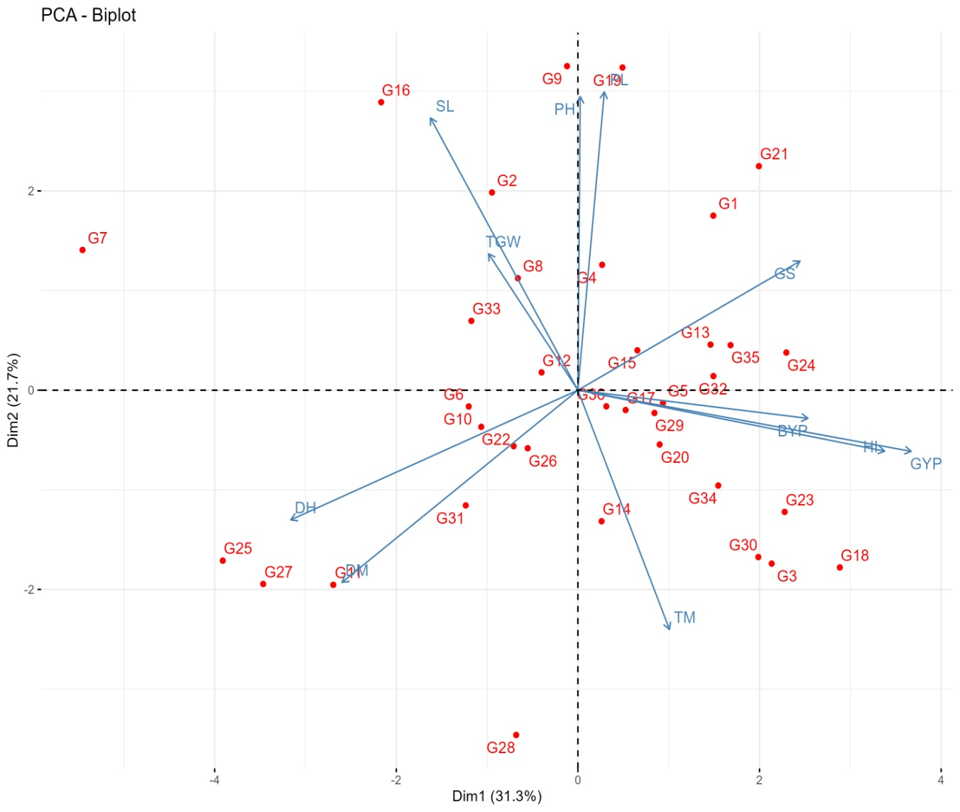
Fig. 2. Biplot of barley genotypes vis-a-vis quantitative traits

Table 6. Clustering of barley genotypes based on quantitative traits and their genetic distances
Cluster members | Number of genotypes | Clusters | Cluster Distances
Cluster members | Number of genotypes | Clusters | C I | C II | C III | C IV | C V | C VI
DWRB 2426, DWRB 2434, DWRB 2430, DWRB 2408, UPB 1129, DWRB 2441, DWRB 2424, DWRB 2410, RD 3120, DWRB 2407, DWRB 2432, DWRB 2437, DWRB 2431 | 13 | C I | 59.323 | 84.029 | 63.393 | 64.635 | 63.232 | 62.151
DWRB 2440, DWRB 2438, DWRB 2435, DWRB 2433 | 4 | C II | 84.029 | 50.691 | 91.189 | 71.156 | 83.048 | 72.695
RD 3125, DWRB 2439, PL 891 (c), RD 3123, RD 3124, RD 3119 | 6 | C III | 63.393 | 91.189 | 63.807 | 69.277 | 63.684 | 48.786
DWRB 2436, DWRB 2428, RD 3121, DWRB 2442, DWRB 2427, PL 976 | 6 | C IV | 64.635 | 71.156 | 69.277 | 51.680 | 63.863 | 66.479
DWRB 2425, DWRB 2409, K 1149 (c), RD 3122, DWRB 2443, DWRB 223 (c) | 6 | C V | 63.232 | 83.048 | 63.684 | 63.863 | 40.640 | 59.839
DWRB 2429 | 1 | C VI | 62.151 | 72.695 | 48.786 | 66.479 | 59.839 | 0.000

Table 7. Performance of clusters for quantitative traits of barley genotypes
Clusters/  Traits | PH | PL | TM | DH | DM | SL | GS | TGW | BYP | HI | GYP
C I | 105.38 | 31.59 | 102.35 | 90.69 | 139.92 | 7.95 | 60.81 | 36.65 | 6.64 | 32.26 | 2.13
C II | 87.50 | 25.26 | 116.00 | 99.00 | 144.00 | 7.66 | 23.25 | 39.08 | 6.06 | 27.55 | 1.67
C III | 107.08 | 35.66 | 92.08 | 90.08 | 139.17 | 8.91 | 38.42 | 47.38 | 6.50 | 29.82 | 1.92
C IV | 94.08 | 30.33 | 113.25 | 88.92 | 140.67 | 6.86 | 47.17 | 40.67 | 7.30 | 38.05 | 2.76
C V | 91.08 | 25.67 | 88.92 | 88.25 | 139.42 | 7.67 | 50.25 | 38.28 | 5.83 | 34.70 | 2.02
C VI | 121.00 | 32.25 | 82.00 | 104.50 | 145.00 | 10.00 | 27.00 | 36.80 | 5.00 | 22.82 | 1.13

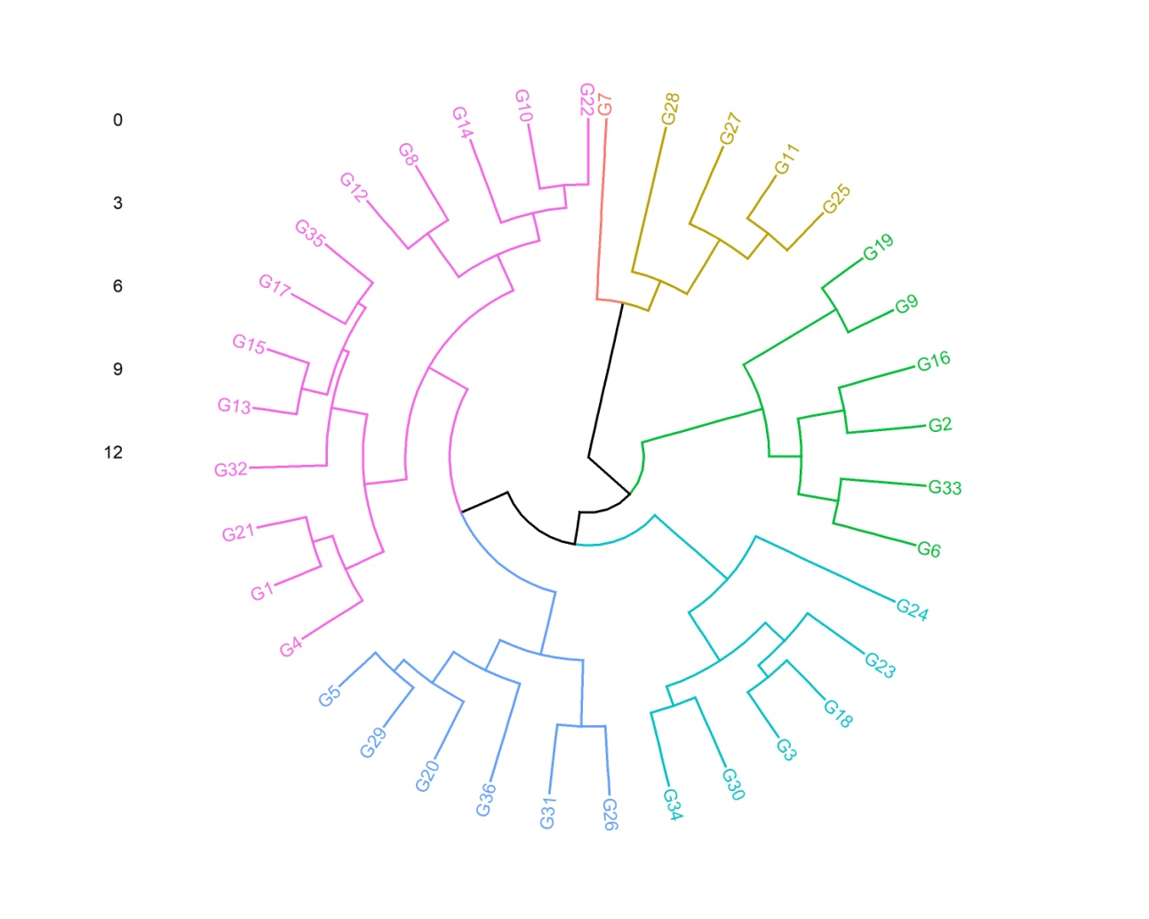
Fig. 3. Dendrogram portraying clustering pattern of 36 hulless barley genotypes
(For detail of genotypes, refer to Table 2)

