Exploring the Potential of Foliar Nano Zinc Oxide Application on Wheat Cultivation in Zinc Deficient Inceptisol Soils

-------------------------------------------------------------------------------------------------------------------------------
ABSTRACT
A field experiment was conducted during rabi season of 2024-25 at Post Graduate Instructional farm, College of Agriculture, Pune to study the effect of foliar application of nano zinc oxide on growth, yield and quality of wheat in Inceptisol. The foliar application of nano ZnO @300, 600, 900, 1200 ppm were compared with foliar spray of 1200 ppm EDTA Zn at 45 and 65 days after sowing. The recommended fertilizer dose was common to all treatments except absolute control treatment. The findings of the present investigation revealed that the chlorophyll content (15.63 mg g⁻¹ at 50 DAS and 19.50 mg g⁻¹ at 70 DAS fresh leaf tissue weight) and leaf zinc concentration (14.15 mg kg⁻¹ at 50 DAS and 17.21 mg kg⁻¹ at 70 DAS) were significantly higher for application of RDF + foliar spray of 1200 ppm nano-ZnO. The application of RDF + foliar spray of 1200 ppm nano-ZnO recorded significantly higher plant height (89.23 cm), number of tillers per square meter (263.67), number of grains per spikelet (42.9), grain yield (43.53 q ha⁻¹) and straw yield (60.15 q ha⁻¹) over other treatments. The foliar sprays of nano zinc oxide significantly enhanced growth and yield of wheat along with improving soil nutrient status and nutrient uptake, indicating their potential as sustainable alternatives over conventional micronutrient fertilizers in zinc deficient Inceptisol soils.

Keywords: Wheat; Nano; Zinc; Oxide; Foliar, Effect, Growth and Yield

1. INTRODUCTION
Nanoscience is the study of materials at a scale that sits between regular-sized matter and atomic-sized matter. Nanotechnology, on the other hand, involves understanding and controlling of matter at the scale of 1 to 100 nanometers. Nanoparticles exhibit size-associated properties that are significantly different from regular sized-materials. These particles can be synthesized by physical, chemical, and biological processes. Due to their small size, NPs have a much larger surface area compared to their unprocessed counterparts, which gives them a wide range of potential applications in the field of agriculture. Among the essential micronutrients, zinc is crucial for plant growth and reproduction. Zinc is involved in numerous essential processes such as biosynthesis of proteins, enzymes, lipids, carbohydrates, chlorophyll, maintaining cell membrane integrity, seed development and various metabolic activities.
Zinc is a key component antioxidant enzymes like alcohol dehydrogenase, alkaline phosphatase and superoxide dismutase which play critical roles in DNA structure, carbohydrate metabolism and maintaining the integrity of cellular membranes. Zinc acts as a cofactor for carbonic anhydrase in chloroplasts, helping to increase CO₂ concentration for photosynthesis (Saini et al. 2021). Beyond transcription factors, zinc-dependent enzymes are involved in RNA and DNA polymerase activities, splicing factors, histone deacetylases and mitochondrial and chloroplast RNA-editing enzymes (Eide, 2020).

____________________________________________________________________________________

Zinc oxide (ZnO) nanoparticles, in particular, have drawn attention of researchers because of their special properties, like size, shape, optical and chemical attributes. These properties make ZnO nanoparticles useful for developing a variety of products. NPs, including ZnO, have shown the potential to enhance plant metabolism, making them beneficial in agricultural applications (Zulfiqar et al., 2019). The effectiveness of nanoparticles depends on factors like their chemical composition, size, surface characteristics, reactivity and importantly, the dose at which they are used (Shang et al., 2019).
Wheat (Triticum aestivum L.) is one of the most important and widely cultivated food crops globally, serving as a vital source of calories, protein and essential micronutrients. It plays a critical role in global food security, especially in developing countries where it contributes to more than 50% of daily calorie intake. Often referred to as the “king of cereals,” wheat is not only a staple for human consumption but also a valuable livestock feed through its straw. Nutritionally, wheat is composed of 60–68% carbohydrates and contains important vitamins like niacin and thiamine. It also provides high-quality protein, with about 12% gluten, which is essential for dough elasticity and bread-making quality. In India, wheat is the second most significant staple food crop after rice. It is commonly consumed in the form of chapatis in wheat-dominant regions, while in rice-dominant areas, it is used to prepare puris, upma or suji-based dishes. Considering the crucial role of zinc in plant health and the advantages of nanotechnology, the present investigation was conducted to synthesize and characterize ZnO nanoparticles and evaluate their effect through foliar application on the growth, yield, nutrient uptake and seed quality of wheat grown on zinc-deficient Inceptisol.

2. MATERIALS AND METHODS
A field experiment was conducted at the Post Graduate Instructional Farm, Division of Soil Science, College of Agriculture, Pune (MS) during rabi season of 2024-25. The performance of nano ZnO was evaluated by comparing the nine treatments as T₁ - Absolute control, T₂ - GRDF (120:60:40 N: P₂O₅: K₂O kg ha⁻¹ + FYM 10 t ha⁻¹), T₃ - GRDF + soil application of ZnSO₄ @20 kg ha⁻¹, T₄ - GRDF + water spray, T₅ - GRDF + foliar spray of 300 ppm nano-ZnO, T₆ - GRDF + foliar spray of 600 ppm nano-ZnO, T₇ - GRDF + foliar spray of 900 ppm nano-ZnO, T₈ - GRDF + foliar spray of 1200 ppm nano-ZnO and T₉ - GRDF + foliar spray of 1200 ppm EDTA Zn which were replicated three times in RBD design. A representative soil sample from the 0–30 cm layer, was collected from the field. The initial soil of the experimental site before sowing of the crop was slightly alkaline (pH 7.82), low electrical conductivity (EC) (0.59 dS m⁻¹), moderate in organic carbon (0.42 %) and calcium carbonate (7.73 %), low in available nitrogen (236.23 kg ha⁻¹) and available phosphorus (20.15 kg ha⁻¹) but high in available potassium (463.00 kg ha⁻¹) levels and deficient in DTPA zinc (0.56 mg kg⁻¹) levels.
The nano zinc oxide particles were synthesized by using chemical precipitation method along with calcination and modified with pectin in the lab of Division of Soil Science, RCSM College of Agriculture, Kolhapur. The size, surface structure and topology of zinc oxide nanoparticles were disclosed by using Scanning Electron Microscope (SEM). It is revealed from the analytical report of Scanning Electron Microscope that the average size of nano zinc oxide particle is 42.37 nm. The NIAW-1994 (Phule Samadhan), variety of wheat was grown as a test crop.
The recommended dose of fertilizer (120:60:40 kg of N, P₂O₅ and K₂O+ 10 t FYM ha⁻¹) was applied except for absolute control. The required quantity of zinc was applied as per the treatments through various sources viz. nano zinc oxide, zinc sulphate heptahydrate and EDTA Zn except for absolute control. The zinc sulphate heptahydrate was incubated with FYM for 15 days before incorporating into soil. The nano zinc oxide and EDTA Zn were applied as foliar sprays at 45 and 65 days after sowing. The characterization of nano zinc oxide (ZnO) particles for size and crystallography was done by using SEM analysis technique before starting of the experiment and given in Table 1 and Fig. 1.
The plant samples were collected and analyzed at 50 and 70 days after sowing and at harvest of wheat crop. The soil samples were also collected after harvest of wheat. The soil and plant samples were analyzed by using standard analytical methods. The observations for yield contributing characters of wheat were recorded at harvest stage of wheat crop. The grain yield and straw yield data were recorded and further statistical analysis was done. A randomized block design (RBD) with analysis of variance (ANOVA) was employed to assess treatment effects on all studied characteristics (Panse and Sukhatme, 1985).

Table 1 Characterization of nano-zinc oxide particles for size using SEM
Sr. No. | Size of nano-zinc oxide (nm) | Sr. No. | Size of nano-zinc oxide (nm)
1 | 20.23 | 13 | 36.45
2 | 21.63 | 14 | 37.77
3 | 22.93 | 15 | 40.83
4 | 24.32 | 16 | 41.03
5 | 28.36 | 17 | 44.84
6 | 29.12 | 18 | 54.11
7 | 29.68 | 19 | 61.52
8 | 29.71 | 20 | 66.63
9 | 31.03 | 21 | 66.91
10 | 32.38 | 22 | 73.95
11 | 35.49 | 23 | 75.41
12 | 36.42 | 23 | 76.33
Average | 42.37

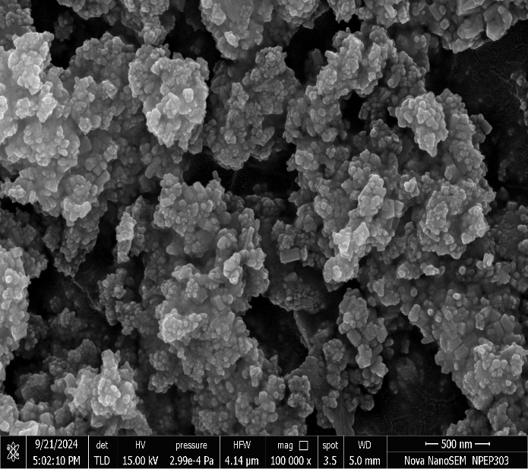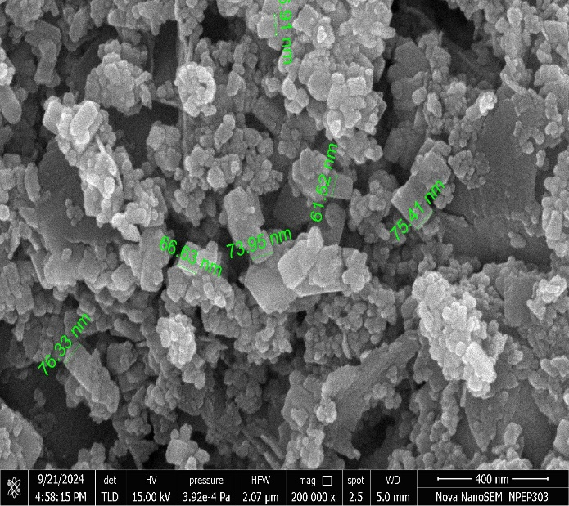
Fig. 1 (a) Characterization of nano zinc oxide (ZnO) particles for crystallography using SEM
Fig. 1 (b) Characterization of nano zinc oxide (ZnO) particles for size using SEM

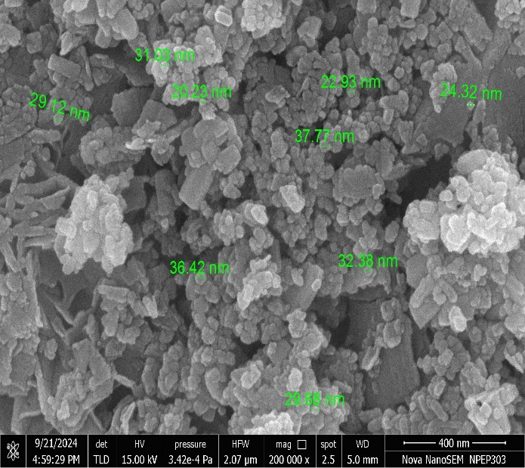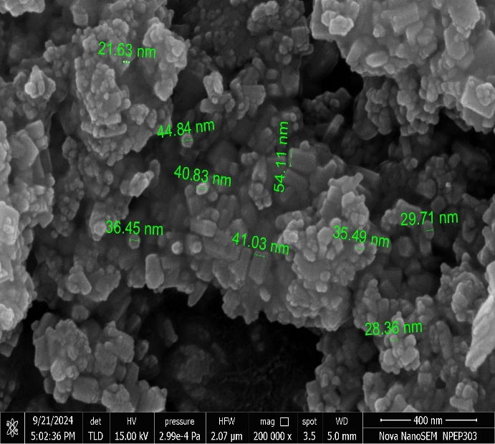
Fig. 1 (d) Characterization of nano zinc oxide (ZnO) particles for size using SEM
Fig. 1 (c) Characterization of nano zinc oxide (ZnO) particles for size using SEM

Fig. 1: Characterization of nano-zinc oxide particles for size and crystallography using Scanning Electron Microscopy

3. RESULTS AND DISCUSSION
3.1 Effect of foliar application of nano zinc oxide on growth of wheat
3.1.1 Total chlorophyll
The total chlorophyll in fresh leaf tissue of wheat at 50 and 70 days after sowing was influenced due to foliar application different sources of zinc. The total chlorophyll (15.63 mg g⁻¹) in fresh leaf tissue at 50 days after sowing was found significantly higher due to application of GRDF + foliar spray of 1200 ppm nano ZnO, while application of GRDF + soil application of ZnSO₄ @20 kg ha⁻¹ (13.75 mg g⁻¹), GRDF + foliar spray of 900 ppm nano-ZnO (13.90 mg g⁻¹) and GRDF + foliar spray of 1200 ppm EDTA Zn (13.75 mg g⁻¹) were at par with this treatment.
The total chlorophyll (23.29 mg g⁻¹) in fresh leaf tissue at 70 days after sowing was found significantly higher in GRDF + foliar spray of 1200 ppm nano ZnO treatment, while GRDF + soil application of ZnSO₄ 20 kg ha⁻¹, GRDF + foliar spray of 300 ppm nano-ZnO, GRDF + foliar spray of 600 ppm nano-ZnO, GRDF + foliar spray of 900 ppm nano-ZnO, and GRDF + foliar spray of 1200 ppm EDTA Zn (19.50, 19.60, 19.97, 21.66 and 21.04 mg g⁻¹, respectively) were at par. The soil application of GRDF + ZnSO₄ @20 kg ha⁻¹ showed a substantial increase in total chlorophyll (13.75 mg kg⁻¹ at 50 days after sowing and 19.50 mg kg⁻¹ at 70 days after sowing), confirming the efficacy of conventional zinc sulphate application.
3.1.2 Leaf zinc concentration
The differences in leaf zinc content across the treatments at both 50 and 70 days after sowing was influenced due to foliar application different sources of zinc. The leaf zinc concentration (14.15 mg kg⁻¹) of wheat at 50 days after sowing was found significantly higher in treatment GRDF + foliar application of 1200 ppm nano ZnO, while GRDF + soil application of ZnSO₄ @20 kg ha⁻¹ (11.81 mg kg⁻¹) GRDF + foliar application of 300 ppm nano-ZnO, (12.09 mg kg⁻¹) GRDF + foliar application of 600 ppm nano-ZnO (12.69 mg kg⁻¹), GRDF + foliar application of 900 ppm nano-ZnO (13.06 mg kg⁻¹), and GRDF + foliar application of 1200 ppm EDTA Zn (12.73 mg kg⁻¹) treatments were at par with treatment.
The leaf zinc concentration (17.21 mg kg⁻¹) of wheat at 70 days after sowing was found significantly higher in treatment GRDF + foliar application of 1200 ppm nano ZnO, while GRDF + soil application of ZnSO₄ @20 kg ha⁻¹ (14.24 mg kg⁻¹) GRDF + foliar application of 300 ppm nano-ZnO, (14.75 mg kg⁻¹) GRDF + foliar application of 600 ppm nano-ZnO (15.13 mg kg⁻¹), GRDF + foliar application of 900 ppm nano-ZnO (16.41 mg kg⁻¹), and GRDF + foliar application of 1200 ppm EDTA Zn (16.31 mg kg⁻¹) treatments were at par with this treatment. The treatment absolute control recorded the lowest zinc content (4.83 mg kg⁻¹ at 50 DAS and 8.38 mg kg⁻¹ at 70 DAS). The application of GRDF + ZnSO₄ @20 kg ha⁻¹ showed a substantial increase in leaf zinc concentration (11.81 mg kg⁻¹ at 50 days after sowing and 14.24 mg kg⁻¹ at 70 days after sowing), confirming the efficacy of conventional zinc sulphate application.
3.1.3 Plant height at harvest of wheat
The plant height (91.10 cm) at harvest of wheat crop was found significantly higher in GRDF + foliar spray of 1200 ppm nano ZnO treatment, while treatments GRDF + soil application of ZnSO₄ @20 kg ha⁻¹ (89.23 cm), GRDF + foliar spray of 300 ppm nano-ZnO (89.25 cm), GRDF + foliar spray of 600 ppm nano-ZnO (89.32 cm), GRDF + foliar spray of 900 ppm nano-ZnO (89.86 cm) and GRDF + foliar spray of 1200 ppm EDTA Zn (89.53 cm) were at par with this treatment.
3.1.4 Number of tillers per square meter at harvest of wheat
The number of tillers per square meter (263.67) were significantly higher in treatment GRDF + foliar spray of 1200 ppm nano ZnO kg ha⁻¹, while the number of tillers per square meter influenced by treatments GRDF + soil application of ZnSO₄ @20 kg ha⁻¹ (249.67), GRDF + foliar spray of 300 ppm nano-ZnO (250.33), GRDF + foliar spray of 600 ppm nano-ZnO (252.33), GRDF + foliar spray of 900 ppm nano-ZnO (255.67) and GRDF + foliar spray of 1200 ppm EDTA Zn (255.33) were at par with this treatment.
3.1.5 Number of grains per spikelet at harvest of wheat
The number of grains per spikelet (42.9) was significantly increased in treatment GRDF + foliar spray of 1200 ppm nano ZnO, while treatments GRDF + soil application of ZnSO₄ @20 kg ha⁻¹ (39.1), GRDF + foliar spray of 300 ppm nano-ZnO (39.6), GRDF + foliar spray of 600 ppm nano-ZnO (40.4), GRDF + foliar spray of 900 ppm nano-ZnO (41.5) and GRDF + foliar spray of 1200 ppm EDTA Zn (40.7) showed higher grains counts per spikelet in comparison and were at par with treatment GRDF + foliar spray of 1200 ppm nano ZnO due to application of zinc.
Nano-zinc oxide particles have a very small size and large surface area, which enhances their reactivity and interaction with plant surfaces. The application of nano zinc oxide zinc particles might have influenced chlorophyll content and leaf zinc concentration by stimulating various biological processes and boosting enzymatic activities. As a result, chlorophyll biosynthesis is promoted, and the activity of catalytic enzymes might be elevated, contributing to the suppression of ethylene production, which is known for its deleterious effects on chlorophyll stability. These results might be because of adequate supplementation of nano zinc oxide particles to wheat crop. The balanced nutrient supply with nano zinc oxide provided essential nutrients throughout different growth stages of wheat offering an initial nutrient boost and ensuring a sustained release of nutrients throughout the growing season. This improved the total chlorophyll content, increased leaf zinc concentration, contributed to higher plant height, higher number of tillers per square meter and higher number of grains per spikelet. These findings are consistent with those reported by Rizwan et al. (2019), Adrees et al. (2021), Sharma et al. (2022), Khule et al. (2023) and Nazir et al. (2024).
Table 2 Effect of foliar application of nano zinc oxide on total chlorophyll content and leaf zinc concentration of wheat in Inceptisol
Tr. No. | Treatments | Chlorophyll (mg g⁻¹ fresh tissue weight) |  | Leaf zinc (mg kg⁻¹)
Tr. No. | Treatments | 50 DAS | 70 DAS | 50 DAS | 70 DAS
T₁ | Absolute Control | 6.77 | 7.89 | 4.83 | 8.38
T₂ | GRDF (120:60:40 N: P₂O₅: K₂O kg ha⁻¹ + FYM 10 t ha⁻¹) | 10.13 | 13.47 | 8.53 | 10.78
T₃ | GRDF + soil application of ZnSO₄ 20 kg ha⁻¹ | 13.75 | 19.50 | 11.81 | 14.24
T₄ | GRDF + water spray | 9.83 | 12.77 | 8.30 | 10.40
T₅ | GRDF + foliar spray of 300 ppm nano-ZnO | 12.17 | 19.60 | 12.09 | 14.75
T₆ | GRDF + foliar spray of 600 ppm nano-ZnO | 12.77 | 19.97 | 12.69 | 15.13
T₇ | GRDF + foliar spray of 900 ppm nano-ZnO | 13.90 | 21.66 | 13.06 | 16.41
T₈ | GRDF + foliar spray of 1200 ppm nano-ZnO | 15.63 | 23.29 | 14.15 | 17.21
 | GRDF + foliar spray of 1200 ppm EDTA Zn | 13.75 | 21.04 | 12.73 | 16.31
 | SE(m) ± | 0.84 | 1.38 | 0.80 | 1.17
 | CD (0.05) | 2.52 | 4.13 | 2.41 | 3.50

Table 3 Effect of foliar application of nano zinc oxide on plant height, number of tillers per square meter and number of grains per spikelet of wheat in Inceptisol
Tr. No. | Treatments | Plant height  (cm) | Number of tillers m⁻² | Number of grains spikelet⁻¹
T₁ | Absolute Control | 63.52 | 144.67 | 29.8
T₂ | GRDF (120:60:40 N: P₂O₅: K₂O kg ha⁻¹ + FYM 10 t ha⁻¹) | 87.41 | 242.67 | 36.8
T₃ | GRDF + soil application of ZnSO₄ 20 kg ha⁻¹ | 89.23 | 249.67 | 39.1
T₄ | GRDF + water spray | 87.24 | 241.33 | 36.2
T₅ | GRDF + foliar spray of 300 ppm nano-ZnO | 89.25 | 250.33 | 39.6
T₆ | GRDF + foliar spray of 600 ppm nano-ZnO | 89.32 | 252.33 | 40.4
T₇ | GRDF + foliar spray of 900 ppm nano-ZnO | 89.86 | 255.67 | 41.5
T₈ | GRDF + foliar spray of 1200 ppm nano-ZnO | 91.10 | 263.67 | 42.9
 | GRDF + foliar spray of 1200 ppm EDTA Zn | 89.53 | 255.33 | 40.7
 | SE(m) ± | 0.68 | 6.23 | 1.31
 | CD (0.05) | 2.06 | 18.68 | 3.93

3.2 Effect of foliar application of nano zinc oxide on yield of wheat
3.2.1 Grain yield
The application of fertilizers along with foliar sprays, regardless of the doses and sources of nutrients, led to a significant increase in grain yield compared to scenarios with no nutrient application, as evidenced by the data. The grain yield (43.53 q ha⁻¹) of wheat was found significantly higher in treatment GRDF + foliar spray of 1200 ppm nano ZnO, while treatments GRDF + soil application of ZnSO₄ @20 kg ha⁻¹ (37.44 q ha⁻¹) GRDF + foliar spray of 900 ppm nano-ZnO (42.88 q ha⁻¹) and GRDF + foliar spray of 1200 ppm EDTA Zn (42.94 q ha⁻¹) were at par with this treatment.
3.2.2 Straw yield
In the present investigation the straw yield (60.15 q ha⁻¹) of wheat was found significantly higher in treatment GRDF + foliar spray of 1200 ppm nano ZnO, while treatments GRDF + soil application of ZnSO₄ @20 kg ha⁻¹(52.04 q ha⁻¹), GRDF + foliar spray of 900 ppm nano-ZnO (58.84 q ha⁻¹) and GRDF + foliar spray of 1200 ppm EDTA Zn (59.69 q ha⁻¹) were at par with treatment GRDF + foliar spray of 1200 ppm nano ZnO.
The effectiveness of nano fertilizers can be attributed to their large surface area and ultra-fine particle size which are smaller than the pores of plant stomata and plant cell. Nano fertilizers facilitate nutrient transport and mobility within plant tissues, which supports better crop performance. The zinc supplementation promotes the synthesis of Indole-3-acetic acid (IAA), a key plant hormone that stimulates reproductive development and activates various metabolic processes. The tryptophan amino acid secretions are more under nano zinc oxide application which is precursor for auxin synthesis. The efficient absorption of zinc via foliar application enhances its movement to storage tissues, thereby supporting photosynthetic activity and accelerating grain development. These physiological improvements contribute to overall plant growth and yield. Similar findings are reported by Al-Juthery et al. (2019), Kumar et al. (2020), Ghiyasi et al. (2023), Gupta et al. (2023), Khule et al. (2023), Maheshwari et al. (2023) and Raza et al. (2025).
Table 4 Effect of foliar application of nano zinc oxide on grain and straw yield of wheat
Treat. No. | Treatments | Grain yield  (q ha⁻¹) | Straw yield  (q ha⁻¹)
T₁ | Absolute Control | 20.49 | 22.95
T₂ | GRDF (120:60:40 N: P₂O₅: K₂O kg ha⁻¹ + FYM 10 t ha⁻¹) | 34.46 | 45.48
T₃ | GRDF + soil application of ZnSO₄ 20 kg ha⁻¹ | 37.44 | 52.04
T₄ | GRDF + water spray | 34.52 | 45.91
T₅ | GRDF + foliar spray of 300 ppm nano-ZnO | 36.49 | 50.58
T₆ | GRDF + foliar spray of 600 ppm nano-ZnO | 36.93 | 50.74
T₇ | GRDF + foliar spray of 900 ppm nano-ZnO | 42.88 | 58.84
T₈ | GRDF + foliar spray of 1200 ppm nano-ZnO | 43.53 | 60.15
T₉ | GRDF + foliar spray of 1200 ppm EDTA Zn | 42.94 | 59.69
 | SE(m) ± | 2.17 | 3.13
 | CD (0.05) | 6.52 | 9.41

4. CONCLUSION
The present study investigated the effect of foliar application of nano zinc oxide on growth and yield of wheat in Inceptisol. Foliar application of nano zinc oxide @1200 ppm along with general recommended dose of fertilizers resulted in the higher total chlorophyll content, leaf zinc concentration, plant height, number of tillers per square meter, number of grains per spikelet as well as higher grain yield and straw yield of wheat. This treatment was at par with the treatments GRDF + soil application of ZnSO₄ @20 kg ha⁻¹, GRDF + foliar spray of 900 ppm nano-ZnO and GRDF + foliar spray of 1200 ppm EDTA Zn. Interestingly, foliar application of EDTA Zn @1200 ppm and GRDF + soil application of ZnSO₄ @20 kg ha⁻¹ also significantly influenced the growth and yield contributing characters of wheat. Overall, application of general recommended dose of fertilizers (120:60:40 N: P₂O₅: K₂O kg ha⁻¹ + 10 t FYM ha⁻¹) along with two foliar sprays of nano ZnO @1200 ppm, 900 ppm, 600 ppm for yield contributing characters of wheat and two foliar sprays of nano ZnO @1200 ppm and 900 ppm for yield of wheat at tillering (45 days after sowing) stage and at jointing (65 days after sowing) stage was recorded beneficial in zinc deficient Inceptisol soils, while EDTA Zn and Zinc sulphate showed promises to use as a zinc source for wheat crop.

COMPETING INTERESTS DISCLAIMER:
Authors have declared that they have no known competing financial interests OR non-financial interests OR personal relationships that could have appeared to influence the work reported in this paper.

REFERENCES
- Adrees, S.N., Sharma, N. and Kumar, L. (2017) Synthesis of graphene oxide (GO) by modified hummers method and its thermal reduction to obtain reduced graphene oxide. Graphene 6(1), 1-18.
- Al-Juthery, H.W.A., Hassan, A.H., Kareem, F.K., Musa, R.F. and Khaeim, H.M. (2019) The response of wheat to foliar application of nano-micro nutrients. Plant Archives 19(Supplement 2), 827–831.
- Arnon, D.I. (1949). Copper enzymes in isolated chloroplasts, polyphenoloxidase in Beta vulgaris. Plant Physiology 24,1-15.
- Eide, D.J. (2020) Transcription factors and transporters in zinc homeostasis: Lessons learned from fungi. Critical Reviews in Biochemistry and Molecular Biology 55(1), 88–110.
- Ghiyasi, M., Younes, R.D., Reza, A., Najafi, S., José, M.M. and Rosa P. (2023) Foliar Applications of ZnO and Its Nanoparticles Increase Safflower Growth and Yield under Water Stress. Agronomy 13, 192.
- Gupta, A.K., Samaiya, R.K., Singh, Y., Rahangdale, S. and Nayak, P.S. (2023) Effect of Nano Zinc Oxide Seed Treatment on Physiological Growth and Biophysical Traits and Seed Quality of Soybean (Glycine Max L.). International Journal of Environment and Climate Change 13(7), 687-99.
- Khule, Y.R., Waghmare, M.S., Shelake, M.S., Boradkar, S.G. and Chavan, A.L. (2023) Effect of foliar application of nano-N fertilizer on growth yield, and quality of linseed. The Pharma Innovation Journal 12(2), 3208-3211.
- Kumar, Y., Tiwari, K.N., Nayak, R.K., Rai, A., Singh, S.P. and Singh, A.N. (2020) Nano fertilizers for increasing nutrient use efficiency, yield and economic returns in important winter season crops of Uttar Pradesh. Indian Journal of Fertilizers 16(6), 772–786.
- Maheshwari, B., Mehera, B., Kumar, P. and Mondal, S. (2023) Effect of foliar application of micronutrients on growth and yield of sesame (Sesamum indicum L.). International Journal of Plant and Soil Science 35(12), Page 69-73.
- Max Knoll. (1935) Book Chapter Entitled - Nano Technology in Soil Science. Soil Science - An Introduction. Indian Society of Soil Science, pp793.
- Nasiri, Y.Z., Nasrullahzadeh S., Najati, N. and Ghasserni-Golezani, K. (2010) Effect of foliar application of micronutrients (Fe and Zn) on flower yield and essential oil of chamomile (Matricaria chamomilla L.). Journal of Medicinal Plant Resource 4(17), 1733-1737.
- Nazir, M.A., Hasan, M. and Mustafa, G. (2024) Zinc oxide nano-fertilizer differentially effect on morphological and physiological identity of redox-enzymes and biochemical attributes in wheat (Triticum aestivum L.). Scientific Reprise 14, 13091.
- Panse, V.G. and Sukhatme P.V. (1985) Statistical Methods for Agricultural Workers. Publication and information division, Indian Council of Agricultural Research, New Delhi; c1985. p 347.
- Raza, M.A.S., Muhammad, F., Farooq, M., Aslam, M.U., Akhter, N., Toleikienė, M., Binobead, M.A., Ali, M.A., Rizwan, M. and Iqbal, R. (2025) ZnO-nanoparticles and stage-based drought tolerance in wheat (Triticum aestivum L.): effect on morpho-physiology, nutrients uptake, grain yield and quality. Scientific Reports 15, 89718.
- Rizwan, M., Ali, S., Ali, B., Adrees, M., Arshad, M. and Hussain, A. (2019) Zinc and iron oxide nanoparticles improved plant growth and reduced oxidative stress and cadmium concentration in wheat. Chemosphere 214, 269–277.
- Saini, P., Nagpal, S., Saini, P., Kumar, A. and Gani, M. (2021) Microbial mediated zinc solubilization in legumes for sustainable agriculture. In Combating the Abiotic Stress Through Phytomicrobiome Studies, pp. 254–276.
- Shang, Y., Hasan, M.K., Ahammed, G.J., Li, M., Yin, H. and Zhou, J. (2019) Applications of nanotechnology in plant growth and crop protection: A Review. Molecules 24(14), 2558.
- Sharma, K., Meena, R.H., Meena, S.C., Jain, D., Ameta K.D., Khardia, N. and Meena, D. (2022) Impact of Foliar Application of Nano Nitrogen and Nano Zinc on Yield Attributes and Yield of Mustard. Frontiers in Crop Improvement 10, 1126-1130.
- Zasoski, R.J. and Burau, R.G. (1977) A rapid nitric‐perchloric acid digestion method for multi‐element tissue analysis. Communications in Soil Science and Plant Analysis 8(5), 425–436.
- Zulfiqar F.M., Navarro, M., Ashraf, N.A., Akram, S. and Munné-Bosch. (2019) Nanofertilizer use for sustainable agriculture: Advantages and limitations. Plant Science 289, 110270.

