Original Research Article
Fungal biopriming: Ophiocordyceps neovolkiana mycelial extract enhances rice (Oryza sativa L) seed germination

Abstract
Rice (Oryza sativa L.) is an important global staple, with promising germination being a pivotal factor for optimum yield and crop establishment. This study investigated the potential of Ophiocordyceps neovolkiana, an entomopathogenic fungus native to Kerala, as a novel biopriming agent to increase rice seed germination. Rice seeds of the Jyothi variety were sterilized and bioprimed by soaking in mycelial extract of O. neovolkiana for 30 minutes. Percent germination was observed over one week. Results demonstrated a significant increase in germination percentage for seeds treated with the mycelial extract (94%) compared to both the solvent control (79%) and the absolute control (80%). Furthermore, the mycelial extract treatment induced earlier germination (3.25 days) compared to the solvent control (5 days) and the absolute control (4.75 days). These findings align with existing research on various microbial biopriming agents that enhance seed vigor and early seedling development. This study provides convincing evidence that O. neovolkiana mycelial extract is a promising biological tool for improving rice seed germination, offering a sustainable method to boost crop establishment and productivity.
Key words: Rice, Biopriming, Germination, Ophiocordyceps neovolkiana
Introduction
Cordyceps, a genus of parasitic fungi, has been used in traditional Chinese medicine for centuries. Well-known species like Ophiocordyceps sinensis and Cordyceps militaris are recognized for their diverse medicinal properties, including antiviral, antifungal, antibacterial, anticancer, and immunomodulatory actions. Beyond medicinal values, the non-pathogenic efficiency of this entomopathogen is also reported. Several studies have documented the endophytic nature of Ophiocordyceps (Evans et al., 2011; Gazis et al., 2014; Wang et al., 2020; Saltamachia and Araujo, 2020). Seed treatment with Cordyceps fumosorosea on brinjal seeds significantly improved plant growth and reduced the incidence of the sucking pest Bemisia tabaci (Sun et al., 2020). Ophiocordyceps neovolkiana, a species endemic to the Kasaragod district of Kerala, India, parasitizes coconut root grubs (Leucopholis coneophora Burm.). The comprehensive characterization of O. neovolkiana, including its morphology, physiology, and molecular characteristics, has been previously documented (Laya, 2018). This study investigates the impact of O. neovolkiana mycelial extract on the germination of 'Jyothi', a prominent rice variety cultivated in Kerala. Rice is a globally significant crop, with approximately 163.1 million hectares cultivated worldwide, yielding 520.5 million metric tons at an average of 4.00 tons per hectare (FAO, 2023). Asia dominates both global rice production and consumption. Achieving rapid and uniform seed germination and seedling emergence is crucial for optimizing rice yield and quality (Hasan et al., 2020). Poor germination and seedling uniformity can severely reduce production. High-vigor seeds, characterized by uniform and rapid germination, are essential for robust seedling growth, enhanced tolerance to adverse conditions, and ultimately, higher yields. The initial stages of plant development are foundational for the entire crop cycle. Uniform germination promotes more effective competition with weeds and optimizes resource utilization, including light, water, and nutrients (Ashraf et al., 2018). Furthermore, a strong start during germination minimizes the incidence of pests and diseases, fostering healthier plants and increasing yield potential (Yamauchi et al., 2019). Efficient germination is particularly vital in direct-sown rice systems, where planting depth control is limited (Farooq et al., 2011). Studies indicate that rice cultivars with superior germination rates often exhibit higher yields due to the development of robust root systems that support growth and nutrient uptake throughout the crop cycle (Ali et al., 2019). Moreover, high germination rates reduce seed consumption, providing economic benefits to farmers and promoting sustainable agricultural practices (Jahan et al., 2021). Thus, achieving a high germination rate is a critical determinant for successful rice growth and productivity.
Materials and Methods
Isolation and culturing of the fungus
Isolation of the fungus was carried out from the stroma of a fresh fruiting body by following standard tissue culture technique. The sample was washed under running tap water and cut into small pieces, then disinfected with 1% sodium hypochlorite solution for one minute. After three washings using sterilized distilled water, the tissue bits were placed aseptically on solidified potato dextrose agar (PDA) medium in sterile Petri dishes under a laminar airflow chamber. All dishes were incubated at room temperature (28 ± 2⁰C) and observed from the next day onwards. The fungal growth obtained was subsequently subcultured to Yeast Extract Potato Fructose broth (Laya, 2018).
Mycelial extract preparation
After complete growth, the mycelium was harvested from the growing medium and freeze-dried. The dried sample was then extracted by stirring with methanol (40 ml methanol/1g sample) for 1 hour in a magnetic stirrer and subsequently filtered through Whatman No. 1 filter paper. The residue was then extracted again with methanol (20 ml methanol/1g sample) for 1 hour by following the same procedure. The combined methanolic extract was evaporated to dryness at 40°C in a rotary evaporator and re-suspended in sterile distilled water (Reis et al., 2013).
Biopriming
Rice seeds (100 grains per treatment) were surface sterilized with 1% sodium hypochlorite solution for two minutes, followed by three rinses with sterile distilled water. Subsequently, 25 sterile seeds were placed into each of four replicate Petri plates and soaked in 20 mL of the mycelial extract for 30 minutes (Purwanto et al., 2020). These treated seeds were then transferred to Petri plates lined with double-layered moist cotton, which were then covered with an upper lid containing moist blotter paper. For comparative analysis, a solvent control (treated with methanol) and an absolute control (treated with sterile distilled water) were maintained (Figure 1). All setups were incubated for one week in a plant growth chamber under optimum temperature and relative humidity. Seed germination was then assessed across all treatments.
Result and Discussion
There was a significant increase in percent germination in the mycelial extract treatment (94%) compared to the solvent control (79%) and absolute control (80%) (Figure 2, Table 1, Graph 1). It was also observed that there was an induction of early germination in the mycelial extract treatment (3.25 days) compared to the solvent control (5 days) and absolute control (4.75 days) (Table 2, Graph 2).
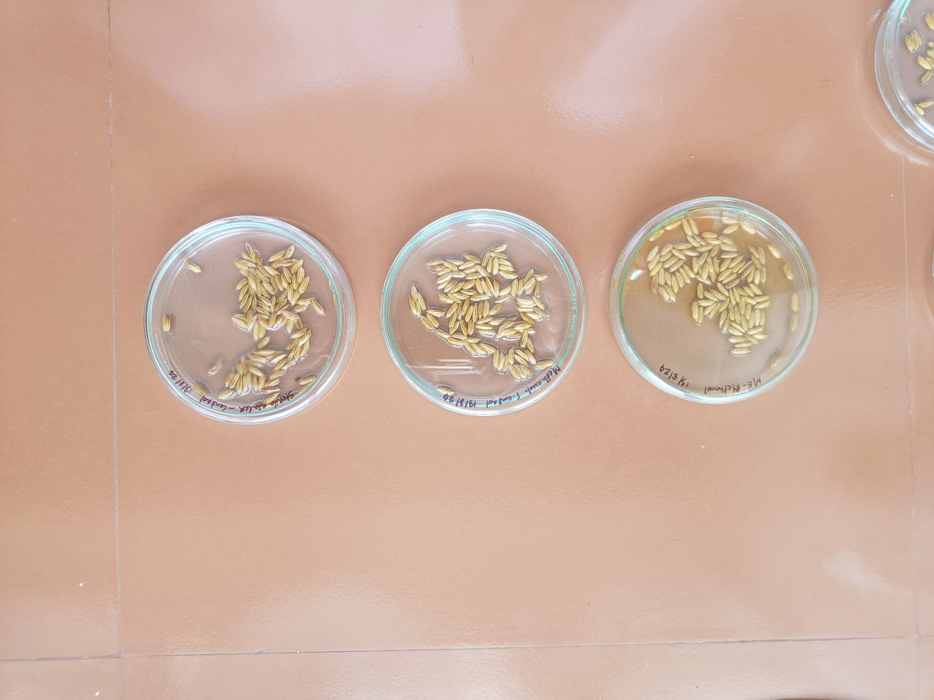
Absolute control (Sterile distilled water treated)

Solvent control (Methanol treated)
Figure 1: Rice seeds treated with mycelial extract, methanol and distilled water

Mycelial extract treated

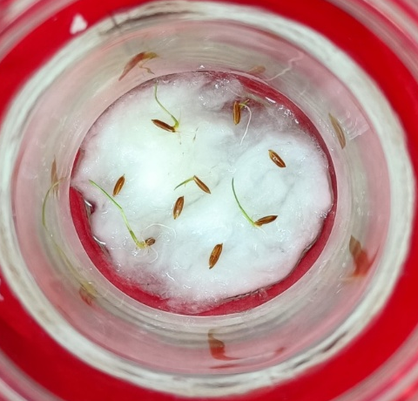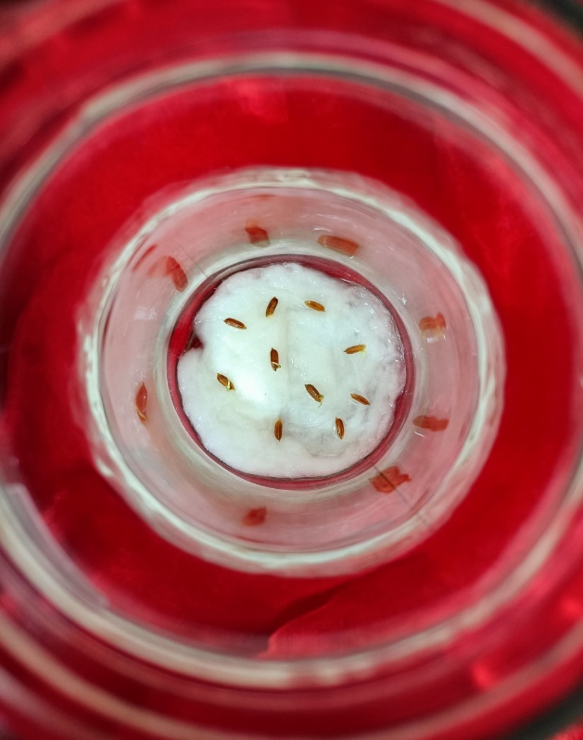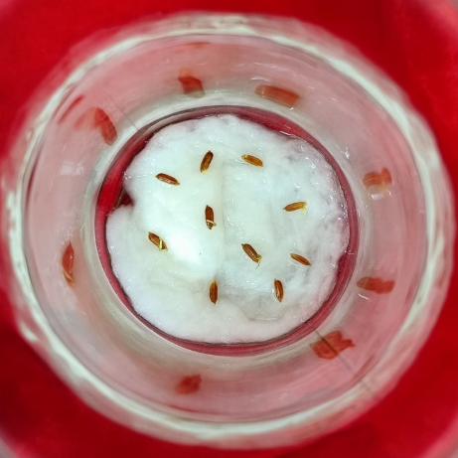
Absolute control (Sterile distilled water treated)

Mycelial extract treated
Solvent control (Methanol treated)
Figure 2: Germinated rice seeds in different treatments

Treatments | Per cent germination
Mycelial extract treated | 94
Solvent control | 79
Absolute control  Table 1: Per cent germination in different treatments (mean of four replications) | 80
Graph 1: Per cent germination in different treatments

Treatments | Days to germination
Mycelial extract treated | 3.25
Solvent control | 5
Absolute control  Table 2: Days to germination in different treatments (mean of four replications) | 4.75
Graph 2: Days to germination in different treatments

The positive outcomes observed in the present study regarding the effect of O. neovolkiana mycelial extract on rice germination are well-supported by and align with a growing body of research demonstrating the efficacy of biological priming agents in enhancing seed performance. Similar to the significant improvements in seed germination rates, growth parameters, and root traits reported with Bacillus megaterium 3456789 by Vaishnavi et al. in 2024, the O. neovolkiana extract likely promotes initial seed development and overall seedling vigor. This aligns with findings on liquid microbial cultures in paddy by Raja et al. in 2017, which also showed enhanced and more uniform germination rates, even under suboptimal conditions, suggesting a broad resilience-improving effect that the O. neovolkiana extract might also confer. The effectiveness of specific microbial isolates, such as the superior performance of Trichoderma harzianum WAI-D in improving germination and vigor in rice, provides a precedent for the study on targeted benefits of particular fungal extracts by Devi et al. in 2019, indicating that O. neovolkiana could similarly possess unique beneficial properties. Furthermore, the enhanced photosynthetic efficiency and increased antioxidant activity seen with yeast extract priming in rice done by Johnson and Puthur in 2021, which led to reduced oxidative stress and improved stress adaptation, suggest that the O. neovolkiana extract might also induce beneficial physiological and biochemical changes within the germinating seeds. This concept is further reinforced by the general understanding that beneficial microorganisms, as discussed in a review on various crops by Cardarelli in 2022, improve nutrient uptake and plant resilience to abiotic stress, contributing to overall better plant growth, a benefit likely shared by the O. neovolkiana treatment. The remarkable increases in dry weight, fresh weight, and root length observed with plant endophyte extracts on rice seedlings in the study by Wang in 2014 underscore the potential for substantial growth promotion beyond just germination, a broader impact that future studies on O. neovolkiana could investigate. Moreover, just as in the study conducted by Makhaye in 2021 on biopriming with seaweed extract and microbial-based biostimulants influenced various germination parameters in Abelmoschus esculentus, the O. neovolkiana extract likely optimizes the timing and success rate of germination. The study on mycorrhizal fungi in curly chili carried out by Meo in 2024, which improved germination quality and vigor, further highlights the diverse fungal agents capable of enhancing early plant establishment. Finally, the significant enhancements in germination speed, root/shoot growth, dry matter production, and vigor index achieved by biopriming rice seeds with phosphobacteria by Sivakumar in 2017, and the improved seedling establishment and yield from seed priming combined with Trichoderma application in Boro rice by Rahman in 2015, collectively provide strong evidence that the positive results from the O. neovolkiana mycelial extract represent a promising avenue for sustainable agricultural practices aimed at improving rice crop performance.
Conclusion
The application of O. neovolkiana mycelial extract significantly enhances rice seed germination, leading to both a higher percentage of germination and an induction of early sprouting compared to control groups. These positive results align comprehensively with a growing body of scientific literature that demonstrates the efficacy of various biological priming agents in improving seed vigor and seedling establishment across different crops. The observed improvements in germination, root and shoot development, and overall plant health in these comparative studies suggest that O. neovolkiana mycelial extract holds considerable promise as a novel biostimulant for rice. This research underscores the potential for sustainable agricultural practices, offering an eco-friendly alternative to conventional methods for improving rice productivity and ensuring robust crop establishment, which is crucial for global food security. Further investigation into the specific mechanisms of action and optimal application strategies for O. neovolkiana mycelial extract could pave the way for its broader adoption in rice cultivation.

COMPETING INTERESTS DISCLAIMER:
Authors have declared that they have no known competing financial interests OR non-financial interests OR personal relationships that could have appeared to influence the work reported in this paper.
References
- Evans, H. C., Elliot, S. L., & Hughes, D. P. (2011). Ophiocordyceps unilateralis: A keystone species for unraveling ecosystem functioning and biodiversity of fungi in tropical forests? Communicative & Integrative Biology, 4(5), 598–602. https://doi.org/10.4161/cib.16721
- Gazis, R., Skaltsas, D., & Chaverri, P. (2014). Novel endophytic lineages of Tolypocladium provide new insights into the ecology and evolution of Cordyceps-like fungi. Mycologia, 106(6), 1090–1105. https://doi.org/10.3852/13-346
- Wang, Z., Li, M., Ju, W., Ye, W., Xue, L., Boufford, D.E., Gao, X., Yue, B., Liu, Y. and Pierce, N.E. (2020). The entomophagous caterpillar fungus Ophiocordyceps sinensis is consumed by its lepidopteran host as a plant endophyte. Fungal Ecology, 47, p.100989.
- Saltamachia, S. J., & Araújo, J. P. M. (2020). Ophiocordyceps desmidiospora, a basal lineage within the “Zombie-Ant Fungi” clade. Mycologia, 112(6), 1171–1183. https://doi.org/10.1080/00275514.2020.1732147
- Sun, T., Shen, Z., Shaukat, M., Du, C., & Ali, S. (2020). Endophytic isolates of Cordyceps fumosorosea to enhance the growth of Solanum melongena and reduce the survival of whitefly (Bemisia tabaci). Insects, 11(2). https://doi.org/10.3390/insects11020078
- Laya, P. K. (2018). Characterization of medicinal mushroom, Cordyceps sp. from Kasargod district M.Sc. (Ag) thesis, Kerala Agricultural University, Thrissur, 94p.
- FAO. (2025). Land statistics 2001–2023 – Global, regional and country trends. FAOSTAT Analytical Briefs, No.107. Rome.
- Hasan, M., Ahmad, A., & Rahman, M. (2020). Influence of seed quality on germination and seedling vigor of rice (Oryza sativa L.). Agricultural Sciences, 11(4), 211-219. doi:10.4236/as.2020.114014
- Ashraf, M., Cheema, S. A., & Rashid, M. A. (2018). Germination and early seedling growth of rice (Oryza sativa L.) under various osmotic stresses. Journal of Agricultural Sciences, 55(2), 121-130. doi:10.2298/JAS1802121A
- Yamauchi, M., Abdelbagi, I., & Kuwano, M. (2019). The role of seed quality in improving rice production and its environmental impact. Journal of Crop Improvement, 33(2), 157-174. doi:10.1080/15427528.2019.1577694
- Farooq, M., Basra, S. M. A., & Ahmad, N. (2011). Enhancing the performance of transplanted rice by seed priming. Pakistan Journal of Botany, 43(2), 1125-1135.
- Ali, A., Liu, X., & Wang, Z. (2019). Seed priming and its role in enhancing seed germination and vigor in rice: A review. International Journal of Agriculture and Biology, 21(1), 1-11. doi:10.17957/IJAB/15.0907
- Jahan, N., Hossain, M. A., & Naznin, S. (2021). Effects of different seed priming techniques on germination and seedling growth of rice (Oryza sativa L.). Journal of Crop Science and Biotechnology, 24(3), 253-260. doi:10.1007/s12892-021-00031-2
- Reis, F. S., Barros, L., Calhelha, R. C., Ćirić, A., van Griensven, L. J. L. D., Soković, M., & Ferreira, I. C. F. R. (2013). The methanolic extract of Cordyceps militaris (L.) Link fruiting body shows antioxidant, antibacterial, antifungal and antihuman tumor cell lines properties. Food and Chemical Toxicology, 62, 91–98. https://doi.org/10.1016/j.fct.2013.08.033
- Purwanto, P., Oktaviani, E., & Leana, N. W. A. (2022). Seed Bio-Priming to Enhance Seed Germination and Seed Vigor of Rice Using Rhizobacteria from The Northern Coast of Pemalang, Central Java, Indonesia. PLANTA TROPIKA: Jurnal Agrosains (Journal of Agro Science), 10(2), 152–159. https://doi.org/10.18196/pt.v10i2.13722
- Vaishnavi, D., Ravichandran, V., Sritharan, N., Anandakumar, S., Prabukumar, G., & Latha, M. (2024). Biopriming of seeds with microbial biostimulant (Bacillus megaterium) on improvement of seedling growth, biochemical and root traits of rice (Oryza sativa L.). Plant Science Today, 11(sp4). https://doi.org/10.14719/pst.5541
- Raja, K., Sivasubramaniam, K., & Anandham, R. (2017). Manipulation of Seed Germination and Vigour by Biopriming with Liquid Microbial Cultures in Paddy (Oryza sativa L.). International Journal of Current Microbiology and Applied Sciences, 6(10), 1612–1618. https://doi.org/10.20546/IJCMAS.2017.610.193
- Devi, K. S., Devi, Ph. S., Sinha, B., Singh, L., Chanu, W. T., Maibam, N., & Devi, H. C. (2019). Effects of bio priming of rice seeds with native Trichoderma spp. isolated from rice rhizospheric soil. Journal of Pharmacognosy and Phytochemistry, 8(4), 1968–1971
- Johnson, R., & Puthur, J. T. (2021). Biostimulant priming in Oryza sativa: a novel approach to reprogram the functional biology under nutrient-deficient soil. Cereal Research Communications, 1–8. https://doi.org/10.1007/S42976-021-00150-4
- Cardarelli, M., Woo, S. L., Rouphael, Y., & Colla, G. (2022). Seed Treatments with Microorganisms Can Have a Biostimulant Effect by Influencing Germination and Seedling Growth of Crops. Plants, 11(3), 259. https://doi.org/10.3390/plants11030259
- Wang, N. (2014). Effects of Extracts of Plant Endophyte on Growth of Rice. Journal of Jilin Agricultural University. https://en.cnki.com.cn/Article_en/CJFDTotal-JLNY201401002.htm
- Makhaye, G., Aremu, A. O., Aremu, A. O., Gerrano, A. S., Tesfay, S. Z., du Plooy, C. P., & Amoo, S. O. (2021). Biopriming with Seaweed Extract and Microbial-Based Commercial Biostimulants Influences Seed Germination of Five Abelmoschus esculentus Genotypes. 10(7), 1327. https://doi.org/10.3390/PLANTS10071327
- Meo, M., Bao, A. P., & Demu, M. (2024). The Effectiveness of Seed Biopriming with Mycorrhiza Fungi as an Effort to Improve the Quality of Germination and Curly Chili Production (Capsicum annum). Jurnal Biologi Tropis, 24(1b), 148–155. https://doi.org/10.29303/jbt.v24i1b.8029
- Sivakumar, T., Ambika, S., & Balakrishnan, K. (2017). Biopriming of rice seed with phosphobacteria for enhanced germination and vigour. ORYZA-An International Journal on Rice, 54(3), 346. https://doi.org/10.5958/2249-5266.2017.00048.0
- Rahman, M., Ali, J., & Masood, M. (2015). Seed Priming and Trichoderma Application: A Method for Improving Seedling Establishment and Yield of Dry Direct Seeded Boro (Winter) Rice in Bangladesh. Universal Journal of Agricultural Research, 3(2), 59–67. https://doi.org/10.13189/UJAR.2015.030205

