Effects of age and storage time on vegetative recovery and growth of Bombax buonopozense (Malvaceae) stumps in nurseries in Côte d'Ivoire

ABSTRACT
Background: Bombax buonopozense is a species of great socio-economic importance that deserves to be included in reforestation campaigns in Côte d'Ivoire.
Aims: The general objective of this study is to contribute to the improvement of knowledge on the propagation pathways of B. buonopozense with a view to its inclusion in reforestation programmes in Côte d'Ivoire.
Materials and methods: The trials were carried out with stumps that were more than one year old and less than one year old before being harvested. The stumps were planted in nursery bags and placed in an experimental set-up comprising two blocks corresponding to the age of the stumps. Each block was subdivided into three sub-blocks for three treatments related to the length of time the stumps had been stored before planting. The vegetative recovery and growth dynamics of the stumps were monitored.
Results: The results showed that plants from stumps less than one year old had the highest recovery rate (80.5 ± 1.73%) with a relatively short vegetative recovery time (7.75 ± 0.96 days) when planted on the same day. In general, a regression in the vegetative recovery parameters of the stumps was observed according to their storage time. In terms of growth dynamics, plants from stumps more than one year old recorded the highest mean value for height (11.07 ± 8.55 cm) and number of leaves (9.53 ± 4.45 leaves), while those from stumps less than one year old recorded the highest value for diameter. Height and diameter growth were strongly correlated in plants from both stump categories.
Conclusion: Propagation by stumps is a form of vegetative propagation in a context of domestication of Bombax buonopozense for forestry.

Key words: Bombax buonopozense, nursery, stumps, reforestation, Côte d'Ivoire

- INTRODUCTION

According to Scouppe (2011), the flora of Côte d'Ivoire contains around 4 000 species of higher forest and savannah plants. This rich and exceptional flora plays a very important role in various aspects of the lives of local populations (Dansi et al., 2008; N'danikou et al., 2011). However, agricultural performance and logging for timber have led to the destruction of more than 83% of forest areas, causing the disappearance or rarefaction of several plant species, including 53% of timber species (Aké Assi, 1997; Konan et al., 2015). As a result, of the 43 timber species commonly exploited in Côte d'Ivoire for the technological quality of their wood, 26 are on the IUCN red list published in 2018 (Ouattara et al., 2019). These include Bombax buonopozense (Malvaceae), commonly known as Kapokier, which is considered a species of Least Concern. It is a megaphanerophytic species of semi-deciduous dense forest and sometimes evergreen forest found in West Africa, from Guinea to Cameroon (Denise, 1989). It belongs to category 2 of timber species in Côte d'Ivoire and the flower calyxes are a food supplement in rural areas (Vanié-Bi, 2021). The exploitation of timber from this species is not sustainable, as it mainly concerns natural stands, and constitutes a threat that may increase the risk of the species becoming extinct. For this reason, it is vital to carry out research into the biology of B. buonopozense, in order to obtain reliable data on germination and initial growth parameters, if the species is to be sustained. However, although many studies have been carried out on propagation techniques for local wood species, in particular by sexual reproduction and vegetative propagation of seedlings in nurseries (Kouadio et al., 2014; Silué et al., 2021; Houphouët et al., 2022; Kouamé et al., 2023), very few studies have been carried out on the domestication of Kapokier and, more specifically, its propagation by stumps (Osadolor and Oyibotie, 2021).
This technique, which is well suited to forestry, has focused on exotic species such as Tectona grandis, with the result that there is a renewed lack of interest in attempts to domesticate local species. In fact, B. buonopozense, like many other local species, does not benefit from any reforestation or management policy. However, in view of the utilitarian advantages of this species, the problem of its artificial regeneration should nowadays be an obvious economic issue. It is with this in mind that this study was carried out, with the general aim of contributing to the improvement of knowledge on the processes likely to guarantee the plantation of B. buonopozense with a view to its integration into a sustainable reforestation system in Côte d'Ivoire. More specifically, the aim was to assess the influence of the age and storage time of stumps of the species on the rate of vegetative recovery and to describe the growth dynamics of the resulting seedlings.

2. MATERIALS AND METHODS

2.1 Study site
The study was carried out in the nursery of the botanical garden of the Peleforo GON COULIBALY University of Korhogo in Côte d'Ivoire, located between longitude 5°38'11'' and 5°37'43 W and latitudes 9°25'42 and 9°26'06 N (Fig. 1). The climate is tropical Sudanian, with a unimodal rainfall pattern (March-October) and average annual rainfall varying between 1,100 mm and 1,200 mm. The average annual temperature is 28°C. The soils are predominantly ferralitic (Avenard et al., 1971). The vegetation cover is that of the sub-Sudanese sector, characterised by dense dry forests, open forests, wooded savannahs and shrub savannahs (Kouamé et al., 2010).

2.2 Harvesting and packaging of plant material

The material consisted mainly of Bombax buonopozense stumps. These stumps were collected from plants more than one year old and less than one year old, produced in the nursery in bags (Fig. 2). Stumps were collected from 120 plants in each category, for a total of 240 plants. The plants were dressed as stumps by reducing the length of the stems and tap roots (Fig. 3). The stumps measured 7 cm above the collar and 7 cm below. This choice was guided by practices carried out on teak stumps (Koné et al., 2010). The diameter of the stumps at the collar was between 0.5 cm and 1.2 cm for plants more than one year old, and between 0.1 cm and 1 cm for plants less than one year old.
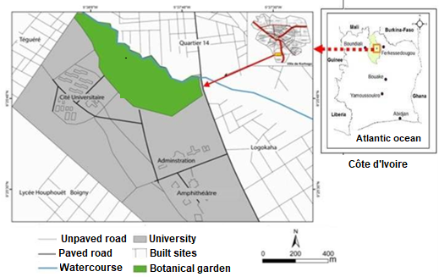
Fig. 1. Geographical location of the study site

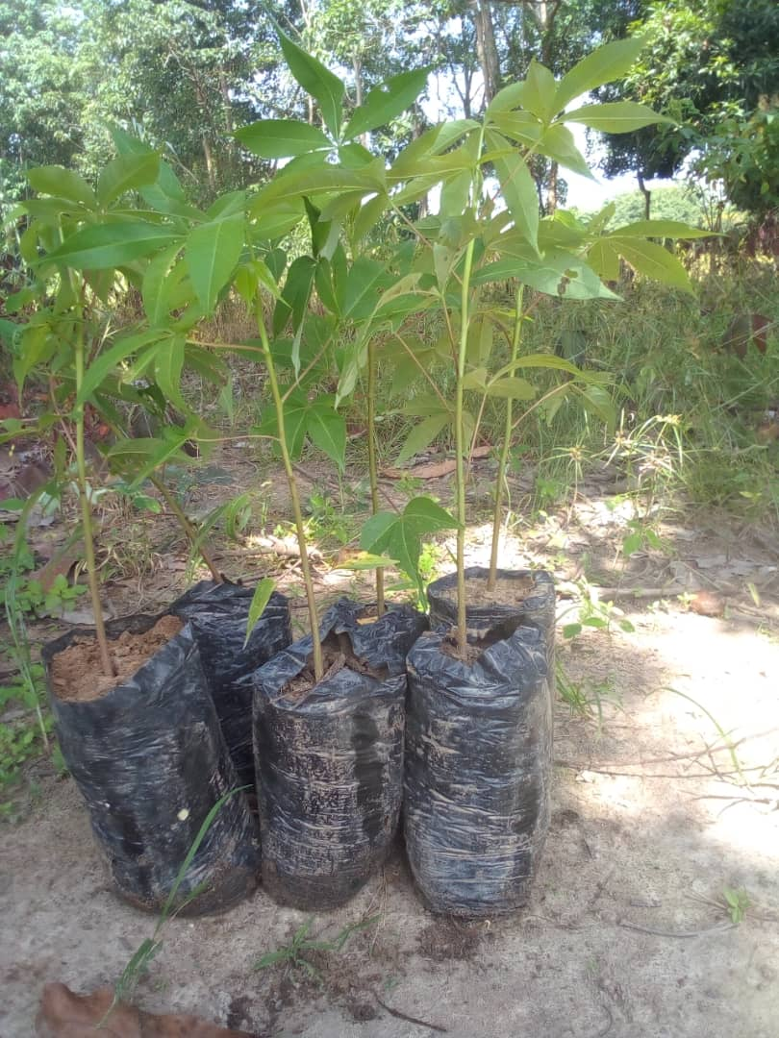
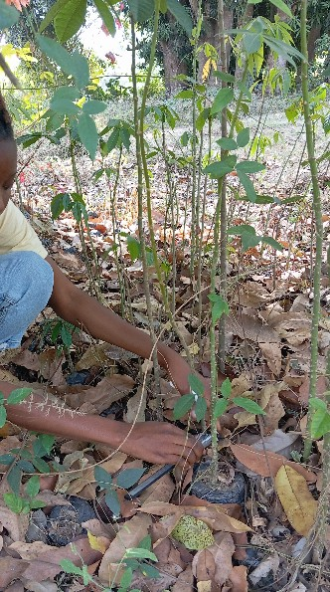
Fig. 2. Plants less than one year old (A) and plants more than one year old (B) of Bombax buonopozense.

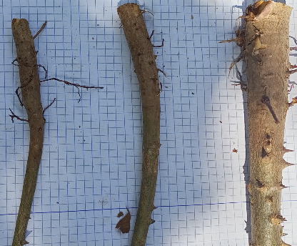
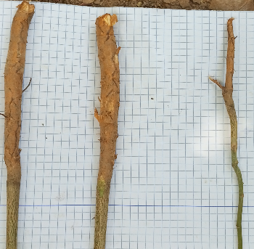
A
B
Fig. 3. Stumps less than one year old (A) and more than one year old (B) harvested in the nursery.
The stumps were planted in nursery bags arranged in an experimental set-up in two blocks corresponding to the two age categories of the stumps and in a shaded environment. Each block consisted of three sub-blocks corresponding to three treatments (T) applied to the stumps: T1 for stumps planted on the day of collection, T2 for stumps planted 3 days after collection and T3 for stumps planted one week after collection. The experimental unit consisted of 10 bags corresponding to four replicates per treatment for each category of stumps.
The recovery of the stumps was monitored every day until no recovery was observed following the death of the stumps. A systematic count of the stumps that had recovered was carried out each day. To assess their growth dynamics, the height and diameter at the crown of the regrowth from the stumps were measured at weekly intervals over a period of five months.

2.3 Data analysis
The variables observed during the trial were:
- the recovery time (TR), which is the time elapsed between the planting of the stumps and the appearance of the first bud;
- the recovery delay (DR), which is the time elapsed between the appearance of the first bud and the appearance of the last bud;
- the recovery rate (TRe), which is the ratio of the number of recovered stumps to the number of planted stumps multiplied by 100.
Growth dynamics were analysed by determining the average initial (Hi) and final (Hf) heights, the average collar diameter of the sampled stumps (Dm) and the average number of leaves per plant. Growth rates for height (TARh) and number of leaves (TARnf) were calculated using the following mathematical formulae (Castel and Terradas, 1994):
$$\text{TARh}\text{=[ln}\text{⁡}\text{(hT2)-}\text{ln}\left(\text{hT1}\right)\text{]/(T2-T1)}$$
$$\text{TARnf}\text{=[ln}\text{⁡}\text{(nfT2)-}\text{ln}\left(\text{nfT1}\right)\text{]/(T2-T1)}$$
with h the height expressed in centimetres, nf the number of leaves and T the time in weeks.
2.4 Statistical analysis test
The data from the experimental trials were processed using XLSAT software and EXCEL spreadsheet software to produce the graphs. The variables measured were subjected to parametric tests (Student's t-test and ANOVA) and non-parametric tests (Kruskal-Wallis test) at the 5% threshold (p = 0.05), after verification of their normality by the Shapiro test. A correlation test was also carried out between various measured or calculated quantities, in particular the diameter, height and number of leaves of the plants from the stumps.

3. RESULTS AND DISCUSSION
3.1 Results
3.1.1 Effect of the age of the stumps on the recovery parameters of Bombax buonopozense buds
The results obtained with Bombax buonopozense stumps did not show any significant difference with regard to the recovery time and delay, whereas a significant effect was noted for the recovery rate, for all the treatments applied (Table 1). For recovery time, mean values ranged from 7.75 ± 0.96 days (T1) to 22.25 ± 1.26 days (T3) for stumps less than one year old and from .8 ± 0.82 days (T1) to 22 ± 1.41 days (T3) for stumps more than one year old. Recovery times ranged from 1.5 ± 1 day (T3) to 5.5 ± 0.58 days (T1) for stumps less than one year old, and from 1.5 ± 0.58 days (T3) to 6 ± 0.82 days (T1) for stumps more than one year old. In terms of recovery rate, the highest values were obtained with stumps less than one year old and ranged from 80.5 ± 1.73% (T1) to 20 ± 1.63% (T3), while the lowest values were observed with stumps more than one year old and ranged from 71.5 ± 2.08% (T1) to 14.25 ± 1.26% (T3).
Table 1. Mean values of the recovery parameters for stumps less than 1 year old and more than 1 year old of Bombax buonopozense
Treatments | Age of stumps | TR (day) | DR (day) | TRe (%)
T1 | +1 year | 8 ± 0,82 | 6 ± 0,82 | 71,5 ± 2,08
T1 | -1 year | 7.75 ± 0,96 | 5.5 ± 0,58 | 80.5 ± 1,73
T1 | Statistical test | t = 0.39 | t = 1 | t = -6.64
T1 | Statistical test | p = 0.70 | p = .36 | p = .001
T2 | +1 year | 11 ± 0,82 | 3 ± 0,82 | 43,5 ± 1,29
T2 | -1 year | 11 ± 1.41 | 3 ± 0.82 | 60 ± 1.41
T2 | Statistical test | t = 0 | t = 0 | U= 0
T2 | Statistical test | p = 1 | p = 1 | p = .03
T3 | +1 year | 22 ± 1,41 | 1,5 ± 0.58 | 14,25 ± 1,26
T3 | -1 year | 22.25 ± 1,26 | 1.5 ± 1 | 20 ± 1.63
T3 | Statistical test | U= 6.50 | U= 9 | t = -5.578
T3 | Statistical test | P = .76 | P = 0.87 | p = .001

3.1.2 Effect of storage time of stumps more than one year old on recovery parameters of Bombax buonopozense
The storage time before planting of stumps more than one year old significantly affected the recovery parameters of Bombax buonopozense buds (Table 2). The recovery time of the stumps was shorter (8 ± 0.82 days) in treatment 1, while it was longer (22 ± 1.41 days) in treatment 3 (P = .007). The shortest recovery time (1.5 ± 0.58 days) was recorded in treatment 3, while the highest value (6 ± 0.82 days) of this parameter was observed in treatment 1 (P < .0001). The recovery rate for stumps in treatment 1 (71.5 ± 1.29%) was significantly higher than for stumps in treatments 2 and 3 (P = .007).
Table 2. Mean values of the recovery parameters of Bombax buonopozense stumps more than one year old according to treatments
Treatments | TR (day) | DR (day) | TRe (%)
T1 | 8 ± 0.82ª | 6 ± 0.82ª | 71.5 ± 1.29ª
T2 | 11 ± 0.82^{b} | 3 ± 0.82^{b} | 43.5 ± 1.29^{b}
T3 | 22 ± 1.41^{c} | 1,5 ± 0.58^{c} | 14.25 ± 1.26^{c}
Statistical test | k = 9.95 | F = 37.8 | k = 9.88
Statistical test | P = .007 | P < .0001 | P = .007

3.1.3 Effect of storage time of stumps less than one year old on recovery parameters of Bombax buonopozense
The storage time before planting of stumps less than one year old significantly influenced the recovery parameters of Bombax buonopozense buds (Table 3). The results show that the recovery time of the stumps was shorter (7.75 ± 0.96 days) in treatment 1, while it was longer (22.25 ± 1.26 days) in treatment 3 (P = .008). The shortest time to stump recurrence (1.5 ± 1 day) was observed in treatment 3, while the highest value for this parameter (5.5 ± 0.58 days) was obtained with treatment 1 (P < .000). With regard to the stump recovery rate, the highest value (80.5 ± 1.73%) was obtained with treatment 1, while the lowest value for this parameter (20 ± 1.63%) was recorded with treatment 3 (P = .007).

Table 3. Mean values of the recovery parameters for stumps less than one year old of Bombax buonopozense according to treatments
Treatments | TR (day) | DR (day) | TRe (%)
T1 | 7.75 ± 0.96ª | 5.5 ± 0.58ª | 80.5 ± 1.73ª
T2 | 11 ± 1.41^{b} | 3 ± 0.82^{b} | 60.5 ± 1.73^{b}
T3 | 22.25 ± 1.26^{c} | 1.5 ± 1^{b} | 20 ± 1,63^{c}
Statistical test | k = 9.68 | F = 24.50 | k = 9.95
Statistical test | P = .008 | P < .001 | P = .007

3.1.4 Effect of stump age and storage time on the growth dynamics of Bombax buonopozense plants
Analysis of the results obtained with Bombax buonopozense showed that the age of the stumps had a significant effect on the average height of the plants when the stumps were planted 3 days after harvesting (Table 4).
For plants from stumps more than one year old, the mean height varied from 11.93 ± 5.22 cm at (T2) to 8.24 ± 3.92 cm (T3), while that of plants from stumps less than one year old ranged from 8.25 ± 5.87 cm (T3) to 8.25 ± 5.87 cm (T2).
In terms of diameter, the age of the stumps had a significant effect on plant growth in all treatments (Table 4). The highest mean value was 5.61 ± 2.31 mm (T3) in plants from stumps less than one year old, while it was 4.99 ± 1.34 mm (T2) in plants from stumps more than one year old.
Regarding the number of leaves, the age of the stumps, in general, did not have a significant effect on the number of leaves produced by the stems (Table 4). For stumps more than one year old, the average number of leaves on the plants ranged from 9.53 ± 4.45 leaves (T1) to 8.6 ± 3.99 leaves (T3), while for stumps less than one year old, the average number of leaves on the plants ranged from 9.39 ± 4.5 leaves (T3) to 7.07 ± 3.59 leaves (T2). As for leaf length, the observations were the opposite of those for the number of leaves. The age of the stumps produced a significant increase in leaf length between treatments. Stumps more than one year old produced plants with an average leaf length of between 6.71 ± 2.32 cm (T2) and 4.31 ± 1.69 cm (T3). For stumps less than one year old, the average leaf length of the plants ranged from 5.27 ± 1.69 cm (T3) to 4.03 ± 2.15 cm (T1).
Table 4: Mean values for growth parameters of Bombax buonopozense stumps
Treatments | Age of stumps | Mean Height (cm) | Mean Diameter (mm) | Number of average leaves | Average leaf length (cm)
T1 | +1 an | 11.07 ± 8.55 | 4.57 ± 1.65 | 9.53 ± 4.45 | 5.52 ± 2.52
T1 | -1 an | 8.60 ± 6.90 | 3.78 ± 1.42 | 7.8 ± 3.34 | 4.03 ± 2.15
T1 | Test statistique | U= 1099 | U= 1147.5 | U= 1104 | U= 1215.5
T1 | Test statistique | P = .08 | P = .03 | P =0.07 | P = .006
T2 | +1 an | 11.93 ± 5.22 | 4.99 ± 1.34 | 9.35 ± 4.28 | 6.71 ± 2.32
T2 | -1 an | 8.25 ± 5.87 | 3.63 ± 1.3 | 7.07 ± 3.59 | 4.77 ± 2.82
T2 | Test statistique | U= 516,5 | t = -4.59 | U= 557 | U = 472.5
T2 | Test statistique | P = ,006 | P < .0001 | P = .019 | P = .002
T3 | +1 an | 8.24 ± 3.92 | 3.98 ± 1.09 | 8.6 ± 3.99 | 4.31 ± 1.69
T3 | -1 an | 11.37 ± 5.35 | 5.61 ± 2.31 | 9.39 ± 4.5 | 5.27 ± 1.69
T3 | Test statistique | t = -2.987 | U= 413.5 | U= 723 | U= 470
T3 | Test statistique | P = .004 | P < 0.001 | P = .46 | P = .002
The length of time that stumps older than one year were kept before planting did not significantly affect the relative growth rates in height of Bombax buonopozense (Table 5). However, during the trial, T3 showed the highest mean value (0.14 ± 0.30), while the lowest value was recorded by T2 (0.08 ± 0.07). The curves for the rate of increase in height show different trends (Fig. 4A). For the rate of increase in the number of leaves, the observations are similar. The length of time the stumps were kept did not have a significant effect on this parameter, but the highest mean value (0.10 ± 0.06) was recorded at T3 and the lowest mean value (0.08 ± 0.03) at T2. Fig. 4B shows the trends in the curves for the rate of increase in the number of leaves during the trial.
For plants less than one year old, the length of time the stumps were kept did not have a significant effect on the rate of relative growth in height (Table 6). However, the highest average value for this parameter was observed in T2 and T3, while the lowest value was observed in T1. The general trend in the growth rate curves for the number of leaves was regressive for all treatments (Fig. 5A). For the relative rate of increase in number of leaves, no significant difference was observed between the mean values for the treatments. The evolution curves for this parameter are marked by a succession of regressive and evolutionary phases (Fig. 5B).

Table 5. Mean values of the relative rate of increase in height of Bombax buonopozense plants more than one year old as a function of the length of time the stumps have been stored
Treatments | Relative growth rate in height | Relative growth rate in number of leaves
Treatment 1 (T1) | 0.10 ± 0.09 | 0.09 ± 0.07
Treatment 2 (T2) | 0.08 ± 0.07 | 0.08 ± 0.03
Treatment 3 (T3) | 0.14 ± 0.30 | 0.10 ± 0.06
Statistical test | k = 0.29 | k = 0.04
Statistical test | P = .86 | P = .98

Table 6. Mean values of the relative rate of increase in height of Bombax buonopozense plants less than one year old as a function of the length of time the stumps have been stored
Treatments | Relative growth rate in height | Relative growth rate in number of leaves
Treatment 1 (T1) | 0.10 ± 0,08 | 0.08 ± 0.04
Treatment 2 (T2) | 0.11 ± 0,10 | 0.09 ± 0.07
Treatment 3 (T3) | 0.11 ± 0,10 | 0.11 ± 0.08
Staistical test | k = 0.04 | k = 0.59
Staistical test | P = .98 | P = .74

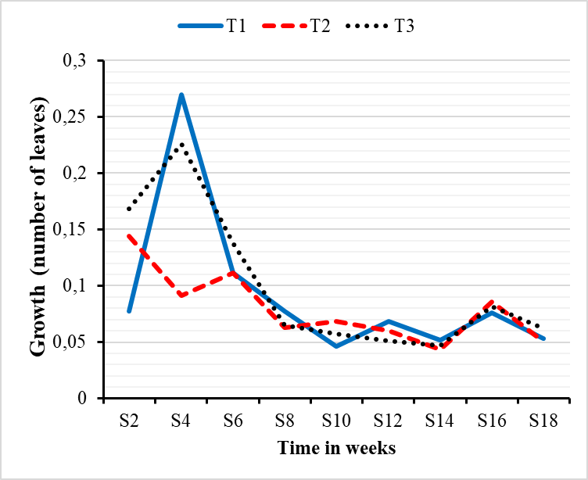
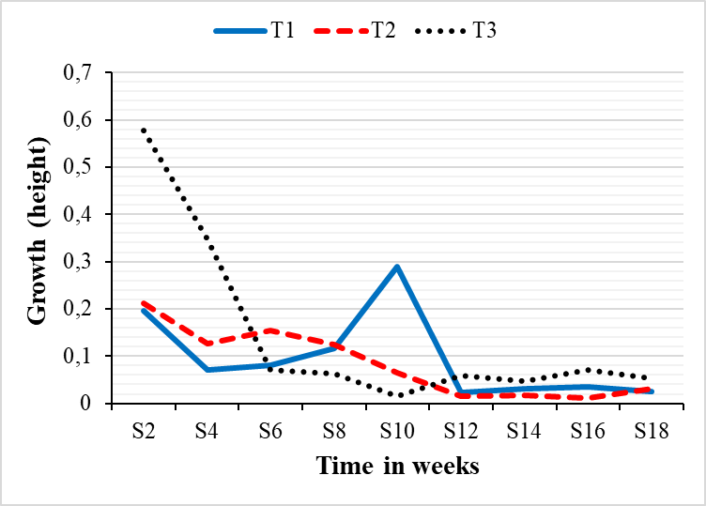
Fig. 4. Variation in the relative rate of growth in height (A) and number of leaves (B) of Bombax buonopozense plants over one year old as a function of the length of time the stumps have been stored

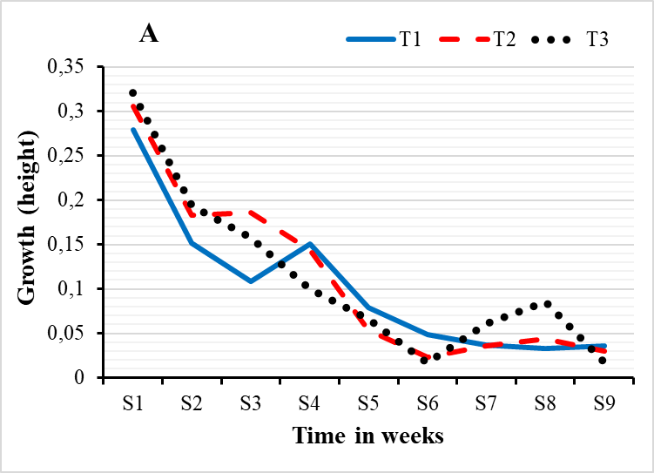
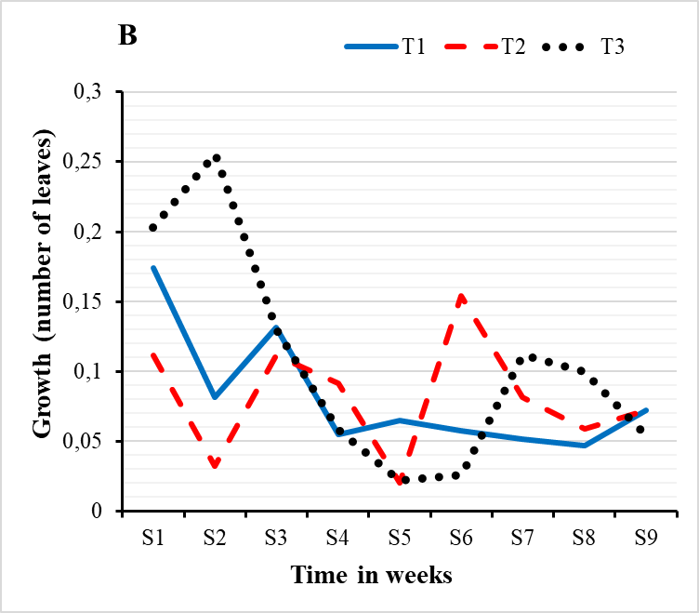
Fig. 5. Variation in the relative rate of growth in height (A) and number of leaves (B) of Bombax buonopozense plants less than one year old as a function of the length of time the stumps have been stored

3.1.5 Correlation between growth parameters of young stems from stumps in Bombax buonopozense
A correlation test was carried out on the various growth dynamics parameters (height, diameter and number of leaves of plants from stumps). The regression curves obtained show a higher correlation (R² = .74; P < .0001) between the height and diameter of the stems and a lower correlation (R² = 0.38; P < .0001) between the height and number of leaves in plants from stumps more than one year old (Fig. 6). In plants from stumps less than one year old, the regression curves show a good relationship between the height and diameter of the tigers (R² = .70; P < .0001) and between the height and number of leaves on the stems (R² = 0.68; P < .0001) (Fig. 7).

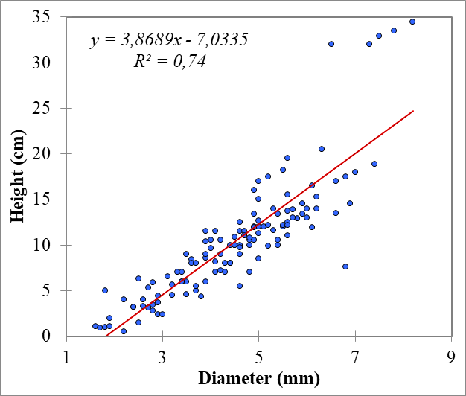
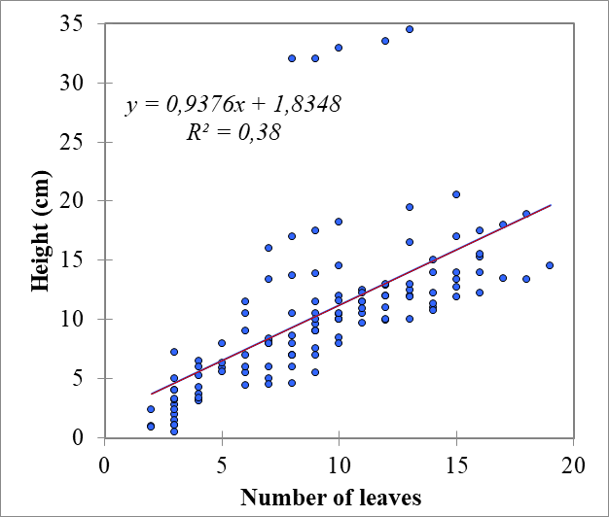
Fig. 6. Regression between the height (A) and number of leaves (B) of pants from stumps more than one year old in Bombax buonopozense

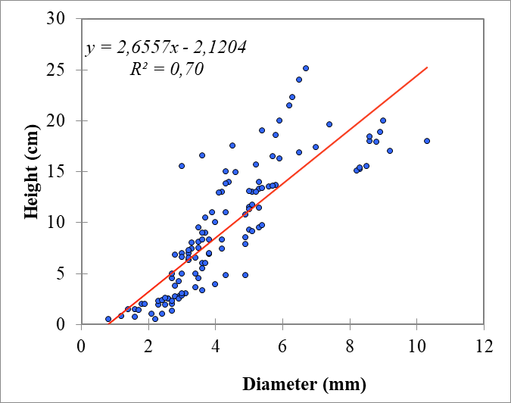
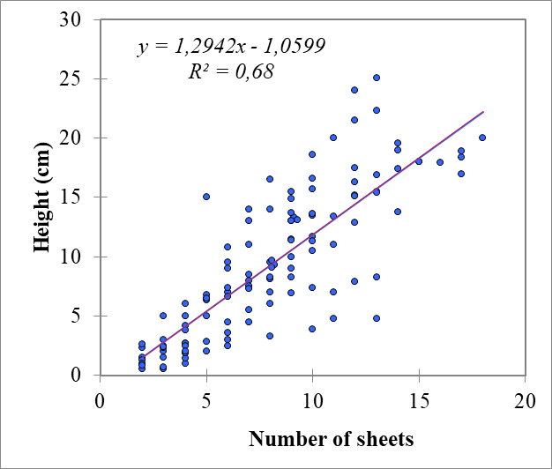
Fig. 7. Regression between the height (A) and number of leaves (B) of pants from stumps less than one year old in Bombax buonopozense

3.2 Discussion
The vegetative propagation trial of Bombax buonopozense showed that regardless of the age of the stumps, the recovery times and delays were similar. This indicates that the recovery time and delay do not depend on the age of the stumps and therefore on endogenous factors linked to the physiological state of the plant from which the stumps were taken. These results are contrary to those of Asseh et al (2024) on the domestication of Justicia flava cuttings. On the other hand, the age of the plants in the nursery influenced the rate of vegetative recovery of the stumps. Stumps less than one year old performed better than those older than one year, with an average recovery rate reaching 80 % in treatment T1. This performance of stumps less than one year old could be explained by the fact that they are less lignified and close up much more nutrient reserves to ensure their recovery. These results corroborate those of other authors who have shown that high lignification and ageing of vegetative organs may be the main cause of vegetative propagation failure (Sanogo et al., 2008; Nguema et al., 2013).
Extrinsic factors, linked to the trial period, may also have influenced the stump recovery rate. The experiment took place during the dry season, which was characterised by low rainfall in the study area. As a result, the stumps were harvested at a time when the plants from which they came did not have sufficient resources and water reserves. This could explain the significant effect of stump storage time on all recovery parameters. It is likely that the storage time increased the water deficiency induced by the dry season. This had the effect of delaying or preventing the development of stump buds. Similar results were obtained by Nguema et al. (2013) on Jatropha curcas cuttings under the climatic conditions of south-eastern Gabon.
Monitoring the growth of stems from stumps has shown that the age of the stumps has an effect on the height growth of the plants when they come from stumps kept for at least three days before planting. The height growth of plants from stumps more than a year old was higher than that of plants from stumps less than a year old. This could be linked to the fact that environmental factors (water deficit, for example) would affect plants from stumps less than one year old more than those from stumps more than one year old. These results corroborate those of Niang-Diop et al (2011) on the natural regeneration of Cordyla pinnata (Fabaceae) in the Fathala forest in Senegal. This effect of abiotic factors on plant age seems to be amplified by the length of storage, which leads to a loss of water reserves in the stumps. However, the high average height obtained at T2 (stumps more than one year old) and T3 (stumps less than one year old) shows that this growth parameter does not depend on stump storage time. It depends on endogenous factors, mainly related to the physiological state of the plants from which the stumps were taken (Asseh et al., 2024). For diameter, a significant effect of stump age was observed for all treatments. Plants from stumps more than one year old showed better growth in diameter than those from stumps less than one year old when the stumps were kept for no more than three days. This result could be explained by the fact that strongly lignified stumps over a year old are more subject to storage time, which reduces the nutrient reserves necessary for the initial growth of young stems. These plants use the reserves they contain to ensure development and some growth for several weeks (Sanogo et al., 2008). However, it is still difficult to determine a very clear trend from the results obtained with plants from stumps less than one year old. The highest mean diameter value was observed in T3 plants (5.61 ± 2.31 mm). This observation is in line with the conclusions of M'Sadak et al (2013), who state that collar diameter is a variable that incorporates the morphological response to environmental factors.
The rate of relative increase in height is rhythmic in Bombax buonopozense. This result is the species' adaptive response, which consists of the development of the root system during the growth phase to cope with water stress (Ado et al., 2017). This rate is more progressive in plants from stumps subjected to treatment 1, although no significant difference was observed between the mean values of the growth rate of the different treatments. The relative growth rate in terms of number of leaves showed an evolutionary and regressive trend. This could be justified by the alternating internal activities of the buds, which are hardly expressed by the appearance of leaves (Ado et al., 2017).
With regard to the relationship between growth parameters, the regression curves obtained showed that plant height and diameter growth were highly correlated, regardless of the age of the stumps. This result highlights the production of plants with ideal height and diameter, good robustness and a good above-ground dry matter/root dry matter ratio (El Boukhari et al., 2013). In addition, the correlation observed between height and number of leaves suggests that plants grown from stumps have a good assimilative capacity and good biomass production. These results are similar to those obtained by Ebgewole and Clément (2016) on monitoring the early growth of Ceiba pentandra in nurseries in Nigeria.

4. Conclusion
The study of the Bombax buonopozense propagation trial using stumps showed that stumps less than one year old had a good vegetative recovery capacity of up to 80% when planted on the same day as their harvest. Also, the average growth in height and diameter and the number of leaves were, in general, greater in plants from stumps aged more than one year, although significant differences were not observed between the average values of certain parameters. The length of time the stumps were kept did not have a significant effect on the relative growth rates in height and number of leaves. The results also showed that there was a good correlation between growth in height and diameter for the two categories of plants. This suggests that robust and vigorous plants can be obtained from Bombax buonopozense stumps, which could constitute a means of propagating the species in forest reforestation programmes in Côte d'Ivoire.

DISCLAIMER (ARTIFICIAL INTELLIGENCE)
Author(s) hereby declare that NO generative AI technologies such as Large Language Models (ChatGPT, COPILOT, etc) and text-to-image generators have been used during writing or editing of this manuscript.

COMPETING INTERESTS
Authors have declared that no competing interests exist.

COMPETING INTERESTS DISCLAIMER:
Authors have declared that they have no known competing financial interests OR non-financial interests OR personal relationships that could have appeared to influence the work reported in this paper.

REFERENCES
Ado A., Issoufou H. B. A., Dan G. I., Toudou D. A. K., Mahamane A. & Saadou M. (2017). Effect of pretreatments, substrates and water stress on the germination and initial growth of Diospyros mespiliformis Hochst. Ex A.DC. European Scientific Journal, 13, 1857-7431.
Ake-Assi L. (1997). Preface. In Bois de Côte d’Ivoire: Compendium of Recognition of Commercialized Trees, Sattler D (Ed.). CEDA: Abidjan, Côte d’Ivoire, 7-9.
Asseh E. E., Kouassi F. A., Kouassi K. B. A., & Kouassi E. A. A. (2024). Influence of substrate type and cutting dressing method on the survival and growth dynamics of Justicia flava (Forssk.) Vahl (Acanthaceae). Ivorian Journal of Science and Technology, 43, 16-32.
Dansi, A., Adjatin, A., Adoukonou-sagbadja, H., Falade, V., Yedomonhan, H., Odou, D., & Dossou, B. (2008). Traditional leafy vegetables and their use in the Benin Republic. Genetic Resources Crop Evolution, 55, 1239-1256
Denise, G.-B. (1989). Bombax buonopozense P. Beauv. and Salacia owabiensis Hoyle, two species of harvested plants used in the diet of villagers in Zougoussi, Central Côte d'Ivoire. Bulletin of the Botanical Society of France. Botanical News, 136, 3-4, 45-52.
Ebgewole, Z. T. & Clément, S. A. (2016). Seed germination assessment and early growth trial of Ceiba pentandra (L. Gaertn). Journal of Animal Production Advances, 6, 1039-1048.
El Boukhari, E. M., Gmira, N. & Brhadda, N. (2013). Effect of physical treatments on the growth and development of cork oak (Quercus suber L.) acorn seedlings in a forest nursery in Morocco. Geo-Eco-Trop., 37, 177-190.
Houphouet, Y. P., Kouassi, K. H., Adji, B. I. & Akaffou, D. S. (2022). Effect of Seed Sowing Depth on the Germination Quality of Pterocarpus erinaceus Poir., 1804 (Fabaceae) Seeds. European Scientific Journal, 18, 330-342.
Konan, D., Bakayoko A., Tra Bi F. H., Bitignon B. G. A., & Piba S. C. (2015). Dynamics of the Diameter Structure of Woody Stands in Different Biotopes of the Yapo-Abbé Classified Forest, Southern Côte d’Ivoire. Journal of Applied Biosciences, 94, 8869-8879.
Kouadio, K., Koné, M. & Soro, D. (2014). Influence of Sunlight on the Germination of Four Threatened Forest Species in Ivorian Forests. Journal of Animal & Plant Sciences, 23, 3529-3538.
Kouame, A. P. R., Groga N. & Vouhy B. N. (2023). Effect of Forestry and Agricultural Waste-Based Substrates on the Growth of Terminalia ivorensis A. Chev Seedlings in Forest Nursery in Côte d’Ivoire. European Scientific Journal, 19, 189-210.
M’Sadak, Y., Hamdi W. & Zaalani, Ch. (2013). Production and growth of Acacia seedlings on compost-screened substrates in a soilless nursery (Tunisia). Revue Agriculture, 6, 29-34.
N’danikou, S., achigan-dako, G. E. & wong, J. L. G. (2011). Estimating the value of edible harvest plants in southern Benin and defining priority species for conservation. Economic Botany, 65, 381-395
Nguema, N. P., Bouanga, E. B., Massounga, Y. C. & Boussiengui, B. G. (2013). Comparative study of three propagation methods of Jatropha curcas L. in the climatic conditions of southeastern Gabon. Journal of Applied Biosciences, 65, 4989-4998.
Niang-Diop F., Lykke, A. M. & Sambou, B. (2011). Natural regeneration of Cordyla pinnata (Lepr. Ex. A. Rich.) Milne-Redh. in a savannah subject to fire and grazing. Drought, 22, 186-91.
Osadolor, N. & Oyibotie, G. O. (2021). Influence of temperature and shade on the germination and early growth of Bombax buonopozense p. Beauv. Journal of Research in Forestry, Wildlife & Environment, 13(3), 91-97
Ouattara, S.F.P., Kouadio, K. & Soro, D. (2019). Diversity of Endangered Timber Species in the Flora of Côte d'Ivoire, in the Yapo-Abbé Forest Massif. European Scientific Journal, 15, 1857-788.
Sanogo, D., Badji M. & Akpo, L. E. (2008). Possibilities of In Situ Cuttings of Lawsonia Inermis L. (Henna). Tropical Woods and Forests, 297, 35-41.
Scouppe, M. 2011. Floristic Composition and Vegetation Diversity of the Eastern Zone of Taï National Park (Côte d'Ivoire). Master's Degree, University of Geneva, 194 p.
Silué, P. A., Koffi, K. A. D., Koffi, A. B., & Kouassi, K. E. (2021). Germination trials and monitoring of growth performance of Khaya senegalensis (Desv.) A. Juss. seedlings in the Sudanian zone (Côte d’Ivoire). Journal of Animal & Plant Sciences. 48, 8673-8685.
IUCN (2018). IUCN Red List of Threatened Species. https://www.iucnredlist.org/species/144306050/149039826
Vanié,-Bi I. G., Béné, K., & Zouzou, M. (2021). Ethnobotanical study of edible wild plants in the Zuénoula department (Central-West of Côte d’Ivoire). European Scientific Journal, 17(29): 242-262.

