Original Research Article
Effect of baby corn (Zea mays L.) under irrigation, tillage and mulch management

ABSTRACT

A field experiment was conducted during the rabi season of 2024-25 at the Agricultural Research Station, Brinjhagiri, Chattabar of the Faculty of Agricultural Sciences, Siksha O Anusandhan (Deemed to be University), Bhubaneswar, Odisha, India to know the performance of baby corn under irrigation, tillage and mulch management. The experimental site is situated in the South East Coastal Plain Zone of India, specifically at Latitude 20.46° N and Longitude 85.67° E. The experiment was conducted using a split plot design with three replications. The main plot treatments comprised three irrigation levels: I1 (7 cm depth of irrigation at 2, 4, 6, and 8 weeks after sowing), I2 (5 cm depth of irrigation at the same intervals), and I3 (3 cm depth of irrigation at 2, 4, 6, and 8 weeks after sowing). The sub-plot treatments involved four conservation practices: C1 (zero tillage without mulch), C2 (zero tillage with paddy straw mulch at 4 t ha⁻¹), C3 (conventional tillage without mulch), and C4 (conventional tillage with paddy straw mulch at 4 t ha⁻¹).The experimental field was sandy loam in texture, slightly acidic in reaction pH (5.65), EC (7.35dS/m), low in soil organic car bon content (0.42%) and medium in available nitrogen (257.3 kg/ha), phosphorus (19.7 kg/ha) and potassium (174.8 kg/ha). The recommended dose of fertilizer @ 120-60- 60 N, P2O5, K2O kg/ha used and spacing of crop was 50cm x 20cm. Effect of yield attributes, yield, uptake, quality, soil nutrient status, water use efficiency and economics of baby corn were significantly influenced by different irrigation levels and conservation practices management. At harvest, 7cm depth of irrigation 2, 4, 6, and 8 weeks after sowing recorded highest fresh corn weight (35.1 g/plant), corn yield (1.39 t/ha), green fodder yield (21.6 t/ha), biological yield (27.4 t/ha), crude protein content in corn (10.58%) and protein yield (147.18 kg/ha). Conventional tillage with paddy straw mulch @ 4t ha-1 recorded fresh corn weight (36.7 g/plants), corn yield (1.42 t/ha), green fodder yield (21.6t/ha), biological yield (28.1 t/ha), crude protein content and protein yield in corn (10.63% and 151.13 kg/ha) and in fodder (3.96% and 85.51 kg/ha). WUE recorded highest (7.58 kg/ha-mm) in 3cm depth of irrigation at 2, 4, 6, and 8 weeks after sowing + conventional tillage with paddy straw mulch @ 4t ha -1. From this experiment, it can be concluded that, the corn yield (1.52 t/ha), and fodder yield (22.45 t/ha) observed maximum by 7cm depth of irrigation at 2, 4, 6 and 8 weeks after sowing with conventional tillage + paddy straw mulch @ 4 t/ha. The gross return (Rs. 227850/-) and net return (Rs. 162383/-) recorded highest in 7cm depth of irrigation at 2, 4, 6 and 8 weeks after sowing with conventional tillage + paddy straw mulch @ 4 t/ha. The return per rupees investment calculated maximum (3.62) in 5cm depth of irrigation at 2, 4, 6 and 8 weeks after sowing with zero tillage + paddy straw mu lch
@ 4 t/ha and being at par with 7cm depth of irrigation at 2, 4, 6 and 8 weeks after sowing with zero tillage + paddy straw mulch @ 4 t/ha (3.58).

Keywords: Rabi baby corn, depth of irrigation, tillage, straw mulch and economics

Introduction

Baby corn (Zea mays L.), known as the immature cob of maize, is harvested 2–4 days after silk emergence before fertilization. It is a diploid crop (2n=20) from the Poaceae family and is believed to have originated in Mexico. Baby corn is valued for its delicate flavour, crisp texture, high nutritional content, and pesticide-free nature, being harvested young while tightly wrapped in husk (Rani et al., 2017). It is a short-duration crop (65–75 days), allowing for 3–4 harvests per year, making it ideal for crop diversification and rural employment (Prasad et al., 2024). Baby corn contains 89.1% moisture, 1.9g protein, 8.2g carbohydrates, 0.2g fat, and is rich in calcium, phosphorus, and vitamin C (Rakesh et al., 2017). It is also high in fibre and folate, low in calories and cholesterol, and has a low glycaemic index, making it beneficial for blood sugar control (Mohan et al., 2022). Maize, referred to as the “Queen of Cereals”, ranks third globally in cereal production after wheat and rice. It is a C4 plant that efficiently uses solar radiation. In India, maize is grown on 9.43 million hectares with a production of 24.35 million tonnes and a productivity of 2583 kg/ha (Government of India, 2014). Water is increasingly scarce due to climate change, population growth, and industrial demand (Shemer et al., 2023; Yang et al., 2022). Maize, being a high-yielding crop, requires of water per cycle, with irrigation during flowering and yield formation stages being most critical. Deficit irrigation, developed in the 1970s, helps conserve water by reducing irrigation without major yield loss (Yu et al.,
2020). Zero-tillage (ZT) systems, initiated widely post-1940s with herbicides like paraquat, eliminate the need for tillage, reduce soil compaction and erosion, conserve resources, and improve maize yields up to 68% (Buah, 2017). ZT also enhances water efficiency, reduces machinery costs, and promotes sustainable farming (Sayed et al., 2020). Mulching, particularly with crop residues, conserves soil moisture, prevents erosion, improves structure, and supports higher yield by regulating temperature, reducing weed growth, and increasing organic matter (Rina et al., 2020). Together, baby corn production, zero tillage, efficient water use, and mulching present a sustainable and economically viable agricultural model.

Materials and method

A field experiment entitled "Effect of baby corn (Zea mays L.) under irrigation, tillage and mulch management" was conducted during the rabi season of 2024-25 at the Agricultural Research Station, Brinjhagiri, Chatabar of the Faculty of Agricultural Sciences, Siksha O Anusandhan (Deemed to be University), Bhubaneswar, Odisha, India to know the performance
of baby corn under irrigation, tillage and mulch management. The experimental site is situated in the South East Coastal Plain Zone of India, specifically at Latitude 20.46° N and Longitude
85.67° E.The experimental field was sandy loam in texture, slightly acidic in reaction pH (5.65), EC (7.35dS/m), low in soil organic carbon content (0.42%) (Walkley and Black, 1934 and Muhr et al., 1965), and medium in available nitrogen 257.3 kg/ha. (Jackson, 1973), phosphorus 19.7 kg/ha (Bray’s method, Bray and Kurtz method, 1945) and potassium 174.8 kg/ha (Muhr et al., 1965) (Table1). The experiment was conducted using a split plot design with three replications. The main plot treatments comprised three irrigation levels: I1 (7 cm depth of irrigation at 2, 4, 6, and 8 weeks after sowing), I2 (5 cm depth of irrigation at the same intervals), and I3 (3 cm depth of irrigation at 2, 4, 6, and 8 weeks after sowing). The sub-plot treatments involved four conservation practices: C1 (zero tillage without mulch), C2 (zero tillage with paddy straw mulch at 4 t ha⁻¹), C3 (conventional tillage without mulch), and C4 (conventional tillage with paddy straw mulch at 4 t ha⁻¹). The treatments were replicate thrice in net plot size 5m × 4m. The experimental region has a hot, dry tropical climate. The baby corn (Zea mays L.) variety G 5414 was sown at a spacing of 50cm × 20cm. Fertilizers (120-
60-60 N:P₂O₅: K₂O kg/ha) were applied using urea, SSP, and MOP, with N as two split and full P, K as basal. Zero tillage involved direct sowing with herbicide use; conventional tillage included ploughing and laddering. Agronomic sampling covered yield parameters (cob, stover, fodder yield and harvest index) using random and destructive methods. Protein and fibre content were measured using Kjeldahl and acid-alkali digestion. Water use efficiency was calculated based on rainfall, irrigation, and yield. Initial and final soil NPK status analysed. Data were analysed using ANOVA (Gomez & Gomez, 1984), with F-test and CD at 5% levels (Fisher & Yates,1963).

Result and discussion

Yield attributing and yield

Yield attributing characters, specifically fresh corn weight and dry corn weight, varied significantly with irrigation and conservation practices. I1 (7 cm irrigation depth of irrigation with 2, 4, 6 and 8 weeks after sowing) consistently led to the highest fresh (35.1 g/plant), dry (5.40 g/plant) corn weight, cob (7.21 t/ha), corn (1.39 t/ha) and fodder (21.6 t/ha) yield closely followed by I2 (5 cm irrigation depth of irrigation with 2, 4, 6 and 8 weeks after sowing) fresh (33.6 g/plant), dry (5.18 g/plant) corn weight, cob (7.14), corn (1.36) and fodder (21.3), respectively. Among conservation practices, C4 (Conventional tillage with paddy straw mulch
@ 4t/ha) produced the highest fresh (36.7 g/plant), dry (5.64 g/plant) corn weight, cob (7.38
t/ha), corn (1.42 t/ha) and fodder (21.6 t/ha) yield found at par with C2 (zero tillage with paddy straw mulch @ 4t/ha) fresh (34.8 g/plant), dry (5.41 g/plant) corn weight, cob (7.20 t/ha), corn (1.38 t/ha), and fodder (21.2 t/ha) respectively (Table 1). I1C4, I2C4 and I1C2 are found to be superior over other treatments. Optimal irrigation schedules significantly enhanced baby corn yield, primarily due to sustained soil moisture throughout the growth period (Abdelraouf and Anter, 2020). The treatment I1 consistently produced maximum corn and fodder yield, concurring with Sonawane et al. (2010), while water deficiency significantly reduced the yield (Ekom et al., 2019) and the positive impact of straw mulch on cob and fodder yield (Kumar et al., 2022). Improved soil physical properties under zero tillage also contributed to enhanced cob yield and biomass (Jat et al., 2014). Zero-tillage coupled with straw mulch also contributed to higher grain yield in maize during rabi seasons (Rao et al., 2016). The higher cob and
biological yields in conventional tillage with paddy straw mulch @ 4t/ha are likely due to increased soil moisture and nutrient availability, consistent with Pervaiz et al. (2009). (Table 2)

Quality

Baby corn protein content was obtained highest under I1 (7 cm irrigation depth of irrigation with 2, 4, 6 and 8 weeks after sowing) (10.58%), while fodder protein content peaked under I2 (5 cm depth of irrigation with 2, 4, 6 and 8 weeks after sowing), (3.84%). The same way, I1 produced the highest corn protein yield (147.18 kg/ha), and I2 found highest in fodder protein yield (82.01 kg/ha). One of the major roles of water is to transport food to the sink from source (Vadodariya and Patel, 2024). While, irrigation amount didn't significantly affect crude protein content overall (Esmailian et al., 2011). C4 (Conventional tillage with paddy straw mulch @
4t/ha) consistently resulted in the highest protein content for both corn (10.63%) and fodder (3.96%) as well as highest protein yield for both corn (151.13 kg/ha) and fodder (85.51 kg/ha). Thus, the I1C4 combination yielded the highest protein (Roy et al., 2015) (Table 3).

Soil NPK status

Available nitrogen (278.44), phosphorus (22.53) and potassium (191.69) was recorded highest in 3cm depth of irrigation with 2, 4, 6, and 8 weeks after sowing along with zero tillage without mulch (I3C1) after the crop season. I1C4 (7cm irrigation depth of irrigation with 2, 4, 6 and 8 weeks after sowing along with conventional tillage + paddy straw mulch @ 4t/ha) had the lowest nitrogen (244.39), (18.29 kg/ha) and potassium (164.39) content after the harvest (Figure 1, 2 and 3). Zero tillage plots consistently showed higher availability of N P and K (Alam et al. 2014 and Singh et al. 2020).

Water Use Efficiency

The highest WUE (7.58 kg/ha-mm) was calculated in I3C4 (3cm depth of irrigation with 2, 4, 6 and 8 weeks after sowing along with conventional tillage with paddy straw mulch @ 4t/ha), reflecting efficient water use was much less without affecting much yield. I1C1 (7cm depth of irrigation with 2, 4, 6 and 8 weeks after sowing + zero tillage without mulch) had the lowest WUE (3.85 kg/ha-mm) due to higher water application without proportional yield increase (Figure 4). While 7cm depth of irrigation with 2, 4, 6 and 8 weeks after sowing maximized grain yield, 3cm depth of irrigation with 2, 4, 6 and 8 weeks after sowing showed significantly higher WUE (Roy et al. 2015).

Economics-

Gross return (Rs. 227850/-) and net return (Rs. 162383/-) recorded highest in 7cm depth of irrigation at 2, 4, 6 and 8 weeks after sowing with conventional tillage + paddy straw mulch @
4 t/ha (I1C4). Followed by 5cm depth of irrigation at 2, 4, 6 and 8 weeks after sowing with conventional tillage + paddy straw mulch @ 4 t/ha (I2C4) (Rs. 224400/- and Rs. 160633/- respectively). The return per rupees investment calculated maximum (3.62) in (I2C2) 5cm depth of irrigation at 2, 4, 6 and 8 weeks after sowing with zero tillage + paddy straw mulch @ 4 t/ha. followed by I1C2 (3.58) (Table 4).
Conclusion

From this experiment it can be concluded that the application of 7cm depth of irrigation at 2,
4, 6 and 8 weeks after sowing with conventional tillage + paddy straw mulch @ 4 t/ha as well as 5cm depth of irrigation at 2, 4, 6 and 8 weeks after sowing with conventional tillage + paddy straw mulch @ 4 t/ha produced higher corn yield and fodder yield, increased the protein uptake maximise gross return and net return. So, these treatments are economical. Whereas, WUE recorded highest (7.58 kg/ha-mm) in 3cm depth of irrigation at 2, 4, 6, and 8 weeks after sowing
+ conventional tillage with paddy straw mulch.

COMPETING INTERESTS DISCLAIMER:
Authors have declared that they have no known competing financial interests OR non-financial interests OR personal relationships that could have appeared to influence the work reported in this paper.

References
Abdelraouf, R. E., & Anter, A. S. (2020). Response of new sesame lines (Sesamum indicum L.) to deficit irrigation under clay soils conditions. Plant Archives, 20(2), 2369–2377.

Alam, M. K., Islam, M. M., Salahin, N., & Hasanuzzaman, M. (2014). Effect of tillage practices on soil properties and crop productivity in wheat-mungbean-rice cropping system under subtropical climatic conditions. The Scientific World Journal, 2014, 437283. https://doi.org/10.1155/2014/437283

Brady, N. C. (1974). The nature and properties of soils (8th ed.). Macmillan.

Bray, R. H., & Kurtz, L. T. (1945). Determination of total organic and available forms of phosphorus in soils. Soil Science, 59, 39–45.

Buah, S. S. J., Ibrahim, H., Derigubah, M., et al. (2017). Tillage and fertilizer effect on maize and soybean yields in the Guinea savanna zone of Ghana. Agriculture & Food Security, 6, 17. https://doi.org/10.1186/s40066-017-0093-6

Ekom, D. T., Guidjinga, K. N. A., Memena, O., & Nome, A. T. (2019). Performance of sesame seeds produced from plants subjected to water stress for early selection of tolerant genotypes. International Journal of Plant & Soil Science, 28(1), 1–10.

Esmailian, Y., Ghanbari, A., Babaeian, M., & Tavassoli, A. (2011). Influence of organic and inorganic fertilizers and wastewater irrigation on yield and quality traits of corn. American-Eurasian Journal of Agricultural & Environmental Sciences, 10(4), 658–666.

Fisher, R. A., & Yates, F. (1963). Statistical tables for biological, agricultural and medical research
(6th ed.). Oliver and Boyd.

Gomez, K. A., & Gomez, A. A. (1984). Statistical procedures for agricultural research (2nd ed.). Wiley.

Government of India. (2014). Directorate of Economics and Statistics, Department of Agriculture and
Cooperation, Ministry of Agriculture. Government of India.

Jackson, M. L. (1973). Soil chemical analysis: Advanced course (2nd ed.). Prentice Hall of India.

Jat, R. K., Sapkota, T. B., Singh, R. G., Jat, M. L., Kumar, M., & Gupta, R. K. (2014). Seven years of conservation agriculture in a rice–wheat rotation of eastern Gangetic Plains of South Asia: Yield trends and economic profitability. Field Crops Research, 164, 199–210.
Kumar, R., Deka, B., Thirugnanavel, A., & Pravin, U. (2022). Influence of the best management practices on performance of dual-purpose baby corn (Zea mays) under eastern Himalayas. Indian Journal of Agronomy, 67, 407–411.

Mohan, K. P., Rajesh, S., & Thakur, I. (2022). Effect of phosphorus and zinc on yield and economics of baby corn (Zea mays L.). Journal of Pharmaceutical Innovation, 11, 1466–1469.

Muhr, G. R., Datta, N. P., Shankara, S. N., Dever, F., Lecy, V. K., & Donahue, R. R. (1965). Soil testing in India (p. 120). USAID.

Pervaiz, M. A., Iqbal, M., Shahzad, K., & Hassan, A. U. (2009). Effect of mulch on soil physical properties and NPK concentration in maize (Zea mays L.) shoots under two tillage systems. International Journal of Agriculture and Biology, 11, 119–124.

Prasad, M. S., Srinivas, J., Nagaraju, K., Sheker, B. C., Soniya, M., & Sankeerthana, K. (2024). Importance and future prospects of baby corn (Zea mays L.) in India. International Journal of Applied and Basic Research (IJABR) Special Issue, 8(12), 1343–1345.

Rakesh, K., Kumawat, N., Kumar, S., Singh, A. K., & Bohra, J. S. (2017). Effect of NPKS and Zn fertilization on growth, yield, and quality of baby corn—A review. International Journal of Current Microbiology and Applied Sciences, 6(3), 1392–1428.

Rani, R., Sheoran, R. K., Soni, P. G., Kaith, S., & Sharma, A. (2017). Baby corn: A wonderful vegetable. International Journal of Science, Environment and Technology, 6(2), 1407–1412.

Rao, K. V., Bajpai, A., Gangwar, S., Chourasia, L., & Soni, K. (2016). Effect of mulching on growth, yield, and economics of watermelon (Citrullus lanatus Thunb.). International Journal of Agriculture, Environment and Biotechnology, 5(4), 153–159.

Rina, L., Singh, V., & Dawson, J. (2020). Effect of row spacing with different levels of phosphorus and bio-fertilizer on growth and yield of maize (Zea mays L.). International Journal of Chemical Studies, 8(3), 1171–1173.

Roopa, H. S., & Prasanna Kumar, P. S. (2015). Economics of baby corn production in peri-urban areas of Bangalore. Trends in Biosciences, 8(10), 2509–2512.
Roy, S., Sengupta, A., Barman, M., Puste, A. M., & Gunri, S. K. (2015). Effect of irrigation and nutrient management on growth, yield, quality, and water use of summer baby corn (Zea mays L.) in new alluvial zone of West Bengal. Journal of Crop and Weed, 11(2), 111–116.

Sayed, A., Sarker, A., Kim, J.-E., Rahman, M., & Mahmud, G. A. (2020). Environmental sustainability and water productivity on conservation tillage of irrigated maize in red brown terrace soil of Bangladesh. Journal of the Saudi Society of Agricultural Sciences, 19, 276–284.

Shemer, H., Wald, S., & Semiat, R. (2023). Challenges and solutions for global water scarcity.
Membranes, 13(6), 612. https://doi.org/10.3390/membranes13060612

Singh, R., Meena, R. K., & Meena, M. C. (2020). Effect of tillage and nutrient management on productivity and nutrient uptake in soybean (Glycine max L.). Legume Research: An International Journal, 43(6), 802–807.

Vadodariya, H. P., & Patel, D. S. (2024). Role of sink and source in crop improvement. Agri Articles,
4(3), 210.
Yang, B., Fu, P., Lu, J., Ma, F., Sun, X., & Fang, Y. (2022). Regulated deficit irrigation: An effective way to solve the shortage of agricultural water for horticulture. Stress Biology, 2(1), 28. https://doi.org/10.1007/s44154-022-00037-1

Yu, L., Zhao, X., Gao, X., & Siddique, K. H. (2020). Improving/maintaining water-use efficiency and yield of wheat by deficit irrigation: A global meta-analysis. Agricultural Water Management, 228,
105906. https://doi.org/10.1016/j.agwat.2019.105906

Table 1. Physico-chemical properties of the experimental soil.

Sl. | Properties | Value | Method used
1. | Soil texture | Sandy loam soil | USDA system (Brady, 1974)
2. | Bulk density (g/cm3) | 1.33 | Core sampler method (Dastane,  1972)
3. | pH | 5.65 | (Jackson, 1973)
3. | Electrical conductivity (ds m−1) | 7.35 | (Jackson, 1973)
4. | Organic carbon (%) | 0.42 | Walkley and Black method  (Jackson, 1973)
5. | Available nitrogen (kg/ha) | 257.3 | Alkaline permanganate method  (Jackson, 1973)
6. | Available phosphorus (kg/ha) | 19.7 | Olsen’s method (Olsen et al., 1954)
7. | Available potassium (kg/ha) | 174.8 | Flame photometric method  (Jackson, 1973)

Table 2 Effect of irrigation and conservation practices on fresh corn weight, dry corn weight, cob yield, corn yield, fodder yield and biological yield of rabi baby corn

Treatment | Fresh corn weight (g/plant) | Dry corn weight (g/plant) | Cobs yield  (t/ha) | Corn yield  (t/ha) | Fodder yield  (t/ha) | Biological yield (t/ha)
I1 (7cm irrigation at 2,4,6 and 8 weeks after sowing) | 35.1 | 5.40 | 7.21 | 1.39 | 21.6 | 27.4
I2 (5cm irrigation at 2,4,6 and 8 weeks after sowing) | 33.6 | 5.18 | 7.14 | 1.36 | 21.3 | 27.1
I3 (3cm irrigation at 2,4,6 and 8 weeks after sowing) | 25.2 | 4.43 | 5.95 | 1.13 | 19.0 | 22.6
SEm (±) | 1.2 | 0.20 | 0.03 | 0.01 | 2.2 | 0.5
CD (0.05) | 4.6 | 0.78 | 0.12 | 0.02 | 8.6 | 2.1
C1 (zero tillage without mulch) | 25.7 | 4.29 | 6.10 | 1.16 | 19.7 | 23.2
C2 (zero tillage with paddy straw mulch @ 4t/ha) | 34.8 | 5.41 | 7.20 | 1.38 | 21.2 | 27.5
C3 (conventional tillage without mulch) | 28.0 | 4.67 | 6.38 | 1.21 | 20.1 | 24.2
C4 (conventional tillage with paddy straw mulch @ 4t/ha) | 36.7 | 5.64 | 7.38 | 1.42 | 21.6 | 28.1
SEm (±) | 1.0 | 0.15 | 0.02 | 0.01 | 1.0 | 0.6
CD (0.05) | 3.9 | 0.57 | 0.08 | 0.03 | 3.9 | 2.3

Table 3 Effect of irrigation and conservation practices on crude protein content (%) and protein yield (kg/ha) of corn and fodder of rabi baby corn

Treatments | Crude protein (%) |  | Protein yield (kg/ha)
 | Corn | Fodder | Corn | Fodder
I1 (7cm irrigation at 2,4,6 and 8 weeks after sowing) | 10.58 | 3.72 | 147.18 | 80.23
I2 (5cm irrigation at 2,4,6 and 8 weeks after sowing) | 10.42 | 3.84 | 142.11 | 82.01
I3 (3cm irrigation at 2,4,6 and 8 weeks after sowing) | 10.33 | 3.75 | 116.70 | 71.48
SEm (±) | 0.03 | 0.02 | 2.11 | 1.63
CD (0.05) | 0.1 | 0.08 | 8.73 | 6.42
C1 (zero tillage without mulch) | 10.29 | 3.75 | 119.30 | 74.09
C2 (zero tillage with paddy straw mulch @ 4t/ha) | 10.44 | 3.67 | 144.24 | 77.58
C3 (conventional tillage without mulch) | 10.42 | 3.71 | 126.64 | 74.43
C4 (conventional tillage with paddy straw mulch @ 4t/ha) | 10.63 | 3.96 | 151.13 | 85.51
SEm (±) | 0.03 | 0.02 | 1.6 | 0.74
CD (0.05) | 0.12 | 0.08 | 6.4 | 2.90

Table 4 Effect of irrigation and conservation practices on economics of rabi baby corn

Treatments | Cost of cultivation  (Rs/ha) | Gross return  (Rs/ha) | Net return  (Rs/ha) | Return per rupee investment
I1C1 | 57867 | 187730 | 129863 | 3.24
I1C2 | 61867 | 221700 | 159833 | 3.58
I1C3 | 61467 | 196800 | 135333 | 3.20
I1C4 | 65467 | 227850 | 162383 | 3.48
I2C1 | 56167 | 183150 | 126983 | 3.26
I2C2 | 60167 | 217931 | 157764 | 3.62
I2C3 | 59767 | 191700 | 131933 | 3.21
I2C4 | 63767 | 224400 | 160633 | 3.52
I3C1 | 54467 | 150300 | 95833 | 2.76
I3C2 | 58467 | 181650 | 123183 | 3.11
I3C3 | 58067 | 158100 | 100033 | 2.72
I3C4 | 62067 | 187350 | 125283 | 3.02
SEm (±) |  | 534 | 534 | 0.04
CD (0.05) |  | 2134 | 2134 | 0.15

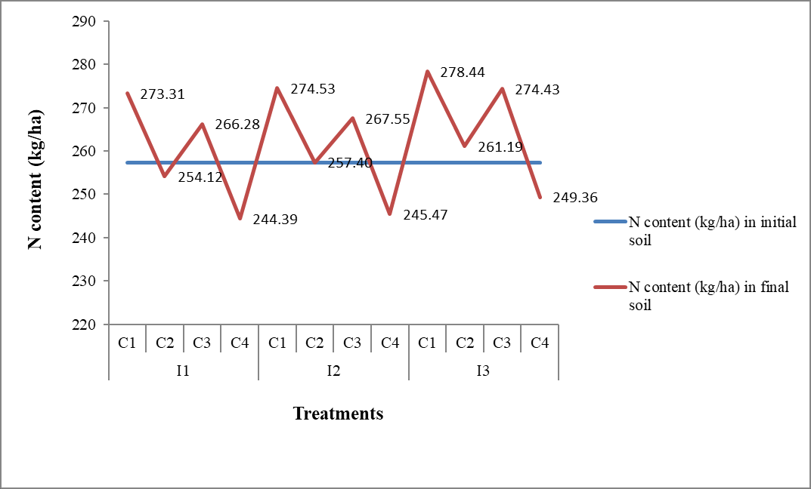
Figure 1 Initial and final soil nitrogen (kg/ha)

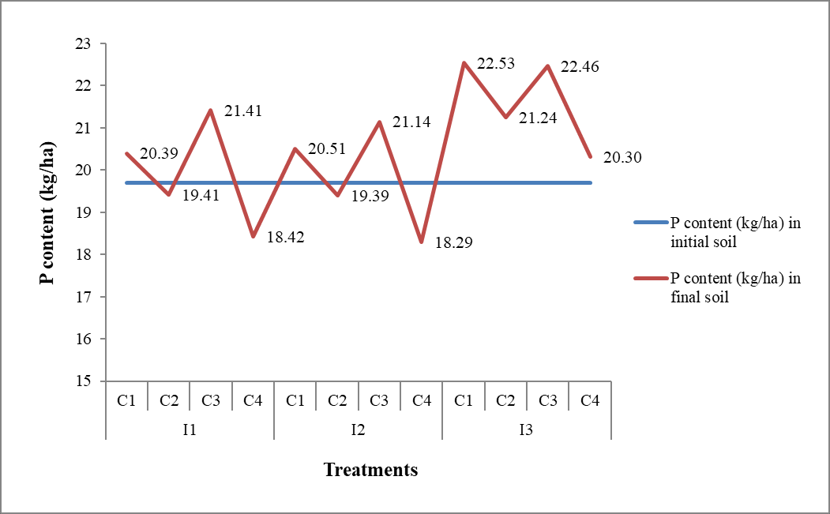

Figure 2 Initial and final soil phosphorus (kg/ha)

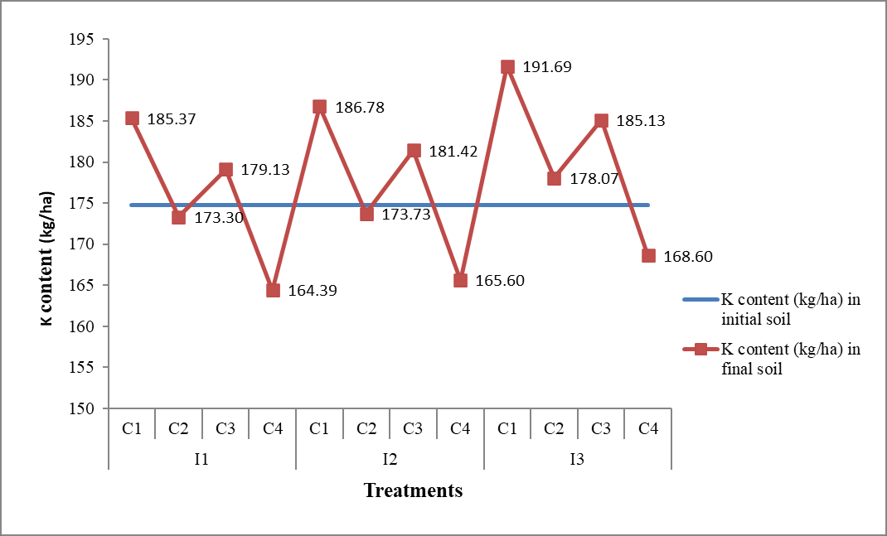

Figure 3 Initial and final soil potassium (kg/ha)
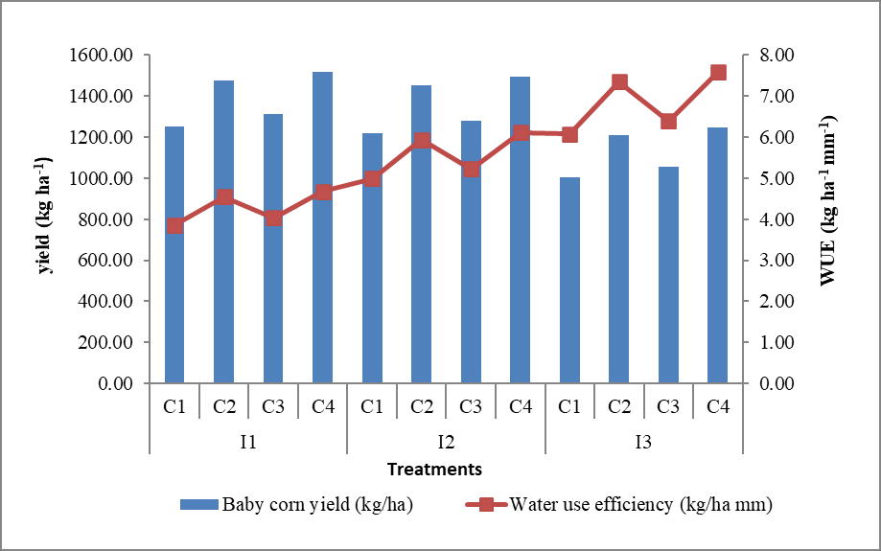

Figure 4 Effect of irrigation and conservation practices on water use efficiency of rabi baby corn

