Original Research Article

Character Association and Path Analysis for Yield and Yield-Contributing Traits in Linseed (Linum usitatissimum L.)

.
ABSTRACT

Linseed (Linum usitatissimum L.) is a self-pollinated (2n = 30) annual crop grown during the Rabi season, primarily cultivated for flax fiber and oil due to its commercial uses. Yield is a quantitatively inherited trait controlled by many genes, and its expression is influenced by environmental interactions. Because of its complex polygenic nature, direct selection for yield may not always lead to significant genetic improvement unless the genetic basis of its component traits is considered. Understanding the relationship between yield and its contributing traits is crucial, as it provides insights into these relationships, enhancing selection efficiency. Path coefficient analysis is a method that breaks down the relationship between traits and yield into direct and indirect effects. While simple correlation shows how traits are related, path analysis explains how much each trait directly or indirectly affects yield. This analysis helps breeders identify the traits that most impact yield and guides them in selecting the best traits for breeding programs. The present investigation aimed to analysis association for yield and its contributing traits in linseed. A total of 36 genotypes were evaluated at the Oilseeds Research Station, College of Agriculture, Latur, during the Rabi 2024-2025 season using a randomized block design with two replications. The trial was sown on November 23, 2024, with a spacing of 30 × 5 cm. The 1000-seed weight, number of capsules per plant, number of seeds per capsule, number of branches per plant, harvest index, and plant height showed highly significant and positive correlations with seed yield per plant. Path coefficient analysis revealed that the number of capsules per plant, followed by 1000-seed weight, harvest index, number of branches per plant, plant height, days to maturity, and oil content had the maximum positive direct effect on seed yield.

Keywords: Correlation coefficient analysis, Path coefficient analysis, Indirect effect, Positive significant, Negative significant, Residual effect, Genotypic, Phenotypic.

1. INTRODUCTION
Linseed, commonly referred to as flax, alsi, or jawas, is an essential oilseed crop belonging to the Linaceae family, which consists of 14 genera and over 200 species. It originated in Southwest Asia, especially in India (Richharia, 1952). This crop is primarily grown during the Rabi season. The ideal temperature range for its vegetative and reproductive stages is between 21°C and 27°C. However, when temperatures exceed 32°C, especially during the flowering stage, coupled with moisture stress, seed yield tends to decrease. Linseed is predominantly self-pollinated, although there is a small amount of outcrossing (less than 2%) due to insect activity.
Linseed is valued for its exceptional nutritional content, with oil levels ranging from 33% to 45% and protein content around 24%, depending on the variety. It is particularly abundant in unsaturated fatty acids, such as oleic acid (16–24%) and linoleic acid (18–24%). Notably, linseed is a significant source of alpha-linolenic acid (ALA), which accounts for 52–53% of the total fatty acid composition. ALA is an omega-3 fatty acid that is essential for human health, recognized for its beneficial effects in lowering cholesterol levels and supporting cardiovascular health.
Russia leads global linseed production, cultivating 2 million hectares and producing 1.7 million tonnes, followed by Kazakhstan with 1.3 million hectares and 800,000 tonnes. Canada, despite cultivating just 300,000 hectares, achieves a higher productivity of 450,000 tonnes. While China and India have similar cultivation areas (~200,000 ha), India’s production (126,000 tonnes) significantly lags behind China (290,000 tonnes), reflecting a yield gap (ICAR-IIFOR, 2022–23). In India, Madhya Pradesh is the top producer, followed by Uttar Pradesh and Jharkhand. Rajasthan leads in productivity (1071 kg/ha), while Maharashtra reports moderate productivity (475 kg/ha) (MH State APY, 2023–24).
Linseed is a valuable crop that plays an important role in the livelihoods of Indian farmers. However, despite the large area under cultivation and its many uses, the productivity of linseed in India is relatively low at 535 kg/ha, compared to the global average of 1013 kg/ha. Several factors contribute to this issue, including the low yield potential and late maturity of current varieties, the vulnerability of modern varieties to pests and diseases, lack of stability in yields, and the cultivation of the crop on marginal lands with poor agronomic practices. Additionally, linseed crops grown in tropical and semi-tropical climates are increasingly facing the challenges of rising temperatures and extreme soil moisture stress, which further hamper their growth and productivity.

2. material and methods

2.1 Experimental Site and Experimental Design

The present investigation was conducted at the Oilseeds Research Station, Latur, during the Rabi season of 2024-25 under normal irrigated conditions. The experimental material consisted of 36 genotypes, including two checks, which were analyzed using a Randomized Block Design with two replications. Line sowing was the method of planting. Recommended fertilizers and cultural practices were followed to ensure the growth of healthy crops. Morphological observations of 10 quantitative characters were recorded by randomly selecting 5 plants from each plot and replication. Each genotype was sown in rows, each 5 meters in length, with a spacing of 30 cm between rows and 5 cm between plants. Border rows were planted on all sides of the experimental plots to prevent border effects. All recommended practices were adhered to for optimal crop growth, and the plot size was 5 x 11.6 m².

2.2 Characters Studied
Morphological observations for 10 quantitative traits were recorded by randomly selecting 5 plants from each plot and replication. The traits measured included days to 50% flowering, days to maturity, plant height (cm), number of branches per plant, number of capsules per plant, number of seeds per capsule, 1000-seed weight (g), harvest index (%), oil content (%), and seed yield per plant (g). The number of days to 50% flowering was recorded when half the plants in each plot had flowered, while the days to maturity were noted when the plants reached physiological maturity. Plant height was measured from the base to the tip of the tallest stem, and the number of branches per plant, number of capsules per plant, and number of seeds per capsule were counted to evaluate reproductive potential. 1000-seed weight was determined by weighing a random sample of 1000 seeds, and the harvest index was calculated as the ratio of seed yield to total plant biomass, expressed as a percentage. Oil content percentage was determined by using NMP facility available like Regional Research Station, Raichur.
2.3 Stastical Analysis
Both genotypic correlation coefficient and phenotypic correlation coefficient were estimated from the variance and covariance components as given by Al-Jibouri et al. (1958). Path analysis measures the cause of association between two variables as described by Dewey and Lu (1959. All statistical analyses were performed by using R-software 4.5.1.
3. results and discussion

3.1 Correlation coefficient analysis

The genetic association between two traits may arise due to pleiotropy or linkage. Pleiotropy involves a single gene affecting multiple traits, whereas linkage refers to the closeness of genes influencing different traits on the same chromosome. In both cases, correlations may be positive or negative depending on whether the genes involved enhance or suppress the expression of the associated traits. The correlation coefficient quantifies the strength and direction of such relationships, thereby aiding in the understanding of trait interactions and their combined influence on yield.

At the genotypic level, seed yield per plant showed highly significant and positive correlations with 1000-seed weight (0.6858**), number of capsules per plant (0.6733**), number of branches per plant (0.5726**), number of seeds per capsule (0.6420**), harvest index (0.5255**) and significant and positive correlation with plant height (0.3559*) indicating these traits are major contributors to yield improvement.

At the phenotypic level, seed yield per plant also showed significant and positive correlations with 1000-seed weight (0.5062**), number of capsules per plant (0.5614**), number of branches per plant (0.3551**), number of seeds per capsule (0.4336**), harvest index (0.4002**), and signficant and positive correlation with plant height (0.2609*). Similar findings were reported by Rajanna et al. (2018), Choudhary et al. (2016), Gudmewad et al. (2015), Choudhary et al (2017), Patial et al. (2018), Dogra et al (2020), Kumar et al. (2024) and Karla et al. (2024).

The trait oil content has a positive but non-significant association with seed yield per plant. The trait days to 50% flowering had a negative and significant correlation with seed yield per plant, in agreement with Gudmewad et al. (2018), Meena et al. (2020), and Korra et al. (2024). Days to maturity have a negative and non-significant association with seed yield per plant agreement with Gudmewad et al. (2018), Patial et al. (2018), Meena et al. (2020), Choudhary et al. (2023). Days to maturity have negative and non-significant association with seed yield per plant. These results are in agreement with Sonwane et al. (2015), Gudmewad et al. (2018) and Meena et al. (2020).

3.2 Path analysis

The correlation between yield and its related traits can sometimes be confusing, as it may not show the true nature of their relationship. This is because many traits influence yield at the same time, which can make the correlation appear stronger or weaker than it really is. To get a clearer picture, path coefficient analysis is used to separate the total effect into direct and indirect effects. By using both correlation and path analysis together, we can better understand how each trait contributes to yield and make more effective choices during selection in breeding programs.

Path coefficient analysis revealed that, at the genotypic level, the trait exerting the maximum positive direct effect on seed yield per plant was the number of capsules per plant (0.26760), 1000-seed weight (0.22652), number of branches per plant (0.14958), harvest index (0.14328), and number of seeds per capsule (0.12175). Traits such as oil content (0.01657), days to maturity (0.00887), and plant height (0.00803) had smaller positive direct effects.

At the phenotypic level, the highest direct effect was recorded for the number of capsules per plant (0.31234), followed by 1000-seed weight (0.18723), harvest index (0.11031), number of seeds per capsule (0.098), and number of branches per plant (0.05369). Smaller direct effects were observed for plant height (0.02355). similar result was recorded by Comparable findings were also observed by Tadesse et al. (2009), Hussain et al. (2016), Gudmewad et al. (2016), Leelavathi et al. (2018), Meena et al. (2020), Dogra et al. (2020), Paul et al. (2020), Patel et al. (2023) and Paliwal et al (2024).

The maximum indirect and positive effect on seed yield per plant was recorded for 1000 seed weight (P = 0.16694, G = 0.16714), harvest index (P = 0.16207, G = 14514), number of seeds per capsule (P = 0.13996, G = 0.16910), number of branches per plant (0.10763, G = 0.10540) and plant height (0.11047, G = 0.09827) through number of capsules per plant. Whereas the maximum indirect negative effect on seed yield per plant was recorded for days to 50 per cent flowering through 1000 seed weight (P = -0.06141, G =-0.07729) followed by number of seeds per capsule (P = -0.03149, G = -0.04281) and for days to maturity through days to 50 per cent flowering (P = -0.04511, G = -0.10153) and number of capsules per plant (P = -0.02452, G = -0.02157).

Days to 50 per cent flowering had a negative direct effect on seed yield per plant (-0.0058 and -0.0343 respectively) at both genotypic and phenotypic levels, confirming their negative connection. Similar findings reported by Tadesse et al. (2009) include a negative indirect influence on days to maturity, the number of branches per plant, the number of secondary branches per plant, and the number of capsules per plant. Also days to maturity had a negative direct effect on seed yield per plant ( -0.06964 and -0.00887 respectively) at both phenotypic genotypic and genotypic levels Similar findings reported by Leelavathi et al. (2018), Kasana et al. (2018) and Patial et al. (2018).

4. Conclusion

The current research concluded that correlation analysis revealed that seed yield per plant was positively and significantly associated with the number of branches per plant, number of capsules per plant, number of seeds per capsule, 1000-seed weight, harvest index, and plant height. This suggests that improvement in any of these traits is likely to contribute to increased seed yield per plant. The presence of positive correlations among these desirable traits is particularly beneficial, as it enables the simultaneous improvement of multiple characters through selection. Traits including the number of capsules per plant, 1000-seed weight, number of seeds per capsule, oil content, number of branches per plant, plant height, days to maturity, and harvest index were found to exert a positive direct effect on seed yield. This suggests that these characters have a direct and substantial influence on yield performance. Consequently, incorporating these traits as selection criteria in breeding programmes would be advantageous for the development of high-yielding linseed genotypes.

References

ICAR-IIFOR. 2023. Linseed Crop Statistics Report (2022–23). Indian Council of Agricultural Research – Indian Institute of Fibres and Oilseed Research, Hyderabad, India.
Government of Maharashtra. 2024. State Agricultural Production and Yield Report (2023–24). Department of Agriculture, Maharashtra.
Al-jibouri, H.A., Miller, P.A., and Robinson, H.F. (1958). Genotypic environment variances in an upland cotton cross of interspecific origin. Journal of Agronomy, 50, 633-637.
Deway, D.R. and Lu, K.H. (1959). Correlation and path coefficient analysis of crested wheat grass seed production. Agronomy Journal 51: 515-518.
Rajanna, B.; Biradar, S.A. & Ajithkumar, K. (2014). Correlation and path analysis in linseed. The bioscan. 9(4), 1599-1602.
Ranjana Patiala, Satish Paul and Devender Sharma, (2018), Correlation and path coefficient analysis for improvement of seed yield in Linseed (Linum usitatissimum L.). International Journal of Current Microbiology and Applied Sciences,7(3): 1853- 1860.
Chaudhary, M., Rahul, V.P., Singh, V. and Chauhan, M.P. (2016). Correlation and path coefficient analysis for yield and yield-related traits in linseed (Linum ussitassimum L.) An International Quarterly Journal of Life Sciences,11(2):939-942.
Gudmewad, R., Misal, A., Dhutmal, R. & Pole, S. (2016). Correlation and path analysis studies in linseed. Annals of Plant and Soil Research, 18(2), 123-126.
Choudhary, A.K., Marker, S. and Rizvi, A.F. 2017. Genetic variability and character association for seed yield in linseed (Linum usitatissimum L.) under rainfed conditions. Journal of Pharmacognosy and Phytochemistry, 6(5): 457–460.
Patial, R., Paul, S. and Sharma, D., (2018). Correlation and path coefficient analysis for improvement of seed yield in linseed (Linum usitatissimum L.). International Journal of Current Microbiology and Applied Sciences. 7(3), 1853-1860.
Dogra, R., Paul, S., & Satasiya, P. (2020). Assessment of genetic variability, correlation and path analysis for yield and it’s components in Linseed (Linum usitatissimum L.). Journal of Pharmacognosy and Phytochemis try. 9(5), 2384-2389.
Kumar, A., Kumar, R. and Nirala, R.B.P. 2024. Genetic Variability, Correlation and Path Coefficient analysis of Linseed (Linum usitatissimum L.) in Bihar, India. Plant archives Vol. 24, No.2, 2024pp. 2018-2024.
Karla, U., Sharma, H., Yadav, P., Dadeech, A., Dubey, R.B. and Jain, D. (2024). Correlation and path coefficient analysis for identifying important traits contributing to seed yield in Linseed (Linum usitatissimum L.). Ecology, Environment and Conservation 30 (October Supplementary Issue): 2024; pp. (S239-S243)
Meena, A. K., Kulhari, S., Kumar, M., Koli, N. R., Tak, Y., Meena, D., & Meena, N. (2020). Studies on genetic variability and character association in linseed (Linum usitatissimum L.) genotypes. International Journal of Current Microbiology and Applied Sciences. 9(7), 3949-3957.
Choudhary, S.K., Nirala R.B., & Kumar, A. (2023). Character Association and Path coefficient Analysis for Yield and Yield Components in Linseed (Linum usitatissimum L.). Biological Forum – An International Journal 15(3): 40-44.
Sonwane, A. G., Kathale, M. N., Ghodke, M. K. & Ingle, A. U. (2015). Correlation and path analysis studies for yield and yield contributing characters in linseed (Linum usitatissimum). Trends in Biosciences, 8(14), 3655- 3659.
Gudmewad. R. B, Ghodke. M.K & Dhuppe. M.V, (2018). Genetic and association studies in linseed. Journal of Genetics, Genomics and Plant Breeding 2(2) 7-14. 2581-3293.
Tadesse, T., Singh, H. and Weyessa, B., (2009), Correlation and path coefficient analysis among seed yield traits and oil content in Ethiopian linseed germplasm. International Journal of Sustainable Crop Production, 4: 8-16.
Hussain, M. E., Moitra, P. & Goyal, V. (2016). Genetic variability, correlation and path coefficient analysis in linseed (Linum usitatissimum L.). The Bioscan 11(4), 3111-3115.
Gudmewad, R., Misal, A., Dhutmal, R. & Pole, S. (2016). Correlation and path analysis studies in linseed. Annals of Plant and Soil Research, 18(2), 123-126.
Leelavathi, T. M. & Mogali, S. C. (2018). Genetic variability, character association and path analysis for yield and yield components in mutant population of linseed. Journal of farm sciences, 31(1), 17-20.
Paul. S, Satasiya. P & Kumar. A. (2020) Genetic variability, correlation and path coefficient analysis of introduced genotypes of linseed in mid hills of North West Himalayas. Journal of Pharmacognosy and Phytochemistry 9(1): 1189- 11992.
Patel A.V., Patel N.B., P.P., Tiwari K. K., Mahla J.S., Roul S. (2023). Morphological characterization and genetic divergence studies in linseed (Linum usitatissimum L.). Pharma Innovation;12(3):3279-3284.
Paliwal, S., Tripathi, M.K., Sikarwar, R.S. and Sharma, S. 2024. Study of genetic variability and path analysis for yield attributing traits in linseed (Linum usitatissimum L.). International Journal of Plant and Soil Science, 36(7): 20–29.
Kasana, R. K., Singh, P. K., Tomar, A., Mohan, S., & Kumar, S. (2018). Selection parameters (heritability, genetic advance, correlation and path coefficient) analysis in linseed (Linum usitatissimum L.). The Pharma Innovation Journal. 7(6), 16-19

Characters | Days to 50 %  Flowering | Days to maturity | Plant height (cm) | Number of  branches per plant | Number of  capsules per plant | Number of seed per capsule | 1000  Seed weight  (g) | Harvest index (%) | Oil  Content  (%) | Seed yield per plant (g)
Days to 50 % flowering | 1 ** | 0.6805 ** | 0.0486 | -0.2482 | -0.3059 | -0.3516 * | -0.3412 * | -0.1041 | 0.1908 | -0.3936 *
Days to maturity |  | 1 ** | 0.3477 * | -0.0024 | -0.0806 | -0.1909 | -0.0617 | 0.0141 | 0.2165 | -0.1434
Plant height (cm) |  |  | 1 ** | 0.1707 | 0.3672 * | 0.3851 * | 0.4971 ** | 0.4399 ** | 0.3475 * | 0.3559 *
Number of branches per plant |  |  |  | 1 ** | 0.3939 * | 0.5749 ** | 0.5858 ** | 0.5248 ** | 0.0829 | 0.5726 **
Number of capsules per plant |  |  |  |  | 1 ** | 0.6319 ** | 0.6246 ** | 0.5424 ** | 0.1666 | 0.6733 **
Number of seed per capsule |  |  |  |  |  | 1 ** | 0.7057 ** | 0.3501 * | 0.0788 | 0.6420 **
1000 seed weight (g) |  |  |  |  |  |  | 1 ** | 0.4045 * | 0.3780 * | 0.6858 **
Harvest index (%) |  |  |  |  |  |  |  | 1** | 0.3123 | 0.5255 **
Oil content (%) |  |  |  |  |  |  |  |  | 1 ** | 0.1898
Seed yield per plant (g) |  |  |  |  |  |  |  |  |  | 1 **

Table 1 : Genotypic correlation coefficients among seed yield and yield-contributing traits in linseed

* Significant at 5% level of significance; ** Significant at 1% level of significance

Characters | Days to 50 %  Flowering | Days to maturity | Plant height (cm) | Number of  branches per plant | Number of  capsules per plant | Number of seeds per capsule | 1000 Seed weight (g) | Harvest index (%)) | Oil  content (%) | Seed yield per plant  (g)
Days to 50 % flowering | 1 ** | 0.6415 ** | 0.0509 | -0.2088 | -0.2683 * | -0.3213 ** | -0.3286 ** | -0.0912 | 0.1590 | -0.3151 **
Days to maturity |  | 1 ** | 0.3111 ** | 0.0084 | -0.0785 | -0.0997 | -0.0633 | 0.0461 | 0.1996 | -0.1521
Plant height (cm) |  |  | 1 ** | 0.1657 | 0.3537 ** | 0.2518 * | 0.4336 ** | 0.4001 ** | 0.3189 ** | 0.2609 *
Number of branches per plant |  |  |  | 1 ** | 0.3448 ** | 0.4259 ** | 0.4833 ** | 0.4179 ** | 0.0839 | 0.3551 **
Number of capsules per plant |  |  |  |  | 1 ** | 0.4481 ** | 0.5346 ** | 0.5189 ** | 0.1476 | 0.5614 **
Number of seed per capsule |  |  |  |  |  | 1 ** | 0.563 ** | 0.3051 ** | 0.0478 | 0.4336 **
1000 seed weight (g) |  |  |  |  |  |  | 1 ** | 0.3646 ** | 0.3181 ** | 0.5062 **
Harvest index (%) |  |  |  |  |  |  |  | 1 ** | 0.2330 * | 0.4002 **
Oil content (%) |  |  |  |  |  |  |  |  | 1 ** | 0.1021
Seed yield per plant (g) |  |  |  |  |  |  |  |  |  | 1 **

Table 2 : Phenotypic correlation coefficients among seed yield and yield-contributing traits in linseed

* * Significant at 5% level of significance; ** Significant at 1% level of significance

*

Table 3 : Direct and indirect effects (genotypic) of different characters on seed yield per plant in linseed.
Characters | Days to 50 %  Flowering | Days to maturity | Plant height (cm) | Numberof  branches per plant | Number of  capsules per plant | Number of seeds per capsule | 1000  seed weight  (g) | Harvest index (%)) | Oil  content (%) | Seed yield per plant  (g)
Days to 50 % flowering | -0.1492 | 0.00604 | 0.00039 | -0.03712 | -0.08187 | -0.04281 | -0.07729 | -0.01491 | 0.00316 | -0.3936
Days to maturity | -0.10153 | 0.00887 | 0.00279 | -0.00036 | -0.02157 | -0.02324 | -0.01398 | 0.00202 | 0.00359 | -0.1434
Plant height (cm) | -0.00725 | 0.00308 | 0.00803 | 0.02553 | 0.09827 | 0.04688 | 0.11261 | 0.06302 | 0.00576 | 0.3559
Number of branches per plant | 0.03703 | -0.00002 | 0.00137 | 0.14958 | 0.1054 | 0.06999 | 0.13270 | 0.07519 | 0.00137 | 0.5726
Number of capsules per plant | 0.04564 | -0.00071 | 0.00295 | 0.05892 | 0.26760 | 0.07693 | 0.14148 | 0.07771 | 0.00276 | 0.6733
Number of seed per capsule | 0.05246 | -0.00169 | 0.00309 | 0.08599 | 0.16910 | 0.12175 | 0.15986 | 0.05016 | 0.00131 | 0.6420
1000 seed weight (g) | 0.05091 | -0.00055 | 0.00399 | 0.08763 | 0.16714 | 0.08592 | 0.22652 | 0.05796 | 0.00626 | 0.6858
Harvest index (%) | 0.01553 | 0.00013 | 0.00353 | 0.0785 | 0.14514 | 0.04262 | 0.09164 | 0.14328 | 0.00517 | 0.5255
Oil content (%) | -0.02846 | 0.00192 | 0.00279 | 0.0124 | 0.04458 | 0.0096 | 0.08563 | 0.04475 | 0.01657 | 0.1898

[ Residual effect = 0.3619]

Characters | Days to 50 %  Flowering | Days to maturity | Plant height (cm) | Number of  branches per plant | Number of  capsules per plant | Number of seed per capsule | 1000  seed weight  (g) | Harvest index (%)) | Oil content (%) | Seed yield per plant  (g)
Days to 50 % flowering | -0.07031 | -0.04467 | 0.0012 | -0.0112 | -0.0838 | -0.03149 | -0.06141 | -0.01006 | -0.00336 | -0.3151
Days to maturity | -0.04511 | 0.06964 | 0.00733 | 0.00046 | -0.02452 | -0.00976 | -0.01183 | 0.00509 | -0.00421 | -0.1521
Plant height (cm) | -0.00358 | -0.02167 | 0.02355 | 0.00889 | 0.11047 | 0.02468 | 0.08105 | 0.04413 | -0.00673 | 0.2609
Number of branches per plant | 0.01468 | -0.00059 | 0.00391 | 0.05369 | 0.10763 | 0.04157 | 0.0905 | 0.04610 | -0.00178 | 0.3551
Number of capsules per plant | 0.01886 | 0.00547 | 0.00833 | 0.01848 | 0.31234 | 0.04391 | 0.09989 | 0.05724 | -0.00312 | 0.5614
Number of seed per capsule | 0.02259 | 0.00694 | 0.00593 | 0.02275 | 0.13996 | 0.0980 | 0.10527 | 0.03368 | -0.00101 | 0.4336
1000 seed weight (g) | 0.0231 | 0.00441 | 0.01022 | 0.02597 | 0.16694 | 0.0552 | 0.18723 | 0.04024 | -0.00672 | 0.5062
Harvest index (%) | 0.00641 | -0.00321 | 0.00942 | 0.02241 | 0.16207 | 0.02992 | 0.06817 | 0.11031 | -0.00492 | 0.4002
Oil content (%) | -0.01119 | -0.0139 | 0.00751 | 0.00453 | 0.0461 | 0.00468 | 0.05948 | 0.02569 | -0.02111 | 0.1021
Table 4 : Direct and indirect effect of seed yield and its component characters on seed yield per plant (g) at phenotypic level in linseed

[Residual effect = 0.5874]

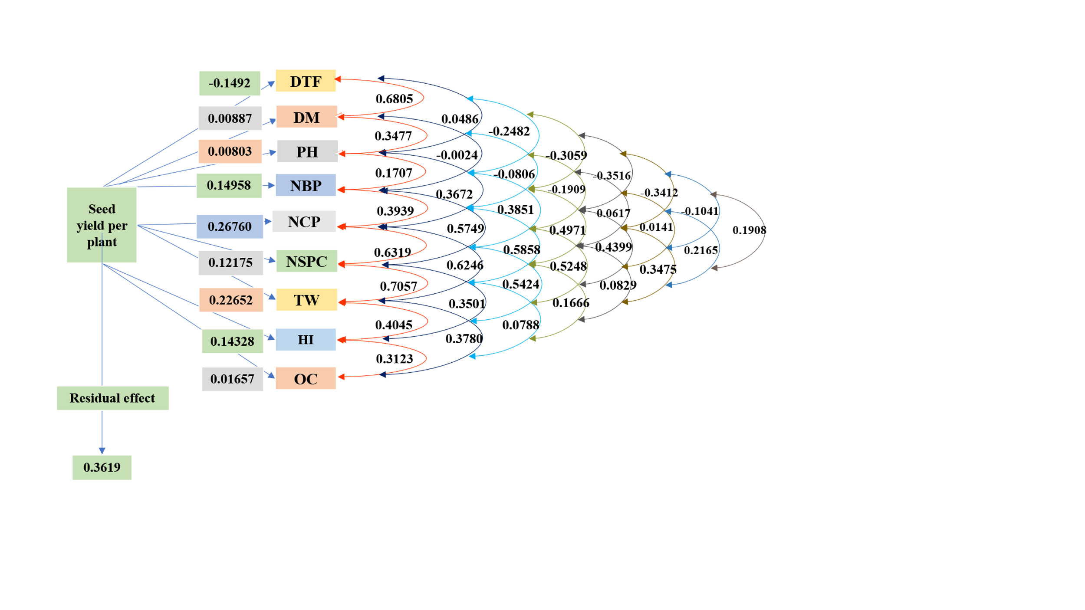

Fig. 1. Direct and indirect effects of yield components on seed yield per plant at the genotypic level

DTF : Days to 50 % flowering, DM : Days to maturity, , PH : Plant height, NBP : Number of branches per plant, NCP : Number of capsules per plant, NSPC : Number of seeds per capsule, TW : Thousand seed weight, HI : Harvest Index, OC : Oil content.

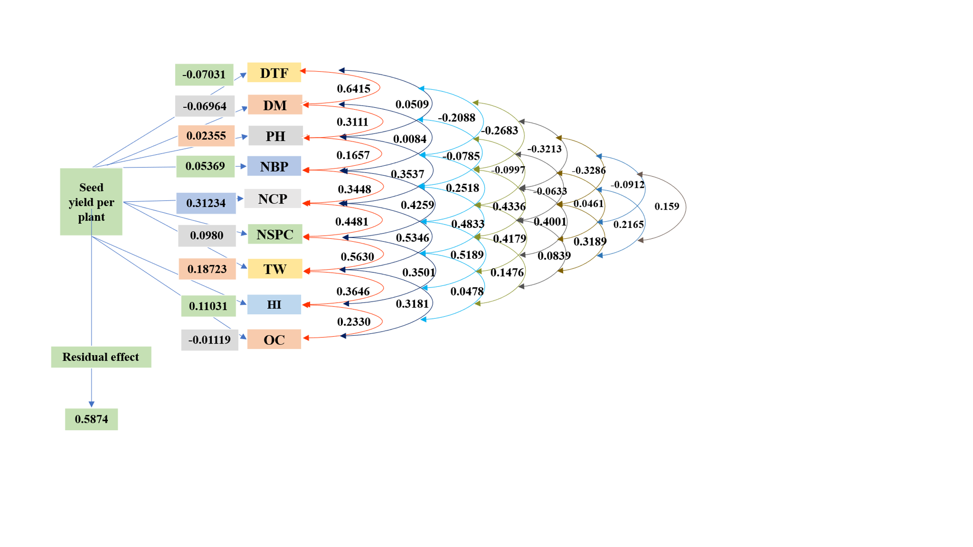

Fig. 2. Direct and indirect effects of yield components on seed yield per plant at the phenotypic level

DTF : Days to 50 % flowering, DM : Days to maturity, , PH : Plant height, NBP : Number of branches per plant, NCP : Number of capsules per plant, NSPC : Number of seeds per capsule, TW : Thousand seed weight, HI : Harvest Index, OC : Oil content.

