Study of genetics and tagging of gene linked to spotted stem borer (Chilo partellus) resistance in maize

Abstract
Maize spotted stem borer, Chilo partellus (Swinhoe), is a serious pest causing yield losses of 24.3-36.3%. Knowledge of genetics of resistance is a prerequisite for development of resistant cultivars. Present investigation was carried out to study the genetics of resistance to spotted stem borer and to find linked SSR marker using BSA. Twenty eight inbreds along with 2 checks were screened for C. partellus resistance by considering damage parameters namely LIR, exit hole, dead heart and percent stem tunnelling in field trial at ICAR-IIMR, New Delhi. Maize genotypes WNZPBTL 2 and HKI 1352 were selected as resistant and susceptible parents, respectively. Individuals of F₂ mapping population developed from WNZPBTL 2 and HKI 1352 were phenotyped for the LIR and classified into 1 to 9 scales. F₂ distribution of LIR indicates monogenic control of spotted stem borer resistance in maize with dominance of resistance. Screening of parents with 200 simple sequence repeat (SSR) markers identified 37 polymorphic markers across the genome. Chromosome 1, 5 and 6 revealed to carry most distinct genome whereas chromosome 8 was more similar between parents. Only one marker (bnlg1057) at map location bin1.06 showed polymorphism between parents as well as bulks with distinct frequency of resistant and susceptible alleles. Strength of linkage between marker and trait in F₂ was assessed by binary logistic regression which was significant with a value of regression coefficient 1.453. Additional twelve markers from identified bin1.06 flanking bnlg1057 were selected to identify closer marker to gene but absence for polymorphism between parents for these markers suggests use of different population to find more closely linked markers.
Key words:Maize, spotted stem borer, Genetics, BSA, SSR and linkage analysis.

Introduction
Worldwide insect pest affect global maize growing area nearly by 46% which accounts for 24.5% maize loss annually. Fifty two million tons of grain which valued about $5.7 billion is lost. Again use of insecticide worth of US $550 million is used annually to curb losses (Munyiri and Mugo 2017).Maize is known as queen of cereal owing to its great yield potential and existing genetic diversity (Prasanna, 2012). In India, maize is the third most important cereal crop next to rice and wheat and is produced over an area of 9.09 mha with an annual production of 24.26 mt, and productivity of 2.56 mt/ha (Yadavet al. 2015). However, maize cultivation in India is being regularly under severe attack byboth biotic and abiotic stresses.Maize (Zea mays L.) is attacked by a number of insect pests in India. Lepidopteran pests, particularly stem borers, are major constraints to productivity and of economic importance in most maize-growing countries around the world. Of these, the maize stem borer, Chilo partellus (Swinhoe) is an important pest and causing direct economic damage to the crop. Severe attack could results in dead heartsof the affected plant which might causehuge yield loss. Estimated yield losses due to its occurrencehave been reported to vary between 24.3-36.3% ( Saraswati et al 2022).Exploitation of host plant resistance to develop resistant cultivars using conventional methods has always remained the most acceptable due to lack of any biosafety concerns.The development and use of insect resistant cultivars is non-polluting, stable and durable both across time and environments. Resistant cultivars can also be successfully incorporated into an integrated pest management strategy. Breeding for host plant resistance, therefore, deserves major emphasis in maize improvement programmes. Inheritance study of stem borer resistance in maize is a prerequisite for determining an effective plant breeding strategy for the development of resistant cultivars.However there are limited studies available about genetics of stem borer resistance in maize. However, identification of cultivars based on phenotype alone is laborious, prolonged, and expensive. In contrast, molecular markers are not affected by environment independent and scorable at any stage of crop growth which also ensures quicker and clear cut analysis at lower cost (Selviet al., 2002, Satishet al., 2009 and Yueyingli et al., 2010).Identification of genomic region of stem borer resistance linked to molecular markers would have paramount importance for improving efficiency in marker assisted breeding (MAB) programme. Closely linked markers to resistant loci are being routinely used to introgress and select associated traits in early generations to minimize the costly phenotypic analysis (Drinic et al., 2004).Earlier many authors documented molecular markers associated with resistance to number of pests in maize (Schonet al 1993, Bohn et al 1997, Khairallahet al 1998, Cardinal et al 2001, Jampotnet al., 2002 and Krakowshyet al., 2007).QTLs for different maize stem-borer specieshave been reported in some temperate and tropical maize germplasm (Bohn et al., 2000; Jiménez-Galindo et al., 2017 and 2019, Monogenetic resistance against stem borer in maize observed by Girhotra and Saxena 2005, Anil Cholla et al 2018, Anil kumar cholla et al 2019 Suby et al 2020) Therefore an attempt was made in present study to study the inheritance of C. partellus resistance and to identify SSR marker linked to C. partellus resistance in maize using Bulked Segregant Analysis (BSA) approach.
Materials and Methods:
Plant materials:
Twenty eight maize inbreds viz.,CM-202,CM-501, JCY2-2-4-1, PFSR R3-7, PFSR 51016/1, WNZPBTL 2, WNZPBTL 3, WNZPBTL 6, WNZPBTL 8, WNZPBTL 9, WNZPBTL 10 (9 F), WNZPBTL 11 (57 D), AEB (Y) C5 F 38-1, AEB (Y) C5 F43-1, V 351, P 72 CL BRASIL 1177-2-2-1, HK I-PC-5, HKI-161, HKI-163, HKI-193-1, HKI-170 (1+2+3), HKI-1378, HKI-1354-2, HKI-1352, HKI-335, HKI-295, HKI-1332 and HKI-488, along with two checks CM-500(resistant) and Basilocal Selection (susceptible) were tested for their response to spotted stem borer infestation under field condition at IIMR, Pusa campus, New Delhi during Kharif season 2012.
Phenotypic screening:
Phenotypic screening for spotted stem borer (SSB) damage parameters was carried out for 28 inbreds along with the two checks for selection of contrasting parents to develop F2 mapping population. Each entry was sown in 2 row plots of 4 m row length with three replications in a randomized complete block design (RCBD). Infestation with neonates was done at 15 days of seedling emergence (DAE). Freshly hatched five larvae of C. partellus were carefully picked up with the help of fine brush and placed in the whorl of the plant. The maize plant leaf whorl was gently tapped before infestation to avoid drowning of the larvae in water retained in the leaf whorl. Larvae started feeding on and growing inside the plant immediately. After 25 days of infestation (DAI) all the plants in each replication were observed for leaf injury and rating was done using Leaf Injury Rating (LIR) scale of 1 (healthy plant) to 9 (dead heart) employing the scale developed by Sarup (1983). Where 1 to 9 scale represents degree of damage to different plant parts viz. 1: indicates apparently healthy plant, 2: Plant showing slightest damage on leaf or few pinholes on 1-2 leaves, 3: Plant showing more pin holes of shot holes on 3-4 leaves, 4: Plant showing injury (pin holes, shot holes, slits) in about one third of total number of leaves and mid-rib tunnelling on1-2 leaves, if any, 5: Plant showing 50 % of leaf damage (pin holes, shot-holes, slits, streaks and mid-rib damage, if any), 6: Plant showing varied types of leaf injury in about two-third of the total number leaves, 7: Plants with every type of leaf injury and almost all the leaves damaged, 8: The entire plant showing maximum of leaf injury and likely to form dead-heart (such plant usually show stunted growth) and 9: Dead heart.Data on number of plants with C. partellus dead hearts were recorded at 25 days after infestation for each entry. The number of deadhearts is then expressed as percentage of the total number of plants for that entry. Stem tunnelling was recorded at maturity, the main stem of plants infested with spotted stem borer larvae were split opened from the base to the apex and the tunnel length was measured in centimetres. Exit holes per plant were also recorded at maturity and number of exit holes was counted per plant after selecting five randomly plants in each replication.
Development of F₁ and F₂ mapping population:
Phenotypic screening was performed for selecting resistant and susceptible inbred parents by conducting rigorous screening tests like no choice and multi choice tests for adult ovipositional preference and leaf injury ratings , percent Dead Hearts for larval damage (Anil Cholla et al 2018, Anil Kumar Cholla et al 2019). The F₁ was developed from a cross between the selected susceptible parent (HKI 1352) as the female and resistant parent (WNZPBTL 2) as the male. From a single self-pollinated F₁ individual a F₂ population was raised and individual plants were phenotyped for response to spotted stem borer One hundred forty individuals in F₂ mapping population were scored only for LIR as mentioned above to classify them as resistant or susceptible.
When phenotyping is correlated with genotyping, LIR will be the more appropriate measure, since a score will be assigned for all the plants. Whereas, a null value for tunnel length will be recorded for plants with LIR 1 and 9. LIR 1 is a healthy plant and LIR 9 is the ‘dead heart’. Dead heart is formed while the plant is at V6-8 stage with only 2 above ground internodes under development, which are completely eaten up by the larvae and F₂ population can’t be replicated. Hence LIR was only used for F₂ phenotyping in our experiment.
Genomic DNA isolation:

DNA was extracted from leaves of parents and individual of F₂ mapping population when plants are at thirty days old following the method of Saghai-Maroofet al (1984) with minor modifications. Fresh leave (1gm) were grounded to fine powder in liquid nitrogen, and then were transferred to 2 ml centrifuge tubes containing 1 ml pre warmed CTAB extraction buffer (1M Tris-Cl, 0.5M EDTA, 2% CTAB, pH 8.0). Sample tubes were incubated in water bath at 65°C for 1 h with occasional swirling. After centrifugation at 10000 rpm for 10 min at 4°C, supernatant was transferred to new tube. Equal volume of chloroform: isoamyl alcohol (24:1 v/v) was added to the tubes and mixed thoroughly followed by centrifugation at 10000 rpm for 10 min at 4°C. The upper aqueous phase was pipetted out carefully in a fresh tube. The tubes were kept overnight at -20°Cafter adding 0.6 volume of isopropanoal and 120µl of sodium acetate. Tubes were centrifuged at 5000 rpm for 5 min, supernatant was discarded and pellets were washed twice with 70% ethanol. Finally dried pellet was dissolved in 100µl TE buffer (100 mMTris-Cl, 10 mM EDTA, pH 8.0) and RNAse treatment was given for 2hour at 37°C.
PCR amplification:
The PCR amplification cycle consisted of initial denaturation at 94°C for 4 min followed by 35 cycles of denaturation at 94°C for 45 second, primer annealing at 60°C for 45 second and primer extension at 72°C for 1 min. The final extension step was performed at 72°C for 7 min. The amplified products were resolved on 4% agarose gel along with 100bp ladder. The gel was run in 1x TBE buffer at a constant voltage of 100 V for about 6 h (until the tracking dye migrated to the end of the gel). The gel image was captured using a gel documentation system (AlphaImager® HP).
Bulked Segregant Analysis (BSA):
DNA was isolated from each F₂ plants and two contrasting bulk was prepared by mixing10 highly susceptible (LIR score 7.1 )and 10 highly resistant individual(LIR score 2.1). This was achieved by pooling DNA (50 ng/μl) of equivalent amount from each individual. A large set SSR markers (200) uniformly distributed across the 10 chromosome had been selected from maize GDB (www.maizegdb.org) to conduct the parental polymorphism survey.Only the polymorphic markers between parents were used to amplify two bulks DNA. The marker which shows polymorphism between parents as well as bulks was used to screen entire F₂ population.
Data analysis:
Replicated data for all the damage parameters on these set of inbreds were subjected to analysis of variance (ANOVA) and DMRT(Duncans Multiple Range Test)test inSPSS 16.0 to rank the genotypes. Individuals of F₂ population were scored manually for the SSR marker as resistant homozygote (A), susceptible homozygote (B) and heterozygote (H) based on the alleles amplified. Frequency distribution chart of F₂ individual was prepared for phenotype, genotype and LIR in Excel 2010. Chi-square test of goodness of fit was performed for phenotypic data (3:1) and marker data (1:2:1) in F₂ whereas susceptible and resistant allele frequency in bulks by comparing observed data with expected in SPSS16.0. Association of the marker bnlg1057 with the phenotype was confirmed by regression analysis using SPSS 16.0.

Results and Discussion:
ANOVA for damage parameters and choice of parents:
Inbred were screened for damage parameters viz. LIR, dead heart, exit hole and percent stem tunnelling. The leaf injury rating score ranged from 2.16 to 7.71 with mean 5.38 and genotype PFSR 51016/1 (2.16) and HKI-1352 (8.74) recorded lowest and highest score respectively (Table: 1).Mean value for exit hole count was 7.37 with maximum exit hole recorded by genotype CM500 (10.88) whereas minimum value was revealed by WNZPBTL 2 (5.06). Similarly range for dead heart and percent stem tunnel varied from 55.94 (HKI-1378) to 14.03 (WNZPBTL 2) and 44.75(HKI-1378) to 13.75(WNZPBTL 2) with mean value 30.36 and 31.34 respectively.Analysis of variance based on transformed data (arc sine transformation for dead heart and stem tunnelling and square root for LIR and exit holes per plant) of damage parameters revealed presence of significant variation between the genotypes for LIR (p=0.00), dead heart (p=0.00) and stem tunnelling (p=0.00) but not for exit holes (p=0.44).
Selection of parents for mapping population development was based on ranking of genotypes using DMRT test of genotypes for these three traits. WNZPBTL 2 recorded least score for dead heart (14.03) and stem tunnelling (13.75), and classified in same group with least scoring genotype for LIR viz. PFSR 51016/1 (2.15). Hence WNZPBTL 2 was selected as resistant parent to develop mapping population. In same manner HKI-1352 has been identified as susceptible parent which scored highest LIR (8.74) and second highest followed by HKI-1378 for dead heart (55.11) and stem tunnelling (43.44) with no significant difference among them.
Genetics of stem borer resistance:
The complete F₂ population was phenotyped only for LIR in 1 to 9 scaling for spotted stem borer incidence during kharif 2015. Figure 1 indicates the number of F₂ plants belonging to different scores (1-9) of the LIR scale. The frequency distribution curve is skewed toward resistant score which indicates involvement of major genes in controlling spotted stem borer resistance. Individual F₂ plants scored LIR rating 1 to 5 was considered as resistant individuals whereas 6 to 9 as susceptible individuals.Thus all the individuals were classified into two broader groups as resistant and susceptible which classified 104 as resistant and 36 plants as susceptible (Figure: 2). Chi-square test (Table 2) for goodness of fit for single gene model resulted non-significant p (0.845) value which indicates monogenic control of spotted stem borer infestation (LIR) in maize with resistance as dominant over susceptible. Girhotra et al (2005) also reported monogenic inheritance of leaf injury grades for spotted stem borer in maize but resistance as recessive. Resistance to spotted stem borer under natural infestation is controlled by major genes in sorghum has been reported by Hagi (1984). Pechan et al (1999) reported single major gene mir1confers resistance to Spodoptera frugiperda in maize. Single dominant gene has also been reported to determine resistance to corn leaf aphid Rhopalosiphum maidis (Cartier and Painter; 1956). In contrast to the findings of this study, polygenic inheritance of spotted stem borer resistance has been reported by Rana and Murthy (1971) and Pathak and Olelea (1983) in sorghum.
Bulked Segregant analysis (BSA):
BSA is a rapid and simple means of identifying marker linked to target gene.Linkage between molecular marker and the gene may vary from complete linkage to incomplete depending on the distance between the gene and marker. In complete linkage no recombinants between the gene and markers are expected and both inherit together. Incomplete linkage produces recombinants at different proportion depending on map distance.Considerable amount of genetic dissimilarity between parents in the target region is important to find out reliable linked molecular marker (Michelmore et al, 1991). A set of 200 SSR primers distributed uniformly around the 10 chromosome were selected initially to screen the parents. Thirty seven polymorphic primers between parents were identified (Table 3). Most of the polymorphism was revealed by chromosome 1, 5 and 6, each with 6 markers and least by chromosome 8 with only 1 marker. Each of these polymorphic markers was used to screen the DNA pool of resistant and susceptible bulk made out from F₂ individuals.More the number of individuals used to constitute the bulk less is the chance of false positive. However, probability of any dominant RAPD marker giving false positive in bulkswith 10 individual is as low as 2 x 10⁻⁶ (Michelmore et al, 1991).Hence bulking of DNA from 10 individual is sufficient to draw confirmed conclusion.
BSA identified only one marker (bnlg1057) to be linked to spotted stem borer resistance which was able to distinguish between susceptible and resistant bulk (Fig: 3) whereas rest of the 36 marker were monomorphic between susceptible and resistant bulks. This identified marker (bnlg1057) amplified single allele in susceptible bulk whereas both the alleles in resistant bulk. However, the intensity of resistant allele was much stronger than susceptible allele in resistant bulk which indicates lesser frequency of this allele in resistant bulk. Individuals used to constitute the bulk were further genotyped with bnlg1057. Among the susceptible bulk all the individuals were susceptible homozygote except one heterozygote and within the resistant bulk one was susceptible homozygote, four was resistant homozygote and five was resistant heterozygote. Homozygote resistant and heterozygote genotype is likely to be present in the resistant bulk as both represent resistance reaction. But presence of susceptible homozygote in resistant bulk and heterozygote in susceptible bulk indicates possible crossing over event between the causal gene and incompletely linked marker (bnlg1057). Frequency of susceptible and resistant allele in individuals of susceptible bulk was 0.95 and 0.05, respectively whereas the same in resistant bulk was 0.65 and 0.35 respectively (χ2: 81.00; 9.00 respectively). Disequilibrium in frequency of resistant and susceptible alleles in these two bulks also indicates association of the marker bnlg1057 with spotted stem borer resistance. Absence of resistant allele in susceptible bulk could be due to preferential amplification during initial PCR cycle of susceptible allele because of its many fold concentration.

Segregation analysis in F₂:
Once the marker is identified that distinguish bulks, segregation analysis in mapping population can reveal the strength of the marker to identify the trait (Michelmore et al, 1991). Individuals of the F2 population were screened with bnlg1057 and segregation behaviour of this primer was tested by chi-square statistic for goodness of fit. Out of 140 F₂ individuals 37 found to be resistant homozygote (R), 68 Heterozygote and 35 was susceptible homozygote (S). The marker segregation was as per the expectation (1:2:1; χ2: 0.171) with no segregation distortion (Table 4). F₂ individuals were also classified in a two way table based on both genotype and phenotype (Table5).Out of 140 F₂ individuals, 36 individual were scored phenotypically susceptible and 104 individuals as resistance. Of these 36 susceptible individuals 17 were susceptible by genotype, 14 were heterozygotes and 5 are resistant. Again out of 104 resistant individuals 18 were genotypically susceptible, 54 were heterozygotes and 32 resistant homozygotes.Binary logistic regression analysis was performed to quantify the strength of association between the putative marker and the trait by taking marker genotype as independent variable and phenotype as dependent variable. Effect of marker was significant (p=.001) with regression coefficient 1.453. Regression model was also significant (p=.001) with chi-square value11.826, however the model described about 11.9 % of variation.Low R² value of the model indicates the marker is located away from the actual gene.Though functional marker,in absence of crossing over between marker and gene is ideal marker assisted selection (Gupta et al. 2013) but simple co-dominant SSR markers identified in this present study can be effectively used to discriminate resistant and susceptible parents.
Additional markers from the map:
Map location of bnlg1057 was available from maize GDB linkage map (IBM2 2004 neighbors 1) at bin1.06. Twelve additional markers (umc1924, bnlg1908, umc1668, bnlg2057, umc1811, bnlg1615, bnlg1273, umc1396, umc1398, umc1664, umc1748 and umc2235) flanking bnlg1057 from bin1.06 was further selected to find out the more closely linked marker to the gene but none of them show polymorphism between the parents. In absence of parental polymorphism in the target region, it necessitates the use of distinct sourcegermplasm to find out closer marker to the gene.
Conclusion:
Screening of 28inbreds of Indian origin for LIR helped to identify two contrasting resistant and susceptible plants. Complete phenotyping of F₂ individual revealed that spotted stem borer resistance in this investigation is established as under monogenic control with dominance of resistance over susceptibility. One potential SSR marker (bnlg 1057) has been identified to be linked with our gene of interest using BSA. Further investigation is required to identify closer marker to the gene.

Table 1:Phenotype of F₂ population (3:1)obtained from the cross between HKI 1352 and WNZPBTL 2 infested with C. partellus larvae
Total no.of plants | Resistant (R) | Susceptible (S) | Expected ratio | χ2 | P value | df
140 | 104 | 36 | 3:1 | 0.038 | 0.845 | 1

Table 4: Segregation of bnlg1057 (1:2:1) in F₂obtained from the cross between HKI 1352 and NZPBTL 2 infested with C. partellus larvae based on genotype
Total no f plants | Category |  |  | χ2 | P value | df
Total no f plants |  | Observed | Expected | χ2 | P value | df
140 | Resistant Homozygote (R) | 37 | 35 | 0.171 | 0.918 | 2
140 | Heterozygote | 68 | 70 | 0.171 | 0.918 | 2
140 | Susceptible homozygote (S) | 35 | 35 | 0.171 | 0.918 | 2
 | Total number of plants | 140 | 140 | 0.171 | 0.918 | 2

Table 5: Classification of F₂ individuals based on genotype and phenotype

Genotype Phenotype | Susceptible (B) | Heterozygote (H) | Resistant (A)
Susceptible | 17 | 14 | 5
Resistant | 18 | 54 | 32

Figure 1: Distribution of leaf injury rating in F2 mapping population the cross between HKI 1352 and WNZPBTL 2maize genotypes infested with chilo partellus larvae.
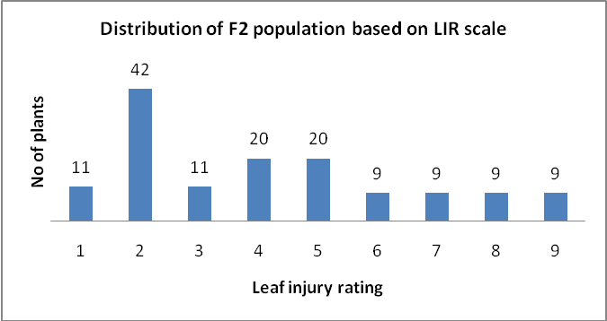

Figure 2: Distribution of F2 mapping population (140) based on phenotype the cross between HKI 1352 andWNZPBTL 2maize genotypes infested with C. partellus larvae.
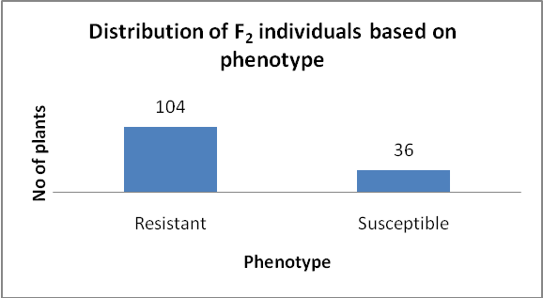

. 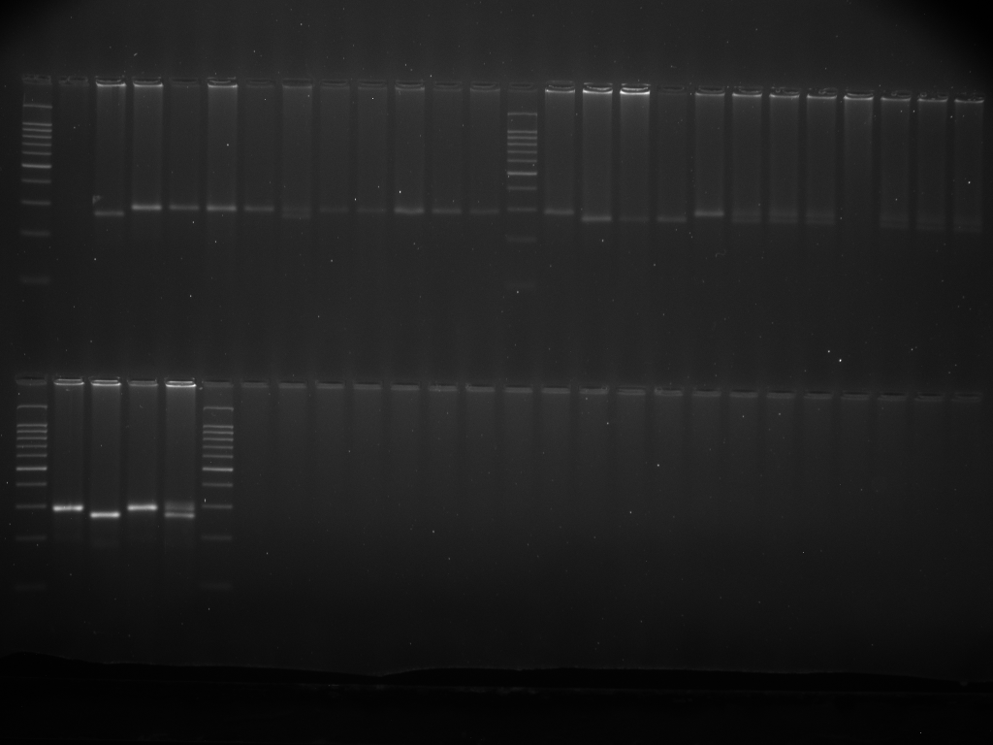
L SP RP SB RB L
Fig 3: PCR products generated by SSR primer bnlg 1057 with SP, RP, SB and RP respectively, during segregant analysis. SP- Susceptible parent, RP- Resistant parent, SB- Susceptible bulk and RB-Resistant bulk

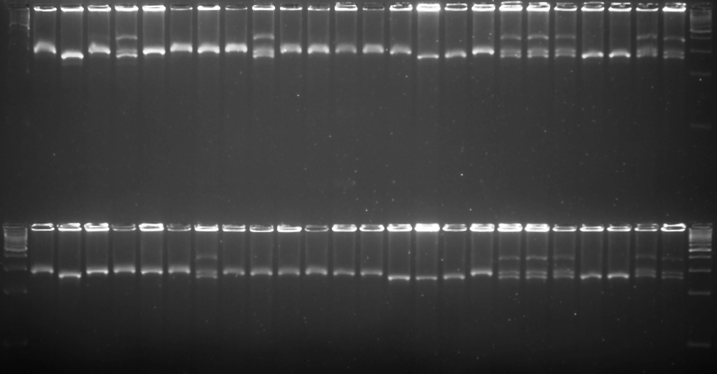
L SP RP SB RB S1 S2 S3 S4 S5 S6 S7 S8 S9 S10 R1 R2 R3 R4 R5 R6 R7 R8 R9 R10 L

Fig 4: PCR products generated by SSR primer bnlg 1057 with SP, RP, SB , RB ten susceptible and ten resistant individuals respectively, during segregant analysis. SP- Susceptible parent, RP- Resistant parent, SB- Susceptible bulk and RB-Resistant bulk, Ten Susceptible individuals (S1 to S10), ten resistant individuals (R1 to R10),L-100 bp Ladder

Table 3: List of polymorphic SSR markers between parents (HKI 1352 andWNZPBTL 2)
Sl.no | SSR marker | Bin location | Sequence
Sl.no | SSR marker | Bin location | Forward | Reverse
1 | umc2183 | 1.00 | TTAGAGCATGTGGCTCTTAGTCCC | TCTACTGCCAAGAAGAAATCCTGG
2 | umc1305 | 1.01 | TGCTGTGTGTTTGATGCTTTAGTTT | CAATTTGATGCTGGGATTCAGATA
3 | umc2185 | 1.02 | CTTCTTCTGCCACAGCACGAAC | CAAGGTTAAGAGCATGTACGCGAT
4 | umc1734 | 1.05 | TTGTGCATTTTGCAGAAACTAGGA | AGTACTTGTCGGTGGAGACTGGAG
5 | bnlg 1057 | 1.06 | TTCACCGCCTCACATGAC | GCAACGCTAGCTAGCTTTG
6 | bnlg1023 | 1.06 | CGGACGATTGAAAAGGAAAA | TTGCAAGGGTCATTCGTAGT
7 | umc1422 | 2.02 | GAGATAAGCTTCGCCCTGTACCTC | CTCATCGCGATCTCCCAGTC
8 | umc2252 | 2.05 | CACTGCACTGCAAGGTACATACG | GTCTTTGACCCCTTCCTCTTCTTG
9 | nc132 | 2.05 | TCATCTTGCTCTGATGCTCG | TGTGGGGGCACGTTAATTAC
10 | umc2101 | 3.01 | CCCGGCTAGAGCTATAAAGCAAGT | CTAGCTAGTTTGGTGCGTGGTGAT
11 | bnlg1022 | 3.05 | GTGTTGTCGATCCACTCCCT | GCAAAGATCTGTGAGGGGAC
12 | umc1690 | 3.07 | ACCTTAGTTACACAGGCACACGGT | GGTGATGGGATTTTCGCATTATTA
13 | Phi088 | 3.08 | GATTGCGATAAGCATTGCGGCAGTT | CTTCTGTTCCGCCATCCAGTATGT
14 | bnlg252 | 4.05 | CGTTCTCCGTACAGCACAGACCAACGT | CTCAGATGAACTCCTCAGCAGCTGTAGCCT
15 | bnlg1444 | 4.08 | AGACGACGAAGCTTTTGCAT | GCATGGATGGAGAAAGAGGA
16 | phi098 | 4.08 | GAGATCACCGGCTAGTTAGAGGA | GTATGGTTGGGTACCCGTCTTTCTA
17 | umc2036 | 5.01 | TCAATCAAGCCTCTCGTAAGGAAC | CTCTTGATCTCAACCGAAATCCTG
18 | phi396160 | 5.02 | GGAGCCTCCTCAACCCTT | GCTCGAGGTCCATGAGCA
19 | umc1587 | 5.02 | AGGTGCAGTTCATAGACTTCCTGG | ATGCGTCTTTCACAAAGCATTACA
20 | umc1192 | 5.04 | GATCGAACTGCAGAGGAACAAGAG | CGCTCCACATCCACATCTACAC
21 | phi087 | 5.06 | GAGAGGAGGTGTTGTTTGACACAC | ACAACCGGACAAGTCAGCAGATTG
22 | bnlg386 | 5.09 | CACCCTCCCTTTGCAGGTA | TGGTTTATCAGATAACGATTCAGC
23 | bnlg426 | 6.01 | TGCATTAATTAGAAGGCTATCAAA | GGTTTGGTGACTGGACTGACTT
24 | bnlg2243 | 6.01 | ATCTATCACGACGAACGGGA | ATCTCCCTAGCTCGCTCTCC
25 | umc1572 | 6.02 | CAAGGTGTCCTTGGTGTGTATCAG | AATCCTTCTCTGCGTCCTTTCTCT
26 | phi389203 | 6.03 | GACGAAAAGGTGGCTCGT | TGCAGTCCTAGATCAGTTCCAA
27 | umc1424 | 6.06 | CCGGCTGCAGGGGTAGTAGTAG | ATGGTCAGGGGCTACGAGGAG
28 | bnlg1759 | 6.07 | AGACGGAGTCCTCGTTTGC | ACCGGTTCGTACCACTCACT
29 | umc1986 | 7.02 | CTACTTACGAACGGAAACGCCC | ACGAGACGGTCGACAAGGAAG
30 | phi116 | 7.06 | GCATACGGCCATGGATGGGA | TCCCTGCCGGGACTCCTG
31 | umc1858 | 8.04 | GTTGTTCTCCTTGCTGACCAGTTT | ATCAGCAAATTAAAGCAAAGGCAG
32 | bnlg1714 | 9.04 | CATCATGGAGGCATATGTCG | ACACATTTAGACCCACCCCA
33 | umc1657 | 9.07 | ATGGATGAATATGATCCCACGG | GATCCGCACGTAGCTTTTCG
34 | bnlg619 | 9.07 | ACCCATCCCACTTTCCACCTCCTCCT | GCTTTCAGCGAATACTGAATAACGCGGA
35 | phi059 | 10.02 | AAGCTAATTAAGGCCGGTCATCCC | TCCGTGTACTCGGCGGACTC
36 | phi052 | 10.02 | CAGAATGGGACGACAAGGTCATC | GGGACACTTCTAGCAGGATCTGTTT
37 | umc1432 | 10.03 | GGCCATGATACAGCAAGAAATGAT | TACTAGATGATGACTGACCCAGCG

COMPETING INTERESTS DISCLAIMER:
Authors have declared that they have no known competing financial interests OR non-financial interests OR personal relationships that could have appeared to influence the work reported in this paper.

References

Bohn, M., Khairallah, M.M. Jiang, C. González-de-León, D. Hoisington, D.A.Utz, H.F. Deutsch, J.A. Jewell, D.C. Mihm, J.A. andMelchinger, A.E. 1997. QTL mapping in tropical maize: II. Comparison of genomic regions for resistance to Diatraea spp. Crop Science. 37: 1892-1902.
Bohn, M., Schulz, B. , Kreps, R. Klein, D.andMelchinger, A.E. 2000. QTL mapping for resistance against the European corn borer (OstriniaNubilalisH.) in early maturing European dent germplasm.Theoretical and Applied Genetics.101: 907-917.
Cardinal, A.J., Lee, M. Sharopova, N. Woodman-Clikeman, W.L.and Long, M.J. 2001. Genetic mapping and analysis of quantitative trait loci for resistance to stalk tunneling by the European corn borer in maize. Crop Science. 41: 835-845.
Cartier, J.J. and Painter, R.H. 1956. Differential reaction of two biotypes of the corn leaf aphid to resistant and susceptible varieties, hybrids and selections of sorghum. Journal of Economic Entomology.49: 498-508.
Chatterji S.M., Young W.R., Sharma G.C., Sayi I.V., Chahai B.S., Khare B.P., RathoreY.S., PanwarV.P.S. andSiddiqui K.H. 1969. Estimation of loss in yield of maize due to insect pests with special reference to borers.Indian Journal of Entomology 31(2):109-115.
Drinic SM, Micic DI, Eric I, Andelkovic V, Jelova D, Konstantinov K (2004).Biotechnology in breeding.Genetika 36:93-109.
FAOSTAT, 2013. FAOSTAT Statistics Division: Agricultural data, Food and Agriculture Organization of the United Nations, Rome.
Girhotra, R. P. ,Saxena, V. K. andMalhi, N. S. 2005. Genetics of Resistance to Maize Stem Borer (Chilo portellus[Swinhoe]) in Maize. Proceedings of the Ninth Asian Regional Maize workshop. Pp 199-206. Beijing, China
Gupta, H.S, Babu, R. Agrawal, P.K. Mahajan, V. and Hossain, F. 2013: Accelerated development of quality protein maize hybrid through marker-assisted introgression of opaque-2 allele. Plant Breeding. 132:77–82.
Hagi, H. M. 1984. Gene affects for resistance to stem borer (Chilo partellus Swinhoe) in sorghum Sorghumbicolor (L.) (Moench).M.Sc. thesis, Andhra Pradesh Agricultural University, Hyderabad, Andhra Pradesh, India.

Jiménez-Galindo JC, Ordás B, Butrón A, Samayoa FL, Malvar RA (2017). QTL Mapping for Yield and Resistance against Mediterranean Corn Borer in Maize. Front. Plant Sci. 8:698.
Jampatong, C., McMullen, M.D. Barry, B.D. Darrah, L.L. Byrne, P.F. andKross, H. 2002. Quantitative trait loci for first- and second-generation European corn borer resistance in the maize inbred Mo47. Crop Science. 42: 584-593.
Khairallah, M.M., Bohn, M., Jiang, C. Deutsch, J.A. Jewell, D.C., Mihm, J.A.Melchinger, A.E. Gonzales-de-Leon, D.and Hoisington, D.A. 1998. Molecular mapping of QTLs for southwestern corn borer resistance, plant height, and flowering in tropical maize. Plant Breeding .117: 309-318.
Krakowsky, M.D., M. Lee and J.B. Holland. 2007. Genotypic correlation and multivariate QTL analyses for cell wall components and resistance to stalk tunnelling by the European corn borer in maize. Crop Science. 47: 485-490.
Mathur L.M.L. 1987. Bibliography of maize pests in India. New Delhi, India: AICRP, Indian Agricultural Research Institute.
Michelmore, R. W. Paran, I and. Kesseli, R. V .1991. Identification of markers linked to disease-resistance genes by bulked segregant analysis: A rapid method to detect markers in specific genomic regions by using segregating populations. Proceedings of the National Academy of Sciences. USA. 88: 9828-9832.
Pathak, R. S. and Olela, J. C. 1983. Genetics of host plant resistance in foods crops with special reference to sorghum stem borer. Insect Sci Appl4: 127 – 34.
Pechan, T.B., D. Jiang, L. Steckler, L .Ye, and L. Lin, 1999: Characterization of three distinct cDNA clones encoding cysteine proteinases from maize (Zea mays L.) callus. Plant Molecular Biology. 40:111-19
Prasanna BM, 2012. Diversity in global maize germplasm: characterization and utilization. J Biosci 37(5): 2843–855
Rana, B. S. and Murty, B. R. 1971.Genetic analysis of resistance to stem borer in sorghum.Indian journal of Genetics and Plant Breeding. 31: 521-529.
SagahiMaroof, M., Soliman, K., Jorgenesis, R. and Allard, R. 1984. Ribosomal DNA spacer length polymorphisms in barley: Mendalian inheritance, chromosome location and population dynamics, Proceeding of National Academy of Sciences .81: 8018.
Sarup.P. (1983) Standardization of techniques for scoring of lines against the stalk borers of maize.In Techniques of scoring for resistance to the major insectpe.st.s of maize.cd. Joginder Singh, pp.64-72. All India Coordinated Maize Improvement Project. IARI.New Delhi.
Satish, K., Srinivas, G., Madhusudhana, R., Padmaja, P. G., Nagaraja Reddy, R., Murali Mohan, and S. Seetharama, N. 2009. Identification of quantitative trait loci for resistance to shoot fly in sorghum [Sorghum bicolor (L.)Moench].Theoretical and Applied Genetics .119.1425-1439
Schon, C.C., Lee, M., Melchinger, A.E. Guthrie, W.D. and Woodman, W.L. 1993. Mapping and characterization of quantitative trait loci affecting resistance against second-generation European corn borer in maize with the aid of RFLPs. Heredity, 70: 648-659.
Selvi.A, Shanmugasundaram, P, Mohan, Mohan Kumar, S. and Raja, J.A.J. 2002. Molecular markers for yellow stem borer Scirpophagaincertulas (Walker) resistance in rice. Euphytica.124: 371-377.
www.maizegdb.org
Yadav O P, Hossain F, Karjagi C G, Kumar B, Zaidi P H, Jat S L, Chawla J S, Kaul J, Hooda K S, Kumar P, Yadava P and Dhillon B S. 2015. Genetic improvement of maize in India – retrospect and prospects.Agricultural Research 4: 325–38.
Yueyingli.,Lijun Chen, Feng Lin, Khalid Hussain and Jianquizou. 2010. Identification of SSR markers linked to resistance against the spotted stem borer in sorghum. Middle East Journal of Scientific Research.6 (5): 505-511.
Saraswati Neupane, Subash Subedi, Ramesh Kumar Shrestha and Sunita Pandey. 2022. Damage and yield loss estimate in maize varieties owing to stem borer (Chilo partellus Swinhoe) infestation and insecticidal control. Journal of Agriculture and Natural Resources 5(1): 1-11
S. B. Suby, Sunil Kumar Jha, Chikkappa G. Karjagi, Pradyumn Kumar, Javaji Chandra Sekhar, Jaswinder Kaur, Anil Kumar Cholla, P. Lakshmi Soujanya, Rakesh Kumar Sharma & Sujay Rakshit. 2020. Penetration resistance of second above ground internode in V6–10 stage maize plants confer resistance to stalk boring larvae of Chilo partellus (Swinhoe) in maize. Phytoparasitica 48 :455–469
Anil Cholla, Subhash Chander, Jaswinder Kaur, S. B. Suby and Pradyumn Kumar. 2018. Improved method of screening maize Germplasm for resistance aganst Chilo partellus (Swinhoe). Indian journal of genetics and plant breeding. 78(4): 454-459.
Anil Kumar Cholla, Pradyumn Kumar, Subhash Chander , Abhijit Kumar Das, Suby, S.B, Sunil Chandra Dubey and J.C .Sekhar. 2019. Identification of key damage parameters and plant morphological traits associated with Chilo partellus resistance in maize (Zea mays L.) Journal of Entomology and Zoology studies. 7 (2): 1300-1305.

