Case report
Between trauma and infection: diagnostic and therapeutic approach to progressive orbital cellulitis – a case report
Abstract : Orbital cellulitis is a rare but potentially serious condition with diverse etiologies, requiring prompt diagnosis and management to avoid severe complications such as blindness or meningitis. We report the case of a 75-year-old female patient admitted with a clinical presentation of left orbital cellulitis occurring two days after an ocular trauma. Medical history revealed a prior episode of instability for which the patient consulted a neurologist one year ago, with brain imaging confirming anterior sinusitis. The unusual context of onset posed a diagnostic and therapeutic dilemma for the practitioner. We discuss our approach to this situation, as well as the importance of close clinical monitoring and appropriate management in case of failure of initial medical treatment

Keywords: case report, Orbital cellulitis, Sinusitis, Surgical decompression

Introduction
Orbital cellulitis is an infection of the orbital tissues, located behind the orbital septum. This infection can be caused by local trauma(less common) or the spread of adjacent sinus infections. It is a rare but serious infection due to the risk of major complications such as blindness and death. Therefore, it is crucial to recognize the symptoms and treat this infection appropriately. Additionally, it is essential to differentiate orbital cellulitis from preseptal (periorbital) cellulitis, as the management and prognosis differ.
Through this clinical case, we report our clinical and therapeutic approach to a case of orbital cellulitis, where both traumatic and sinus-related etiologies were considered.

Case Report
We report the case of a 75-year-old female patient with a history of hypertension (on treatment), left amblyopia, and neurological follow-up for instability over the past year. Previous brain imaging was unremarkable except for left anterior ethmoidal sinusitis.
She presented as an emergency with left red and painful eye, occurring two days after a traumatic fall with left ocular impact, but no associated rhinological symptoms (no rhinorrhea, postnasal drip, rhinitis, nasal obstruction, or sinus pain) (Images 1).
Our Clinical Examination foud that the patient was confused and febrile (37°C), with left eye swelling, edematous and inflamed conjunctiva. Visual acuity appeared preserved, but ocular motility was reduced in all directions. Rhinological examination with endoscopy revealed a free nasal cavity, but the left middle meatus was edematous and contained pus (which was sampled). Neurological examination showed no other abnormalities.
A sinus CT scan (Images 2) demonstrated was performed and shows a Left fronto-ethmoido-maxillary sinusitis with complete opacification of the left ethmoid cells, Hyperdense spontaneous filling of the ipsilateral maxillary and frontal sinuses; Left eyelid soft tissue infiltration without a clearly defined abscess, consistent with Chandler grade 1 preseptal cellulitis.
Blood tests was performed , Inflammatory markers (pre-antibiotics) showed elevated CRP and leukocytosis. Lumbar puncture was sterile. And Bacteriological analysis of the pus from the middle meatus identified a sensitive Staphylococcus species.

Given the pre-existing sinusitis on imaging and the post-traumatic onset (left ocular impact), both traumatic and sinus-related origins of the cellulitis were considered.
The patient was hospitalized and started on empirical broad-spectrum antibiotics (ciprofloxacin, metronidazole, and an aminoglycoside for 3 days), along with nasal treatment (nasal irrigation and xylocaine-naphazoline packing).
In Clinical Course at 48 Hours the symptoms worsened : Increased chemosis, proptosis, and restricted eye movement.Persistent local inflammation (though CRP decreased). We Repeat CT that revealed Chandler stage II orbital cellulitis with grade 2 proptosis (Image 3).
Given the progression, surgical management was indicated, consisting of External orbital decompression. And an Endoscopic sinus drainage via Left middle meatal antrostomy and Frontal sinus drainage (Draf II procedure), resecting the frontal sinus floor up to the lamina papyracea and middle turbinate.Samples were sent for pathology and bacteriology.
Postoperatively, antibiotics and extensive nasal irrigation were continued. The patient's condition improved significantly, with Reduction in eyelid and conjunctival inflammation and Restoration of ocular motility (Image 4).
Discussion

Orbital cellulitis is a rare but serious infection affecting orbital tissues, associated with a significant risk of blindness, meningitis and death. Consequently, practitioners must be aware of the diagnosis and management of this condition.
Orbital cellulitis cases are observed mainly between ages 6-15 and 60-70, with male predominance. The most frequently observed pathogens are Streptococcus pneumoniae, Staphylococcus aureus and Haemophilus influenzae. Infectious invasion of the orbit occurs either hematogenously or by contiguity (sinus origin is most often involved) (1).
The etiologies of cellulitis are diverse and grouped in Table 1 (2).
During history taking, it is essential to systematically investigate trauma or skin infection (stye, boil, herpes, etc.), sinusitis, recent dental or pulmonary problems, and immunosuppression. Unilateral purulent rhinorrhea and presence of pus in the middle meatus are highly suggestive findings.
Ophthalmological clinical signs and imaging (sinus CT scan) allow classification of cellulitis into 5 Chandler stages (3):
- Stage I corresponds to preseptal cellulitis (the eyeball is normal)
- Stages II-V or true orbital cellulitis, clinically marked by chemosis, proptosis and reduced ocular motility, sometimes with decreased visual acuity
(Stage II: orbital cellulitis, Stage III: subperiosteal abscess, Stage IV: intraorbital abscess, Stage V: cavernous sinus thrombosis)
Preseptal forms do not always require hospitalization. Conversely, postseptal forms always require hospitalization, broad-spectrum antibiotic therapy, nasal irrigation and local corticosteroid therapy. In case of no improvement or worsening of clinical signs, surgical drainage becomes necessary (4). The procedure depends on the affected sinus (middle meatal antrostomy, Draf procedure, etc.)

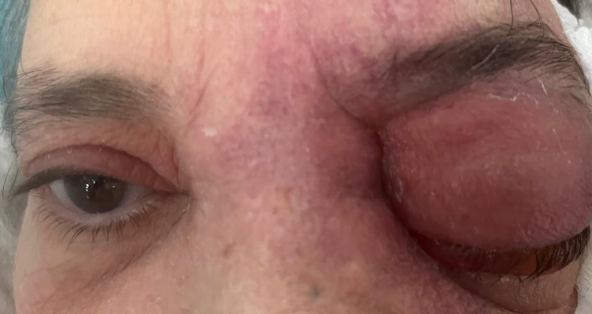
Figure 1 : left orbital cellulitis with chemosis
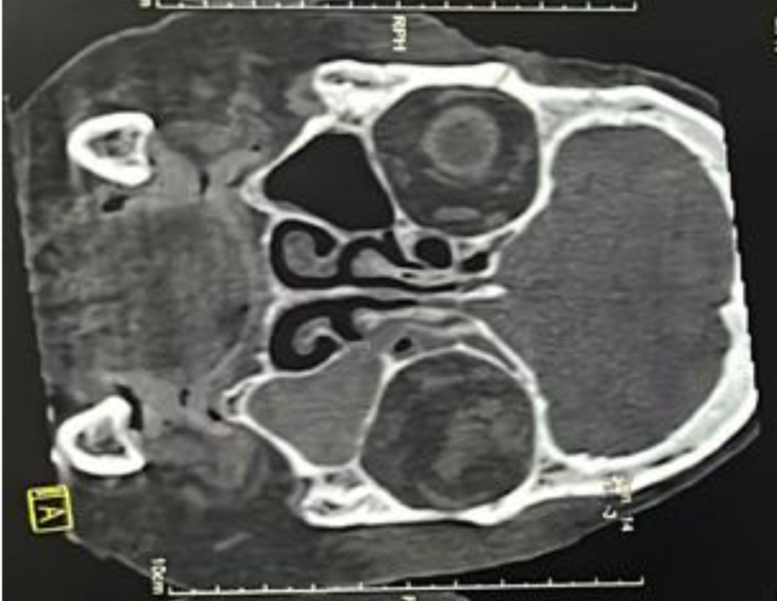
Figure 2: Coronal sinus CT scan: Left fronto-ethmoido-maxillary opacification with infiltration of the left orbital cellulofatty tissue.
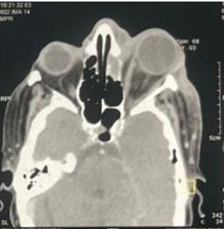
Figure 3 : Axial CT scan revealing grade II Chandler's cellulitis with grade II exophthalmos.

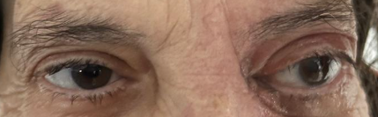
Figure 4: Postoperative day 30, showing a normal-appearing eyeball

Références
- Mouriaux F, Rysanek B, Cattoir V, Babin E. Infections orbitaires EMC Ophtalmologie 2011;8(4):1—9 [Article 21-650-A-15]
- Wald ER, Periorbital, orbital infections. Infect Dis Clin North Am 2007;21:393—408
- Chandler JR, Langenbrunner DJ, Stevens ER. The pathogene sis of orbital complications in acute sinusitis. Laryngoscope 1970;80:1414—28.
- Spires JR, Smith RJ. Bacterial infections of the orbital and periorbital soft-tissues in children. Laryngoscope 1986;96: 763—7.

