Original Research Article
Assessment of the environmental and social impacts of semi-mechanized gold mining: the case of the Amzegar site, rural commune of Tabelot, Agadez region

ABSTRACT

This study highlights the environmental and social impacts of semi-mechanized gold mining at the Amzegar site. Our methodological approach is based on field visits and consultation of certain quarterly activity reports from companies. We identified three methods used to extract the ore: surface mining, open-pit mining, and shaft mining, which involves sinking a shaft in the direction of the vein. Once extracted, the ore undergoes mechanical processing using traditional methods (manual crushing) and semi-mechanized methods (jaw crushers, grinding mills, grinding tanks with wheels, etc.), as well as chemical processing involving the use of mercury, cyanide, and acids.
In addition, a methodology for identifying and assessing the impacts of this activity is implemented. The identification of these impacts is based on determining the activities that cause impacts through field visits and consultation of company activity reports and the environmental and social monitoring program. The assessment of these impacts was based on the Fecteau grid using impact assessment parameters (nature, intensity, extent, and duration), which allowed us to identify that this activity, despite its positive impact on the local and national economy, has minor, moderate, or major negative impacts on biophysical components (soil, air, water resources, vegetation, and wildlife) and human components (safety and health, noise levels, and the local economy) depending on the different phases of the activity (preparation and installation, operation, and closure).
Finally, this methodology for identifying and assessing impacts has enabled us to highlight a number of environmental risks (ecosystem degradation, water contamination, soil erosion, and air pollution) and social risks (management of mining residues, land restoration, use of cleaner technologies, and environmental monitoring). Mitigation measures for these impacts are proposed, and recommendations are reformulated in order to guard against these risks and mitigate the impacts of the aforementioned operation.

Keywords: Semi-mechanized gold mining; environment; Fecteau grid; Amzegar site.

1. INTRODUCTION

Gold mining has been around for a very long time and is practiced by millions of people around the world. It involves more than 10 to 15 million people in over 70 countries worldwide (Sanoussi, 2020).
Mining resources are an important driver of the economy in many African countries. Artisanal and semi-mechanized gold mining contributes to the development of certain localities and the survival of increasingly large populations involved in this activity (Klamadji et al., 2025). In Niger, the Agadez region has recently seen a resurgence of gold mining at a variety of sites (Djado, Tchibarakaten, the Aïr Mountains, etc.). The sites in the Aïr Mountains were discovered in 2014. Numerous and scattered, they are located in the municipalities of Tabelot (Arey, Fasso, Amziguer), Dabaga (Gofat), Timia (Ibil), etc. This list is neither exhaustive nor definitive, as discoveries continue.
Indeed, semi-mechanized gold mining in the rural commune of Tabelot, which began in 2015 using rudimentary methods with poor gold recovery rates (20 to 40%), is a matter of crucial importance, both environmentally and socially. This activity, which has expanded significantly in recent years, raises major concerns regarding its impact on the environment and the communities that depend on it (Konaté et al., 2025; Tindano et al., 2024). It poses risks such as the discharge of fine particles and chemicals into waters that are generally used as sources of drinking water, the drilling of mega holes, and the felling of trees, which cause significant and progressive ecological imbalance. (Anene et al., 2024; Mimba et al., 2023).
Subsequently, it seems important to identify and assess the environmental and social impacts of this semi-mechanized gold mining operation at this site in order to mitigate the consequences. It is with this in mind that this study was conducted.

2. material and methods

2.1 Location of the study area
The rural commune of Tabelot is located in the Agadez region, specifically in the Aïr Mountains. It is situated 145 km northeast of the regional capital of Agadez. It is under the administrative authority of the Department of Tchirozérine and covers an area of approximately 47,122.59 km², or 30.45% of the total area of the Department of Tchirozérine. It is bordered by:
Timia to the north;
- Dannet to the northwest;
- Aderbissanat to the south;
- Fachi to the east;
- Dabaga and Tchirozérine to the west.
Fig. 1 shows the rural commune of Tabelot and the study area (Amzegar).
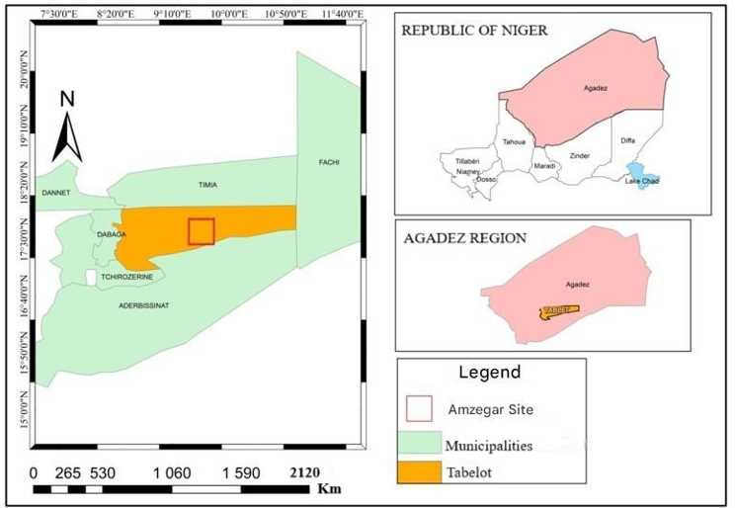
Fig.1. Map showing the location of the rural commune of Tabelot and the Amzegar site

2.2 Geological context
The rural commune of Tabelot, located in the Agadez region of Niger, is situated in a particularly rich and attractive geological context for gold mining. This region is primarily characterized by the presence of ancient geological formations, including metamorphic rocks, granites, and volcanic rocks, which have created conditions conducive to the formation of gold deposits. The tectonics of this area have played a key role in the concentration of precious minerals, with the formation of faults and shear zones promoting the accumulation of gold. Geological processes that have taken place over millions of years have resulted in the creation of gold veins, often scattered throughout the bedrock. Figure 2 illustrates the geological profile of this area.
This complex and varied geology has attracted the attention of gold prospectors, leading to the development of semi-mechanized mining in the region. However, this geological wealth also poses environmental and social challenges, as gold mining can have significant consequences for these fragile geological formations, as well as for local populations and their way of life.

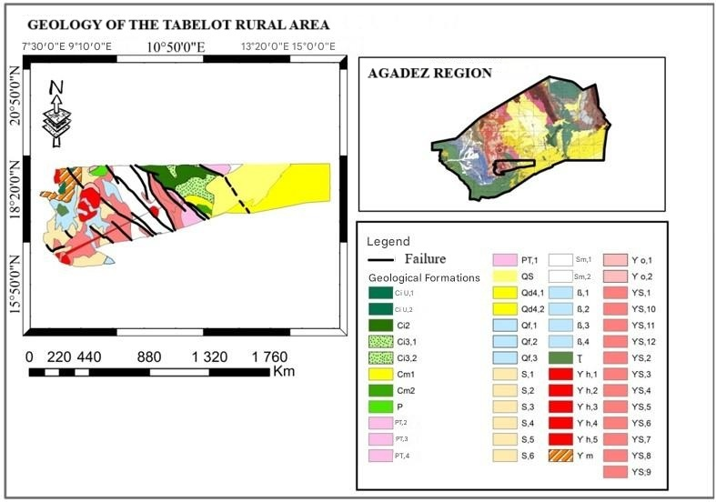
Qd4: Active dunes;
QS: Flat ante-Neolithic sands of the Ténéré;
PT: Conglomerates, arkases, schists;
Ci2: El Rhas Formation;
Ci3: Echkar Formation;
Cm1: Alanlara Formation;
Cm2: Zoo Baba formation;
ϒS: Syntectonic granites;
Sm: Fossil hydrographic network valley fill products;
S: Undifferentiated Suggarian;
ß: Basalts (Quaternary);
P: Plagioclases (anorthosites);
ϒ m: Mignatitic granites;
ϒ h: Hyperalkaline granites with acgurine-ricbackite;
Ʈ : Grauwackes, arkoses;
ϒ o: Alkaline granites with hornblende-biotite;
Qf : Fluvial deposits (gray surfaces of the Ténéré du Tafassasset);
Ci U : Agades sandstone group.
Fig 2. Geological profile map of the rural municipality of Tabelot

2.3 Semi-mechanized gold mining
At the Amzegar site, semi-mechanized gold mining is characterized not only by the use of artisanal methods and techniques, but also and above all by the use of mechanized infrastructure, equipment, and methods, hence the term “semi-mechanized.”

2.4 Infrastructure and equipment
In order to mine the ore, operators use a variety of infrastructure and equipment.
2.4.1 Equipements
The main equipment used at the Amzegar site is:
• Excavators (mechanical shovels, bulldozers, manual shovels; picks, hammers, picks, bags, ropes, and machetes);
• Drills;
• Battery-powered torches;
• Dynamite (very rarely used);
• Loaders;
• Trucks;
• Generators;
• Jackhammers;
• Metal detectors;
• Crusher;
• dry and wet grinders;
• sodium cyanide leaching tubes;
• cyanidation feed tubes;
• all-terrain vehicles;
However, artisanal miners proceed by identifying the site or prospecting, then extracting/processing the ore and managing the mining residues.

2.5 Extraction
At the Amzegar site, mining operators generally use three methods to extract ore: open pit mining, bench mining, and shaft mining.

2.5.1 Excavation extraction
This involves digging up soft rock using traditional, largely non-mechanized tools such as pickaxes, crowbars, jackhammers, and, in exceptional cases, mechanical shovels. This method is used for any mineralization found in eluvium or alluvium. It is carried out using metal detectors (GMT Monomineral, GPX 5000, etc.) and pneumatic screens commonly known as garbala (Fig.3). The gold ore is thrown onto this screen using manual shovels. Fine particles are blown away by air emitted from the machine's compressor, and heavy particles (including gold) are stored in a container located at the bottom of the machine. In this way, they undergo mechanical processing and rarely chemical processing.
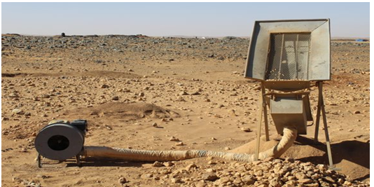

Fig.3. Extraction of ore by excavation (garbala)

2.5.2 Open pit extraction
Open pit mining is the standard method for extracting gold ore, as the deposit is deep underground and has limited lateral extension. This generally requires the use of “non-standard” construction equipment, such as that found in some large quarries or aggregate operations (hydraulic excavators, dump trucks, large loaders). Horizontal tunnels (Fig. 4) are dug to reach the mineralized zone or access the work sites, and access ramps are used to reach the different mining levels.
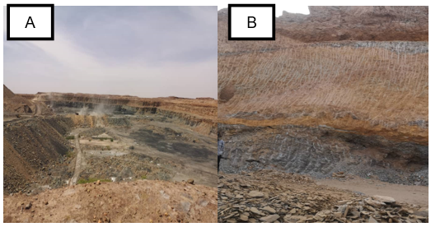
Fig. 4. Step extraction operations (A), working face (B)

2.5.3 Well extraction
Drilling involves digging holes to reach the ore found in rock. It is done manually and is the most difficult and arduous phase of the extraction process. The orientation of the hole follows the ore bed (vein) and can be vertical or horizontal. The holes are often circular (1 to 2 m in diameter) or rectangular, varying in size from 1.5 x 1 m to 3 x 2 m, with depths ranging from 4 to 20 m or even 24 m, depending on the richness of the shaft (Fig. 5A). To check whether the extracted ore is rich in gold, a test is carried out at the site to perform mechanical and chemical processing when it is poor in gold. This test consists of crushing the rock with a mortar and metal pestle, then using a plate and bowl to wash the ore and evaluate the gold concentrate. To prevent rockfalls and stabilize the walls of the holes, supports are made with wooden beams (Fig. 5B). Support is provided as excavation progresses, given the low bearing capacity of the soil. The sinking of a hole is stopped once the water table is reached and the owner of the hole no longer has a pump powerful enough to drain it.

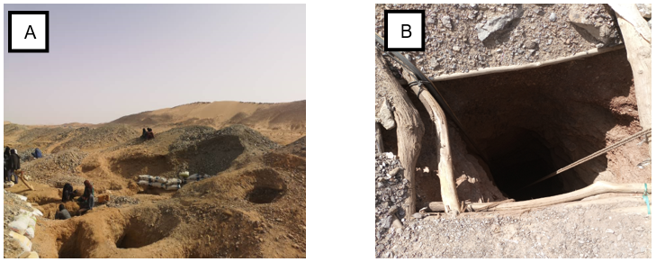
Fig. 5. Extraction wells (A), well support (B)

2.6 Treatment
Two main types of treatment are used, namely:
• mechanical treatment;
• chemical treatment.

2.6.1 Mechanical processing
The ore first undergoes mechanical processing, which is generally a preparatory phase for washing and chemical processing. This involves crushing and grinding.

2.6.2 Crushing
This phase consists of reducing the size of the extracted ore to small pieces (a few millimeters). Manual crushing is done using a hammer, an anvil (granite stone), and a sack knot to prevent particles from flying and to protect the fingers (Fig. 6). Most often, crushing is done by young people or anyone else, depending on the number of 50 kg bags.

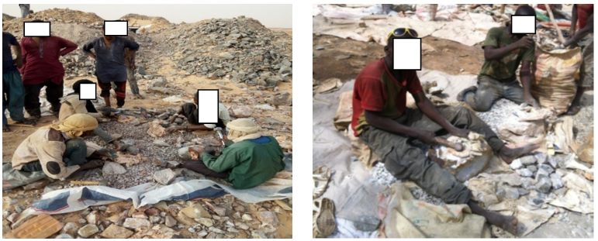

Fig. 6. Manual crushing of ore

However, semi-mechanized mining companies in the Amzegar area (Tenert mining sarl, Issiknouggour sarlu, Sahara mining and energy company, la societe “emalaoule” sarlu) use equipment found on official sites (semi-mechanized mining authorization) to crush ore, such as jaw crushers (Fig. 7).

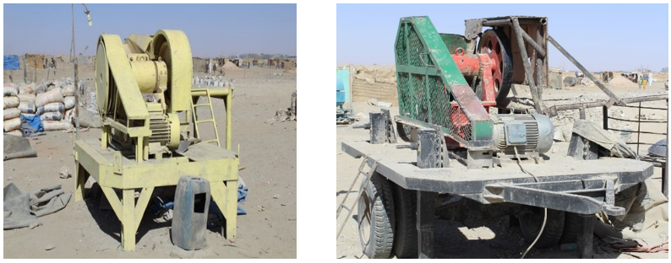
Fig.7. Jaw crushers

Once the ore has been crushed, it is then placed in 50 kg bags for transport to the grinding site (Fig. 8).
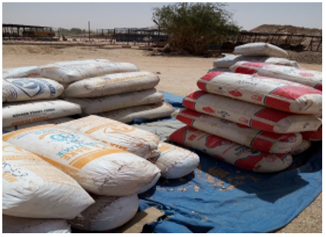
Fig. 8. Bags of ore after crushing

Once the ore has been properly crushed, it moves on to the grinding stage, which involves reducing it to the gold release size (< 100 μm).

2.6.3 Grinding
During this phase, the ore is reduced to a powder with a particle size of 75 to 100 microns. The ore is ground in mills twice in succession and dried between each grinding when the moisture content is high.
This grinding device consists of a mill, a motor connected to the mill by a belt to operate it, two drums of diesel fuel to power the motor, two drums of water to cool the motor, a “grinding wheel dynamo” used to sharpen the grinding wheels, trays to collect the flour, and tarpaulins to dry the flour (Fig. 9).

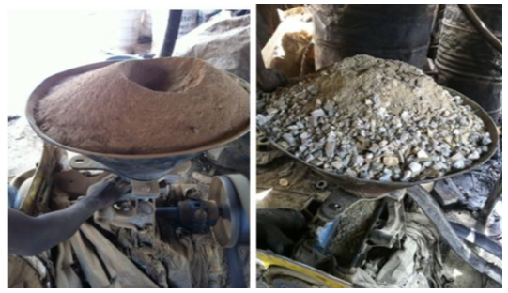
Fig. 9. Grinding of the ore using a mill grinder

In addition, at the Amzegar site, another device is used for wet grinding of the ore: grinding tanks with wheels (Fig.10). The result of this grinding is intended for treatment by chemical methods, in particular with mercury. The ore, which has been pre-crushed on site, is placed in tanks containing water and wheels that rotate around a central axis. Depending on its size, a tank can contain two (2) to three (3) wheels. The wheels can weigh between 1 and 1.5 tons, depending on their diameter. The movement of these wheels in the tank crushes the ore to a particle size of around 100 μm to facilitate the release of gold. However, the crushing time varies from 4 to 24 hours depending on the hardness of the host rock. It is at this stage that chemical processing with mercury begins.

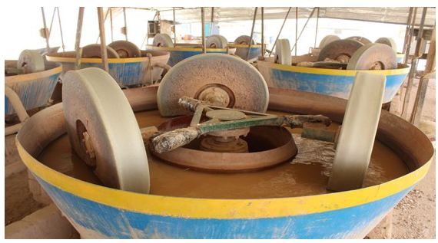
Fig.10. Wheel grinding tanks for wet grinding of ore

2.6.4 Washing
The ore from dry grinding, which is stored in 50 kg bags, is mixed with water. A small amount of the mixture is placed in a sieve, then water is poured over it to liquefy it. This is an inclined plane with grooves (sluice) on its surface, covered with a mat or carpet (Fig. 11). As gold is a dense mineral (d = 19.3), it is trapped on the fabric in the grooves while the other lighter particles are carried away by the water. The mat is then removed and washed in a container to recover the sludge containing gold. The sludge is recovered and reprocessed using the same initial process.

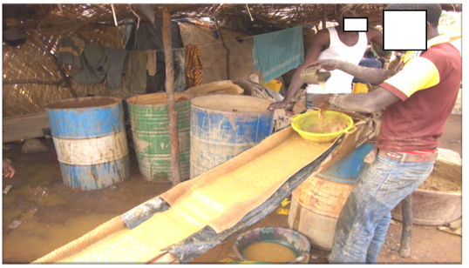
Fig. 11. Washing operations at Sluice

2.7 Chemical treatment
After crushing, grinding, and washing the ore, two chemical processes are commonly used:
• mercury amalgamation;
• cyanidation.

2.7.1 Mercury treatment
The black powder obtained after washing is mixed by hand with mercury (Hg) for amalgamation. According to a United Nations report, the gold-mercury ratio is approximately 1 g of gold to 1.3 g of mercury. However, it should be noted that the amount of mercury to be used depends on the type of deposit and the quantity of amalgamable minerals. For example, if silver is present in the ore, it will consume an additional amount beyond what is necessary to amalgamate the gold (Schwartz et al., 2023; Atangana et al., 2025).
After agitation and mixing, the mercury amalgamates with the gold. Water is added to the mixture and, after agitation, the amalgam settles at the bottom of the container (Fig. 12 A). The water is drained off and the rest of the ore is placed in a cloth to squeeze out all the water and recover only the amalgam. The gold-mercury mixture is then burned (Fig. 12 B) using aluminum foil recovered from cigarette boxes, with a blowtorch at approximately 357 °C until the mercury evaporates. This produces a gold concentrate, which is weighed on site by a buyer who is an employee of the site owner (Fig. 12 C). This process recovers 20 to 40% of the gold (Ministry of the environment, 2020).

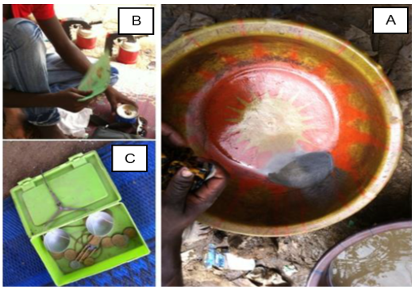
Fig. 12. Deposit of the amalgam at the bottom of the container (A), Burning of the amalgam (B), Weighing of the gold concentrate (C)

However, mercury can be added directly to the ore contained in the wheel tanks during grinding. It combines with the released gold to form a gold-mercury complex within the slurry that settles at the bottom of the tank. The water is then drained from the tank through pipes and discharged into basins. This water will be reused in the next treatment after settling. The slurry containing the gold-mercury complex is washed in a pan to isolate the complex. It is then pressed in a piece of cloth to remove the water and excess mercury (Fig. 13 A) in order to obtain only the gold-mercury complex, which forms a whitish ball (Fig. 13 b). This ball is then burned at 357ºC, the temperature at which mercury evaporates and gold is recovered.

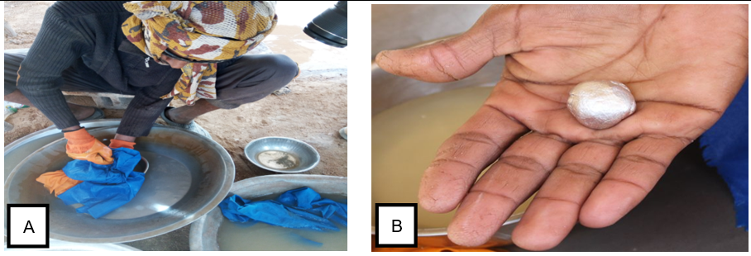
Fig. 13. Pressing of the gold-mercury complex by washing the sludge (A), the amalgam (B)

2.7.2 Cyanide treatment
This process involves separating gold by immersing the raw ore or crushed ore, including very low-grade ore and mercury treatment waste with a particle size of < 100 μm, on an impermeable layer (waterproof membrane). A diluted sodium cyanide (NaCN) solution is sprayed onto the pile at a rate of approximately 200 mL per 200 L of slurry (Tankari Dan-Badjo et al. 2015) and, as it percolates through the ore, it dissolves the gold present (Fig. 14 A). The mixture is left to stand for 3 to 4 days to allow the solution to form. This process is governed by the following reaction, known as Elsner's equation (1):
$4 Au+8 NaCN + O_{2} + 2 H_{2}O → 4 Na\left[{Au(CN)}_{2}\right] + 4 NaOH$ (1)
The solution, which is said to be “supersaturated” with gold, is then directed to a basin, where it is pumped and sent to columns where the gold is recovered by zinc chips through the U-shaped pipe (Fig. 14 B). The gold precipitates on the surface of the zinc chips, and the process is complete when the zinc has completely blackened (cementation). The reaction governing this mixture is follows in equation (2):
$2{ \left[{Au(CN)}_{2}\right]}^{-} + Zn → 2Au+ {\left[{Zn(CN)}_{4}\right]}^{2-}$ (2)
Sulfuric acid (H₂SO₄) is then added to this mixture, which dissolves the zinc to produce a gold concentrate (zinc dissolution). This concentrate is then treated with nitric acid (HNO₃) to recover the silver and remove other impurities from the gold concentrate. The concentrate is then melted down to obtain gold (gold smelting). This process allows for 60 to 80% recovery of the gold concentrate (Altinkaya et al., 2020).

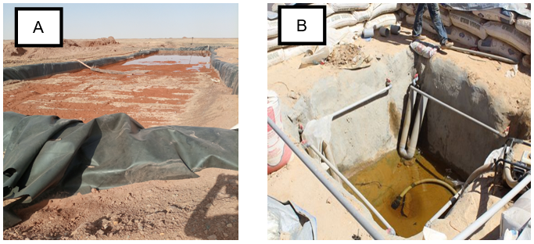
Fig. 14. Heap leaching basin (A), Collector pipe (U-shaped), loaded with zinc chips (B)

In addition, some companies at this site use activated carbon to recover gold from leaching. After leaching, the gold-bearing solution is directed to tanks filled with activated carbon (Fig. 15). Activated carbon is a porous material with a high adsorption capacity. The gold-cyanide particles present in the solution are adsorbed onto the surface of the activated carbon due to its chemical properties. One ton of activated carbon can adsorb 70 kg of gold. The gold is recovered (desorption) by treating the carbon with a hot solution (brought to boiling temperature) consisting of 1% soda and 0.1% NaCN (sodium cyanide). The gold is recovered by electrolysis. It is deposited on an iron wool cathode before being melted. The gold obtained is of high purity. The coal is recycled after being heated to 600-750°C in an airtight environment.
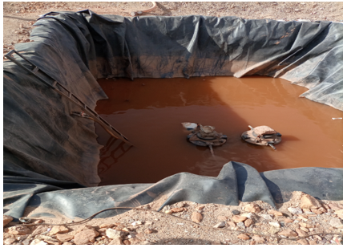

Fig. 15. Activated carbon recovery basin

After these various stages, the gold concentrate obtained from amalgamation, precipitation on zinc, and adsorption on activated carbon is refined by electrolysis to remove any remaining impurities and/or by using nitric acid to dissolve the silver, resulting in 99.99% pure gold bars. These bars are then sold on the domestic or international market. It is important to note that the exact process may vary depending on the initial source and purity of the gold concentrate, as well as industry standards and local regulations.

2.8 Mining waste management
Once the veins have been mined, the holes are often left as they are without any rehabilitation (Fig. 16 A). Mercury treatment waste is stored for cyanidation treatment, and some operators carry out the treatment themselves, while others sell their waste. However, the tailings are used to fill the holes, and the surrounding area is littered with spoil and some processing residues (Fig. 16 B). As a result, the site becomes unsuitable not only for agriculture but also for grazing.
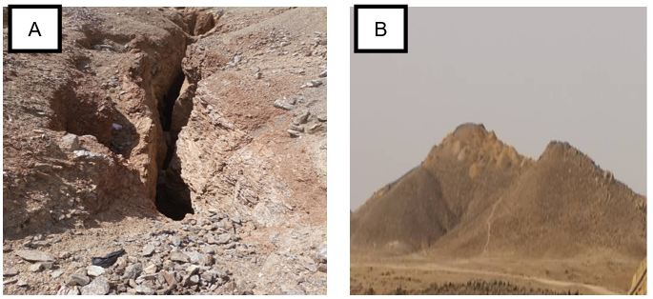

Fig.16. Abandoned well (A), Mine waste heap (B)

However, gold mining activities at the Amzegar site have environmental and social impacts that need to be identified and assessed.

3. results and discussion

The general approach we used to identify the environmental and social impacts of semi-mechanized gold mining at the Amzegar site was based on field visits and consultation of company activity reports to determine the activities causing impacts and the environmental and social monitoring program.

3.1 Impact-generating activities
Impact-generating activities are defined as all activities planned as part of the operation that are likely to have adverse effects on the biophysical and human environment.
Thus, the impact-generating activities in the context of the semi-mechanized mining operation at the Amzegar site are listed in Table 1, based on the reports on semi-mechanized gold mining activities at the Amzegar site.

Table 1. Impact-generating activities
Phases | Impact-generating activities
Preparation and installation | Staff recruitment and presence at the site;
Preparation and installation | Layout of the facilities and access road;
Preparation and installation | Setting up site facilities (building, workshop, fuel station, office, laboratory, crushing station, grinding, processing, etc.);
Preparation and installation | Movement of machinery (site development) and trucks and vehicles (supplying the site with equipment and materials for the various installations).
Mining and transport of ore | Recruitment and presence of temporary and permanent staff;
Mining and transport of ore | Site excavation work;
Mining and transport of ore | Drilling and blasting (step extraction);
Mining and transport of ore | Operation of the crusher and mill (crushing);
Mining and transport of ore | Storage of crushed products (50 kg bags);
Mining and transport of ore | Loading and transporting materials in trucks;
Mining and transport of ore | Maintenance and repair of machinery (vehicles and equipment);
Mining and transport of ore | Fuel storage for machinery needs.
Treatment | Use of chemicals (mercury and cyanide);
Treatment | Use of sulfuric acid.
Closure | Dismantling of equipment;
Closure | Site restoration.

3.2 Environmental and social monitoring program
The environmental monitoring plan makes it possible to measure, observe, and document any changes (natural or activity-related) in the environment in relation to the baseline condition. It is jointly coordinated by the Agadez Regional Directorate of Mines, the Regional Directorate of the Environment, and the municipalities concerned.

3.3 Rehabilitation
The rehabilitation plan developed is supported by a monitoring program. Inspections by the monitoring committee are conducted in accordance with best practices and in compliance with the requirements of the mining industry rehabilitation plan.
Table 2 presents the environmental monitoring elements in detail.

Table 2. Environmental monitoring program
Monitoring elements | Actions to be taken | Monitoring indicators | Monitoring frequency
Soils | Regularly analyze soil to assess changes in heavy metal concentrations. | Changes in heavy  metal concentrations in water. | Twice a year during the first three years of operation
Water | Regularly analyze groundwater to assess its quality. | Changes in the  physical and  chemical parameters of water. | Twice a year during the first three years of operation.
Water | Monitor water levels in the area operated by the mine. | Groundwater recharge rate.
Redesign of the site closure | Develop, validate, and implement a site closure plan. | Existence of a redevelopment and closure plan for the site. | Once per year
Local and regional economy | Evaluate jobs created, contracts awarded, and purchases of goods and services from local and regional suppliers. | Number of jobs created  Number of contracts awarded to local suppliers | Once per year
Safety and health | Assess the level of safety on site and around the industrial unit.  Assess the measures in place for organizing and preventing workplace accidents, and ensuring health and hygiene.  Check that equipment and facilities comply with regulations at all levels.  Check the storage and handling facilities for hazardous chemicals on site.  Check whether there is an occupational health and safety committee. | Number of accidents and/or incidents recorded  Existence of safety instructions on site  Level of effectiveness of the occupational health and safety committee  Number of cases of occupational illness recorded  Level of compliance with regulatory and standard monitoring relating to chemical substances  Number of training and awareness sessions on occupational health and safety risks provided and organized. | Twice per year over the 18 months (duration) of the operational work.

Once identified, these impacts are subject to an environmental and social impact assessment.
3.4 Environmental and social impact assessment
The methodology used to assess these identified impacts is based on the parameters of the nature of the impact, its intensity, its extent, and its duration, as outlined in Fecteau's grid (Ayiwouo et al., 2023). This allows them to be aggregated to determine the absolute significance or consequence of these impacts.

3.5 Evaluation parameters
3.5.1 Nature
The nature of an impact refers to the positive or negative effects of an activity on a given component of the environment, whether biophysical or human.

3.5.2 Intensity
The intensity of an impact expresses the relative importance of the consequences on the environment that the alteration of a component will have, while considering its environmental value and degree of disturbance (extent of structural and functional changes).

Table 3. Impact intensity assessment grid (Infrastructure 2016)
Degree disturbance | Environmental value
Degree disturbance | High | Moderate | Low
Strong | Strong | Moderate | Low
Moderate | Strong | Moderate | Low
Low | Moderate | Low | Low

3.5.3 Extent
The extent of an impact corresponds to the spatial reach or influence of the effects generated by an intervention on the environment. The extent can be described as localized when the impact is limited to the immediate vicinity or proximity of the activity, local when the impact is felt throughout the study area, and regional when the impact is felt outside the study area, such as throughout the country, for example.

3.5.4 Duration
This is the length of time during which changes to a component will be felt. It is important to note that an intervention lasting a few weeks could have repercussions on certain components of the environment lasting several years. Therefore, the duration of an impact must refer to the recovery or adaptation period of the affected components. Impacts are categorized as long, medium, and short term.
We use Fecteau's grid (Table 4) as a reference to determine the absolute consequences of the impact for a given activity and environmental component.

Table 4. Impact assessment grid (Elono et al., 2022)
Intensity | Extent | Duration | Absolute consequence of the impact
Intensity | Extent | Duration | Major | Moderate | Minor
High | Regional | Long
High | Regional | Moderate
High | Regional | Short
High | Local | Long
High | Local | Moderate
High | Local | Short
High | Punctual | Long
High | Punctual | Moderate
High | Punctual | Short
Moderate | Regional | Long
Moderate | Regional | Moderate
Moderate | Regional | Short
Moderate | Local | Long
Moderate | Local | Moderate
Moderate | Local | Short
Moderate | Punctual | Long
Moderate | Punctual | Moderate
Moderate | Punctual | Short
Low | Regional | Long
Low | Regional | Moderate
Low | Regional | Short
Low | Local | Long
Low | Local | Moderate
Low | Local | Short
Low | Punctual | Long
Low | Punctual | Moderate
Low | Punctual | Short

3.6 Results of the environmental and social impact assessment
The results of the environmental and social impact assessment of semi-mechanized gold mining at the Amzegar site are summarized in a table (Table 5).

Table 5. Results of the environmental and social impact assessment
Preparation and Installation Phase
Biophysical components | Nature | Intensity | Extent | Duration | Absolute consequence of the impact
Soil | Negative | Moderate | Punctual | Short | Minor
Water resources | Negative | Low | Punctual | Short | Minor
Air | Negative | Low | Punctual | Short | Minor
Vegetation | Negative | Low | Punctual | Short | Minor
Wildlife | Negative | Moderate | Punctual | Short | Minor
Human components
Safety and health | Negative | Moderate | Punctual | Moderate | Moderate
Soundscape | Negative | Low | Punctual | Short | Minor
Local economy | Positive | Moderate | Local | Short | Moyenne
Operational phase
Biophysical components | Nature | Intensity | Extent | Duration | Absolute consequence of the impact
Soil | Negative | Moderate | Local | Long | Moderate
Water resources | Negative | Moderate | Local | Long | Moderate
Air | Negative | High | Local | Long | Moderate
Vegetation | Negative | Moderate | Local | Long | Moderate
Wildlife | Negative | Moderate | Punctual | Long | Moderate
Human components
Safety and health | Negative | High | Local | Long | Major
Soundscape | Negative | High | Local | Moderate | Moderate
Local economy | Positive | High | Local | Long | Major
Closing phase
Biophysical components | Nature | Intensity | Extent | Duration | Absolute consequence of the impact
Soil | Positive | High | Punctual | Long | Major
Water resources | Negative | Moderate | Local | Long | Major
Vegetation | Positive | High | Punctual | Long | Major
Wildlife | Positive | High | Punctual | Long | Major
Human components
Safety and health | Negative | Low | Punctual | Short | Minor
Soundscape | Negative | Moderate | Punctual | Short | Minor
Local economy | Negative | Moderate | Punctual | Long | Moderate

In general, the consequences of these environmental and social impacts vary depending on the different phases and components involved. During the preparation and installation phase, the absolute consequences of the impact are minor, negative for biophysical components, and mostly moderate for human components. Thus, during the operational phase, these absolute consequences of the impact are mainly moderate (except for air, where they are major) for biophysical components and major (except for noise, where they are moderate) for human components.
Nevertheless, during the closure phase, these consequences are uniformly major for biophysical components and minor (including average for the local economy) for human components. However, the consequences we have identified vary according to the magnitude of the impact depending on the different phases and respective components, based on the four evaluation parameters (nature, intensity, extent, and duration). Many researchers have reported similar results on the environmental impacts of semi-mechanized gold mining (Ralph et al. 2018; Tchable et al., 2025).
This methodology for identifying and assessing the environmental and social impacts of semi-mechanized gold mining at the Amzegar site makes it possible to determine the risks involved and the mitigation measures required.

3.7 Risks incurred
These identified and assessed impacts present several environmental and social risks.

3.7.1 Environmental risks
The main environmental risks of the aforementioned operation in this area (Amzegar) include:
• Ecosystem degradation: Mining can lead to the destruction of natural habitats, deforestation, and disruption of local ecosystems.
• Water contamination: chemicals used in the gold extraction process, such as cyanide and mercury, can contaminate water resources, affecting drinking water quality and aquatic wildlife.
• Soil erosion: Mining activities can contribute to soil erosion, loss of agricultural land fertility, and increased sedimentation in waterways.
• Air pollution: Mining operations can generate dust and fine particle emissions, which can have negative effects on air quality and human health.

3.7.2 Social risks
The social risks associated with this activity are as follows:
• population displacement: mining projects may require the displacement of local communities, leading to social disruption and the loss of agricultural land;
• health issues: exposure to toxic chemicals used in gold mining, as well as precarious working conditions, can have adverse effects on workers' health;
• Conflict and social tensions: Competition for access to mining resources can lead to conflicts between different stakeholders, including local communities, mining companies, and authorities.
• Cultural impact: Mining activities can disrupt the cultural and traditional practices of local communities.
• Economic fragility: local economies can become dependent on the mining industry, making them vulnerable to fluctuations in commodity prices.
Thus, as reported (Quarm et al., 2022), water pollution, soil degradation, and destruction of agricultural land were considered the most common environmental effects associated with ASM, while increased cases of malaria, skin diseases, physical injuries, and fatal accidents were the most frequent health effects observed in the region.
To mitigate these risks, it is essential to implement strict regulations, responsible mining practices, mechanisms for consulting local communities, and environmental monitoring measures. Prudent management of mining aims to minimize negative impacts while maximizing benefits for local populations and the national economy.

3.8 Impact mitigation measures
Environmental and social measures are necessary to reduce the impacts of semi-mechanized gold mining at the Amzegar site, in the rural commune of Tabelot, and in other regions.

3.8.1 Environmental measures
Environmental measures to mitigate these impacts include:
• Mining waste management: Establish waste management systems to safely store mining waste and minimize the risk of toxic chemicals leaking into the environment.
• Land restoration: Rehabilitate mining areas after operations have ended to restore soil and natural habitats by planting trees and promoting vegetation regeneration.
• Use of cleaner technologies: Adopt cleaner and more efficient mining technologies to reduce natural resource consumption and pollutant emissions.
• Environmental monitoring: Implement regular monitoring of water, air, and soil quality to quickly detect undesirable changes and take corrective action.

3.8.2 Social
The social measures to reduce these impacts are as follows:
• Community consultation: actively involve local communities in the decision-making process by organizing public consultations and taking their concerns and needs into account;
• Compensation and resettlement: provide adequate compensation to displaced persons and affected communities, as well as alternative housing and land where necessary;
• Local development programs: Invest in local development programs aimed at diversifying local economies, strengthening skills, and improving community infrastructure.
• Worker safety: Ensure the safety and well-being of workers by implementing workplace safety measures and providing appropriate training.
• Respect for human rights: Ensure respect for human rights in mining operations, avoiding conflicts and promoting positive relations with local communities.
• Transparency and accountability: Encourage transparency in mining activities by disclosing information on impacts, benefits, and payments made to local and national authorities.
These mitigation measures aim to balance the economic benefits of mining with environmental protection and the well-being of local communities. They are generally implemented in accordance with local and international laws and regulations, and their effectiveness often depends on rigorous monitoring and enforcement. As such, many organizations and authors have reported solutions to mitigate these environmental impacts as much as possible. (The Government of the Republic of Union of Myanmar, 2018; Minnesota Pollution Control Agency et al., 2008; Kazapoe et al., 2023).

.

4. Conclusion

At the end of this study, it appears that semi-mechanized gold mining in the Amzegar area presents significant challenges in terms of environmental and social impacts. Although this activity has the potential to generate economic benefits, it cannot be ignored given its impact on the local environment and the communities that depend on it.
Indeed, our methodology for identifying and assessing impacts has enabled us to observe that, for biophysical components, the absolute consequences of the impact are minor during the preparation and installation phase, moderate overall during operation, and major after closure. For human components, these consequences are mostly moderate (including minor for noise pollution) during the preparation and installation phase, mainly major (except for noise pollution, which is moderate) during operation, and essentially minor (including moderate for the local economy) after site closure.
However, the risks associated with these identified and assessed impacts are determined, and mitigation measures play a crucial role in reducing these impacts. Thus, to ensure sustainable mining, it is necessary to strengthen regulations, promote transparency, diversify local economies, and invest in training and capacity building.
Gold mining must evolve towards a more responsible approach that takes into account both economic needs and the preservation of the environment and the well-being of local communities. This requires ongoing commitment from stakeholders and a long-term vision to ensure that gold mined at the Amzegar site, and elsewhere, can contribute to the sustainable development of the region and the country while respecting essential environmental and social values.
3.9 Recommendations
In addition to mitigation measures, there are several key recommendations for improving the management of semi-mechanized gold mining in the rural commune of Tabelot and other similar regions. These recommendations aim to enhance sustainability, reduce negative impacts, and maximize benefits for local communities and the environment.
Indeed, the following recommendations deserve to be implemented by the State of Niger:
• Strengthening regulations: Government authorities should strengthen mining regulations by implementing stricter environmental and social standards. In addition, existing laws should be strictly enforced and new regulations created where necessary;
• Ongoing community participation: Encourage the ongoing participation of local communities in the decision-making process, including planning, monitoring, and impact assessment;
• Site rehabilitation: Establish funds for the rehabilitation of mining sites after closure, ensuring that the land is restored to conditions as close as possible to its original state;
• Control of activities: bring operators together in associations and unions to better monitor their activities;
• Transformation of sites: consider the conversion of sites once their exploitation has ended;
• Economic diversification: invest in local economic development programs aimed at reducing dependence on the mining industry and creating alternative economic opportunities.
Therefore, for companies mining gold at the Amzegar site and elsewhere, the following recommendations are necessary:
• Circular economy: encouraging the adoption of sustainable mining practices that promote the recovery and recycling of materials, thereby reducing waste production;
• Research and innovation: investing in research and innovation to develop cleaner and more efficient mining technologies (optimization of grinding, concentration by jigs, centrifugal concentrators, flotation cells, etc.), as well as solutions for mining waste management;
• Mining effluent management: avoid discharging mercury and cyanidation treatment wastewater directly into the environment without prior treatment. Dig watertight basins in which wastewater can be stored and eventually reused;
• Environmental management: avoid as much as possible the amalgamation of raw ore, open-air burning, and cyanide leaching of ore residues already treated with mercury;
• Training and capacity building: provide training and capacity building to local workers so that they can actively participate in the mining industry and access skilled jobs.
These recommendations aim to strike a balance between the economic benefits of gold mining and the protection of the environment and local communities. They require collaboration between governments, mining companies, local communities, and international stakeholders to be implemented effectively

References

- Altinkaya, Pelin, Zulin Wang, Ivan Korolev, Joseph Hamuyuni, Mika Haapalainen, Eero Kolehmainen, Kirsi Yliniemi, and Mari Lundström. (2020). “Leaching and Recovery of Gold from Ore in Cyanide-Free Glycine Media.” Minerals Engineering, 158(12), 106610. https://doi.org/10.1016/j.mineng.2020.106610.
- Anene, Nnamdi C., Bashir M. Dangulbi, and Marcello M. Veiga. (2024). “Assessment of Gold and Mercury Losses in an Artisanal Gold Mining Site in Nigeria and Its Implications on the Local Economy and the Environment.” Minerals, 14(11), 1–23. https://doi.org/10.3390/min14111131.
- Atangana, Marie Sorella Bella, Pol Magermans, Jules Rémy Ndam Ngoupayou, and Jean François Deliege. (2025). “Quantifying Mercury Use and Modeling Its Fate and Transport in Artisanal and Small-Scale Gold Mining in the Lom Basin.” Hydrology, 12(4), 1–22. https://doi.org/10.3390/hydrology12040077.
- Ayiwouo, Mouhamed Ngounouno, Sridevi Sriram, Fadimatou Yamgouot Ngounouno, Karthikeyan Rajagopal, and Ismaila Ngounouno. (2023). “Assessment of the Environmental Impacts of Gold Mining Activities at Gankombol (Adamawa-Cameroon) Using Leopold Matrix, Fecteau Grid and Remote Sensing Approach.” Journal of African Earth Sciences, 207(11), 105050.
- https://doi.org/10.1016/j.jafrearsci.2023.105050.
- Elono, Alvine Larissa Meyabeme, Alida Londji Meli, and Henri Gabriel Tsila. (2022). “Environmental Impacts of Farm Waste Treatment Methods and Perspectives of Valorization by Composting: The Case of the Farm ‘Soci&#233;T&#233; de Provenderies Du Cameroun (SPC)’ of Foumbot.” Journal of Geoscience and Environmental Protection, 10 (06), 220–33. https://doi.org/10.4236/gep.2022.106014.
- Infrastructure, Ministry O F. (2016). REPUBLIC OF RWANDA Environmental and Social Impact Assessment (ESIA) Report.
- Kazapoe, Raymond Webrah, Ebenezer Ebo Yahans Amuah, Saad Ahmed Abdiwali, Paul Dankwa, Douti Biyogue Nang, Jesse Pwayivi Kazapoe, and Prosper Kpiebaya. (2023). “Relationship between Small-Scale Gold Mining Activities and Water Use in Ghana: A Review of Policy Documents Aimed at Protecting Water Bodies in Mining Communities.” Environmental Challenges, 12(5).
- https://doi.org/10.1016/j.envc.2023.100727.
- Klamadji, Moussa Ngarena, Joël Esso Pemi, Moussa Abderaman, and Gabvourta Courage. (2025). “Assessment of the Environmental Impacts of Artisanal Gold Mining in West Mayo-Kebbi / Chad: Gamboke and Mbibou Sites”,16(7), 739–53.
- https://doi.org/10.4236/jep.2025.167038.
- Konaté, Ahmed Amara, Fanta Kaba, Joseph Hébélamou, and Falaye Traoré. (2025). “Evaluation of the Geo-Environmental, Socio-Economic, and Health Impacts of Artisanal Gold Mining in the Sub-Prefecture of Kounsitel, Gaoual.” Discover Applied Sciences, 7(7). https://doi.org/10.1007/s42452-025-07352-z.
- Mimba, Mumbfu Ernestine, Phebe Ursula Teh Mbafor, Salomon César Nguemhe Fils, and Melvin Tamnta Nforba. (2023). “Environmental Impact of Artisanal and Small-Scale Gold Mining in East Cameroon, Sub-Saharan Africa: An Overview.” Ore and Energy Resource Geology, 15(9), 100031. https://doi.org/10.1016/j.oreoa.2023.100031.
- Minister of environment, of the fight against desertification. (2020). “Plan D’Action National Pour L’Extraction Artisanale Et À Petite Échelle De L’or Au Niger, Conformément À La Convention De Minamata Sur Le Mercure 2021-2025.” Ministere De L’Environnement, De La Lutte Contre La Desertification, 172.
- Minnesota Pollution Control Agency, David W Litke, World Health Organization, Amec Foster, Wheeler Earth, Consulting Afrique, and Côte Ivoire. (2008). “Environmental and Social Impact Assessment Report Yaoure Gold Project, CôTe d’Ivoire.” Water Quality, 3 (3), 2.4.
- Quarm, Joseph Albert, Alexander Kofi Anning, Bernard Fei-Baffoe, Veronica Frempomaa Siaw, and Ebenezer Ebo Yahans Amuah. (2022). “Perception of the Environmental, Socio-Economic and Health Impacts of Artisanal Gold Mining in the Amansie West District, Ghana.” Environmental Challenges, 9(11), 100653.
- https://doi.org/10.1016/j.envc.2022.100653.
- Ralph, Obase, Ngoran Gilles, Nde Fon, Henry Luma, and Ngwane Greg. (2018). “Impact of Artisanal Gold Mining on Human Health and the Environment in the Batouri Gold District, East Cameroon.” Academic Journal of Interdisciplinary Studies, 7(1), 25–44.
- https://doi.org/10.2478/ajis-2018-0003.
- Sanoussi, Abdou Amadou. (2020). “Evaluation Des Impacts de l’exploitation Artisanale de l’or Sur Le Site d’orpaillage de Komabangou (Liptako, NIGER).” Université de Liège/Université Catholique de Louvain, 68.
- Schwartz, Michelle, Kathleen Smits, and Thomas Phelan. (2023). “Quantifying Mercury Use in Artisanal and Small-Scale Gold Mining for the Minamata Convention on Mercury’s National Action Plans: Approaches and Policy Implications.” Environmental Science and Policy, 141(11), 1–10. https://doi.org/10.1016/j.envsci.2022.12.002.
- Tankari Dan-Badjo, A, DA Tidjani, T Idder, Y Guero, N Dan Lamso, A Matsallabi, JMK Ambouta, C Feidt, T Sterckeman, and G Echevarria. (2015). “Diagnostic de La Contamination Des Eaux Par Les Éléments Traces Métalliques Dans La Zone Aurifère de Komabangou – Tillabéri, Niger.” International Journal of Biological and Chemical Sciences, 8(6), 2849. https://doi.org/10.4314/ijbcs.v8i6.41.
- Tarras-Wahlber, N. H., A. Flachier, G. Fredriksson, S. Lane, B. Lundberg, and O. Sangfors. (2000). “Environmental Impact of Small-Scale and Artisanal Gold Mining in Southern Ecuador: Implications for the Setting of Environmental Standards and for the Management of Small-Scale Mining Operations.” Ambio, 29(8), 484–91. https://doi.org/10.1579/0044-7447-29.8.484.
- Tchable, Bangourou, Ibrahim Tchakala, Faouzou Ouro-Agoro, Goumpoukini Boguido, Akpénè Amenuvevega Dougna, Tomkouani Kodom, Seyf-Laye Mande Alfa-Sika, and Moctar Limam Bawa. (2025). “Study of the Working Conditions of Semi-Industrial and Traditional Gold Miners in the Central Region of Togo and Their Impact on the Environment.” Journal of Geoscience and Environmental Protection, 13(05), 74–92.
- https://doi.org/10.4236/gep.2025.135006.
- The Government of the Republic of Union of Myanmar. (2018). “Environmental Impact Assessment Guidelines for the Mining Sector TECHNICAL GUIDANCE Prepared by Myanmar Mining EIA Guidelines Working Group with the Technical,” 11.
- Tindano, Elycée, Moussa Ganame, Sita Bongoungou, and Philippe Bayen. (2024). “Effect of Artisanal Gold Mining on Woody Plant Diversity in Western Burkina Faso.” Scientific African, 24(5), 1–12. https://doi.org/10.1016/j.sciaf.2024.e02221.

