The Analysis of Hydrological Dynamics and Multivariate Factors in the Gosekhurd Reservoir, India

.
ABSTRACT
The water quality was assessed over 18 months, from January 2024 to June 2025 of the Gosekhurd Reservoir in Maharashtra, India, by examining its hydrological and multivariate characteristics. It employed methods such as Principal Component Analysis (PCA), correlation evaluations, and descriptive statistics to examine various situations. Measurements were taken at five separate sites and focused on six leading indicators: alkalinity, pH, dissolved oxygen (DO), temperature, electrical conductivity (EC), and water clarity. The results showed that there were big changes depending on the season and the region. For example, there was a negative correlation between rising temperatures and levels of DO, alkalinity, and clarity. This suggests that heat causes stress in hotter times. The connections also showed how carbonate activities help keep the system stable. The PCA helped make the dataset easier to work with by identifying patterns in thermal-chemical interactions and optical-ionic changes, which explained 84% of the observed differences. At sites S4 and S5, there was clear evidence of nutrient overload causing eutrophication, especially during the summer heat and monsoon rains. This study shows that combining traditional assessment methods with modern multivariate methodologies can help find ecological changes more accurately. It also calls for flexible monitoring strategies to protect the health of reservoirs like Gosikhurd.
Keywords: [Water quality, Gosekhurd Reservoir, Multivariate analysis, PCA,
Eutrophication]

1. INTRODUCTION
In India, the reservoirs are important because they supply water for hydroelectric plants, farms, and residences. They are crucial to the management of water resources, particularly in times of drought or aridity. Because they offer a range of habitats for various land and aquatic species, these reservoirs also promote biodiversity. These freshwater bodies are important for more than just their practical uses; they are also important homes for many different types of fish. Natural phenomena in the environment can both change the quality of surface water (Jarvie et al., 1998; Ravichandran, 2003). The weather changes and water levels, such as changes in temperature, rainfall patterns, and seasonal flow, cause significant changes in water quality throughout the year (Vega et al., 1998; Ouyang et al., 2006). It is challenging to determine the extent of water contamination and its nature (Huang et al., 2010). We can learn more about river systems by monitoring water quality and conducting hydrochemical investigations over time. However, the vast amounts of data provided can make it challenging to examine and interpret (Shin & Fong, 1999). To deal with these problems, more and more people are using advanced statistical methodologies and machine learning techniques. These technologies can make it easier to work with data, which will help us make better decisions about how to take care of the environment and get more precise readings of water quality. To remedy this, we need to utilize strong statistical approaches that can manage large datasets and keep crucial data safe. This method enables the identification of significant trends over time and space, the determination of the most impactful factors, and the detection of elusive sources of pollution (Shrestha & Kazama, 2007; Zhang et al., 2009). The structure and long-term health of fish populations in these types of habitats depend a lot on what is happening with the water below the surface. These factors affect the quality of the habitat, the amount of oxygen, the food web, and the signals for reproduction.
Comprehending the ecological elements influencing fish diversity and distribution requires an analysis of hydrological parameters. In the Gosekhurd Reservoir, six crucial parameters were monitored: alkalinity, pH, dissolved oxygen (DO), electrical conductivity (EC), temperature, and transparency were studied, in five stations (S1 to S5). The study provides insights into how environmental gradients affect ichthyofaunal biodiversity and ecosystem health by using Principal Component Analysis (PCA) to identify spatiotemporal patterns and interactions among the variables. This all-encompassing method not only makes biodiversity assessment easier, but it also helps guide data-driven conservation and reservoir management plans.

2. materialS and methods
2.1 The area of study and the sampling plan
The Gosekhurd Reservoir is a big water resource project in the Bhandara district of Maharashtra, India. The dam is an earthfill project built on the Wainganga River, major tributary of the Godavari River system. Its main goal is to provide drinking water to adjacent rural and urban areas, irrigation, and hydropower generation. The dam is one of the most important irrigation projects in the Vidarbha area. It is 11,350 meters long and 22.55 meters high. The reservoir has 33 radial spillway gates and can hold 1,146 mcm meters of water. It is important to manage the amount of water that is available all year.
Five sample sites (S1 to S5) were chosen in different parts of the reservoir (Figure 1) to check for differences in water quality over time. Accessibility, depth, human impact, and hydrological relevance were the main factors that led to the choice of the site.

Figure 1: Map of Sampling Stations (S1–S5) at Gosekhurd Reservoir
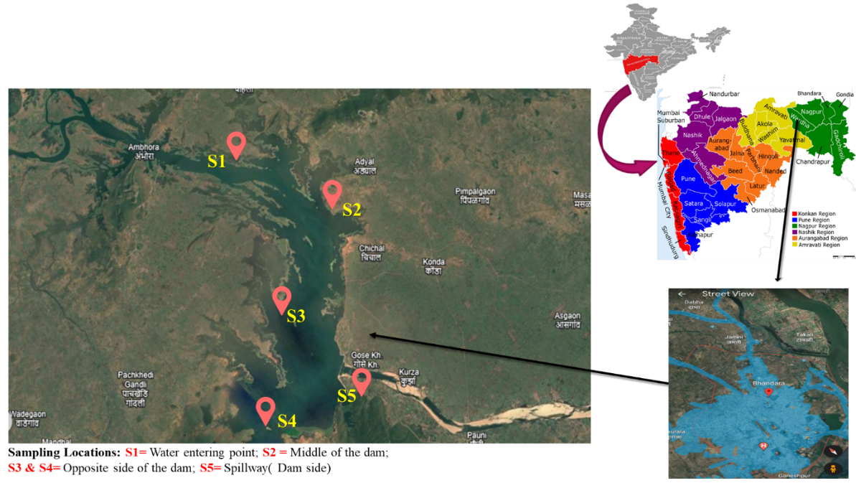

2.2 How often and when to sample
We took water samples from all five monitoring stations (S1–S5) during a coordinated monitoring campaign conducted under stable weather conditions, thereby reducing the time required for sample collection. We took all of the samples collected in the morning (8:00 AM to 10:00 AM) to make sure that the diurnal values were the same. The sample took place over eighteen months, from January 2024 to June 2025, and included several seasonal and hydrological phases.

2.3 Physicochemical Parameters:
To evaluate the ecological status and water quality of the selected reservoirs, a comprehensive set of physicochemical parameters was analyzed. These parameters were selected based on their ecological relevance, sensitivity to environmental changes, and their ability to reflect the trophic condition and habitat suitability for aquatic organisms. Each parameter offers insight into critical processes such as buffering capacity, oxygen dynamics, ionic content, and light penetration, which collectively influence biological productivity and species distribution. All parameters were assessed following the protocols prescribed by the American Public Health Association (APHA, 1985), ensuring standardization and comparability across sampling sites and periods. Collectively, these parameters provide an integrated understanding of the limnological conditions prevailing in the reservoirs and form the foundation for further ecological interpretation, conservation planning, and fisheries management.

2.4 Sample Collection
2.4.1 Water Sampling Protocol
Surface water samples were obtained at a depth of approximately 30 cm using acid-washed, pre-cleaned 1 L polyethylene bottles. Before sampling, bottles were rinsed thrice with sample water to eliminate residual contaminants. The sampling depth was selected to avoid surface interference. Samples were immediately stored in insulated containers at 4 °C and conveyed to the laboratory for analysis within 12 hours of collection.

2.5 Data Analysis
The hydrological dataset collected from the five sampling stations (S1–S5) was subjected to a comprehensive statistical analysis to evaluate spatial variation and identify underlying patterns among the measured parameters. The analytical workflow was structured into two major components: 1. Descriptive Statistics: To summarize and explore the central tendencies, dispersion, and range of individual parameters. 2. Multivariate Analysis (Principal Component Analysis, PCA): This is used to find correlations or gradients in the dataset over time and space and to reduce the number of dimensions. This dual approach enabled both univariate insights and holistic pattern recognition, forming the basis for subsequent interpretation of ecological processes within the reservoir system.

2.5.1. Descriptive Statistical Analysis
Descriptive statistics were employed to evaluate the central tendency and variability of six hydrological parameters: dissolved oxygen (DO), pH, alkalinity, transparency, temperature, and electrical conductivity (EC). Data from five monitoring sites (S1–S5) were analyzed using Microsoft Excel and SPSS. Key statistical descriptors such as mean, minimum, maximum, range, and standard deviation (SD) were computed to establish baseline water quality conditions and identify potential anomalies. A multi-panel heatmap was used to visualize spatial and temporal trends, while seasonal variability was assessed through boxplots categorized by Indian climatic seasons (Winter, Summer, Monsoon, and Post-Monsoon). A Pearson correlation matrix was also developed to examine interrelationships among parameters, with results presented in a correlation heatmap for easier interpretation of co-varying variables and possible biogeochemical linkages.

2.5.2 Multivariate analysis
a. Principal Component Analysis
Principal Component Analysis was applied using the prompt () function in SPSS to identify patterns as well as to reduce dimensionality in the hydrological dataset. Prior to analysis, all parameters were standardized via z-score transformation to eliminate scale effects. Due to differing measurement units, the correlation matrix was used instead of the covariance matrix.

2.5.4 Site Clustering and Ecological Interpretation
To visually interpret the results of Principal Component Analysis (PCA), a biplot was created, plotting the sampling data in a two-dimensional ordination space defined by the first two principal components (PC1 and PC2). In the PCA biplot, each point represents a specific sampling site and month, projected into a reduced two-dimensional space defined by the first two principal components. This spatial arrangement allows for the visualization of similarities or differences in hydrological profiles across time and location. Superimposed on this ordination are red arrows representing the six hydrological parameters, where the direction and length of each arrow indicate the magnitude and orientation of that parameter’s influence on the dataset. Parameters pointing in similar directions suggest positive correlations, while opposing vectors reflect negative associations. The biplot thus provides an intuitive overview of how different environmental variables interact and contribute to the observed variation in reservoir conditions.

3. results and discussion
3.1.1Statistical summary of hydrological parameter across five sampling stations
The analysis of six core hydrological parameters, i.e., dissolved oxygen (DO), pH, alkalinity, transparency, temperature, and electrical conductivity (EC), revealed distinct spatio-temporal variations across the five sampling stations (S1–S5) over the 18-month monitoring period.

Table 1: Spatio–temporal variations of alkalinity (mg/L) across sampling stations

Month Station | Jan-24 | Feb-24 | Mar-24 | Apr-24 | May-24 | Jun-24 | Jul-24 | Aug-24 | Sep-24 | Oct-24 | Nov-24 | Dec-24 | Jan-25 | Feb-25 | Mar-25 | Apr-25 | May-25 | Jun-25
S1 | 142 | 153 | 115 | 177 | 123 | 95 | 98 | 111 | 87 | 120 | 140 | 151 | 156 | 145 | 134 | 156 | 145 | 97
S2 | 136 | 167 | 118 | 176 | 126 | 98 | 96 | 102 | 90 | 134 | 134 | 144 | 159 | 154 | 145 | 150 | 149 | 99
S3 | 123 | 170 | 111 | 117 | 145 | 97 | 95 | 97 | 94 | 143 | 156 | 156 | 155 | 146 | 145 | 167 | 145 | 95
S4 | 123 | 166 | 114 | 115 | 124 | 100 | 101 | 96 | 96 | 138 | 123 | 140 | 152 | 145 | 143 | 162 | 138 | 98
S5 | 127 | 162 | 117 | 119 | 145 | 99 | 105 | 87 | 98 | 132 | 140 | 166 | 145 | 154 | 145 | 176 | 157 | 102

Alkalinity values fluctuated between 87 and 177 mg/L, with peak levels observed during the pre-monsoon months (March–April), especially at Stations S1 and S2 (Table 1). This trend reflects heightened carbonate buffering capacity, likely due to increased photosynthetic activity and geochemical weathering. Conversely, a clear decline in alkalinity was recorded during the monsoon (June–September), indicating dilution from rainwater and surface runoff.

Table 2: Spatio–temporal variations of pH across sampling stations
Month Station | Jan-24 | Feb-24 | Mar-24 | Apr-24 | May-24 | Jun-24 | Jul-24 | Aug-24 | Sep-24 | Oct-24 | Nov-24 | Dec-24 | Jan-25 | Feb-25 | Mar-25 | Apr-25 | May-25 | Jun-25
S1 | 6.74 | 7.11 | 7.19 | 7.50 | 7.10 | 7.20 | 6.80 | 6.90 | 7.10 | 7.10 | 6.80 | 7.30 | 6.76 | 7.00 | 7.20 | 7.35 | 7.30 | 7.00
S2 | 6.42 | 7.58 | 7.00 | 7.51 | 7.21 | 7.00 | 7.20 | 6.60 | 6.90 | 6.40 | 6.80 | 7.32 | 7.00 | 6.90 | 7.28 | 7.42 | 7.21 | 6.90
S3 | 6.63 | 7.45 | 7.85 | 7.68 | 7.25 | 7.10 | 6.80 | 7.20 | 6.40 | 7.00 | 7.20 | 7.35 | 7.20 | 6.85 | 7.56 | 7.32 | 7.23 | 6.99
S4 | 6.40 | 7.57 | 7.11 | 7.34 | 7.47 | 7.20 | 6.50 | 7.10 | 6.70 | 7.10 | 6.90 | 7.38 | 6.65 | 7.80 | 7.45 | 7.24 | 6.56 | 6.55
S5 | 6.50 | 7.56 | 7.10 | 7.42 | 7.48 | 6.90 | 6.40 | 6.80 | 6.60 | 6.90 | 7.10 | 7.20 | 6.51 | 7.49 | 7.56 | 7.26 | 7.21 | 7.10

The pH values from 6.40 to 7.85, remaining within neutral to slightly alkaline range across all sites (Table 2). Higher pH readings were generally recorded during the spring and early summer (March–May), particularly at S3 and S4, likely driven by algal photosynthesis reducing CO₂ levels. In contrast, slightly acidic conditions emerged during monsoon months, associated with increased organic input and microbial respiration.

Table 3: Spatio–temporal variations of DO across sampling stations
Month Station | Jan-24 | Feb-24 | Mar-24 | Apr-24 | May-24 | Jun-24 | Jul-24 | Aug-24 | Sep-24 | Oct-24 | Nov-24 | Dec-24 | Jan-25 | Feb-25 | Mar-25 | Apr-25 | May-25 | Jun-25
S1 | 6.5 | 5.5 | 5.02 | 5.28 | 5.26 | 5.5 | 2.9 | 4.5 | 5 | 6.22 | 5.8 | 5.21 | 5.8 | 5.25 | 5.25 | 4.57 | 5 | 5.3
S2 | 5.6 | 5 | 5 | 5.4 | 6.1 | 5.17 | 3 | 3.9 | 4.5 | 6.71 | 4.7 | 4.88 | 5.81 | 5.78 | 4.3 | 3.37 | 5.2 | 5.5
S3 | 5 | 5.2 | 4.4 | 5.5 | 6.7 | 6.67 | 3.7 | 3.77 | 3.9 | 5.24 | 3.9 | 4.7 | 4.9 | 4.65 | 5.26 | 3.7 | 4 | 4.9
S4 | 4.85 | 3.63 | 4.8 | 5.6 | 5.56 | 5.55 | 2.55 | 3.58 | 4.4 | 4.72 | 4 | 3.81 | 5.5 | 4.3 | 6.3 | 4.25 | 4.3 | 4.8
S5 | 6.5 | 6 | 5 | 6.7 | 5.56 | 4.5 | 2.3 | 3.31 | 5 | 5 | 4.5 | 3.8 | 5.3 | 4.55 | 5.25 | 4.3 | 5 | 5.2

Dissolved oxygen (DO) showed notable seasonal and spatial variation, with values from 2.3 mg/L to 6.7 mg/L (Table 3). Higher DO levels were measured during winter (January–February) across most stations due to cooler water temperatures enhancing oxygen solubility. In contrast, substantial DO depletion occurred in summer and monsoon (May–August), most severely at S4 and S5, possibly due to thermal stratification and elevated biological oxygen demand.

Table 4: Spatio–temporal variations of Temperature across sampling stations
Month Station | Jan-24 | Feb-24 | Mar-24 | Apr-24 | May-24 | Jun-24 | Jul-24 | Aug-24 | Sep-24 | Oct-24 | Nov-24 | Dec-24 | Jan-25 | Feb-25 | Mar-25 | Apr-25 | May-25 | Jun-25
S1 | 24.0 | 22.1 | 25.0 | 27.0 | 30.0 | 28.0 | 23.2 | 22.1 | 23.1 | 22.0 | 23.2 | 21.7 | 23.4 | 24.6 | 27.2 | 32.0 | 33.0 | 23.0
S2 | 23.5 | 22.7 | 24.0 | 28.0 | 28.0 | 27.0 | 24.1 | 23.3 | 22.4 | 23.4 | 24.1 | 21.9 | 24.0 | 25.9 | 26.5 | 30.0 | 32.0 | 25.0
S3 | 24.4 | 24.2 | 28.0 | 29.0 | 29.0 | 29.0 | 22.0 | 24.3 | 24.5 | 22.6 | 25.3 | 22.0 | 23.7 | 25.2 | 28.9 | 29.1 | 32.0 | 23.3
S4 | 23.7 | 22.8 | 27.0 | 27.0 | 29.5 | 28.0 | 24.0 | 24.5 | 25.3 | 25.1 | 24.1 | 21.8 | 24.8 | 25.1 | 28.0 | 28.0 | 31.0 | 24.2
S5 | 22.2 | 23.7 | 28.0 | 25.0 | 30.5 | 27.0 | 24.0 | 23.2 | 21.5 | 24.7 | 25.3 | 22.2 | 24.5 | 26.1 | 29.0 | 27.1 | 32.2 | 21.5

Water temperature followed a clear seasonal pattern, ranging from 21.5°C to 33.0°C (Table 4). The highest temperatures were recorded during April–May at Stations S1 and S2, while the lowest were recorded during the winter months, particularly at S5. Temperature patterns directly influenced DO solubility and, to some extent, biological activity.
Table 5: Spatio–temporal variations of Electrical conductivity across sampling stations

Month Station | Jan-24 | Feb-24 | Mar-24 | Apr-24 | May-24 | Jun-24 | Jul-24 | Aug-24 | Sep-24 | Oct-24 | Nov-24 | Dec-24 | Jan-25 | Feb-25 | Mar-25 | Apr-25 | May-25 | Jun-25
S1 | 324 | 310 | 400 | 423 | 432 | 400 | 350 | 345 | 365 | 323 | 321 | 325 | 312 | 321 | 432 | 451 | 438 | 431
S2 | 320 | 312 | 423 | 421 | 423 | 388 | 355 | 349 | 356 | 322 | 324 | 326 | 324 | 324 | 430 | 435 | 430 | 430
S3 | 321 | 314 | 429 | 435 | 426 | 389 | 345 | 345 | 367 | 327 | 321 | 321 | 327 | 334 | 421 | 431 | 437 | 456
S4 | 325 | 312 | 401 | 422 | 412 | 350 | 347 | 365 | 345 | 321 | 320 | 322 | 324 | 321 | 455 | 421 | 432 | 435
S5 | 320 | 314 | 423 | 421 | 425 | 354 | 342 | 342 | 351 | 320 | 324 | 324 | 325 | 324 | 422 | 425 | 435 | 442

Electrical conductivity (EC) varied between 310 and 456 S/m, with higher values observed during the drier summer months (March–May), particularly at S3 and S4 (Table 5). These trends suggest an increased ionic concentration from evaporation and mineralization. Lower EC values occurred during early monsoon (June–July), reflecting dilution from fresh inflows.

Table 6: Spatio–temporal variations of Transparency across sampling stations

Month Station | Jan-24 | Feb-24 | Mar-24 | Apr-24 | May-24 | Jun-24 | Jul-24 | Aug-24 | Sep-24 | Oct-24 | Nov-24 | Dec-24 | Jan-25 | Feb-25 | Mar-25 | Apr-25 | May-25 | Jun-25
S1 | 200 | 180 | 180 | 165 | 140 | 70 | 87 | 90 | 86 | 110 | 125 | 112 | 145 | 156 | 176 | 60 | 79 | 67
S2 | 240 | 170 | 175 | 170 | 135 | 90 | 89 | 94 | 81 | 125 | 134 | 113 | 134 | 167 | 167 | 69 | 120 | 72
S3 | 211 | 165 | 150 | 180 | 137 | 87 | 72 | 80 | 84 | 123 | 123 | 117 | 145 | 169 | 168 | 75 | 100 | 70
S4 | 215 | 150 | 155 | 170 | 143 | 81 | 84 | 86 | 87 | 124 | 145 | 123 | 125 | 165 | 167 | 80 | 97 | 69
S5 | 218 | 146 | 165 | 167 | 132 | 89 | 87 | 85 | 90 | 135 | 135 | 123 | 124 | 168 | 178 | 78 | 115 | 65

Transparency exhibited a wide range from 60 to 240 cm (Table 6). Maximum water clarity occurred during the dry winter season (January–February), especially at Station S2, likely due to minimal disturbance and sedimentation. In contrast, the monsoon months (June–August) were marked by significantly reduced transparency across all stations due to suspended solids from surface runoff. Among all sites, S2 consistently exhibited the clearest water, while S5 experienced the most turbidity, possibly due to catchment land use and inflow characteristics. These collective observations underscore the dynamic interplay of seasonal cycles, site-specific characteristics, and catchment processes in shaping the hydrological profile of the study area.

3.1.2 Spatiotemporal combined heat map of six hydrological parameters
Overall, a combined multi-panel heatmap showed significant spatio-temporal variations of six hydrological parameters across five stations (S1–S5) from January 2024 to June 2025 (Figure 2).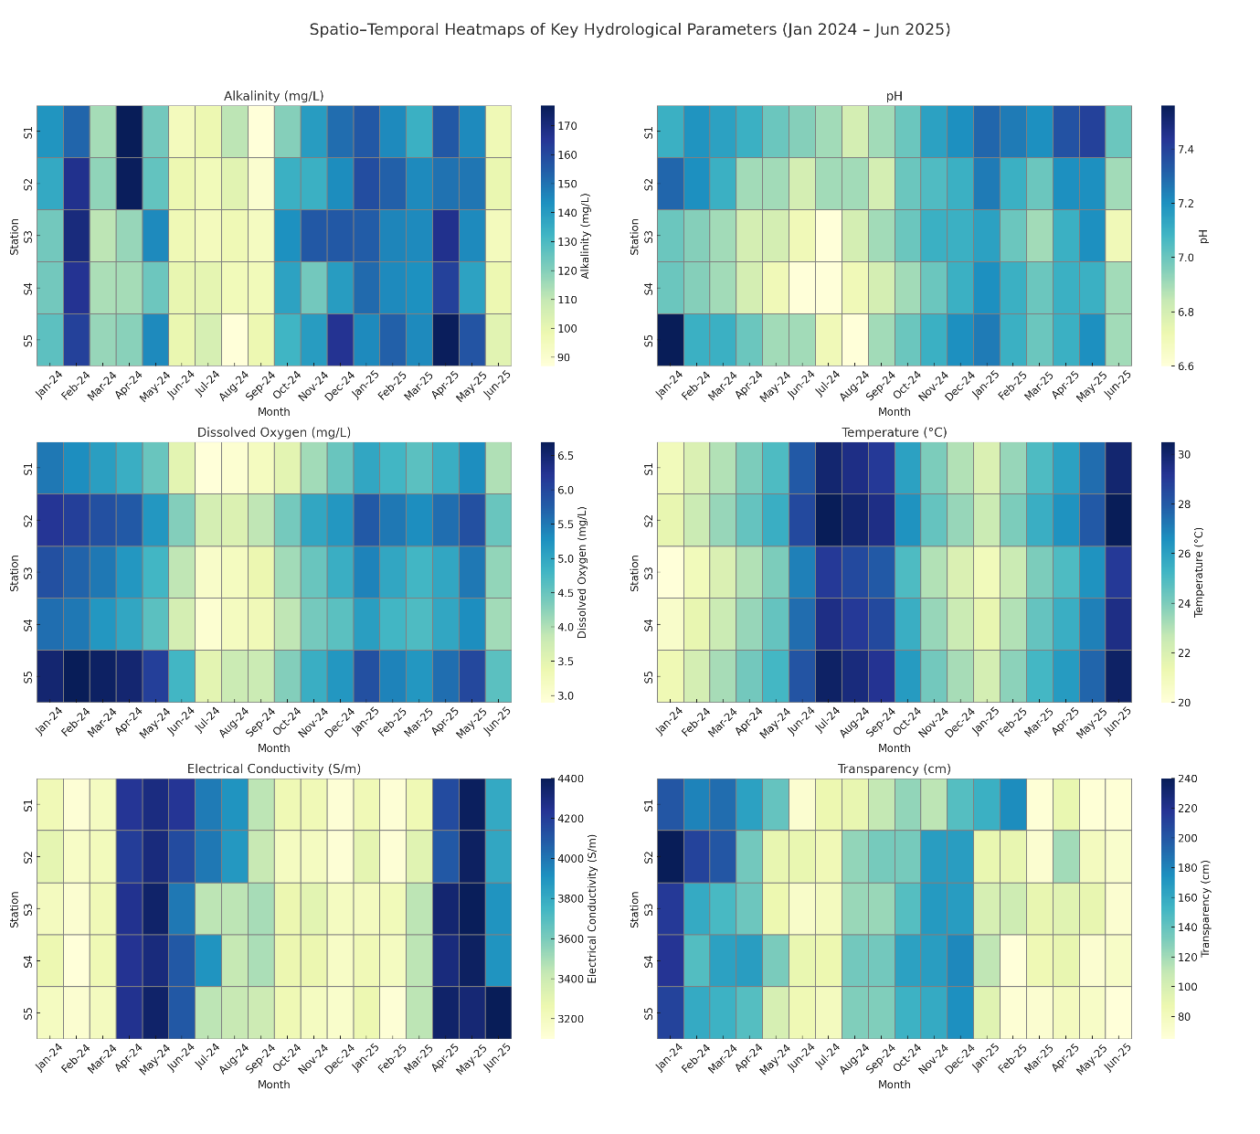
Figure 2. Combined Multipanel Heatmaps of Six Hydrological Parameters
The multi-panel heatmap illustrates spatio-temporal variations of six key hydrological parameters i.e. Alkalinity (mg/L), pH, Dissolved Oxygen (mg/L), Temperature (°C), Electrical Conductivity (S/m), and Transparency (cm) across five sampling stations (S1–S5) over 18 months (January 2024 to June 2025). Each panel represents a single parameter, with months along the X-axis and stations along the Y-axis. Color gradients depict the magnitude of each parameter, enabling easy comparison of seasonal patterns and station-specific anomalies.

3.1.3 Seasonal Boxplots of Hydrological Parameters
The seasonal boxplots provided a comparative visualization of hydrological parameter distributions across the four defined seasons- the winter, summer, monsoon, and the post-monsoon (Figure 3).
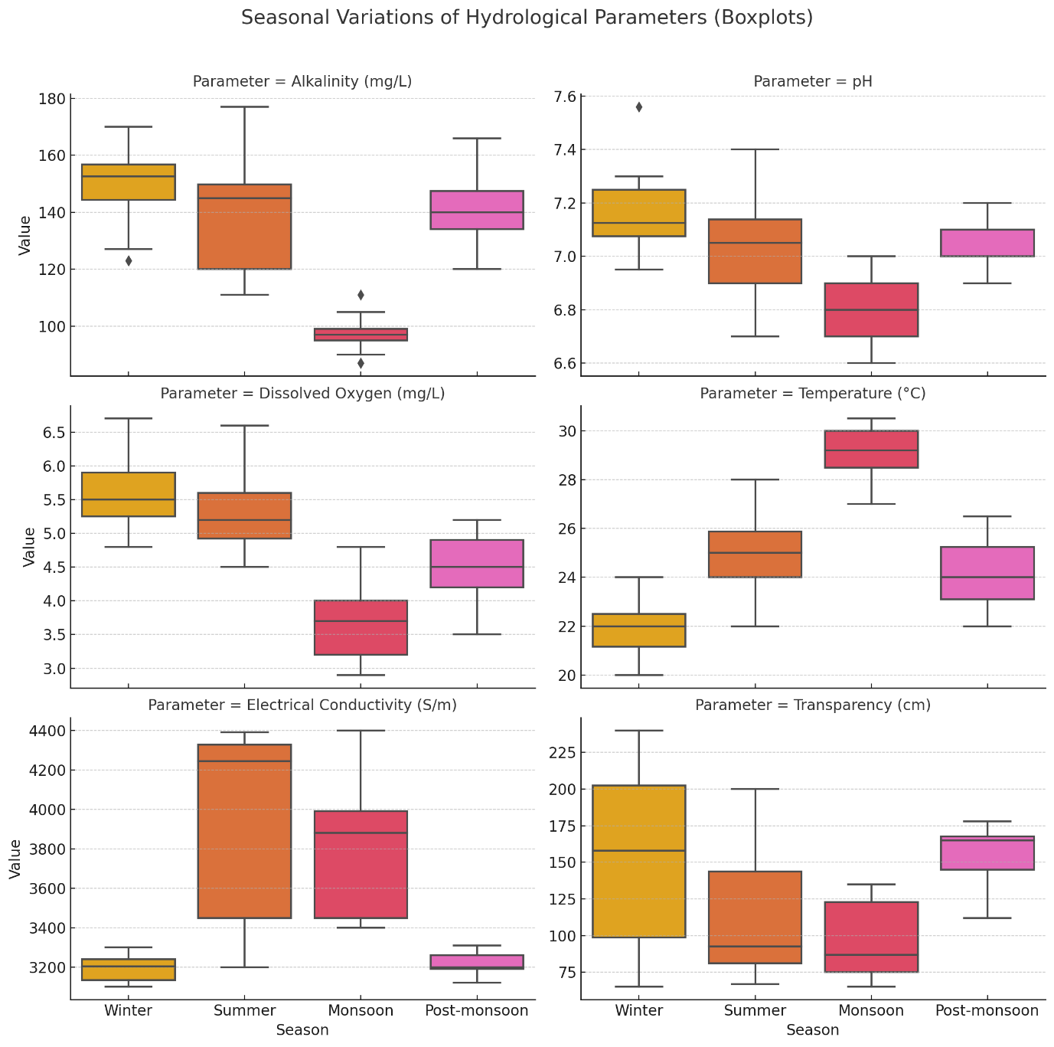
Figure 3. Seasonal Boxplots of Hydrological Parameters
Boxplots highlighting patterns such as increased temperature in summer, reduced DO in warm or eutrophic months, and lowered transparency during monsoon due to increased turbidity.
3.1.4 Correlation Matrix of Hydrological Parameters
The correlation matrix of hydrological parameters reveals several notable relationships among the six variables studied across all sampling stations (Figure 4)
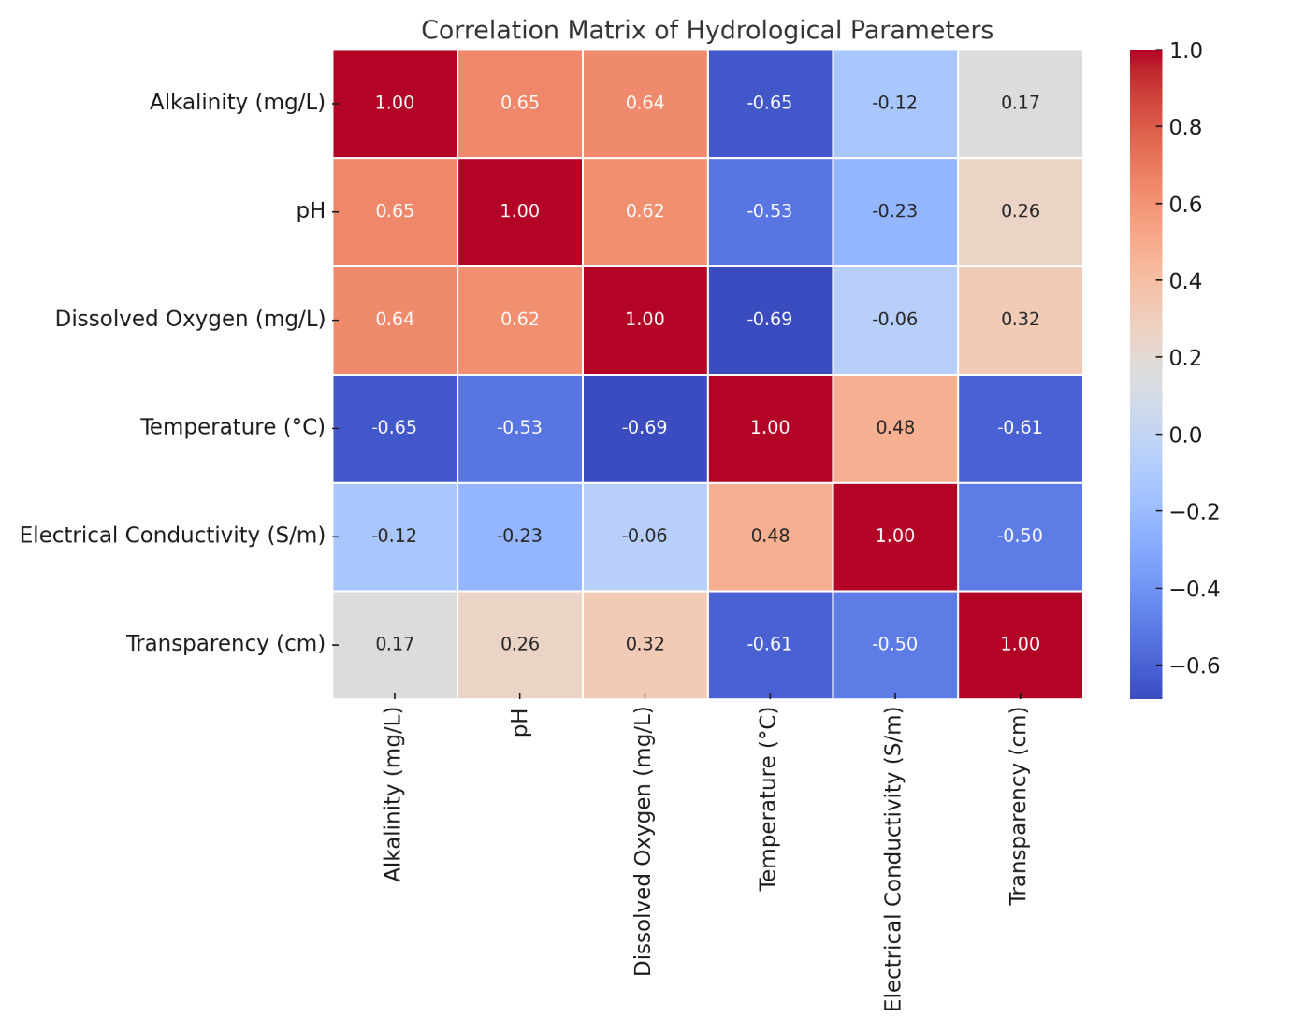
Figure 4: Pearson Correlation Matrix of Hydrological Parameters
The heatmap shows pairwise Pearson correlation coefficients among six important hydrological parameters measured from January 2024 to June 2025 across five stations. A large negative correlation between temperature and dissolved oxygen (r = –0.69) exist, and there are also positive relationships between alkalinity, pH, and DO. Transparency exhibits a moderate inverse relationship with temperature and conductivity, reflecting seasonal and turbidity-driven changes.
Alkalinity exhibited a strong positive correlation with both pH (r =0.65) and dissolved oxygen (r=0.64), suggesting that waters with higher buffering capacity also tended to support better oxygenation and maintain more neutral to slightly basic pH levels. On the other hand, temperature exhibited a robust negative correlation with DO (r = -0.69) and alkalinity (r = -0.65), indicating that warmer waters are generally less oxygenated and possess lower buffering potential. Electrical conductivity (EC) had a moderate positive correlation with temperature (r = 0.48), implying that higher temperatures may be associated with increased ionic concentrations, possibly due to enhanced mineral dissolution. Transparency was positively related to DO (r = 0.32) and pH (r = 0.26), while showing a negative relationship with temperature (r = -0.61) and EC (r = -0.50), suggesting clearer water tends to occur in cooler, less mineral-rich conditions. These findings align with established ecological principles and provide foundational insights for subsequent multivariate analyses.

3.2. Principal Component Analysis
The Principal Component Analysis biplot provided a visual summary of the multivariate relationships among the six measured hydrological parameters across different months (Figure 5).
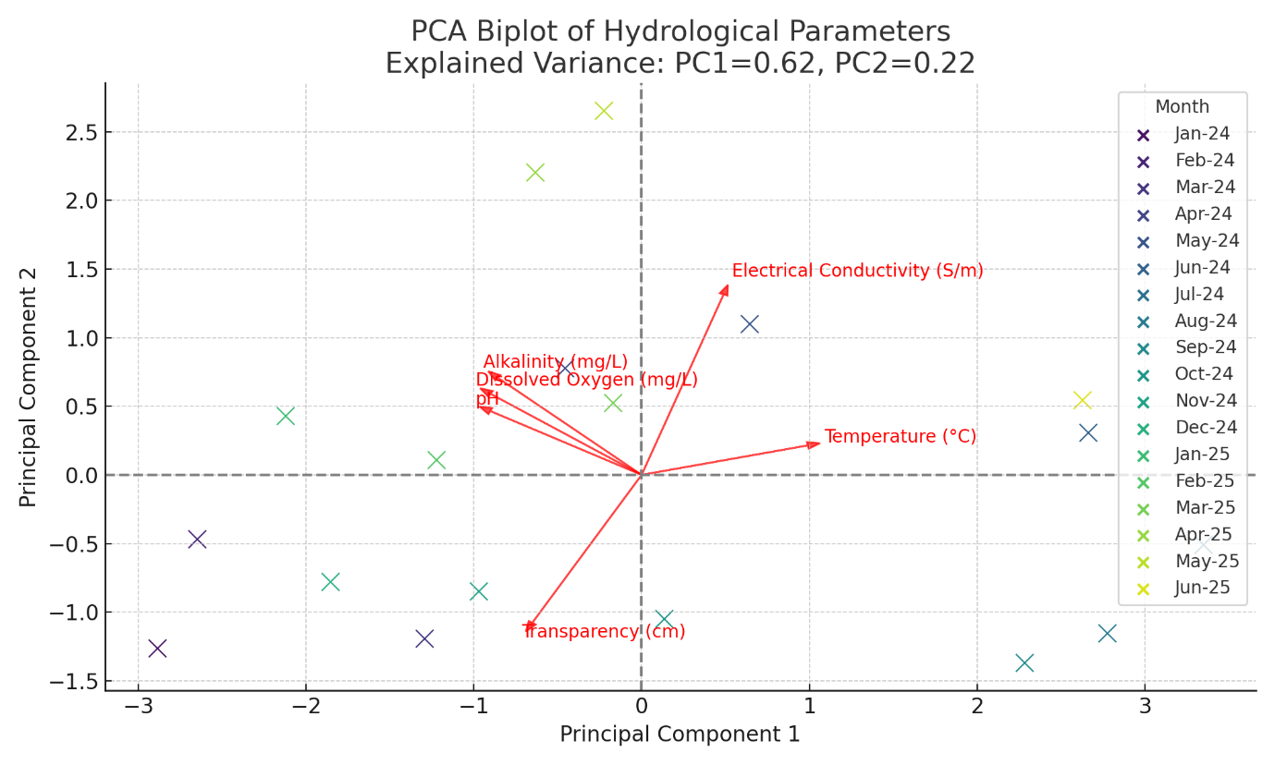
Figure 5. PCA Biplot for hydrological parameters
This PCA biplot visualizes how monthly observations (colored by month) are distributed across two principal components (PC1 and PC2), which together explain 84% of the total variance in the dataset (PC1 = 62%, PC2 = 22%). Red arrows represent the hydrological parameters, showing their contribution to the principal components.

The first two principal components (PC1 and PC2) explain a cumulative 84% of the total variance (PC1: 62%, PC2: 22%), effectively capturing the dominant gradients in the dataset. PC1 primarily represents a thermal-chemical axis, positively associated with temperature and electrical conductivity, and negatively correlated with dissolved oxygen (DO), alkalinity, and pH. This pattern highlights the seasonal contrast, where summer months (April–June) exhibit high temperatures and mineral content but reduced oxygen and buffering capacity, resulting in their placement on the right-hand side of the biplot. Conversely, winter months (January–February), characterized by lower temperatures and higher DO and alkalinity, are positioned toward the left.
PC2, on the other hand, captures an optical–ionic gradient, strongly influenced by transparency (negatively) and electrical conductivity (positively). Monsoon and post-monsoon months (July–September) tend to group in the lower-left quadrant, corresponding with increased turbidity and moderate conductivity due to rainfall-driven inflows. The orientation and length of the red vectors (representing the hydrological parameters) indicate the relative strength and direction of their contributions to the principal components. Acute angles between vectors (e.g., between alkalinity and DO) suggest a positive correlation, while opposing directions (e.g., temperature and DO) confirm strong negative relationships. Overall, the PCA biplot reveals clear seasonal clustering of months and highlights temperature, DO, and transparency as the most influential parameters shaping hydrological variability across the reservoir system.
The spatio-temporal analysis of hydrological parameters in the Gosekhurd Reservoir reveals significant seasonal and site-specific variations, reflecting complex interactions among climatic conditions, catchment characteristics, and internal reservoir processes. These observations align with previous studies that underscore the dynamic nature of freshwater ecosystems and their sensitivity to both natural and anthropogenic drivers (Wetzel, 2001; Shrestha & Kazama, 2007). Notably, seasonal hydrological shifts have been shown to directly influence fish migration and aggregation patterns, thereby affecting catch rates (Mohanty et al., 2017; Kumar et al., 2020).
Fish production in reservoir ecosystems is intricately linked to fluctuations in key hydrological variables such as dissolved oxygen (DO), pH, alkalinity, transparency, temperature, and electrical conductivity (EC). Temperature modulates biological functions including metabolism, feeding, and reproduction, ultimately driving seasonal variation in fish abundance (Dey et al., 2020). Adequate DO levels are essential for fish survival, and their depletion often caused by thermal stratification or eutrophication, can result in physiological stress or fish mortality (Patra et al., 2021). pH and alkalinity affect nutrient cycling and ammonia toxicity; optimal conditions enhance fish health and reproductive success (Sarka`r et al., 2017). Electrical conductivity (EC), which reflects the total ionic concentration, provides an indirect indication of nutrient status and influences plankton availability, an essential food source for many fish species (Nath et al., 2023). Transparency, governed by light penetration and turbidity, plays a pivotal role in regulating primary productivity and supporting higher trophic levels (Singh et al., 2022). The interactions among these parameters create the ecological foundation necessary for sustaining fish populations in reservoir environments.
One of the most prominent findings of this study is the antithetical relationship observed between temperature and the DO. The DO concentrations were notably lower during the summer and monsoon months, particularly at stations S4 and S5. Elevated temperatures reduce the solubility of oxygen and promote thermal stratification, which restricts vertical mixing and oxygen replenishment in bottom layers (Boyd, 1990; Wetzel, 2001). Additionally, higher biological oxygen demand during warmer periods—driven by increased microbial activity and organic matter decomposition can further exacerbate oxygen depletion, potentially leading to localized hypoxia. Similar seasonal DO declines have been documented in tropical and subtropical reservoirs globally (Vega et al., 1998; Sharma et al., 2014).
A positive correlation between alkalinity, pH, and DO was particularly evident during the pre-monsoon months at stations S1–S3. This suggests that areas with higher buffering capacity tend to maintain more stable pH levels and higher oxygen availability. Photosynthetic activity by phytoplankton and aquatic macrophytes during this period may reduce CO₂ concentrations, thereby increasing pH and enhancing carbonate alkalinity (Carlson, 1977; Liu et al., 2003). These interdependencies are well-established in limnological studies, where biological and geochemical processes jointly regulate diel and seasonal water chemistry.
Electrical conductivity values increased noticeably during the dry summer months, likely due to over concentration and mineral dissolution processes. As water volume declines, dissolved ions become more concentrated a trend previously reported in Indian reservoirs during extended dry spells (Lumb et al., 2006; Sharma et al., 2014). Conversely, EC values were at their lowest during the early monsoon, reflecting the dilution effect from inflowing freshwater.
Transparency, measured via Secchi depth, was highest during the winter and lowest during the monsoon, particularly at station S5. This seasonal drop in transparency is attributed to suspended solids, resuspension of bottom sediments, and runoff-borne turbidity (Shrestha & Kazama, 2007). These conditions restrict light penetration, which in turn limits photosynthetic activity and affects benthic ecosystem processes. Reduced water clarity during nutrient-rich conditions may also indicate algal blooms or detrital accumulation.
The results of Principal Component Analysis (PCA) further supported these interpretations. The first two principal components elucidated 84% of the total variance—PC1 representing a thermal–chemical gradient dominated by temperature and EC, and PC2 capturing an optical–ionic gradient influenced by transparency and associated parameters. The clear seasonal clustering of sampling months on the PCA biplot underscores the influence of monsoonal dynamics on reservoir limnology, consistent with patterns observed in other Asian and North American reservoirs (Liu et al., 2003; Vega et al., 1998).
Spatial heterogeneity in hydrological quality was also evident from the PCA ordination, particularly the consistent clustering of stations S4 and S5. These stations recorded lower DO and reduced transparency, suggesting potential localized eutrophication, sediment loading, or anthropogenic runoff. Such site-specific degradation emphasizes the importance of targeted monitoring and adaptive management strategies (Sharma et al., 2014).
In conclusion, the findings of this study align with established limnological frameworks and highlight the value of integrating classical and multivariate statistical approaches in reservoir monitoring. The observed seasonal trends and interlinked hydrological parameters provide a robust basis for designing ecosystem-based management interventions especially under the increasing pressures of climate variability and changing land-use patterns within the reservoir catchment.

4. Conclusion
The findings underscore the pivotal role of temperature in modulating other hydrological parameters. A strong inverse relationship between temperature and DO, alkalinity, and transparency suggests that warmer months are associated with reduced oxygen availability, diminished buffering capacity, and increased turbidity—conditions that can adversely impact aquatic ecosystem health. Conversely, winter months exhibited enhanced DO levels and greater transparency, likely due to lower thermal stress and reduced biological oxygen demand.
The correlation matrix highlighted synergistic interactions among pH, alkalinity, and DO, reinforcing the importance of carbonate buffering systems in maintaining chemical stability and oxygenation. Transparency also emerged as an ecologically sensitive indicator, responding to both physical (e.g., runoff, sediment load) and chemical (e.g., ionic concentration) drivers.
Principal Component Analysis (PCA) effectively reduced dataset complexity and revealed that the first two principal components accounted for 84% of the total variance. PC1 captured a thermal–chemical gradient dominated by temperature and EC, while PC2 reflected an optical–ionic axis shaped by transparency and EC. Seasonal clustering along these axes provided clear visual evidence of the reservoir’s hydrological transitions, particularly the contrast between dry and monsoon periods.
Ecologically, the low DO and transparency levels observed at Stations S4 and S5 during summer and monsoon suggest localized eutrophication, potentially driven by organic enrichment and reduced water column mixing. These spatial patterns emphasize the importance of targeted monitoring and catchment management, particularly in regions prone to anthropogenic influence.
Overall, the integration of classical statistics and PCA offered robust insights into the temporal variability and ecological functioning of the Gosekhurd Reservoir. These findings not only enhance our understanding of reservoir limnology but also offer a scientific basis for developing adaptive water quality monitoring frameworks. Continued and expanded surveillance of these key parameters is essential for early detection of ecological shifts and for guiding sustainable management practices in large reservoir systems like Gosekhurd.

COMPETING INTERESTS DISCLAIMER:
Authors have declared that they have no known competing financial interests OR non-financial interests OR personal relationships that could have appeared to influence the work reported in this paper.

References
Boyd, C. E. (1990). Water quality in ponds for aquaculture. Alabama Agricultural Experiment Station, Auburn University.

Carlson, R. E. (1977). A trophic state index for lakes. Limnology and Oceanography, 22(2), 361–369.

Dey, S., Banerjee, P., Kumar, R., & Singh, M. (2020). Seasonal variation in physicochemical parameters and its impact on fish diversity in Indian reservoirs. Journal of Environmental Biology, 41(5), 1023–1031.

Huang, F., Wang, X. Q., Lou, L. P., Zhou, Z. Q., & Wu, J. P. (2010). Spatial variation and source apportionment of water pollution in Qiantang River (China) using statistical techniques. Water Research, 44(5), 1562–1572.

Jarvie, H. P., Whitton, B. A., & Neal, C. (1998). Nitrogen and phosphorus in east coast British rivers: Speciation, sources and biological significance. Science of the Total Environment, 210/211, 79–109.

Liu, C. W., Lin, K. H., & Kuo, Y. M. (2003). Application of factor analysis in the assessment of groundwater quality in a blackfoot disease area in Taiwan. Science of the Total Environment, 313(1–3), 77–89.

Lumb, A., Halliwell, D., & Sharma, T. (2006). Application of CCME water quality index to monitor water quality: A case study of the Mackenzie River Basin, Canada. Environmental Monitoring and Assessment, 113(1–3), 411–429.

Nath, D., Pradhan, R., Sinha, T., & Barman, A. (2023). Electrochemical properties and trophic status of Indian freshwater bodies. Limnology and Oceanography Bulletin, 32(1), 25–35.

Ouyang, Y., Nkedi-Kizza, P., Wu, Q. T., Shinde, D., & Huang, C. H. (2006). Assessment of seasonal variations in surface water quality. Water Research, 40(20), 3800–3810.

Patra, R. W., Mehta, A., Ghosh, N., & Reddy, B. P. (2021). Oxygen dynamics and fish stress in freshwater reservoirs. Aquatic Ecology, 55(3), 355–366.

Ravichandran, S. (2003). Hydrological influences on the water quality trends in Tamiraparani Basin, South India. Environmental Monitoring and Assessment, 87(3), 293–309.

Sarkar, S., Choudhury, M., Bhattacharjee, S., & Verma, D. (2017). Influence of limnological parameters on reservoir fish productivity. Environmental Monitoring and Assessment, 189(12), 657.

Sharma, D., Kansal, A., & Meenakshi. (2014). Water quality assessment of river Yamuna using water quality index in the National Capital Territory, India (2000–2009). Applied Water Science, 5, 41–50.

Shin, P. K. S., & Fong, K. Y. S. (1999). Multiple discriminant analysis of marine sediment data. Marine Pollution Bulletin, 39(1–2), 285–294.

Shrestha, S., & Kazama, F. (2007). Assessment of surface water quality using multivariate statistical techniques: A case study of the Fuji River Basin, Japan. Environmental Modelling & Software, 22(4), 464–475.

Singh, A. K., Dubey, R., Yadav, L., & Shankar, P. (2022). Light penetration, transparency and primary productivity in relation to fish yield. Aquatic Ecosystem Health & Management, 25(2), 190–198.

Vega, M., Pardo, R., Barrado, E., &Debán, L. (1998). Assessment of seasonal and polluting effects on the quality of river water by exploratory data analysis. Water Research, 32(12), 3581–3592.

Wetzel, R. G. (2001). Limnology: Lake and river ecosystems (3rd ed.). Academic Press.

Zhang, Y., Guo, F., Meng, W., & Wang, X. Q. (2009). Water quality assessment and source identification of Daliao River Basin using multivariate statistical methods. Environmental Monitoring and Assessment, 152(1–4), 105–121.

