Studies on Genotype x Environment Interaction (G X E) in Selected Silkworm Hybrid FC1×FC2 and FC2×FC1: A Preliminary Approach

ABSTRACT: Genotype × Environment Interaction (G × E) plays a vital role while determining the vigor and suitability of silkworm hybrids under varied environmental conditions. This preliminary study was conducted to evaluate the influence of G × E interaction on two silkworm hybrids, FC1×FC2 and FC2×FC1, reared under the sub-temperate climatic conditions of the Poonch district of Jammu and Kashmir. The results revealed noticeable differences in hybrid performance in response to environmental variables, highlighting the sensitivity of seasonal factors such as temperature, humidity, and rearing season. The study emphasizes the need for region-specific evaluation of silkworm hybrids to enhance cocoon yield and silk quality under variable environmental conditions which indicates the significant difference between the hybrids, showing unique responses to the prevailing seasonal factors while underscoring the importance of understanding G × E interactions in silkworm breeding programs aimed at improving hybrid performance and stability across diverse agro-climatic zones.
Keywords: Genotype, Environment, Interaction, Vigor, Breeding, Performance.
INTRODUCTION
The mulberry silkworm (Bombyx mori) is a commercially exploited lepidopteran species extensively used for silk production worldwide. This monophagous insect is highly specialized, for construction of cocoon, from which the silk filament is extracted (Suresh et al., 2002 & Dayananda et al., 2011). The growth and sustainability of the silk industry are contingent upon the availability of genetically superior silkworm breeds, improved mulberry varieties for enhanced leaf quality, and optimal rearing practices. The productivity of the mulberry silkworm, Bombyx mori L., is highly influenced by environmental conditions (Shabir et al., 2017), directly affecting its growth rate, cocoon formation, and silk quality (Datta et al., 2000b). Environmental parameters such as temperature, humidity, light, and quality of mulberry leaves significantly determine the physiological and metabolic processes of the silkworm during different developmental stages (Khan MA; 2015 & Bindroo BB; 2016).
In sericulture, hybrid performance is often evaluated not only on the basis of genetic potential but also by understanding how environmental conditions affect their genotypic expression (He et al., 1991). Bivoltine hybrids, known for producing superior quality silk, are particularly sensitive to climatic conditions, especially in regions with fluctuating temperatures and humidity (Datta et al., 2000a). The Poonch district of Jammu and Kashmir, characterized by a sub-temperate climate, presents a unique ecological environment for silkworm rearing (Kshor et al., 2001). The environmental impact on two bivoltine silkworm hybrids namely FC1×FC2 and FC2×FC1 to understand their adaptability and performance in the local agro-climatic setting.
METHODOLOGY
The study was conducted under the sub-temperate climatic conditions of Poonch District of Jammu and Kashmir, India, during the commercial rearing seasons i.e. March-April during the year 2021. The experiment was carried out to evaluate the G x E interaction and its impact on the growth rate and adaptability of silkworm hybrid under the specific agro-climatic conditions. The study was executed with basic rearing technique as per methodology described below:
- Silkworm Hybrids: FC1×FC2 and FC2×FC1.
- Rearing Method: The silkworms were reared according to the standard DFL brushing and shoot rearing method under hygienic and controlled conditions (Suresh et al., 2006).
- Feeding Material: Fresh and mature Morus alba (mulberry) leaves were used for feeding throughout the larval stages (Dandin et al., 2006).
- Growth rate calculation: The growth rate was calculated based on the fresh weight gain per unit of time per gram of larval weight using the formula:
Growth rate= {(G) / (T×A)}
Where:
G= Fresh weight gain by the larvae during the feeding period (g),
T = Duration of the feeding period (days),
A = Mean larval weight during the feeding period (g).
Statistical Analysis
Raw data obtained from the current experiment on various parameters was pooled and subjected to descriptive statistical analysis using mean values and standard deviations.
RESULTS
- Growth Rate Study
- Adaptability to Local Conditions
- Growth rate:
Growth rate is a measure of the increase in fresh or dry matter in the body of larvae, expressed per day per gram of body weight. It provides a standardized metric to assess larval growth efficiency over time. Growth rate= {(G) / (T×A)}
Where:
G= Fresh weight gain by the larvae during the feeding period (g),
T = Duration of the feeding period (days),
A = Mean larval weight during the feeding period (g).
This formula allows for normalization of growth in term of body size and time, thereby facilitating comparisons across experimental groups. These measurements were undertaken to assess the daily increment in larval body weight relative to mean body weight, providing insights into the comparative growth efficiency of both hybrid combinations throughout this critical developmental stage.
Table-1: Growth rate values were systematically recorded in the silkworm hybrids FC1×FC2 and FC2×FC1 at successive intervals during the 4th instar
Growth rate of single larva | 4th Instar | FC1XFC2 | FC2XFC1
Growth rate of single larva | Day 01 | 0.46±0.22a | 0.73±0.34a
Growth rate of single larva | Day 02 | 0.74±0.22a | 0.36±0.34a
Growth rate of single larva | Day 03 | 0.98±0.22b | 0.42±0.34b
Growth rate of single larva | Day 04 | 0.72±0.22b | 0.52±0.34b
Growth rate of single larva | Day 05 | 0.34±0.22c | 0.94±0.34c
Growth rate of 10 larva | Day 01 | 0.64±0.12a | 0.61±0.64a
Growth rate of 10 larva | Day 02 | 0.30±0.12a | 0.25±0.64a
Growth rate of 10 larva | Day 03 | 0.38±0.12ab** | 0.43±0.64b
Growth rate of 10 larva | Day 04 | 0.27±0.12b | 0.35±0.64c
Growth rate of 10 larva | Day 05 | 0.24±0.12c | 0.64±0.64c

Growth of individual larva (g) | 5th Instar | FC1XFC2 | FC2XFC1
Growth of individual larva (g) | Day 01 | 0.77±0.35a | 0.81±0.22a
Growth of individual larva (g) | Day 02 | 0.43±0.35b | 0.61±0.22a
Growth of individual larva (g) | Day 03 | 0.46±0.35b | 0.43±0.22b
Growth of individual larva (g) | Day 04 | 0.18±0.35c | 0.73±0.22b
Growth of individual larva (g) | Day 05 | 0.13±0.35c | 0.33±0.22c
Growth of individual larva (g) | Day 06 | 0.71±0.35c | 0.88±0.22c
Growth of individual larva (g) | Day 07 | 0.86±0.35c | 0.62±0.22d
Growth rate of 10 larva | Day 01 | 0.87±0.33a | 0.88±0.12a
Growth rate of 10 larva | Day 02 | 0.43±0.33a | 0.71±0.12a
Growth rate of 10 larva | Day 03 | 0.40±0.33b | 0.56±0.12b
Growth rate of 10 larva | Day 04 | 0.83±0.33b | 0.24±0.12b
Growth rate of 10 larva | Day 05 | 0.99±0.33c | 0.15±0.12c
Growth rate of 10 larva | Day 06 | 0.70±0.33d | 0.59±0.12c
Growth rate of 10 larva | Day 07 | 0.86±0.33d | 0.73±0.12d

Table-2. Growth rate values were systematically recorded in the silkworm hybrids FC1×FC2 and FC2×FC1 at successive intervals during the 5th instar

(Datta et al., 2001c); suggested that among the various factors influencing silkworm performance, G × E is responsible for performance and consistency for adaptability of hybrid strains across different ecological regions by Bombyx mori L. However, the expression of hybrid traits is often modulated by environmental conditions such as temperature, humidity, and nutritional availability. These results represented close conformity with the current results where silkworm larvae of FC1xFC2 showed improved larval growth during the 4th instar on day 5, the larvae showed minimum and maximum growth values of 0.24 ± 0.12c and 0.64 ± 0.64c, respectively. In the 5th instar on day 7, the growth values were 0.86 ± 0.33d and 0.73 ± 0.12d. Additionally, on day 1 of the 4th instar, the growth values were 0.46 ± 0.22a and 0.73 ± 0.34a, while on day 7 of the 5th instar, they were 0.86 ± 0.35c and 0.62 ± 0.22d respectively. Whereas, (Ghazy et al., 2017et al.,) reported larval growth directly proportional to environmental factors that confirms the current results.
- Adaptability to Local Conditions
The adaptability of the silkworm hybrids FC1×FC2 and FC2×FC1 was evaluated under the prevailing sub-temperate climatic conditions of the study region. Both hybrids exhibited a satisfactory level of acclimatization to the local environmental parameters, including temperature, humidity, and seasonal mulberry leaf availability. However, FC1×FC2 demonstrated slightly superior adaptability, as reflected in its consistent larval growth, higher survival rate, better cocoon yield, and stable economic traits across rearing cycles. These traits make them suitable for sericulture practices in regions with diverse climatic conditions. The FC2×FC1 hybrid also performed well but showed comparatively greater sensitivity to minor fluctuations in ambient conditions. These observations suggest that FC1×FC2 may be more suitable for large-scale commercial rearing in the region, owing to its better physiological resilience and performance stability. As per the reports of Suresh et al., 2002 & Shabir et al., 2017; variations in larval growth rate and cocoon traits is significantly contributed by the selection region and season specific hybrids suitable for specific agro-climatic zones that validates the current findings.
Table-3: Metrological data of rearing period (March–April 2021) of Poonch district.
Month | Average High (°C) | Average Low (°C) | Rainfall (mm/in) | Rain Days | Humidity (%) | Sunshine Hours
March | 12 °C | 2 °C | 158.9 mm (~6.26 in) | 10 Days | 58% | 202 hrs
April | 18 °C | 6 °C | 144–147 mm (~5.7–5.8 in) | 11–14 Days | 54% | 208 hrs

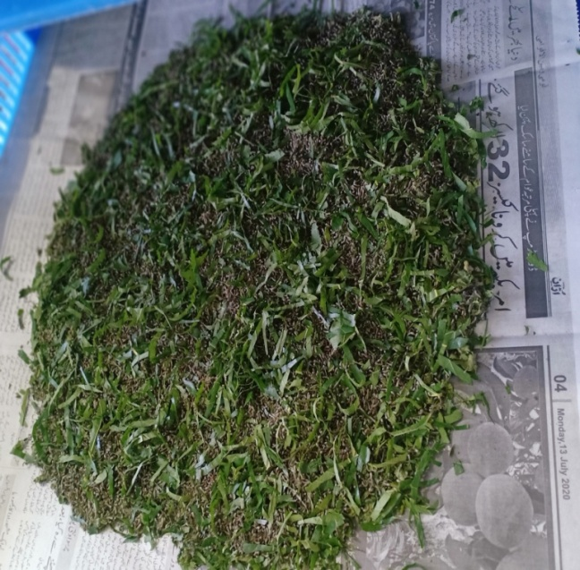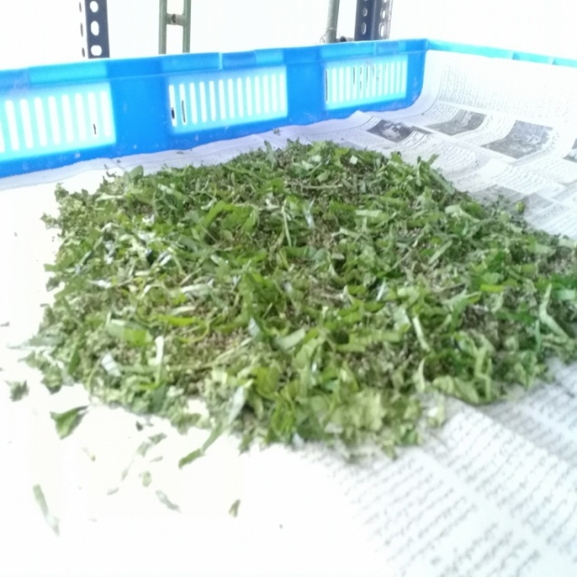
Fig.- 1: 1st instar Silkworm larvae of FC1xFC2 and FC2xFC1 hybrids.
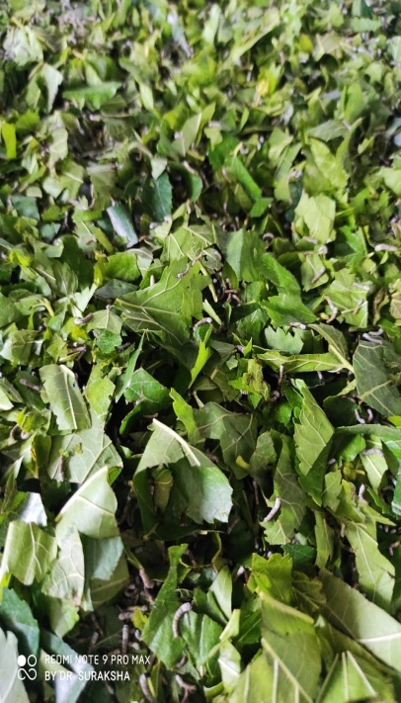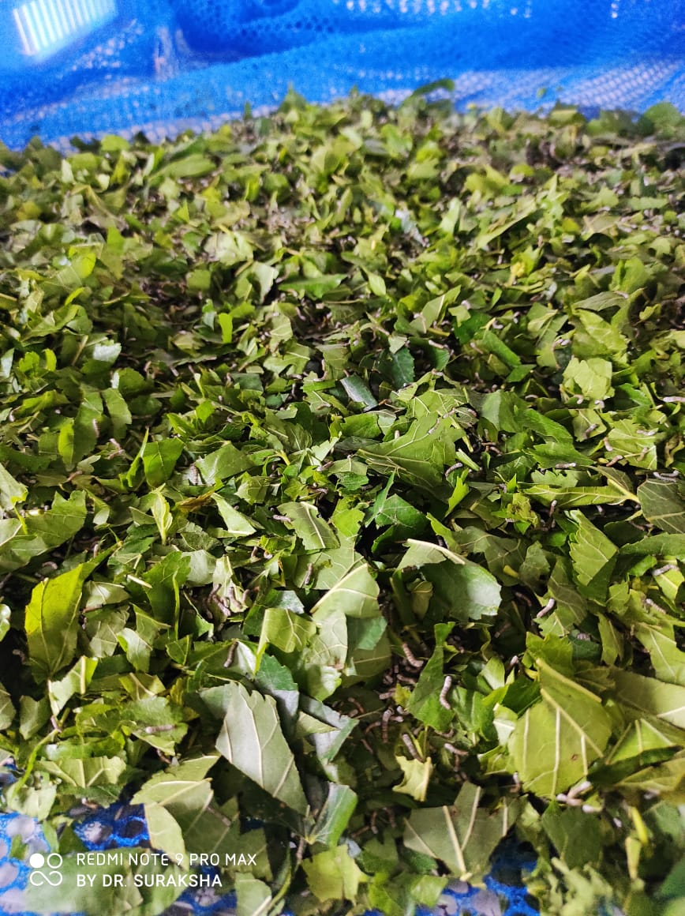
Fig.- 2: 2nd instar Silkworm larvae of FC1xFC2 and FC2xFC1 hybrids.
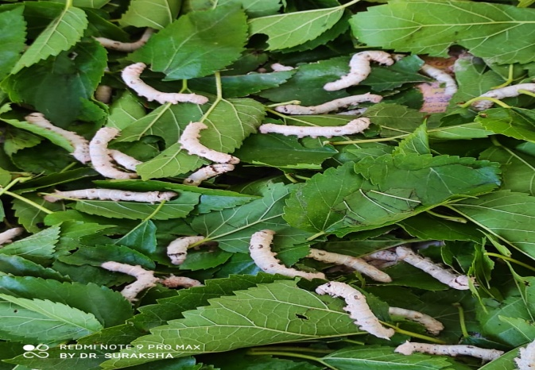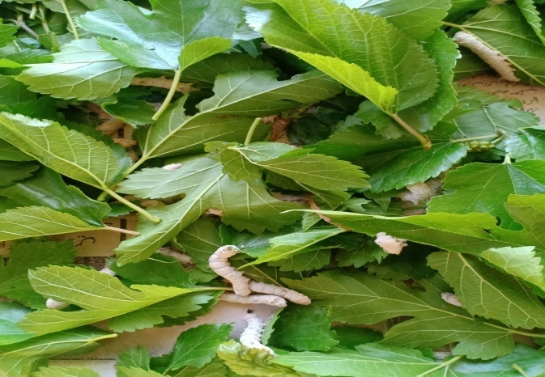
Fig.- 3: 3rd instar Silkworm larvae of FC1xFC2 and FC2xFC1 hybrids.

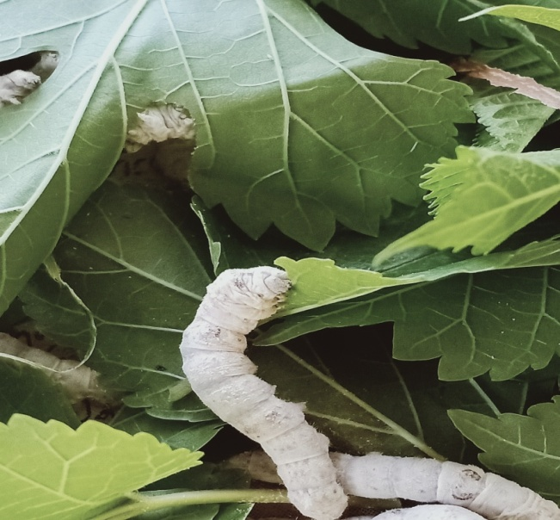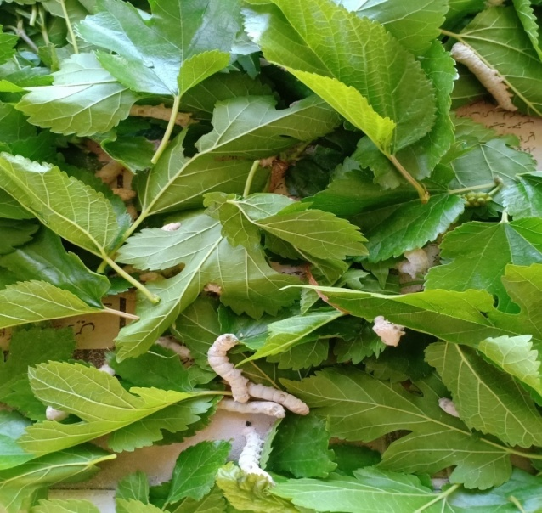
Fig.- 4: 4th instar Silkworm larvae of FC1xFC2 and FC2xFC1 hybrids.
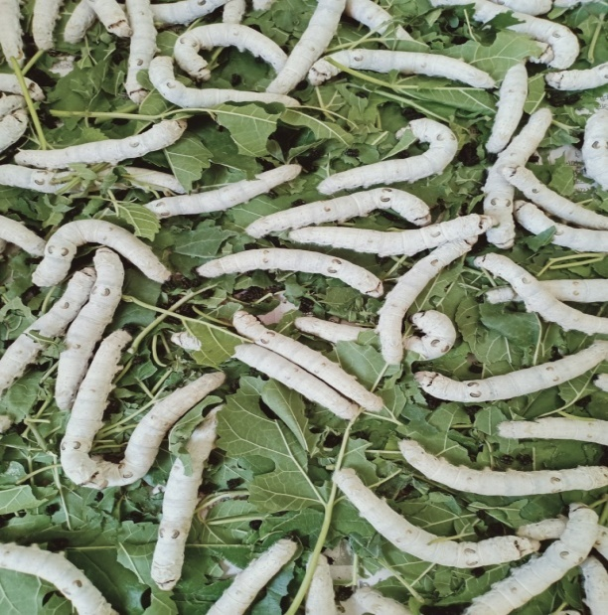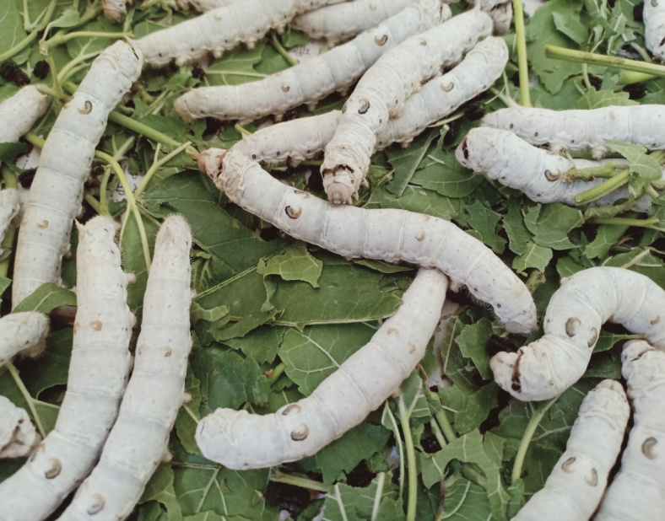
Fig.- 5: 5th instar Silkworm larvae of FC1xFC2 and FC2xFC1 hybrids.
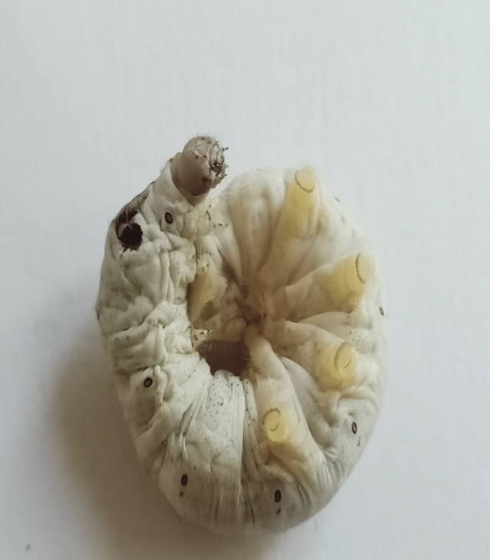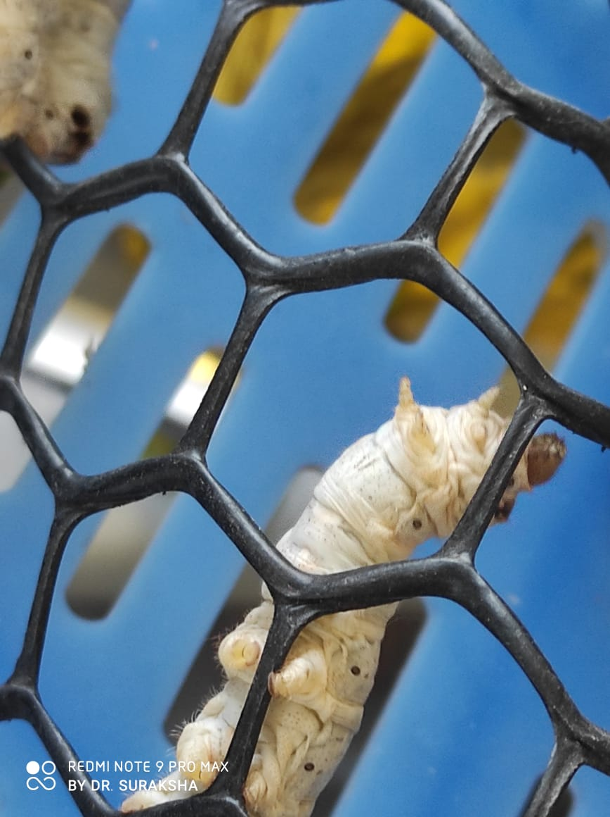
Fig.- 6: Mature/ ripen Silkworm larva on mountages.
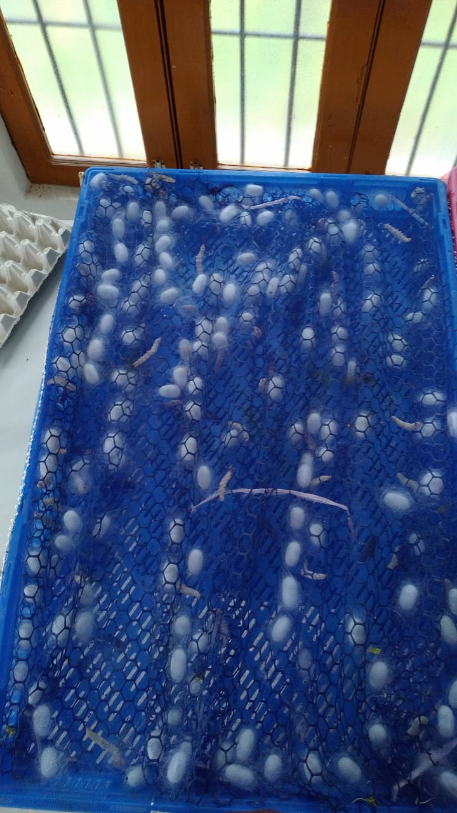
Fig.- 7: Cocoon harvesting.

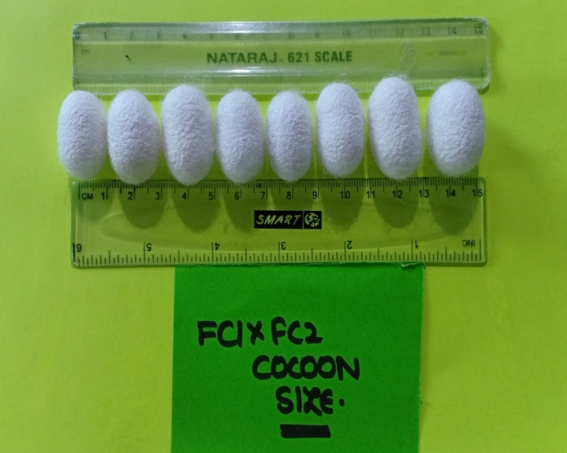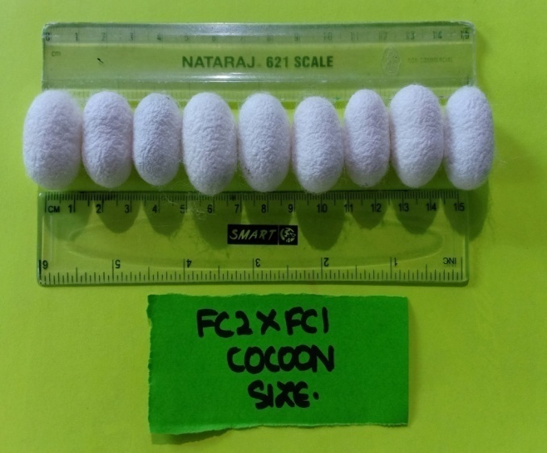
Fig.- 8: Cocoons of FC1 x FC2 andFC2 x FC1
DISCUSSION
In this pilot study, we assess how two bivoltine hybrids—FC1 × FC2 and FC2 × FC1—respond to seasonal variation in sub-temperate climate, focusing on genotype × environment interaction effecting on growth, cocoon and silk traits while comprising wide range of sudden fluctuations in the environmental condition as pooled with poor quality mulberry and management practices which requires more flexible genetic makeup. The pre-requisite success for the breeds of the given (G X E) interaction needs proper selection of potential parents with most effective analyzed genotypes accompanied by the actual evaluation of the genetic endowment of stocks. As balancing and fixing the desirable traits for local conditions being a challenge for the sericulturists, under the range of selected reaction, the relationship of variable climatic conditions for appropriate use in breeding programmes correlates with findings of (Nataraju, et al., 2006). It is important to measure the phenotypic and genotypic expression of the contributing traits under diversified climatic conditions in order to understand the genetic endowment pertaining to its adaptability and productivity. The ultimate goal of rearing is to identify the genotypic suitability under fluctuating environment which influence the yielding traits. The genotypes that can adjust according to the varying atmospheric conditions gives maximum output of economic traits, which are considered as stable. To identify such genotypes, G x E interactions was studied to descriptive statistical analysis using mean values and standard deviations. As Seasonal variations in manifestation of genotypes are also ascribed to the genetic differences among different silkworm breeds with an interaction of changing environmental conditions as equates with (Benchamin, et al., 1986). Further, prevailing ecological conditions influence variable expression of traits during different seasons of the sub-temperate conditions are observed by many researchers (Krishnaswami, et al., 1986). These observations are made on the variable responses of growth rate and seasonal adaptability are in agreement with the earlier findings of (Griffing, et al., 1971). Srinivasa, et al., 2004 proposed that Meterological data during spring season shows significant differences in yield parameters between the genotypes. The adoption of genotype with relatively constant yield despite of unpredictable and transcient environmental conditions used to select stable genotypes unaffected by environmental changes, put forwarded by (Nasir, et al., 2006). The role of temperature in silkworm rearing is a well-documented. Research by Pandey & Tripathi (2006) found that increasing temperature from 24 °C to 36 °C shortened the larval duration, affecting the later stages. However, higher temperatures can accelerate gut passage and reduce conversion efficiency, leading to faster but less efficient growth disclosed by (Muniraju et al., 2004). These findings emphasize the complex interaction between temperature and silkworm physiology, where rising temperature can boost certain nutritional processes but compromise others, such as conversion efficiency. Temperature increases from 20 °C to 30 °C reduce the efficiency of leaf-to-silk conversion, affecting food intake and silk production described by (Rahmathulla et al., 2004). Reported by Shen, 1986 that the cooler temperatures, especially during the late larval stages, have been found to improve mulberry leaf consumption and silk conversion efficiency. Research by Narayana et al. (1985) revealed that optimal temperatures between 23 °C and 25 °C improved key nutritional indices like food intake and digestibility, enhancing physiological performance. Similarly, Dahi et al. (2016) showed that food utilization efficiency, including the conversion of ingested and digested food into cocoon mass, varied with temperature. As temperature rises, indices like consumption index (CI), approximate digestibility (AD) and growth rate (GR) increase due to enhanced physiological activity suggested by (Basavaraju et al., 1998). Daily mean temperature and relative humidity of rearing room during larval duration was 20.770◦C and 72.18% respectively during this rearing time. The mean range temperature and relative humidity were 19.33 - 22.00◦C and 64.00 – 75.33% respectively detailed by (Gawade, 2006).
The verdicts typically reported that both the hybrid cross (FC1×FC2 x FC2×FC1) and the rearing environment had significantly effected on economic traits such as yield, cocoon weight, shell weight, filament length, and hatching percentage. As FC1 × FC2 showed more stable performance across environments, making it broadly adaptable to sub-temperate conditions of Jammu and Kashmir, while FC2 × FC1, in contrast, showed less favourablility under diverse seasons. The observed G × E interaction suggests that FC1×FC2 is more suitable as a broadly reared hybrid across sub-temperate zones due to its general stability. FC2×FC1, while still valuable, may be better exploited in season-specific batches (e.g. during early autumn or moderately high-temperature rearing periods), capitalizing on its higher relative plasticity. The discussion revealed that this preliminary G×E study, involving only two seasons/environments, warranted follow-up trials across multiple geographic locations and with more seasonal / temperature variation and also recommended formal stability analyses, for more precise hybrid recommendations.
CONCLUSIONS
The existing study highlights the significance of Genotype × Environment (G × E) interaction in determining the performance and flexibility of silkworm hybrids featuring the comparative evaluation of FC1×FC2 and FC2×FC1 under the sub-temperate conditions of the Poonch district, under notable differences in key economic traits such as larval duration, cocoon weight, shell weight, shell ratio, and filament length and adaptability under local conditions. Genotype x environment interactions are considered to be adaptive and stable one with high mean yield and low degree of fluctuation in yielding ability in diverse environments. Therefore, the present study was carried out to evaluate genotype x environment interaction to understand the extent of adoptability/stability in performance under varying environmental conditions in respect of silkworm rearing to produce qualitatively and quantitatively superior cocoons, which in turn have a direct bearing on the raw silk production. In fact, Genotype x Environment interactions are of major importance to the silkworm breeders while developing new breeds.
Among the two hybrids, FC1×FC2 consistently exhibited superior performance, indicating better versatility to the environmental conditions of the region which influence the phenotypic expression of genotypes. These interactions considered in silkworm breeding and hybrid selection programs to ensure optimal productivity and silk quality in specific agro-climatic zones by providing a foundational understanding of how these reciprocal hybrids respond to atmospheric conditions. Furthermore, multi-season and multi-location trials validates the most stable, high-yielding hybrids for sericulture development in temperate and sub-temperate regions. Therefore, the present study was carried out to evaluate genotype environment interaction to understand the extent of adoptability/stability in performance under varying environmental conditions in respect of quantitative traits and to identify stable genotypes under varied environments.
COMPETING INTERESTS
Author have declared that no competing interests exist.

COMPETING INTERESTS DISCLAIMER:
Authors have declared that they have no known competing financial interests OR non-financial interests OR personal relationships that could have appeared to influence the work reported in this paper.

REFERENCES
- Basavaraju CD, Lakshmi Kumari B, Ananthanarayana SR. Effect of temperature on consumption and utilization of food in two races of Bombyx mori L. Sericologia. 1998;38(4):615-621.
- Benchamin KV, Jolly MS; Principles of Silkworm rearing. Proc. of Sem. on problems and prospects of sericulture. Vellore, India,1986: 63-106.
- Bindroo BB. Breakthroughs and betterments in silkworm improvement. Central Silk Board, Bangalore. 2016;163- 176.
- Dahi HF, Rehab H, Taha, Walaa Ibrahim G. Nutritional efficiency and its relation to Bombyx mori L. productivity under different constant temperatures. J Plant Prot Pathol. 2016;7(1):21-26.
- Dandin SB, Suresh Kumar N, Basavaraja HK, Mal Reddy N, Kalpana GV, Joge PG, Nataraju B, Balavenkatasubbaiah M, Nanje Gowda B. Development of a new robust bivoltine hybrid, Chamaraja (CSR50 x CSR51) of Bombyx mori L. for tropics, Indian J. Seric., 2006;45(1):35-44.
- Datta RK, Basavaraja HK, Mal Reddy N, Nirmal Kumar S, Ahsan MM, Suresh Kumar N, Ramesh Babu M. Evolution of new productive bivoltine hybrids, CSR2 x CSR4 and CSR2 x CSR5, Sericologia. 2000a;40(1):151-167.
- Datta RK, Basavaraja HK, Mal Reddy N, Nirmal Kumar S, Ahsan MM, Suresh Kumar N, Ramesh Babu M. Evolution of new productive bivoltine hybrid, CSR3 x CSR6, Sericologia. 2000b;40(3):407- 416.
- Datta RK, Basavaraja HK, Reddy MN, Kumar NS, Ahsan MM, Kumar NS, Babu RM. Evolution of new bivoltine hybrids, CSR2 × CSR4 and CSR2 × CSR5. Sericologia. 2000; 40: 151-167.
- Datta RK, Suresh Kumar N, Basavaraja HK, Kshor Kumar CM, Mal Reddy N. CSR18 x CSR19 – A robust bivoltine hybrid for all season rearing, Indian Silk. 2001c;39(12):5-7.
- Dayananda D, Satish K, Rama Mohana PR, Obalaiah G, Sundara Murthy, Nirmal K. Evaluation and identification of promising bivoltine double hybrids of the silkworm Bombyx mori L. for tropics through large Scale in-house testing. Int. J. Indust. Entomol. 2011;23(2):187-191.
- Eberhart SA,Russel WA; Stability parameters for comparing varieties. Crop Sci., 1996;6:36-40.
- Gawade, BV., (2006). Evaluation of mulberry varieties for rearing performance and their different economic traits on silkworm (Bombyx mori). M.Sc. (Agri.) Thesis, MAU, Parbhani.
- Ghazy UMM, Fouad TA, Haggag K. New double hybrids of mulberry silkworm, Bombyx mori L. to be suitable for changed caused in Egyptian climate. Int. J. Appl. Res. 2017;3(11):09-17.
- Griffing LV, ZsirosZ;Heterosis associated with genotype-environment interactions. Genetics, 1971;68: 443-445.
- He Y, Oshiki T; Study on cross breeding of a robust silkworm race for summer and autumn rearing at low latitude area in China. J SericSciJpn., 1984; 53:320-324.
- He Y, Sine YH, Jian DX, Ping D. Breeding of the silkworm variety for summer and autumn rearing ‘Xuhua’, ‘Auixing’ and their hybrids. Canye Kexue. 1991; 17:200-207.
- Hebert Y, Plomion C,Harzic N; Genotype x environment interaction for root traits in maize as analyzed with factorial regression models. Euphytica,1995; 81: 85-92.
- Khan MA. Heterosis studies on indigenous bivoltine silkworm hybrids. M.Sc. Division of Sericulture Sher-e-Kashmir University of Agricultural Sciences & Technology of Jammu Main Campus, Chatha, Jammu. 2015;56-64.
- Krishnaswami S, Narasimhanna MN, Suryanarayana SK, Kumararaj S; Manual on Sericulture. Volume2, Silkworm rearing UN Food and Agriculture Organization, Rome, 1973: 54-88.
- Kumar NS, Basavaraja HK, Dandin SB. Breeding of robust bivoltine silkworm, Bombyx mori L. for temperature tolerancea review. I. J. Seric. 2004;43(2):111-124.
- Muniraju E, Sekharappa BM, Raghuraman R. Food intake and utilization efficiency in silkworm Bombyx mori L. (Pure Mysore) reared at different temperature combinations. Int J Trop Insect Sci. 2004;24(2):135-142.
- Narayana PR, Periaswamy K, Radhakrishnan S. Effect of dietary water content on food utilization and silk production in Bombyx mori L. (Lepidoptera: Bombycidae). Indian J Sericult. 1985;24:12-17.
- Nasir THS, Ibrahim MM, Aboud KA; Stability parameters in yield of white mustard (Brassica Alba L.) in different environments. World J AgriSci., 2006;2: 47-55.
- Pandey P, Tripathi SP. Effect of ecological factors on larval duration of silkworm (Bombyx mori L.). J Ecophysiol Occup Health. 2006;6(3):3-5.
- Rahmathulla VK, Srinivasa G, Himantharaj MT, Rajan RK. Influence of various environmental and nutritional factors during fifth instar silkworm rearing on silk fibre characters. Man Made Textiles India. 2004;47(7):240-243. 52.
- Shabir AB, Malik Farooq Khan, Sahaf KA. Studies on the performance of some silkworm (Bombyx mori), hybrids during the summer season in Kashmir. J. Entomol. Zool. Stud. 2017;5(5):1346-1348.
- Shen WD. Effect of different rearing temperature on fifth instar larvae of silkworm on nutritional metabolism and dietary efficiency. J Sericult Sci Japan. 1986;12(2):72-76.
- Suresh Kumar N, Basavaraja HK, Joge PG, Mal Reddy N, Kalpana GV, Dandin SB. Development of a new robust bivoltine hybrid (CSR46 x CSR47) of Bombyx mori L. for tropics, Indian J. Seric. 2006;45(1): 21-29.
- Suresh Kumar N, Basavaraja HK, Kishor Kumar CM, Mal Reddy N, Datta RK. On the breeding of CSR18 × CSR19, a robust bivoltine hybrid of silkworm, Bombyx mori L. for the tropics. Int. J. Indust. Entomol. 2002;5(2):153-162.
- Krishnaswami S, Narasimhanna MN, Suryanarayana SK, Kumararaj S; Manual on Sericulture. Volume2, Silkworm rearing UN Food and Agriculture Organization, Rome, 1973: 54-88.

