Original Research Article
Evaluation of the Hepatoprotective Potentials of Jatropha tanjorensis Aqueous Leaf Extract on Carbon Tetrachloride (CCl₄)-Induced Hepatic Injury in Wistar Rats

ABSTRACT
Aims: The effect of the aqueous extract of Jatropha tanjorensis leaves on Wistar rats was carried out to ascertain biochemical efficacy in ameliorating carbon tetrachloride (CCl₄)-induced damage on histopathology and biochemical parameters such as Glucose, Aspartate transaminase (AST), Alanine transaminase (ALT), Creatinine, and Urea.
Study design: A total of twenty (20) rats weighing 100-250g were divided into five (5) groups (four rats per group), comprising of Control (Group 1), CCl₄ induced without treatment (Group II), CCl₄ induced with treatment of 5% plant extract (Group III), CCl₄ induced with treatment of 10% plant extract (Group IV), CCl₄ induced with treatment of 15% plant extract (Group V).
Place and Duration of Study: The animal house of the Department of Biochemistry, University of Port Harcourt; and Department of Chemical Pathology, University of Port Harcourt Teaching Hospital (UPTH), between January and June 2018.
Methodology: The CCl₄ was induced intravenously, while formulated feed, water, and extract were orally administered for fourteen (14) days after one week of acclimatization. The animals were subsequently sacrificed after 14 days, and the blood and liver samples were taken for histopathological examination and biochemical analysis respectively.
Results: The biochemical results revealed a significant increase (P>0.05) in all the parameters of the Group II rats and a significant decrease (P<0.05) in all the parameters of the Group II, IV, and V after treatment with Jatropha tanjorensis extract.
Conclusion: This study reveals that this plant can be used in the management of liver disorders especially those caused by CCl₄.

Key words: Jatropha tanjorensis, aqueous extract, histopathology, liver disorders, biochemical parameters.
1. INTRODUCTION
Over the years, plants apart from serving as food, have also been known to exhibit medicinal properties. A large and increasing number of patients use medicinal herbs or seek the advice of their physician regarding their uses. Presently, more than half of the world population use herbal drugs (Wargovich et al., 2001).
Jatropha is a genus of flowering plants in the spurge family. The name is derived from the Greek words; iatros meaning “physician”, and trophe meaning “nutrition”, hence, the common name “physic nut”. Another common name is nettlespurge. Jatropha tanjorensis belongs to the family, Euphorbiaceae. It is a common weed of field crops, bush re-growth, road sides and disturbed places in the higher rainfall forest zones of West Africa. It is nicknamed as “hospital too far”, “catholic vegetable”, “iyana-ipaja”, and “lapalapa” (Iwalewa et al., 2005). The leaf is a commonly consumed vegetable in many parts of Southern Nigeria. It is also popular as a natural remedy against diabetes in this region (Wargovich et al., 2001).
Jatropha species have a high adaptability for thriving under different climatic conditions (Oyewole & Akingbala, 2011). It is, therefore, suitable for all types of soils and barren land. Jatropha is a versatile plant owing to its excellent regeneration capability and long, productive life. Other species of this plant are Jatropha curcas, Jatropha gossypifolia, Jatropha podagrica, Jatropha glandulifolia, Jatropha multifida, Jatropha intergerrima (Oyewole & Akingbala, 2011).
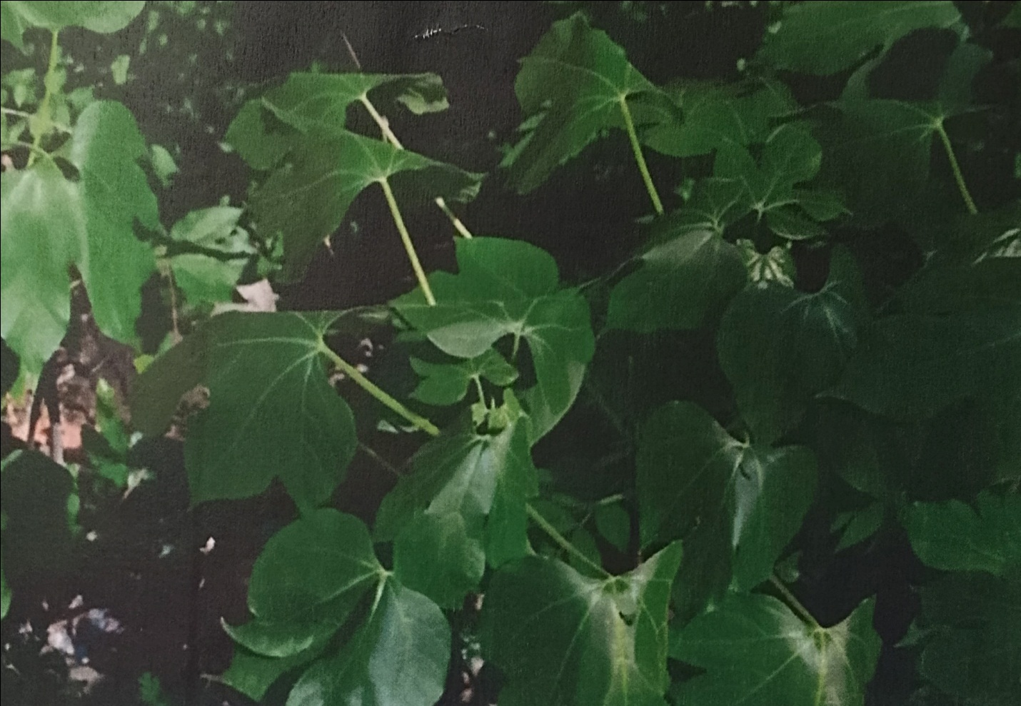
Figure 1 Jatropha tanjorensis
1.1 Aim and Objectives of the Study
Aim: The aim of this study is to evaluate the hepatoprotective potentials of Jatropha tanjorensis leaf extract on CCl₄-induced hepatic injury on wistar rats.
Objectives: The objectives of the study are to:
1. Evaluate the aqueous extract of Jatropha tanjorensis leaves for its effect on some biochemical parameters and antioxidant enzymes.
2. Investigate the effect of the medicinal and nutritional properties of Jatropha tanjorensis.
3. Ascertain the effect of treatment with aqueous leaf extract of Jatropha tanjorensis on CCl₄-induced liver damage on rats.
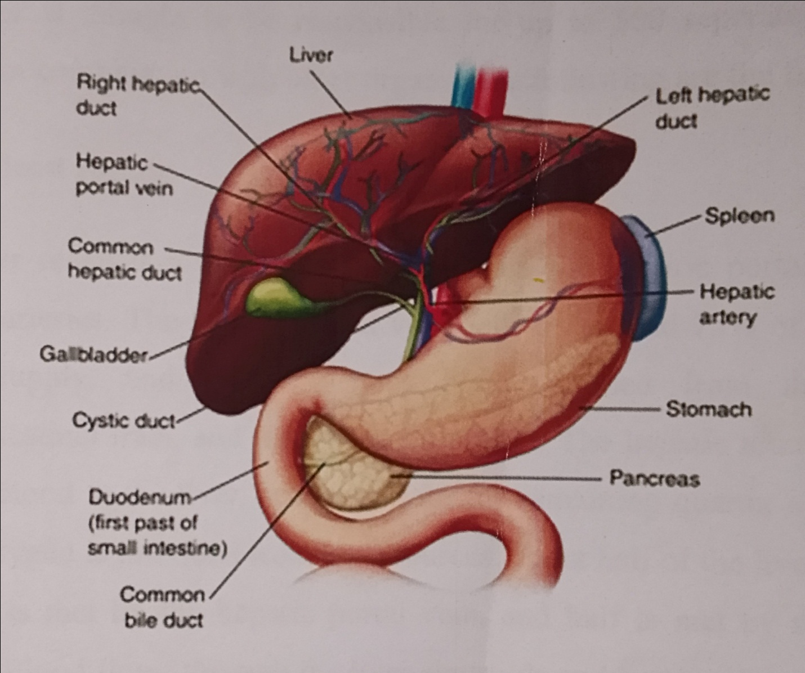
Figure 2 The Liver
1.2 Significance of the Study
Base-line data could be provided for medical personnels in the evaluation of the hepatoprotective potentials of Jatropha tanjorensis and treatment of hepatic injury.
This study intends to make available some scientific information on Glucose, Alanine transaminase (ALT), Aspartate transaminase (AST), Alkaline phosphatase (ALP), Albumin, Gamma-Glutamyl transferase (GGT), Total bilirubin, Superoxide dismutase (SOD), Catalase, and Glutathione peroxidase (GPx) in the treatment of CCl₄-induced hepatic injury on wistar rats.

1.3 Uses of Jatropha tanjorensis
Different parts of Jatropha plants are used in many ways and in different countries. Nutritionally, the leaves of J. tanjorensis are locally consumed as vegetable (Iwalewa et al., 2005, Orhue et al., 2008). The leaves also serve medicinal purposes as they are used for the treatment of fevers, cabuncles, eczema, itches, sores on the tongues of babies, stomach ache, and veneral diseases (Orhue et al., 2008).
1.4 Study Area
The study area includes Rumuomasi community in Obio/Akpor Local Government Area of Rivers State, Nigeria. This area is located in the Niger Delta region bordering the Atlantic Ocean and lies approximately in latitudes 6°54'N and longitudes 4°53'E.
2. MATERIALS AND METHODS
2.1 Experimental Animals
Twenty (20) Wistar rats weighing between 100-250g were purchased from the animal house of the Department of Biochemistry, University of Port Harcourt, Rivers State. The animals were housed in the ventilated experiment house under constant conditions throughout the period of the experiment. They were maintained on standard animal pellets (rat feed) and water ad libitum. The animals were acclimatized for one week prior to the commencement of the experiment.

2.2 Carbon tetrachloride (CCl₄)
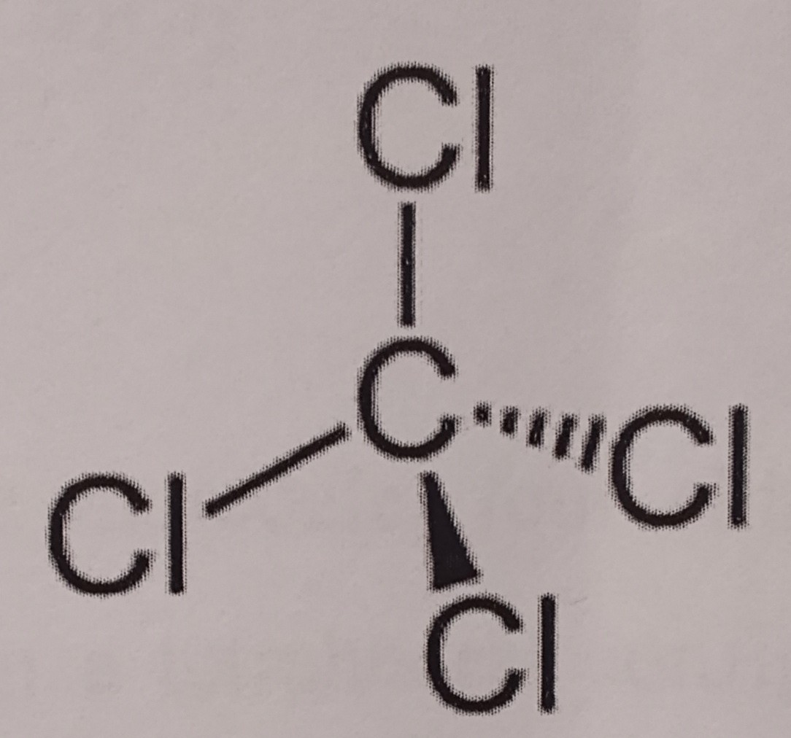
Figure 3Carbon tetrachloride (CCl₄)
Carbon tetrachloride, also known as tetrachloromethane is a colourless liquid with a “sweet” smell that can be detected at low levels and has practically no flammability at lower temperatures. It is mainly produced from methane (CH₄):
CH₄ + 4Cl₂ CCl₄ + 4HCl
The production often utilizes by-products of other chlorination reactions, such as from the syntheses of dichloromethane and chloroform. Higher chlorocarbons are also subjected to “chlorinolysis”:
C₂Cl₆ + Cl₂ 2CCl₄
As a solvent, it is well suited to dissolving other non-polar compounds; fats and oils. Like many other volatile substances, CCl₄ is prone to misuse by inhalation due to its possible depressant and/or dissociative effect upon the central nervous system. Use of CCl₄ in this manner presents serious health risks and may result in toxic effects (Masuda, 2006).
Carbon tetrachloride, CCl₄, is one of the most potent hepatotoxins (toxic to the liver), to the extent that it is widely used in scientific research to evaluate hepatoprotective agents. Exposure to high concentrations of CCl₄ can affect the central nervous system, and degenerate the liver and kidneys (Seifert et al., 1994). Prolonged exposure to the hepatotoxin may lead to coma or death. Chronic exposure to CCl₄ can cause liver and kidney damage and could result in cancer (Zakim & Boyer, 2002). Symptoms of hepatic damage may appear after a delay of one or more days following acute exposure (Seifert et al., 1994). Several sensitive and specific tests are available to measure CCl₄ in exposed persons. The most convenient way is to measure CCl₄ in exhaled air. CCl₄ can also be measured in the blood, fat, or other tissues (Zakim & Boyer, 2002).
2.3 Preparation of Stock (CCl₄)
10ml of CCl₄ was diluted in 10ml of olive oil in a ratio 1:1 and was employed for inducing liver damage.
2.4 Plant Material Collection and Extraction
2.4.1 Plant Collection
Jatropha tanjorensis was purchased from Rumuomasi market in Obio-Akpor Local Government Area of Rivers State.
2.4.2 Preparation of Aqueous Extract
Fresh leaves of Jatropha tanjorensis were washed under running water to remove dirt, debris, and other contaminants. The leaves were dried in open air, avoiding direct contact with moisture and sun for a period of three (3) weeks after which the leaves were ground to fine powder using mortar and pestle. 20g of the powder was soaked in 200ml of distilled water. After vigorous shaking for 10 minutes, the mixture was allowed to stand for 24 hours. The mixture was then filtered thrice, each time through a piece of white clean cotton cloth. A final filtration using Whatman No. 541 filter paper followed. The extract was then separated into different concentrations and diluted in different volumes of water (5%, 10%, and 15% of extract was diluted in 95ml, 90ml, and 85ml of distilled water respectively) in different plastic bottles.
2.5 Preparation of the Animals
A total of 20 Wistar rats (100-250g) of about four months old and bred in the animal house of the Department of Biochemistry, University of Port Harcourt, Choba, Rivers State, were used in the study. The rats were randomly selected and kept in five (5) different groups of four (4) rats per group and in separate cages. The animals were fed commercially with formulated rat feed and water ad libitum. Their cages were cleaned daily and their food and water were changed daily. The animals were allowed to acclimatize for one week.
2.6 Study Design
The rats were divided into 5 experimental groups with each group consisting of 4 rats per cage.
Group I (Positive [+ve] Control) was fed with formulated pellet and water ad libitum.
Group 1I (Negative [-ve] Control) was induced with CCl₄ and kept without administering any extract but was fed with commercially formulated pellet and water ad libitum.
Groups III, IV, and V were fed with commercially formulated feed, water ad libitum, and 5%, 10%, and 15% respectively of the extract according to individual body weight of each rat. After fourteen (14) days of treatment, the rats were anaesthetized in chloroform and sacrificed. The blood and liver specimens of the rats were collected and stored in 10% formalin for histological examination. The serum activities of the selected liver enzymes were assayed.
2.7 Method of Blood and Organ Collection
The animals were anaesthetized using cotton wool soaked in chloroform in a desiccator. The anaesthetized animals were placed on a dissecting slab, the blood samples were collected from the jugular vein into lithium heparin bottles. The liver was collected and stored in tissue bottles with formaldehyde for biochemistry test. The blood and tissue samples were then taken to the Departmental of Chemical Pathology laboratory at the University of Port Harcourt Teaching Hospital (UPTH) for analytical purpose.
2.8 Analysis
2.8.1 Phytochemical Analysis of Jatropha tanjorensis
Earlier studies on the Jatropha tanjorensis leaf revealed that it contains bioactive principles such as alkaloids, flavonoids, tannins, cardiac glycosides, anthraquinones, and saponins (Ehimwenma & Osagie, 2007). The leaves contain the antioxidant vitamins (C and E). It also contains important mineral elements such as iron, sodium, potassium, calcium, selenium, manganese, magnesium, phosphorus, and zinc (Oyewole & Akingbala, 2011).
Phytochemicals are secondary metabolites produced by plants. They import colour characteristics to the plants as well as flavour, smell, and are parts of a plant natural defense system (Doughari et al., 2009). They are present in a variety of plants utilized as important components of both human and animal diets including seeds, herbs, fruits, and vegetables (Iwalewa et al., 2005). Different mechanisms have been suggested for the action of phytochemicals. They may act as antioxidants or modulate gene expression and signal transduction pathways (Doughari et al., 2009). They may be used as chemotherapeutic or chemopreventive agents (Oyewole & Akingbala, 2011).
2.8.2 Biochemical Analysis
All biochemical tests – Glucose, AST, ALT, Urea, and Creatinine were assayed using Randox kits.
2.8.2.1 Enzyme assays
The determination of aspartate aminotransferase in the serum samples were performed at 37⁰C using the Randox kit by measuring the amount of oxaloacetate hydrazone formed in the presence of L-aspartate, α-oxoglutarate and 2,4-dinitrophenyl hydrazine reported by Ibekwe et al., (2007). For alanine aminotransferase, L-alanine replaced L-aspartate (Ibekwe et al., (2007)).
2.9 Histopathological Examination of Liver Fixation
After sacrificing the animals on day 14, the liver of the animals was removed and placed in properly labeled sterile sample bottles that was two-third (2/3) full of alcoholic bouins solution (fixative) and stored for 4 days. This was conducted to preserve the animals’ cellular structure and to harden the tissue, similar to paraffin. Sections of the preserved liver slices obtained with the use of a tissue slicer were fixed on microscopic slides and stained before observing under the microscope following the method described by Baker and Silverton (2005).
2.9.1 Dehydration
This process was done in order to remove the water in the tissue because water is not miscible with paraffin. After fixation, varying concentrations of alcohol (70%, 90%, 95%, and 100%) were sequentially used to remove the water in the tissue (2 hours each time).
2.9.2 Clearing
Clearing was conducted because alcohol does not mix with paraffin. This was done by placing the organ in xylene after dehydration for about 1 hour.
2.9.3 Infiltration
After clearing, the organ was placed in molten paraffin for about two hours at 56°C. This process was repeated. Embedding, Microtomy or Sectioning, Mounting of paraffin sections, and Staining were all carried out.
2.10 Statistical analysis
All the results were expressed as Mean ± SD (Standard deviation or Stdev) and analyzed using analysis of variance (ANOVA) statistical package for the social sciences (SPSS) 15.0 version (SPSS Inc., USA). P-values of less than or equal to (≤) 0.05 were considered to be statistically significant.

3. RESULTS AND DISCUSSION
3.1 RESULTS
TABLE1: Effect of administration of 300mg/kg aqueous leaves extract of J. tanjorensis on the selected parameters in Wistar rats.
PARAMETERS | Group I | Group II | Group III | Group IV | Group V
GLUCOSE | 3.975±0.36 | 10.80±0.29 | 6.95±0.34 | 6.18±0.67 | 5.65±0.59
AST | 10.75±0.50 | 44.50±6.03 | 20.5±2.65 | 19.5±1.29 | 17.0±1.41
ALT | 8.00±0.82 | 43.75±3.3 | 21.5±1.29 | 17.75±0.96 | 16.25±1.71
CREATININE | 74.25±7.20 | 155.75±9.9 | 154.0±7.8 | 145.25±3.6 | 138.8±2.22
UREA | 3.60±0.29 | 8.22±0.68 | 7.90±0.36 | 7.58±0.48 | 7.10±0.22
Values are expressed as Mean ± SD, n=4
Notably, Table 1 indicates significant decrease (p<0.05) in increasing extract concentration for all the parameters ranging from 5% to 15% in Groups III to V.
The overall results comparing the different parameters in various groups are contained in Figure 4 to 8 below.
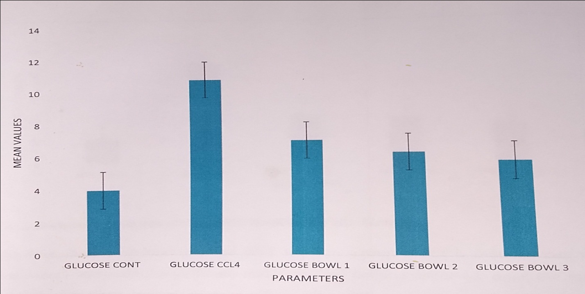
Figure 4 The result of Glucose level in all the groups
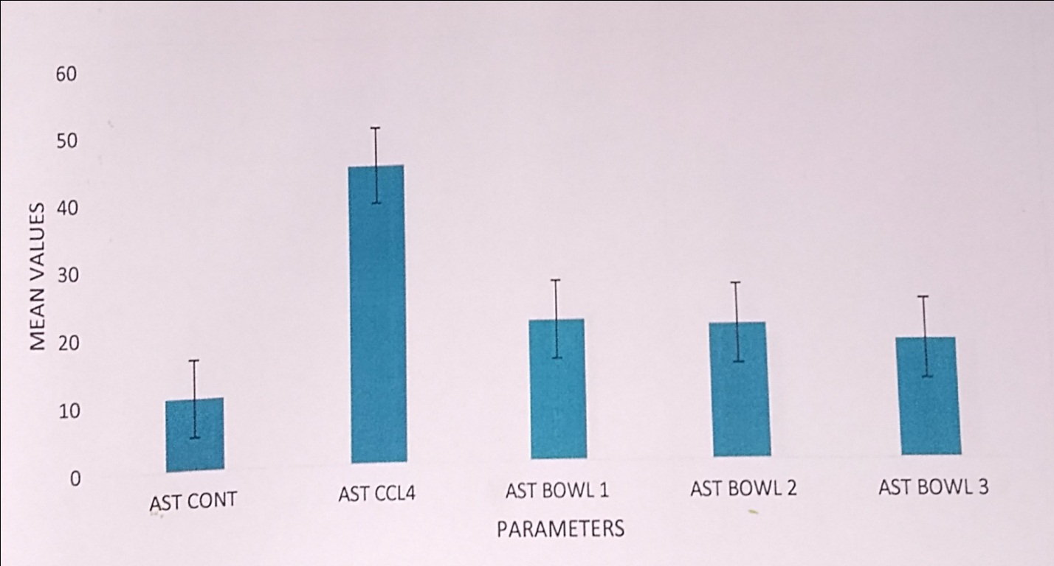
Figure 5 The result of AST level in all the groups

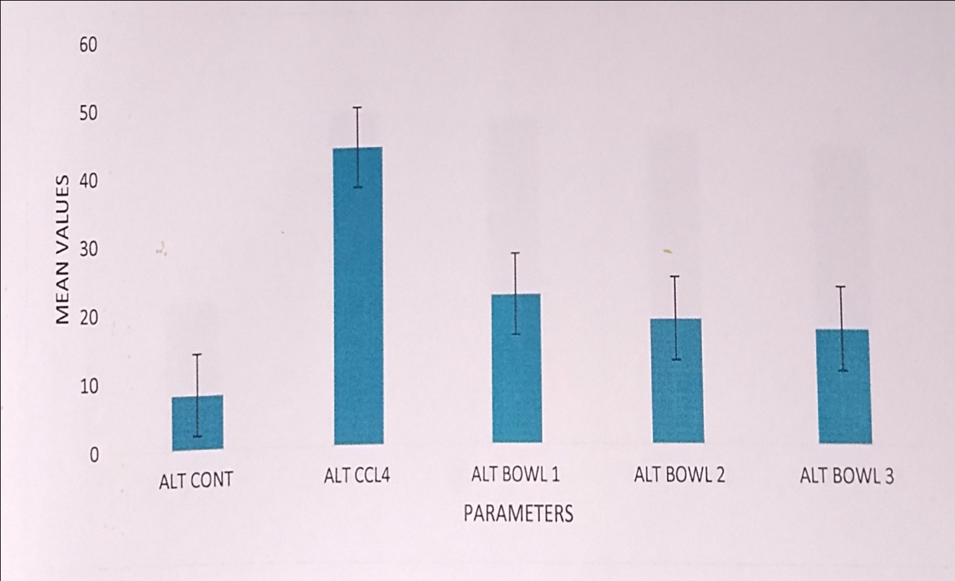Figure 6The result of ALT level in all the groups
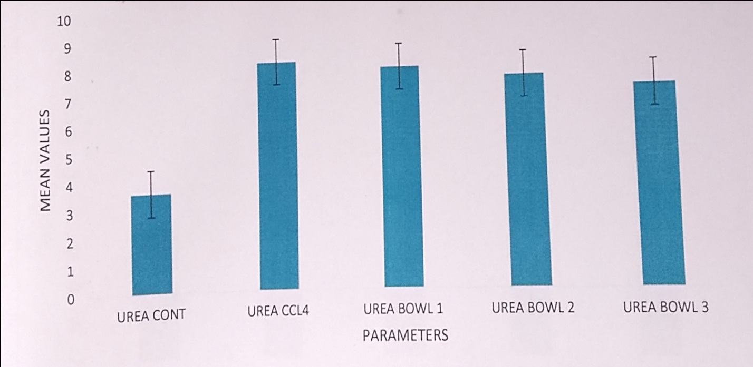
Figure 7 The result of Urea level in all the groups

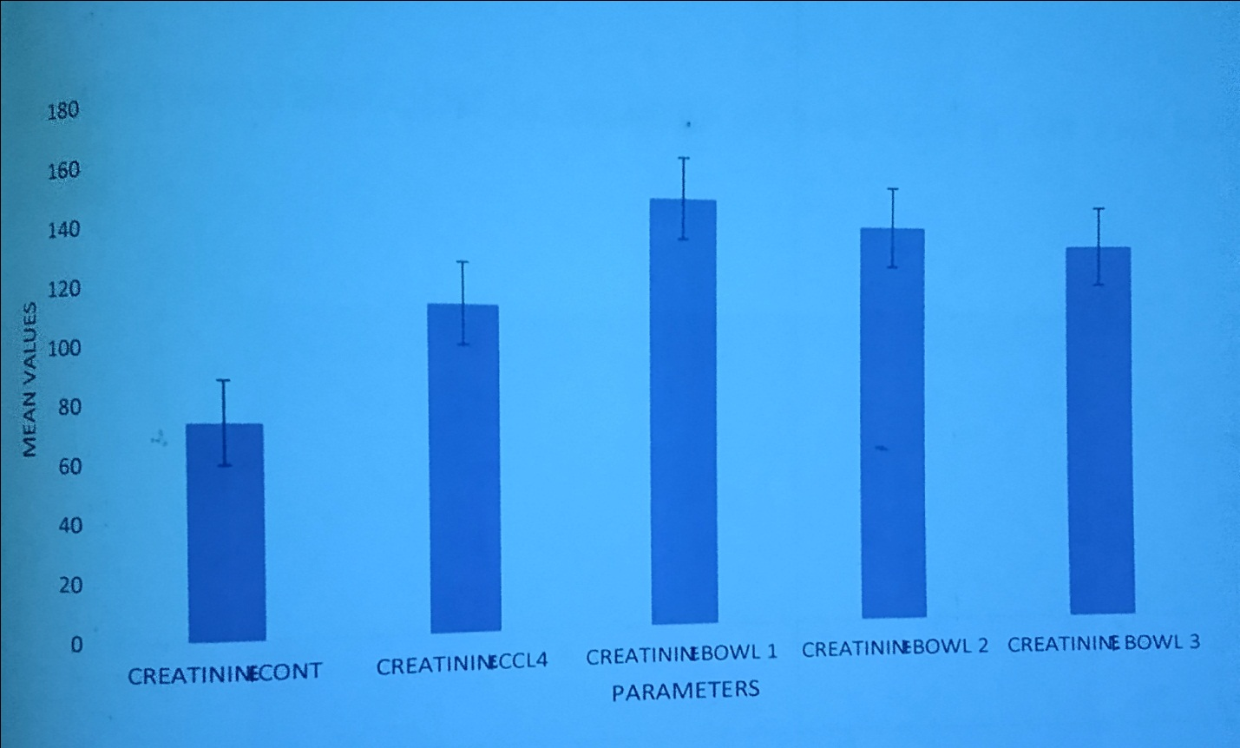
Figure 8 The result of Creatinine level in all the groups
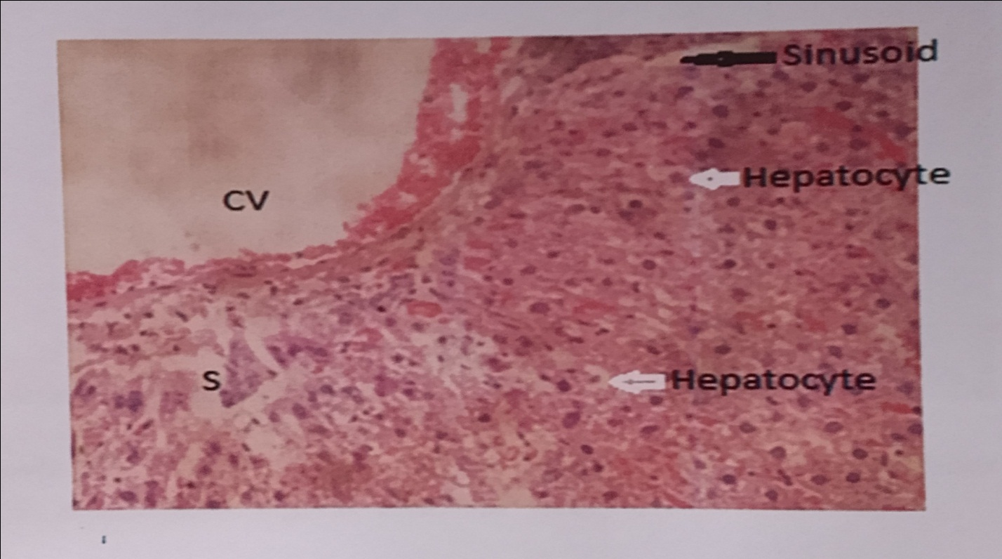
Plate.1 The microscopic view of the liver in Group 1 Rat. A histopathological distorted liver. Congested capillaries and Degenerative changes seen.
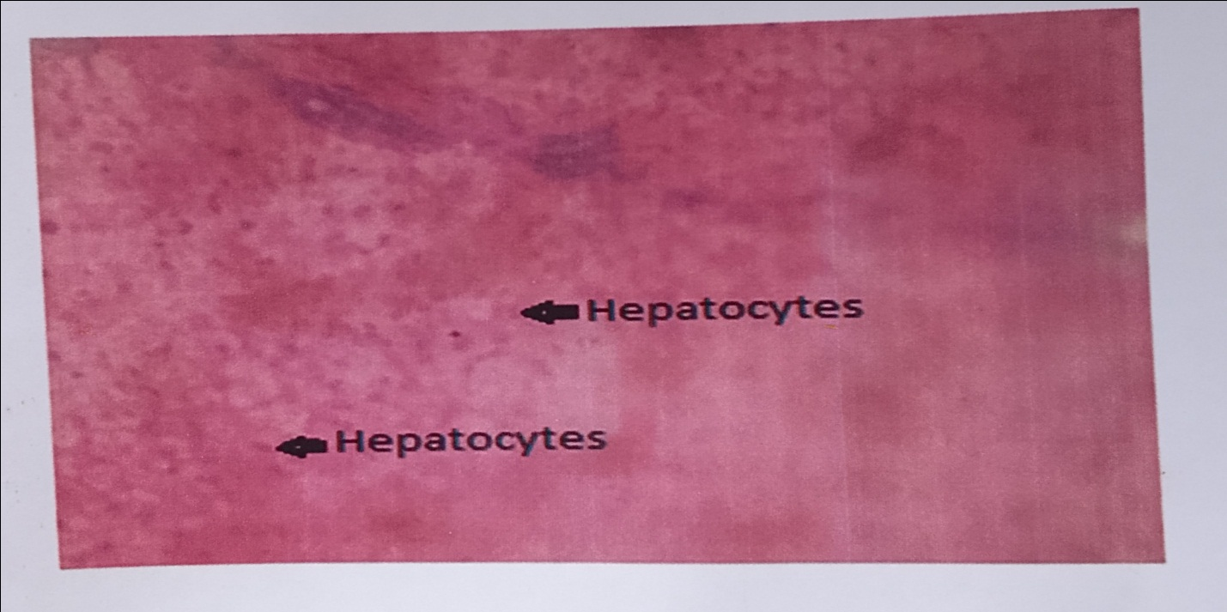
Plate 2 The microscopic view of the liver in –ve Control (Group II) Rat. A histopathological distorted liver. Macrovesicular and microvesicular steatosis.
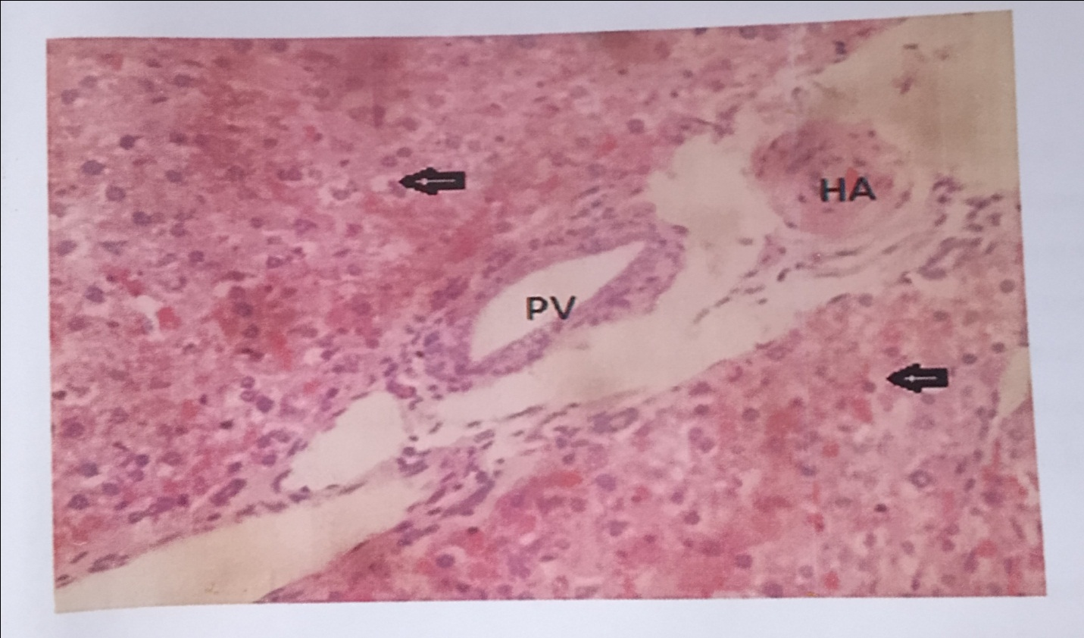
Plate 3 The microscopic view of the liver in CCl₄-induced Group with extract. A histopathological distorted liver. Patent portal vein. Distorted hepatocytes.

3.2 DISCUSSION
Liver is the largest organ and it is target for toxicity because of its role in clearing and metabolizing chemicals through the process called detoxification (Larrey, 2003). Drug induced liver disorders occurring frequently can be life threatening and mimic all forms of liver diseases (Watkins & Seef, 2006).
The ability of a hepatoprotective drug to reduce the injurious effects or to preserve the normal hepatic physiological mechanisms which have been disturbed by a hepatotoxin is the index of its protective value. CCl₄ is one of the most commonly used hepatotoxins in experimental study to induce liver damage because it is metabolized in hepatocytes by cytochrome P₄₅₀, generating a highly reactive carbon centred trichloromethyl radical leading to the initiation of a chain of lipid peroxidation. This chain of lipid peroxidation is one of the principal causes of hepatotoxicity of CCl₄ (Yadav & Dixit, 2003).
In recent times, antioxidants from plant sources have received a lot of attention and are even preferred to synthetic ones especially due to their potential health benefits, availability, affordability, and in many cases, reduced toxicity (Wargovich et al., 2001). The presence of phytochemicals in J. tanjorensis is an indication that the leaves might offer medicinal benefits to its users because the leaves have been shown to confer protection on human health. The high concentration of flavonoids and moderate concentration of phenolics found in the leaf extract might be responsible for the high antioxidant activity of this plant (Madubuike et al., 2015).
Several studies have demonstrated that polyphenolic compounds, especially the flavonoids, possess potent antioxidant properties as they prevent or repair damage done to cells by highly reactive oxygen and nitrogen species by scavenging lipid peroxy radicals, superoxide anions, and hydroxyl radicals (Wargovich et al., 2001). The increase in antioxidant enzymes’ activities may be due to the presence of metallic cofactors which are needed for their action in the plant as reported by Wargovich et al., (2001).
The results in Table 1 shows a significant increase (p>0.05) in the level of all the parameters of the CCl₄-induced rats without treatment (Group II) compared to that of the positive control (Group I). It also shows a significant decrease (p>0.05) in the level of all the parameters when the treatment (J. tanjorensis extract) was administered. This shows that as the concentration of the plant extract increases, there is further decrease in the glucose level, liver enzymes, and biomarkers as corroborated by Keith & Robert (2001).
4. CONCLUSION
This study has demonstrated the hepatoprotective potentials of J. tanjorensis. J. tanjorensis possess antioxidant properties and carry out such activity due to the presence of important phytochemicals. The findings gave credence to the various claims of the medicinal and nutritional properties of this plant which can be exploited in the production of pharmaceutically important antioxidant drug alternatives, and indicated that treatment with aqueous leaf extract of the plant on CCl₄-induced liver damage on rats would significantly reduce the hepatotoxic effect and long term administration of higher doses may elicit problems.

REFERENCES
Baker, F. J. & Silverton, R. E. (2005). Introduction to Medical Laboratory Techniques, 7th edition, Butterworts, London. pp. 310-330.
Doughari, J. H., Human, S. I., Bennade, S., & Ndakidemi, P. A. (2009). Phytochemicals as chemotherapeutic agents and antioxidants: Possible solution to the control of antibiotic resistant verocytotoxin producing bacteria. Journal of Medicinal Plant Research, 3(11), 839-848.
Ehimwenma, S. O. & Osagie, A. U. (2007). Phytochemical screening and anti-anaemic effects of Jatropha tanjorensis leaf in protein malnourished rats. Plant Archives, 7, 509-516.
Ibekwe, S. E., Uwakwe, A. A., & Monanu, M. O. (2007). In vivo effects of sodium benzoate on plasma aspartate aminotransferase and alkaline phosphatase of wistar abino rats. Scientific Research and Essay, 2(1), 010-012.
Iwalewa, E. O., Adewunmi, N. O., & Omisore, O. A. (2005). Pro-antioxidant effects and cytoprotective potentials of nine edible vegetables in Southwest Nigeria. Journal of Medicinal Food, 8, 539-544.
Keith, G. T. & Robert, R. E. J. (2001). Liver Function In: Tietz fundamentals of Clinical chemistry (5th edition). W.B. Saunders Company. pp. 747-770.
Larrey, D. (2003). Drug induced liver disease. Journal of Hepatology, 32, 77-88.
Madubuike, K. G., Yusuf, N. O., & Robinson, E. S. (2015). Evaluation of the in vitro and in vivo antioxidant potentials of Jatropha tanjorensis methanolic leaf extract. International Journal of Pharmacognosy and Phytochemical Research, 7(4), 648-652.
Masuda, Y. (2006). Learning toxicology from carbon tetrachloride-induced hepatotoxicity. Yakugaku Zasshi (in Japanese), 126, 885-899.
Orhue, E. S., Idu, M., Ataman, J. E., & Ebite, L. E. (2008). Haematological and histopathological studies of Jatropha tanjorensis leaves in rabbits. Asian Journal of Biological Sciences, 1(2), 84-89.
Oyewole, O. I. & Akingbala, P. F. (2011). Phytochemical analysis and hypolipidemic properties of Jatropha tanjorensis leaf extract. European Journal of Medicinal Plants, 1(4), 180-185.
Seifert, W. F., Bosma, A., & Brouwer, A. (1994). Vitamin A deficiency potentiates carbon tetrachloride induced liver fibrosis in rats. Hepatology, 19, 193-201.
Wargovich, M. J., Woods, C., Holis, D. M., & Zancler, M. E. (2001). Herbals, cancer prevention and health. Journal of Nutrition, 131 (11), 30345-30365.
Watkins, P. B. & Seef, L. B. (2006). Drug induced liver injury: Summary of a single topic research committee. Hepatology, 43, 618-31.
Yadav, A. N. & Dixit, E. L. (2003). Protective nature of hepatoprotective drugs. Journal of Pharmacology, 117 (8), 21-29.
Zakim, D. & Boyer, T. D. (2002). Hepatology, A Textbook of Liver Disease (4th edition). pp. 2-4.

APPENDICES
APPENDIX I
POSITIVE CONTROL (GROUP I)
Weight | Glucose (mmol/l) | AST (mmol/l) | ALT (mmol/l) | Urea (mmol/l) | Creatinine  (mmol/l)
200g | 3.8 | 11 | 9 | 3.5 | 70
175g | 4.5 | 10 | 8 | 4.0 | 85
150g | 3.7 | 11 | 8 | 3.3 | 70
125g | 3.9 | 11 | 7 | 3.6 | 72
Total | 15.9 | 43 | 32 | 14.4 | 297
Mean | 3.98 | 10.75 | 8 | 3.6 | 74.25
Stdev | 0.36 | 0.5 | 0.82 | 0.29 | 7.23

APPENDIX II
NEGATIVE CONTROL (GROUP II)
Weight | Glucose (mmol/l) | AST (mmol/l) | ALT (mmol/l) | Urea (mmol/l) | Creatinine  (mmol/l)
225g | 10.4 | 36 | 40 | 7.4 | 165
200g | 10.9 | 47 | 43 | 8.5 | 142
175g | 11.1 | 50 | 48 | 9.0 | 160
150g | 10.8 | 45 | 44 | 8.0 | 156
Total | 43.2 | 178 | 175 | 32.9 | 623
Mean | 10.8 | 44.5 | 43.75 | 8.23 | 155.75
Stdev | 0.29 | 6.03 | 3.3 | 0.68 | 9.88

APPENDIX III
CCl₄ INDUCED WITH 5% PLANT EXTRACT TREATMENT (GROUP III)
Weight | Glucose (mmol/l) | AST (mmol/l) | ALT (mmol/l) | Urea (mmol/l) | Creatinine  (mmol/l)
225g | 7.3 | 21 | 20 | 8.4 | 165
200g | 6.9 | 18 | 23 | 7.6 | 143
175g | 6.5 | 24 | 21 | 8.0 | 154
150g | 7.1 | 19 | 22 | 7.7 | 143
Total | 27.8 | 82 | 86 | 31.7 | 616
Mean | 6.95 | 20.5 | 21.5 | 7.93 | 154
Stdev | 0.34 | 2.65 | 1.29 | 0.36 | 7.79
APPENDIX IV
CCl₄ INDUCED WITH 10% PLANT EXTRACT TREATMENT (GROUP IV)
Weight | Glucose (mmol/l) | AST (mmol/l) | ALT (mmol/l) | Urea (mmol/l) | Creatinine  (mmol/l)
250g | 7.0 | 21 | 18 | 7.4 | 150
200g | 6.4 | 20 | 19 | 8.1 | 142
150g | 5.5 | 18 | 17 | 7.8 | 143
100g | 5.8 | 19 | 17 | 7.0 | 146
Total | 24.7 | 78 | 71 | 30.3 | 581
Mean | 6.18 | 19.5 | 17.75 | 7.58 | 145.25
Stdev | 0.67 | 1.29 | 0.96 | 0.48 | 3.5
APPENDIX V
CCl₄ INDUCED WITH 15% PLANT EXTRACT TREATMENT (GROUP V)
Weight | Glucose (mmol/l) | AST (mmol/l) | ALT (mmol/l) | Urea (mmol/l) | Creatinine  (mmol/l)
225g | 6.2 | 19 | 18 | 7.1 | 138
200g | 6.1 | 17 | 16 | 6.8 | 142
175g | 5.0 | 16 | 17 | 7.3 | 138
150g | 5.3 | 16 | 14 | 7.2 | 137
Total | 22.6 | 68 | 65 | 28.4 | 555
Mean | 5.65 | 17 | 16.25 | 7.1 | 138.75
Stdev | 0.59 | 1.41 | 1.71 | 0.22 | 2.22

