Short Research Article

Determining Latent Anisotropy Inherent in the Two-way Propagation of Light in Vacuum

.

ABSTRACT

The propagation of light in vacuum has always been assumed, but never directly measured, to be isotropic; i.e., that its propagational speed going away from the observer is identical with its return speed going back to the observer.

Many intricate and ingenious speed of light measurement methodologies have been devised in the attempt to measure, directly or indirectly, the speed of light between two points, both terrestrially and between the Earth and planetary bodies. Such experiments have been limited by the inability to accurately synchronize the participating atomic clocks and to distinguish between the one-way and “round-trip” light times, thus precluding detection of any latent anisotropy which may be inherent in light propagation.

We propose means whereby mutually distant atomic clocks may be accurately synchronized, opening the possibility for the one-way speed of light to be measured directly, and for any latent anisotropy inherent in the propagation of light to be detected, both terrestrially and between the Earth and Moon or other planetary bodies.

Keywords: Speed of light measurement; anisotropy; atomic clocks

1. INTRODUCTION

Since the time of the original Michelson-Morley speed of light experiments (Morley et. al., 1887), the closed path (“round-trip”) speed of light has been measured many times to an increasingly high degree of accuracy, so much so that it has been canonically defined to have a standard value (Gibbs et. al., 1997; NIST, 2022). However, due to experimental limitations, the one-way speed of light has never been measured directly. But to determine if light propagation is anisotropic, i.e., varies according to direction, determining the one-way speed of light in varying directions is essential.

2. ANISOTROPY AND SYNCHRONIZATION

The one-way speed of light, measured from point A to point B (and optionally, but separately, from point B back to point A), has never been measured directly (Herrmann et. al., 2009; Finklestein, et al., 2009; Iyer et. al., 2010; Nissim-Sabat, 1982; Cooke et. al., 1968). A daunting obstacle to one-way speed of light measurement has been in synchronizing two (or potentially more) mutually distant atomic clocks. Should one of the locally paired, synchronized clocks be translated in space or time, even minutely, the synchronization between them is lost (Mansouri et. al., 1977; Feenberg, 1979; Hsu et. al., 2001; Zhang, 1997).

Interplanetary space is neither a uniform medium nor a true vacuum, and presents numerous factors that can influence the propagation of light, the primary of which are gravitational time dilation and various relativistic effects (Shapiro, 1964; Bailey, 1977).

Rather than focus on such effects, we first propose instead generalized methodologies whereby mutually distant atomic clocks may be accurately synchronized. Once remote clock synchronization has been established, it follows that the one-way speed of light may then be measured, and any large-scale, latent anisotropy inherent in the propagation of light may be detected (but of orders of magnitude greater than the influence imparted by relativistic or gravitational effects, which are beyond the scope of this paper).

3. SYNCHRONIZATION CONVENTION

In the 1905 paper, “On the Electrodynamics of Moving Bodies,” Albert Einstein’s second postulate, together with his synchronization convention, established the ground rules for synchronizing clocks within a common reference frame (Einsteinª, 1905):

We have not defined a common “time” for A and B, for the latter cannot be defined at all unless we establish by definition that the “time” required by light to travel from A to B equals the “time” it requires to travel from B to A.

Thus, within a common reference frame, the speed of light in one direction is defined to be equal to its speed in the opposite direction. Additionally, in the postulated case of propagation anisotropy wherein the speed of light would vary directionally, the effects of time dilation in accordance with Lorentz invariance would vary likewise, perfectly masking any clock desynchronization (Terrell, 1959; Einstein^{b}, 1905), making the direct measurement of the one-way speed of light seemingly impossible.

The inability to directly synchronize clocks at a distance is a problem that heretofore has not availed itself of an immediate solution. However, the proposed clock synchronization scheme (refer to §4 Synchronization Scheme), postulates the possibility of synchronizing two or more mutually distant clocks through correlation to a system-external entity, i.e., a common external event.

4. SYNCHRONIZATION SCHEME

For our purposes, the participating atomic clocks in these experiments must all be identical and contain embedded computer circuitry to set themselves to a requested time upon receipt of an information-laden electromagnetic command signal. The yet-unsynchronized clocks may be distributed about the Earth or elsewhere (refer to §5 Anisotropy Experiment 𝛼 and §6 Anisotropy Experiment 𝜷).

To synchronize the clocks, we utilize a remote common external event, equidistant from all participating clocks, which will serve as our timing “ground truth.” Such an event could be chosen to be any suitably located ongoing celestial event, such as a pulsar, supernova, etc. However, to have configurational control over and repeatability of the experiments, we have chosen to position an electromagnetic signal-emitting space probe at an arbitrarily far distance from the Earth. The maneuverable probe is positioned so that it is equidistant from all participating Earth clocks (refer to Figure 1).

The Earth clocks, having identical distances (i.e., within experimental error) from the distant space probe, simultaneously receive the same electromagnetic command signals transmitted by the probe. A typical signal would be to command all participating clocks to immediately set themselves to a specified arbitrary time, e.g., “SET CLOCK TO 10:00:00.00”. Once the identical clocks have received such a signal, they set themselves en masse to the same time simultaneously, after which they can be considered to be mutually synchronized with a high degree of accuracy. This scheme can extend to any number of participating clocks provided they are all identical and situated so as to be equidistant from the space probe. The SET signal may be retransmitted periodically from the probe for the purpose of experiment reset, or for assessing time drift in the clocks.

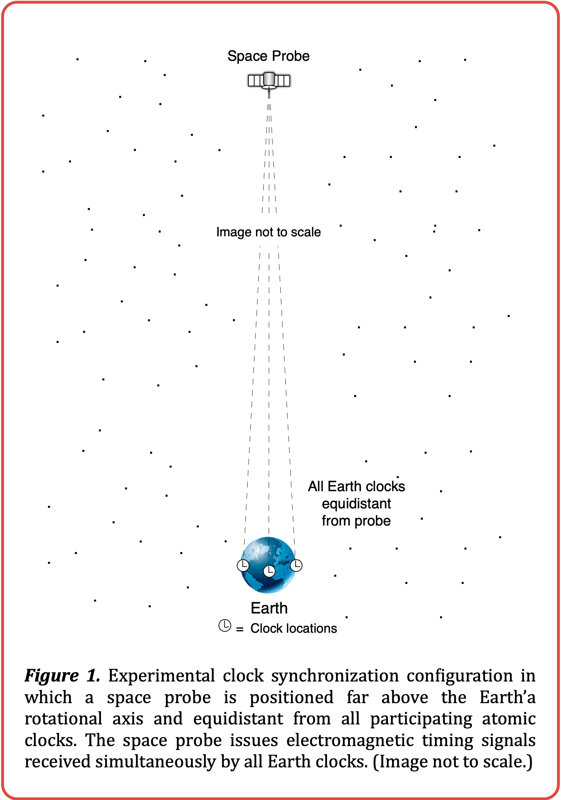
With this experimental configuration, one-way and round-trip speed of light experiments may then be run amongst any of the synchronized clocks, regardless of location or distance.

5. ANISOTROPY EXPERIMENT 𝛼

Utilizing the above clock synchronization scheme enables investigation into any potential latent anisotropy inherent in the propagation of light through space. For such purpose we first place one high-precision atomic clock on the Earth and another on the Moon, yet unsynchronized. We employ a clock synchronization scheme similar to that above, utilizing the same deployed space probe, however, here the space probe is sent to an arbitrarily far distance from the Earth-Moon system and outside the ecliptic plane, perpendicular to and centered upon the imaginary line that can be drawn between the two clocks (refer to Figure 2).

By choosing the Earth and Moon as platforms for this experiment we can obtain a large-scale and easily measurable time delay since the average round-trip light time between the Earth and the Moon, ∆t_{rt}, is approximately 2.56444 seconds (Battat et. al., 2009):

$$Δt_{rt}=\frac{2d_{em}}{c}=\frac{2(384,399,000m)}{299,792,458m/s}$$

$$≈2(1.28222s)=2.56444s$$

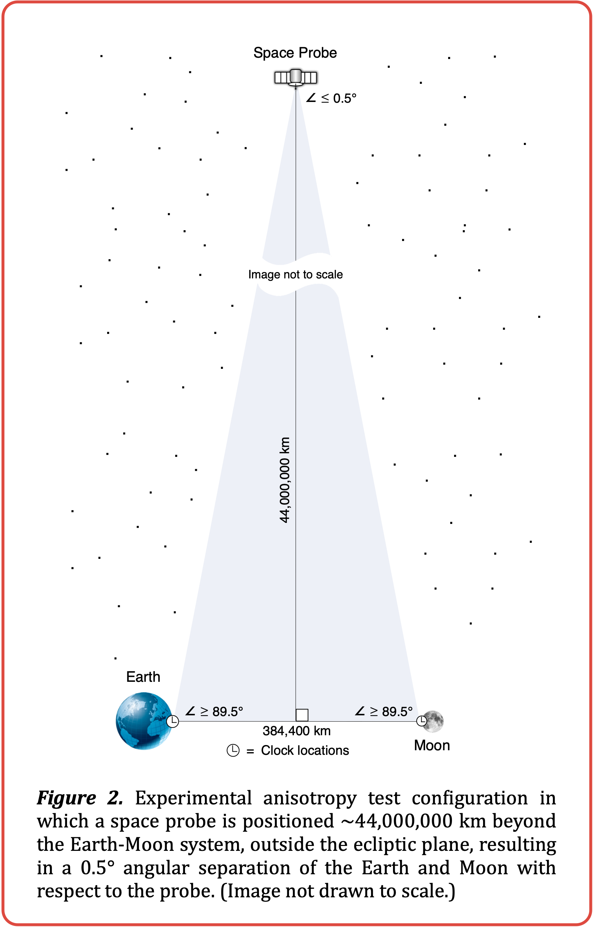
where d_{em} is the average distance from the Earth to the Moon. (If it is desired to obtain a larger time delay between clocks, another celestial body, such as Mars, or even a man-made satellite may be used, but with certain additional experimental limitations.)

As before, the Earth and Moon clocks become mutually synchronized upon receipt of a SET command from the space probe, wherein both clocks immediately set themselves to the prescribed time. The Moon clock then sends an electro-magnetic message to the Earth clock, containing its local timestamp of transmission of the message, t_{mt}. The Earth clock then timestamps its reception of the Moon clock’s message, t_{mr}. Subtracting the Moon clock’s transmission timestamp from the Earth clock’s reception timestamp gives ∆t_{me}, the one-way light time from the Moon to the Earth:

$Δt_{me}=t_{mr}-t_{mt}$

The Earth clock proceeds to determine the current round-trip light time between the Earth and the Moon, ∆t_{rt}, by sending a laser pulse to one of the laser retroreflectors deployed on the surface of the Moon by the Apollo and Lunokhod missions (Pavlov et. al., 2016; Dickey, 2014).

If the speed of light is isotropic, ∆t_{me} (the Earth clock’s local time of receipt of the Moon clock’s message, minus the Moon clock’s local time of transmission), should equal to half of ∆t_{rt}, the measured round-trip light time, to a high degree of accuracy.

$Δt_{me}=\frac{t_{rt}}{2}$

Lack of deviation from this result in practice would imply that there is no evidence of measurable anisotropy in the speed of light on the tested path(s) between the Earth and the Moon.

6. ANISOTROPY EXPERIMENT 𝜷

As a more elaborate experiment to investigate any potential latent anisotropy, we again synchronize the Earth and Moon clocks, but in a more intricate manner. As before, the Earth clock determines the current round-trip light time between the Earth and the Moon by sending a laser pulse to one of the lunar laser retroreflectors deployed on the Moon. Then it sends this information, plus its local timestamp, to the Moon clock via electromagnetic signal. In accordance with the synchronization convention, the Moon clock sets itself to the Earth clock’s timestamp plus half of the just-measured round-trip light time between the Earth and the Moon. The Moon clock then sends a return acknowledgement to Earth, again via electromagnetic signal, communicating its newly-set local timestamp information.

At this point it is assumed by convention (Einstein^{b}, 1905) that both Earth and Moon clocks are “synchronized” with each other in the traditional sense. Thus, if light propagation is isotropic for this path between the Earth and the Moon and back, the two clocks are synchronized by definition. This is a tentative assumption, and the object of our investigation.

Once the space probe is suitably positioned (as in §5 Anisotropy Experiment 𝛼), it thereafter issues randomly-timed electromagnetic signals — timing strobes — toward the Earth-Moon system.

The propagation of light is isotropic in the directions measured if the times at which the Earth clock has recorded seeing the probe’s timing strobes match the times at which the Moon clock has recorded seeing them, within an arbitrarily small delta time.

The propagation of light is anisotropic in the directions measured if the recorded timing strobe reception times differ consistently by a significant delta time. In such case, we can conclude that the speed of light is anisotropic in the directions measured by an amount proportional to the difference between the Earth and Moon timing strobe reception times. This consistent, significant time differential can then be used to calculate the one-way speed of light in each direction, from EARTH→MOON and MOON→EARTH.

7. ANISOTROPIC VELOCITY

Consider the hypothetical case in which we compare the Earth and Moon clock timestamp logs and discover that the Earth clock consistently records each received timing strobe one second ahead of the Moon clock. Since each timing strobe sent by the space probe arrives at the Earth and Moon clocks simultaneously, this implies that the clocks are “synchronized” one second apart, i.e., the Earth clock time is set one second ahead of the Moon clock time. This is indicative of a directional anisotropy along the paths between the Earth and the Moon.

Utilizing the synchronization convention, the isotropic one-way light times EARTH→MOON and MOON→EARTH are equal:

$Δt_{em}=Δt_{me}=\frac{Δt_{rt}}{2}=\frac{2.56444s}{2}=1.28222s$

where t_{em} is the isotropic one-way light time EARTH→MOON, t_{me} is the isotropic one-way light time MOON→EARTH, and t_{rt} is the round-trip light time EARTH→MOON→EARTH, measured to be 2.56444 seconds in the lunar ranging experiment, above.

But based on the timestamp logs, the one-way light time ∆t_{em} is shown to be one second longer, or 2.28222 seconds. Since the round-trip light time ∆t_{rt} is 2.56444 seconds, the return trip, ∆t_{me}, is:

$Δt_{me}=Δt_{rt}-Δt_{em}=2.56444s-2.28222s=0.28222s$

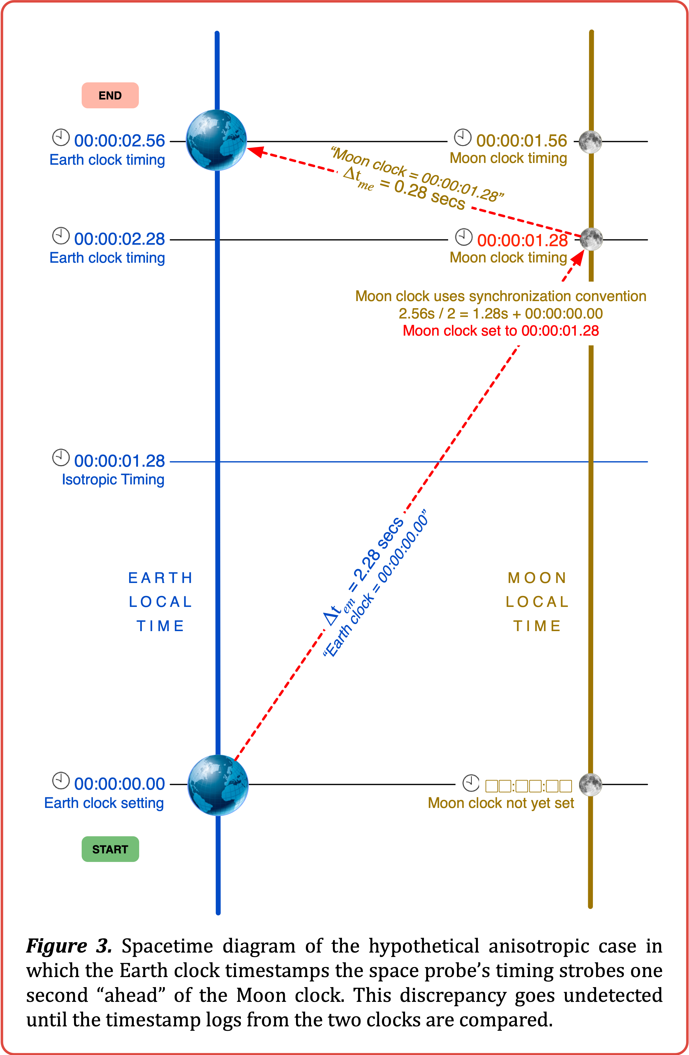
This is depicted in the spacetime diagram of Fig. 3:
From this we can derive c_{em}, the approximate one-way speed of light, in meters/second, in the EARTH→MOON direction, based on the measured anisotropy:

$c_{em}=\frac{d_{em}}{Δt_{em}}=\frac{384,400,000m}{2.28222s}≈168,432,491m/s$

where d_{em} is the current distance from the Earth to the Moon, in meters, and ∆t_{em} is the amount of time, in seconds, light requires to travel from the Earth to the Moon.

Next we derive c_{me}, the approximate one-way speed of light, in meters/second, in the MOON→EARTH direction, based on the measured anisotropy:

$c_{me}=\frac{d_{me}}{Δt_{me}}=\frac{384,400,000m}{0.28222s}≈1,372,057,969m/s$

where d_{me} is the current distance from the Moon to the Earth, in meters, and ∆t_{me} is the amount of time, in seconds, light requires to travel from the Moon to the Earth, not considering relativistic effects.

8. discussion

The proposed schemes described above represent direct ways of synchronizing mutually distant atomic clocks, and by extension, of enabling one-way speed of light measurement, as well as the determination of whether the speed of light is isotropic or anisotropic in the directions tested. However, there are numerous implementation aspects which must be considered.

As noted above, the accuracy of the synchronization may be affected by the degree to which the atomic clocks involved in the synchronization are “identical,” as they must operate and set themselves according to electronic signals at exactly the same rate. Any such operational differential may be determined and compensated for beforehand.

To aid in the accuracy of the experiments, the space probe’s signals should ideally travel identical distances to the atomic clocks. For these experiments, the accuracy will depend on how closely maintained the probe’s position is in this regard.

For the Earth-Moon anisotropy experiment, the probe’s maneuverability limitations and the Moon’s orbital geometry must be taken into consideration, as these may limit the window of investigational opportunity to certain times and/or phases of the lunar cycle. However, an inevitable small distance discrepancy can be factored into the calculations without invalidating the experiment. Additionally, a second probe may also be positioned similarly on the opposite side of the ecliptic plane in order to corroborate the experimental findings derived from the first probe.

Also, since the space probe cannot be positioned at an infinite distance away from the clocks, there will always be a non-zero angular distance between them with respect to the probe. The arrangements diagrammed in Figures 1 and 2 depict an isosceles triangle having the space probe at the apex, with the angle between the clocks kept to a minimum by increasing the distance of the probe from the clocks as much as is practicable. It is unknown how much this residual angular distance may influence the results, as it is unknown how much, if at all, any potential anisotropy of light velocity might vary by angle. This aspect can be investigated by conducting additional experiments, each having varying degrees of angular distance between the clocks, as would occur naturally over the course of time when using the Earth-Moon system as the chosen experimental platform.

Another issue when using a remote planetary body such as the Moon or Mars in this manner is that there will necessarily be a non-zero, time-variant velocity component between the remote body and the Earth that must be taken into consideration. Note that this and other orbital characteristics are already factored into the lunar laser retroreflector round-trip light time measurement algorithms (Pavlov et. al., 2016). The influence this has on the results can also be investigated by conducting numerous additional experiments, each under varying conditions.

Lastly, we consider what effect the geographic placement of the Earth and Moon clocks may have. Due to the effect of synchronous rotation, the Moon rotates at the same rate as its orbital motion. This allows the Moon clock to be placed at any convenient site on the Earth-facing side. By placing the clocks at their respective planetary equators, we find that the Moon’s “ground speed” at its sublunar (normal) point across the surface of the Earth is approximately 1627km/hr, or 452m/s (Pegrume, 2024). Thus, in the 2.56444 seconds it takes to conduct the lunar laser ranging experiment, the current sublunar point on Earth has traveled nearly 1.16 kilometers from its previous location. This is an additional aspect to the velocity component consideration, above.

9. CONCLUSIONS

The accurate synchronization of remote atomic clocks is a sine qua non for modern speed of light measurement. The methods described herein posit practicable ways to achieve such mutual synchronization.

Once all participating clocks are synchronized (as per §4 Synchronization Scheme), even if all subsequent measurement efforts show an isotropic propagation of light, and even if the correlated Earth and Moon clock timestamp logs of common external events agree consistently to an arbitrarily high degree, this is support for but not de facto demonstration of universal isotropy.

It may happen that the velocity of light is isotropic in certain “preferred” round-trip directions and anisotropic in others, or in certain regions of the universe and not in others. Discovery of even local inherent anisotropy would challenge the cosmological principle, the prevailing notion of an isotropic universe (Keel, 2007; Eisele et. al., 2009), with far-reaching ramifications.

DISCLAIMER (AI)

The author(s) hereby declare that no generative AI technologies, such as Large Language Models, etc. were used in the preparation or writing of this manuscript.

COMPETING INTERESTS DISCLAIMER:
Authors have declared that they have no known competing financial interests OR non-financial interests OR personal relationships that could have appeared to influence the work reported in this paper.

REFERENCES

Bailey, H. (1977). Measurements of relativistic time dilatation for positive and negative muons in a circular orbit. Nature 268 (5618): 301–305.

Battat, J. B., Murphy, T. W., Adelberger, E. G. (2009). The Apache Point Observatory Lunar Laser-ranging Operation (APOLLO): Two Years of Millimeter-Precision Measurements of the Earth-Moon Range. Astronomical Society of the Pacific121 (875):29–40.

Cooke, J., Martin, M., McCartney, H., Wilf, B. (1968). Direct determination of the speed of light as a general physics laboratory experiment. American Journal of Physics. 36 (9): 847.

Dickey, J. O. (2014). Lunar laser ranging: A continuing legacy of the Apollo program. https://trs.jpl.nasa.gov/bitstream/2014/32452/1/94-0193.pdf

Einsteinª, A. (1905). On the electrodynamics of moving bodies. Fourmilab. https://www.fourmilab.ch/etexts
/einstein/specrel/www

Einstein^{b}, A. (1905). Zur Elektrodynamik bewegter Körper. Annalen der Physik. 322 (10): 891–921.

Eisele, C., Nevsky, A. Y., Schiller, S. (2009). Laboratory test of the isotropy of light propagation at the 10¹⁷ level. Physical Review Letters, 25 Aug 2009, 103(9):090401.

Feenberg, E. (1979) Distant synchrony and the one-way velocity of light. Foundations of Physics 9 329.

Finkelstein, J. (2009). Comment on “A one-way speed of light experiment by E. D. Greaves, A. Michel Rodriguez, and J. Ruiz Camacho”. American Journal of Physics.

Gibbs, P. (1997). How is the speed of light measured? The Physics and Relativity FAQ.

Herrmann, S., Senger, A., Möhle, K., Nagel, M., Kovalchuk, E. V., Peters, A. (2009). Rotating optical cavity experiment testing lorentz invariance at the 10-17 level. Physical Review D. 80 (100): 105011.

Hsu, J. P., Zhang, Y. Z. (2001). Lorentz and Poincaré invariance. Advanced Series on Theoretical Physical Science. Vol. 8. World Scientific.

Iyer, C., Prabhu, G. M. (2010). A constructive formulation of the one-way speed of light. American Journal of Physics. 78, 195.

Keel, W. C. (2007), The road to galaxy formation (2nd ed.). Springer-Praxis. ISBN 978-3-540-72534-3.

Mansouri, R. M., Sexl, R. U. (1977). A test theory of special relativity: I. Simultaneity and clock synchronization. General Relativity and Gravitation, 8 497.

Morley, E., Michelson, A. A. (1887). On the relative motion of the earth and the luminiferous ether. American Journal of Science 34 333.

National Institute of Standards and Technology (2022). Codata value: Speed of light in vacuum. The NIST reference on constants, units, and uncertainty. https://physics.nist.gov/cgi-bin/cuu/Value?c.

Nissim-Sabat, C. (1982). Can one measure the one-way speed of light?, American Journal of Physics. 50, 533.

Pavlov, D. A., Williams, J. G., Suvorkin, V. V. (2016). Determining parameters of moon’s orbital and rotational motion from LLR observations using GRAIL and IERS-recommended models. Celestial Mechanics and Dynamical Astronomy. 126 (1): 61–88.

Pegrume, K. D. (2024). Moon ground speed calculation. https://wolframcloud.com/obj/kpegrume/Published/MoonGroundSpeed.nb

Shapiro, I. (1964). Fourth test of general relativity. Physical Review Letters, 13.

Terrell, J. (1959). The invisibility of the Lorentz contraction. Physical Review 116(4):1041-1045.

Zhang, Y. Z. (1997). Special relativity and its experimental foundations. Advanced Series on Theoretical Physical Science. Vol. 4. World Scientific.

_______________________________________

_________________________________________________________________________________

