***Original Research Article***

**Effect of 1-MCP Treatment on the Shelf-life of Rape vegetables Stored under Ambient and Cooler Conditions**

.

**ABSTRACT**

|  |
| --- |
| **AIMS: The main objective of the study was to assess the effect of 1-methylcyclopropene (1-mcp) on the shelf life of rape vegetables. Specifically, when treated with 1-mcp at 6 and 24 hours of exposure times, respectively.**  **STUDY DESIGN: Rape (brassica napus) were purposively harvested from a local farm along chivu river banks. after harvesting, the rape were washed, sorted out to remove all vegetables that started undergoing senescence, bruised vegetables, and also put into groups based on sizes. fresh rape vegetables were chosen for both the treated and untreated groups using criteria such as homogeneity in color, size, and shape. The vegetables were then sorted into six groups, each containing three new vegetables of comparable sizes, selected at random. the vegetables in each group were labeled and treated with 1-mcp at 6 and 24 hours of exposure times using a completely randomized design.**  **PLACE AND DURATION OF STUDY: This research was conducted at the malawi university of science and technology (must) in thyolo district of malawi between april and may 2025.**  **METHODOLOGY: the 1-mcp used in the treatments was extracted from a commercial powdered formulation containing 0.43% (w/w) at its original concentration. using a balance, 0.30g of the powdered 1-mcp was weighed into a 300ml volumetric flask to create a 1 ppm 1-mcp solution. the volumetric flask containing the powdered 1-mcp was filled with distilled water to the mark. the solution was swirled about 10 times for proper dissolution. the 300ml 1-mcp solution was further diluted using the dilution formula. for a 1ppm 1-mcp, 24.36 of 1-mcp poured into a beaker was used for the treatment. the rape vegetables were exposed to 1-mcp of 1 ppm in different 16l air-tight containers at 21⁰c for 6 hours and 24 hours. there were control groups that were not exposed to 1-mcp. after exposure to 1-mcp, the control and exposed vegetables (6hrs and 24hrs) were stored under ambient and cooler storage conditions. vegetables stored under ambient conditions were placed on the shelf. the ambient and cooler temperatures were 28⁰c and 16⁰c, respectively. the vegetables were subjected to analysis by determining the weight loss, shrinkage, decay, and color. the samples were removed every two days for further analysis.**  **RESULTS: Weight loss ranged from 0.00±0.00% to 18.57±0.49%. Rape vegetables exposed to 1-mcp for 24 hours and also stored under cooler conditions had the least weight loss. Vegetables exposed to 1-mcp for 24 hours under ambient conditions were best for storage since it reduced the rate of decay in the vegetables. The color of rape vegetables changed from green to dark brown and some to yellowish green during storage. However, during storage, it was observed that 1-mcp-treated vegetables had a minimal change in color from green to yellowish green. Shrinkage of rape vegetables ranged from 0.00±0.00% to 10.34±0.95%, with control vegetables stored under ambient conditions recording the highest value.**  **CONCLUSION: The Result Indicated That 1-Mcp Extends The Shelf Life Of Rape Vegetables During Storage.** |

*Keywords: 1- MCP, Rape vegetable, weight loss, shrinkage, decay, color.*

**1. INTRODUCTION**

Rape is a green leaf (Brassica napus) which is locally grown and consumed in Malawi.

Several indigenous technologies have been developed to increase the shelf life of vegetables so that they store longer in good condition before going bad.

According to Asante-Kyei et al. [1], the average post-harvest losses for vegetables across the globe are estimated to be over 30%; however, post-harvest losses in Africa, even though hard to estimate, are put at 50%.

Studies have shown that in Malawi, many people prefer consuming indigenous green leafy vegetables such as green vegetables “Rape” [2], as such, it is widely grown.

They provide vital food security for many subsistence farmers in the country.

Vegetables outnumber the crops normally consumed in the country in terms of production [3]. Their nutritive value is preferred when harvested freshly [4].

Vegetables provide energy to human beings and livestock upon consumption and are a good source of income for farmers in Malawi, Asia, and Latin America [5].

It has been reported that Rape is a good source of micronutrients, including vitamin A, vitamin C, iron, calcium, magnesium, and others, and therefore prevents morbidity and mortality as well as impairment of learning ability in children [6].

Kwenin et al. [3] reported that rotational consumption of these green vegetables is important because each contains a different mineral proportion.

The quality of Rape is lost after harvest as its green color normally reduces and becomes yellow due to chlorophyll degradation if not stored at the appropriate condition (low temperatures).

As a result, some consumers are not attracted to it, thereby rendering a great loss of income to producers [7].

However, the major limiting factor in storage at ambient temperature is rapid yellowing of vegetables resulting from chlorophyll degradation [8].

While storing it in the cooler, the quality loss is also due to both color change from green to yellow and the onset of rotting [6].

Chemicals like 1-Methylcyclopropene (1-MCP) are utilized to regulate ethylene-dependent processes, including fruit ripening and vegetable yellowing.

It is demonstrated to significantly enhance the shelf life of several green vegetables since it plays a very important role in the regulation of chlorophyll degradation as well as the control of organ abscission [9].

1 MCP has been shown to extend the shelf life of fruits and vegetables. Sun et al. [10] investigated the effect of 1-MCP on postharvest characters, antioxidants and glucosinolate content in bolting stems of Chinese kale.

The result demonstrated that 1-MCP treatment is a good practice for prolonging shelf life, maintaining the appearance and nutrient value, and reducing the loss of health promoting compounds, particularly antioxidants and glucosinolate in Chinese kale.

Another study conducted by Wills et al. [11] examined the effect of 1-MCP on iceberg lettuce stored for 1-5 hours at 5 ⁰C in air containing ethylene.

The results showed 100% increase in the storage life in the lettuce.

Studies on the shelf lives of green leafy vegetables in California and India revealed that they had less than 80 hours at 20°C due to leaf yellowing.

However, treatments with 0.5 l/L or even greater concentrations of 1-MCP reduced this leaf yellowing of the foods, extending the shelf life [9].

Treatment with 0.5 μl/L 1-MCP indicated an increase in the shelf life of the purse by 37.5%, 23.8% and 36.8%, respectively, compared to the controlled sample.

An extension of shelf life by 1-MCP was also reported in other vegetables studies [4].

Few works have been conducted on improving the shelf life of Rape using 1-MCP.

In this study, we investigate the effect of 1-MCP on the shelf life of Rape stored under two storage conditions.

**2. materials and methods**

**2.1 Study design**

**2.2 Plant material**

Rape (Brassica napus) were purposively harvested from a local farm along Chivu river banks near the Malawi University of Science and Technology in Thyolo district, Malawi between April and May 2025.

After harvesting, the Rape were washed, sorted out to remove all vegetables that started undergoing senescence, bruised vegetables, and also put into groups based on sizes.

Fresh Rape vegetables were chosen for both the treated and untreated groups using criteria such as homogeneity in color, size, and shape.

The vegetables were then sorted into six groups, each of which had three new vegetables of comparable sizes, at random.

The vegetables in each group were labeled and treated with 1-MCP at 6 and 24 hours exposure times using a completely randomized design.

**2.2 1-MCP and Storage treatments**

The 1-MCP utilized in the treatments was extracted from a commercial powdered formulation (EthylBloc® Floralife Inc., Walterboro, SC, USA) that included 0.43 percent (w/w) 1-MCP at its original concentration.

Using an A- HCB 302 to 1502 precision balance, 0.30g of the powdered 1-MCP was weighed into a 300ml volumetric flask to create a 1ppm 1-MCP solution.

The volumetric flask containing the powdered 1-MCP was filled with distilled water to the mark. The solution was swirled about 10 times for proper dissolution.

The 300ml 1-MCP solution was further diluted using the dilution formula.

For a 1ppm 1-MCP, 24.36ml of 1-MCP poured into a beaker was used for the treatment.

The Rape vegetables were exposed to 1-MCP of 1 ppm concentration in different 16L air-tight containers at 21⁰C for 6hrs and 24hrs.

There were control groups that were not exposed to 1-MCP. After exposure to 1-MCP, the control and exposed vegetables (6hrs and 24hrs) were stored under ambient and cooler storage conditions.

Vegetables stored under ambient condition were placed on the shelf. The ambient and cooler temperatures were 28⁰C and 16⁰C respectively.

The vegetables were subjected to analysis by determining the weight loss, shrinkage, decay and color.

The samples were removed every two days for further analysis.

**2.3 Quality Assessment**

**2.3.1 Determination of weight loss**

At the first day of harvest, the weight of the fresh Rape vegetables was determined using an A-HCB 302 to 1502 precision balance.

The Rape vegetables for each treatment were weighed every two days in order to determine the weight loss.

The formula below was used to determine the weight loss in accordance with a technique presented by Association of Official Analytical Chemists (AOAC) [12].

$\frac{Wf-wi}{Wi}×100$ (1)

Where;

Wi, was the weight at day 0

Wf, was the weight at a certain day after storage.

**2.3.2 Determination of decay index**

The decay was assessed using a method described by Wu et al. [13] with modifications Each Rape leaf's amount of decay was categorized as follows: 0, no decay; 1, decay less than 25%; 2, decay of 25–50%; 3, decay of 50–75%. The decay index was calculated using the formula:

$\frac{(1×A1+2×A2+3×A3)×100}{(3×A)}$ (2)

Where;

A, is the total number of Rape vegetables measured and A1, A2 and A3 were the number of vegetables showing the different degrees of decay.

**2.3.3 Determination of shrinkage ratio**

Shrinkage is the reduction in volume to the starting volume after or during drying.

A method described by Rajkumar et al. [14] was used to measure the Rape vegetables' shrinking.

The following equation was used to calculate the diameter and length shrinkage of the Rape vegetables:

Length Shrinkage (Sl) = $\frac{lf-ld}{lf}$ × 100% (3)

Diameter shrinkage (Sd) = $\frac{df-dd}{df}$ × 100% (4)

Where;

$lf$ (mm) and $ld$ (mm) are the length and diameter of the fresh vegetables respectively,

$df$ (mm) and $dd$ (mm) are the length and diameter of the dried vegetables respectively.

The shrinkage ratio in percentage was estimated using the values for length shrinkage and diameter shrinkage as shown in the equation below;

Shrinkage ration (Sr) = $\frac{ly-lx}{ly}$ × 100% (5)

Where;

$ly$ (cm) is the average length and intermediate diameter of fresh Rape vegetables

$lx$ (cm) is the average length and intermediate diameter of dried Rape vegetables

**2.3.4 Determination of skin color**

With the aid of images and the approach Cox et al. [15] described for the Hass avocado pear during ripening, the color of the Rape vegetables before and after treatment were determined visually (by the eye).

**2.4 Data Analysis**

A three factor, full general factorial in a completely randomized design was used.

A two-way analysis of variance (ANOVA) was conducted on the data acquired using Minitab version 20.

A pairwise comparison of means was performed using Tukey in knowing the differences among the means at a significance level of 5%.

**3. Results and discussion**

Effect of 1-MCP and storage days on the decay index of Rape vegetables stored

under ambient (28˚C) and cooler conditions (16˚C) are presented in Table 1.

|  |  |  |  |  |  |
| --- | --- | --- | --- | --- | --- |
| **Testing index** | **Treatment** | **Storage days** |  |  |  |
|  |  | **0** | **2** | **4** | **6** |
| Decay index (%) | Control (Ambient) | 0.00±0.00h | 10.33±0.57g | 75.16±1.77d | 99.16±0.73a |
|  | 6 hrs 1-MCP (Ambient) | 0.00±0.00h | 1.29±0.36h | 32.47±1.12e | 94.17±4.09bc |
|  | 24 hrs 1-MCP (Ambient) | 0.00±0.00h | 1.04±0.07h | 31.87±0.68e | 92.95±1.81c |
|  | Control (cooler) | 0.00±0.00h | 12.37±0.50g | 97.01±1.21ab | 98.31±0.90a |
|  | 6 hrs 1-MCP (cooler) | 0.00±0.00h | 1.15±0.18h | 20.70±0.86f | 95.70±2.06abc |
|  | 24 hrs 1-MCP (cooler) | 0.00±0.00h | 0.00±0.00h | 20.41±0.86f | 99.47±0.91a |

**Table 1: The Decay Index of Rape vegetables stored under Ambient (28˚C) and Cooler Conditions (16˚C)**

Means that are not identical (P < 0.05) are significantly different.

Notes: The means ± standard deviations of triplicate determination values were presented.

From Table 1, the decay index for Rape vegetables stored for 6 days ranged from 0.00±0.00 % to 99.47±0.91 %.

For day 0, vegetables decay was not observed for treated and control Rape vegetables. Decay occurred from day 2 to day 6 after the start of the storage and a gradual increase in decay was observed with storage time.

Control Rape vegetables stored under ambient condition (28˚C) and cooler (16 ˚C) both exhibited an increase in decay from day 2 to day 6 during storage.

There was no significant difference(P>0.05) in the decay index between control vegetables stored under ambient and control vegetables stored under cooler for day 2 and day 6 with the exception of day 4 where there was a significant difference.

This may be due to the temperature suppressing the activities of the pathogenic fungi. Microbes have optimum temperatures for their metabolic activities.

Temperatures below or above their optimum temperatures may render them dormant.

Rape vegetables exposed to 6 hours 1-MCP under ambient and cooler conditions had no significant differences in the means of the decay for day 0, day 2 and day 6.

However, there was a significant difference in the decay for day 4.

For 24 hours Rape vegetables stored under ambient and cooler conditions, there was a significant difference (P<0.05) in the decay from day 4 to day 7.

Vegetables exposed for 24 hours and stored under cooler started decaying from day 4 whiles leave stored under ambient started decaying from day 2.

This may be attributed to the 1-MCP retarding the decay process and also the temperature slowing down the activities of the pathogenic microbes.

Comparing treated vegetables to the control under ambient condition, the minimum decay index recorded was 92.95±1.81 % for vegetables exposed to 1-MCP for 24 hours and the highest decay was observed in control vegetables with a value of 99.16±0.73 %.

However, for treated and control vegetables stored under cooler, the minimum decay index recorded was 95.70±2.06 % for vegetables exposed to 1-MCP for 6hours and the highest decay was 99.47±0.91 % seen in vegetables exposed for 24 hours.

There was no significant difference (P>0.05) in decay among the three vegetables (control, 6hours and 24 hours).

From statistics, storage days had effect on the decay with a p-value = 0.000.

The interaction effect of storage days, 1-MCP exposure and storage conditions on the decay index was significant (P<0.05).

This indicates, all the factors had an effect on the decay index.

From the table, it can be deduced that vegetables exposed to 1-MCP for 24 hours under ambient condition was best for storage since it reduced the rate of decay in the vegetables.

Effect of 1-MCP and storage days on the weight loss of Rape vegetables stored under ambient (28˚C) and cooler conditions (16˚C) are shown in Table 2.

**Table 2: The weight loss of Rape vegetables stored under ambient (28˚C) and cooler conditions (16˚C)**

|  |  |  |  |  |  |
| --- | --- | --- | --- | --- | --- |
| **Testing index** | **Treatment** | **Storage days** |  |  |  |
|  |  | **0** | **2** | **4** | **6** |
| Weight loss (%) | Control (Ambient) | 0.00±0.00j | 3.73±1.21i | 11.96±1.68cd | 18.57±0.49a |
|  | 6 hrs 1-MCP (Ambient) | 0.00±0.00j | 2.17±0.94ij | 9.63±0.62defg | 11.41±1.53cde |
|  | 24 hrs 1-MCP (Ambient) | 0.00±0.00j | 1.96±0.86ij | 7.45±0.75gh | 8.26±1.12fgh |
|  | Control (cooler) | 0.00±0.00j | 2.81±0.80i | 12.39±0.92c | 15.70±0.57b |
|  | 6 hrs 1-MCP (cooler) | 0.00±0.00j | 2.13±0.92ij | 9.21±1.00efgh | 10.22±0.81cdef |
|  | 24 hrs 1-MCP (cooler) | 0.00±0.00j | 1.43±0.42ij | 6.90±0.37h | 7.94±0.16gh |

Means that are not identical (P < 0.05) are significantly different.

Notes: The means ± standard deviations of triplicate determination values were presented.

Weight loss is one of the indicators used in checking the shelf life of leafy vegetables.

From Table 2, the weight loss ranged from 0.00±0.00 % to 18.57±0.49 %.

The highest weight loss recorded was for control Rape vegetables stored under ambient condition.

There was an increase in the weight loss from day 2 to day 6 for both treated and untreated samples.

This increase may be due to transpiration, which is facilitated by the actions of the stomata, lenticels, cuticles, and epidermal cells.

This process occurs when water vapor is transferred from the surface of plant organs to the surrounding air and when there is a gradient of water vapor pressure between the tissue and the surrounding air [16].

This increase in weight loss for control, 6hr, 24hrs exposure stored under both ambient and cooler conditions is in line with a study conducted by Wu et al. [13] on the effect of 1-MCP on postharvest quality of Chinese chive Scapes.

At day 0, there was no weight loss recorded for all samples because the samples were all fresh and had not started undergoing transpiration.

The weight loss of control vegetables stored under ambient conditions at day 2 had no significance difference (P>0.05) between 1-MCP treated vegetables (6hrs and 24 hrs). However, at day 4, there was a significant difference (P<0.05) between control vegetables and 24hr 1-MCP treated vegetables.

This difference may be due to the 1-MCP reducing the rate of transpiration occurring in the Rape vegetables.

During that same day 4, there was no significant difference between control vegetables and 6hr 1-MCP treated vegetables, all under ambient conditions.

Control vegetables stored under both ambient and cooler conditions had no significance difference (P>0.05) in the weight loss from day 0 to day 4.

However, there was a significant difference at day 6 and this may be attributed to the temperature decreasing the rate of transpiration in the vegetables.

For 1-MCP treated vegetables stored under ambient and cooler conditions had no significance difference in the weight loss from day 0 to day 6.

From the results presented, it could be observed that 24 hrs 1-MCP vegetables stored under cooler conditions had the least weight loss at day 6.

Color is one of the indicators of determining the quality of fruits and vegetables. Rape leaf has a shorter life span and hence, undergoes senescence, browning and yellowing relatively quickly.

From Figure 1, Treated and untreated Rape vegetables had a change in color from day 0 to day 6 during storage under ambient and cooler conditions is presented in Figure 1.

DAY 0 DAY 2 DAY 4 DAY 6

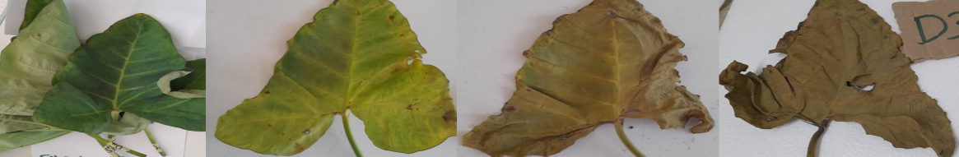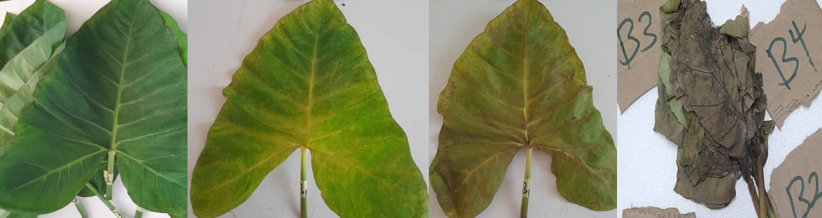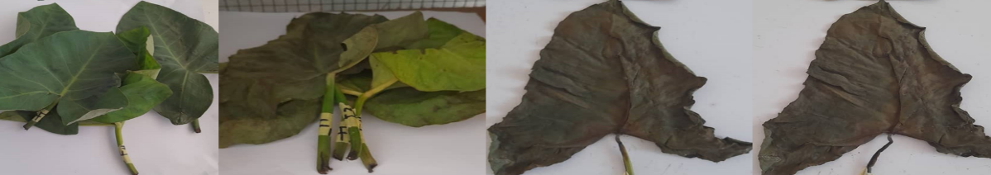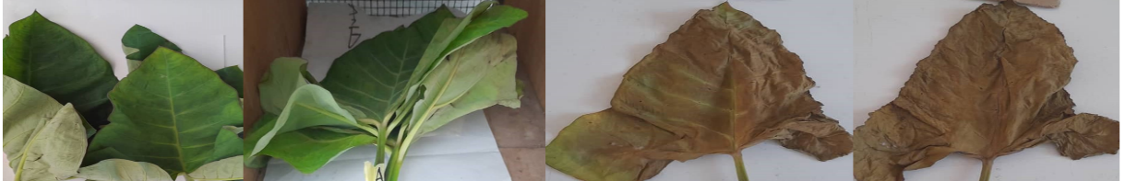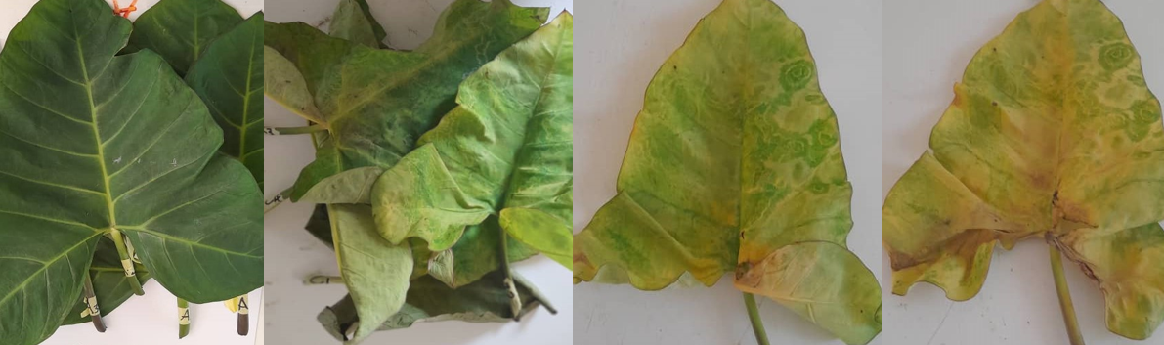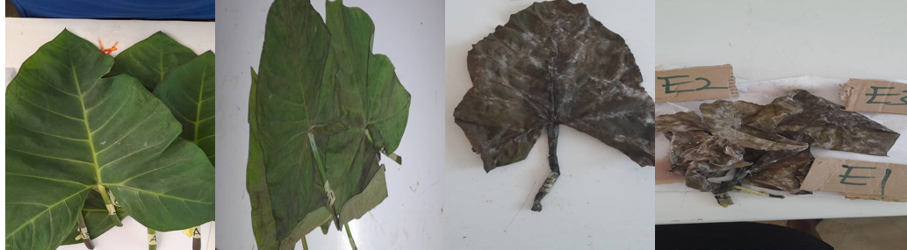

**24HRS COOLER**

**CONTROL AMBIENT**

**CONTROL COOLER**

**6HRS AMBIENT**

**6HRS COOLER**

**24HRS AMBIENT**

**Figure 1: Color changes in treated and untreated Rape vegetables during**

**storage under ambient(28˚C) and cooler (16˚C) condition for a period of 6 days**.

From Figure 1, it was observed that the control Rape vegetables stored under ambient temperature, had its natural green color which is due to the presence of chlorophyll pigments in day 0.

After day 0, the vegetables started changing color from green to dark-brown.

This dark-brown color appearing may be attributed to enzymatic browning occurring where phenolic compounds are being oxidized by the enzyme phenol oxidase which triggers the production of dark pigments as the vegetables undergo senescence [17]. This change in green color may be also due to the degradation of the chlorophyll contents in the vegetables.

A study conducted by Hassan and Mahfouz [18] on the effect of 1-MCP treatment on sweet basil leaf senescence and ethylene production during shelf-life reported on the decline in the total chlorophyll content in the vegetables during storage.

For control vegetables stored under cooler condition, change in green color started from day 4.

The low temperature might have had an effect on the degradation of the chlorophyll and also slowing down the rate of enzymatic browning in the vegetables.

There was a change in green pigmentation in 6 hours treated vegetables stored under ambient condition.

The green color was changed to yellowish green from day 2 to day 6.

There was some chlorophyll pigment in the vegetables at day 6 and this may be due to 1-mcp delaying chlorophyll degradation.

Gong and Mattheis [19] and Hershkovitz et al. [20] found out that 1-MCP treated broccoli florets and avocado fruit had a reduction in the chlorophyllase activity. However, in 6 hours exposed vegetables stored under cooler, changed from green to dark color on day 4 and day 6.

This may be due to the temperature increasing the activity of the enzyme chlorophyllase leading to a degradation the chlorophyll content in the vegetables.

For 24 hours exposed vegetables stored under both ambient and cooler conditions exhibited a yellow color as the number of days increased.

However, there were some dark brown colors in the vegetables and this may be due to some enzymatic browning occurring and decrease in chlorophyll content.

The effect of 1-MCP and storage days on the shrinkage ratio of Rape vegetables stored under ambient (28˚C) and cooler conditions (16˚C) are shown in Table 3.

**Table 3: Effect of 1-MCP and storage days on the shrinkage ratio of Rape vegetables stored under ambient (28˚C) and cooler conditions (16˚C).**

|  |  |  |  |  |  |
| --- | --- | --- | --- | --- | --- |
| **Testing index** | **Treatment** | **Storage days** |  |  |  |
|  |  | **0** | **2** | **4** | **6** |
| Shrinkage ratio (%) | Control (Ambient) | 0.00±0.00h | 5.40±0.92f | 11.76±0.64bc | 15.34±0.53a |
|  | 6 hrs 1-MCP (Ambient) | 0.00±0.00h | 1.38±0.23h | 7.52±0.62e | 10.34±0.95cd |
|  | 24 hrs 1-MCP (Ambient) | 0.00±0.00h | 0.75±0.07h | 7.12±0.16e | 11.00±0.97cd |
|  | Control (cooler) | 0.00±0.00h | 3.03±0.15g | 12.62±0.81b | 16.62±0.59a |
|  | 6 hrs 1-MCP (cooler) | 0.00±0.00h | 0.77±0.22h | 6.51±0.34ef | 10.04±0.41d |
|  | 24 hrs 1-MCP (cooler) | 0.00±0.00h | 0.31±0.03h | 6.30±0.32ef | 9.96±0.17d |

Means that are not identical (P < 0.05) are significantly different.

Notes: The means ± standard deviations of triplicate determination values were presented.

The results showed that 1-MCP-treated samples kept under ambient conditions for 6 days started shrinking at a slower rate, which ranged from 0.00±0.00% to 10.34±0.95%, while the rape vegetables kept as a control under the same condition and period showed a high rate of shrinkage, which ranged from 0.00±0.00% to 15.34±0.53%.

In both rape vegetables, no shrinkage was observed for the first day.

Other studies had reported that treating leafy vegetables with 0.5 μl/L 1-MCP indicated an increase in the shelf life of 37.5%, 23.8%, and 36.8%, respectively, compared to the controlled sample [4].

Shrinkage was observed from day 2 to day 6 after storage, and there was a steady increase in shrinkage with the passing of storage time, with 24-hour vegetables exhibiting shrinkage at day 2 and then sharply increasing from day 4 to day 6 from 7.12±0.16% to 11.00±0.97%. Control Rape vegetables stored under ambient conditions (28°C) and cooler (16°C) both exhibited an increase in shrinkage from day 4 to day 6 after storage.

There was no significant difference (P>0.05) in the shrinkage between control vegetables stored under ambient conditions and control vegetables stored under cooler conditions for days 4 and 6, respectively.

This may be attributed to the temperature suppressing the degradation of leaf cell sap activities.

When the temperature increases or decreases, it affects the cell’s respiration processes, thereby depriving the leaf of turgidity and then shrinking it.

Rape vegetables exposed to 6 hours of 1-MCP under ambient and cooler conditions had no significant differences in the means of the shrinkage for day 0, day 4, and day 6.

Nonetheless, there was a significant difference in the shrinkage for day 4 (7.52±0.62% to 6.51±0.34%).

For 24 hours, rape vegetables were stored under ambient and cooler conditions; there was a significant difference (P<0.05) in the shrinkage from day 4 to day 6.

Vegetables exposed for 24 hours and stored under cooler and ambient conditions both started shrinking from day 2, but with a slow rate of shrinkage on the treated vegetables.

This may be as a result of the 1-MCP retarding the shrinkage process, and also the temperature slowing down the respiration processes of the Rape.

Comparing treated vegetables to the control under ambient conditions, the minimum shrinkage index observed was 9.96±0.17 % for vegetables exposed to 1-MCP for 24 hours, and the highest shrinkage was observed in control vegetables with a value of 16.62±0.59%.

However, for treated and control vegetables stored under cooler conditions, the minimum shrinkage index recorded was 9.96±0.17 % for vegetables exposed to 1-MCP for 6hours, and the highest shrinkage was 11.00±0.97% observed in vegetables exposed for 24 hours.

There was no significant difference (P>0.05) in shrinkage among the three vegetables (control, 6hours, and 24 hours).

From Table 3, it can be deduced that vegetables exposed to 1-MCP for 24 hours under ambient conditions were best for storage since it reduced the rate of shrinkage in the Rape vegetables.

**4. Conclusion**

In this present study, the effect of 1-MCP on the shelf life of Rape vegetables stored under ambient (28˚C) and cooler (16˚C) conditions for 6 days was assessed.

There are several parameters to assess the shelf life of leafy vegetables.

Weight loss, shrinkage, decay, and color were the quality parameters determined in assessing the shelf life of Rape vegetables.

Regarding the Weight loss, Rapeseed vegetables had an increase in weight loss during storage. However, 24 hours after 1-MCP, Rape vegetables stored under cooler conditions had the least weight loss.

From this observation, it can be said that 1-MCP reduces the loss in weight during storage of Rape vegetables. For shrinkage, 1-MCP-treated vegetables had minimal shrinkage.

During storage, the vegetables decayed as the number of days increased.

Vegetables exposed to 1-MCP for 24 hours under ambient conditions were best for storage since it reduced the rate of decay in the vegetables.

Furthermore, the color of Rape vegetables changed from green to dark brown and some to yellowish green during storage.

However, during storage, it was observed that 1-MCP-treated vegetables had a minimal change in color from green to yellowish green.

Therefore, 1-MCP prolongs the shelf life of Rape vegetables during storage.

**References**

[1] Asante-Kyei, Kofi, Alexander Addae, & Mercy Abaka-Attah. (2019). “Production of Clay Containers for Curbing Plantain Post-Harvest Losses in Ghana.” New Journal of Glass and Ceramics, 09(03):50–65. DOI: 10.4236/njgc. 2019.93005.

[2] Afrifa, T. J. (2013). Extending the Shelf-Life of Green Vegetables (Xanthosoma Sagittifolium) Through Blanching, Irradiation, and Low-Temperature Storage. 2010.

[3] Kwenin, W. K. J.; Wolli, M., & Dzomeku, B. M. (2011). Assessing the nutritional value of some African indigenous green leafy vegetables in Malawi. Journal of Animal & Plant Sciences, 10(2), 1300–1305.

[4] Ma, S. J., Zheng, Y. H., Cao, S. F., Li, N., Yang, Z. F., & Tang, S. S. (2006). The effects of 1-methylcyclopene on the shelf life and quality of three leafy vegetables. Acta Horticulturae, 712 I, 401–406. https://doi.org/10.17660/ActaHortic.2006.712.46

[5] Oguntowo, O., Obadina, A. O., Sobukola, O. P., & Adegunwa, M. O. (2016). Effects of processing and storage conditions of green strips on the quality of fries. Food Science and Nutrition, 4(6), 906–914. https://doi.org/10.1002/fsn3.358

[6] Pogson, B. J., & Morris, S. C. (1997). Consequences of cool storage of broccoli on physiological and biochemical changes and subsequent storage at 20 °C. In Journal of the American Society for Horticultural Science (Vol. 122, Issue 4, pp. 553–558). https://doi.org/10.21273/jashs.122.4.553.

[7] Able, A. J., Wong, L. S., Prasad, A., & O’Hare, T. J. (2005). The physiology of senescence in detached pak choy vegetables (Brassica rapa var. chinensis) during storage at different temperatures. Postharvest Biology and Technology, 35(3), 271–278. https://doi.org/10.1016/j.postharvbio.2004.10.004.

[8] King, G. A., & Morris, S. C. (1994). Physiological changes of broccoli during early postharvest senescence and through the preharvest-postharvest continuum. Journal of the American Society for Horticultural Science, 119(2), 270–275. https://doi.org/10.21273/jashs.119.2.270

[9] Ku, V. V. V., & Wills, R. B. H. (1999). Effect of 1-methylcyclopropene on the storage life of broccoli. Postharvest Biology and Technology, 17(2), 127–132. https://doi.org/10.1016/S0925-5214(99)00042-3.

[10] Sun, B., Yan, H., Liu, N., Wei, J., & Wang, Q. (2012). Effect of 1-MCP treatment on postharvest quality characters, antioxidants and glucosinolates of Chinese kale. Food Chemistry, 131(2), 519–526. https://doi.org/10.1016/j.foodchem.2011.09.016

[11] Wills, R. B. H., Ku, V. V. V., & Warton, M. A. (2002). Use of 1-methylcyclopropene to extend the postharvest life of lettuce. Journal of the Science of Food and Agriculture, 82(11), 1253–1255. https://doi.org/10.1002/jsfa.1188.

[12] Association of Official Analytical Chemists (AOAC). (2005). Official Methods of Analysis (22nd Edition). Association of Official Analytical Chemists. Washington U.S.A

[13] Wu, C., Du, X., Wang, L., Wang, W., Zhou, Q., & Tian, X. (2009). Effect of 1-methylcyclopropene on postharvest quality of Chinese chive scapes. Postharvest Biology and Technology, 51(3), 431–433. https://doi.org/10.1016/j.postharvbio.2008.08.005.

[14] Rajkumar, G., Shanmugam, S., Galvâo, M. D. S., Leite Neta, M. T. S., Dutra Sandes, R. D., Mujumdar, A. S., & Narain, N. (2017). Comparative evaluation of physical properties and aroma profile of carrot slices subjected to hot air and freeze drying. Drying Technology, 35(6), 699–708. https://doi.org/10.1080/07373937.2016.1206925.

[15] Cox, K. A., McGhie, T. K., White, A., & Woolf, A. B. (2004). Skin colour and pigment changes during ripening of ‘Hass’ avocado fruit. Postharvest Biology and Technology, 31(3), 287–294. https://doi.org/10.1016/j.postharvbio.2003.09.008.

[16] Ben‐Yehoshua, S., & Rodov, V. (2003). Transpiration and water stress In Bartz JA, & Brecht JK (Eds.), Postharvest physiology and pathology of vegetables (pp. 111–159).

[17] Yuan, G., Sun, B., Yuan, J., & Wang, Q. (2010). Effect of 1-methylcyclopropene on shelf life, visual quality, antioxidant enzymes, and health-promoting compounds in broccoli florets. Food Chemistry, 118(3), 774–781. https://doi.org/10.1016/j.foodchem.2009.05.062.

[18] Hassan, F., & Mahfouz, S. (2010). Effect of 1-methylcyclopropene (1-MCP) treatment on sweet basil leaf senescence and ethylene production during shelf-life. Postharvest Biology and Technology, 55(1), 61–65. https://doi.org/10.1016/j.postharvbio.2009.07.008.

[19] Gong, Y., & Mattheis, J. P. (2003). Effect of ethylene and 1-methylcyclopropene on chlorophyll metabolism of broccoli florets. Plant Growth Regulation, 40(1), 33–38. https://doi.org/10.1023/a:1023058003002

[20] Hershkovitz, V., Saguy, S. I., & Pesis, E. (2005). Postharvest application of 1-MCP to improve the quality of various avocado cultivars. Postharvest Biology and Technology, 37(3), 252–264. https://doi.org/10.1016/j.postharvbio.2005.05.003.