INFLUENCE OF SOCIO-DEMOGRAPHIC FACTORS ON DIETARY DIVERSITY AMONG PREGNANT BUSINESS WOMEN IN TUNDUMA TOWN COUNCIL, TANZANIA

ABSTRACT
Dietary diversity was a key factor in nutritional sufficiency particularly for business women who struggle to access diverse nutrients rich foods due to socio economic and occupation pressures. This study examine the influence of socio demographic factors on dietary diversity of pregnant business women attending antenatal clinics from their second and third trimesters to term. Data collected at baseline were (Socio demographic factors and dietary diversity) and endline (pregnancy outcomes and dietary diversity). The Minimum Dietary Diversity for women based on guidance provided by FAO for the Minimum Dietary Diversity for Women (MDD-W). It based on 10 food groups and used seven days food frequency questionnaire to assess dietary diversity. The findings revealed that at baseline over half of the pregnant business women (55.6%) had inadequate dietary diversity but by the study end this improved significantly with 65.5% exhibiting adequate dietary diversity. Food group consumption showed that staples starch had higher consumption rate at baseline (70.8) and endline (86.1 %) while other fruits had the lowest consumption baseline 16.2% and increased at endline 57.1%. Maternal outcomes 89.2% had a normal birth weight while 6.7% were low birth weight. In terms of birth length 76.7% were normal length with 13.5% below. Head circumference 72.6% were normal with 18.4 below and 19.7 over. Agricultural produce traders and shopkeepers had significantly lower DDS scores by 2.937 and 2.158 respectively compared to restaurant operators (P=0.045 and P=0.050). Study showed that for each small improvement in a mothers diet there was related improvement in the baby’s predicted health at birth. The dietary pattern suggest potential risks for micronutrient deficiencies due to suboptimal consumption of diverse food groups. Government, health care providers and NGOs should implement nutritional counseling, improve access to diverse local food markets and enhanced micronutrient supplementation programs.

Key words: Dietary diversity, Business women, socio-demographic factors and food groups

1.0 INTRODUCTION
Dietary diversity is a very important determinant of food quality and nutritional sufficiency particularly among women reproductive age. It reflects the variety of foods consumed across different food groups and is directly associated with improved maternal and child health outcomes (FAO, 2016). Poor dietary diversity is a public health issue in Tanzania and especially to women in peri-urban and rural environments. Business women including those who are pregnant, often face unique social economic and occupational pressures that can limit their ability to access and consume diverse, nutrient-rich diet (Getaneh, 2021).Recent studies have shown that only 46% of rural women in Tanzania meet the Minimum Dietary Diversity with diets typically dominated by starchy staples and limited in animal source foods, fruits and vegetable (Herned et al., 2024).

Social-demographic factors such as education level, income, type of business and marital status have been consistently identified as strong predictor’s dietary diversity. Women with higher education and formal employment are more likely to achieve adequate dietary diversity due to greater nutritional knowledge, access to food resources and structured daily routines (Hasham et al., 2020). In contrast women involved in informal business or with lower income levels may struggle with time constraints, food insecurity and lack of dietary awareness, limiting their intake of essential nutrients (Milele et al., 2021).

Pregnant women are particularly vulnerable as their nutritional needs are increased to support fetal growth and maternal wellbeing. Poor maternal dietary diversity is associated with adverse pregnancy outcomes such as low birth weight, preterm birth and impaired infant growth and development (Fang, 2024 & Panzeri, 2024). In Tunduma Town Council a rapidly growing border town with a large population engaged in small scale business, understanding the dietary behaviors of these pregnant business women is vital. Despite their economic activity, many still face dietary challenges due to socio-economic inequalities, occupational stress and limited access to health information (Li et al., 2021).

This study examining the influence of socio-demographic factors on dietary diversity of pregnant business women in Tunduma Town Council. The findings aim to provide evidence for targeted nutrition interventions and policy strategies to improve maternal nutrition and health outcomes in this context.

2.0 MATERIALS AND METHODS
2.1 Study Setting
The study was conducted in Tunduma Town Council, Songwe Region. The area of Tunduma is about 87.46 square kilometers and it has a total population of 219,309 out of which 114, 967 are female according to Tanzania National census (NBS, 2022).

Tunduma is busy urban center located in the Songwe Region of Tanzania and situated near the border with Zambia. Tunduma serves as a key commercial center, attracting business activities and diverse population including business women engaged in various trades (Stephen, 2023). There are 23 health facilities owned by the council in Tunduma. These including 1 hospital, 8 health centers and 14 dispensaries. The study was conducted in the Tunduma health centers which offers a range of essential health services including maternal and child health care, outpatient and inpatient treatment and emergency services. It plays a key role in supporting pregnant women by providing antenatal and postnatal care.

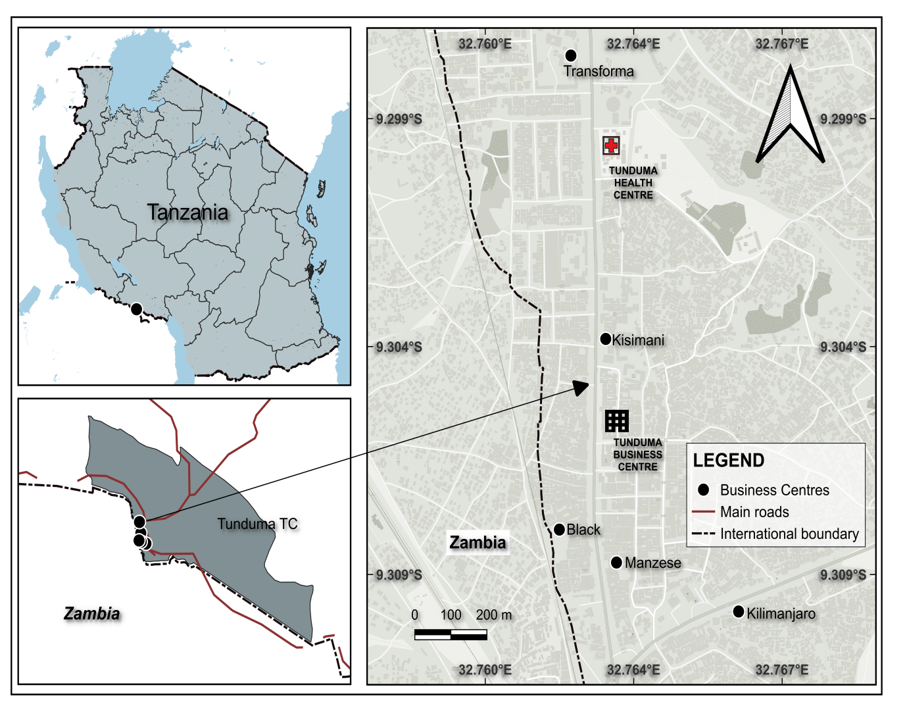
Figure 1: Map of the study area, Tunduma Town Council Tanzania

2.2 Study design and population
A panel longitudinal study was conducted to investigate influence of socio-demographic factors on dietary diversity and pregnancy outcomes among pregnant business women by capturing changes over time through data collection at multiple points during pregnancy and after childbirth. The study was involved a sample of business women aged between 15 to 49 years who are currently pregnant specifically in their second and third trimesters of pregnancy until given birth. Data were collected from November 2024 to May 2025 in the catchment areas of Tunduma Health Center located within Tunduma Town Council. The data collection occurred at two time point: At enrollment (baseline) and after delivery (endline). Pre-survey data collection focused on examined socio demographic factors and dietary diversity while post survey data collection examined dietary diversity and determine pregnancy outcomes (birth weight, birth length and head circumference). To ensure data linkage while maintain anonymity participants were asked during the pre-survey to create a personal memorable code such as a combination of their birth month and the first letter of their mothers name that they could easily recall and use in both surveys. Eligible pregnant business women attending antenatal care (ANC) visits at the Tunduma Health center were identified with the help of health care providers at the clinic. The recruitment process occurred in two phases: In phase 1(T1), participants were recruited and baseline data were collected on dietary diversity and socio-demographic factors and in phase 2 (T2) a final follow up was carried out to collect comprehensive information on pregnancy outcomes along with dietary diversity.

2.3 Sampling procedures
Both probability and non-probability sampling methods were employed to recruit pregnant business women at Tunduma Health Center for the study. Collaboration was established with trained research assistance and health care providers especially those working in antenatal clinics to help identify and refer pregnant women engaged in business activities. During routine antenatal visits, eligible participants were approached by trained research assistants who explained the purpose, benefits and ethical aspects of the study. For non-probability sampling, purposive sampling was used to gain targeted insights based on specific characteristics. Pregnant business women were selected from facilities known to have high concentration of such individuals to ensure the sample was representative of the target population. For probability sampling, stratified sampling was used. The population of pregnant business women was divided into subgroups (strata) based on trimesters to ensure the sample reflected the diversity of the population of pregnant business women.

2.4 Sample Size
The total number of pregnant business women who participated in the study was determined using the sample size formula developed by Fisher et al., (1991).

N=Z² p q/ d²
Where
- N-It is the population sample
- Z- It is the standard normal deviation which corresponds 95% confidence level (1.96)
- P- It is the proportion of women in Songwe Region met the minimum dietary diversity which was 15.8%=0.158 (TDHS, 2022).
- q- (1-P)=0.842
- d=0.05 (error)
N=1.96²x0.158x0.842/0.05²

=202
In order to cater for non- response rate the sample size was increased by 10% (Fisher et al., 1991).
N=202 + 202(10%)
Therefore the sample size was 223.

2.5 Data collection
2.5.1 Construction and administration of a Questionnaire
The study was employed a three section for constructed questionnaire together information. Section A focused establishing rapport, introducing the study’s purpose and collecting basic demographic data. Section B utilized a food frequency questionnaire to assess dietary diversity, while section C aimed together data on pregnancy outcomes specifically birth weight, length and head circumference. To ensure its effectiveness, the questionnaire was pre-test with 20 business women in Mbeya and necessary adjustments were incorporated. Five enumerators received comprehensive training on question delivery and response recording to ensure consistent data collection. Finally the questionnaires were administered through face to face interviews at Tunduma health center (Antenatal clinic visiting) during morning hours.

2.5.2 Socio-Demographic factors
Information on socio-demographic factors of the study participants was collected using pretested questionnaire administered by trained research assistants. The collected data included age, education, income, marital status, parity, family size and type of business. All data were collected during the baseline.

2.5.3 Dietary Consumption
The study used a 7-day Food Frequency Questionnaire to assess the dietary habits of pregnant business women in Tunduma, focusing on the types of food they ate, meal frequency and how they accessed their meals. Participants were given a list of common foods and asked to indicate how frequently they consumed them (frequently, almost, daily, occasionally and never). The FFQ also explored how they got their meals in order to understand the challenges they faced. Responses were recorded as 1.Never consumed, 2. Occasionally consumed (1-2days) 3. Frequently consumed (3-4 days) 5. Almost daily consumed (5-6 days) 6. Daily consumed.

2.5.4 Dietary Diversity
Dietary diversity were computed based on guidance provided by FAO for the minimum dietary diversity for women (MDD-W) (FAO, 2021). The MDD-W was used to assess the dietary diversity of the respondents since it has been shown to indicate adequate nutrients intake and can be used as a proximal indicator for measuring nutrients adequacy among women. Dietary diversity among pregnant business women in Tunduma was assessed using a 7-day Food Frequency Questionnaire (FFQ), designed to capture the usual consumption patterns of the study participants. This questionnaire was structured around the 10 food groups commonly recommended for assessing dietary diversity, aligning with the Minimum Dietary Diversity for Women (MDD-W) guidelines. As proposed by FAO, 10 food groups were computed such as starch staples (grains, white root and tubers and plantains), legumes (beans, peas and lentils), nuts and seeds (peanuts, sesame) dairy (milk, cheese and yogurt) Meat, poultry and fish (beef, chicken, fish), eggs, dark green leafy vegetables (flesh pumpkin leaves, bean leaves, spinach) Other vitamin A-rich fruits and vegetables (carrots, pumpkin leaves, bean leaves, spinach), Other vitamin A-rich fruits and vegetables (carrots, pumpkin, mangoes), Other vegetables (tomatoes, onion, green beans) and other fruits (banana, apple, avocado) (FAO, 2021). During the assessment period each food group consumed contributes one point in the total score with a maximum possible score of ten points. The criteria for meeting Minimum Dietary Diversity (MDD-W) was the consumption of food from > 5 of the 10 food groups. Dietary scores were classified into adequately (high) and inadequately (low) diversity based on MDD-W.

2.5.5 Anthropometric measurement
Birth weight, birth length and head circumference were measured at birth by trained study nurse using calibrated weight scale, length board and tape measure respectively . Birth weight was measured in grams using an infant weighing scale, recorded to the nearest 0.1 kg and categorized as: less than 2.5kg (low birth weight), 2.5-4.0kg (normal) and over 4.0kg (overweight). Birth length was measured in centimeters using a length board, recorded to the nearest 0.1 cm and categorized as less than 45cm (low birth length ), 45-55 cm (normal) and over 55cm (over length). Head circumference was measured using a tape circumference), 32-37cm (normal) and over 37 (Over). These measurements were used to assess outcome variables to determine the influence of socio-demographic factors on dietary diversity serving as critical indicators of newborn health and maternal nutritional status during pregnancy. (WHO, 2006)
2.6 Data Analysis
2.6.1 Compilation and Coding
Food items were categorized into food groups (fruits, vegetables, staple starch) and coded allowing for Dietary Diversity Scores (DDS). One scores was given to each respondent that consumed a specific group and zero score to a respondent who did not consume a specific group. Sums of scores were calculated for each respondent. Pregnancy outcomes were categorized as birth weight, birth length and head circumference into low, normal and over.

2.6.2 Statistical Analysis
Data analysis was conducted by using IBM SPSS Version 27.0 where descriptive and inferential statistics were used. Descriptive statistics include frequency, percent, mean, standard deviation and minimum and maximum which show in socio-demographic and reproductive characteristics, dietary diversity, changes in frequency of food group consumption, Dietary Diversity Score at baseline and endline, distribution of Dietary Diversity categorical and challenges. Dietary Diversity Score (DDS) were computed and categorized as either adequate or inadequate based on standardized thresholds. Inferential statistics include Chi-square test used to show changes in frequency of food group consumption among pregnant business women at baseline and endline. Then Related-Samples Wilcoxon signed Rank Test summary used to show comparing baseline and endline. Dietary Diversity Score (DDS) was analyzed using multiple linear regression, with results presented in the form of an ANOVA table and a coefficient table, showing the model used to predict DDS.

2.7 Ethical Consideration
Ethical approval was obtained from the National Institute for Medical Research (NIMR/HQ/R.8a/Vol.IX/5013) while permission to undertake the study was obtained from Sokoine University of Agriculture (SUA/ADM/R.I8I1346). Written informed consent was obtained for all subjects. Permission was also obtained from relevant administrative offices. Data confidentiality and privacy were maintained throughout the research process.

3.0 RESULTS
3.1 Socio-Demographic characteristics of the respondents
A total of 223 pregnant business women were recruited for the study and completed all two rounds. The present studied, the majority 49.3% (n=110) were aged between 25-34 years indicating most respondents were young adults. Most respondents had attained Secondary education 50.7% (n=113), while a small proportion 1.3 %( n=3) had no formal education. The present study had 1-2 previous pregnancies 66.8% (n=149). A significant portion were married 86.5 % (n=193) and worked primarily as shopkeepers 75.3% (n=193). In terms of income 30.9% (n=69) earned less than 500,000 TZS monthly, while only 3.6% (n=8) earned more than 5,000,000 TZS. Regarding family size 60.5% (n=135) had fewer than four children.

Table1: Socio-demographic and reproductive Characteristics of the respondents
Variable | Frequency | Percent %
Age
16 – 24 | 57 | 25.60
25 – 34 | 110 | 49.30
≥ 35 | 56 | 25.10
Education level
Non-formal | 3 | 1.30
Primary | 76 | 34.10
Secondary | 113 | 50.70
College/University | 31 | 13.90
Parity (number of previous pregnancies)
Nulliparous | 0 | 0.00
1−2 | 149 | 66.80
≥ 3 | 74 | 33.20
Marital status
Single | 30 | 13.5
Married | 193 | 86.50
Income (monthly)
Less than 500,000 TZS | 69 | 30.90
1,000,000 - 2,000,000 TZS | 52 | 23.30
2,000,000 - 5,000,000 TZS | 42 | 18.80
500,000 - 1,000,000 TZS | 52 | 23.30
More than 5,000,000 TZS | 8 | 3.60
Type of business
Agricultural produce trader | 45 | 20.20
Shopkeepers | 168 | 75.30
restaurant operators | 10 | 4.50
Family size (number of children)
Less than 4 | 135 | 60.50
More than 4 | 88 | 39.50

3.2 Food group Consumption
The majority of participants reported high consumption of starchy staples at both baseline 70.8% (n=158) and endline 86.1% (n=193). The consumption of other fruits was relatively low at baseline 16.2% (n=36) but showed a notable increased by endline 57.9% (n=129). This indicated that their diets heavily relied on starch staples and very few respondents reported frequent or near daily consumption of nutrient rich food categories such as milk and milk products, legumes, meat, poultry and fish.

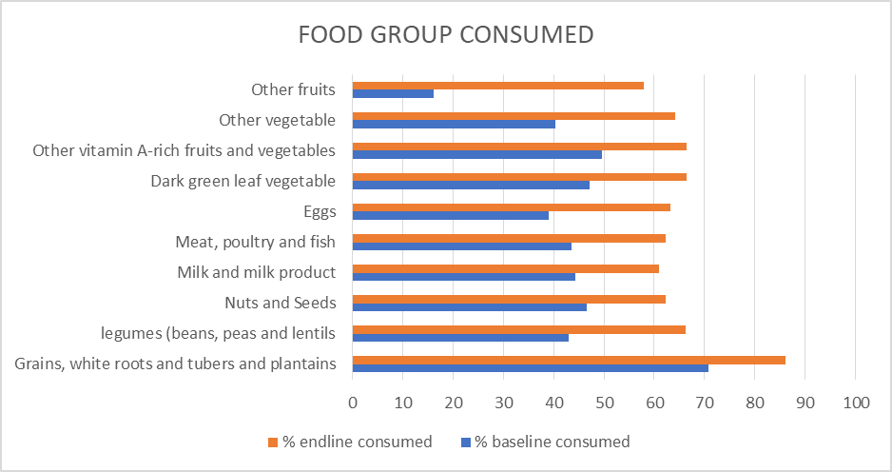
Figure 2: Frequency of food group consumption

3.3 Dietary Diversity Score.
The present study show that at baseline more than half of pregnant business women 55.6% (n=124) had inadequate dietary diversity while 44.4% (n=99) had adequate dietary diversity. At the endline there was improved with the proportion of women exhibiting adequate dietary diversity increasing to 65.5% (n=146) and decreasing inadequate dietary diversity 34.5% (n=77).

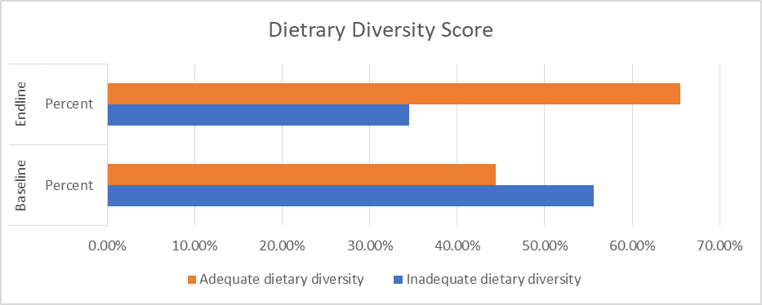
Figure 3: Dietary Diversity Score classification

3.4 Difference in Dietary Diversity Score between baseline and endline.
The related samples Wilcoxon signed rank test was conducted to assess the difference in dietary diversity scores (DDS) between baseline and endline among 223 pregnant business women. The test yields at statistically significant results (Z=-7.69, P<0.01), indicating a significant increase in DDS from baseline to endline.

Table 2: Wilcoxon signed rank Test comparing baseline and endline Dietary diversity scores.
Related-Samples Wilcoxon Signed Rank Test Summary
Total N | 223
Test Statistic | 3816.5
Standard Error | 823.682
Standardized Test Statistic | -7.69
Asymptotic Sig.(2-sided test) | <0.001

3.5 Dietary and Nutritional Challenges
The findings indicate that majority of business women in Tunduma reported no cultural or traditional dietary influences (92.4%). Additionally only a small proportion (3.1%) had access to health food options during work and 4.5% reported challenges in maintaining balance diet during pregnancy.

Table 3: Dietary and nutritional challenges among pregnant business women.
Variable | Category |  | Freq. | Percent%
Dietary restrictions or preferences |  | No | 219 | 98.20
 |  | Yes | 4 | 1.80
Consume any fortified foods |  | No | 206 | 92.40
 |  | Yes | 17 | 7.60
Cultural or traditional dietary practices that influence |  | No | 222 | 99.60
 |  | Yes | 1 | 0.40
Access to healthy food options at work |  | No | 216 | 96.90
 |  | Yes | 7 | 3.10
Challenges in maintaining a balanced diet during pregnancy |  | No | 213 | 95.50
 |  | Yes | 10 | 4.50

3.6 Changes in frequency of food group consumption
The present study showed that fruit consumption improved with the proportion of those who never consumed dropping from 83.9% to 42.2% while occasional and frequent consumption increased. Similarly pattern were observed for vegetables, legumes, starch staples, fish/meat, dairy and nuts and seeds all showing increased frequency of consumption. Chi-square tests indicated that the changes in consumption frequency for all food groups were statistically significant, which show overall improvement in dietary diversity.

Table 4: Changes in frequency of food group consumption among pregnant business women in Tunduma at baseline and endline.
Variable | Category | STATUS |  |  | Test statistics
 |  | Baseline (T1) | Endline (T2) | Chi-square |  | Sig.
Grain, white roots and tubers and plantains | Never | 29.1 | 13.9 | 20.408 |  | <0.001
 | Occasionally (1-2 days) | 65.5 | 76.7
 | Frequently (3-4 days) | 4.9 | 8.5
 | Almost daily (5-6 days) | 0.4 | 0.9
Dark green leaf vegetable | Never | 52.9 | 33.6 | 20.663 |  | <0.001
 | Occasionally (1-2 days) | 41.3 | 59.7
 | Frequently (3-4 days) | 2.7 | 5.4
 | Almost daily (5-6 days) | 3.1 | 1.3
Legumes (e.g. Beans, pigeon peas, cowpeas, lentils, chickpeas, black beans) | Never | 57 | 33.6 | 25.862 |  | <0.001
 | Occasionally (1-2 days) | 35.4 | 56
 | Frequently (3-4 days) | 5.4 | 8.5
 | Almost daily (5-6 days) | 2.2 | 1.8
Nuts and Seeds (e.g. Pumpkin seed, groundnuts, almonds, walnuts, chia seeds) | Never | 53.4 | 37.7 | 13.441 |  | 0.009
 | Rarely (1-2 times) | 22.4 | 33.2
 | Occasionally (1-2 days) | 15.2 | 20.6
 | Frequently (3-4 days) | 5.8 | 6.7
 | Almost daily (5-6 days) | 3.1 | 1.8
Other vitamin A-rich fruits and vegetables | Never | 50.2 | 33.6 | 14.74 |  | 0.005
 | Occasionally (1-2 days) | 42.1 | 57.9
 | Frequently (3-4 days) | 6.3 | 5.4
 | Almost daily (5-6 days) | 1.3 | 3.1
Other vegetable | Never | 59.6 | 35.9 | 27.381 |  | <0.001
 | Occasionally (1-2 days) | 34.5 | 55.6
 | Frequently (3-4 days) | 5.4 | 7.6
 | Almost daily (5-6 days) | 0.4 | 0.9
Milk and milk product (e.g., Milk, yogurt and other dairy) | Never | 55.6 | 39 | 19.072 |  | 0.001
 | Occasionally (1-2 days) | 38.5 | 57.4
 | Frequently (3-4 days) | 4.9 | 1.8
 | Almost daily (5-6 days) | 0.9 | 1.8
Meat, poultry and fish (e.g., Fish, Beef, goat, poultry, pork, eggs) | Never | 56.5 | 37.7 | 20.328 |  | <0.001
 | Occasionally (1-2 days) | 36.8 | 57.8
 | Frequently (3-4 days) | 5.4 | 4
 | Almost daily (5-6 days) | 1.3 | 0.4
Eggs | Never | 61 | 36.8 | 31.3 |  | <0.001
 | Occasionally (1-2 days) | 34.1 | 55.6
 | Frequently (3-4 days) | 3.6 | 5.4
 | Almost daily (5-6 days) | 1.3 | 2.2
Other fruits | Never | 83.9 | 42.2 | 85.872 |  | 0
 | Occasionally (1-2 days) | 14.4 | 50.7
 | Frequently (3-4 days) | 1.8 | 6.3
 | Almost daily (5-6 days) | 0 | 0.9

3.7 Anthropometric Parameters
Result showed that 89.2% (n=199) of infants had normal birth weight (2.5-4.0kg), 6.7% (n=15) had low birth weight (<2.5kg) and 4.0% (n=9) had over weight (>4.0kg). For birth length, 76.7% (n=171) were normal length (45-55cm), 13.5% (n=30) were below 45cm, and 9.9% (n=22) were above 55cm. Regarding head circumference, 72.6% (n=162) measured 32-37cm, 18.4% (n=41) were below 32cm and 19.7% were over 37 cm. Low birth weight, below normal birth length and head circumference suggest that a significant proportion of mothers experiencing nutritional deficiencies during pregnancy which can directly impact fetal growth and development.

Table 5: Birth weight, length, and head circumference information of infants.
Variable |  | Freq. | Percent%
Infant’s Birth Weight | <2.5 kg | 15 | 6.7
 | 2.5 - 4.0 kg | 199 | 89.2
 | >4.0 kg | 9 | 4.00
Infant’s Birth Length | < 45 cm | 30 | 13.5
 | 45 - 55 cm | 171 | 76.7
 | >55 cm | 22 | 9.9
Infant’s Head Circumference | <32 cm | 20 | 9.0
 | 32 - 37 cm | 162 | 72.6
 | <37 cm | 41 | 18.4

3.8 Factors associated with MDD-W
3.8.1 Demographic factor
The results of a multiple linear regression model predicting Dietary Diversity Scores (DDS) show that cultural or traditional dietary practices and access to healthy food option at work showed positive but statistically insignificant effects on DDS (P=0.621 and P=0.716). In contrast type of business significantly influenced DDS: agricultural produce traders and shopkeepers had lower DDS by 2.937 and 2.158 points respectively compared to restaurant operators (P=0.0045 and P=0.050 respectively). The model constant (_cons), representing the average DDS for restaurant operators without dietary restrictions or cultural practices and with no healthy food access at work was 6.586.

Table 6: Coefficients of Multiple Linear Regression Model Predicting DDS.
DDS score | Coefficient | Std. err. | t | P>t | [95% conf. interval]
Cultural or traditional dietary practices (1) | 1.414 | 2.853 | 0.5 | 0.621 | -4.209 | 7.037
Access to healthy food options at work (1) | 0.405 | 1.110 | 0.36 | 0.716 | -1.783 | 2.593
Type of business (1) | -2.937 | 1.457 | -2.02 | 0.045** | -5.810 | -0.065
Type of business (2) | -2.158 | 1.094 | -1.97 | 0.05** | -4.315 | -0.001
_cons | 6.586 | 0.202 | 32.62 | 0.00*** | 6.188 | 6.984
Note: ** significance at 95% confidence level, *** significance at 99% confidence level, Reference for Dietary restrictions or preferences, cultural or traditional dietary practices, and Access to healthy food options at work was No, Reference for Type of business was restaurant operators

3.8.2 Birth outcome
Based on the Anova results for linear regression model where dependent variable (birth weight) the model shows a statistically significant relationship between the independent variable (DDS) and outcome. The regression model has an F-statistic of 4.456 with corresponding p-value of 0.036 which is less than the convectional threshold of 0.05. The independent variables included in the model explain a statistically significant portion of the variance in the birth weight. This means there’s a meaningful linear relationship between the predictor and birth weight.

Table 7: ANOVA summary for linear Regression model predicting Birth Outcome
Model |  | Sum of Squares | Df | Mean Square | F | Sig.
1 | Regression | 4.388 | 1 | 4.388 | 4.456 | 0.036
 | Residual | 217.612 | 221 | 0.985
 | Total | 222 | 222

The DDS score has a positive and statistically significant association with birth weight: for every one unit increase in DDS, the birth weight improves by 0.060 units (P=0.036), with a 95% confidence interval ranging from 0.004 to 0.117. The model constant which represents the predicted birth weight when DDS is zero, is -0.266, but this is not statistically significant (P=0.063)

Table 8: Coefficients from linear regression model predicting birth outcome from DDS score
Birth outcome | Coefficient | Std. err. | T | P>t | [95% conf. interval]
DDS score | 0.060 | 0.029 | 2.11 | 0.036** | 0.004 | 0.117
_cons | -0.266 | 0.142 | -1.87 | 0.063 | -0.547 | 0.015
Note: ** significance at 95% confidence level, *** significance at 99% confidence level

4.0 DISCUSSION
4.1 Socio-demographic characteristics of respondents
The study found that the majority of respondents are young adult females aged 25–34 years, a group commonly representing the reproductive age demographic in many low- and middle-income countries (Chipako, 2024). Educational attainment among this population is moderate, with nearly half having completed secondary education; however, a notable minority lack formal education. Education generally equips individuals with better nutritional knowledge and resource management skills. However despite education factors like limited access to diverse food market and affordability of food can still restrict dietary variety. This was supported by study conducted by Ghiasi (2021) show that high nutrition knowledge as significant associated with adequately dietary diversity. Most respondents are married and actively engaged in small-scale entrepreneurial activities, such as operating shops and agricultural produce trader. This linking to their family responsibilities and the need for additional income. It was similar to study conducted by Magrin et al., (2021) often married women highlighting family responsibilities as a driving factor for seeking additional income and also Women dominating small holder agriculture making them key players in the post-harvest activities like trade produce. Despite this socioeconomic engagement, many earn less than 500,000 TZS per month, which falls below Tanzania’s minimum wage in several sectors, indicating economic vulnerability. A study by Nkoma (2017) highlights low profits and significant challenges faced by women entrepreneurs in Tanzania’s informal sector that limit their income potential.

4.2 Dietary diversity scores of business women
The study indicated a positive shift in dietary diversity categories among pregnant business women from baseline to endline. At baseline, over half of the women exhibited inadequate dietary diversity, while a smaller proportion had adequate dietary diversity while the endline, these figures had significantly reversed, with the majority demonstrating adequate dietary women go through many changes that affect what and how much they eat. Their bodies are healing, and if they are breastfeeding, they need more energy and nutrients to make enough milk. This naturally leads to eating more and possibly a wider range of foods, as long as they have access to them. Also, during the postnatal period, women often get more support from family and have better access to health information through clinic visits (Rees & Brough, 2025). This is consistent with findings from Huang et al (2018) who reported that about 40% of mothers in Dodoma lacked diverse diets. Another study reported only 28% of pregnant women in Coast region met the minimum dietary diversity standard (Hemed et al., 2024). The improvement of business women likely reflects increased nutritional needs after childbirth, better utilization of prior antenatal nutrition education, and enhanced social and healthcare support during the postnatal period, leading to a reversal of the baseline inadequacy (Huang et al., 2018).

4.3 Food group consumption
The present study showed that at baseline high consumption of grains, white roots, tubers, and plantains and low consumption of other fruits, eggs, meat, poultry, and fish. By endline, there was a universal increase in the percentage of women consuming all listed food groups.
Limited consumption of food group could be due to seasonal availability, affordability, and access. These trends align with previous research which showed that staple foods like maize and cassava, often eaten as stiff porridge (ugali) with leafy vegetables and legumes dominate Tanzanian diets (Magrini et al., 2021).

4.4 Changes in frequency of food group consumption
The data showed that women’s diets improved significantly from the beginning (baseline) to the end of the study (endline). Fewer women said they "never" ate important foods like green leafy vegetables, legumes, nuts and seeds, milk products, meat, and eggs. One big change was in fruit consumption only 16.2% of women ate other fruits at the start, but by the end, that number had jumped to 57.9%. This improvement likely happened due to that women may have learned more about healthy eating during their antenatal (pregnancy) care visits. Also their bodies may have needed more nutrients after giving birth and they have had better support from their families or community when it came to food. In line with previous study focusing on nutrition services offered in ANC clinics identified nutrition education and dietary assessment as commonly provided services (Saronga et al ., 2020). This was due to that antenatal care provide a structured platform for health professional to delivery nutrition education, increasing women’s knowledge and potentially influencing their food choices. The increase in consumption of diverse food groups like fruits, vegetables and animal source food can be directly linked to this increased awareness.

4.5 Association of MDD-W with socio-demographic factor and birth outcome
This study revealed an association between Minimum Dietary Diversity Scores and type of business. The multiple linear regression analysis showed that the type of business had a lower DDS score. This means that women involved in types of businesses especially those that are very demanding or take up a lot of time may struggle to eat a wide variety of foods. This align with previous studies shown that many women in Tanzania's informal economy work long hours in tough conditions, leaving them little time to shop for or prepare diverse meals (UN Women, 2020). Also linear regression analysis shows a clear and positive link between a mother's Dietary Diversity Score and her baby's birth weight. Specifically, for every one-point increase in DDS, the birth weight improved. This means that women who ate a wider variety of foods during pregnancy were more likely to have healthier babies. This because eating different types of foods helps pregnant women get all the important micronutrients they need for their own health and their baby’s growth. This finding is supported by a study in Dar es Salaam which found that women with higher DDS were less likely to give birth to underweight (Anato et al., 2020).

5.0 CONCLUSION
The study conclude that pregnant business women are at risk of micronutrients deficiency at baseline data and significant improvements in dietary diversity were observed at endline with adequate dietary diversity increasing from 44.4% (n=99) to 65.5% (n=146) which was a big and meaningful changed. This improvement was statistically significant as demonstrated by a related samples Wilcoxon signed rank test (Z=-7.69, P<0.001), indicating a substantial increase in Dietary Diversity Score (DDS).

The study suggest that type of business negatively influenced DDS (B=-0.79, P=0.016) because of limited time or unstable income. The study showed that for each small improvement in a mother’s diet, there was a related improvement in baby’s predicted health at birth. This highlights how important postpartum care that supports women in eating a diverse diet is for both mother and baby predicted health at birth.

6.0 RECOMMENDATION
Healthcare providers particularly those offering antenatal and postnatal services, must integrate comprehensive nutritional counseling. This counseling should empower women with practical strategies for achieving diverse diets. Simultaneously, government and community organizations should develop and implement programs that offer accessible, affordable and culturally appropriate food resources, coupled with educational initiatives on nutrient dense foods and meal planning, to mitigate the negative influence of certain business types on dietary intake. Also government should consider and improve micronutrients supplementation and policies that support flexible work arrangements and access to healthy food options, development an environment conducive to optimal maternal nutrition post-delivery, thereby ensuring the continued positive impact on both maternal and infant health.

Limitations
The study faces significant limitations due to seasonal variations and food shortages that limited food availability of some food groups during the study. The main challenge included non-availability of some foods during some seasons which affects the variety and quantity of food availability.

REFERENCES
FAO & FHI 360. (2016). Minimum Dietary Diversity for Women: A Guide for Measurement. Food and Agriculture Organization of the United Nations.
Fisher, A. A., Laing, J. E., Stoeckel, J. E., & Townsend, J. W. (1991). Handbook for family planning operations research design (2nd ed.). Population Counci
Getaneh, T., Negesse, A., Dessie, G., Desta, M., Assemie, M. A., & Tigabu, A. (2021). Predictors of malnutrition among pregnant women in Ethiopia: a systematic review and meta-analysis. Human Nutrition & Metabolism, 26, 200131.
Hasham, S. S., & Manji, K. P. (2020). Antenatal Care and its association with birth weight in Temeke District, Dar-Es-Salaam, Tanzania. Tanzania Medical Journal, 28(2), 223.
Hemed, R., Msuya, L., & Mmbaga, M. (2024). Dietary diversity and associated factors among women attending antenatal clinics in the Coast region of Tanzania. BMC Nutrition, 10(1), 1–10.
Huang, M., Sudfeld, C., Ismail, A., Vuai, S., Ntwenya, J., Mwanyika-Sando, M., & Fawzi, W. (2018). Maternal dietary diversity and growth of children under 24 months of age in rural Dodoma, Tanzania. Food and Nutrition Bulletin, 39(4), 496–506.
Kamala, B. A. (2018). Predictors of low birth weight and 24-hour perinatal outcomes at Muhimbili National Hospital in Dar es Salaam, Tanzania: a five-year retrospective analysis of obstetric records. Pan African Medical Journal, 29, 220.
Kathuria, K. (2023). Impact of Maternal Health and Disease on Neonatal Outcome. In Clinical Anesthesia for the Newborn and the Neonate (pp. 11-27). Singapore: Springer Nature Singapore.
Killel, M., Mmbaga, M., & Msuya, L. (2024). Dietary intake and associated risk factors among pregnant women in Mbeya, Tanzania. BMC Nutrition, 10(1), 1–9.
Li, M., Grewal, J., Hinkle, S. N., Yisahak, S. F., Grobman, W. A., Newman, R. B., & Zhang, C. (2021). Healthy dietary patterns and common pregnancy complications: a prospective and longitudinal study. The American journal of clinical nutrition, 114(3), 1229-1237.
Magrini, E., Balié, J., & Kilic, T. (2021). Farm production diversity and household dietary diversity: Panel data evidence from rural households in Tanzania. Frontiers in Sustainable Food Systems, 5, 612341
Martínez-Galiano, J. M., Cano-Ibáñez, N., Hernández-Martínez, A., & Delgado-Rodríguez, M. (2020). Nutrition in Reproductive Health: Nutritional Conditioning Factors during Pregnancy and Its Impact on Health. Reproductive Medicine, 1(3), 13.
Mate, A., Reyes-Goya, C., Santana-Garrido, Á. & Vázquez, C. M. (2021). Lifestyle, maternal nutrition and healthy pregnancy. Current vascular pharmacology, 19(2), 132-140.
Mesfin, B. A., Argaw, A. T., Getahun Negash, F., Emiru, D. A., Aserese, A. D., & Matebe, G. Y. (2023). Minimum dietary diversity and associated factors among pregnant women living in Arba Minch health and demographic surveillance sites, Southern Ethiopia, 2022. Health Services Research and Managerial Epidemiology, 10, 23333928231166671.
Miele, M. J., Souza, R. T., Calderon, I. M., Feitosa, F. E., Leite, D. F., Rocha Filho, E. A., & Cecatti, J. G. (2021). Maternal nutrition status associated with pregnancy-related adverse outcomes. Nutrients, 13(7), 2398.
Mkoma, S. (2017). Socio-cultural factors affecting the performance of women entrepreneurs in Tanzania: A case study of women entrepreneurs in Ilala Municipality, Dar es Salaam.
Mweya, C. N., & Ephard, R. (2022). A population-based study on smoking, alcohol consumption, and substance use among women of reproductive age in Mbeya, Tanzania. Tanzania Journal of Health Research, 23(1), 1-10.
National Bureau of Statistics (NBS) & ICF. (2023). Tanzania Demographic and Health Survey and Malaria Indicator Survey (TDHS-MIS) 2022–2023.
Panzeri, C., Pecoraro, L., Dianin, A., Sboarina, A., Arnone, O. C., Piacentini, G., & Pietrobelli, A. (2024). Potential Micronutrient Deficiencies in the First 1000 Days of Life: The Pediatrician on the Side of the Weakest. Current Obesity Reports, 13(2), 338-351.
Saronga, N. L., Kamugisha, M., & Ndenge, M. O. (2020). Nutrition services offered to pregnant women attending antenatal clinics in Dar es Salaam, Tanzania: A qualitative study. Midwifery, 89, 102783.
Shenoy, S., Sharma, P., Rao, A., Aparna, N., Adenikinju, D., Iloegbu, C., & Peprah, E. (2023). Evidence-based interventions to reduce maternal malnutrition in low and middle-income countries: a systematic review. Frontiers in Health Services, 3.
Stephen, K. (2023). Electrical Energy for Rural, Small Scale and Value Creation Industrialization in Mbozi District-Songwe. Tanzania. J Eco Res & Rev, 3(1), 22-30.
UN Women. (2020). Spotlight on rural women: Key facts and figures. United Nations Entity for Gender Equality and the Empowerment of Women. https://www.un women.org/en/news/in-focus/commission-on-the-status-of-women-2020/facts-and-figures
Wasswa, G., Kizza, J., & Amwonya, D. (2024). Exploring the impact of maternal marital status on child health: insights from the 2022 Tanzanian Demographic and Health Survey. African Journal of Reproductive Health, 28(7)
World Health Organization (WHO). (2021). Minimum dietary diversity for women: A guide to measurement. Geneva: World Health Organization and Food and Agriculture Organization of the United Nations.
World Health Organization. (2006). WHO Child Growth Standards: Length/height-for-age, weight-for-age, weight-for-length, weight-for-height and body mass index-for-age: Methods and development. World Health Organization.
Zegeye, A. F., Mekonen, E. G., Tamir, T. T., & Workneh, B. S. (2024). Prevalence and determinants of inadequate dietary diversity among pregnant women in four Sub-Saharan Africa countries: A multilevel analysis of recent demographic and health surveys from 2021 to 2022.

