Original Research Article
Functional Herbal Teas from Fruit Peels: A Flavourful Solution to Food Waste

ABSTRACT
Food waste, particularly fruit and vegetable peels, presents both an environmental challenge and an opportunity for sustainable innovation. This study explores the development of functional tea infusions using peels from orange, lemon, amla, grape, and karonda—rich sources of antioxidants, phytochemicals, and essential nutrients. Five formulations (S1–S5) were prepared and evaluated for sensory attributes, proximate composition, and phytochemical content. Sensory analysis identified Sample S3, containing higher proportions of grape and citrus peels, as the most preferred, with superior scores in colour (8.0), aroma (8.2), taste (8.5), and overall acceptability (8.3). Proximate analysis revealed a balanced nutritional profile, including 5.86% protein, 3.21% fiber, and 61.62% carbohydrates. Phytochemical evaluation confirmed high levels of total phenolics (190.67 mg GAE/100 g), flavonoids (65.78 mg QE/100 g), anthocyanins (42.33 mg/100 g), vitamin C (54.23 mg/100 g), and tannins (36.67 mg/100 g), indicating strong antioxidant potential. The study highlights the feasibility of converting fruit peel waste into a health-promoting beverage, contributing to waste valorization, environmental sustainability, and functional food innovation. These findings support the integration of peel-based infusions into eco-conscious dietary practices and offer a scalable model for sustainable product development.
Keyword: fruit peel tea, food waste valorization, and sustainable food processing.
- INTRODUCTION
Food waste is a pressing global challenge with profound economic, environmental, and social implications. It accounts for approximately 8–10% of total global greenhouse gas emissions (You et al., 2022) and poses serious threats to food security and sustainability (Wani et al., 2024). Addressing this multifaceted issue requires an integrated approach encompassing technological innovations, policy interventions, and behavioral changes throughout the food supply chain (Swetha et al., 2024). Sustainable practices such as urban home hydroponics have emerged as complementary solutions to conventional food production, with the potential to enhance food security and reduce environmental footprints (Sousa et al., 2024). Additional strategies include source reduction, valorization of food waste into value-added products, and its conversion into biofuels (Wani et al., 2024).
Among food waste streams, fruit and vegetable peels have attracted considerable interest due to their rich composition of antioxidants, phytochemicals, and essential nutrients, making them suitable for nutraceutical and functional food applications (Sadef et al., 2022; Hussain et al., 2023; Adeoye, 2024). Studies have demonstrated that peels from fruits such as mango, apple, pomegranate, and grapes possess high levels of total phenolic content, antioxidant activity, and bioactive compounds (Sadef et al., 2022; Hussain et al., 2023). These peels are also abundant in vital minerals, including potassium, iron, and magnesium (Hussain et al., 2023). Their pharmacological and functional properties suggest potential applications in medical nutrition therapy and as dietary supplements (Adeoye, 2024). Incorporating such by-products into food formulations and therapeutic strategies not only enhances health outcomes but also contributes to effective waste management (Sadef et al., 2022; Adeoye, 2024). However, further research is required to elucidate the molecular mechanisms of these bioactive compounds and explore their therapeutic efficacy (Adeoye, 2024).
Recent investigations have explored the potential of traditional herbal teas and novel peel-based infusions as functional beverages. Herbal teas are recognized for their diverse health benefits, including antioxidant, anti-inflammatory, and immunomodulatory properties (Malek et al., 2024). Advances in extraction technologies, such as ultrasound-assisted methods, have shown promise in producing functional tea beverages with reduced energy requirements and shorter extraction times (Uzuner, 2022). Conventional filter infusion methods have been reported to yield higher polyphenol and mineral contents compared to pod-based systems, thereby enhancing the nutritional quality of the beverage (Lo et al., 2024). Notably, peel-based infusions, such as those prepared from pomegranate peels, exhibit exceptional antioxidant activity, often surpassing that of commercial green tea brands (Singh et al., 2024). Furthermore, lipidomic profiling of various herbal teas has revealed distinct lipid signatures, with some teas demonstrating potential health benefits due to their polyunsaturated fatty acid content (Malek et al., 2024). These findings underscore the nutritional and functional potential of both conventional and innovative herbal infusions.
The present study focuses on the innovative utilization of fruit peels, conventionally regarded as food waste, for the development of functional tea infusions. The primary objective is to formulate a value-added beverage using peels from fruits such as orange, lemon, amla, grape, and karonda, which are known for their rich phytochemical and antioxidant profiles. This research aims to evaluate the nutritional composition, bioactive constituents, and sensory attributes of the resulting tea infusions. Detailed analyses of proximate composition, phenolic content, antioxidant capacity, and organoleptic properties will be conducted to establish the health-promoting potential and consumer acceptability of peel-based teas. By transforming food industry by-products into functional beverages, the study promotes sustainable waste valorization while contributing to environmental conservation and the development of health-oriented alternatives in the beverage sector.
2. MATERIALS AND METHODS
2.1 Raw materials
The raw material for this study like fruits peels includes orange (Citrus sinensis L), lemon (Citrus limon L.), amla (Phyllanthus emblica L), grape (Vitis vinifera L) and karonda (Carissa carandas L) are collected from small juice centres on Parbhani city. The infusion paper bags were purchased from Parbhani local market. The required chemicals, process equipment and analytical instruments are used and accessed from the Department of Food Engineering, College of Food Technology, VNMKV, Parbhani.
2.2 Preparation of fruit tea infusion
Fruit peels collected from selected sources orange, lemon, amla, grape, and karonda and were utilized as raw materials for the formulation of functional tea infusions. The preparation process involved several sequential steps to ensure quality, uniformity, and optimal extraction potential as shown in Figure 1.
Initially, the peels were manually sorted to remove any spoiled, discoloured, or extraneous material. The sorted peels were then thoroughly washed under running potable water to eliminate surface impurities and residual contaminants. Then the peels were uniformly cut into pieces measuring approximately 1 × 1 cm, facilitating consistency in subsequent pretreatment and drying operations. For pretreatment, the cut peels were immersed in a 3% citric acid solution at ambient temperature for 3-5 minutes. This step was performed to enhance colour retention, reduce enzymatic browning, and preserve phytochemical integrity (Sanches et. al., 2021). Following pretreatment, the peels were subjected to drying in a vacuum dryer maintained at 45°C for a duration of 4–5 hours (Suri eet. Al., 2022), until a stable moisture content was achieved. The dried peels were then ground using a laboratory grinder to obtain a coarse powder. The particle size of the ground material was standardized to fall within the range of 500–850 μm, ensuring optimal infusion characteristics and minimizing sedimentation (Farakte 2016). The powdered peel was subsequently packed into infusion bags, each containing a measured quantity suitable for single-use brewing. The complete process flow for fruit peel tea infusion preparation is illustrated in Figure 1.

Figure 1: Process flowsheet for fruit tea
Fruit peel

Sorting

Washing and cleaning

Cutting
(1×1cm)

Pretreatment
(3%Citric acid dip at 25°C for 3–5 min)

Drying
(Vacuum drying 45°C 4-5 Hr)

Size reduction
(500–850 μm)

Packing

Figure 2: Pictorial flowsheet for fruit tea
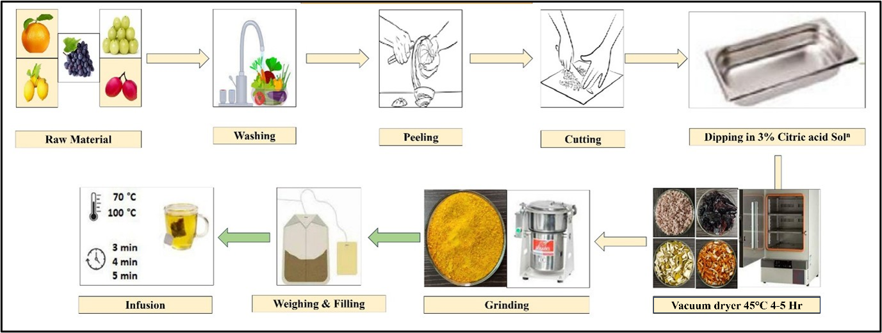
2.3 Formulation of fruit peel tea (2 g total)
Five fruit peel tea formulations (S1–S5) were formulated by varying the composition of orange, lemon, amla, grape, and karonda peels within a fixed 2 g sample. by assessing the impact of peel composition on sensory attributes and functional properties.
Table 1: Formulation of fruit tea
Sample Code | Level (in grams)
Sample Code | Orange | Lemon | Amla | Grape | Karonda
S1 | 0.40 | 0.40 | 0.40 | 0.40 | 0.40
S2 | 0.20 | 0.60 | 0.60 | 0.20 | 0.40
S3 | 0.60 | 0.20 | 0.40 | 0.60 | 0.20
S4 | 0.30 | 0.30 | 0.80 | 0.20 | 0.40
S5 | 0.50 | 0.50 | 0.20 | 0.40 | 0.40

2.4 Infusion preparation:
For infusion preparation, standardized tea bags containing 2 grams of the formulated fruit peel powder were used. Each tea bag was immersed in 220 mL of hot water maintained at a temperature of 90 ± 5°C. The infusion was allowed to steep for 120 ± 15 seconds to ensure optimal extraction of bioactive compounds and flavour constituents (Pérez-Burillo et. al., 2018). After steeping, the tea bag was removed, and the infusion was allowed to cool slightly before being subjected to further analysis. This preparation method was selected based on preliminary trials to balance sensory quality, antioxidant release, and practical brewing conditions suitable for consumer use.
2.5 Sensory evaluation:
Sensory evaluation was conducted to assess consumer acceptability of five fruit peel tea formulations (S1-S5), each containing 2 g of blended peels in varying proportions. A panel of semi-trained evaluators (n=15) was done sensory and rate the samples based on four key attributes like colour, aroma, taste and overall acceptability. Each attribute was rated using the 9-point hedonic scale, where 9 Like extremely, 8 Like very much, 7 Like moderately, 6 Like slightly, 5 Neither like nor dislike, 4 Dislike slightly, 3 Dislike moderately, 2 Dislike very much and 1 Dislike extremely.
Sensory evaluation were subjected to one-way Analysis of Variance (ANOVA) to determine whether significant differences existed among the five formulations (S1-S5). The null hypothesis assumed no difference in mean scores across samples for each attribute.
2.6 Proximate composition of fruit tea infusion
The proximate composition of the formulated fruit peel tea was analyzed to evaluate its nutritional profile and assess its potential as a functional beverage. Standard AOAC methods were employed to determine the key parameters, including moisture content, ash, crude fat, crude protein, crude fiber, and total carbohydrates.
2.7 Phytochemical analysis
The phytochemical composition of the fruit peel tea infusion was analyzed by determining total phenolic content (TPC), total flavonoid content (TFC), vitamin C (ascorbic acid), tannin content, and total anthocyanin content using standardized analytical protocols. The TPC was measured using the Folin–Ciocalteu colorimetric method as described by Zhou et al. (2020). In this method, 1 mL of tea infusion was mixed with 5 mL of diluted Folin–Ciocalteu reagent (1:10 dilution with distilled water) and allowed to react for 5 minutes. Subsequently, 4 mL of 7.5% sodium carbonate solution was added, and the mixture was incubated at room temperature in the dark for 30 minutes. The absorbance was recorded at 765 nm using a UV–Vis spectrophotometer. Gallic acid was used as the standard, and the results were expressed as milligrams of gallic acid equivalents (mg GAE/100 mL).
The total flavonoid content was determined using the aluminum chloride colorimetric assay following the procedure of Tristantini and Amalia (2019). A 1 mL sample of the tea infusion was combined with 4 mL of distilled water and 0.3 mL of 5% sodium nitrite solution. After 5 minutes, 0.3 mL of 10% aluminum chloride solution was added, followed by 2 mL of 1 M sodium hydroxide after 6 minutes. The volume was made up to 10 mL with distilled water, and the absorbance was measured at 510 nm. Quercetin was used as the reference standard, and the results were expressed as milligrams of quercetin equivalents (mg QE/100 mL).
Vitamin C (ascorbic acid) content was estimated using the 2,6-dichlorophenolindophenol (DCPIP) titration method (Modenese and Barra, 2011). A known volume of tea infusion was titrated against standardized DCPIP solution until a persistent pink color was observed. The amount of DCPIP consumed was used to calculate the vitamin C concentration, which was expressed as milligrams of vitamin C per 100 mL of infusion.
Tannin content was analyzed using the vanillin–HCl method as reported by Amarowicz et al. (2017). For this assay, 1 mL of the infusion was mixed with 5 mL of vanillin reagent (1% vanillin prepared in 7 M HCl) and incubated at room temperature for 20 minutes. The absorbance was measured at 500 nm, with catechin as the standard. Results were expressed as milligrams of catechin equivalents (mg CE/100 mL).
The total anthocyanin content was quantified using the pH differential method (Lee et al., 2005). Two dilutions of the tea infusion were prepared, one in pH 1.0 potassium chloride buffer and the other in pH 4.5 sodium acetate buffer. Absorbance readings were taken at 520 nm and 700 nm for both buffers. The anthocyanin concentration was calculated using the molar extinction coefficient of cyanidin-3-glucoside and expressed as milligrams of cyanidin-3-glucoside equivalents (mg C3G/100 mL).
- RESULTS AND DISCUSSION
3.1 Sensory evaluation
The sensory evaluation of five onion jam formulations (S1 to S5) was conducted using a 9-point hedonic scale to assess attributes including colour, aroma, taste, and overall acceptability. All attributes showed statistically significant differences (p < 0.05) among formulations. The samples,
Colour: Colour scores ranged from 6.2 to 8.0 across formulations. Sample S3, containing a higher proportion of grape and citrus peels, received the highest score (8.0), likely due to the presence of anthocyanins and carotenoids that impart vibrant hues. The visual appeal was a significant factor influencing overall acceptability.
Aroma: Aroma was notably enhanced in samples with orange and lemon peels, attributed to the presence of limonene, linalool, and other volatile compounds. S3 again scored highest (8.2), suggesting a favourable aromatic profile that complemented the taste.
Taste: Taste emerged as the most discriminating attribute, with scores ranging from 5.8 to 8.5. S3 achieved the highest taste score (8.5), indicating a balanced flavour profile with minimal bitterness and a pleasant citrus undertone.
Overall Acceptability: It followed the trend of taste and aroma, with S3 rated highest (8.3). This suggests that the sensory synergy of colour, aroma, and taste in S3 contributed to its superior consumer preference.
Sample S3 consistently received the highest mean scores across all sensory parameters colour-8.0, aroma-8.2, taste-8.5 and overall acceptability-8.3. Based on its optimal sensory performance, Sample S3 was selected for subsequent proximate and phytochemical analyses.
Table 2: Sensory evaluation of fruit tea
Sample | Colour | Aroma | Taste | Overall Acceptability
S1 | 7.2 | 7.0 | 6.8 | 7.0
S2 | 6.5 | 7.5 | 5.9 | 6.3
S3 | 8.0 | 8.2 | 8.5 | 8.3
S4 | 6.0 | 6.8 | 5.5 | 6.0
S5 | 7.8 | 7.9 | 7.6 | 7.8
F-value | 4.32 | 6.78 | 9.45 | 8.12
p-value | 0.012 | 0.003 | 0.001 | 0.002

Figure 3: Sensory evaluation of fruit tea
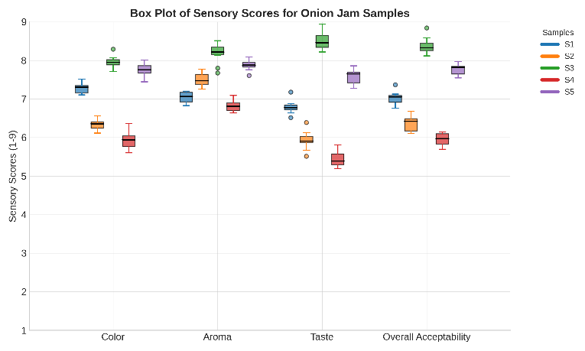
Figure 4: Infused fruit tea
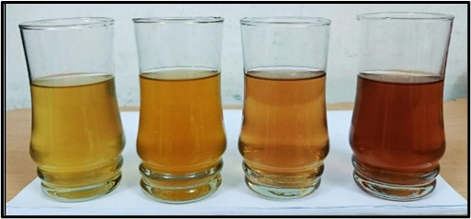
3.2 Proximate composition
The proximate analysis of the optimized fruit peel tea formulation (Sample S3) was conducted to evaluate its nutritional profile. The results are presented in Table 3.
Moisture Content (6.42%) was relatively low, indicating good shelf stability and reduced microbial susceptibility. This is consistent with the vacuum drying technique used, which effectively minimizes water activity. Ash Content (2.56%) reflects the presence of essential minerals such as calcium, potassium, and magnesium, which are abundant in citrus and pomegranate peels. Crude Fat (4.33%) supports digestive health and satiety. The fibre content, primarily insoluble, originates from the albedo and rind portions of the fruit peels. Crude Protein (5.86%) suggests moderate protein content, primarily from residual cellular material in the peels. While not a primary protein source, it adds functional value to the formulation. Crude Fibre (3.21%) enhances digestive benefits and supports satiety. The presence of insoluble fibre from citrus albedo and pomegranate rind contributes to this value. Carbohydrates (61.62%) were the major component, providing mild sweetness and energy. These include simple sugars and complex polysaccharides retained post-drying. Energy Value (348.21 kcal/100g) positions the product as a light, functional beverage suitable for health-conscious consumers.
Table 3: Proximate composition of fruit tea
Sr. No. | Parameter | Amount (%)
1 | Moisture content | 6.42
2 | Protein | 5.86
3 | Fat | 4.33
4 | Carbohydrates | 61
5 | Crude fibre | 3.21
6 | Ash | 2.56

3.3 Phytochemical composition
Phytochemical analysis was conducted to evaluate the functional potential of fruit peel tea formulations, with a focus on bioactive compounds known for their antioxidant, anti-inflammatory, and health-promoting properties. The results for the optimized formulation (Sample S3) are presented in Table 4.
Total Phenolic Content (TPC) was highest (190.67 mg GAE) in S3, indicating strong antioxidant potential. This is attributed to the inclusion of grape and orange peels, which are rich in polyphenolic compounds such as resveratrol, catechins, and flavanones. Flavonoid Content (65.78 mg QE/100 g) reflects the presence of bioactive flavanones (e.g., hesperidin, naringin) from citrus peels and anthocyanins from grape peels. These compounds contribute to both health benefits and sensory attributes like bitterness and astringency. Anthocyanin Content (42.33 mg/100 g) was notably high due to the elevated grape peel level (0.60 g in S3). Anthocyanins are known for their anti-inflammatory properties and contribute to the deep coloration of the infusion. Vitamin C (54.23 mg/100 g) was retained effectively, suggesting minimal degradation during vacuum drying. Its presence enhances antioxidant synergy and supports immune health. Tannin Content (36.67 mg/100 g) contributes to mouthfeel and antimicrobial activity. Moderate levels ensure palatability without excessive astringency, balancing functional and sensory appeal.
Table 4: Phytochemical composition of fruit tea
Parameter | Value (per 100 g)
Total Phenolic Content (TPC) | 190.67 mg GAE
Flavonoid Content | 65.78 mg QE
Vitamin C | 54.23 mg
Tannin Content | 36.67 mg
Anthocyanin Content | - g

- CONCLUSION
This study demonstrates the successful valorization of fruit peels, typically considered food waste into a functional tea infusion with promising nutritional and sensory attributes. Among the five formulations tested, Sample S3, comprising higher proportions of grape and citrus peels, emerged as the most preferred based on sensory evaluation, achieving superior scores in colour, aroma, taste, and overall acceptability. Proximate analysis of the optimized formulation revealed a balanced nutritional profile, with notable levels of protein, fiber, and essential minerals, alongside a low moisture content conducive to shelf stability. Phytochemical profiling further confirmed the infusion’s functional potential, with high concentrations of total phenolics, flavonoids, anthocyanins, vitamin C, and tannins compounds known for their antioxidant, anti-inflammatory, and health-promoting properties.
The findings underscore the feasibility of transforming fruit peel waste into a value-added beverage that aligns with sustainability goals and consumer health trends. By integrating waste valorization with functional food development, this research contributes to circular economy practices and offers a scalable model for eco-conscious innovation in the beverage sector. Future studies may explore advanced extraction techniques, bioavailability assessments, and long-term storage stability to further enhance the therapeutic efficacy and commercial viability of peel-based tea infusions.

REFERENCES
You, S., Sonne, C., Park, Y. K., Kumar, S., Lin, K. Y. A., Ok, Y. S., & Wang, F. (2022). Food loss and waste: a carbon footprint too big to be ignored. Sustainable Environment, 8(1), 2115685.
Wani, N. R., Rather, R. A., Farooq, A., Padder, S. A., Baba, T. R., Sharma, S., ... & Ara, S. (2024). New insights in food security and environmental sustainability through waste food management. Environmental Science and Pollution Research, 31(12), 17835-17857.
Swetha, B. S., Prabhakar, I., & Ainapur, S. D. (2024). Food waste reduction and sustainable food systems: Strategies, challenges, and future directions. Journal of Scientific Research and Reports, 30(5), 328-336.
Sousa, R. D., Bragança, L., da Silva, M. V., & Oliveira, R. S. (2024). Challenges and solutions for sustainable food systems: The potential of home hydroponics. Sustainability, 16(2), 817.
Sadef, Y., Javed, T., Javed, R., Mahmood, A., Alwahibi, M. S., Elshikh, M. S., ... & Rasheed, R. A. (2022). Nutritional status, antioxidant activity and total phenolic content of different fruits and vegetables’ peels. Plos one, 17(5), e0265566.
Hussain, T., Kalhoro, D. H., & Yin, Y. (2023). Identification of nutritional composition and antioxidant activities of fruit peels as a potential source of nutraceuticals. Frontiers in Nutrition, 9, 1065698.
Adeoye Bayo Olufunso et al (2024). Peels of Edible Plants as Treasure Trove of Remarkable Nutraceutical Properties:Prospects for Medical Nutrition Therapy. EAS J Nutr Food Sci, 6(6), 184-196
Malek, M. A., B. Gowda, S. G., M. Gangadhara, R., Gowda, D., & Hui, S. P. (2024). Exploration of New Lipid Nutrients and Their Characterization in Herbal Teas Using Non-Targeted Liquid Chromatography–Mass Spectrometry. Foods, 13(12), 1877.
Uzuner, S. (2022). Ultrasonication effects on quality of tea-based beverages. Beverages, 9(1), 1.
Lo Turco, V., Nava, V., Potorti, A. G., Sgro, B., Arrigo, M. A., & Di Bella, G. (2024). Total Polyphenol Contents and Mineral Profiles in Commercial Wellness Herbal Infusions: Evaluation of the Differences between Two Preparation Methods. Foods, 13(13), 2145.
Singh, K., Kaur, H., Krishania, M., Bains, K., & Kaur, A. (2024). Hot water infusion technique to prepare antioxidant-rich beverage with pomegranate peel: Formulation, nutritional study and cost analysis. Food Chemistry Advances, 4, 100601.
Sanches, A. G., Repolho, R. P. J., Santos, E. X. D., Lima, K. S., & Cordeiro, C. A. M. (2021). Combination effect of citric acid and hot water treatment on the quality of pulp and pericarp of rambutan fruit. Journal of Horticulture and Postharvest Research, 4(2), 151-162.
Suri, S., Singh, A., Nema, P. K., Malakar, S., & Arora, V. K. (2022). Sweet lime (Citrus limetta) peel waste drying approaches and effect on quality attributes, phytochemical and functional properties. Food Bioscience, 48, 101789.
Farakte, R. A., Yadav, G., Joshi, B., Patwadhan, A. W., & Singh, G. (2016). Role of particle size in tea infusion process. International Journal of Food Engineering, 12(1), 1-16.
Pérez-Burillo, S., Giménez, R., Rufián-Henares, J. A., & Pastoriza, S. (2018). Effect of brewing time and temperature on antioxidant capacity and phenols of white tea: Relationship with sensory properties. Food chemistry, 248, 111-118.
Zhou J, Yang Q, Zhu X, Lin T, Hao D, Xu J (2020) Antioxidant activities of Clerodendrum cyrtophyllum Turcz leaf extracts and their major components. PLoS ONE 15(6): e0234435. doi: 10.1371/journal.pone.023443
Tristantini, D., & Amalia, R. (2019, December). Quercetin concentration and total flavonoid content of anti-atherosclerotic herbs using aluminum chloride colorimetric assay. In AIP conference proceedings (Vol. Amarowicz, R., Karamać, M., Dueñas, M., & Pegg, R. B. (2017). Antioxidant activity and phenolic composition of a red bean (Phasoelus vulgaris) extract and its fractions. Natural Product Communications, 12(4), 1934578X1701200420.1, p. 030012). AIP Publishing LLC.
Modenese, B., & Barra, P. (2011). How do the vitamin C levels in fruit juices in the market today compare to the values in the Food Tables?. Proceedings of the Nutrition Society, 70(OCE4), E141.
Lee, J., Durst, R. W., Wrolstad, R. E., & Collaborators: Eisele T Giusti MM Hach J Hofsommer H Koswig S Krueger DA Kupina; S Martin SK Martinsen BK Miller TC Paquette F Ryabkova A Skrede G Trenn U Wightman JD. (2005). Determination of total monomeric anthocyanin pigment content of fruit juices, beverages, natural colorants, and wines by the pH differential method: collaborative study. Journal of AOAC international, 88(5), 1269-1278.

