Original Research Article
Impact of insect’s infestation in various packaging materials on Indigenous millet Kodo (Paspalum scrobiculatum) physico-chemical quality

______________________________________________________________________
Abstract
In India, one of the main reasons for grain losses during storage is insect infestation. The current study examined how insects were stored in various packaging materials and how infestation affected the physical and chemical properties of dehulled kodo millet. Insects and pests that attack kodo millet include the khapra beetle (Trogoderma granarium), rice weevil (Sitophilus oryzae), grain moth (Sitotroga cerealella), and flour beetle (Tribolium castaneum). These pests and mites cause losses in both the quantity and quality of nutrients during the storage period. The current investigation focused on grain storage tests, quality trait analysis, and post-harvest practices. After being dehulled and ground on a Perfura dehulling and milling machine, raw kodo grains were kept at room temperature during different storage periods (0, 60, 120, and 180 days) in a range of packaging methods (such as vacuum packing, LDPE, HDPE, and gunny bags). The products' physical and chemical properties were assessed, together with the relevant insect observations. According to the data collected, samples packed in gunny bags appeared to contain the majority of insects during the six-month period, whereas samples packed in vacuums showed no change.According to the findings, six months of storage was when biophysical qualities changed, not when samples were vacuum-packed. As a result, during the six-month storage at the studies, it was found that the vacuum-packed kodo millet samples showed significant results for all of their quality characteristics. Dehulled kodo millet can be stored for longer by using vacuum packaging since it preserves their physico-chemical composition.
Keywords: Kodo millet, Insect pests, LDPE, HDPE and Vacuum packaging.
- Introduction
Kodo millet (Paspalum scrobiculatum L) is grown as a cereal in India only; although the wild grass is a wide spread tropical weed. The crop has been grown for at least 3000 years, but could not find any clear racial differentiation. Wild weeds and cultivated types merged in all the characters studied. Kodo millet is said to be poisonous after rain. This could be due to a fungal infection. Winnowed clear healthy grain seems to pose no health problems (Hegde & Chandra, 2005).
Due to its intriguing protein and mineral content, Kodo millet is another significant minor millet variety that is very essential in the tribal areas of India (Neelam, Kanchan, & Alka, 2013). It is a crucial crop of the Deccan plateau and is said to have been cultivated in India, millets are cultivated in an area of 12.45 million hectares, producing 15.53 million Tons with a yield of 1247 kg/ha. It is interesting to note that; India is the topmost producer of Barnyard (99.9%), Finger (53.3%), Kodo (100%), little millet (100%) and pearl millet (44.5%), producing about 12.46 million metric tons from an area of 8.87 million ha (Kumar, Patel, Naik, & Mishra, 2016). Madhya Pradesh, Maharashtra, Uttar Pradesh, Himachal Pradesh, Gujarat, Karnataka, and portions of Tamil Nadu are the principal growing regions. Because of its robust outer shell, which enables it to thrive even in high-drought areas, it is regarded as the toughest millet grain (Sharma, Handa, & Pathania, 2017). The seeds require around five to six months to fully mature (Rachie, 1975), which, when compared to other millet cultivars, generally has the longest agricultural production (FAO, 2001).
Millets contain the bioactive phytochemicals feraxans, lignans, glucan, inulin, resistant starch, sterols, and phenolic compounds (such as ferulic acid, caffeic acid, and quercetin). Studies have revealed that polyphenols have anti-oxidative, anti-carcinogenic, anti-inflammatory, antiviral, and neuroprotective characteristics, all of which have been shown to be beneficial in the treatment and prevention of diseases like cancer, cardiovascular disease, diabetes, high blood pressure, high cholesterol, inflammatory diseases, metabolic syndrome, and Parkinson's disease (Dayakar et al., 2018).
Post-harvest management is an essential part of achieving high-quality grain to meet specific market requirements. Food hygiene regulations apply to stored grain, which must be protected from mould, bacteria, rodent, bird, and insect damage, while pesticide residues must not exceed UK statutory levels (Goodingm and Davies, 1997). These standards form the basis of recently introduced quality assurance schemes, combining all facets of grain production from field to store and on to the mill.
- MATERIALS AND METHODS
To conduct the experiment Kodo millet were procured from the different blocks of Mandla and Dindori district of Madhya Pradesh. The sample materials were properly cleaned, graded hulled and milled by perfura, hulling and milling machine then properly packed in (gunny bags, LDPE, HDPE, & Vacuumed pack) and stored at ambient room temperature for further use in experiments.

Tab.1 Experimental plan of evaluation of kodo millet in different Packaging Materials during storage period
S. N. | Storage structures | Opening secured/tight cover | Moisture proof | Insect proof | O₂ proof | Storage period (days)
 | Gunny bag | Yes | No | No | No | 0,60,120,180
 | LDPE | Yes | No | No | No | 0,60,120,180
 | HDPE | Yes | No | No | No | 0,60,120,180
 | Vacuumed pack | Yes | Yes | Yes | Yes | 0,60,120,180

Fig.-1: Unit operation for grading, Dehulling, milling, and packaging of milled ( kodo millet)
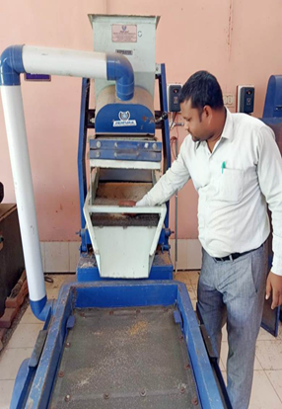 | 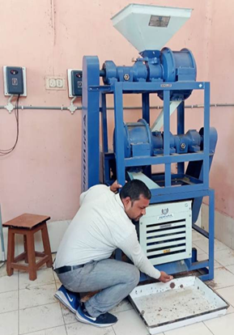 | 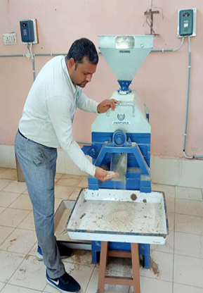
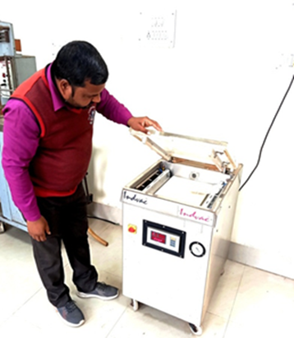 | 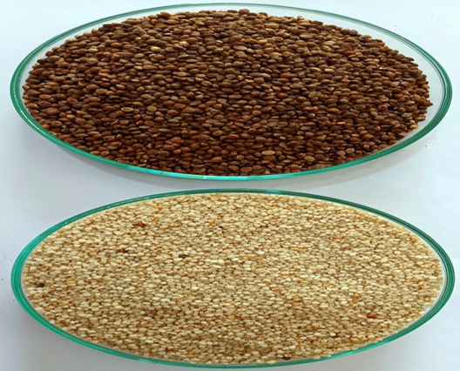

2.1 Analytical methods

2.1.1 Estimation of moisture content
The milled kodo sample's moisture content was assessed using the traditional air oven method. The formula that followed has been used to assess the loss of weight and calculate the percentage of moisture AACC (2000).
Moisture content, % (db) = $\frac{Weight of moisture}{Weight of dry matter}$ × 100

2.1.2 Bulk density
The weight of the seed in the given dimension has been utilized for estimating the bulk density (Bd) of the seed grains (7).
(Bd) = $\frac{W}{V}$
2.1.3 True density
The ratio of grain density to the actual area occupied is known as the actual density (Td). Utilizing the liquid displacement technique, it is determined (7).
Td =$\frac{M}{ S}$
2.1.4 Porosity
A ratio of the difference among the grain and bulk densities to the grain density, expressed as a percentage, was used to calculate porosity (7).
Porosity (ε) % = 1 – $\frac{Bd}{Td}$

2.1.5 Determination of crude fiber
The crude fiber was determined by the method as described in AOAC (1984).
Reagents

1. Sulphuric acid 0.255 N
2. Sodium hydroxide 0.313N

Procedure
2gm of dry defatted sample was transferred into a 500ml conical flask to which 200 ml of 0.255 N boiling sulphuric acids was added then it was boiled for 30 minutes, keeping the volume constant by the addition of water at frequent intervals. The mixture was cooled and filtered through a muslin cloth and the residue was washed with hot water till free from acid. The material was then transferred to the same beaker and 200ml of boiling 0.313 N NaOH was added. After boiling for 30 minutes the mixture was cooled and again filtered through muslin cloth. The residue was washed with water till free from alkali, followed by washing with absolute alcohol and ether to remove the moisture and residue fat. It was then transferred to a weighed crucible and kept in the oven at 100 ºC for 4-6 hours. The crucible was cooled and weighed. The difference in weight represents the crude fiber content.

Difference in wt. of crucible
Crude fiber (%) = ---------------------------------- × 100
Weight of sample

2.1.6 Determination of Fat/ Oil
The fat content of the sample was determined by the procedure as described in AOAC (1984). 5 gm. of sample was weighed accurately, placed in thimble and plugged with cotton. The extractor-containing thimble was placed over a pre-weighted extraction flask (A). Fat content was determined by extracting the sample with solvent petroleum ether (AR grade 60-80°c) for 8 hr. using sox lets extraction procedure. After extraction the excess of solvent was distilled off and the residual solvent was removed by heating at 80ºc in the oven for 4-6 hours. The fat content was determined as below:

Crude fat (%) = $\frac{Weight of flask \left(b\right)-weight of flask \left(a\right) }{ Weight of sample}× 100$

2.1.7. Estimation protein
The protein content in the sample was determined by using conventional micro-Kjeldahl digestion and distillation procedure as given in AOAC (1984).
Reagents
- Catalyst mixture- A mixture of 100 g K2SO4, 20g of CuSO4 and 2.5 g of SiO2.
- Sodium hydroxide 40%(w/v)
- Boric acid 2 %( w/v).
- Concentrated sulphuric acid AR (sp. gr. 1.81)
- Mixed indicator: 2 parts of 0.2 %( w/v) methyl red and 1 parts 0.2% (w/v) methyl blue in absolute alcohol.
- Standard sulphuric acid (0.1N)
2.1.8. Procedure
The sample (0.2g) was weighed accurately and transferred to a Kjeldahl flask taking care to see that the material did not stick to the neck of the flask. The catalyst mixture of about 1g and concentrated sulphuric acid (5ml) were added. Then the flask was heated in an inclined position in the digestion chamber for about 4-6 hr. till the liquid became clear (green blue colour).

2.1.9. Distillation
The content in the flask were allowed to cool and the digested material was transferred quantitatively to a vacuum jacketed flask of micro Kjeldahl distillation apparatus and the ammonia liberated by the addition of 10 ml of 40% NaOH on heating was absorbed in 20 ml of boric acid containing 2-3 drops of mixed indicator in 100ml conical flask. The distilled ammonia was titrated against 0.1N sulphuric acid. The blank was also run in a similar way.

N (%) = | Normality of H2SO4 X Volume of 0.1N H2SO4 X 14 | x 100
 | Weight of sample X 1000
Crude protein (%) = N % X 6.25

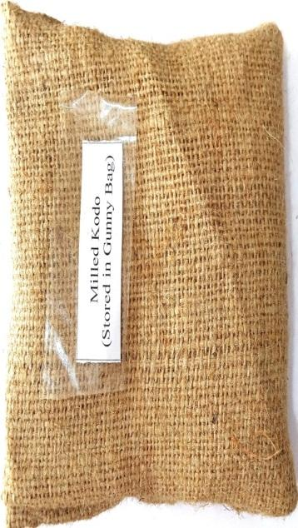 | 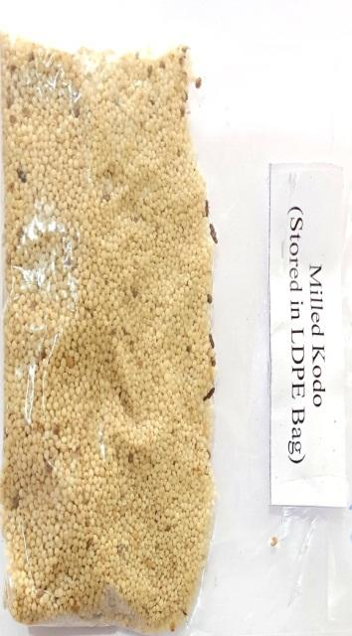
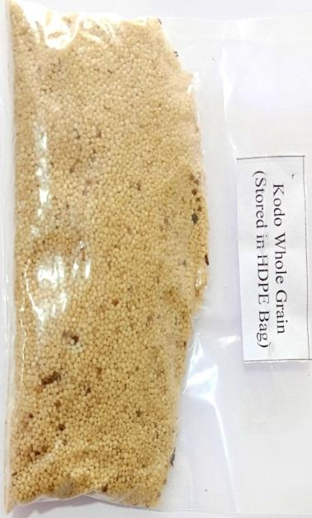 | 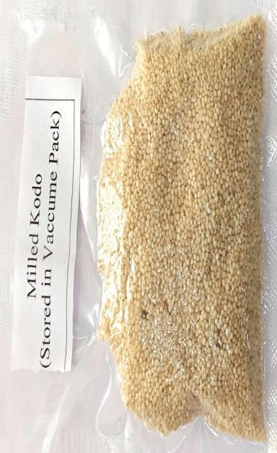
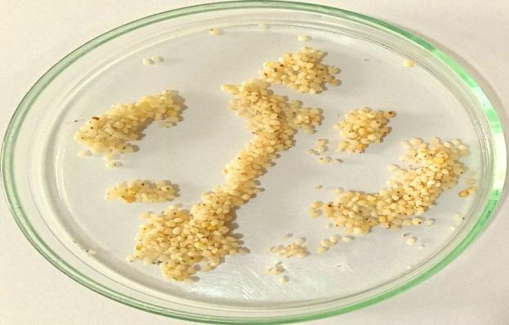 | 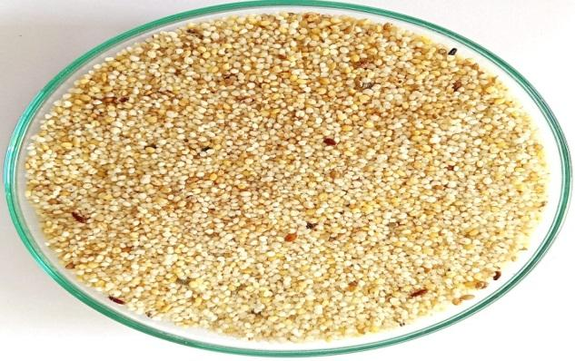

Fig.-2: Effect of insect infestation on different Packaging Materials of milled kodo millet

Table- 1: Insect infestation of milled kodo millet in different packaging materials during Storage Period

Packaging Material | Insect Infestation of Milled Kodo During Storage Period
 | 0 days | 30 days | 60 days | 90 days | 180 days
GB | 0 | 7 | 18 | 57 | 83
LDPE | 0 | 6 | 15 | 27 | 34
HDPE | 0 | 0 | 7 | 13 | 18
VP | 0 | 0 | 0 | 0 | 0
Sem+ | 0 | 0.05 | 0.13 | 0.42 | 0.38
CD @ 5 % | 0 | 0.16 | 0.40 | 1.27 | 1.23

Fig-3: Insect infestation of milled kodo millet in different packaging materials during Storage Period

Table-2: Physico-chemical properties of milled kodo in various packaging materials during storage periods
Storage Periods | Packaging  material | Kodo (Milled)
 |  | Moisture (%) | Protein (%) | Fat/Oil (%) | Fiber  (%) | B.D.  (g/ml³ ) | T.D. (g/ml³ ) | Porosity (%)
Zero Days | GB | 8.42 | 7.79 | 1.65 | 8.43 | 0.85 | 1.21 | 28.96
 | LDPE | 8.37 | 7.56 | 1.82 | 9.01 | 0.84 | 1.19 | 29.72
 | HDPE | 8.28 | 7.38 | 1.96 | 9.12 | 0.84 | 1.19 | 29.78
 | VP | 7.68 | 8.03 | 1.91 | 9.64 | 0.82 | 1.18 | 29.45
 | Sem± | 0.13 | 0.13 | 0.02 | 0.15 | 0.01 | 0.02 | 0.34
 | CD@ 5% | 0.42 | 0.43 | 0.08 | 0.49 | NS | NS | NS
60  Days | GB | 8.84 | 7.88 | 1.45 | 8.71 | 0.85 | 1.19 | 28.95
 | LDPE | 8.79 | 7.47 | 1.62 | 9.08 | 0.85 | 1.21 | 28.96
 | HDPE | 8.46 | 7.81 | 1.86 | 8.93 | 0.84 | 1.17 | 28.46
 | VP | 8.05 | 8.02 | 2.04 | 9.88 | 0.83 | 1.15 | 28.43
 | Sem± | 0.12 | 0.09 | 0.03 | 0.12 | 0.01 | 0.02 | 0.48
 | CD@ 5% | 0.40 | 0.29 | 0.08 | 0.40 | NS | NS | NS
120 Days | GB | 9.34 | 8.16 | 1.21 | 8.43 | 0.86 | 1.16 | 25.86
 | LDPE | 9.27 | 8.54 | 1.14 | 9.01 | 0.84 | 1.14 | 26.31
 | HDPE | 8.54 | 8.44 | 1.88 | 9.12 | 0.84 | 1.13 | 25.66
 | VP | 8.51 | 9.51 | 2.01 | 9.64 | 0.83 | 1.11 | 25.25
 | Sem± | 0.11 | 0.12 | 0.01 | 0.15 | 0.01 | 0.01 | 0.38
 | CD@ 5% | 0.35 | 0.39 | 0.04 | 0.49 | NS | 0.03 | NS
180 Days | GB | 9.86 | 7.75 | 1.11 | 7.88 | 0.86 | 1.14 | 24.86
 | LDPE | 9.24 | 8.74 | 1.32 | 8.71 | 0.85 | 1.13 | 24.94
 | HDPE | 8.66 | 7.89 | 1.78 | 9.64 | 0.85 | 1.13 | 24.88
 | VP | 8.76 | 9.23 | 2.31 | 9.76 | 0.83 | 1.05 | 26.74
 | Sem± | 0.15 | 0.12 | 0.02 | 0.17 | 0.01 | 0.01 | 0.36
 | CD@ 5% | 0.5 | 0.40 | 0.07 | 0.57 | NS | 0.03 | 1.18

3. Results and Discussion
Present investigation deals with the results obtained for various physical and biochemical properties and insect infestation of dehusked kodo millet and it also includes the results of experiments conducted to investigate the effect of different packaging materials on shelf-life of dehusked kodo millet.
Insect infestation of milled kodo millet during storage periods with various packaging materials
Table (2) compares the results of the effects of different packaging materials on insect infestation in various milled kodo millets during the storage period.
The insect infestation of milled kodo packed in a gunny bag, LDPE, HDPE, and vacuumed varied from 7-83, 6-43, 7-18, and zero number of insects at 0, 30, 60, 90, and 180 days of storage, respectively (Table 2). The maximum number of insects was found (83) in gunny bag storage milled kodo samples at 180 days, while vacuum packed samples showed a nil number of insects. The analysis of the variance table indicates that the F-ratio of the model was lower as compared with the table value of 5%% level of significance. There was no significant difference among the different treatments observed for insect infestation of milled kodo.

Physical properties of milled kodo millet during storage periods with different packaging materials
3.1 Bulk density:
The mean value of milled kodo compared the result of the effect of different packaging materials on Bulk Density (g/ml3) packed in various packaging materials and stored for varying storage periods. The Bulk Density of milled kodo packed in Gunny bags, LDPE, HDPE, and vacuumed packs varied from 0.85-0.82, 0.85-0.83, 0.86-0.83, and 0.86-0.83 at 0, 60, 120, and 180 days of storage, respectively (Table 3). The F-ratio is less than the indicated value at the 5% level of significance, according to the analysis of variance table. Regarding milled kodo, there was no obvious distinction between the various treatments.
3.2 True density:
Table (3) compares the results of the effects of different packaging materials on the true density (g/ml3) of various milled kodo millets during storage studies.
The True density of milled kodo packed in gunny bags, LDPE, HDPE, and vacuumed varied from 1.21-1.18, 1.19-1.15, 1.16-1.1, and 14-1.05 at 0, 30, 60, 90, and 180 days of storage, respectively. The maximum True density was found (2.21) in the gunny bag at zero-day storage, while the minimum True density was found (1.05) for the vacuumed pack at 180-day storage. The analysis of the variance table indicates that the F-ratio of the model was lower as compared with the table value of 5%% level of significance. There was no significant difference among the different treatments observed for the True density of 0, 60, and 60 days sored in GB, LDPE, HDPE, and VP, respectively. Whereas significant effects were found in GB, LDPE, HDPE, and VP at 120 and 180 day storage periods,
3.3 Porosity:
The mean value of milled kodo compared the result of the effect of different packaging materials on Porosity (%) packed in various packaging materials and stored for different storage periods. The Porosity (%) of milled kodo packed in Gunny bags, LDPE, HDPE, and vacuumed packs varied from 28.96–29.45, 28.95–28.83, 25.86–25.25, and 24.86–26.74 at 0, 60, 120, and 180 days of storage, respectively (Table 3). The higher value of porosity (%) was observed (31.42) in GB samples at 0 days of storage, while the lower value was found (29.07) at 180 days of storage for VP. The F-ratio is less than the indicated value at the 5% level of significance, observed at 120 and 180 days of storage, according to the analysis of variance table. Regarding the 0, 60, and 90 days of stored milled kodo in different packaging, there was no obvious distinction between the various treatments. A similar finding was observed by pooran pragya, et al. (2018) and Subramanian, et al. (2007)
Biochemical properties of milled kodo millet during storage periods with different packaging materials

3.4 Moisture
Table 3 reveals the results of the moisture content of milled kodo in Gunny Bag, LDPE, HDPE, and Vacuumed Pack, which varied from 8.75–8.16, 9.75–8.16, 10.89–8.45, and 12.54–8.77 percent at 0, 60, 120, and 180 days of storage, respectively. The maximum value was observed in the gunny bag (12.54) at 180 days of storage, whereas the minimum value receded in the vacuumed pack (8.16) at 0 and 60 days of storage. The analysis of variance table indicates that the F-ratio of the model was higher as compared with the table value of a 5% level of significance. The significant difference among the different treatment combinations has been observed during the storage of milled kodo for various packaging material storage periods.
In general, during the storage period, the moisture content varied from 8.16 to 12.54. The ANOVA table indicates that the F-ratio was significant for 0, 60, 120, and 180 days of storage.
3.5 Protein
At 0, 60, 120, and 180 days of storage, the protein content of milled kodo in Gunny Bag, LDPE, HDPE, and Vacuumed Pack ranged from 7.79 to 8.03 percent, 7.88 to 8.02 percent, 8.16 to 9.51 percent, and 7.75 to 9.23 percent, respectively (Table 3). Vacuum-packed samples had a value that was greater after 120 days (9.51); bunny-bag samples showed a lower protein level at 0 and 60 days (7.75). The analysis of variance shows that, at the 5% level of significance, the F-ratio of the model was higher than the table value. The preservation of milled kodo with various packing materials has revealed a notable variation between the various treatment combinations.
On average, the moisture content ranged from 7.75 to 9.51 throughout the storage period. The F-ratio was significant for 0, 60, 120, and 180 days of storage, according to the ANOVA table.
3.6 Fat
Table 3 exposes the consequences of the fat content of milled kodo in Gunny Bag, LDPE, HDPE, and Vacuumed Pack, which vary from 1.65–1.19, 1.45-2.04, 1.21-2.01, and 11.11–2.31 percent at 0, 60, 120, and 180 days of storage, correspondingly. The extreme value was detected in the vacuumed pack (2.31) at 180 days of storage, whereas the least value receded in the gunny bag (1.11) at 180 days of storage. According to the analysis of the variance table, the model's F-ratio was higher than the table value for a 5% level of significance. A significant difference among the different treatment combinations has been observed during the storage of milled kodo for various packaging material storage periods.
3.7 Crude fiber
Table (3) indicated the results of the crude fiber content of milled kodo in Gunny Bag, LDPE, HDPE, and Vacuumed Pack, which varied from 8.8-9.98, 8.71-9.88, 8.83-9.64 and 7.88-9.76 percent at 0, 60, 120, and 180 days of storage respectively. The higher value was observed in the vacuumed pack (9.98) at 0 days of storage, whereas the least value receded in the gunny bag sample (7.88) at 180 days of storage. The analysis of variance table indicates that the F-ratio of the model was higher as compared with the table value of a 5% level of significance. A significant difference among the different treatment combinations has been observed during the storage of milled kodo for various packaging material storage periods.

4. Conclusion
In conclusion, millets have potential for protection against age-onset degenerative Insect-pest. Moisture is another critical factor in safe storage of food grains. Grains stored at around 10 per cent moisture content escape from the attack of insects. The vacuum-packed kodo millet samples were found to have significant results for all the quality parameters during the six-month storage study. Vacuum packaging storage technology effectively extends the shelf-life of dehulled kodo millet by maintaining their physico-chemical qualities.

5. References
A.O.A.C. (1984). Official’s methods of Analysis. Assoiciation of official Analytica chemists. Wshington. D.C., USA
AACC. (2000). Approved methods, American Association of Cereal Chemists. 10th edn, Moisture determination, 44–15A, Minnasota, St Paul.
Balasubramanian S & Viswanathan R. ( 2010). Influence of moisture content on physical properties of minor millets, Food Sci and Technol, 47(3) 279-284.
Baryeh EA (2002) Physical properties of millet. J Food Eng 51: 39–46.
Chandan Kumar V B, Palanimuthu V & Madhusudan Nayak C. (2018). Engineering properties of kodo millet (Paspalum scrobiculatum): CO (3) Variety, Int J Agric Environ bio-res, 3 81–87.
Dayakar Rao B, Bhat BV and Tonapi VA, (2018). Nutri-cereals for Nutritional Security. ICAR – INDIAN INSTITUTE OF MILLETS RESEARCH (IIMR). Rajendranagar, Hyderabad, ISBN: 81-89335-70-7, PP 164
FAO. (2001). Millet:Post-harvest operations. Retrieved from www.fao.org/3/a-av009e.pdf Accessed 14 October 2016.
Finkelman, S., Navarro, S., Rindner, M., Dias, R. (2006). Effect of low pressure on the survival of Trogoder magranarium Everts, Lasioderma serricorne (F.) and Oryzaephilus surinamensis (L.) at 30 oC. Journal of Stored Products Research 42: 23-30.
Goodingm J and Daviesw P. (1997). Wheat production and utilization, systems, quality and the environment. Cab international, oxford.
Hegde, P. S., & Chandra, T. (2005). ESR spectroscopic study reveals higher free radical quenching potential in kodo millet (Paspalum scrobiculatum) compared to other millets. Food Chemistry, 92(1), 177-182.
J. M. De Wet, D. E. Brink, K. P. Rao, and M. H. Mengesha, (1983). “Diversity in kodo millet, Paspalum scrobiculatum,” Economic Botany, vol. 37, no. 2, pp. 159–163,
Kučerová, Z., Kýhos, K., Aulický, R., Stejskal, V.( 2013). Low-pressure treatment to control food-infesting pests (Tribolium castaneum, Sitophilus granarius) using avacuum packing machine. Czech Journal of Food Science 31: 94-98.
Kumar, D., Patel, S., Naik, R. K., & Mishra, N. K. (2016). Study on Physical Properties of Indira Kodo-I (Paspalum Scrobiculatum L.) millet. Paper presented at the International Journal of Engineering Research and Technology.
Malleshi N. (1989). Processing of small millets for food and industrial uses, Small Millets in Global Agriculture,) 325-339.
Maurya S , Shukla S.S. , Mahajan K.C. and Sahu B.L. , (2023). Comparative Study of Engineering and Physical Properties of Whole Grain and Milled Little Millet (Panicum sumatrense). Biological Forum – An International Journal. 15(8a): 18-22(2023)
Maurya S , Shukla S.S. , Mahajan K.C. and Sahu B.L. , (2023). Proximate Assessment and Pasting Properties of Gluten-Free and Refined Wheat Flour. International Journal of Environment and Climate Change,. Vol. 13, Issue 10, Page 2397-2402,
Neelam, Y., Kanchan, C., Alka, S., & Alka, G. (2013). Evaluation of hypoglycemic properties of kodo millet based food products in healthy subjects. Iosr Journal of Pharmacy, 3(2), 14-20.
Pooran Pragnya, Ravi Kumar, P.F. Mathad and Vikas Jha (2018). Effects of Different Retail Packaging Materials on the Shelf Life of Dehusked Foxtail Millet Int.J.Curr.Microbiol.App.Sci 7(5): 1792-1799
Prakash Gyan, and Genitha Immanuel. 2023. “Development and Quality Evaluation of Edible Sachet Prepared With Potato Starch”. Current Journal of Applied Science and Technology 42 (46):182-96.
Prakash Gyan and Rajesh Kumar Mishra. Edible and bio-based food packaging: A
review. The Pharma Innovation Journal. 2023; 12(7S): 1497-1505.
R. S. Chouhan, H. K. Niranjan, and H. O. Sharma, (2019). “Economics of value added products of kodo and kutki,” Indian Journal of Economics and Development, vol. 15, no. 3, pp. 465–469.
Rachie, K. O. (1975). The millets: importance, utilization and outlook.
Ranganna, S. (1995). Manual for the Analysis of Fruits and Vegetables. Tata MeGraw-Hill Publishing Co. New Delhi.
Riudavets, J., Castane, C.R., Alomar, O., Pons, M.J., Gabarra, R. (2009). Modified atmosphere packaging (MAP) as an alternative measure for controlling ten pests that attack processed food products. Journal of Stored Products Research 45: 91-96.
Sharma, S., Sharma, N., Handa, S., & Pathania, S. (2017). Evaluation of health potential of nutritionally enriched Kodo millet (Eleusine coracana) grown in Himachal Pradesh, India. Food chemistry, 214, 162-168.
Sheperd, H. and Bhardwaj, R.K. (1986). Moisture dependent physical properties of pigeon pea. J. Agric. Engng. Res., 35 (4): 227-234.
Sudharshana L, Monteiro P V & Ramachandra G. (1988). Studies on the proteins of kodo millet (Paspalum scrobiculatum), J Sci Food Agric, 42(4) (1) 31 3 3.

