Original Research Article
Combining computational and crystallographic data for an understanding of the hydrogen bond formation of the diisopropylammonium hydrogenophthalate

Abstract :
Hydrogen bonds of the type A–H⋯A′, where A and A′ represent electronegative atoms, have attracted considerable attention in recent years due to their crucial role in stabilizing molecular systems. In this context, diisopropylammonium hydrogenophthalate was synthesized and experimentally characterized, then studied by quantum chemistry in order to optimize its geometry and evaluate hydrogen-bonding interactions. X-ray diffraction analysis revealed the formation of parallel zigzag chains, stabilized by N–H···O hydrogen bonds between the diisopropylammonium cation and the hydrogenophthalate anion. Another intramolecular O–H···O hydrogen bond was also identified within the anion. From a theoretical perspective, Mulliken charges, spectroscopic vibrations, as well as various global descriptors of the compound were investigated within the framework of density functional theory (DFT), using the B3LYP method with the 6-311++G(d,p), 6-311+G(d,p), and 6-311G(d,p) basis sets. The calculated vibrational frequencies were used to simulate infrared spectra for all basis sets considered. All these results confirm that diisopropylammonium hydrogenophthalate exists in the form of a salt, stabilized by a hydrogen bond between the cation and the anion. Finally, the frontier orbital energies (HOMO and LUMO), the energy gap, and global descriptors were determined in order to predict the reactivity of the compound. These findings provide a detailed understanding of how hydrogen bonding influences phthalate-based molecular crystals and their potential for energy applications, advancing scientific knowledge.
Keywords: diisopropylammonium hydrogen phthalate; DFT ; Mulliken charges ; hydrogen bond ; infrared ;

1. Introduction
The examination of hydrogen bonding between a cation and an anion has attracted considerable attention because it strongly influences the stability, solubility, and physicochemical properties of the system []. Thus, the study of this hydrogen bond is crucial, as it plays a key role in chemistry [], biology [], and materials science []. Many experimental and theoretical research works have been carried out. Experimentally, numerous studies on the synthesis and characterization of these compounds have been conducted using X-ray diffraction [, ,]. All of these works confirm the existence of a hydrogen bond between a cation and an anion. However, some detailed structural and electronic properties cannot be determined solely by experimental methods. This justifies the use of theory to complement the experimental results. Accordingly, many theoretical studies have been devoted to this type of hydrogen bond []. These calculations generally show that hydrogen bond lengths are shorter than 3 Å, which validates the theoretical approach since these values fall within the characteristic range of hydrogen bond interactions []. Among theoretical methods, DFT is widely used, particularly because it allows easy determination of global descriptors such as electronegativity [], electronic chemical potential [], hardness [], etc. Recently, Lo et al. [] demonstrated for the first time, using DFT, the self-doping and electropolymerization of 4-amino-3-hydroxy naphthalene sulfonic acid (AHNSA). The hybrid B3LYP functional was used to calculate the structural, electrical, topological, and vibrational properties of this molecule. Other studies have focused on the structural determination of phthalate derivatives by DFT []. For example, dimethyl phthalate has been studied by correlating experimental techniques with DFT investigations []. In addition, phthalate esters have been prepared for the experimental determination of physicochemical parameters such as rate constants and half-lives.
Despite these methodological advances, some molecules, such as diisopropylammonium hydrogenophthalate, have not yet been the subject of any detailed study combining experimental data and theoretical analysis. To our knowledge, no study has been reported in the literature concerning the determination of geometric parameters and the spectroscopic analysis of diisopropylammonium hydrogen phthalate. Moreover, the Mulliken population, frontier molecular orbitals, and global descriptors of this compound have not yet been determined.
In this article, we combine X-ray diffraction, infrared spectroscopy, and quantum chemical calculations in order to investigate hydrogen-type interactions and the structural characteristics of diisopropylammonium hydrogen phthalate. To obtain reliable information about this compound, we performed geometric optimization calculations to determine its most stable conformation. The optimized structural parameters were then used to simulate the X-ray diffraction pattern and calculate vibrational frequencies. Finally, Mulliken population analysis as well as frontier molecular orbital (FMO) studies were carried out to complete the description of the structural properties.
2. Experimental details
2.1. Synthesis of the compound
Diisopropylammonium hydrogenophthalate was obtained from the partial neutralization of phthalic acid (Ph(COH)₂; 5 g, 3 mmol) with diisopropylamine (iPr₂NH, 3.05 g, 3 mmol) in ethanol (50 mL) (Scheme 1). The clear mixture was stirred for two hours. Crystals suitable for X-ray diffraction analysis were obtained after one week of slow evaporation at room temperature. A crystal with dimensions 0.40 × 0.40 × 0.40 mm was used for data collection. The structure was solved and refined using standard programs [13].

Scheme 1: Synthesis procedure of diisopropylammonium hydrogenophthalate

2.2 X-ray and IR spectra
2.3. Computational details
All quantum chemistry calculations were performed using the Becke-3-Lee-Yang-Parr (B3LYP) method with the Gaussian 16 software []. The structures were fully optimized using the 6-311++G(d,p), 6-311++G(d,p), and 6-311++G(d,p) basis sets. This method has been shown to provide sufficiently reliable results for both the geometry and energy of compounds involving hydrogen bonding [,]. The optimized molecular structure was then used for vibrational frequency calculations at the DFT level.
3. Results and discussion
3.1 X-ray powder diffraction analysis
With the parameters a = 8.160(3), b = 14.876(5), and c = 12.549(5), diisopropylammonium hydrogenophthalate crystallizes in a monoclinic system with space group P21/c. One hydrogenophthalate anion and one diisopropylammonium cation constitute the asymmetric unit (Fig. 1). N-H-O hydrogen bonds bind the anions and cations together. The cation's C-C and C-N bonds resemble those seen in compounds that include the diisopropylammonium cation.
[]. The C-C and C-O bonds of the hydrogenophthalate anion are close to the published values for salts containing this anion [26]. In the overall structure, the acidic anions, hydrogenophthalate, are linked to the cations via N-H…O hydrogen bonds (Fig. 1), giving rise to zigzag chains parallel to [010] (Figs. 2 and 3), in which cations and anions alternate. Weak intermolecular hydrogen bonds C-H…O, contribute to the phthalate/phthalate and phthalate/cation interactions (Figs. 2, 3). All oxygen atoms are involved in at least two interactions, C-H…O and N-H…O hydrogen bonds, leading to a 3D architecture.

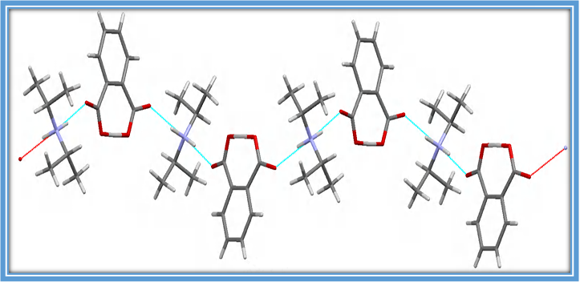
Figure 1 : Zigzag chains of alternating cations and anions connected by hydrogen bonds (N- H··O)
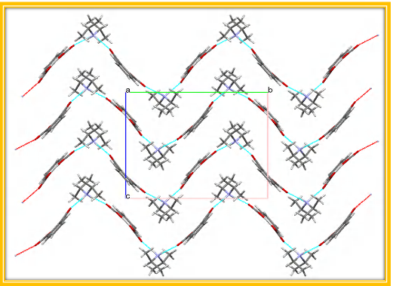
Figure 2: Hydrogen bonds (N-H…O) along the a-axis.
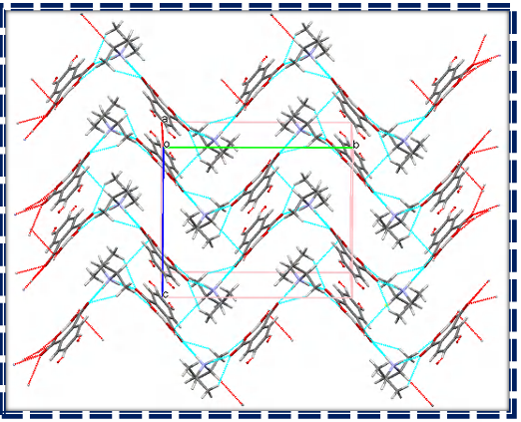
Figure 3 : Layered architecture formed by hydrogen bonds (C-H…O, N-H…O) approximately along the a-axis.
3.2 Geometrical structure
Figure 4, illustrating the optimized structure of the studied molecule, was calculated using density functional theory (DFT) with the 6-311++G(d,p), 6-311+G(d,p), and 6-311G(d,p) basis sets. As shown by this optimized structure, the diisopropylammonium hydrogenophthalate molecule consists of a diisopropylammonium cation and a hydrogenophthalate anion connected by a hydrogen bond (N27–H18···O17). An intramolecular hydrogen bond (O16–H14···O13) is also observed within the anion. These hydrogen-bond interactions help stabilize the molecule by placing it in a minimum energy state. Moreover, the optimized geometry can be confirmed as an energy minimum by the absence of imaginary wavenumbers.
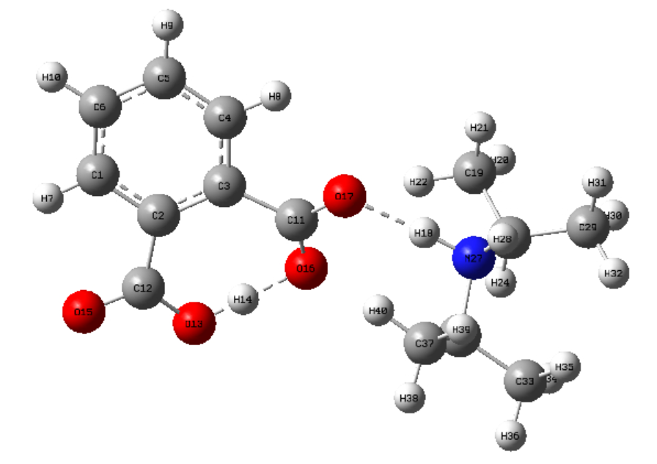
Figure 4: The optimized molecular structure of diisopropylammonium hydrogénophtalate calculated using DFT/B3LYP method.
3.3 Hydrogen bonding
The presence of the intermolecular hydrogen bond (N27–H18···O17) between the hydrogenophthalate anion and the diisopropylammonium cation ensures a strong interaction between these two ions, leading to the formation of diisopropylammonium hydrogen phthalate. This compound also exhibits an intramolecular hydrogen bond (O16–H14···O13). Both bonds together stabilize the molecule, as illustrated in its optimized structure (Fig. 4). The geometric parameters (bond lengths and angles) were determined using the B3LYP method with the 6-311++G(d,p), 6-311+G(d,p), and 6-311G(d,p) basis sets. All obtained values are listed in Table 1. For the intermolecular hydrogen bond H18···O17, the calculated bond lengths are 1.681 Å, 1.682 Å, and 1.653 Å for the 6-311++G(d,p), 6-311+G(d,p), and 6-311G(d,p) basis sets, respectively, compared to the experimental value of 1.820 Å. Regarding the intramolecular hydrogen bond H14···O13, the corresponding values are 1.047 Å, 1.048 Å, and 1.039 Å for the same basis sets, whereas the experimental measurement is 1.190 Å. All these bond lengths fall within the characteristic range of hydrogen-bond interactions, namely below 3.0 Å [30, 31].
The theoretical values of the N27–H18···O17 bond angle are 174.93°, 174.95°, and 173.18° for the 6-311++G(d,p), 6-311+G(d,p), and 6-311G(d,p) basis sets, respectively, while the experimental angle is 166°. Similarly, for the O16–H14···O13 bond angle, the values are 171.21°, 171.39°, and 172.06° for the same basis sets. The experimental value for this bond angle is 173°. These experimental angle measurements confirm the presence of a hydrogen bond, in agreement with reported data for sulfonate groups [13].
Table 1. Bond length and bond angle
 | Experimental | Theoretical
 | Experimental | B3LYP/6-311++G(d,p) | B3LYP/6-311+G(d,p) | B3LYP/6-311G(d,p)
Bonds lengths (Å)
H18···O17 | 1.820 | 1.681 | 1.682 | 1.653
H14···O13 | 1.190 | 1.047 | 1.048 | 1.039
Bonds angles (⁰ )
N27–H18···O17 | 166 | 174.93 | 174.95 | 173.18
O16–H14···O13 | 173 | 171.21 | 171.39 | 172.06

3.4 Mulliken population analysis
The electronic charges of atoms play a decisive role in bond formation and in the conformation of molecules [, ]. In this work, the values of these atomic charges were obtained through Mulliken population analysis, performed using the B3LYP hybrid functional with the 6-311++G(d,p), 6-311+G(d,p), and 6-311G(d,p) basis sets. The Mulliken atomic charges calculated for the diisopropylammonium hydrogenophthalate compound are presented in Table 2. The O13, O17, and N27 atoms, whose electronegativity is higher than that of hydrogen, exhibit negative theoretical Mulliken atomic charges, whereas the H14 and H18 atoms possess positive Mulliken charges. These results thus confirm the formation of the hydrogen bonds H18···O17 and H14···O13.
Table 2. Mulliken atomic charge
 | Theoretical
Atoms | B3LYP/6-311++G(d,p) | B3LYP/6-311+G(d,p) | B3LYP/6-311G(d,p)
017 | -0.321 | -0.3206 | -0.503
H18 | 0.430 | 0.430 | 0.333
N27 | -0.169 | -0.169 | -0.346
O13 | -0.407 | -0.4074 | -0.373
H14 | 0.451 | 0,451 | 0.288
O16 | -0.397 | -0.397 | -0.507

3.5 Vibrational analysis

Figure 5 displays the computed FTIR spectrum of diisopropylammonium hydrogenphthalate at the B3LYP level. Proton vibrations in the N–H···O and O–H···O hydrogen bonds, as well as internal vibrations of the diisopropylammonium cations and hydrogenphthalate anions, are the source of the bands seen in the measured range between 4000 and 100 cm⁻¹. Lattice vibrations are the source of the infrared spectra's bands below 100 cm⁻¹ []. In this work, the vibrational assignments of the observed bands were carried out based on DFT calculations, which serve as a preliminary source for discussion, and also by comparison with previously reported theoretical studies on similar compounds. The FTIR spectra obtained with B3LYP/311++G(d,p), B3LYP/6-311+G(d,p), and B3LYP/6-311+G(d,p) are very similar, indicating the accuracy of the molecular structure.
Vibration of Diisopropylammonium
The experimental frequencies of the asymmetric N-H stretching vibrations in the complex are observed at 3459 and 3351 cm⁻¹ with the B3LYP/311++G(d,p) and B3LYP/311G(d,p) basis sets, respectively. The bands at 2752 and 2668 cm⁻¹ are attributed to the N-H bond stretching vibration. The C-N stretching bands of the side chain are assigned at 1547 and 1577 cm⁻¹ in the IR spectra using B3LYP/311++G(d,p) and B3LYP/311G(d,p), respectively. The C-C stretching mode is observed at 1543 and 1577 cm⁻¹ in the IR spectra of the B3LYP/311++G(d,p) and B3LYP/311G(d,p) basis sets, respectively. The alkyl C-H stretching mode is observed between 2752 and 3119 cm⁻¹. The modes observed between 1000 and 1200 cm⁻¹ in the IR spectra are attributed to in-plane C-H bending.
Vibrations of the Hydrogenophthalate Anion
Phthalic acid takes on a planar shape in the present complex and has carboxyl groups in both COOH and COO⁻ states at the same time. The asymmetric stretching vibrations of the COO group are linked to the IR peaks at 1543 and 1577 cm⁻¹, whereas the symmetric stretching vibrations of the COO⁻ group seen in the hydrogenophthalate anion are linked to the peaks at 1376 and 1392 cm⁻¹. The peaks at 1728 and 1761 cm⁻¹ in the infrared spectrum correspond to the in-plane bending vibrations of the C=O group. The O–H stretching of the carboxylic acid group is shown by the band in the current complex's infrared spectrum at 2263 and 2382 cm⁻¹ for B3LYP/311++G(d,p) and B3LYP/311G(d,p), respectively. In the infrared spectra, the C–H stretching mode of the phenyl group is observed around 1319 and 3138 cm⁻¹. These results are consistent with those reported in the literature [].
Figure 5 : Infrared spectra of diisopropylammonium hydrogenophthalate theoretically calculated using the B3LYP basis sets : a) B3LYP/311+G(d,p), b) B3LYP/6-311++G(d,p), c) B3LYP/311G(d,p).
3.6 Chemical reactivity
Quantum chemistry methods are highly effective for studying the electrochemical behavior and molecular structures of compounds [, ]. In this work, the frontier molecular orbitals (FMOs) were determined to better understand the electronic and optical properties of this compound. The highest occupied molecular orbital (HOMO) and the lowest unoccupied molecular orbital (LUMO) act as electron donor and electron acceptor, respectively []. The energy difference (Egap) between the LUMO and HOMO is an important factor in determining the electrical properties of a molecule []. This energy gap plays a significant role in the chemical and spectroscopic characteristics of the molecule and serves as an essential indicator of its electronic conductivity []. The HOMO and LUMO energies of the diisopropylammonium hydrogenophthalate molecule, as well as the energy gap between HOMO and LUMO, are presented in Table 3. The smaller this energy gap (Egap), the more polarizable the compound is, with higher chemical reactivity and lower kinetic stability [a]. The Egap values obtained for diisopropylammonium hydrogenophthalate are 4.0406 eV, 4.0409 eV, and 4.0972 eV for the B3LYP/6-311++G(d,p), B3LYP/6-311+G(d,p), and B3LYP/6-311G(d,p) basis sets, respectively. For diisopropylammonium phenylsulfonate, the values are 4.09 eV, 4.04 eV, and 4.040 eV [13] using the same basis sets. These results indicate that both compounds exhibit relatively comparable electronic stability. Figure 6 illustrates the HOMO–LUMO transition. It can be observed that, in the HOMO diagram, the electrons are exclusively localized in the diisopropylammonium group region, whereas in the LUMO, they are distributed between both the diisopropylammonium group and the hydrogenophthalate anion.
3.6 Global Descriptors
Global descriptors allow the identification of the most reactive sites in a system and, consequently, the evaluation of a compound’s inhibitory effectiveness []. Among these reactivity descriptors are hardness (η), electronegativity (χ), chemical potential (μ), and the electrophilicity index (ω). They are determined using the following equations [13, ,] :

E_{gap} = E_{LUMO} - E_{HOMO} (1)
$η= E_{LUMO} -\frac{E_{HOMO}}{2}$ (2)
$χ= {-E}_{HOMO}-\frac{E_{LUMO}}{2}$ (3)
$μ= - χ$ (4)
$ω= \frac{μ^{2}}{2 η}$ (5)
A low value of the energy gap (Egap) indicates high chemical reactivity, whereas a high value corresponds to lower reactivity [13,]. Therefore, this parameter serves as an essential indicator of a compound’s stability and reactivity. In the case of diisopropylammonium hydrogen phthalate, calculations show that it exhibits greater stability with the 6-311G(d,p) basis set, while it is more reactive with the 6-311++G(d,p) and 6-311+G(d,p) basis sets. Using the B3LYP/6-311G(d,p) method, this compound has the highest hardness, signifying increased stability. Conversely, the lowest hardness values are obtained with the 6-311++G(d,p) and 6-311+G(d,p) basis sets, confirming higher chemical reactivity under these conditions. These two basis sets also exhibit the highest electronegativity values, reinforcing the compound’s tendency to react more readily. Furthermore, Table 3 highlights that the 6-311++G(d,p) and 6-311+G(d,p) basis sets confer the highest electronegativity and the greatest electrophilicity index to the compound, reflecting an enhanced ability to accept electrons. The dipole moments obtained for the compound are 17.8450, 17.8350, and 16.5775 Debye with the 6-311++G(d,p), 6-311+G(d,p), and 6-311G(d,p) basis sets, respectively. These results indicate that the compound exhibits greater stability when described with the 6-311++G(d,p) and 6-311+G(d,p) basis sets.
Table 3: Global chemical reactivity indices of diisopropylammonium hydrogénophtalate
 | B3LYP/6-311++G(d,p) | B3LYP/6-311+G(d,p) | B3LYP/6-311G(d,p)
E_{HOMO} (eV) | -6,1046 | -6,1062 | -6,0382
E_{LUMO} (eV) | -2,0640 | -2,0653 | -1,9410
Dipole moment (debye) | 17.8450 | 17.8350 | 16.5775
Energy gap (Egap) (eV) | 4,0406 | 4,0409 | 4,0972
$η$(eV) | 0,9883 | 0,9878 | 1,0781
$χ$(eV) | 7,1366 | 7,1389 | 7,0087
$μ$(eV) | -7,1366 | -7,1389 | -7,0087
$ω$(eV) | 25 | 25 | 22

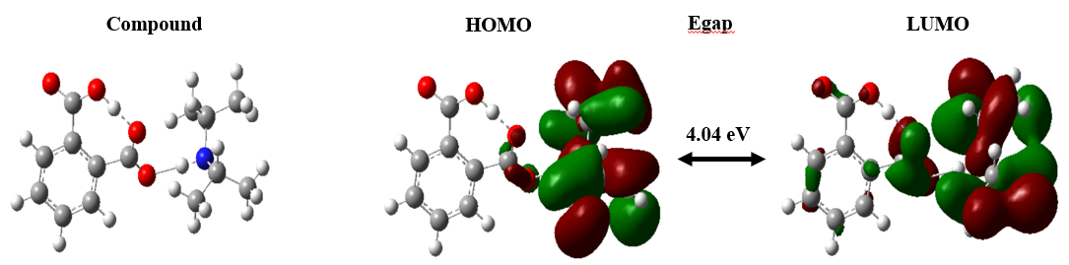 Figure 6: Schematic representation of HOMO and LUMO molecular orbital of diisopropylammonium hydrogénophtalate at the B3LYP/6-311++G(d,p)
4. Conclusion
In this work, we performed calculations on the geometric parameters, vibrational frequencies, and molecular orbital energies of diisopropylammonium hydrogenophthalate using the DFT method with the 6-311G(d,p), 6-311+G(d,p), and 6-311++G(d,p) basis sets. The configuration of this molecule allowed us to study the effect of hydrogen bonding on vibrational frequencies, leading to a more accurate spectral assignment. The hydrogen bond lengths, confirmed by both experimental and theoretical results (using the hybrid B3LYP functional), indicate the presence of both intermolecular and intramolecular hydrogen bonds within the diisopropylammonium hydrogenophthalate molecule. Indeed, all hydrogen bond lengths are less than 3 Å. Furthermore, the calculated geometric parameters (bond lengths and angles) show good agreement with experimental values. The studied infrared spectra revealed the presence of hydrogenophthalate and diisopropylammonium groups, thus confirming the formation of the crystalline molecule. The theoretical Mulliken atomic charges indicate that the most electronegative atom involved in the hydrogen bond carries a negative charge, whereas the hydrogen atoms, being electropositive, carry a positive charge. This result confirms the formation of the hydrogen bond. The energies of the HOMO and LUMO, as well as their energy gap, were also determined; the magnitude of this gap reflects the stability of the compound. In addition, the calculated global chemical reactivity indices support this stability, showing that diisopropylammonium hydrogenophthalate exhibits low chemical reactivity. Further complementary research is currently underway in this field.

REFERENCE

Kun Dong, Suojiang Zhang and Jianji Wang, Understanding the hydrogen bonds in ionic liquids and their roles in properties and reactions, Chem. Commun., 2016,52, 6744-6764 , https://doi.org/10.1039/C5CC10120D
Ming Li, Xuanpeng Wang, Jiashen Meng, Chunli Zuo, Buke Wu, Cong Li, Wei Sun, Liqiang Mai, Comprehensive Understandings of Hydrogen Bond Chemistry in Aqueous Batteries, https://doi.org/10.1002/adma.202308628
Alimet Sema Ozen, Frank De Proft, Viktorya Aviyente, and Paul Geerlings, Interpretation of Hydrogen Bonding in the Weak and Strong Regions Using Conceptual DFT Descriptors, J. Phys. Chem. A 2006, 110, 5860-5868
Jiří Šponer, Jerzy Leszczynski, Pavel Hobza, Electronic properties, hydrogen bonding, stacking, and cation binding of DNA and RNA bases, Volume61, Issue1, 2001/2002, Pages 3-31, https://doi.org/10.1002/1097-0282(2001)61:1<3::AID-BIP10048>3.0.CO;2-4
Koichi Fumino, Ralf Ludwig, Analyzing the interaction energies between cation and anion in ionic liquids: The subtle balance between Coulomb forces and hydrogen bonding, Journal of Molecular Liquids Volume 192, April 2014, Pages 94-102
Dame Seye, Libasse Diop, Cheikh Abdoul Khadir Diop and David K. Geiger, Diisopropylammonium hydrogen phthalate, https://doi.org/10.1107/S2414314618007046
Dame Seye, Cheikh Abdoul Khadir Diop, Libasse Diop and David K. Geiger, Diisopropylammonium benzenesulfonate https://doi.org/10.1107/S2414314618008763
Dame Seye, Assane Toure, Momath Lo, Cheikh Abdoul Khadir Diop, Libasse Diop, David Geiger, Crystal Structure of Diisopropylammonium Hydrogen Maleate, Science Journal of Chemistry 2019 ; 7(6): 110-113, doi: 10.11648/j.sjc.2019070612
J. J. Dannenberg , Raphael Rios, Theoretical Study of the Enolic Forms of Acetylacetone. How Strong Is the Hydrogen Bond? J. Phys. Chem. 1994, 98, 27, 6714–6718, https://pubs.acs.org/doi/10.1021/j100078a011
Matej Žabka and Radovan Šebesta, Experimental and Theoretical Studies in Hydrogen-Bonding Organocatalysis, Molecules 2015, 20(9), 15500-15524, https://doi.org/10.3390/molecules200915500
Zibo Shen, Chang Liu, Yuanyuan Zhou, Jinfeng Zhao, Jiahe Chen, Computational investigation about photo-induced hydrogen bonding interactions and excited state double proton transfer behaviors for alkali substituted BPOH compounds, Chemical Physics Letters Volume 868, June 2025, 142021, https://doi.org/10.1016/j.cplett.2025.142021
G.A. Jaffrey, An Introduction to Hydrogen Bonding, Oxford University Press, USA, 1997. p23.
Mamadou Dieng, Cheikh Ahmadou Bamba Diop, Dame Seye, Moustapha Diaw, Déthié Faye, Arona Ngom, Ismaila Diédhiou, Lamine Yaffa, Momath Lo and Cheikh Abdou Khadir Diop, Harnessing Weak and Hydrogen Bonding Interactions for Tailored Crystal Formation: A Case Study of Diisopropylammonium Phenylsulfonate, nternational Research Journal of Pure and Applied Chemistry Volume 26, Issue 4, Page 160-173, 2025; DOI: 10.9734/irjpac/2025/v26i4938
Savaş Kaya, Chapter 3 - Conceptual density functional theory–based applications in extraction studies, Editor(s): Marcello Locatelli, Savaş Kaya, Green Analytical Chemistry, Elsevier, 2025, Pages 43-58, ISBN 9780443161223, https://doi.org/10.1016/B978-0-443-16122-3.00003-2
Nazia Iram, Ramesh Sharma, Javed Ahmad, Abhinav Kumar, Aman Kumar, Fahad N. Almutairi, Huriyyah A. Alturaifi, A DFT Manifestation of the physical, thermodynamic and thermoelectric properties in Sn-based halide perovskites, Inorganic Chemistry Communications, Volume 172, 2025, 113573, ISSN 1387-7003, https://doi.org/10.1016/j.inoche.2024.113573
Devar, S., More, S., Patil, O. et al. Synthesis, Spectroscopic, DFT Calculation and Molecular Docking Studies of Indole Derivative. J Fluoresc (2025). https://doi.org/10.1007/s10895-025-04301-2
Momath Lo, Mamadou Dieng, Dame Seye, Déthié Faye, Cheikh Ahmadou Bamba DIOP, Arona Ngom, Moustapha Diaw, Mohamed M. Chehimi, Tore Brinck, Modou Fall, Electropolymerization by self-doping of 4-amino-3-hydroxynaphthalene sulfonic acid: spectroscopy characterization and DFT for growth mechanism, Journal of Molecular Structure, Volume 1346, 2025, 143136, ISSN 0022-2860, https://doi.org/10.1016/j.molstruc.2025.143136
Manjeet Bhatia Computational insights into phthalate ester-linked VOCs: A density functional theory (DFT)-based approach for chemical ionization mass spectrometry (CI-MS) analysis Rapid Commun Mass Spectrom. 2024;38:e9863. 2024 https://doi.org/10.1002/rcm.9863
Yanhao Wang, Yunlong Sun, Ruyun Wang, Mengchun Gao, Yanjun Xin, Guangshan Zhang, Peng Xu, Dong Ma, Activation of peroxymonosulfate with cobalt embedded in layered δ-MnO2 for degradation of dimethyl phthalate: Mechanisms, degradation pathway, and DFT calculation, Journal of Hazardous Materials, Volume 451, 2023, 130901, ISSN 0304-3894, https://doi.org/10.1016/j.jhazmat.2023.130901
Huanxuan Li, Xiangrui Miao, Jian Zhang, Jia Du, Shaodan Xu, Junhong Tang, Yayun Zhang, DFT studies on the reaction mechanism and kinetics of dibutyl phthalate initiated by hydroxyl and sulfate radicals: Prediction of the most reactive sites, Chemical Engineering Journal, Volume 381, 2020, 122680, ISSN 1385-8947, https://doi.org/10.1016/j.cej.2019.122680
Yi Chen, Hui Zhang, Wenzhao Zhou, Chao Deng, Jian Liao, The solvent effects on dimethyl phthalate investigated by FTIR characterization, solvent parameter correlation and DFT computation, Spectrochimica Acta Part A: Molecular and Biomolecular Spectroscopy, Volume 199, 2018, Pages 412-420, ISSN 1386-1425, https://doi.org/10.1016/j.saa.2018.03.051
Gaussian 16, Revision C.01, Frisch, M. J.; Trucks, G. W.; Schlegel, H. B.; Scuseria, G. E.; Robb, M. A.; Cheeseman, J. R.; Scalmani, G.; Barone, V.; Petersson, G. A.; Nakatsuji, H.; Li, X.; Caricato, M.; Marenich, A. V.; Bloino, J.; Janesko, B. G.; Gomperts, R.; Mennucci, B.; Hratchian, H. P.; Ortiz, J. V.; Izmaylov, A. F.; Sonnenberg, J. L.; Williams-Young, D.; Ding, F.; Lipparini, F.; Egidi, F.; Goings, J.; Peng, B.; Petrone, A.; Henderson, T.; Ranasinghe, D.; Zakrzewski, V. G.; Gao, J.; Rega, N.; Zheng, G.; Liang, W.; Hada, M.; Ehara, M.; Toyota, K.; Fukuda, R.; Hasegawa, J.; Ishida, M.; Nakajima, T.; Honda, Y.; Kitao, O.; Nakai, H.; Vreven, T.; Throssell, K.; Montgomery, J. A., Jr.; Peralta, J. E.; Ogliaro, F.; Bearpark, M. J.; Heyd, J. J.; Brothers, E. N.; Kudin, K. N.; Staroverov, V. N.; Keith, T. A.; Kobayashi, R.; Normand, J.; Raghavachari, K.; Rendell, A. P.; Burant, J. C.; Iyengar, S. S.; Tomasi, J.; Cossi, M.; Millam, J. M.; Klene, M.; Adamo, C.; Cammi, R.; Ochterski, J. W.; Martin, R. L.; Morokuma, K.; Farkas, O.; Foresman, J. B.; Fox, D. J. Gaussian, Inc., Wallingford CT, 2016.
Linwei Li, Chengjun Wu, Zhiqiang Wang, Lixia Zhao, Zhen Li, Changshan Sun, Tiemin Sun, Density functional theory (DFT) and natural bond orbital (NBO) study of vi brational spectra and intramolecular hydrogen bond interaction of L-Ornithine L-Aspartate, Spectrochimica Acta Part A: Molecular and Biomolecular Spectroscopy, Volume 136, Part B, 5 February 2015, Pages 338-346, doi: http:// dx.doi.org/10.1016/j.saa.2014.08.153
H. Tanak, Crystal Structure, Spectroscopy, and Quantum Chemical Studies of (E)-2-[(2-Chlorophenyl) iminomethyl]-4-trifluoromethoxyphenol, J. Phys. Chem. A. 115 (2011) 13865-13876, https://pubs.acs.org/doi/10.1021/jp205788b
Dame Seye, Déthié Faye, Momath Lo, Cheikh A. B. Diop, Mamadou Dieng, et al.. Varied Analysis of Acid Dissociation Constants by Cyclic Voltammetry and UV-Visible to Determine the Aqueous Solubility of a New Diisopropylammonium Phenylsulfonate Molecule. Chemical Science International Journal, 2024, 33 (6), pp.225-240. ⟨10.9734/CSJI/2024/v33i6940⟩.
Momath Lo, Déthié Faye, Dame Seye, Mamadou Dieng, Mohamed Lamine Sall, et al.. A Novel Method for Combination of Ionic Conductivity and pH-metry Methods for the Determination of the Aqueous Solubility of a New Diisopropylammonium Hydrogenmaleate Crystalline Molecule. International Research Journal of Pure and Applied Chemistry, 2024, 25 (6), pp.12-27. ⟨10.9734/irjpac/2024/v25i6882⟩. ⟨hal-05058738⟩
Linwei Li, Chengjun Wu, Zhiqiang Wang, Lixia Zhao, Zhen Li, Changshan Sun, Tiemin Sun, Density functional theory (DFT) and natural bond orbital (NBO) study of vi brational spectra and intramolecular hydrogen bond interaction of L-Ornithine L-Aspartate, Spectrochimica Acta Part A: Molecular and Biomolecular Spectroscopy, Volume 136, Part B, 5 February 2015, Pages 338-346, doi: http:// dx.doi.org/10.1016/j.saa.2014.08.153
R.S. Mulliken, Electronic Population Analysis on LCAO–MO Molecular Wave Functions, J. Chem. Phys. 23, 1833–1840 (1955) https://doi.org/10.1063/1.1740588
V. Arjunan, M. Kalaivani, M.K. Marchewka, S. Mohan, Structural and vibrational spectral investigations of melaminium maleate monohydrate by FTIR, FT-Raman and quantum chemical calculations, Spectrochimica Acta Part A: Molecular and Biomolecular Spectroscopy, Volume 107, 2013, Pages 90-101, ISSN 1386-1425, https://doi.org/10.1016/j.saa.2013.01.040
Dieng, Mamadou, Cheikh Ahmadou Bamba Diop, Dame Seye, Moustapha Diaw, Déthié Faye, Arona Ngom, Ismaila Diédhiou, Lamine Yaffa, Momath Lo, and Cheikh Abdou Khadir Diop. 2025. “Harnessing Weak and Hydrogen Bonding Interactions for Tailored Crystal Formation: A Case Study of Diisopropylammonium Phenylsulfonate”. International Research Journal of Pure and Applied Chemistry 26 (4):160-73. https://doi.org/10.9734/irjpac/2025/v26i4938.
Rosa L. Camacho-Mendoza, Evelin Gutiérrez-Moreno, Edmundo Guzmán-Percástegui, Eliazar Aquino-Torres, Julián Cruz-Borbolla, José A. Rodríguez-Ávila, José G. Alvarado-Rodríguez, Oscar Olvera-Neria, Pandiyan Thangarasu, José L. Medina-Franco, Density Functional Theory and Electrochemical Studies: Structure–Efficiency Relationship on Corrosion Inhibition, J. Chem. Inf. Model. 2015, 55, 11, 2391–2402, https://pubs.acs.org/doi/10.1021/acs.jcim.5b00385
Abhik Ghosh, Electronic Structure of Corrole Derivatives: Insights from Molecular Structures, Spectroscopy, Electrochemistry, and Quantum Chemical Calculations, Chem. Rev. 2017, 117, 4, 3798–3881, https://pubs.acs.org/doi/10.1021/acs.chemrev.6b00590
said Daoui, Cemile Baydere, Feride Akman, Fouad El Kalai, Lhassane Mahi, Necmi Dege, Yıldıray Topcu, Khalid Karrouchi, Noureddine Benchat, Synthesis, X-ray crystallography, vibrational spectroscopy, thermal and DFT studies of ( E )-6-(4-methylstyryl)-4,5-dihydropyridazin-3( 2H )-one, Journal of Molecular Structure 1225 (2021) 129180
Emmanuel Israel Edache, Adamu Uzairu, Paul Andrew Mamza, Gideon Adamu Shallangwa, Muhammad Tukur Ibrahim, DFT studies on structure, electronics, bonding nature, NBO analysis, thermodynamic properties, molecular docking, and MM-GBSA evaluation of 4-methyl-3-[2-(4-nitrophenyl)-1,3-dioxo-2,3-dihydro-1H -i soi ndole-5-amido]benzoic acid: a potent inhibitor of Graves’ disease, Journal of Umm Al-Qura University for Applied Sciences (2024) 10:652–670 https://doi.org/10.1007/s43994-024-00132-2
Pino-Rios R, Inostroza D, Cárdenas-Jirón G, Tiznado W (2019) Orbital-weighted dual descriptor for the study of local reactiv ity of systems with (quasi-) degenerate states. J Phys Chem A 123(49):10556–10562. https:// doi. org/ 10. 1021/ acs. jpca. 9b075 16
Damous M, Allal H, Belhocine Y, Maza S, Merazig H (2021) Quantum chemical exploration on the inhibition performance of indole and some of its derivatives against copper corrosion. J Mol Liq 340:117136. https://doi.org/10.1016/j.molliq.2021.117136
Thielle Nayara Vieira de Souza, Samira Maria Leão de Carvalho, Melissa Gurgel Adeodato Vieira, Meuris Gurgel Carlos da Silva, Davi do Socorro Barros Brasil, Adsorption of basic dyes onto activated carbon: Experimental and theoretical investigation of chemical reactivity of basic dyes using DFT-based descriptors, Applied Surface Science, Volume 448, 1 August 2018, Pages 662-670
Emmanuel Israel Edache , Adamu Uzairu, Paul Andrew Mamza, Gideon Adamu Shallangwa, Muhammad Tukur Ibrahim, DFT studies on structure, electronics, bonding nature, NBO analysis, thermodynamic properties, molecular docking, and MM GBSA evaluation of 4 me thy l 3 [2 (4 ni tro phe nyl ) 1 ,3 dio xo 2,3 di hyd ro 1H i soi ndole 5 amido]benzoic acid: a potent inhibitor of Graves’ diseas, Journal of Umm Al-Qura University for Applied Sciences (2024) 10:652–670 https://doi.org/10.1007/s43994-024-00132-2
Hao Ai, Qiushuo Li, Qiong Xu, Xiangying Li, Degen Li, Qiong Wu, Halogen substitution for fine-tuning the energy gap and intermolecular interactions of dinuclear iron(III) half schiff base complexes: experimental and theoretical investigation, Journal of Molecular Structure, Volume 1348, Part 2, 2025, 143508, ISSN 0022-2860, https://doi.org/10.1016/j.molstruc.2025.143508

