Original Research Article
Local Practices for Purification Rainwater in Kovié, a Rural Area of Lomé (Togo): Characterization and Health Risks

.
ABSTRACT

Access to drinking water is a constant challenge for populations in arid soil areas, where local practices of collection and purification are developed. The objective of present study is to evaluate local practices of collection and water treatment by the population of Kovié. Our methodological approach is an investigation on the type of rainwater collected at home and the methods of its treatment. Water samples are taken for the analysis of physicochemical parameters and the content of Trace Metal Elements (TME) using a flame atomic absorption spectrophotometer (AAS). Microbiological analysis did according to AFNOR standards. The results show that 88% of households consume rainwater run off on the soil compared to 12% who intercept it from the roof by a system. 65.91% of households use chemical products whom 41% prefer mothballs (naphthalene) and 3.41% plants for clarification of run off rainwater.
The physicochemical parameters indicate that rainwater is rich in Na⁺ and K⁺ and an absence of potentially toxic ETM (Hg²⁺, Pb²⁺, Cd²⁺). Analysis on Total Coliforms, Escherichia coli and Sulfite-Reducing Anaerobic Bacteria revealed a high contamination of the water with 37 CFU/ml Total Coliforms for that of the roof. It can be concluded that rainwater run off on soil and then treated and preserved by mothballs constitutes the main drinking water in the community of Kovié.

Keywords: Rainwater, water treatment, TME, Kovié, chemicals products

1. INTRODUCTION

The demand for water is increasing due to growing population, agricultural needs, and industrialization. According to the WHO major report (2023), 2.4 million people don't have access to drinking water. Coverage by the public drinking water distribution network remains a dream for some populations in African countries. There are also localities in certain countries that historically always have problems of water resources due to the aridity of the land, making it difficult to access water in the ground with rudimentary means.
In these areas where access to drinking water is difficult, the population uses several means of water supply. In TOGO (Africa), on the outskirts of the city of Lomé, there is the canton of Kovié where the coastal sedimentary basin is described as a dry wedge due to its geological structure; making the success rate of drilling very low (Gnazou et al., 2023).
The shortage of drinking water experienced by populations in the outskirts of Lomé leads to purchasing water from trucks, which are often untreated borehole water, or to collecting rainwater in large quantities. It leads populations to treat their own water at home using different processes. This study is the aim of contributing to a better understanding of local practices in water treatment and the frequency of use of chemical and plant substances for the drinking water treatment of rainwater collected in various ways and the health risks associated with these methods by the populations of the canton of Kovié (Lomé / TOGO).

2. material and methods

2.1 Description of study area
Kovié is a suburb of the city of Lomé with a population of approximately 20.834 inhabitants (RGPH5_2023). It is located 30 km northwest of Lomé towards Ghana in the prefecture of Zio, Maritime region of Togo (Toglo et al., 2021). Kovié is indicated at 06°34′38″N–01°11′47″E where the average annual rainfall level is approximately 1015 mm, with a bimodal regime of March to July and September to November represent the heavy rain and short rain seasons respectively. The problems of drinking water availability led the population to collect always rain off water (Houndedjihou et al., 2022). The sampling is limited to 100 households randomly selected throughout the canton collecting rainwater.
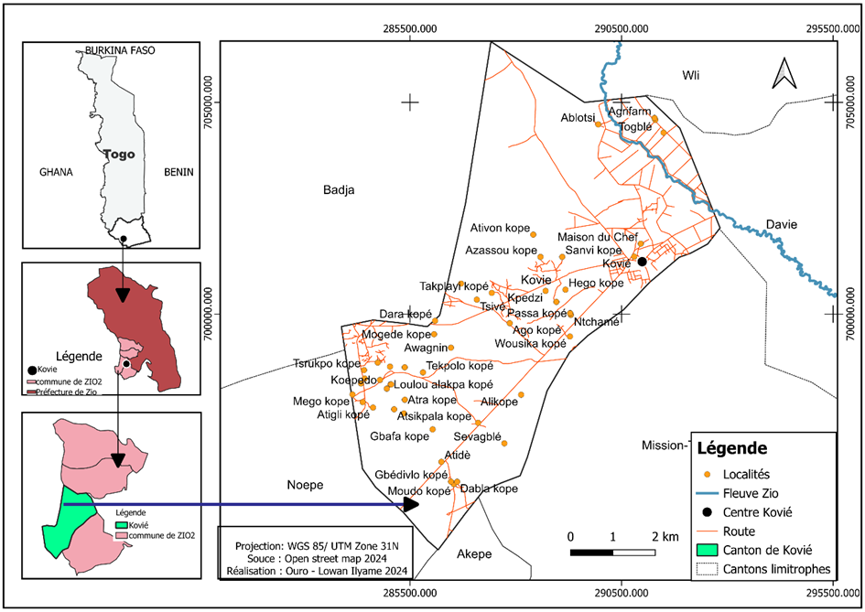
Figure 1: Location map of Kovie; Source: OURO- LOWAN Ilyame 2024
2.2 Processing and analysis of water samples
Rainwater is collected by the population of Kovié in water jars and cisterns for runoff water and by gutter systems for water from the roof. The sampling sites are chosen due to the general representativeness and collection practice. Water samples were collected using 1.5 L plastic containers and sterilized bottles for each type of water: runoff water on soil and water collected from the roof. The bottle is rinsed three times with the water to be sampled. Once filled, it is closed at the bottom of the water and then labeled before being transported to the laboratory for various analyses.

2.3 Methodological approach of Survey
The method is a mixed approach (quantitative and qualitative). The survey did use a questionnaire developed in Kobocollect according to our objectives, namely the type of rainwater collected, the different water treatment techniques, the chemical substances used for water treatment. The questionnaire is mainly aimed at the oldest person or the person who manages domestic tasks at the level of each household.
In this canton, households are randomly selected. The survey consists of asking, based on a pre-established form, to collect data on water sources, treatment methods and products used. In total, 100 households were surveyed, consisting of 90 indigenous households and 10 households of people newly settled in the area. The survey covered the period from March to June 2024. After analyzing the data, descriptive statistics were applied to determine the frequencies of use of each method and chemical substances.

2.4 Physicochemical Analysis of Samples
Physicochemical analyses were performed according to AFNOR standardized routine analysis methods and are summarized in Table 1. Cadmium (Cd), copper (Cu), mercury (Hg), nickel (Ni), lead (Pb), zinc (Zn), iron (Fe), and manganese (Mn) were analyzed using a flame atomic absorption spectrophotometer (AAS).

Table 1: Method and material for parameter analysis (AFNOR, 1997)
Parameters | Methods | Material
pH | Electrometry (NFT90-017) | pH Meter WTW pH330i
Temperature |  | Thermometer
Turbidity - NTU | Nephelometry | Turbidimeter DRT100B, model 20012
$O_{2}$ Dissolved | Oximetry/Volumetry (NF25813/ISO5813) | Oximeter WTW
Conductivity (CE) | Conductimetry (NFT90-111) | Conductimeter WTW
${Ca}^{2+}$; ${Mg}^{2+}$ | Complexometry à l’EDTA (NFT90-003) | Reagents
$H{CO}_{3}^{-}$et ${CO}_{3}^{2-}$ | Volumetric TAC (ISO 9963-I) | Reagents
Oxidability ${KMnO}_{4}$ | Acidic Medium | Reagents
$${Cl}^{-}$$ | Volumetric (NFT90-014) | Reagents
${Na}^{+}$, $K^{+}$ | Spectrophotometry | Flame Spectrophotometer
${NH}_{4}^{+}$, ${NO}_{2}^{-}$, ${NO}_{3}^{-}$ , ${Fe}^{2+}$, ${SO}_{4}^{2-}$, ${Mn}^{2+}$et ${PO}_{4}^{3-}$ | Spectrophotometric (NFT-90015, NFT90-045, NFT90-013, NFT90017) | Digitron Elvi Molecular Spectrophotometer

2.5 Microbiological Analysis
Samples collected, sterilized, and cold-stored according to AFNOR standards were used for microbiological analysis. Three germs were evaluated according to the standardized methods of the French Association for Standardization (AFNOR), summarized in Table 2.

Table 2: Microbiological parameters and methods used
Germs | Culture media | Standardized methods | Temperature / incubation time
Total coliforms | VBRL | NF EN ISO 4832 | 30°C/72h
Escherichia coli | Brillance E. coli | NF EN ISO 16649-2 | 44°C/ 24h
Anaerobes Sulfite-reducing | TSN | NF EN ISO 15213 | 44°C/48h

Crystal Violet Agar with Neutral Red Bile and Lactose; TSN: Typoton Sulfite Neomycincine

3. results and discussion

3.1 source of rainwater collected and characterization

Water is the source of life. It is essential for human survival. The survey of local practices water purification concerns rainwater. Our survey instrument identified two types of collection, namely rainwater collected from the roof and rainwater runoff on soil. The results of the proportion of households according to the types of rain water are illustrated in Figure 2.
Kovié is located on a geological soil structure that makes water drilling difficult (Gnazou et al., (2023). Furthermore, Guebail (2017), showed that in rural areas, the lack of access to modern clean water supply infrastructure and/or the high cost of water pushes households to adopt alternative, often unsafe, solutions such as rainwater runoff water collection. This type of water collection by the population was reported by Houndedjihou et al. (2022).
Our survey shows that 12% of the population collects water directly from the roof, compared to 88% who intercept it through runoff. The determination of the physicochemical parameters of these two types of water collected summarized in Table 3 shows that the turbidity of the water runoff on the soil is higher (28.4NTU) with a conductivity of 112.8 ms/cm and TDS of 106.82 mg/L. it can be explained by the nature of the soil and the atmosphere which also provides an interesting content of Na⁺ (6.1mg/L) and K⁺ (4.7mg/L) for the runoff water. The presence of Na⁺ and K⁺ ions in these rainwaters was notified by Zenati, Belahcene and Messadi, in 2015, during their work on the physicochemical characterization of rainwater in a region of Algeria.
In India, Mukherje et al (2020) showed that the use of various rainwater harvesting techniques, often without adequate treatment, poses significant health risks, particularly with regard to biological and chemical contamination of the water.
Our study, through microbiological analysis reported in Table 4, revealed significant contamination of these two types of water. Rainwater directly from the roof contains also a significant number of Total Coliforms (37 CFU/ml, ˃ 1/250 mL), making this water unfit for consumption.
Our work has shown that in Kovié (Togo), water collected from the roof must also to be purified because it is unfit for consumption. Furthermore, the analysis of the TEMs for the two types of water, the contents of which are recorded in Table 5, revealed an absence of potentially toxic TEMs, namely Hg²⁺, Pb²⁺, Cd²⁺, and negligible traces of Zn. Zn content (0.4 to 0.6 mg/L), values higher than the limit for drinking water (0.3 mg/L) but very far from the upper limit (5.0 mg/L) which gives an undesirable taste to the water (WHO, 2011). The absence of traces of Cd, Pb, and Hg indicates the non-pollution of the environment on the one hand and on the other hand a limited contamination of ETM during runoff. The transport of ETM is not systematic because certain precipitation can limit transport (Zaher et al., 2007; Zenati et al., 2015)

Table 3: Physicochemical parameters of collected rainwater
Paramètres | EPRT | EPRu | Conc maximales O.M.S (*) – UE
Turbidity – NTU | 0.38 | 28.4 | 5(*)
Ph | 7.16 | 6.98 | 6.50 - 8.50
Cond élec 25°C - ms/cm | 65.9 | 112.8 | 400 (number guide)
Solids dissolve - mg/L | 62.4 | 106.82 | 1000(*) – 1500
Bicarbonates (HCO₃⁻) - mg/L | 48.8 | 67.1 | > 30 (number guide)
TH (Dureté totale) - °f | 4.4 | 4.8 | >15
TH calcique (Ca²⁺) - mg/L | 13.6 | 14.4 | 100 (number guide)
TH magnésien (Mg²⁺) -mg/L | 2.4 | 2.88 | 50
Sodium (Na⁺) -mg/L | 1.4 | 6.1 | 150
Potassium (K⁺) -mg/L | 0.5 | 4.7 | 12
Iron total (Fe²⁺ et Fe³⁺) - mg/L | 0.0 | 0.0 | 0.3 (*) – 0.2
Manganèse (Mn²⁺) - mg/L | 0.0 | 0.0 | 0.4 (*) – 0.05
Ammonium (NH₄⁺) - mg/L | 0.17 | 0.11 | 1.5 (*) – 0.5
Nitrates (NO₃⁻ ) - mg/L | 0.01 | 0.09 | 50(*) – 50
Nitrites (NO₂⁻) - mg/L | 0.32 | 0.23 | 3.0 (*) – 0.1
Chlorures (Cl⁻) - mg/L | 0.28 | 0.28 | 250(*) – 250
Sulfates (SO₄²⁻) - mg/L | 0.2 | 1.08 | 400(*) – 250
Fluorure (F⁻) – mg/L | 0.19 | 0.19 | 1.5 (*)
Oxydability KMnO₄ ₋ mgO₂/L | 0 | 0 | - (number guide)

Table 4: Microbiological analysis of collected rainwater samples
Parameters | EPRT | EPRu | EU criteria (2007)
Total coliforms (30°C) | 37 | 700 |  | <1/250ml
Escherichia coli (44°C) | <1 | 150 |  | <1/250ml
Anaerobes Sulfite-reducing (44°C) | <1 | 20 |  | <1/250ml

EPRT: Rainwater directly from the roof, EPRu : Rainwater runoff.

Table 5: Heavy metal (TEMs) content of collected rainwater samples
Metals (mg/L) | Hg | Pb | Cd | Zn | Ni | Cu | Fe | Mn
EPRu | 0.000 | 0.000 | 0.000 | 0.421 | 0.001 | 0.000 | 0.390 | 0.032
EPRT | 0.000 | 0.000 | 0.000 | 0.601 | 0.001 | 0.000 | 0.008 | 0.010

EPRT: Rainwater directly from the roof, EPRu: Rainwater runoff.

Figure 2: Diagram of rainwater sources consumed in Kovié

3.2 Rainwater clarification treatments

The population of Kovié has opted for rainwater clarification treatments to reduce water turbidity. Our survey of different local practices water treatment, illustrated in Figure 3, revealed a high use of chemicals compounds which represent 65.91% of the different clarification processes to the detriment of heating, filtering and decantation. The use of plants represents 3.41% for a bio clarification process. Among the chemical compounds used, our survey identified naphthalene through mothballs (41%) as the most used compound to the detriment of aluminum sulfate (14%) and bleach (14%) (Figure 4).
Aluminum sulfate, a hydrolysis product involved in the coagulation-flocculation mechanism, is conventionally used in water treatment (Zogo et al., 2010; Kheliel et al., 2015). Its low rate of use may be due to its accessibility. Rainwater runoff from the soil and then treated with mothballs constitutes the main drinking water in the Kovié community.

Figure 3: Different water treatment processes in Kovié

Figure 4: Chemicals compounds used for water treatment

4. Conclusion

The population of the Kovié district largely uses rainwater runoff from the ground for its various uses by storing it in cisterns. Various techniques and methods are used for the purification of drinking water. The local practice of purification by the use of mothballs is mostly opted for by this population. In perspective, it will be interesting to undertake a study on the physicochemical and microbiological quality of water treated and conserved with mothballs and certain plant.

DISCLAIMER (ARTIFICIAL INTELLIGENCE)

Author(s) hereby declares that NO generative AI technologies such as Large Language Models (ChatGPT, COPILOT, etc) and text-to-image generators have been used during writing or editing of this manuscript.

References

AFNOR. (1997). Water Quality. Compendium of French Environmental Standards., 1, 2, 3 and 4. 1997

Gnazou, M., Bleza, A., Padaro, E., Kpanzou, S., Gnazou, D. T. (2023). Highlighting the Linear Structures of the Dry Wedge of the Coastal Sedimentary Basin of Togo (BSCT) Using GIS and Remote Sensing: Application to Water Resources. International Journal of Engineering and Science Invention (IJESI), 12 (10), 114-118.

Guebail, A. (2017). Unconventional Approach (Rainwater Harvesting from House Roofs). Doctoral thesis, Mohamed Khider University – Biskra (Algeria)

Houndedjihou, D., Kodom, T., Tchakala, I., Bawa, L.M., Djaneye-Boundjou, G. (2022). Water Harvesting Practices and Consequences in South of Togo: Case of Mission TOVE and KOVIE in Maritime Region, in: Kowenje, C., Haarstrick, A., Biswick, T., Ajeagah, G., Ojwach, S., Odeku, O.A., Baba, G. (Eds.), From Traditional to Modern African Water Management. Springer, Cham, pp. 15–25. https://doi.org/10.1007/978-3-031-09663-1_2

Kheliel, O., Ouakouak, A., Leila, Y., Achour, S. (2015). Groundwater denitrification by activated carbon adsorption and aluminum sulfate coagulation-flocculation. Larhyss Journal, 21, pp. 191-200.

Mukherjee, S., Sundberg, T., Schütt, B. (2020). Assessment of Water Security in Socially Excluded Areas in Kolkata, India: An Approach Focusing on Water, Sanitation and Hygiene. Water, 12, 746. doi:10.3390/w12030746.

WHO. (2011). Guidelines for Drinking Water Quality (4th edn). World Health Organization: Geneva, Switzerland, 307-447.

Toglo, Y. A. R., Ahadji-Dabla, K. M., Koffi, E., Apétogbo, G. Y., Ketoh, G. K. (2021). Mosquito (Diptera: Culicidae) diversity and malaria prevalence in Kovié, Zio prefecture, Togo. International Journal of Mosquito Research, 8(5), 15-19. https://doi.org/10.22271/23487941.2021.v8.i5a.557

WHO / UNICEF. (2023). Joint Monitoring Program for Water Supply, Sanitation and Hygiene (JMP) – Progress on household drinking water, sanitation and hygiene 2000-2022: Special focus on gender

Zaher, H., Caron, J., Angers, D. A. (2007). The specific role of certain organic fractions in the mechanism of soil structural stability. National Soil Study Days, Angers, pp. 219-220

Zenati, N., Belahcene, N., Messadi, D. (2015). Physicochemical Characteristics of Rainwater in a Highly Industrialized and Urbanized Region. Case of the City of Annaba (Algeria). Communication Science & Technology, 15. COST.

Zogo, D., Bawa, L.M., Soclo, H.H., Atchekpe, D. (2010). Removal of Color and Turbidity from Surface Water by Coagulation-Flocculation with Aluminum Sulfate: Case of the Okpara Reservoir in the Republic of Benin. Int. J. Biol. Chem. Sci. 4(5): 1667-1675, https://doi.org/10.4314/ijbcs.v4i5.65583

