Effect of the mineral structure of magnetite synthesized from hematite on the heterogeneous Fenton process of crude-oil waste degradation

.

ABSTRACT

|  |
| --- |
| In this work, magnetite was synthesized by hematite iron ore reduction at temperatures ranging from 650 to 800 K using biochar from waste deposits. The conversion rates were 7%, 34%, 69%, and 78%. After the brief characterization of synthesized products and crude oil, experiments have been carried out to investigate the effect of the mineral structure of synthesized products on the crude-oil mineralization. The heterogeneous Fenton oxidation process, when conducted at room temperature, achieves successful reductions in residual TOC levels by 37.6%, 58.6%, 76.6 and 80.8% with an H2O2/Fe3O4 molar ratio of 10 and at a pH of 6.5 for a crude oil TOC concentration of 1 g/L, compared to a decrease of 53%, 66%, 66.5%, and 74.2% at a pH of 3.2. The Chromatographic analysis using the synthesized product with 78% of magnetite after magnetic separation shows that the degradation rate of alkanes with carbon atoms greater than 15 is low. Although samples rich in hematite have shown good stability, an improvement in recovery and reusability was observed as the magnetite content increased |

*Keywords: Hematite, synthesized, Natural magnetite, Mineral structure, crude oil waste, Advanced oxidation*

1. INTRODUCTION

In many instances, crude spills occur accidentally during transportation on land and sea, often due to leaks from storage facilities or during oil drilling processes. Spilled crude oil causes soil and groundwater pollution by oil compounds (Usman et al., 2012a). Crude oil recalcitrant compounds persist in the environment, bioaccumulate through the food chains, and pose a risk of causing adverse effects to human health. Most crude oil recalcitrant compounds are known to cause cancer, lead to mutations, and possess the potential for biological accumulation in living beings (Luo et al., 2019). The distribution and fate of crude oil are dependent on its physico-chemical properties and its susceptibility to degradation. Today, the emergence of advanced oxidation processes (AOPs: electrooxidation, electrofenton, photocalysis, ozonation, Fenton reaction, etc.) constitutes a real alternative to the limitations of widely used conventional techniques. Indeed, AOPs differ from conventional techniques by the ability to generate non-selective, highly reactive and efficient radical species (●OH, ● 〖OH〗_2). Hydroxyl radicals (●OH), for instance, due to their high oxidation potential (2.81 V), are able to oxidize up to the mineralization stage any type of organic compounds like heavy hydrocarbons, alkane, and aromatic compounds (benzene) present in crude oil. Among the AOPs, the heterogeneous Fenton process in particular has many advantages. Indeed, it is a relatively simple, cost-effective, and efficient method to degrade most refractory and complex molecules. The hydroxyl radicals in the Fenton process are obtained by homolytic breaking O-O covalent bond of hydrogen peroxide molecule (H2O2) in the presence of ferrous ions (Fe 2+) acting as a catalyst. The subsequent equations (1-3) present the mechanism of hydroxyl radical production during the Fenton process.

+ +( + ●OH (1)

+ ●OH $→$ $H_{2}O$ + ●O $H_{2}$ (2)

+ ●OH $→$ ${Fe}^{2+}+{OH}^{-}$ (3)

In most cases, the catalysts used are added directly in solution via metal salts (FeSO4, FeCl2) or deposited by impregnation on porous materials such as activated carbons (Briton et al. 2020). However, this approach has disadvantages related to the costs of the chemicals used and the progressive leaching of supported iron nanoparticles. These drawbacks can be solved by using natural, abundant and iron-rich catalytic materials such as magnetite. Therefore, in order to reduce the cost linked to synthetic products generally added during Fenton process, we were interested in this work in the use of local material. This material which can be used as a catalyst in the advanced oxidation process, caught our attention given its local availability, easy processing and above all its stability. This study is intended to be a contribution to the valorization of available local natural resources. Indeed, to the best of our knowledge, this material has not been used as a catalyst in a heterogeneous Fenton process. Moreover, physico-chemical characteristics of this material are still insufficiently known, hence the unexploitation of its catalytic potential.

This work aims to treat crude oil residues by heterogeneous Fenton process using natural iron ore as catalyst. The use of magnetite also has the advantage of extending the pH to sub-neutral values to meet environmental specifications. Several studies have already focused on the use of magnetite to degrade organic compounds. Most of these researchers have focused on the degradation of simple organic compounds. In addition to our curiosity about complex mixtures, especially crude oil as discussed by Usman et al.,(Usman et al., 2018a) we are also focused on observing the degradation of the various alkanes contained in the waxy crude oil. Many studies have demonstrated that the capacity of raw rocks rich in magnetite to adsorb and degrade pollutants is largely dependent on their mineral structure and composition(Wang et al., 2024; Zhang et al., 2023). Each magnetite-rich rock exhibits variations in mineral structure and composition according to its geographical location. This explains the desire to evaluate the catalytic performance of each magnetite rock. The catalytic activity of magnetite also depends on parameters such as the presence of impurities, the properties of the pollutant and the operating parameters (the amount of catalyst and oxidant, reaction time, temperature, pH and the type of acid used for pH adjustment). These operating parameters should be chosen experimentally taking into account the variable physicochemical properties of the catalyst. To date, the catalytic activities of natural magnetite synthesized from hematite iron ore has not been explored in the degradation of crude oil. In the present study magnetite was synthesized by hematite reduction. After a brief characterization of the synthesized products and the crude oil, experiments have been carried out to investigate the effect of the mineral structure of magnetite on the crude oil mineralization. The effect of magnetite content, pH and the ratio of peroxide to magnetite on the crude oil of mineralization rate were also studied.

2. material and methods

2.1. Magnetite sampling and purification method

The natural material iron ore used in this study was collected from the Air massif at Ofoud Mount (Aziz et al., 2020). These materials (raw rock) have been characterized after being crushed to powder and sieved through a mesh to obtain an average size of 75 µm. Since this iron ore contained a small amount of magnetite, experiments have been conducted to enhance the magnetite content. The magnetite product structure is dependent on temperature and the amount of carbon source (Chen et al., 2019). To increase the magnetite content in the raw rock, experiments at temperatures range from 650 to 800 K were carried out using 0.5 to 1 g biochar (Table 2). For each experiment, the sample was treated in an oven, where it was incinerated at a chosen temperature for three (3) hours.

The mineralogical analysis of each sample was carried out with the X-Ray Diffraction method (XRD). The specific surface area of the sample treated at 800 °C with 2 g of biochar was done by using the BET method.

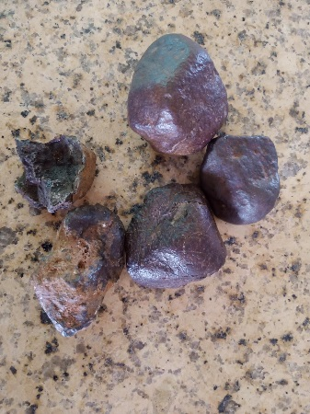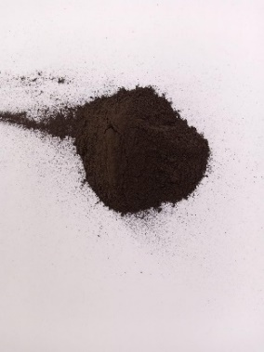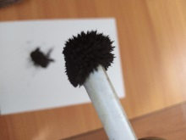

Raw rock samples

Crushed and sieved rock (d<70µm)

Hematite reduction to magnetite

Magnétite

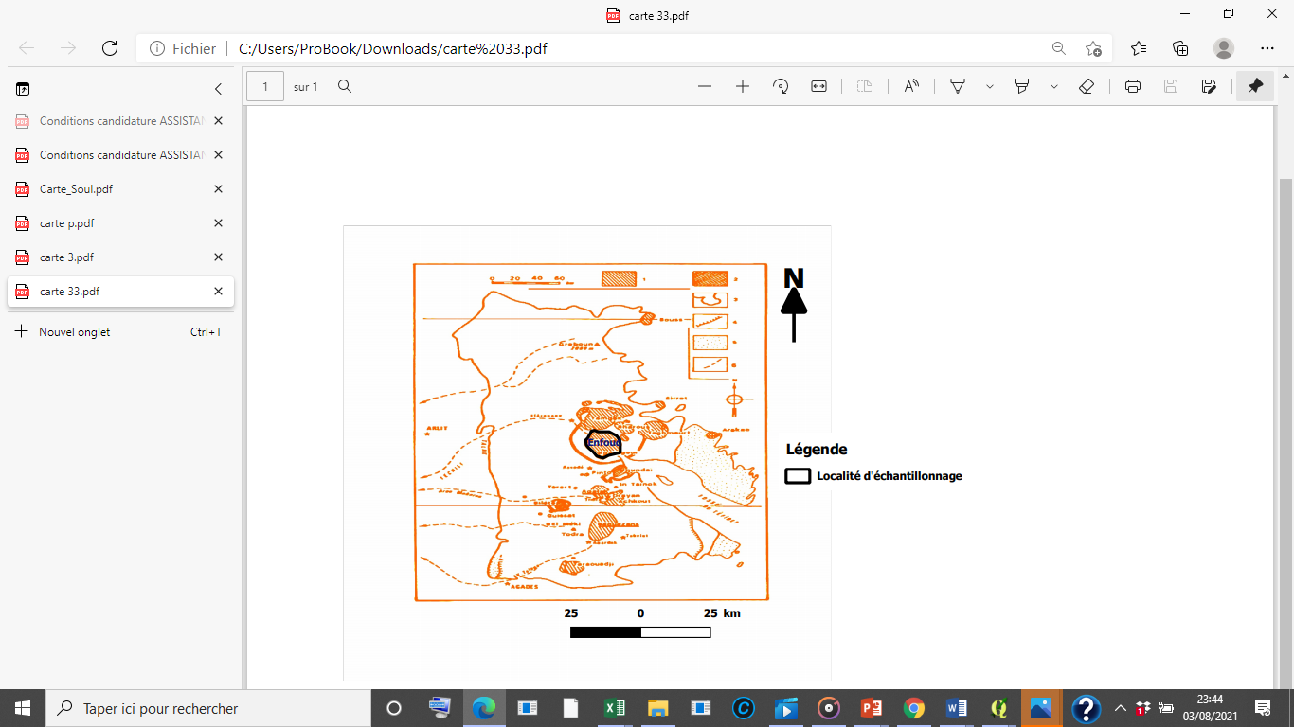

**1**

**2**

**3**

Rock powder

Sampling

**Figure 1. Extraction and preparation of the catalyst**

**2.2. Crude oil extraction technique**

The contaminated soil with crude oil was collected from the Wurin Mai Peter oil production field (Fig 1). Since it is waxy crude oil, the viscosity of this pollutant is high at room temperature (Kiyingi et al., 2022). Its infiltration into the sub-soil is very low. Thus, the contaminated soil in the subsurface (approximately 0-15 cm) was collected. Samples were taken in a glass sampling box. Dead insects, plants and rocks were removed from the sample using standard sieves (40 mesh). In 1000 ml glass beakers, 300 ml of hot water (50 ° C) was added to 100 g of contaminated soil in order to heat the crude oil in the soil matrix. The heat-ing allows releasing the hydrocarbons adsorbed on the surface of the soil particles and also to release the hydrocarbons not solu-ble in n-heptane. Then n-heptane was added according to the sol: solvent ratio:1: 6 (Li et al., 2018). The mixer was stirred for 20 minutes and centrifuged at 3,000 rpm to separate the solid phase from the liquid phase. Since oil and water are immiscible, the two phases were then separated by decantation using a separating funnel. The extraction was repeated several times in order to obtain sufficient crude oil. The extracted oil samples were collected in a glass sampling box and stored at 4 ° C before use.

**2.3. Characterization of crude oil extracted**

The determined physicochemical properties include density, wax content, SARA composition, and n-alkane distribution. Stand-ard methods were used for the characterization of the extracted crude oil. Density was measured at 20 ° C using the ASTMD5002 density meter. The UOP (Universal Oil Products LLC) UOP46 universal extraction method using acetone as a solvent was used to determine the wax content in crude oil. The composition of the extracted crude oil was determined by GC-FID gas chromatographic analysis and by SARA analysis according to Kheirollahi experiments (Kheirollahi et al., 2024).

**2.4. Mechanisms of hydroxyl radical production**

Several studies suggest that the catalytic decomposition of hydrogen peroxide usually happens at the surfactant sites of the catalyst, resulting in the formation of hydroxyl radicals that play a key role in the degradation of the pollutant. The mechanisms of hydrogen peroxide have been proposed by (Wang et al., 2024) using the following model:

$$≡{Fe}_{surf}^{3+}+H_{2}O_{2}→≡{Fe}_{surf}^{2+}+{}_{}^{•}{OOH+H^{+ }\left(4\right)}$$

$$≡{Fe}_{surf}^{2+}+H_{2}O_{2}→≡{Fe}_{surf}^{3+}+{}_{}^{•}{OH+H^{+ }(5)}$$

Hydroxyl radical production during the Heterogenous Fenton process has been determined by the decomposition of hydrogen peroxide in the presence of Fe3O4 (Eqs. (4) and (5). Magnetite powder was added to get 6.0 g. L-1 of catalyst. The mixture was stirred thoroughly to provide sufficient dispersion of the magnetite particles. The pH of the solution was determined to be 4.8. 10 ml of the solution was taken at various times, filtered and the concentration of hydrogen peroxide was determined by titra-tion with the permanganate solution of 0.016 g / mol in the presence of sulfuric acid(Aziz et al., 2022).

**2.5. Crude oil catalytic degradation tests**

The crude oil catalytic degradation was accomplished in batch mode. In order to determine the effect of mineral structure, the crude oil (100 mg/L) and 0.9 g/L of each oxide were stirred for 30 min in distilled water to ensure the adsorption equilibrium. The solution was analyzed to determine the initial Total Organic Carbon (TOC). The role of the acid is to release the hydroxyl radicals trapped on the surface of the catalyst. However, the use of these acids generates radicals less efficient than hydroxyl radicals ,and H+ protons which consume hydroxyl radicals(Wang et al., 2019). Many studies have shown that, unlike the homo-geneous reaction, the heterogeneous system is theoretically not limited to low pH values. The best degradation rates are achieved at subneutral pH (Usman et al., 2018; Wang et al., 2024). As a result, the pH of each solution was adjusted to 3.2 or 6.5 using H2SO4 (0.05 mol L-1) and NaOH (0.1 mol L−1). Then for each iron oxide, batch series were prepared by assigning one batch for each time (1 h, 12 h ,24 h, 48 h) to study the degradation kinetic. The effect of hydrogen peroxide to magnetite molar ratio on the crude oil mineralization rate for each oxide was performed with n(H2O2/n(Mt) equal to 5, 10, 20.

**2.6. Degradation monitoring**

The Total Organic Carbon (TOC) was used to study the degradation rate and the oxidation products were analyzed by gas chro-matography (GC-FID). Before samples analyzing by TOC, the oxidation reaction must be stopped to meet the requirements related to the degradation kinetics. After each reaction time, the residual magnetite is separated from the solution using a mag-net rod. An inhibitor composed of phosphoric acid (0.05mol / L), KI (0.1mol / L), Na2SO3 (0.1mol / L), is then added to the solution. Phosphates precipitate dissolved iron forming FePO4 which is insoluble in water. KI converts H2O2 into H2O according to the equation:

(6).

Na2SO3 reduces the iodine formed according to the equation:

${Na}_{2}{SO}_{3}+I_{2} + H_{2}O→ {Na}_{2}{SO}_{4} + 2 HI (7)$.

The chromatographic analysis allowed us to calculate the Hydrocarbon Index (HI) of the oxidized solution according to the equation:

HI = (Area) t / (Area) t0 (8).

In the case of GC-FID chromatographic analysis, the reaction time is reduced to 2 hours to avoid maximum degradation of the n-alkanes structure.

3. results and discussion

**3.1. Magnetite characterization**

X-ray fluorescence (XRF) is used to determine the elemental composition of the raw rock. The result is shown in **Table 1**.

**Table 1. Chemical composition of raw rock.**

|  |  |  |  |  |  |  |  |  |  |  |  |  |  |
| --- | --- | --- | --- | --- | --- | --- | --- | --- | --- | --- | --- | --- | --- |
| Raw rock | | | | | | | | | | | | | |
| Elements | Co | Ni | Fe | Mn | Ti | Mg | k | Al | Si | Cr | v | ca |  |
| Percent(%) | 0.10 | 0.031 | 76.94 | 0.04 | 0.41 | 3.10 | 0.49 | 10.97 | 6.99 | 0.06 | 0.31 | 0.14 |  |

The iron content of the raw material is 76.94 %. It is thus mainly composed of iron with trace elements (Titanium (Ti), Nickel (Ni), Cobalt (Co), Manganese (Mn), aluminum (Al), magnesium (Mg) and silicon). These elements had been previously reported in natural hematite by many authors (Huang et al., 2016; Salhi et al., 2024; Taheri et al., 2025a). The specific surface area and the mean pore diameter were 69.742 m2 / g and 2.8 nm, respectively. The X-ray diffraction pattern of the raw rock powder (E0) is presented in Figure 2, indicating that the main phase structures of the sample were hematite (62 %) and quartz (27 %) along with other minerals like magnetite (1 %) and orthoclase (10%). According to the XRD analysis, in the raw rock(E0), the major diffraction patterns corresponding to hematite are observed at 2Theta= 24.18, 33.2, 35.68, 39.34, 40.92, 43.57, 49.53, 54.15, 63 and 66. As table 1 shows, the amount of hematite (Fe2O3) converted to magnetite (Fe3O4) increased with the increasing temperature and biochar mass (Ponomar et al., 2019). As the hematite content decreased from 62% to 0%, the magnetite content rose from 1% to 78% (table 2, figure 2 and supplementary document). Moreover, all the hematite was reduced to magnetite at 800 K and 2g of biochar (E4). For more information about the percentage of magnetite in samples, additional data are available in supplementary files.



**Figure 2. Catalysis XRD analysis responses**

**Table 2** **Experimental data and responses of magnetite synthesized by hematite iron ore reduction**

|  |  |  |  |  |  |
| --- | --- | --- | --- | --- | --- |
| Experiment | Temperature(K) | | Reduction  Agent mass(g) | % Magnetite | % Hematite |
| E0 | Room temperature | 0 | | 1 | 62 |
| E1 | 650 | 0.5 | | 29.7 | 59.1 |
| E2 | 650 | 1 | | 34 | 26 |
| E3 | 800 | 0.5 | | 69 | 9.5 |
| E4 | 800 | 1 | | 78 | 0 |

## **3.2. Crude oil characterization**

The distribution and fate of crude oil depends on its physicochemical properties and its susceptibility to degradation. The physico-chemical properties of the crude oil are summarized in **table 3**. The crude oil is light with high wax content. The relative abundance of saturated hydrocarbons suggests that the oil is a predominantly aliphatic hydrocarbon (71.93%) who is resistant to oxidation. The chromatogram of the crude oil (**fig 9a**) indicated a very high paraffinic nature with a large among of paraffinic wax molecules. The pollutant extracted has a high saturated content. The aromatic compounds are benzene, toluene **(Table 3).** 3-methylphenanthrene and methylphenanthrene are also present in this crude oil according to the work of Bang Liu et al. (2017) (Bang Liu1* et al., 2017) Benzene, toluene, 3-methylphenanthrene and methylphenanthrene are carcinogenic and biodegradation resistant compounds that must be degraded.

**Table3. Physicochemical properties of extracted crude oil.**

|  |  |  |  |  |  |  |  |
| --- | --- | --- | --- | --- | --- | --- | --- |
| Density at 20°C g/cm3 | Wax content %(W/W) | Water content (%) | Iron content (%) | Saturates (%) | Aromatics (%) | Resins | Asphaltenes |
| 0.85 | 24.8 | 0.500 | 0.2 | 71.93 | 20.86 | 4.55 | 2.67 |

## **3.3. Kinetic measurements of the catalytic decomposition of hydrogen peroxide**

**Figure 3. Kinetics of H2O2 decomposition by natural magnetite**

**Figure 4. Effect of pH on crude oil catalytic degradation**

Several experiments were conducted to examine how H2O2 interacts with Fe3O4.

The concentrations of H2O2 are represented as a function of reaction time in **Figure 3**. From **figure 3** with 0,6 g of Mt, the rate of H2O2 decomposition rises slowly and linearly, obeying zero-order kinetics, and with an R2 value of 0.9926. The calculated apparent rate constant K from the equation Ct = Kt is 0.10 µg.l-1, min⁻¹. This suggests that the rate of H2O2 decomposition using natural magnetite is quite slow. This could be related to the hydroxyl radicals trapping on the surface of the magnetite, hence the importance of using an acid.

## **3.3. Effect of operating parameters on crude oil catalytic degradation**

## **3.3.1. Effect of pH**

The characterization of catalysts reveals that they are composed of hematite, a mix of hematite and magnetite, or magnetite, all of which provide iron **(Fig 2).** Consequently, we aimed to investigate how the oxidation state of iron affects the pollutant degradation. The experiments were conducted at room temperature, at an initial pH set at 6.5 and 3.2 with 28 mmol. L-1 of H2O2 and 0.9 g. L-1 of catalyst. The crude oil mineralization over time for each iron oxide is shown in **figure 4**.

The decomposition of crude oil results in a gradual decrease in TOC over time. In more acidic solution, mineralization is more rapid at the start of the reaction in hematite-rich samples containing 1% and 7% magnetite than in other magnetite-rich samples. The opposite effect was observed later in the reaction. It could be said that two types of reaction took place during the degradation in more acidic solution. In the initial phase of the reaction, the classical Fenton process with Fe II might occur in samples rich in hematite. In hematite-rich samples, the slowdown in the crude oil mineralization rate in the acid solution could be attributed to the increase in the concentration of hydroxide species(Wang et al., 2024) . Samples rich in hematite display a significantly low degradation rate at pH of 6.5. The degradation rate increases as the percentage of magnetite increases during the reaction. This shows a dominance of the magnetite as catalyst compared to hematite at the sub neutral pH.

## **3.3.2. Effect of H2O2/ iron oxide molar ratio**

Fenton reaction depends on the H2O2 concentration(Wang et al., 2022). Using low concentration of H2O2 makes the Fenton process economically acceptable but very low concentration as excess amount of H2O2 reduced the reaction rate(Di Iaconi et al., 2006). **Figure 5** shows the effect of the molar ratio of peroxide to magnetite on the crude oil of mineralization rate. Our experiment showed that at a pH 3.2, the crude decomposition for all iron oxides decreased as the dosage of hydrogen peroxide increased from five (5) to twenty (20). In the magnetite-rich samples (34, 69 and 78%), at a pH of 6.5, the decomposition rate of crude oil was enhanced as the H2O2/Fe3O4 molar ratio increased from 5 to 10, yet it declined when the ratio was further elevated from 10 to 20. This indicated that the ideal molar ratio in the acid solution was around five (5). According to Wang et al.,(2022) (Wang et al., 2022), at low concentration of H2O2 the •OH preferentially attack the pollutant whereas at higher concentration of H2O2 there is a competitive reaction between the pollutant and H2O2. The•OH radical may react with hydrogen peroxide producing superoxide/hydroperoxyl radicals according to equation 9. At pH 6.5 the maximum value of the crude oil mineralization was recorded with the molar ratio of 10. Consequently, it could be stated that for a given H2O2/Oxide ratio, there may be more •OH present at sub-neutral pH. This also suggested that, the scavenging of hydroxyl radical by sulfate ions is more operational in acidic solution than the neutral solution.

$•OH+H_{2}O_{2}→{•OH}_{2}+H_{2}O$ (9)

**Figure 5. Effect of increasing H2O2 dosage on TOC removal ([oxide]=550 mg/L ; Time =48 hours). [TOC]i = 1 mg/L**

## **3.3.4. Effect of extracted oil concentration**

The most effective removal of crude oil occurs at a pH 6.5, using the sample that contains the highest percentage of magnetite. (78% Mt). To understand the mechanism of the catalytic reduction of the petroleum residue and to study the kinetics of degradation as a function of the concentration of the pollutant, the degradation reaction was studied by varying the concentration of the pollutant. **Figure 6** shows the result obtained with different oil concentrations.

**Figure 6. Kinetics of the effect of catalyst concentration**

**Figure 7. Variation of crude oil degradation rate constant as a function of concentration**

ratio (10) were kept constant. The study of the dependence of the degradation rate constant of the petroleum residue on its concentration clearly shows in **Figure (7),** that the rate decreases as the concentration of the petroleum residue increased. It can be noted that the degradation of the petroleum residue follows pseudo-first-order kinetics. Indeed, we observe a linear correlation of Ln (TOCf )/( TOCi) with time (R2> 0.95) (**Fig 6. b**). According to the work of several authors, the concentration of the pollutant causes a covering film on the surface of the catalyst. This decreases the contact between magnetite and hydrogen peroxide and thus slows the formation of hydroxyl radicals. The surface of magnetite had also a limited of actives sites(Sun et al., 2021). This means that there should be an optimum concentration where the reaction rate is maximum.

## **3.3.5. stability and reusability of catalysts**

The stability of the catalyst has advantages when used on an industrial scale. This reduces the cost of preparing new catalysts. To evaluate the stability of iron oxides as catalysts, we performed reusability tests using H2O2/Oxide mole ratio of 10 at pH 6.5 and a ratio of 5 at pH 3.2.

**Figure 8. Rate of degradation over four cycles**

**Table 4. Loss of catalysts**

|  |  |  |  |  |
| --- | --- | --- | --- | --- |
| Experiment  b | % Magnetite | % Hematite | Loss of catalyst(mg/L) pH=6.5 | Loss of catalyst(mg/L) pH=3.2 |
| E0 | 1 | 62 | 0.13 | 0.16 |
| E1 | 29 | 59 | 0.13 | 0.15 |
| E2 | 34 | 26 | 0.07 | 0.10 |
| E3 | 69 | 9.5 | 0.05 | 0.08 |
| E4 | 78 | 0 | 0.03 | 0.07 |

**Figure 8.** *Quantity of Mt recovered after 48 h incubation; b: rate of degradation over four cycles*

**In Figure 8 b**, Slight decrease in performance of each catalyst was observed after two consecutive cycles of the crude oil degradation. This could be related to the loss of soluble iron from the catalyst or to handling errors.

After this slight increase, the degradation became almost constant until the fourth cycle in the sample containing more than 7% magnetite at all pH levels. A slight reduction in catalyst activities is observed in the sample very rich in hematite (59 and 62%), especially in acidic solution. Many studies have confirmed that a magnetic catalyst shows excellent catalytic performance even after multiple reuse cycles(Aly et al., 2024; Liu et al., 2023; Pincella et al., 2024; Roshni et al., 2024). The loss of the catalyst in the effluent is very weak but increases as magnetite content and pH decrease **(Table 4).** The results of the amount of dissolved magnetite, generated by ICP-MS analysis show iron concentrations of 138.002, 122.09, 60.18, 51.33 and 17.7 ppb and 112.368, 99.40, 48.9, 41.78 and 14.4 ppb in the acidic system and in pH close to neutral as magnetite content increased from 1 to 78 %. Although sample rich in hematite have shown good stability (Taheri et al., 2025), an improvement in recovery and reusability was observed as the magnetite content increased.

## **3.3.6. Chromatographic analysis of by-products generated**

Chromatographic analysis was performed to follow the oxidation of crude oil with the following parameters: pH = 6.5; Peroxide / magnetite molar ratio = 10 using the sample with 78 % of magnetite. This analysis enabled us to follow the degradation of the various alkanes contained in this crude oil after 2 hours of degradation to avoid complete degradation of the pollutant. The Hydrocarbon Index HI was used to monitor the degradation of individual alkanes. It represents the ratio of the specific surface area of each alkane at time t to the specific surface area at the initial time: (**Eq. 3**).

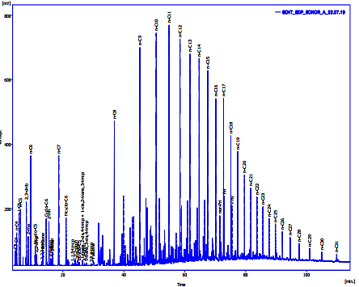

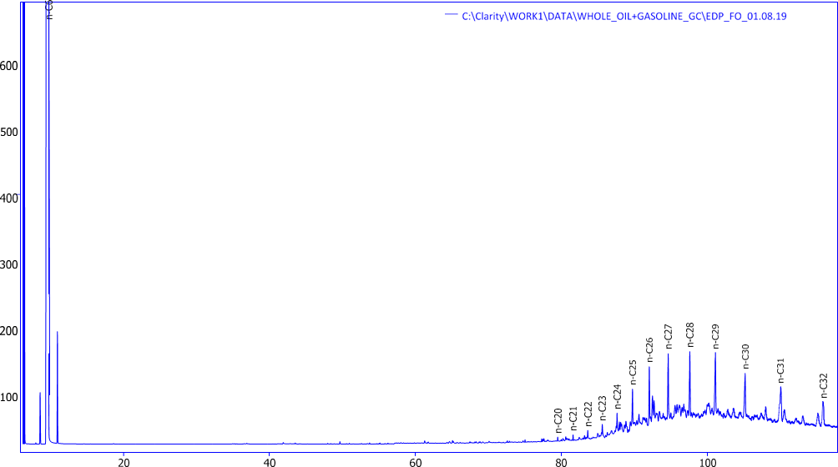

**Figure 9. Chromatogram of the crude oil(a) and oxidized product (b) after 2h incubation (magnetite dose = 0.6 g/L, v(H2O2)=1ml; pH = 6.5)**

Analysis of the chromatogram of the crude oil and oxidized product after 2h incubation in **Figure 9 b** shows non-selective degradation of all the hydrocarbons contained in the pollutant indicating the superiority of the heterogeneous Fenton process on the oxidation processes such photolysis and photocatalysis. According to Lelario et al. (Lelario et al., 2021), in the photolysis degradation, an increase of C13–C23 classes and a decrease of C7–C12 types of compound were observed. Conversely, during photocalysis, C5 compounds rose from 67% to 89%, while C6, C7, C8, and C9 compounds saw a decrease. Branched alkanes increased from 50% to 65%, cyclic alkanes grew from 4% to 5%, and aromatic compounds dropped from 23% to 13%, as did linear alkanes, which declined from 22% to 14%.

However, there is a greater reduction in light hydrocarbons. This is in accordance with the work of Boukir et al., (1998) which showed that the oxidation rate of heavy hydrocarbons is lower than that of light hydrocarbons. Table III (Cf annex document) shows the variation of the hydrocarbon index compared to the initial situation. C1-C7 alkanes have a hydrocarbon index after oxidation of less than 0.1. Their degradation rate τ (τ = (1-IH) * 100) is thus greater than 90%. Liquid alkanes with carbon atoms from C8 to C17 have a degradation rate of approximately 90%. Beyond C17 the degradation rate is less than 90%. It is less than or equal to 70% from C28. It can be seen that as the length of the carbon chain increases, the rate of catalytic degradation decreases(Aziz et al., 2022b). This could be explained by the fact that it is more difficult to degrade macromolecules (heavy hydrocarbons) with long carbon chains. Indeed, these complex molecular generally requires a higher dose of catalyst and/or a longer reaction time. Chromatographic analysis allows us to conclude that the degradation rate of alkanes with carbon atoms greater than 15 is low. These alkanes correspond to paraffinic wax molecules.

4. Conclusion

Crude oil was successfully degraded using varying concentrations of magnetite synthesized from hematite iron ore. These concentrations were achieved by varying the biochar concentration and the temperature. Higher temperatures and greater amounts of biochar led to an increase in the conversion of hematite (Fe2O3) into magnetite (Fe3O4). According to the results of this study, the removal efficiency of crude oil enhanced with an increase in the amount of magnetite present. The stability study of the catalysts also showed an increase in dissolution with the increasing content of hematite. Chromatographic analysis showed that the degradation rate of alkanes with more than 15 carbon atoms was low. In conclusion, this research indicates that transforming hematite into magnetite enhanced the degradation rate of the pollutant, along with the recovery and reuse of the catalyst.

Consent (where ever applicable)

Not applicable

Ethical approval (where ever applicable)

Not applicable

References

Aly, S.T., Saed, A., Mahmoud, A., Badr, M., Garas, S.S., Yahya, S., Hamad, K.H., 2024. Preparation of magnetite nanoparticles and their application in the removal of methylene blue dye from wastewater. Scientific Reports 14, 20100. https://doi.org/10.1038/s41598-024-69790-w

Aziz, M.S.A., Kopoin, A., Sani, O.M., 2020. Compositional, Structural, Surface Characterizations of Natural Magnetite from Air Massif (Niger) in Relation to Its Catalytic Activity. Journal of Minerals and Materials Characterization and Engineering 08, 197. https://doi.org/10.4236/jmmce.2020.84013

Aziz, M.S.A., Yao, B.K., Sani, O.M., 2022a. Effect of Na2CO3 on the Catalytic Degradation of Crude Oil–Polluted Soil by Fenton Heterogène Reaction with Natural Magnetite. Water, Air, & Soil Pollution 233, 211. https://doi.org/10.1007/s11270-022-05682-x

Aziz, M.S.A., Yao, B.K., Sani, O.M., 2022b. Effect of Na2CO3 on the Catalytic Degradation of Crude Oil–Polluted Soil by Fenton Heterogène Reaction with Natural Magnetite. Water, Air, & Soil Pollution 233, 211. https://doi.org/10.1007/s11270-022-05682-x

Bang Liu1*, Guangya Zhang1, Fengjun Mao1, Jiguo Liu1, Dingsheng Cheng1 & Mingsheng Lü1,2 1, 2017. The petroleum system of the Tenere Basin: oil geochemistry from the SH-1 wildcat well in eastern Niger , ,.

Chen, J., Zhang, R., Simmonds, T., Hayes, P.C., 2019. Microstructural Changes and Kinetics of Reduction of Hematite to Magnetite in CO/CO2 Gas Atmospheres. Metallurgical and Materials Transactions B 50, 2612–2622. https://doi.org/10.1007/s11663-019-01659-0

Di Iaconi, C., Ramadori, R., Lopez, A., 2006. Combined biological and chemical degradation for treating a mature municipal landfill leachate. Biochemical Engineering Journal 31, 118–124. https://doi.org/10.1016/j.bej.2006.06.002

Huang, X., Hou, X., Zhao, J., Zhang, L., 2016. Hematite facet confined ferrous ions as high efficient Fenton catalysts to degrade organic contaminants by lowering H2O2 decomposition energetic span. Applied Catalysis B: Environmental 181, 127–137. https://doi.org/10.1016/j.apcatb.2015.06.061

Husch, J.M., Moreau, C., 1982. Geology and major element geochemistry of anorthositic rocks associated with paleozoic hypabyssal ring complexes, air massif, Niger, West Africa. Journal of Volcanology and Geothermal Research 14, 47–66. https://doi.org/10.1016/0377-0273(82)90042-7

Kheirollahi, S., BinDahbag, M., Bagherzadeh, H., Abbasi, Z., Hassanzadeh, H., 2024. Improved determination of saturate, aromatic, resin, and asphaltene (SARA) fractions using automated high-performance liquid chromatography approach. Fuel 371, 131884. https://doi.org/10.1016/j.fuel.2024.131884

Kiyingi, W., Guo, J.-X., Xiong, R.-Y., Su, L., Yang, X.-H., Zhang, S.-L., 2022. Crude oil wax: A review on formation, experimentation, prediction, and remediation techniques. Petroleum Science 19, 2343–2357. https://doi.org/10.1016/j.petsci.2022.08.008

Lelario, F., Bianco, G., Bufo, S.A., Scrano, L., 2021. Simulated Ageing of Crude Oil and Advanced Oxidation Processes for Water Remediation since Crude Oil Pollution. Catalysts 11, 954. https://doi.org/10.3390/catal11080954

Li, X., Yang, Z., Sui, H., Jain, A., He, L., 2018. A Hybrid Process for Oil-solid Separation by a Novel Multifunctional Switchable Solvent. Fuel 221, 303.

Liu, M., Ye, Y., Ye, J., Gao, T., Wang, D., Chen, G., Song, Z., 2023. Recent Advances of Magnetite (Fe3O4)-Based Magnetic Materials in Catalytic Applications. Magnetochemistry 9, 110. https://doi.org/10.3390/magnetochemistry9040110

Luo, H., Wang, H., Kong, L., Li, S., Sun, Y., 2019. Insights into oil recovery, soil rehabilitation and low temperature behaviors of microwave-assisted petroleum-contaminated soil remediation. Journal of Hazardous Materials 377, 341–348. https://doi.org/10.1016/j.jhazmat.2019.05.092

Pincella, F., Isozaki, K., Sato, R., Teranishi, T., Takaya, H., Nakamura, M., 2024. Reusable Magnetite Nanoparticle (Fe3O4 NP) Catalyst for Selective Oxidation of Alcohols under Microwave Irradiation. ACS Omega 9, 24477–24488. https://doi.org/10.1021/acsomega.4c00361

Ponomar, V.P., Brik, O.B., Cherevko, Yu.I., Ovsienko, V.V., 2019. Kinetics of hematite to magnetite transformation by gaseous reduction at low concentration of carbon monoxide. Chemical Engineering Research and Design 148, 393–402. https://doi.org/10.1016/j.cherd.2019.06.019

Roshni, M., Anaina, S., Jagadeesan, D., 2024. Iron Oxide-Based Heterogeneous Catalysts for Environmental Applications, in: Sahoo, H., Sahoo, J.K. (Eds.), Iron Oxide-Based Nanocomposites and Nanoenzymes: Fundamentals and Applications. Springer International Publishing, Cham, pp. 235–263. https://doi.org/10.1007/978-3-031-44599-6_13

Salhi, S., Omri, A., Ben Salem, R., Benzina, M., 2024. Enhanced Reactivity and Stability of Natural Hematite Supported Cobalt for the Catalytic Oxidation of Congo Red Dye. Catalysis Surveys from Asia 28, 243–254. https://doi.org/10.1007/s10563-024-09423-4

Sun, Y., Feng, L., Yang, L., 2021. Degradation of PCB67 in soil using the heterogenous Fenton process induced by montmorillonite supported nanoscale zero-valent iron. Journal of Hazardous Materials 406, 124305. https://doi.org/10.1016/j.jhazmat.2020.124305

Taheri, E., Fatehizadeh, A., Khiadani, M., Ghasemian, M., Bedia, J., 2025a. Application of natural hematite as catalyst in heterogeneous photo-Fenton like process for 2,4-dichlorophenol degradation. Journal of Photochemistry and Photobiology A: Chemistry 459, 116057. https://doi.org/10.1016/j.jphotochem.2024.116057

Taheri, E., Fatehizadeh, A., Khiadani, M., Ghasemian, M., Bedia, J., 2025b. Application of natural hematite as catalyst in heterogeneous photo-Fenton like process for 2,4-dichlorophenol degradation. Journal of Photochemistry and Photobiology A: Chemistry 459, 116057. https://doi.org/10.1016/j.jphotochem.2024.116057

Usman, M., Faure, P., Hanna, K., Abdelmoula, M., Ruby, C., 2012. Application of magnetite catalyzed chemical oxidation (Fenton-like and persulfate) for the remediation of oil hydrocarbon contamination. Fuel 96, 270–276. https://doi.org/10.1016/j.fuel.2012.01.017

Usman, M., Hanna, K., Faure, P., 2018a. Remediation of oil-contaminated harbor sediments by chemical oxidation. Science of The Total Environment 634, 1100–1107. https://doi.org/10.1016/j.scitotenv.2018.04.092

Usman, M., Hanna, K., Faure, P., 2018b. Remediation of oil-contaminated harbor sediments by chemical oxidation. Science of The Total Environment 634, 1100–1107. https://doi.org/10.1016/j.scitotenv.2018.04.092

Wang, C., Liu, H., Li, X., Cao, Y., Jia, K., 2024a. Degradation of organic pollutants in natural magnetite-activated peroxymonosulfate system enhanced by hydroxylamine: Catalytic performance, reaction pathway, and enhancement mechanism. Journal of Water Process Engineering 66, 106000. https://doi.org/10.1016/j.jwpe.2024.106000

Wang, C., Liu, H., Li, X., Cao, Y., Jia, K., 2024b. Degradation of organic pollutants in natural magnetite-activated peroxymonosulfate system enhanced by hydroxylamine: Catalytic performance, reaction pathway, and enhancement mechanism. Journal of Water Process Engineering 66, 106000. https://doi.org/10.1016/j.jwpe.2024.106000

Wang, Q., Zhang, Y., Hu, T., Meng, C., 2019. Fe3O4 nanoparticles/polymer immobilized on silicate platelets for crude oil recovery. Microporous and Mesoporous Materials 278, 185–194. https://doi.org/10.1016/j.micromeso.2018.11.033

Wang, W.-M., Li, X., Du, X., Wu, Q.-Y., 2022. A feasible approach for azo dye degradation using natural magnetite in heterogeneous Fenton oxidation. Water Cycle 3, 100–105. https://doi.org/10.1016/j.watcyc.2022.06.002

Zhang, J., Zhuang, J., Gao, L., Zhang, Y., Gu, N., Feng, J., Yang, D., Zhu, J., Yan, X., 2008. Decomposing phenol by the hidden talent of ferromagnetic nanoparticles. Chemosphere 73, 1524–1528. https://doi.org/10.1016/j.chemosphere.2008.05.050

Zhang, X., Kamali, M., Van Beeck, R., Hens, W., Truyen, J., Cabooter, D., Dewil, R., 2023. Degradation of ciprofloxacin using magnetite nanoparticle-activated periodate: Kinetic, mechanistic and toxicity evaluation. Chemical Engineering Journal 478, 147323. https://doi.org/10.1016/j.cej.2023.147323