**Original Research Article**

**Improvement of Antibacterial Properties of Resorbable Biomaterials Using 1-(Alkylamino)isoquinoline Derivatives**

**ABSTRACT**

In the articleare presented the results of research on obtaining materials with antibacterial and wound healing properties by incorporating 1-(alkylamino) isoquinoline derivatives into PLA/HA-based resorbable biomaterials. It was found that theantibacterial properties increase with the increasing of the alkyl group from methyl to butyl in 1C of 1-(alkylamino) isoquinoline derivatives. According to the results of molecular docking to the enzymes 6COX (cyclooxygenase-2) and 3V99 (lipoxygenase-5), synthesized derivatives can occur binds between ligands and protein molecules hydrogen and hydrophobic bonds, as well as π-π staking interactions. It was shown that the release of drugs from their contents in an aqueous environment, included in the entire volume of the material, reaches its maximum value in 8-10 days. The synthesized materials have the properties of healing artificial wounds *in vitro* in fibroblast cell line *L929 cells*, and in 72-hour experiments was healed about 90% of the wounds.

***Keywords:​*** *isoquinoline derivatives, antibacterial activity, wounds healing, molecular docking, polylactide, hydroxyapatite, biomaterial, resorption.*

**1. INTRODUCTION**

The problem with obtaining resorbable biomaterials is the occurrence of inflammation as a response by the immune system, and the solution to this problem is to improve their properties by introducing drugs with antibacterial properties into the composition of implant materials. Obtaining resorbable materials with both anti-inflammatory and antibacterial properties at the same time is one of the current tasks [15,16].

Recent studies have shown that the antibacterial properties of artificial bone substitutes can be enhanced by incorporating various nanoparticles, such as silver nanoparticles [1]. Studies conducted over a period of 25-40 minutes to 1 week have shown that the antibacterial properties of silver ions against Staphylococcus aureus are maintained.

Many studies have been conducted on the incorporation of standard drugs into biomaterials, which have been proven to have pronounced antibiotic and antibacterial properties. For example, when ciprofloxacin was incorporated into the materials, it was found that they inhibited E. coli and S. aureus even in 56-day experiments [2]. When vancomycin was incorporated into the materials, they retained their initial mechanical strength and demonstrated antibacterial properties against Staphylococcus aureus and S. epidermidis even in 60-day experiments [3].

At the same time, intensive research is being conducted on obtaining biomaterials with anti-inflammatory, osteoconductive, and antibacterial properties using newly synthesized preparations. It has been found that the introduction of polydopamine into the composition of the materials also exhibits antioxidant and anti-inflammatory properties, demonstrating >74% antibacterial efficacy against Staphylococcus aureus and Escherichia coli [4]. The introduction of carvacrol into calcium phosphate-based materials has been shown to accelerate the healing of infected bones, exhibit osteoconductive, and antibacterial properties [5]. It has been shown that the antibacterial properties of the material can be created by introducing 3,4-dichloro-5-hydroxyfuran-2(5H)-one into the composition of poly(methyl methacrylate) (PMMA)-based bone substitute materials [6,19,20]. It has been shown that the incorporation of sodium fusidate into bone biomaterials consisting of hydroxyaptite and carbonated apatite nanocrystals in stoichiometric ratios has properties such as being relatively active against Staphylococcus aureus, being non-cytotoxic towards human peripheral blood mononuclear cells, and not inducing IL-8, an inflammatory marker [7,17,18].

Based on the above, the development of biomaterials with improved physicochemical and mechanical properties, high biocompatibility, non-toxic to living tissues, and antibacterial properties against pathogenic bacteria is one of the urgent tasks of today.

This article presents the results of a study of the possibility of introducing some newly synthesized 1-(alkylamino) isoquinoline derivatives into resorbable materials based on PLA/HA to create anti-inflammatory and antibacterial properties in them while maintaining the required physicochemical and mechanical properties.

**2. EXPERIMENTAL METHOD**

**Synthesis of biomaterials based on PLA-HA**. The “solvent-casting” method was used to obtain resorbable biomaterials based on PLA/HA [8]. The physicochemical, mechanical, and biological properties of the synthesized materials were studied in detail [9, 10]. Based on the results obtained, bioresorbable materials with a Vickers hardness close to that of natural bone (26-50 HV), a biodegradation half-life of 70-130 days, and no cytotoxicity were obtained.

**Synthesis of 1-(alkylamino)isoquinolines based on amino acids**. 1-(alkylamino)isoquinoline heterocyclic compounds were synthesized to provide antibacterial, wound healing, and anti-inflammatory properties in the synthesized materials [11]. By this method, 2-((6,7-dimethoxy-3,4-dihydroisoquinolinyl) methyl) isoindoline-1,3-dione (I), 2-((6,7-dimethoxy-1,2,3,4-tetrahydroisoquinolin-1-yl) ethyl) isoindoline-1,3-dione (II) and 2-((6,7-dimethoxy-3,4-tetrahydroisoquinolin-1-yl) isobutyl) isoindoline-1,3-dione (III) were synthesized and their structures were established using modern research methods[11].

3. results and discussion

**Molecular docking tests.** The biological activity of the samples was studied against the enzymes “cyclooxygenase-2” and “5-lipoxygenase”. Docking analyses were performed using the “Moestro Schrödinger” program. The 6COX (cyclooxygenase-2) and 3V99 (5-lipoxygenase) proteins were obtained from the PDB (Protein Data Bank). The isoquinoline derivatives were included in the analysis based on 3D models through the ligand preparation protocol. During the preparation of the 6COX and 3V99 proteins, water molecules were removed, and protonation was optimized. The isoquinoline derivatives were included in the analysis based on 3D models through the ligand preparation protocol. As a result of docking analyses performed using the Maestro Schrödinger program, the binding energies (i.e., ΔG values ​​- in kcal/mol) of the isoquinoline derivatives relative to the 6COX and 3V99 proteins were estimated to be in the range of -3.5 to -9.5 kcal/mol. Structural analysis revealed that hydrogen and hydrophobic bonds, as well as π-π interactions (Fig. 1, a, b) play a major role in the ligand binding sites. The results show that the binding efficiency of isoquinoline derivatives to 6COX and 3V99 proteins is moderate, indicating the need for further modification of the ligand structure. Further experimental studies and confirmation based on dynamic simulations are planned in the future. These results indicate the need to optimize the ligand structure and binding site and require additional experimental studies.

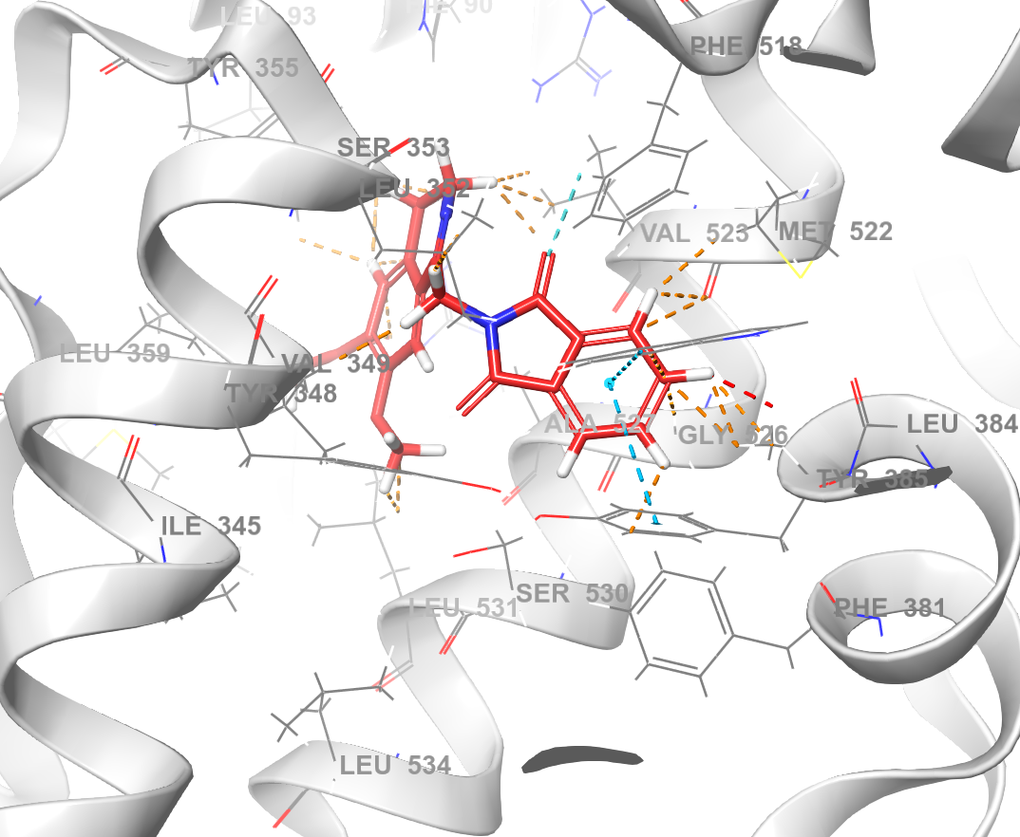 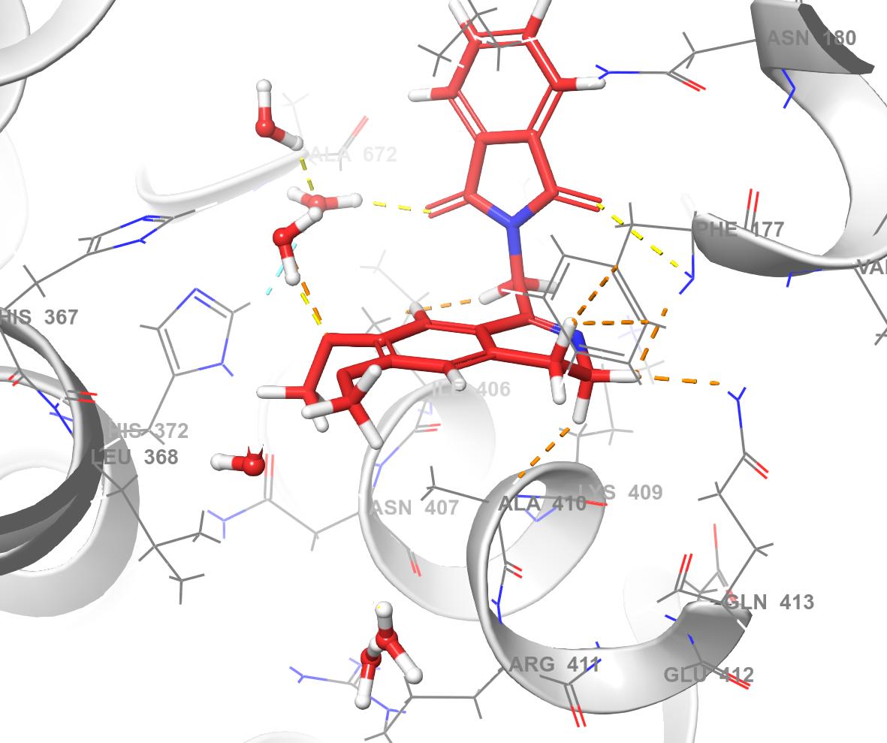

**Cyclooxygenase-5 (A) 5-Lipoxygenase (B)**

Figure 1. Molecular docking results of synthesized drugs with cyclooxygenase (A) and lipoxygenase (B)

**Preparation of polylactide + hydroxyapatite-based resorbable materials containing 1-(alkylamino) isoquinolines**. In order to increase the biological activity of PLA/HA-based resorbable biomedical materials, synthesized isoquinoline derivatives were included in the composition in an amount of 0.1; 0.5 and 1.0% relative to the total mass of the composite material. For this, a solution of polylactide in chloroform was prepared and left for 4 hours until a homogeneous solution was formed, modifiers and 1-(alkylamino) isoquinoline derivatives were added to the resulting solution and mixed for 2 hours using an overhead mixer.

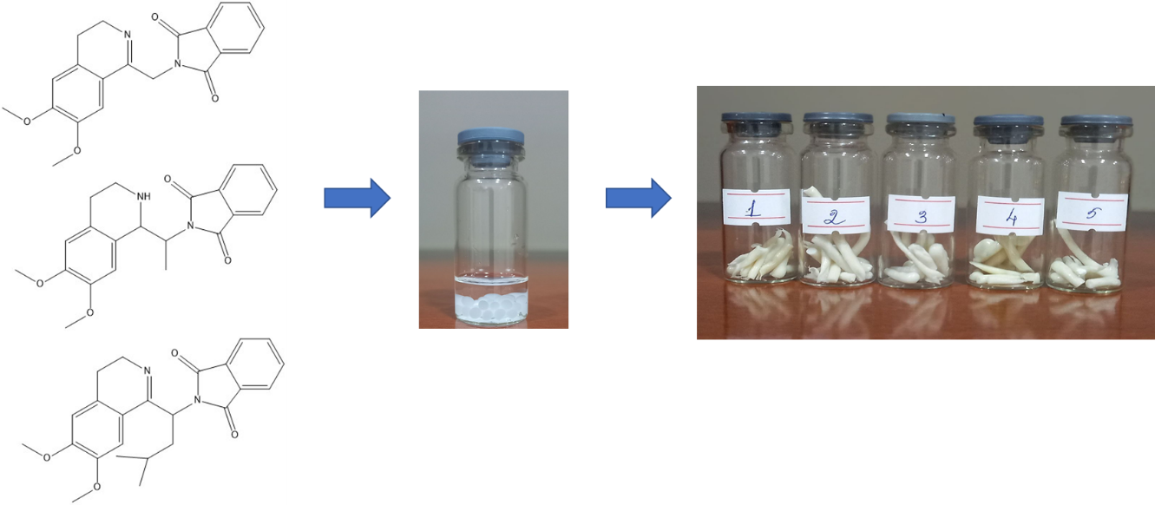

Figure 2. Incorporation of 1-(alkylamino)isoquinoline preparations into

PLA/HA-based materials

The mixture was dried in the open air for 3 days. To remove solvents and residues, it was washed in ethanol and distilled water, dried and ground into a fine powder. To shape the resulting material, it was extruded at a temperature of 140±5 ºC (Figure 2).

**Study of the physicochemical and biological properties of the materials. IR-spectroscopic study**. IR spectra of the samples were obtained on an FT-IR spectrometer (IRAffinity-1S, Shimadzu, Japan). To record the IR spectra of the samples, the samples were first dried and ground. The IR spectra obtained in the ATR mode were processed using a special program. The figure below shows the IR spectra of the samples included in the composition of PLA/HA-based compounds (Figures 3, a, b, c).

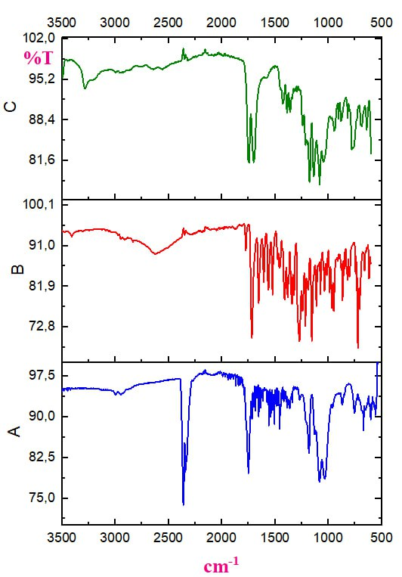 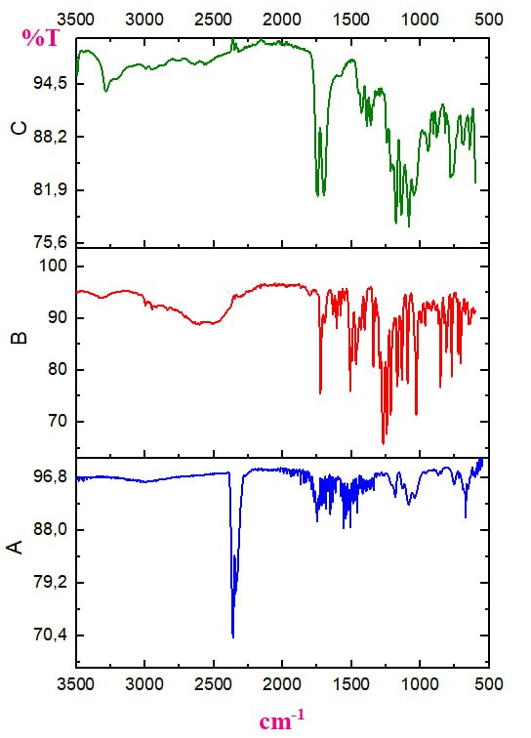 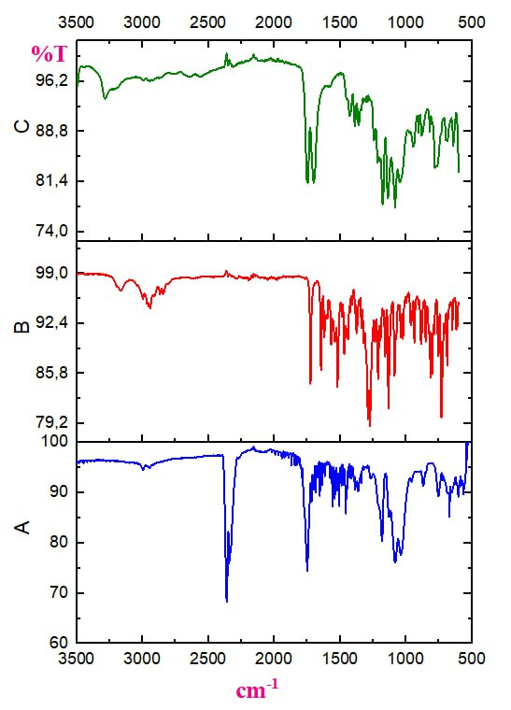

a) b) c)

Figure 3. IR spectra of samples with antibacterial properties obtained from the inclusion of preparations I (a), II (b) and III (c) in the materials

From the IR spectra data presented in Figure 3(a), the following conclusions can be drawn: the band at 3284.28 cm-1 is not sharp and its intensity is low, which suggests that it does not belong to amide N-H (since the material does not contain such a bond), but rather to adsorbed water or a small number of free O-H in PLA. The absence of such bands in both the I-preparation and the material+preparation compositions is explained by the release of adsorbed water after extrusion.

It is observed that the bands at 1744 cm-1, which belong to the carbonyl (C=O) of the ester groups in the material, shifted to the 1737.45 cm-1 region when the preparation (I) was introduced into the material, which in turn indicates the occurrence of interactions between the preparation and the material components. In the preparation itself, these bands are in the region of 1723.24 cm-1, which is explained by the fact that they are due to the nitrogen (N) of the phthalimide fragment. At the same time, bands at 1695.65 cm-1 corresponding to the C=O in the carboxyl group of PLA are also visible.

The disappearance of the band at 2624.58 cm-1, which belongs to the aromatic C-H bond in the preparation, in the IR spectrum of the material + preparation can be explained by the inclusion of a very small amount of the preparation in the material.

The formation of an intense band at 2362.04 cm-1, characteristic of CO2, which was not previously observed in the material + preparation sample, can be explained by the thermal oxidation of organic substances on the surface of the material with oxygen from the air during extrusion.

The fact that the band at 1085 cm-1, characteristic of C-O-C vibrations in the pure material, changes to 1071 cm-1 C-O-C in the material + drug sample indicates that interactions between the drug and the macromolecules of the material occur, and therefore, the introduction of the drug into the material composition is not just a physical inclusion, but a composite with non-covalent interactions (hydrogen, van der Waals, coordination, dipole-dipole, etc.). The same situation can be observed in the IR spectra of compounds II (3b) and III (3c). Let us dwell on some slightly different aspects. At 2943.14 cm-1, bands of vibrations belonging to the C-H of the isobutyl group appear, which differ from preparations I and II. That is, in the isobutyl group, such vibrations are more pronounced than in methyl and ethyl. In the 500-800 cm-1 region, slightly different states can be observed in the bands of Me-O bonds. For example, the bands in the 773, 765, 759, 723, 659 cm-1 regions are slightly different from each other in materials 1-3.

**Study of antibacterial properties of samples**. The synthesized PLA/HA-based materials were first tested in their pure form (Figure 4), then in which newly synthesized heterocyclic compounds - 1-(alkylamino) isoquinoline derivatives - were incorporated (Figure 5) for their antibacterial activity against various pathogenic bacteria: Escherichia coli, Staphylococcus aureus, Bacillus subtillis. The experiments were performed using the agar block method [12, 13]. The agar block method was used to grow antibacterial substances (liquids, solutions) and test cultures in LB medium at 28 °C for 24 hours. Initially, each pathogenic bacterial culture grown for 24 hours was spread onto the surface of the LB agar medium using sterile cotton swabs, and 6 mm wells were formed, and 100 μl samples of the tested solution (I, II, III) were added. Sterile nutrient broth was added as a negative control, and ampicillin was added to the wells as a positive control. After 24 hours, the incubation zones were observed and evaluated by measuring the zone of growth restriction and incubation zones (mm).

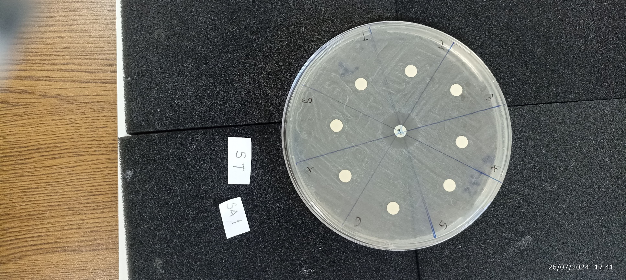

Figure 4. Testing the antibacterial properties of the synthesized

materials in their pure form

Based on the data presented in Figure 4, it was observed that the synthesized materials (pieces 1-8) did not show activity against the bacteria named above, while the control sample - ampicillin (in the middle) showed antibacterial properties. This leads to the conclusion that the materials in their pure form do not have antibacterial properties.

Therefore, in subsequent experiments, newly synthesized 1-(alkylamino) isoquinoline derivatives were introduced into the composition of the materials and their properties were tested (Figure 5).

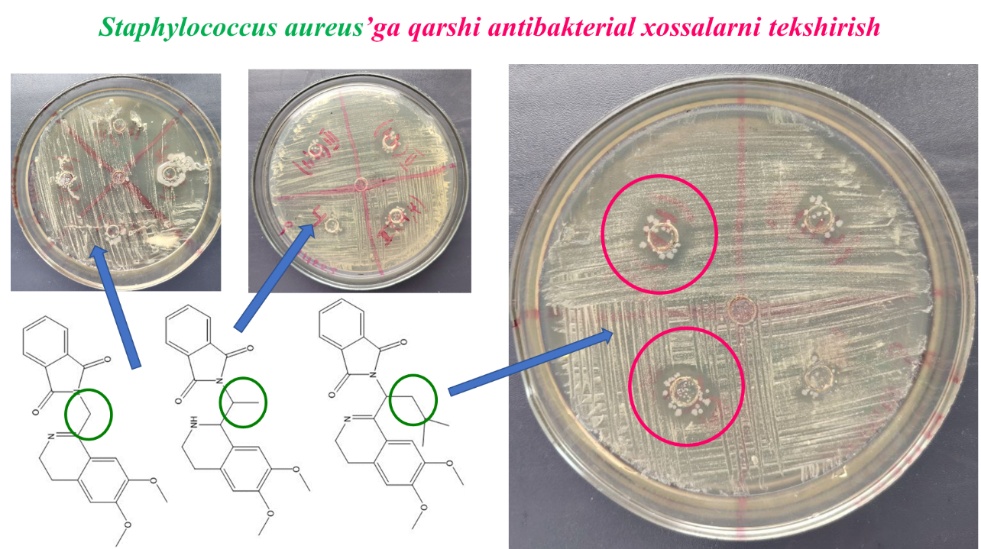

Figure 5. Antibacterial activity of the materials with the introduction of drugs against Staphylococcus aureus

Based on the results obtained, the following conclusions can be drawn: in the case of 1-(alkylamino) isoquinoline derivatives with an alkyl group of methyl, the samples do not show antibacterial activity against Staphylococcus aureus. It was found that when the alkyl group was replaced by ethyl, propyl, butyl, isobutyl, the antibacterial properties increased.

**Study of wound healing properties of samples**. The effect of synthesized materials on wound healing was carried out in vitro in fibroblast cell line L929 cells. In this, the dynamics of wound healing of artificial wounds created by scratching in cells was evaluated. Cells seeded in 24-well plates were incubated until confluent. Wounds were created by scratching 200 μl of confluent cells located at the bottom of the wells with a pipette tip. The medium in the wells was aspirated. Each well was treated with the appropriate medium. Then, a medium containing 2% FBS (Fetal Bovine Serum) was added to each well. A suspension of the test sample at a concentration of 50 μg/ml was added to each wound model. The same volume of medium was added to the control wells. Initial (zero hour) images of the wound model created in each well were taken with an objective at 10× magnification. Images of each well were retaken after 24, 48, and 72 hours of incubation (Figure 6). The amount of cell-free area (wound) in the obtained microscope images was calculated using ImageJ software. The wound closure rate (%) was calculated using the formulas below [13].

Closure rate = [(Areat0 - Areat24) / Areat0] x 100

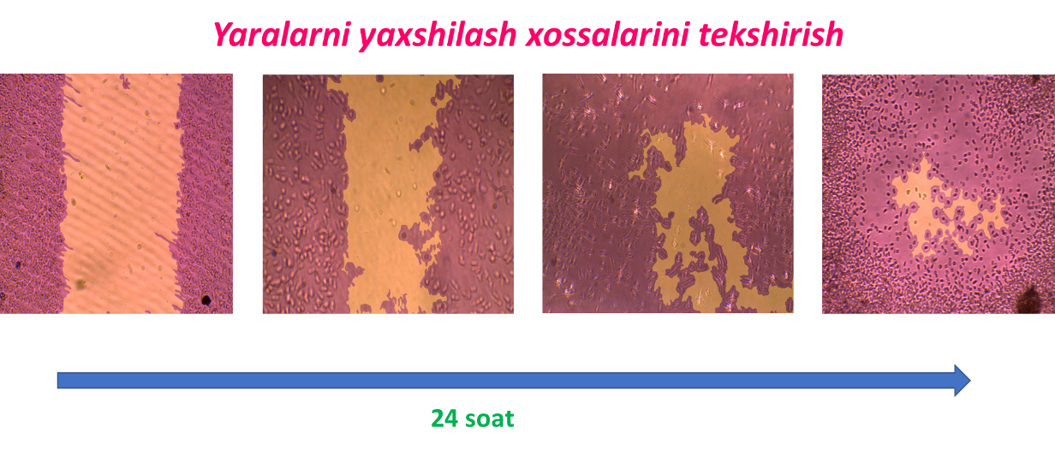

Figure 6. Wound healing properties of the samples within 72 hours

From the results in Figure 6, we can see that the material samples have wound healing properties, and it was found that the artificially created wounds healed by about 90% in 72-hour experiments.

The rate of release of drugs from the material. Studies were conducted to assess the rate of release of drugs included in the material. For this, initially, the electronic absorption spectra (Shimadzu, UV-2600) of 3 drugs were recorded. It was found that λmax = 300 nm for all 3 drugs. Then, standard solutions of each of the drugs with a concentration of 1*10-5 – 1*10-2 mol/l were prepared and a calibration graph was constructed. After that, samples of bioresorbable materials containing 1-(alkylamino)isoquinoline preparations were placed in bottles with clean distilled water, a certain aliquot was taken every day, and the optical activities of the aliquots were measured at a wavelength of λ = 300 nm. Based on the results obtained, the release rate of the preparations from the materials was analyzed (Figure 7).

4

2

6

8

10

12

Days

A

1,0

0,8

0,6

I

II

III

Figure 7. Release rate of drugs from materials

From the results obtained, we can see that intensive release of drugs from the materials occurred in 8-10 days, and the release rate remained stable for the next 15 days. It should be noted that the release of the drug and the manifestation of antibacterial activity are important in the first 7 days, when pathogenic bacteria enter the injured area, suppuration, and inflammation occur. Therefore, it was considered that it would be more effective to absorb antibacterial, anti-inflammatory 1-(alkylamino) isoquinoline derivatives into the surface of the materials rather than introducing them throughout the entire volume of the material, and this method was recommended.

**4. CONCLUSIONS**

It was shown that it is possible to obtain antibacterial and wound-healing materials by introducing 1-(alkylamino) isoquinoline derivatives into the composition of resorbable biomaterials based on PLA/HA. It was found that the materials themselves do not exhibit antibacterial properties, but when 1-(alkylamino) isoquinoline preparations are introduced into them, they exhibit activity against *Escherichia coli, Staphylococcus aureus, and Bacillus subtillis* bacteria, with the antibacterial properties increasing with the increase in the alkyl group from methyl to butyl in 1-(alkylamino) isoquinoline derivatives. According to the results of molecular docking, the binding energies of the preparations with respect to the enzymes 6COX (cyclooxygenase-2) and 3V99 (lipoxygenase-5) range from ΔG = -3.5 to ΔG = -9.5 kcal/mol, and it was found that hydrogen and hydrophobic bonds, as well as π-π interactions, play a major role in the binding positions of the ligands. IR spectroscopic studies have shown that weak non-covalent (hydrogen, van der Waals, dipole-dipole, etc.) bonds can form between drugs and biomaterials. The release of drugs from their contents in an aqueous environment, introduced into the entire volume of the material, reached its maximum value in 8-10 days, and was observed to be stable for the next 15 days. Therefore, it was shown that it is more effective to introduce drugs into the surface of the materials, rather than into the entire volume of the material. The synthesized materials have the properties of healing artificial wounds *in vitro* in fibroblast cell line L929 cells, and in 72-hour experiments, about 90% of the wounds were healed.

References

## 1. Huiling Liu, Peng Li, Ziniu Tang, Haoran Liu, Rui Zhang, Jun Ge, [Huilin Yang](https://www.sciencedirect.com/author/8941549700/huilin-yang), Xinye Ni, Xiao Lin, Lei Yang. Study on injectable silver-incorporated calcium phosphate composite with enhanced antibacterial and biomechanical properties for fighting bone cement-associated infections // [Colloids and Surfaces B: Biointerfaces](https://www.sciencedirect.com/journal/colloids-and-surfaces-b-biointerfaces), [Volume 227](https://www.sciencedirect.com/journal/colloids-and-surfaces-b-biointerfaces/vol/227/suppl/C), July 2023, <https://doi.org/10.1016/j.colsurfb.2023.113382>

## 2. Vidyaalakshmi Venkatesan, Arthi Chandramouli, Aathira Pradeep, Anil Kumar Vasudevan, Vivek Lakshmanan, Jayakumar Rangasamy. Enhanced ciprofloxacin release and antibacterial activity of composite bone cement beads for diabetic pedal osteomyelitis treatment // [Materials Chemistry and Physics](https://www.sciencedirect.com/journal/materials-chemistry-and-physics), [Volume 339](https://www.sciencedirect.com/journal/materials-chemistry-and-physics/vol/339/suppl/C), 15 July 2025, <https://doi.org/10.1016/j.matchemphys.2025.130700>

# 3. Sunjung Kim, Aaron R. Bishop, Matthew W. Squire, Warren E. Rose, Heidi-Lynn Ploeg. Mechanical, elution, and antibacterial properties of simplex bone cement loaded with vancomycin // [Journal of the Mechanical Behavior of Biomedical Materials](https://www.sciencedirect.com/journal/journal-of-the-mechanical-behavior-of-biomedical-materials), [Volume 103](https://www.sciencedirect.com/journal/journal-of-the-mechanical-behavior-of-biomedical-materials/vol/103/suppl/C), March 2020.

# 4. Yalan Ouyang, Rongguang Zhang, Qiyi Zhang, Yonggang Yan. Polydopamine-Modified Composite Bone Cement for Cancellous Bone Repair: Synergism of Bioactivity, Antibacterial Properties, and Biodegradability // Biomacromolecules, 2025, <https://doi.org/10.1021/acs.biomac.5c00157>.

# 5. Chen Cui, Dachuan Liu, Xiaobin Xie, Lijie Wang, Miodrag J. Luki, Xubin Qiu, Weicheng Chen, Jiaxu Shi, Youzhi Hong, Bin Li, Zhiwei Liu, Song Chen. Carvacrol-loaded premixed calcium phosphate bone cements with exceptional osteogenic and antibacterial properties to heal infected bone defects // [Composites Part B: Engineering](https://www.sciencedirect.com/journal/composites-part-b-engineering), [Volume 287](https://www.sciencedirect.com/journal/composites-part-b-engineering/vol/287/suppl/C), December 2024, 111812

# 6. Wen-Han Bu, Ayakuzi Asilebieke, Lu-Yang Han, Yang Xu, Tao Zhou, Jian-Jun Chu. Preparation and characterization of novel PMMA bone cement containing 3,4-dichloro-5-hydroxyfuran-2(5H)-one // [RSC Advances](https://www.sciencedirect.com/org/journal/rsc-advances" \o "Go to RSC Advances on ScienceDirect), [Volume 15, Issue 2](https://www.sciencedirect.com/org/journal/rsc-advances/vol/15/issue/2), 17 January 2025, Pages 806-813. <https://doi.org/10.1039/d4ra06607c>

# 7. Hassan Noukrati, Yousra Hamdan, Olivier Marsan, Rachid El Fatimy, Sophie Cazalbou, Christian Rey, Allal Barroug, Christèle Combes. Sodium fusidate loaded apatitic calcium phosphates: Adsorption behavior, release kinetics, antibacterial efficacy, and cytotoxicity assessment // [International Journal of Pharmaceutics](https://www.sciencedirect.com/journal/international-journal-of-pharmaceutics), [Volume 660](https://www.sciencedirect.com/journal/international-journal-of-pharmaceutics/vol/660/suppl/C), 20 July 2024, <https://doi.org/10.1016/j.ijpharm.2024.124331>

# 8. Muzaffarova B.B., Tillayev S.U. Resorbable biomedical materials: production, physicochemical and biological properties // "Newspaper of Karakalpak State University", 2024, No. 4 (67), p. 45-48 [*in uzbek*].

# 9. Muzaffarova B.B., Tillayev S.U. Biomedical materials based on polylactide and hydroxyapatite: production, physicochemical and mechanical properties // News of the National University of Uzbekistan. 2024, [3/2/1], p. 393-395 [*in uzbek*].

# 10. Muzaffarova B.B., Khudaynazarov J.O., Erkinov M.Sh., Kuchkarova D.B., Sayfullayev Q.A., Tillaev S.U.. Obtaining resorbable biomedical materials based on oxyacids // SamSU Scientific Bulletin. Issue 1 | 143/1 | March 2024. pp. 111-116 [*in uzbek*].

# 11. Tukhtaev DB, Yusupov AB, Vinogradova VI Synthesis of new Amides based on N-Phthaloyl-α-Amino Acids // Egyptian Journal of Chemistry, Vol. 64, No. 6 pp. 3049 - 3058 (2021). DOI: 10.21608/EJCHEM.2021.48494.2990

# 12. Mohamad OA, Lee L., Ma JB, Hatab S., Hu L., Guo JW., Rasulov BA, Liu YH., Hedlund BP, Lee WJ. 2018. Evaluation of the antimicrobial activity of endophytic bacterial populations from Chinese traditional medicinal plant licorice and characterization of the bioactive secondary metabolites produced by *Bacillus atrophaeus* against *Verticillium dahliae* . Frontiers in Microbiology. 9: 924. DOI: 10.3389/fmicb.2018.00924

# 13. Artun H., Hazman O., Tillayev S., Erol I. Preparation of nanocomposite based on chitosan-PDCOEMA containing biosynthesized ZnO: biological and thermal characterization // International Journal of Biological Macromolecules. 2023, 242, <https://doi.org/10.1016/j.ijbiomac.2023.124753>

# 14. Pérez-Rentero, S., Kielland, N., Terrazas, M., Lavilla, R., & Eritja, R. (2010). Synthesis and properties of oligonucleotides carrying isoquinoline imidazo [1, 2-a] azine fluorescent units. Bioconjugate chemistry, 21(9), 1622-1628.

# 15. Chen, Z. Y., Gao, S., Zhang, Y. W., Zhou, R. B., & Zhou, F. (2021). Antibacterial biomaterials in bone tissue engineering. Journal of Materials Chemistry B, 9(11), 2594-2612.

# 16. Fernandes, J. S., Gentile, P., Pires, R. A., Reis, R. L., & Hatton, P. V. (2017). Multifunctional bioactive glass and glass-ceramic biomaterials with antibacterial properties for repair and regeneration of bone tissue. Acta biomaterialia, 59, 2-11.

# 17. Vach Agocsova, S., Culenova, M., Birova, I., Omanikova, L., Moncmanova, B., Danisovic, L., ... & Alexy, P. (2023). Resorbable biomaterials used for 3D scaffolds in tissue engineering: a review. Materials, 16(12), 4267.

# 18. Olmo, J. A. D., Ruiz-Rubio, L., Pérez-Alvarez, L., Sáez-Martínez, V., & Vilas-Vilela, J. L. (2020). Antibacterial coatings for improving the performance of biomaterials. Coatings, 10(2), 139.

# 19. Shi, C., Pu, X., Zheng, G., Feng, X., Yang, X., Zhang, B., ... & Xia, H. (2016). An antibacterial and absorbable silk-based fixation material with impressive mechanical properties and biocompatibility. Scientific Reports, 6(1), 37418.

# 20. Spałek, J., Ociepa, P., Deptuła, P., Piktel, E., Daniluk, T., Król, G., ... & Okła, S. (2022). Biocompatible materials in otorhinolaryngology and their antibacterial properties. International journal of molecular sciences, 23(5), 2575.

# 