**Optimising methane production using a**

**mixing plan for yellow and violet bran**

**and maize cobs in the katiola region (Côte**

**D'ivoire)**

.

ABSTRACT

|  |
| --- |
| The work aims to use a mixing plan to improve the production of methane by anaerobic codigestion of waste: the case of yellow bran (Xj), violet bran (Xv) and maize cobs (Xr). The methodology adopted started with the establishment of the constraints for each mass fraction required by the Expert 13 software. This was followed by the performing of 11 experimental points and finally the mathematical and statistical analysis of the model.  The results revealed the following constraints: 0.25 < Xv < 0.625, 0.25 < Xj < 0.625, 0.125 < Xr < 0.5. The second-degree polynomial model was used. The regression coefficient R² = 0.824 tends towards 1 and a P-value = 0.625. These criteria confirm the descriptive quality of the model. The optimum biogas production increases from 167.2 m³/t for purple bran to 2990.784 m³/t for the mixture of yellow and purple bran and maize cobs. The optimum production was found to be 2033.73 m³/tonne of methane (68% biogas), achieved by a formulation of the mass fractions (0.313 cob, 0.25 violet bran and 0.438 yellow bran). This combination produced energy of around 10,432.8 kWh/tonne, or 10.43 kWh/kg of biomass. |

*Keywords: Maize cobs, Anaerobic digestion, experimental design, Katiola*

1. INTRODUCTION

Excessive use of fossil fuels has led to massive greenhouse gas emissions (Baldé, 2022) such as carbon dioxide and methane. The resulting climate change is now undeniable (Zinla bi, 2022). That's why people are speaking out against this environmental crisis. Fortunately, initiatives are emerging, spearheaded by public authorities, NGOs, ecologists and environmentalists. Humanity is increasingly turning to renewable energies such as bioenergy, solar, wind, geothermal and nuclear power (Boutoute, 2022). These clean energy sources have the capacity to renew themselves several times over during our generation, unlike exhaustible fossil fuels (Oumar, 2023). This study is part of a global context of diversification of energy sources and energy transfer. It should be noted that renewable energy sources are becoming strategic energy sources in the energy environment (González et al., 2022). With a view to sustainable development and reducing global warming, biogas production from agricultural waste is an alternative (Azevedo, 2023). However, biodegradation of this waste requires appropriate technology. Methanisation is one of the main techniques used for this purpose. It is a site of complex activities by micro-organisms in the absence of oxygen. To be effective and sustainable, this biogas production technique requires an abundance of agricultural waste. Indeed, corn is the most cultivated cereal in the world (Kambalé, 2023). Ivory Coast is an agricultural country and a major producer of several varieties of corn (purple, yellow and white) (N’da et al., 2013). After rice, corn is the most cultivated cereal (Kouakou et al., 2010). According to ANADER (National Agency for Rural Development), maize is grown on almost 350,000 ha, mainly in the north of Côte d'Ivoire. The average yield is expected to be 1.9 t/ha between 2022 and 2023. In Katiola in particular, a survey revealed that maize production averages 8.254 tons/capita per season (2021 and 2022 seasons) for a population of around 56,796. Maize is the staple food for the indigenous Tagbana population (Mrosso et al., 2023, Guédou et al., 2015). However, from harvesting to consumption of maize in all its forms, many by-products are abandoned or burnt in abundance in the open air. According to Saïdur et al., (Saïdur et al., 2011), this practice releases toxic constituents and ash into the atmospheric environment and groundwater. According to physico-chemical analyses, this biomass contains an average of 80% volatile dry matter, 12.87% lignin and 81% fibre (Koumayo et al., 2023). The COD/BOD5 ratio is less than 1.5 for most of these discharges (Koumayo et al., 2023). These results confirm the biodegradability of this biomass. Despite these advantages, maize and its by-products are not used for energy purposes. These often-neglected maize by-products consist mainly of the pericardium (the husk) and embryo (the nutrient-rich germ) of the maize kernel. Advantageously, the anaerobic co-digestion of this biomass produces biogas consisting essentially of methane and carbon dioxide. The general objective of this work is to optimize methane production by anaerobic codigestion using a mixing plan. The rejects chosen for this study are coded: yellow bran (Xj), violet bran (Xv) and cobs (Xr). This will involve:

* Determination of mass fraction constraints
* The carrying out of experimental points by the methanization method.

- Assessment of the descriptive quality of the model

- Identification of the formulation of mass fractions for maximum biogas production.

2. material and methods

**2.1. Material**

**Origin of biomass:**

The research focused on biodegradable waste from food processing, in particular bran, cobs and maize infusion juice. The samples were taken near the small FRONAN village processing units located 7 km from Katiola, in the Hambol region of Côte d'Ivoire. According to geographers, this region lies between 8°10' north latitude and 5°4' west longitude. The landscape is characterised by wooded savannah (pre-forest), and the average temperatures recorded vary between 26°C and 45°C. Fronan, a young commune made up of five villages (Nienankaha, Offiakaha, Souroukaha, Affounkaha and Nangbatokaha), has a population of around 56,796 according to the 2021 general population and housing census. The local population includes Tagbana and Mangoro natives, as well as Djimini, Baoulé and Burkinabé non-natives.

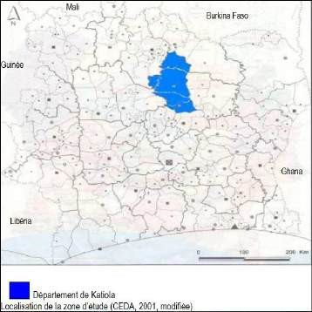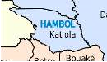

### Figure 1: Geographical location of the HAMBOL region (Kouakou & al., 2010)

Figures 2a, 2b, 2c and 2d show the stages from harvesting to storage of maize. Figure 2a shows a 10-hectare field of mixed maize. Figure 2b shows the Tagbanan people.

The Tagbanans store maize over a long period. Figure 2c shows maize cobs with their husks removed. Figure 2d shows poorly preserved maize in an advanced state of deterioration.

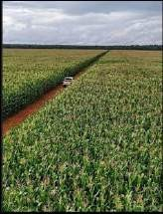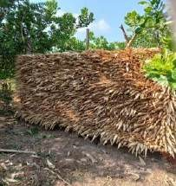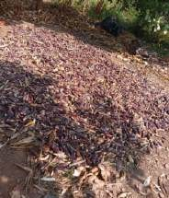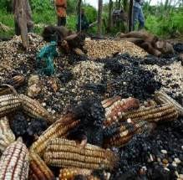

2a 2b 2c 2d

***Figure 2: Maize field 2a; Preserved maize 2b; Maize cobs 2c; Poorly preserved maize 2d.***

**2.2. Methods**

**2.2.1. Biomass Description**

The biomass used comes from the different types of maize found in the region considered in this study:

purple maize bran, yellow maize bran and maize cob.

- Maize bran

Figure 3 hows yellow and purple maize bran.

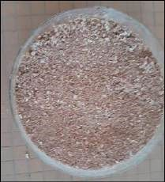

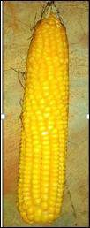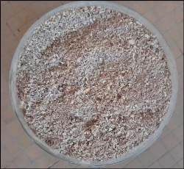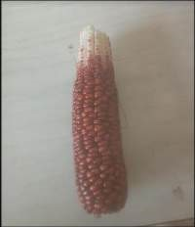

***3a 3b 3c 3d***

***Figure 3: yellow corn cob 3a; yellow corn bran3b; purple corn cob 3c; purple corn bran 3d***

Originally, the maize cobs are lightly dried in the sun, then the kernels are separated from the cob. This collection of kernels is washed and rinsed. At the mill, "bran" is obtained from the maize seeds and the crushed remains of the maize kernels are used to make maize flour (semolina). In other times, our mothers would mix the maize with fine, clean sand and a little water and then crush the mixture in a suitable mortar. Finally, the mixture is winnowed, and the maize bran is obtained by hand) - Maize cobs

Figure 4 shows the unground maize cobs and the purple maize cob powder.

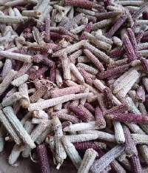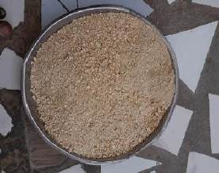

#### 4a 4b

#### Figure 4: corn roundup 4a ; ground maize cobs 4b

* The cob is the stalk that bears the maize kernels. It accounts for more than 50% of the mass of an ear of maize. It is white or purple in colour yellow and purple varieties of maize respectively.

* The maize infusion juice

**Figure 5** shows the maize infusion juice used to prepare the inoculum with cow dung.

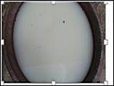

#### Figure 5: Maize infusion juice

The crushed maize obtained, washed, rinsed and placed in hot water at around 80°C. After three days, the maize infusion juice is obtained. In the old days, in FRONAN, this juice, with its smell of alcohol, was used as a thinner cow dung to paint the inside of round earthen huts.

**2.2.2. Processing of corn waste in Katiola**

* Harvesting and initial drying

The maize cobs are first dried in the sun. The seeds are then separated from the cob. If this stage is not carried out properly, the product can degrade and give off unpleasant odors.

* - Obtaining the bran and crushed seeds

At the mill, "bran" is obtained from the maize kernels. The maize kernels are also crushed.

* Preparing maize infusion juice

The crushed maize is washed, rinsed and placed in hot water at around 80°C. After three days, the maize infusion juice is obtained. In the past, in FRONAN, this juice, with its smell of alcohol, was used as a thinner to paint the inside of the round earthen huts.

* Sampling maize waste

Samples of maize bran were freshly taken from maize varieties at a number of mills before being deposited in village rubbish tips. After collection by variety, they were packed in plastic containers.

**2.2.3. Conventional combination of mass fractions of maize waste**

The classic formulation of waste mass fractions is shown in Table 1 (Hanna et al., 2009). Conventional experimental methodology involves varying the mass fraction of one factor Xi while holding the mass fractions of the other factors Xj and Xj' at zero. Then two factors Xi and Xi' are varied while keeping the mass fraction of the third factor Xj fixed. This will generate an unlimited number of trials. Here we are limited to 13 trials. These 13 trials will be the subject of experimental points to be carried out.

#### Table 1: Biodigester load combination according to the classic HENRY Cheffer matrix (Hanna et al., 2009)

#### 

|  |  |  |  |  |  |
| --- | --- | --- | --- | --- | --- |
| **N° Experience** | **Sample** | **Symbol** | **%**  **Purple maize bran** | **%**  **Yellow maize bran** | **%**  **Maize**  **Bran**  **Powder** |
| **1** | Purple maize bran | **Xv** | 100 | 0 | 0 |
| **2** | Yellow maize bran | **Xj** | 0 | 100 | 0 |
| **3** | Maize Bran Powder | **Xr** | 0 | 0 | 100 |
| **4** | Purple and yellow bran | **Xvj(1/2)** | 50 | 50 | 0 |
| **5** | Purple and yellow bran | **Xvj(3/4)** | 75 | 25 | 0 |
| **6** | Purple and yellow bran | **Xvj(1/4)** | 25 | 75 | 0 |
| **7** | Yellow bran and cob powder | **Xjr(1/2)** | 0 | 50 | 50 |
| **8** | Purple bran and cob powder | **Xvr(1/2)** | 50 | 0 | 50 |
| **9** | Blend purple bran and cob powder | **Xvr(3/4)** | 75 | 0 | 25 |
| **10** | Blend purple bran and cob powder | **Xvr(1/4)** | 25 | 0 | 75 |
| **11** | Yellow bran and cob powder | **Xjr(3/4)** | 0 | 75 | 25 |
| **12** | Yellow bran and cob powder | **Xjr(1/4)** | 0 | 25 | 75 |
| **13** | Violet and yellow bran and cob powder | **Xvjr(1/3)** | 33 | 33 | 33 |

d) Constraints generated by the Combination of mass fractions for optimisation -- Setting constraints

Table 2 shows the low and high limits for mass fractions.

#### Table 2: Presentation of constraints confirmed by Design expert 13 software

|  |  |  |
| --- | --- | --- |
| Low level | Organic matter | High level |
| 0,25 | Xv | 0,625 |
| 0,25 | Xj | 0,625 |
| 0,125 | Xr | 0,5 |

To set up a mixing plan, constraints (mass fraction ranges) had to be defined for each of the three constituents: purple bran, yellow bran and maize cobs. The proposed constraints were validated by the software. As a result, a matrix of residues or experimental points will be established.

- Formulation of the Combination of mass fractions for optimization

Once the constraints have been validated, the proportions of the components for the formulation of the various experimental points are established, again using the software. Table 3 shows the new mass fraction formulation. The research methodology using mixing design considers the study of interactions between the three factors. However, this method generates a limited number of trials. The experimental research methodology described above saves time by proposing a minimum and limited number of trials. This practice provides the maximum amount of information, i.e. a global view of the field of study. We interrogated the **Design Expert 13** software to obtain exactly the selective formulations. As each factor only takes two levels called constraints, the number of trials is easy to control and is close to the formulation that will produce the optimum result. In this case, the risk of error is minimized. We need to carry out 11 experiments, including one repeat (Table 3). We will experimentally obtain the responses in m³/t of organic matter (OM) for the digestion of the 11 mixtures, including one repeat, which we will record in the results and discussion section.

#### Table 3: New formulation of mass fractions

|  |  |  |  |  |
| --- | --- | --- | --- | --- |
| **Std** | **Run** | **Component 1**  **(Xr)** | **Component 2 (Xv)** | **Component 3**  **(Xj)** |
| **8** | 1 | 0,1875 | 0,5 | 0,3125 |
| **10** | 2 | 0,25 | 0,375 | 0,375 |
| **4** | 3 | 0,3125 | 0,4375 | 0,25 |
| **3** | 4 | 0,125 | 0,25 | 0,625 |
| **2** | 5 | 0,125 | 0,625 | 0,25 |
| **11** | 6 | 0,5 | 0,25 | 0,25 |
| **1** | 7 | 0,5 | 0,25 | 0,25 |
| **9** | 8 | 0,1875 | 0,3125 | 0,5 |
| **5** | 9 | 0,3125 | 0,25 | 0,4375 |
| **6** | 10 | 0,125 | 0,4375 | 0,4375 |
| **7** | 11 | 0,375 | 0,3125 | 0,3125 |

- Loading and installation of biodigesters

A biodigester equipped with its accessories was used to produce and compare the biogas production potential obtained by anaerobic co-digestion of each type of waste (bran, maize cobs) as well as the mixture of these wastes.

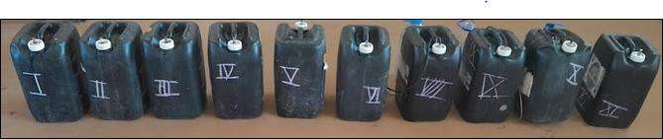

##### Figure 6: 20 L batch biodigesters

The various digesters were charged in accordance with the table in the new formulation. Five days after loading, they were found to be swollen. Biogas has therefore formed inside them.

**2.2.4. Installation of gasometers on bioreactors**

**Figure 7** shows the complete biogas production and extraction systems. Biogas volumes are measured by liquid displacement.

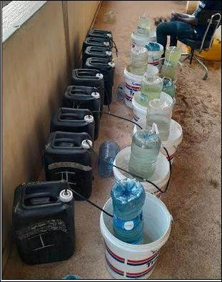

***Figure 7: Installation of gasometers on biodigesters***

The digestion of 11 mixtures was repeated, including one repetition (see **Table 9**), and the responses concerning biogas production in m³/t of organic matter were recorded. These 11 points of experiment were proposed to us by the **Design-Expert 13** software. They were run for 20 consecutive days after a 5-day conditioning period.

3. results and discussion

**3.1. Results of the conventional formulation**

The results for biogas productivity (in m3/t OM) are shown in the histogram in Figure 8. Figure 8 gives an overall view of the results of the conventional experimental method.

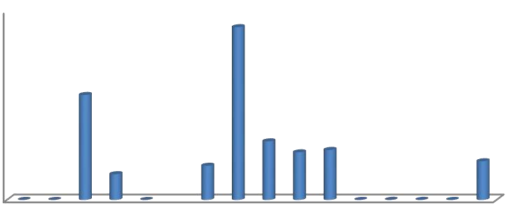

0

50

100

150

200

250

300

**Productivity m**

**3**

**/t**

**Conventional formulation**

***Figure 8: result of biogas production from the conventional formulation.***

For the other mixtures (Xvj(1/2) < Xvjr(1/3) < XXjr(1/2) < Xvj(1/4) < Xvj(3/4)), we observed an improvement in biogas production, without however reaching the minimum objective of 400 m3/t. The result for mixture 5 is close to that of the authors R. Salmi & al, (2023). In general, there does not appear to be any logic to explain the interactions between the various components of the mixtures used. And yet the optimization of biogas production could lie in the nature of the proportions of the waste mixtures available. However, it would be interesting to conduct further research using an experimental matrix. This matrix will be identified with the help of Design expert 13 software specializing in mixing plans.

**3.2. Biogas production results from experimental points**

The biogas productivity results are shown in **Table 5**. Points 5, 8, 9 and 11 show the highest productivity. In particular, the Run 9 formulation produced more than **2990 m³/t** of organic matter (OM), followed by Run 8, which generated **2015 m³/t**. These results show an improvement in productivity in the presence of favourable temperatures.

#### Table 5: Presentation of responses from experimental points

|  |  |  |  |  |  |
| --- | --- | --- | --- | --- | --- |
| **Standard** | **Run** | **Component 1 Xr** | **Component 2 Xv** | **Component 3 Xj** | **Réponse R1 Y(m3/t MO ) mesuré** |
| **8** | 1 | 0,1875 | 0,5 | 0,3125 | 70 |
| **10** | 2 | 0,25 | 0,375 | 0,375 | 40 |
| **4** | 3 | 0,3125 | 0,4375 | 0,25 | 120 |
| **3** | 4 | 0,125 | 0,25 | 0,625 | 10 |
| 2 | **5** | **0,125** | **0,625** | **0,25** | **1505** |
| **11** | 6 | 0,5 | 0,25 | 0,25 | 15 |
| **1** | 7 | 0,5 | 0,25 | 0,25 | 15 |
| 9 | **8** | **0,1875** | **0,3125** | **0,5** | **2015** |
| 5 | **9** | **0,3125** | **0,25** | **0,4375** | **2990** |
| **6** | 10 | 0,125 | 0,4375 | 0,4375 | 15 |
| 7 | **11** | **0,375** | **0,3125** | **0,3125** | **1270** |

All the results were achieved within the temperature ranges shown in Figure 9.

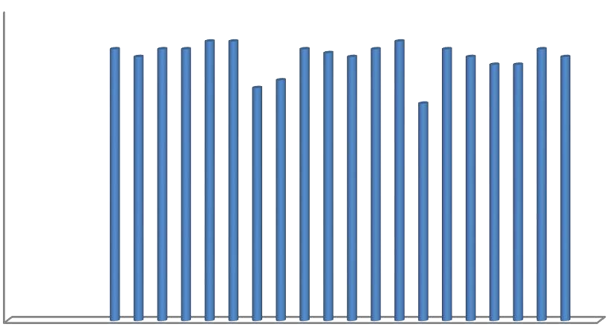

0

5

10

15

20

25

30

35

40

1

2

3

4

5

6

7

8

9

10

11

12

13

14

15

16

17

18

19

20

21

22

23

24

25

**Température in**

**°**

**C**

**Day**

##### Figure 9: Temperature variations over the 15-day experiment (SODEXAM)

According to the work of [14], temperature plays an essential role in anaerobic co-digestion. During the biogas production process, a temperature of between 30 and 36°C was observed, which corresponds to a warm period. These thermal conditions are favourable for methanisation.

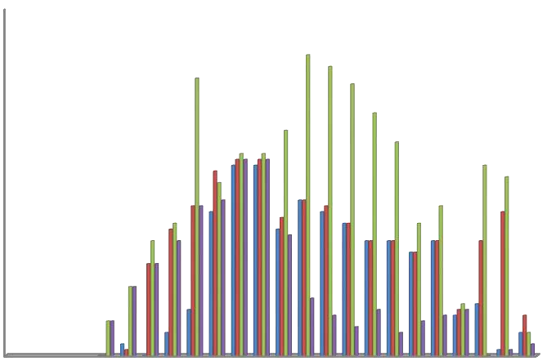

0

50000

100000

150000

200000

250000

300000

1

3

5

7

9

11

13

15

17

19

21

23

**Volume mL**

**Day**

R 5

R8

R9

R11

##### Figure 10: Histogram of daily biogas production at the 4 most significant experimental points

Considering the hot period of the process, the daily productions of the most biogas-productive mass fraction formulations are shown in the figure. Run or series 9 reaches its maximum productions at 9ᵉ, 15ᵉ, 16ᵉ, 17ᵉ and 19ᵉ days. Runs 5, 8 and 11 have biogas productions coinciding at 10ᵉ, 11ᵉ, 12ᵉ, 14ᵉ and 15ᵉ days. All these periods of high production occurred when the temperature was around 35°C. The highest temperatures for each day were recorded and presented in Figure 11.

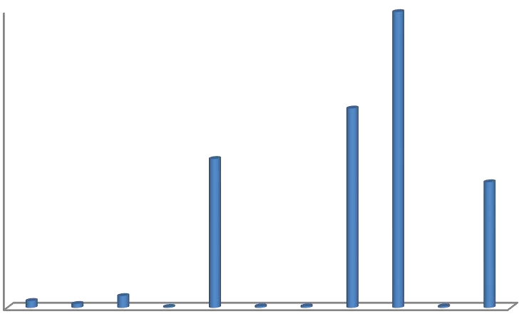

0

500

1000

1500

2000

2500

3000

1

2

3

4

5

6

7

8

9

10

11

**Productivity m**

**3**

**/t**

**Formulation**

##### Figure 11: Histogram of the productivity of the 4 most significant experimental points

Points 9, 8, 5 and 11, respectively in ascending order of response in m³/t of OM, are of particular interest (see Table 5). We have also plotted daily production in Figure 11, and it is clear that formulation 9 outperforms the other 3 residues at all times. The highest productions occurred between 15th and 19th day of biogas production (see Figure 11). Now, let us interrogate the same software to check whether our experimental results are consistent with the predictions of the chosen model.

**3.3. Results of statistical analysis of model coefficients and residuals**

* + 1. **Coding of mixture components**

Table 6 presents the results of the calculation of the linear regression coefficients which allow the quality of the model to be assessed (Gbangbo et al., 2023).

**Table 6. Coefficient for the model quality appreciation**

|  |  |  |
| --- | --- | --- |
| **Coefficients** | **Value** |  |
| Std. Dev. | 523,61 |  |
| Mean | 692,86 |  |
| C.V. % | 75,57 |  |
| R² | 0,8240 |  |
| Adjusted R² | 0,7139 |  |
| Predicted R² | 0,6543 |  |

Indeed, the predicted coefficient of determination (R²) of 0.6543 is in reasonable agreement with the adjusted R² of 0.7139, meaning that the difference between the two is less than 0.2. In addition, accuracy adequacy measures the signal-to-noise ratio, and a ratio greater than 4 is desirable. The ratio of 9.267 indicates an adequate signal. Consequently, this model can be used to navigate the design space.

* + 1. **Sum of squares of the sequential model**

Table 7 has allowed us to select the highest order polynomial for which the additional terms are significant, and the model is not alienated. This polynomial model of degree 2 (quadratic) leads us to the analysis of variance of the single response R1 (Hanna et al., 2009).

#### Table 7: Sum of squares suggested by the model

|  |  |  |  |  |  |
| --- | --- | --- | --- | --- | --- |
| Source | Sum of Squares | df | Mean Square | F-value | p-value |
| Mean vs Total | 6,721E+06 | 1 | 6,721E+06 |  |  |

Linear vs Mean 1,650E+05 2 82487,47

0,0738

0,9293

12

28

,

0,0023

|  |  |  |  |  |  |  |
| --- | --- | --- | --- | --- | --- | --- |
| Quadratic vs Linear | 1,010E+07 | 3 | 3,367E+06 |  |  | Suggested |
| Sp Cubic vs Quadratic | 5,304E+05 | 1 | 5,304E+05 | 2,23 | 0,1788 |  |
| Cubic vs Sp Cubic | 9,459E+05 | 2 | 4,730E+05 | 3,30 | 0,1221 | Aliased |
| Quartic vs Cubic | 7,170E+05 | 1 | 7,170E+05 |  |  | Aliased |
| Residual | 0,0000 |  | 0,0000 |  |  |  |
| Sp Quartic vs Quadratic | 1,476E+06 |  | 4,921E+05 | 3,43 | 0,1089 |  |
| Quartic vs Sp Quartic | 7,170E+05 | 1 | 7,170E+05 |  |  | Aliased |
| Residual | 0,0000 | 4 | 0,0000 |  |  |  |
| **Total** | **1,918E+07** | **14** | **1,370E+06** |  |  |  |

The model's F-value of 7.49 implies that the model is significant. In other words, there is only a 0.69% chance that such a high F-value is due to noise. P-values below 0.0500 indicate that the model terms are significant, while P-values above 0.1000 indicate that the model terms are not significant. If many terms in the model are not significant (excluding those needed to support the hierarchy), reducing the model could improve its performance (Table 8).

#### Table 8: ANOVA for the R1 response of the quadratic model

Source Sum of Squares df Mean Square F-value p-value

Model 1,027E+07 5 2,053E+06 significant

7

49

,

0,0069

0,3009

0,7482

⁽¹⁾Linear Mixture 1,650E+05 2 82487,47

|  |  |  |  |  |  |
| --- | --- | --- | --- | --- | --- |
| AB  AC  BC  Residual  Lack of Fit  Pure Error  Cor Total | 1,095E+06  8,510E+06  1,035E+06  2,193E+06  2,193E+06  0,0000  1,246E+07 | 1  1  1  8  4  4  13 | 1,095E+06  8,510E+06  1,035E+06  2,742E+05  5,483E+05  0,0000 | 3,99 | 0,0807 |
| 31,04 | 0,0005 |
| 3,77 | 0,0880 |
|  |  |
|  |  |
|  |  |
|  |  |

* + 1. **Coefficients in terms of coded factors**

The estimated coefficients represent the expected variation in response per unit variation in the value of the factor, when all other factors are held constant. The intercept in an orthogonal plane is the overall mean response of all the series. The coefficients are fits around this mean as a function of the factor parameters.

When the factors are orthogonal, the VIFs (variance inflation factors) are equal to 1. VIFs greater than 1 indicate multi-collinearity. The higher the VIF, the greater the correlation between the factors. As a general rule, VIFs below 10 are tolerable. The coefficients estimated using the VIF greater than 1 are used to generate a final equation using the factors coded A, B, C, AB and BC (Table 9).

#### Table 9: estimated coefficients

**Component Coefficient Estimate df Standard Error 95% CI Low 95% CI High VIF**

|  |  |  |  |  |  |  |
| --- | --- | --- | --- | --- | --- | --- |
| A-rafle  B-violet  C-jaune  AB  AC | 61,88  1451,16  179,14  -3436,44  11481,09 | 1  1  1  1  1 | 363,43  363,43  363,07  1719,33  2060,81 | -776,20 | 899,95 | 1,62 |
| 613,09 | 2289,24 | 1,62 |
| -658,10 | 1016,39 | 1,50 |
| -7401,21 | 528,34 | 1,76 |
| 6728,85 | 16233,33 | 1,55 |

BC -4003,19 1 2060,81 -8755,43 749,05 1,55

* + 1. **Final equation using coded factors**

The results of the experiments (Table 10) and the coefficients calculated from the different degrees of combination made it possible to establish the equation of the model.

#### Table 10: Final equation with coded factors

|  |  |
| --- | --- |
| **Response R1** | **Coded factors** |
| +61,88 | A |
| **+1451,16** | **B** |
| +179,14 | C |
| -3436,44 | AB |
| **+11481,09** | **AC** |
| -4003,19 | BC |

R1 = +61,88A+**1451,16B** +179,14C – 3436,44AB +**11481,09AC** – 4003,19BC

Indeed, the equation in terms of coded factors can be used to make predictions about the response for given levels of each factor. This coded equation is useful for identifying the relative impact of factors by comparing factor coefficients. According to the equation, the factors of B and AC are significant. We can also estimate the final equation from the actual factors such as Xr, Xv, Xj, Xrv, Xrj and Xvj. (Gbangbo et al., 2023)

* + 1. **Final equation in terms of real components**

The coded factors are replaced by real factors (Table 11) :

* The equation in terms of real factors is used to make predictions about the response (in this study case, biogas production) as a function of the specific levels of each factor. We can interpret the different parts of this equation as:
* The Real Factors, which are the independent variables (e.g. temperature, mass fraction, etc.). These factors influence the response (biogas production). The levels of these factors must be specified in their original units.
* The scaled coefficients in the equation are adjusted to take account of the units of each factor. This means that if the unit of a factor is changed, the corresponding coefficient will also be changed to maintain consistency.
* The y-intercept (or constant) is not necessarily at the centre of the design space. It represents the value of the response when all factors are at their reference level (for example, ambient temperature, standard mass fraction, etc.).

#### Table 11: Final equation with real factors

|  |  |
| --- | --- |
| R1 | Real Factors |
| -15235,59781 | Xr |
| **+12942,17329** | **Xv** |
| -3709,90512 | Xj |
| -24436,87882 | Xr * Xv |
| **+81643,33013** | **Xr* Xj** |
| -28467,14606 | Xv * Xj |

R1 = -15235,59781Xr + **12942,17329Xv** – 3709,90512Xj - 24436,87882XrXv + **81643,33013XrXj** 28467,14606XvXj

In summary, this equation allows you to predict biogas production based on the specific levels of each factor, taking into account the units and coefficients. However, it does not allow you to determine the relative impact of each factor, as this would require further analysis. In this case, according to the equation, the coefficients of the real factors Xv , Xr and Xj are significant (Gbangbo et al., 2023,Hanna et al., 2009)

* + 1. **Diagnosis of model suitability**

The degree of significance of the model and the distribution of the residuals presented are shown in Figures 12A and 12B respectively. The goodness-of-fit plot and the scatter plot represent the values of a Y response for each line of the experimental design.

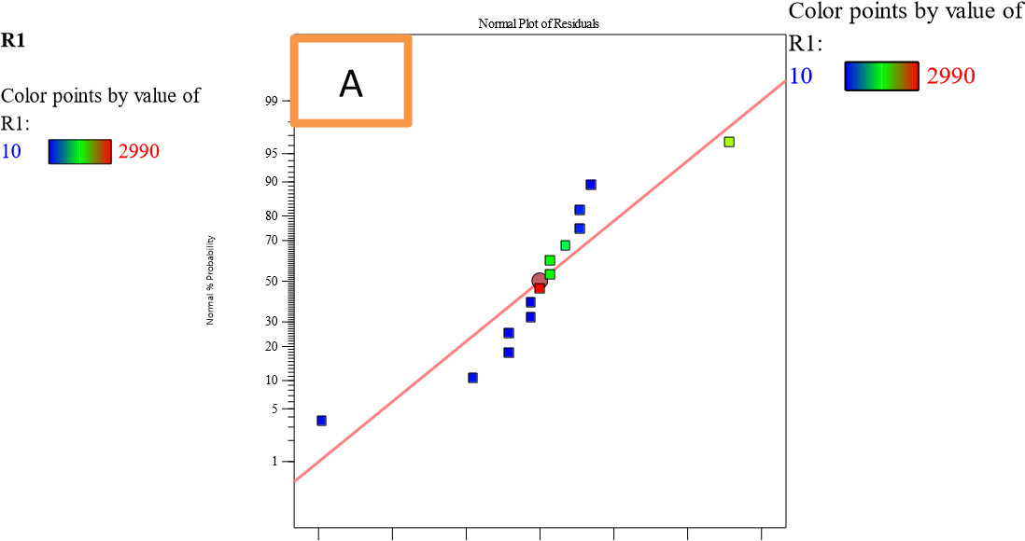

***Figure 12: Degree of significance observed and predicted by the model and residuals as a function of the predicted response***

On the one hand, the points are clustered around the regression line (see **Figure 12A**) and, on the other hand, **Figure 12B** shows a random distribution of the model residuals, with no trend. All this is corroborated by **the coefficient of determination** (R2 = 0.8240) which indicates that the data predicted by the model are close to those obtained experimentally. In fact, this coefficient evaluates the adequacy of the experiments acquired and their fit to the model, providing a good estimate of the response variable throughout the process. This indicates a good prediction of the maximum response and confirms that the model is well fitted (Hanna et al., 2009)

.

* + 1. **Iso-response curves**

We need to look at the response surfaces in Figure 13, which are presented in 2D and 3D.

Component Coding: Actual

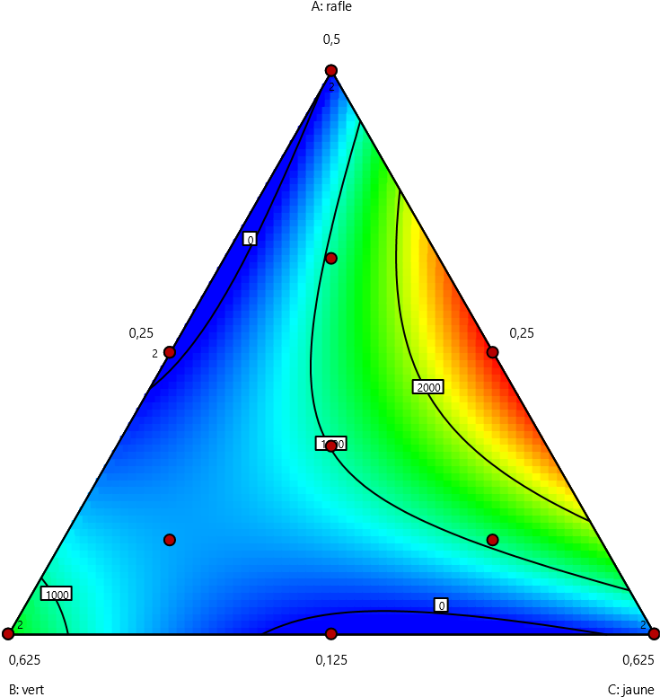**R1 (t/m3)**

Design Points

|  |  |
| --- | --- |
|  |  |

102990

X1 = A

X2 = B

X3 = C

R1 (t/m3)

|  |  |
| --- | --- |
| Component Coding: Actual  **R1 (t/m3)**  Design Points: | 3D Surface |

Above Surface

Below Surface

|  |  |
| --- | --- |
|  |  |

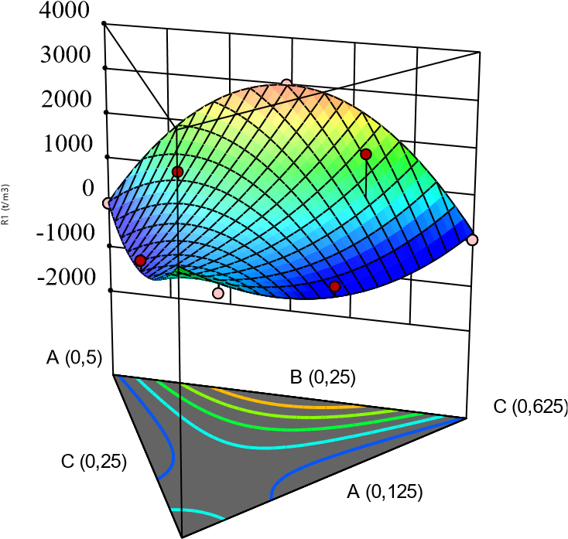102990

X1 = A

X2 = B

X3 = C

B (0,625)

##### Figure 13: 2D and 3D surface plot showing the effect of mass fractions on response

The **response surface** represents the regression surface from a graph in a three-dimensional or twodimensional space. In our case, **Figure 13** represents the response surface **R1** as a function of three variables: **Xr, Xv** and **Xj**. The important points to note are

Plotting the model equation allows you to see how the response (biogas production, in your context) varies as a function of the different combinations of factors (Xr, Xv and Xj). This helps you to visualize the effects of the independent variables on the response (Gbangbo et al., 2023).

By examining the response surface, we can identify an area of the experimental domain where the response is optimal. In our case, we refer to a **red zone** where **R1** is greater than or equal to **2990.784 m3/t OM**. This means that this range of values for the variables Xr, Xv and Xj leads to satisfactory biogas production. The generalization of this production model will contribute to meeting the challenge of sustainable development (Gbangbo et al., 2023).

We also referred to **the formulation of the mass fractions of the feedstock constituents**, which is confirmed by results.

In short, the response surface is a powerful visual tool for understanding the interactions between factors and optimizing the response in your biogas production process.

The mass fractions identified for optimum response are shown in Table 12.

#### Table 12: Selecting the mix that produces the maximum response

|  |  |  |  |  |  |
| --- | --- | --- | --- | --- | --- |
| A roundup | B purple | C yellow | R1 (m3/t) | P- value | R2 |
| **0,313** | **0,250** | **0,438** | 2990,784 | 0,0069 | 0,8240 |

The Design Constraints and the estimation of the regression analysis that allowed us to achieve this optimal result are shown in Table 13.

#### Table 13: Mixture Coding: Actual

|  |  |  |  |  |
| --- | --- | --- | --- | --- |
| **Low Limit** |  | **Constraint** |  | **High Limit** |
| **0,125** | ≤ | A : roundup | ≤ | 0,500 |
| **0,250** | ≤ | B : purple | ≤ | 0,625 |
| **0,250** | ≤ | C : yellow | ≤ | 0,625 |
|  |  | **A+B+C** | **=** | **1,000** |

## **Conclusion**

At the end of this research, it should be noted that maize waste is biodegradable. Considered individually, purple maize bran is kinetically biodegradable within the first few days of conditioning (167.2 m3/t OM). Then, when the classical formulation of mass fractions is carried out, the highest biogas production is 274.6 m3/t OM (Xvj (3/4)). This production is still low compared to our minimum target of 400 m3/t OM. Contrary to the classical experimental methodology, which consists of varying the mass fraction by one factor while keeping the others fixed, which does not consider the study of interactions and which requires many trials, the mixed design methodology was considered. This considers the study of interactions and generates a limited number of trials. Using this experimental method, we identified the results of four trials, each with a biogas production of up to 2990 m3/t OM. The formulation of the mass fractions in question, the source of such optimal biogas production, is 0.313 stover, 0.250 purple bran and 0.438 yellow bran.

# References

[1] Y.M. Baldé, 2022. Modeling and Estimation of Anaerobic Digesters for Waste Remediation and Energy Production.

[2] ZINLA Bi, 2022. Study of Electricity Production from a 5 MW Thermal Power Plant Using Biomass: The Case of Rice, Coffee, and Cocoa Crop Residues from Kodaya. Institut Polytechnique Félix HB Côte d’Ivoire (INPHB)

[3] A. Boutoute, 2022. Modeling of a Dry Methanization Reactor and Study of In-Situ Ammonia Treatment.

[4] C.I. Oumar, 2023. Modeling, Optimization, and Energy Management of a Hybrid Renewable Energy Power Plant. Hal science theses

[5] González, R., Peña, D.C., Gómez, X., (2022). Anaerobic Co-Digestion of Wastes: Reviewing

Current Status and Approaches for Enhancing Biogas Production. Appl. Sci. 12, 8884.

https://doi.org/10.3390/app12178884

[6] Azevedo, A., Lapa, N., Moldão, M., Duarte, E., (2023). Opportunities and challenges in the anaerobic codigestion of municipal sewage sludge and fruit and vegetable wastes: A review. Energy Nexus 10, 100202.

https://doi.org/10.1016/j.nexus.2023.100202

[7] Kambalé H. 2023. Incidence of the armyworm (Spooppera frugiperda) and agronomic performance of six maize varieties grown in Butembo, North Kivu, Journal of Applied Biosciences 184:19245-19258 ISSN 1997-5902

[8] H.A.N’da, L. Akanvou, C.K. Kouakou - International Journal of Biological and, 2013 - ajol.info.

Local Management of Purple Maize (Zea mays L.) Varietal Diversity by the Tagouana in North-Central Côte d'Ivoire

[9] CK Kouakou, L. Akanvou, YA Konan. J.App.biosci, 2010. Farmer Strategies for Maintaining and Managing Maize Biodiversity.

[10] Mrosso, R., Kiplagat, J., Mecha, A.C., (2023). Anaerobic Codigestion of Tuber Waste and Fruit Waste: Synergy and Enhanced Biogas Production. Int.J. Chem. Eng. 2023, 1–10. https://doi.org/10.1155/2023/6637249

[11] M.S.E. GUEDOU, M.F. HOUNDONOUGBO, C.A.A.M. CHRYSTOME, and G.A. MENSAH. 2015. Grain Maize and Its By-Products in Poultry Feed in Benin: Bibliographic Summary. Annals of Agricultural Sciences, Special Volume: 149-164, ISSN 1659-3009.

[12] Saïdur, EA Abdelaziz, A Demibas, Monowar S Hossain, SAAD Mekhilef, 2011. Study on Biomass as a Fuel for Boilers. Journal of Renewable and Sustainable Energy, 15(5), 22622289.

[13] KOUMAYO HIE, KRA Essi Kouadio Francis, GBANGBO Rémis; 2023. Characterization of agricultural waste for anaerobic codigestion: the case of Katiola yellow and purple bran – CI

[14] Gbangbo K. R., Kouakou A. R., Ehouman A. D., Yao B., Adouby K., Goli Lou G. V. E., Gnaboa Z. , 2023, Study of Adsorption of Hydrogen Sulfide in Biogas with Musa Paradisicaca Activated Carbon using Full Factorial Design, J. Mater. Environ. Sci., 14(4), 491-510.

[15] Hanna Hanen, Walter Tinsson. Experimental Designs for Mixing Mixtures. 41st Statistical Conference, SFdS, Bordeaux, 2009, Bordeaux, France. 2009. <inria-00386588>

[16] Jonathan Hess, 2007, Modeling the Quality of Biogas Produced by a Methanogenic Fermenter and a Control Strategy for Its Recovery. Automation/Robotics. University of Nice Sophia Antipolis. French. ffNNT: ff. fftel-00257347f