INFLUENCE OF VEGETAL ROOFS ON THERMAL COMFORT IN HOUSING IN SAHEL REGION

ABSTRACT
The concern for improving comfort in housing has led man to focus on the temperature that mainly influences thermal comfort inside the building. In a building, all the walls are likely to receive and transfer heat, but the roof contributes significantly to heat exchange more than the other walls. The simulation results with the COMSOL software for the three types of roofs show that inside the habitat with a green roof, the average temperature is around 27°C compared to 36°C inside the flat roof building and 40°C inside the metal roof building. In this study, we have defined two objectives. The first objective was to compare the interior temperature of a habitat with a green roof to that of a habitat with a metal or slab roof. The second objective was to study the effect of the green roof on thermal comfort in the habitat in the Sahelian zone. The simulation results obtained show that the temperature inside the green roof is lower compared to other types of roofs. The green roof better ensures good thermal comfort for the occupant.
Keywords : green roofs, thermal comfort, biodiversity, evapotranspiration.

INTRODUCTION
In Burkina Faso, solar radiation is very significant; "the solar energy potential per km² is estimated at 1500 GWh/year based on the assumption of a production of around 4 to 6 kWh/m²/day" ⦋1⦌. This solar radiation affects a large part of the country with high temperatures. It also impacts the roofs of buildings, which absorb more than 40% of energy consumption [3i] and influences thermal comfort inside the building. The recommended thermal comfort for a person inside the building is generally an air temperature between 17°C and 22°C and humidity between 40% and 60%, with a difference between the average temperature of the surfaces of the walls, floor, and ceiling (mean radiant temperature) and the air temperature [1i]. For the human body, the ideal temperature for a normal person is between 36.5°C and 37.5°C [2i]. In hot and dry countries like Burkina Faso, the comfort zone is defined within a temperature range of 20 to 27°C Yezouma COULBALY [2]. For human health, it is noted that the body cannot withstand intense heat. It quickly becomes dehydrated due to a lack of water for its proper functioning, leading to fatalities. According to the Mali Actu newspaper dated April 30, 2019, "more than 550 people have died due to the heat" ⦋3⦌. Mechanisms must be sought to protect it. How can we mitigate the effects of heat on habitats and on people ? According to the results from some authors, green roofs help ensure thermal insulation, reduce heat buildup, and decrease air conditioning needs [4]. Greening roofs reduces the air temperature inside the building by 7°C for a substrate of 70cm thickness. The green roof helps to decrease thermal flux inside the room and improves its sound performance by 15 to 20 dB depending on whether the substrate of the green roof is dry or saturated with water. Subsequently, we will conduct a temperature modeling study inside the different types of roofs (green, metal, slab). This will allow us to assess which type of roof meets the thermal comfort needs for humans in our habitats.

- Physical model of green roofs and flat roofs with bare surfaces
The objective of this article is to compare the thermal comfort provided by green roofs to that of flat or metal roofs. Figure 1 shows the effect of reduced heat entering the building provided by a green flat roof (GFR) compared to a bare flat roof (BFR).
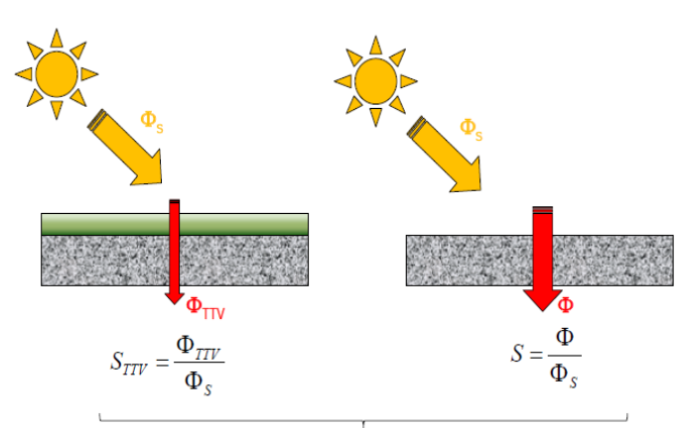
Figure1 : Reduced building penetration due to green roof terrace
  - Modeling of the system
The diagram of the prototype of a habitable cell with a green roof is shown in Figure 2. Figure 3 explains the different thermal exchange phenomena produced between the green roof and the atmosphere.
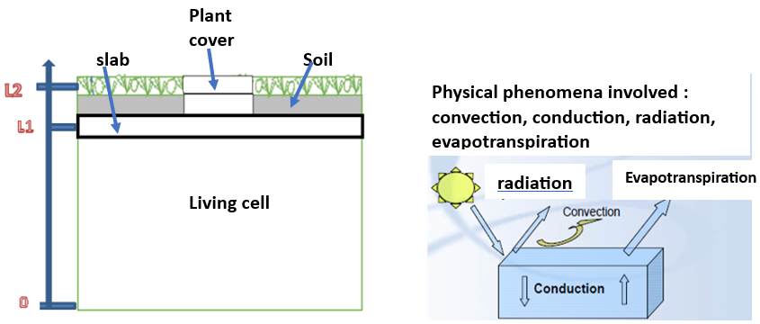
Figure 2 : Diagram of the living cell prototype with green roof
Figure 3 : heat transfer phenomena of green roofs

  - Boundary conditions
The boundary conditions are defined as follows:
z=0 ; $ϕ_{0}(t)=alfa.Pw(t)+h\left(T(t)-{T(t)}_{sheet}\right)-{\dot{m}}_{e}.Lv$
z=L1 : T2(L1,t)=T3(L1,t)
z=L2 ; T3(L2,t)=T4(L2,t)
These equations are introduced into a calculation program using the finite element method of Comsol software.
  - Modeling Hypothesis
We assumed that the different types of heat transfers considered occur as follows:- Conduction takes place between the roof, the ground, and the slab;- Convection occurs from the inside of the room to the outside (roof);- Radiation is manifested inside the rooms through the absorption of materials;- Evapotranspiration proceeds through a gain of energy to release the amount of water stored in the roofs.
2- Heat transfer equations
2.1- At the level of the vegetation cover and the soil
Here we use the assumption that transfers are predominant along the z-axis. The vegetation cover and the soil are modeled in a porous medium having an interface with the air. A phenomenon of evapotranspiration thus simplifies a convective exchange between the leaves and the atmosphere. The convective exchange is defined by equation (3).
$${\left(ρCp\right)}_{eff}\frac{∂T_{2}}{∂t}+ρCp.\vec{V}.\vec{∇T_{2}}-λΔT_{2}=alfa.Pw+h\left(T-Tfeuille\right)-{\dot{m}}_{e}.Lv (3)$$
$${avec : \left(ρCp\right)}_{eff}=θ_{p}ρ_{p}C_{p,p}+\left(1-θ\right).Cp$$
$$λ_{eff}=θ_{p}λ_{p}+\left(1-θ\right).λ$$
Pw= solar power received on the roof ;
alfa= solar fraction intercepted ;
${\dot{m}}_{e}$=0.2083[kg/h] mean evapotranspiration ;
$θ_{p}$=porosity ;
$C_{p,p}$=specific heat of water ;
Cp=specific heat of dry soil .
2.2- At the level of the concrete slab
The concrete slab is governed by the classic equation of heat transfer in a solid defined by equation (4).
${\left(ρCp\right)}_{concrete}\left( \frac{∂T_{3}}{∂t}+\vec{V}.\vec{∇T_{3}}\right)=+λ_{concrete}ΔT_{3}$ (4)
2.3- Regarding the air volume of the isolated habitable cell
Within the confines of the habitable cell, the movement of the air volume is characterized by a thermal exchange defined by equation (5).
${\left(ρCp\right)}_{air}\left( \frac{∂T_{4}}{∂t}+\vec{V}.\vec{∇T_{4}}\right)=+λ_{air}ΔT_{4 }$(5)
3-Results and Discussion
The objective of the simulation is to determine the variation of solar radiation from 7 AM to 5 PM over the course of the day on May 23, 2019. This variation in radiation allows us to determine the thermal flux inside the room. The greater the radiation, the larger the flux. For the case of our research, we will study the evolution of temperature for each type of roofing and within the room in relation to solar radiation. Figure 4 shows the variation of solar radiation for the day of May 23, 2019.
Radiation of a typical day on May 23, 2019
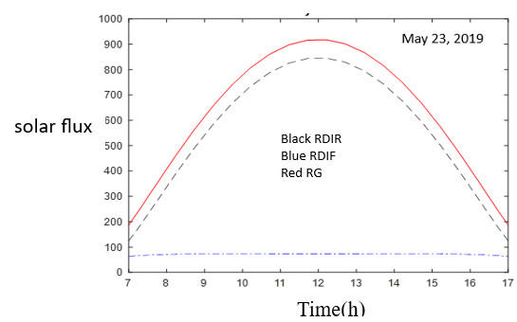
Figure 4 : Variation of solar radiation as a function of time on May 23, 2019.
The thermal conductivities of the materials of the three types of roofs
We considered three types of materials namely reinforced concrete, iron, plant fibers with respective thermal conductivity λ1=1.5 λ2=72 λ3= 0.05. When the thermal conductivity of a material is low, its thermal resistance (R/h = e/λ) is high and the heat flux through it is low. From these three types of materials, we remember that plant fiber has difficulty passing through the heat flow due to its low thermal conductivity compared to other types of materials.
3.2- Evolution of the temperature in the green roof and in the insulated room.
The simulation with the Comsol software allowed us to graphically represent the curves of temperature variations (figure 6); the red curve represents the evolution of the temperature of the slab, the blue curve shows the evolution of the ambient temperature, and the green curve indicates the evolution of the internal temperature of the room. Under the effect of solar radiation, the temperature of the slab reaches 31.5°C in 24 hours. The temperature in the room is 28°C and the ambient air temperature is 27.25°C compared to 28 to 30°C, which is the comfort temperature in the context of hot and dry countries, resulting in a gap of -2°C Madiana HAZOUME[9]. The presence of vegetation cover helps to reduce the temperature that reaches the surface of the slab. Consequently, the temperature inside the room and the ambient temperature have gradually decreased. Figure 5 shows a perspective of the green roof. Figure 6 shows the temperature evolution profile in the green roof and in the insulated room.
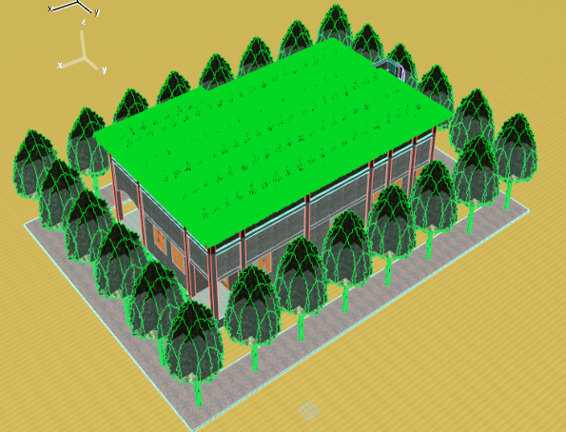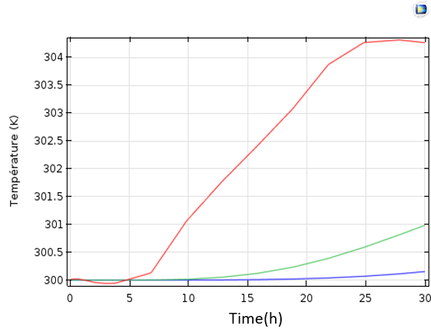
Figure 5: Perspective view of the green roof
Figure 6 : temperature profile in the green slab and in the insulated room

The evolution of the temperatures of the different environments (ambient temperature, room temperature, slab temperature, plant layer temperature) is represented in figure 7.
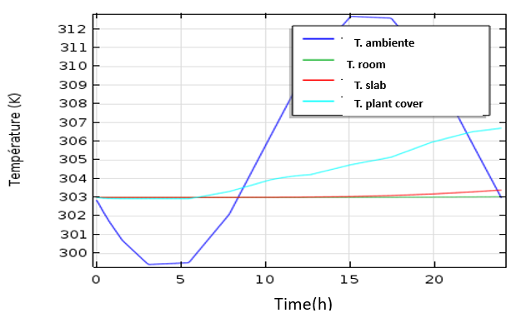
Figure7: Temperature point graph
3.3- Evolution of the temperature in the bare slab and in the room
In the case of the bare slab, its temperature rises to 52°C in 18 hours, compared to an ambient temperature of around 29.5°C. The temperature of the slab decreases to 49°C in 24 hours, while the ambient temperature rises to 34°C, compared to 28 to 30°C, which is the comfortable temperature in the context of hot and dry countries, leading to a gap of +7°C Madiana HAZOUME[9]. This temperature is significantly higher than that of the vegetated roof, which is 27.25°C. We can conclude that the bare slab allows for greater thermal flow compared to the vegetated terrace roof. It provides less thermal comfort for the occupant in the habitat compared to the vegetated roof. Figure 8 shows a perspective view of the bare slab roof. Figure 9 shows the temperature evolution profile in the bare slab roof and in the room.
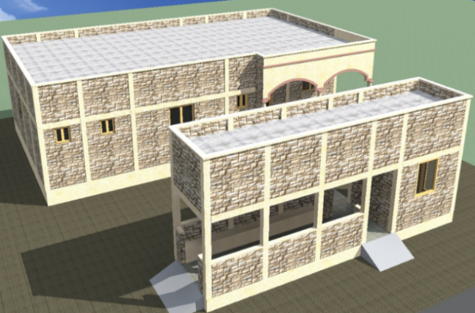
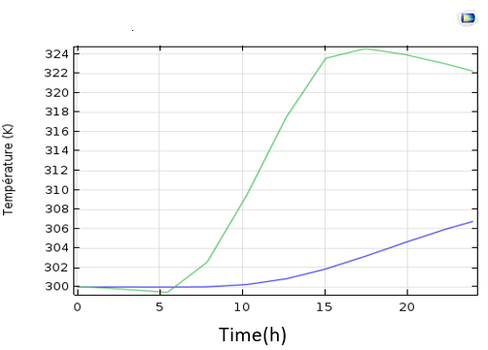
Figure 9: Temperature profile for the bare slab roof and the room
Figure 8: Perspective view of the bare slab roof

3.4- Evolution of the temperature in the plate and in the part
In the case of the sheet metal, its temperature rises to 56°C in 18 hours, against an ambient temperature of around 31°C. The temperature of the sheet metal decreases to 49°C in 24 hours, and the ambient temperature rises to 35°C compared to 28 to 30°C, which is the comfort temperature in the context of hot and dry countries, resulting in a +8°C difference, according to Madiana HAZOUME. This temperature is significantly higher than that of the bare slab roof, which is at 34°C. We can conclude that the sheet metal allows more thermal flow compared to the bare slab roof. The sheet metal roof does not guarantee thermal comfort for the occupant compared to the slab roof. Figure 10 shows the perspective of the sheet metal roof. Figure 11 shows the profile of the temperature evolution in the sheet metal and in the room.
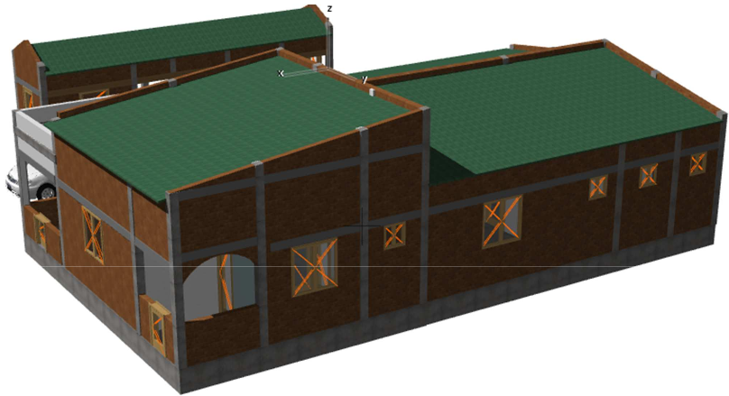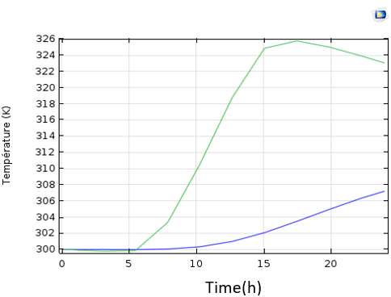
Figure 10: Perspective view of the sheet metal roof
Figure11: Temperature profile in the sheet and in the room

Referring to the principle of heat exchange, the higher the internal temperature of a room, the greater the thermal flow inside that room, and vice versa. The results of the modeling with the Comsol software allow us to conclude that among these three types of roofs, the green roof guarantees good thermal comfort compared to the other types of roofs (slab, metal). Therefore, the green roof improves the thermal comfort for the occupant in the habitat.
3.5- Advantages of green roofs on thermal comfort in the Sahelian zone.
It is a factor in the preservation of biodiversity, environmental recovery, and ecological continuity in the Sahelian zone. It meets the need for high-quality environment through thermal insulation of buildings, hygrometric comfort, acoustic comfort, and sanitary air quality due to their capacity for CO2 absorption and O2 contribution from the air by plants owing to the phenomenon of photosynthesis. The green roof covering an area of 1.5 m2 fulfills the oxygen needs of an adult man. Figure 12 shows the production and absorption of (CO2, O2) by humans and plants.
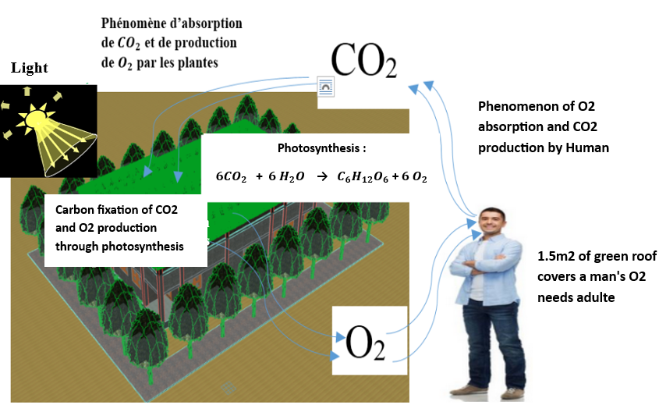
Factor in the formation and development of life on earth.
Figure 12: Production and absorption of (CO2, O2) by humans and plants

CONCLUSION
We note that green roofs ensure better thermal comfort in housing than other types of roofs. They help preserve biodiversity and ecological continuity. From a high environmental quality perspective, green roofs help maintain freshness in the building's environment and contribute to the phenomenon of photosynthesis through significant oxygen production for respiration. Not to mention that from an economic standpoint, green roofs reduce energy costs and maintenance expenses of waterproofing systems. They provide many benefits, and their maintenance can be a source of employment for young people. Hence the need to promote the construction of green roofs to support demographic balance in the Sahelian region.

REFERENCES
[1] Ministry of Energy of Burkina Faso, “Solar Electricity in Burkina Faso: What if the Sun Shined for All?”. Report on the Results of a Commissioned Study (2018);
[2] Yezouma COULBALY, “Energy Saving in Buildings and Industry” (F[3] Bamako Central PMI, “Investigation Results” of April 30, 2019;
2iE Foundation 2010);
[4] Yann DUSZA, “Green Roofs and Ecosystem Services,” Doctoral Thesis in Ecology (2017);
[5] Kokogiannakis et al., “Modeling Green Roofs in Beijing (China)” (2011);
[6] Dominique et al., “Sedum roof vegetation in Saint-Pierre (Reunion Island)” (2014);
[7] Fauconnier R., “The effect of air humidity on health in commercial buildings, article published in issue 10 (1992) of the journal Chauffage Ventilation Conditionnement”;
[8] ef. Y09 12 0000494, “Reconciling energy efficiency and acoustics in buildings; CSTB (Scientific and Technical Committee for Building)”.
[9] Madiana HAZOUME, “Thermal comfort in Nubian vault buildings” ICAM Nantes 2012-2013.
[1i] https://www.google.com/search?client=firefox-b-d&q=temp%C3%A9rature+de+confort+thermique+de+l%27homme+dans+l%27habitat
[2i] https://www.google.com/search?client=firefox-b-d&q=Pour+certains+auteurs+la+temp%C3%A9rature+id%C3%A9ale+pour+un+homme+est+comprise+entre+36%2C5%C2%B0C+et+37%2C5%C2%B0C
[3i] https://www.google.com/search?client=firefox-b-d&q=temp%C3%A9rature+ambiante+d%27un+homme+normal+dans+l%27habitat.
[4i] https://www.toit-vegetalise.fr/avantage-d-un-toit-vegetalise-confort-d-ete-re2020/

