AN ARTIFICIAL NEURAL NETWORK (ANN) MODEL TO FORECAST ONION SHELF LIFE

Abstract
Prediction of the shelf life of onions using artificial neural network was carried out to obtain high quality product that will last for a long time. Drying of food products is a significant process in food processing and agricultural industry and was dried at varying temperatures (40 – 80 °C). It is very vital as improper drying conditions can affect the composition of the dried onions and thereby increases the risk of it running into deterioration of the nutrient contents of the product and post-harvest loss. Onions were processed by washing and sorting into required weight. Samples obtained were dried in triplicate using a DHG-9109 oven at different temperatures of 40, 50, 60, 70 and 80ºC. A multilayer feed forward neural network was proposed to accurately predict the shelf life of onion. The proposed artificial neural network model was developed to predict the shelf life of onion when supplied temperature, drying time and moisture content as inputs. The oven drying of onions was carried out experimentally at five oven temperatures settings of 40, 50, 60, 70 and 80ºC. A number of network configurations consisting of different number of hidden neurons and transfer functions were investigated in this study. Judging from the results of the trained networks, the best performing network was composed of ten hidden neurons and used the tangent sigmond transfer function. The developed model predicted very accurately and the minimal error, with an overall correlation coefficient of 0.99462 and mean squared error (MSE) of 0.00089. The model also returned regression coefficient (R²) value of 0.9891 for the correlation between the predicted and experimental outputs. The result showed the good generalization of the developed model. These statistical values enhance the reliability of the model for predicting moisture content of onions in food product processing. This work provides a reliable model that can be applied to determine the shelf life of onions and hence calculate its moisture content. In the process of putting together this work, various challenges were encountered in the course of this study, for the aim of future improvements on the ANN for the prediction of shelf life of onion development.

Keywords: Onion, Drying time, Temperature, Moisture content,

INTRODUCTION
Onions rank among the most widely consumed vegetables globally. Typically utilized for enhancing the flavor of various food items, fresh onions are pivotal in culinary applications (Suleria et al., 2013). Onions (Allium cepa L.), also known as bulb onions or common onions, are the most extensively cultivated species within the Allium genus. The onion plant features hollow, bluish-green leaves arranged in a fan shape, with its bulb at the plant's base beginning to enlarge upon reaching a specific day-length. These bulbs consist of compressed, underground stems surrounded by fleshy modified scale leaves that encase a central bud at the stem's tip. In autumn (or spring for overwintering onions), the foliage withers, and the outer layers of the bulb dry out and become brittle. The crop is then harvested, dried, and ready for storage or use. Onions are vulnerable to various pests and diseases, including the onion fly, onion eelworm, and various fungi that can cause rotting (Taglienti et al., 2021).
Over the past decade, global onion production has seen a remarkable increase, exceeding 98 million tons, with 2021 production reaching 106.59 million tons, as reported by FAOSTAT (2021). Approximately 8% of this global onion production is traded internationally. The production and market value of this versatile vegetable (onions) are steadily increasing. Onions are renowned for their ability to enhance the flavor of various dishes while remaining low in calories (50 kcal/100 g). Beyond culinary uses, onions are valued for their nutritional benefits and medicinal properties. They contain moderate amounts of protein, fat, and fiber, along with significant quantities of calcium, phosphorus, potassium, vitamin C, and B6. Even the onion stalk is edible, rich in carotene and iron. Onions contain both glucose (reducing sugar) and sucrose (non-reducing sugar), and their pungent taste is attributed to the presence of volatile oil Allyl propyl disulfide (Mitra et al., 2012)
Moreover, onions are a notable source of the flavonoid quercetin. Research indicates that quercetin absorption from onions surpasses that from tea and apples, with onions providing twice the absorption rate of tea and more than three times that of apples (Singh, 2005). Onions have stimulating and mild counter-irritant properties; applying crushed raw onion to the forehead can relieve headaches, while small red onions serve as expectorants. Consumption of raw onions has been linked to lower cholesterol levels by increasing high-density lipoproteins, although it may cause bad breath. Sulphur compounds in onions are believed to inhibit cancer cell growth. Onions are also used in treating conditions such as anaemia, urinary disorders, bleeding piles, and dental issues. Researchers have identified additional health benefits of onions, including anti-tumor and anti-cancer effects, anti-platelet aggregation properties, anti-hypercholesterolemia, anti-ulcer, and anti-gastric cancer activities (Mitra et al., 2012; Kim et al., 2023).
However, drying is widely recognized as the oldest method of preserving food (Lewicki, 2005). It involves the removal of almost all water content from foodstuffs, a crucial unit operation in agriculture for enhancing storage capabilities and facilitating use in the food industry. The primary objectives of drying include extending shelf life, reducing packaging needs, and easing transportation logistics (Simal et al., 2000; Adum and Inyang, 2024). Drying, defined as the process of moisture removal through heat and mass transfer (Gogus, 1994), Thus, it is essential in agriculture for long-term storage, reducing packaging needs, and facilitating transportation (Simal et al., 2000). This involves reducing the water content and inhibiting biochemical and disease processes, the storage time of dried plant materials are extended and the dimensions are reduced. This facilitates their storage and transport. It is a thermal process that requires heat and is very energy-intensive, which results in high costs (Inyang and Bassey, 2021).
During drying, free water is eliminated from vegetables to prevent the survival and growth of microorganisms. Drying involves applying heat to vaporize water and removing moist air from the dryer. Dehydrated onions are highly sought after in international trade, with India ranking as the world's second-largest producer of dehydrated onions. European countries, particularly, exhibit substantial demand for dehydrated onions (SrinivasaMurthy and Subramanyam, 1999). Jyothi (2003) observed a significant annual growth rate of 6.27% in onion exports. Typically, onions are dried from an initial moisture content of approximately 86% (wb) to 7% (wb) or less for efficient storage and processing. Dehydrated onion flakes or powder are particularly popular in markets such as the UK, Japan, Russia, Germany, the Netherlands, and Spain (Sarsavadia et al., 1999).
There are many different methods for drying, each with their own advantages for particular applications but in this research we decided to settled for oven drying which a hot air drying. A standard oven set to a thermostat at 60°C is appropriate for drying fruits, vegetables, fruit leathers, and meats. This type of setup resembles a cabinet dryer (Kendall and Sofos, 2012).
Kamoi et al. (1981) investigated microwave drying of onion with a hot air pretreatment and compared the products with traditionally dried ones. The colour of microwave and freeze dried onions was similar to that of air dried onions at 80 and 60°C, respectively. However, rehydration was better in case of freeze drying. Higher level of shrinkage was observed in case of microwave dried samples. Swasdisevi et al. (1999) conducted fluidized bed drying of chopped spring onion and found air temperature and specific air velocity as major parameters affecting the drying characteristics. Experimental results showed that at air temperature of 32°C and relative humidity of 62%, the minimum fluidization velocities were approximately 1.36, 1.20, 0.95 and 0.62 m/s at initial moisture contents of 95, 71, 56 and 5% w.b., respectively. They recommended Page’s model to predict the experimental data accurately. The air-product temperature should be kept lower than 53°C to maintain the acceptable green color of the dried product.
Dehydrating this essential seasoning is particularly beneficial for creating packaged soups, sauces, and meals, significantly extending their shelf life. When predicting drying characteristics of agricultural products, empirical correlations based on extensive experimental data are commonly employed. However, Artificial Neural Networks (ANN), due to their ability to model complex relationships without extensive prior knowledge, have emerged as a superior method for predicting drying parameters (Topuz, 2009).
The concept of shelf life in food indicates the estimated duration during which a food product remains suitable for consumption. Manufacturers generally strive to maximize shelf life while considering factors such as cost, handling, and consumer preferences among distributors and retailers. The moisture content of a food product plays a critical role in determining its shelf life; insufficient duration can lead to consumer dissatisfaction and potential health issues (Freitas and Costa, 2006). Predicting the shelf life of dried foods traditionally relies on empirical correlations derived from drying data. However, achieving more precise predictive models necessitates the application of Artificial Neural Networks (ANN). Onions, being the most widely used vegetable globally, particularly in tropical regions (Mitra et al. 2012), highlight the importance of not only processing onions but also accurately forecasting the shelf life of dried onions. Therefore, this study aims to develop an ANN model to enhance the accuracy and efficiency of predicting and optimizing the shelf life of dried onions

1.1 OVERVIEW OF ARTIFICIAL NEURAL NETWORK
Artificial neural networks (ANN) have proven effective in various fields, including bio-processing and chemical engineering, for tasks such as process control, dynamic modeling, and fault diagnosis (Baughman and Liu, 1995). ANN's capability to handle non-linear relationships and adapt to evolving data, coupled with advances in computing technology, has made it economically viable and increasingly preferred for predicting the drying behavior of agricultural products (Topuz, 2009). ANN is a massively parallel-distributed information processing system that exhibits certain performance characteristics similar to biological neural networks found in the human brain. It has been developed as a generalization of mathematical models of human cognition and neural biology (Satish and Setty, 2005).
A neural network consists of interconnected processing elements, units, or nodes, whose operations are loosely inspired by animal neurons. The network's computational capability resides in the strengths of these inter-unit connections, known as weights, which are adjusted through a process of learning from a set of training patterns. Essentially, a neural network is an interconnected assembly of simple processing elements whose functionality mirrors that of human neurons. The weights in the network represent its long-term memory and are adapted through various learning rules based on input-output relationships from training data (Hussain et al., 2002). Artificial neural network (ANN) have emerged as an effective, fast and accurate method for modeling, simulating and predicting shelf life in food (Shi et al., 2023)
The shelf life of the dried material (onion) at a given time during drying process was adopted as the dependent variable (output), while the following were adopted as the independent variables (inputs): drying time/rate, and temperature.

2.0 MATERIAL AND METHOD:
Drying experiments were conducted in the Chemical Engineering laboratory of the University of Uyo, located in Uyo, Akwa Ibom State, Nigeria, using a DHG-9109 oven. Freshly obtained onion samples were washed, peeled manually, and sliced into uniform crosswise segments. These slices were dried using an oven (model DHG-9109) at temperatures ranging from 40°C to 80°C. Throughout the drying process, samples were periodically removed and weighed using an electronic digital balance. Weighing occurred every 5 minutes until a consistent weight was achieved. Drying duration and sample weights were recorded accordingly. The drying process concluded upon achieving constant weight of the samples. Additionally, the initial moisture content of the onion samples was determined by drying 5 grams of the sample to constant weight at 105°C over a period of 3 hours.

2.1 MOISTURE CONTENT
The moisture content X (expressed in kg of water per kg of dry matter) is calculated using the following equation:
$X=\frac{\left(w_{0}-w\right)-w_{1}}{w_{1}}$ Equation 1
Where $w_{o}$is the initial weight of sample, w is the amount of evaporated water, and $w_{1}$ is the sample dry matter mass.

2.2 MOISTURE RATIO
The moisture ratio (MR) is defined as follows:
$MR = \frac{M_{t} - M_{e}}{M_{o}-M_{e}}$ Equation 2

2.3 DRYING TIME
This is the time required to achieve a desired state of dryness. Drying rate can be found by the expression, which can be integrated to give time:
$DR=\frac{M_{t}+ M_{t+dt}}{t}$ Equation 3

3.0 RESULTS AND DISCUSSION
The results obtained will be presented below:

3.1 Selection of best Input and Target Parameters for ANN mode
In developing an ANN model, sufficient data is always required, choosing the best input parameters is equally as important since more input parameters than necessary will result in a large network size with reduced learning speed and efficiency (Goda et al., 2005) hence hindering the optimal performance of the model. Below is a table showing some statistical properties of the selected input parameters.

Table 1: Parameters used for ANN
PARAMETER | MINIMUM | MAXIMUM | AVERAGE | STANDARD DEVIATION
Drying Time (mins) | 0 | 650 | 291.2707 | 229.3421478
Temperature (ºC) | 40 | 80 | 49.11602 | 10.28984492
Initial Moisture Content (%) | 0 | 85.4 | 4 | 4

3.2 Training of the ANN model
The training of the ANN model was achieved using MATLAB software which has ANN as one of its features. This was done with the command window using the nntool command to start up the neural network training user interface. To train the network, different training algorithms—Levenberg Marquardt, Bayesian Regularization, or Scaled Conjugate—are available. For this work, the Levenberg-Marquardt (TRAINLM) training algorithm was selected to train the input and target datasets.

3.3 Architecture Design of the ANN
Artificial neural network models consist of input, hidden and output layers each connected by neurons. The number of neurons in the input and output layers are dependent on the number of input and output parameters. The hidden layer is located between the input and output layers and is responsible for carrying out computations. A configuration consisting of two hidden layers was chosen to train the network. This could be represented as in Figure 1.

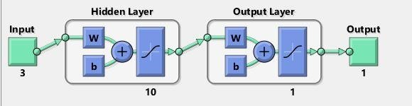

Figure 1: ANN model network configuration

3.4 Artificial Neural Network (ANN) Validation and Testing
A sample from the bulk of the data is held back from the model training and used to give an estimate of the model’s skill while adjusting the model’s hyper-parameters; this is the validation dataset. The validation dataset is used for regularization by early stopping: stop training when the error on the validation dataset increases, as this is a sign of over-fitting to the training dataset. The test dataset is a sample of data that is equally held back from the training of the model and is used to give an estimate of accuracy of the final trained model in making predictions. When comparing or selecting between final models the testing data set is used to test the final model in order to ascertain the accuracy of its predictive power.

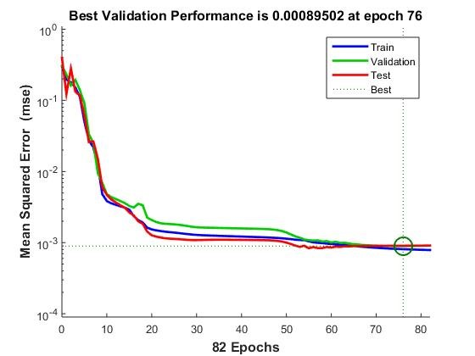

Figure 2: Performance of the trained neural network

Figure 2 shows how the mean squared error (MSE) decreases, during training, validation and testing of the networks as the number of epochs increase. The optimal performance of the neural network was observed to occur at the 76th epoch with an approximate MSE value of 0.00089502. This is indicative of the fact that the neural network learned better as the number of epochs increased. The Levenberg Marquardt training algorithm was used to train the neural network. This choice was made particularly because it takes a less amount of time compared to others algorithms.(Inyang et al., 2021) The regression plots for training, testing, validation and the overall plot are shown in Figure 3.
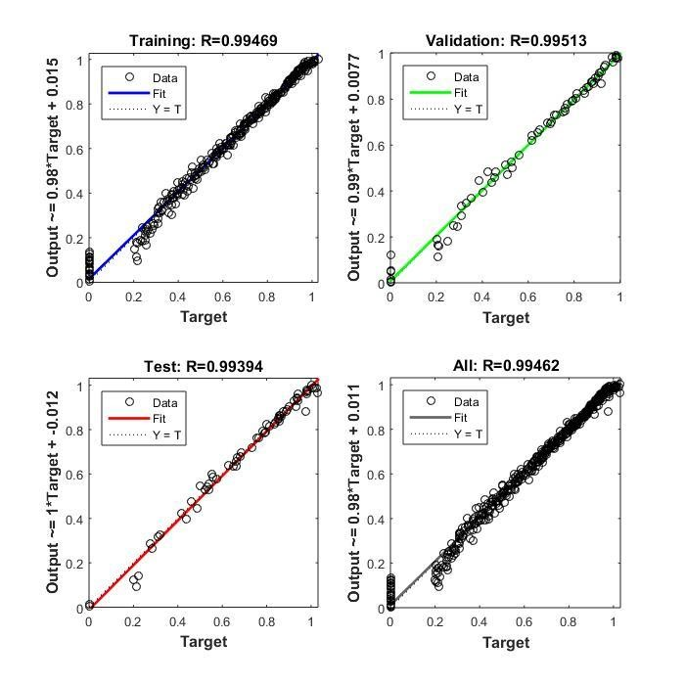

Figure 3: Regression analysis plots for training, validation, and testing of overall datasets

The correlation coefficients for training, validation and testing were 0.99469, 0.99513 and 0.99394 respectively as well an overall coefficient of 0.99462. These values of R are key indicators to the fact that the network performed well.



Figure 4: ANN Interface for selection of data and network configuration

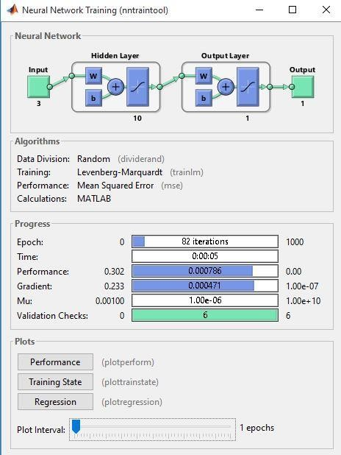

Figure 5: ANN training user interface

3.5 Artificial Neural Network Based Equation

The assignment of weights and biases to variables were performed by the network. The letters ‘W’ and ‘b’ represent weights (W) and biases (b). The values for weights and biases were automatically generated by the network. The relationship between the weights, bias and input variables is linearly developed using Equation 4 carefully outlined below:
$$E1,i,n =\sum_{i=1 }^{j}{\left(W1,i,t * t + W1,i,T * Tn + W1,i,th * thn\right)+b1,i}$$

Equation 4
Where W_{1,i,t}, W_{1,i,T}, W_{1,i,th} refer to the weights assigned respectively to the drying time (t), temperature (T), and moisture content ‘b_{l,i}’ is the bias at the particular hidden layer (l) assigned to the neuron (i). ‘E_{l,i,n}’ refers to the nth sum of the weighted variables, based on the weight assignment in association with the ith neuron at the hidden layer (l); j is the last count of neuron in the network.

Table 2: Summary of weights and bias
Hidden layers | W1,I,t | W1,I,T | W1,I,th | W1,O,MR | Bias
1 | 8.6262 | -1.7271 | 8.6117 | -3.6489 | 1.8346
2 | 0.35847 | 5.492 | 3.9425 | 13.2597 | 0.72876
3 | -2.8737 | 0.21188 | 4.3304 | 0.26383 | -1.3427
4 | 3.3039 | 4.3637 | -7.6301 | -1.3491 | 4.0902
5 | -0.30874 | -3.4292 | -1.3032 | -0.81241 | 0.028802
6 | 0.17117 | -1.2418 | 0.01372 | -16.0107 | -0.41956
7 | 10.7823 | -5.1073 | 3.2911 | 3.8567 | 0.071576
8 | -2.0583 | -0.29368 | 0.12687 | -0.41371 | 0.72876
9 | -2.788 | 0.54551 | 0.70274 | 7.0022 | -1.3427
10 | -1.0624 | 1.2382 | -3.6357 | -0.92201 | 4.0902

Table 3: Summary of results
Input parameters | Time, Temperature, Initial moisture content
Output parameter | Shelf Life. – Final Moisture content
Partition ratio | 70-15-15
Network topology | 3-10-1
Training algorithm | Levenberg Marquardt
Network type | Feed forward back propagation
Transfer function | TANSIG
R | 0.99462
MSE | 0.00089502

Table 3 shows the parameters, the training algorithm employed and the performance summary as expressed by the R and MSE values. The weights and biases indicated in Table 2 were automatically generated by the network. The ‘E_{1,i,n}’ value can be readily determined by multiplying the appropriate weights (in Table 2) with values of the independent variables in Equation 5. The next step in developing the ANN-based model requires mathematical operation on the E_{1,i,n} so obtained using TANSIG transfer function.
The function is mathematically expressed below:
$$TANSIG (E1,i,n) = M1,i,n = \frac{2}{1+e^{-2E1,i,n}}$$
Equation 5

It is pertinent to state that the description is limited to the single-hidden layer model used and it is solely for the sake of simplicity. The final output is given in Equation 6 here:

𝑷_{𝟎} = (𝑾_{𝒐,} ∗ 𝑴_{𝟏,𝒊,𝒏}) + 𝒃_{𝒐} Equation 6
Where W_{o,i} and b_{o} are the weights and bias at the output layer (o) respectively; b_{o=} -1.8047

3.6 Model simulation and performance
Various works have developed ANN models for the prediction of moisture ratio of various food substances. This is essential in food preservation and in estimation of useful shelf life of food substances as it satisfies the need for dried foods to have their shelf lives estimated.
The developed ANN model for the prediction of moisture ratio of onions performed very well as expressed by the very low MSE value and good R value. The results from the simulation run with the model showed that it predicted values approximately equal to the experimental values.

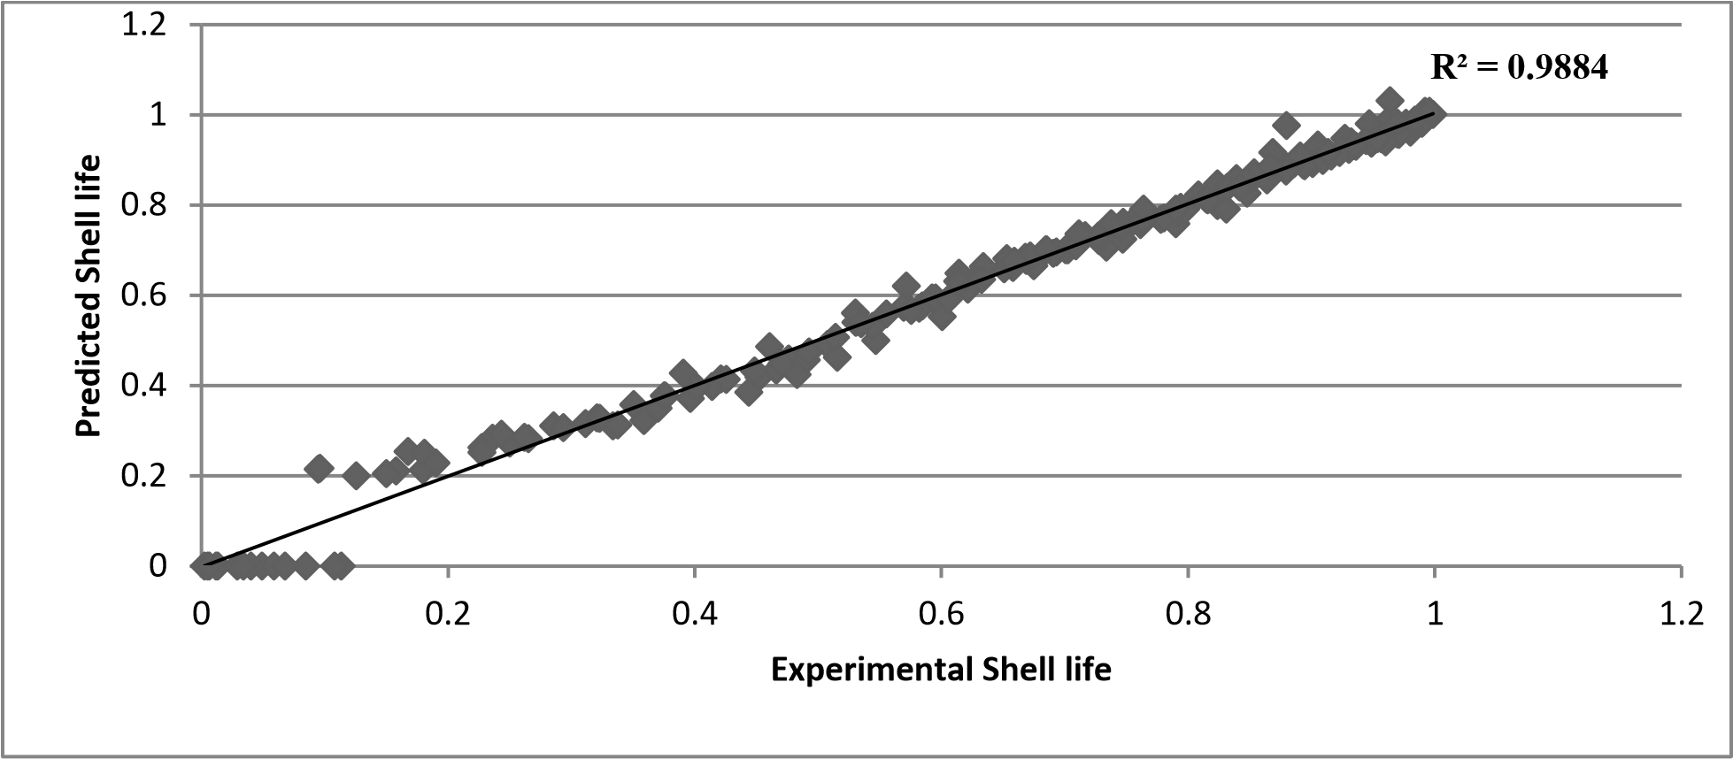
Fig 6 Predicted Shelf Life versus Experimental Shelf Life

4.0 Conclusion
The application of Artificial Neural Network (ANN) for the prediction of the shelf life of Onions with drying time, temperature and slice thickness parameters are provided has been demonstrated elaborately. By providing the network with drying time, slice thickness and temperature data as well as the target moisture ratio outputs in sufficient quantity, the ANN predictive model was effectively trained to predict shelf life under different conditions of temperature, time and moisture content. Statistical analyses of the different ANN configurations that were tried were carried out and the well thought out choice of [3-10-1] was finally settled with. Inability to estimate the shelf life of dried foods results in the lack of control over the parameters that determine the final moisture content of dried foods. Insufficient drying to safe moisture content limits can result in spoilage of foods. Onions is a very common source of carbohydrates and the feedstock for many other foodstuffs. Thus, prediction of shelf life that will result from controlling moisture content, drying time and temperature parameters gives an estimate of the tendency for food spoilage beforehand and can significantly reduce the cost of onions drying processes, and enhance the overall efficiency and control over the onions drying process. The output predicted by the developed ANN model provided good matches with original experimental data. Hence, the work shows the reliability and applicability of the ANN in the prediction of moisture content of onions from drying time, temperature and moisture content. The developed model in the work is universally accessible and is very easy to use.

Recommendation on this work, thus are this research is centered about Artificial Neural Networks (ANN). The ability of this tool to predict is very highly dependent on the quality and quantity of data utilized in the training process. A major challenge encountered in this work was the unavailability of very adequate data. It is therefore recommended that further study on this work be embarked upon but with sufficient, quality and quantity data. The temperature and moisture content range over which the drying experiments were performed are the limits within which the models prediction would return results of top notch accuracy. Further work should focus on exploring higher temperatures and slice thickness as one of the input parameters.

5.0 REFERENCES

Adum, U. U. & Inyang, U. E. (2024) Optimization of Drying Parameters of Hot Leaves (Piper Guineense) using Artificial Neural Network and Response Surface Methodology, Journal of Systematic and Modern Science Research, 4(9), 28 – 44

Baughman, D. R. & Liu, Y. A. (1995) Neural Networks in Bioprocessing and Chemical Engineering, academic press, Blacksburg, VR

FAO. Food & Agriculture Organization of the United Nations (FAO), Statistical Databases. 2021. Available online: https://www.fao.org/land-water/databases-and-software/crop-information/onion/fr/ (accessed on 16th August 2024).

Freitas, M. A. & Costa, J. C. (2006) Shelf life determination using sensory evaluation scores: a general Weibull modelling approach. Computing Industrial Engineering, 51, 652– 670

Gogus, F., (1994). The effect of movement of solutes on millard reaction during drying. Ph.D. Thesis. Leeds University, Leeds. ¨

Hussain, M., Sulaiman, M. N. & Ibrahim, H. (2002) Artificial neural networks: A review, Journal of Applied Sciences Research, 2(12), 1024 - 1031

Inyang, U. E., Alexander, J. A. & Chibuzo, N. P. (2021) Prediction of Cocoyam Drying Parameters Using Artificial Neural Network, International Journal of Novel Research in Engineering and Science, 8(1), 4 – 13

Inyang, U. E. & Bassey, V. J. (2021) Prediction of the moisture ratio of Atama (Heinsia Crinita) leaves using artificial neural network (ANN), International Journal of Engineering and Technology, 10 (2), 232 – 240

Jyothi, H. (2003) Export performance of onion and potato from India – An economic analysis, Indian Journal of Agricultural Marketing, 17(3), 131 – 141

Kamoi, T., Sato, T. & Sato, T. (1981)Microwave Drying of Onion with hot air Pretreatment, Journal of Food science, 46(5), 1450 - 1453

Kendall, P. & Sofos, J. (2012) Drying vegetables. Colorado State University Extention Fact sheet No. 9308

Kim, S., Yoon, J. B., Han, J., Yum Am Seo, Y. A., , Kang, B. H., Lee, J. & Ochar, K. (2023) Green Onion (Allium fistulosum): An Aromatic Vegetable Crop Esteemed for Food, Nutritional and Therapeutic Significance, Foods, 12(24), 4503; 2 - 20
Lewicki, P. P., (2005). Design of hot air drying for better foods. Trends in Food Science Technology. XX, 1–11.

Mitra J., Shrivastava, S. L., & Rao, P. S. (2012). Onion dehydration: a review. Journal of Food Science Technology 49(3), 267–277

NHRDF (2009) Area and production data. National Horticultural Research and Development Foundation. www.nhrdf.com. Access date 27th November 2009.

Satish, T. & Setty, P. Y. (2005) Modeling of a continuous fluized bed dryer using artificial neural networks, International communications in Heat and mass transfer, 31(1), 143 -150

Sarsavadia, P. N, Sawhney, R. L, Pangavhane, D. R, & Singh, S. P. (1999). Drying behaviour of brined onion slices. Journal of Food Engineering, 40, 219 – 226

Singh, Y. (2005) Neural networks in data mining, Journal of Theoretical and applied Information Technology, 5(1):

Shi, C., Zhao Z., Jia, Z., Hou, M., Yang, X., Ying, X. & Ji, Z. (202)3 Artificial neural network-based shelf life prediction approach in the food storage process: A review, Critical Reviews In Food Science and Nutrition 64(32), 1-16

Simal, S., Femenıa, A., Lull, P., & Rossello, C., (2000). Dehydration of aloe vera: simulation of drying curves and evaluation of functional properties. Journal of Food Engineering, 43(2), 109 –114.

Suleria, H. A. R., Butt, M. S.; Anjum, F. M., Saeed, F. & Khalid, N. (2013) Onion: Nature protection against physiological threats. Critical Review in Food Science and Nutrition, 55, 50–66
Srinivasamurthy D. & Subramanyam K. (1999) Agricultural Economics Research Review 12(2), 118-128.

Swasdisevi, T., Soponronnarit, S., Rakwichian, W. & Thadnium, V. (1999). Industrial-scale solar vegetable drying. Proc. World Renewable Energy Congress, Murdoch University, Western Australia.

Taglienti, A.; Araniti, F.; Piscopo, A. & Tiberini, A. (2021) Characterization of Volatile Organic Compounds in ‘Rossa di Tropea’ Onion by Means of Headspace Solid-Phase Microextraction Gas Chromatography–Mass Spectrometry (HS/SPME GC–MS) and Sensory Analysis. Agronomy, 11, 874, 1- 14

Topuz, A. (2009) Predicting moisture content of agricultural products using artificial neural networks, Advances Engineering Software, 41(3), 464 - 470

