Dilated Cardiomyopathies: Comprehensive Overview and Clinical Experience from Our Cardiology Department

ABSTRACT

Background : Dilated cardiomyopathy (DCM) is a disease of the heart muscle characterized by dilatation of the left ventricle (LV) associated with systolic dysfunction, in the absence of a clear triggering factor.
Study Objective: To determine the epidemiological, clinical, paraclinical and therapeutic aspects of patients with DCM.
Patients and methods: Our series is a retrospective, descriptive and analytical study based on records of patients with dilated cardiomyopathy hospitalized in the cardiology department of the MHA, over a 2-year period from January 1, 2021 to January 1, 2023.
Results:
Ninety-one patients were enrolled. The sex ratio M/F was 3.7. The mean age was 66 years. The majority of patients had more than 3 cardiovascular risk factors. The most common clinical manifestations were those of right heart failure. The electrocardiogram showed various non-specific abnormalities, dominated by rhythm disorders (90%), conduction disorders (56%) and electrical cavitary hypertrophy (90%). Chest radiography revealed cardiomegaly in all patients, with a mean cardiothoracic index of 0.62.
On echocardiography, the mean left ventricular EDD was 65.2 mm, the ejection fraction had a mean value of 33%, valvular diseases was found in the majority of patients (78%), and global hypokinesia was present in 63 patients. Regarding the right ventricular function, the mean TAPSE and PAPs were 18.4 mm and 45.5 mm Hg respectively.
The most frequent etiology in our series was ischemic heart disease with a rate of 48.4%, followed by rhythmic origin in 17.5%, then valvular disease in 12.08%. Other etiologies were systemic lupus erythematosus in 4 patients, mixed connectivitis in 2 patients, while Behçet's disease, hypocalcemia, radiotherapy, post partum, post covid, and celiac disease were found in only one patient.
Treatment was based mainly on the management of heart failure. All patients were treated with dietetic measures, 97.8% with diuretics, 83.5% with ACE inhibitors, 75.8% with beta-blockers and 39.5% with ISGLT2. Treatment of the underlying etiology was initiated in conjunction with treatment of heart failure.
The outcome was generally favorable in 59% of cases and unfavorable in 33%. Four deaths occurred, including two following a sustained ventricular tachycardia that did not recover despite CPR measures, and two due to refractory cardiogenic shock following acute decompensation of their heart failure.
Conclusion:
At the end of this study, we highlight the importance of early diagnosis of this pathology in improving the long-term prognosis of patients.
The key issue is etiological diagnosis, based on biological and radiological tests, with MRI playing an important role in positive diagnosis and etiological orientation.
Management is mainly based on the treatment of heart failure associated with the treatment of the etiology.

Keywords: Aortic stenosis; multivalvular disease; AVA; hemodynamic valvular assessment

1. INTRODUCTION

Dilated cardiomyopathy (DCM) is a myocardial disorder characterized by dilation of the cardiac chambers—most commonly beginning with the left ventricle—impaired systolic function (reduced ejection fraction), and decreased myocardial contractility, leading to heart failure of variable progression.
Classification systems facilitate understanding of the disease, enhance patient management, improve communication between clinicians, and support the development of multicenter and multinational registries to promote research and therapeutic advances.

DCM predominantly affects young adults aged 20–60 years [1]. Etiologies are diverse; however, 20–50% of cases remain idiopathic. Besides genetic forms, DCM may result from viral infections, toxic exposures, autoimmune and inflammatory diseases, or secondary to pre-existing cardiac conditions such as coronary artery disease, hypertension, or valvular disease [2].

Although current therapeutic strategies have improved patient care and quality of life, their impact on morbidity and mortality remains limited, underscoring the importance of early diagnosis—often challenging due to the prolonged asymptomatic phase. Advances in imaging have significantly enhanced DCM assessment. Echocardiography in its various modalities (TTE, 2D, 3D) remains the cornerstone of diagnosis, while cardiac MRI and computed tomography offer complementary non-invasive tools for etiological evaluation, risk stratification, and clinical decision-making.

2. material and methods

Study design and population
Our series is based on a retrospective, descriptive, and analytical study using medical records of patients diagnosed with dilated cardiomyopathy who were hospitalized in the cardiology department of HMA over a two-year period, from January 1, 2021, to January 1, 2023.
Eligible for inclusion were all patients admitted to the cardiology department in whom echocardiography demonstrated left ventricular dilation associated with systolic dysfunction. A total of 91 patients were included in the study.

Exclusion criteria were:

- Patients with DCM who were not hospitalized during the study period.
- Cardiomyopathies with left ventricular dysfunction without chamber dilation.
- Heart diseases with isolated right ventricular dilation.
- Patients lost to follow-up.
- Patients with incomplete medical records preventing data analysis.
Data collection:
For this study, we reviewed individual hospitalization records compiling clinical, paraclinical, and management data for each patient.
All patients underwent a complete clinical examination, electrocardiogram (ECG), chest radiography, transthoracic echocardiography (TTE), coronary angiography, and standard laboratory tests. Additional paraclinical investigations were ordered according to clinical indications.
Data collection and entry were performed using Microsoft Word 2020 and Microsoft Excel 2020. Quantitative variables were expressed as means, while qualitative variables were expressed as percentages.
Ethical Considerations
Data collection was carried out in accordance with general ethical guidelines, respecting patient confidentiality and data protection.

3. results and discussion

Results:
In our sample, there was a male predominance (72 men vs. 19 women), with a male-to-female sex ratio of 3.7.

Figure 1: distribution by sex
The mean age was 66 years (range: 32–92 years). The 60–80-year age group was by far the most represented, comprising 63 patients (69.2%).
In our study, the majority of patients (72 cases) had more than three cardiovascular risk factors.

TABLE 1: distribution of major risk factors
Risk Factor | n | %
Diabetes mellitus | 36 | 39.56%
Hypertension | 31 | 34.06%
Dyslipidemia | 20 | 21.97%
Smoking | 33 | 36.26%

As for other relevant medical histories, which are essential to investigate in any suspected case of dilated cardiomyopathy, alcoholism was the most common toxic habit (50.5%).
Table II – Distribution of patients according to other medical histories (n = 91)
Medical History | n | %
Cardiac arrhythmia | 14 | 15.38%
Ischemic cardiomyopathy (ICM) | 21 | 23.07%
Valvular heart disease | 9 | 9.89%
Thyroid disorder | 2 | 2.19%
  Radiochemotherapy
  1
  1 | %
  Viral infection (SARS-CoV-2)
  1
  1%
  Venous thromboembolism (PE or DVT)
  5
  5.49%
Toxic habits
 | 46 | 53.84%
  Alcohol
 | 3 | 53.84%
  Cannabis use

The clinical presentation of our patients was dominated by dyspnea (91.20%), followed by chest pain (37.36%) and palpitations (19.78%).
65% of patients presented with signs of heart failure, half of whom exhibited features of global heart failure.
The electrocardiogram was abnormal in all cases. Analysis of the patients’ ECG tracings revealed various abnormalities.
- The most common rhythm was sinus rhythm (57.2%).
- The arrhythmias observed were mainly ventricular extrasystoles (86.8%) and atrial fibrillation (42.8%).
- Conduction disorders were identified in 51 patients (56%), with left bundle branch block being the most frequent abnormality (41.8%)
- Regarding chamber hypertrophy: 89% of patients presented with electrocardiographic left ventricular hypertrophy (LVH).
- As for repolarization abnormalities, these were observed in 63 patients (69.2%).
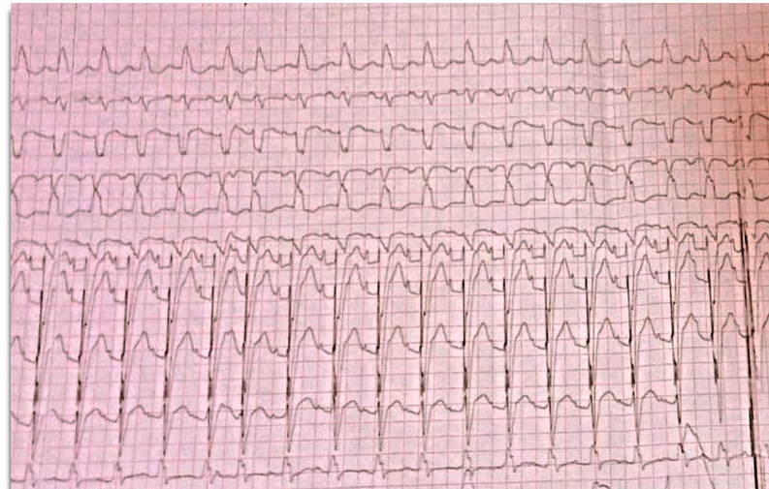
Figure 2: An ECG showing a regular sinus rhythm at 130 bpm, leftward cardiac axis, right atrial enlargement (RAE), prolonged PR interval (first-degree AV block), and complete left bundle branch block (LBBB) from one of the patients in our series.

Chest radiograph analysis revealed cardiomegaly in all patients, with a mean cardiothoracic index (CTI) of 0.62. Associated abnormalities included pleural effusion and an alveolo-interstitial pattern.

Echocardiography showed LV dilation in 87.9% of patients and biventricular dilation in 48.4%. Left and right atrial enlargement were present in 73.6% and 46.2% of cases, respectively. LVEF was reduced in 62% (mean 35%, range 15–49%). Valvular disease was observed in 78%, predominantly isolated MR (41%) and combined MR with AR (15%). Most MR cases were moderate, with 45% functional and 27% ischemic in origin. Global hypokinesia was found in 69.2% of patients, segmental hypokinesia in 28.6% (including 8 with apical akinesia), most often involving basal and mid anteroseptal segments. Mean PASP was 45.5 mmHg (range 21–70 mmHg). Intracavitary LV thrombus was detected in 6.6%, and pericardial effusion in 13.2% of patients.
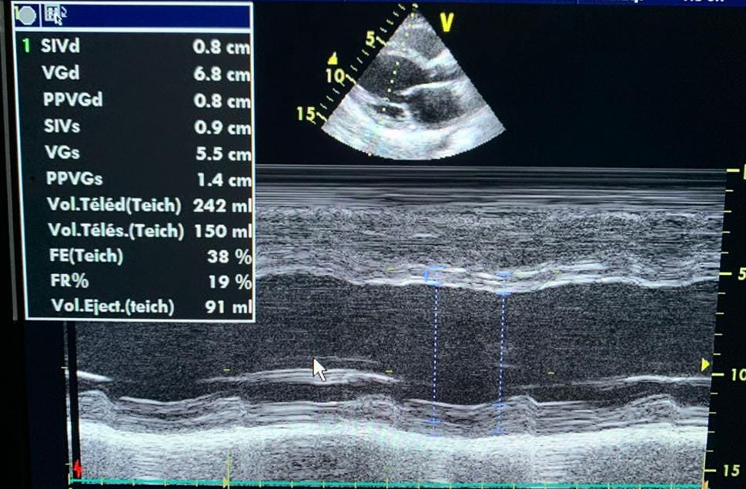
Figure 3 :Transthoracic echocardiography in M-mode of dilated cardiomyopathy in a patient from our series, showing a dilated, non-hypertrophied left ventricle: LVEDD/LVESD = 68/55 mm.

Three patients in our series underwent cardiac MRI during hospitalisation or on an outpatient basis, but given the retrospective nature of our study:

The results are as follows:

Absence of viability due to delayed transmural contrast enhancement in two patients with ischaemic CMD.

Myocardial oedema with delayed enhancement in the basal septum in the patient with post-COVID DCM.
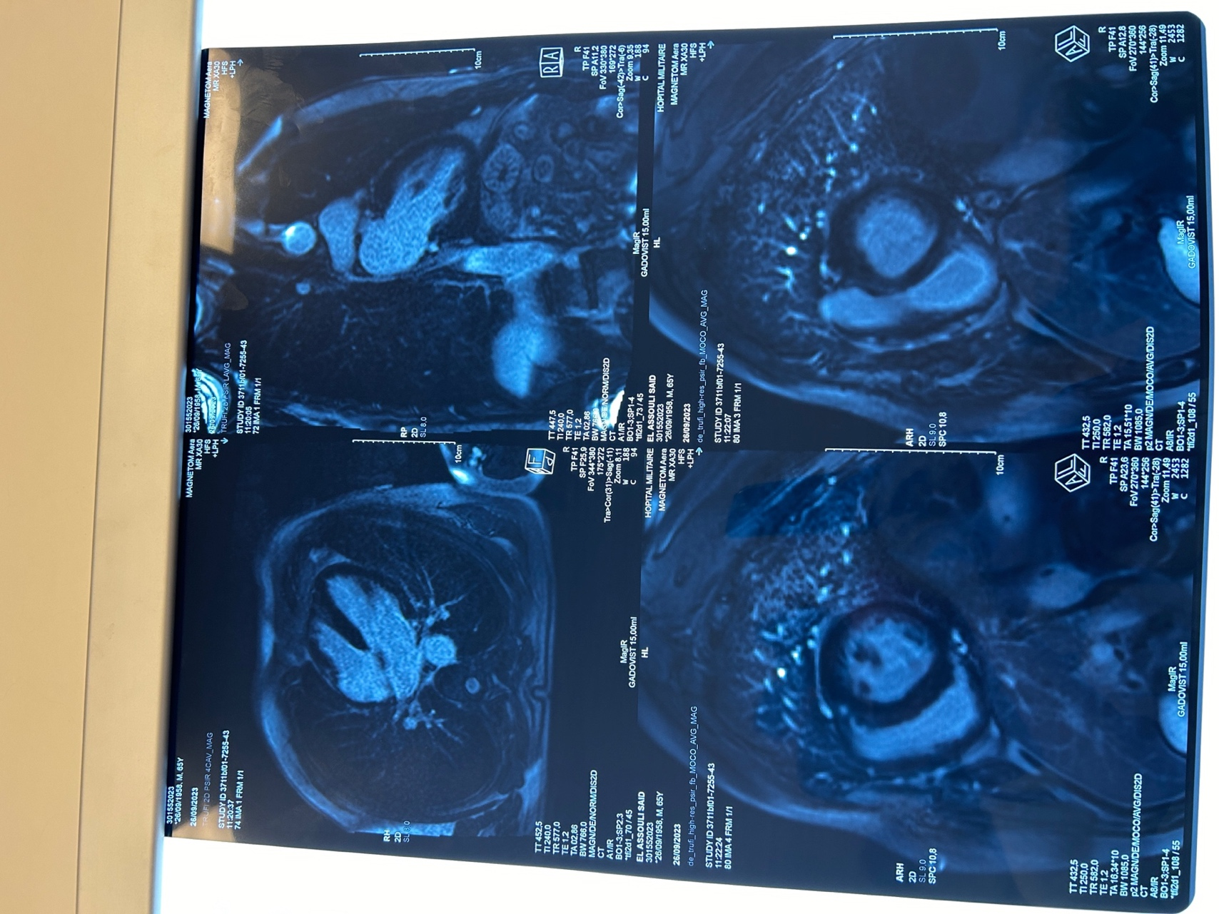
Figure 4 : Short-axis view showing late intramural contrast uptake in the basal septum. Avicenne Military Hospital, Marrakech

All of our patients underwent coronary angiography, which was abnormal in 48.3% of cases, as objectively confirmed by the study: 3 patients had associated common trunk involvement, 26 patients (59%) had single-vessel involvement, two-vessel disease in 5 patients (11.3%), and three-vessel disease in 13 patients (29.5%).

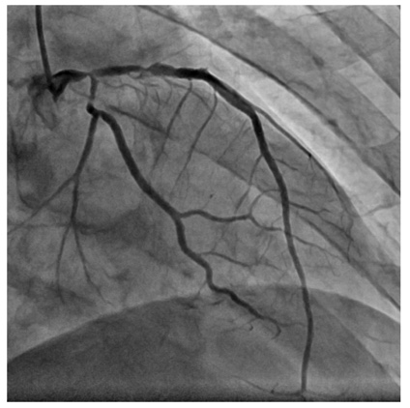
Figure 5: Coronary angiogram image in caudal OAD incidence showing a 70-90% severe stenosis of the distal TC encompassing the ostium of the IVA and the Cx, associated with a severe stenosis of the proximal segment of the IVA and the CX. Avicenne Military Hospital, Marrakech

Of the 91 cases selected, the etiologies were dominated by ischaemic damage in 44 patients (48.4%) and arrhythmia in 16 patients (17.5%), which together accounted for more than half of all etiologies.
For the remaining half of the cases, the aetiologies were distributed as follows:
- Coeliac disease: one patient.
- Behçet's disease: one patient.
- Valvular: 11 patients.
- Infectious: one patient.
- Toxic due to radiotherapy: one patient.
- Metabolic due to hypocalcaemia: one patient.
- Postpartum: one patient.
- ANCA-associated vasculitis: one patient.
- Systemic lupus erythematosus: four patients.
- Mixed connective tissue disease: two patients.
- Idiopathic: seven patients.
Treatment focused mainly on heart failure management with lifestyle measures and risk factor correction for all patients.
- 89 patients (97.8%) received diuretics, mostly combined with ACE inhibitors (83.5%) and beta-blockers (75.8%).
- 36 patients (39.5%) were on SGLT2 inhibitors, 15 (16.4%) on ARBs, and 12 (13.2%) on neprilysin inhibitors.
Etiology-specific interventions included angioplasty in 30 patients and coronary bypass surgery in 10 patients; 4 patients received medical treatment only.
- Valve replacement was performed in 11 patients.
- Cardiac resynchronization therapy was indicated in 16 patients.
- Hypocalcemia correction was done in 1 patient with dilated cardiomyopathy.
- 1 patient with postpartum cardiomyopathy was treated with azathioprine.
- Patients with autoimmune disease received cyclophosphamide boluses.
- Antiplatelet therapy was prescribed for 51 patients (56%), anticoagulants for 50 patients (54.9%) — mainly for atrial fibrillation (78%), intracavitary thrombus (12%), or venous thromboembolism history (10%).
- Ivabradine was used in 3 patients (3.3%), and digitalis in 5 patients (5.5%).
All our patients were closely monitored with scheduled consultations at 15 days, then 1 month, and subsequently every 3 months.
In our study, the clinical evolution of patients treated for heart failure, combined with therapy targeting the underlying disease, was generally favorable in 59% of cases, characterized by an improvement in left ventricular ejection fraction (LVEF) and stabilization of ventricular dilation.Improvement in LVEF was observed in 54 patients, with an average increase of 15 to 20% over a mean follow-up of 18 months.
A decline in LVEF occurred in 36% of patients, mainly during the mid-term follow-up.There were four deaths reported: two due to sustained ventricular tachycardia refractory to resuscitation measures, and two due to refractory cardiogenic shock following acute decompensation of heart failure.

Discussion:

The average age of our patients was 66 years, with a predominance of the 60 to 80-year age group, consistent with results from other cardiology series cited below. In our cohort, men represented 79% with a sex ratio of 3.7, similar to findings by Lompo et al. [3], Faraj et al. [4], and Halliday et al. [5]. However, several studies have reported a female predominance, which may be explained by the higher prevalence of systemic diseases in women and the fact
The main modifiable cardiovascular risk factors in our sample were diabetes (39.56%), smoking (36.26%), hypertension (34.06%), and, lastly, dyslipidemia. Besides these risk factors, it is essential to investigate toxic history such as alcohol consumption, viral infections, thyroid disorders (suggestive of recent viral involvement), and treatments like radiochemotherapy.(6,7)
Dyspnea, classically reported in the literature, was the predominant symptom, also noted in recent series by Ikama et al. [8], Faraj et al. [4], and Simon et al. [9], as well as in our study. NYHA functional classes II and III were predominant, likely due to healthcare accessibility and close patient follow-up. Other symptoms included chest pain and palpitations, with palpitations observed in only 19.78% of patients, consistent with Simon et al.'s findings.
Signs of global heart failure predominated clinically, aligning with literature reports. Electrocardiograms (ECGs) were nearly always abnormal in dilated cardiomyopathy (DCM), though no specific sign is pathognomonic [4].
Cardiac arrhythmias are a major cause of clinical deterioration and death in patients with dilated cardiomyopathy [10]. In our sample, 39 patients (42.8%) had atrial fibrillation (AF), and 79 patients (86.8%) had ventricular extrasystoles (VES). According to S. Kumar [11], 30–40% of patients with chronic heart failure develop AF during their disease course, increasing morbidity and mortality [10]. Non-sustained ventricular tachycardias (NSVT) are also frequent, with 90% of patients exhibiting VES and 50–60% showing NSVT [10]. Two patients in our series experienced sustained ventricular tachycardia leading to death.
Conduction abnormalities were also present: left bundle branch block (LBBB) was found in 41.8% of patients, a relatively high rate compared to the literature except for a study at the University Hospital of Rabat, which reported 76%. LBBB is associated with mechanical asynchrony, worsening left ventricular systolic function, heart failure, and increased risk of sudden death [10].

ECG also revealed other anomalies such as chamber hypertrophy (Table XXVI). Left ventricular hypertrophy (LVH) was the most frequent chamber hypertrophy, except in Lompo et al. [3]. Radiology showed cardiomegaly in all patients (100%), consistent with the literature. According to Bouakez et al. [12], pulmonary edema patterns are constant at this disease stage. In line with clinical findings, 41.8% of patients had alveolo-interstitial syndrome and hilar congestion, suggestive of acute pulmonary edema due to left or global heart failure
Transthoracic echocardiography (TTE) remains a cornerstone for diagnosing DCM due to its low cost and accessibility. It enables monitoring ventricular remodeling, guiding etiologic assessment, and prognostication. Echocardiography can be repeated frequently, allowing rigorous treatment adjustment based on parameters such as ventricular asynchrony and right ventricular function. It is the only non-invasive imaging feasible in unstable patients, like most in our heart failure cohort.
In our sample, 100% had left ventricular dilation, with an average end-diastolic diameter of 65.2 mm, comparable to Faraj et al. (64.74 mm), slightly less than Bouakez et al. (67 mm), and higher than Hoque et al. (61.8 mm) and Visalakshi et al. (58 mm) [4,12,13,14]
Left ventricular dysfunction was present in all patients, with a mean ejection fraction (LVEF) of 35%, similar to Hoque et al. (13), Ikama et al. [8], and Simon et al. [9]. Mitral regurgitation, typically due to ventricular remodeling, was observed in 56% of patients. Other valvular lesions such as aortic insufficiency were also found, consistent with Faraj et al. However, Simon et al. [9] and Dieudonné et al. [15] reported lower rates

Right ventricular (RV) function is a significant independent prognostic factor in DCM. Studies by Ghio et al. [16] and Kjaergaard et al. [17] established a TAPSE threshold of ~14 mm for prognosis, independent of left ventricular function. Thus, comprehensive RV assessment should be performed at each follow-up, aiming for early reversal of RV remodeling as a therapeutic target. RV analysis is complex due to its geometry.
In our series, 44% had RV dysfunction versus 25% in Venner et al. [18]. Mean TAPSE was 18.4 mm, consistent with Venner et al. but higher than Zairi et al. (12.5 mm) [18,19].
#Due to its non-invasive nature and ability to detect late gadolinium enhancement (LGE), cardiac MRI is increasingly the first-line examination, surpassing invasive coronary angiography for differentiating ischemic vs. non-ischemic DCM .
Three patients in our series underwent CMR during hospitalization or outpatient follow-up:
Bland-Altman analysis (Ibrahim et al. [20]) showed strong concordance between echocardiographic and CMR LVEF estimates: mean LVEF was 30% by CMR and 31% by echocardiography with a 1% mean difference P. Wood et al. similarly reported no significant difference, though comparisons can be affected by different hemodynamic conditions [21].
LGE has increasing prognostic value due to its association with arrhythmias independent of LVEF [22]. It predicts higher rates of ventricular arrhythmias and sudden cardiac death risk per Di Marco’s meta-analysis [23].
Beyond arrhythmic complications, CMR is highly sensitive for detecting complications such as left ventricular thrombi, critical for initiating anticoagulation.It also differentiates ischemic vs. non-ischemic etiologies by superior tissue characterization. For myocarditis, diagnosis relies on identifying edema and LGE (often subepicardial or subendocardial) without coronary distribution fibrosis .According to Mahrholdt et al. LGE location may guide infectious myocarditis diagnosis, e.g., parvovirus B19 or herpes simplex virus. [24]
Etiological diagnosis in DCM is challenging due to heterogeneous and overlapping causes. Literature suggests approximately 50% of cases are idiopathic . In our study, ischemic cardiomyopathy predominated (48.4%), followed by arrhythmic causes (17.5%) and valvular DCM (12.08%). Other causes were rare, consistent with previous studies. [25,26].
Current treatment of DCM centers on heart failure management, with β-blockers, renin-angiotensin system inhibitors (ACE inhibitors or ARBs), angiotensin receptor-neprilysin inhibitors (ARNI), aldosterone antagonists, SGLT2 inhibitors, and diuretics forming the pharmacologic cornerstone [27]. These apply equally to idiopathic DCM and specific etiologies.
In idiopathic DCM, triggers are unknown, so treatment is symptomatic. Physical rest is particularly recommended for inflammatory cardiomyopathies [28].
In our cohort, treatment mainly included diuretics (97.6%), ACE inhibitors (83.5%), beta-blockers (75.8%), and antiplatelet agents (56%), consistent with literature
In our series, idiopathic and post-COVID viral DCM patients received corticosteroids; autoimmune DCM patients were treated with corticosteroids and immunosuppressants, consistent with ESETCID and Latham studies. [29,30].
A postpartum cardiomyopathy patient was treated with heart failure medications, aligning with McNamara et al. [31].

Historically, DCM prognosis was poor, with median survival around 2 years post-diagnosis and a 5-year survival rate near 50%. Following major randomized trials in the US and Europe demonstrating survival benefits from ACE inhibitors/ARBs and beta-blockers, these drugs became fundamental for all stages of DCM management [32].
In our study, evolution was generally favorable in 54 patients, marked by LVEF improvement and ventricular dilation stabilization. LVEF deterioration occurred in 33 patients. Four deaths occurred: two from sustained ventricular tachycardia and two from refractory cardiogenic shock.

4. Limitations:
The study has several limitations. Firstly, the sample size was small, which limits the generalizability of the findings. Therefore, larger studies involving both pre-diabetic and non-diabetic populations are warranted. Secondly, the short duration of the study did not allow for long-term follow-up of the patients. Additionally, potential underlying mechanisms—such as insulin resistance or pro-thrombotic states—were not explored. Future prospective studies in pre-diabetic individuals are essential to better understand these mechanisms and to inform management strategies. Lastly, the assessment of coronary angiographic and echocardiographic findings was based on visual interpretation, which may be subject to inter- and intra-observer variability.
5. Conclusion :

Dilated cardiomyopathy is a prevalent and serious cardiac condition marked by left ventricular dilation and systolic dysfunction without an obvious trigger. Accurate diagnosis requires a comprehensive clinical, biological, and imaging approach, with echocardiography as the cornerstone and cardiac MRI increasingly indispensable for detailed tissue assessment. Given the heterogeneous causes, multidisciplinary management is essential. Advances in heart failure therapies and early etiological identification have notably improved patient prognosis, underscoring the importance of timely and tailored treatment strategies.

References
- Pelliccia F, Limongelli G, Autore C, Gimeno-Blanes JR, Basso C, Elliott P
Sex-related differences in cardiomyopathies. Int J Cardiol. 2019
- Vikhorev PG, Vikhoreva NN.
Cardiomyopathies and Related Changes in Contractility of Human Heart Muscle.
Int J Mol
https://www.ncbi.nlm.nih.gov/pmc/articles/PMC6121228/
- Lompo DL.
Les Cardiomyopathies dilatées au CHN-YO : aspects épidémiologiques, cliniques, paracliniques et évolutifs : à propos de 143 cas colligés de 1996 à 1999.
- Faraj , Berbich, Lazrak, Chkili, Alaoui, Belmahi.
Les Cardiomyopathies dilatées au CHU-rabat : aspects épidémiologiques, cliniques, paracliniques et évolutifs
- Halliday BP, Gulati A, Ali A, Newsome S, Lota A, Tayal U, et al.
Sex- and age-based differences in the natural history and outcome of dilated cardiomyopathy: Sex- and age-based differences in DCM.
Eur J Heart Fail. oct 2018;
- Machihudé Pio1 et al.
Epidémiologie et étiologies des insuffisances cardiaques à Lomé.
- Tschöpe C, Ammirati E, Bozkurt B, Caforio ALP, Cooper LT, Felix SB, et al.
Myocarditis and inflammatory cardiomyopathy: current evidence and future directions.
Nat Rev Cardiol 2021
Disponible sur: https://www.ncbi.nlm.nih.gov/pmc/articles/PMC7548534/
- Ikama SM, Moualengue B, Makani J, Mongo-Ngamami SF, Ellenga-Mbolla B, Ondze-Kafata I, et al.
Profil épidémio-clinique et évolutif des cardiomyopathies dilatées au Centre Hospitalier Universitaire de Brazzaville, Congo.
Pan Afr Med J 2018
Disponible sur: http://www.panafrican-med-journal.com/content/article/31/164/full/
- Simon M.
Idiopathic Dilated Cardiomyopathy at the Hospital De La Paix in Ziguinchor: About 79 Cases.
- Peters S, Kumar S, Elliott P, Kalman JM, Fatkin D.
Arrhythmic Genotypes in Familial Dilated Cardiomyopathy: Implications for Genetic Testing and Clinical Management.
Heart, Lung and Circulation. janv 2019;
- Kumar S, Stevenson WG, John RM.
Arrhythmias in Dilated Cardiomyopathy.
Cardiac Electrophysiology Clinics. juin 2015;
- Bouakez A, Bouakez AH.
ASPECTS EPIDEMIOLOGIQUES ET EVOLUTIFS DES CARDIOMYOPATHIES DILATEES. 2000
- Hoque SJ, Rahman A, Alam MdZ, Irfan SMR.
Clinical profile of patients with Idiopathic Dilated Cardiomyopathy in a Tertiary Care Hospital of Bangladesh.
Bangladesh Crit Care J. 8 oct 2019;.
- Kumar S et al.
A Study of Clinical Profile of Dilated Cardiomyopathy in Co- Relation with ECG and Echocardiography |
IOSR Journals
Disponible sur: https://www.academia.edu/41333818/A_Study_of_Clinical_Profile_of_Dilated_Cardiomyopathy_in_Co-_Relation_with_ECG_and_Echocardiography?auto=download
- DIEUDONE,
Cardiomyopathies dilatées dans le service de cardiologie « B » DE l’HOPITAL NATIONAL DU POINT.
- Ghio S, Recusani F, Klersy C, Sebastiani R, Laudisa ML, Campana C, et al.
Prognostic usefulness of the tricuspid annular plane systolic excursion in patients with congestive heart failure secondary to idiopathic or ischemic dilated cardiomyopathy.
The American Journal of Cardiology. avr 2000;
- Damas F, Ancion A, Tridetti J, Lancellotti P
Non-compaction du ventricule gauche :
Diagnostic et prise en charge.
Disponible sur: https://orbi.uliege.be/bitstream/2268/262964/1/202012_06.pdf
- Venner C, Selton-Suty C, Huttin O, Erpelding ML, Aliot E, Juillière Y.
Right ventricular dysfunction in patients with idiopathic dilated cardiomyopathy: Prognostic value and predictive factors.
Archives of Cardiovascular Diseases. avr 2016;
- Zairi I, Mzoughi K, Jabeur M, Jnifene Z, Ben Moussa F, Kamoun S, et al.
Right ventricular systolic echocardiographic parameters in dilated cardiomyopathy and prognosis.
Tunis Med. févr 2017;.
- Ibrahim HR, Housseini AM, Khalil TH, Allam KE, Ali HH.
Role of cardiac MRI in assessment of patients with dilated cardiomyopathy.
The Egyptian Journal of Radiology and Nuclear Medicine. déc 2017;
- Wood PW, Choy JB, Nanda NC, Becher H.
Left Ventricular Ejection Fraction and Volumes: It Depends on the Imaging Method.
Echocardiography. janv 2014;
- Wu E, Judd RM, Vargas JD, Klocke FJ, Bonow RO, Kim RJ.
Visualisation of presence, location, and transmural extent of healed Q-wave and non-Q-wave myocardial infarction.
The Lancet. janv 2001;
- Di Marco A, Anguera I, Schmitt M, Klem I, Neilan TG, White JA, et al.
Late Gadolinium Enhancement and the Risk for Ventricular Arrhythmias or Sudden Death in Dilated Cardiomyopathy.
JACC: Heart Failure. janv 2017;
- Mahrholdt H, Wagner A, Deluigi CC, Kispert E, Hager S, Meinhardt G, et al.
Presentation, Patterns of Myocardial Damage, and Clinical Course of Viral Myocarditis.
Circulation. 10 oct 2006;
- Olbrich HG. [
Epidemiology-etiology of dilated cardiomyopathy
Z Kardiol. 2001;
- Kasper EK, Agema WRP, Hutchins GM, Deckers JW, Hare JM, Baughman KL.
The causes of dilated cardiomyopathy: A clinicopathologic review of 673 consecutive patients.
Journal of the American College of Cardiology 1 mars 1994
Disponible sur: https://www.sciencedirect.com/science/article/pii/0735109794907404

- Yancy CW, Jessup M, Bozkurt B, Butler J, Casey DE, Colvin MM, et al.
2017 ACC/AHA/HFSA
Focused Update of the 2013 ACCF/AHA Guideline for the Management of Heart Failure: A Report of the American College of Cardiology/American Heart Association Task Force on Clinical Practice Guidelines and the Heart Failure Society of America.
Circulation. 8 août 2017;
- Maisch B, Funcker R, Alter P, Portig I, Pankuweit S.
Dilatative Kardiomyopathie und Myokarditis Aktuelle diagnostische Erfordernisse und therapeutische Mglichkeiten.
Der Internist. 2002;
- Hufnagel G, Pankuweit S, Richter A, Schönian U, Maisch B.
The European Study of Epidemiology and Treatment of Cardiac Inflammatory Diseases (ESETCID).
- Latham RD, Mulrow JP, Virmani R, Robinowitz M, Moody JM.
Recently diagnosed idiopathic dilated cardiomyopathy: Incidence of myocarditis and efficacy of prednisone therapy.
American Heart Journal 1 avr 1989
Disponible sur: https://www.sciencedirect.com/science/article/pii/0002870389906261
- Dennis M. McNamara, Richard Holubkov, Randall C. Starling, G. William Dec, Evan Loh, Guillermo Torre-Amione, Alan Gass, Karen Janosko, Tammy Tokarczyk, Paul Kessler, Douglas L. Mann, Arthur M. Feldman
Controlled Trial of Intravenous Immune Globulin in Recent-Onset Dilated Cardiomyopathy
Circulation
Disponible sur: https://www.ahajournals.org/doi/10.1161/01.cir.103.18.2254?url_ver=Z39.88-2003&rfr_id=ori:rid:crossref.org&rfr_dat=cr_pub%20%200pubmed
- Matsumura Y, Takata J, Kitaoka H, Kubo T, Baba Y, Hoshikawa E, et al.
Long-Term Prognosis of Dilated Cardiomyopathy Revisited An Improvement in Survival Over the Past 20 Years: An Improvement in Survival Over the Past 20 Years.
Circ J 2006
Disponible sur: http://www.jstage.jst.go.jp/article/circj/70/4/70_4_376/_articl

