Case report
ACUTE OBSTRUCTIVE THROMBOSIS OF A MECHANICAL AORTIC VALVE: A CASE REPORT OF THROMBOLYTIC SUCCESS AND CORONARY EMBOLIC COMPLICATION

Abstract
Background:
Prosthetic valve thrombosis (PVT) is a rare but life-threatening complication of mechanical heart valves, particularly in the setting of subtherapeutic anticoagulation. Obstructive PVT in the aortic position can result in acute heart failure and sudden cardiac death. While emergency surgery is the recommended treatment, thrombolytic therapy may be considered when surgical access is limited or contraindicated.
Case summary:
We report the case of a 69-year-old female with a mechanical aortic valve who presented with acute dyspnea and signs of cardiogenic shock following a 15-day interruption of vitamin K antagonist therapy. Transthoracic echocardiography revealed a severely elevated transaortic gradient, consistent with obstructive valve thrombosis. Due to the unavailability of emergency surgery, low-dose slow-infusion thrombolysis with tenecteplase was administered, resulting in rapid clinical and hemodynamic improvement. However, the patient developed a coronary embolism as a complication of thrombolysis, manifesting as anteroseptal ST-segment elevation and reduced left ventricular ejection fraction. Subsequent imaging confirmed restored prosthetic valve function.
Discussion:
This case illustrates the critical role of anticoagulation adherence in preventing mechanical valve thrombosis. Thrombolysis remains a life-saving alternative in emergency settings lacking surgical support, particularly when using slow-infusion protocols that optimize efficacy and reduce complications. Nonetheless, clinicians must remain vigilant for embolic events, including coronary embolism, which may present with atypical symptoms and contribute to myocardial dysfunction.
Conclusion:
In select patients with obstructive mechanical valve thrombosis and no access to surgery, thrombolysis is a viable option, but requires close monitoring for iatrogenic embolic complications. This case emphasizes the dual challenge of timely intervention and anticipation of thrombolysis-related risks.
Keywords:
Mechanical aortic valve, prosthetic valve thrombosis, thrombolysis, coronary embolism, anticoagulation, tenecteplase.

INTRODUCTION :
Mechanical heart valve replacement remains a cornerstone in the management of advanced valvular heart disease, particularly in younger patients or those with contraindications to bioprosthetic valves. Despite their durability, mechanical prostheses carry a substantial lifelong thromboembolic risk, mandating permanent anticoagulation. Subtherapeutic anticoagulation—most commonly due to non-adherence—is a major contributor to prosthetic valve thrombosis (PVT), a rare but potentially fatal complication.
The incidence of mechanical PVT varies between 0.1% and 6% per patient-year, with higher rates observed in mitral position compared to aortic valves, owing to lower flow velocities and increased stasis [1,2]. Obstructive thrombosis can present as acute dyspnea, cardiogenic shock, or sudden death, depending on the degree of valvular obstruction and hemodynamic impact [3]. Early diagnosis is essential but remains challenging, and management decisions must be made swiftly.
Current guidelines advocate urgent surgical intervention as the treatment of choice for obstructive PVT, especially in patients with hemodynamic instability [4]. However, surgical mortality can exceed 15–20% in this setting [5], particularly in unstable patients or those with comorbidities. As an alternative, thrombolytic therapy has shown increasing promise, with recent evidence supporting its efficacy and safety when administered using low-dose, slow-infusion protocols. In studies such as TROIA and PROMETEE, success rates of thrombolysis exceeded 80%, with acceptable rates of major bleeding and systemic embolism [6,7].
Nevertheless, thrombolysis is not devoid of risks. Major complications include systemic embolism, intracerebral hemorrhage, and, more rarely, coronary embolism—a potentially catastrophic event. These iatrogenic risks must be weighed against the urgency of valve re-opening in each clinical scenario.
We present the case of a young woman with a mechanical aortic valve who developed obstructive PVT following poor adherence to VKA therapy. She was successfully treated with thrombolysis but developed an acute coronary embolism as a complication. This report aims to illustrate the clinical severity of mechanical valve thrombosis, evaluate thrombolysis as a non-surgical therapeutic strategy, underscore the importance of strict therapeutic adherence, and raise awareness of the potential iatrogenic risks associated with thrombolytic therapy.
CASE REPORT
A 69-year-old female patient, with a known history of rheumatic aortic stenosis, underwent a mechanical aortic valve replacement in 2018. Postoperative follow-up was uneventful, and transthoracic echocardiography (TTE) consistently demonstrated a well-functioning prosthesis, with a mean transaortic gradient never exceeding 15 mmHg. The patient was compliant with her anticoagulation therapy, taking vitamin K antagonists (VKA) regularly, with appropriate INR monitoring during the follow-up period.
The patient also had a 3-year history of type 2 diabetes mellitus. Her preoperative coronary angiography, performed in 2018 prior to valve replacement, revealed no significant coronary artery disease. Following surgery, serial transthoracic echocardiograms (TTE) consistently confirmed appropriate prosthetic valve function, with a mean transaortic gradient remaining below 15 mmHg. She remained compliant with anticoagulation therapy using vitamin K antagonists (VKA), and no thromboembolic or hemorrhagic complications were previously reported.
However, the patient presented to the emergency department late at night with acute-onset dyspnea that had rapidly worsened over the previous hours, progressing to orthopnea and signs of cardiogenic shock. Upon admission, she was found to have hypotension with signs of low cardiac output (cold extremities, prolonged capillary refill time), bilateral pulmonary crackles reaching the apices, and a complete absence of the aortic prosthetic valve click on auscultation. Further investigation revealed that she had discontinued VKA therapy 15 days prior to admission, without medical supervision.
An urgent TTE revealed a markedly elevated transprosthetic aortic gradient of 73 mmHg. Although leaflet motion could not be clearly visualized in the emergent setting due to the patient's unstable condition, the clinical presentation and echocardiographic findings were highly suggestive of acute obstructive prosthetic valve thrombosis.
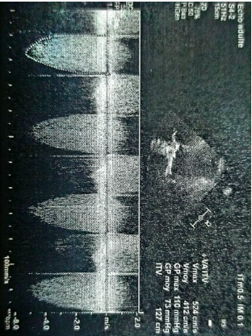
Figure 1 : Transthoracic echocardiographic image showing an increased transaortic gradient of 73 mmHg consistent with obstructive thrombosis of an aortic valve prosthesis.
According to European Society of Cardiology (ESC) guidelines, emergency valve replacement surgery is the treatment of choice in such cases, with thrombolytic therapy reserved for situations where surgery is unavailable or contraindicated. Due to the unavailability of immediate surgical intervention, intravenous thrombolysis with tenecteplase (Metalyse) was initiated, alongside supportive medical therapy for cardiogenic shock, including non-invasive ventilation (CPAP), loop diuretics, and continuous cardiac and respiratory monitoring.
Within three hours of thrombolysis, the aortic valve click reappeared, accompanied by marked improvement in both hemodynamic and respiratory parameters. No neurological deficits suggestive of cerebral embolism were observed post-thrombolysis. However, the patient developed left shoulder pain raising suspicion for atypical chest pain, which was later confirmed to be coronary embolism, a rare but known complication of thrombolytic therapy. Electrocardiography showed ST-segment elevation in the anteroseptal leads, and serial high-sensitivity troponin assays revealed a sharp and exponential rise, consistent with acute coronary syndrome secondary to embolization.
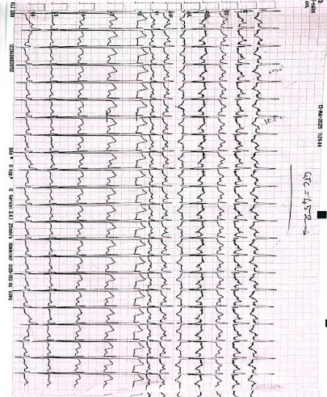
Figure 2 : ECG showing an embolic complication of thrombolysis consistent with a coronary embolism: ST-segment elevation in the antero-septo-apical leads with reciprocal changes in the inferior leads.
Subsequent echocardiographic evaluation demonstrated a reduction in left ventricular ejection fraction (LVEF) to 40%. The transprosthetic gradient had decreased significantly to 12 mmHg, and prosthetic leaflet mobility was restored. This was confirmed by both transesophageal echocardiography (TEE) and cinefluoroscopy. These findings indicated successful thrombolysis in resolving the obstructive prosthetic thrombosis
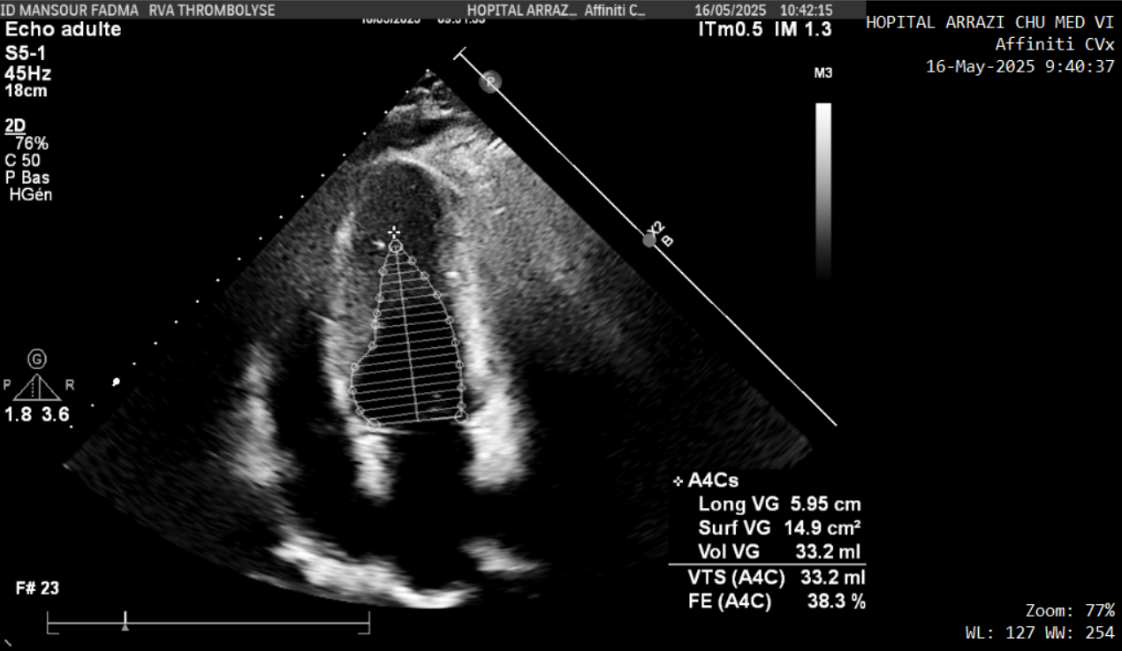
Figure 3 : Echocardiographic image showing impaired left ventricular ejection fraction of ischemic origin due to a coronary embolism.
DISCUSSION :
Prosthetic valve thrombosis (PVT) is a rare but life-threatening complication of mechanical heart valves, with obstructive forms representing a medical emergency due to the risk of acute heart failure, cardiogenic shock, and sudden cardiac death [2]. Although PVT is more common in the mitral position, mechanical aortic valve thrombosis, while less frequent, is associated with high mortality when left untreated [3]. Our case illustrates a classic presentation of obstructive aortic PVT in the setting of a 15-day interruption of vitamin K antagonist (VKA) therapy—currently identified as the most significant modifiable risk factor for thrombotic events in these patients [8].
Clinically, the abrupt onset of dyspnea, signs of low cardiac output, pulmonary edema, and the abolition of the prosthetic valve click were highly suggestive of a mechanical obstruction. Transthoracic echocardiography (TTE) confirmed the diagnosis through a markedly elevated transvalvular gradient. Although imaging of leaflet motion was suboptimal due to the patient’s hemodynamic instability, the combination of clinical and echocardiographic findings was sufficient to presume an obstructive thrombus [9]. Additional imaging modalities, such as transesophageal echocardiography (TEE) or multidetector computed tomography (MDCT), may be helpful to distinguish thrombus from pannus in less urgent cases [10].

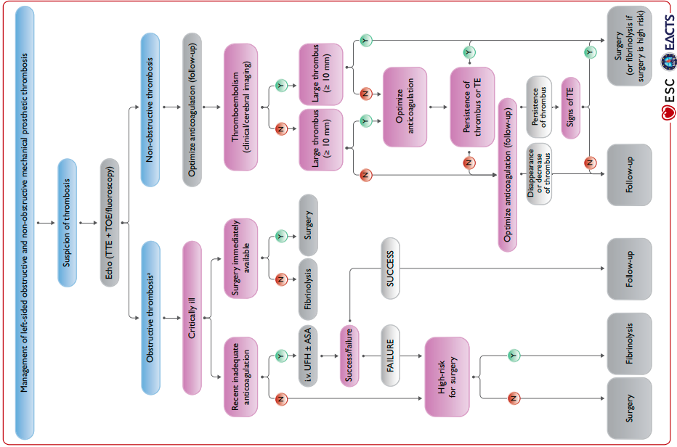
Figure 4 : Management of left-sided obstructive and non-obstructive mechanical prosthetic valve thrombosis according to the 2021 ESC guidelines.
Management of obstructive left-sided PVT remains challenging and time-sensitive. According to the 2021 European Society of Cardiology (ESC)/European Association for Cardio-Thoracic Surgery (EACTS) guidelines, emergency surgery is the treatment of choice in critically ill patients with NYHA class III–IV symptoms [11]. However, thrombolytic therapy is considered an acceptable alternative when surgery is contraindicated or not readily available. Recent data suggest that thrombolysis may be equally effective in select patients, with comparable survival rates to surgery when initiated early [12].
In our case, the lack of immediate access to cardiac surgery justified the use of thrombolysis with tenecteplase after careful risk-benefit assessment. The patient showed rapid clinical improvement with normalization of the transvalvular gradient and reappearance of the prosthetic click. These findings support existing evidence demonstrating that low-dose, slow-infusion thrombolytic protocols can achieve high success rates while minimizing adverse events [13]. The TROIA and PROMETEE trials previously highlighted the efficacy and safety of such regimens [7], and more recent reports have confirmed these outcomes across different clinical settings, including mechanical aortic valve thrombosis [15].
Despite the favorable response to thrombolysis, our patient experienced a rare but serious complication: coronary embolism, likely resulting from thrombus fragmentation. Although cerebrovascular events are the most frequently reported embolic complications, coronary artery embolism is increasingly recognized and may present atypically, as in our case with isolated shoulder pain [16]. Diagnosis was established based on ST-segment elevation in the anterior leads and a marked rise in troponin levels, indicating embolic myocardial infarction. The resulting reduction in left ventricular ejection fraction to 40% further supported the presence of ischemic myocardial injury, a consequence documented in several reports of coronary embolism following thrombolysis [17].
This case highlights several important clinical lessons. First, it underscores the absolute necessity of strict adherence to anticoagulation therapy in patients with mechanical heart valves. Second, it demonstrates that thrombolysis remains a life-saving therapeutic option in emergencies when surgery is not immediately available, particularly with the use of carefully titrated regimens. Finally, it emphasizes the importance of clinician awareness regarding potential iatrogenic complications of thrombolysis, including underrecognized coronary embolism, which may occur even in the absence of typical chest pain symptoms.

CONCLUSION :
This case highlights the diagnostic and therapeutic challenges of obstructive prosthetic valve thrombosis (PVT), a rare but life-threatening complication, particularly when affecting mechanical aortic valves. The abrupt clinical deterioration in our patient following anticoagulation discontinuation illustrates the critical importance of strict adherence to VKA therapy, which remains the cornerstone of prevention in patients with mechanical heart valves [4].
Although emergency surgical intervention is considered the gold standard in patients with obstructive PVT and hemodynamic instability, thrombolysis can serve as a life-saving alternative in centers without immediate surgical access [4]. In our case, thrombolytic therapy led to rapid hemodynamic improvement and full recovery of prosthetic valve function, supporting its utility in appropriately selected patients. This aligns with findings from large observational studies and trials, including TROIA and PROMETEE, which confirmed the effectiveness and relative safety of thrombolytic regimens when carefully administered [7].
However, this therapeutic approach is not without risk. Our patient developed a coronary embolism, a rare but serious complication of thrombolysis, which manifested atypically. Although stroke is the most frequently encountered embolic event, this case serves as a reminder that non-cerebral embolic complications, particularly coronary embolism, must also be actively monitored for following thrombolytic therapy [5].
In summary, this case reinforces several essential clinical messages:
- Early recognition of prosthetic valve dysfunction in the emergency setting is vital.
- Thrombolysis remains a valid therapeutic option in resource-limited situations, when surgical delay may result in death [6].
- Close clinical and imaging follow-up is critical to confirm therapeutic success and detect possible complications.
- Most importantly, sustained patient education and anticoagulation adherence are paramount to preventing these catastrophic events [4].
CONSENT
As per international standards or university standards, patient(s) written consent has been collected and preserved by the author(s).

ETHICAL APPROVAL
It is not applicable.

DISCLAIMER (ARTIFICIAL INTELLIGENCE)
Author(s) hereby declare that NO generative AI technologies and text-to-image generators have been used during writing or editing of this manuscript.

Competing interests
Author has declared that no competing interests exist.
References
- Lengyel M, et al. Recommendations for the management of prosthetic valve thrombosis. Eur Heart J. 1997;18(1):132–138.
- Roudaut R, et al. Mechanical prosthetic valve thrombosis. J Am Coll Cardiol. 2003;41(4):653–658.
- Barbetseas J, et al. Clinical presentation of prosthetic valve thrombosis. Circulation. 1995;91(4):1031–1035.
- Nishimura RA, et al. 2017 AHA/ACC Focused Update on the Management of Valvular Heart Disease. J Am Coll Cardiol. 2017;70(2):252–289.
- Lengyel M. Thrombosis of prosthetic heart valves: classification, diagnosis, and management. Heart. 2004;90(4):446–451.
- Özkan M, et al. Comparison of different thrombolytic regimens for the treatment of prosthetic valve thrombosis: The TROIA trial. Am J Cardiol. 2013;112(10):1621–1627.
- Özkan M, et al. Long-term results of thrombolytic therapy for mechanical prosthetic valve thrombosis: The PROMETEE trial. J Am Coll Cardiol. 2013;62(13):1260–1266.
- Habib G, et al. Prosthetic valve thrombosis: an update. Curr Probl Cardiol. 2023;48(6):101698.
- Ríos RA, et al. Imaging prosthetic heart valve obstruction: distinguishing thrombus from pannus. J Cardiovasc Imaging. 2022;30(1):28–37.
- Farag M, et al. Evaluation of prosthetic valve obstruction by multimodality imaging. Eur Heart J Cardiovasc Imaging. 2023;24(4):448–460.
- Vahanian A, et al. 2021 ESC/EACTS Guidelines for the management of valvular heart disease. Eur Heart J. 2022;43(7):561–632.
- Latib A, et al. Thrombolysis vs surgery for left-sided mechanical valve thrombosis: outcomes from a multicenter registry. J Am Coll Cardiol. 2021;78(20):2020–2030.
- Sadeghian H, et al. Low-dose, slow-infusion thrombolysis for prosthetic valve thrombosis: a safe alternative. J Tehran Univ Heart Cent. 2023;18(1):1–6.
- Iqbal A, et al. Mechanical aortic valve thrombosis successfully treated with intravenous thrombolytic therapy: a case report. Cureus. 2023;15(5):e39345.
- Joshi A, et al. Mechanical valve thrombosis in low-resource settings: role of repeat thrombolysis. Indian Heart J. 2024;76(1):12–16.
- Little SH, et al. Coronary embolism complicating thrombolysis for prosthetic aortic valve thrombosis. JACC Case Rep. 2020;2(10):1572–1576.
- Choi JY, et al. Coronary embolism after mechanical aortic valve replacement: a rare cause of myocardial infarction. J Cardiothorac Surg. 2024;19(1):25

