***Case report***

Severe Pulmonary Arterial Hypertension Induced by Dasatinib in a Patient with Chronic Myeloid Leukemia: A Case Report

# Abstract

Background: Pulmonary arterial hypertension (PAH) is a rare but serious complication of some tyrosine kinase inhibitors (TKIs), notably Dasatinib, used in chronic myeloid leukemia (CML). Early diagnosis is crucial, as clinical improvement is often possible after drug discontinuation.  
  
Case Presentation: We report the case of a 60-year-old man treated with Dasatinib for CML who developed progressive and severe dyspnea. Transthoracic echocardiography revealed marked right heart dilation and an estimated pulmonary artery systolic pressure of 105 mmHg. Right heart catheterization confirmed severe precapillary PAH. After ruling out other causes, Dasatinib was discontinued, and a targeted triple therapy was initiated, resulting in significant clinical and hemodynamic improvement.  
  
Conclusion: This case highlights the importance of recognizing drug-induced PAH in patients on Dasatinib. Any unexplained dyspnea should prompt cardiopulmonary evaluation. Timely drug discontinuation and initiation of specific therapy can improve prognosis.  
  
Keywords: Pulmonary arterial hypertension, Dasatinib, Chronic myeloid leukemia, Tyrosine kinase inhibitors, Right heart catheterization

# Introduction

Pulmonary arterial hypertension (PAH) is a rare and potentially life-threatening vascular disorder characterized by progressive elevation of pulmonary artery pressure, leading to right heart failure. In the current ESC/ERS classification, drug-induced PAH constitutes a well-defined subgroup that requires early recognition and appropriate management.  
  
Dasatinib is a second-generation tyrosine kinase inhibitor (TKI) targeting BCR-ABL, commonly used in cases of intolerance or resistance to Imatinib in CML. Since 2009, multiple cases of Dasatinib-induced PAH have been reported. Although the prevalence remains below 1%, the condition may be underdiagnosed due to the insidious nature of symptoms. Suggested mechanisms include endothelial dysfunction, PDGF inhibition, nitric oxide pathway alterations, and chronic vascular inflammation leading to pulmonary vascular remodeling.  
  
We report a case of severe PAH in a patient with CML, confirmed by right heart catheterization, with favorable evolution after drug withdrawal and specific vasodilator therapy.

# Case Presentation

A 60-year-old man with no prior cardiovascular history was diagnosed with chronic phase CML in January 2023. Initial treatment with Imatinib was stopped due to a severe allergic reaction, and Dasatinib was initiated at 100 mg daily. The patient achieved a complete hematologic response within weeks and tolerated the drug well initially.  
  
In December 2024, nearly two years after starting Dasatinib, the patient presented with progressively worsening dyspnea, eventually reaching NYHA class IV. There were no chest pains, peripheral edema, or syncope. On examination, the patient had tachycardia, jugular venous distension, and a systolic murmur over the tricuspid area. Oxygen saturation was 93% on room air, and blood pressure was stable.  
  
The ECG revealed right axis deviation and signs of right ventricular hypertrophy. Transthoracic echocardiography showed marked right ventricular dilation, elevated TAPSE (42 mm), estimated pulmonary artery systolic pressure of 105 mmHg, and preserved left ventricular ejection fraction (67%). Chest CT angiography excluded pulmonary embolism but showed septal inversion and significant right-sided cardiomegaly.  
  
A comprehensive etiological work-up ruled out thromboembolic disease, parenchymal lung pathology, left heart disease, or autoimmune disorders. Liver and renal function were normal. Right heart catheterization confirmed severe precapillary PAH with a mean pulmonary artery pressure (mPAP) of 51 mmHg, pulmonary vascular resistance of 12.6 Wood Units, and a reduced cardiac index of 1.77 L/min/m². Vasoreactivity testing was negative.  
  
Following multidisciplinary discussion, Dasatinib and beta-interferon (Rebif), recently co-prescribed, were discontinued. The patient was initiated on a triple therapy consisting of continuous intravenous epoprostenol, oral bosentan (125 mg twice daily), and tadalafil (40 mg daily). Significant clinical improvement was observed within a few weeks, with the patient improving to NYHA class II after two months. Multidisciplinary follow-up was established.

# Discussion

This case illustrates a typical presentation of drug-induced PAH due to Dasatinib, occurring after prolonged exposure. While its reported incidence is low (<1%), it may be underestimated due to the nonspecific nature of symptoms and the lack of systematic screening.  
  
The pathophysiological mechanism remains under investigation. Dasatinib inhibits multiple tyrosine kinases, including SRC and PDGFR, which are important for vascular homeostasis. Endothelial injury, prolonged vasoconstriction, and inflammation may lead to irreversible vascular remodeling. Unlike idiopathic PAH, drug-induced forms may improve significantly with early drug withdrawal and appropriate vasodilator therapy.  
  
Right heart catheterization remains essential for confirming the diagnosis of precapillary PAH, especially in the absence of left heart dysfunction or pulmonary parenchymal disease. According to the 2022 ESC/ERS guidelines, immediate discontinuation of the causative drug is mandatory, particularly in patients presenting with severe functional limitations or high-risk hemodynamic profiles.  
  
Targeted vasodilator therapy involving prostacyclins, endothelin receptor antagonists, and phosphodiesterase-5 inhibitors has shown favorable outcomes in drug-induced PAH. In our case, combination therapy with epoprostenol, bosentan, and tadalafil led to rapid clinical and hemodynamic improvement, validating the strategy of initial triple therapy in severe cases.  
  
This case also highlights the importance of early recognition of respiratory symptoms in patients receiving Dasatinib. Routine cardiopulmonary monitoring, including echocardiography, may be warranted in selected patients. Coordination between hematologists, cardiologists, and pulmonologists is essential to optimize management and outcomes. Long-term follow-up is crucial, as PAH may persist or recur even after cessation of the offending drug.

# Conclusion

Dasatinib-induced PAH is a rare but serious complication in patients with CML. Unexplained dyspnea in patients on TKIs should prompt comprehensive cardiopulmonary evaluation. Right heart catheterization remains the gold standard for diagnosis. Early drug withdrawal and initiation of targeted triple therapy can significantly improve prognosis. A multidisciplinary approach is essential in managing such complex cases.

# Patient Consent

Written informed consent was obtained from the patient for the publication of this case report and any accompanying data or images.

# References

1. Simonneau G, Montani D, Celermajer DS, et al. Eur Respir J. 2019;53(1):1801913.  
   2. Humbert M, Kovacs G, Hoeper MM, et al. Eur Heart J. 2022;43(38):3618–3731.  
   3. Montani D, Bergot E, Günther S, et al. Circulation. 2012;125(17):2128–2137.  
   4. Weatherald J, Chaumais MC, Savale L, et al. Eur Respir J. 2020;55(1):1900377.  
   5. Martignetti JA, Kumar R, Yeung SJ. J Clin Hypertens. 2021;23(1):79–85.  
   6. Galiè N, McLaughlin VV, Rubin LJ, Simonneau G. Eur Respir J. 2019;53(1):1802148.  
   7. Lebrin M, Savale L, Jaïs X, et al. ERJ Open Res. 2023;9(1):00654-2022.

# Figures

Figure 1. Chest X-ray showing cardiomegaly and prominent pulmonary arteries.

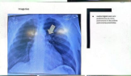

Figure 2. Echocardiography demonstrating right ventricular dilation and elevated pulmonary artery pressure.

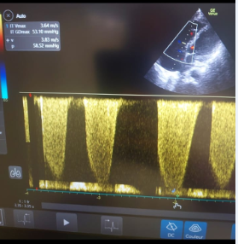

Figure 3. Thoracic CT scan revealing right heart dilation and septal inversion.

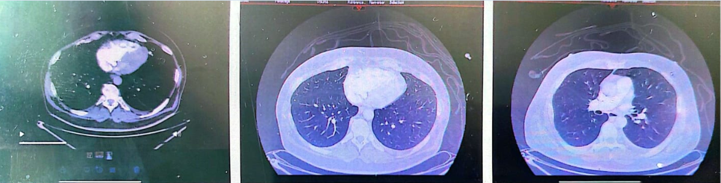

Figure 4. Right heart catheterization waveform showing precapillary pulmonary arterial hypertension.

