**IMPACTS OF KOLAVIRON ON SOME GENES ASSOCIATED WITH GLUCOSE METABOLISM IN STREPTOZOTOCIN-INDUCED DIABETIC WISTAR RATS**

**ABSTRACT**

**Background:** Despite advances in diabetic treatment, side effects of antidiabetic drugs, including hypoglycemia and allergic reactions, drive the search for safer natural alternatives. Kolaviron, a biflavonoid complex from Garcinia kola, has demonstrated antihyperglycemic properties, but its molecular impact on glucose metabolism-related genes remains understudied. This study aims to evaluate the effects of kolaviron on ARNT, RATINS, GLUT-4, and TLR-4 gene expression in streptozotocin-induced diabetic Wistar rats. **Materials and Methods:** A total of 28 adult male and female Wistar rats weighing 200–250g were divided into five groups. Diabetes was induced in 26 rats using 42 mg/kg streptozotocin. Animals were grouped into five: Group A (non-diabetic control, n=2), Group B (untreated diabetic, n=2), Group C (diabetic, metformin 100 mg/kg, n=6), Group D (diabetic, kolaviron 100 mg/kg, n=6), and Group E (diabetic, kolaviron 200 mg/kg, n=6). Treatments lasted three months. Blood glucose and HbA1c were assessed monthly. mRNA expression of target genes was evaluated by qPCR. Sequence variations were analyzed using Sanger sequencing. **Results:** Kolaviron at 100 and 200mg/kg body weight significantly reduced blood glucose and HbA1c levels (P<0.001). There was a significant upregulation of ARNT, RATINS, GLUT-4, and TLR-4 in kolaviron-treated groups, with minor fluctuations in some months. A silent A→G mutation was detected at amino acid 885 of TLR-4 without altering protein function. **Conclusion:** Kolaviron improved glycemic control and modulated key genes in glucose metabolism without inducing harmful mutations, supporting its potential as a natural antidiabetic agent.

**Keywords:** Diabetes, kolaviron, dtreptozotocin, ARNT, RATINS, GLUT-4, TLR-4.

**1. INTRODUCTION**

Medicinal plants have gained global interest as affordable and accessible treatments for chronic diseases, particularly diabetes mellitus [1]. Despite the availability of numerous standard drugs like insulin and oral hypoglycemic agents, issues like adverse effects, high cost, limited accessibility in low-resource settings, and the emergence of drug resistance highlight the urgent need for alternative remedies [2 and 3]. Many traditional medicinal plants have demonstrated promising antidiabetic properties, including antioxidant, hypoglycemic, and insulin-sensitizing effects, and continue to be investigated for their bioactive phytochemicals and mechanisms of action [4]. Consequently, integrating ethnomedicinal knowledge with modern scientific validation offers a sustainable pathway for developing safer, cost-effective treatments to manage and prevent diabetes and its complications.

*Garcinia kola*, commonly called bitter kola, is a plant native to West and Central Africa. Its biflavonoid extract, kolaviron, has exhibited antioxidant, anti-inflammatory, and hypoglycemic properties in various in vivo and in vitro studies [5]. Previous studies primarily focused on its biochemical effects using ELISA and histology, but the genetic pathways involved remain scarcely understood [6].

Several genes regulate glucose metabolism, such as ARNT (Aryl Hydrocarbon Receptor Nuclear Translocator), which are essential for insulin signaling and glucose homeostasis [7]. RATINS (Rat Insulin-like gene), regulates pancreatic insulin synthesis [8] while the Glucose Transport type 4 genes (GLUT-4) facilitate insulin-stimulated glucose uptake [9]. Toll-like Receptor type genes (TLR-4) are linked to inflammation-mediated insulin resistance [10]. Understanding kolaviron’s effect on these genes could broaden its therapeutic profile and elucidate the molecular pathways involved in its antidiabetic actions. Against this background, this study aimed to determine the effect of kolaviron on some genes associated with glucose metabolism in streptozotocin-induced diabetic Wistar rats.

**2. MATERIALS AND METHODS**

**2.1 Plant Collection and Identification**

*Garcinia kola* seeds from a market in the city of Ilorin, Nigeria, were authenticated at the University of Ilorin Herbarium (voucher no: UILH/001/1217/2024).

**2.2 Plant Extraction Preparation**

Fresh *Garcinia kola* seeds were dried, pulverized, and about 100g of the powder was defatted using petroleum ether. The ethanolic extraction was carried out at room temperature (18-220C) as described by [11] using Soxhlet apparatus.

**2.3 Animal Housing**

The study was carried out at the University of Benin, Benin City, Nigeria. Thirty-two Wistar rats (10–15 weeks, ~230g) were acclimatized for one week under standard laboratory conditions at the Animal house of the Department of Anatomy, University of Benin, Benin City. Food and water were provided ad libitum.

**2.4 Ethical Approval**

The protocol for this study was approved by the Ministry of Agriculture and Natural Resources, Benin City, Edo State, Nigeria (Ref: V.1041/27).

**2.5 Acute Toxicity (LD₅₀) Test**

Acute oral toxicity was assessed by administering single doses of 1,000–5,000 mg/kg kolaviron (KV) as previously described by the Locke’s method [12]. No mortality or behavioral changes were observed after 24–72 hours, confirming its safety. Behavioural toxicity signs and also mortality were closely monitored.

**2.6 Diabetes Induction**

Following overnight fasting, diabetes was induced using a single intraperitoneal dose of 42 mg/kg streptozotocin in 0.1M citrate buffer (pH 4.5). Rats with fasting glucose ≥250 mg/dL after 72 hours were considered diabetic [13].

**2.7 Experimental Grouping and Treatment**

A total of 22 Wistar rats that consisted of 11 males and 11 females were distributed into 5 groups in the test experiment of kolaviron administration as follows in Table 1.

**Table 1: Abatement Administration in relation to Duration**

Group Description No of Rats Treatment

______________________________________________________________________________

A Non-diabetic control 2 1mL of distilled water

B Diabetic, untreated 2 NIL

C Diabetic + Metformin 6 100mg/kg of metformin

D Diabetic + Kolaviron (Low dose) 6 100mg/kg of kolaviron

E Diabetic + Kolaviron (High dose) 6 200mg/kg of kolaviron

**___________________________________________________________________________**

Treatments were administered for three consecutive months.

**2.8 Sample Collection and Laboratory Analysis**

At each month’s end, blood was drawn via retro-orbital puncture after fasting. Glucose was measured using the glucose oxidase method [14]. HbA1c was quantified with the MISPA-i2 analyzer [15].

Liver, kidney, and pancreatic tissues were harvested post-mortem. RNA was extracted using Trizol, quantified, and converted to cDNA. Quantitative PCR (qPCR) was performed using gene-specific primers. β-actin served as the housekeeping gene. Gene expression was analyzed using the ΔΔCt method. Sanger sequencing analyzed mutations in the amplified genes [16, 17 and 18].

All organs were examined for gross lesions. Tissues of interest were taken at necropsy, fixed in 10% buffered formol saline (1 part of tissue to 10 parts of fixative) and then labelled. The tissues were dehydrated through ascending grades of alcohol, cleared in xylene, wax impregnated and finally embedded in paraffin wax. They were sectioned at 5µm using a Rotary microtome and stained by Mayer’s haematoxylin and Eosin (H & E) method for microscopic assessment. Any evidence of histopathological changes was observed using CX23 Olympus microscope.

**2.9 Statistical Analysis**

Data were expressed as mean ± SEM. One-way ANOVA with Tukey’s post hoc test analyzed group differences. P-values <0.05 were considered statistically significant. Genetic analysis was performed using BioEdit and MEGA 6.0.

**3.0 RESULTS**

**Effects on Blood Glucose and HbA1c**

Kolaviron (KV) significantly reduced fasting blood glucose and HbA1c in diabetic rats, similar to metformin. Diabetic rats (Group B) showed persistent hyperglycemia, confirming successful diabetes induction (Table 2).

**3.1 Gene Expression Findings in the Kidney, Liver, and Pancreas of STZ Induced-diabetic Wistar rats.**

Treatment of diabetic rats with 100 mg/kg body weight of Metformin, 100 and 200mg/kg body weight of kolaviron throughout the three months of the study; caused consistent upregulation of ARNT, RATINS, TLR-4 and GLUT-4 genes in the kidney of diabetic rats across all treated groups. Meanwhile, there were occasional exceptions: **TLR‑4** showed **downregulation** in the **first month**, and **GLUT‑4** was **downregulated** in the **second month**. **Kolaviron**, at both dosages (100 and 200 mg/kg), produced a **greater gene expression effect** than metformin during the entire study period (Figure 1).

The same four genes in the liver of diabetic rats experienced remarkable **elevated expression** under treatment with 100mg/kg of kolaviron eliciting more than 10 fold increases in nearly all target genes, outperforming metformin (Figure 2).

The administration of 100 and 200 mg/kg of kolaviron for three months enhanced the upregulation of all four genes in the pancreas of diabetic rats throughout the study. A**silent mutation** was identified at **position 885 of the TLR‑4** gene in kolaviron‑treated animals (Figures 3 and 4).

**3.2 Histological Observations**

Histopathological analysis of the liver, kidney, and pancreas showed no structural damage in kolaviron-treated groups, supporting the compound's safety.

**4. DISCUSSION**

The synthesis and release of insulin by the β-cells maintain glucose homeostasis and prevent metabolic diseases. Inflamed and stressed β-cells of the pancreas are functionally impaired and may not promptly respond to increased insulin demand in hyperglycaemic conditions. This invariably worsens β-cells dysfunction, resulting in β-cell failure and the onset of diabetes mellitus [19].

Glycated haemoglobin (HbA1c) expresses the percentage of haemoglobin bound to glucose; this sensitive index measures the mean blood glucose level over 6–8 weeks (life span of red blood cells) and reflects glycemic control in patients [20]. Diabetes disrupts glucose homeostasis, leading to metabolic complications. Current medications, though effective, are often accompanied by side effects or are inaccessible in low-resource settings.

This study demonstrates that kolaviron, a biflavonoid complex isolated from *Garcinia kola* seeds, significantly ameliorated hyperglycemia as evidenced by the remarkable reduction in blood glucose and HbA1c levels at both 100 and 200 mg/kg body weight doses of kolaviron (P < 0.001). This finding is in tandem with the previous reports of Adaramoye et al. [21] and Iwalokun et al. [22] that indicate the kolaviron’s hypoglycemic properties in diabetic animal models. This finding of the reduction in HbA1c which is an integrated marker of long-term glycemic control, suggests sustained glucose-lowering effects beyond acute glycemic fluctuations by the up regulation influence of kolaviron on the ARNT, RATINS, TLR4, and GLUT4 gene expressions that are responsible for glucose homeostasis in the cells.

ARNT (Aryl Hydrocarbon Receptor Nuclear Translocator) has been recognized to play a pivotal role in glucose homeostasis. It does this by dimerizes HIF-1α to regulate hypoxia-induced genes and has been reported in β-cell function and insulin secretion [23]. The upregulation of ARNT suggests that kolaviron may aid the performance of β-cell and insulin synthesis under metabolic stress.

Similarly, increased expression of an insulin gene homolog called RATINS could indicate augmented pancreatic insulin production, complementing the ARNT effect. Although direct studies on kolaviron’s regulation of insulin gene expression are scarce, flavonoids are known to modulate β-cell gene transcription [24]. A significant finding is the upregulation of GLUT-4, the insulin-regulated glucose transporter predominantly expressed in adipose tissue and skeletal muscle. GLUT-4 expression facilitates increased glucose uptake into peripheral tissues, thereby reducing circulating glucose levels [25]. Polyphenolic compounds, including kolaviron, may activate signaling pathways like PI3K/Akt that promote GLUT-4 gene transcription and translocation to the plasma membrane [26].

ARNT, a transcription factor in insulin gene regulation, and RATINS, an insulin precursor gene, were both upregulated, indicating enhanced insulin production.

The upregulation of TLR-4 is particularly intriguing because it has dual roles in metabolic regulation and innate immunity. While TLR-4 activation is generally associated with pro-inflammatory responses and insulin resistance [27], recent study suggests that certain contexts of mild TLR-4 activation may also promote tissue repair and modulate insulin sensitivity [28]. In this study, the significance of TLR-4 upregulation may be due to an immunomodulatory effect of kolaviron that balances metabolic inflammation. A silent A→G mutation at amino acid 885 of TLR-4 was detected in this study. It has been observed that silent mutations do not alter the encoded amino acid and thus typically do not affect protein function directly. However, they can influence mRNA stability, translational efficiency, or splicing in some contexts [29]. Since no functional alteration was observed, this mutation is likely a neutral polymorphism, although its long-term biological relevance warrants further study. Its occurrence without amino acid alteration suggests kolaviron’s genomic safety.

The mild fluctuations in gene expression levels observed across the treatment months may be reflective of adaptive responses to chronic kolaviron exposure in this study. Bioactive plant compounds often exhibit varying pleiotropic effects with dosage and duration, as observed in other flavonoid studies [30].

Taken together, the present findings support kolaviron’s multifaceted antidiabetic potential, combining direct hypoglycemic effects with modulation of key genes regulating insulin secretion, glucose uptake, and innate immunity. The findings in this study reinforce the ethnomedicinal use of *Garcinia kola* in managing metabolic disorders. toxicities. This supports its ethno-medicinal use as a viable alternative therapy, particularly in resource-limited regions

Treatment of diabetic rats with kolaviron has an ameliorative effect on all the organs, especially the liver and pancreas, where the activity of the Glucose transporter type 4 gene was upregulated throughout the whole three-month duration of the study. Furthermore, histopathological findings revealed that the administration of kolaviron, regardless of dosage, did not elicit any adverse effect on the cellular architecture of the kidney, liver, and pancreas when compared with the non-diabetic Wistar rats (Figures 5-7). The antidiabetic and antihyperlipidemic properties of kolaviron have been previously reported [20], which is consistent with the findings in this study.

Comparatively, kolaviron’s efficacy rivaled metformin, the standard antidiabetic drug, without observed. Future studies should delineate the precise molecular pathways involved, the role of gut microbiota, and the possible long-term safety implications of chronic TLR-4 modulation in kolaviron metabolism.

**Table 2: Effect of Kolaviron on Glycaemic Biomarkers of STZ Induced-diabetic Wistar rats for Three Months**

|  |  |  |  |  |  |  |  |  |  |  |  |  |  |
| --- | --- | --- | --- | --- | --- | --- | --- | --- | --- | --- | --- | --- | --- |
| Parameter | Non-diabetic Control  **A** | | Untreated Diabetic  **B** | | Metformin Treated  **C** | | Kolaviron 100mg/Kg  **D** | | Kolaviron 200mg/Kg  **E** | | | ***\*P-value*** | |
| Glucose | | 8.42±0.64 | | 20.76±8.72 | | 9.13±0.14 | | 9.87±0.21 | | 9.38±0.23 | <0.001 | |
| HbA1c | | 5.63±0.47 | | 6.43±0.66 | | 5.71±0.12 | | 5.83±0.09 | | 5.73±0.11 | <0.001 | |

*P-values were expressed as Mean±SD for six animals (n=6) in each group after treatment with Metformin (Group C) and Kolaviron (Groups D and E) respectively for three months.

**Figure 1: Dose-dependent effect of kolaviron on the expression of genes in the kidney of STZ induced-diabetic Wistar rats**

**Figure 2: Dose-dependent effect of kolaviron on the expressions of genes in the liver of STZ induced-diabetic Wistar rats**

**Figure 3:** **Dose-dependent effect of kolaviron on the expressions of genes in the pancreas of STZ induced-diabetic Wistar rats**

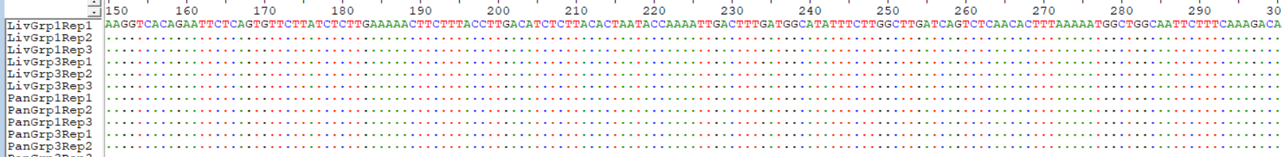 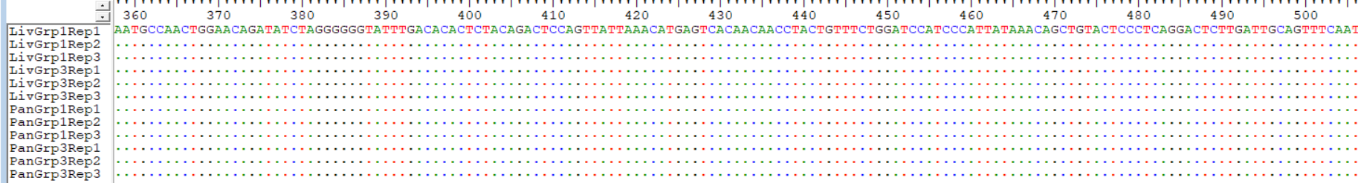 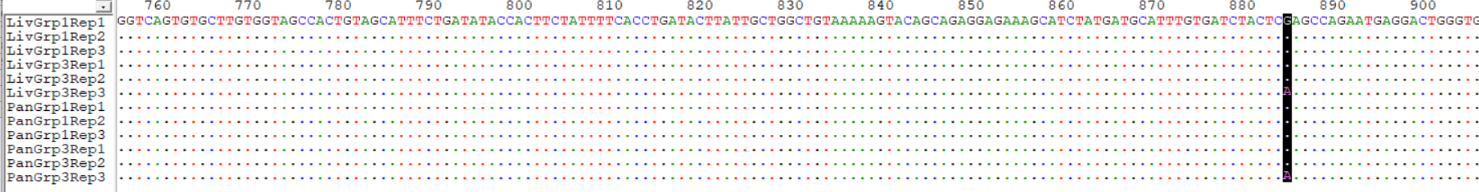

**Figure 4: Sequence Alignment Showing the Position of SNPs along the Amplified Toll-Like Receptor 4 (TLR4) Sequenced Fragment**

The SNP Position is marked with a bolded colour to indicate where the sample sequence deviates from the reference. Sequencing revealed a silent mutation in TLR-4, with a nucleotide substitution (A→G) at amino acid 885, changing AAA to AAG. This synonymous mutation did not alter lysine’s coding, indicating no functional impairment.

**Group A Group B Group C Group D Group E**

**(Control) (Untreated) (100mg/kg Metformin) (100mg/kg KV) (200mg/kg KV)**

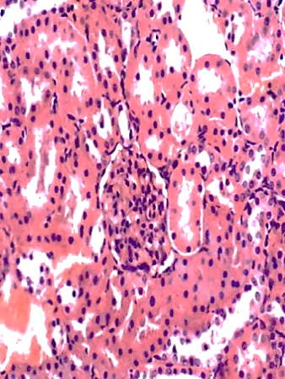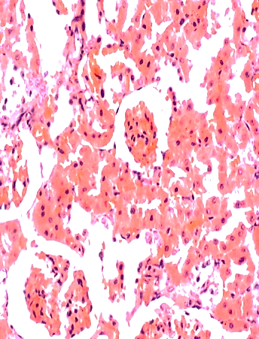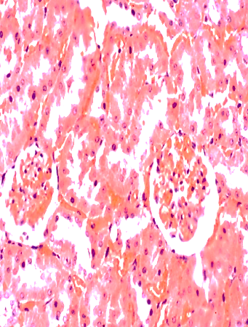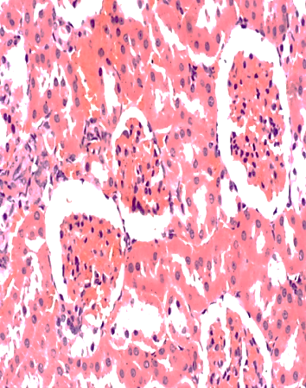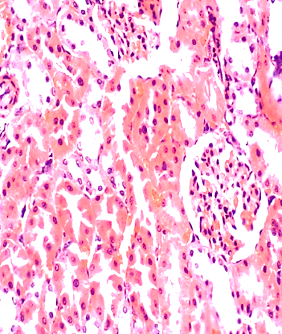

**KIDNEY X400 (H & E)**

**Figure 5: Dose-dependent effect of administration of metformin and kolaviron on the kidney of diabetic Wistar rats**

**Group A Group B Group C Group D Group E**

**(Control) (Untreated) (100mg/kg Metformin) (100mg/kg KV) (200mg/kg KV)**

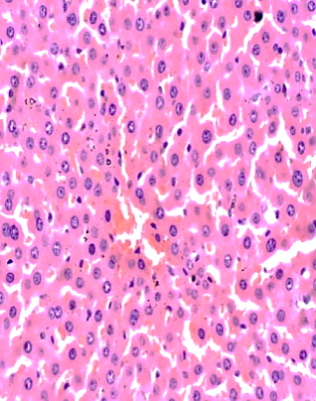 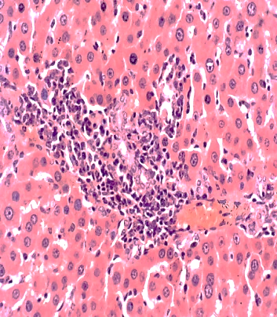 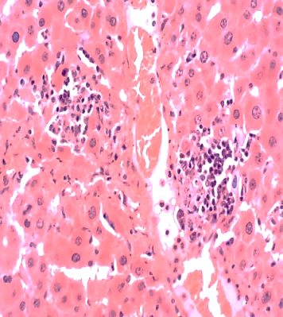 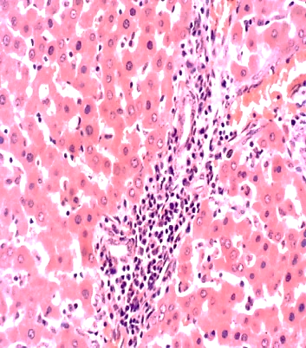 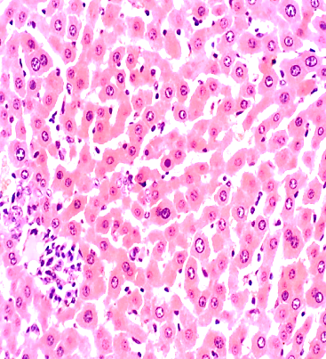

**LIVER X400 (H & E)**

**Figure 6: Dose-dependent effect of administration of metformin and kolaviron on the liver of diabetic Wistar rats**

**Group A Group B Group C Group D Group E**

**(Control) (Untreated) (100mg/kg Metformin) (100mg/kg KV) (200mg/kg KV)**

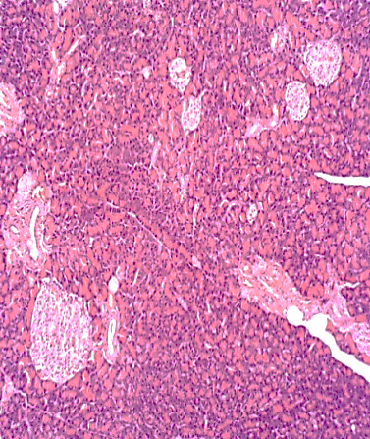 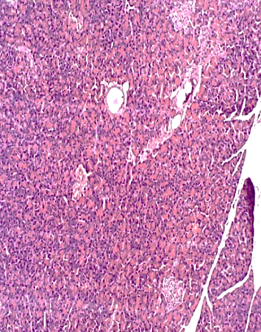 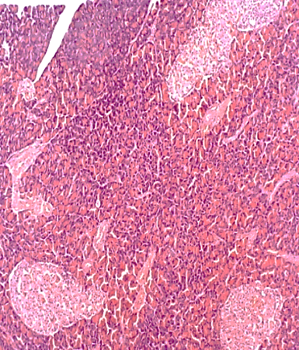 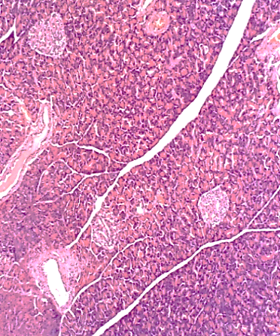 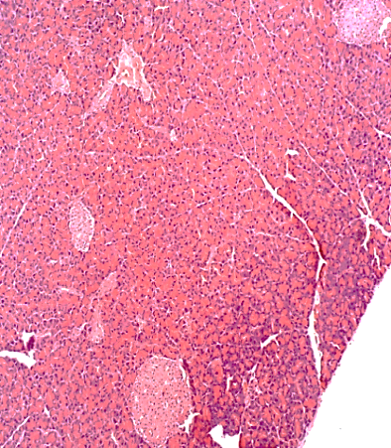

**PANCREAS X400 (H & E)**

**Figure 7: Dose-dependent effect of administration of metformin and kolaviron on the Pancreas of diabetic Wistar rats**

Longitudinal sections of the kidney, liver and pancreas following three months treatment of diabetic groups C, D, and E with 100mg/kg of metformin, 100mg/kg and 200mg/kg of kolaviron (KV) respectively as compared with the non-diabetic control (1 mL of distilled water) and untreated diabetic group B. Sections show a well preserved architecture of all the three organs for the control group. Groups B, C, D, and E show varied histological changes from widening of the Bowman’s space (arrow) and mild distortion of the flattened squamous tubular epithelial cells lining the Bowman’s space of the kidney. Sections of the liver from Groups B, C, D and E revealed hepatic tissue with preserved architecture composed of cords of normal hepatocytes (Black arrow). The portal tracts showed mild to moderate inflammation (Red arrow) with predominantly lymphocytes and histiocytes. Furthermore, groups B, C, D and E showed pancreatic tissue characterized by preserved architecture with numerous small to large size Islets of Langerhans (arrows). There are no features of significant inflammation or damage seen as compared with the control. Magnification was set x400.

**5. CONCLUSION**

Kolaviron at 100 and 200 mg/kg effectively improved glycemic control and upregulated genes critical to glucose metabolism in diabetic Wistar rats. Its safety was confirmed by the absence of toxic histological changes and harmless genetic mutations. These findings recommend kolaviron as a promising natural alternative for diabetes management.

**6. RECOMMENDATIONS**

Human clinical trials must be conducted to validate kolaviron’s efficacy and safety.

Affordable kolaviron-based formulations for diabetes treatment must be developed.

Further studies into its molecular pathways and long-term safety are needed.

**CONSENT**

It is not applicable

**REFERENCES**

1. Eddouks, M., Maghrani, M., Lemhadri, A., Ouahidi, M. L., and Jouad, H. (2012).

Ethnopharmacological survey of medicinal plants used for the treatment of diabetes

mellitus, hypertension and cardiac diseases in the south-east region of Morocco

(Tafilalet). *Journal of Ethnopharmacology,* 82(2-3), 193-202.

2. Modak, M., Dixit, P., Londhe, J., Ghaskadbi, S., & Paul, A. (2007). Indian herbs and

herbal drugs used for the treatment of diabetes. *Journal of Clinical Biochemistry and*

*Nutrition,* 40(3), 163–173.

3. Patel, D. K., Prasad, S. K., Kumar, R., & Hemalatha, S. (2012). An overview on

antidiabetic medicinal plants having insulin mimetic property. *Asian Pacific Journal of*

*Tropical Biomedicine,* 2(4), 320–330.

4. American Diabetes Association. (2020). Standards of Medical Care in Diabetes. *Diabetes*

*Care,* 43(Supplement 1), S1–S212.

5. Tcheghebe, O. T., Signe, M., Seukep, A. M. and Tatong, F. N. (2016)/ Review on

Traditional uses, phytochemical and pharmacological profiles of *Garcinia kola* Heckel.

*Merit Research Journal of Medicine and Medical Sciences,* 4(11), 480-489.

6. Ayepola, O. R., Cerf M. E., Brooks N. L.and Oguntibeju O. O. (2014). Kolaviron, a

biflavonoid complex of Garcinia kola seeds modulates apoptosis by suppressing

oxidative stress and inflammation in diabetes-induced nephrotoxic rats. *Phytomedicine*,

21(14), 1785–1793.

7. Lee, J., and Jaemin, L. (2022). Endoplasmic Reticulum (ER) Stress and its Role in

Pancreatic β-Cell Dysfunction and Senescence in Type 2 Diabetes. *International Journal*

*of Molecular Sciences,* 23(9), 4843.

8. Wataru, N., Hiroak, I., and Munkhtuya, T. (2022). Role of the Transcription Factor

MAFA in the Maintenance of Pancreatic β-cells. *International Journal of Molecular*

*Science,* 23(9), 4478-4480.

9. Al-Ishaq, R. K., Abotaleb, M, K., Kajo, K. and Büsselberg, D. (2019): Flavonoids and the

Anti-[diabetic Effects: Cellular Mechanisms and Effects to Improve Blood Sugar Levels.](https://pubmed.ncbi.nlm.nih.gov/31480505/)

*Biomolecules,*9(9), 430-432.

10. Sameer, A. S. and Saniya, N. (2021). Toll-Like Receptors (TLR): Structure, Functions,

Signaling and Role of their Polymorphisms in Colorectal Cancer Susceptibility. *Biomedical Research International,* 21**,** 1157023.

11. Komolafe, I. J., Akinlalu, A. O., Ogunsusi, M., and Oyedapo, O. O. (2016). Protective

effects of extract and fraction of root-bark of *Garcinia kola* (Heckel) on the renal

biochemical parameters of gentamicin-induced nephrotoxic rats. *African Journal of*

*Biochemistry Research,* 10 (5)**,** 30-37.

12. Sadiq, I. S., Abubakar, F. S., Hassan, H. A. and Ibrahim, M. (2020). Working with

Bioactive Substances from Medicinal Plants in Animals. *South Asian Journal of Natural*

*Products,* 3(2), 27 – 37.

13. Asghar, G. and Sajad, J. (2023). Streptozotocin as a Tool for Induction of Rat Models of

Diabetes: A Practical Guide. *EXCLI Journal of Experimental and Clinical Sciences,* 22,

274-279.

14. Trinder, P. (1969). Determination of Glucose in blood using Glucose Oxidase with an

alternative Oxygen Acceptor. *Annal of Clinical Biochemistry,* 6, 24-27.

15. Navin, K. S., Binod, K., Uma, S. S. and Ila, J. (2018). Role of Glycosylated Haemoglobin

(HbA1c) Estimation in cases of Gestational Diabetes. *IOSR Journal of Dental and*

*Medical Sciences,* 17(7), 1-3.

16. Al-Shaqha, M. K., Waleed, M., Nasir, S., Arezki, A., and Ahmad, A. C. (2015). Anti-

diabetic potential of Catharanthus roseus Linn. And its effect on the glucose transport

gene (GLUT-2 and GLUT-4) in Streptozotocin induced diabetic Wistar rats. *BMC*

*Complementary and Alternative Medicine,* 15, 379.

17. Artika, M. I., Yora, P. D., Ita, M. N., Josephine, E. S., and Ungke, A. (2022). Real-Time

Polymerase Chain Reaction: Current Techniques, Applications and Roles in COVID-19

Diagnosis. *Genes*, 13(12), 2387-2388.

18. Crossley, B.M., Bai, J., Glaser, A., Maes, R., Porter, E., Killian, M.L., Clement, T. and

Toohey-Kurth, K. (2020). Guidelines for Sanger Sequencing and Molecular Assay

Monitoring. *Journal of Veterinary Investigation:* Official Publication of the American

Association of Veterinary Laboratory Diagnosticians, Inc, 32(6), 767-775.

19. Dludla, P.V., Sihle, E.M., Ziqubu, K., Bongani, B.N., Sithandiwe, E.M., Sidney, H.,

Albert, K.B., Carmen, P., Andre, P.K. (2023). Pancreatic β-cell dysfuction in Type 2

Diabetes; Implications of Inflammation and Oxidative Stress. *World Journal of Diabetes;*

14(13), 130-146.

20. [Shariq, S.](https://pubmed.ncbi.nlm.nih.gov/?term=%22Sherwani%20SI%22%5BAuthor%5D), [Haseeb, A. K.](https://pubmed.ncbi.nlm.nih.gov/?term=%22Khan%20HA%22%5BAuthor%5D), [Aishah, E.](https://pubmed.ncbi.nlm.nih.gov/?term=%22Ekhzaimy%20A%22%5BAuthor%5D), [Afshan, M.](https://pubmed.ncbi.nlm.nih.gov/?term=%22Masood%20A%22%5BAuthor%5D), [Meena, K. S.](https://pubmed.ncbi.nlm.nih.gov/?term=%22Sakharkar%20MK%22%5BAuthor%5D) (2016). Significance of

HbA1c Test in Diagnosis and Prognosis of Diabetic Patients. *Biomarker Insights,* 11,

95–104.

21. Adaramoye, O. A., and Adeyemi, E. O. (2006). Hypoglycaemic and hypolipidaemic

effects of fractions from kolaviron, a biflavonoid complex from Garcinia Kola in

streptozotocin-induced diabetes mellitus rats. *The Journal of Pharmacy and*

*Pharmacology,*58(1),121-128.

22. Iwalokun, B. A. (2006). Effect of kolaviron on hepatic antioxidant status and plasma

lipids in alloxan-induced diabetic rats. *Pharmaceutical Biology,* 44(4), 284–291.

23. [Gunton](https://pubmed.ncbi.nlm.nih.gov/?term=Gunton+JE&cauthor_id=16096055), J. E., [Kulkarni](https://pubmed.ncbi.nlm.nih.gov/?term=Kulkarni+RN&cauthor_id=16096055), R. N.,  [Yim](https://pubmed.ncbi.nlm.nih.gov/?term=Yim+S&cauthor_id=16096055), S. H., [Okada](https://pubmed.ncbi.nlm.nih.gov/?term=Okada+T&cauthor_id=16096055), T., [Hawthorne](https://pubmed.ncbi.nlm.nih.gov/?term=Hawthorne+WJ&cauthor_id=16096055), W. J., [Russell, S. R.](https://pubmed.ncbi.nlm.nih.gov/?term=Roberson+RS&cauthor_id=16096055), [Camillo, R.](https://pubmed.ncbi.nlm.nih.gov/?term=Ricordi+C&cauthor_id=16096055), [O'Connell](https://pubmed.ncbi.nlm.nih.gov/?term=O%27Connell+PJ&cauthor_id=16096055), P. J.,  [Gonzalez](https://pubmed.ncbi.nlm.nih.gov/?term=Gonzalez+FJ&cauthor_id=16096055), F. J., [Kahn](https://pubmed.ncbi.nlm.nih.gov/?term=Kahn+CR&cauthor_id=16096055), C. R. ( 2005). Loss of ARNT/HIF1beta mediates altered gene expression and pancreatic-islet dysfunction in human type 2 diabetes. *Cell,* 122(3), 337-49.

# 24. [Kleemann](https://pubmed.ncbi.nlm.nih.gov/?term=Kleemann+R&cauthor_id=21601209), R., [Verschuren](https://pubmed.ncbi.nlm.nih.gov/?term=Verschuren+L&cauthor_id=21601209), L., [Morrison](https://pubmed.ncbi.nlm.nih.gov/?term=Morrison+M&cauthor_id=21601209), M., [Zadelaar](https://pubmed.ncbi.nlm.nih.gov/?term=Zadelaar+S&cauthor_id=21601209),S.,   [van Erk](https://pubmed.ncbi.nlm.nih.gov/?term=van+Erk+MJ&cauthor_id=21601209), M. J., [Wielinga](https://pubmed.ncbi.nlm.nih.gov/?term=Wielinga+PY&cauthor_id=21601209), P.

# Y., [and Kooistra](https://pubmed.ncbi.nlm.nih.gov/?term=Kooistra+T&cauthor_id=21601209), T. (2011). Anti-inflammatory, anti-proliferative and anti-

# atherosclerotic effects of quercetin in human in vitro and in vivo models. *Atherosclerosis,*

# 218(1):44-52.

# 25. Huang, S., and Czech, M. P. (2007). The GLUT4 glucose transporter. *Cell Metabolism,*

# 5(4), 237–252.

26. Hanhineva, K., [Törrönen](https://pubmed.ncbi.nlm.nih.gov/?term=T%C3%B6rr%C3%B6nen+R&cauthor_id=20480025), T.,  [Bondia-Pons](https://pubmed.ncbi.nlm.nih.gov/?term=Bondia-Pons+I&cauthor_id=20480025), I., [Pekkinen](https://pubmed.ncbi.nlm.nih.gov/?term=Pekkinen+J&cauthor_id=20480025), J., [Kolehmainen](https://pubmed.ncbi.nlm.nih.gov/?term=Kolehmainen+M&cauthor_id=20480025), M., [Mykkänen](https://pubmed.ncbi.nlm.nih.gov/?term=Mykk%C3%A4nen+H&cauthor_id=20480025), H., and [Poutanen](https://pubmed.ncbi.nlm.nih.gov/?term=Poutanen+K&cauthor_id=20480025), K. (2010). Impact of dietary polyphenols on carbohydrate metabolism. *International Journal of Molecular Sciences,* 11(4), 1365–1402.

27. Shi, H., [Kokoeva](https://pubmed.ncbi.nlm.nih.gov/?term=Kokoeva+MV&cauthor_id=17053832), M. V., [Inouye](https://pubmed.ncbi.nlm.nih.gov/?term=Inouye+K&cauthor_id=17053832), K., [Tzameli](https://pubmed.ncbi.nlm.nih.gov/?term=Tzameli+I&cauthor_id=17053832), I., [Yin](https://pubmed.ncbi.nlm.nih.gov/?term=Yin+H&cauthor_id=17053832), H., [Flier](https://pubmed.ncbi.nlm.nih.gov/?term=Flier+JS&cauthor_id=17053832), J. S. (2006). TLR4 links

innate immunity and fatty acid–induced insulin resistance. *The Journal of Clinical*

*Investigation,* 116(11), 3015–3025.

28. Reynolds, C. M., and McGillicuddy, F.C. (2012). Toll-like receptor 4 knockout mice are

protected from adipose tissue inflammation in obesity. *Diabetes,* 61(12), 3271–3280.

29. Chamary, J. V., Parmley, J. L., and Hurst, L. D. (2006). Hearing silence: non-neutral

evolution at synonymous sites in mammals. *Nature Reviews Genetics,* 7(2), 98–108.

30. [Yao](https://pubmed.ncbi.nlm.nih.gov/?term=Yao+LH&cauthor_id=15678717), L. H., [Jiang](https://pubmed.ncbi.nlm.nih.gov/?term=Jiang+YM&cauthor_id=15678717), Y. M., [Shi](https://pubmed.ncbi.nlm.nih.gov/?term=Shi+J&cauthor_id=15678717), J., [Tomás-Barberán](https://pubmed.ncbi.nlm.nih.gov/?term=Tom%C3%A1s-Barber%C3%A1n+FA&cauthor_id=15678717), F. A., [Datta](https://pubmed.ncbi.nlm.nih.gov/?term=Datta+N&cauthor_id=15678717), N., [Singanusong](https://pubmed.ncbi.nlm.nih.gov/?term=Singanusong+R&cauthor_id=15678717), R., and

[Chen](https://pubmed.ncbi.nlm.nih.gov/?term=Chen+SS&cauthor_id=15678717), S. S. (2004). Flavonoids in food and their health benefits. *Plant Foods for Human*

*Nutrition,* 59(3), 113–122.