Influence of substrates, growing conditions and N-P-K (15-15-15) in the production of Teak plants Tectona grandis Linn.f., Verbenaceae from stumps, Daloa (Haut Sassandra, Côte d'Ivoire)
Abstract
Teak is a highly prized forest species on the international tropical timber market, due to its multiple uses. Its high international demand has led to the depletion of natural stocks. The aim of this study was to evaluate the vegetative propagation method, in this case stumps, for the production of teak seedlings, in order to test the factors of substrate type, growing conditions and the impact of N-P-K in its production. The experimental set-up was a split splot with three factors. The first factor (growing conditions) consisted of two levels (in the open air and under a combrière), the second factor (growing substrates) consisted of two levels (decomposed coffee parchment and decomposed sawdust) and the third factor of N-P-K with seven levels (0; 5; 10; 20, 30; 50; 100 g/L) with three repetitions for each factor. Parameters evaluated included bud break rate (Td), average plant height (H), average number of leaves (NF), leaf area (SF), average pivot length (Lp) and average number of roots (Nr).
The best bud-break rate (93.33%) was recorded in the open air with sawdust at a dose of 5g/L.
In terms of average root number and pivot length, the shaded area proved to be the best condition with the 50g/L dose of NPK.
These results show that teak is well suited to vegetative propagation by stump. Open air was the best growing condition and decomposed sawdust (SBD) the best substrate.
Translated with DeepL.com (free version)

Keywords: teak, NPK (15 15 15), growing conditions, subtrate, stump

Introduction
Teak is a highly prized forest species on the international tropical timber market due to its multiple uses, and its strong international demand has led to the depletion of natural stocks (Koné et al, 2010). This forced users to choose teak from planting of various origins. In Côte d'Ivoire, teak plantations are set up and managed by the Société de Développement des Forêts (SODEFOR). The latter plants hectares of them every year. In 2020, the cumulative area reforested with teak exceeded 76000 hectares.
To safeguard the species in many countries, reforestation based on plants from seeds, cuttings or stumps is undertaken. It has become the most cultivated tropical tree species in the world, with Côte d'Ivoire at the forefront of African countries (Padré, 2002). For the production of seedlings, the use of seeds raises the problem of the non-reproducibility of the characteristics from the mother plant to the daughter plant (Paluku et al, 2018) and the loss of the germination power of the grains in case of conservation. As the alternative, vegetative propagation from cuttings, layering, grafting and in vitro culture are adopted (Paluku et al, 2018).
Previous research on several tropical tree species has indicated a wide range of factors influencing the rooting of cuttings under many conditions. These factors include the species' genotype, substrate type, and climate factors (Bellefontaine 2018).
This study aims to evaluate stump-based vegetative propagation. Specifically, the influence of the type of substrate (sawdust and decomposed coffee parchment), the growing condition (open air and shade) and different doses of NPK (15-15-15) on the production of teak plants as a function of time was evaluated.

1. Materials and methods
1.1. Materials
1.1.1. Study site
The study was carried out in the Haut-Sassandra region, in central-western Côte d'Ivoire, in Daloa (6°53'58''N latitude North and 6°26'32''W longitude West), which has an area of 15,205 km2 and an estimated population of 1,430,960 inhabitants (RGPH, 2014). Average temperatures range from 25°C to 28°C. The region is divided into four seasons, a large rainy season (April to mid-July); a short dry season (mid-July to mid-September); a short rainy season from mid-September to November and the long dry season, from December to March (N'guessan et al., 2014). The edaphic heritage is of the ferralitic type. Rainfall has decreased from 1868.5 mm in 1968 to an average of 1120.4 mm of rain in 2005, and the region has experienced a 40% decrease in rainfall (Ligban et al., 2009). The department is watered by the Sassandra River and its tributary, the "Lobo", whose ramifications, the Dé and the Gore, flood all the localities (Sangaré et al., 2009). It is a humid tropical zone with dense forest vegetation that is changing in decline due to the practice of extensive and itinerant agriculture coupled with the uncontrolled exploitation of forest species (Sangaré et al., 2009). The experimental site is located in the Jean Lorougnon Guédé University, about 100 m from the library of this university (Figure 1).
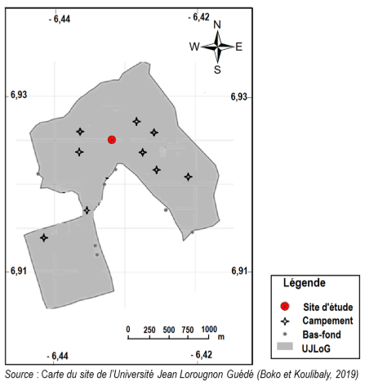

Figure 1: Location of the study site
1.1.2. Plant material
The biological material consists of teak stumps. To obtain the stumps, the teak plants, which are about 12 months old, were dug up in the teaker grove of the Vavoua forest development company, in the Haut-Sassandra region. These plants have been stripped of leaves and secondary roots. The main root was cut about 5 cm from the crown. Stumps ranging from 15 to 20 cm in length were chosen for the study (Figure 2).
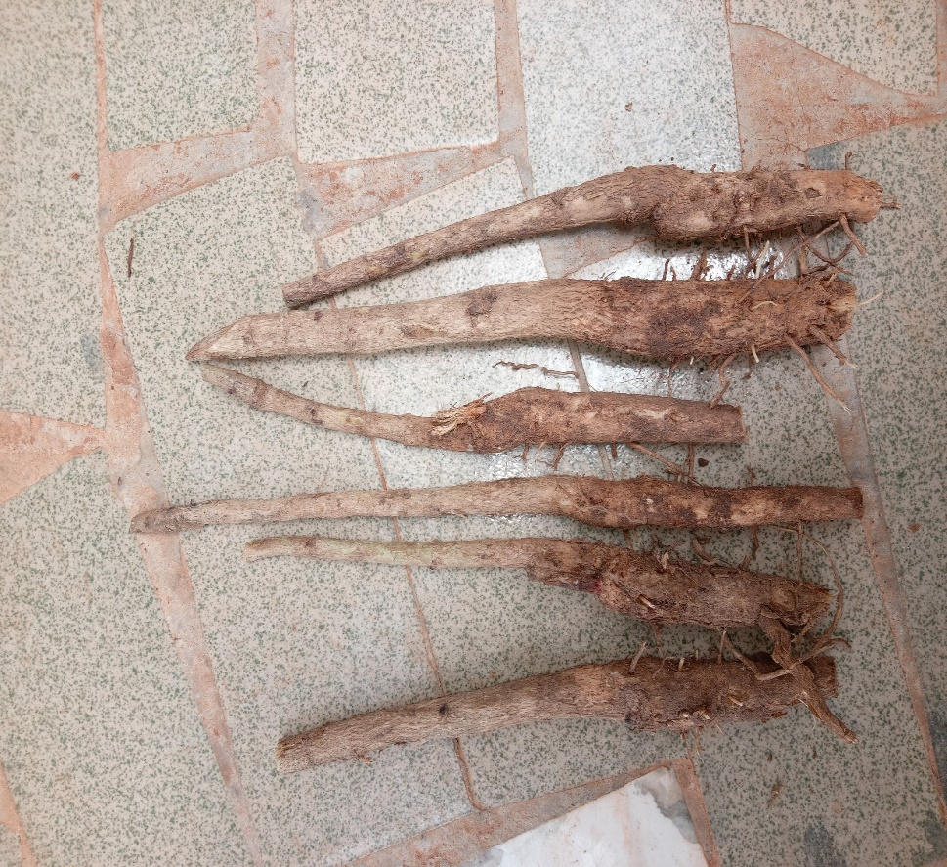
Figure 2 : stumps de Tectona grandis Linn. f. habillés
1.1.2. Chemical materials and substrates
The chemical material consists of NPK fertilizer with a concentration of 15-15-15. This fertilizer was supplied by the company YARA-CI. The substrates used consist of decomposed sawdust (SBD) and decomposed coffee parchment (PCD). The sawdust was harvested at the Société Général du Bois Tropical (SGBT) in Daloa. As for the coffee parchment, it was obtained from a coffee hulling machine factory (UNICAFE) in the garage district.

1.2. Methods
1.2.1. Obtaining the plants
The teak stumps obtained were placed vertically in perforated polystyrene bags, previously filled with 50 g of substrate sterilized by heating. Following this, the culture was placed under shade (SW) and in the open air (AL) according to a split splot (Figure 3).

1.2.2. Treatment of Stumps with NPK
The study was carried out using the method of Toukourou and Carsky (2001) and those of Lopez Zada et al (1994) modified. Seven (7) NPK solutions were prepared (0, 5, 10, 20, 30, 50 and 100g/L). Watering with the different concentrations was done once, after sowing. Each solution was applied at a rate of 10 ml per sachet per collar watering.
1.2.3. Experimental design and treatments
The experimental setup was a split plot with three factors. The first factor (growing condition) consists of two levels (in the open air and under combrière), the second factor (growing media) consists of two levels (decomposed coffee parchment and decomposed sawdust) and the third factor of N-P-K doses (15-15-15) with seven levels (0, 5, 10, 20, 30, 50, 100 g/L) with three replicates for each factor.

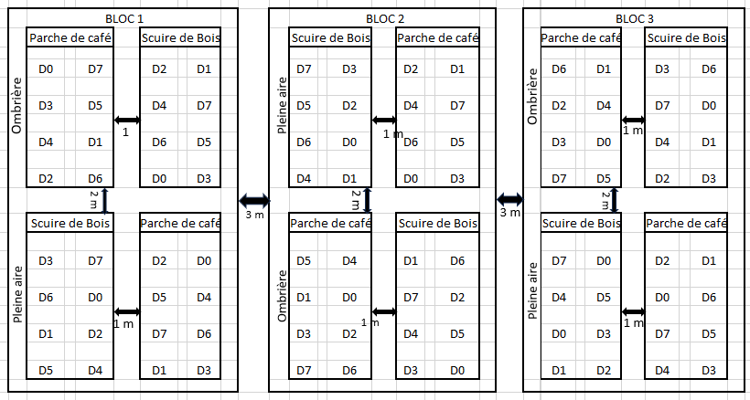
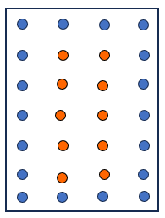
Elementary plot

Plants de bordure
Plants utils

Figure 3: experimental design

1.2.3. Evaluation of agromorphological parameters

Table I: Methods for measuring agromorphological parameters of teak plants
Parameters  growth | Evaluation method | Formulas
Mean bud break rate (Td) | The average bud break rate (Td) is obtained by comparing the number of cuttings that have resumed by the number of cuttings transplanted (Nt) | $Td=\frac{Nr}{Nt}$ x100; Nr= number of cuttings bearing buds  Nt=number of total cuttings transplanted
Average Plant Height (H) | The height of the stems was determined from the point of insertion of the stem on the cutting or the crown to the caulinary apex using a tape measure. | $H=\frac{\sum{H_{i}}}{NP}$ ; Hi = height of each plant;  NP = nombre total de plants
Average Number of Sheets (NF) | The number of leaves per plant was assessed by manually counting the open leaves. | $NF= \frac{\sum{{NF}_{i}}}{NP}$ ; NFi = number of leaves per plant  NP = nombre total de plants
Mean Leaf Area (AF) | The leaf area was determined by multiplying the length taken by measuring the main vein and the width taken in the middle of the leaf. | $SF= \frac{\sum{{SF}_{i}}}{NP}$ ; $SF$_{i} = leaf area per plant  NP = nombre total de plants
Average Pivot Length (Lp) | The length of the root was determined from the point of insertion of the root on the cutting to the root apex using a tape measure. | $Lp =\frac{\sum{{Lr}_{i}}}{NP}$ ; LRI = average root length/plant  NP = total number of roots
Average number of roots (Nr) | The number of roots per plant was assessed by manually counting secondary roots. | $Nr= \frac{\sum{{Nr}_{i}}}{NP}$ ; NFi = number of roots per plant  NP = nombre total de plants

1.2.4. Statistical analysis of the data
The data obtained were subjected to an analysis of variance (ANOVA) with the SPSS (Statistical Package for the Social Sciences) version 11.5 software at the 5% level. If P˂0.05, homogeneous groups were then determined by Fisher's LSD method. Results were expressed as means ± the ecartype.
2. Results

2.1. Influence of the interaction of the factors studied on the bud break rate of NPK-treated teak stumps (15, 15, 15)
The data in Table II show that the interaction of the factors studied influenced the bud break rate of the stumps and varied according to culture conditions, substrates and treatments. The bud break rate of teak stumps increased gradually to a maximum by the fourth week.
During the first week, the highest rate (66.67%) was observed outdoors on SBD with NPK solution of 30 g/L, while the lowest rate (43.33%) was recorded on PDC with treatments of 50 and 100 g/L NPK. At week four, the highest level (93.33%) was recorded outdoors on SBD substrate with 5 g/L NPK treatment, and lowest (83.33%) with 100 g/L NPK treatment.
For plots with PCD as a substrate, bud break also peaked in week four, with the lowest rate (63.33%) for the control batch (0 g/L NPK) and the highest (90%) with 10 g/L NPK treatment.
Under the shade, the highest rate (66.67%) of the first week was observed on the SDB substrate with the 10 g/L NPK treatment, and on the PDC with the control batch. By the fourth week, bud break had peaked. The highest levels were recorded with the 5 and 10 g/L NPK treatments on SBD, and the lowest level was recorded on PDC with 50 g/L treatment.

Table II: Effect of substrate, nursery, and NPK concentration on the mean bud break rate of teak stumps
Conditions | Substrats | Treatments | Week 1 | Week 2 | Week 3 | Week 4
Open air | SBD | 0 g/L  5 g/L  10 g/L  20 g/L  30 g/L  50 g/L  100 g/L | 63.33±15.28abcd  53.33±23.10abcd  63.33±30.55abcd  63.33±32.15abcd  66.67±41.63abcd  50.00±26.46abc  60.00±45.83abcd | 86.67±15.28bc  73.33±23.09abc  76.67±23.09abc  76.67±20.82abc  76.67±32.15abc  60.00±30.00abc  60.00±30.00abc | 86.67±11.55cde  80.00±17.32BCDE  80.00±17.32BCDE  86.67±15.26cde  76.67±23.09BCde  70.00±20.00abcde  76.67±32.15BCde | 86.67±11.55ef  93.33±5.77F  90.00±17.32ef  90.00±10.00ef  90.00±17.32ef  86.67±15.28ef  83,33±28,87def
Open air | LGD | 0 g/L  5 g/L  10 g/L  20 g/L  30 g/L  50 g/L  100 g/L | 53.33±11.55abcd  56.67±25.17abcd  46.67±25.17abc  56.67±20.82abcd  60.00±20.46abcd  43.33±20.82AB  43.33±41.63abc | 70.00±17.32abc  76.67±23.04abc  66.67±30.55abc  73.33±23.09abc  76.67±20.82abc  70.00±26.46abc  60.00±45.83abc | 86.67±11.55cde  86.67±15.28cde  73.33±25.17bde  76.67±20.82BCeE  80.00±20.00BCde  70.00±20.00abcde  70.00±36.06abcde | 63.33±46.19bcdef  80,00±14,14def  90.00±10.00ef  83.33±20.82def  86.67±15.28ef  80,00±10,00def  86.66±15.28ef
Under shade | SBD | 0 g/L  5 g/L  10 g/L  20 g/L  30 g/L  50 g/L  100 g/L | 60.00±51.96abcd  56.67±40.41abcd  66.67±49.33abcd  63.33±37.86abcd  43.33±15.28ab  62.50±22.17abcd  60.00±43.59abcd | 66.67±40.41abc  73.33±37.86abc  73.33±46.19abc  70.00±36.06abc  66.67±28.87abc  80.00±26.46bc  53.33±37.86abc | 96.67±5.77e  76.67±32.15BCde  76.67±40.41bcde  70.00±20.00abcde  70.00±10.00abcde  66.67±20.82abcde  53.33±15.28bcd | 83,33±11,55def  86.67±15.28ef  86.67±11.55ef  83,33±28,87def  76,67±11,55CDEF  80,00±28,28bcdef  60.00±36.06abcde
 | LGD | 0 g/L  5 g/L  10 g/L  20 g/L  30 g/L  50 g/L  100 g/L | 66.67±49.33abcd  60.00±36.06abcd  53,33±23,04ABCD 63,33±37,86ABCD  50.00±36.06abc  55.00±35.36abcd  46.67±32.15abc | 76.67±40.41abc  66.67±41.63abc  56.67±32.15abc  50.00±30.00ab  63.33±20.82abc  63.33±25.17abc  53.33±37.86abcd | 83.33±28.87cde  83.33±28.87cde  60.00±26.46abc  53.33±25.17abcd  70.00±10.00abcde  66.67±20.82abcde  53.33±15.28bcd | 53.33±5.77abcd  46.67±11.55abc  60.00±20.00abcde  53.33±20.82abcd  46.67±20.82abc  30.00±10.00A  53.33±11.55abcd
 |  | p | 0,033 | 0,06 | 0,018 | 0,00
For each factor studied, the averages followed by the same letter in a given column do not differ statistically at the 5% threshold (LSD test). SBD: finely ground decomposed sawdust, PCD: decomposed coffee parchment

2.2. Influence of the interaction of the factors studied on the number of leaves of teak plants
The data in Table III show that the interaction of the factors studied influenced the average leaf count of teak plants, varying according to growing conditions, substrates, treatments, with a general increase in leaf count over time.
In the open air, on the SBD substrate, the 50 g/L NPK treatment yielded the highest average leaf count (9±2.99 leaves), followed by the 30 g/L NPK treatment (8±3.35 leaves), while the control plants recorded an average of 6±2.13 leaves. On the PCD substrate, the maximum average number of leaves was recorded for the control plants (9±3.93 leaves), followed by the plants treated with 50 g/L NPK (8±3.76 leaves).
Under shade, the plants on the SBD substrate had more leaves than those on the PCD substrate. The 10 g/L NPK treatment produced the highest average leaf count (9±4.42 leaves), followed by the 20 g/L NPK treatment (8±4.22 leaves), compared to the control plants (7±3.74 leaves). The lowest mean leaf count was observed with the 100 g/L NPK treatment (7±3.44 leaves on SBD and 6±1.96 on PCD).

Table III: Effect of substrate, nursery, and NPK concentration on the average leaf count of teak plants
Conditions | Substrats | Treatments | Week 4 | Week 6 | Week 8 | Week 10 | Week 12
Open air | SCB | 0 g/L  5 g/L  10 g/L  20 g/L  30 g/L  50 g/L  100 g/L | 5±1,35bcde  5±1.68de  5±1,78bcde  5±1,99bcde  5±1,67bcde  5±2,01bcde  4±1,19abcd | 6±2,07bcde  6±1,98abcde  6±2,21bcde  6±2,62bcde  6±3,51cde  6±2,59bcde  5±1,66from | 6±1,80from  5±1,81from  6±2,21abc  7±1,92bcdef  6±3,19abcdef  6±3,23abcdef  5±1,34a | 6±1,90abc  6±1,99abcd  6±2,21abcde  7±2,19abcdefghi  7±2,89abcdefgh  7±2,77bcdefghi  5±1,61a | 6±2,13abcd  7±4.28bcdefgh  8±4,80  7±3.79bcdefgh  8±3,35fghi  9±2,99d  6±3,28defghi
Open air | PCD | 0 g/L  5 g/L  10 g/L  20 g/L  30 g/L  50 g/L  100 g/L | 5±1,87bcde  5±1,45bcde  5±1,76bcd  4±1,56abcd  5±1,62bcde  5±1,64bcde  4±1,39a | 6±2,45bcde  7±2.89de  6±3,15cde  6±2,59bcde  6±2,11bcde  7±3,37e  6±2,80abcde | 7±2,38defg  8±2,49fg  7±2,99efg  7±2,81bcdef  7±2,70bcdef  8±3,18g  7±3,18cdefg | 8±2,56he  8±2.72gh  8±4,08fghi  7±3,04bcdefghi  7±3,58CFhUgh  9±3,89I 8±3,75Efghi | 9±3,93hi  6±2,00abc  6±2,08abcde  7±2,41bcdefGH  7±2,93abcdef  8±3,76  5±2,07a
Under shade | SCB | 0 g/L  5 g/L  10 g/L  20 g/L  30 g/L  50 g/L  100 g/L | 5±2,07bcde  6±1,72e  5±1,94bcde  6±1.68e  4±1,67abcd  5±1,46cde  5±1,44bcde | 5±1,76abc  6±2,41bcde  5±1,88abc  6±2,59abcde  5±1,31from  6±2,55bcde  5±2,43from | 7±2,55CDEF  7±2,92bcdef  6±2,06abcdef  6±2,56abcd  6±1,68abcd  7±3,05abcdef  6±2,83abcde | 6±3,14abcde  7±2,32ABCDEFGHI  6±2,71abcdefg  6±2,77abcdef  9±1,58abcd  7±3,06abcdefg  6±2,74from | 7±3,74cdefghi  7±3,57bcdefGH  9±4.42Record  8±4,22fghi  8±4,60fghi  6±3,87from
Under shade | PCD | 0 g/L  5 g/L  10 g/L  20 g/L  30 g/L  50 g/L  100 g/L | 4±1,30abcd  5±1,7abcd  5±1,38bcde  5±1,71bcde  5±1,74abcd  4±1,51from  4±1,65abc | 5±2,10from  5±1,46from  5±2,51abc  5±2,06abcd  6±2,13abcde  5±1,14from  4±2,26a | 7±2,51bcdef  7±2,30abcdef  7±2,71CDEF  7±3,39defg  7±2,89cdefg  6±2,45abcdef  6±3,12abcdef | 7±2,25defghi  7±2,71abcdefghi  8±3,49  8±4,50ij  8±3,85  6±2,78from  6±3,47abcde | 6±3,08abcde  7±1,66abcde  6±2,31abcde  6±2,83abcd  6±1,84abc  7±2,93abcde  6±1,96abcd
Under shade |  | p | 0,034 | 0,02 | 0.003 | 0,016 | 0.01
For each factor studied, the averages followed by the same letter in a given column do not differ statistically at the 5% threshold (LSD test). SBD: finely ground decomposed sawdust, PCD: decomposed coffee parchment

2.3. Influence of the interaction of the factors studied on the leaf area
The interaction between the factors studied had a very significant impact on the average leaf area, with variation observed depending on growing conditions, substrates, NPK treatments and timing of data collection. In all situations, the leaf area increased gradually to reach a peak at the twelfth week.
In the two substrates (SBD and PCD) of the plots exposed to the open air, the different treatments influenced the leaf area. On SBD, plants grown from stumps treated with the NPK solution (15-15-15) at a concentration of 30g/L recorded the largest average leaf area (17.70±24.18cm2). This leaf area gradually increased until reaching a maximum at the twelfth week (26.16±33.53cm2). However, the concentration of 100g/L of NPK solution recorded the lowest observed leaf area (13.06±13.91cm²) at the twelfth week. On PCD, stumps treated with the 50g/L solution of NPK recorded the largest mean leaf area (71.02±76.73cm²) at the twelfth week.
On the plots under shade, NPK-based treatments also had a significant effect on the average leaf area. The largest leaf areas were observed at the level of the PCD plot, with the treatment of 100g/L of NPK (41.93±66.35cm²).

Table IV: Effect of substrate, nursery, and NPK concentration on the average leaf area of teak plants
Conditions | Substrats | Treatments | Week 4 | Week 6 | Week 8 | Week 10 | Week 12
Open air | SCB | 0 g/L  5 g/L  10 g/L  20 g/L  30 g/L  50 g/L  100 g/L | 13.76±16.82Defghi  13.93±15.68AB  10.52±12.79abcde  17.04±30.53Defghi  17,70±24,18hijkl  12.16±13.50bcdefg  7.47±7.17a | 16,040±20,37cdefg  14.03±16.43abcdef  10.67±12.12a  19,13±31,83jkl  21,87±30,86hijk  15.61±19.19cdefg  12.97±15.90abcde | 18.34±20.07abcd  14.89±15.76a  11.02±12.89a  22.37±33.74CDEFG  21.60±29.21abcd  17.10±22.13abcd  12.69±13.38ab | 19.29±20.41abc  15.12±16.97abc  13.03±16.76ABCDEF  24,95±33,16CDEFG  22,79±32,25CDefG  18.22±23.12abc  12.55±13.14ab | 20.22±21.78abc  16,29±16,33Ghijk  13,38±15,30a  27,97±37,76bcdef  26.16±33.53cdefgh  23.00±26.63abcde  13.06±13.91a
Open air | LGD | 0 g/L  5 g/L  10 g/L  20 g/L  30 g/L  50 g/L  100 g/L | 22,10±31,58l  15,82±17,87Ghijk  16,63±25,71ghijk  18,14±32,38efghij  15.21±19.29ghij  14,21±16,33EFGHI  8.14147±9.22abc | 20.31±28.98ghij  20,24±18,95ghij  26.02±41.46k  20,26±35,14kl  23.36±36.36jk  23.52±33.39JK  16.97±23.25Defghi | 37,98±54,41jkl  28,80±27,44FGHI  30,78±39,22hij  35,83±49,08ijk  41,52±57,91kl  45,06±59,19l  37,36±50,83jkl | 38,15±27,56jkl  31,49±30,48fghij  36,31±53,45ijk  40.55±48.36ghij  50.81±68.35m  66.06±64.39N  45.63±51.98lm | 61,02±92,90lm  32,72±37,88efghi  40.50±64.63ghij  42,28±51,91klm  55,60±75,30kl  71,02±76,73m  48,40±52,55jk
Under shade | SCB | 0 g/L  5 g/L  10 g/L  20 g/L  30 g/L  50 g/L  100 g/L | 16.24±24.16ghijk  13.51±23.14DefGH  15,03±21,66fghij  15,55±21,93ghe  14.55±22.62fghi  18,28±24,65ijkl  7,62±8,48from | 17,03±19,25defghi  22.43±33.21ijk  19,30±25,38fghij  16,02±20,24a  16.55±20.72defgh  21,59±28,67hijk  14.98±15.18bcdefg | 19.79±25.55bcd  29.22±37.83GHI  21,97±26,43CDefG  20.21±28.22bcd  19.88±21.07bcd  25.76±33.54CDefG  19.20±25.04bcd | 20.70±34.34BCeE  30.44±38.44cdefg  22.85±26.56abcde  20.83±28.41cde  19,96±20,52from  26,41±34,63abcde  20,20±27,54bcd | 21,72±34,51abcd  32,49±40,13ghe  23,31±26,00cdef  22.43±27.75ijk  21,62±25,79cdefg  27.83±40.69EFGH  22,64±28,90abcde
Under shade | PCD | 0 g/L  5 g/L  10 g/L  20 g/L  30 g/L  50 g/L  100 g/L | 7,19±10,14a  8.14±10.79abc  9,90±14,40abcde  9,66±11,72abcde  12.65±21.07cdefg  9.33±14.05abcd  8.13±15.71abc | 9,02±11,58a  10.79±15.67abc  15,16±22,18cdefg  11.73±11.47ABCD  14,12±18,75abcdef  13,83±18,55abcdef  9,54±14,62from | 20,13±30,44bcd  18,10±28,22abcd  22,19±27,30cdefg  21,09±29,18cdef  17,15±21,14ABCD  24.28±29.00DefGH  22,41±35,21cdefg | 28.67±41.65defghi  24,47±32,51cdefg  29.41±37.78EFGHE  26.89±36.62cdefgh  34.97±43.05 hours  32,50±41,90ghe  30,26±43,40fghij | 30,97±43,13DefGH  29,26±35,52bcdef  33,49±42,25fghi  33,58±52,85fghi  41,16±58,25he  34,22±46,34fghi  41.93±66.35ij
Under shade |  | p | 0.00 | 0,00 | 0,00 | 0,00 | 0,00
For each factor studied, the averages followed by the same letter in a given line do not differ statistically at the 5% threshold (LSD test). SBD: finely ground decomposed sawdust, PCD: decomposed coffee parchmente

2.4. Influence of the interaction of the factors studied on the mean length and the mean number of roots three months after transplanting
The statistical analysis revealed that the interaction of the factors studied significantly influences the mean length and the mean number of roots of the teak plants aged three months (p=0.00). These parameters vary according to the growing conditions, substrates and treatments.
In the open air, the treatments improved the length and number of roots. Decomposed sawdust (SBD) was the ideal substrate, especially with a treatment of 50 g/L NPK for root length (12.67±4.73 cm), compared to the control batch (10.32±5.65 cm). The 30 g/L NPK treatment produced the highest average root count (13±8.38cm).
Under shade, the treatments also had a positive effect. SBD resulted in the longest roots with the treatment of 20 g/L NPK (12.87±3.51 cm), followed by the treatment of 10 g/L NPK (12.45±4.45 cm), compared to the control batch (11.75±5.30 cm). The treatment of 100 g/L of NPK resulted in the shortest roots. The highest average root count (19±11.41cm) was obtained with the treatment of 50 g/L NPK on SBD.
To maximize root length and number, it is recommended to grow plants under shade with SBD substrate, using 20 g/L NPK for length and 50 g/L NPK for root count.
Table V: Effect of substrate, nursery, and NPK concentration on the mean length and average number of roots of three-month-old teak plants.

Conditions | Substrats | Treatments | Long R | No. R
Open air | SCB | 0  5  10  20  30  50  100 | 10,32±5,65cdef  11,83±5,30f  12,20±5,30f  11,83±4,95f  11,60±5,69ef  12,67±4,73f  11,16±5,20ef | 9±5,82abcd  9±5,26abcd  10±4,67abcd  9±5,28abc  13±8,38defghi  10±5,65abcde  10±3,83abcdef
Open air | PCD | 0  5  10  20  30  50  100 | 7,88±4,17abc  8,05±4,26abc  7,87±4,53abc  8,28±5,21abcd  8,16±4,39abcd  10,96±5,15ef  9,14±5,03bcde | 8±5,74from  7±3,41a  7±3,10a  11±7.00bcdefg  7±5,09a  12±9,60bcdefgh  9±5,42abcd
Under shade | SCB | 0  5  10  20  30  50  100 | 11,75±5,30f  11,34±4,50ef  12,45±4,43f  12,87±3,51f  12,23±5,72f  12,12±5,83f  11,60±4,74ef | 16±9,87ij  14±8,96  14±9,26fghi  15±8.20Record  16±10,21ij  19±11.41d  15±9,41gi
Under shade | PCD | 0  5  10  20  30  50  100 | 8.31±5.08abcd  8,17±5,16abcd  6,04±3,74a  7,16±5,43from  8,12±4,73abc  8,08±6,19abc  10,70±5,85def | 13±9,55defghi  13±8,10cdefghi  8±5,85from  11±7,04abcdef  11±6,44bcdef  13±7,94defghi  12±7,06bcdefgh
Under shade |  | p | 0,00 | 0,00
For each factor studied, the averages followed by the same letter in a given column do not differ statistically at the 5% threshold (LSD test). SBD: finely ground decomposed sawdust, PCD: decomposed coffee parchment; Long R: root length; Nbre R: number of roots.
3. Discussion

3.1. Influence of the interaction of the factors studied on the bud break rate of NPK-treated teak stumps (15, 15, 15)
The results obtained in this study showed that the factors studied (conditions, substrates, treatments and time) influenced the parameters evaluated in teak plants. However, these parameters varied according to the growing conditions, the substrates used, the treatments and the time.
When the stumps were treated with NPK (15, 15, 15), the highest bud break rate in the experiment was recorded in the open-air using SBD with 5g/L. Under these conditions, the bud break rate is estimated at 93.33 p.c at the 4th week. Our results show that light intensity plays an important role in bud break of cuttings. This confirms the idea of Cornu and Boulay (1986), according to which the action of light acts on the speed of the vegetative recovery of cuttings. However, in our case, the low light intensity does not prevent the vegetative resumption of the species cultivated in the shade where there was up to 86.67 p.c bud break rate at the fourth week. In other words, as demonstrated by Hartmann et al. (1997), in general, photosynthesis is not necessary when rooting cuttings because they can use their own reserves to ensure vegetative recovery. The bud break rate (86.67 p.c.) recorded under shade could be explained by the fact that the shade reduces the impact of solar rays on the stumps and therefore their dehydration. The results obtained on cuttings exposed to the sun confirm the fact that teak is a heliophilic plant (N'Dabalishye, 1995).
SBD was the best substrate in contrast to decomposed coffee parch. Our results are in agreement with those of Aka (2022) who also achieved a better germination rate of tomato seeds using sawdust. This substrate (PCD) is insufficiently ground and releases fewer nutrients.
Despite the effectiveness of the growing conditions, substrates and treatments, some cuttings did not regenerate at 28 days after transplanting. This phenomenon could be linked to an unfavourable microenvironment effect. Several other parameters could explain this. In many cases, cuttings do not pass the healing stage, which does not promote the emission of their roots (Asseh et al., 2017). Wound healing is indeed a key step in cuttings that is influenced by several factors including the hormonal balance between the auxin used and other plant hormones such as cytokine (Agbogan et al., 2014; Jaenicke and Benies, 2003).

3.2. Influence of the interaction of the factors studied on the number of leaves of teak plants
The interaction of the factors studied had a significant effect on the number of leaves of teak plants. Indeed, the results showed that the number of leaves of teak plants varies according to growing conditions, substrates, treatments and time. The highest number of leaves was recorded in the batch of plants exposed to the open air with SDB as a substrate and treated with a 50g/L solution. At this the number of leaves is estimated at 9±2.99 leaves.
The number of leaves of plants in the sun could be explained by the action of light that promotes their development through photosynthetic activity. Our results are in agreement with those of Asseh et al. (2017) who also obtained a large number of Thunbergia leaves atacorensis in the area only under shade. The results prove that regardless of the treatment applied to the stumps, the physiology of teak seedlings was stimulated in the nursery. our results are in agreement with those of Tchaniley et al., (2020) in lettuce. In his article, the author highlighted the effectiveness of the different NPK-based treatments on the average number of leaves compared to control plots.

3.3. Influence of the interaction of the factors studied on the leaf area
The results obtained show that the leaf area of teak plants varies according to growing conditions, treatments and substrates.
, the largest average leaf area was recorded in the open air at the level of the PDC associated with the NPK-based solution with a concentration of 50g/L. under these conditions the average leaf area is estimated at 71.02±76.73cm² three months after transplanting. These results prove that the leaf area would be influenced by the mode of exposure to the sun. Indeed, plants in plots exposed to the sun bear large leaves than plants in plots exposed to shade. Our results are in agreement with those of Asseh et al, 2017 who obtained the same results under the same conditions with the cultivation of Thunbergia atacorensis. The large leaf area of plants exposed to the sun could be explained by the action of light which promotes their development through increased photosynthetic activity. On the other hand, the small leaf area for teak plants in shaded plots could be one of the consequences of the phenomenon of etiolation (Renaudin, 1998). Indeed, teak plants, exposed to the shade, can no longer ensure the growth and development of their leaves. Thus, this loss of the ability to regenerate their energy resources due to a lack of light is accentuated and leads to the fall of the leaf surface. This result suggests that photosynthesis would be more important in the open air than under shade. Yue and Margolis (1993) reported that shelter decreases light intensity (0-50 mμ mol.m-2 s-1) and consequently limits photosynthesis. On the contrary, for Langellier (2000), photosynthesis depends more on the quality (type of radiation) of light than on the quantity (light intensity).

3.4. Influence of the interaction of the factors studied on the mean length and number of roots three months after transplanting
The average length and average number of roots of teak plants that are three months old vary depending on the factors studied. Statistical analysis of the interaction of factors shows that it has a significant effect on the average length and average number of teak plants aged three months. When stumps were treated with NPK, the best results were seen at the shade with SBD as the substrate. For treatments, the 20g/L solution was effective in terms of root length and teak plants treated with the 50g/L solution recorded the highest number of roots. The values recorded at this level are 12.87±3.51 cm and 19.30±11.41 roots, respectively. These results are consistent with those of William (2003) who indicate that nitrogen stimulates above-ground growth that also promotes root growth. Stevenson in 1986 approached in the same direction through his work which proved that nitrogen promotes the use of carbohydrates which stimulate development and root activity, thus promoting the export of other mineral elements. This difference could also be explained by the amount of sunlight that reaches the leaves. Our results show that low light intensity promotes root development. These results are contrary to those of Asseh et al (2017) in Thunbergia atacorensis. For this author, the low light intensity slows down the bud break of Thunbergia atacorensis cuttings exposed to the shade, and therefore to an action on rhizogenesis.
Conclusion
This work has shown that teak offers a good appreciation for vegetative propagation by cuttings (stump). Rates of more than 93.33 p.c. of rooted cuttings have even been achieved. Rooting substrate, growing conditions, treatments and weather significantly influenced bud break rate, leaf count, leaf area, pivot length and root count. Decomposed finely ground decomposed sawdust (SBD) has proven to be the best substrate compared to decomposed coffee parch. The open air was the best growing condition in terms of bud break rate compared to the shade house. Regarding the bud break rate, treatment with a dose of 5 g/L proved to be the most effective. For other treatments, the 50 g/L dose generally gave the best results. In general, the treatments had a positive effect on the parameters measured. Open air and SBD would seem to be the ideal conditions for the production of teak plants.
REFERENCES
Anonymous 1, (1959). Teak: I. Botanical and forestry data sheet, II. Industrial and commercial data sheet. Tropical timber and forests, No. 15, 255-260p.
Atangana AR, Tchoundjeu Z, Asaah EK, Simons AJ, Khasa DP, (2006). Domestication of Allanblackia floribunda: Amenability to vegetative propagation. Forest Ecology and Management 237: 246 – 251p.
Avana TM, (2006). Domestication of Prunus africana (Hook.f.) Kalkam (Rosaceae): Study of germination and cuttings. Thesis. University of Yaoundé I, Yaoundé, Cameroon, 132p.
Bellefontaine R, with Q. MEUNIER, A. ICHAOU, A. MORIN, P.M. MAPONGMETSEM, B. BELEM, F. AZIHOU, A. HOUNGNON, H. ABDOURHAMANE (2018). REGENERATION BY SEEDS AND BY VEGETATIVE MULTIPLICATION AT LOW COST (SUCKERS AND CUTTINGS OF ROOT SEGMENTS), cirad, 463p.
Caspa RG, Kuoudiekong L, Nwegueh BA, Djeudeng TS, Lahjou JC, Onana J, (2009). Effect of different substrates on rooting and shoot development of juvenile stem cuttings of Nuclea diderichiii (De Wild & T. Durand) Merill. International Journal for Biological and Chemical Sciences 3 (5): 1124 – 1132.
Guyot M, (1992). Angiosperm Systematics: Reference to the Flora of Togo, 217p.
Kone K.H.C., Boraud N.K.M., Issali A.E., Kamanzi A.K. (2010). Influence of Planting Method on the Survival and Growth Dynamics of Teak Stumps Used in Industrial Reforestation in a Dense Semi-Deciduous Forest Zone of Côte d'Ivoire. Journal of Applied Bioscience 32: 1956-1963p.
Ligban R., Gone L.D., Kamagate B., Saley M.B. & Biemi J. (2009). Hydrogeochemical Processes and Origin of Natural Springs in the Daloa Square Degree (West-Central Côte d'Ivoire), International Journal of Biological and Chemical Sciences, 3:17 p.
Maldonado G. (1999). Teak (Tectona grandis Linn.) from Ivory Coast. ENGRE memory? 86p.
Mialoundama F, Avana ML, Youmbi E, Mampouya PC, Tchoundjeu Z, Mbeuyo M, Galamo GR, Bell JM, Kopguep F, Tsobeng AC, Abega J, (2002). Vegetative propagation of Dacryodes edulis (G. Don) H. Lam by marcotts, cutting and micropropagation. Journal of Forests, Trees and livelihoods 12 (1): 85-96p.
Ngo-Mpeck ML, Tchoundjeu Z, Asaah E, (2003). Vegetative propagation of Pausinystalia johimbe (K. Schum) by leafy stem cutting. Propagation of Ornamental Plants 3 (2): 11 – 18p.
N’Guessan A.H., N’Guessan K.F., Kouassi K.P., Kouamé N.N. & N’Guessan. P.W. (2014).
Population dynamics of the cocoa stem borer, Eulophonotus myrmeleon. Felder (Lepidoptera: Cossidae) in the Haut-Sassandra region of Côte d’Ivoire, Journal of Applied Biosciences, volume 83, 9 p.
Paluku et al., J. Appl. Biosci. 2018 Cuttings of Cola acuminata (P. Beauv.) Schott & Endl.: Influence of substrate, leaf length and surface area on the rooting of cuttings in Kisangani, DR Congo, Journal of Applied Biosciences 123: 12354-12362p.
Sangaré A., Koffi E., Akamou F. & Fall C. A. (2009). State of plant genetic resources for food and agriculture. Ministry of Agriculture, Abidjan, Republic of Côte d’Ivoire, Second report, 65 p.
Shiembo PN, Newton AC, Leakey RRB, (1997a). Vegetative propagation of Irvingia gabonensis, a West African fruit tree. Forest Ecology and Management 87: 185–192p.
Schiembo PN, Newton AC, Leakey RRB, (1997b). Vegetative propagation of Ricinodendron heudelotii, a West African fruit tree. Journal of Tropical Forest Science 9 (4): 514 – 525p.
Tchoundjeu Z, (1989). Vegetative Propagation of the Tropical Hardwoods of Khaya ivorensis (A. Chef) and Lovoa trichilioides (Harm). Thesis Submitted to the University of Edinburgh for the Degree of Doctor of Philosophy, 261p.
Tchoundjeu Z, Avana ML, Leakey RRB, Simons AJ, Asaah E, Duguma B, Bell JM, (2002b). Vegetative propagation of Prunus africana: Effect of rooting medium, auxin concentrations and leaf area. Agroforestry Systems 54: 183–192p.
Toukourou A.M and Carsky R, (2001). Cassava response to nitrogen, phosphorus and potassium on barren lands in southern Benin. In Proceedings of the Scientific Workshop, December 12–13, 2001, 149–154p.
Troup R.S, (1921). The silviculture of Indian Trees, Vol. 2. The Clarendon Press, Oxford, 698–774p.
White H.K.J, (1991). Forestry of teak II. Regeneration of teak China/ESCAP/FAO Regional Senior on Research and Development of teak Guangzhou Hainnan. China. 37p.

