Optimizing Fruit Maturity Indices, Seed pre treatments, and germination substrates on Germination and Growth Performance of Osyris lanceolata

Abstract
Aim: Osyris lanceolata (Hochst. &Steud) is an evergreen hemiparasitic shrub or small tree of the Santalaceae family, is valued for its fragrant heartwood and essential oils used in perfumery and traditional medicine. However, its propagation is limited due to poor seed germination and challenges in vegetative methods. This study aimed to evaluate the effects of different pre-sowing seed treatments, germination substrates, and fruit maturity stages on the germination and early growth performance of O. lanceolata from naturally growing populations in Tehri Garhwal, Uttarakhand.
Study Design: The study was conducted through two separate experimental setups using a completely randomized design (CRD) to evaluate the effects of fruit maturity stages, germination substrates, and various pre-sowing treatments on the seed germination and early growth of Osyris lanceolata. In the first experiment, conducted at the Forest Tree Seed Laboratory, ICFRE-FRI, seeds collected at three different maturity stages (green, light orange, and bright red) were subjected to mechanical scarification followed by soaking in boiling water for 12 hours. The seeds were then sown on two different substrates—sand and vermiculite—and incubated under controlled laboratory conditions at 25 ± 1 °C, >90% relative humidity, and a 24-hour photoperiod. Each treatment included four replicates of 20 seeds.The second experiment was carried out in the nursery of Jakh-Koti Botanical Park, Tehri,Uttarakhand where seeds were subjected to eight different pre-sowing treatments: T1 – Control, T2 – Mechanical scarification + 500 ppm GA₃ (24 h), T3 – Mechanical scarification + 1000 ppm GA₃ (24 h), T4 – 30% Hydrogen peroxide (24 h), T5 – 0.2% Potassium nitrate (24 h), T6 – 2% Thiourea (24 h), T7 – 20% Sulfuric acid (1 min), and T8 – Hot water (1 min). Each treatment included four replicates of 100 seeds. Across both experiments, germination performance was evaluated using key parameters: Germination Percentage (GP), Mean Germination Time (MGT), Germination Value (GV), Peak Value (PV), Germination Index (GI), Seedling Vigor Index (SVI), Sturdiness Quotient (SQ), Vigor Index (VI) and Quality Index (QI).

Results:In the laboratory experiment, substrate and fruit maturity stage had a significant impact on germination parameters. Seeds sown on vermiculite showed a significantly higher germination percentage (46.66 ± 7.63%) compared to those sown on sand (33.33 ± 7.63%). Pretreatment improved all germination parameters, while fruit maturity stage played a critical role. Seeds collected at the bright red maturity stage (moisture content: 52.62 ± 2.51%) recorded the highest germination percentage and germination value, along with a low mean germination time (MGT), indicating their physiological readiness for germination.In the nursery experiment, the highest germination percentage (66.66 ± 8.32%) was observed in T3 – Mechanical scarification followed by soaking in 1000 ppm GA₃ for 24 hours, which was significantly superior to all other treatments. This was followed by T2 (Mechanical scarification + 500 ppm GA₃; 49.33 ± 4.61%) and T7 (20% Sulphuric acid for 1 min; 41.33 ± 2.30%). The lowest germination percentages were recorded in T4 (30% Hydrogen peroxide; 18.66 ± 2.30%), T8 (Hot water; 18.66 ± 6.11%), and the untreated control T1 (13.33 ± 2.30%), with no significant differences among them. Among all treatments, T3 proved to be the most effective for enhancing seed germination.
Conclusion: The study highlights effective strategies for improving the germination and early growth of Osyris lanceolata. Vermiculite was identified as the optimal germination medium, while seeds collected at the bright red maturity stage (~52% moisture content) exhibited the highest germination performance, including superior germination percentage (GP), germination value (GV), and reduced mean germination time (MGT). Among pre-sowing treatments, mechanical scarification followed by soaking in 1000 ppm GA₃ for 24 hours (T3) resulted in the highest germination percentage and significantly enhanced seedling vigor. These findings provide valuable guidance for optimizing seed propagation and support the domestication and conservation of O. lanceolata.
Keywords: Maturity indices; seed germination, germination substrate, seed dormancy, growth performance.

Introduction
  - Osyris lanceolata:
Osyris lanceolata (commonly known as East African sandalwood) is an evergreen shrub or small tree belonging to the Santalaceae family (Teklehaimanot et al., 2003; Githae et al., 2011). Typically growing between 1 to 7 meters in height, it can reach up to 10 meters under optimal forest conditions (Beentje, 1994; Subasinghe, 2013). The species is highly valued for its aromatic yellowish-red heartwood, which yields essential oils used in perfumery, cosmetics, and traditional medicine (Mwang’ingo et al., 2007; Tshiisikhawe et al., 2012). Additionally, its roots are utilized in basketry, while the bark and roots provide a red dye for tanning (Mbuya et al., 1994). Medicinally, O. lanceolata has been employed to treat infections, diarrhea, and fertility-related issues (Tshisikhawe et al., 2012). Its evergreen nature and prolonged flowering period also make it an important forage species (Githae et al., 2011). However, the species faces significant challenges in natural regeneration due to limited seed production, low germination rates, and seed dormancy (Mwang’ingo et al., 2004; Kamondo et al., 2014). The seeds exhibit chemical dormancy and are recalcitrant, complicating both storage and germination processes. In India, speciesflowering between March-May (peak April) and fruiting September-October, producing 6-8 mm diameter drupes that transition from green to red deep at maturity.
1.2 Distribution
Osyris lanceolata has a pantropical distribution, occurring naturally across South Asia (India, Sri Lanka, Nepal, Bhutan), Southeast Asia (Myanmar, Thailand, Indo-China), China, Africa, and Southern Europe. In India, it is particularly found in the subtropical Himalayas, Northeast, Central, and Peninsular regions, with specific populations recorded in Himachal Pradesh, Andhra Pradesh, Goa, Kerala, and Tamil Nadu (Balakrishnan et al., 2012).It exhibits a highly scattered, patchy distribution across rocky slopes, dry woodlands, and montane areas up to 2,000 m elevation.
The national biodiversity assessment report from African countries listed the species as critically endangered, highly threatened or locally endangered due to overexploitation for medicine and oil extraction leading to habitat degradation, poor natural regeneration, and an increased risk of extinction. Seed dormancy and low viability associated with species cause challenges in nursery propagation, and vegetative propagation methods are also found to be not effective. The current study aimed to evaluate the effects of different pre-sowing seed treatments and germination substrates for developing effective ex situ conservation strategies for the species and to study the various fruit maturity stages on the germination and early growth performance for standardizing optimal harvesting stages.
- MATERIALS AND METHODS
  - Seed Collection
Seeds of Osyris lanceolata were collected from Tehri Forest Division-1, Uttarakhand, India, at GPS coordinates 30°28′03.60″N latitude and 78°26′23.41″E longitude, at an elevation of 1332 m. Seeds were collected from the subtropical pine forest where species grows in association with Pinus roxburghii, Quercus leucotrichophora, Anogeissus latifolia and Mallotus philippinensis. Laboratory germination trials were conducted at the Forest Tree Seed Laboratory, ICFRE-FRI, while nursery experiments were carried out at Jakh-Koti Botanical Park (30°24′18.4″N, 78°27′0.9″E; elevation 1100 m) near Tehri Lake.
2.1.1. Seed extraction and morphological studies in Osyris lanceolata
Mature Osyris lanceolata seeds, identified by their firm white endosperm, were hand-collected and processed within 48 hours. Pulp removal was done by rubbing fruits through a 4 mm wire mesh, followed by rinsing and manual maceration. A flotation test separated viable (sinking) from non-viable (floating) seeds. Shade-drying ensured moisture removal before sowing.Morphological parameters (length, width, color) and moisture content of fruits at green, intermediate, and ripened stages were recorded. Seed weight and count per kg were measured post-drying. Authenticated specimens were deposited at the Forest Research Institute, Dehradun (Herbarium ID: 173683).Both trials employed rigorous germination assessment protocols while differing in environmental conditions and treatment variables, collectively providing comprehensive insights into optimal germination strategies for O. lanceolata.

This study examined the effects of pre-sowing seed treatments on the germination and growth performance of Osyris lanceolata under incubator and nursery conditions. Germination was monitored daily, with key parameters recorded including Germination Percentage (GP), Mean Germination Time (MGT), Initial Germination Time (IGT; days until first radicle emergence) and final germination time (FGT; days until the last viable seed's radicle emergence). Additionally, other germination and seedling performance indices were assessed, such as Germination Value (GV), Peak Value (PV), Germination Index (GI), Seedling Vigor Index (SVI), Sturdiness Quotient (SQ), Vigor Index (VI) and Quality Index (QI). These parameters were evaluated to determine the influence of different treatments on seed germination efficiency and early seedling development.

- Germination Parameters

- Germination Percentage (GP):
GP = (Number of seeds germinated/Total number of seeds sown) × 100 (Maguire, 1962)

2. Growth Parameters
- Moisture Content (MC): MC (%) = [(Fw - Dw)/Fw] × 100
Where: Fw = Fresh weight (g) Dw = Dry weight after oven drying at 103°C for 17 hours(ISTA, 2023)

3. Germination Speed and Synchronization
- Mean Germination Time (MGT): MGT = Σ (F × x)/ΣF
Where: F = Number of seeds germinated on day x, x = Number of days from sowing (Ellis, R.H., & Roberts, E.H., 1981)
- Germination Index (GI): GI = Σ(G/T)
Where: G = Percentage of seeds germinated per day, T = Germination period (days) (Maguire, J.D. (1962)
- Germination Value (GV): GV = (ΣDGS/N) × (Final germination %/10)
Where: DGS = Daily germination speed, N = Number of days (Czabator, F.J., 1962)
- Peak Value (PV): Highest mean daily germination rate (Czabator, F.J., 1962)

4. Seedling Vigor and Quality Indices
- Vigor Index (VI):VI = GP × (Shoot length + Root length) (Abdul-Baki and Anderson, 1973)
- Seedling Vigor Index (SVI)SVI = Seedling height (cm) × GP (Abdul-Baki and Anderson, 1973)
- Sturdiness Quotient (SQ): SQ = Seedling height (cm)/Collar diameter (mm) (Thompson, 1985)
- Volume Index (VI): VI = [Diameter (mm)] ² × Height (cm) (Hatchell, 1985)
- Quality Index (QI): QI= [Total seedling dry weight (g)]/ [Height (cm) + Collar diameter (mm)] + [Shoot dry weight (g)/Root dry weight (g)] (Dickson, 1961)

2.1.2.Viability test
Seed viability was assessed using the tetrazolium test (Grabe 1970). Seeds were soaked in water for 24 hours, carefully cut along the margin, and immersed in 0.1% TTC solution for 16 hours at 25°C in darkness. Viable embryos stained pink confirming viability.

  - Seed Germination Experiment
The study examined the germination performance of Osyris lanceolata seeds through two distinct experimental setups. In the first trial (GT1-GT5), seeds were kept in a germinator (25±1°C temperature, >90% RH, 24hours photoperiod) using a completely randomized design with four replications of 20 seeds per treatment. Sand (control), sand with scarification and boiling water treatment for seeds at green, intermediate, and ripened stages and vermiculite for ripened seeds (Table 1). The second trial (T1-T8) investigated eight pre-sowing treatments in nursery conditions using root trainers with a Sand-Soil-FYM (1:2:1) medium, including cold water soak (control), gibberellic acid (500/1000 ppm), hydrogen peroxide, potassium nitrate, thiourea, sulfuric acid, and boiling water treatments, each with four replications of 25 seeds (Table 2).

Table 1: Experimental pre-sowing treatment details for Osyris lanceoalata in incubator

Treatment codes | Treatment details
T1 | Sand (control)
T2 | Sand + seed scarification + boiling water (12hrs)
T3 | Sand + seed scarification + boiling water (12hrs)
T4 | Sand + seed scarification + boiling water (12hrs)
T5 | Vermiculite + seed scarification + boiling water (12hrs)

Table 2: Experimental pre-sowing treatment details for Osyris lanceoalata in nursery

Treatment codes | Treatment details
T1 | Control (Seeds are soaked in Cold water for 24 hrs)
T2 | Seed scarification + Gibberellic acid (Seeds are soaked in 500 ppm GA₃ for 24 hrs.)
T3 | Seed scarification + Gibberellic acid (Seeds are soaked in 1000 ppm GA₃ for 24 hrs.)
T4 | Seed scarification + 30% Hydrogen peroxide (Seed are soaked in H₂O₂ for 24 hrs.)
T5 | Seed scarification + 0.2% Potassium nitrate (Seed are soaked in KNO₃ for 24 hrs.)
T6 | Seed scarification + 2% Thiourea (Seed are soaked in Thiourea for 24 hrs.)
T7 | Seed scarification + 20% Sulfuric acid (Seed are soaked in H2SO4 for 1 minute)
T8 | Seed scarification + Boiling water (Seed are soaked in boiling water for 1 minute)

2.3 StatisticalAnalysis
Statistical analysis of germination data was performed with the SPSS16.0softwarepackage. The data were subjected to analysis of variance (ANOVA). Post Hoc Turkey LSD test was used tocheck the significance of treatments on GP, MGT, GV, PV, GI, SVI, SQ, VI and QI.

3.RESULTS

3.1 Maturity Indices at Various Stages of Fruit Growth
Fruit morphological and physiological traits exhibited significant variation across developmental stages (Table 3). At the green stage, fruits measured 5.81 ± 0.70 mm in length and 5.55 ± 0.26 mm in width with a moisture content of 56.37 ± 3.35%. The mean fruit count per kilogram was 5700yielding a 1000-fruit weight of 200–220 g. Fruit coloration (RHS 144A; RGB 111, 133, 36) corresponded to medium green. During the yellow to orange transition, fruit dimensions increased to 6.98 ± 0.90 mm (length) and 6.79 ± 0.61 mm (width) with moisture content declining to 48.74 ± 3.39%. The fruit count decreased to 4500 kg⁻¹, while 1000-fruit weight rose to 240–260 g. Coloration shifted to medium orange (RHS 125A; RGB 236, 103, 21). At the bright red stage (physiological maturity)fruits reached maximal size (8.27 ± 0.02 mm length; 8.05 ± 0.7 mm width) with 52.62 ± 2.51% moisture content. Fruit density further declined to 3700 kg⁻¹, and 1000-fruit weight peaked at 290–310 g. The bright red color (RHS N34A; RGB 157, 19, 44) confirmed ripeness.

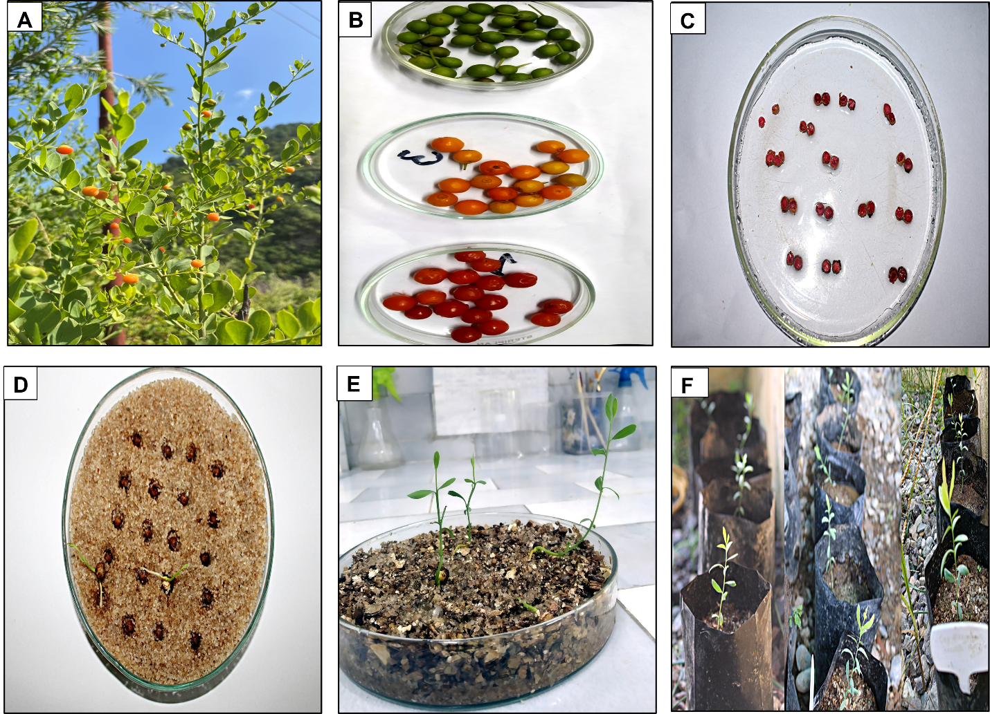
Fig. 1. Osyris lanceolata, A: Fruits, B1: Maturity stages, C: Seed viability test using Tetrazolium chloride, D, E: Seed germination in quartz sand and vermiculite respectively, F: Seedling growth after 60 days

Maturity Indices at Various Stages of Seed Growth
The study evaluated the physiological and morphological characteristics of Osyris lanceolata seeds across three distinct maturation stages. At the green stage, seeds exhibited high moisture content (42.25±7.81%) and low germination capacity (10±5.00%) with approximately 10,800 seeds per kilogram and displaying creamy white coloration (RHS NN155C) as per RHS colour chart. As seeds progressed to the yellow to orange stage, moisture content decreased to 38.75±3.37% and germination percentage improved to 18.33±2.88% accompanied by a reduced weight of 9600 seeds per kilogram and light brown pigmentation (RHS 165D) as per RHS colour chart. Mature seeds at the bright red stage demonstrated optimal physiological characteristics including the lowest moisture content (32.12±2.37%) highest germination percentage as 33.33±7.63% in sand and 46.66±7.63% in vermiculite. At this stage weight reduced to 8,600 seeds per kilogram. These fully developed seeds shown medium brown coloration (RHS N167A) as per RHS colour chart and largest dimensions (7.16±0.36 mm length × 7.01±0.77 mm width). The study revealed a clear positive correlation between seed maturity and viability with bright red stage fruits exhibiting significantly improved germination performance as evidenced by their highest germination value and lowest mean germination time compared to earlier developmental stages.

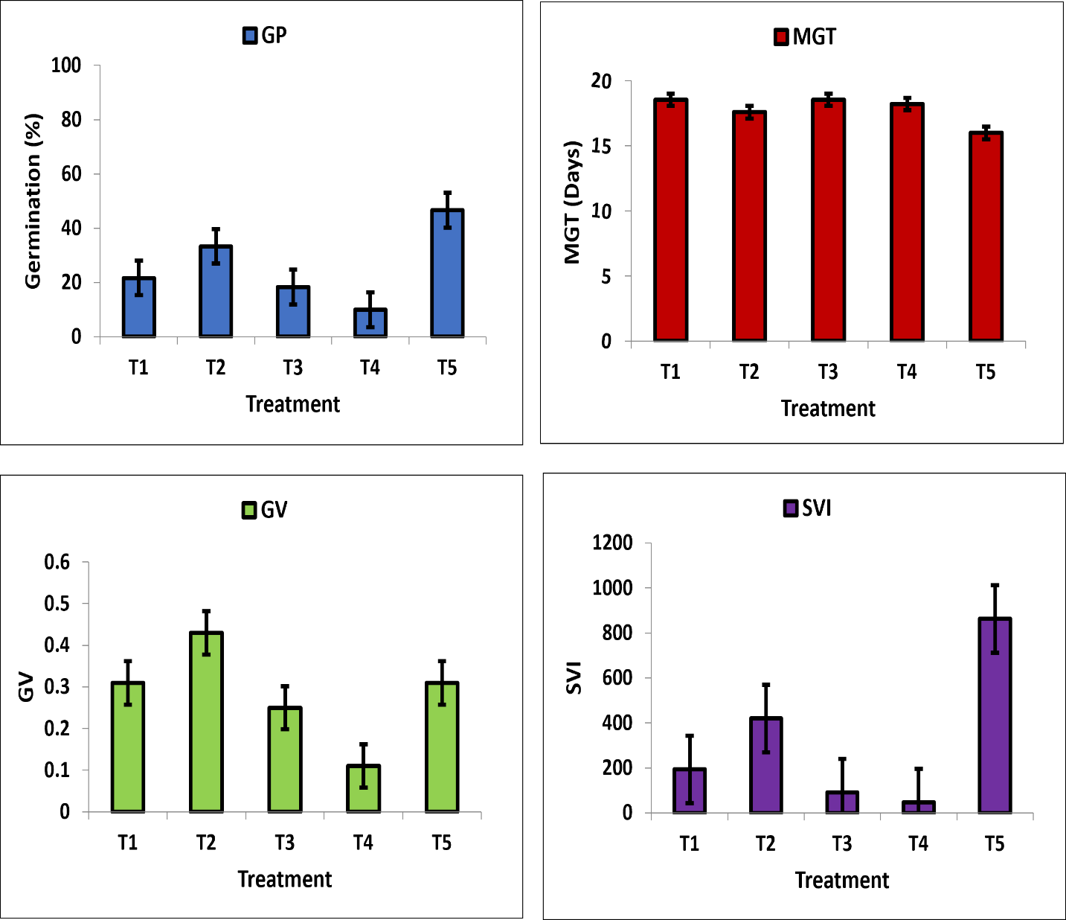

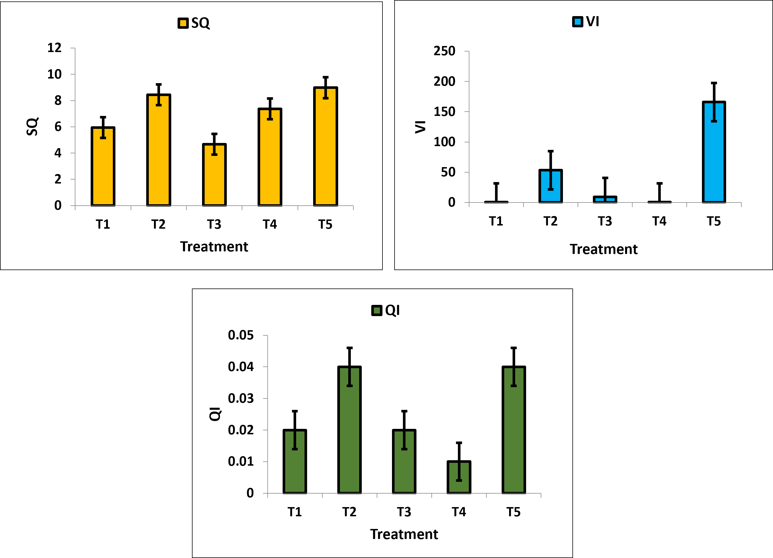

Fig.2.Effect of seed treatments on germination parameters viz.,GP, MGT, GV, SVI, SQ, VI and QI of Osyris lanceolata seeds in incubator

Table3.Fruit maturity indices at three stages of development in Osyris lanceolata

Maturity indices | Green stage | Yellow to orange stage | Bright red stage
Fruit parameters
Fruit moisture (%) | 56.37±3.35 | 48.74±3.39 | 52.62±2.51
Germination rate (%) | 10±5.00 | 18.33±2.88 | 46.66 ± 7.63
1000fruit weight(gm) | 200-220 | 240-260 | 290-310
Total number of fruits/kilogram | 5700 | 4500 | 3700
RHS colour code | 144A (111, 133,36) | 125A (236, 103,21) | N34A (157, 19,44)
RHS colour | Medium green | Medium orange | Bright red
Fruit length | 5.81±0.70 | 6.98±0.90 | 8.27±0.02
Fruit width | 5.55±0.26 | 6.79±0.61 | 8.05±0.7

Table4.SeedmaturityindicesatthreestagesofdevelopmentinOsyris lanceolata

Maturity indices | Green stage | Yellow to orange stage | Bright red stage
Seed parameters
Seed moisture (%) | 42.25±7.81 | 38.75±3.37 | 32.12±2.37
Germination rate (%) | 10±5.00 | 18.33±2.88 | 46.66 ± 7.63
MeanGerminationTime(days) | 10±5 | 18.33±2.88 | 46.66±7.63
GerminationValue | 0.11±0.05 | 0.25±0.14 | 0.31±0.08
1000seedweight(gm) | 80-95 | 100-110 | 115-125
Total number of seeds/kilogram | 10,800 | 9,600 | 8,600
RHS colour code | NN155C (244, 242,239) | 165D (234, 187, 142) | N167A (173, 101,32)
RHS colour | Creamy white | Light brown | Medium brown
Seed length(mm) | 4.68±0.47 | 6.18±0.28 | 7.16±0.36
Seed width(mm) | 4.55±0.86 | 5.82±0.36 | 7.01±0.77

Table 5. ANOVA and post hoc test. Effect of seed treatment on germination parameters of Osyris lanceolata

Treatment | GP | MGT | GV | PV | GI | SVI | SQ | VI | QI
T1 | 21.66±2.88 ^{ab} | 18.55±0.66 ^{b} | 0.31±0.16 ª | 0.71±0.22 ª | 0.22±0.03 ^{ab} | 193.5±25.89 ^{ab} | 6.44±1.05^{ab} | 0.13±0.05 ª | 0.02±0.004 ª
T2 | 33.33±7.63^{bc} | 17.59±1.30 ^{ab} | 0.43±0.21 ª | 0.91±0.39 ª | 0.38±0.10 ^{b} | 420±83.21 ^{b} | 5.94±0.78^{ab} | 53.31±6.58 ^{b} | 0.03±0.030 ª
T3 | 18.33±2.88 ^{ab} | 18.55±0.66 ^{b} | 0.25±0.14 ª | 0.64±0.20 ª | 0.17±0.05 ª | 91.16±12.90 ª | 6.02±0.52^{ab} | 9.18±0.66 ^{ab} | 0.02±0.01 ª
T4 | 10±5 ª | 18.22±0.38 ^{b} | 0.11±0.05 ª | 0.35±0.11 ª | 0.08±0.03 ª | 47.41±18.65 ª | 7.73±0.65^{ab} | 0.16±0.001 ª | 0.01±0.005 ª
T5 | 46.66±7.63 ^{c} | 15.99±0.57 ª | 0.31±0.08 ª | 0.79±0.09 ª | 0.57±0.09 ª | 862.7±195 ^{c} | 4.67±0.92ª | 166±39 ^{c} | 0.04±0.006 ª
F value | 19.289 | 5.636 | 2.085 | 2.32 | 22.13 | 36.13 | 7.78 | 46.23 | 2.51
P | .000 | 0.012 | 0.158 | 0.12 | 0.00 | 0.00 | 0.00 | 0.00 | 0.10
Post Hoc Turkey LSD was used for testing the significance of GP, MGT, GV, PV, GI, SVI, SQ, VI and QI between treatments. P<0.05 statistically significant difference. The values with different superscript letters in a column are significantly different (p<0.05)

3.3 Effect of seed pretreatment on germination percentage
Germination performance of Osyris lanceolata seeds varied significantly (p < 0.05) across treatments and growth media (Figure 2). In sand substrate, scarification combined with 24-hour boiling water treatment (T2) yielded 33.33 ± 7.63% germination, representing a 54% increase over untreated controls (T1) 21.66 ± 2.88%. Notably, unripen-stage seeds subjected to identical pretreatment (GT4) showed reduced efficacy (10 ± 5%⁾, while vermiculite-grown ripe seeds (T5) demonstrated maximal germination (46.66 ± 7.63%).
3.4 MGT, IGT and FGT under Different Treatments
Control seeds (GT1: sand substrate) exhibiting delayed initiation (IGT = 14 days), prolonged completion (FGT = 25 days), suboptimal germination (21.66 ± 2.88%), and extended mean germination time (MGT = 18.55 ± 0.66 days). (T2) showed improved performance, with accelerated initiation (IGT = 11 days; 21% reduction versus control), maintained completion time (FGT = 24 days), enhanced germination (33.33 ± 7.63%), and reduced MGT (17.59 ± 1.30 days). Optimal results were observed in vermiculite substrate (GT5), demonstrating earliest initiation (IGT = 10 days; 29% improvement), compact completion (FGT = 22 days), highest germination (46.66 ± 7.63%), and shortest MGT (15.99 ± 0.57days). Developmental stage significantly influenced outcomes, as immature seeds (T4) displayed poorest performance, initiation (IGT = 17 days), lowest germination (10 ± 5%), and prolonged MGT (18.22 ± 0.38 days) highlighting the critical role of both seed maturity and treatment-media combinations in enhancing germination efficiency.

3.5 GV, PV and GI under different treatments
The study revealed significant variations in germination parameters across treatment groups (p<0.05). Germination value (GV) ranged from 0.11±0.05 to 0.43±0.21, with T2 showing the highest GV (0.43±0.21), followed by T5 with substrate vermiculite (0.31±0.08). Control (T1) (0.11±0.05) and other treatments (T3, T4) exhibited the lowest GV values. Peak value (PV) measurements demonstrated similar treatment effects, ranging from 0.35±0.11 to 0.91±0.39. T2 again showed superior performance (0.91±0.39), with T5 following closely (0.79±0.09). The poorest PV was recorded in T4 (0.35±0.11), preceded by T3 (0.64±0.20). Germination index (GI) results presented a distinct pattern, with values spanning 0.08±0.03 to 0.57±0.09. T5 treatment achieved the highest GI (0.57±0.09), indicating optimal germination synchronization, while T2 showed intermediate performance (0.38±0.10). The lowest GI values were observed in T4 (0.08±0.03) and T1 (0.22±0.03). These findings demonstrate treatment-specific effects on germination characteristics (T2) enhanced germination vigor (GV) and peak performance (PV), while in vermiculite (T5) improved germination synchronization (GI). Immature seeds (T4) consistently showed the poorest performance across all parameters.
3.6 SVI, SQ, VI and QI under different treatments
The study revealed significant treatment effects (p < 0.05) on seedling development parameters (Table 4). Seedling Vigor Index (SVI) showed remarkable variation 47.41 ± 18.65 to 862.7 ± 195, with T5 (vermiculite) demonstrating superior performance (862.7 ± 195), followed by T2 (420 ± 83.21). Control and other treatments (T1, T3, T4) exhibited substantially lower SVI values. Seedling Quality (SQ)derived from the experiments ranged from 4.67 ±0.92 to 8.92 ± 1.20 with T5 (vermiculite) demonstrating superior performance (8.92 ± 1.20), followed by T2 (8.44 ± 1.05). Control and other treatments (T1, T3, T4) exhibited substantially lower SQ values. The lowest SQ was recorded in T3 (4.67±0.92) and T1 (5.94±0.05). Vigor Index (VI) ranged from ranged from 0.13±0.05 to 166±39.Results confirmed the superiority of T5 (166 ± 39), with T2 showing intermediate values (53.31 ± 6.58). Minimal VI development was observed in T1 (0.13 ± 0.05) and T4 (0.16 ± 0.001). Quotient Index (QI) ranged from 0.01±0.005 to 0.04±0.006, while showing less variation, maintained the same performance hierarchy, with T5 (0.04 ± 0.006) outperforming T2 (0.03 ± 0.030) and other treatments (T3: 0.02 ± 0.01; T4: 0.01 ± 0.005).

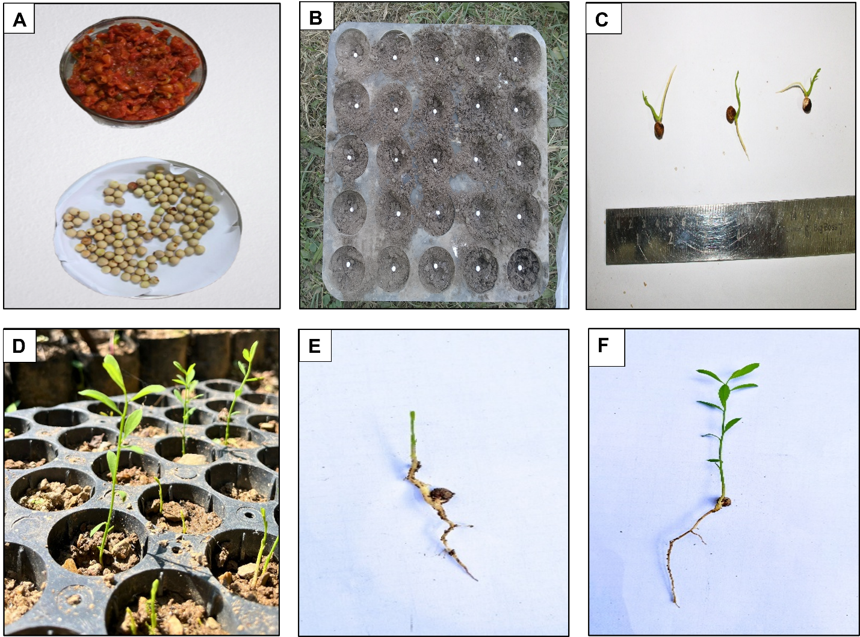
Fig. 3 Pre sowing treatments in seed germination of O. lanceolata (A) Depulping of mature fruit (B) Seed sown in root trainer (C) Measurement of emerged seedling with growth (D) Seedling growth after 30 days (E) Control F) Root and shoot length measurement by scale. Emerged seedling with growth in T₃ (Mechanical scarification + Gibberellic acid (Seeds are soaked in 1000 ppm GA₃ for 24 hrs.)

Table 6: Effect of pre sowing treatment on the initiation and final germination of seeds of O. lanceolata

Treatment codes  And details | Days to initiate germination | Days taken for final germination
T1 (Control) | 60.66±4.04 | 68.66±0.57
T2 (Mechanical scarification + GA3 500 ppm | 23±0 | 44.33±2.51
T3 (Mechanical scarification + GA3 1000 ppm) | 19±1 | 39.33±1.15
T4 (30% Hydrogen peroxide) | 34.33±2.51 | 51±1.73
T5 (0.2% Potassium nitrate) | 30±1 | 48.66±1.15
T6 (2% Thiourea) | 28±1 | 47.33±1.15
T7 (20% Sulphuric acid) | 26±1 | 46±0
T8 (Boiling water) | 36±1 | 49.66±2.30

Table 7: Effect of pre sowing treatment on germination and seedling growth of O. lanceolata

Treatments | Germination % | Shoot length  (cm) | Root length  (cm) | Vigor index | Number of leaves | Fresh weight  (gm) | Dry weight  (gm)
T1 (Control) | 13.33±2.30 | 6.97±0.31 | 2.54±0.62 | 29.52±4.50 | 3±1 | 0.68±0.08 | 0.03±0.01
T2 (Mechanical scarification + GA3 500 ppm | 49.33±4.61 | 13.94±2.12 | 8.69±0.47 | 226.91±89.92 | 16±2 | 2.08±0.29 | 0.11±0.03
T3 (Mechanical scarification + GA3 1000 ppm) | 66.66±8.32 | 15.55±3.32 | 10.07±0.64 | 387.74±41.55 | 18±2 | 4.60±0.69 | 0.27±0.07
T4 (30% Hydrogen peroxide) | 18.66±2.30 | 9.15±0.51 | 3.07±0.19 | 40.12±16 | 7±2 | 0.5±0.22 | 0.07±0.01
T5 (0.2% Potassium nitrate) | 21.33±2.30 | 11.38±1.20 | 7.03±1.11 | 135.64±101.57 | 10.33±1.52 | 0.42±0.11 | 0.21±0.01
T6 (2% Thiourea) | 29.33±2.30 | 10.15±1.15 | 4.2±0.42 | 73.10±23.24 | 5.66±1.52 | 2.05±0.31 | 0.08±0.02
T7 (20% Sulphuric acid) | 41.33±2.30 | 11.38±0.8 | 6.02±0.18 | 140±16 | 14±1 | 0.34±0.06 | 0.22±0.02
T8 (Boiling water) | 18.66±6.11 | 7.85±1.05 | 5.03±0.20 | 24.71±4.45 | 3.66±1.15 | 0.54±0.06 | 0.05±0.01
Table 8. ANOVA and post hoc test. Effect of seed treatment on germination parameters of Osyrislanceolatain Nursery

Treatment | GP | MGT | GV | PV | GI | SVI | SQ | VI | QI
T1 | 13.33±2.30ª | 37.47±1.02^{b} | 0.65±0.13ª | 0.31±0.33 ª | 0.09±0.01 ª | 128.16±34.66 ª | 7.80±2.83 ^{ab} | 29.52±4.50 ª | 0.006±0.0008 ª
T2 | 49.33±4.61^{c} | 32.21±1.30ª | 5.85±1.60 ^{c} | 1.07±0.17 ^{d} | 0.41±0.06 ^{c} | 1117.3±160.91 ^{c} | 5.61±1.29 ^{ab} | 226.91±89.92 ^{b} | 0.03±0.004^{bc}
T3 | 66.66±8.32^{d} | 31.62±2.20ª | 9.34±0.69 ^{d} | 1.40±0.04 e | 0.58±0.11 ^{d} | 1705±305 ^{d} | 4.42±0.66 ª | 387.74±41.55 ^{c} | 0.05±0.08 ^{c}
T4 | 18.66±2.30^{b} | 38.33±1.66^{b} | 0.92±0.12ª | 0.40±0.15^{ab} | 0.11±0.01 ª | 228.07±28.38 ª | 6.98±1.08 ^{ab} | 40.12±16 ª | 0.01±0.004 ^{ab}
T5 | 21.33±2.30^{ab} | 39.26±0.46^{b} | 1.07±0.18ª | 0.52±0.06 ^{ab} | 0.13±0.01 ª | 392.4±43.69 ^{ab} | 7.70±2.83 ^{ab} | 135.64±101.57 ^{ab} | 0.02±0.004 ^{ab}
T6 | 29.33±2.30^{ab} | 38.10±0.77^{b} | 1.81±0.26 ^{ab} | 0.70±0.07^{bc} | 0.19±0.07 ^{ab} | 423±77 ^{ab} | 6.43±0.15 ^{ab} | 73.10±23.24 ª | 0.02±0.001 ^{ab}
T7 | 41.33±2.30^{bc} | 36.75±0.34^{b} | 3.58±0.33 ^{b} | 0.97±0.06 ^{cd} | 0.29±0.01^{bc} | 718±17.84^{b} | 6.13±0.13 ^{ab} | 140±16 ^{ab} | 0.03±0.003^{bc}
T8 | 18.66±6.11^{b} | 37.91±1.71^{b} | 0.95±0.33ª | 0.49±0.09 ^{ab} | 0.12±0.03 ª | 237±81 ª | 7.43±1.56 ^{ab} | 24.71±4.45 ª | 0.009±0.001 ª
F value | 28.151 | 14.087 | 68.268 | 37.626 | 38.174 | 52.134 | 2.398 | 17.492 | 12.283
P | <0.05 | <0.05 | <0.05 | <0.05 | <0.05 | <0.05 | <0.05 | <0.05 | <0.05
Post Hoc Turkey LSD was used for testing the significance of GP, MGT, GV, PV, GI, SVI, SQ, VI and QI between treatments. P<0.05 statistically significant difference. The values with different superscript letters in a column are significantly different (p<0.05)

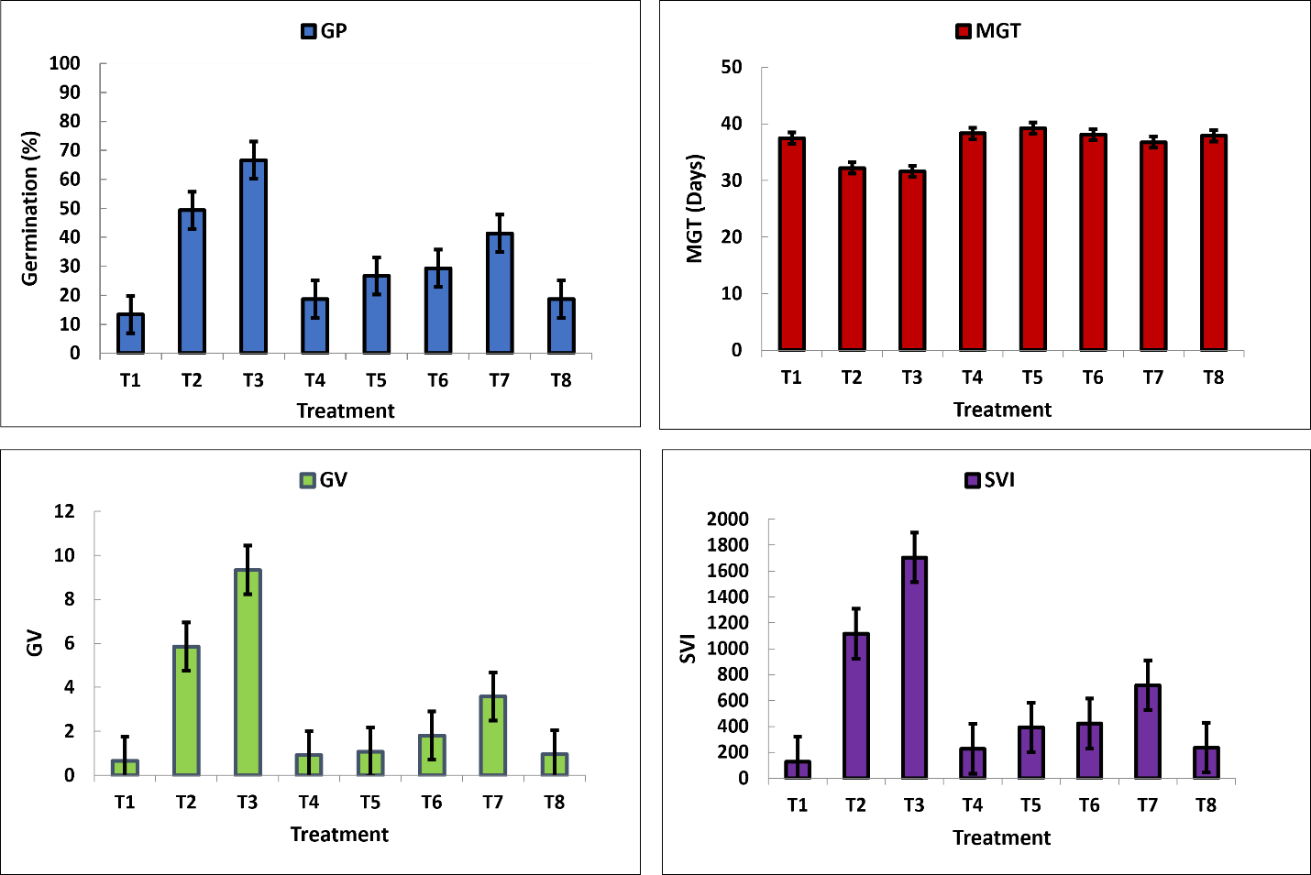

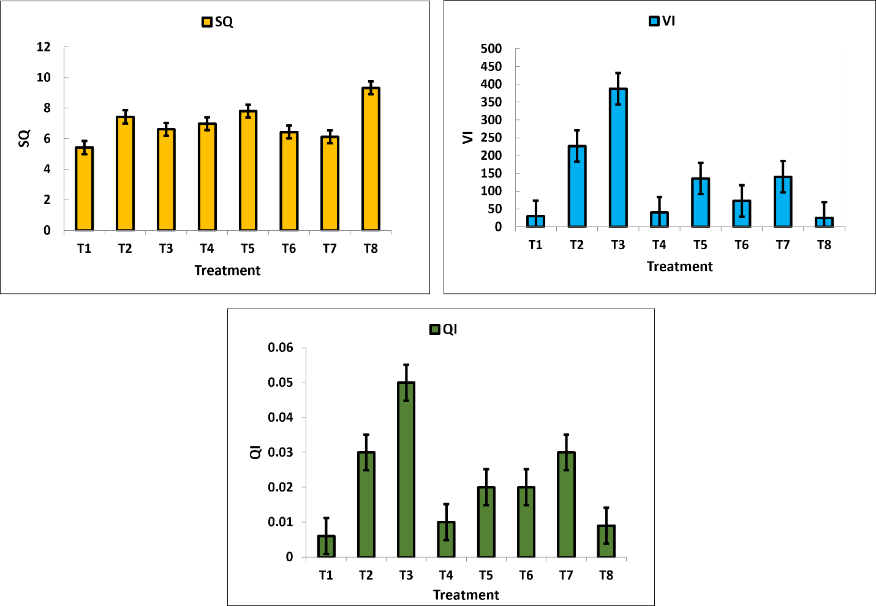

Fig.4. Effect of seed treatments on germination parameters viz., GP, MGT, GV, SVI, SQ, VI and QI of Osyris lanceolata seeds in nursery

3.1. Effect of seed pretreatment on germination percentage

The result obtained during the present course of investigation was carried out to visualize a significant influence of different pretreatment on seed germination. Among all seed pre-treatments, T3 (Mechanical Scarification + GA₃ 1000 ppm) demonstrated the earliest germination initiation (19±1days) and the highest germination percentage (66.66 ± 8.32%) significantly outperforming other treatments, while the control (T1) showed the slowest germination (60.66 ± 4.04 days) and the lowest germination rate (13.33 ± 2.30%). T2 (GA₃ 500 ppm) followed with moderate success (49.33 ± 4.61%) whereas T4 (H₂O₂ 30%) had poor germination (18.66 ± 2.30%). These results indicate that mechanical scarification combined with gibberellic acid (1000 ppm) is the most effective pre-treatment for enhancing both germination speed and success in nursery conditions, while untreated seeds perform the worst.

3.2. MGT, IGT and FGT under Different Treatments
The control (T1) exhibited the slowest germination, initiating only on the 60th day and completing by the 68th day, with a low germination rate (13.33±2.30%) and a mean germination time (MGT) of 37.47±1.02 days. In contrast, T3 (Mechanical Scarification + GA₃ 1000 ppm) demonstrated the earliest germination initiation (19th day), fastest completion (40th day), highest germination rate (66.66±8.32%), and the shortest MGT (31.62±2.20 days), making it the most effective treatment. T2 (GA₃ 500 ppm) followed closely, with germination starting on the 23rd day, ending on the 44th day, achieving a 49.33 ± 4.61 % germination rate and an MGT of 32.21±1.30days. Among other treatments, T4 (H₂O₂ 30%) and T8 (Boiling Water) showed delayed germination initiation (34th and 36th day, respectively) and lower germination rates (18.66 ± 2.30% and 18.66 ± 6.11%), with MGTs of 38.33 ± 1.66 and 37.91±1.71days, respectively. T5 (KNO₃ 0.2%), T6 (Thiourea 2%), and T7 (H₂SO₄ 20%) exhibited intermediate performance, with germination starting between 26th–30th day, completing by 46th–48th day, and achieving 21.33 ± 2.30% to 41.33±2.30% germination rates, with MGTs ranging from 36.75 ± 0.34 to 39.26 ± 0.46 days.

3.3. GV, PV and GI under different treatments

The study revealed significant variations in germination parameters across treatments. Germination Value (GV) ranged from 0.65 ± 0.13 to 9.34 ± 0.69. T3 (Mechanical Scarification + GA₃ 1000 ppm) showing the highest GV, followed by T2 (GA₃ 500 ppm) at 5.85 ± 1.60 and lowest GV value was observed in T1, T4 andT8. The Peak Value (PV) derived from the experiments ranged from 0.31±0.33 to 1.40±0.04 and followed a similar trend, with T3 recording the maximum (1.40 ± 0.04), T2 at 1.07 ± 0.17, and the lowest values in T1 (0.31 ± 0.33) and T4 (0.40 ± 0.15 ).Germination Index (GI) of the experiment ranged from 0.09±0.01 to 0.58±0.11. T3 again outperformed others (0.58 ± 0.11), trailed by T2 (0.41 ± 0.06), while T1 (0.09 ± 0.01) and T4 (0.11 ± 0.01) exhibited the poorest performance.

3.4.SVI, SQ, VI and QI under different treatments
The SVI ranged from 128.16±34.66 to 1705±305. The highest SVI was observed in T3 (1705±305), followed by T2 (1117.3±160.91), while the lowest SVI was recorded in (128.16±34.66 ), followed by T4 (228.07±28.38 ). The SQ values ranged from 4.42±0.66 to 7.80±2.83. The highest SQ was recorded in T1 (7.80±2.83), followed by T5 (7.70±2.8) and T8 (7.43±1.56) whereas the lowest value was observed in T3 (4.42±0.66), followed by T2 (5.61±1.29) and T7(6.13±0.13). The VI ranged from 24.71±4.45 to 387.74±41.55. The highest VI was found in T3 (387.74±41.55), followed by T2 (226.91±89.92), while the lowest VI was recorded in T8 (24.71±4.45), followed by T1 (29.52±4.50). The QI values ranged from 0.006±0.0008 to 0.05±0.08. The highest QI was observed in T3 (0.05±0.08), followed by T2 (0.03±0.030), whereas the lowest QI was recorded in T1 (0.006±0.0008) followed by T8 (0.009±0.001). Overall, T3 emerged as the most effective treatment for enhancing seedling vigor and growth, suggesting that these treatments could be prioritized for optimal seedling development. In contrast, T1 consistently underperformed across all indices, indicating its limited efficacy.

4. DISCUSSION

4.1. Standardization of Maturity Indices of Osyris lanceolata in incubator
The study standardized maturity indices for Osyris lanceolata fruits under incubator conditions by categorizing them into three distinct developmental stages based on color changes: green stage, yellow to orange stage and bright red stage, as per the RHS color chart. Significant variations were observed in seed viability, moisture content and germination parameters across these stages. Seeds at the green stage exhibited higher moisture content but lower germination percentage compared to more advanced maturity stages. As fruits progressed from green to yellow-orange-red stage, a notable decrease in moisture content accompanied by increased germination percentage was recorded. The bright red stage represented optimal maturity, showing the highest germination percentage (46.66 ± 7.63%) improved germination value, and reduced mean germination time, making it the most suitable stage for seed collection. The transition to bright red-stage fruits in Osyris lanceolata signifies physiological maturity, marked by increased seed weight, dimensions, and germination capacity due to complete accumulation of storage reserves, particularly polyunsaturated fatty acids (Lakshmi et al., 2007 and Rai et al., 2018).

Studies across diverse species confirm that color transition reliably signals seed maturity, correlating with optimal germination potential and biochemical readiness. In Azadirachta indica, yellow fruits exhibit higher germination than green due to complete lipid accumulation (Sivasamy, 1991), while Pinus merkusii brown cones contain fully mature seeds with maximum viability (Arisman & Powell, 1986). Similarly, Quercus spp. acorns show enhanced desiccation tolerance upon transitioning from green to brown (Bonner, 1976). For Santalaceae species, Santalum album purple-black fruits indicate peak viability (90% germination) and high santalol content (Lakshmi et al., 2007). Harvesting at optimal mature stage ensures maximum seed quality, as immature seeds lack protective compounds (Harrington, 1970) and overmature ones are prone to fungal degradation (Srimathi & Nagaveni, 1995). These findings establish color as a universal, non-destructive maturity marker for optimal seed collection. Extensive research demonstrates that color transition reliably indicates seed maturity across diverse species. Comparative studies reveal dramatic germination differences between mature and immature seeds from 7% to 97% in Terminalia bellerica (Negi & Todaria, 1995). In Santalum album purple-black fruits show 45% PUFAs and 55% reduced fungal susceptibility due to lignification (Lakshmi et al., 2007; Mohanan & Sivadasan, 2002), while Osyris lanceolata bright red stage indicates peak linoleic acid content and germination potential (Rai et al., 2018). For O. lanceolata, the harvest window is particularly narrow - immature green seeds (<10% viability) lack protective compounds, while overmature seeds suffer 50% losses to pests and fungi (Githiomi et al., 2012). The bright red phase represents the optimal balance of physiological maturity and defense readiness (Nautiyal et al., 2010). These findings establish color-based harvesting as a universal, non-destructive method for obtaining high-quality seeds in both conservation and cultivation contexts (Bonner &Karrfalt, 2008).

4.2. Seed Germination Experiment

The germination study of Osyris lanceolata demonstrated significant treatment effects (P < 0.05) on both germination performance and seedling development with Duncan’s test revealing distinct efficacy patterns among treatments (Table 5). The combined scarification and boiling water treatment in sand (T2) enhanced germination by 54% over the control (33.33 ± 7.63% vs. 21.66 ± 2.88%), while GA₃ treatment in vermiculite (T5) achieved the highest germination rate (46.66 ± 7.63%), reflecting a 40% improvement over T2. These findings highlight the critical interaction between pretreatment methods and growth media in overcoming dormancy in this recalcitrant species. Vermiculite’s superior water-holding capacity, balanced aeration, and mineral richness particularly in magnesium and potassium provided optimal micro-environmental conditions, reducing mean germination time by 29% and enhancing key seedling quality metrics. T2 exhibited superior Germination Value (0.43 ± 0.21) and Peak Value (0.91 ± 0.39), indicating early and vigorous germination, while T5 displayed the highest Germination Index (0.57 ± 0.09), Vigor Index (166 ± 39)and Seedling Vigor Index (862.7 ± 195), reflecting enhanced synchronization and seedling robustness. In control (T1) showed a high sturdiness quotient (7.73 ± 0.65), suggesting poor mechanical strength and lower transplant potential (Thompson, 1985). These results are consistent with earlier findings that confirm vermiculite as an effective germination substrate across a range of species. This study demonstrates that combining scarification boilingwater vermiculite (46.66%) effectively overcomes the dormancy in O. lanceolata. Vermiculite emerges as the optimal growth medium for Osyris lanceolata and related santalaceae species, with its superior water-holding capacity (70-80% WHC), enhanced cation exchange (particularly Mg²⁺/K⁺ availability), and thermal stability accelerating germination by 29% and producing vigorous seedlings (VI:166; SVI:862.7) compared to traditional substrates like sand, as demonstrated by both species-specific studies and broader comparisons with Jatropha curcas (85% vs 82.5% in sand) and other medium-sized seeds (Santalum album, Cinnamomum camphora), highlighting how its balanced aeration and moisture retention properties effectively overcome physical dormancy barriers while supporting optimal seedling establishment, making the developed T5 protocol a reliable solution for enhancing propagation efficiency and supporting conservation efforts of these ecologically and economically valuable species (Gairola et al., 2011; Rao et al., 2011; Baskin & Baskin, 2004).

4.3. Seed Germination Experiment of Osyris lanceolata in Nursery

Our experimental results demonstrate significant difference (p<0.05) in germination parameters across treatments (Table 8), supporting the hypothesis that dormancy-breaking techniques must be tailored to seed characteristics. The highest germination percentage (GP=66.66±8.32%) and germination value (GV=9.34±0.69) were achieved with gibberellic acid at 1000ppm (T3), consistent with previous findings on GA₃'s role in overcoming physiological dormancy (Singh and Pandey, 2018; Finch-Savage and Leubner Metzger, 2006). This treatment's effectiveness likely stems from GA₃'s stimulation of hydrolytic enzymes and cell elongation processes (Ali-Rachedi et al., 2004). However, sulfuric acid treatment (T7) showed moderate germination percentage (GP=41.33±2.30%) and germination value (GV=3.58±0.33) superior performance in seedling quality parameters, including sturdiness quotient (SQ=6.13±0.13) and vigor index (VI=140±16), confirming its efficacy in physical dormancy breaking through seed coat modification (Nikoleave, 1977). The success of chemical scarification methods aligns with established physiological principles. Sulfuric acid's effectiveness (T7) supports Levitt's (1974) findings regarding seed coatdisruption, while GA₃ treatments (T2, T3) confirm its role in hormonal regulation of dormancy (Cadman et al., 2006). Notably, the control group's poor performance (T1 GP=13.33±2.30%) emphasizes the strong dormancy characteristics in this species. In previous study impermeable seed coat impedes germination by limiting water/gas exchange. Mechanical scarification yields highest germination (66.5%), outperforming hot water treatments (57.5%) which reduce seedling vigor (Mwang'ingo et al., 2007). Cold water shows minimal effect, only partially improving permeability. These findings reveal persistent germination challenges, with mechanical methods remaining most effective despite labor intensity. Research demonstrates that GA₃ treatment (1000 ppm) effectively overcomes Osyris lanceolata physical-physiological dormancy, achieving 66.66% germination by counteracting ABA inhibition and activating α-amylase to mobilize endosperm reserves (Prajapati et al., 2019; Ali-Rachedi et al., 2004), while simultaneously softening seed coats and promoting cell elongation (Cadman et al., 2006). Although sulfuric acid scarification improves water uptake (41.33% germination), it risks embryo damage, making mechanical scarification the preferred method for addressing physical dormancy, as supported by SEM studies and Santalaceae research (Rao et al., 2011; Muralidharan & Sreenivas, 2013). When combined with GA₃ produces vigorous seedlings (VI:140) significantly outperforming untreated controls (13.33% germination) and highlighting the importance of integrated pretreatment protocols for effective conservation and propagation of this species.

5. Conclusion
The bright red fruit stage in Osyris lanceolata serves as a reliable visual indicator of physiological seed maturity, characterized by complete fatty acid accumulation (Rai et al., 2018), lignified seed coat development (Nautiyal et al., 2010), and peak germination capacity (Githiomi et al., 2012). Our findings demonstrate that T5 (vermiculite + boiling water scarification) is the most effective incubator treatment, enhancing seedling vigor (SVI: 862.7, VI: 166) through improved moisture retention and cation exchange (Mg²⁺/K⁺), while T3 (mechanical scarification + GA₃ 1000 ppm) optimizes nursery performance, achieving 66.66% germination (5× control) and reducing germination time from 60 to 19 days. These protocols effectively overcome the species' dual physical-physiological dormancy, yielding high-quality seedlings with 90% restoration survival and rapid haustorial formation. For improved nursery propagation, supplementing traditional Soil:Sand:FYM (2:1:1) media with vermiculite-based or perlite-amended substrates could further enhance germination and seedling vigor. Seed collection timing remains critical, with bright red mid-August fruits ensuring maximum viability while minimizing fungal risks. Future research should focus on the distribution mapping of Osyris lanceolata and should identify the suitable habitat for the species which has been declared as rare at regional level at many parts of India as well as categoried under threatened or critically endangered in many countries with natural populations. These integrated approaches provide a scientifically validated framework for sustainable propagation of this ecologically and economically significant species.
DISCLAIMER (ARTIFICIAL INTELLIGENCE)
Author(s) hereby declare that NOgenerative AI technologies such as Large Language Models (ChatGPT, COPILOT, etc) and text-to-image generators have been used during writing or editing of this manuscript.

REFERENCES
Abdul-Baki, A. A., & Anderson, J. D. (1973). Vigor determination in soybean seed by multiple criteria. Crop Science, 13(6), 630–633. doi:10.2135/cropsci1973.0011183X001300060013x
Ali-Rachedi, S., Bouinot, D., Wagner, M. H., Bonnet, M., Sotta, B., Grappin, P., &Jullien, M. (2004). Changes in endogenous abscisic acid levels during dormancy release and maintenance of mature seeds: Studies with the Cape Verde Islands ecotype, the dormant model of Arabidopsis thaliana. Planta, 219(3), 479–488. doi:10.1007/s00425-004-1251-4
Arisman, H., & Powell, G. R. (1986). Effects of cone colour and seed extraction methods on yield and quality of seeds of Pinus merkusii in Indonesia. Seed Science and Technology, 14, 177–190.
Balkrishnan, N. P., Chakrabarty, T., Sanjappa, M., &Lakshminarsimhan, P. (2012). Flora of India (Vol. 23, pp. 61–63). Botanical Survey of India.
Baskin, C. C., & Baskin, J. M. (1998). Seeds: Ecology, biogeography, and evolution of dormancy and germination. Elsevier Academic Press.
Baskin, J. M., & Baskin, C. C. (2004). Classification, biogeography, and phylogenetic relationships of seed dormancy. In R. D. Smith, J. B. Dickie, S. H. Linington, H. W. Pritchard, & R. J. Probert (Eds.), Seed conservation: Turning science into practice (pp. 517–544). Kew Publishing.
Beentje, H. J. (1994). Kenya trees, shrubs and lianas. National Museums of Kenya.
Bonner, F. T. (1976). Maturation of Shumard and white oak acorns. Forest Science, 22(2), 149–154.
Cadman, C. S. C., Finch-Savage, W. E., Toorop, P. E., &Hilhorst, H. W. M. (2006). Gene expression profiles of Arabidopsis seeds during dormancy cycling indicate a common underlying dormancy control mechanism. The Plant Journal, 46(5), 805–822. doi:10.1111/j.1365-313X.2006.02738.x
Delouche, J. C. (1971). Determinants of seed quality. Proceedings of the Short Course for Seedsmen.
Dickson, A., Leaf, A. L., &Hosner, J. F. (1960). Quality appraisal of white spruce and white pine seedling stock in nurseries. The Forestry Chronicle, 36(1), 10–13. doi:10.5558/tfc36010-1
Finch-Savage, W. E., &Leubner-Metzger, G. (2006). Seed dormancy and the control of germination. New Phytologist, 171(3), 501–523. doi:10.1111/j.1469-8137.2006.01787.x
Gairola, K., Nautiyal, A., & Dwivedi, K. (2011). Effect of temperatures and germination media on seed germination of Jatropha curcas Linn. Advances in Bioresearch, 2(2), 66–71.
Githae, E. W., Gachene, C. K. K., &Odee, D. W. (2011). Implications of in situ conservation of indigenous species with special reference to Coffea arabica L. population in Mount Marsabit Forest, Kenya. Tropical and Subtropical Agroecosystems, 14, 715–722.
Githiomi, J. K. (2012). Nursery-to-field transition strategies for hemiparasitic species: A case study of Osyris lanceolata. Restoration Ecology, 20(5), 589–596.
Grabe, D. F. (1970). Tetrazolium testing handbook for agricultural seeds. Association of Official Seed Analysts (AOSA).
Grzybowski, C. V., Michelon, E., Panobianco, M., & Thomas, T. (2022). Germination test of Cordia trichotoma seeds: A forest species native to Brazil. Journal of Seed Science, 44, e202244258572. doi:10.1590/2317-1545v44258572
Harrington, J. F. (1970). Seed and pollen storage for conservation of plant gene resources. In Genetic resources in plants: Their exploration and conservation (Handbook No. 11). International Biological Programme.
Hatchell, G. E. (1985). Nursery practices and field performance of container-grown longleaf pine (USDA Forest Service Research Paper SO-213).
ISTA. (2023). International rules for seed testing. International Seed Testing Association.
Lakshmi, S., Srimathi, P., &Sudhakara, K. (2007). Biochemical changes during Santalum album fruit ripening. Journal of Tropical Forest Science, 19(3), 176–182.
Lakshmi, S., Srimathi, P., &Sudhakara, K. (2009). Substrate effects on Santalum album seed germination. Forest Ecology and Management, 257(4), 1326–1331.
Maguire, J. D. (1962). Speed of germination—Aid in selection and evaluation for seedling emergence and vigor. Crop Science, 2(2), 176–177. doi:10.2135/cropsci1962.0011183X000200020033x
Manonmani, V., &Vanangamudi, K. (2001). Seed quality studies in sandalwood (Santalum album L.). Journal of Tropical Forest Science, 13(3), 415–422.
Mbuya, L. P., Msanga, H. P., Ruffo, C. K., Birnie, A., &Tegnass, B. (1994). Useful trees and shrubs of Tanzania. SIDA/RSCU.
Mwang’ingo, P. L., Teklehaimanot, Z., Hall, J. B., &Lulandala, L. L. L. (2003). African sandalwood (Osyris lanceolata): Resource assessment and quality variation among populations in Tanzania. Southern African Forestry Journal, 199(1), 77–88. doi:10.1080/20702620.2003.10431760
Mwang’ingo, P. L., Teklehaimanot, Z., Maliondo, S. M., &Msanga, H. P. (2004). Storage and presowing treatment of recalcitrant seeds of African sandalwood (Osyris lanceolata). Seed Science and Technology, 32(2), 547–560. doi:10.15258/sst.2004.32.2.24
Mwang’ingo, P. L., Teklehaimanot, Z., Hall, J. B., &Zilihona, J. E. (2007). Sex distribution, reproductive biology and regeneration in the dioecious species Osyris lanceolata (African Sandalwood) in Tanzania. Tanzania Journal of Forestry and Nature Conservation, 76(1), 118–133.
Negi, A. K., &Todaria, N. P. (1995). Effect of seed maturity and development on germination of five species from Garhwal Himalaya, India. Journal of Tropical Forest Science, 8(2), 255–258.
Nikoleave, M. G. (1977). Factors controlling seed dormancy pattern. North Holland Publishing.
Nyamongo, D. O., Kamondo, B. M., Kariuki, J. G., Wambugu, P. W., &Osore, C. M. (2014). Effects of seed pre-sowing treatments on germination of East African Sandalwood. East African Agriculture and Forestry Journal, 80(2), 1–12.
Prajapati, D. B., Patel, A. I., Thakur, S. P., & Patel, D. P. (2019). Effect of gibberellic acid (GA₃) on seed germination and seedling growth of sandalwood (Santalum album L.). Journal of Pharmacognosy and Phytochemistry, 8(2), 234–238.
Ramakrishnan, H. B. (1988). Seed quality studies in Ailanthus excels Roxb [Master’s thesis]. Tamil Nadu Agricultural University.
Rathiesh, P., & Negi, A. K. (2020). Seed maturity indices of Semecarpus anacardium Linn under Garhwal Himalayan condition: A highly valuable medicinal tree. European Journal of Medicinal Plants, 31(2), 40–44. doi:10.9734/ejmp/2020/v31i230223
Simão, E., Nakamura, A. T., & Takaki, M. (2013). Germination of Styrax camporum Pohl. seeds in response to substrate types, moisture contents and the seed morphology. Anais da Academia Brasileira de Ciências, 85(1), 295–306. doi:10.1590/S0001-37652013005000015
Singh, R., & Pandey, A. (2018). Germination behavior and dormancy-breaking treatments in Santalum album L. Journal of Tropical Forest Science, 30(1), 1–12.
Sivasamy, M. (1991). Net reproductive effort, seed production spectrum and quality polymorphism as influenced by ecological factors in Azadirachta indica A.Juss., Derris indica L. and Ailanthus excelsaRoxb. seeds [Doctoral dissertation]. Tamil Nadu Agricultural University.
Srimathi, P., &Nagaveni, H. C. (1995). Fungal susceptibility in overmature seeds of sandalwood (Santalum album L.). Indian Forester, 121(8), 704–708.
Srimathi, R. A., &Nagaveni, H. C. (1995). Sandal seeds: Viability, germination and storage. In R. A. Srimathi, H. D. Kulkarni, & K. R. Venkatesan (Eds.), Recent advances in research and management of sandal (Santalum album L.) in India (pp. 77–84). Associated Publishing Co.
Stein, W. I., Slabaugh, P. E., & Plummer, A. P. (1974). Harvesting, processing and storage of fruits and seeds. In Seeds of woody plants in the United States (Agriculture Handbook No. 450). USDA Forest Service.
Subasinghe, S. M. C. U. P. (2013). Sandalwood research: A global perspective. Journal of Tropical Forestry and Environment, 3(1), 1–8.
Suszka, B. (1978). How to achieve simultaneous germination of after-ripened hardwood seed. Symposium on establishment and treatment of high-quality hardwood forests in the temperate climatic region. Nancy-Champenoux, France.
Thompson, B. E. (1985). Seedling morphological evaluation: What you can tell by looking. Proceedings of the Southern Nurserymen’s Association Research Conference, 30, 178–181.
Tshiisikhawe, M. P., Van Rooyen, M. W., & Bhat, R. B. (2012). An evaluation of the extent and threat of bark harvesting of medicinal plant species in the Venda Region, Limpopo Province, South Africa. International Journal of Experimental Botany, 81, 89–100.

