***Original Research Article***

**Unmasking the Nymph: Taxonomic Delimitation of *Pygolampis foeda* Stål, 1859 revealed through Mitochondrial COI Barcoding and Cybertaxonomy**

**Abstract:**  
*Pygolampis foeda*, an assassin bug, is a good biological pest control species was recorded from Kaimur Wildlife Sanctuary, Bihar. In spite of its ecological significance, the taxonomic status of this organism has been confused by morphological indeterminacy, to carry out morphology-based identification especially at early life developmental stages such as the nymphs. This article explores the use of DNA barcoding and cybertaxonomy in refining the identification of *P. foeda*, in agroecosystems by considering the economic value. By combining cybertaxonomy with molecular tools such as COI Barcoding and Phylogenetic Analysis, we explore *P. foeda’s* evolutionary identity from nymphal life stages and advocate its consideration in sustainable pest management programmes.

Keyword: *Pygolampis foeda,* Reduviidae, Hemiptera, COI Barcoding, Phylogenetic Analysis, Cybertaxonomy.

**1. Introduction**

**1.1. Background on *Pygolampis foeda* and the family Reduviidae.**

The family Reduviidae of assassin bugs (Hemiptera: Heteroptera: Reduviidae) is a diverse group of predatory hemipterans which have an ecological function as natural pest controllers in different ecosystems, mostly agroecosystems. Reduviidae Latreille, 1802 (Cimicomorpha) is a diversified family of order Hemiptera represented by a large number of terrestrial predators commonly known as assassin bugs (Schuh and Slater, 1995). Members of this group includes 25 sub-families and nearly 7000 described species worldwide (Weirauch et al., 2014). Of them, *Pygolampis* Germar, 1825 is the second largest genus in the subfamily *Stenopodainae* and contains 92 species worldwide (Okuda K. 2021). For the detailed information on taxonomic status, distribution and diagnostic morphological characteristics of Indian assassin bugs since 1976 are credited to Ambrose (1980; 1987a,b; 1988; 1991; 1996a,b; 1999; 2000; 2003; 2004a,b). The estimated global diversity of hemipterans is 1,03,590 species worldwide (Chandra et al., 2018). Recent hemipteran checklist by (Praveen K et al, 2024) reported 6,058 species from India.

The genus *Pygolampis* are characterized by their predatory behaviour to control populations of agriculturally important insect pests (Ambrose, 2006; Swanson, 2018). These reduviids are generally sit-and-wait predators with high levels of prey specialization, and usually become beneficial insects in integrated pest management (IPM) programs (Zhang & Weirauch, 2014).

However, *P. foeda*, a species not widely studied within the genus, rather paid more attention for its predation on soft-bodied insect pests including aphids and caterpillars (Ambrose & Livingstone, 1981; Hwang & Weirauch, 2012). According to field observations, it is spread across tropical and subtropical Asia, especially in India, and is regularly seen in crop fields, near forests, and in scrub areas. Its ecological role is particularly relevant in light of growing concerns over pesticide overuse and the search for sustainable pest control alternatives (Kaur & Brar, 2015).

**1.1. Importance of accurate taxonomic delimitation**

Even though it has potential for controlling pests, the classification and identification up to species level of *P. foeda* is uncertain especially at early life developmental stages such as the nymphs. Pronounced intraspecific morphological variation is common among Reduviidae members, which also makes it hard to identify this species with certainty (Weirauch & Munro, 2009). In addition, the recent studies utilizing cybertaxonomic techniques indicate that cryptic species exist within the group currently referred to as *P. foeda*, unsettling the delineation of its species ranges and borders (Zhao et al., 2022). Traditional morphological identification keys often inadequate for dealing with morphological variation, thus possibly resulting in incorrect identification and a lack of recognition for true species diversity, especially at nymphal stage identity confirmation. As a solution to these problems, DNA sequencing along with cybertaxonomy techniques are being more widely used to separate similar species and find undetected genetic variances (Park et al., 2011; Chaves et al., 2020). They constitute a more robust means for species recognition and have therefore greatly improved our understanding of difficult groups such as the reduviids. Our study combines cyber-taxonomical and molecular analyses of *P. foeda* in order to identify its taxonomic status and speculate on its contribution to pest control in agricultural systems.

**1.3. DNA Barcoding, Cybertaxonomy, and Species Delimitation**

Proper species recognition is essential for accomplishment in biological research, conservation, pest management, and ecological studies. However, relying solely on morphology for classification can be limiting and potentially inaccurate (Weirauch & Munro, 2009). As a result of these issues, the molecular approach known as DNA barcoding has greatly improved the field by providing a dependable and standardised technique for species identification and separation (Hebert et al., 2003a; Ratnasingham & Hebert, 2007). A standard DNA barcoding practise involves sequencing a ~658 base-pair region of the COI gene from the mitochondria to identify animals at the species level. Since this region varies between species but not much within species, it makes it effective for delineating species that are closely related (Hebert et al., 2003b) and DNA barcoding has resulted in considerable taxonomic improvements (Park et al., 2011).

We utilised COI-based DNA barcoding in this study to analyse both the genetic makeup and taxonomic stability of *Pygolampis foeda* Stål, 1859, a predatory reduviid of growing ecological importance for its possible use in biological pest control (Ambrose, 2006). Considering the complexity that comes with regional diversity and cryptic species, molecular methods have been essential in species identification and to conduct meaningful ecological studies (Zhang & Weirauch, 2014). Cumulatively, these data indicate that DNA barcoding not only helps to resolve species limits but also helps detect cryptic genetic diversity in widely distributed taxa. As adoption of DNA barcoding continues to gain use in biodiversity research and integrative cybertaxonomy, the technique has the potential to be exploited in the definition of the species limits of significant but poorly studied lineages, such as the assassin bugs, especially at early developmental stages.

**2. Materials and Methods**

**2.1. Specimen Collection, Morphological Identification**, **DNA Extraction and PCR Amplification**

The specimen was collected on 24th November 2024 from Kaimur, Bihar, India and preserved in 99.9% molecular grade ethanol without any contamination. The specimen was examined for taxonomic identification using available morphological keys; however, due to its nymphal stage, it could not be identified up to the species level. Then in order to proceed with the molecular identification, the genomic DNA was extracted from the tissues by using Qiagen DNA easy blood and tissue kit, following the manufacturer’s protocols which involves a streamlined process designed for high yield and purity. First, the specimen leg and body parts are sliced into small portions. These pieces are then mixed with a lysis buffer (Buffer ATL) containing proteinase K which breaks down the proteins and frees the DNA from the tissues. This mixture is then incubated at 56°C till the tissues is completely digested, which usually takes a few hours to overnight. After lysis, the sample is mixed with buffer AL and ethanol and DNA binds to the silica membrane of the spin column included in the kit. The mixture is then applied to the spin column and spun to capture the DNA to the column while the rest of the debris is washed through. The column is then washed with buffer AW1 and then with buffer AW2 several times to eliminate any contaminants. Last but not the least, the DNA is washed off the column with buffer AE or molecular grade water to obtain pure genomic DNA. This DNA is then ready for use in a number of downstream applications which include PCR amplification and sequencing and the Qiagen kit was observed to be efficient in the extraction process.

**2.2. PCR Amplification, and Sequencing**

The presence of extracted DNA was estimated on 1% agarose gel and employing a DNA molecular weight marker (GelPilot® 100 bp Plus). DNA thus obtained was then amplified through PCR using Eppendorf, Master Cycler. Each PCR reaction of 50 μL consisted of 5 μL10X Qiagen master mix, 2 μL of 10 mMdNTP mix, 1 μL (20 pmol/μL) each of gene-specific forward and reverse mt COI primers (LCO1490: 5’-GGTCAACAAATCATAAAGATATTGG-3’HCO2198:5’ TAAACTTCAGGGTGACCAAAAAATCA-3’), 0.5 μL Dream Taq DNA polymerase (5 U/μL), 5 μL DNA (50 ng/μL), and 35.5μL sterile water. Thermo-cycling conditions used in the present study include a denaturation step of 5min at 94°C, and 30 PCR cycles of 1min at 94°C, annealing at particular temperature for 1 min and extension for 1 min at 72°C. The PCR amplification was closely observed by the use of a positive test sample as well as a negative test sample. The amplification PCR products was then stored at 4°C. The amplified products were characterized on 1. 5% agarose gel electrophoresis. The PCR amplified products were then purified with QIAquick® PCR Purification Kit of Qiagen to remove the unincorporated nucleotides and the DNA samples were then sequenced with the help of Genetic Analyzer of Applied Biosystems 3500 using BigDye 3. 1 sequencing. All the PCR samples of the specimen were bidirectional sequenced, and homology check, insertion and deletion, stop codon, frame shift was also done.

**3. RESULTS AND DISCUSSION**

**3.1. COI Barcoding and Phylogenetic Analysis**

These sequences obtained in the current study aligned with Chromas (Version 2. 6. 6) and MEGA Version 11 (Koichiro et al, 2021) and also were imported along with other available mitochondrial COI sequences obtained from NCBI, GenBank. From similarity search presently generated COI sequences was resembled to *P. foeda* Stål, 1859 and was submitted to NCBI GenBank database and accession number was assigned (PV292128). The identification of species was confirmed by using the BLAST program, NCBI (Zheng et al, 2000). The obtained sequence was then used for polymorphism studies and additional cyber taxonomy analysis with the COI sequences available based upon geographical distribution and also as per the sequences available at the NCBI nucleotide database (Fig. 1).

The molecular phylogenetic analysis of the obtained sequence was also carried out using the Neighbour-Joining method on the mitochondrial COI gene. The neighbour-joining method that is widely used in constructing the phylogenetic trees was used to analyse the evolutionary relationships using genetic distances between the sequences. The study showed a precise phylogenetic position of assassin bugin the Reduviidae family and common genetic relations to other *P. foeda* specimen sequences. This molecular phylogenetic study proved useful in generating data on the evolutionary history of *P. foeda* and highlighted the application of mt COI gene sequences in biodiversity documentation and species delimitation studies.

Additionally, NCBI MSA Viewer 1.26.0 is an effective program for dealing with multiple alignment of sequences, which allows for further comparison of genetic sequences. In the present study, the *P. foeda* sequence was searched with the help of Basic Local Alignment Search Tool (BLAST) which compares a given sequence with the other known sequences to find out the similarity. The MSA Viewer was then used to analyse the multiple sequence alignment outcomes. This tool used to compare the query sequence with other reference species’ sequences to find the similarities, differences, and to understand the evolutionary relationships. The visualization tools in the form of MSA Viewer help in the proper demarcation of the sequence similarities and dissimilarities both of which play a vital role in the identification and characterization of the genetic profile and species level delimitation (Fig. 2).

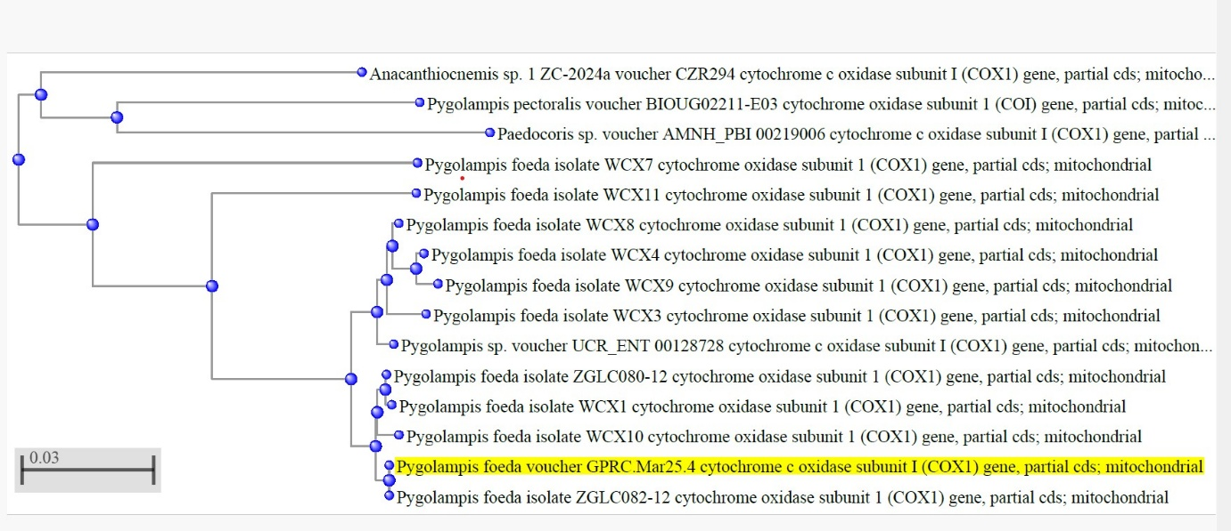

**Fig. 1. Molecular phylogenetic analysis by neighbour joining method using mitochondrial cytochrome c oxidase 1 gene of *Pygolampis foeda*, an assassin bug through DNA Barcoding.**

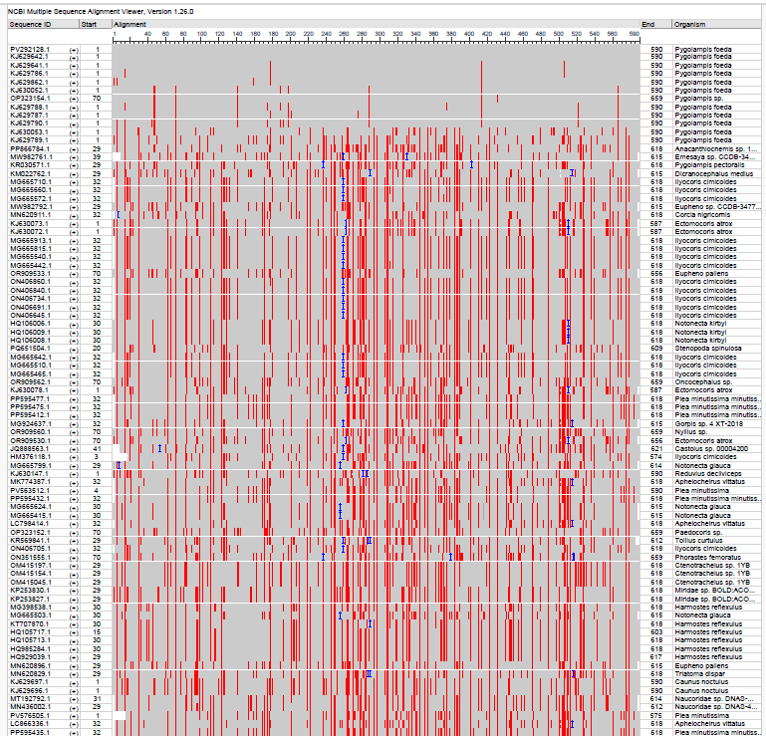

**Fig. 2. NCBI Multiple Sequence Alignment Viewer 1.25.0 results showing database of known sequences regions of similarity for *Pygolampis foeda*, an assassin bug revealed through cyber taxonomy analysis and COI Barcoding.**

**3.2. Morphological taxonomy and Cybertaxonomic Delimitation**

Accurate taxonomic resolution of any taxa is fundamental to the biological studies, particularly in biodiversity conservation, ecological monitoring, and integrated pest management. In the Reduviidae, the genus *Pygolampis* Burmeister, 1835 is known for their predatory activity in the agroecosystems (Ambrose, 2006). The taxonomic history of *P. foeda* goes back to its original placement by Stål (1859) while it has been commonly misidentified or synonymized in local faunal records because of its similarity in morphology with congeners like *P. bidentata* and *P. annulata* (Stål, 1874; Distant, 1906). Previously, in classical taxonomy, as demonstrated by Distant (1904, 1910), the main aspects were the external morphological characters - rostrum segmentation, coloration, wing venation, and leg armature - to distinguish species. However, these characters are prone to intraspecific variation or convergence and, thus, unresolved synonymies and ambiguous identifications (Weirauch, 2008).

*P. foeda* can easily be distinguished by its elongate body, dark brown body color with light brown markings, and a distinct pronotal constriction. The rostrum is divided into three parts, the first part extends up to the posterior margin of the head, the third part is distinctly tapering (Distant, 1904). Legs are of moderate length and slender, femora are often annulated. Hemelytra are transparent with distinct corium and membrane. Genitalic characters, and especially structure of pygophore and parameres in males, are more reliable distinguishing features but are rarely applied in routine field identification because of a necessity for dissection (Rédei & Tsai, 2010). Modern taxonomic treatments have highlighted the need to revisit the classical descriptions by integrative approaches, bring together the external morphology with the genitalic dissection and more recently DNA barcoding (Weirauch & Schuh, 2011; Zhao et al., 2022).

**4. CONCLUSION**

*P. foeda*, belonging to family Reduviidae, is a potential biocontrol agent, in the agricultural ecosystems, because of its ability to feed on a wide array of soft-bodied insects pest. However, this taxon has often been taxonomically poorly defined particularly at the immature stages like the nymphal instars, where diagnostic characters are still embryonic or undeterminable, causing less precision in identification and documentation of specimens, thus limiting its use in selective control programmes. Therefore, the integrated use of classical taxonomy, molecular biology and digital data-sharing frameworks; known as cybertaxonomy is a transformative approach to addressing this problem. Morphological description coupled with DNA sequencing, especially the mitochondrial COI barcoding, will allow accurate delineation of species of *P. foeda*. This type of integrative approach will enhance our understanding of the evolutionary role of *P. foeda* in Reduviidae and highlight its importance as a component of sustainable pollinator-friendly pest-management paradigms. By developing both molecular and morphological reference standards, the species will be able to be better utilized within integrated pest-management systems, reducing the over-reliance on chemical insecticides, enhancing the resilience of agroecosystems, and restoring biodiversity.

**DISCLAIMER (ARTIFICIAL INTELLIGENCE)**

Author(s) hereby declare that NO generative AI technologies such as Large Language Models (ChatGPT, COPILOT, etc.) and text-to-image generators have been used during the writing or editing of this manuscript.

**REFERENCES**

1. Ambrose, D. P. (2006). The Fauna of India and the Adjacent Countries: Hemiptera: Reduviidae (Part 1). Zoological Survey of India.
2. Ambrose, D. P., & Livingstone, D. (1981). Bionomics and behaviour of an assassin bug Pygolampis bidentata (Fabricius) (Heteroptera: Reduviidae). Proceedings of the Indian Academy of Sciences - Animal Sciences, 90(4), 403–409.
3. Ambrose, D.P. (1980). Bioecology, Ecophysiology and Ethology of Reduviids (Heteroptera) of the Scrub Jungles of Tamil Nadu, India. Ph.D. Thesis, University of Madras, Madras, India.
4. Ambrose, D.P. (1987a). Assassin bugs of Tamil Nadu and their role in biological control (Insecta: Heteroptera: Reduviidae), pp. 16-28. In: Joseph, K.J. and U.C. Abdurahiman (Eds.). Advances in Biological Control Research in India. Printex Ltd., Calicut.
5. Ambrose, D.P. (1987b). Biological, behavioural and morphological tools in the biosystematics of Reduviidae (Insecta: Heteroptera: Reduviidae). Proceedings of Indian Academy of Sciences (Animal Science) 96: 499-508.
6. Ambrose, D.P. (1988). Biological control of insect pests by augmenting assassin bugs (Insecta: Heteroptera: Reduviidae), pp.25-40. In: Ananthasubramanian, K.S., P. Venkatesan and S. Sivaraman (Eds.). Bicovas. Loyola College, Madras.
7. Ambrose, D.P. (1991). Conservation and augmentation of predaceous bugs and their role in biological control. pp. 225-257. In: Veeresh, GK., D. Rajagopal and C.A. Viraktamath (Eds.). Advances in Management and Conservation of Soil Fauna. Oxford & IBH Publishing Co. Ltd., New Delhi.
8. Ambrose, D.P. (1996a). Biosystematics, distribution, diversity, population dynamics and biology of reduviids of Indian subcontinent - an overview, pp.93- 102. In: Ambrose, D.P. (Ed.). Biological and Cultural Control of Insect Pests, an Indian Scenario. Adeline Publishers, Tirunelveli, India.
9. Ambrose, D.P. (1996b). Assassin bugs (Insecta-Heteroptera-Reduviidae), pp.262-284. In: Ambrose, D.P. (Ed.). Biological and Cultural control of Insect Pests, an Indian Scenario. Adeline Publishers, Tirunelveli, India.
10. Ambrose, D.P. (1999). Assassin Bugs. Science Publishers, New Hampshire, USA and Oxford and IBH Publishing Company Private Limited, New Delhi, India, 337pp.
11. Ambrose, D.P. (2000). Assassin Bugs (Reduviidae excluding Triatominae), pp. 695-712. In: Schaefer, C.W. and A.R. Panizzi (Eds.). Heteroptera of Economic Importance. CRC Press, Florida, U.S.A. 828pp.
12. Ambrose, D.P. (2003). Biocontrol potential of assassin bugs (Hemiptera: Reduviidae). Journal of Experimental Zoology India 6(1): 1-44.
13. Ambrose, D.P. (2004a). Biodiversity of Indian Assassin Bugs (Insecta: Hemiptera: Reduviidae), pp.69-104. In: Gupta, A.K., Ajith Kumar and V. Ramakantha (Eds.). ENVIS Bulletin: Wildlife & Protected Areas, Conservation of Rainforests in India. Wildlife Institute of India, Dehra Dun, 382pp.
14. Ambrose, D.P. (2004b). The status of Biosystematics of Indian Reduviidae (Hemiptera: Heteroptera), pp. 441-459. In: Rajmohana, K., K. Sudheer, P. Girish Kumar and S. Santhosh (Eds.). Perspectives on Biosystematics and Biodiversity. Harvest Media Services, Calicut.
15. Chandra, K., Gupta, D. Kushwaha, S. Das, P. and Ghosh, J. (2018). Arthropoda: Hexapoda. In: Faunal diversity of Biogeographic zones: Islands of India (K. Chandra, and C. Raghunathan, editors). Published by the Director, Zoological Survey of India, Kolkata, Records of Zoological Survey of India, Kolkata: 1–523.
16. Chaves, L. F., Cohen, J. M., Pascual, M., Wilson, M. L., & Kitron, U. D. (2020). Morphological and genetic variation among three closely related Reduviidae species: A case for cryptic speciation. Insect Systematics and Diversity, 4(6), 1–12.
17. Distant, W. L. (1904). The Fauna of British India, Including Ceylon and Burma. Rhynchota. Vol. II. Taylor and Francis.
18. Distant, W. L. (1906). The fauna of British India, including Ceylon and Burma. Rhynchota Vol. III. Taylor and Francis.
19. Distant, W. L. (1910). Descriptions of Oriental Reduviidae. Annals and Magazine of Natural History, Series 8, 5(30), 517–536.
20. Hebert, P. D. N., Cywinska, A., Ball, S. L., & deWaard, J. R. (2003a). Biological identifications through DNA barcodes. Proceedings of the Royal Society B: Biological Sciences, 270(1512), 313–321. https://doi.org/10.1098/rspb.2002.2218
21. Hebert, P. D. N., Ratnasingham, S., & deWaard, J. R. (2003b). Barcoding animal life: Cytochrome c oxidase subunit 1 divergences among closely related species. Proceedings of the Royal Society B: Biological Sciences, 270(Suppl 1), S96–S99. https://doi.org/10.1098/rsbl.2003.0025
22. Hwang, W. S., & Weirauch, C. (2012). Evolutionary history of assassin bugs (Insecta: Hemiptera: Reduviidae): insights from divergence dating and ancestral state reconstruction. PLOS ONE, 7(9), e45523.
23. Kaur, H., & Brar, R. S. (2015). Diversity and predatory behaviour of assassin bugs (Hemiptera: Reduviidae) in Punjab agroecosystems. Journal of Entomology and Zoology Studies, 3(2), 60–63.
24. Koichiro Tamura, Glen Stecher, Sudhir Kumar (2021). MEGA11 molecular evolutionary genetics analysis version 11. Molecular Biology and Evolution; 38(7):3022–3027.
25. Okuda K (2021). Re-description of the assassin bug species Pygolampis striata Miller, 1940 with new distributional records from Japan and Indonesia (Heteroptera, Reduviidae, Stenopodainae). Biodiversity Data Journal 9: e63695. https://doi.org/10.3897/BDJ.9.e63695.
26. Park, D. S., Foottit, R., Maw, E., & Hebert, P. D. N. (2011). Barcoding bugs: DNA-based identification of the true bugs (Insecta: Hemiptera: Heteroptera). PLoS ONE, 6(4), e18749. https://doi.org/10.1371/journal.pone.0018749
27. Praveen K., Hassan, M. E., Saha, P. C., Kushwaha, S., Dubey, A. K., Dash, S., Lyngdoh, J., Pal, A., Jehamalar, E. and Khanra, S. (2024). Checklist of Fauna of India: Arthropoda: Insecta: Hemiptera. Version 1.0. Zoological Survey of India. DOI: https://doi.org/10.26515/Fauna/1/2023/Arthropoda:Insecta:Hemiptera.
28. Ratnasingham, S., & Hebert, P. D. N. (2007). BOLD: The Barcode of Life Data System (www.barcodinglife.org). Molecular Ecology Notes, 7(3), 355–364. https://doi.org/10.1111/j.1471-8286.2007.01678.x
29. Rédei, D., & Tsai, J. F. (2010). On some Oriental and Australasian Reduviidae in the Hungarian Natural History Museum. Annales Historico-Naturales Musei Nationalis Hungarici, 102, 105–120.
30. Schuh, R.T., Slater, J.A. (1995). True bugs of the world (Hemiptera: Heteroptera): classification and natural history. Cornell University Press, Ithaca, New York. xii + pp 336.
31. Stål, C. (1874). Enumeratio Hemipterorum. Kongliga Svenska Vetenskaps-Akademiens Handlingar, 12(1), 1–162.
32. Swanson, D. R. (2018). Assassin bugs (Reduviidae) as beneficial insects. American Entomologist, 64(4), 224–232.
33. Weirauch C, Bérenger JM, Berniker L, Forero D, Forthman M, Frankenberg S, Zhang J, et al. (2014). An illustrated identification key to assassin bug subfamilies and tribes (Hemiptera: Reduviidae). Canadian Journal of Arthropod Identification 26 (2): 1‑115. https://doi.org/10.3752/cjai.2014.26.
34. Weirauch, C. (2008). Cladistic analysis of Reduviidae (Heteroptera: Cimicomorpha) based on morphological characters. Systematic Entomology, 33(2), 229–274. https://doi.org/10.1111/j.1365-3113.2007.00399.x
35. Weirauch, C., & Munro, J. B. (2009). Molecular phylogeny of the assassin bugs (Hemiptera: Reduviidae), based on mitochondrial and nuclear ribosomal genes. Molecular Phylogenetics and Evolution, 53(1), 287–299. https://doi.org/10.1016/j.ympev.2009.05.037
36. Weirauch, C., & Schuh, R. T. (2011). Systematics and evolution of Heteroptera: 25 years of progress. Annual Review of Entomology, 56, 487–510. https://doi.org/10.1146/annurev-ento-120709-144833
37. Zhang, G., & Weirauch, C. (2014). Molecular phylogeny and taxonomic revision of the genus Pygolampis. Zootaxa, 3847(3), 401–423. https://doi.org/10.11646/zootaxa.3847.3.6
38. Zhao, Y., Ren, D., & Wang, Y. (2022). Hidden diversity in assassin bugs: DNA barcoding reveals cryptic species within the Reduviidae of China. Systematic Entomology, 47(1), 99–113. https://doi.org/10.1111/syen.12503
39. Zheng Zhang, Scott Schwartz, Lukas Wagner, and Webb Miller (2000). A greedy algorithm for aligning DNA sequences. J. Comput. Biol.;7(1-2):203-14.