MINOR SILK PRODUCING SPECIES: DEVERSITY AND PROSPECTS

ABSTRACT
Silk has long been valued as a luxurious and versatile natural fibre with the mulberry silkworm, Bombyx mori L., dominating global production. However, several lesser-known natural silk-producing species including Anaphe, Fagara, the ancient Coan silkworm, Cricula, marine mussels and spiders contribute unique fibres with exceptional structural and functional properties. These silks differ markedly in origin, appearance and performance offering remarkable strength, elasticity, luster and even adhesive qualities that surpass conventional silk in some aspects. Despite their fascinating properties and historical significance, these silks have remained niche, largely due to challenges in harvesting, low yield and lack of awareness. This review explores the biology, ecology and traditional uses of Anaphe, Fagara, coan, Cricula, mussel and spider silks, as well as their distinctive characteristics and potential applications. Further, the review highlights the constraints hindering their commercialization and identifies avenues for future research and sustainable utilization.

Keywords: Minor silk; spiders; coan silk; anaphe silk; fagara silk; sericigenous insects

- INTRODUCTION
Natural silk, a protein fibre secreted by various arthropods and even some molluscs, has captivated humans for millennia as a symbol of luxury, durability and elegance (Srivastava and Thangavelu. 2005). While the domesticated mulberry silkworm, B. mori remains cornerstone of the global silk industry, history and nature reveal a much wider array of silk-producing organisms, many of which yield fibres with remarkable qualities and cultural significance (Peigler, 1993).
Among these lesser-known silk sources are African Anaphe moths known for producing communal cocoons with coarse but durable silk, Fagara silks derived from certain Saturniid moths used locally in parts of Africa (Ravi Kumara and Kumar, 2022); marine mussels, which secrete adhesive silk-like byssal threads; the ancient Coan silkworm (Pachyposa otus), historically used in the Mediterranean region and spiders, whose silks are renowned for their unparalleled strength and elasticity (Ahmad et al., 2006). Each of these fibres possesses unique properties such as exceptional tensile strength, biocompatibility and natural adhesion that make them attractive for specialized applications beyond traditional textiles (Fening et al., 2010).
Despite their potential and historical use, these silks remain largely unexplored in modern industry due to limitations such as low production volume, difficulty in harvesting and ecological or conservation concerns (Kavane and Sathe, 2011). With increasing interest in sustainable and high-performance biomaterials, revisiting these natural silks offers exciting opportunities for innovation in textiles, biomedical engineering and materials science.
This review aims to provide a comprehensive overview of Anaphe, Fagara, coan, Cricula, mussel and spider silks, detailing their biological origins, properties, traditional and modern uses and prospects for future research and development.
Lesser-known sericigenous insects which produce silk, play a significant role in various ways, even though they might not be as famous as the silkworm, Bombyx mori L.

The scope and importance of lesser-known sericigenous insects
- Alternative Fiber Sources: Lesser-known sericigenous insects can provide alternative sources of silk and other valuable fibres, offering different textures, colours, and properties
- Cultural and Traditional Uses: In some regions, these insects have cultural and traditional significance, being used for rituals, ceremonies or artisanal products
- Biotechnological Research: Studying these insects can yield insights into silk production, genetics and biotechnology, potentially benefiting industries beyond textiles
- Sustainable Farming: Some lesser-known silk-producing insects are hardier and more adaptable, which can lead to sustainable farming practices
- Silk Variability: These insects contribute to the richness and variability of silk, which can be explored for various applications, from fashion to medical textiles
- Medical and Biomedical Applications: Unique silk proteins from less-known insects might have applications in medicine, like sutures, drug delivery and tissue engineering
- Sericulture Diversification: Incorporating lesser-known sericigenous insects into sericulture practices diversifies the silk industry, reducing the risk associated with relying solely on one species

- MINOR SILK PRODUCING SPECIES
2.1 Anaphae Silk:
Systematic position:
Kingdom: Animalia
Phylum: Arthropoda
Class: Insecta
Order: Lepidoptera
Family: Notodontidae
Genus: Anaphe
Species: panda
Species: Anaphae infracta, A. panda, A. reticulata, A.ambrizia, A.vinata, A.carteri, A. moloneyi
Distribution: Inter tropical regions of Continental Africa, Nigeria, Uganda, Zambia, Cameroon, Cango etc.
Host plants: Triplochiton scleroxylon, Casenina equisectifolia, Albizzia qummetra, Tamarindus indica, Zizypus spp., Bridelia micrantha (wild coffee) (Douny, 2013).
The silkworm is polyphagous insect that chiefly feed on host plant, Triplochiton scleroxylon. They spin cocoons in communes, all enclosed by a thin layer of silk. The tribal people collect them from the forest and spin the fluff into raw silk that is soft and lustrous. The silk produced from A. infracta is locally known as boko and those from A. moloneyi as koko and Trisnian-tsamia (Elumalai et al., 2021).
The Anaphe silkworm is univoltine and undergoes diapause at the pupal stage. The silkworms form the cocoons communally; the cocoon is large nest like (spun by 1000 worms) weighs about 3.5 kg. Generally, 12-100 worms collectively spin cocoon for about 4 months. These cannot be reeled and looks like mulberry cocoons. The fabric obtained from Anaphe silk is elastic and stronger than that of mulberry silk. Anaphe silk is used in velvet and plush making (Kebede et al., 2014).

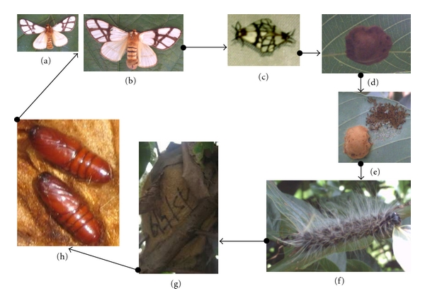
Fig. 1: Life cycle of Anaphe panda
a. Male moth, b. Female moth,
c. Mating, d. Egg cluster,
e. Hatching, f. larvae,
g. Cocoon nest h. Pupa in the cocoon nest

(Mbahin et al., 2012)

Eggs:
The eggs of A. panda are usually laid in clusters underside of leaves of the host plant Bridelia micrantha. The eggs were laid in cluster. The eggs are small and they are usually discoidal and isodiametric. The incubation period ranges from 40 to 45 days in the dry season and from 45 to 55 days in the rainy season.
Larva:
The larvae are gregarious from the first to the seventh instars, undergoes six moults. The larval stage was between 83 to 86 days in the dry season and 112 to 118 days in the rainy season. Pupa:
The pupa was enclosed in a tough silk cocoon. In rainy season, the duration of the pupal period ranges between 158 to 178 days in rainy season and 107 to 138 days for those which spun in dry season.
Adults:
The wingspan of forewing was 2.347 ± 0.216 cm and 3.019 ± 0.251 cm for males and females, respectively. Whereas, the length of forewing were 1.137 ± 0.106 cm and 1.448 ± 0.138 cm for males and females, respectively. Size of the female moth is larger than the male moth.

2.2 Fagara Silk
Systematic position:
Kingdom: Animalia
Phylum: Arthropoda
Class: Insecta
Order: Lepidoptera
Family: Saturniidae
Genus: Attacus
Species: atlas

- Attacus atlas is most popularly called as atlas moth, also called as empire silkworm due to its large size and the fagara silk that is obtained from its cocoons (Peigler, 1983).
- Species - Attacus atlas L., A. edwardsi
Distribution
- It is inhabiting in the Indo-Australian bio-geographic region, particularly in China and Sudan.
- The Attacus atlas is primarily found in tropical and subtropical rainforests
- The A. atlas is widely considered to occupy habitats at elevations ranging from sea level to 1500 m to 2000 m
Hosts plants of Attacus atlas:
- Averrhoa carambola (carambola), Cinchona officinalis (Cinchona tree), Elettaria cardamomum (cardamom), Litchi chinensis (lichi), Mangifera indica (mango), Persea americana (avocado), Psidium guajava (guava), Swietenia macrophylla (big leaved mahogany), Syzygium samarangense (water apple)
- An additional 21 hosts have also been identified, including tea, cocoa, and pepper plants (CAB International, 2020) Over 100 plant species belonging to 90 genera in 48 families as host plants for Atacus spp. have been reported

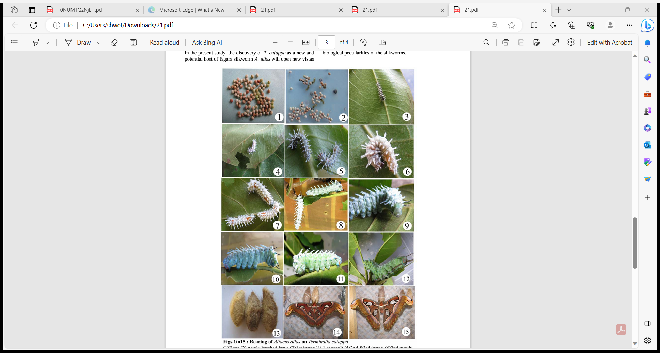
Eggs 1st instar 2nd instar 3rd instar 4th instar

5th instar 6th instar Cocoon Male and Female moths

Fig. 2: Life cycle of Attacus atlas
(Kumara, 2024)
Eggs:
Eggs are oval, dorsoventrally flattened and dull white in color. The newly laid eggs look creamy white but become light brown later. Egg stage lasts for 10 days.
Larva:
It has 6 instars, each instar possesses different morphological characters.
Pupa and Cocoon:
Mature larva constructs its cocoon on fresh leaves and suspends it from the twig with the help of a long stalk, it spins its silk fiber around its body with the help of spinneret and tubercles.
Moth:
The males are more active and couples with the females at dusk which lasts for 12-24 hours.
The rearing of the fagara silk moth A. atlas was done on T. catappa under indoor rearing condition. A. atlas completed its life cycle from egg to adult within 62 days. Incubation period, larval (Six instars) and pupal period 10 days, 27.5 days and 25 days, respectively (Kavane, 2014). Fagara silk is produced from the pedunculate cocoons of the giant silk moth Attacus atlas, they spin light-brown cocoons nearly 6cm long with peduncles of varying lengths (2-10 cm). The average cocoon weight was 14.11g and 10.29g for male and female, respectively, the average shell weight of single cocoon recorded 2.04 g and 1.84 g for female and male, respectively which is five times more than shell weight of domesticated Eri silkworm, Samia ricini. The large cocoons of Attacus atlas have similar properties to those of the silkworm Bombyx mori and thus offer an alternative form of silk production (Reddy et al., 2013). The tan to brown silk of atlas moths has been used in East Asia to weave the naturally brown textile fagara silk (Seltzer and Peigler, 2015).

2.3 Coan Silk
Systematic position:
Kingdom: Animalia
Phylum: Arthropoda
Class: Insecta
Order: Lepidoptera
Family: Lasiocampidae
Genus: Pachyposa
Species: otus
Distribution: it is commercially produced from the Mediterranean bio-geographic region (Southern Italy, Greece, Romania, Turkey etc.,)
Host plants: Pine, ash, Cyperus, juniper and oak (Rougeot and Viette, 1978)
They spin white cocoons which have dimension of 8.9 cm x 7.6 cm. In ancient times, this silk was used to make the crimson-dyed apparel worn by the dignitaries of Rome (Ulanowska, 2022)

2.4 Cricula trifenestrata
Systematic position:
Kingdom: Animalia
Phylum: Arthropoda
Class: Insecta
Order: Lepidoptera
Family: Saturniidae
Genus: Cricula
Species: trifenestrata
Species: Cricula trifenestrata, Cricula endrei
Distribution: Eastern parts of India (Sikkim, regions of Himalaya), Bangladesh
Host Plants: Mangifera indica, Machilus bombycine, Anacardium occidentale, Cassellia theifera, Careya arborea, Eugenia fruiticosa, E. jambolana, Grewia microcosa, Litsoea sebefera and Machilus odoratissima (Hridya et al., 2021).
Fig 3 : Life cycle of Cricula trifenestrata
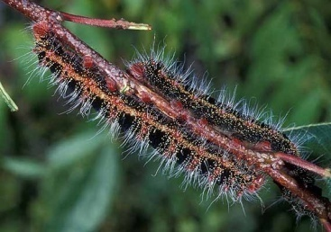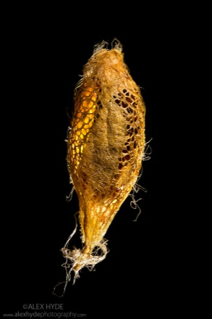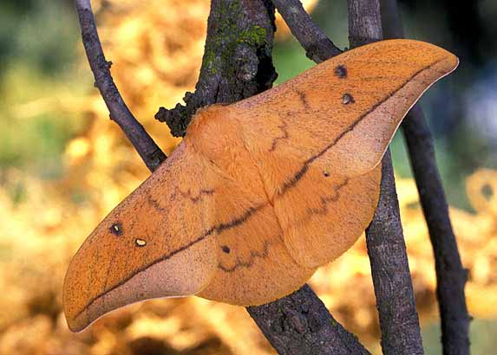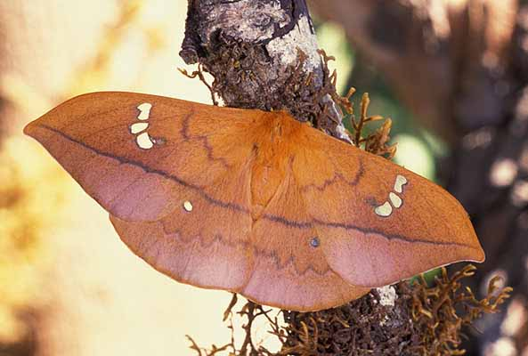
Larva Cocoon Female Male

- Hairy caterpillar pest on Mango, builds loosely webbed perforated ‘Golden bright’ coloured cocoons in communes
- Adult is a small dark brown moth
- Avgerage cocoon weight 2.12g
- Average shell weight 0.09g
- Average pupal (female) weight 1.83g
- Average pupal (male) weight 1.18g

2.5 Mussel Silk
Systematic position:
Kingdom: Animalia
Phylum: Mollusca
Class: Bivalvia
Order: Pteriida
Family: Pinnidae
Genus: Pinna
Species: squamosa
Distribution: it is found in the shallow waters along the Italian and Dalmatian shores of the Adriatic (Diana et al., 2017)
- This is a silk of non-insect origin. It is a marine organism lives in association with mollusk this is anchor to a rock or other surface to spun silk and byuss it is known as Fish wool their fabric is famous in Italy, because of the hydro gel property of silk, it is suited for baby's Huggies (Lee et al., 2011)

2.6 Spider Silk
Systematic position:
Kingdom: Animalia
Phylum: Arthropoda
Class: Arachnida
Order: Araneae
Family: Nephilidae
Genus: Nephila
Species: madagascarensis
- Spiders are distributed in all habitats in nature and different types are encountered in different type of ecosystem
Silk of the majority of spiders are not of commercial use however silk form 5 species of spiders are commercially exploited by man they are
- The orb weaver - Araneus diadematus
- Madagascar spider - Nephila madagascarensis
Mirinda aurantia
Epeira spp.
- Orb web spider - Nuctenea cornuta

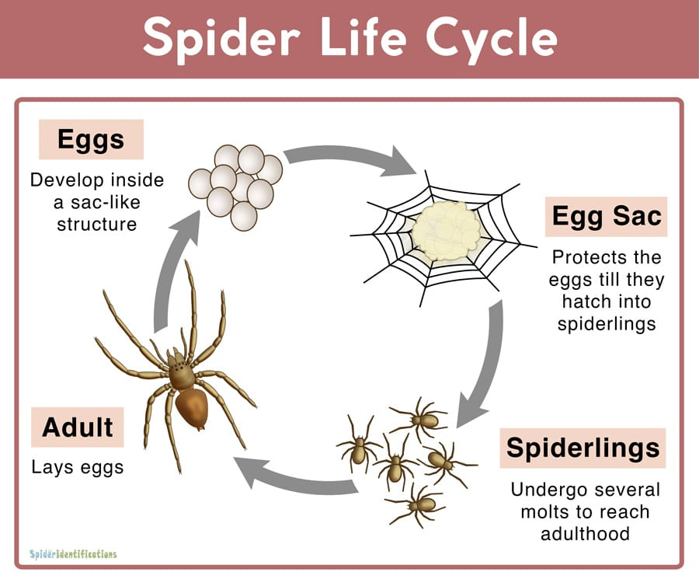
Fig. 4: Life cycle of spider
(Bittencourt et al., 2022)
Egg:
After mating, the females store spermatophores until they are all set to lay eggs. The number of eggs laid varies by the spider species, ranging from a few eggs to hundreds and thousands of eggs. These eggs are usually wrapped with an egg sac constructed from silk.
Egg Sac:
The egg sac, made for protecting the eggs from the elements and against predators such as birds and ants, it is the place where the offspring develop. The eggs start hatching in a few weeks. Some spiders carry the sac until the eggs hatch while others leave it in a secure location such as a burrow, under bark or hidden among leaves or foliage.
Spiderlings:
The spiderlings are the immature spiders that bear a great resemblance to their parents. After coming out from the egg sac, the spiderlings immediately disperse by either walking or ballooning. As they develop, these young spiders moult several times and they remain vulnerable until the formation of the new exoskeleton.
Adult:
After five to ten moults, most spider species reach adulthood. When the spiderlings attain maturity, they are ready to reproduce and start the life cycle again.

Different silk types produced by female orb weaving spiders:
Female orb-weaver spiders (Araneidae), can produce seven kinds of silk or glue from seven different types of glands, including major ampullate silk, minor ampullate, flagelliform, aggregate, cylindriform, aciniform and pyriform. The structure-property-function relationship of these seven types of spider silk is significantly different
Fig 5 : Different types of silk produced by female orb weaving spiders

Major ampullate silk: Also known as dragline silk, it is the most well-investigated prototype due to its superior mechanical properties that combine a unique combination of high tensile strength and elasticity. This silk is used for the orb web outer rim and spokes as well as for the lifeline to escape enemies. Nephila major ampullate silk, at the primary structure scale, is made by two large spidroins (350kDa): the major ampullate spidroin1 (MASp1) and the major ampullate spidroin2 (MASp2).

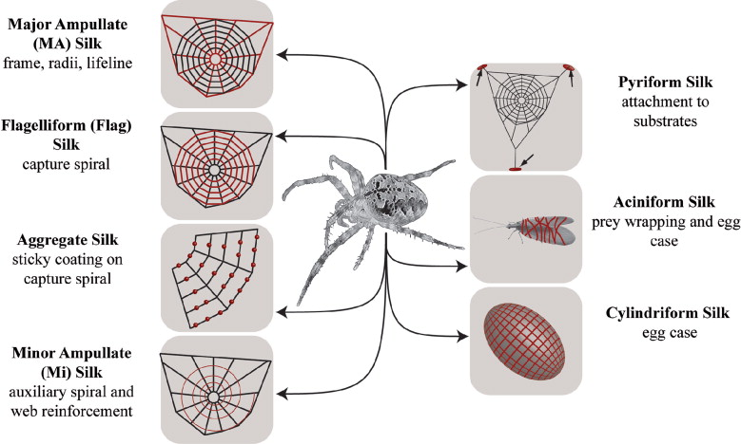

Flagelliform silk: It is used to construct capture spirals, which are sticky, robust, and highly stretchable. The extreme elasticity of flagelliform silk is end owed by proline-rich repetitive domain (GPGGX), which allows the absorption of a considerable amount of energy without failure and ensures there is sufficient time for the aggregate to adhere to any aerial prey flying into the web

Aggregate silk: Provide sticky coating on the capture spiral, enhancing its adhesive properties

Minor ampullate silk has a similar tensile strength but less elasticity than major ampullate silk. It is used for reinforcement of the web and the temporary capture spiral. The minor ampullate silk has a high molecular weight (i.e., 44 320kDa for the minor spidroin1 protein and 250kDa for the minor spidroin2 protein)

Cylindriform silk: Exclusively used for the egg case, providing a protective structure for the eggs. Reproduction is the main function

Aciniform silk: Utilized for pray wrapping and the egg case, protecting the spider offspring’s

Pyriform silk: serves as an attachment disk to bond spider silks to maintain the structural stability of the web.

(Kiseleva et al., 2020)

Properties of Spider silk
- Durable, resistant to high temperature and relative humidity, so this is used for optical cross wires
- It has some fungicides bacterial effect, so it is used to dressing wounds
- Strong at greater extension, it must not break and soft at small extension
- Have greater energy absorption to spring back rapidly
- Generally, break when they are extending to more than 25%
- It has good elasticity, luster, shrinkage is negligible and its strongest silk

Commercial Exploitation of spider silk
- Spider silk is a soft, fine, strong and elastic
- It is used in engineering laboratory and optical devices
- It is also used in telescopes and such other related to engineering equipment's.

Table 1: Comparative Overview of Lesser-Known Silk-Producing Species

Species | Region | Host Plants | Unique Properties | Current Use | Challenges
Anaphe (A. panda) | Africa (Nigeria, Uganda) | Triplochiton, Tamarind, Albizzia etc. | Stronger, elastic than mulberry silk | Velvet, plush | Low yield, communal nests
Fagara (Atlas moth) | Asia (China, India, SE Asia) | Mango, Guava, Litchi, Avocado, etc. | Naturally brown, coarse silk | Textiles (Fagara silk) | Not reelable, short filaments
Coan (Pachypasa otus) | Mediterranean (Italy, Greece) | Pine, Oak, Juniper, ash,  Cyprus | White silk, historically dyed crimson | Ancient Roman garments | Rare, historical interest only
Cricula | India, Bangladesh, Himalaya | Mango, Eugenia, Anacardium | Golden bright silk, decorative | Decorative crafts | Pest of mango, low quality silk
Mussel (Pinna spp.) | Adriatic Sea (Italy, Croatia) | Marine rocks | Waterproof, fine, hypoallergenic | Baby clothing, Huggies, crafts (Sea Silk) | Extremely rare, overfishing
Spider (Nephila spp.) | Global | Insects (predatory) | Exceptional tensile strength & elasticity | Optical devices, research | Harvesting difficulty, low output

- Sustainability and Conservation of Minor Silk-Producing Species:
The exploration and utilization of minor silk-producing species bring with them important sustainability and conservation challenges that must be addressed to ensure their long-term viability. Many of these species, such as the Coan silkworm or certain mussel and spider species, inhabit fragile ecosystems and are susceptible to overharvesting and habitat destruction. For instance, studies on Anaphe panda in the Kakamega Forest of Kenya by Kioko et al., 2012, highlight the impact of indiscriminate nest collection on local populations and forest ecology.
Ethical and ecological considerations also play a significant role in the harvesting of these silks. Since most of these organisms are not domesticated, large-scale exploitation could negatively impact biodiversity, food webs and cultural heritage in their native regions. Craig et al.(2012) in Madagascar have demonstrated that unregulated collection of wild silkmoths such as Antherina suraka and Ceranchia appolina can threaten native species unless sustainable practices like host tree agroforestry and community-based silk farming are adopted. Developing sustainable cultivation and management practices for these species could help mitigate such risks. Semi-domestication, regulated harvesting and habitat restoration programs can support the conservation of these species while providing economic opportunities for rural communities.
Promoting awareness and implementing policies that balance utilization with conservation will be essential to preserving these unique organisms and their ecosystems. Cultivation and sustainable use of minor silks thus have the potential not only to diversify the silk industry but also to contribute to biodiversity conservation and support the livelihoods of local and indigenous communities.

3.1 Conservation Issues:
Several minor silk-producing species face significant conservation challenges, as many are harvested directly from the wild without sustainable management. Overharvesting to meet local demands can deplete natural populations, this is particularly true of communal cocoon-building insects like Anaphe moths and rare marine mussels used to produce sea silk. For instance, research by Addis et al. (2009) and Deudero et al. (2015) documents the intense exploitation of the pen shell Pinna nobilis in the Mediterranean over centuries for sea-silk production, ornamental shell trade, bait and food significantly diminishing wild populations.
Habitat loss caused by deforestation, urbanization, pollution and climate change further threatens these organisms by degrading their critical host-plant or seafloor environments. The decline of P. nobilis, now listed as Critically Endangered by IUCN (2019), has been linked not only to overharvesting but also to habitat degradation, anchor damage, pollution and mass mortality outbreaks linked to a protozoan parasite (Haplosporidium pinnae) (Kersting et al., 2019; Catanese et al., 2018). Although not specifically documented for the Coan silkworm, similar silkworm declines due to overexploitation and habitat loss have been reported widely in literature.

3.2 Future Prospects of Minor Silk-Producing Species
- Sustainable Cultivation & Conservation
Promote sustainable harvesting practices and habitat conservation to ensure the long-term availability of minor silk species while protecting biodiversity.
- Biotechnological Advances
Develop genetic engineering, synthetic biology, or recombinant protein production methods to mass-produce spider and mussel silk proteins economically.
- Biomedical Applications
Explore the use of minor silks in advanced medical fields, such as tissue scaffolds, wound dressings, surgical sutures and drug delivery systems due to their biocompatibility and strength.
- Luxury and Eco-Friendly Textiles
Introduce minor silks into niche luxury and eco-conscious textile markets, leveraging their unique colours, textures and natural properties.
- Material Science Innovations
Utilize unique mechanical properties of minor silks (e.g., elasticity, adhesion, tensile strength) for high-performance materials in aerospace, defence and engineering.
- Market Development & Awareness
Conduct economic feasibility studies and raise awareness among consumers and industries about the value and potential of these alternative silks.
- Interdisciplinary Research
Encourage collaboration between biologists, material scientists, engineers and designers to unlock innovative uses for minor silk fibres.

- CONCLUSION
The diversity of lesser-known natural silk producing species such as Anaphe moths, Atlas moths, Coan silkworms, mussels and spiders highlights the remarkable ingenuity of nature in creating fibres with exceptional properties. These minor silks exhibit unique characteristics, including superior strength, elasticity, biocompatibility, natural coloration and adhesion, making them promising materials for specialized applications in textiles, biomedicine and engineering. Despite their fascinating qualities and historical significance, the utilization of these silks remains limited due to challenges in harvesting, low yield and ecological concerns. Advancing research to address these limitations, coupled with sustainable management and increased awareness could open new avenues for their commercial and scientific use. Harnessing the potential of these extraordinary fibres offers a path toward innovative, high-value and sustainable material solutions.

DISCLAIMER (ARTIFICIAL INTELLIGENCE):
Author(s) hereby declares that NO generative AI technologies such as Large Language Models (ChatGPT, COPILOT, etc) and text-to-image generators have been used during writing or editing of manuscripts.
COMPETING INTERESTS
Authors have declared that no competing interests exist.

- REFERENCES:

- Addis, P., Secci, M., Brundu, G., & Cannas, R. (2009). Contribution to the knowledge of the biology and the conservation of the fan mussel Pinna nobilis (Bivalvia: Pinnidae) in the western Mediterranean. Mediterranean Marine Science, 10(1), 225-238.
- Ahmad, I., Ar-Rasyid, M. H., Salim, S., & Hosen, M. J. (2006). Effect of Feeding on The Larval Growth and Development of Silkworm, Bombyx mori L. Race: Nistari (M). International Journal of Sustainable Agricultural Technology, 2, 66-68.
- Bittencourt, D. M. D. C., Oliveira, P., Michalczechen-Lacerda, V. A., Rosinha, G. M. S., Jones, J. A., & Rech, E. L. (2022). Bioengineering of spider silks for the production of biomedical materials. Frontiers in Bioengineering and Biotechnology, 10, 1-16.
- Catanese, G., Grau, A., Valencia, J. M., Garcia-March, J. R., Vazquez-Luis, M., Alvarez, E., & Navas, J. I. (2018). Haplosporidium pinnae sp. a haplosporidan parasite associated with mass mortalities of the fan mussel Pinna nobilis in the Western Mediterranean Sea. Journal of Invertebrate Pathology, 157, 9–24.
- Craig, C. L., Weber, R. S., & Akai, H. (2012). Wild silk: wild silk enterprise programs to alleviate poverty and protect habitats. Handbook of Natural Fibres, P. 576-604.
- Deudero, S., Vazquez-Luis, M., & Alvarez, E. (2015). Human stressors are driving the loss of the Mediterranean fan mussel Pinna nobilis. Ocean & Coastal Management, 114, 10-17.
- Diana, A., Reguzzoni, M., Congiu, T., Rescigno, A., Sollai, F., & Raspanti, M. (2017). The byssus threads of Pinna nobilis: A histochemical and ultrastructural study. European Journal of Histochemistry, 61(4), 280-286.
- Douny, L. (2013). Wild silk textiles of the Dogon of Mali: the production, material efficacy and and cultural significance of sheen. Textile, 11(1), 58-77.
- Elumalai, D., Raj, P. M., Ramamoorthy, R., Mohan, C., & Poovizhiraja, B. (2021). Introduction to Non-Mulberry Silkworms. CRC Press. 251-258.
- Fening, Ken, O., Kioko, E. N., Raina, S. K., & Mueke, J. M. ( 2010). Effect of Seasons and Larval Food Plants on the Quality of Gonometa Postica Cocoons. Phytoparasitica, 38, 111-119.
- Hridya, H., Guha, L., Mazumdar, M., Sarkar, B. N., Vijayakumar, S., & Borpuzari, P. (2021). Probing the potentiality of the defoliator Cricula trifenestrata Helfer silk: a revisit. Bull Natl Res Cent, 45(1), 215-219.
- Kavane , R. P., & Sathe T.V. (2011). Wild silk technology. D.P.H, New Delhi.1-236.
- Kavane, R. P. (2014). Terminalia catappa–A potential new host of Fagara Silkmoth Attacus atlas (Lepidoptera-Saturniidae) from Western Maharashtra. Journal of Entomology and Zoology Studies, 2(6),179-182.
- Kebede, A.T., Raina, S.K., & Kabaru, J. M. (2014). Structure, composition, and properties of silk from the African Wild Silkmoth, Anaphe panda (Boisduval)(Lepidoptera: Thaumetopoeidae). International Journal of Insect Science, 6, 9-14.
- Kersting, D., Benabdi, M., Cizmek, H., Grau, A., Jimenez, C., Katsanevakis, S., Ozturk, B., Tuncer, S., Tunesi, L., Vázquez-Luis, M., & Vicente, N. (2019). Pinna Nobilis. The IUCN Red List of Threatened Species 2019. IUCN Red List of Threatened Species.
- Kioko, E. N., Mueke, J. M., Raina, S. K., & Mbahin, N. (2012). Biology of the Wild Silkmoth Anaphe panda (Boisduval) in the Kakamega Forest of Western Kenya. International Journal of Forestry Research, 1-7.
- Kiseleva, A. P., Kiselev, G. O., Nikolaeva, V. O., Seisenbaeva, G., Kessler, V., Krivoshapkin, P. V., & Krivoshapkina, E. F. (2020). Hybrid spider silk with inorganic nanomaterials. Nanomaterials, 10(9), 1-16.
- Kumara, R. R. (2024). The Wild Silkworm, Fagara (Attacus atlas Linn.) on Cipadessa baccifera: A Report from Karnataka, India. International Journal of Industrial Entomology and Biomaterials, 48(4), 238-244.
- Lee, B. P., Messersmith, P. B., Israelachvili, J.N., & Waite, J. H. (2011). Mussel-inspired adhesives and coatings. Annual review of materials research, 41(1), 99-132.
- Mbahin, N., Raina, S. K., Kioko, E. N. & Mueke, J. M. (2012). Biology of the wild silkmoth Anaphe panda (Boisduval) in the Kakamega forest of western Kenya. International Journal of Forestry Research, 1-7.
- Peigler, R. S. (1983). A Revision of the Indo-Australian Genus Attacus (Lepidoptera: Saturniidae). Texas A&M University, 1-24.
- Peigler, R. S. (1993). Wild silks of the world. American Entomologist, 39(3), 151-162.
- Ravi Kumara, R., & Kumar, H. (2022). The Fagara Silkworm (Attacus atlas L.): An underutilized Vanya Silkworm of India. Journal of Biodiversity, 8(5).
- Reddy, N., Zhao, Y., & Yang, Y. (2013). Structure and Properties of Cocoons and Silk Fibers Produced by Attacus atlas. Journal of Polymers and the Environment, 21, 16–23.
- Rougeot, P. C., Viette, P. (1978). Handbook of European and North African moths. International System for Agricultural Science and Technology, 1-6.
- Seltzer J. L., & Peigler, R. S. (2015). The Wild Silks of Southeast Asia. Cultural Significance and Entomological Identity. 1-6.
- Srivastava, P. K., & Thangavelu, K. (2005). Sericulture and Seri-biodiversity. Associated Publishing Company, New Delhi. P. 254.
- Ulanowska, A. (2022). Investigating Relations between Textile Production and Seals and Sealing Practices in Bronze Age Greece: A Presentation of the New “Textile and Seals” Project. Chemistry, 295-317.

