Ethnobotanical study, phytochemistry, toxicity and anti-inflammatory activities of a medicinal plant recipe used in the treatment of cervical cancer

abstract
Aims: The objective of this work was to carry out an ethnobotanical survey to identify the recipes of medicinal plants used in the treatment of cervical cancer, then to carry out the phytochemical study, evaluate the anti-inflammatory activity and the toxicity of the recipe.
Study design: Our study focused primarily on determining the content of compounds as well as the anti-inflammatory activity of the recipe.
Place and Duration of Study: These studies were carried out in Burkina Faso in the ecotoxicology of natural substances laboratory of INERA/Bobo and in the Life and Earth Sciences laboratory of Norbert ZONGO University during September 2023 and July 2024.
Methodology: A semi-structured interview was conducted with traditional health practitioners. Hydroethanolic macerate was used for tube tests and quantification tests using the spectrophotometer. Anti-inflammatory activity was performed by the paw immersion method using the Plethysmometer after formalin injection (1%) and acute toxicity was assessed according to OECD Guideline 423.
Results: In total, 112 traditional practitioners were surveyed; 30 medicinal species composed of 21 recipes were identified. The tube characterization tests allowed the identification of tannins, alkaloids, saponosides in the extracts. The quantification tests allowed obtaining 1.294 ± 0.011 mg EQ /100mg and 24.723 ± 1.071 mg EAG /100mg respectively in total flavonoids and phenolics. The inhibition percentages of 35.81% and 43.80% were obtained by performing the anti-edematous test at the first hour at doses of 25 and 50 mg/kg also, the extracts showed no signs of toxicity at the dose of 300 mg/kg. of the recipe.
Conclusion: Given these results, the recipe could be used on a line of cervical cancer cells to evaluate their effects on these cells.
Keywords: cervical cancer, inflammation, toxicity, ethnobotany
1. INTRODUCTION

Cervical cancer ranks 4th among women's cancers and is ranked 2nd among female gynecological cancers after breast cancer in Africa [1]. In Burkina Faso it is the first most common cancer [2]. Worldwide, the annual rate of cervical cancer is increasing (471,000 in 2000, 529,000 in 2008 and 570,000 in 2018 with 311,000 deaths) ([3]; [4]). In Africa, in 2020, 110,755 new cases were recorded with 72,705 deaths. In Burkina Faso we have a rate of 21.6% with 2517 new cases each year [5]. Prophylaxis is based on vaccination [6] and the treatments for this pathology are surgery, chemotherapy and radiotherapy depending on the stage of development [7]. Modern treatments for this pathology are certainly effective; but are very costly with enormous disadvantages, both physical (immune deficiency, anemia, hearing problems, cardiovascular problems, kidney problems) and mental with risks of relapse ([1]; [2]; [8]). In addition to this modern medicine, African populations use traditional medicine [9]. According to Bouquet (1969) African people use this medicine for socio-cultural and historical reasons. However, most traditional pre-registrations lack scientific evidence. Studies have proven that in South Africa Combretum molecular, Sideroxylon inermis [10] and Uvaria chamae, Dicliptera paniculata in Nigeria [11] are plants traditionally used in the treatment of cervical cancer. Therefore, we asked ourselves this question: are there plant recipes capable of treating cervical cancer in Burkina Faso? To answer this question, we undertook to carry out an ethnobotanical survey. Thus, the general objective of this study was to conduct an ethnobotanical survey in the towns of Bobo-Dioulasso and Koudougou to list the different medicinal plant recipes involved in the local management of cervical cancer.

2. MATERIALS AND METHODS

  - 2.1 Ethnobotanical investigation
The methodology used was a semi-structured interview with each respondent. The inclusion criteria were as follows: Both sexes, all ethnicities and religions. Profiles include herbalists and traditional therapists. Data collection focused on their sociodemographic condition and their ethnobotanical knowledge of plants used in the treatment of cervical cancer.
2.2 Biological material

Female mice of NMRI strains with an average weight of 40g from the animal facility at Joseph KY-ZERBO University in Ouagadougou were used for in vivo tests of anti-inflammation activity and toxicity.
The plant material was a recipe consisting of three plants namely Paullinia pinnata L., Mitragyna inermis (Willd.) K. Schum. and Xeroderris sthulmannii Taub..
  - 2.3 Laboratory equipment
The equipment used consisted of a precision balance, a “UVISCO” brand Spectrophotometer, a “Ugo Basil S.R.L. Biological Research Apparatus 21038 Gemonio VA Italy” brand Plethysmometer, an aluminum mortar, EDTA tubes, a gavage probe and a dissection kit. Regarding solvents and reagents, Diclofenac, 10% hydrochloric acid, Bouchardat reagent, ethanol, chloroform and Folin-Ciocalteu reagent were used.
  - 2.4 Phytochemistry

2.4.1 Extraction

The protocol used by Adinortey et al. [12] was used for extraction with modifications. After spraying, powders of M. inermis, X. sthulmannii and P. pinnata were taken in proportions 1/3. A 20g sample of powder from the mixture of the three species was extracted with a hydroethanolic solvent (20% ethanol). The crushing facilities were macerated for 48 hours while stirring with an agitator. Filtration, concentration in the rotavapor and drying in the oven at 40 ºC were carried out.
2.4.2 characterization tests
- The characterization of saponosides was carried out following the protocol used by N’guessan et al. [13] with modifications. A mass of 0.2 g of powder of each species is diluted in 2 mL in a hydroethanolic solution (20% ethanol). One milliliter (1 mL) of each extract was diluted in three milliliters (3 mL) of distilled water then shaken for 15-45 seconds. The appearance of persistent foam at least 1cm high would mean the presence of saponosides.
- The Mayer and Dragendorf test made it possible to characterize the alkaloids. 0.1 g of powder of each species was dissolved in 1.5 mL of acidified aqueous solution (HCl 10%). To one milliliter (1 mL) of this solution were added 2-3 drops of Bouchardat reagent. A yellow-orange precipitate would indicate the presence of alkaloids.
- The tannins were characterized by taking a mass of 0.2 g of powder of each species and diluted in 2 mL in a hydroethanolic solution (20% ethanol). Two milliliters (2 mL) of distilled water were added to one milliliter (1 mL) of each extract. To the mixture were added 2 to 3 drops of iron chloride (FeCl3). A blue-greenish or black-greenish color would indicate the presence of tannins.
2.4.3 Determination of total phenolics
The estimation of total extractable phenolic compounds was carried out using the Folin-Ciocalteu method described by Bangou et al. [14]. The extracts were dissolved in pure ethanol to have a concentration of 10 mg/mL, then diluted 1/100 in distilled water. A volume of 0.5 mL of the diluted solution was then mixed with 2.5 mL of 0.2 N Folin-Ciocalteu reagent and incubated for 5 min. 2 mL of a 75 g/L sodium carbonate solution in distilled water is then added and the mixture incubated for 2 hours. At the end of the incubation, the optical densities are read at 760 nm using a spectrophotometer. The standard calibration curve was plotted using gallic acid (200mg/l) (Y=12.619x+0.0201; R2 = 0.9994). In total, three (3) tests were carried out for the extract and the result given is an average from these analyses. The results are expressed in milligrams of gallic acid equivalent per 1 g of dry extract (mg EAG/1 g), determined by the formula:
$$C=\left( c*\frac{D}{ci}\right)*100$$
C= concentration of total phenolics in mg EAG/100mg of extract; c= concentration of the sample read on the standard curve; D= dilution factor of the sample subjected to the assay; ci= initial concentration of the solution to be dosed
2.4.4 Determination of total flavonoids
The method used for the estimation of total flavonoids in the extracts is that described by Bangou et al. [14]. A volume of 5 mL of 2% AlCl₃ in pure ethanol is mixed with an equal volume of 1 mg/mL extract in ethanol. The optical densities are read after 10 min of incubation in the dark at 415 nm using a spectrophotometer. Quercetin (0-100 mg/L) was used as a standard for the development of the calibration curve (Y= 20.542x+0.0395; R2 = 0.9985). A mixture of 5 ml of extract and 5 ml of ethanol without AlCl₃ served as a blank. In total, three (3) tests were carried out and the result given is an average of the three readings. The results are expressed in milligrams of quercetin equivalent per 1 g of dry extract (mg EQ/ g) according to the formula:
$$C=\left( c*\frac{D}{ci}\right)*100$$
C= concentration of total flavonoids in mg EQ/100mg of extract; c= concentration of the sample read on the standard curve; D= dilution factor of the sample subjected to the assay; ci= initial concentration of the solution to be dosed
2.5 Toxicity study
The acute toxicity study was carried out according to OECD guideline 423 (2001) with some modifications. Six (06) female mice aged 8 to 12 weeks were distributed in two (02) cages at a rate of three (03) per cage. They were fasted 4 hours before the start of the experiment. After the fasting period, they were weighed. Batch 1 (control) was treated with 0.9% NaCl and batch 2 received the extract solution at a single dose of 300 mg/kg mg/kg body weight. The administration volume was 1 ml/100 g of body weight. Two (2) hours after administration of the extract, the mice were refed. They were observed carefully during the first four hours, 24 hours, 48 hours and 72 hours after administration of the extract. During these observation periods, signs of toxicity will be noted (mobility, stools, aggressiveness, salivation, tremor, sleep, convulsion, mass, morbidity). At the end of the toxicity study, the extract was classified according to the Hodge and Stener scale (table I).

Table 1: Toxicity class according to the Hodge and Stener scale (1943)
Toxicity index or class | Commonly used term | Toxicological parameter (LD50)
1 | Extremely toxic | LD50≤1mg/Kg
2 | Highly toxic | 1mg/Kg≤ LD50≤50mg/Kg
3 | Moderately toxic | 50mg/Kg≤ LD50≤500mg/Kg
4 | Slightly toxic | 500mg/Kg≤ LD50≤5g/Kg
5 | Almost toxic | 5g/Kg$≤$ LD50≤15g/Kg
6 | Relatively harmless | LD50$≥$ $15g/Kg$

2.5 Evaluation of anti-inflammatory properties
For the evaluation of anti-inflammatory activity, the protocol of Rahmani et al. [15] with modifications was used. Twenty-five (25) NMRI mice weighing an average of 40 g and aged 12 weeks were randomized into five groups of four mice and treated as follows:
• Lot 1 or neutral control: the mice received neither induction of inflammation nor treatments
• Lot 2 or negative control: the mice received orally a 0.9% NaCl solution 30 minutes before the injection of 0.1ml of formalin (1%) into the right footpad
• Lot 3 or positive control: the mice received orally a solution of Diclofenac at 25 mg/kg b.w 30 minutes before the injection of 0.1ml of formalin (1%) into the right footpad
• Lot 4 or test 1: the mice received orally an extract solution at 25 mg/kg b.w 30 minutes before the injection of 0.1ml of formalin (1%) into the right footpad
• Lot 5 or test 2: the mice received orally an extract solution at 50 mg/kg b.w 30 minutes before the injection of 0.1ml of formalin (1%) into the right footpad.
The different treatments lasted seven days at the frequency of a single daily administration. Using the immersion method with the Ugo Basile Plethysmometer, the volume of the paw was measured from the first to the sixth hour after injection of formalin on the first day (acute inflammation), then every 2 days for 7 days (subacute inflammation).
On the 7th day, the animals were anesthetized by chloroform inhalation. By decapitation, the arteriovenous blood of the mice was collected in anticoagulant (EDTA) tubes and used for complete blood count (CBC). The liver, kidneys and spleen were removed and weighed. The relative organ weights of each rat were determined by the following formula:
Relative weight = [Organ Weight/Body Weight]x 100
3. RESULTS AND DISCUSSION

3.1 Data from the ethnobotanical survey

3.1.1 Sociodemographic characteristics
The distribution of traditional practitioners by gender indicates that for the city of Bobo-Dioulasso, women dominate (71%) while men (68%) are dominant in Koudougou (Fig. 1). Traditional medicine is then practiced by both genders. The predominance of women in the city of Bobo-Dioulasso can be explained by the responsibility that falls on women to watch over the health of the family, especially that of the children. In addition, the profession of traditional therapist would be a source of income for her in this locality could justify their dominance in Bobo-Dioulasso. These results are comparable to those of Kamboulé et al. [16] who in their study carried out in Bobo-Dioulasso also reported the practice of traditional medicine by both genders with a predominance of women (58.83%).
As for the age of traditional practitioners, it varied between [20-80[with a peak between [50-60[ (Fig. 2). These results suggested that traditional medicine is practiced by the elderly. In addition, knowledge of medicinal plants and their uses is generally acquired after many years of experience [16]. These could be reasons why older people exercise this profession. Ouattara et al. [17] reported a peak for the age group over 80 years old and Makita-Ikouaya, Milleliri and Rudant, [18] reported a dominance of those over 30 years old during their study in Gabon.

Fig. 1: distribution of traditional practitioners according to gender

Fig. 2: distribution of traditional practitioners according to age
3.1.2 Ethnobotanical characteristics
The leaves (46%) and roots (43%) are the most used parts (Fig. 3). The heavy use of roots in different treatments constitutes a real threat for the safeguarding and restoration of these species and the balance of ecosystems [16]. The use of leaves would therefore be of great help in preserving biodiversity because they regenerate easily. Kamboulé et al. [16] also report following their study the use of leaves and roots in the treatment of hemorrhoidal disease with respective frequencies of 31% and 25%.
For the preparation of the recipe, the traditional practitioners of Bobo-Dioulasso use the decoction (82%) and those of Koudougou the infusion (50%) (Fig. 4). The studies by Kamboulé et al. [16]; Mounkaila et al. [17] also report a predominance of the decoction with respective percentages of 88.3% and 62.3%. The decoction is the most used because it allows better diffusion of the metabolites in the solvent, resulting in a better extraction yield of the metabolites.
Regarding citation frequency, a total of 30 species belonging to 21 families were identified (Fig. 5). Among these species, the most cited were Xeroderis sthulmannii (14%), Mitragyna inermis (14%), Paullinia pinnata (14%), Ximenia americana (14%) and Zanthoxylum zanthoxyloides (14%). The most cited species constituting the most used recipe are Xeroderis sthulmannii (14%), Mitragyna inermis (14%), Paullinia pinnata (14%).

Fig. 3: distribution according to the organs used in plants

Fig. 4: distribution according to the method of preparation of the recipe
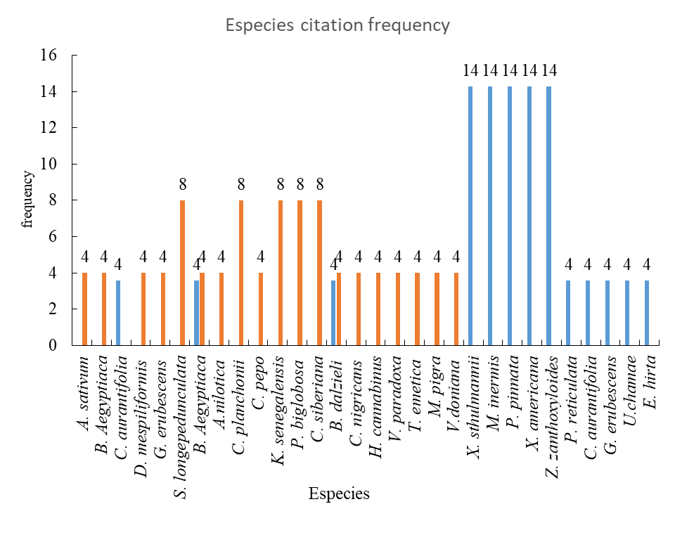
Fig. 5: frequency of species citation

3.2 Characterization test data
The presence of tannins, alkaloids and saponosides was highlighted in the extract.
3.3 Determination of total phenolics and flavonoids
The content of total flavonoids in the extract was 1.294±0.011 mg EG/g and that of total phenolics was 24.723±1.071 mg EG/g. Nafui et al. [19] obtained a phenolic level of 150mg EG/g with a methanolic extract of P. Pinnata leaves.
3.4 Results of biological tests
3.4.1 Acute toxicity
The single dose of 300 mg/kg body weight of the extract showed no signs of toxicity in mice. No mouse mortality was also recorded. Konko et al. [20]; Monjanel-Mouterde et al. [21] obtained results similar to ours during a toxicity study carried out on M. inermis with respective doses of 5000 mg/kg and 300 mg/kg. Adeyemo-Salami and Makinde [22] in their study with the methanolic extract of P. pinnata concluded that the use of the extract at a dose of 200 mg/kg of body weight orally is not toxic. Furthermore, Adinortey et al. [12] indicate non-toxicity of the hydroethanolic extract of the roots of the species at a dose of more than 2000 mg/kg of body weight. No significant toxic effects were observed in toxicity studies of Nyathi et al. [23]; Selemani et al. [24] with the species X. sthulmannii. In conclusion, the extract consisting of the mixture of these three species is non-toxic at the dose studied. In view of these results, the extract could be classified according to the Hodge scale in category 5 which is the class of low toxic substances.
3.4.2 Effect of the extract on acute inflammatory edema induced by formalin
The extract at all doses significantly (p<0.001) inhibited the volume of the mouse paw at times 1h, 2h and 3h compared to the control having received NaCl. The extract at doses of 50 and 25 mg/kg significantly (p<0.001) inhibited inflammatory edema at 1 hour and 2 hours. These inhibitions were respectively 43.80±2.9% and 41±1.5% for the first hour (Fig. 6) then 41±3.9% and 37.07±3.1% for the second hour (Fig. 7). On the other hand, at the third hour, the extract doses resulted in a non-significant inhibition (p>0.05) of edema of 43.80±3.06% for the extract at 50 mg/kg and 36.66±5.6% for the extract at 25 mg/kg.
Formalin causes the formation of edema in two phases: the first phase which consists of the release of substance P and bradykinin and the second phase the release of serotonin, histamine, prostaglandins [25]. The inhibition of inflammatory edema in the early hours by the extract suggested that it has an effect on the production of bradykinins and substance P, thus reducing vasodilation. This inhibition of vasodilation is due to the tannins contained in the extract [25].
Our results are consistent with those of Ngono et al. [26] who showed a reduction in inflammatory pain of 38.5% at the second hour with P. pinnata extract at 125 mg/kg body weight. The aqueous extract of M. inermis also showed an inhibitory effect on pain at a dose of 100 mg/Kg with an inhibition percentage of 66.05% during the study by Dénou et al. [27] with acetic acid.
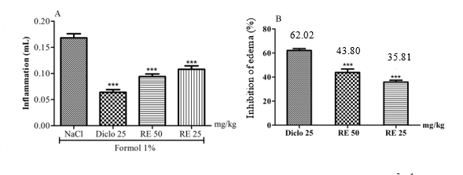
Fig. 6: Change in mouse paw volume (A) and percentage inhibition of edema (B) one hour of treatment
***: very significant (P=0.01): significant inhibition of paw inflammation in batches receiving recipe compared to the batch receiving NaCl
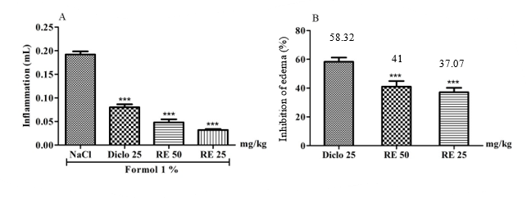
Fig. 7: Change in mouse paw volume (A) and percentage inhibition of edema (B) two hour of treatment
***: very significant (P=0.01): significant inhibition of paw inflammation in batches receiving the recipe compared to the batch receiving NaCl

3.4.3 Effects of the extract on subacute inflammatory edema induced by formalin
The inflammation of the mouse paw was observed over a period of 7 days with an increase in the volume of the paws every two days. The extract at 50 and 25 mg/kg caused a very significant inhibition of the volume of paw edema from the first to the seventh day. Maximum inhibitions were noted on the third day of treatment. They were 45.24±3.284% for the extract at 50 mg/kg and 38.09±6.8% for the extract at 25 mg/kg (table 2). In fact, polyphenols reduce the production of pro-inflammatory molecules by preventing the migration of the immune cells that produce them [28]. Our results are similar to those of Onapka et al. [29] who found anti-inflammatory activity of M. inermis with the egg albumin test.
3.4.4 Effects of the extract on some hematological parameters
Compared to the neutral or white control, the extract at all doses and Diclofenac did not cause significant variations (p>0.05) in the levels of red blood cells (Fig. 8), hemoglobin’s (Fig. 9) and platelets (Fig. 10). The single injection of formalin led to a significant increase (p<0.01) in the level of white blood cells compared to the neutral control (Fig. 11). This increase in the level of white blood cells is due to the inflammation created which attracts innate immunity cells to the inflammatory focus [29]. The extract at all doses and Diclofenac caused a non-significant decrease (p>0.05) in the level of white blood cells compared to the negative control (NaCl). From its results, the extract has an effect on the migration of inflammatory cells by inhibiting the action of pro-inflammatory cytokines; moreover, it does not cause anemia after administration. Lunda et al. [30] in their study obtained results similar to ours on the variation of hematological parameters with the methanolic extract of P. pinnata leaves at a dose of 446.00 mg/kg.

Tableau 2 : résultat inflammation subaigüe de la recette
Treatment | Time
Treatment | Day 1 | Day 3 | Day 5 | Day 7
NaCl 0.9% | 0.104±0.02 | 0.098±0.02 | 0.142±0.018 | 0.108±0.03
Diclofénac 25 mg/kg | 0.016±0.002***  (56.25±2.8) | 0.011±0.002**  (60.83±3.43) | 0.06±0.0004***  (56.4±2.7) | 0.015±0.003**  (57.02±2.55)
RE 50 mg/kg | 0.026±0.004***  (41.9±3.73) | 0.021±0.005**  (45.24±3.284) | 0.034±0.002***  (43.14±1.83) | 0.024±0.004**  (44.43±3.91)
RE 25 mg/kg | 0.046±0.01**  (34.61±6.29) | 0.038±0.0*  (38.09±6.8) | 0.022±0.002***  (33.23±2.56) | 0.044±0.008*  (36.17±4.88)

***: very significant (P=0.01) ** significant (P=0.05)
significant inhibition of paw inflammation in batches receiving the recipe compared to the batch receiving NaCl

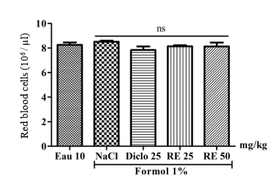
Fig. 8: Effect of recipe on the number of red blood cells
ns: no significant volume change of red blood cells in mouse from batches receiving the recipe compared to the batch receiving NaCl
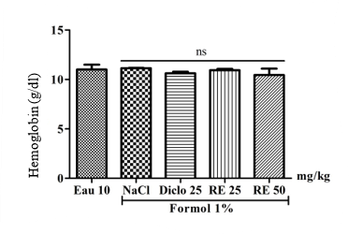
Fig. 9: Effect of recipe on the number of hemoglobin
ns: no significant volume change of hemoglobin in mouse from batches receiving the recipe compared to the batch receiving NaCl

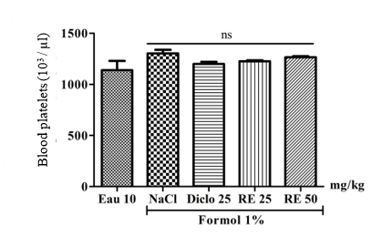
Fig. 10: Effect of recipe on the number of blood platelets
ns: no significant volume change of blood platelets in mouse from batches receiving the recipe compared to the batch receiving NaCl
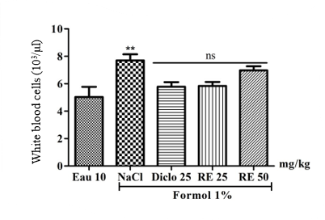
Fig. 11: Effect of recipe on the number of white blood cells
ns: no significant; ** significant (P=0,01):
no significant volume change of white blood cells in mouse from batches receiving recipe compared the batch receiving Diclo
significant volume changes of white blood cells in mouse from batches receiving NaCl compared to the batch receiving recipe

4. Conclusion

The study was carried out with the general objective of carrying out an ethnobotanical investigation into the medicinal recipes used in the towns of Bobo-Dioulasso and Koudougou to treat cervical cancer. The most cited recipe and consisting of three species, namely M. inermis, P. pinnata and X. sthulmannii, was selected after said investigation for biologicals. Tube tests revealed the presence of tannins, alkaloids and saponosides. The content of total flavonoids in the recipe extract was 1.294 ± 0.011 mg EG /100mg and that of total phenolic was 24.723 ±1.071 mg EG /100mg. The anti-inflammatory activity was carried out according to the model of formalin injection into the arch of the mouse paw. The extract from the recipe showed an anti-inflammatory effect by inhibiting the volume of edema from the first hour with an inhibition percentage of 35.81% and 43.80% for respective doses of 25 and 50 mg/kg of body weight and this during the 07 days of the test. The blood count showed an inhibitory effect on the proliferation of immune cells in inflammation and the stabilization of red blood cell levels.

REFERENCES
- 1. WHO. (2021). Framework for implementing the global strategy to eliminate cervical cancer as a public health problem in the WHO African Region.
- 2. Ouédraogo E., Bayala B., Zohoncon T. M., Ouédraogo S., Lompo O. M., Dovo E. E., et al. (2024). Cytotoxic Properties on Cervical and Liver Cancer Cells of Two Plant Recipes from Burkina Faso. Journal of Biosciences and Medicines, 12, pp. 216-229.
- 3. WHO. (2019). WHO Presence in Countries, Territories, and Areas. 2019 Report
- 4. Ferré V. (2022). Molecular Mechanisms and Biological Markers in the Pathogenesis of HPV-Induced Anogenital Cancers. Microbiology and Parasitology. Paris Cité University.
- 5. National Cancer Control Strategy 2021-2025, September 2022. Burkina Faso.
- 6. WHO. (2024). Cervical Cancer.
- 7. Hafiane A., Guerfa M. (2020). Cytopathological and Biochemical Study of Cervical Cancer Associated with HPV Infection. Master's Thesis. Larbi Tébessi University–Tébessa. 30p.
- 8. Adico1 M. D. W., Bayala B., Zoure A. A., Lagarde A., Bazie J. TV., Traore L., et al. (2024). In Vitro Activities and Mechanisms of Action of Anticancer Molecules from African Medicinal Plants: A Systematic Review. Am J Cancer Res , 14(3):1376-1401
- 9. WHO. (2000). World Health Report, 2000.
- 10. 85. Rademana S., Anantharajub P. G., Madhunapantulab S. V., Lalla N. (2019). The anti-proliferative and antioxidant activity of four indigenous south African plants. Afr., J. Complement Altern Med. 16 (1), pp.13-23
- 11. Aseney E.G., Akinleye E.T., George E.U., Mgbeje I.B., Adewumi M.O., Adeniji A.J. (2023). Cytotoxic action of the leaves of Uvaria chamae P.Beauv. and Dicliptera paniculata (Forssk.) I.Darbysh. from Nigeria mediated through intrinsic apoptotic pathway induction in four cancer cell lines. Phytomedicine Plus 3 100423
- 12. Adinortey M. B., J.K. Sarfo, J.K., Adukpo, G.E., Dzotsi, E., Kusi, S., Ahmed, M. A., and O. Abdul-Gafaru (2912). Acute and subacute oral toxicity assessment of hydroalcoholic root extract of Paullinia pinnata on hematological and biochemical parameters. Biology and Medicine, 4 (3): pp. 121–125.
- 13. N’guessan, K., Kadja, B., Zirihi, G.N., Traoré, D., and L. Aké-Assi (2009). Phytochemical screening of some Ivorian medicinal plants used in Krobou country (Agboville, Ivory Coast). Sciences & Nature, Vol. 6, No. 1, pp. 1–1.
- 14. bangou
- 15. Rahmani S., Belboukhari N., Sekkoum K., Cheriti A. (2016). Evaluation of the anti-inflammatory activity of aqueous extracts of Limoniastrum feei (Plumbaginacea) leaves. Algerian journal of arid environment vol. 6, n°1, pp 80-86.
- 16. Kamboule B. E., Méda Z. C., Koura M., Héma A., Zouré N., Hien H., Ouattara Z. D., Sawadogo A. (2020). Knowledge, Attitudes and Practices of Traditional Health Practitioners in Bobo-Dioulasso Regarding Hemorrhoidal Disease. Health Sciences and Diseases: Vol 21(3), pp.21-30.
- 17. Ouattara Y.S.R., Zerbo P., Ouattara A., Sourabie S., Boussim I.J. (2021). Sociodemographic Profiles of Traditional Health Practitioners Practicing in Western Burkina Faso. RAMReS Journal – Series Pharm. Med. Trad. Afr. 20(2): pp. 113-121.
- 18. Makita-Ikouaya E., Milleliri J.-M., Rudant J.-P. (2010). The Place of Traditional Medicine in the Healthcare System of Sub-Saharan African Cities: The Case of Libreville, Gabon. Cahiers Santé Vol. 20, No. 4, 10p.
- 19. Nafui O. M., Olaniyi S. S., Salawu O. M., Ajao A. A., Akanji A. M. (2018). Studies on Ameliorative Effects of Polyphenolic Extract from Paullinia pinnata L. (Sapindaceae) on Carbon Tetrachloride-Induced Hepatotoxicity and Oxidative Stress: an in vivo Assessment. Not Sci Biol, 10(1):79-86
- 20. Konkon N. G., Adjoungoua A. L., Manda P., Simaga D., N’Guessan K. E., Kone B. D. (2008). Toxicological and phytochemical screening study of Mitragyna Inermis (willd.) O ktze (Rubiaceae), anti-diabetic plant. Journal of Medicinal Plants Research Vol. 2(10), pp. 279-284.
- 21. Monjanel-Mouterde S., Traore F., Gasquet M., Dodero F., Delmas F., Ikoli J. F., et al. (2006). Lack of toxicity of Hydroethanolic extract from Mitragyna inermis (Willd.) O. Kuntze by gavage in the rat. Journal of ethnopharcology, 103 (3), pp. 319-326.
- 22. Adeyemo-Salami O.A., Makinde J.M. (2013). Acute and sub-acute toxicity studies of the methanol extract of the leaves of Paullinia Pinnata (Linn.) in wistar albino mice and rats. Afr. J.Med. med. Sci. 42, pp. 81-90.
- 23. Nyathi1 B., Bvunzawabaya J. T., Mudawarima C. V. P., Manzombe E., Tsotsoro K., Selemani M. A., et al. (2023). Inhibitory and in silico molecular docking of Xeroderis stuhlmannii (Taub.) Mendonca & E.P. Sousa phytochemical compounds on human α-glucosidases. bioRxiv 39p.
- 24. Selemania M. A., Kazingizia L. F., Manzombea E., Bishia L. Y., Mureyab C., Gwatab T. T., Rwerea F. (2021). Phytochemical characterization and in vitro antibacterial activity of Xeroderris stuhlmannii (Taub.) Mendonca & E.P. Sousa bark extracts. South African Journal of Botany 142, pp. 344-351.
- 25. Minoue Kuum M. G. (2020). Analgesic, anti-inflammatory and antipyretic activities of extracts from the trunk bark of Albizia ferruginea Guill et Perr. (Mimosaceae) in mice and rats. Thesis for the award of the Doctoral degree. University of Yaoundé I.
- 26. Ngono X. R., Tembe E.F., Ngameni B., Nono N. B., Fokunang C. N. (2019). Phytochemical Screening, Analgesic Properties and Acute Toxicity of the Aqueous Extract of Paullinia Pinnata (Sapindaceae) Stem Bark. Health Sci. Dis, Vol 20 (6), pp. 1-8.
- 27. Dénou A., Koudouvo K., Haidara M., Togola A., Sanogo R., Essien K., et al. (2016). Analgesic Activity of Four Plants Used in the Traditional Management of Malaria in Mali and Togo. Int. J. Biol. Chem. Sci. 10(3), pp. 1342-1349.
- 28. Yeo D., Dinica R., Yapi H. F., Furdui B., Praisler M., Djaman A. J., N’Guessan j. D. (2011). Evaluation of the anti-inflammatory activity and phytochemical screening of Annona senegalensis leaves. Phytotherapy 66 (1), pp.73–80.
- 29. Onakpa M.M., Ezugwu C.G., Ode J.O., Kolawole V.O., Ajagbonna O.P. (2019). evaluation of anti-inflammatory and analgesic activities of methanolic extract of Mitragyna Inermis. Journal of Veterinary and Biomedical Sciences Vol. 1 (2). pp. 85 – 94.
- 30. Lunga P. K., Tamokou J. de D., Fodouop S.PC., Kuiate J.-R., Tchoumboue J., Gatsing D. (2014). Antityphoid and radical scavenging properties of the methanol extracts and compounds from the aerial part of Paullinia pinnata. SpringerPlus, 3:302, 9p.

