Original Research Article

Star Chromatic Index of Some Types of Graphs

Abstract
In graph theory, graph coloring is a major branch, where we assign colors to the elements of a graph, subject to certain constraints. This research explores the concept of star edge coloring, a part of graph coloring, where there cannot be any path or cycle of length four which is bicolored. This limitation ensures that each bicolor class constitutes a star forest, and thus the structure is more suited to a vast range of theoretical as well as practical considerations. The concept was initially proposed by Liu and Deng in 2008, and since then, this has become an actively pursued area of graph theory due to the complexity involved and the applicability to real-world network systems. Finding the star chromatic index, $χ_{st}^{'}(G)$ of a graph $G$ is a challenging problem in this research area. It is computationally intractable to find $χ_{st}^{'}(G)$ for general graphs, and has provoked researchers to consider special graph families where good bounds or exact values are achievable. The primary objective of this work is to determine the star chromatic index of pan graphs ($T_{n,1}$), tadpole graphs ($T_{n,m}$), friendship graphs ($F_{n}$), ladder graphs ($L_{n}$), flower graphs ($U_{2,m}$), and umbrella graphs ($U_{n,m}$). Based on previous work, utilizing the established upper bounds and known results from the star edge coloring of paths, cycles, and stars, $χ_{st}^{'}(G)$ has been proven for those graph types. Beyond theoretical analysis, this study provides a method for constructing a valid star edge coloring for those families of graphs. The proposed algorithms are generic and can be applied to numerous classes of graphs with similar features.
Keywords: Friendship graph, Ladder graph, Star chromatic index, Star edge coloring, Star graph, Tadpole graph, Umbrella graph
1. INTRODUCTION

Graph theory, originating with Leonhard Euler’s solution to the Königsberg Bridge Problem in 1736, provides a powerful framework for modeling relationships and connections in various systems. One of its most important branches is graph coloring, which involves assigning colors to elements of a graph under certain constraints. This idea first emerged in the 19th century with Francis Guthrie’s observation that four colors seemed sufficient to color any map, giving rise to the famous four-color problem; a seemingly simple question that resisted proof for over a century and was finally resolved in 1976 by Appel, Haken, and Koch. Beyond maps, graph coloring has wide-ranging applications, including scheduling problems, frequency assignment in mobile networks, and transportation problems, making it a vital tool in both theoretical and applied mathematics.
Star coloring, introduced by Grünbaum in 1973, is a stricter form of graph coloring where no path or cycle of length three is bi-colored. A similar concept to star coloring, but applied to the edges, was introduced by Liu and Deng in 2007.

Definition 1.1. [Lužar et al., 2017] A proper edge coloring of a graph $G$ is called a star edge coloring if there are neither bi-chromatic paths nor bi-chromatic cycles of length four.

Definition 1.2. [Lužar et al., 2017] The minimum number of colors for which $G$ admits a star edge coloring is called the star chromatic index, and it is denoted by $χ_{st}^{'}(G)$.

In 2007 and 2008, the pioneers of star edge coloring Liu & Deng worked on finding upper bounds for some types of graphs.

Theorem 1.1. [Liu & Deng, 2008] For the path graph $P_{n} (n≥2)$ and the cycle graph $C_{n} (n≥3)$, $χ_{st}^{'}\left(P_{n}\right)=\left\{\begin{aligned}1, &n=2 \\ 2, &n=3,4 \\ 3, &n≥5\end{aligned}\right.$ and $χ_{st}^{'}\left(C_{n}\right)=\left\{\begin{aligned}3, &n≠5 \\ 4, &n=5\end{aligned}\right.$.
For any integer $n≥4$, the wheel graph $W_{n}$ (resp. the fan graph $F_{n}$) is the $n$-vertex graph obtained by joining a vertex to each of the $n-1$ vertices of the cycle graph $C_{n-1}$ (resp. the path graph $P_{n-1}$). Then, $χ_{st}^{'}\left(W_{n}\right)=\left\{\begin{aligned}n+2: &n=5 \\ n+1: &n=4,6,7 \\ n-1: &n≥8\end{aligned}\right.$ and $χ_{st}^{'}\left(F_{n}\right)=\left\{\begin{aligned}n+1: &n=5 \\ n: &n=3,4,6,7 \\ n-1: &n≥8\end{aligned}\right.$.

Theorem 1.2. [Liu & Deng, 2008] Let $G$ be a graph with maximum degree $∆ ≥7$. Then,
$χ_{st}^{'}\left(G\right)≤ \left\lceil 16{(∆-1)}^{3/2}\right\rceil$.

Theorem 1.3. [Wang et al., 2019] Every graph $G$ with $∆ =4$ satisfies $χ_{st}^{'}\left(G\right)≤14$.

Theorem 1.4. [Casselgren et al., 2021] Let G be a sub-cubic planar graph with girth at least 7. If G has a perfect matching, then $χ_{st}^{'}\left(G\right)≤6$.

Theorem 1.5. [Bezegova et al., 2016] Let $T$ be a sub-cubic tree. Then $χ_{st}^{'}\left(G\right)≤4$.

Theorem 1.6. [Bezegova et al., 2016] Let G be an outer-planar sub-cubic graph. Then $χ_{st}^{'}\left(G\right)≤5$.

Theorem 1.7. [Fernando & Athapattu, 2025] If $G$ is a simple connected sub-cubic graph, then $χ_{st}^{'}\left(G\right)≤6$.

2. results and discussion

In this section, we present star chromatic indices of pan graphs ($T_{n,1}$), tadpole graphs ($T_{n,m}$), friendship graphs ($F_{n}$), ladder graphs ($L_{n}$), flower graphs ($U_{2,m}$), and umbrella graphs ($U_{n,m}$).

Definition 2.1. Define the distance between two edges $e_{1}, e_{2} ∈ E(G)$ by $d\left(e_{1}{, e}_{2}\right)=N+1$where $N$ is the number of edges between $e_{1}$ and $e_{2}$ in the shortest path.

Here, two algorithms are introduced to star edge color any path ($P_{n}$) or cycle ($C_{n}$), which are used to prove the newly introduced star chromatic indices later on this section.

Remark 2.1: Define $f:E\left(G\right)→\{α_{i}|i∈N\}$ where $G$ is the considered graph ($P_{n}$ or $C_{n}$) and $\{α_{i}|i∈N\}$ is the collection of distinct colors.
Case I. For $n(≥5)∈N$, let $e∈E(P_{n})$ be a terminal edge, and without loss of generality, let $f\left(e\right)=α_{1}$. Then $f\left(e^{'}\right)=\left\{\begin{aligned} α_{1} :d(e^{'}, e)=d_{1} \\ α_{2} :d(e^{'}, e)=d_{2} \\ α_{3} :d(e^{'}, e)=d_{3}\end{aligned}\right.$ for $e'∈E(P_{n})$, where $d_{1}≡3(mod3)$, $d_{2}≡1\left(mod3\right)$, and $d_{3}≡2(mod3)$.
Case II. For any odd $n(≠5)∈N$, let $e∈E(C_{n})$ such that $f\left(e\right)=α_{1}$. For $e'(≠e)∈E(C_{n})$, color $f\left(e^{'}\right)=\left\{\begin{aligned} α_{1} :d(e^{'}, e)=d_{1} \\ α_{2} :d(e^{'}, e)=d_{2} \\ α_{3} :d(e^{'}, e)=d_{3}\end{aligned}\right.$ where $d_{1}≡3(mod3)$, $d_{2}≡1\left(mod3\right)$, and $d_{3}≡2(mod3)$. Since $f\left(e_{1}\right)=f(e_{2})$ for $e_{1}, e_{2}∈E(C_{n})$ such that $d\left({e, e}_{1}\right)=d\left({e, e}_{2}\right)=\frac{n-1}{2}$ , change the color of $e_{1}$ so that edge coloring condition is satisfied.
These algorithms validate the results in the Theorem 1.1.

Lemma 2.1. For the pan graph $T_{n,1}$, $χ_{st}^{'}\left(T_{n,1}\right)=\left\{\begin{aligned} 4 :n=4,5 \\ 3 :o/w\end{aligned}\right.$.

Proof. $T_{n,1}$ is composed of the cycle $C_{n}$ and a pendent edge $e_{p}$. Hence, $χ_{st}^{'}\left(T_{n,1}\right)≥χ_{st}^{'}\left(C_{n}\right)$ for all $n∈N$. Referring to the Case II in Remark 2.1, $χ_{st}^{'}\left(T_{5,1}\right)≥4$, and $χ_{st}^{'}\left(T_{n,1}\right)≥3$ for $n≠5$. Color $C_{n}$ according to the above remark, and for $e_{p}$, take $f\left(e_{p}\right)=α$ where $f\left(e_{1}\right)≠f\left(e_{2}\right)≠α$for $d\left(e_{p}, e_{1}\right)=d\left(e_{p}, e_{2}\right)=1$ for $e_{1}, e_{2}∈E(C_{n})$. This method gives a valid star edge coloring for $T_{n,1}$ for all $n∈N$ except for $n=4$. For $n=4$, a new color is needed in order to avoid bicolored paths of length four. Hence, $χ_{st}^{'}\left(T_{4,1}\right)=4$ and $χ_{st}^{'}\left(T_{n,1}\right)=χ_{st}^{'}\left(C_{n}\right)$ for $n≠4$.

Theorem 2.1. For the tadpole graph $T_{n,m}$, then $χ_{st}^{'}\left(T_{n,m}\right)=\left\{\begin{aligned} 3 :n=3, m=1 \\ 4 :n=3, m≥2 \\ 4 :n=4,5, m≥1 \\ 3 :n≥6, m≥1\end{aligned}\right..$

Proof. For $T_{n,m}$ extend the coloring of $T_{n,1}$ in Lemma 2.1, so that the remaining path is colored using the Case I introduced in the Remark 2.1. Since $χ_{st}^{'}\left(T_{n,m}\right)≥χ_{st}^{'}\left(T_{n,1}\right)$, it is clear that $χ_{st}^{'}\left(T_{n,m}\right)=χ_{st}^{'}\left(T_{n,1}\right)$ for $n≥4$ and $m≥1$. For $n=3$ and $m=2$, there is a newly added edge $e_{p}^{'}$ to $T_{3,1}$. It is shown that $T_{3,1}$ needs only 3 colors, say $α_{1}, α_{2}, α_{3}$ and the star edge coloring was given. But whenever $f\left(e_{p}^{'}\right)=α_{1} or α_{2} or α_{3}$, it will form a path of length 4 which is bicolored.
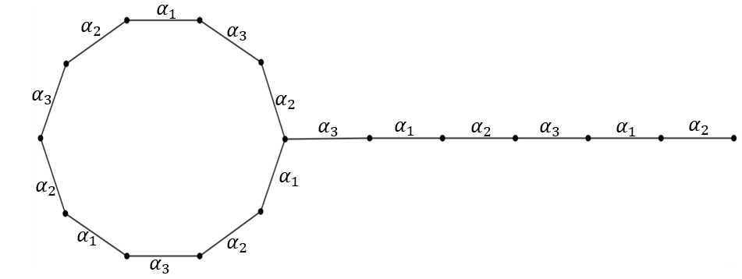
Fig. 1. Star edge coloring of $T_{10,6}$
Theorem 2.2. For the friendship graph $F_{n}$, then $χ_{st}^{'}\left(F_{n}\right)=\left\{\begin{aligned} 5 :n=2 \\ 2n :n≥3\end{aligned}\right.$ .

Proof. Note that $F_{n}$ is composed of $n$ number of $C_{3}$’s, and each $C_{3}$ has two edges ${e_{s}∈E(S}_{2n})$ and an edge ${e_{r}∈E(F_{n}-S}_{2n})$. Label the cycles as $C_{3}^{k}$ anticlockwise, and the edges as $e_{s}^{k}, e_{s}^{k+1}, e_{r}^{k}∈E(C_{3}^{k})$ for $k=1,3, …, 2n-1$. Since for the star, 2n distinct colors are required, $χ_{st}^{'}\left(F_{n}\right)≥χ_{st}^{'}\left(S_{2n}\right)=2n$ for all $n∈N$. Hence for $n=2$, $χ_{st}^{'}\left(F_{2}\right)≥χ_{st}^{'}\left(S_{4}\right)=4$. Once ${e_{s}∈E(S}_{4})$ are colored, for the two $e_{r}$’s, at least a one new color is needed, so that there is no bicolored path of length four. Hence, $χ_{st}^{'}\left(F_{2}\right)=5$. For $n≥3$, color as follows: $f\left(e_{s}^{k}\right)=α_{k}$, $f\left(e_{s}^{k+1}\right)=α_{k+1}$, and $f\left(e_{r}^{k}\right)=α_{k+2}$ for $k=1,3, …, 2n-1$ under $modulo 2n$. That gives a star edge coloring. So $χ_{st}^{'}\left(F_{n}\right)=χ_{st}^{'}\left(S_{2n}\right)=2n$ for $n≥3$.

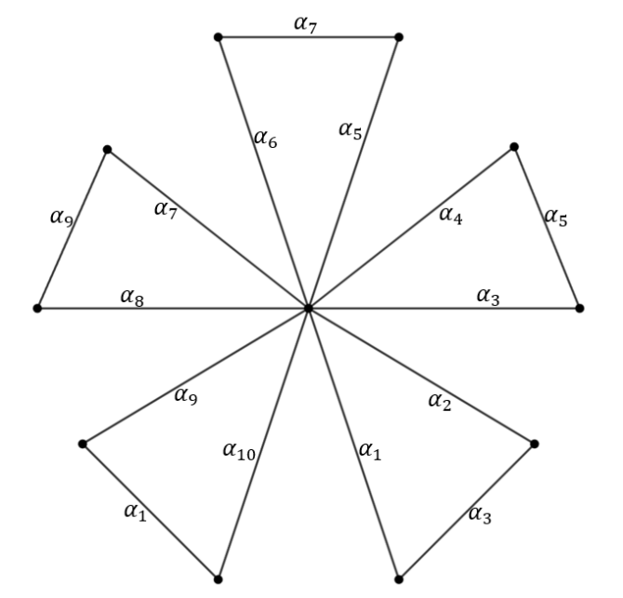
Fig. 2. Star edge coloring of $F_{5}$

Theorem 2.3. For the ladder graph $L_{n}$, then $χ_{st}^{'}\left(L_{n}\right)=\left\{\begin{aligned} 1 :n=1 \\ 3 :n=2 \\ 4 :n=3,4 \\ 5 :n≥5\end{aligned}\right.$ .

Proof. For $n=1, 2, 3, 4$ the result holds trivially by the Remark 2.1. For $n=5$, four colors are not enough and a fifth color is needed for the newly added two vertical vertices. Hence, $χ_{st}^{'}\left(L_{5}\right)=5$. Also note that, $χ_{st}^{'}\left(L_{n}\right)≥χ_{st}^{'}\left(L_{5}\right)=5$ for all $n≥6$. Note that $L_{n}$ has $n$ horizontal edges: $e_{h}$ and $2(n-1)$ vertical edges: $e_{v}$. Label $e_{h}∈E(L_{n})$ from top to bottom as $e_{h}^{i}$ where $i=1, 2, …, n$. There are $n-1$ $C_{4}$ s’ and label them from top to bottom as $C_{4}^{k}$ where $k=1, 2, …, n-1$. Each $C_{4}^{k}$ has two $e_{v}$’s, label both as $e_{v}^{k}$. Color those edges as follows: $f\left(e_{h}^{i}\right)=\left\{\begin{aligned} α_{1} :i≡1(mod2) \\ α_{2} :i≡2(mod2)\end{aligned}\right.$ and $f\left(e_{v}^{k}\right)=\left\{\begin{aligned} α_{3} :k≡1(mod3) \\ α_{4} :k≡2(mod3) \\ α_{5} :k≡3(mod3)\end{aligned}\right.$. This method gives a star edge coloring for $L_{n}$ $\left(n≥5\right)$ that uses only five colors.

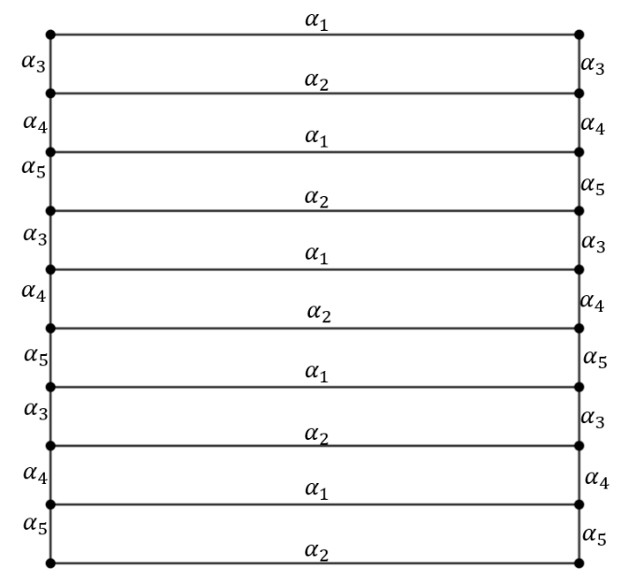
Fig. 3. Star edge coloring of $L_{10}$
Theorem 2.4. For the umbrella graph $U_{n,m}$, $χ_{st}^{'}\left(U_{n,m}\right)=\left\{\begin{aligned} m+2 : m=2, 3, 4, 6 \\ m+1 : o/ w \end{aligned}\right.$ for $n≥3$.

In particular, when $n=2$, for the flower graph $U_{2,m},$ $χ_{st}^{'}\left(U_{2,m}\right)=\left\{\begin{aligned} m+2 : m=3,4 \\ m+1 : o/w\end{aligned}\right.$.

Proof. Note that $U_{n,m}$ consists of a star $S_{m+1}$ of $m+1$ edges, and two paths: $P_{m}$ of $m-1$ edges that connects $m$ vertices of $S_{m+1}$ to form a fan $U_{1,m}$, and $P_{n-1}$ of $n-2$ edges that connects to the remaining vertex of $S_{m+1}$.
For $m=2$, there is a $S_{3}$. Since for the star graph $S_{m}$, $χ_{st}^{'}\left(S_{m}\right)=m$, $χ_{st}^{'}\left(U_{n,2}\right)≥χ_{st}^{'}\left(S_{3}\right)=3$. When $n=2$, the color of the pendent edge can be used for the remaining edge in the fan, and hence, $χ_{st}^{'}\left(U_{2,2}\right)=3$. When $n=3$, the newly added edge cannot be colored by used colors in order to preserve the star edge coloring. So, $χ_{st}^{'}\left(U_{3,2}\right)=4$, and for further extension of the tail the three colors used for $S_{3}$ can be used referring to the Theorem 1.1. For $m=3,4$, $χ_{st}^{'}\left(U_{n,3}\right)≥χ_{st}^{'}\left(S_{4}\right)=4$ and $χ_{st}^{'}\left(U_{n,4}\right)≥χ_{st}^{'}\left(S_{5}\right)=5$. It is clear that for both cases one more new color is needed, and hence, $χ_{st}^{'}\left(U_{n,3}\right)=5$ and $χ_{st}^{'}\left(U_{n,4}\right)=6$. There, the length of the tail can be ignored as for any path it needs a maximum three colors for the star edge coloring according to the Theorem 1.1.
For $m≥5$, $χ_{st}^{'}\left(U_{n,m}\right)≥χ_{st}^{'}\left(S_{m+1}\right)=m+1$. Label the edges of $S_{m+1}$ as $e_{s}^{k}$ for $k=1, 2, …, m+1$ such that the bridging edge that connects the fan $U_{1,m}$ to the tail $P_{n-1}$ is $e_{s}^{1}$ and the rest labeled anticlockwise. Color ${f(e}_{s}^{k})=α_{k}$. Label the edges of the path $P_{m}$ as $e_{p}^{i}$ for $i=1, 2, …, m-1$ clockwise. When $m$ is even, color ${f(e}_{p}^{1})={f(e}_{p}^{m/2})={f(e}_{p}^{m-1})=α_{1}$, and when $m$ is odd, color ${f(e}_{p}^{1})={f(e}_{p}^{m-1})=α_{1}$, and for the remaining edges, ${f(e}_{p}^{i})=\left\{\begin{aligned} α_{i} : 2≤i≤\left\lfloor \frac{m-1}{2}\right\rfloor \\ α_{i+3} : \left\lceil \frac{m+1}{2}\right\rceil ≤i≤m-2\end{aligned}\right.$. Thus $χ_{st}^{'}\left(U_{2,m}\right)=χ_{st}^{'}\left(S_{m+1}\right)=m+1$.
Finally, for the tail $P_{n-1}$, use the Case I in Remark 2.1. Since for any path, that needs only three colors, $χ_{st}^{'}\left(U_{n,m}\right)=χ_{st}^{'}\left(S_{m+1}\right)=m+1$ for $m(≠6)≥5$.

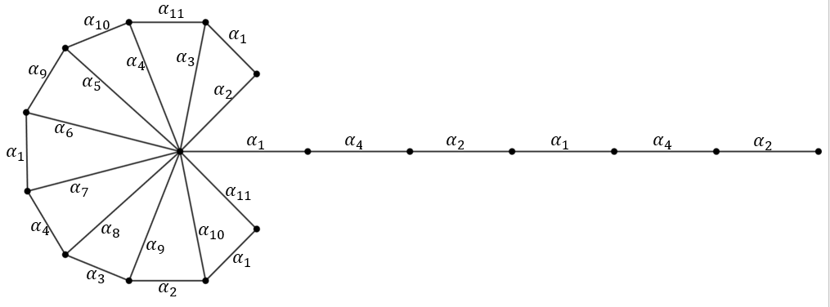
Fig. 4. Star edge coloring of $U_{7,10}$

4. Conclusion

In conclusion, this research has explored the star edge coloring of pan graphs ($T_{n,1}$), tadpole graphs ($T_{n,m}$), friendship graphs ($F_{n}$), ladder graphs ($L_{n}$), flower graphs ($U_{2,m}$), and umbrella graphs ($U_{n,m}$). It was successfully proved that the introduced star chromatic indices hold for those types of graphs, and algorithms were given to star edge color any such graph. The limitation of this research is that the algorithms introduced in this paper can only be used to star edge color those specific graph types, and their generalized versions, but for other graphs, further algorithms should be generated. This work can be extended further to real world situations, like networking, and planning cities.

REFERENCES

(Bezegova et al., 2016) Bezegova, L., Lužar, B., Mockovčiaková, M., Skrekovski, R. & Soták, R. (2016). Star edge coloring of some classes of graphs. Journal of Graph Theory, 81(1) (2016), pp. 73–82.

(Casselgren et al., 2021) Casselgren, C.J., Granholm, J.B., & Raspaud A. (2021). On star edge colorings of bipartite and subcubic graphs. Discrete Applied Mathematics 298 (2021), pp. 21–33.

(Fernando & Athapattu, 2025) Fernando, C.L.R., & Athapattu, A.M.C.U.M. (2025). An upper bound for star chromatic index of simple connected sub-cubic graphs and applications. Journal of the National Science Foundation of Sri Lanka (2025) (Pre-print).

(Liu & Deng, 2008) Liu, Xinsheng & Deng, Kai. (2008). An upper bound on the star chromatic index of graphs with $∆ ≥7$. Journal of Lanzhou University. Natural Sciences. 44.

(Lužar et al., 2017) Lužar, B., Mockovčiaková, M., & Soták, R. (2017a). Note on list star edge-coloring of subcubic graphs. Journal of Graph Theory. https://doi.org/10.1002/jgt.22402

(Wang et al., 2019) Wang, Y., Wang, Y., & Wang, W. (2019). Star edge-coloring of graphs with maximum degree four. Applied Mathematics and Computation, 340, 268–275. https://doi.org/10.1016/j.amc.2018.08.035

