Original Research Article

Evaluation Of Female Infertility Factors: A Prospective Observational Study

.

ABSTRACT

|  |
| --- |
| **Aims: T**o evaluate the factors associated with female infertility. This is a prospective observational study of 100 woman in reproductive age group with complaints of primary and secondary infertility.  **Study design:** Prospective observational study.  **Place and Duration of Study:** Department of Obstetrics and Gynaecology at our tertiary care centre.  **Methodology:** 100 women (mean age: 24.68 years) in reproductive age group with complaints of primary and secondary infertility were included. A comprehensive history was taken from the participants covering their socio-demographic background, menstrual patterns, obstetric details, and medical history. Thorough general and systemic examinations were conducted with particular attention to pelvic examination for clinical assessment. All symptoms, clinical findings, and examination results were systematically recorded. Ultrasonography was performed to assess the pelvic organs, including the uterine cavity, endometrial thickness, and any adnexal abnormalities. Hysterolaparoscopy was undertaken in cases requiring further investigation, and the findings were duly noted.  **Results:** Tubal factors were the major causes of primary and secondary infertility accounting for 43.9% and 38.2% respectively. PCOS was the major pathological reason among ovarian factors for primary infertility (24.4%) and secondary infertility (20%). With regards to peritoneal factors endometriosis (13.3%) and tuberculosis (16%) were responsible for primary and secondary infertility respectively. With respect to uterine factors Mullerian pathology was found to be the major cause for primary (8.9%) and secondary (12%) infertility in women. Ovarian factors were the major causes of primary infertility identified through hysterolaparoscopy, and which is accounting for 55.6% followed by peritoneal factors (35.6%), tubal factors (33.3%), and uterine factors (24.4%). Similarly, with respect to secondary infertility in women ovarian factors identified through hysterolaparoscopy accounts for 52% followed by tubal factors (40%), peritoneal factors (36%), and uterine factors (24%).  **Conclusion:** Hysteroscopy combined with laparoscopy remains the only diagnostic method that allows direct visualization of the female reproductive system to identify the underlying causes of infertility. |

*Keywords: Female infertility; tubal factors; ovarian factors; PCOS; B/L tubal block; endometriosis; hysterolaparoscopy.*

**1. INTRODUCTION**

The inability to conceive remains one of the most emotionally challenging experiences for couples. It not only affects a woman’s sense of completeness but is also deeply entangled with strong societal stigmas. Reproduction is fundamental to the survival of any species, and in contemporary society, significant emphasis is placed on the family unit, with women often expected to fulfill the biological role of bearing and raising children. Failure to reproduce is frequently viewed as a personal misfortune or social curse, impacting not only the couple but also their extended family and surrounding community. The psychosocial effects of childlessness can be profound and damaging (Ombelet et al., 2008). A major but often overlooked reproductive health concern in developing nations is the high rate of infertility (Garg et al., 2020).

Infertility is a global health issue that affects approximately 8–10% of couples worldwide. According to the World Health Organization (WHO), an estimated 60–80 million couples globally are currently suffering infertility (Soni & Kumari, 2018). In India, infertility rates have shown a slight decline of 7.7% between NFHS-2 and NFHS-3, dropping from about 2% to 1.85%. WHO defines infertility as the failure to achieve pregnancy after 12 months of unprotected intercourse in women under 34 years of age (Cooper et al., 2010). Diagnostic work-ups typically begins when a couple has not conceived after a year of regular, contraception-free intercourse by which time approximately 85–90% of couples are expected to conceive (Bovin et al., 2007).

Various biological and sociocultural factors influence fertility, including psychological stress, religious norms, delayed marriages, higher education, contraceptive practices, and the shift towards nuclear family structures (Jejeebhoy, 1998). Infertility can also result from anatomical, genetic, hormonal, immunological issues, or sexually transmitted infections (Daar & Meerali, 2001). Female infertility may stem from a range of causes such as ovulatory disorders, tubal blockages, uterine malformations, fibroids, Asherman’s syndrome, and endometriosis (Campbell & Irvine, 2000).

There is paucity of data about the causes of infertility among infertile women of reproductive age group in our study setting. With this context, the present study was carried out with the main objective to evaluate the factors associated with female infertility at our tertiary care centre.

2. material and methods

**2.1 Study design and patients**

This is a prospective observational study conducted with total of 100 woman in reproductive age group with complaints of primary and secondary infertility coming to the Department of Obstetrics and Gynaecology (OBG) at J. J. M. Medical College (JJMMC), Davangere, Karnataka. A written informed consent was taken from all the subjects participating in the study.

**2.2 Inclusion criteria**

1. Gender: Females
2. Age: 18-40 years
3. Pregnancy has not been achieved in a year of regular contraceptive-free intercourse
4. Primary or secondary infertility

**2.2 Exclusion criteria**

1. No male infertility factor
2. Surrogate women
3. Postmenopausal women
4. Non-adherence of treatment
5. Unmarried women seeking child
6. Lack of full examinations, laboratory tests
7. Suffering from any neurological or psychiatric illness
8. Other chronic medical disorders like Systemic Lupus Erythematosus (SLE) or cancer

**2.3 Assessment parameters**

A comprehensive history was taken from the participants covering their socio-demographic background, menstrual patterns, obstetric details, and medical history. Thorough general and systemic examinations were conducted with particular attention to pelvic examination for clinical assessment. All symptoms, clinical findings, and examination results were systematically recorded. Relevant diagnostic tests such as complete blood count (CBC), blood glucose levels, thyroid function tests, and viral serology were carried out, and their results were documented. Ultrasonography was performed to assess the pelvic organs, including the uterine cavity, endometrial thickness, and any adnexal abnormalities. Hysterolaparoscopy was undertaken in cases requiring further investigation, and the findings were duly noted.

**2.4 Statistical analysis**

Data were entered in Microsoft Excel 2021 and statistical analysis was done using IBM Statistical Software for Social Sciences (SPSS) version 22. Categorical variables were represented in the form of frequency, and percentage. Continuous variables were presented as descriptive statistics (Mean and Standard deviation)..

3. results

The results of distribution of study participants based on socio-demographic characteristics were represented in Table 1. Results depicted that majority of the study subjects i.e., 78% were belonged to age group of 20-25 years with mean age of 24.68 years. 68% and 32% of the study participants were from rural and urban background respectively. Major proportion of study participants enrolled were housewives (56%) followed by private employee (25%), Govt. employee (14%), and self-employed (5%).

The discussion should not repeat the results, but provide detailed interpretation of data. This should interpret the significance of the findings of the work. Citations should be given in support of the findings. The results and discussion part can also be described as separate, if appropriate.

**Table 1: Distribution of study participants based on** **socio-demographic characteristics**

|  |  |  |
| --- | --- | --- |
| **Variables** | **Frequency** | **Percentage** |
| **Age (Years)** | | |
| 20-25 | 78 | 78.0 |
| 26-30 | 12 | 12.0 |
| 31-35 | 6 | 6.0 |
| 36-40 | 4 | 4.0 |
| Mean ± SD | 24.68 ± 4.65 | |
| **Residence** | | |
| Rural | 68 | 68.0 |
| Urban | 32 | 32.0 |
| **Occupation** | | |
| Housewives | 56 | 56.0 |
| Private employee | 25 | 25.0 |
| Govt. employee | 14 | 14.0 |
| Self-employed | 5 | 5.0 |

Majority of the study participants i.e., 66% were suffering primary infertility followed by secondary infertility (34%, Fig. 1).

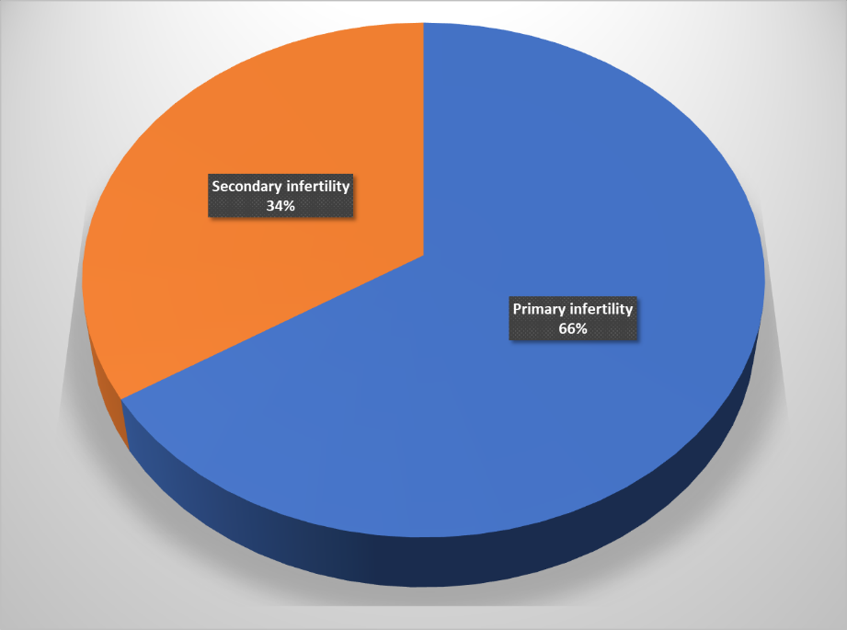

**Fig. 1. Distribution of study participants based on types of infertility**

The results of distribution of study participants based on infertility factors were represented in Table 2. Results portray that tubal factors were the major causes of primary infertility accounting for 43.9% followed by ovarian factors (27.3%), peritoneal factors (16.7%), and 12.1% of uterine factors were responsible for primary infertility in women. Similarly, with regards to secondary infertility in women tubal factors accounts for 38.2% followed by ovarian factors (26.5%), peritoneal factors (23.5%), and uterine factors (11.8%).

**Table 2:** **Distribution of study participants based on infertility factors**

|  |  |  |
| --- | --- | --- |
| **Infertility Factors** | **Primary Infertility**  **(n=66)** | **Secondary Infertility**  **(n=34)** |
| Tubal factors | 29 (43.9) | 13 (38.2) |
| Ovarian factors | 18 (27.3) | 9 (26.5) |
| Peritoneal factors | 11 (16.7) | 8 (23.5) |
| Uterine factors | 8 (12.1) | 4 (11.8) |

Values were expressed n (%)

The results of distribution of study participants based on laparoscopically identified pathology of female infertility were represented in Table 3. Results inferred that among tubal factors, B/L block was the major pathological cause for primary infertility (20%) and secondary infertility (24%). PCOS was the major pathological reason among ovarian factors for primary infertility (24.4%) and secondary infertility (20%). With regards to peritoneal factors endometriosis (13.3%) and tuberculosis (16%) responsible for primary and secondary infertility respectively. With respect to uterine factors Mullerian pathology was found to be major cause for primary (8.9%) and secondary (12%) infertility in women.

**Table 3: Distribution of study participants based on laparoscopically identified pathology of infertility**

|  |  |  |  |
| --- | --- | --- | --- |
| **Infertility Factors** | | **Primary Infertility**  **(n=45)** | **Secondary Infertility (n=25)** |
| Tubal factors | U/L block | 3 (6.7) | 3 (12.0) |
| B/L block | 9 (20.0) | 6 (24.0) |
| Hydrosalpinx | 2 (4.4) | 3 (12.0) |
| TO mass | 4 (8.9) | 1 (4.0) |
| Peritubal adhesions | 1 (2.2) | 2 (8.0) |
| Total | 19 (42.2) | 15 (60.0) |
| Ovarian factors | PCOS | 11 (24.4) | 5 (20.0) |
| Chocolate cyst | 2 (4.4) | 2 (8.0) |
| Complex cyst | 3 (6.7) | 1 (4.0) |
| Simple cyst | 4 (8.9) | 2 (8.0) |
| Total | 20 (44.4) | 10 (40.0) |
| Peritoneal factors | Pelvic adhesions | 5 (11.1) | 3 (12.0) |
| Tuberculosis | 4 (8.9) | 4 (16.0) |
| Endometriosis | 6 (13.3) | 1 (4.0) |
| Total | 15 (33.3) | 8 (32.0) |
| Uterine factors | Mullerian pathology | 4 (8.9) | 3 (12.0) |
| Fibroid | 3 (6.7) | 0 (0.0) |
| Hypoplastic | 1 (2.2) | 1 (4.0) |
| Total | 8 (17.8) | 4 (16.0) |

Values were expressed n (%)

The ovarian factors were the major causes of primary infertility identified through hysterolaparoscopy, and which is accounting for 55.6% followed by peritoneal factors (35.6%), tubal factors (33.3%), and 24.4% of uterine factors identified through hysterolaparoscopy were responsible for primary infertility in women. Similarly, with respect to secondary infertility in women ovarian factors identified through hysterolaparoscopy accounts for 52% followed by tubal factors (40%), peritoneal factors (36%), and uterine factors (24%, Fig. 2).

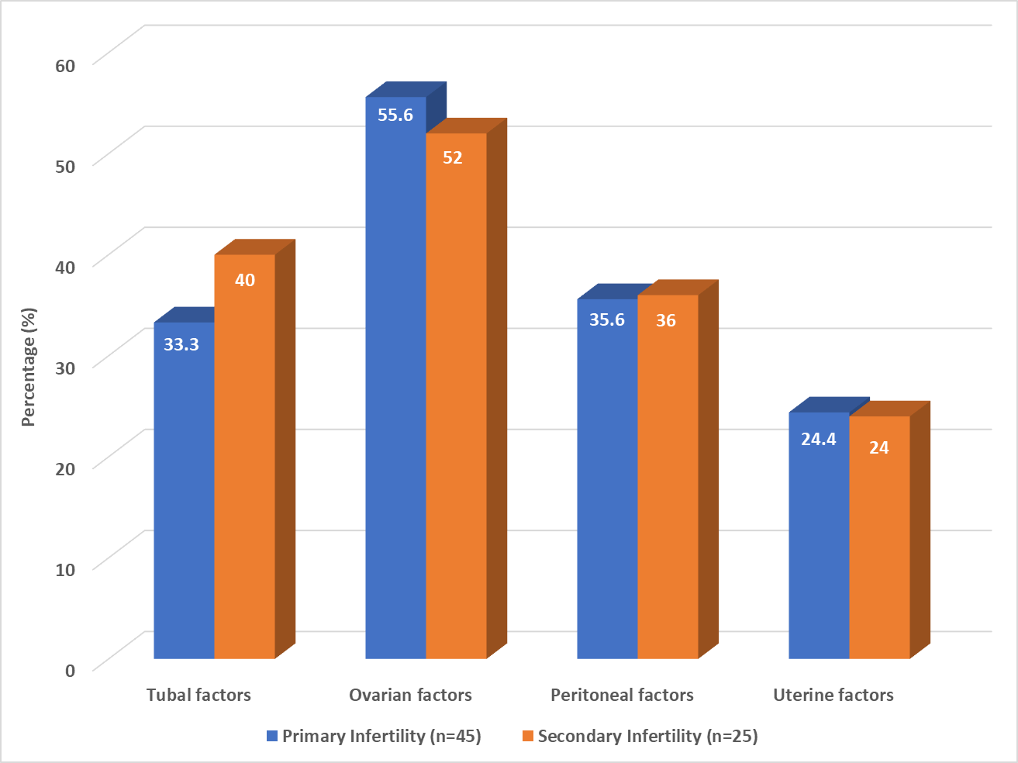

**Fig. 2. Distribution of study participants based on causes of infertility identified with** **hysterolaparoscopy**

4. discussion

Infertility is a complex health concern with multiple contributing factors. While it often results from abnormalities in the fallopian tubes, ovaries, or endometrial lining, modern lifestyle factors such as delayed age of marriage, pursuit of higher education, stress, obesity, and restrictive legal policies around assisted reproductive techniques also play a pivotal role (Soni & Kumari, 2018). Additionally, limited data is available regarding the causes of female infertility in our study setting. Therefore, this prospective observational study was designed to investigate the underlying factors responsible for infertility in women presented with primary or secondary infertility to the Obstetrics and Gynaecology department of our tertiary care hospital.

In our study, the mean age of participants was 24.68 years. This observation aligns with findings from other researchers. For instance, Adamson et al., conducted a study assessing the prevalence and correlates of primary infertility among young women in Mysore, India, and reported a mean age of 25.9 years, which is consistent with our data (Adamson et al., 2011). Age is a crucial factor in infertility, with a noticeable decline in ovarian reserve as women grow older (Thatipelli et al., 2024). Our study revealed the highest infertility rate (78%) among women aged 20–25 years, which differs from the findings of Mamatha and Sreelatha, who noted the highest rate in the 26–30 age group (38%) (Mamatha et al., 2024). According to Adamson et al., the predominance of infertility among younger women may be associated with early marriage (Adamson et al., 2011).

In a prospective study involving 50 women, Garg et al., observed that 54% suffering from primary infertility, while 46% had secondary infertility (Garg et al., 2020). These findings are in line with our study, which showed a higher proportion of primary infertility (66%) compared to secondary infertility (34%). Similar prevalence rates were reported by Duignan et al. (77% primary, 23% secondary) (Duignan et al., 1972), and Templeton and Kerr (74.9% primary, 25.1% secondary) (Templeton & Kerr, 1977).

Previous literature highlights the significant role of tubal disease in infertility, emphasizing the importance of tubal assessment before initiating treatment (Practice Committee of the American Society for Reproductive Medicine, 2015). Correspondingly, in our study, tubal pathology was the leading cause of primary infertility (43.9%), followed by ovarian (27.3%), peritoneal (16.7%), and uterine factors (12.1%). In secondary infertility, tubal causes accounted for 38.2% followed by ovarian factors (26.5%), peritoneal issues (23.5%), and uterine abnormalities (11.8%). These results are supported by findings from other studies. For example, Garg et al., reported that tubal factors were responsible for 18.4% of primary and 23% of secondary infertility cases (Garg et al., 2020). Similarly, Sudha et al., found ovulatory dysfunction in 53.45% and tubal blockages in 58.85% of cases, particularly within 1–2 years of infertility. Hormonal imbalances significantly contribute to anovulation (Sudha et al., 2013). Gohill et al., also reported that hormonal disturbances can hinder follicular development necessary for ovulation (Gohill et al., 2001). Additionally, Hema et al. noted that uterine causes accounted for 20.9% of infertility, which aligns with our findings (Hema & Lalitha, 2017). Peritoneal causes were reported by Garg et al., in 25.9% of primary and 4.3% of secondary infertility cases (Garg et al., 2020).

Polycystic ovarian syndrome (PCOS) emerged as the most common ovarian cause in our study (24.4%), similar to the 26% reported by Nandhini & Murugalakshmi, (2016). Bilateral tubal blockage was the most frequent tubal pathology in our participants (20%), comparable to the 12.86% reported by Bhide et al., (1990). Literature consistently identifies Mullerian tract anomalies as a predominant uterine abnormality in infertile women (Sholapurkar, 1986; Sud et al., 1987; Prabhu et al., 1988), and so in our study, their prevalence was 8.9%. Endometriosis was the most common peritoneal factor identified (13.3%). Other studies have shown that 25%–50% of infertile women are affected by endometriosis, while 30%–50% of women with endometriosis also suffer from infertility (Missmer et al., 2004). Although it remains uncertain whether endometriosis directly causes infertility or contributes to it, the condition is frequently observed among infertile women (Garg et al., 2020).

Laparoscopy, by providing a magnified view of the pelvic anatomy, enables accurate assessment of tubal and ovarian structures, tubal adhesions, and patency. It also allows direct visualization of abnormalities like endometriosis and peritoneal adhesions that can interfere with ovum pickup despite normal-appearing tubes. As such, laparoscopy is the gold standard for diagnosing these conditions and offers the benefit of simultaneous surgical correction (Garg et al., 2020). Subsequently, in our study, hysterolaparoscopy identified ovarian causes as the most common contributors to primary infertility (55.6%) followed by peritoneal (35.6%), tubal (33.3%), and uterine causes (24.4%). For secondary infertility, the most common findings through hysterolaparoscopy were ovarian factors (52%) followed by tubal (40%), peritoneal (36%), and uterine factors (24%).

5. Conclusion

The tubal and ovarian factors are the leading causes of female infertility observed in our tertiary care centre. PCOS is the most common ovarian factor and bilateral tubal blocks are the most common tubal factors associated with both primary and secondary infertility in women, Hysteroscopy combined with laparoscopy remains the only diagnostic method that allows direct visualization of the female reproductive system to identify the underlying causes of infertility. Given the growing prevalence of female infertility, our study’s insights into its causes represent an essential initial step toward addressing the issue.

Consent and ethical approval

A written informed consent was taken from all the subjects participating in the study.

Ethical approval (where ever applicable)

The ethical approval was obtained from the Institutional Scientific Committee and the Institutional Ethics Committee of J. J. M. M. C., Davangere. All authors hereby declare that all experiments have been performed in accordance with the ethical standards laid down in the 1964 Declaration of Helsinki

COMPETING INTERESTS DISCLAIMER:

Authors have declared that they have no known competing financial interests OR non-financial interests OR personal relationships that could have appeared to influence the work reported in this paper.

References

Adamson, P. C., Krupp, K., Freeman, A. H., Klausner, J. D., Reingold, A. L., & Madhivanan,

P. (2011). Prevalence and correlates of primary infertility among young women in Mysore, India. Indian Journal of Medical Research, 134(4), 440–446.

Bhide, A. G. (1990). Laparoscopic evaluation of the etiopathology of infertility. Journal of

Obstetrics and Gynecology of India, 40, 680–682.

Boivin, J., Bunting, L., Collins, J. A., & Nygren, K. G. (2007). International estimates of

infertility prevalence and treatment-seeking: Potential need and demand for infertility medical care. Human Reproduction, 22(6), 1506–1512.

Campbell, A. J., & Irvine, D. S. (2000). Male infertility and intracytoplasmic sperm injection

(ICSI). British Medical Bulletin, 56, 616–629.

Cooper, T. G., Noonan, E., & Eckardstein, S. N. (2010). World Health Organization

reference values for human semen characteristics. Human Reproduction Update, 16(3), 231–245.

Daar, A., & Merali, Z. (2001). Infertility and social suffering: The case of ART in developing

countries (pp. 16–21). World Health Organization.

Duignan, N. M., Jordan, J. A., Coughlan, B. M., & Logan Edwards, R. (1972). One thousand

consecutive cases of diagnostic laparoscopy. Journal of Obstetrics and Gynaecology of the British Commonwealth, 79(11), 1016–1024.

Garg, K., Paul, D. P., & Ray, J. (2020). Evaluation of female factors in infertility by diagnostic

laparohysteroscopy in a tertiary health care centre. International Journal of Reproduction, Contraception, Obstetrics and Gynecology, 9, 3596–3601.

Gohill, B. C., Rosenblum, L. A., Coplan, J. D., & Kral, J. G. (2001). Hypothalamic-pituitary-

adrenal axis function and the metabolic syndrome X of obesity. CNS Spectrums, 6(7), 581–586.

Hema, K. R., & Lalitha, H. S. (2017). Evaluation of role of laparoscopy in determining

etiology of infertility. International Journal of Reproduction, Contraception, Obstetrics and Gynecology, 6(12), 5322–5326.

Jejeebhoy, S. J. (1998). Infertility in India—Levels, patterns and consequences: Priorities for

social science research. Journal of Family Welfare, 44, 15–24.

Mamatha, C. H., & Sreelatha, B. (2024). A clinical study on factors influencing occurrence

infertility in females. International Journal of Pharmaceutical and Clinical Research, 16(1), 1678–1683.

Missmer, S. A., Hankinson, S. E., Spiegelman, D., Barbieri, R. L., Marshall, L. M., & Hunter,

D. J. (2004). Incidence of laparoscopically confirmed endometriosis by demographic, anthropometric, and lifestyle factors. American Journal of Epidemiology, 160(8), 784–796.

Nandhini, V., & Murugalakshmi. (2016). Role of diagnostic hysterolaparoscopy in primary

infertility. Journal of Dental and Medical Sciences, 15(8), 25–28.

Ombelet, W., Cooke, I., Dyer, S., Serour, G., & Devroey, P. (2008). Infertility and the

provision of infertility medical services in developing countries. Human Reproduction Update, 14(6), 605–621.

Prabhu, J. R., Sivaraman, R., Srinivasan, O., & Rajarathnam, S. (1988). Diagnostic

laparoscopy: A review of 800 cases. The Journal of Obstetrics and Gynaecology of India, 38, 205.

Practice Committee of the American Society for Reproductive Medicine. (2015). Diagnostic

evaluation of the infertile female: A committee opinion. Fertility and Sterility, 103(6), e44–e50.

Sholapurkar, M. L. (1986). Primary amenorrhoea: A clinical and laparoscopic study. Journal

of Obstetrics and Gynaecology of India, 36, 1052.

Soni, M., & Kumari, S. (2018). Prospective evaluation of causes of infertility at a tertiary care

hospital. International Journal of Research in Medical Sciences, 6, 3988–3992.

Sud, K., Malan, R., Saxena, P., & Thakur, K. (1987). Analysis of 300 diagnostic

laparoscopies. Journal of Obstetrics and Gynaecology of India, 37, 156.

Sudha, G., & Reddy, K. S. (2013). Causes of female infertility: A cross-sectional study.

International Journal of Latest Research in Science and Technology, 2(6), 119–123.

Templeton, A. A., & Kerr, M. G. (1977). An assessment of laparoscopy as the primary

investigation in the subfertile female. British Journal of Obstetrics and Gynaecology, 84(10), 760–762.

Thatipelli, R. C., Parunandi, Y., Nousheen, S., Shenkeshi, S., Fathima, H., & Anitha, A.

(2024). An observational study on causes of female infertility. International Journal of Reproduction, Contraception, Obstetrics and Gynecology, 13, 2450–2456.